

**目录**

TEXT1 3

TEXT2 6

TEXT3 9

TEXT4 12

TEXT5 15

TEXT6 18

TEXT7 21

TEXT8 24

TEXT9 27

TEXT10 31

TEXT11 34

TEXT12 37

# 226df8811a170232b47004b95121b73TEXT1

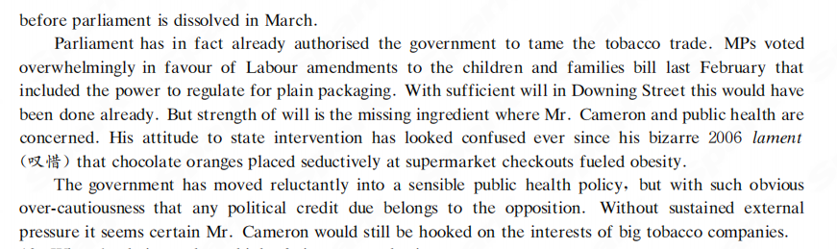

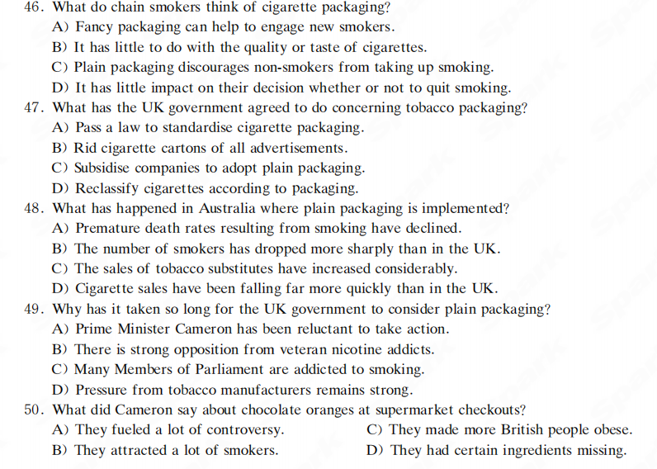

阅读答案：DABAC

词汇拓展：

请将文中生词整理誊写至词汇拓展区

|  |  |  |
| --- | --- | --- |
| 词汇拓展 | | |
| 生词 | 文中搭配 | 中文释义 |
|  |  |  |
|  |  |  |
|  |  |  |
|  |  |  |
|  |  |  |
|  |  |  |
|  |  |  |
|  |  |  |
|  |  |  |
|  |  |  |
|  |  |  |
|  |  |  |
|  |  |  |
|  |  |  |
| 随写区 | | |

# 2bb8273287d9c99aa69e799e1a1af96TEXT2

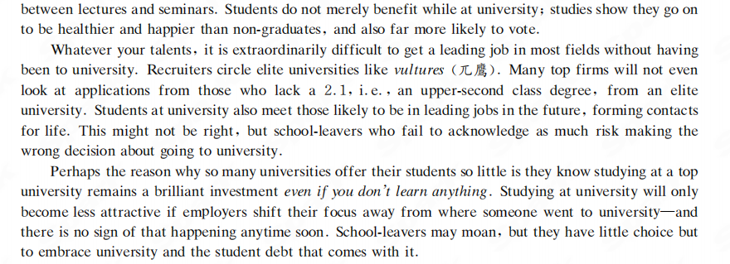

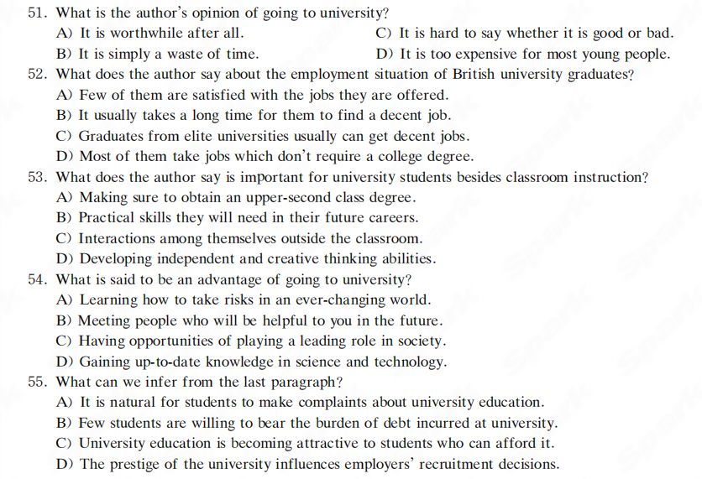

阅读答案：ADCBD

词汇拓展：

请将文中生词整理誊写至词汇拓展区

|  |  |  |
| --- | --- | --- |
| 词汇拓展 | | |
| 生词 | 文中搭配 | 中文释义 |
|  |  |  |
|  |  |  |
|  |  |  |
|  |  |  |
|  |  |  |
|  |  |  |
|  |  |  |
|  |  |  |
|  |  |  |
|  |  |  |
|  |  |  |
|  |  |  |
|  |  |  |
|  |  |  |
| 随写区 | | |

# TEXT3

It is not controversial to say that an unhealthy diet causes bad health. Nor are the basic elements of healthy eating disputed. Obesity raises susceptibility to cancer, and Britain is the sixth most obese country on Earth. That is a public health emergency. But naming the problem is the easy part. No one disputes the costs in quality of life and depleted health budgets of an obese population, but the quest for solutions gets diverted by ideological arguments around responsibility and choice. And the water is muddied by lobbying from the industries that profit from consumption of obesity-inducing products.

Historical precedent suggests that science and politics can overcome resistance from businesses that pollute and poison but it takes time, and success often starts small. So it is heartening to note that a programme in Leeds has achieved a reduction in childhood obesity, becoming the first UK city to reverse a fattening trend. The best results were among younger children and in more deprived areas. When 28% of English children aged two to 15 are obese, a national shift on the scale achieved by Leeds would lengthen hundreds of thousands of lives. A significant factor in the Leeds experience appears to be a scheme called HENRY, which helps parents reward behaviours that prevent obesity in children.

Many members of parliament are uncomfortable even with their own government's anti-obesity strategy, since it involves a “sugar tax” and abandon the sale of energy drinks to under-16s. Bans and taxes can be blunt instruments, but their harshest critics can rarely suggest better methods. These critics just oppose regulation itself.

The relationship between poor health and inequality is too pronounced for governments to be passive about large-scale intervention. People living in the most deprived areas are four times more prone to die from avoidable causes than counterparts in more affluent places. As the structural nature of public health problems becomes harder to ignore, the complaint about over protective government loses potency.

In fact, the polarised debate over public health interventions should have been abandoned long ago. Government action works when individuals are motivated to respond. Individuals need governments that expand access to good choices. The HENRY programme was delivered in part through children's centres. Closing such centres and cutting council budgets doesn’t magically increase reserves of individual self-reliance. The function of a well-designed state intervention is not to deprive people of liberty but to build social capacity and infrastructure that helps people take responsibility for their wellbeing. The obesity crisis will not have a solution devised by left or right ideology—but experience indicates that the private sector needs the incentive of regulation before it starts taking public health emergencies seriously.

46. Why is the obesity problem in Britain so difficult to solve?

A) Government health budgets are depleted.

B) People disagree as to who should do what.

C) Individuals are not ready to take their responsibilities.

D) Industry lobbying makes it hard to get healthy foods.

47. What can we learn from the past experience in tackling public health emergencies?

A) Governments have a role to play.

B) Public health is a scientific issue.

C) Priority should be given to deprived regions.

D) Businesses' responsibility should be stressed.

48. What does the author imply about some critics of bans and taxes concerning unhealthy drinks?

A) They are not aware of the consequences of obesity.

B) They have not come up with anything more constructive.

C) They are uncomfortable with parliament anti-obesity debate.

D) They have their own motives in opposing government regulation.

49. Why does the author stress the relationship between poor health and inequality?

A) To demonstrate the dilemma of people living in deprived areas.

B) To bring to light the root cause of widespread obesity in Britain.

C) To highlight the area deserving the most attention from the public.

D) To justify government intervention in solving the obesity problem.

50. When will government action be effective?

A) When the polarised debate is abandoned.

B) When ideological differences are resolved.

C) When individuals have the incentive to act accordingly.

D) When the private sector realises the severity of the crisis.

阅读答案：BABDC

词汇拓展：

请将文中生词整理誊写至词汇拓展区

|  |  |  |
| --- | --- | --- |
| 词汇拓展 | | |
| 生词 | 文中搭配 | 中文释义 |
|  |  |  |
|  |  |  |
|  |  |  |
|  |  |  |
|  |  |  |
|  |  |  |
|  |  |  |
|  |  |  |
|  |  |  |
|  |  |  |
|  |  |  |
|  |  |  |
|  |  |  |
|  |  |  |
| 随写区 | | |

# TEXT4

Home to virgin reefs, rare sharks and vast numbers of exotic fish, the Coral Sea is a unique haven of biodiversity off the northeastern coast of Australia. If a proposal by the Australian government goes ahead, the region will also become the world's largest marine protected area, with restrictions or bans on fishing, mining and marine farming.

The Coral Sea reserve would cover almost 990 000 square kilometres and stretch as far as 1 100 kilometres from the coast. Unveiled recently by environment minister Tony Burke, the proposal would be the last in a series of proposed marine reserves around Australia's coast.

But the scheme is attracting criticism from scientists and conservation groups, who argue that the government hasn't gone far enough in protecting the Coral Sea, or in other marine reserves in the coastal network.

Hugh Possingham, director of the Centre of Excellence for Environmental Decisions at the University of Queensland, points out that little more than half of the Coral Sea reserve is proposed as “no take” area, in which all fishing would be banned. The world's largest existing marine reserve, established last year by the British government in the Indian Ocean, spans 554 000 km² and is a no-take zone throughout. An alliance of campaigning conversation groups argues that more of the Coral Sea should receive this level of protection.

“I would like to have seen more protection for coral reefs,” says Terry Hughes, director of the Centre of Excellence for Coral Reef Studies at James Cook University in Queensland. “More than 20 of them would be outside the no-take area and vulnerable to catch-and-release fishing”.

As Nature went to press, the Australian government had not responded to specific criticisms of the plan. But Robin Beaman, a marine geologist at James Cook University, says that the reserve does “broadly protect the range of habitats” in the sea. “I can testify to the huge effort that government agencies and other organisations have put into trying to understand the ecological values of this vast area,” he says.

Reserves proposed earlier this year for Australia's southwestern and northwestern coastal regions have also been criticised for failing to give habitats adequate protection. In August, 173 marine scientists signed an open letter to the government saying they were “greatly concerned” that the proposals for the southwestern region had not been based on the “core science principles” of reserves—the protected regions were not, for instance, representative of all the habitats in the region, they said.

Critics say that the southwestern reserve offers the greatest protection to the offshore areas where commercial opportunities are fewest and where there is little threat to the environment, a contention also levelled at the Coral Sea plan.

51. What do we learn from the passage about the Coral Sea?

A) It is exceptionally rich in marine life.

B) It is the biggest marine protected area.

C) It remains largely undisturbed by humans.

D) It is a unique haven of endangered species.

52. What does the Australian government plan to do according to Tony Burke?

A) Make a new proposal to protect the Coral Sea.

B) Revise its conservation plan owing to criticisms.

C) Upgrade the established reserves to protect marine life.

D) Complete the series of marine reserves around its coast.

53. What is scientists' argument about the Coral Sea proposal?

A) The government has not done enough for marine protection.

B) It will not improve the marine reserves along Australia's coast.

C) The government has not consulted them in drawing up the proposal.

D) It is not based on sufficient investigations into the ecological system.

54. What does marine geologist Robin Beaman say about the Coral Sea plan?

A) It can compare with the British government's effort in the Indian Ocean.

B) It will result in the establishment of the world's largest marine reserve.

C) It will ensure the sustainability of the fishing industry around the coast.

D) It is a tremendous joint effort to protect the range of marine habitats.

55. What do critics think of the Coral Sea plan?

A) It will do more harm than good to the environment.

B) It will adversely affect Australia's fishing industry.

C) It will protect regions that actually require little protection.

D) It will win little support from environmental organisations.

阅读答案：ADADC

词汇拓展：

请将文中生词整理誊写至词汇拓展区

|  |  |  |
| --- | --- | --- |
| 词汇拓展 | | |
| 生词 | 文中搭配 | 中文释义 |
|  |  |  |
|  |  |  |
|  |  |  |
|  |  |  |
|  |  |  |
|  |  |  |
|  |  |  |
|  |  |  |
|  |  |  |
|  |  |  |
|  |  |  |
|  |  |  |
|  |  |  |
|  |  |  |
| 随写区 | | |

# TEXT5

Danielle Steel, the 71-year-old romance novelist is notoriously productive, having published 179 books at a rate of up to seven a year. But a passing reference in a recent profile by Glamour magazine to her 20-hour workdays prompted an outpouring of admiration.

Steel has given that 20-hour figure when describing her “exhausting” process in the past: “I start the book and don't leave my desk until the first draft is finished.” She goes from bed, to desk, to bath, to bed, avoiding all contact aside from phone calls with her nine children. “I don't comb my hair for weeks,” she says. Meals are brought to her desk, where she types until her fingers swell and her nails bleed.

The business news website Quartz held Steel up as an inspiration, writing that if only we all followed her “actually extremely liberating” example of industrious sleeplessness, we would be quick to see results.

Well, indeed. With research results showing the cumulative effects of sleep loss and its impact on productivity, doubt has been voiced about the accuracy of Steel’s self-assessment. Her output maybe undeniable, but sceptics have suggested that she is guilty of erasing the role of ghost writers(代笔人) at worst, gross exaggeration at best.

Steel says working 20 hours a day is “pretty brutal physically.” But is it even possible? “No,” says Maryanne Taylor of the Sleep Works. While you could work that long, the impact on productivity would make it hardly worthwhile. If Steel was routinely sleeping for four hours a night, she would be drastically underestimating the negative impact, says Alison Gardiner, founder of the sleep improvement programme Sleep station. “It’s akin to being drunk.”

It’s possible that Steel is exaggerating the demands of her schedule. Self-imposed sleeplessness has “become a bit of a status symbol”, says Taylor, a misguided measure to prove how powerful and productive you are. Margaret Thatcher was also said to get by on four hours a night, while the 130-hour workweeks endured by tech heads has been held up as key to their success.

That is starting to change with increased awareness of the importance of sleep for mental health. “People are starting to realise that sleep should not be something that you fit in between everything else,” says Taylor.

But it is possible—if statistically extremely unlikely—that Steel could be born a “short sleeper” with an unusual body clock, says sleep expert Dr. Sophie Bostock. “It’s probably present in fewer than 1% of the population.”

Even if Steel does happen to be among that tiny minority, says Bostock, it's “pretty irresponsible” to suggest that 20-hour days are simply a question of discipline for the rest of us.

46. What do we learn from the passage about Glamour magazine readers?

A) They are intrigued by the exotic romance in Danielle Steel's novels.

B) They are amazed by the number of books written by Danielle Steel.

C) They are deeply impressed by Danielle Steel's daily work schedule.

D) They are highly motivated by Danielle Steel’s unusual productivity.

47. What did the business news website Quartz say about Danielle Steel?

A) She could serve as an example of industriousness.

B) She proved we could liberate ourselves from sleep.

C) She could be an inspiration to novelists all over the world.

D) She showed we could get all our work done without sleep.

48. What do sceptics think of Danielle Steel's work schedule claims?

A) They are questionable.

B) They are alterable.

C) They are irresistible.

D) They are verifiable.

49. What does Maryanne Taylor think of self-imposed sleeplessness?

A) It may turn out to be key to a successful career.

B) It may be practiced only by certain tech heads.

C) It may symbolise one's importance and success.

D) It may well serve as a measure of self-discipline.

50. How does Dr. Sophie Bostock look at the 20-hour daily work schedule?

A) One should not adopt it without consulting a sleep expert.

B) The general public should not be encouraged to follow it.

C) One must be duly self-disciplined to adhere to it.

D) The majority must adjust their body clock for it.

阅读答案：CAACB

词汇拓展：

请将文中生词整理誊写至词汇拓展区

|  |  |  |
| --- | --- | --- |
| 词汇拓展 | | |
| 生词 | 文中搭配 | 中文释义 |
|  |  |  |
|  |  |  |
|  |  |  |
|  |  |  |
|  |  |  |
|  |  |  |
|  |  |  |
|  |  |  |
|  |  |  |
|  |  |  |
|  |  |  |
|  |  |  |
|  |  |  |
|  |  |  |
| 随写区 | | |

# TEXT6

Organic agriculture is a relatively untapped resource for feeding the Earth's population, especially in the face of climate change and other global challenges. That's the conclusion I reached in reviewing 40 years of science comparing the long-term prospects of organic and conventional farming.

The review study, “Organic Agriculture in the 21st Century,” is featured as the cover story for the February issue of the journal Nature Plants. It is the first to compare organic and conventional agriculture across the main goals of sustainability identified by the National Academy of Sciences: productivity, economics, and environment.

Critics have long argued that organic agriculture is inefficient, requiring more land to yield the same amount of food. It's true that organic farming produces lower yields, averaging 10 to 20 percent less than conventional. Advocates contend that the environmental advantages of organic agriculture far outweigh the lower yields, and that increasing research and breeding resources for organic systems would reduce the yield gap. Sometimes excluded from these arguments is the fact that we already produce enough food to more than feed the world's 7.4 billion people but do not provide adequate access to all individuals.

In some cases, organic yields can be higher than conventional. For example, in severe drought conditions, which are expected to increase with climate change in many areas, organic farms can produce as good, if not better, yields because of the higher water-holding capacity of organically farmed soils.

What science does tell us is that mainstream conventional farming systems have provided growing supplies of food and other products but often at the expense of other sustainability goals.

Conventional agriculture may produce more food, but it often comes at a cost to the environment. Biodiversity loss, environmental degradation, and severe impacts on ecosystem services have not only accompanied conventional farming systems but have often extended well beyond their field boundaries. With organic agriculture, environmental costs tend to be lower and the benefits greater.

Overall, organic farms tend to store more soil carbon, have better soil quality, and reduce soil erosion compared to their conventional counterparts. Organic agriculture also creates less soil and water pollution and lower greenhouse gas emissions. And it’s more energy-efficient because it doesn't rely on synthetic fertilizers or pesticides.

Organic agriculture is also associated with greater biodiversity of plants, animals, insects and microorganisms as well as genetic diversity. Biodiversity increases the services that nature provides and improves the ability of farming systems to adapt to changing conditions.

Despite lower yields, organic agriculture is more profitable for farmers because consumers are willing to pay more. Higher prices, called price premiums, can be justified as a way to compensate farmers for providing ecosystem services and avoiding environmental damage or external costs.

51. What do we learn from the conclusion of the author's review study?

A) More resources should be tapped for feeding the world's population.

B) Organic farming may be exploited to solve the global food problem.

C) The long-term prospects of organic farming are yet to be explored.

D) Organic farming is at least as promising as conventional farming.

52. What is the critics' argument against organic farming?

A) It cannot meet the need for food.

B) It cannot increase farm yields.

C) It is not really practical.

D) It is not that productive.

53. What does the author think should be taken into account in arguing about organic farming?

A) Growth in world population.

B) Deterioration in soil fertility.

C) Inequality in food distribution.

D) Advance in farming technology.

54. What does science tell us about conventional farming?

A) It will not be able to meet global food demand.

B) It is not conducive to sustainable development.

C) It will eventually give away to organic farming.

D) It is going mainstream throughout the world.

55. Why does the author think higher prices of organic farm produce are justifiable?

A) They give farmers going organic a big competitive edge.

B) They motivate farmers to upgrade farming technology.

C) Organic farming costs more than conventional farming.

D) Organic farming does long-term good to the ecosystem.

阅读答案：BDCBD

词汇拓展：

请将文中生词整理誊写至词汇拓展区

|  |  |  |
| --- | --- | --- |
| 词汇拓展 | | |
| 生词 | 文中搭配 | 中文释义 |
|  |  |  |
|  |  |  |
|  |  |  |
|  |  |  |
|  |  |  |
|  |  |  |
|  |  |  |
|  |  |  |
|  |  |  |
|  |  |  |
|  |  |  |
|  |  |  |
|  |  |  |
|  |  |  |
| 随写区 | | |

# TEXT7

What is the place of art in a culture of inattention? Recent visitors to the Louvre report that tourists can now spend only a minute in front of the Mona Lisa before being asked to move on. Much of that time, for some of them, is spent taking photographs not even of the painting but of themselves with the painting in the background.

One view is that we have democratised tourism and gallery-going so much that we have made it effectively impossible to appreciate what we’ve travelled to see. In this oversubscribed society, experience becomes a commodity like any other. There are queues to climb Mt. Jolmo Lungma as well as to see famous paintings. Leisure, thus conceived, is hard labour, and returning to work becomes a well-earned break from the ordeal.

What gets lost in this industrialised haste is the quality of looking. Consider an extreme example, the late philosopher Richard Wollheim. When he visited the Louvre he could spent as much as four hours sitting before a painting. The first hour, he claimed, was necessary for misperceptions to be eliminated. It was only then that the picture would begin to disclose itself. This seems unthinkable today, but it is still possible to organise. Even in the busiest museums there are many rooms and many pictures worth hours of contemplation which the crowds largely ignore. Sometimes the largest crowds are partly the products of bad management; the Mona Lisa is such a hurried experience today partly because the museum is being reorganised. The Uffizi in Florence, another site of cultural pilgrimage, has cut its entry queues down to seven minutes by clever management. And there are some forms of art, those designed to be spectacles as well as objects of contemplation, which can work perfectly well in the face of huge crowds.

Olafur Eliasson’s current Tate Modern show, for instance, might seem nothing more than an entertainment, overrun as it is with kids romping (喧闹地玩耍)in fog rooms and spray mist installations. But it’s more than that: where Eliasson is at his most entertaining, he is at his most serious too, and his disorienting installations bring home the reality of the destructive effects we are having on the planet — not least what we are doing to the glaciers of Eliasson’s beloved Iceland.

Marcel Proust, another lover of the Louvre, wrote: “ It is only through art that we can escape from ourselves and know how another person sees the universe, whose landscapes would otherwise have remained as unknown as any on the moon.”If any art remains worth seeing, it must lead us to such escapes. But a minute in front of a painting in a hurried crowd won’t do that.

46. What does the scene at the Louvre demonstrate according to the author?

A) The enormous appeal of a great piece of artistic work to tourists.

B) The near impossibility of appreciating art in an age of mass tourism.

C) The ever-growing commercial value of long-cherished artistic works.

D) The real difficulty in getting a glimpse at a masterpiece amid a crowd.

47. Why did the late philosopher Richard Wollheim spend four hours before a picture?

A) It takes time to appreciate a piece of art fully.

B) It is quite common to misinterpret artistic works.

C) The longer people contemplate a picture, the more likely they will enjoy it.

D) The more time one spends before a painting, the more valuable one finds it.

48. What does the case of the Uffizi in Florence show?

A) Art works in museums should be better taken care of.

B) Sites of cultural pilgrimage are always flooded with visitors.

C) Good management is key to handling large crowds of visitors.

D) Large crowds of visitors cause management problems for museums.

49. What do we learn from Olafur Eliasson’s current Tate Modern show?

A) Children learn to appreciate art works most effectively while they are playing.

B) It is possible to combine entertainment with appreciation of serious art.

C) Art works about the environment appeal most to young children.

D) Some forms of art can accommodate huge crowds of visitors.

50. What can art do according to Marcel Proust?

A) Enable us to live a much fuller life.

B) Allow us to escape the harsh reality.

C) Help us to see the world from a different perspective.

D) Urge us to explore the unknown domain of the universe

.

阅读答案：BACBC

词汇拓展：

请将文中生词整理誊写至词汇拓展区

|  |  |  |
| --- | --- | --- |
| 词汇拓展 | | |
| 生词 | 文中搭配 | 中文释义 |
|  |  |  |
|  |  |  |
|  |  |  |
|  |  |  |
|  |  |  |
|  |  |  |
|  |  |  |
|  |  |  |
|  |  |  |
|  |  |  |
|  |  |  |
|  |  |  |
|  |  |  |
|  |  |  |
| 随写区 | | |

# TEXT8

Every five years, the government tries to tell Americans what to put in their bellies. Eat more vegetables. Dial back the fats. It’s all based on the best available science for leading a healthy life. But the best available science also has a lot to say about what those food choices do to the environment, and some researchers are annoyed that new dietary recommendations of the USDA (United States Department of Agriculture) released yesterday seem to utterly ignore that fact.

Broadly, the 2016 - 2020 dietary recommendations aim for balance: More vegetables, leaner meats and far less sugar.

But Americans consume more calories per capita than almost any other country in the world. So the things Americans eat have a huge impact on climate change. Soil tilling releases carbon dioxide, and delivery vehicles emit exhaust. The government’s dietary guidelines could have done a lot to lower that climate cost. Not just because of their position of authority: The guidelines drive billions of dollars of food production through federal programs like school lunches and nutrition assistance for the needy.

On its own, plant and animal agriculture contributes 9 percent of all the country’s greenhouse gas emissions. That’s not counting the fuel burned in transportation, processing, refrigeration, and other waypoints between farm and belly. Red meats are among the biggest and most notorious emitters, but trucking a salad from California to Minnesota in January also carries a significant burden. And greenhouse gas emissions aren’t the whole story. Food production is the largest user of fresh water, largest contributor to the loss of biodiversity, and a major contributor to using up natural resources.

All of these points and more showed up in the Dietary Guidelines Advisory Committee’s scientific report, released last February. Miriam Nelson chaired the subcommittee in charge of sustainability for the report, and is disappointed that eating less meat and buying local food aren’t in the final product. “Especially if you consider that eating less meat, especially red and processed, has health benefits,” she says.

So what happened? The official response is that sustainability falls too far outside the guidelines’ official scope, which is to provide “nutritional and dietary information.”

Possibly the agencies in charge of drafting the decisions are too close to the industries they are supposed to regulate. On one hand, the USDA is compiling dietary advice. On the other, their clients are US agriculture companies.

The line about keeping the guidelines’ scope to nutrition and diet doesn’t ring quite right with researchers. David Wallinga, for example, says, “ In previous guidelines, they’ve always been concerned with things like food security — which is presumably the mission of the USDA. You absolutely need to be worried about climate impacts and future sustainability if you want secure food in the future.”

51. Why are some researchers irritated at the USDA's 2016 - 2020 Dietary Guidelines?

A) It ignores the harmful effect of red meat and processed food on health.

B) Too much emphasis is given to eating less meat ald buying local food.

C) The dietary recommendations are not based on medical science.

D) It takes no notice of the potential impact on the environment.

52. Why does the author say the USDA could have contributed a lot to lowering the climate cost through its dietary guidelines?

A) It has the capacity and the financial resources to do so.

B) Its researchers have already submitted relevant proposals.

C) Its agencies in charge of drafting the guidelines have the expertise.

D) It can raise students’ environmental awareness through its programs.

53. What do we learn from the Dietary Guidelines Advisory Committee’s scientific report?

A) Food is easily contaminated from farm to belly.

B) Greenhouse effect is an issue still under debate.

C) Modern agriculture has increased food diversity.

D) Farming consumes most of our natural resources.

54. What may account for the neglect of sustainability in the USDA’s Dietary Guidelines according to the author?

A) Its exclusive concern with Americans’ food safety.

B) Its sole responsibility for providing dietary advice.

C) Its close ties with the agriculture companies.

D) Its alleged failure to regulate the industries.

55. What should the USDA do to achieve food security according to David Wallinga?

A) Give top priority to things like nutrition and food security.

B) Endeavor to ensure the sustainable development of agriculture.

C) Fulfill its mission by closely cooperating with the industries.

D) Study the long-term impact of climate change on food production.

阅读答案：DADCB

词汇拓展：

请将文中生词整理誊写至词汇拓展区

|  |  |  |
| --- | --- | --- |
| 词汇拓展 | | |
| 生词 | 文中搭配 | 中文释义 |
|  |  |  |
|  |  |  |
|  |  |  |
|  |  |  |
|  |  |  |
|  |  |  |
|  |  |  |
|  |  |  |
|  |  |  |
|  |  |  |
|  |  |  |
|  |  |  |
|  |  |  |
|  |  |  |
| 随写区 | | |

# TEXT9

Vegetarians would prefer not to be compelled to eat meat. Yet the reverse compulsion (强迫)is hidden in the proposals for a new plant-based “planetary diet.” Nowhere is this more visible than in India.

Earlier this year, the EAT-Lancet Commission released its global report on nutrition and called for a global shift to a more plant-based diet and for “substantially reducing consumption of animal source foods.” In countries like India, that call could become a tool to aggravate an already tense political situation and stress already undernourished populations.

The EAT report presumes that “traditional diets” in countries like India include little red meat, which might be consumed only on special occasions or as minor ingredients in mixed dishes.

In India, however, there is a vast difference between what people would wish to consume and what they have to consume because of innumerable barriers around class, religion, culture, cost, geography, etc. Policymakers in India have traditionally pushed for a cereal-heavy “vegetarian diet” on a meat-eating population as a way of providing the cheapest sources of food.

Currently, under an aggressive Hindu nationalist government, Muslims, Christians, disadvantaged classes and indigenous communities are being compelled to give up their traditional foods.

None of these concerns seem to have been appreciated by the EAT-Lancet Commission’s representative, Brent Loken, who said “India has got such a great example” in sourcing protein from plants.

But how much of a model for the world is India’s vegetarianism? In the Global Hunger Index 2019, the country ranks 102nd out of 117. Data from the National Family Health Survey indicate that only 10 percent of infants of 6 to 23 months are adequately fed.

Which is why calls for a plant-based diet modeled on India risk offering another whip with which to beat already vulnerable communities in developing countries.

A diet directed at the affluent West fails to recognize that in low-income countries undernourished children are known to benefit from the consumption of milk and other animal source foods, improving cognitive functions, while reducing the prevalence of nutritional deficiencies as well as mortality.

EAT-Lancet claimed its intention was to “spark conversations” among all Indian stakeholders. Yet vocal critics of the food processing industry and food fortification strategies have been left out of the debate. But the most conspicuous omission may well be the absence of India’s farmers.

The government, however, seems to have given the report a thumbs-up. Rather than addressing chronic hunger and malnutrition through an improved access to wholesome and nutrient-dense foods, the government is opening the door for company-dependent solutions, ignoring the environmental and economic cost, which will destroy local food systems. It’s a model full of danger for future generations.

46. What is more visible in India than anywhere else according to the passage?

A) People’s positive views on the proposals for a “planetary diet”.

B) People’s reluctance to be compelled to eat plant-based food.

C) People’s preferences for the kind of food they consume.

D) People’s unwillingness to give up their eating habits.

47. What would the EAT-Lancet Commission’s report do to many people in countries like India?

A) Radically change their dietary habits.

B) Keep them further away from politics.

C) Make them even more undernourished.

D) Substantially reduce their food choices.

48. What do we learn from the passage about food consumption in India?

A) People’s diet will not change due to the EAT-Lancet report.

B) Many people simply do not have access to foods they prefer.

C) There is a growing popularity of a cereal-heavy vegetarian diet.

D) Policymakers help remove the barriers to people’s choice of food.

49. What does the passage say about a plant-based diet modeled on India?

A) It may benefit populations whose traditional diet is meat-based.

B) It may be another blow to the economy in developing countries.

C) It may help narrow the gap between the rich and poor countries.

D) It may worsen the nourishment problem in low-income countries.

50. How does the Indian government respond to the EAT-Lancet Commission’s proposals?

A) It accepts them at the expense of the long-term interests of its people.

B) It intends them to spark conversations among all Indian stakeholders.

C) It gives them approval regardless of opposition from nutrition experts.

D) It welcomes them as a tool to address chronic hunger and malnutrition.

阅读答案：BCBDA

词汇拓展：

请将文中生词整理誊写至词汇拓展区

|  |  |  |
| --- | --- | --- |
| 词汇拓展 | | |
| 生词 | 文中搭配 | 中文释义 |
|  |  |  |
|  |  |  |
|  |  |  |
|  |  |  |
|  |  |  |
|  |  |  |
|  |  |  |
|  |  |  |
|  |  |  |
|  |  |  |
|  |  |  |
|  |  |  |
|  |  |  |
|  |  |  |
| 随写区 | | |

# TEXT10

Back in 1964, in his book Games People Play, psychiatrist Eric Berne described a pattern of conversation he called “ Why Don’t You——Yes But”，which remains one of the most irritating aspects

of everyday social life. The person adopting the strategy is usually a chronic complainer. Something is terrible about their relationship, job, or other situation, and they moan about it ceaselessly, but find some excuse to dismiss any solution that’s proposed. The reason, of course, is that on some level they don’t want a solution; they want to be validated in their position that the world is out to get them. If they can “win” the game—dismissing every suggestion until their interlocutor(对话者)gives up in annoyance—they get to feel pleasurably righteous (正当的)in their resentments and excused from any obligation to change.

Part of the trouble here is the so-called responsibility/fault fallacy (谬误). When you’re feeling hard done by—taken for granted by your partner, say, or obliged to work for a half-witted boss—it’s easy to become attached to the position that it’s not your job to address the matter, and that doing so would be an admission of fault. But there’s a confusion here. For example, if I were to discover a newborn at my front door, it wouldn’t be my fault, but it most certainly would be my responsibility. There would be choices to make, and no possibility of avoiding them, since trying to ignore the matter would be a choice. The point is that what goes for the baby on the doorstep is true in all cases: even if the other person is 100% in the wrong, there’s nothing to be gained, long-term, from using this as a justification to evade responsibility.

Should you find yourself on the receiving end of this kind of complaining, there’s an ingenious way to shut it down—which is to agree with it, ardently. Psychotherapist Lori Gottlieb describes this as “ over-validation ”. For one thing, you’ll be spared further moaning, since the other person’s motivation was to confirm her beliefs, and now you’re confirming them. But for another, as Gottlieb notes, people confronted with over-validation often hear their complaints afresh and start arguing back. The notion that they’re utterly powerless suddenly seems unrealistic—not to mention rather annoying—so they’re prompted instead to generate ideas about how they might change things.

“And then, sometimes, something magical might happen,” Gottlieb writes. The other person “might realise she’s not as trapped as you are saying she is, or as she feels.” Which illustrates the irony of the responsibility/fault fallacy: evading responsibility feels comfortable, but turns out to be a prison; whereas assuming responsibility feels unpleasant, but ends up being freeing.

51. What is characteristic of a chronic complainer, according to psychiatrist Eric Berne?

A) They only feel angry about their ill treatment and resent whoever tries to help.

B) They are chronically unhappy and ceaselessly find fault with people around them.

C) They constantly dismiss others，proposals while taking no responsibility for tackling the problem.

D) They lack the knowledge and basic skills required for successful conversations with their interlocutors.

52. What does the author try to illustrate with the example of the newborn on one’s doorstep?

A) People tend to think that one should not be held responsible for others’ mistakes.

B) It is easy to become attached to the position of overlooking one’s own fault.

C) People are often at a loss when confronted with a number of choices.

D) A distinction should be drawn between responsibility and fault.

53. What does the author advise people to do to chronic complainers?

A) Stop them from going further by agreeing with them.

B) Listen to their complaints ardently and sympathetically.

C) Ask them to validate their beliefs with further evidence.

D) Persuade them to clarify the confusion they have caused.

54. What happens when chronic complainers receive over-validation?

A) They are motivated to find ingenious ways to persuade their interlocutor.

B) They are prompted to come up with ideas for making possible changes.

C) They are stimulated to make more complaints.

D) They are encouraged to start arguing back.

55. How can one stop being a chronic complainer according to the author?

A) Analysing the so-called responsibility/fault fallacy.

B) Avoiding hazardous traps in everyday social life.

C) Assuming responsibility to free oneself.

D) Awaiting something magical to happen.

阅读答案：CDABC

词汇拓展：

请将文中生词整理誊写至词汇拓展区

|  |  |  |
| --- | --- | --- |
| 词汇拓展 | | |
| 生词 | 文中搭配 | 中文释义 |
|  |  |  |
|  |  |  |
|  |  |  |
|  |  |  |
|  |  |  |
|  |  |  |
|  |  |  |
|  |  |  |
|  |  |  |
|  |  |  |
|  |  |  |
|  |  |  |
|  |  |  |
|  |  |  |
| 随写区 | | |

# TEXT11

Why does social media trigger feelings of loneliness and inadequacy? Because instead of being real life, it is, for the most part, impression management, a way of marketing yourself, carefully choosing and filtering the pictures and words to put your best face forward.

Online “friends” made through social media do not follow the normal psychological progression of an interpersonal relationship. You share neither physical time nor emotional conversations over the Internet. You simply communicate photographs and catchy posts to a diverse group of people whom you have “friended” or “followed” based on an accidental interaction. This is not to say that your social media friends can’t be real friends. They absolutely can, but the two are not synonymous.

Generally speaking, there are no unfiltered comments or casually taken photos on our social media pages. And, rightfully so, because it wouldn’t feel safe to be completely authentic and vulnerable with some of our “ friends ” whom we don’t actually know or with whom trust has yet to be built.

Social media can certainly be an escape from the daily grind, but we must be cautioned against the negative effects, such as addiction, on a person’s overall psychological well-being.

As humans, we yearn for social connection. Scrolling (滚动)through pages of pictures and comments, however, does not provide the same degree of fulfillment as face-to-face interactions do. Also, we tend to idealize others’ lives and compare our downfalls to their greatest accomplishments, ending in feelings of loneliness and inadequacy.

Social media can lead people on the unhealthy quest for perfection. Some people begin to attend certain events or travel to different places so that they can snap that “ perfect ” photo. They begin to seek validation through the number of people who “ like ” their posts. In order for it to play a psychologically healthy role in your social life, social media should supplement an already healthy social network. Pictures and posts should be byproducts of life’s treasured moments and fun times, not the planned and calculated image that one is putting out into cyberspace in an attempt to fill insecurities or unmet needs.

Ultimately, social media has increased our ability to connect with various types of people all over the globe. It has opened doors for businesses and allowed us to stay connected to people whom we may not otherwise get to follow. However, social media should feel like a fun experience, not one that contributes to negative thoughts and feelings. If the latter is the case, increasing face-to-face time with trusted friends, and minimizing time scrolling online, will prove to be a reminder that your social network is much more rewarding than any “ like,” “ follow ” or “ share ” can be.

46. What does the author imply social media may do to our life?

A) It may facilitate our interpersonal relationships.

B) It may filter our negative impressions of others.

C) It may make us feel isolated and incompetent.

D) It may render us vulnerable and inauthentic.

47. Why do people post comments selectively on social media?

A) They do not find all their online friends trustworthy.

B) They want to avoid offending any of their audience.

C) They do not want to lose their followers.

D) They are eager to boost their popularity.

48. What are humans inclined to do according to the passage?

A) Exaggerate their life’s accomplishments

B) Strive for perfection regardless of the cost.

C) Paint a rosy picture of other people’s lives.

D) Learn lessons from other people’s downfalls.

49. What is the author’s view of pictures and posts on social media?

A) They should record the memorable moments in people’s lives.

B) They should be carefully edited so as to present the best image.

C) They should be shown in a way that meets one’s security needs.

D) They should keep people from the unhealthy quest for perfection.

50. What does the author advise people to do when they find their online experience unconstructive?

A) Use social media to increase their ability to connect with various types of people.

B) Stay connected to those whom they may not otherwise get to know and befriend.

C) Try to prevent negative thoughts and feelings from getting into the online pages.

D) Strengthen ties with real-life friends instead of caring about their online image.

阅读答案：CACAD

词汇拓展：

请将文中生词整理誊写至词汇拓展区

|  |  |  |
| --- | --- | --- |
| 词汇拓展 | | |
| 生词 | 文中搭配 | 中文释义 |
|  |  |  |
|  |  |  |
|  |  |  |
|  |  |  |
|  |  |  |
|  |  |  |
|  |  |  |
|  |  |  |
|  |  |  |
|  |  |  |
|  |  |  |
|  |  |  |
|  |  |  |
|  |  |  |
| 随写区 | | |

# TEXT12

Imagine that an alien species landed on Earth and, through their mere presence, those aliens caused our art to vanish, our music to homogenize, and our technological know-how to disappear. That is effectively what humans have been doing to our closest relatives — chimps (大猩猩).

Back in 1999, a team of scientists led by Andrew Whiten showed that chimps from different parts of Africa behave very differently from one another. Some groups would get each other’s attention by rapping branches with their knuckles (指关节)，while others did it by loudly ripping leaves with their teeth. The team identified 39 of these traditions that are practiced by some communities but not others — a pattern that, at the time, hadn’t been seen in any animal except humans. It was evidence, the team said, that chimps have their own cultures.

It took a long time to convince skeptics that such cultures exist, but now we have plenty of examples of animals learning local traditions from one another.

But just when many scientists have come to accept the existence of animal cultures, many of those cultures might vanish. Ammie Kalan and her colleagues have shown, through years of intensive fieldwork, that the very presence of humans has eroded the diversity of chimp behavior. Where we flourish, their cultures wither. It is a bitterly ironic thing to learn on the 20th anniversary of Whiten’s classic study.

“ It’s amazing to think that just 60 years ago, we knew next to nothing of the behavior of our sister species in the wild,” Whiten says. “ But now, just as we are truly getting to know our primate(灵长类)cousins, the actions of humans are closing the window on all we have discovered.”

“ Sometimes in the rush to conserve the species, I think we forget about the individuals,” says Cat Hobaiter, a professor at the University of St. Andrews. “ Each population, each community, even each generation of chimps is unique. An event might only have a small impact on the total population of chimps, but it may wipe out an entire community — an entire culture. No matter what we do to restore habitat or support population growth, we may never be able to restore that culture.”

No one knows whether the destruction of chimp culture is getting worse. Few places have tracked chimp behavior over long periods, and those that have are also more likely to have protected their animals from human influence.

Obviously, conservationists need to think about saving species in a completely new way—by preserving animal traditions as well as bodies and genes. “ Instead of focusing only on the conservation of genetically based entities like species, we now need to also consider culturally based entities,” says Andrew Whiten.

51. What does the author say we humans have been doing to chimps?

A) Ruining their culture.

C) Treating them as alien species.

B) Accelerating their extinction.

D) Homogenizing their living habits.

52. What is the finding of Andrew Whiten’s team?

A) Chimps demonstrate highly developed skills of communication.

B) Chimps rely heavily upon their body language to communicate.

C) Chimps behave in ways quite similar to those of human beings.

D) Different chimp groups differ in their way of communication.

53. What did Ammie Kalan and her colleagues find through their intensive fieldwork?

A) Whiten’s classic study has little impact on the diversity of chimp behavior.

B) Chimp behavior becomes less varied with the increase of human activity.

C) Chimps alter their culture to quickly adapt to the changed environment.

D) It might already be too late to prevent animal cultures from extinction.

54. What does Cat Hobaiter think we should do for chimp conservation?

A) Try to understand our sister species’ behavior in the wild.

B) Make efforts to preserve each individual chimp community.

C) Study the unique characteristics of each generation of chimps.

D) Endeavor to restore chimp habitats to expand its total population.

55. What does the author suggest conservationists do?

A) Focus entirely on culturally-based entities rather than genetically-based ones.

B) Place more stress on animal traditions than on their physical conservation.

C) Conserve animal species in a novel and all-round way.

D) Explore the cultures of species before they vanish.

阅读答案：ADBBC

词汇拓展：

请将文中生词整理誊写至词汇拓展区

|  |  |  |
| --- | --- | --- |
| 词汇拓展 | | |
| 生词 | 文中搭配 | 中文释义 |
|  |  |  |
|  |  |  |
|  |  |  |
|  |  |  |
|  |  |  |
|  |  |  |
|  |  |  |
|  |  |  |
|  |  |  |
|  |  |  |
|  |  |  |
|  |  |  |
|  |  |  |
|  |  |  |
| 随写区 | | |