信件：模板

开头段：**1、问候**；2、自我介绍；**3、写信背景（为什么会写这封信）写信目的**

中间段：根据题目写句子，可以套用万能第二段

结尾段：客套结尾

**Please kindly be informed. 凑字数神句 请知晓**

**Lee Ming**

Dear XXX，

How’s everything going? I’m_____, a student studying in Peking University. I’m writing this letter (on the behalf of______) to______. (invite ,apologize道歉, complain about sth 投诉, offer suggestion to sth 建议,apply for this position 申请，求职信,**let you know about 告知信**) The followings are the details.

First thing I want to deliver(ask) is________________.(翻译提纲，造简单句)**Second matter concerned is**(翻译提纲，造简单句) At last(翻译提纲，造简单句)______________.

Thank you for your time.

**Directions:** *For this part you are required to write a letter based on the following information given in Chinese. Remember to write your letter in the space given on Answer Sheet.*

说明：假设你是项目经理Jane Hart。根据以下内容给John Smith 先生写一封信。**写信时间为**2013年5月5日，信的内容包含：

1. **感谢他上周发来的邮件；**
2. **告诉**他工程进度始终是在按照合同规定的时间进行；
3. 对当地员工的培训还未完成，预计下月底可结束；
4. 随信附上一份参加培训的员工名单。

请注意信函格式！

May 5th , 2013

**Dear John Smith, （Sir or Madam）**

How’s everything going? My name is _Jane Hart___, and I am **the project manager.** _**Thank you for your E-mail last week.** I’m writing this letter （on the behalf of company ）to **let you know about the training progress**. The followings are the details.

First thing I want to deliver is_**the progress of the project is always carried on according to time on the contract**. **Please kindly be informed. Second matter concerned is** that **the training of the local employees** isn’t finished. It is expected to be done in the end of next month _. At last____**the list of training employees** is on the attachment.

Thank you for your time.

Sincerely yours,

Jane Hart**.**

**Directions:** *For this part you are required to write a letter based on the following information given in Chinese. Remember to write your letter in the space given on Answer Sheet.*

说明：假设你是大学生Lee Lei。根据以下内容给你的外国朋友**John Smith**写一封信。

他计划明年来中国留学。写信时间为2019年5月5日，信的内容包含：

1. **表示欢迎**
2. **推荐他读哪所大学（ ）**
3. 推荐理由
4. 建议他做哪些准备

Recommend

Dear John Smith,

How’s everything going? I’m lee lei, a student from Peking University. I’m writing this letter (on the behalf of______) to______.

请注意信函格式

May 5th , 2019

Dear John Smith, 笔友

My name is _Lee Lei___, and I am **your** **pen pal from China.** ___**__I’m glad to heard that you’re going to be an international student in China.** I’m writing this letter on the behalf of your Chinese friends to welcome you and introduce some universities to you. The followings are the details. （recommend，suggest）

First thing I want to deliver **is** **you should go to Peking University if possible. It is the best University in China.** There, you could learn a lot about your major and Chinese culture**. Second matter concerned** is **you should** practice **your Chinese** as much as possible. **Because all the courses are taught in Chinese.** If you don’t brush up you language ability, you’ll be left behind. **At last,**_**please pack some warm clothes, because it’s extremely cold in the winter** comparing to your country.

Thank you for your time.

Sincerely yours,

Lee Lei_**.**

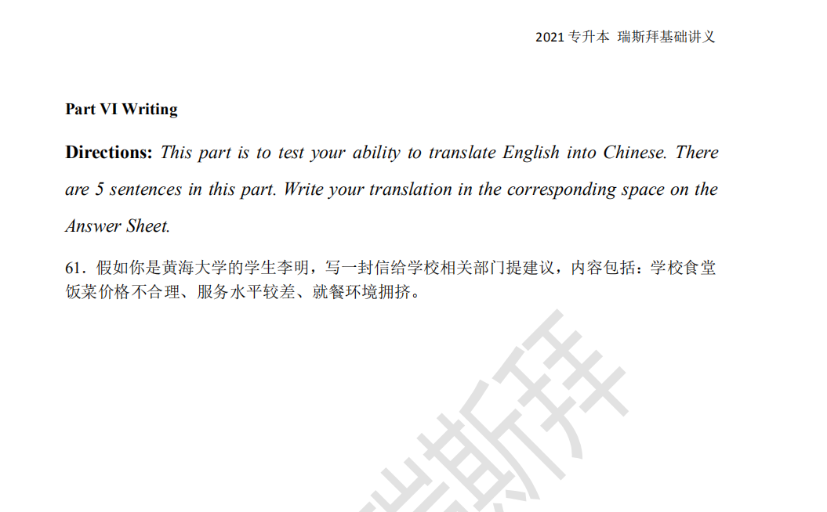

Dear **Sir or Madam**,

My name is _Li Ming___, and I am a student in HuangHai University. **_I’m bothered by the service in the school dinning hall(canteen) recently.** I’m writing this letter on the behalf of the student Union to **complain about** the service in the school dinning hall. The followings are the details.

First thing I want to deliver(convey,say) is **the food price** is too high**.(unreasonable) As a student, we need to pay 40 yuan a day for the food only. It’s totally unreasonable.**

**(Based on big data, 2/3 students, who eat at school everyday, admitted that they can’t afford it)**  Second matter concerned is **the service of the staff** is **too poor.** **All staff seem angry all the time**. We’re students, not enemies. At last,_**the seats** are not enough, so we have to eat in a crowded environment everyday.

I hope you can consider my advice carefully. Thank you for your time.

Sincerely yours,

Li Ming

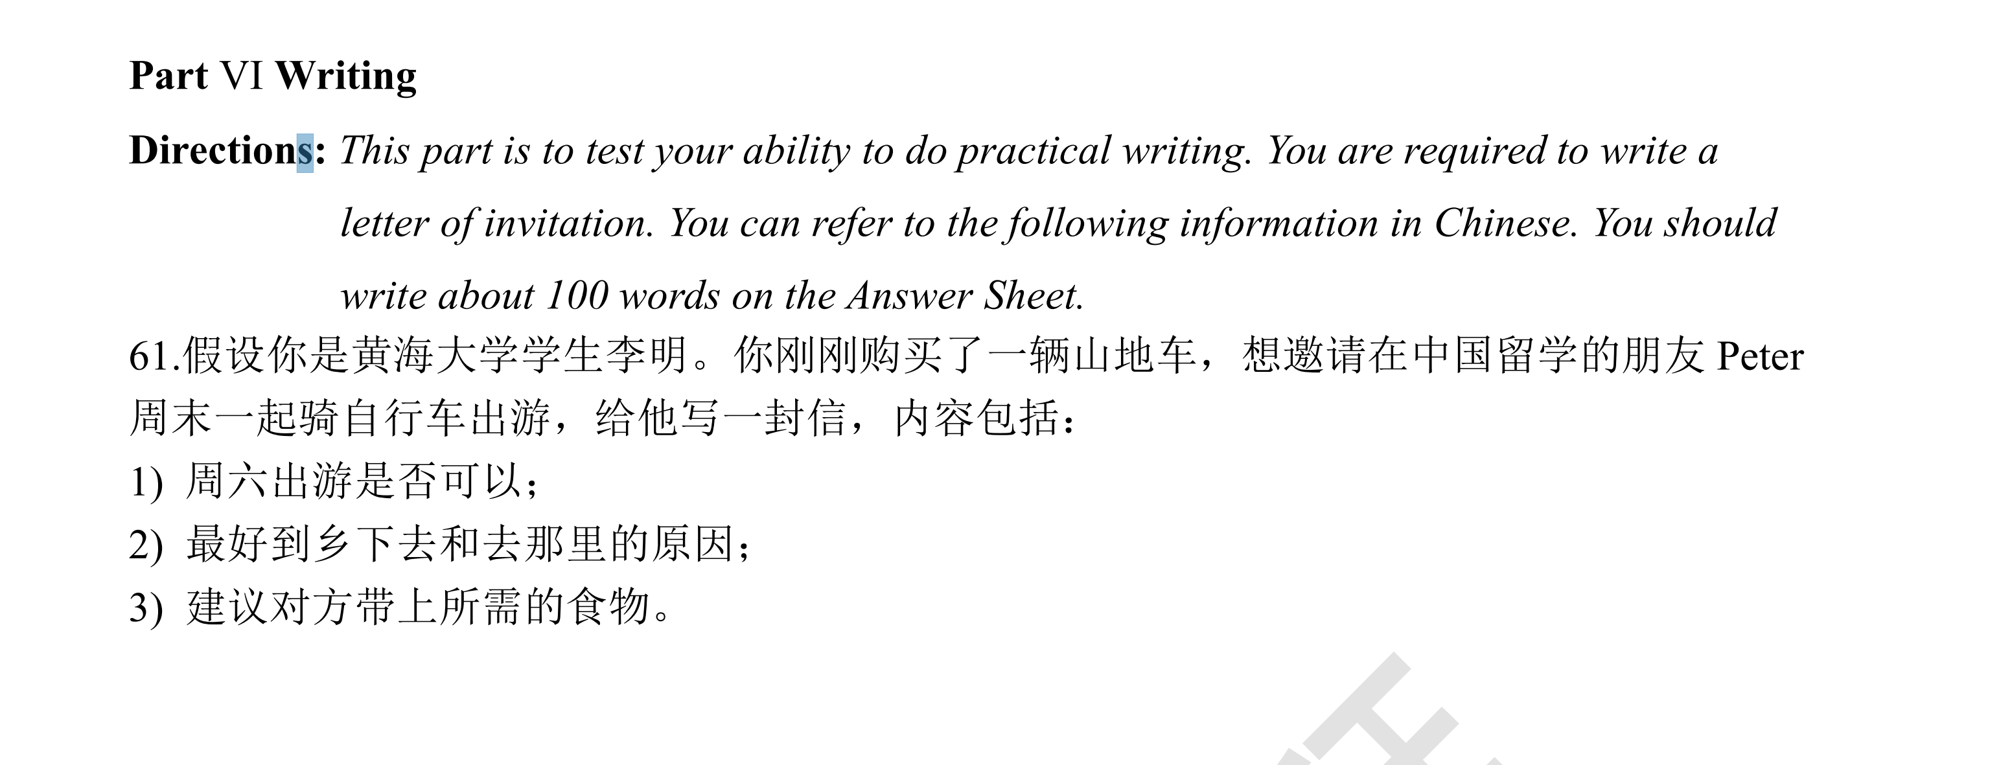

Dear peter,

How’s everything going? My name is _Li Ming___, and I’ve just bought **a sport mountain bike.** I’m writing this letter to **invite you to bike with me on weekends.** The followings are the details.

First thing I want to **ask** is **that are you free on Saturday.** I don’t have anything to do on that day. Second matter concerned is I suggest we(should) bike to the rural area(countryside)(outskirt). There are less people, and it’s safer. At last,_you should take(pack) enough food for lunch and dinner, because it is extremely remote there .

I hope you can consider my **invitation** carefully. Thank you for your time.

Sincerely yours,

Li Ming