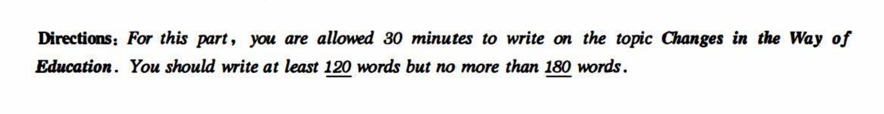

现象解释

**With the rapid globalization of /education, it is of great necessity for students to receive various kinds of education.(know about education) It's quite natural for us to ponder over the question of changes in the way of education.**

First and foremost, there is no doubt that new technology brings new education forms, such as online education and Moocs. Based on big data，a majority of successful social elites admitted that they have spent 2/3 of their time in studying online. Furthermore，it is obvious that education in the classroom（classroom facility） has evolved in the past 2 decades.(classroom education has changed a lot).Where there are classrooms, there is multimedia(computers). Last but not least，no one can deny that there are more students going to the college comparing to 20 years ago.(more students go to university now).Though not everyone can go to university, the higher education isn’t impossible.

In a word, the whole society should pay close attention to the problem of education. Only in this way can we have a bright and promising future.

总之，全社会都应该关注（教育）问题，只有这样我们才能有一个光明和有前途的未来



**With the rapid development of /society, technology,economy, it is of great necessity for citizens to get a variety of transportation. (know about transportation)It's quite natural for us to ponder over the question of changes in the way of transportation.**

First and foremost, there is no doubt that economy booming brings new transportation forms, such as subway. Based on big data，a majority of residents admitted that they have spent 2/3 of their time in travelling on new transportation forms. Furthermore，it is obvious that the number of private cars has increased over the past 2 decades.(there are more private cars nowadays).Where there are roads, there are private cars. Last but not least，no one can deny that there are more travelers taking airplane comparing to 20 years ago.(more travelers take airplane now).Though not everyone can afford air flight tickets, taking airplane isn’t impossible.

In a word, the whole society should pay close attention to the problem of traffic. Only in this way can we have a bright and promising future.