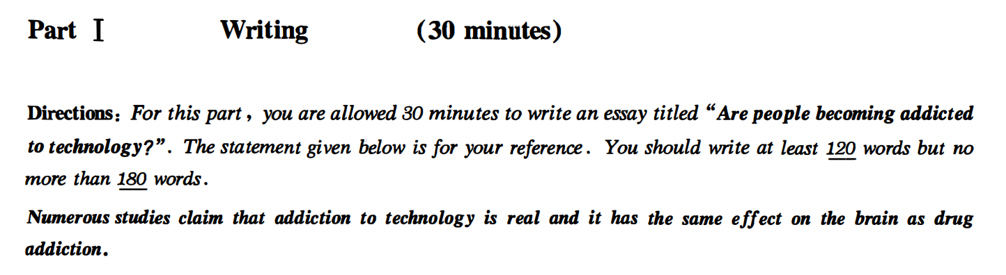

方法一：可以写现象解释

Are people becoming addicted to technology?

Numerous studies clam that addiction to technology is real and it has the same effect on the brain as drug addiction.With the rapid development of technology, technology has become increasingly important in our life. It is quite natural for us to ponder that are people becoming addicted to technology? I think it’s not true.

First and foremost, no one can deny technology has helped people in a lot of areas, such as medical science, physics and entertainment. Based on big data, it is revealed that most scientists admitted that they have spent 2/3 of their time in studying technology. However, every coin has two sides. Many people have lost their jobs because of technology. Where there is technology, there is a cheap work force. Last but not least, I firmly believe that although there are disadvantages of technology, it has a hopeful future.

In a word, the whole society should pay close attention to the problem of technology. Only in this way can we have a bright and promising future.

方法二观点选择：

Numerous studies clam that addiction to technology is real and it has the same effect on the brain as drug addiction. Some think that addiction to technology is possible, while others think lacking of the self-control ability is the reason.（列举选择） Personally, I prefer the former.做出选择 The following reasons can account for my preference.过渡句

First and foremost, no one can deny technology has helped people in a lot of areas, such as medical science, physics and entertainment. Based on big data, it is revealed that most scientists admitted that they have spent 2/3 of their time in studying technology. However, every coin has two sides. Many people have lost their jobs because of technology. Where there is technology, there is a cheap work force. Last but not least, I firmly believe that although there are disadvantages of technology, it has a hopeful future.

In a word, the whole society should pay close attention to the problem of technology. Only in this way can we have a bright and promising future.

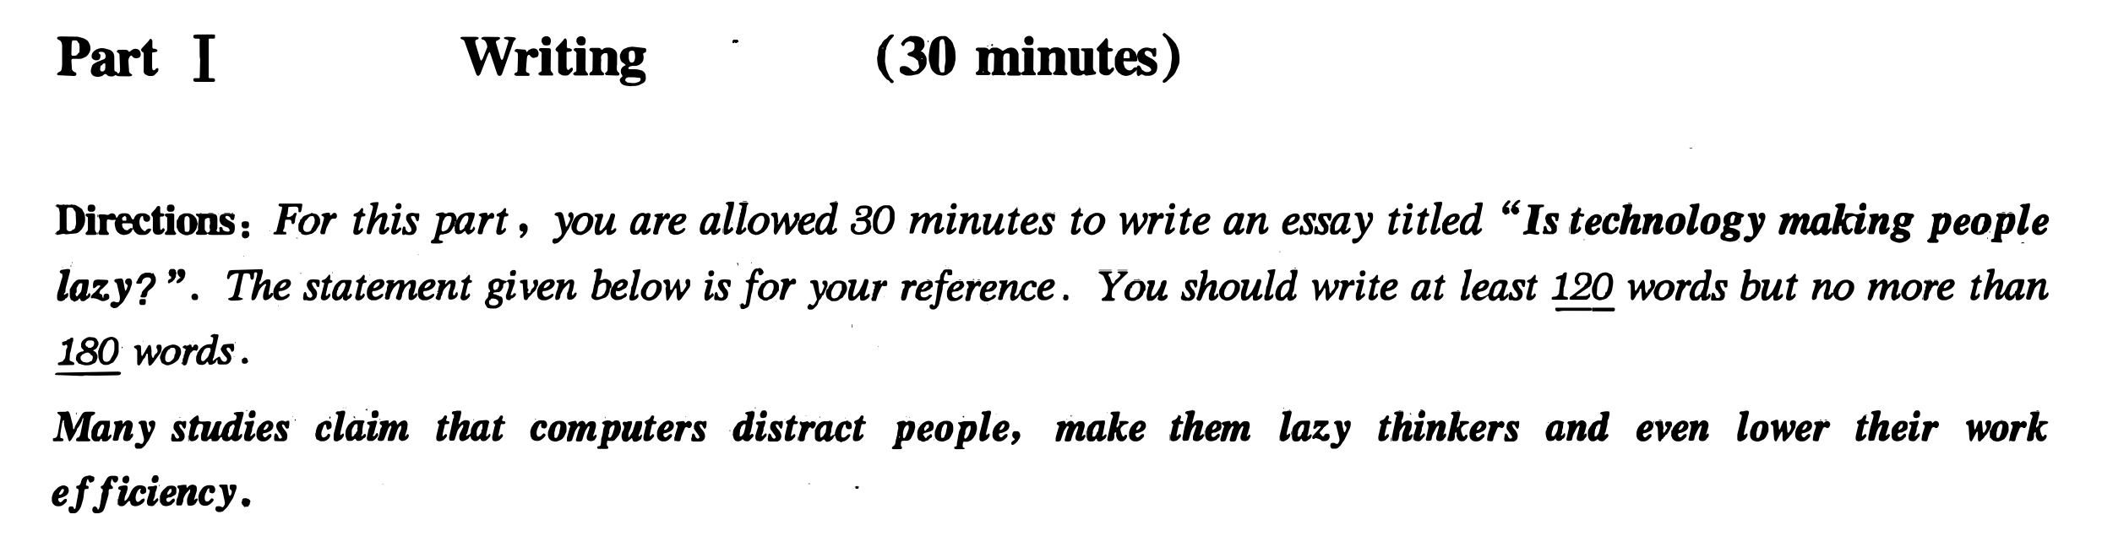

观点选择：

Is technology making people lazy?

Many studies claim that computer distract people, make them lazy thinkers and eve lower their work efficiency, while some hold the opposite opinion that technology is beneficial instead of making people lazy. Personally I prefer the latter one.The following reasons can account for my preference.

First and foremost, no one can deny technology has helped people in a lot of areas, such as medical science, physics and entertainment. Based on big data, it is revealed that most scientists admitted that they have spent 2/3 of their time in studying technology. However, every coin has two sides. Many people have lost their jobs because of technology. Where there is technology, there is a cheap work force. Last but not least, I firmly believe that although there are disadvantages of technology, it has a hopeful future.

In a word, the whole society should pay close attention to the problem of technology. Only in this way can we have a bright and promising future.

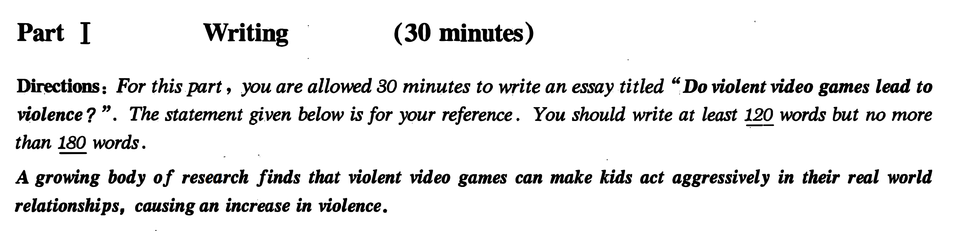

观点选择：

A growing body of research finds that violent video games can make kids act aggressively in their real world relationships, causing an increase in violence. On the other hand, some people argue that it’s not true. Personally I prefer the former one. The The following reasons can account for my preference.

First and foremost, there is no doubt that most children are so ignorant that they take in everything they watch. 论点1Based on big data, it is revealed that a majority of children admitted that believe everything in the game.论据1 Additionally, it is obvious that young kids are good at imitating.Where there are violent games, there are violent behaviors. 论据2Last but not least, no one can deny that we need to provide a healthy environment for kids. 论点3Though some people find violent games interesting, it’s not necessary for kids to play them.论据3

In a word, the whole society should pay close attention to the problem of violent game. Only in this way can we have a bright and promising future.