目录



课程观看B站：我是瑞斯拜

四六级我只看瑞斯拜

Life is like a marathon. There are ups and downs downs downs.

**我是瑞斯拜六级**

**翻译**

请打印听课

All Copyrights reserved

2022上

延安位于陕西省北部，地处黄河中游，是中国革命的圣地。毛泽东等老一辈革命家曾在这里生活战斗了十三个春秋，领导了抗日战争和解放战争，培育了延安精神，为中国革命做出了巨大贡献。延安的革命旧址全国数量最大、分布最广、级别最高。延安是全国爱国主义、革命传统和延安精神教育基地。延安有9个革命纪念馆，珍藏着中共中央和老一辈革命家在延安时期留存下来的大量重要物品，因此享有"中国革命博物馆城"的美誉。

听课笔记

参考翻译

Yan'an, located in north Shaanxi Province and in the middle reaches of the Yellow River, is a holy land of Chinese revolu-tion where the old generation of revolutionaries including Mao Zhedong used to live and fight for 13 years, leading the War of Resistance against Japanese Aggression and the Lib-eration War, cultivating the Yan'an spirit and making tre-mendous contribution to the Chinese revolution. With the best revolutionary sites in terms of number, extensiveness and level across the country, Yan'an is well recognized as a national education base for patriotism, revolutionary tra-ditions and the Yan'an spirit. Yan'an boasts 9 revolution-ary memorial halls which hold a huge number of significant objects left by CPC Central Committe and the old genera-tion of revolutionaries,enjoying a high reputation as "the museum city of Chinese revolution."

中国共产党第一次全国代表大会会址位于上海兴业路76号，是一栋典型的上海式住宅，建于1920年秋。1921年7月23日，中国共产党第一次全国代表大会在此召开，大会通过了中国共产党的第一个纲领和第一个决议，选举产生了中央领导机构，宣告了中国共产党的诞生。1952年9月，中共一大会址修复，建立纪念馆并对外开放。纪念馆除了介绍参加一大的代表之外，还介绍党的历史发展进程，现已成为了解党史、缅怀革命先烈的爱国主义教育基地。

听课笔记

参考翻译

The site of the 1st National Congress of the Communist Party of China,located at #76, Xingye Road, Shanghai, is a residence of typical Shanghai style which was built in the autumn of 1920.On July 23,1921, the 1st National Congress of the CPC was held here, where the first creed and the first convention were passed, the central leading body was elect-ed, and the birth of the CPC was announced. In September, 1952, the site was renovated and turned into a memorial hall open to the public, where both the representatives attend-ing the 1st National Congress of the CPC and the history of the CPC are introduced. It has become a patriotism educa-tion base where people know the history of the CPC and commemorate the revolutionary martyrs.

青藏铁路是世界上最高最长的高原铁路**，**全长1 956公里**，**其中有960公里在海拔4 000多 米之上**，**是连接西藏和中国其他地区的第一条铁路**。**由于铁路穿越世界上最脆弱的生态系统**，** 在建设期间和建成后都采取了生态保护措施**，**以确保其成为一条**“**绿色铁路**”。**青藏铁路大大 缩短了中国内地与西藏之间的旅行时间**。**更重要的是**，**它极大地促进了西藏的经济发展**，**改善 了当地居民的生活**。**铁路开通后**，**愈来愈多的人选择乘火车前往西藏**，**这样还有机会欣赏沿线 的美景**。**

听课笔记

参考翻译

The Qinghai-Tibet Railway is the highest and longest plateau railway in the world, with a total length of 1 956 kilometers, of which 960 kilometers are over 4 000 meters above sea level. It is the first railway connecting Tibet with other parts of China.As the railway crosses the world's most fragile ecosystems, ecological protection measures were taken during and after construction to ensure it becomes a "green railway".The Qinghai-Tibet Railway has greatly reduced travel time between mainland China and Tibet.What's more, it has greatly promoted the economic development of Tibet and improved the lives of local residents.After the opening of the railway, more and more people choose to travel to Tibet by train, which gives them a chance to enjoy the beautiful scenery along the route.

港珠澳大桥(Hong Kong-Zhuhai-Macau Bridge)全长55公里，是我国一项不同寻常的工程 壮举。大桥将三个城市连接起来，是世界上最长的跨海桥梁和隧道系统。大桥将三个城市之间 的旅行时间从3小时缩短到30分钟。这座跨度巨大的钢筋混凝土大桥充分证明中国有能力建 造创纪录的巨型建筑。它将助推区域一体化，促进经济增长。大桥是中国发展自己的大湾区总 体规划的关键。中国希望将大湾区建成在技术创新和经济繁荣上能与旧金山、纽约和东京的湾 区相媲美的地区。

参考翻译

The 55-kilometer Hong Kong-Zhuhai-Macau Bridge is an unusual engineering feat for our country.The bridge connects the three cities and is the longest sea-crossing bridge and tunnel system in the world.The bridge cut travel time between the three cities from three hours to 30 minutes.The huge steel and concrete bridge is a testament to China's ability to build record-breaking megastructures.It will boost regional integration and economic growth.The bridge is key to China's master plan to develop its own Greater Bay Area.China hopes to build the Greater Bay Area into an area that rivals the Bay Areas of San Francisco, New York and Tokyo in terms of technological innovation and economic prosperity.

北京大兴国际机场位于天安门广场以南46公里处，于2019年9月30日投入使用。该巨型工程于2014年开工建设，高峰时工地上有4万多工人。航站楼设计紧凑，可以允许最大数量的飞机直接停靠在最靠近航站楼中心的位置，这给乘客提供了极大的方便。航站楼共有82个登机口，但乘客通过安检后，只需不到8分钟就能抵达任何一个登机口。机场的设计可确保每小时300架次起降。机场年客运量2040年将达到1亿人次，有望成为世界上最繁忙的机场。

参考翻译：

*TLocated 46 kilometers south of Tian 'anmen Square, Beijing Daxing International Airport was put into operation on September 30, 2019.Construction of the mega project began in 2014, with more than 40,000 workers on the site at its peak.The compact design of the terminal allows the maximum number of aircraft to park directly in the location closest to the center of the terminal, which provides great convenience to passengers.Passengers can get to any of the terminal's 82 gates in less than eight minutes after passing through security.The airport is designed to ensure 300 takeoffs and landings per hour.With an annual passenger capacity of 100 million by 2040, the airport is expected to be the busiest in the world.*

第四套：

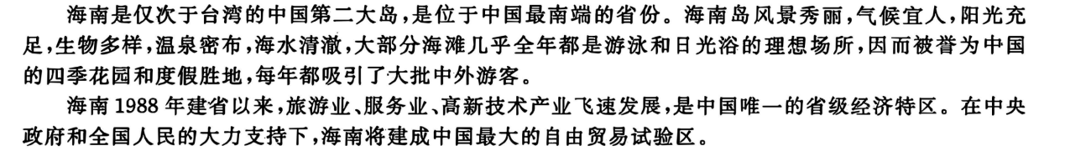

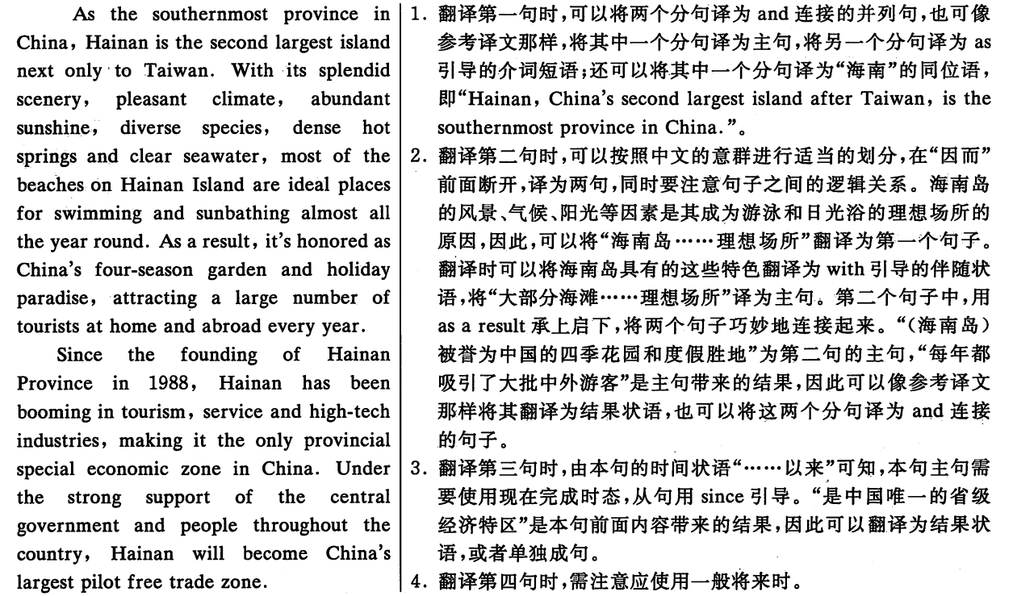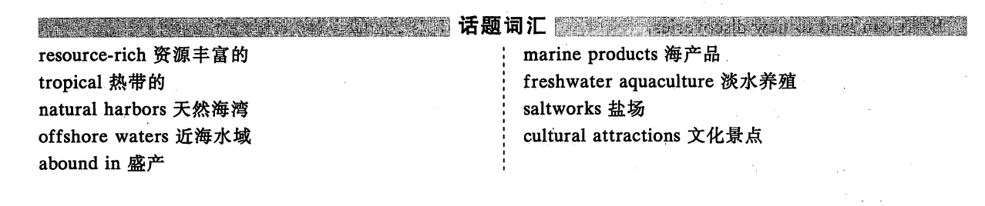

第五套

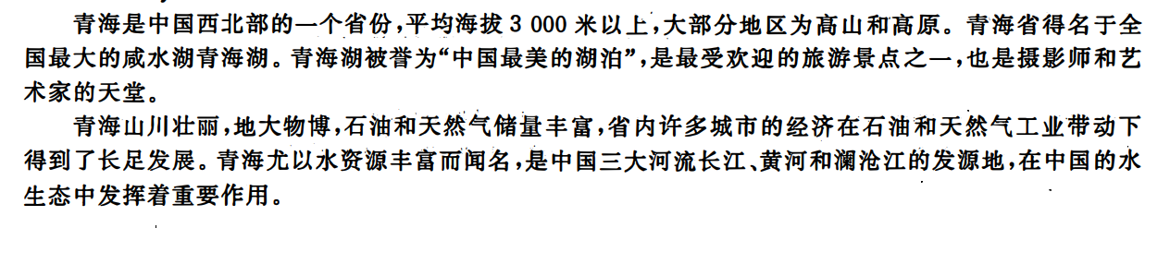

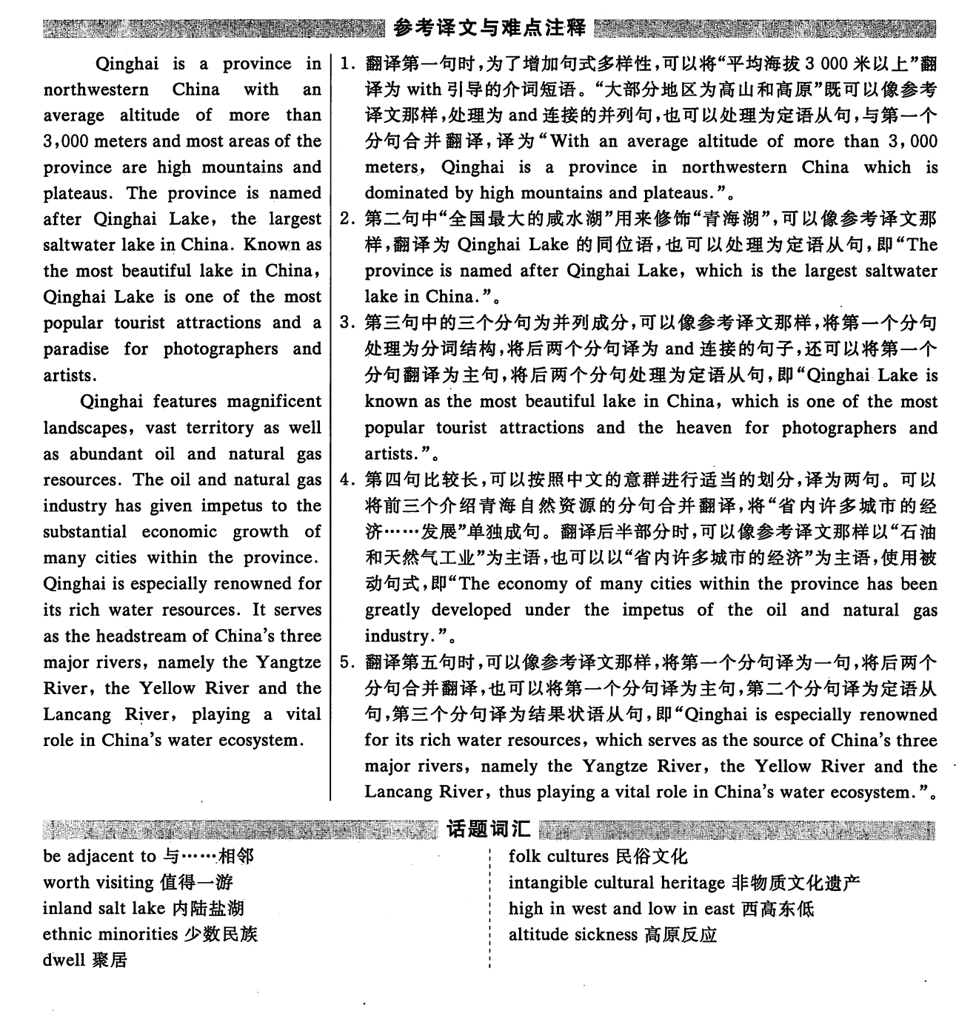

第六套：

