目录



课程观看B站：我是瑞斯拜

四六级我只看瑞斯拜

Life is like a marathon. There are ups and downs downs downs.

**我是瑞斯拜六级**

**写作模板**

请打印听课

All Copyrights reserved

2022下

写在前面

亲爱的同学，

六级考试中作文是第一个版块，也是我们相对比较好拿分的一个版块。就同学们的反馈来看，只要按照课程模板套上去分数都不错。

根据往年的题目分布和大纲来看，六级作文考察议论文或图表图片两种题型。在我们时间充裕的情况下要进行系统的复习。**如果你是考试前才来复习，本次最有可能考察的是议论文，你的重点就是议论文的脑图。**

议论文包括：现象解释，观点选择，问题解决三种类型

还有可能考到的是图片和图表类，如果考到我们可以用议论文的模板来套，只用第一段稍微变一下就可以。

**虽然考察的题型那么多种，但是模板就是一个，我们需要变的只有第一段。所有大家不要担心记不下来。**

讲义顺序是以考察的频率和重要程度来编排的。

总之这套教程属于比较速成的教程，及时你明天要考试，今天也可以花一个小时时间对照视频进行学习，相信会有不少帮助。

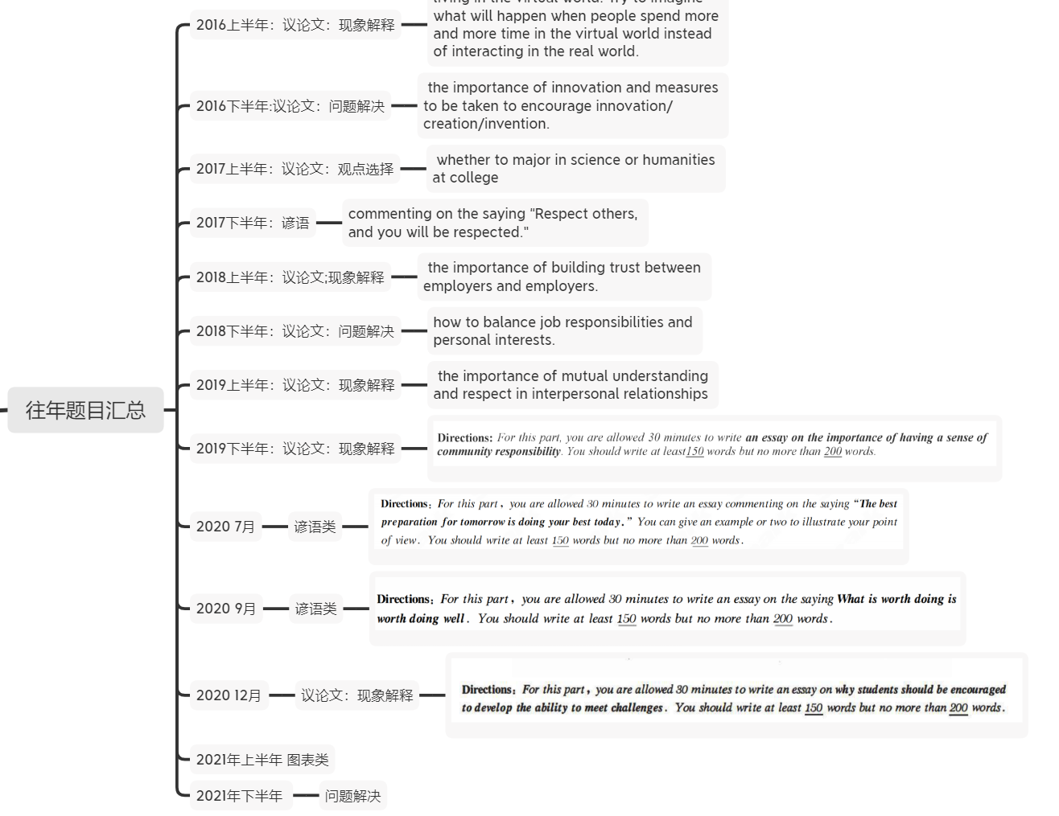题目回顾

六级模板

1.议论文分为哪几类？ **关键词**

**问题解决：how to, measure,solution 现象解释：what, why 观点选择：choice option**

**图片图表：image，cartoon，diagram，chart**

**2.段落结构划分**

**三个段落（10-11句）**

**第一段（2-3句）**

**前1-2句提出你的问题（你对这个问题的看法是什么，好还是不好，应不应该这样做）**

**第3句过渡句.**

**第二段（6个句子）：3个论点和3个论据**

**第三段2句： 第一句：重申观点， 第二句万能结尾（提出期望）**

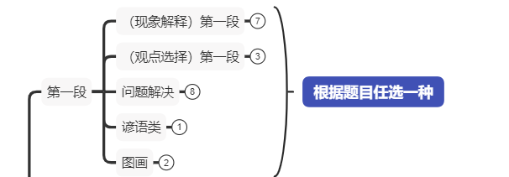

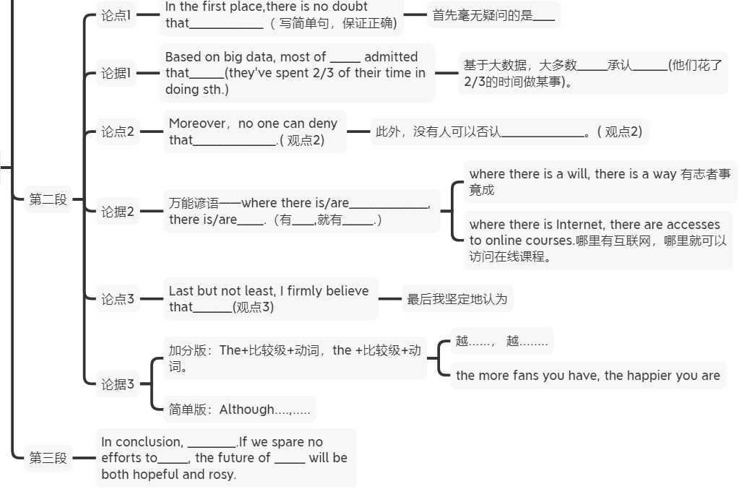

议论文练习 一、现象解释

**living in the virtual world. Try to imagine what will happen when people spend more and more time in the virtual world instead of interacting in the real world.**

In the contemporary world, _______(主题词) have/has become increasingly important. It's of great necessity for___to______. Reasons and concrete evidence to support my view point are as follows.

In the first place,there is no doubt that_________________Based on big data, most of _______ admitted that________(they've spent 2/3 of their time in doing sth.) Moreover，no one can deny that___________________.where there is/are__________________, there is/are______.Last but not least, I firmly believe that_________. The more responsibilities you have, the more repay you will get.越......， 越........

In conclusion, ___________.If we spare no efforts to_______, the future of _______ will be both hopeful and rosy.

With the rapid advancement of technology,

In the contemporary world, _virtual reality has become increasingly important. When people spending an increasing amount of time in the virtual world, our life can be very easy and happy. Reasons and concrete evidence to support my view point are as follows.

In the first place,there is no doubt that our social life will be very convenient(with the appearance and popularization of virtual reality, great convenience will be brought to our social life).Based on big data, most of netizens admitted that they've spent 2/3 of their time in online social life. Moreover，no one can deny that we can have more entertainment at home. Where there is Internet, there are fun activities. Last but not least, I firmly believe that we can study more easily. The more time you spend on virtual world, the more learning resources you will get.

In conclusion, our life can be easy and happy in the virtual world.If we spare no efforts to balance it reasonably, the future of our life will be both hopeful and rosy.

练习二、 问题解决

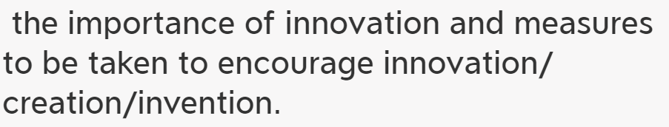

In the contemporary world, _______(主题词) have/has become increasingly important. It's of great necessity for___to______. The following solutions can account for this issue properly.

下面的解决方案可以很好地处理这个问题。

In the first place,there is no doubt that_________________Based on big data, most of _______ admitted that________(they've spent 2/3 of their time in doing sth.) Moreover，no one can deny that___________________.where there is/are__________________, there is/are______.Last but not least, I firmly believe that_________. The more responsibilities you have, the more repay you will get.越......， 越........

In conclusion, ___________.If we spare no efforts to_______, the future of _______ will be both hopeful and rosy.

In the contemporary world, innovation has become increasingly important. It's of great necessity for us students to have an innovative mind. The following solutions can account for this issue properly.

In the first place,there is no doubt that we should be curious all the time(curiosity does contribute to innovation.).Based on big data, most of successful social elites admitted that they've spent 2/3 of their time in learning(trying) new things. Moreover，no one can deny that we need to study more.(new inspiration can be enlightened by things we acquire everyday. ).Where there is knowledge, there are new ideas. Last but not least, I firmly believe that we need to be humble(humbleness is helpful to stimulate creation). The more humble you are, the more creative you will be.

练习三、观点选择

**Suppose you are asked to give advice on whether to major in science or humanities at college， write an essay to state your opinion. You are required to write at least 150 words but no more than 200 words.**

**In the contemporary world, _______(主题词) have/has become increasingly important. When faced with decision of A or B, quite a few would deem that________, but others, in contrast, believe that A/B is the premier choice and that is also my point. Among countless reasons which support my view, there are three conspicuous aspects as follow.**

**当面对A或B的决定时，相当多的人会认为________，但另一些人，相反，认为A/B是首要的选择，这也是我的观点。在无数支持我观点的理由中，有三个显著的方面如下。**

In the first place,there is no doubt that_________________.Based on big data, most of _______ admitted that________(they've spent 2/3 of their time in doing sth.) Moreover，no one can deny that___________________.where there is/are__________________, there is/are______.Last but not least, I firmly believe that_________. The more responsibilities you have, the more repay you will get.越......， 越........

In conclusion, ___________.If we spare no efforts to_______, the future of _______ will be both hopeful and rosy.

**In the contemporary world, _major in university has become increasingly important. When faced with decision of choosing major, quite a few would deem that science, but others, in contrast, believe that humanity is the premier choice and that is also my point. Among countless reasons which support my view, there are three conspicuous aspects as follow.**

**In the first place,there is no doubt that humanity is more useful in finding jobs. Based on big data, most of job seekers admitted that 2/3 of jobs require major of humanity. ) Moreover，no one can deny that we can learn more culture in humanity. Where there are humanities, there is cultural knowledge. Last but not least, I firmly believe that we can have a better personality if we major in humanity. The more humanity knowledge you know, the more interesting and elegant you are.**

**In conclusion, ___________.If we spare no efforts to_______, the future of _______ will be both hopeful and rosy.**

练习四谚语类

**commenting on the saying “Respect others, and you will be respected.”**

As an old saying goes:_______. For us college students, it has an increasingly important significance: （）解释含义___. The following reasons can account for this issue.

In the first place,there is no doubt that_________________Based on big data, most of _______ admitted that________(they've spent 2/3 of their time in doing sth.) Moreover，no one can deny that___________________.where there is/are__________________, there is/are______.Last but not least, I firmly believe that_________. The more responsibilities you have, the more repay you will get.越......， 越........

In conclusion, ___________.If we spare no efforts to_______, the future of _______ will be both hopeful and rosy.

As an old saying goes: respect others, and you will be respected. For us college students, it has an increasingly important significance: a good manner is needed when dealing with people. The following reasons can account for this issue.

In the first place,there is no doubt that we can’t divorce from reality that politeness plays an important role in one’s success. Based on big data, most successful social elites admitted that they’ve spent 2/3 of their time in dealing with people. Moreover, no one can deny that courtesy makes us stronger. Where there is good manner, there is respect. Last but not least, I firmly believe that respect should be mutual. The more polite you are, the more respect you will get.

In conclusion,respecting others(a respectful manner) is essential for everyone to succeed.If we spare no effort to **cultivate a good manner**, the future of our study and career will be both hopeful and rosy.

练习五 现象解释 请先写再看范文。

**the importance of building trust between employers and employees.**

In the contemporary world, _______(主题词) have/has become increasingly important. It's of great necessity for___to______. Reasons and concrete evidence to support my view point are as follows.

In the first place,there is no doubt that_________________Based on big data, most of _______ admitted that________(they've spent 2/3 of their time in doing sth.) Moreover，no one can deny that___________________.where there is/are__________________, there is/are______.Last but not least, I firmly believe that_________. The more responsibilities you have, the more repay you will get.越......， 越........

In conclusion, ___________.If we spare no efforts to_______, the future of _______ will be both hopeful and rosy.

In the contemporary world, **life in work place** has become increasingly important. It's of great necessity for **staff and employers** to build mutual trust. Reasons and concrete evidence to support my view point are as follows.

In the first place,there is no doubt that **mutual trust can foster(cultivate) a friendly working atmosphere(environment).** Based on big data, most of successful social elites admitted that their bosses trust them very much. Moreover，no one can deny that mutual trust can increase working efficiency. Where there is trust, there is devotion. Last but not least, I firmly believe that mutual trust makes employee more loyal. The more trust you have, the more willing you are to work.

In conclusion, building trust in work places is essential for a company to succeed **.If we** spare no efforts to believe **people around us,** the future of our career will be both hopeful and rosy.

**练习 六 先写再看范文**

**how to balance job responsibilities and personal interests.**

In the contemporary world, _______(主题词) have/has become increasingly important. It's of great necessity for___to______.The following solutions can account for this issue properly.

In the first place,there is no doubt that_________________Based on big data, most of _______ admitted that________(they've spent 2/3 of their time in doing sth.) Moreover，no one can deny that___________________.Where there is/are__________________, there is/are______.Last but not least, I firmly believe that_________. The more responsibilities you have, the more repay you will get.越......， 越........

In conclusion, ___________.If we spare no efforts to_______, the future of _______ will be both hopeful and rosy.

In the contemporary world, a balanced life has become increasingly important. It's of great necessity for staff to balance job responsibilities and personal interests.The following solutions can account for this issue properly.

In the first place,there is no doubt that **we should connect our interests to the job(our interests should be connected to the job) *(A win win situation can be reached if we cultivate an interest related to our job responsibility)**. Based on big data, most of social elites admitted that they've spent 2/3 of their time in doing jobs related to their hobby. Moreover，no one can deny that we should **put job responsibility first(we should prioritize job responsibility)**. Where there are jobs, there are possibilities to cultivate(foster) interests. Last but not least, I firmly believe that personal interests play an important(crucial) role in our sense of happiness too. The more interests you have, the happier you are.

In conclusion, job responsibilities and personal interests are extremely crucial. If we spare no efforts to balance them, the future of our life and career will be both hopeful and rosy.

练习七 先写再看

**how to balance job responsibilities and personal interests.**

In the contemporary world, _______(主题词) have/has become increasingly important. It's of great necessity for___to______.The following solutions can account for this issue properly.

In the first place,there is no doubt that_________________Based on big data, most of _______ admitted that________(they've spent 2/3 of their time in doing sth.) Moreover，no one can deny that___________________.Where there is/are__________________, there is/are______.Last but not least, I firmly believe that_________. The more responsibilities you have, the more repay you will get.越......， 越........

In conclusion, ___________.If we spare no efforts to_______, the future of _______ will be both hopeful and rosy.

In the contemporary world, a balanced life has become increasingly important. It's of great necessity for staff to balance job responsibilities and personal interests.The following solutions can account for this issue properly.

In the first place,there is no doubt that **we should connect our interests to the job(our interests should be connected to the job) *(A win win situation can be reached if we cultivate an interest related to our job responsibility)**. Based on big data, most of social elites admitted that they've spent 2/3 of their time in doing jobs related to their hobby. Moreover，no one can deny that we should **put job responsibility first(we should prioritize job responsibility)**. Where there are jobs, there are possibilities to cultivate(foster) interests. Last but not least, I firmly believe that personal interests play an important(crucial) role in our sense of happiness too. The more interests you have, the happier you are.

In conclusion, job responsibilities and personal interests are extremely crucial. If we spare no efforts to balance them, the future of our life and career will be both hopeful and rosy.

练习8 先写再看



In the contemporary world, _______(主题词) have/has become increasingly important. It's of great necessity for___to______. Reasons and concrete evidence to support my view point are as follows.

In the first place,there is no doubt that_________________.Based on big data, most of _______ admitted that________(they've spent 2/3 of their time in doing sth.) Moreover，no one can deny that___________________.where there is/are__________________, there is/are______.Last but not least, I firmly believe that_________. The more responsibilities you have, the more repay you will get.越......， 越........

In conclusion, ___________.If we spare no efforts to_______, the future of _______ will be both hopeful and rosy.

In the contemporary world, _community life has become increasingly important. It's of great necessity for residents to increase the sense of community responsibility. Reasons and concrete evidence to support my view point are as follows.

In the first place,there is no doubt that having a sense of community responsibility makes your popular. Based on big data, most of successful social elites admitted that they've spent 2/3 of their time in helping seniors in their communities. Moreover，no one can deny that responsibility makes you stronger. Where there are responsibilities, there are possibilities for you to succeed. Last but not least, I firmly believe that responsibility is rewarding(beneficial). The more responsibilities you have, the more repay you will get.

In conclusion, having a sense of community responsibility is essential for everyone to succeed_.If we spare no efforts to cultivate it, the future of life and career will be both hopeful and rosy.

练习9 先写再看

谚语类

As an old saying goes:_______. For us college students, it has an increasingly important significance: （）解释含义___. The following reasons can account for this issue.

In the first place,there is no doubt that_________________. Based on big data, most of _______ admitted that________(they've spent 2/3 of their time in doing sth.) Moreover，no one can deny that___________________.where there is/are__________________, there is/are______.Last but not least, I firmly believe that_________. The more responsibilities you have, the more repay you will get.越......， 越........

In conclusion, ___________.If we spare no efforts to_______, the future of _______ will be both hopeful and rosy.

As an old saying goes: the best preparation for tomorrow is doing your best today. For us college students, it has an increasingly important significance: If you want to achieve something, you need to overcome procrastination. The following reasons can account for this issue.

In the first place,there is no doubt that we can’t divorce from reality that time plays an important role in one’s success. Based on big data, most successful social elites admitted that they’ve spent 2/3 of their time in valuable places(doing valuable things). Moreover, no one can deny that **procrastination** makes us weaker. Where there is procrastination, there is **time wasted**. Last but not least, I firmly believe that y**our future is what you do today(your today decides your future).** The more serious you are, the more possibility you will succeed.

In conclusion, **doing our best today** is essential for everyone to succeed. If we spare no effort to **cherish the time today**, the future of our study and career will be both hopeful and rosy.

练习10先写再看



谚语类

（括号为可以替换的简单词）

As an old saying goes: What is worth doing, worth doing well. For us college students, it has an increasingly important significance: If you want to achieve something, you need a serious attitude. The following reasons can account for this issue.

In the first place,there is no doubt that we can’t divorce from the reality that attitude plays an important role in one’s success. Based on big data, most successful social elites admitted that they have a serious mindset towards everything. Moreover, no one can deny that a serious attitude makes us stronger. Where there is serious spirit, there are opportunities. Last but not least, I firmly believe that without a serious attitude, we can’t make any achievements.(If we don’t have the serious mindset, we can’t do anything.) The more serious you are, the more possibility you will succeed .

In conclusion, the serious attitude towards everything is essential for everyone.If we spare no effort to（不遗余力） cultivate this mindset, the future of our study and career will be both hopeful and rosy.

练习11 先写再看



In the contemporary world, the ability to meet challenges has become increasingly important. It's of great necessity for students to improve the ability to solve problems when facing difficulty. The following are reasons and concrete evidence to support my view point.

In the first place,there is no doubt that we can’t divorce fromt he reality that **challenge is everywhere**(we can’t avoid challenges). Based on big data, most successful social elites admitted that they've spent 2/3 of their time in facing challenges. Moreover, no one can deny that challenges make us stronger. Where there are difficulties, there are opportunities. Last but not least, I firmly believe that without the ability to meet challenges, we can’t make any achievements.(If we don’t have the ability to meet challenges, we can’t do anything.) The more problems you solve, the smarter and capable you are.

In conclusion, the ability to meet challenges and solve problems is essential for everyone.If we spare no effort to cultivate this ability, the future of our study and career will be both hopeful and rosy.

练习12

图表类模板

第一段：

As is starkly mirrored（reflected） in the image/chart（表格）that -_________, it is revealed that____ （图片内涵）The following reasons can account for this issue.（过渡句）

第二段

In the first place,there is no doubt that_________________（ 写简单句，保证正确)Based on big data, most of _______ admitted that________(they've spent 2/3 of their time in doing sth.) Moreover，no one can deny that___________________.( 观点2) where there is/are__________________, there is/are______.（有_____,就有_______.）Last but not least, I firmly believe that_________(观点3) The+比较级+动词，the +比较级+动词.

第三段：In conclusion, ___________.If we spare no efforts to_______, the future of _______ will be both hopeful and rosy.

范文一

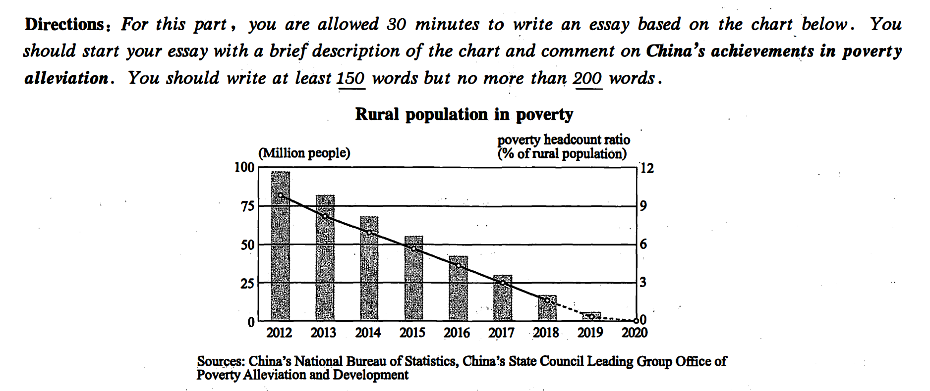

As is starkly mirrored in the chart（表格）that Chinese rural population has been lifted out of poverty. It is revealed that China’s achievements in poverty alleviation are extraordinary. （图片内涵）The following reasons can account for this issue.（过渡句）

In the first place, there is no doubt that officials in the governments have played an important role in this process . Based on big data, most of the governors involved have admitted that they've spent 2/3 of their time in the rural area. Moreover，no one can deny that the poverty alleviation policy is indeed beneficial.Where there are good policies, there are incentives. Last but not least, I firmly believe that the personal efforts of the rural residents can’t be ignored. The harder they work，the wealthier they are.

In conclusion, the accomplishment of poverty alleviation in China is outstanding.If we spare no efforts to implement the policy and maintain the work, the future of our country will be both hopeful and rosy.

范文二

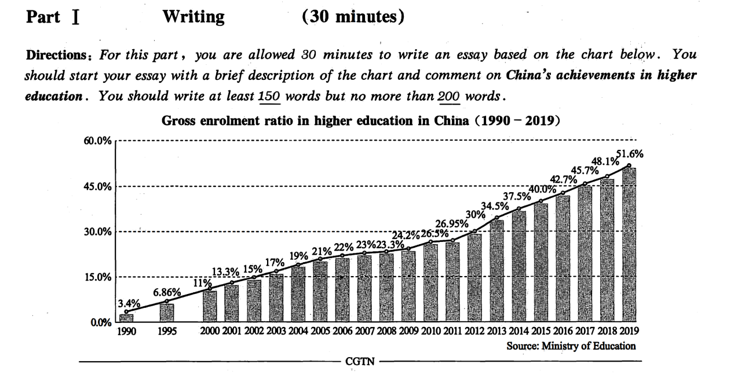

As is starkly mirrored in the chart（表格）that gross enrolment ratio in higher education in China has rocketed up from 1990 to 2019. In 2019, more than half of the high school graduates can seek for further education. It is revealed that China’s achievements in higher education are extraordinary. （图片内涵）The following reasons can account for this issue.（过渡句）

In the first place, there is no doubt that officials in the governments have played an important role in this process . Based on big data, most of the governors involved have admitted that they've spent 2/3 of their time in promoting education. Moreover，no one can deny that the advanced education policy is indeed beneficial. Where there are good policies, there are incentives. Last but not least, I firmly believe that the personal efforts of the students can’t be ignored. The harder they study，the better education they can get.

In conclusion, the accomplishment of education in China is outstanding.If we spare no efforts to implement the policy and maintain the work, the future of our country will be both hopeful and rosy.

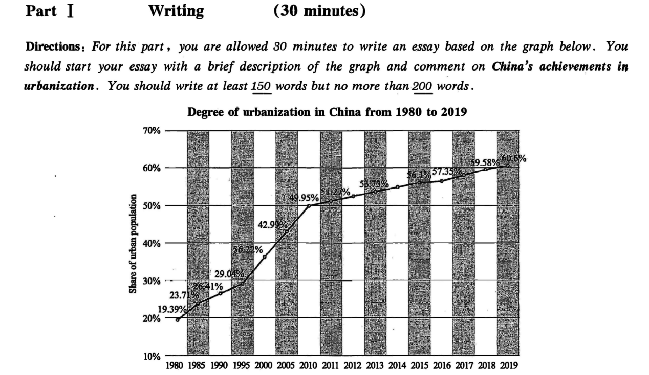

请先写再看解析

As is starkly mirrored in the chart（表格）that degree of urbanization in China has rocketed up from 1980 to 2019. In 2019, more than half of the citizens can live in the city. It is revealed that China’s achievements in urbanization are extraordinary. （图片内涵）The following reasons can account for this issue.（过渡句）

In the first place, there is no doubt that officials in the governments have played an important role in this process . Based on big data, most of the governors involved have admitted that they've spent 2/3 of their time in promoting urbanization. Moreover，no one can deny that the policy of urbanization is indeed beneficial. Where there are good policies, there are incentives. Last but not least, I firmly believe that the personal efforts of the residents can’t be ignored. The harder they work，the better life they can get.

In conclusion, the accomplishment of urbanization in China is outstanding.If we spare no efforts to implement the policy and maintain the work, the future of our country will be both hopeful and rosy.

练习13问题解决

Directions: For this part.you are allowed 30 minutes to write an essay related to the short passage given below. In your essay, you are to comment on the phenomenon described in the passage and suggest measures to address the issue. You should write at least 150 words but no more than 200 words. Young people spend a lot of time on the internet. However,they are sometimes unable to recognize false information on the internet,judge the reliability of online information sources,or tell real news stories from fake ones.

In the contemporary world, authenticity of information on the internet has become increasingly important. It's of great necessity for netizens to distinguish the fake from the real. The following solutions can account for this issue properly.

In the first place,there is no doubt that we can trust information from authorities, like CCTV. Based on big data, most of social elites have admitted that they've spent 2/3 of their time in watching news from CCTV. Moreover，no one can deny that we need to enhance the regulation of self-media. Where there is regulation there is order. Last but not least, I firmly believe that the rumour makers should stop their miserable behaviors at once. The more lies you make, the more price you will pay for.越......， 越........

In conclusion,authenticity of information is crucial in the era of Internet.If we spare no efforts to tackle the problem, the future of online environment will be both hopeful and rosy.