目录



课程观看B站：我是瑞斯拜

四六级我只看瑞斯拜

Life is like a marathon. There are ups and downs downs downs.

**我是瑞斯拜四级**

**写作模板**

请打印听课

All Copyrights reserved

2022下

写在前面

亲爱的同学，

四级考试中作文是第一个版块，也是我们相对比较好拿分的一个版块。就同学们的反馈来看，只要按照课程模板套上去分数都不错。

根据往年的题目分布和大纲来看，四级作文考察议论文和应用文两种题型。在我们时间充裕的情况下要进行系统的复习。**如果你是考试前才来复习，本次最有可能考察的是议论文或信件，你的重点就是议论文的脑图和信件格式。**

议论文包括：现象解释，观点选择，问题解决三种类型

应用文包括：信件，通知，报道，广告等

还有可能考到的是图片和图表类，如果考到我们可以用议论文的模板来套，只用第一段稍微变一下就可以。

**虽然考察的题型那么多种，但是模板就是一个，我们需要变的只有第一段。所有大家不要担心记不下来。**

讲义顺序是以考察的频率和重要程度来编排的。

总之这套教程属于比较速成的教程，及时你明天要考试，今天也可以花一个小时时间对照视频进行学习，相信会有不少帮助。

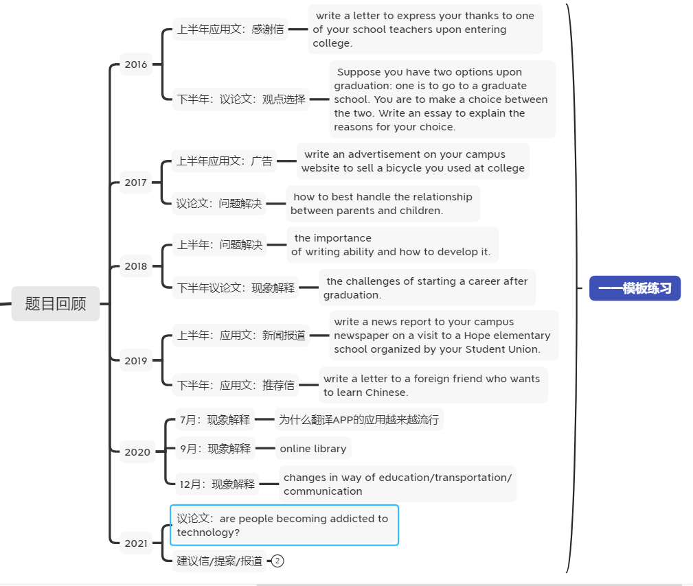题目回顾

10句话解决议论文

1.议论文分为哪几类？ **关键词**

**问题解决：how to, measure,solution 现象解释：what, why 观点选择：choice option**

**图片图表：image，cartoon，diagram，chart**

**2.段落结构划分**

**三个段落（10-11句）**

**第一段（2-3句）**

**前1-2句提出你的问题（你对这个问题的看法是什么，好还是不好，应不应该这样做），**

**第3句过渡句.**

**第二段（6个句子）：3个论点和3个论据**

**第三段2句： 第一句：重申观点， 第二句万能结尾（提出期望）**

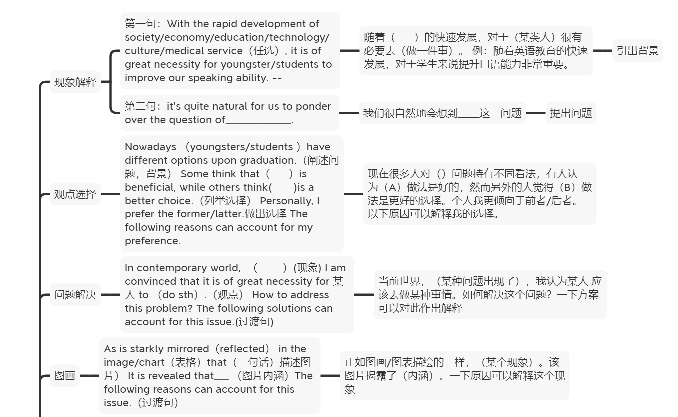根据不同题型选择不同第一段即可 下面是最主要的脑图

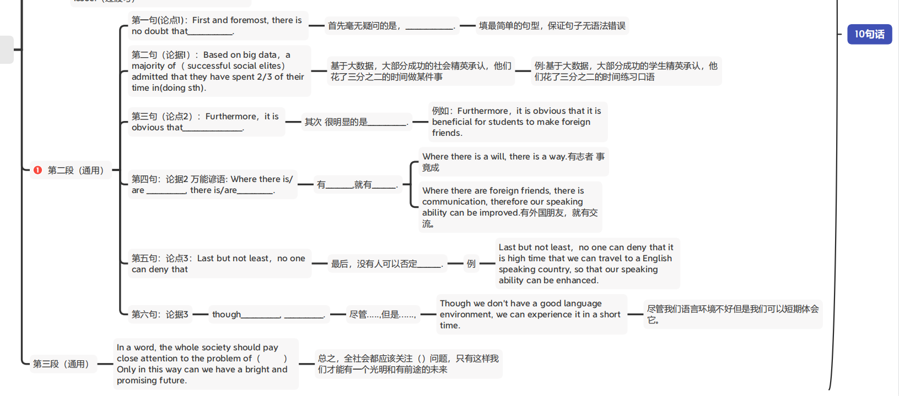

议论文练习 一、

**2018年12月真题**

**the challenges of living in a big city.**

**第一段：现象解释**

**With the rapid development of /economy, it is of great necessity for students to study in a big city. It's quite natural for us to ponder over the question of the challenges of living in a big city.**

**First and foremost,** there is no doubt that **the price of housing will be a huge problem. 点1 Based on big data, a majority of successful social elites have admitted that they have spent 2/3 of their income on housing.Furthermore, it is obvious that the competition is stronger in big cities.论点2 Where there are people, there is competition.Last but not least,no one can deny that the traffic condition in big cities is worse than in rural area.(the traffic condition isn’t good in big city)论点3 Although the roads are wider in big cities, there are more vehicles.论据3**

**In a word, the whole society should pay close attention to the problem of the living in big cities. Only in this way can we have a bright and promising future.**

现象解释 2018年12月

**模板与脑图一致：**

第一段：

With the rapid development of \_\_\_\_\_\_\_\_\_\_(填：society, culture, medical service, education, economy), it is of great necessity for\_\_\_\_\_（填：students,residents,citizens,youngsters）to \_\_\_\_\_\_\_\_. it is quite natural for us to ponder over the question of\_\_\_\_\_\_(填：主题词）.

随着\_\_\_\_（社会、文化、医疗服务、教育、经济）的发展，对于\_\_\_\_\_（学生、居民、公民、年轻人）来说我们应该\_\_\_\_\_\_。很自然的我们应该思考\_\_\_\_\_问题。

第二段

First and foremost, there is no doubt that\_\_\_\_\_\_\_\_\_\_\_\_\_\_\_. Based on big data，a majority of successful social elites have admitted that they have spent 2/3 of their time in doing sth. Furthermore，it is obvious that\_\_\_\_\_\_\_\_\_\_\_\_\_\_\_\_\_\_\_\_. Where there is/are \_\_\_\_\_\_\_\_\_\_\_\_\_, there is/are\_\_\_\_\_\_\_\_\_\_\_\_.Last but not least，no one can deny that\_\_\_\_\_\_. Though\_\_\_\_\_\_\_\_\_\_\_\_\_, \_\_\_\_\_\_\_\_\_\_\_\_\_.

首先，毫无疑问的是\_\_\_\_\_\_\_. 基于大数据，大部分成功社会精英都承认，他们花了三分之二的时间来做一件事。其次，很明显的是\_\_\_\_\_\_\_. 只要有\_\_\_\_\_,就有\_\_\_\_\_\_.最后但是同样重要的是，没有人可以否认\_\_\_\_\_. 尽管\_\_\_\_\_\_,但是\_\_\_\_\_\_.

第三段

In a word, the whole society should pay close attention to the problem of\_\_\_\_\_\_，Only in this way can we have a bright and promising future.

总之，全社会都应该关注 问题，只有这样我们才能有一个光明和有前途的未来。

练习二、 观点选择 2016年下半年

题目： Suppose you have two options upon graduation: one is to find a job somewhere and the other to start a business of your own， you are to make choice, write an essay to explain the reason.

模板见脑图

范文：

**With the rapid globalization of economy, nowadays** youngsters/students **have different options upon** graduation.（阐述问题，背景） Some think that to find a job somewhere is beneficial, while others think to start a business of your own is a better choice.（列举选择） Personally, I prefer the former.做出选择 **The following reasons can account for my preference.过渡句**

**第二段 三个论点加三个论据**

**First and foremost,** there is no doubt that **to find a job somewhere is more free**. 论点1Based on big data, it is revealed that a majority of successful social elites have admitted that \_\_\_\_their careers are free.论据1 Additionally, it is obvious that we can make useful friends when we have a decent job.(a good job is better for you to make friend)论点2Where there **are jobs/work places**, there **are friends. 论据2Last but not least, no one can deny that** to find a job **is easier than** to start a company. 论点3Though **some people do succeed in starting a business of their own**, most of entrepreneurs failed when they just start.论据3

结尾段：重申观点+提出期望

In a word, A is better/more suitable than B. 重申观点If we spare no efforts to (不遗余力)**work hard in our career**, the future of \_\_our life\_ will be promising and **rosy**.提出希望

练习三、

2018上半年作文 how to 问题解决

the importance of speaking ability and how to develop it

模板见脑图

范文：

第一段：1万能开头作用：提出问题

With the rapid development of society/economy/education/technology/culture/medical service（任选）, it is of great necessity for youngster/students to improve our speaking ability. 2过渡句：The following solutions can account for this phenomenon/issue.

第二段6句话

First and foremost, there is no doubt that we should practice more. 第二句：论据1

Based on a most recent survey，a majority of successful social elites have admitted **that they prefer practicing new things.**第三句：论点2Furthermore，it is obvious that it is beneficial for students to make foreign friends. 第四句：论据2 万能谚语Where there are foreign friends, there is communication, therefore our speaking ability can be improved.第五句：论点3Last but not least，no one can deny that it is high time that we can travel to a English speaking country, so that our speaking ability can be enhanced.第六句：论据3Though we don’t have a good language environment, we can experience it in a short time.

最后一段 两句话 重申观点+万能结尾

In a word, it is clear that we should promote our speaking ability. If we try our utmost to\_\_develop our spoken English\_, the future of our life will be promising and hopeful.

练习四 图画类/图表类

模板见脑图

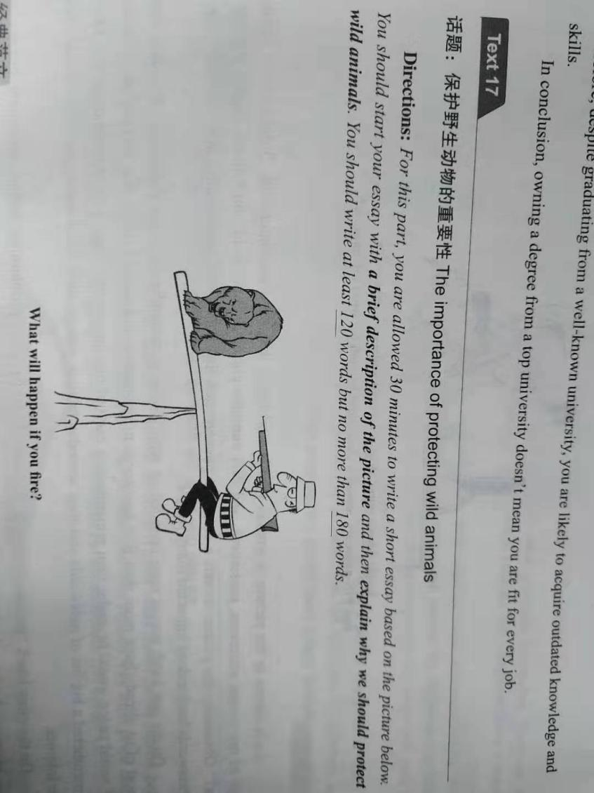

**As is starkly mirrored in the image/chart（表格), a** cruel hunter was holding an ice-cold gun towards an innocent bear.**（描述图片）** There is a question/statement below/above: what will happen if you fire? It is revealed that human should protect wildlife. **The following reasons can account for this issue.（过渡句）**

**First and foremost, there is no doubt** that animals are our friends.  **Based on big data, a majority of successful social elites have admitted that** they share a harmonious relationship with wildlife.**Furthermore, it is obvious that** biodiversity can be helpful for maintaining eco-balance.**论点2 Where** there is no buying, there is killing. **Last but not least,no one can deny that** there are numerous mysterious benefits on the genes of wild life.论点3 Although we can’t take advantage of all of them temporarily, the potential will be buried out if we don’t protect them **.论据3**

**In a word, the whole society should pay close attention to the problem of** wildlife protection. **Only in this way can we have a bright and promising future.**

练习五 名言警句类

Write an essay to explain why "Haste makes waste".

模板第二段第三段用万能模板 第一段进行替换

As an old saying goes:\_\_\_\_\_\_\_. For us college students, it has an increasingly important significance: If you want to achieve something, you need to take time to do it\_\_\_. The following reasons can account for this issue.

First and foremost， there is no doubt that if you do something in a very short time you might make some mistakes. Based on a most recent survey, it is revealed that a majority of successful social elites admitted even it’s an easy job, if you want to do it perfectly, it takes some time. Furthermore, it is obvious that people may doubt you if you finish your task too quick. Where there is doubt, there is concern. Last but not least, no one can deny that a great accomplishment is not achieved in one day. **Although t**he productivity is improved a lot**,** patience is also necessary.

In a word, if you want to have some achievement, you need to take some time. Don’t be so haste. If we try out utmost to **slow down and work carefully**, the future of **our career** will be promising and hopeful.

俗话说得好:\_\_\_\_\_\_\_。对于我们大学生来说，它有一个越来越重要的意义:如果你想要实现某事，你需要花时间去做它。以下原因可以解释这个问题。

首先，毫无疑问，如果你在很短的时间内做某事，你可能会犯一些错误。据最近的一项调查结果显示，大部分成功的社会精英承认，即使这是一项简单的工作，但如果想做得完美，也需要时间。此外，很明显，如果你过快完成任务，人们可能会怀疑你。哪里有怀疑，哪里就有担忧。最后但并非最不重要的是，没有人能否认，伟大的成就不是一天完成的。虽然工作效率提高了很多，但耐心也是必要的

总之，如果你想要取得一些成就，你需要一些时间。别这么着急。如果我们尽最大努力放慢速度，认真工作，我们的事业的未来将是充满希望的。

练习六

How to handle relationships between teachers and students

请不要看范文 先自行判断类型 并用模板套练

范文

With the rapid development of society/economy/science/technology/education/,

In contemporary world, many people have difficulty in handling relationship between teachers and students.(现象) I am convinced that it is of great necessity for teachers and students to respect each other.（观点） How to address this problem? The following solutions can account for this issue.(过渡句)

First and foremost(逻辑词), there is no doubt that（无敌句型）we need to listen to each other when they are talking(观点句1).

Based on a survey, a majority of international organizations and firms acknowledge that they prefer recruiting employees who can listen to their teachers.论据1

Furthermore/moreover, no one can deny that teachers should understand their students（论点2）.+论据2 For instance, 句子2 （where there is \_\_\_ there is ）.

Last but not least, it is clear that+论点3teachers should make friend with students. 论据3Though their ages are different, communication is equal.

In a word, it is obvious that we should handle the relationships between teachers and students properly. 重申观点If we try our utmost to enhance it, the future of our school life will be both promising and hopeful.

练习7

Directions:For this part, you are allowed 30 minutes to write **an essay on** the use of translation apps.You can start your essay with the sentence “The use of translation apps is becoming increasingly popular.”You should write at least 120words but no more than 180 words

请不要看范文 先自行判断类型 并用模板套练

范文：With the rapid development of technology, the use of translation apps is becoming increasingly popular. It's quite natural for us to ponder over the question of why do people use it ? (why do we use it all of a sudden?)

First and foremost, there is no doubt that **language study and translation have** become easier and faster with the help of the app.(we can learn better if we have the app). Based on big data，a majority of successful social elites admitted that they have spent 2/3 of their time in studying language by using translation apps. Furthermore, it’s obvious that communication between different countries can be enhanced without language barrier. (we can **make** foreign **friends** if we have translation app.) Where there is translation, there is communication. Last but not least, no one can deny that we can travel more easily if we have translation apps. Though we don’t have a good language environment, we can experience it in a short time.

In a word, the whole society should pay close attention to the use of translation apps. Only in this way can we have a bright and promising future.

总之，全社会都应该关注翻译APP的使用，只有这样我们才能有一个光明和有前途的未来.

练习8

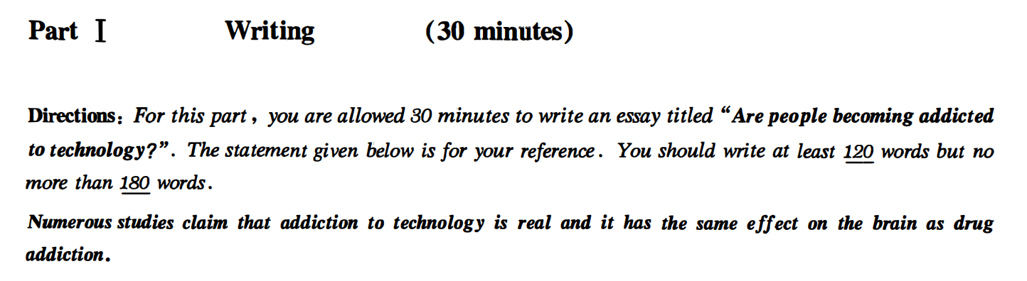

请不要看范文 先自行判断类型 并用模板套练

练习8 范文方法一：可以写现象解释

Are people becoming addicted to technology?

Numerous studies clam that addiction to technology is real and it has the same effect on the brain as drug addiction.With the rapid development of technology, technology has become increasingly important in our life. It is quite natural for us to ponder that are people becoming addicted to technology? I think it’s not true.

First and foremost, no one can deny technology has helped people in a lot of areas, such as medical science, physics and entertainment. Based on big data, it is revealed that most scientists admitted that they have spent 2/3 of their time in studying technology. However, every coin has two sides. Many people have lost their jobs because of technology. Where there is technology, there is a cheap work force. Last but not least, I firmly believe that although there are disadvantages of technology, it has a hopeful future.

In a word, the whole society should pay close attention to the problem of technology. Only in this way can we have a bright and promising future.

方法二观点选择：

Numerous studies clam that addiction to technology is real and it has the same effect on the brain as drug addiction. Some think that addiction to technology is possible, while others think lacking of the self-control ability is the reason.（列举选择） Personally, I prefer the former.做出选择 The following reasons can account for my preference.过渡句

First and foremost, no one can deny technology has helped people in a lot of areas, such as medical science, physics and entertainment. Based on big data, it is revealed that most scientists admitted that they have spent 2/3 of their time in studying technology. However, every coin has two sides. Many people have lost their jobs because of technology. Where there is technology, there is a cheap work force. Last but not least, I firmly believe that although there are disadvantages of technology, it has a hopeful future.

In a word, the whole society should pay close attention to the problem of technology. Only in this way can we have a bright and promising future.

练习9 请不要看范文 先自行判断类型 并用模板套练

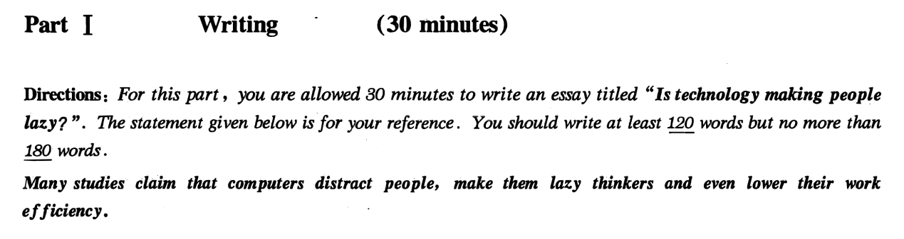

练习9范文

观点选择：

Is technology making people lazy?

Many studies claim that computer distract people, make them lazy thinkers and eve lower their work efficiency, while some hold the opposite opinion that technology is beneficial instead of making people lazy. Personally I prefer the latter one.The following reasons can account for my preference.

First and foremost, no one can deny technology has helped people in a lot of areas, such as medical science, physics and entertainment. Based on big data, it is revealed that most scientists admitted that they have spent 2/3 of their time in studying technology. However, every coin has two sides. Many people have lost their jobs because of technology. Where there is technology, there is a cheap work force. Last but not least, I firmly believe that although there are disadvantages of technology, it has a hopeful future.

In a word, the whole society should pay close attention to the problem of technology. Only in this way can we have a bright and promising future.

练习10 请不要看范文 先自行判断类型 并用模板套练

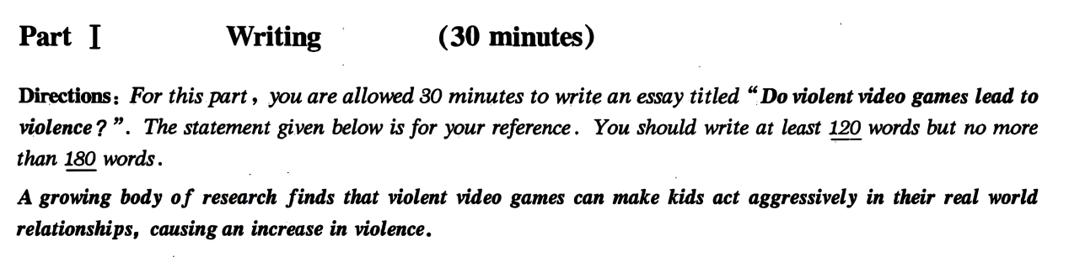

练习10 范文

观点选择：

A growing body of research finds that violent video games can make kids act aggressively in their real world relationships, causing an increase in violence. On the other hand, some people argue that it’s not true. Personally I prefer the former one. The The following reasons can account for my preference.

First and foremost, there is no doubt that most children are so ignorant that they take in everything they watch. 论点1Based on big data, it is revealed that a majority of children admitted that believe everything in the game.论据1 Additionally, it is obvious that young kids are good at imitating.Where there are violent games, there are violent behaviors. 论据2Last but not least, no one can deny that we need to provide a healthy environment for kids. 论点3Though some people find violent games interesting, it’s not necessary for kids to play them.论据3

In a word, the whole society should pay close attention to the problem of violent game. Only in this way can we have a bright and promising future.

练习11 不要看范文 先自行判断类型 并用模板套练

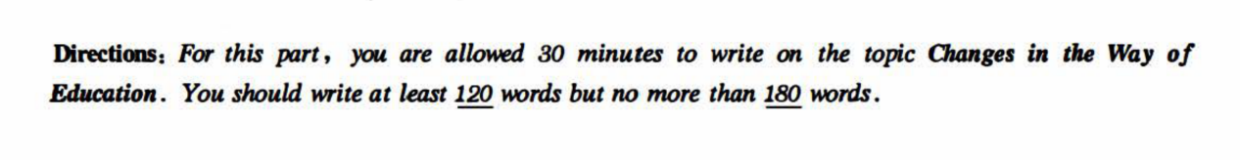

**With the rapid globalization of /education, it is of great necessity for students to receive various kinds of education.(know about education) It's quite natural for us to ponder over changes in the way of education.**

First and foremost, there is no doubt that new technology brings new education forms, such as online education and Moocs. Based on big data，a majority of successful social elites admitted that they have spent 2/3 of their time in studying online. Furthermore，it is obvious that education in the classroom（classroom facility） has evolved in the past 2 decades.(classroom education has changed a lot).Where there are classrooms, there is multimedia(computers). Last but not least，no one can deny that there are more students going to the college comparing to 20 years ago.(more students go to university now).Though not everyone can go to university, the higher education isn’t impossible.

In a word, the whole society should pay close attention to the problem of education. Only in this way can we have a bright and promising future.

总之，全社会都应该关注（教育）问题，只有这样我们才能有一个光明和有前途的未来

练习12 不要看范文 先自行判断类型 并用模板套练



**With the rapid development of /society, technology,economy, it is of great necessity for citizens to get a variety of transportation. (know about transportation)It's quite natural for us to ponder over changes in the way of transportation.**

First and foremost, there is no doubt that economy booming brings new transportation forms, such as subway. Based on big data，a majority of residents admitted that they have spent 2/3 of their time in travelling on new transportation forms. Furthermore，it is obvious that the number of private cars has increased over the past 2 decades.(there are more private cars nowadays).Where there are roads, there are private cars. Last but not least，no one can deny that there are more travelers taking airplane comparing to 20 years ago.(more travelers take airplane now).Though not everyone can afford air flight tickets, taking airplane isn’t impossible.

In a word, the whole society should pay close attention to the problem of traffic. Only in this way can we have a bright and promising future.

应用文

信件

通知

通知

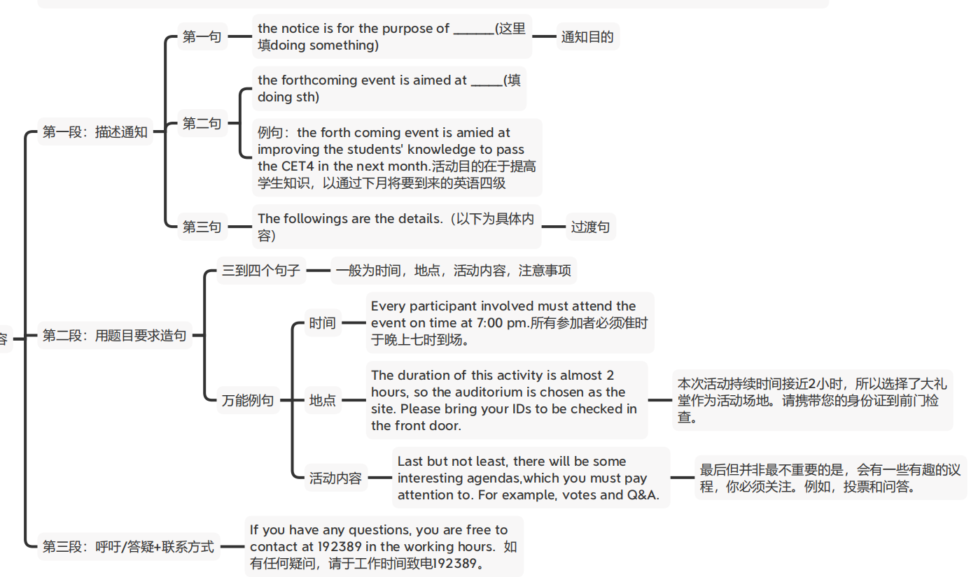

**信件范文：**

**Part V Writing (25 minutes)**

**Directions:** *For this part you are required to write a letter based on the following information given in Chinese. Remember to write your letter in the space given on Answer Sheet.*

说明：假设你是项目经理Jane Hart。根据以下内容给John Smith 先生写一封信。写信时间为2013年5月5日，信的内容包含：

1. 感谢他上周发来的邮件；
2. 告诉他工程进度始终是在按照合同规定的时间进行；
3. 对当地员工的培训还未完成，预计下月底可结束；
4. 随信附上一份参加培训的员工名单。

请注意信函格式！

May 5th , 2013.

Dear John Smith,

My name is \_Jane Hart\_\_\_, and I am project manager. \_\_\_\_**\_\_Thank you for your E-mail last week.** I’m writing this letter on the behalf of company to let you know about the training progress. The followings are the details.

First thing I want to deliver is\_the progress of the project is always carried on according to time on the contract. Please kindly be informed. Second matter concerned is that the training of the local employees isn’t finished. It is expected to be done in the end of next month \_\_. At last\_\_\_\_the list of training employees is on the attachment.

. Thank you for your time.

Sincerely yours,

Jane Hart**.**

通知范文：

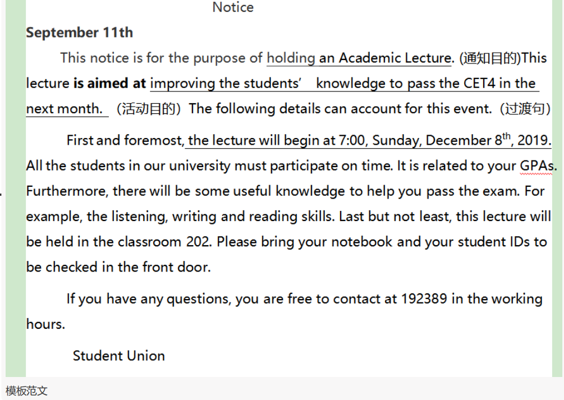

通知范文2： Directions: For this part, you are allowed 30 minutes to write a notice for the Travel agency to tourists that about tomorrow schedule.At least 120 words but no more than 180 words.

写作提纲：明早集合时间，集合地点，所带物品，日程安排

Notice

September 11th  
    This notice is for the purpose of holding an Academic Lecture. (描述通知)This lecture **is aimed at** improving the students’ knowledge to pass the CET4 in the next month. （通知目的）The following details can account for this event.（过渡句）

First and foremost, the lecture will begin at 7:00, Sunday, December 8th, 2019. All the students in our university must participate(be there) on time. It is related to your GPAs. Furthermore, there will be some useful knowledge to help you pass the exam. For example, the listening, writing and reading skills. Last but not least, this lecture will be held in the classroom 202. Please bring your notebook and your student IDs to be checked in the front door.

If you have any questions, you are free to contact at 192389 in the working hours.

Student Union

#### 新闻报道

2019年6月

Directions: For this part, you are allowed 30 minutes to write a **news report** to your campus newspaper on a visit to a local farm organized by your **Student Union**. You should write at least 120 words but no more than180 words.

新闻文体：客观（第三人称：they，he，she，Student Union不要出现：I We），过去式（一般过去时 ved 事件的结果， ）过去进行时（事件的背景。）

新闻的结构（先出结果 +再出细节+意义）

三个段落：

**第一段：时间，地点，参与者，事件本身，事件结果**

**On December First, Monday, the Student Union organized a meaningful activity to visit the local farm, in which 300 volunteers actively participated. It turns out to be a great success.**

**第二段：活动目的+三个具体事件+三句补足+以时间顺序串联**

**This activity** was aimed at cultivating the practical abiliity of students by visiting the farmland and helping the peasants with hard labours.In the early morning just after the arrival of students, the students watered the crops in the field for farmers.(事件1)+**When asked about those volunteers’ feelings about such an experience, all of them responded** with a smile**, saying “what a wonderful practice and I really appreciate this experience, for it makes me learn to use my knowledge in practice.” (万能补足语1) After the lunch, the farmers held an experience sharing meeting, in which the students anwsered various useful questions. 补足语2 Some students showed how to use technology to improve the productivity. In the evening, the students and the farmers enjoyed a feast together, which was prepared by the students. The peasants prasied the cooking of students.**

**第三段：新闻的意义**

**This activity turns out to be a beneficial event for both sides. T**he Student Union **expressed that there will be more meaningful events in the future. 结尾选择2More efforts will be made to help farmers in the rural areas.**

**广告：ad. advertisement**

**Directions:** *For this part, you are allowed 30 minutes to write an* ***advertisement*** *on your campus website to sell a computer you used at college. Your advertisement may include* ***its brand, specifications/features, condition and price, and your contact information.*** *You should write at least 120 words but no more than 180 words.*

**

IMG_256IMG_256



标题： 卖什么就写什么

A nearly brand-new computer

One man’s trash is another man’s treasure. Currently I’m selling\_\_\_\_\_. It’s a \_\_\_\_\_,which I bought 3 years ago on the Internet. \_\_\_\_\_\_\_（细节1）. Its functions are all perfect, because I maintain it every week. Now I really need money , so I sell it at a price of 100 yuan. It’s really worth it! If you need it, You need to take action now to call me at 18788888888. Trust me, if you miss this, you will be regretful for a life time.