Are you tired of standing in line, waiting for the ferry to arrive, only to find out it's running late due to the unpredictable water levels of the Elbe? Well, worry no more! Introducing ferryALeRT, the ultimate solution to your ferry frustration!

At ferryALeRT, we've harnessed the power of smart systems to tackle the ferry problem head-on. Our genius team of problem solvers has developed a cutting-edge smart system that reads the water levels of the Elbe in real-time. Using state-of-the-art technology, we publish this information through MQTT, update our dynamic database, so you get access to up-to-the-minute ferry availability information, both online and on our fancy LCD displays right at the docks.

But we didn't stop there! We understand that waiting can be a drag, so we've gone the extra mile to make your waiting experience as pleasant as possible. Our smart system calculates and displays the estimated wait time, so you can plan your day accordingly. No more aimlessly twiddling your thumbs or wondering when that ferry will finally arrive.

Now, let's talk about our team. We're not just a bunch of tech enthusiasts; we're a well-oiled machine! With tasks split up in our great engineering and designing team and a fabulous project manager we made sure that everything runs smoothly. And all that with a secret ingredient: our team chemistry. We gel together like peanut butter and jelly, like cookies and milk, like... well, you get the idea. We've got the perfect blend of expertise, camaraderie, and a dash of quirky humor to keep things lively.

So hop aboard the ferryALeRT revolution, where we're making waiting for the ferry a thing of the past. Say goodbye to uncertainty, and say hello to real-time information and shorter wait times. Rem ember, when it comes to smart systems, we're the captains of innovation!

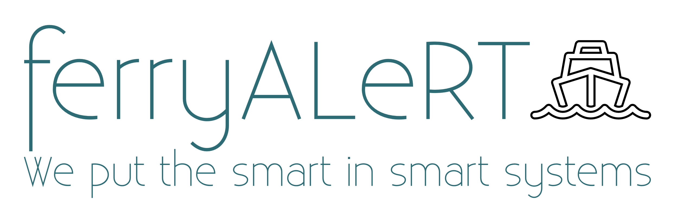 "We put the smart in smart systems!"

chat gpt anweisung:

schreib einen pitch auf english für ein marketplace stand, bei dem wir die lösung für das ferry problem (die ferry line 73 fährt in wilhemsburg abhängig vom wasserstand der elbe unregelmäßig, informationen sind nur teilweise online verfügbar) präsentieren. wir haben ein smart system entwickelt, welches den wasserstand abliest, davon abhängig die verfügbarkeit der fähre über mqtt published, eine datenbank aktualisiert, sodass informationen in echtzeit auf unserer website und einem lcd display vor ort an den jeweiligen docks angezeigt werden. auch die wartezeit wird angezeigt. sei kreativ und witzig. beziehe dich auch auf unser gut aufgestelltes team und die teamchemie. unser teammotto: We put the smart in smart systems! Teamname (ferryALeRT)