convnext_large.fb_in1k訓練80epoch
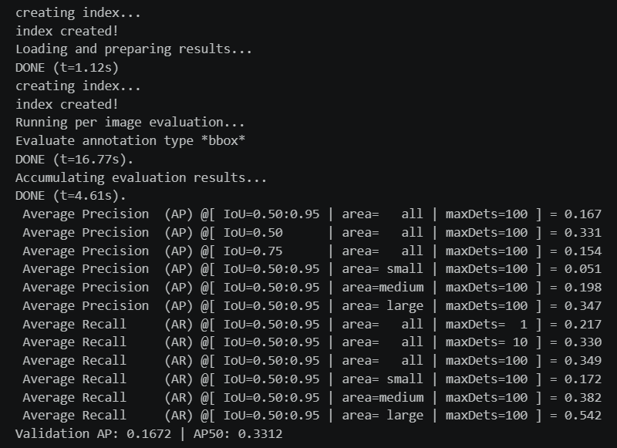
darknet53.c2ns_in1k訓練50epoch


