**ISCG 8045 –**

**FreshTreasure Online Study Hub Instructions**

Yixin, Zhang       1483998

Website address

Visit <https://iscg7427demo.mybluemix.net/>, then click the button “Login From Here”

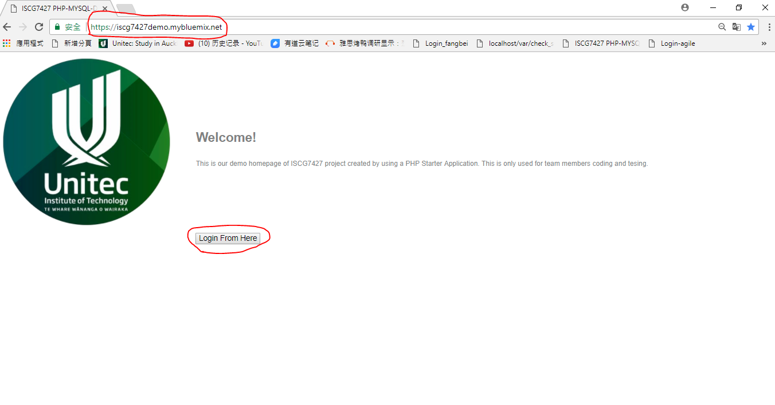

Then, you will see the log in page.

Features Table

|  |  |  |
| --- | --- | --- |
|  |  | features |
|  |  |  |
| all users | 1 | log in |
|  |  |  |
| admin | 2 | assign courses |
| 3 | add/delete books |
| 4 | add/delete courses |
|  |  |  |
| lecturer | 5 | course list |
| 6 | enroll student |
| 7 | recommend books |
| 8 | add comment |
|  |  |  |
| student | 9 | course list |
| 10 | select books |
| 11 | add notes |
| 12 | add comment |

You can find how to use these features in detail in the following sessions

Feature 1 log in

Users can enter his name and password to get log in.

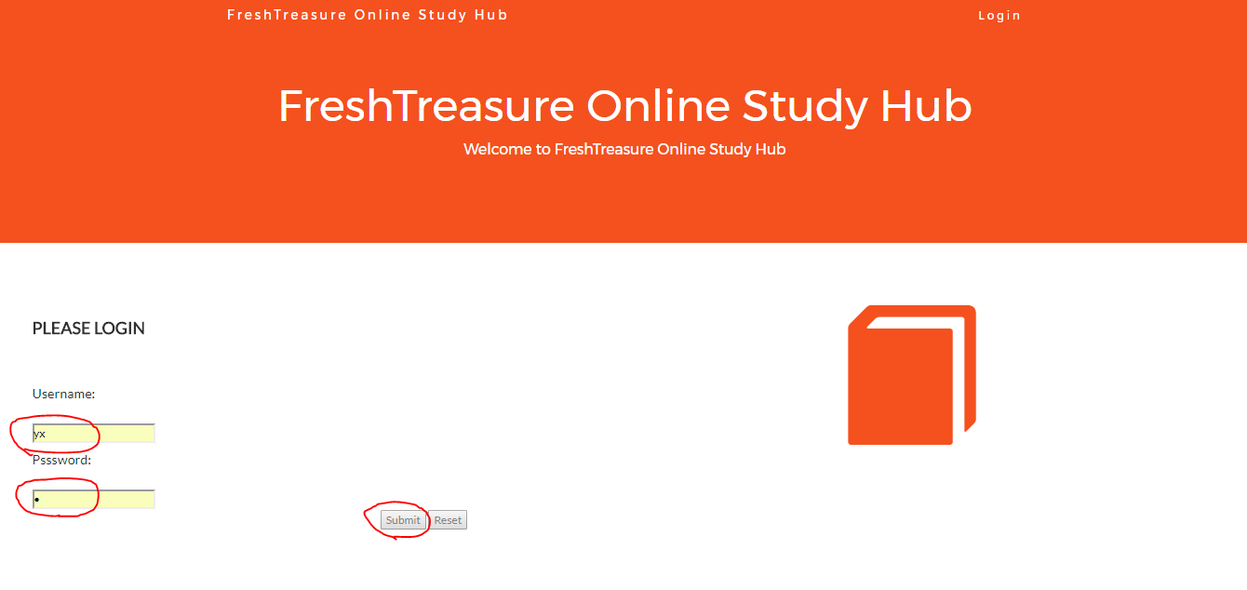

For the administrator

After log in successfully, you will see the welcome page



Click “Enter Hub” , the dashboard would show the features users can use as a Administrator.

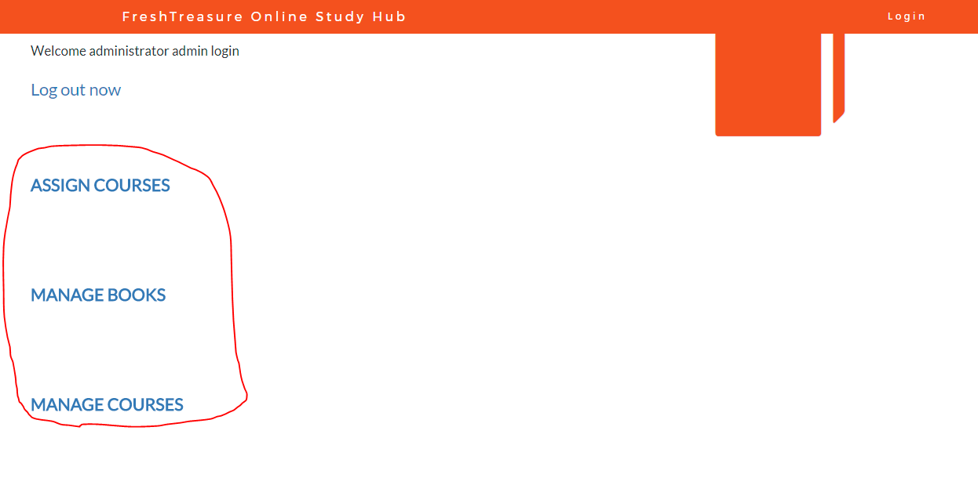

Feature 2 Assign courses

As a administrator, you can assign courses to a certain lecturer.

In the dashboard page, click “ASSIGN COURSES”

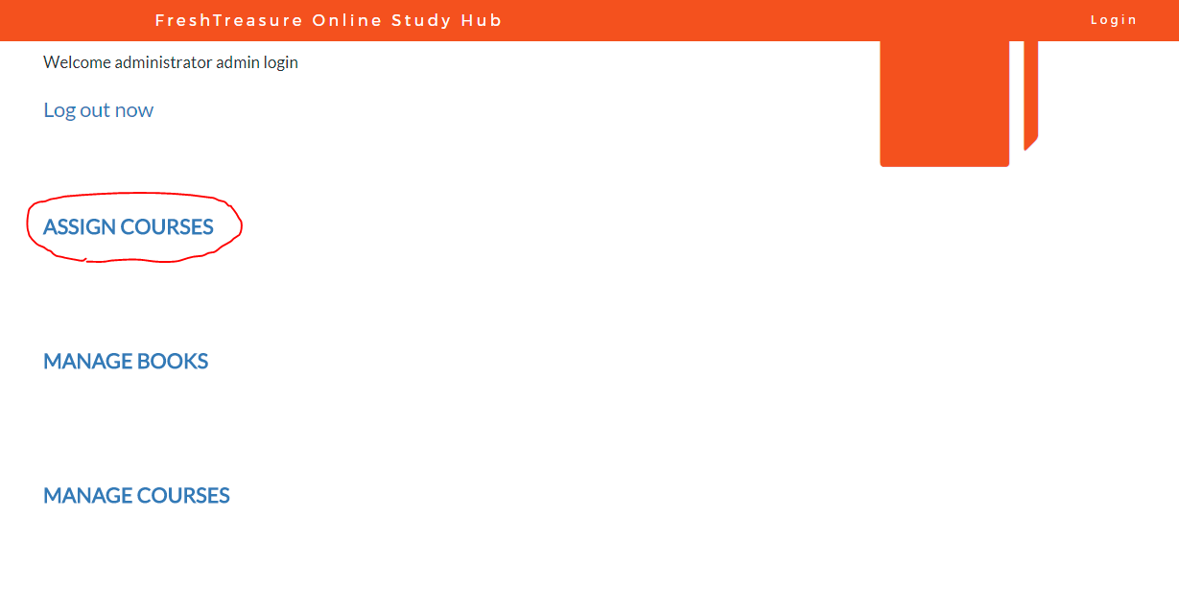

For example, if you want to assign Database Design & Development this course to lecture Sam

Step1 select his name in the lecture list

Step2 click the “submit” button at the bottom

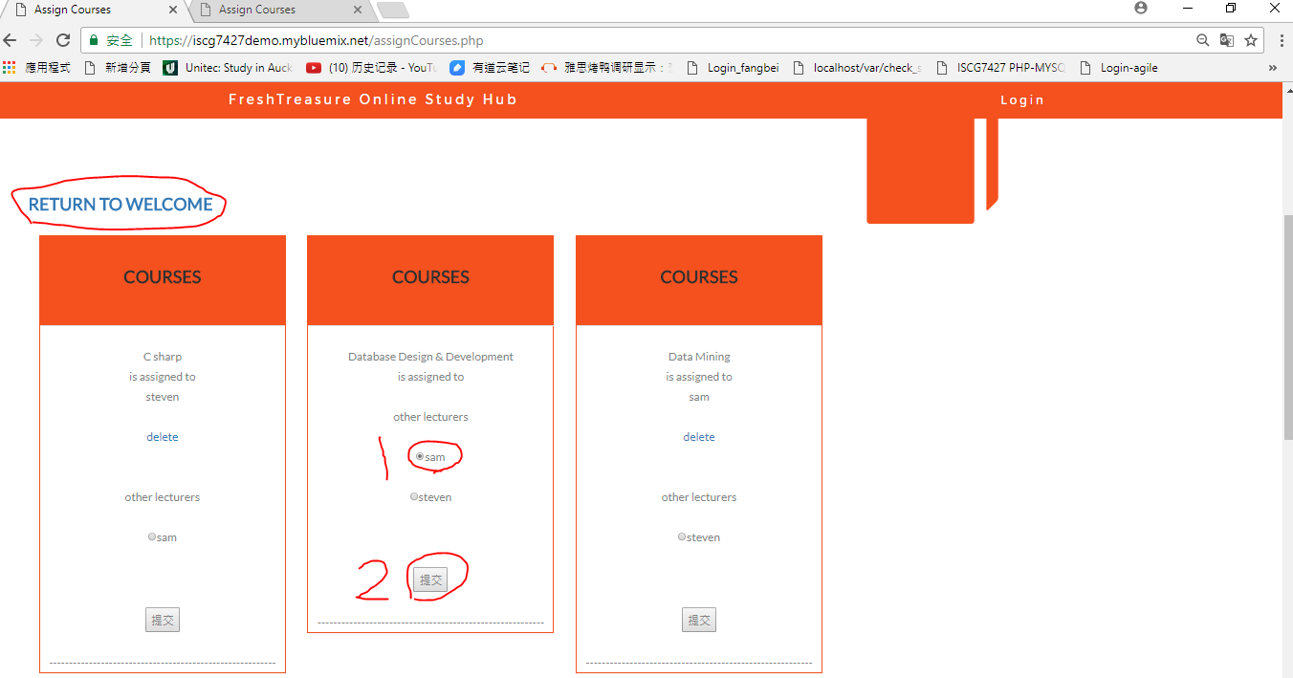

After assign successfully, you will see this:

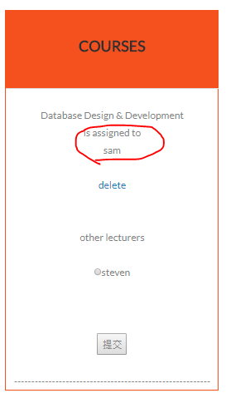

If you want to cancel this operation, you can click the “delete” label below the lecture’s name.

If you want to use other features, click the “RETURN TO WELCOME” at the left top of the page.

Feature 3 Manage books

As a administrator, you can manage books stored in the associated system database.

You can add/delete a books using the manage books page.

In the dashboard page, click “ MANAGE BOOKS” to enter the manage books page.

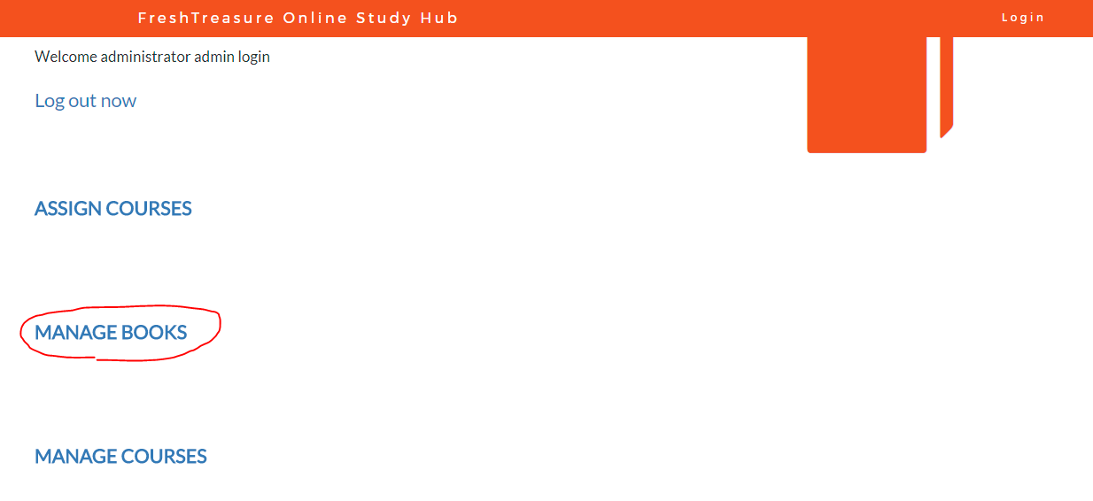

For example, if you want to add testing book, you have to enter the book info like the following and then click “add book”:

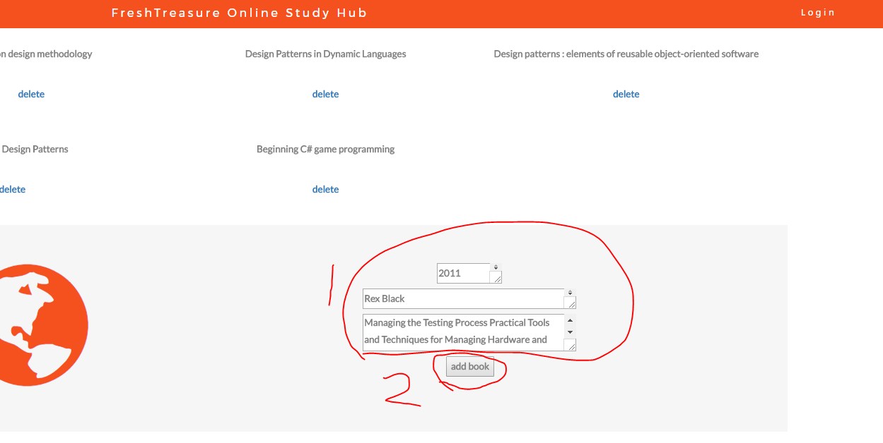

And you can also delete a book by click the “delete” label below the book to remove it from the database.

Like in the assign courses page, click the “RETURN TO WELCOME” at the left top of the page to enter to other features:

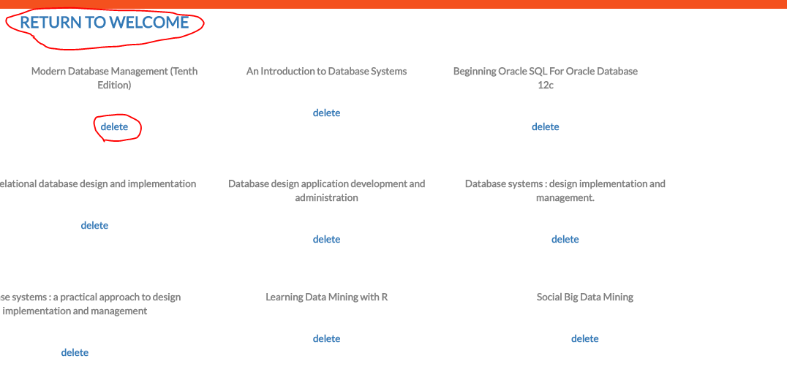

Feature 4 Manage courses

As a administrator, you can manage courses stored in the associated system database.

You can add/delete a course using the manage course page.

In the dashboard page, click “ MANAGE COURSES” to enter the manage books page.

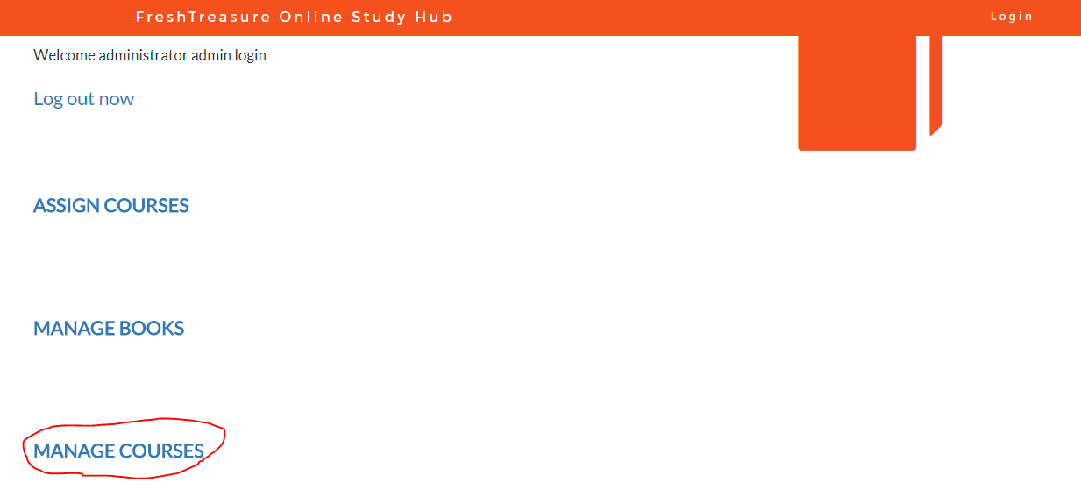

For example, if you want to add course named “ios”, you have to enter the course name like the following and then click “add course”:

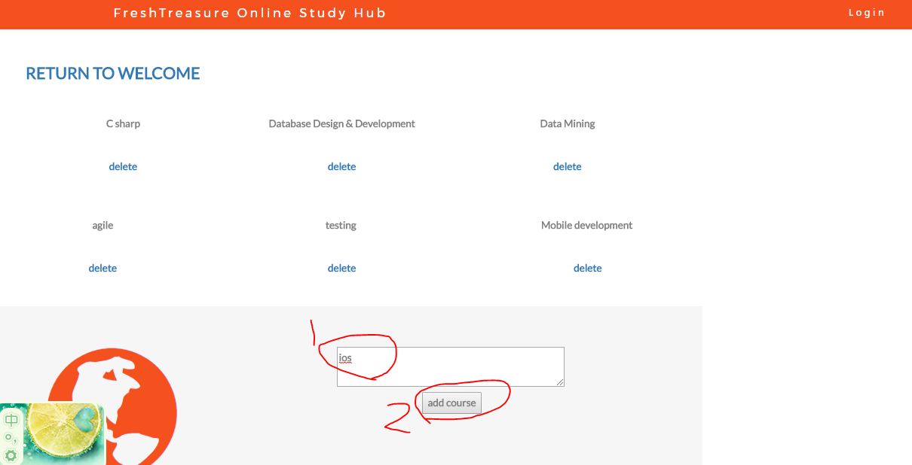

And you can also delete a course by click the “delete” label below the book to remove it from the database.

Like in the assign courses page, click the “RETURN TO WELCOME” at the left top of the page to enter to other features:

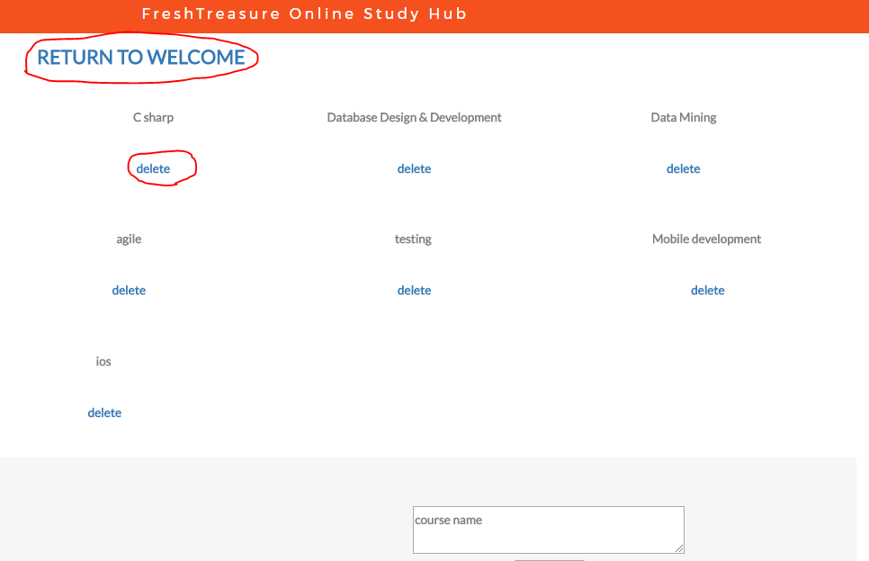

For the lecturer

Feature 5 Courses list

After log in successfully, click “MY COURSES” to browse the course list

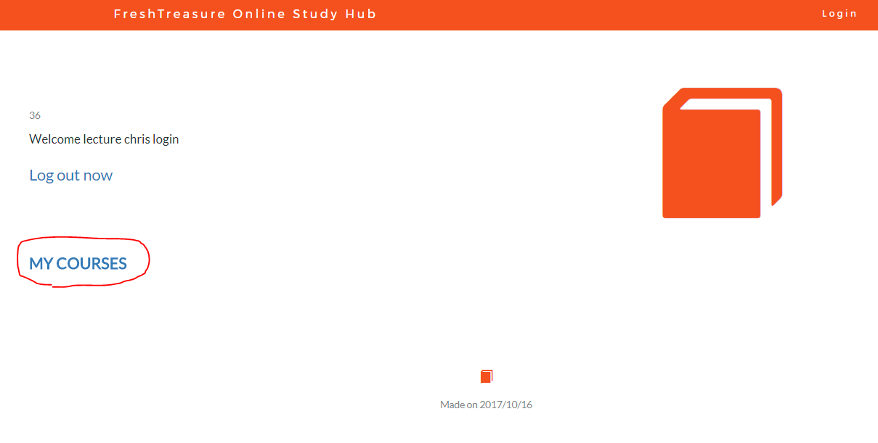

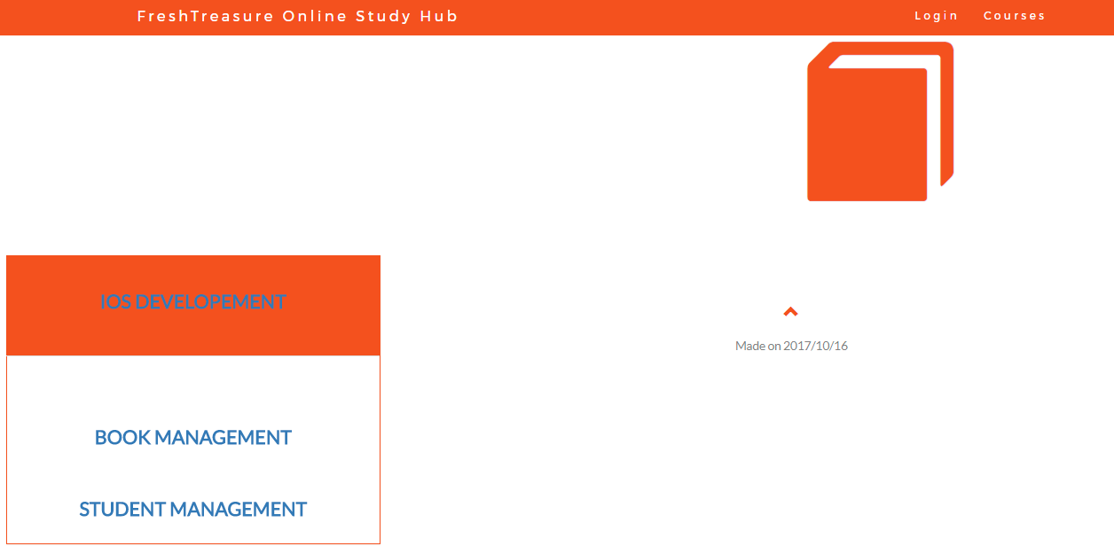

Feature 5 Add comments

Click course name in the course list page to open the comments page:

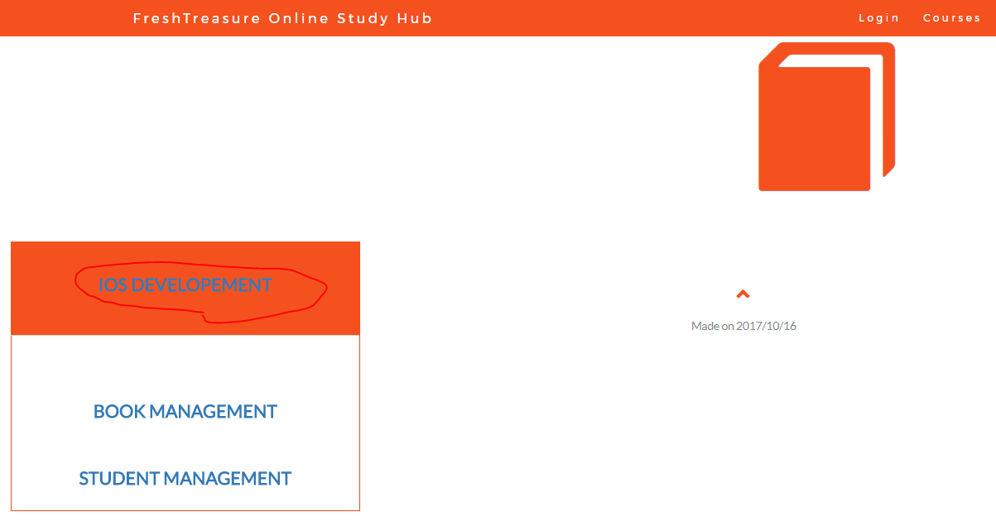

As a leturer, you can add some comments for the course you teach. Input the comments in the comment box and then click “Add comments”.

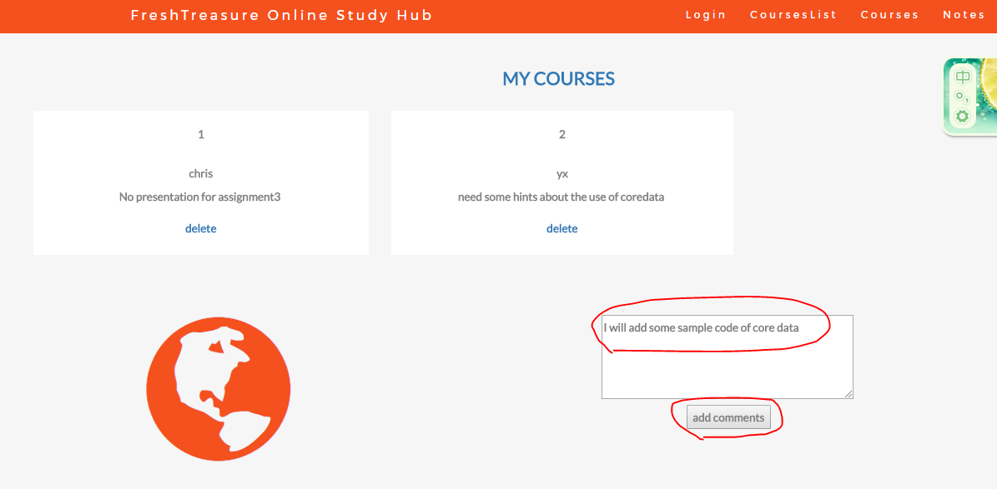

And you can also review the comments from the students enrolled in this course:

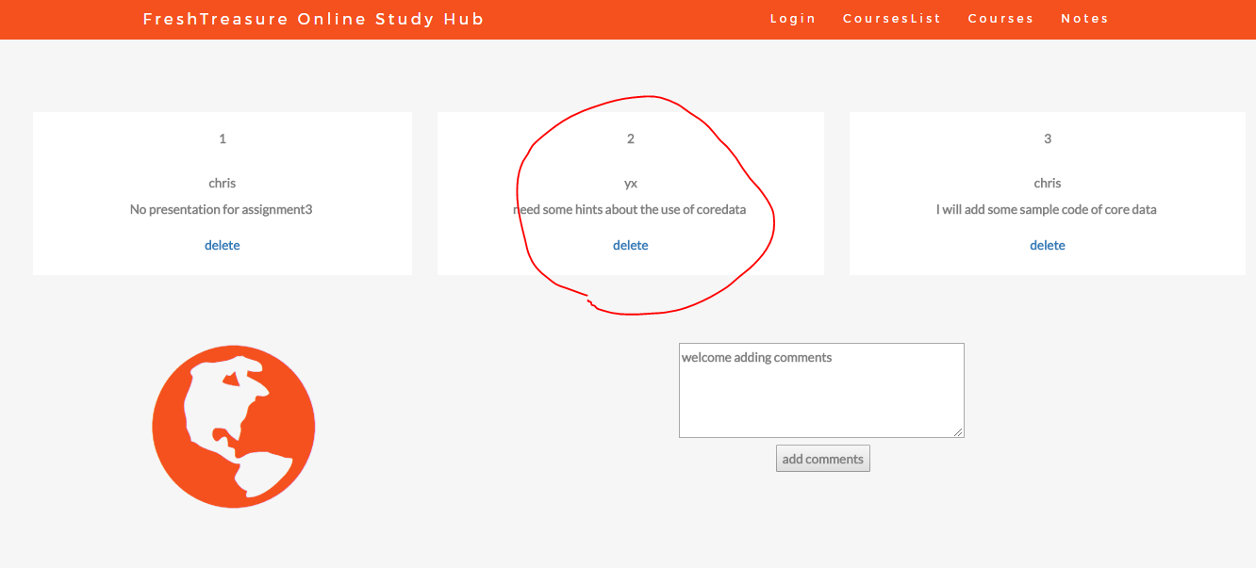

To remove a comment, click the “delete” in the comment box.

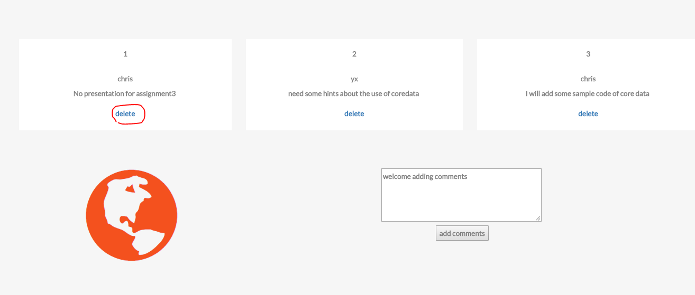

Feature 6 recommend books

In the course list page, click the “BOOK MANAGEMENT” under the course name to see the book list.

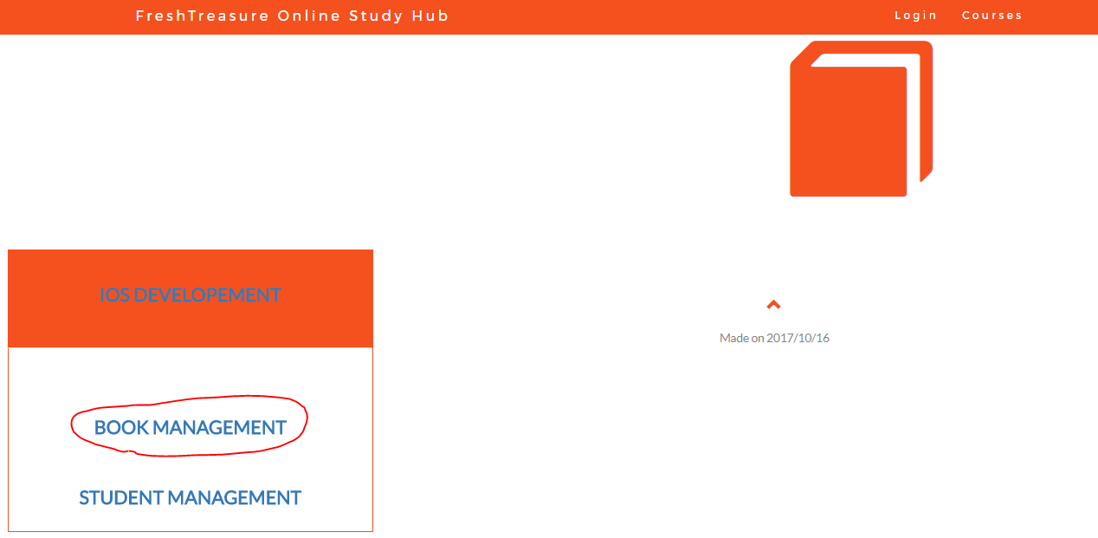

You can select books helpful to the course from the booklist to recommend them to the student

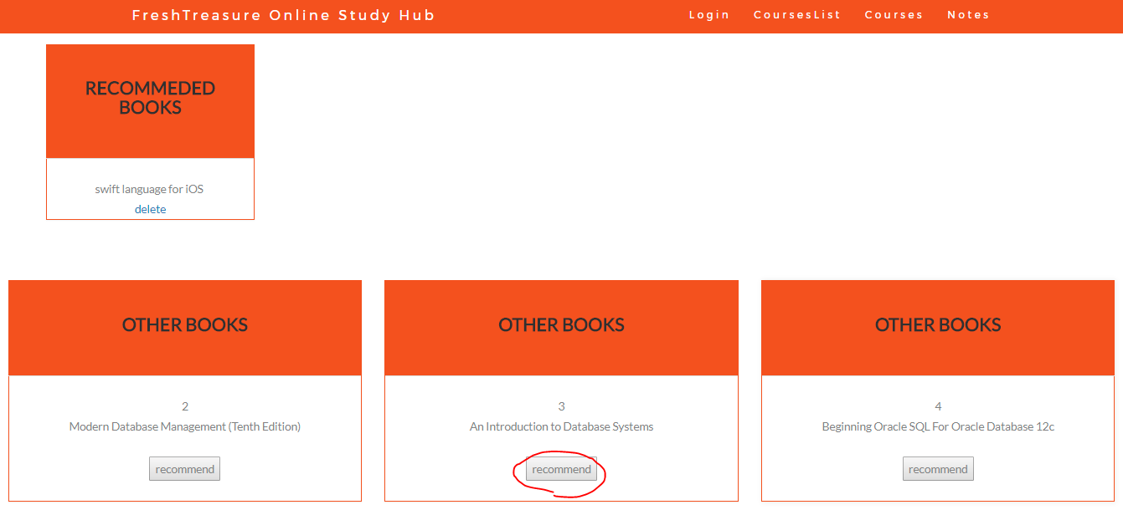

Select a book in the “OTHER BOOKS” list and then click “recommend” to recommend it.

You can also remove the recommended status by clicking the “delete” under the book name in the “RECOMMENDED BOOKS” box.

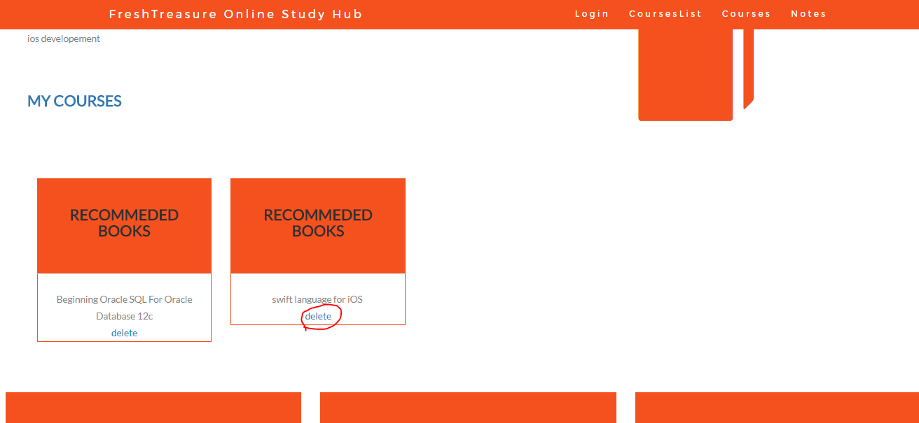

Feature 7 enroll students

In the course list page, click “student management”

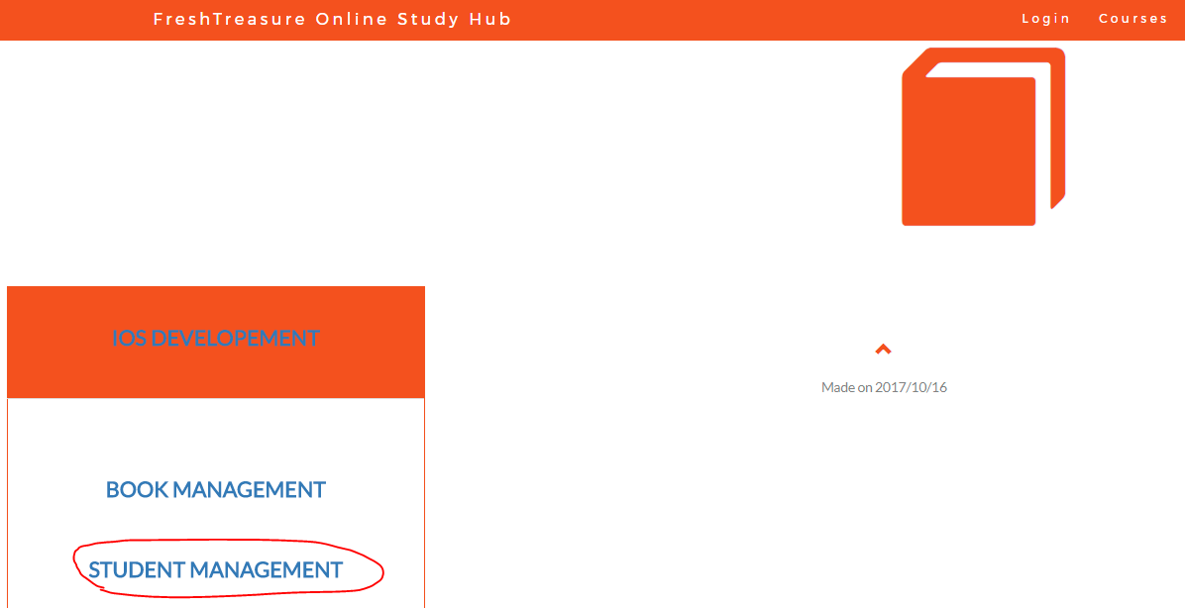

You can select students from the student list to enroll them to the course you teach

Student in the “OTHER STUDENTS” block are not enrolled yet, you can click the “enroll ”button under their name to get them enrolled.

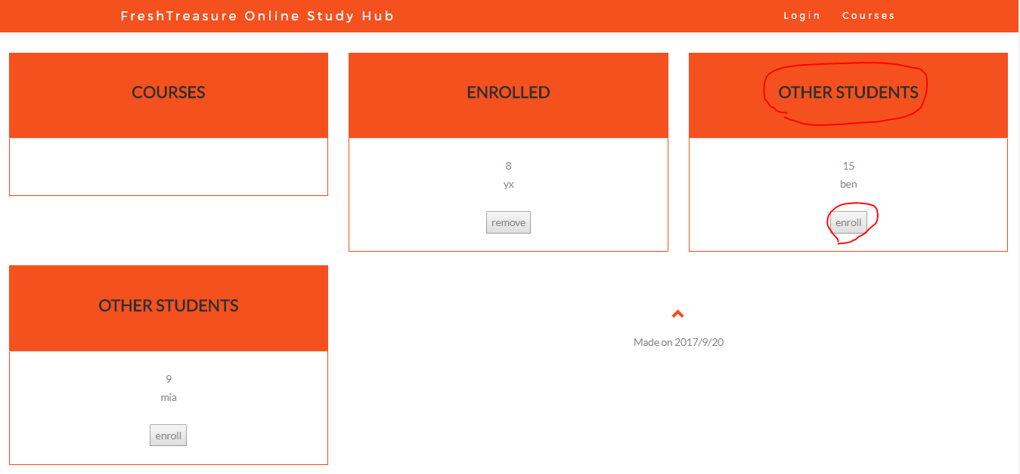

Then the students’ name would appear in the “ENROLLED” boxes.

You can also remove the student who is not eligible for this course by clicking the “remove” button to cancel their enrolled status:

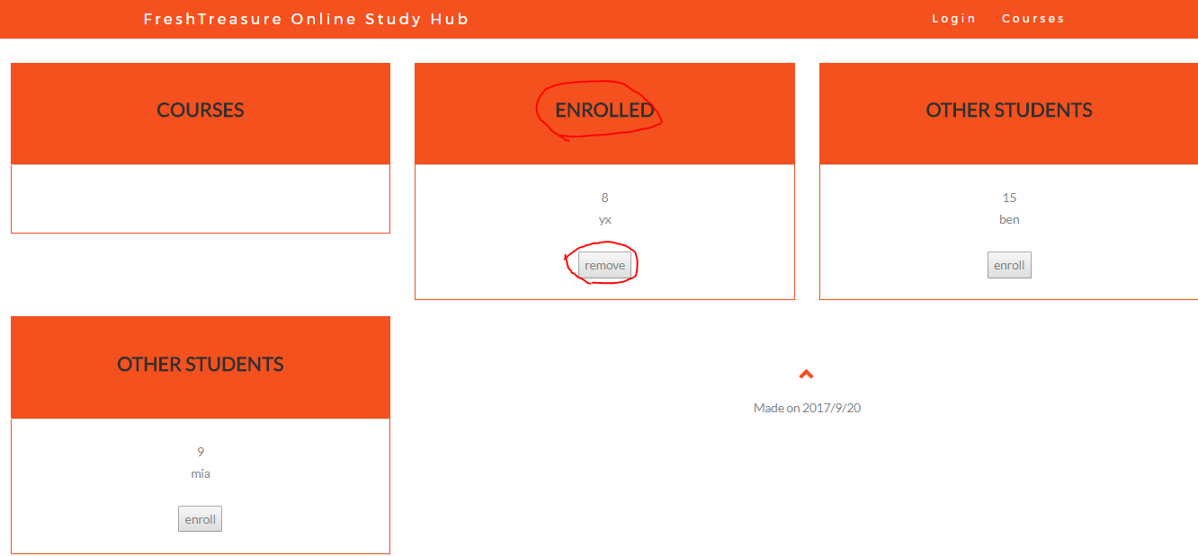

For the students

Feature 9 Courses list

After log in successfully, click “MY COURSES” to browse the course list

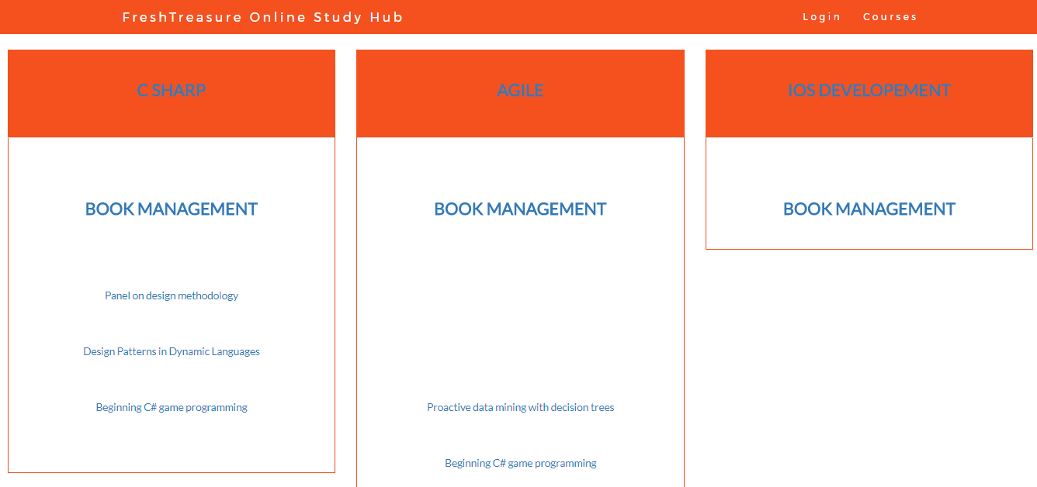

Note that the title of each course box is the course name and the items under the “BOOK MANAGEMENT ” is the selected book list for the course. So you can see all the courses and all the selected books belong to this course at the same time.

Feature 10 Add and review comments

As a student, like the lecture, you can also add some comments to the courses you enrolled and you can review others’ comments as well. Click the course name to enter the comment page:

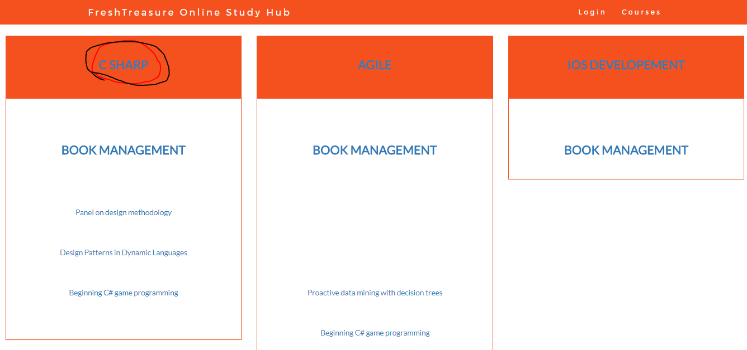

To add a comment, input the text in the box and then click “add comments” button.

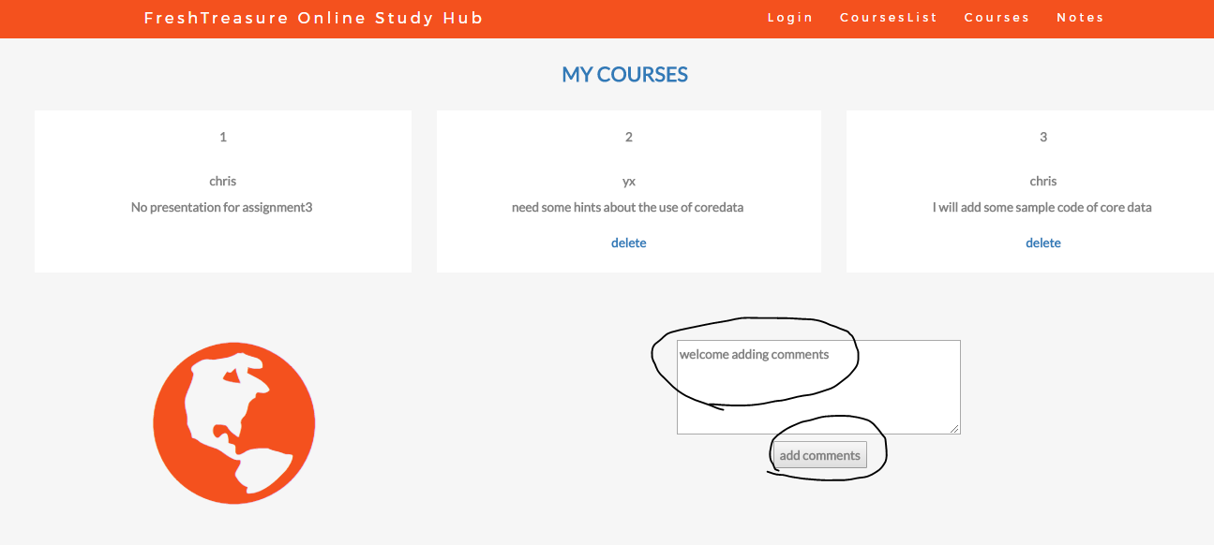

And you can also review the comments from others in this course:

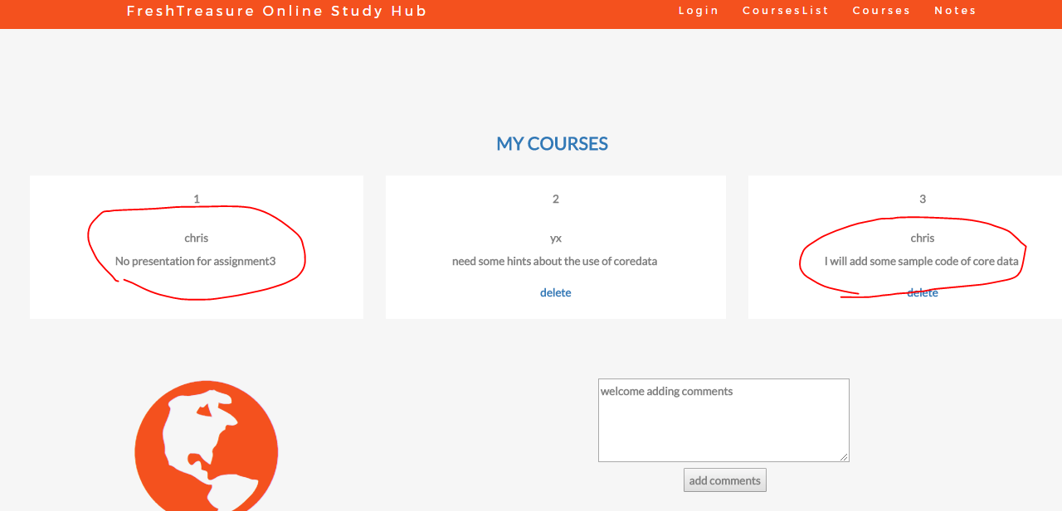

You can also delete your comment, by click the “delete” in the comment box:

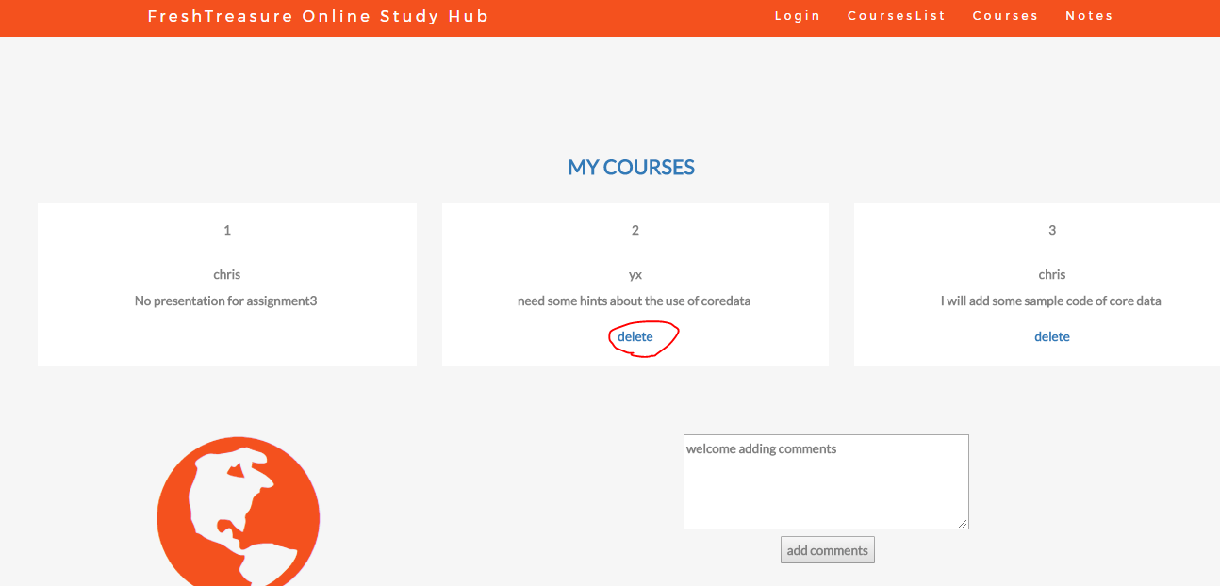

Feature 11 select study books:

In the course list page, Click “BOOK MANAGEMENT” to enter the select book page

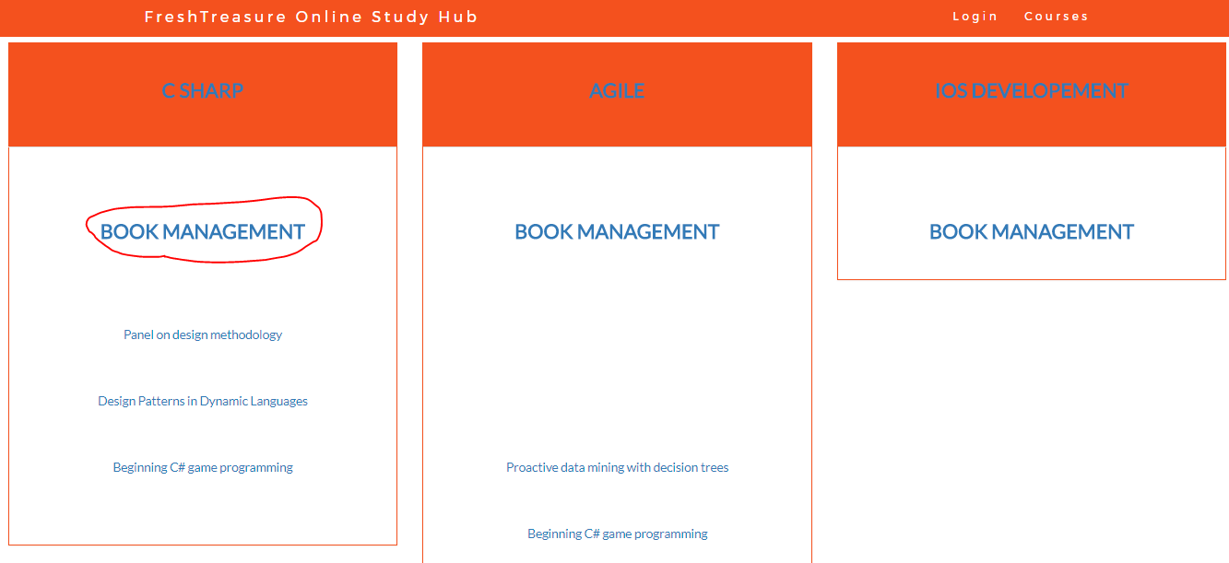

In this page, the books already be selected are shown in the “SELECTED BOOKS” boxes, whereas the books have not been selected are shown in the “LEFT BOOKS” boxes. The book with a desciption of “it is rec” means this book is recommended by the lecturer. You can select both the books recommended as well as the books not recommended. It’s up to you. Find the book box and then click “select” to select it.

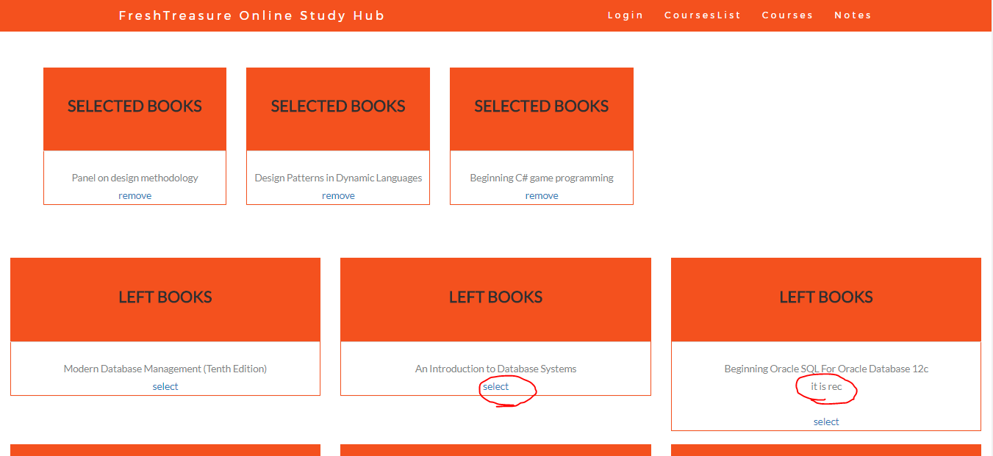

To remove a book from your selection, click the “remove” label under the book name in the selected box.

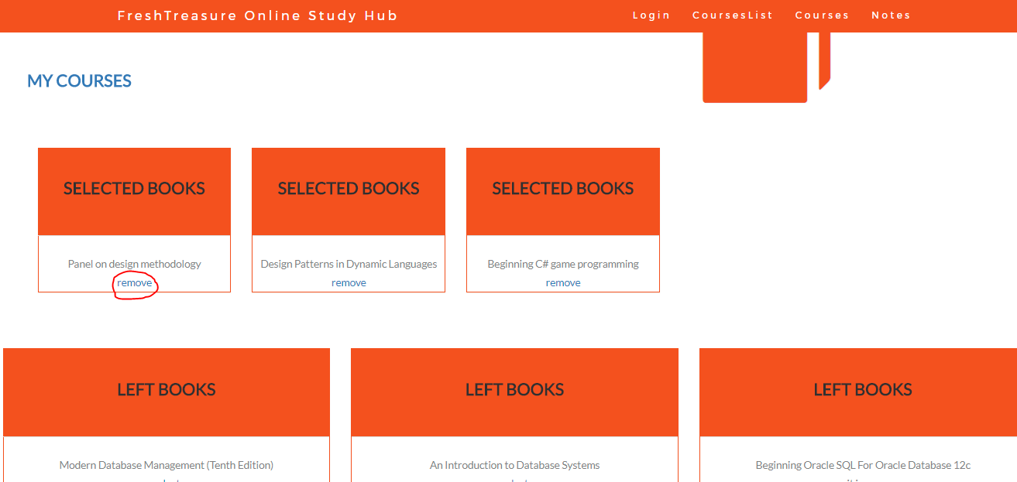

Click the “MY COURSES” at the left top of the page to return to the course list.

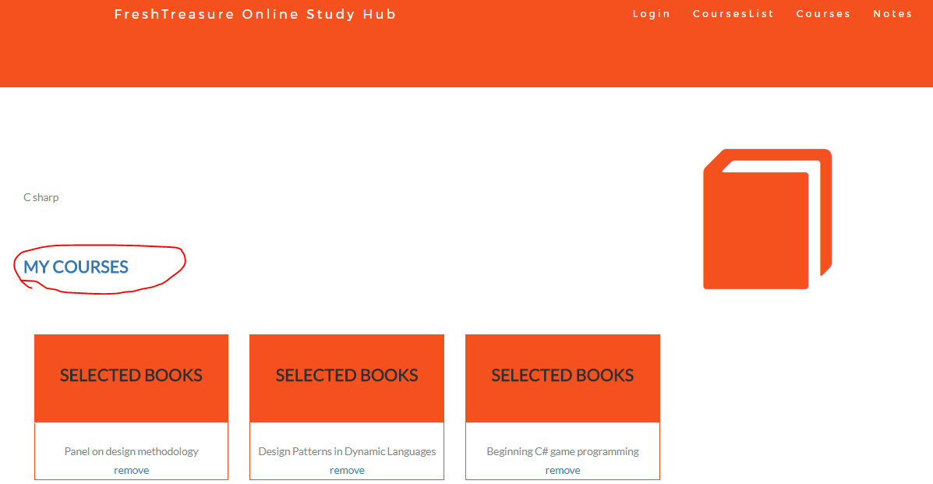

Feature 12 add books notes

In th course list page, Click the book name to enter the select book notes page:

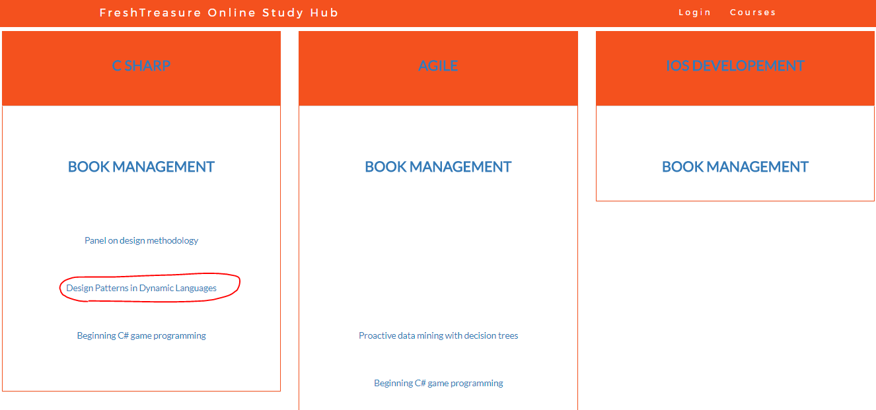

You can see the note list. To add a new note, enter the text in the box and then click “add note” button.

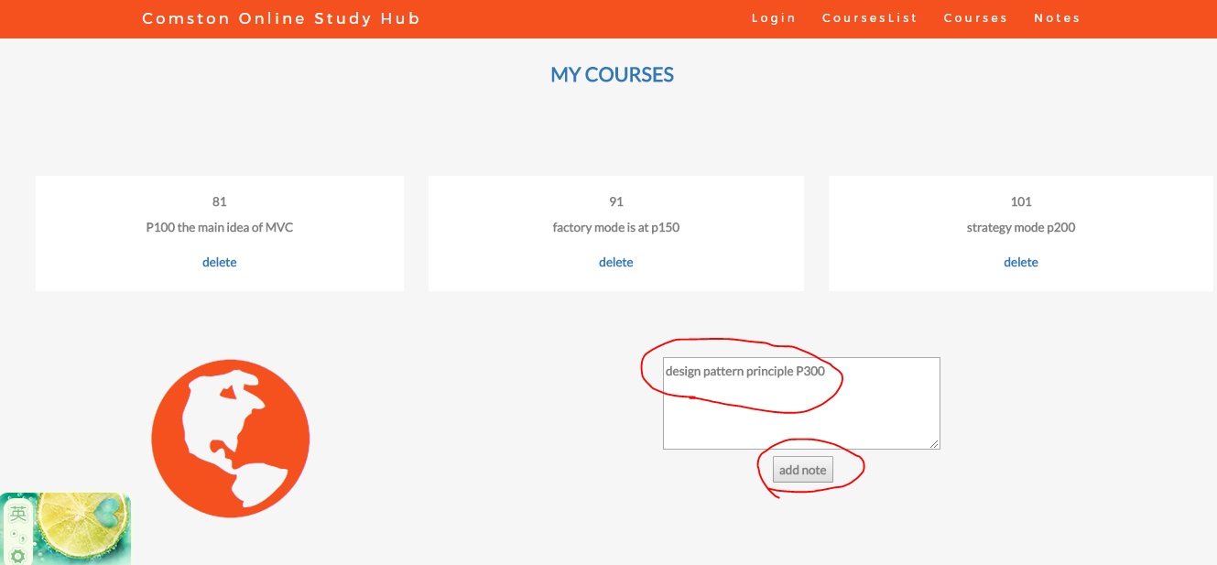

To remove a no use note, click the “delete” in the note box.

