**Physical Geology (GOL 105)**  Name: \_\_\_\_\_\_\_\_\_Xinying Huang\_\_\_\_\_\_\_\_\_\_\_\_\_\_\_\_\_\_\_\_\_\_\_

*40 points possible*

# EARTHQUAKES & SEISMOLOGY

To prepare for this lab, please read Chapter 16 in your lab manual and Chapter 11 in your textbook.

Familiarize yourself with the typical “anatomy” of a seismogram using the following example. [Watch the pre-lab video online here](https://mediaplayer.pearsoncmg.com/assets/3NpEFKJ8LR5f9kI4q7UbciahHfiN9msI) to review key techniques.

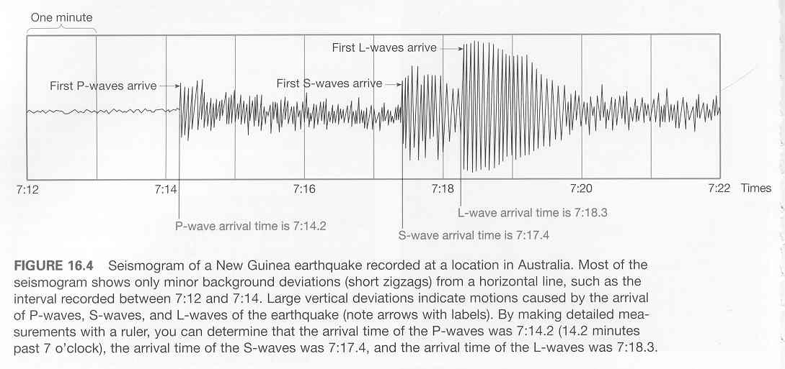

1) On page 395 of the lab manual, you are provided with P-, S-, and L-wave travel times for seismographs at nine locations, all for this one New Guinean earthquake. You won’t necessarily know which measurement refers to which wave until you **plot them all on the accompanying graph paper**. Once all the data have been recorded, you should draw three “best-fit” curves to show the travel-times for P-waves, S-waves, and L-waves. (P will be fastest, L slowest, and S somewhere in between.) **Figure 16.5 in your lab manual can serve as a guide**, but *you must plot the data yourself*. If you wish to plot the data using a spreadsheet program (such as Microsoft Excel), that’s fine too. Just attach your graph to the lab as a new page when you submit it for grading.

Travel time (minutes)

0 1 2 3 4 5 6 7 8 9 10 11 12 13 14 15 16 17 18 19 20 21 22 23 24 25





0 1000 2000 3000 4000

Distance to epicenter (kilometers)

Red = P-wave; Black=S-wave; Blue=L-wave

Red=P wave:

2) Now examine the three seismographs below. **Only P- and S- waves are shown (*not* L).** For each, determine the time the first P-wave arrived, the time the first S-wave arrived, and then the S-minus-P time (expressed in minutes and seconds). Fill these values into the data table below. Then use the graph you made on the previous page to determine how far away the earthquake was from each of these three stations. Finally, use the three-circle method to plot the location of the earthquake on the map below.

|  |  |  |  |  |
| --- | --- | --- | --- | --- |
| seismogram_lab  **Sitka**  **Charlotte**  **Honolulu** | P-wave arrival time | S-wave arrival time | S-P time (difference between S and P) | Distance to earthquake (km) |
| Sitka, Alaska (57°N, 135°W) | 8.6,25s | 8.11.25s | 5s. | 4000km |
| Charlotte, North Carolina (35°N, 81°W) | 8.8,24s | 8.14.2s | 5.2s | 3500km |
| Honolulu, Hawai’i (21°N, 158°W) | 8.9,20s | 8.15.8s | 4.5s | 3000km |

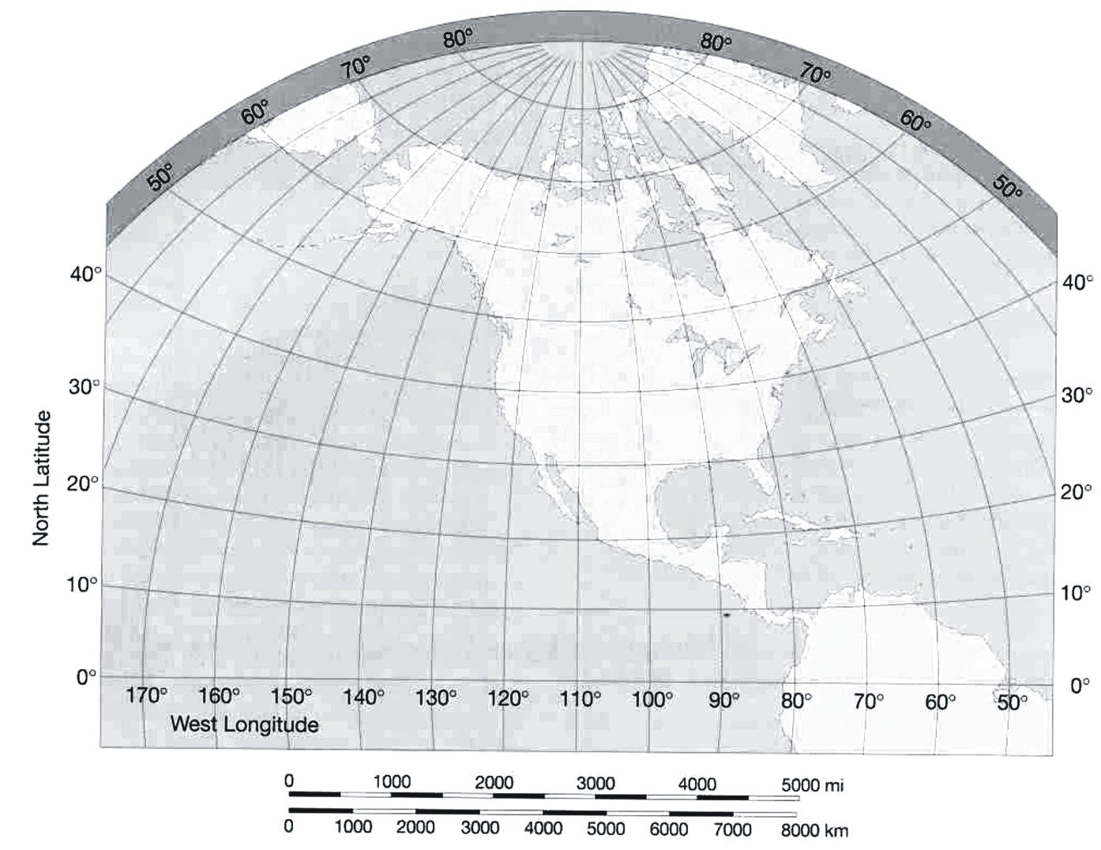



Now, use the following information to help you determine the sense of motion (“left-lateral” or “right-lateral”) on an important strike-slip fault in the middle of the North American continent.

3) Which major tectonic-boundary **fault** lies at the location you have determined? \_\_\_reserve fault\_\_\_\_\_\_\_\_\_\_\_\_

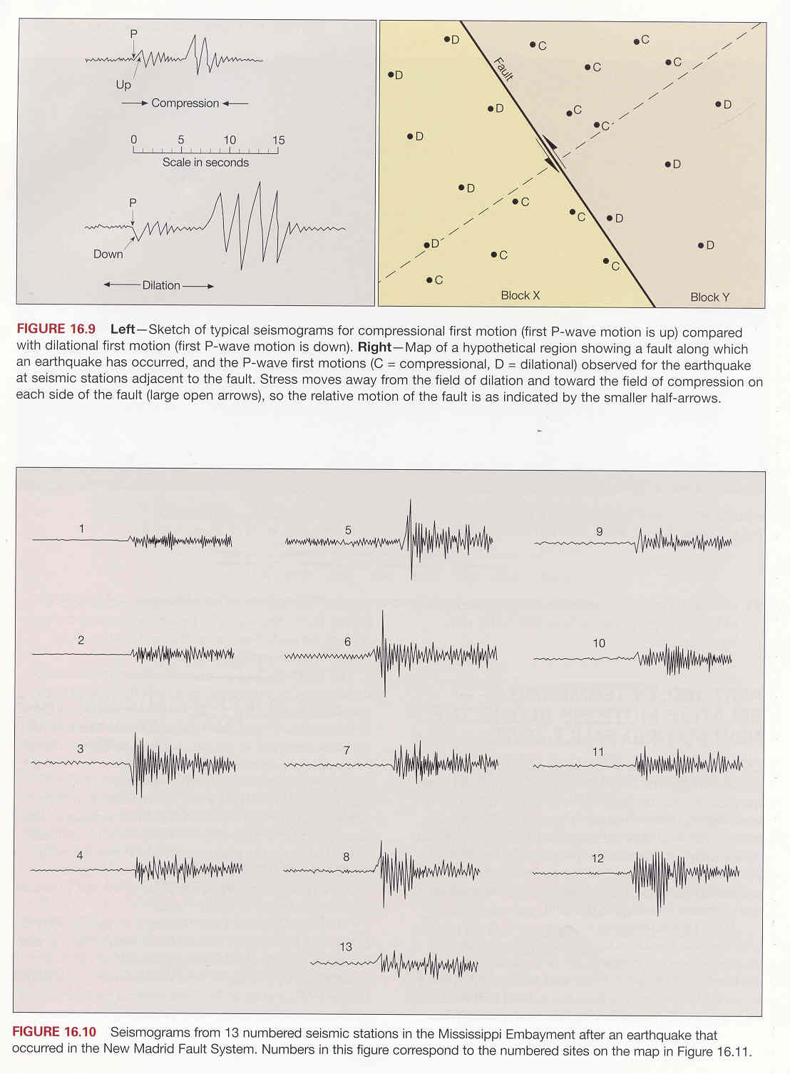

4) Using the 13 seismograms below (**P-waves only**), determine the relative stress (compression or dilation) for each. Mark each with a C or a D, according to whether it is compressional or dilational.



1.c 2.c 3.d 4.d 5.d 6.c 7d. 8c. 9d. 10c. 11c. 12.d 13.c

5) Using the stress information you determined for the preceding 13 seismograms, and the following map showing seismographic station locations, determine the relative motion of the New Madrid Fault system (shown as a dark line on the map). **Mark the map first with your C’s and D’s**, and then **draw a pair of arrows** (parallel to the fault) showing the direction this fault is moving.

Revised CB, 3/2018

6) Is the New Madrid Fault system left-lateral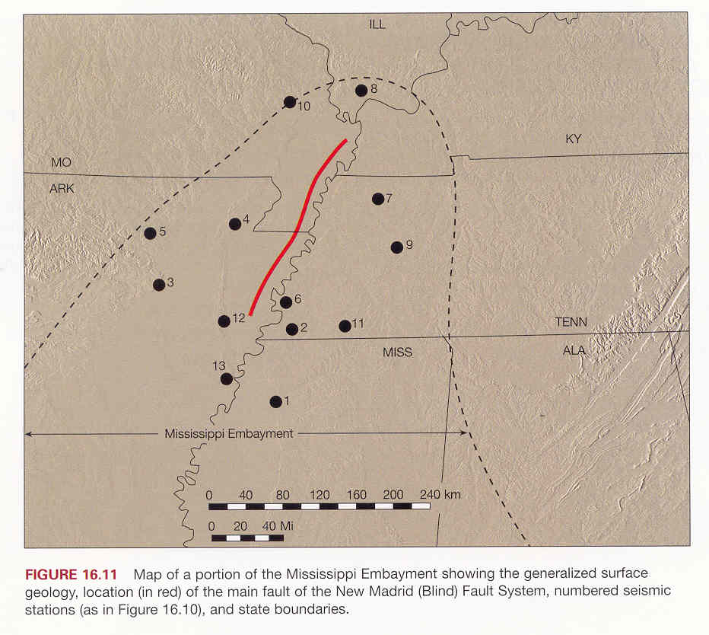 or right-lateral? \_\_\_\_\_\_\_right-lateral\_\_\_\_\_\_\_\_\_\_\_\_\_\_\_\_\_\_\_\_\_\_



7) You have an earthquake with S-P time of **10 seconds**, and a S-wave amplitude of **50 mm**.

Determine the magnitude of the earthquake on the Richter Scale; write it in the box provided.

4.5

*Use Figure 11.20 in your textbook if you need a hint; or [watch this SmartFigure](http://media.pearsoncmg.com/bc/bc_0media_geo/smartfigure/sf-intensity-vs-magnitude.html) video.*

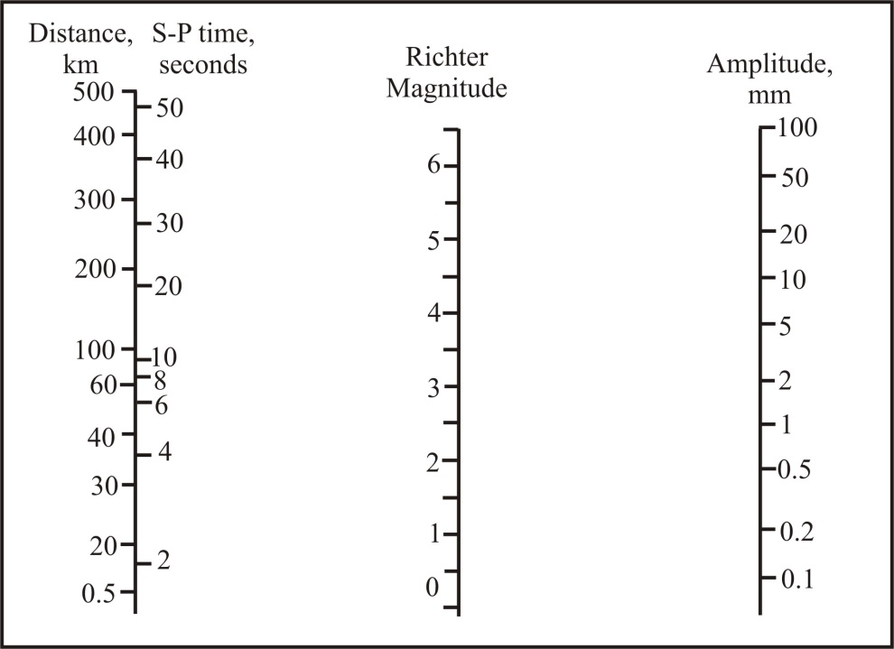



**8)** For this **same earthquake**,

but at another seismograph **300 km**

away from the quake, what would be

the amplitude of the S waves? \_\_\_\_\_\_\_5\_\_\_\_\_\_\_ mm

9) What does this indicate about the amount of shaking that happens, further away from the epicenter?

Felt by nearly everyone; many awakened. Some dishes, windows broken. Unstable objects overturned. Pendulum clocks may stop.\_\_\_\_\_\_\_\_\_\_\_\_\_\_\_\_\_\_\_\_\_\_\_\_\_\_\_\_\_\_\_\_\_\_\_\_\_\_\_\_\_\_\_\_\_\_\_\_\_\_\_\_\_\_



**Magnitude**