ET 110 – Introduction to circuit analysis

Due date: Monday, 11/21/16. Homework 9 – Mesh analysis and Nodal analysis

1. Use mesh analysis to find the voltage and the current through R1, R2, and R3 ( 25 points)

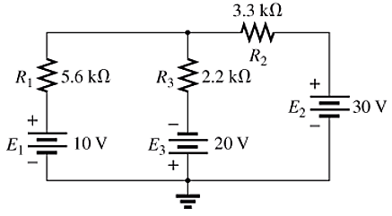

1. Use mesh analysis to find the voltage and the current through R1, R2, and R3 (25 points)

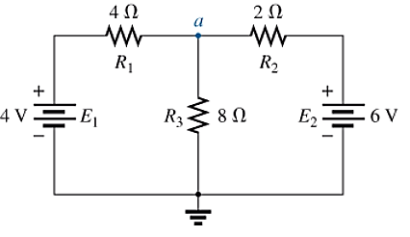

1. Use Nodal analysis to find the voltage and the current through R1 and R2 (25 points)

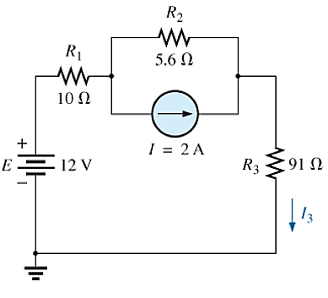

1. Use Nodal analysis to find the voltage and the current through R1 and R2 (25 points)

