ET 110 – Introduction to circuit analysis

Due date: Monday, 11/14/16

Homework 8 – Circuit theorems: source transformation and superposition

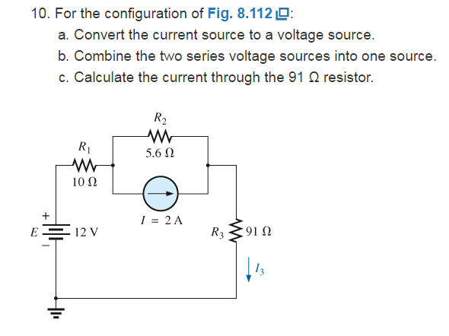

**Source Transformation**

1. For the following circuit:
2. Convert the current source to a voltage source (8 points)
3. Combine the two series voltage sources into one voltage source (equivalent voltage source) (6 points)
4. Calculate the current and voltage through R1, R2, and R3(3 points each)
5. For the given circuit
6. Convert the voltage sources into current sources (8 points)
7. Find the equivalent resistance and current sources (5 points each)
8. Find the voltage Vab and the polarity of points ***a*** and ***b*** (5 points)
9. Find the magnitude and direction of the current IS(4 points)

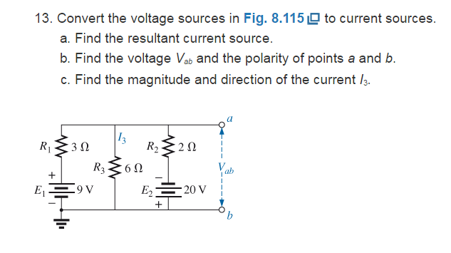

**Superposition**

1. For the following circuit
2. Using the superposition theorem, determine the current through the 12 Ω resistor (20 points)

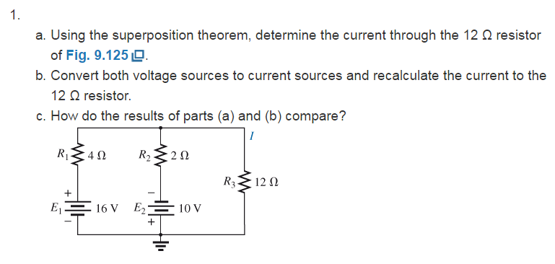

4. Using superposition, find the current through R1 for the network below. (30 points)

