QUEENSBOROUGH COMMUNITY COLLEGE

Department of Electrical and Computer Engineering Technology

ET-821

Lab 4 Creating a Laboratory Report

In this exercise you will use many of the skills you have used in your previous exercises. These include tables, graphs, and equation editor to create a laboratory report. You will use the clipboard to transfer information from one application to another. This is accomplished by cutting or copying the information in an application to the clipboard, minimizing or closing the application, opening another application, and pasting the information in the clipboard into the second application.

1. Open a new document and **Save** it **As** LAB4. Be certain to **save** your work often as you work on this exercise. Enter the following sections of a lab report. Note the omega symbol can be obtained from the **Insert Symbol** button. A sample of the final document appears at the end of the procedure. Begin by entering the material in the box below.

**SERIES DC RESISTIVE CIRCUITS**

**OBJECTIVE:** To investigate the characteristics of a series DC resistive circuit.

**EQUIPMENT:**

Resistors 1- 330W

2- 220W

1- 470W

1- 100W

Instruments 1- DMM or VOM

1- dc Power Supply

**RESUME OF THEORY:**

In a series circuit, the current is the same through all of the circuit elements. The total resistance, RT, of a series circuit is the sum of the individual resistance’s. By Ohm's law, the current is equal to the voltage divided by the resistance.

2. Minimize *Word for Windows* by clicking on the small **dash (-)** **button** in the topmost right-hand corner of the screen.

3. MultiSim is an Application you will use in many of your ET courses. This exercise will help to familiarize you with the the program. Open the **MultiSim** program by clicking **Start, All Programs, National Instruments, Circuit Design Suite 11.0, Multisim 11**.0. Note that you will now have two programs open. Follow steps 4 thru 15 to create the schematic diagram below for your report.

**DIAGRAM:**

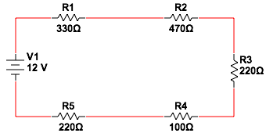

4. If the grid ( a dot pattern on the screen) is not on, select **Options – Sheet Properties, Workspace Tab,** and **check the box Show Grid**. Click **OK**.

5. Using the third row of buttons to select parts, select the **Resister** button, click on **Resistor from the Family list** and choose a **Component value of 330**. Click **OK** and position the part on the worksheet grid dots and click to place the part. Continue to place all of the resistors as shown on the diagram above. Note you will rotate the 220Ω Resistor in the next step. When the five resistors have been placed on the diagram, click **Close** to end the process.

1. Rotate the 220Ω Resistor by first selecting it by clicking on it and then **Right Clicking** in the box that appears. Select **90 Clockwise**. Position the 220Ω Resistor as necessary.
2. Select the **Battery** button, click on **Power_Sources** from the **Family list** and choose **DC_Power**. Click **OK** and position the batter and click the **Close** button.

8. Connect the wire lines by clicking on the end of any component and moving the mouse an end of another component and clicking again. You can also choose Place, Wire from the menu bar. Repeat the process until you have inserted all wires. Note that the **ESC** key will erase wires.

9. Select **Place, Text** from the **Menu** bar and type and position the word **DIAGRAM:** above the circuit.

10. When the entire circuit is the drawn to your satisfaction, Select the entire circuit by drawing a rectangle around it with the pointer. Choose **Copy** from the **Edit** menu.

12. **Minimize** the **Multisim** application by clicking on the small **dash (-)** **button** in the topmost right corner of screen.

13. **Maximize** *Word for Windows* by clicking on the Word icon (W) on the task bar at the bottom of the screen.

14. Position the pointer, **Right Click** and select **Paste** to insert the circuit into the Word document.

15. Select the circuit schematic and center it on the page.

16. Create the 6 x 2 Table shown below using the **Table button on the Insert tab**. Select the *entire* table and **Right Click** in the table. Select **Table Properties, Row tab** and check the Specify height box. Changethe **Row height** to 2 lines by entering **24 pt** in the **At** box and then set the **Row height is:** to **Exactly**. Click **OK**. With the entire table still selected go to the **Home tab** and click on the arrow in the lower right corner of the **Paragraph** section. Change the **Spacing Before** a line to **6 Pt**. Click **OK**. With the entire table still selected **Right click** in the table and select **Cell Alignment** and choose **Align Center** (middle choice).

17. Select *only* the first row of the table, **Richt Click** in the first row and choose **Borders and Shading** and click on the Shading tab. Change the **Fill** to **25%**. Click **OK**. Next type the data into each cell.

18. Skip a few lines. This is an important step before you proceed.

**DATA:**

|  |  |
| --- | --- |
| VOLTAGE (V) | CURRENT (mA) |
| 0 | 0 |
| 10 | 7.5 |
| 20 | 14.9 |
| 40 | 29.9 |
| 50 | 37.3 |

1. Create a graph of your table by choosing **Chart** from the **Insert Tab**.
2. Select **XY (Scatter)** and click on the Chart sub-type for **Scatter with Smooth Lines and Markers.** Click **OK**.
3. You will need to resize the table for a 6 x2 size. Stretch from the lower right mark to resize the table.
4. Replace the data in the spreadsheet with the data you created in table. You can copy and paste it or retype it.
5. **Select** the entire graph and click on the **Layout tab** and select **Chart Title, Centered Overlay Title**. Enter the title **Voltage Vs. Current**.
6. Select Axis Titles. (X) Axis, Voltage (V), (Y) Axis, Current (MA).
7. Click on white area of screen to insert chart in document.
8. Position the graph to be approximately centered under the table. You may also wish to resize the graph. Your graph should look like the one shown below.

**GRAPH:**

1. Open the equation editor by clicking the **Insert tab,** and then clicking on  **Equation.**

**CALCULATIONS:**

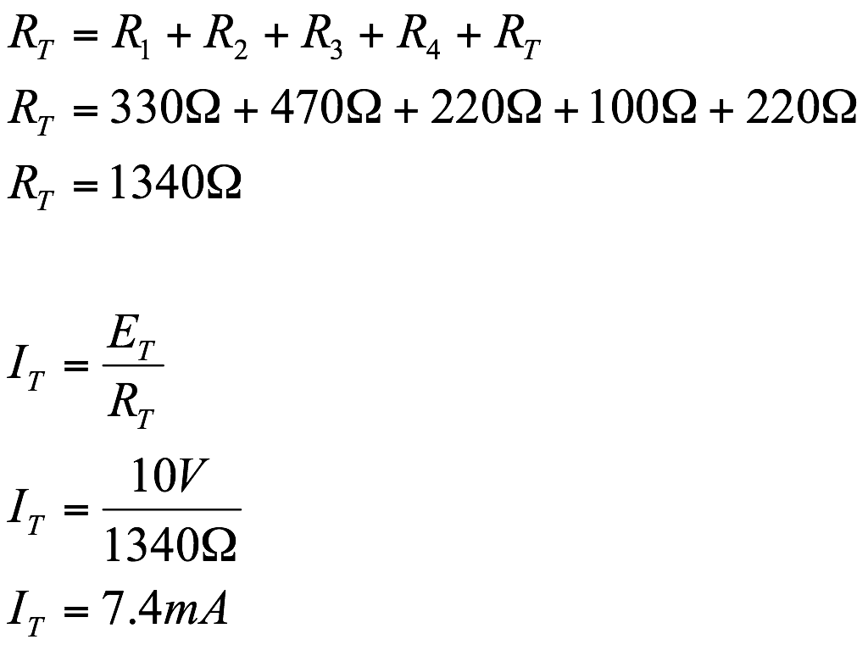

1. Center the equations and center them on the page.
2. Complete the conclusion section of the report. You can make up your own conclusion or use the one below.

**CONCLUSION:**

From the data collected we saw that in a series circuit, the total resistance RT, is the sum of the individual resistance’s. Furthermore we were able to verify Ohm’s Law, which states that the current is equal to the voltage divided by the resistance. Our calculations and graphs agreed with the theory we learned in class.

1. Make a **cover page** for your report and include some clip art on it. Feel free to modify the format or to be creative in any way that might enhance your final report. Your final report should have the following section headings: **OBJECTIVES, EQUIPMENT, RESUME OF THEORY, DIAGRAM, DATA, GRAPH, CALCULATIONS, CONCLUSION**. Be certain to include the headings in bold type at the beginning of the section. You may add any additional sections which you feel would enhance your report.

COVER PAGE

Design your own cover page but include at least the information shown here

NAME

COURSE/SECTION

DATE

EXERCISE NUMBER

EXERCISE TITLE

INSTRUCTOR



**SERIES DC RESISTIVE CIRCUITS**

**OBJECTIVE:** To investigate the characteristics of a series DC resistive circuit.

**EQUIPMENT:**

Resistors 1-330Ω

2-220Ω

1-470Ω

1-100Ω

Instruments 1- DMM or VOM

1- dc Power Supply

**RESUME OF THEORY**

In a series circuit, the current is the same through all of the circuit element. The total resistance, R, of a series is the sum of the individual resistance’s. By Ohm’s laws, the circuit current is equal to the voltage divided by the resistance.

**DIAGRAM:**



**DATA:**

| **VOLTAGE (V)** | **CURRENT(mA)** |
| --- | --- |
| 0 | 0 |
| 10 | 7.5 |
| 20 | 14.9 |
| 40 | 29.9 |
| 50 | 37.3 |

|  |  |  |  |  |  |
| --- | --- | --- | --- | --- | --- |
| **GRAPH:** |  |  |  |  |  |
|  |  |  |  |  |  |

**CALCULATIONS:**

**CONCLUSION:**

From the data collected we saw that in a series circuit, the total resistance RT, is the sum of the individual resistance’s. Furthermore we were able to verify Ohm’s Law, which states that the current is equal to the voltage divided by the resistance. Our calculations and graphs agreed with the theory we learned in class.