**THE JAZZICIANS**

*present the*

**4th Annual Festival of *Jazz***

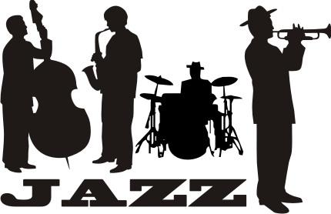

* Join us for a fun-filled day of entertainment for the whole family
* The fun starts at 10:00 a.m. and ends at 11:00 p.m. on **Saturday, October 14, 2012**, at Riverfront Park
* Festival attractions include games, rides, food, crafts, and live music from the talented artists of The Brass Beat, Dave and the Hornets, and The Nance Lance Band

*Hope to see you there!*

**SAILING CLUB**

**Monthly Meeting**

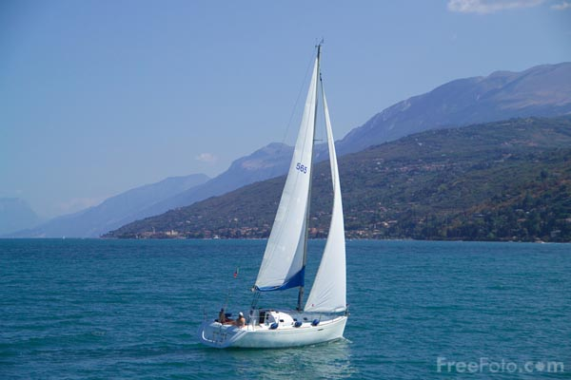

**Plan to attend the meeting of the Sailing Club on May 1, 2012, in the auditorium of Queensborough Community College.**

**Ranger Robin Hood will lecture on:**

**• Harbor Patrol rules and regulations**

**• Basic sailing techniques**

**Please call Little John, (718) 631-6207, to make your reservation.**

**Reservations Required**

**See You There!**

***Lost dog***



***Dog Name: ALLBLACKS***

***Description: Male, Black and white, Shy, Pomsky***

***Location: Near 41 Ave & 147 St, Flushing, NY***

***Date: 8/20/16***

**Call if any sightings!!!**

***Phone: 212-256-9777***

**Reward**