**QUEENSBOROUGH COMMUNITY COLLEGE**

**Department of Engineering Technology**

ET-501

Lab #1 Introduction to Microsoft Word

Student name: Xin Shen

Date: 8/31/16

Inspector: Prof. Lawrence

1 Writing Intensive Assignment:  
Part A) Watch SAP Video 1 (start at the point 2-hour point, http://youtu.be/8TyInwndq1c) and write a summary of what you learned.

# According to the video “BTECH Faculty Institute (June 2015): Day 1”, the professor was introducing the teaching environment on SAP ERP course. He also stated how to design a database for all the documenting can be easily found by using SAP system. It meant the SAP system allowed the company management by purchasing the materials, manufacturing the products, arranging the inventory and warehouse and planning the way to use the materials in different locations in the world. Furthermore, He said the SAP system also could link the customer service, HCM, financial accounting, management accounting and even running program and project together for the company. He mentioned 2 kinds of the enterprise structure. There is single company code (SCC) and multi-company code (MCC).

# In the SCC, all master date is under the same company code, however, it had 1000 copies.

# And it shared the same general ledger in the master date. So it would be confusing the financial accounting. On the other hands, MCC is individual for all the master date and general ledger. In other words, the master date had to put in the system before using MCC, and nothing would be shared by others.

Part B) Research Graphene and summarize your thoughts generically or from the perspective of your major, Computer Engineering, Electrical Engineering or Mechanical Engineering.

One of the strongest known material in the world is the graphene. How strong is it? An elephant standing on a tip of a pencil to puncture could be held on a sheet as thick as saran wrap. It is a single atomic layer of graphite and the shape looks like a chicken wire. Between each graphene only has 0.142 nm. In addition, the graphene is also the world’s thinnest material while being conductive, transparent and flexible. Furthermore, the graphene is also anti-bacterial properties because of the graphene oxide is able to kill the bacterial cells. However, that is not all about it, the scientists still research it. Even we still don’t know all about the graphene, but the graphene had already been used by ITO replacement, high strength composites, functional links, supercapacitors, sensors, and RFID. Thus, the graphene demand is over $12 US billion every year. The graphene right now supplies for 2 categories which are 40% of flake form and 60% amorphous. For the Electrical Engineering, the graphene becomes more and more useful than the ordinary material such as copper and silicon. Because it has better to heat than copper, plus it is not only 0.77mg/m2 but also can flex 20% without damage. And most important thing is the conductivity 10 times more than copper. Another example is compared with silicon. The Graphene is unbreakable and flexibility is higher than silicon. And Graphene has no band gap energy comparing the silicon has 1.1V. Additional, the graphene is 200 times faster on the electron transfer than silicon. Plus, the graphene can break over the voltage less than 0.3v. To sum all the benefits about the graphene, it well replaces copper and silicon for the electrical engineering in the world.

Reference

# Graphene science | Mikael Fogelström |

Graphene from Wikipedia

<http://www.aerogelgraphene.com/buy-graphene-products/>

Graphene mobile phone by Mr. Kalyan Acharjya, Ass. Prof, ECE

**Practice with Fonts:**

Xin Shen

**Xin Shen**

*Xin Shen*

Xin Shen

Xin Shen

**THE JAZZICIANS**

*present the*

**4th Annual Festival of *Jazz***



* Join us for a fun-filled day of entertainment for the whole family
* The fun starts at 10:00 a.m. and ends at 11:00 p.m. on **Saturday, October 14, 2012**, at Riverfront Park
* Festival attractions include games, rides, food, crafts, and live music from the talented artists of The Brass Beat, Dave and the Hornets, and The Nance Lance Band

*Hope to see you there!*

**SAILING CLUB**

**Monthly Meeting**

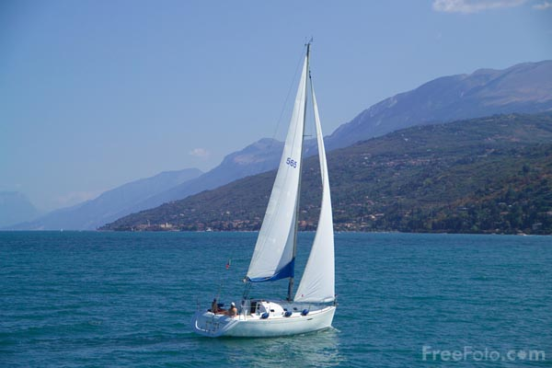

**Plan to attend the meeting of the Sailing Club on May 1, 2012, in the auditorium of Queensborough Community College.**

**Ranger Robin Hood will lecture on:**

**• Harbor Patrol rules and regulations**

**• Basic sailing techniques**

**Please call Little John, (718) 631-6207, to make your reservation.**

**Reservations Required**

**See You There!**

***Lost dog***



***Dog Name: ALLBLACKS***

***Description: Male, Black and white, Shy, Pomsky***

***Location: Near 41 Ave & 147 St, Flushing, NY***

***Date: 8/20/16***

**Call if any sightings!!!**

***Phone: 212-256-9777***

**Reward**