实验报告
实验名称：常用排序算法的对比分析 日期：2016年1月8日
姓名：杨程鑫 学号：20142863班级：信1405-1班 指导教师：郭芳

1、实验目的
（1）旨在集中对几个专门的问题作较为深入的探讨和理解， 也不强调对某些特定的编程技术的训练。
2、实验内容和要求
对以下常用的内部排序算法进行比较：起泡排序、直接插入排序、简单选择排序、快速排序、希尔排序、堆排序。
- 实验步骤
- 程序代码
#include<iostream>
#include <stdlib.h>
#include <time.h>
#define MAXSIZE 110
using namespace std;

typedef struct
{
int key;
char other;
}RedType;

typedef struct
{
RedType R[MAXSIZE+1];
int length;
int Compare;
int Move;
}Sqlist;

void InsertSort(Sqlist &L)//直±接ó插?入?排?序ò
{
L.Compare = 0;
L.Move = 0;
int i,j;
for(i = 2;i <= L.length;i++)
{
if(L.R[i].key < L.R[i - 1].key)
{
L.R[0] = L.R[i];
L.R[i] = L.R[i-1];
L.Move += 2;
L.Compare++;
for(j = i - 2;L.R[0].key < L.R[j].key;j--)
{
L.R[j + 1] = L.R[j];
L.Move++;
}
L.R[j + 1]=L.R[0];
L.Move++;
}
}
}

void ShellInsert(Sqlist &L,int n)//希￡尔?排?序ò
{
L.Compare = 0;
L.Move = 0;
int i,j;
for(i = n + 1;i <= L.length;i++)
{
if(L.R[i].key < L.R[i - n].key){
L.Compare++;
L.R[0] = L.R[i];
L.Move++;
for(j = i - n;j > 0 && L.R[0].key < L.R[j].key;j -= n){
L.R[j + n] = L.R[j];
L.Move++;
}
L.R[j + n] = L.R[0];
L.Move++;
}
}
}

void ShellSort(Sqlist &L,int &C,int &M){
int array[3];
array[0] = 5,array[1] = 3,array[2] = 1;
int t = 3;C = 0,M = 0;
for(int k = 0;k < t;k++)
{
ShellInsert(L,array[k]);
C += L.Compare;
M += L.Move;
}
}

void BubbleSort(Sqlist &L)//冒°泡Y排?序ò
{
RedType *t = new RedType;
L.Compare = 0;
L.Move = 0;
int m = L.length - 1;
bool flag = 1;
while((m > 0) && (flag == 1))
{
flag = 0;
for(int j = 1;j <= m;j++)
{
if(L.R[j].key > L.R[j + 1].key)
{
flag = 1;
L.Compare++;
*t = L.R[j];
L.R[j] = L.R[j+1];
L.R[j+1] = *t;
L.Move += 3;
}
}
m--;
}
}

int Partition(Sqlist &L,int low,int high)//快ì速ù排?序ò
{
L.R[0] = L.R[low];
int pivotkey = L.R[low].key;
while(low < high)
{
while((low < high) && (L.R[high].key >= pivotkey))
{
high--;
}
L.R[low] = L.R[high];
while((low < high) && (L.R[low].key <= pivotkey))
{
low++;
}
L.R[high] = L.R[low];
}
L.R[low] = L.R[0];
return low;
}

void QSort(Sqlist &L,int low,int high)
{
int pivotloc;
if(low < high)
{
pivotloc = Partition(L,low,high);
QSort(L,low,pivotloc - 1);
QSort(L,pivotloc + 1,high);
}
}

void QuickSort(Sqlist &L)
{
QSort(L,1,L.length);
}

void SelectSort(Sqlist &L)//简ò单蹋?选?择?排?序ò
{
L.Compare = 0;
L.Move = 0;
int i,j,k;
for(i = 1;i < L.length;i++)
{
k = i;
for(j = i + 1;j <= L.length;j++)
{
if(L.R[j].key < L.R[k].key)
{
k = j;
L.Compare++;
}
}
if(k != i)
{
RedType *t = new RedType;
*t = L.R[i];
L.R[i] = L.R[k];
L.R[k] = *t;
L.Move += 3;
}
}
}

void HeapAdjust(Sqlist &L,int s,int m)//堆?排?序ò
{
RedType *Rc = new RedType;
*Rc = L.R[s];
for(int j = 2 * s;j <= m;j *= 2)
{
if(j < m && L.R[j].key < L.R[j+1].key)
{
j++;
}
if(Rc->key >= L.R[j].key)
{
break;
}
L.R[s] = L.R[j];
s = j;
}
L.R[s] = *Rc;
}

void CreatHeap(Sqlist &L)
{
int n = L.length;
for(int i = n / 2;i > 0;i--)
{
HeapAdjust(L,i,n);
}
}

void HeapSort(Sqlist &L)
{
CreatHeap(L);
RedType *t = new RedType;
for(int i = L.length;i > 1;i--)
{
*t = L.R[1];
L.R[1] = L.R[i];
L.R[i] = *t;
HeapAdjust(L,1,i - 1);
}
}

void main()
{
int j;
Sqlist L;
L.length = 100;
for(int i = 0;i < 8;)
{

for(j = 1;j <= L.length;j++)
{
L.R[j].key = rand() % 1000;
}
cout << "/*常￡用?算?法ぁ?的?对?比括?分?析?*/" << endl;
cout <<"1\t原-顺3序ò表括? << endl;
cout <<"2\t直±接ó插?入?排?序ò" << endl;
cout <<"3\t希￡尔?排?序ò" << endl;
cout <<"4\t冒°泡Y排?序ò" << endl;
cout <<"5\t快ì速ù排?序ò" << endl;
cout <<"6\t简ò单蹋?选?择?排?序ò" << endl;
cout <<"7\t堆?排?序ò" << endl;
cout <<"8\t退?出?" << endl;
cin >> i;
if(i == 1)
{
for(j = 1;j <= L.length;j++)
{
cout << L.R[j].key << endl;
}
}
if(i == 2)
{
InsertSort(L);
for(j = 1;j <= L.length;j++)
{
cout << L.R[j].key << endl;
}
cout << "比括?较?次?数簓为a：阰" << L.Compare << endl;
cout << "移?动ˉ次?数簓为a：阰" << L.Move << endl;
}
if(i == 3)
{
int C,M;
ShellSort(L,C,M);
for(j = 1;j <= L.length;j++)
{
cout << L.R[j].key << endl;
}
cout << "比括?较?次?数簓为a：阰" << C << endl;
cout << "移?动ˉ次?数簓为a：阰" << M << endl;
}
if(i == 4)
{
BubbleSort(L);
for(j = 1;j <= L.length;j++)
{
cout << L.R[j].key << endl;
}
cout << "比括?较?次?数簓为a：阰" << L.Compare << endl;
cout << "移?动ˉ次?数簓为a：阰" << L.Move << endl;
}
if(i == 5)
{
QuickSort(L);
for(j = 1;j <= L.length;j++)
{
cout << L.R[j].key << endl;
}
}
if(i == 6)
{
SelectSort(L);
for(j = 1;j <= L.length;j++)
{
cout << L.R[j].key << endl;
}
cout << "比括?较?次?数簓为a：阰" << L.Compare << endl;
cout << "移?动ˉ次?数簓为a：阰" << L.Move << endl;
}
if(i == 7)
{
HeapSort(L);
for(j = 1;j <= L.length;j++)
{
cout << L.R[j].key << endl;
}
}
if(i == 8)
{
break;
}
}
}
（2）测试结果
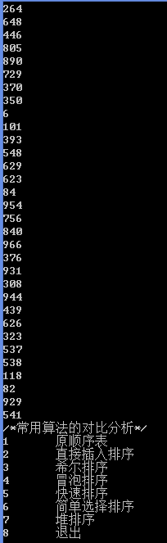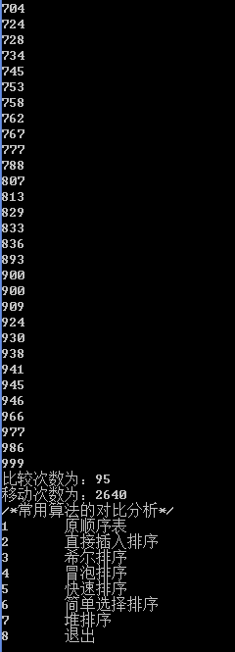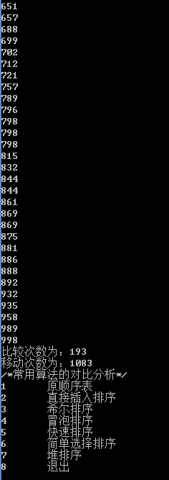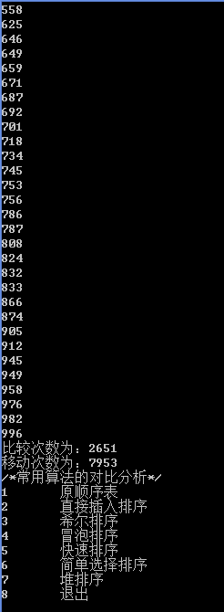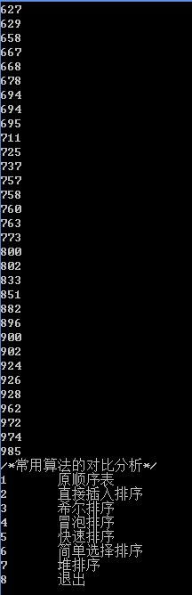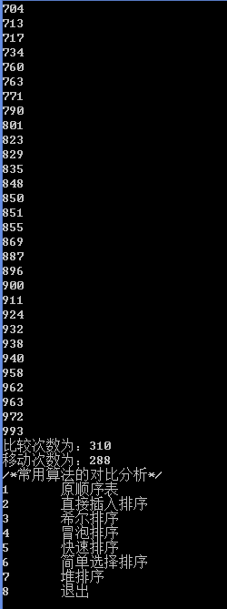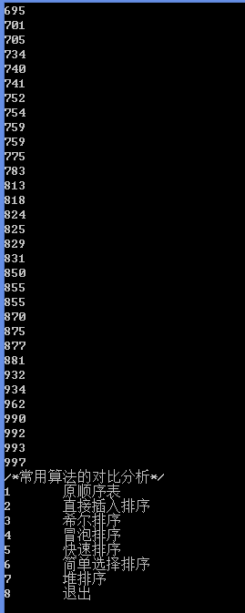
- 实验心得
明白了各种排序算法的的优劣，尤其是早就学习的冒泡排序，原来这么繁琐。

