**实验二 白盒测试**

班级：信1405-1班 学号：20142863 姓名：杨程鑫

**一、实验目的**

* 1. 掌握白盒测试的基础知识；
  2. 掌握白盒测试的检查内容及测试目的；
  3. 掌握黑盒测试的几种基本测试方法：语句覆盖、判定覆盖、条件覆盖、判定/条件覆盖、组合覆盖、路径覆盖。

**二、实验要求**

1. 复习有关内容，理解白盒测试；
2. 掌握语句覆盖、判定覆盖、条件覆盖、判定/条件覆盖、组合覆盖、路径覆盖，并能设计出测试用例；
3. 对具体软件，能分别使用相应的白盒测试方法设计测试用例，并实施测试、分析测试结果。

**二、实验内容**

**第1题：设计函数实现输入日期显示星期几，并用逻辑覆盖法测试**

**源代码：**

public class MainClass

{

private static Component frame = null;

public static void main(String args[]) throws ParseException

{

String dataString = "";

ConvertTools convertTools = new ConvertTools();

while(true)

{

dataString = JOptionPane.showInputDialog("请输入日期,(00010101)");

if(dataString == null)

{

System.exit(0);

}

if(dataString.length() != 8)

{

JOptionPane.showMessageDialog(frame ,"输入日期长度应为8。");

continue;

}

if(convertTools.IsGreaterThanFiveNumber(dataString))

{

if(convertTools.isDate(dataString))

{

break;

}

else

{

JOptionPane.showMessageDialog(frame ,"月份或日期不在范围。");

}

}

else

{

JOptionPane.showMessageDialog(frame ,"输入日期不满足格式。");

}

}

Date data = convertTools.convertToDate(dataString);

String[] info = data.toString().split(" ");

System.out.println(info[0]);

}

}

**流程图**

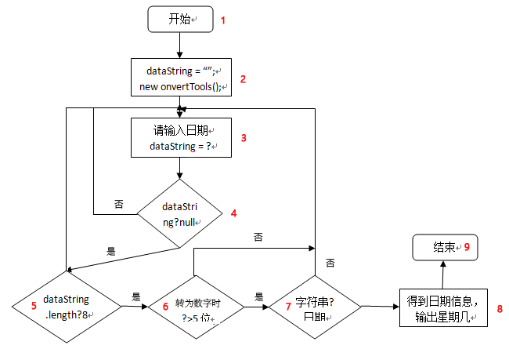

**表1-1 语句覆盖**

|  |  |  |  |
| --- | --- | --- | --- |
| 序号 | 输入 | 测试路径 | 测试结果 |
| 1 | 2017010100且20170330 | 1-2-3-4-5-6-7-3-4-5-6-7-8-9 | 重新输入+Sat |

**表1-2 判定，条件，判定-条件，条件组合，路径覆盖**

|  |  |  |  |
| --- | --- | --- | --- |
| 序号 | 输入 | 测试路径 | 测试结果 |
| 1 | 20170330 | 1-2-3-4-5-6-7-8-9 | Sat |
| 2 | Null且20170330 | 1-2-3-4-3-4-5-6-7-8-9 | 重新输入+Sat |
| 3 | 2017033且20170330 | 1-2-3-4-5-3-4-5-6-7-8-9 | 重新输入+Sat |
| 4 | 00001010且20170330 | 1-2-3-4-5-6-3-4-5-6-7-8-9 | 重新输入+Sat |
| 5 | 2017010100且20170330 | 1-2-3-4-5-6-7-3-4-5-6-7-8-9 | 重新输入+Sat |

**第二题 找零钱最佳组合**

**源代码：**

public class MainClass

{

private static Component frame;

public static void main(String[] args)

{

int cost = 0;

int money = 0;

ConvertTools convertTools = new ConvertTools();

while(true)

{

String costString = JOptionPane.showInputDialog("请输入花销,(1-100)");

if(costString == null)

{

System.exit(0);

}

if(!convertTools.isNumber(costString))

{

JOptionPane.showMessageDialog(frame,"请输入正确花销");

continue;

}

cost = Integer.valueOf(costString);

if(cost >= 1 && cost <= 100)

{

break;

}

else

{

JOptionPane.showMessageDialog(frame,"花销不在范围");

}

}

while(true)

{

String moneyString = JOptionPane.showInputDialog("请输入钱数,(1-100)");

if(moneyString == null)

{

System.exit(0);

}

if(!convertTools.isNumber(moneyString))

{

JOptionPane.showMessageDialog(frame,"请输入正确钱数");

}

money = Integer.valueOf(moneyString);

if(money >= 1 && money <= 100)

{

if(money >= cost)

{

break;

}

else

{

JOptionPane.showMessageDialog(frame,"钱数应大于花销");

}

}

else

{

JOptionPane.showMessageDialog(frame,"钱数不在范围");

}

}

int change = money - cost;

int numberOfN50 = 0;

int numberOfN10 = 0;

int numberOfN5 = 0;

int numberOfN1 = 0;

boolean isOver = false;

if(change >= 50 && !isOver)

{

numberOfN50 = change / 50;

change %= 50;

if(change == 0)

{

isOver = true;

}

}

if(change >= 10 && !isOver)

{

numberOfN10 = change / 10;

change %= 10;

if(change == 0)

{

isOver = true;

}

}

if(change >= 5 && !isOver)

{

numberOfN5 = change / 5;

change %= 5;

if(change == 0)

{

isOver = true;

}

}

if(change >= 1 && !isOver)

{

numberOfN1 = change / 1;

change %= 1;

if(change == 0)

{

isOver = true;

}

}

if(change == 0)

{

isOver = true;

}

if(isOver)

{

System.out.print("50元:\t" + numberOfN50 + "张\n"

+ "10元:\t" + numberOfN10 + "张\n"

+ "5元:\t" + numberOfN5 + "张\n"

+ "1元:\t" + numberOfN1 + "张");

}

}

}

**流程图**

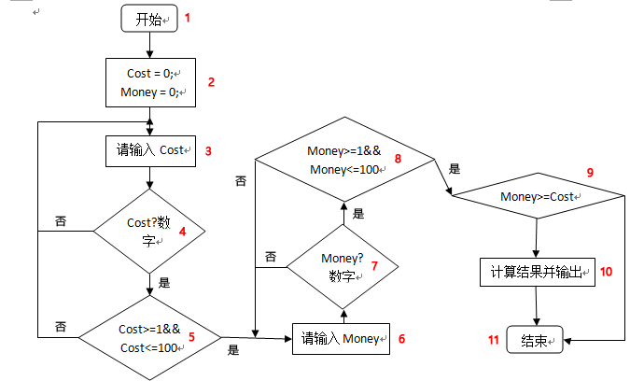

**表2-1 基本路径**

|  |  |  |  |  |  |  |  |
| --- | --- | --- | --- | --- | --- | --- | --- |
| 序号 | 输入 | | 基本路径 | 测试结果 | | | |
| Cost | Money | 50 | 10 | 5 | 1 |
| 1 | 50 | 49 | 1-2-3-4-5-6-7-8-9-11 | 钱数应大于花销 | | | |
| 2 | -1且50 | -1且51 | 1-2-3-4-5-3-4-5-6-7-8-6-7-8-9-10-11 | 0 | 0 | 0 | 1 |

**第三题 客房预订系统**

**源代码：**

public class MainFrame

{

private JFrame frame;

public static void main(String[] args)

{

EventQueue.invokeLater(new Runnable()

{

public void run()

{

try

{

MainFrame window = new MainFrame();

window.frame.setVisible(true);

}

catch(Exception e)

{

e.printStackTrace();

}

}

});

}

public MainFrame()

{

initialize();

}

private void initialize()

{

frame = new JFrame();

frame.setTitle("客房预订系统");

frame.setBounds(450,170,420,275);

frame.setDefaultCloseOperation(JFrame.EXIT_ON_CLOSE);

frame.getContentPane().setLayout(null);

JLabel costTypeLabel = new JLabel("房款支付");

costTypeLabel.setHorizontalAlignment(SwingConstants.CENTER);

costTypeLabel.setBounds(250,40,60,20);

frame.getContentPane().add(costTypeLabel);

ButtonGroup buttonGroup = new ButtonGroup();

JRadioButton fullPaymentRadio = new JRadioButton("支付全款");

fullPaymentRadio.setHorizontalAlignment(SwingConstants.CENTER);

fullPaymentRadio.setBounds(180,75,100,25);

buttonGroup.add(fullPaymentRadio);

frame.getContentPane().add(fullPaymentRadio);

JRadioButton depositPaymentRadio = new JRadioButton("支付定金");

depositPaymentRadio.setBounds(300,75,100,25);

buttonGroup.add(depositPaymentRadio);

frame.getContentPane().add(depositPaymentRadio);

JLabel roomTypeLabel = new JLabel("房间类型");

roomTypeLabel.setHorizontalAlignment(SwingConstants.CENTER);

roomTypeLabel.setBounds(175,145,60,20);

frame.getContentPane().add(roomTypeLabel);

JButton singleRoomButton = new JButton("单人间");

singleRoomButton.addMouseListener(new MouseAdapter()

{

private Component frameTemp;

public void mouseClicked(MouseEvent e)

{

if(fullPaymentRadio.isSelected())

{

FullPaymentSuccess fullPaymentSuccess = new FullPaymentSuccess

(fullPaymentRadio.getText(),singleRoomButton.getText());

fullPaymentSuccess.setVisible(true);

}

else if(depositPaymentRadio.isSelected())

{

DepositPaymentWarning depositPaymentWarning = new DepositPaymentWarning

(depositPaymentRadio.getText(),singleRoomButton.getText());

depositPaymentWarning.setVisible(true);

}

else

{

JOptionPane.showMessageDialog(frameTemp,"请选择支付类型");

}

}

});

singleRoomButton.setBounds(40,180,90,25);

frame.getContentPane().add(singleRoomButton);

JButton doubleRoomButton = new JButton("双人间");

doubleRoomButton.addMouseListener(new MouseAdapter()

{

private Component frameTemp;

public void mouseClicked(MouseEvent e)

{

if(fullPaymentRadio.isSelected())

{

FullPaymentSuccess fullPaymentSuccess = new FullPaymentSuccess(

fullPaymentRadio.getText(),doubleRoomButton.getText());

fullPaymentSuccess.setVisible(true);

}

else if(depositPaymentRadio.isSelected())

{

DepositPaymentWarning depositPaymentWarning = new DepositPaymentWarning

(depositPaymentRadio.getText(),singleRoomButton.getText());

depositPaymentWarning.setVisible(true);

}

else

{

JOptionPane.showMessageDialog(frameTemp,"请选择支付类型");

}

}

});

doubleRoomButton.setBounds(160,180,90,25);

frame.getContentPane().add(doubleRoomButton);

JButton DeluxeRoomButton = new JButton("豪华间");

DeluxeRoomButton.addMouseListener(new MouseAdapter()

{

private Component frameTemp;

public void mouseClicked(MouseEvent e)

{

if(fullPaymentRadio.isSelected())

{

FullPaymentSuccess fullPaymentSuccess = new FullPaymentSuccess(

fullPaymentRadio.getText(),DeluxeRoomButton.getText());

fullPaymentSuccess.setVisible(true);

}

else if(depositPaymentRadio.isSelected())

{

DepositPaymentWarning depositPaymentWarning = new DepositPaymentWarning

(depositPaymentRadio.getText(),singleRoomButton.getText());

depositPaymentWarning.setVisible(true);

}

else

{

JOptionPane.showMessageDialog(frameTemp,"请选择支付类型");

}

}

});

DeluxeRoomButton.setBounds(280,180,90,25);

frame.getContentPane().add(DeluxeRoomButton);

JPanel panel = new JPanel()

{

private static final long serialVersionUID = 1L;

public void paint(Graphics g)

{

g.drawImage(Toolkit.getDefaultToolkit().getImage("src\\test1_3\\image.png"),0,0,this);

}

};

panel.setBounds(44,30,116,89);

frame.getContentPane().add(panel);

}

}

**流程图**

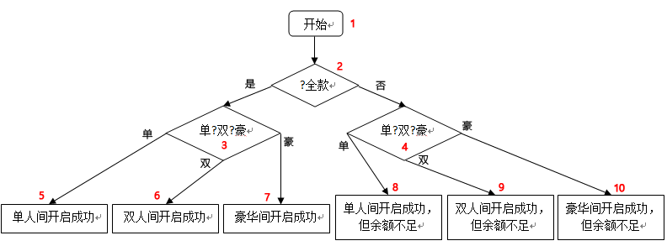

**表3-1 语句，判定，条件，判定-条件，条件组合，路径覆盖**

|  |  |  |  |  |
| --- | --- | --- | --- | --- |
| 序号 | 输入 | | 测试路径 | 测试结果 |
| ?全款 | 单?双?豪 |
| 1 | 全款 | 单人间 | 1-2-3-5 | 单人间开启成功 |
| 2 | 全款 | 双人间 | 1-2-3-6 | 双人间开启成功 |
| 3 | 全款 | 豪华间 | 1-2-3-7 | 豪华间开启成功 |
| 4 | 定金 | 单人间 | 1-2-4-8 | 单人间开启成功，但余额不足 |
| 5 | 定金 | 双人间 | 1-2-4-9 | 双人间开启成功，但余额不足 |
| 6 | 定金 | 豪华间 | 1-2-4-10 | 豪华间开启成功，但余额不足 |

**第四题 航空服务查询问题**

**源代码：**

public class MainClass

{

private JFrame frame;

public static void main(String[] args)

{

EventQueue.invokeLater(new Runnable()

{

public void run()

{

try

{

MainClass window = new MainClass();

window.frame.setVisible(true);

}

catch(Exception e)

{

e.printStackTrace();

}

}

});

}

public MainClass()

{

initialize();

}

private void initialize()

{

frame = new JFrame();

frame.setBounds(100,100,340,350);

frame.setDefaultCloseOperation(JFrame.EXIT_ON_CLOSE);

frame.getContentPane().setLayout(null);

JPanel airLinePanel = new JPanel();

airLinePanel.setBounds(33, 22, 260, 48);

frame.getContentPane().add(airLinePanel);

airLinePanel.setLayout(null);

JLabel airLineLabel = new JLabel("航线：");

airLineLabel.setBounds(10, 2, 60, 20);

airLinePanel.add(airLineLabel);

ButtonGroup airLineButtonGroup = new ButtonGroup();

JRadioButton airLineType1 = new JRadioButton("欧美");

airLineType1.setSelected(true);

airLineType1.setBounds(5, 20, 60, 20);

airLinePanel.add(airLineType1);

airLineButtonGroup.add(airLineType1);

JRadioButton airLineType2 = new JRadioButton("国外非欧美");

airLineType2.setBounds(75, 20, 100, 20);

airLinePanel.add(airLineType2);

airLineButtonGroup.add(airLineType2);

JRadioButton airLineType3 = new JRadioButton("国内");

airLineType3.setBounds(185, 20, 60, 20);

airLinePanel.add(airLineType3);

airLineButtonGroup.add(airLineType3);

JPanel typePanel = new JPanel();

typePanel.setBounds(33, 90, 260, 48);

frame.getContentPane().add(typePanel);

typePanel.setLayout(null);

JLabel typeLabel = new JLabel("航位：");

typeLabel.setBounds(10, 2, 60, 20);

typePanel.add(typeLabel);

ButtonGroup typeButtonGroup = new ButtonGroup();

JRadioButton businessClassRadio = new JRadioButton("商务舱");

businessClassRadio.setSelected(true);

businessClassRadio.setBounds(40, 20, 80, 20);

typeButtonGroup.add(businessClassRadio);

typePanel.add(businessClassRadio);

JRadioButton touristClassRadio = new JRadioButton("经济舱");

touristClassRadio.setBounds(140, 20, 80, 20);

typeButtonGroup.add(touristClassRadio);

typePanel.add(touristClassRadio);

JPanel timePanel = new JPanel();

timePanel.setBounds(33, 159, 260, 48);

frame.getContentPane().add(timePanel);

timePanel.setLayout(null);

JLabel timeLabel = new JLabel("飞行时间：");

timeLabel.setBounds(10, 2, 60, 20);

timePanel.add(timeLabel);

ButtonGroup timeButtonGroup = new ButtonGroup();

JRadioButton withinTwoRadio = new JRadioButton("两小时以内");

withinTwoRadio.setSelected(true);

withinTwoRadio.setBounds(40, 20, 100, 20);

timeButtonGroup.add(withinTwoRadio);

timePanel.add(withinTwoRadio);

JRadioButton moreThanTwoRadio = new JRadioButton("超过两小时");

moreThanTwoRadio.setBounds(140, 20, 100, 20);

timeButtonGroup.add(moreThanTwoRadio);

timePanel.add(moreThanTwoRadio);

JLabel resultLabel = new JLabel("航空服务：");

resultLabel.setBounds(50, 230, 60, 20);

frame.getContentPane().add(resultLabel);

JTextField resultTextField = new JTextField();

resultTextField.setBounds(120, 230, 150, 20);

frame.getContentPane().add(resultTextField);

resultTextField.setColumns(10);

JButton selectButton = new JButton("查询");

selectButton.addMouseListener(new MouseAdapter()

{

public void mouseClicked(MouseEvent e)

{

if(airLineType1.isSelected())

{

resultTextField.setText("有食物供应，可播放电影");

}

else if(airLineType2.isSelected())

{

if(businessClassRadio.isSelected())

{

resultTextField.setText("有食物供应，可播放电影");

}

else

{

resultTextField.setText("有食物供应");

}

}

else if(airLineType3.isSelected())

{

if(businessClassRadio.isSelected())

{

resultTextField.setText("有食物供应");

}

else if(touristClassRadio.isSelected())

{

if(moreThanTwoRadio.isSelected())

{

resultTextField.setText("有食物供应");

}

else

{

resultTextField.setText("无服务");

}

}

}

else

{

resultTextField.setText("无服务");

}

}

});

selectButton.setBounds(45, 265, 90, 25);

frame.getContentPane().add(selectButton);

JButton exitButton = new JButton("退出");

exitButton.addMouseListener(new MouseAdapter()

{

public void mouseClicked(MouseEvent e)

{

System.exit(0);

}

});

exitButton.setBounds(180, 265, 90, 25);

frame.getContentPane().add(exitButton);

}

}

public class MainClass

{

private JFrame frame;

public static void main(String[] args)

{

EventQueue.invokeLater(new Runnable()

{

public void run()

{

try

{

MainClass window = new MainClass();

window.frame.setVisible(true);

}

catch(Exception e)

{

e.printStackTrace();

}

}

});

}

public MainClass()

{

initialize();

}

private void initialize()

{

frame = new JFrame();

frame.setBounds(100,100,340,350);

frame.setDefaultCloseOperation(JFrame.EXIT_ON_CLOSE);

frame.getContentPane().setLayout(null);

JPanel airLinePanel = new JPanel();

airLinePanel.setBounds(33, 22, 260, 48);

frame.getContentPane().add(airLinePanel);

airLinePanel.setLayout(null);

JLabel airLineLabel = new JLabel("航线：");

airLineLabel.setBounds(10, 2, 60, 20);

airLinePanel.add(airLineLabel);

ButtonGroup airLineButtonGroup = new ButtonGroup();

JRadioButton airLineType1 = new JRadioButton("欧美");

airLineType1.setSelected(true);

airLineType1.setBounds(5, 20, 60, 20);

airLinePanel.add(airLineType1);

airLineButtonGroup.add(airLineType1);

JRadioButton airLineType2 = new JRadioButton("国外非欧美");

airLineType2.setBounds(75, 20, 100, 20);

airLinePanel.add(airLineType2);

airLineButtonGroup.add(airLineType2);

JRadioButton airLineType3 = new JRadioButton("国内");

airLineType3.setBounds(185, 20, 60, 20);

airLinePanel.add(airLineType3);

airLineButtonGroup.add(airLineType3);

JPanel typePanel = new JPanel();

typePanel.setBounds(33, 90, 260, 48);

frame.getContentPane().add(typePanel);

typePanel.setLayout(null);

JLabel typeLabel = new JLabel("航位：");

typeLabel.setBounds(10, 2, 60, 20);

typePanel.add(typeLabel);

ButtonGroup typeButtonGroup = new ButtonGroup();

JRadioButton businessClassRadio = new JRadioButton("商务舱");

businessClassRadio.setSelected(true);

businessClassRadio.setBounds(40, 20, 80, 20);

typeButtonGroup.add(businessClassRadio);

typePanel.add(businessClassRadio);

JRadioButton touristClassRadio = new JRadioButton("经济舱");

touristClassRadio.setBounds(140, 20, 80, 20);

typeButtonGroup.add(touristClassRadio);

typePanel.add(touristClassRadio);

JPanel timePanel = new JPanel();

timePanel.setBounds(33, 159, 260, 48);

frame.getContentPane().add(timePanel);

timePanel.setLayout(null);

JLabel timeLabel = new JLabel("飞行时间：");

timeLabel.setBounds(10, 2, 60, 20);

timePanel.add(timeLabel);

ButtonGroup timeButtonGroup = new ButtonGroup();

JRadioButton withinTwoRadio = new JRadioButton("两小时以内");

withinTwoRadio.setSelected(true);

withinTwoRadio.setBounds(40, 20, 100, 20);

timeButtonGroup.add(withinTwoRadio);

timePanel.add(withinTwoRadio);

JRadioButton moreThanTwoRadio = new JRadioButton("超过两小时");

moreThanTwoRadio.setBounds(140, 20, 100, 20);

timeButtonGroup.add(moreThanTwoRadio);

timePanel.add(moreThanTwoRadio);

JLabel resultLabel = new JLabel("航空服务：");

resultLabel.setBounds(50, 230, 60, 20);

frame.getContentPane().add(resultLabel);

JTextField resultTextField = new JTextField();

resultTextField.setBounds(120, 230, 150, 20);

frame.getContentPane().add(resultTextField);

resultTextField.setColumns(10);

JButton selectButton = new JButton("查询");

selectButton.addMouseListener(new MouseAdapter()

{

public void mouseClicked(MouseEvent e)

{

if(airLineType1.isSelected())

{

resultTextField.setText("有食物供应，可播放电影");

}

else if(airLineType2.isSelected())

{

if(businessClassRadio.isSelected())

{

resultTextField.setText("有食物供应，可播放电影");

}

else

{

resultTextField.setText("有食物供应");

}

}

else if(airLineType3.isSelected())

{

if(businessClassRadio.isSelected())

{

resultTextField.setText("有食物供应");

}

else if(touristClassRadio.isSelected())

{

if(moreThanTwoRadio.isSelected())

{

resultTextField.setText("有食物供应");

}

else

{

resultTextField.setText("无服务");

}

}

}

else

{

resultTextField.setText("无服务");

}

}

});

selectButton.setBounds(45, 265, 90, 25);

frame.getContentPane().add(selectButton);

JButton exitButton = new JButton("退出");

exitButton.addMouseListener(new MouseAdapter()

{

public void mouseClicked(MouseEvent e)

{

System.exit(0);

}

});

exitButton.setBounds(180, 265, 90, 25);

frame.getContentPane().add(exitButton);

}

}

**流程图**

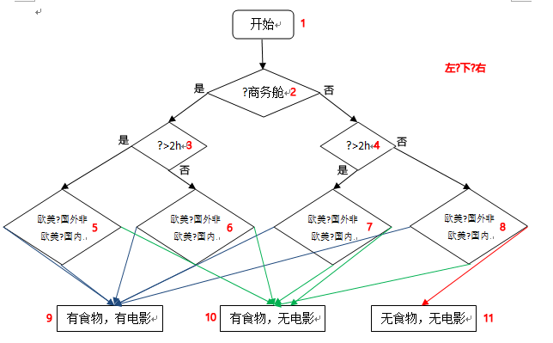

**表4-1 基本路径**

|  |  |  |  |  |  |
| --- | --- | --- | --- | --- | --- |
| 序号 | 输入 | | | 基本路径 | 测试结果 |
| 航线 | 航位 | 时间 |
| 1 | 欧美 | 商务 | 大于2h | 1-2-3-5-9 | 有食物，有电影 |
| 2 | 国内 | 商务 | 大于2h | 1-2-3-5-10 | 有食物，无电影 |
| 3 | 欧美 | 商务 | 小于2h | 1-2-3-6-9 | 有食物，有电影 |
| 4 | 国内 | 商务 | 小于2h | 1-2-3-6-10 | 有食物，无电影 |
| 5 | 欧美 | 经济 | 大于2h | 1-2-4-7-9 | 有食物，有电影 |
| 6 | 国内 | 经济 | 大于2h | 1-2-4-7-10 | 有食物，无电影 |
| 7 | 欧美 | 经济 | 小于2h | 1-2-4-8-9 | 有食物，有电影 |
| 8 | 国外非欧美 | 经济 | 小于2h | 1-2-4-8-10 | 有食物，无电影 |
| 9 | 国内 | 经济 | 小于2h | 1-2-4-8-11 | 无食物，无电影 |