实验五： 结构型设计模式
实验目的：
- 理解适配器模式、桥接模式
- 理解组合模式、外观模式
- 理解装饰模式、享元模式
- 理解代理模式

实验内容：
- 完成实训教程第一大题选择题，直接在书上做。
- 完成实训教程第二大题填空题，直接在书上做。
- 完成实训教程第三大题综合题的第1至6题。
- 根据下面的描述，用装饰模式实现。
“小猪逃命”游戏：一只小猪和一只灰狼，小猪最多5条命，灰狼每咬到小猪一次，小猪就要少一条命，小猪的任务是要逃过灰狼的追咬到猪栏。在逃的过程中小猪可以吃到三种苹果，吃“红苹果”可以给小猪加上保护罩，吃“绿苹果”可以加快小猪奔跑速度，吃“黄苹果”可以使猪趟着水跑。小猪如果吃多种苹果的话，小猪可以拥有多种苹果提供的功能。
这个例子如果用类的继承来实现的话那可就麻烦了，你需要为小猪派生3*2*1=6个子类（有保护罩的小猪，奔跑速度加快的小猪，会趟水的小猪，既有保护罩又会趟水的小猪，奔跑速度快且会趟水的小猪，有保护罩且奔跑速度快的小猪，有保护罩、奔跑速度快且会趟水的小猪），当小猪吃到不同的苹果，你就把小猪换成相应的子类实例（好麻烦）。如果有四种苹果的话那你要为小猪派生4*3*2*1=24个子类，如果有五种苹果......“子类复子类，子类何其多”。
如果使用装饰模式的那就不用派生诸多子类了，当小猪每吃到一个苹果，我们就用装饰模式给小猪加一个动态增加一个新功能即可。

3-1题
源代码：
package experiment5.adapter;
public class Adapter implements Cat, Dog {
private Cat cat;
private Dog dog;
Adapter(Cat cat, Dog dog) {
this.cat = cat;
this.dog = dog;
}
@Override
public void miao() {
dog.wang();//猫学狗叫
}
@Override
public void wang() {
dog.wang();
}
@Override
public void action() {
cat.catchMouse();//狗学猫捉老鼠
}
@Override
public void catchMouse() {
cat.catchMouse();
}
}
class Test{
public static void main(String[] args) {
Dog dog = new ConcrateDog();
Cat cat = new ConcrateCat();
Adapter adapter = new Adapter(cat,dog);
System.out.println("猫学狗叫");
adapter.miao();
System.out.println("狗学猫捉老鼠");
adapter.catchMouse();
}
}
interface Cat {
public void miao();
public void catchMouse();
}
interface Dog {
public void wang();
public void action();
}
class ConcrateCat implements Cat {
@Override
public void miao() {
System.out.println("喵喵喵");
}
@Override
public void catchMouse() {
System.out.println("猫捉老鼠");
}
}
class ConcrateDog implements Dog {
@Override
public void wang() {
System.out.println("汪汪汪");
}
@Override
public void action() {
System.out.println("狗捉老鼠");
}
}

运行结果：
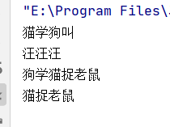
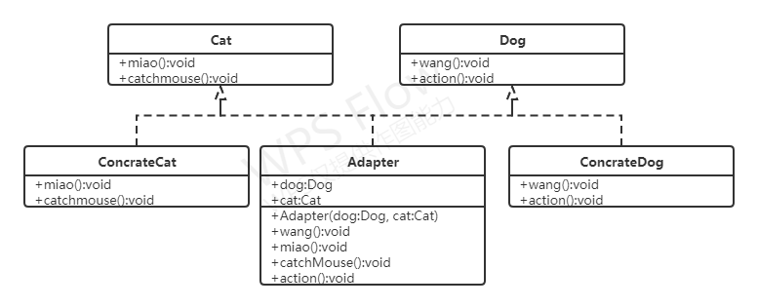
实验结果分析：
Adapter为双向适配器，其中Cat与Dog为接口，ConcrateCat与ConcrateDog分别实现Cat与Dog中方法，Adapter实现Cat与Dog接口，在miao()方法中调用dog.wang()实现猫学狗叫，在action调用cat.catchMouse()实现狗学猫捉老鼠。
3-2题
源代码：
package experiment5.brige;
public abstract class TVFactory {
private Machine machine;
TVFactory(Machine machine){
this.machine = machine;
}
public abstract void makeMachine();
public void getMachine(){
machine.display();
}
}
class Haier extends TVFactory{
Haier(Machine machine) {
super(machine);
}
@Override
public void makeMachine() {
System.out.println("Haier maker");
super.getMachine();
}
}
class TCL extends TVFactory{
TCL(Machine machine) {
super(machine);
}
@Override
public void makeMachine() {
System.out.println("TCL maker");
super.getMachine();
}
}
class Hisense extends TVFactory{
Hisense(Machine machine) {
super(machine);
}
@Override
public void makeMachine() {
System.out.println("Hisense maker");
super.getMachine();
}
}
abstract class Machine{
public abstract void display();
}
class TV extends Machine{
@Override
public void display() {
System.out.println("I'm TV");
}
}
class AirCondition extends Machine{
@Override
public void display() {
System.out.println("I'm AirCondition");
}
}
class Refrigeratory extends Machine{
@Override
public void display() {
System.out.println("I'm Refrigeratory");
}
}
class Test{
public static void main(String[] args) {
Machine tv = new TV();
Machine refrigeratory = new Refrigeratory();
Machine airCondition = new AirCondition();
TVFactory hisense = new Hisense(tv);
hisense.makeMachine();
hisense = new Hisense(refrigeratory);
hisense.makeMachine();
TVFactory haire = new Haier(tv);
haire.makeMachine();
haire = new Haier(airCondition);
haire.makeMachine();
TVFactory tcl = new TCL(tv);
tcl.makeMachine();
tcl = new TCL(refrigeratory);
tcl.makeMachine();
tcl = new TCL(airCondition);
tcl.makeMachine();
}
}

运行结果：
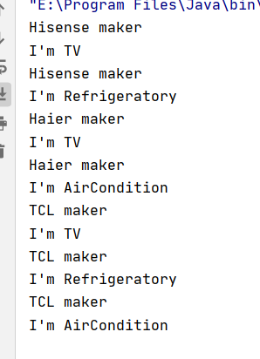
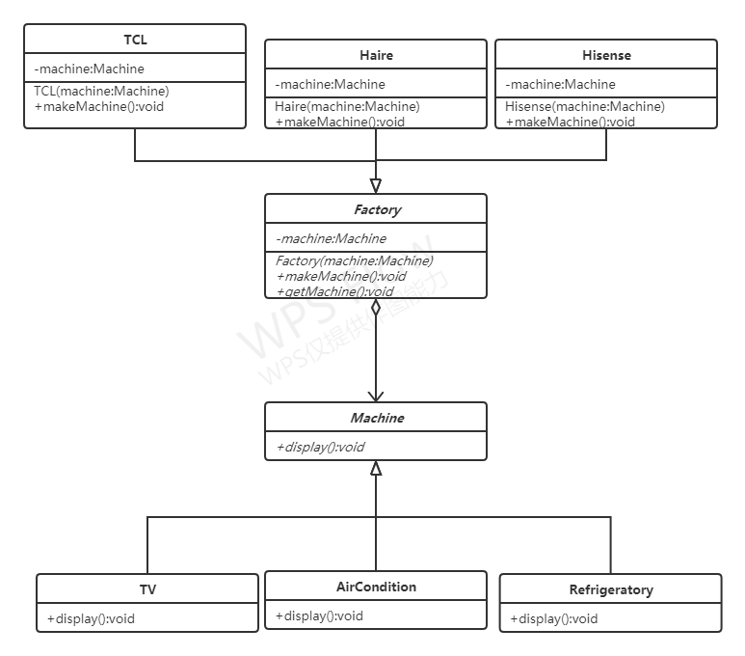

实验结果分析：
Factory为抽象类，Haier、TCL和Hisense继承抽象类，Machine为抽象类，TV、AirCondition和Refrigeratory为具体实现类。只需要修改具体品牌类和具体品种类，即可生产不同品牌的不同商品。
3-3题
源代码：
package experiment5.component;
import java.util.ArrayList;
import java.util.List;
public abstract class Component {
private String name;
public Component(String name) {
this.name = name;
}
public abstract void Add(Component c);
public abstract void delete(Component c);
public abstract void display();
public String getName() {
return name;
}
}
class ConcreteCompany extends Component {
private List<Component> children = new ArrayList<>();
public ConcreteCompany(String name) {
super(name);
}
@Override
public void Add(Component c) {
children.add(c);
}
@Override
public void delete(Component c) {
children.remove(c);
}
@Override
public void display() {
for (Component c : children) {
System.out.print(super.getName() + " ");
c.display();
}
}
}
class finalCompany extends Component {
public finalCompany(String name) {
super(name);
}
@Override
public void Add(Component c) {
System.out.println("不支持该方法");
}
@Override
public void delete(Component c) {
System.out.println("不支持该方法");
}
@Override
public void display() {
System.out.println(super.getName() + " ");
}
}
class Test {
public static void main(String[] args) {
Component root = new ConcreteCompany("北京总部");
Component c = new finalCompany("教务办公室");
Component c1 = new finalCompany("行政办公室");
Component root1 = new ConcreteCompany("湖南分校");
root.Add(c);
root.Add(c1);
root.Add(root1);
Component root2 = new ConcreteCompany("长沙教学点");
Component root3 = new ConcreteCompany("湘潭教学点");
root1.Add(c);
root1.Add(c1);
root1.Add(root2);
root1.Add(root3);
root2.Add(c);
root2.Add(c1);
root3.Add(c);
root3.Add(c1);
root.display();
}
}

运行结果：
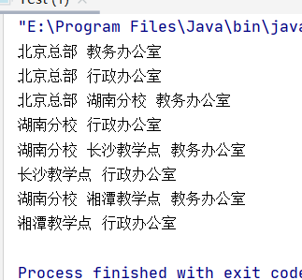
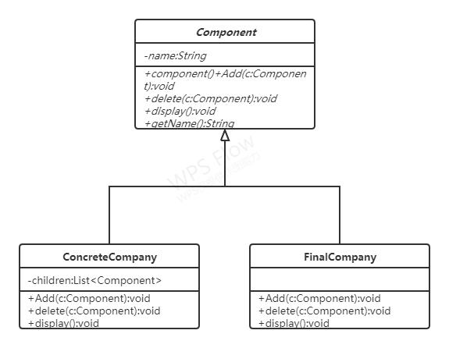
实验结果分析：
设计抽象类Component,ConcreteCompany与FinalCompany继承Component，并实现其中的add与delete方法，在ConcreteCompany中设置私有变量children储存ConcreteCompany子节点，在display方法中递归调用子节点的display方法，展示其结构。
3-4题
源代码：
package experiment5.decorate;
public interface Component {
public abstract void display();
}
class TextView implements Component {
@Override
public void display() {
System.out.println("I'm textView");
}
}
class PictureView implements Component {
@Override
public void display() {
System.out.println("I'm PictureView");
}
}
abstract class Decorate implements Component {
private Component c;
Decorate(Component c) {
this.c = c;
}
public void display() {
c.display();
}
}
class Scoller extends Decorate {
Scoller(Component c) {
super(c);
}
@Override
public void display() {
super.display();
description();
}
public void description() {
System.out.println("I'm Scoller");
}
}
class BlackBorder extends Decorate {
BlackBorder(Component c) {
super(c);
}
@Override
public void display() {
super.display();
description();
}
public void description() {
System.out.println("I'm BlackBorder");
}
}
class Test {
public static void main(String[] args) {
Component textView = new TextView();
System.out.println("基础款");
textView.display();
Component c1 = new Scoller(textView);
System.out.println("加上滑动框");
c1.display();
Component c2 = new BlackBorder(c1);
System.out.println("加上滑动框与黑色边框");
c2.display();
Component pictureView = new PictureView();
System.out.println("基础款");
pictureView.display();
Component c3 = new Scoller(pictureView);
System.out.println("加上滑动框");
c3.display();
Component c4 = new BlackBorder(c3);
System.out.println("加上滑动框与黑色边框");
c4.display();
}
}

运行结果：
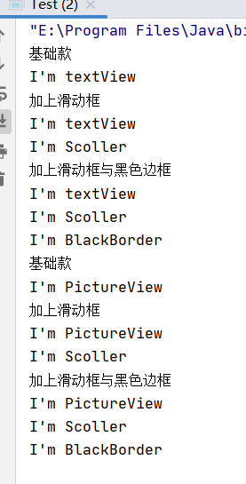
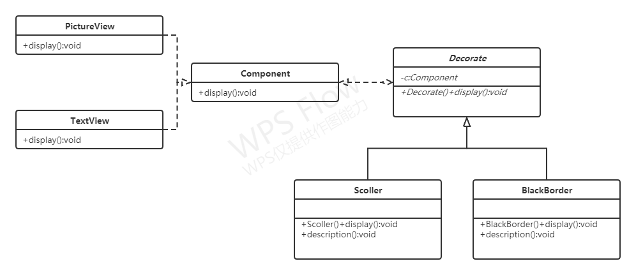
实验结果分析：
设置一个组件接口Component，TextView，PictureView，Decorate实现Component,在Decorate中设置私用变量Component的实例c，在构造方法中传入Component实例，Scoller与BlackBorder继承Decorate，重写display方法。
3-5题
源代码：
package experiment5.outlook;
public class MainFrame {
private Memory memory = new Memory();
private Cpu cpu = new Cpu();
private HardDisk hardDisk = new HardDisk();
private OS os = new OS();
public void on() {
memory.check();
cpu.run();
hardDisk.read();
os.load();
}
}
class Memory {
public void check() {
System.out.println("Memory check");
}
}
class Cpu {
public void run() {
System.out.println("Cpu run");
}
}
class HardDisk {
public void read() {
System.out.println("HardDisk Read");
}
}
class OS {
public void load() {
System.out.println("OS load");
}
}
class Client {
public static void main(String[] args) {
MainFrame mainFrame = new MainFrame();
mainFrame.on();
}
}

运行结果：
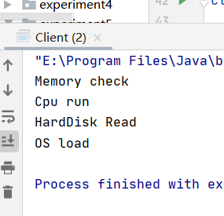
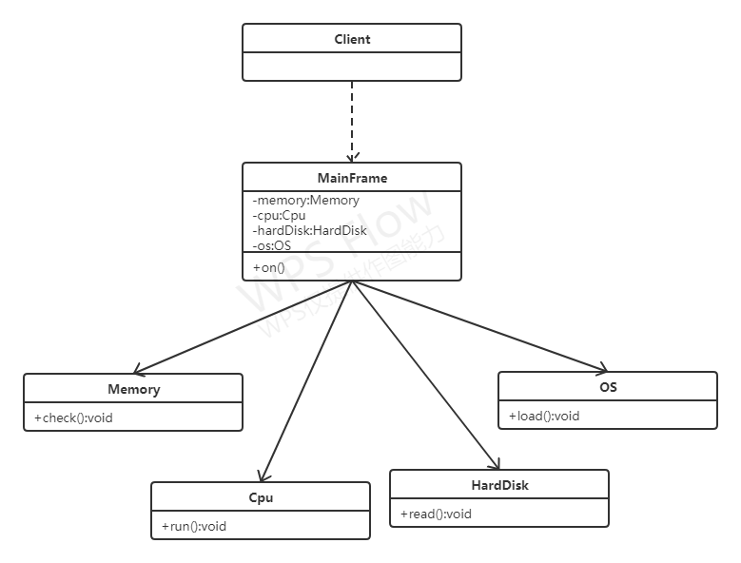
实验结果分析：
采用外观模式，MainFrame中设置私有变量Memory，Cpu，HardDisk,OS实例，在on()方法中依次调用个变量中方法，用户只需要与MainFrame交流即可开启电脑。
3-6题
源代码：
package experiment5.share;
import java.util.Hashtable;
public class Share {
private String s;
public Share(String s) {
this.s = s;
}
public String getS() {
return s;
}
public void display(Color color, Size size) {
System.out.println("字符：" + s + "\n颜色：" + color.getS() +
"\n大小：" + size.getS());
}
}
class Color {
private String s;
public Color(String s) {
this.s = s;
}
public void setS(String s) {
this.s = s;
}
public String getS() {
return s;
}
}
class Size {
private String s;
public Size(String s) {
this.s = s;
}
public void setS(String s) {
this.s = s;
}
public String getS() {
return s;
}
}
class ShareFactory {
private Hashtable ht;
public ShareFactory() {
ht = new Hashtable();
}
public Share getShare(String s) {
if (ht.contains(s)) {
return (Share) ht.get(s);
} else {
Share share = new Share(s);
ht.put(s, share);
return share;
}
}
}
class Client{
public static void main(String[] args) {
ShareFactory shareFactory = new ShareFactory();
Share share1 = shareFactory.getShare("java");
Share share2 = shareFactory.getShare("java");
System.out.println("share1与share2是否相等:");
System.out.println(share1 == share2);
share1.display(new Color("black"),new Size("200"));
share1.display(new Color("red"),new Size("500"));
share2.display(new Color("green"),new Size("20"));
share2.display(new Color("yellow"),new Size("40"));
}
}

运行结果：
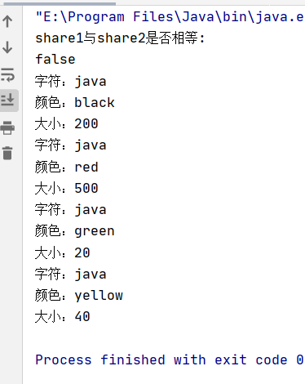
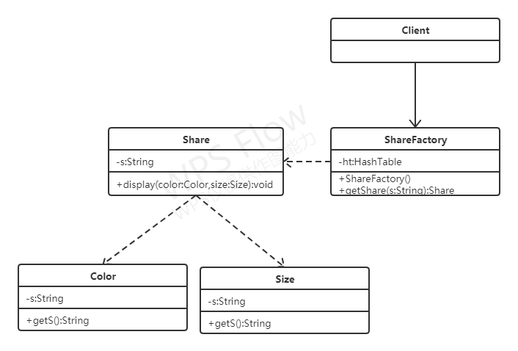
实验结果分析：
Share作为共享类，其中的s为共享状态，Color与Size为私有状态，使用注入的方式传递给Share，ShareFactory作为享元工厂，使用HashTable存储Share类。
3-7题
源代码：
package experiment5.agent;
public abstract class Application {
public abstract void run();
}
class RealApplication extends Application{
@Override
public void run() {
System.out.println("真正的应用run方法");
}
}
class Poxy extends Application{
private RealApplication realApplication = new RealApplication();
@Override
public void run() {
System.out.println("代理的应用run方法");
realApplication.run();
}
}
class Client{
public static void main(String[] args) {
Poxy poxy = new Poxy();
poxy.run();
}
}

运行结果：
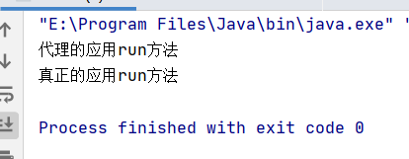
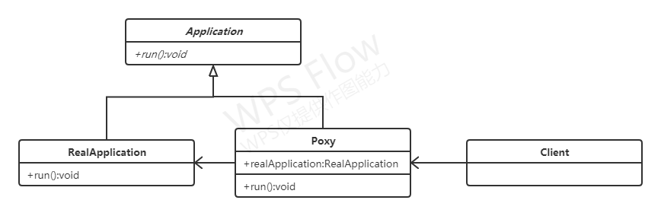

实验结果分析：
RealApplication与Poxy都继承自Application,在Poxy的run方法中调用RealApplication的run方法，Client只调用Poxy内run方法即可调用RealApplication的run方法。
实验内容第（4）题
源代码：
package experiment5.pig;
import experiment1.A;
public interface Animal {
public void display();
}
class Pig implements Animal {
@Override
public void display() {
System.out.println("我是一只猪");
}
}
abstract class Decorate implements Animal {
public abstract void display();
}
class RedApple extends Decorate{
private Animal animal;
public RedApple(Animal animal){
this.animal = animal;
}
@Override
public void display() {
animal.display();
System.out.println("加上保护罩");
}
}
class GreenApple extends Decorate{
private Animal animal;
public GreenApple(Animal animal){
this.animal = animal;
}
@Override
public void display() {
animal.display();
System.out.println("加快奔跑速度");
}
}
class YellowApple extends Decorate{
private Animal animal;
public YellowApple(Animal animal){
this.animal = animal;
}
@Override
public void display() {
animal.display();
System.out.println("趟着水跑");
}
}
class Client{
public static void main(String[] args) {
Animal pig = new Pig();
System.out.println("基础款：");
pig.display();
pig = new RedApple(pig);
System.out.println("\n吃红苹果：");
pig.display();
pig = new GreenApple(pig);
System.out.println("\n吃绿苹果：");
pig.display();
pig = new YellowApple(pig);
System.out.println("\n吃黄苹果：");
pig.display();
}
}

运行结果：
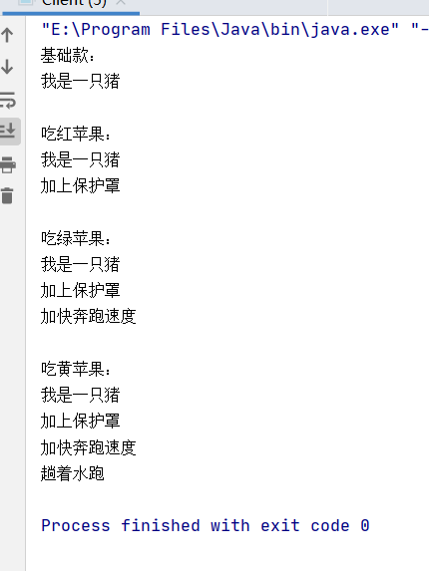
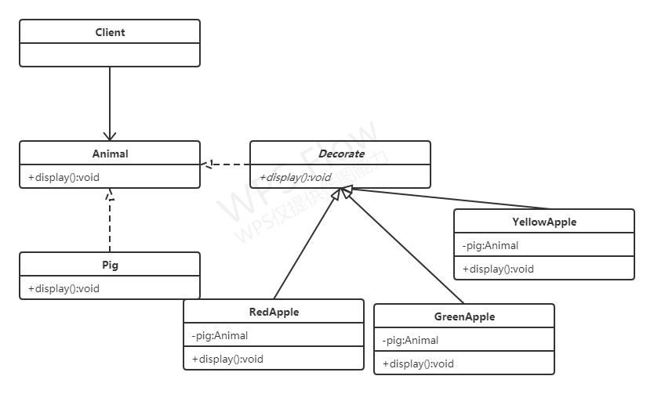

实验结果分析：
Pig与Decorate实现Animal接口，RedApple,GreenApple与YellowApple继承Decorate,并且设置私有变量pig，在各自的display方法中增加功能。

