实验四： 创建型设计模式
实验目的：
- 理解简单工厂模式、工厂方法模式
- 理解抽象工厂模式、建造者模式
- 理解单例模式
- 理解原型模式

实验内容：
- 完成实训教程p64第一大题选择题，直接在书上做。
- 完成实训教程p69第二大题填空题，直接在书上做。
- 完成实训教程p80第三大题综合题1，2，3，4，5，6。
(4) 完成《java设计模式》教程P70 习题6, P89 习题5
3-1题
源代码：
package experiment4;
public abstract class People {
public abstract void say();
}
class Man extends People{
@Override
public void say() {
System.out.println("I'm a man");
}
}
class Woman extends People{
@Override
public void say() {
System.out.println("I'm a woman");
}
}
//新增robot类
class Robot extends People{
@Override
public void say() {
System.out.println("I'm a Robot");
}
}

package experiment4;
public class Nvwa {
public static People makePeople(String kind){
People people = null;
kind = kind.toLowerCase();
switch (kind){
case "m":people = new Man();break;
case "w":people = new Woman();break;
//添加robot
case "r":people = new Robot();break;
}
return people;
}
}

package experiment4;
import java.util.Scanner;
public class test {
public static void main(String[] args) {
Scanner in = new Scanner(System.in);
int i = 5;
while (i > 0) {
System.out.println("请输入参数(w,m,或者r)");
String kind = in.next();
People people = Nvwa.makePeople(kind);
try {
people.say();
} catch (Exception e) {
e.printStackTrace();
}
i--;
}
}
}

运行结果：
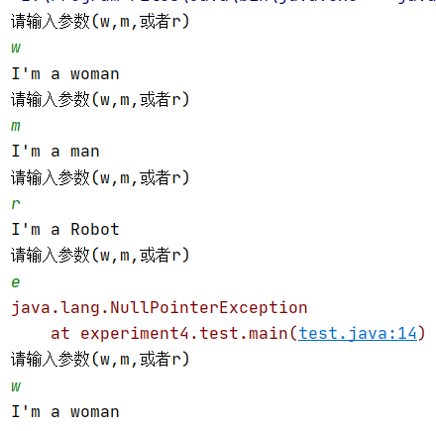
图3-1

实验结果分析：
Nvwa根据输入参数，使用switch-case来new出People子类。输入参数为w时，people为Woman类型，输入参数为m时，people类型为Man，当新增一个Robot类型，只需要继承People类，在Nvwa1switch-case中增加一种判断即可。
3-2题
源代码：
package experiment4.ImageReader;
public abstract class ImageReader {
public abstract void read();
}
class GifReader extends ImageReader{
@Override
public void read() {
System.out.println("Reade Gif");
}
}
class JpgReader extends ImageReader{
@Override
public void read() {
System.out.println("Reade Jpg");
}
}

package experiment4.ImageReader;
public interface ImageReaderFactory {
public ImageReader maker();
}
class GifReaderFactory implements ImageReaderFactory {
@Override
public ImageReader maker() {
return new GifReader();
}
}
class JpgReaderFactory implements ImageReaderFactory {
@Override
public ImageReader maker() {
return new JpgReader();
}
}

package experiment4.ImageReader;
public class test {
public static void main(String[] args) {
ImageReaderFactory imageReaderFactory = new GifReaderFactory();
ImageReader imageReader = imageReaderFactory.maker();
imageReader.read();
imageReaderFactory = new JpgReaderFactory();
imageReader = imageReaderFactory.maker();
imageReader.read();
}
}

运行结果：

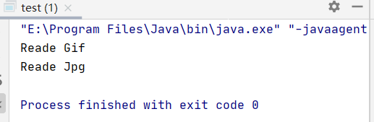
图3-2
实验结果分析：
采用工厂方法模式GifReaderFactory与JpgReadreFactory继承ImageReaderFactory实现make方法，返回对应的GifReader与JpgReader。
3-3题
源代码：
package experiment4.computer;
public abstract class Cpu {
public abstract void introduce();
}
class MacCpu extends Cpu{
@Override
public void introduce() {
System.out.println("I'm MacCpu");
}
}
class PcCpu extends Cpu{
@Override
public void introduce() {
System.out.println("I'm PcCpu");
}
}
package experiment4.computer;
public abstract class Factory {
public abstract Cpu createCPU();
public abstract RAM createRAM();
}
class MacFactory extends Factory{
@Override
public Cpu createCPU() {
return new MacCpu();
}
@Override
public RAM createRAM() {
return new MacRAM();
}
}
class PcFactory extends Factory{
@Override
public Cpu createCPU() {
return new PcCpu();
}
@Override
public RAM createRAM() {
return new PcRAM();
}
}

package experiment4.computer;
public abstract class RAM {
public abstract void introduce();
}
class MacRAM extends RAM{
@Override
public void introduce() {
System.out.println("I'm MacRAM");
}
}
class PcRAM extends RAM{
@Override
public void introduce() {
System.out.println("I'm pcRAM");
}
}
package experiment4.computer;
public class test {
public static void main(String[] args) {
Factory factory = new MacFactory();
Cpu cpu = factory.createCPU();
RAM ram= factory.createRAM();
cpu.introduce();
ram.introduce();
factory = new PcFactory();
cpu = factory.createCPU();
ram = factory.createRAM();
cpu.introduce();
ram.introduce();
}
}

运行结果：

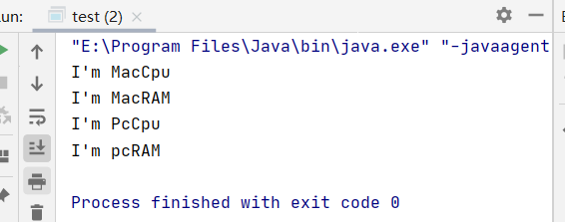
图3-3
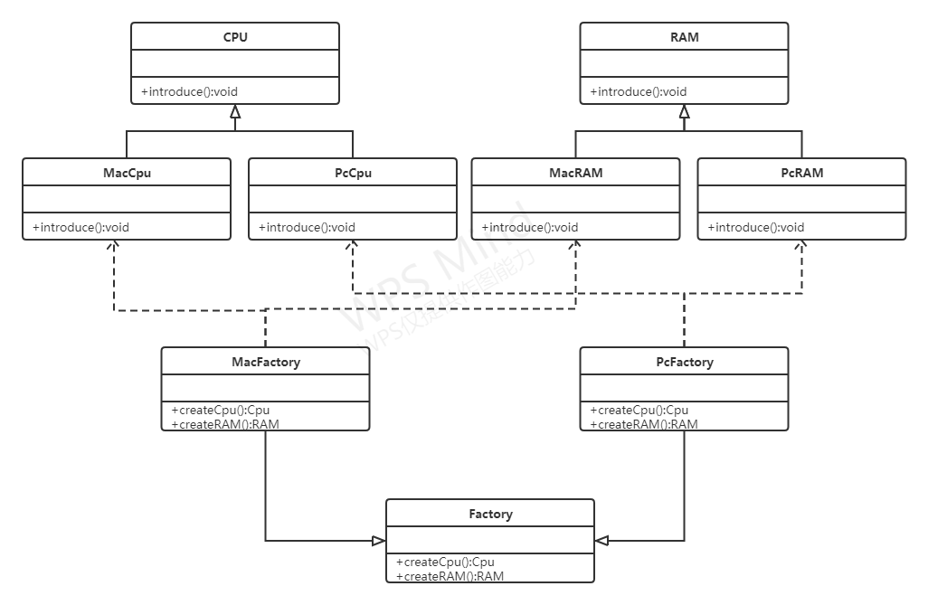
图3-4

实验结果分析：
将Cpu分为MacCpu与PcCpu，RAM分为MacRAM与PcRAM，在MAcFactory中，创建输入Mac的Cpu与RAM,在PcFactory中创建输入Pc的Cpu与RAM。
3-4题
源代码：
package experiment4.buildeComputer;
public class Computer {
private boolean cpu;
private boolean memory;
private boolean hardDisk;
private boolean host;
private boolean screen;
public boolean isCpu() {
return cpu;
}
public void setCpu(boolean cpu) {
this.cpu = cpu;
}
public boolean isMemory() {
return memory;
}
public void setMemory(boolean memory) {
this.memory = memory;
}
public boolean isHardDisk() {
return hardDisk;
}
public void setHardDisk(boolean hardDisk) {
this.hardDisk = hardDisk;
}
public boolean isHost() {
return host;
}
public void setHost(boolean host) {
this.host = host;
}
public boolean isScreen() {
return screen;
}
public void setScreen(boolean screen) {
this.screen = screen;
}
public void display(){
System.out.println("my Computer");
System.out.println("cpu:"+cpu);
System.out.println("memory:"+memory);
System.out.println("hardDisk:"+hardDisk);
System.out.println("host:"+host);
System.out.println("screen:"+screen);
}
}
package experiment4.buildeComputer;
public abstract class Builder {
protected Computer computer = new Computer();
public abstract void buildCpu();
public abstract void buildMemory();
public abstract void buildhardDisk();
public abstract void buildhost();
public abstract void buildscreen();
public void buildComputer() {
buildCpu();
buildMemory();
buildhardDisk();
buildhost();
buildscreen();
}
public Computer getResult() {
return computer;
}
}
class Builder1 extends Builder {
@Override
public void buildCpu() {
computer.setCpu(true);
}
@Override
public void buildMemory() {
computer.setHardDisk(true);
}
@Override
public void buildhardDisk() {
computer.setHardDisk(false);
}
@Override
public void buildhost() {
computer.setHost(false);
}
@Override
public void buildscreen() {
computer.setScreen(true);
}
}
class Builder2 extends Builder {
@Override
public void buildCpu() {
computer.setCpu(true);
}
@Override
public void buildMemory() {
computer.setHardDisk(true);
}
@Override
public void buildhardDisk() {
computer.setHardDisk(false);
}
@Override
public void buildhost() {
computer.setHost(true);
}
@Override
public void buildscreen() {
computer.setScreen(true);
}
}
package experiment4.buildeComputer;
public class Director {
public Builder builder ;
public Director(Builder builder){
this.builder = builder;
}
public Computer construct(){
builder.buildComputer();
return builder.getResult();
}
}
package experiment4.buildeComputer;
public class test {
public static void main(String[] args) {
Builder builder = new Builder1();
Director director = new Director(builder);
Computer computer = director.construct();
computer.display();
builder = new Builder2();
director = new Director(builder);
computer = director.construct();
computer.display();
}
}

运行结果：
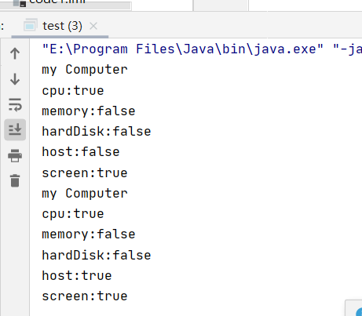
图3-5
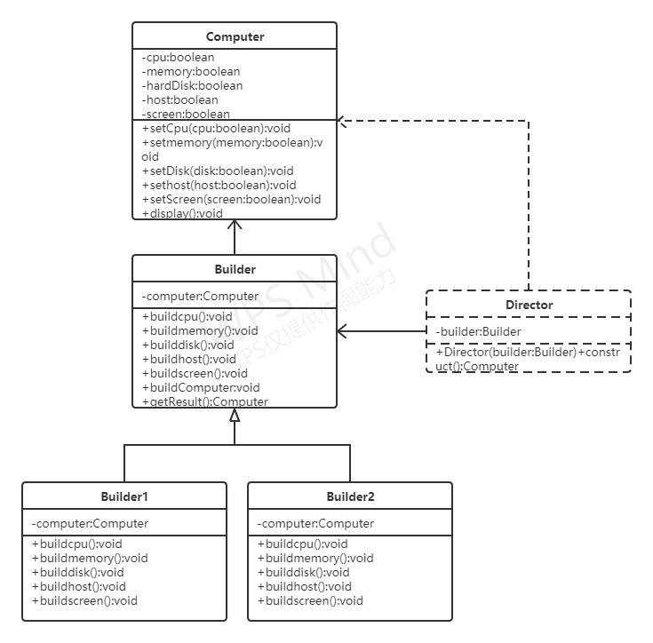
图3-6

实验结果分析：
在Builder1和Builder2中，定义各自的buildcpu,buildmemory,buildhost,builddisk,buildscreen方法，在buildComputer中调用buildcpu,buildmemory,buildhost,builddisk,buildscreen方法，在Director构造方法中传入Builder子类，在Director中调用construct方法，返回创建出computer。
3-5题
源代码：
package experiment4.Customer;
import java.io.Serializable;
public class Customer implements Cloneable{
private Address address = null;
public Customer(){
this.address = new Address();
}
public Address getAddress() {
return address;
}
public void setAddress(Address address) {
this.address = address;
}
public Object clone(){
Object obj = null;
try {
obj = super.clone();
} catch (CloneNotSupportedException e) {
System.out.println("Clone is failure");
}
return obj;
}
}
class Address implements Serializable {
}

package experiment4.Customer;
import java.io.*;
public class Customer1 implements Serializable {
private Address address = null;
public Customer1(){
this.address = new Address();
}
public Address getAddress() {
return address;
}
public void setAddress(Address address) {
this.address = address;
}
public Object deepClone() throws IOException, ClassNotFoundException {
ByteArrayOutputStream bao = new ByteArrayOutputStream();
ObjectOutputStream oos = new ObjectOutputStream(bao);
oos.writeObject(this);
ByteArrayInputStream bis = new ByteArrayInputStream(bao.toByteArray());
ObjectInputStream ois = new ObjectInputStream(bis);
return (ois.readObject());
}
}
package experiment4.Customer;
import java.io.IOException;
public class test {
public static void main(String[] args) throws IOException, ClassNotFoundException {
Customer customer = new Customer();
Customer1 customer1 = new Customer1();
Customer obj = (Customer) customer.clone();
Customer1 obj1 = (Customer1) customer1.deepClone();
System.out.println(obj.getAddress().toString());
System.out.println(customer.getAddress().toString());
System.out.println(obj1.getAddress().toString());
System.out.println(customer1.getAddress().toString());
}
}

运行结果：
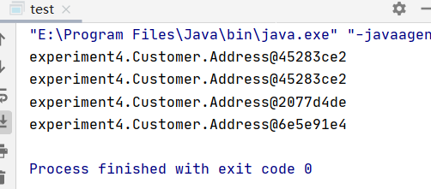

实验结果分析：
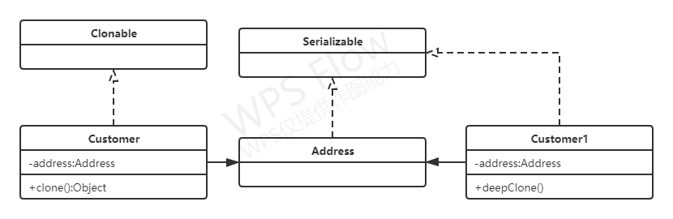
浅克隆对于引用类型，会把引用对象地址复制一份给克隆对象，深克隆会直接复制一份给克隆对象，所以在对custoomer使用浅克隆出的obj两个的address的地址一样，而customer1使用深度克隆的obj1的address地址不一样。
3-6题
源代码：
package experiment4.multiton;
import java.util.Random;
public class Multiton {
private static Multiton[] array = {new Multiton(), new Multiton(), new Multiton(), new Multiton()};
private Multiton() {
}
public static Multiton getInstance() {
return array[random()];
}
public static int random(){
Random random = new Random();
int value = Math.abs(random.nextInt());
value = value%4;
return value;
}
public static void main(String args[]){
Multiton m1,m2,m3,m4;
m1 = Multiton.getInstance();
m2 = Multiton.getInstance();
m3 = Multiton.getInstance();
m4 = Multiton.getInstance();
System.out.println(m1==m2);
System.out.println(m1==m3);
System.out.println(m1==m4);
}
}

运行结果：
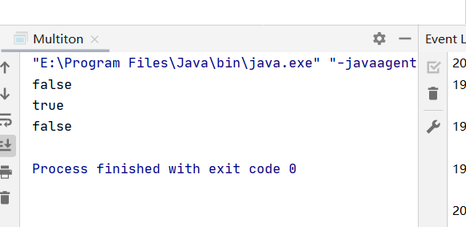

实验结果分析：
通过静态集合对象来储存实例可以实现存储多个实例
《java设计模式》教程P70 习题6
源代码：
package experiment4.phone;
public abstract class OperationController {
public abstract void display();
}
class AndroidOperationController extends OperationController{
@Override
public void display() {
System.out.println("i am AndroidOperationController");
}
}
class IOSOperationController extends OperationController{
@Override
public void display() {
System.out.println("i am IOSOperationController");
}
}
class WindowsOperationController extends OperationController{
@Override
public void display() {
System.out.println("i am WindowsOperationController");
}
}

package experiment4.phone;
public abstract class InterfaceController {
public abstract void display();
}
class AndroidInterfaceController extends InterfaceController{
@Override
public void display() {
System.out.println("i am AndroidInterfaceController");
}
}
class IOSInterfaceController extends InterfaceController{
@Override
public void display() {
System.out.println("i am IOSInterfaceController");
}
}
class WindowsInterfaceController extends InterfaceController{
@Override
public void display() {
System.out.println("i am WindowsInterfaceController");
}
}
package experiment4.phone;
public abstract class Factory {
public abstract InterfaceController createInterfaceController();
public abstract OperationController createOperationController();
}
class AndroidFactory extends Factory {
@Override
public InterfaceController createInterfaceController() {
return new AndroidInterfaceController();
}
@Override
public OperationController createOperationController() {
return new AndroidOperationController();
}
}
class IOSFactory extends Factory {
@Override
public InterfaceController createInterfaceController() {
return new IOSInterfaceController();
}
@Override
public OperationController createOperationController() {
return new IOSOperationController();
}
}
class WindowsFactory extends Factory {
@Override
public InterfaceController createInterfaceController() {
return new WindowsInterfaceController();
}
@Override
public OperationController createOperationController() {
return new WindowsOperationController();
}
}
package experiment4.phone;
public class test {
public static void main(String[] args) {
Factory factory = new AndroidFactory();
InterfaceController interfaceController = factory.createInterfaceController();
OperationController operationController = factory.createOperationController();
interfaceController.display();
operationController.display();
factory = new IOSFactory();
interfaceController = factory.createInterfaceController();
operationController = factory.createOperationController();
interfaceController.display();
operationController.display();
factory = new WindowsFactory();
interfaceController = factory.createInterfaceController();
operationController = factory.createOperationController();
interfaceController.display();
operationController.display();
}
}

运行结果：
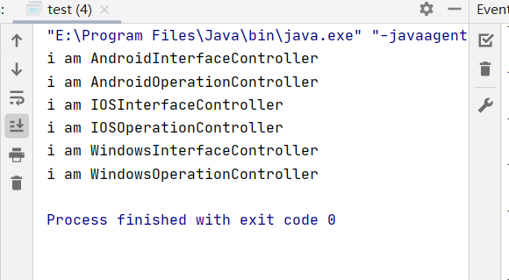

实验结果分析：
使用抽象工厂模式，在本次实验中，首先将InterfaceController分为IOSInterfaceController,WindowsInterfaceController和AndroidInterfaceController，然后将OperationController分为IOSOperationController，WindowsOperationController和AndroidOperationController，在IOSFactory中，创建输出IOS的interfaceController与OperationController,在WIndowsFactory中，创建输出Windows的interfaceController与OperationController,在AndroidFactory中，创建输出Android的interfaceController与OperationController。
《java设计模式》教程P89 习题5
源代码：
package experiment4.vedio;
public class Vedio {
private boolean menu;
private boolean list;
private boolean windows;
private boolean controller;
private boolean collection;
public boolean isMenu() {
return menu;
}
public void setMenu(boolean menu) {
this.menu = menu;
}
public boolean isList() {
return list;
}
public void setList(boolean list) {
this.list = list;
}
public boolean isWindows() {
return windows;
}
public void setWindows(boolean windows) {
this.windows = windows;
}
public boolean isController() {
return controller;
}
public void setController(boolean controller) {
this.controller = controller;
}
public boolean isCollection() {
return collection;
}
public void setCollection(boolean collection) {
this.collection = collection;
}
public void display(){
System.out.println("my Vedio");
System.out.println("menu:"+menu);
System.out.println("list:"+list);
System.out.println("windows:"+windows);
System.out.println("controller:"+controller);
System.out.println("collection:"+collection);
}
}
package experiment4.vedio;
public abstract class Builder {
protected Vedio vedio = new Vedio();
public abstract void setMenu();
public abstract void setList();
public abstract void setWindows();
public abstract void setController();
public abstract void setCollection();
public void setVedio() {
setMenu();
setList();
setWindows();
setController();
setCollection();
}
public Vedio getResult() {
return vedio;
}
}
class CompletePattern extends Builder {
@Override
public void setMenu() {
vedio.setMenu(true);
}
@Override
public void setList() {
vedio.setList(true);
}
@Override
public void setWindows() {
vedio.setWindows(true);
}
@Override
public void setController() {
vedio.setController(true);
}
@Override
public void setCollection() {
vedio.setCollection(false);
}
}
class MemoryPattern extends Builder {
@Override
public void setMenu() {
vedio.setMenu(false);
}
@Override
public void setList() {
vedio.setList(false);
}
@Override
public void setWindows() {
vedio.setWindows(true);
}
@Override
public void setController() {
vedio.setController(true);
}
@Override
public void setCollection() {
vedio.setCollection(true);
}
}
class SimplePattern extends Builder {
@Override
public void setMenu() {
vedio.setMenu(false);
}
@Override
public void setList() {
vedio.setList(false);
}
@Override
public void setWindows() {
vedio.setWindows(true);
}
@Override
public void setController() {
vedio.setController(true);
}
@Override
public void setCollection() {
vedio.setCollection(false);
}
}
package experiment4.vedio;
public class Director {
private Builder builder;
public Director(Builder builder) {
this.builder = builder;
}
public Vedio construct() {
builder.setVedio();
return builder.getResult();
}
}
package experiment4.vedio;
public class test {
public static void main(String[] args) {
Builder builder = new CompletePattern();
Director director = new Director(builder);
Vedio vedio = director.construct();
vedio.display();
builder = new SimplePattern();
director = new Director(builder);
vedio = director.construct();
vedio.display();
builder = new MemoryPattern();
director = new Director(builder);
vedio = director.construct();
vedio.display();
}
}

运行结果：
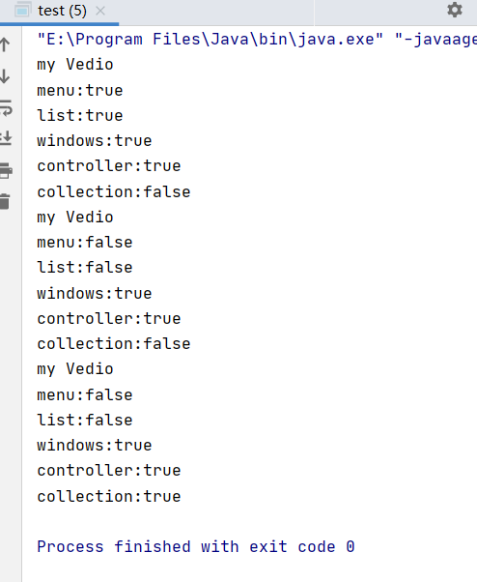

实验结果分析：
使用建造者模式，在CompletePattern，MemoryPattern和SimplePattern中，定义各自的setMenu()，setList()，setWindows()，setController()，setCollection()方法，在buildVedio中调用setMenu()，setList()，setWindows()，setController()，setCollection()方法，在Director构造方法中传入Builder子类，在Director中调用construct方法，返回创建出Vedio。

