实验七： 行为型设计模式
实验目的：
掌握行为型模式的原理和应用。
实验内容：
- 完成实训教程第一大题选择题，直接在书上做。
- 完成实训教程第二大题填空题，直接在书上做。
- 完成实训教程第三大题1、2、4--11。
实验内容第（3）题--综合题第1题：
源代码：
package experiment7.army;
public class Officer {
private Officer successor;
public void setSuccessor(Officer successor) {
this.successor = successor;
}
public Officer getSuccessor() {
return successor;
}
public void request(Mission mission) {
}
}
class Banzhang extends Officer {
public void request(Mission mission) {
if (mission.getNum() < 10) {
System.out.println("班长处理命令");
} else {
super.getSuccessor().request(mission);
}
}
}
class Paizhang extends Officer {
public void request(Mission mission) {
if (10 <= mission.getNum() && mission.getNum() < 50) {
System.out.println("排长处理命令");
} else {
super.getSuccessor().request(mission);
}
}
}
class Yingzhang extends Officer {
public void request(Mission mission) {
if (50 <= mission.getNum() && mission.getNum() < 200) {
System.out.println("营长处理命令");
} else {
System.out.println("开会处理");
}
}
}
class Mission {
private int num;
public Mission(int num) {
this.num = num;
}
public int getNum() {
return num;
}
}
class Client {
public static void main(String[] args) {
//设置职责链
Officer banzhang = new Banzhang();
Officer paizhang = new Paizhang();
Officer yingzhang = new Yingzhang();
banzhang.setSuccessor(paizhang);
paizhang.setSuccessor(yingzhang);
//改变命令人数，交由职责链处理
Mission mission = new Mission(5);
banzhang.request(mission);
mission = new Mission(30);
banzhang.request(mission);
mission = new Mission(300);
banzhang.request(mission);
}
}

运行结果：
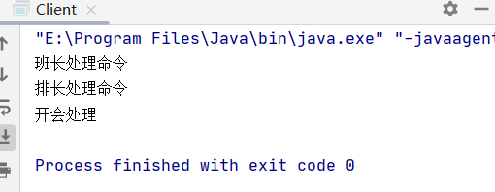
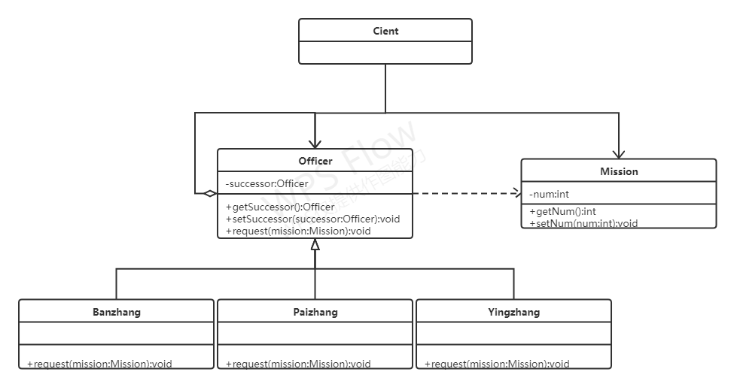

实验结果分析：
在Officer中设置successor，Banzhang，Paizhang，Yingzhang继承Officer，重写request方法，判断传入mission人数是否符合条件，如果符合条件则输出结果，如果不符合条件则调用super.getSuccessor.request方法，在Client中创建职责链，传入命令。
实验内容第（3）题--综合题第2题：
源代码：
package experiment7.commend;
public class FunctionButton {
private Commend[] commends = new Commend[2];
public void onPressButton(int button){
commends[button].on();
}
public void setCommends(int button,Commend commend){
commends[button] = commend;
}
}
interface Commend {
void on();
}
class SystemExitClassComend implements Commend {
protected SystemExitClass systemExitClass;
public SystemExitClassComend(SystemExitClass systemExitClass){
this.systemExitClass = systemExitClass;
}
@Override
public void on() {
systemExitClass.display();
}
}
class DisplayHelpClassCommend implements Commend {
protected DisplayHelpClass displayHelpClass;
public DisplayHelpClassCommend(DisplayHelpClass displayHelpClass){
this.displayHelpClass = displayHelpClass;
}
@Override
public void on() {
displayHelpClass.display();
}
}
class SystemExitClass {
public void display() {
System.out.println("打开退出系统");
}
}
class DisplayHelpClass {
public void display() {
System.out.println("打开帮助界面");
}
}
class Client{
public static void main(String[] args) {
SystemExitClass systemExitClass = new SystemExitClass();
DisplayHelpClass displayHelpClass = new DisplayHelpClass();
Commend commend1 = new SystemExitClassComend(systemExitClass);
Commend commend2 = new DisplayHelpClassCommend(displayHelpClass);
FunctionButton functionButton = new FunctionButton();
functionButton.setCommends(0,commend1);
functionButton.setCommends(1,commend2);
functionButton.onPressButton(1);
functionButton.onPressButton(0);
}
}

运行结果：
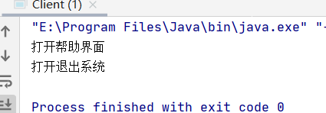
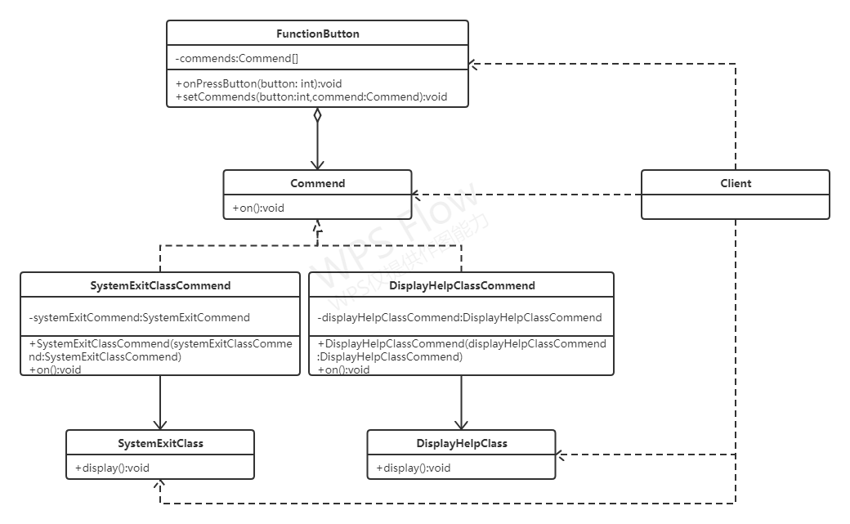
实验结果分析：
SystemExitClassCommend与DisplayHelpClassCommend实现接口Commend，具体实现on方法，在FunctionButton中设置数组commends，调用setCommends方法给数组赋值，在onPressButton中通过传入参数确实调用commends数组中那个commend的方法。
实验内容第（3）题--综合题第4题：
源代码：
package experiment7.iterate;
import java.util.ArrayList;
import java.util.Collections;
import java.util.List;
public class Clazz implements MyCollection {
private List<Student> students;
@Override
public void setArray(List<Student> array) {
this.students = array;
}
@Override
public List<Student> getArray() {
return students;
}
@Override
public Iterate createIterate() {
return new ConcreteIterate(this);
}
}
interface MyCollection {
public void setArray(List<Student> array);
public List<Student> getArray();
public Iterate createIterate();
}
interface Iterate {
public void first();
public void last();
public void next();
public void previous();
public boolean isLast();
public boolean isFirst();
public Object getItem();
}
class ConcreteIterate implements Iterate {
private List<Student> objects;
private int index = 0;
public ConcreteIterate(Clazz clazz) {
this.objects = clazz.getArray();
}
@Override
public void first() {
index = 0;
}
@Override
public void last() {
index = objects.size() - 1;
}
@Override
public void next() {
if (index < objects.size())
index++;
}
@Override
public void previous() {
if (index>0){
index--;
}
}
@Override
public boolean isLast() {
return index == objects.size();
}
@Override
public boolean isFirst() {
return index == 0;
}
@Override
public Object getItem() {
return objects.get(index);
}
}
class Student implements Comparable<Student>{
private int age;
public Student(int age) {
this.age = age;
}
public int getAge() {
return age;
}
public void setAge(int age) {
this.age = age;
}
public void display(){
System.out.println("我的年龄是"+age);
}
@Override
public int compareTo(Student student) {
return this.age-student.getAge();
}
}
class Client{
public static void main(String[] args) {
List<Student> students = new ArrayList<>();
students.add(new Student(4));
students.add(new Student(5));
students.add(new Student(2));
students.add(new Student(5));
students.add(new Student(6));
students.add(new Student(4));
students.add(new Student(7));
students.add(new Student(3));
Collections.sort(students);
MyCollection myCollection = new Clazz();
myCollection .setArray(students);
Iterate iterate = myCollection.createIterate();
while (!iterate.isLast()){
Student student = (Student) iterate.getItem();
student.display();
iterate.next();
}
}
}

运行结果：
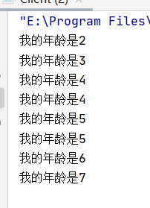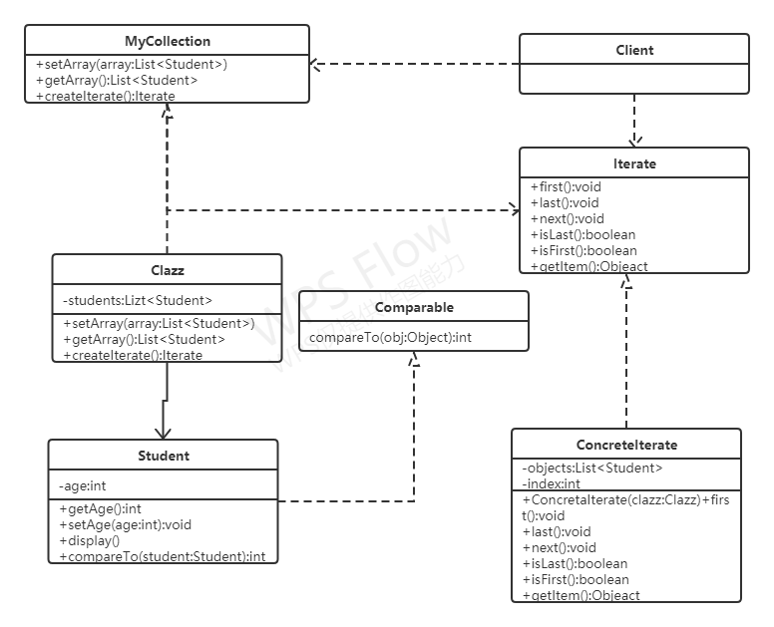

实验结果分析：
Clazz实现MyCollection接口，实现createIterate方法返回一个迭代器，ConcreteIterate实现Iterate接口，实现其中方法，Student实现Comparable接口，实现compareTo方法，以便实现按年龄大小排列。
实验内容第（3）题--综合题第5题：
源代码：
package experiment7.Mediator;
public abstract class UniteadNations {
public abstract void action(Nation nation,String value);
}
class WTO extends UniteadNations {
public China china;
public American american;
@Override
public void action(Nation nation,String value) {
if (china == nation){
System.out.println("这里是WTO");
american.update(value);
}
if (american == nation){
System.out.println("这里是WTO");
china.update(value);
}
}
}
class WHO extends UniteadNations {
public China china;
public American american;
@Override
public void action(Nation nation,String value) {
if (china == nation){
System.out.println("这里是WHO");
american.update(value);
}
if (american == nation){
System.out.println("这里是WHO");
china.update(value);
}
}
}
abstract class Nation {
protected UniteadNations uniteadNations;
public void modify(String value){
uniteadNations.action(this,value);
}
public abstract void update(String value);
}
class China extends Nation {
public China(UniteadNations uniteadNations) {
super.uniteadNations = uniteadNations;
}
@Override
public void update(String value) {
System.out.println("中国更新："+value);
}
}
class American extends Nation {
public American(UniteadNations uniteadNations) {
super.uniteadNations = uniteadNations;
}
@Override
public void update(String value) {
System.out.println("美国更新："+value);
}
}
class Client{
public static void main(String[] args) {
WHO who = new WHO();
WTO wto = new WTO();
China china1 = new China(who);
China china2 = new China(wto);
American american1 = new American(who);
American american2 = new American(wto);
who.china = china1;
who.american = american1;
wto.china = china2;
wto.american = american2;
china1.modify("世界和平");
china2.modify("奥特曼是真的");
american1.modify("芭比梦想豪宅");
american2.modify("创造101");
}
}

运行结果：
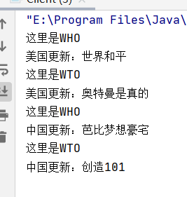
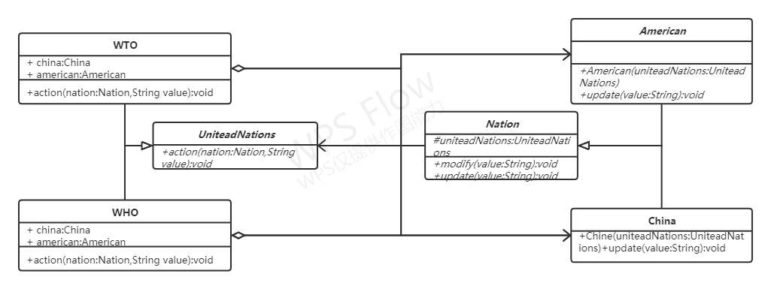
实验结果分析：
抽象类UniteadNations充当抽象终结者，WTO,WHO为具体终结者，抽象类Nation为抽象同事类，包含modify和update两个方法，American与China为具体同事类。当China改变时，引起American改变，而且China与American之间不发生直接联系。
实验内容第（3）题--综合题第6题：
源代码：
package experiment7.momento;
import java.util.Stack;
public class Chess {
private int x;
private int y;
public Chess(int x, int y) {
this.x = x;
this.y = y;
}
public void setX(int x) {
this.x = x;
}
public void setY(int y) {
this.y = y;
}
public void restore(ChessMemento chessMemenTo) {
this.x = chessMemenTo.getX();
this.y = chessMemenTo.getY();
}
public ChessMemento save() {
return new ChessMemento(x, y);
}
public void display() {
System.out.println("我的位置是：(" + x + "," + y + ")");
}
}
class ChessMemento {
private int x;
private int y;
public ChessMemento(int x, int y) {
this.x = x;
this.y = y;
}
public void setX(int x) {
this.x = x;
}
public void setY(int y) {
this.y = y;
}
public int getY() {
return y;
}
public int getX() {
return x;
}
}
class MementoCareTaker {
private Stack<ChessMemento> chessMementos = new Stack<>();
public ChessMemento getChessMemento() {
return chessMementos.pop();
}
public void saveChessMemento(ChessMemento chessMemento) {
chessMementos.push(chessMemento);
}
}
class Client {
public static void main(String[] args) {
Chess chess = new Chess(3, 4);
chess.display();
MementoCareTaker mc = new MementoCareTaker();
mc.saveChessMemento(chess.save());
chess.setX(6);
chess.display();
mc.saveChessMemento(chess.save());
chess.setY(11);
chess.display();
mc.saveChessMemento(chess.save());
System.out.println("我悔棋了");
chess.restore(mc.getChessMemento());
chess.display();
chess.restore(mc.getChessMemento());
chess.display();
chess.restore(mc.getChessMemento());
chess.display();
}
}

运行结果：
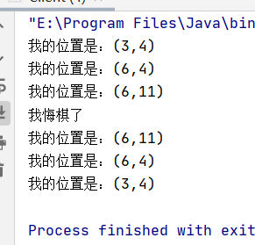
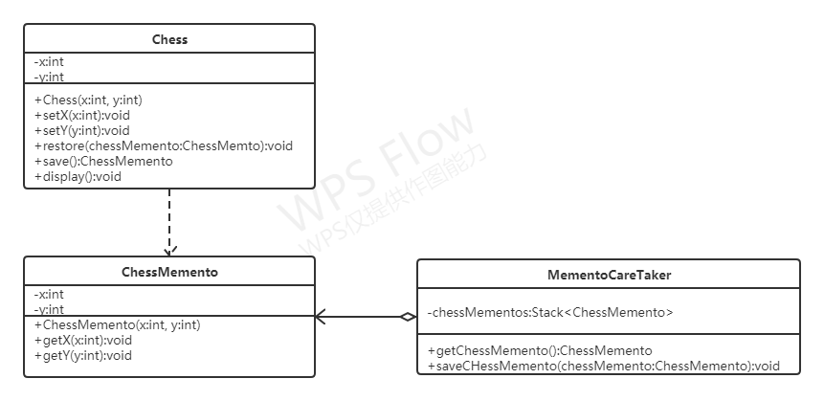

实验结果分析：
Chess每次改变x,y时MementoCareTaker使用栈，将每次围棋状态存储下来，chess悔棋时，MementoCareTaker中栈pop出ChessMemento实例，改变Chess的x,y位置。
实验内容第（3）题--综合题第7题：
源代码：
package experiment7.Observe;
import java.util.ArrayList;
import java.util.List;
public class Tame {
private List<Companion> companions = new ArrayList<>();
public void register(Companion companion) {
companions.add(companion);
}
public void trigger(String name) {
System.out.println(name+"受到攻击！！！");
for (Companion obj : companions) {
if (obj.getName() != name)
obj.alarm();
}
}
}
class Companion {
private String name;
public Companion(String name) {
this.name = name;
}
public String getName() {
return name;
}
public void alarm() {
System.out.println("我是" + name + "我们来救你啦");
}
}
class Client {
public static void main(String[] args) {
Companion c1 = new Companion("张三");
Companion c2 = new Companion("李四");
Companion c3 = new Companion("Lily");
Companion c4 = new Companion("Jack");
Companion c5 = new Companion("Mark");
Companion c6 = new Companion("Tony");
Tame tame = new Tame();
tame.register(c1);
tame.register(c2);
tame.register(c3);
tame.register(c4);
tame.register(c5);
tame.register(c6);
tame.trigger("Lily");
}
}

运行结果：
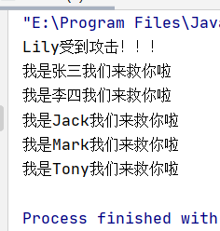
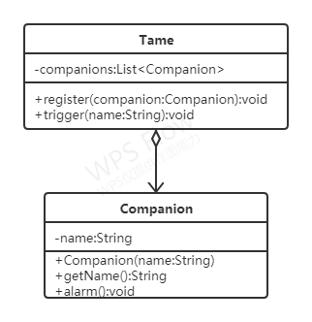

实验结果分析：
Tame中使用companions存储注册的Companion实例，当受到攻击时，调用trigger方法，遍历companions中的companion的alarm方法做出相应动作。
实验内容第（3）题--综合题第8题：
源代码：
package experiment7.state;
public class Game {
private State state;
public State getState() {
return state;
}
public void setState(State state) {
this.state = state;
}
public void play(int score, String result) {
state.display();
state.play(score, result);
}
public void doubleScore(int score, String result) {
state.display();
state.doubleScore(score, result);
}
public void changeCards() {
state.display();
state.changeCards();
}
public void peekCards() {
state.display();
state.peekCards();
}
}
abstract class State {
protected Game game;
protected int point;
protected String grade;
public void display() {
System.out.println(grade + ":");
}
public abstract void play(int score, String result);
public abstract void doubleScore(int score, String result);
public abstract void changeCards();
public abstract void peekCards();
public abstract void check();
}
class PrimaryState extends State {
public PrimaryState(Game game) {
this.point = 0;
this.grade = "入门级";
this.game = game;
}
public PrimaryState(State state) {
this.point = state.point;
this.grade = "入门级";
this.game = state.game;
}
@Override
public void play(int score, String result) {
if (result.equals("win")) {
this.point += score;
System.out.println("获胜，增加积分" + score + "当前积分" + point);
} else {
this.point -= score;
System.out.println("失利，减少积分" + score + "当前积分" + point);
}
check();
}
@Override
public void doubleScore(int score, String result) {
System.out.println("暂不支持该功能");
}
@Override
public void changeCards() {
System.out.println("暂不支持该功能");
}
@Override
public void peekCards() {
System.out.println("暂不支持该功能");
}
@Override
public void check() {
if (point >= 10000)
this.game.setState(new FinalState(this));
else if (point >= 5000)
this.game.setState(new ProfessionState(this));
else if (point >= 1000)
this.game.setState(new SecondaryState(this));
}
}
class SecondaryState extends State {
public SecondaryState(Game game) {
this.point = 1000;
this.grade = "熟练级";
this.game = game;
}
public SecondaryState(State state) {
this.point = state.point;
this.grade = "熟练级";
this.game = state.game;
}
@Override
public void play(int score, String result) {
if (result.equals("win")) {
this.point += score;
System.out.println("获胜，增加积分" + score + "当前积分" + point);
} else {
this.point -= score;
System.out.println("失利，减少积分" + score + "当前积分" + point);
}
check();
}
@Override
public void doubleScore(int score, String result) {
if (result.equals("win")) {
score *= 2;
this.point += score;
System.out.println("获胜，增加双倍积分" + score + "当前积分" + point);
} else {
score *= 2;
this.point -= score;
System.out.println("失利，减少双倍积分" + score + "当前积分" + point);
}
check();
}
@Override
public void changeCards() {
System.out.println("暂不支持该功能");
}
@Override
public void peekCards() {
System.out.println("暂不支持该功能");
}
@Override
public void check() {
if (point >= 10000)
this.game.setState(new FinalState(this));
else if (point >= 5000)
this.game.setState(new ProfessionState(this));
else if (point >= 1000)
this.game.setState(new SecondaryState(this));
}
}
class ProfessionState extends State {
public ProfessionState(Game game) {
this.point = 0;
this.grade = "高手级";
this.game = game;
}
public ProfessionState(State state) {
this.point = state.point;
this.grade = "高手级";
this.game = state.game;
}
@Override
public void play(int score, String result) {
if (result.equals("win")) {
this.point += score;
System.out.println("获胜，增加积分" + score + "当前积分" + point);
} else {
this.point -= score;
System.out.println("失利，减少积分" + score + "当前积分" + point);
}
check();
}
@Override
public void doubleScore(int score, String result) {
if (result.equals("win")) {
score *= 2;
this.point += score;
System.out.println("获胜，增加双倍积分" + score + "当前积分" + point);
} else {
score *= 2;
this.point -= score;
System.out.println("失利，减少双倍积分" + score + "当前积分" + point);
}
check();
}
@Override
public void changeCards() {
System.out.println("使用换牌功能");
}
@Override
public void peekCards() {
System.out.println("暂不支持该功能");
}
@Override
public void check() {
if (point >= 10000)
this.game.setState(new FinalState(this));
else if (point >= 5000)
this.game.setState(new ProfessionState(this));
else if (point >= 1000)
this.game.setState(new SecondaryState(this));
}
}
class FinalState extends State {
public FinalState(Game game) {
this.point = 0;
this.grade = "骨灰级";
this.game = game;
}
public FinalState(State state) {
this.point = state.point;
this.grade = "骨灰级";
this.game = state.game;
}
@Override
public void play(int score, String result) {
if (result.equals("win")) {
this.point += score;
System.out.println("获胜，增加积分" + score + "当前积分" + point);
} else {
this.point -= score;
System.out.println("失利，减少积分" + score + "当前积分" + point);
}
check();
}
@Override
public void doubleScore(int score, String result) {
if (result.equals("win")) {
score *= 2;
this.point += score;
System.out.println("获胜，增加双倍积分" + score + "当前积分" + point);
} else {
score *= 2;
this.point -= score;
System.out.println("失利，减少双倍积分" + score + "当前积分" + point);
}
check();
}
@Override
public void changeCards() {
System.out.println("使用换牌功能");
}
@Override
public void peekCards() {
System.out.println("使用他人的牌功能");
}
@Override
public void check() {
if (point >= 10000)
this.game.setState(new FinalState(this));
else if (point >= 5000)
this.game.setState(new ProfessionState(this));
else if (point >= 1000)
this.game.setState(new SecondaryState(this));
}
}
class Client {
public static void main(String[] args) {
Game game = new Game();
game.setState(new PrimaryState(game));
game.play(400,"win");
game.doubleScore(200,"win");
game.play(1000,"win");
game.changeCards();
game.doubleScore(3000,"win");
game.changeCards();
game.peekCards();
game.doubleScore(5000,"win");
game.peekCards();
game.doubleScore(5000,"lose");
game.peekCards();
}
}

运行结果：
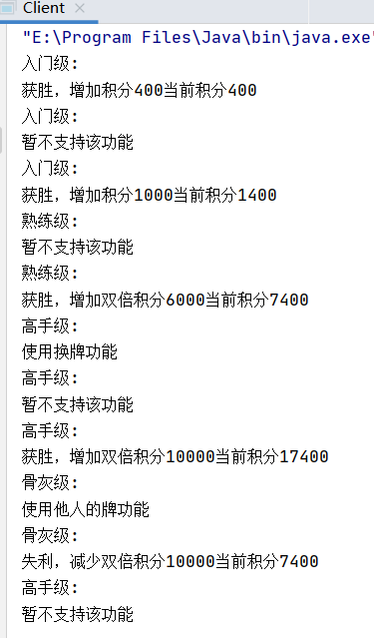
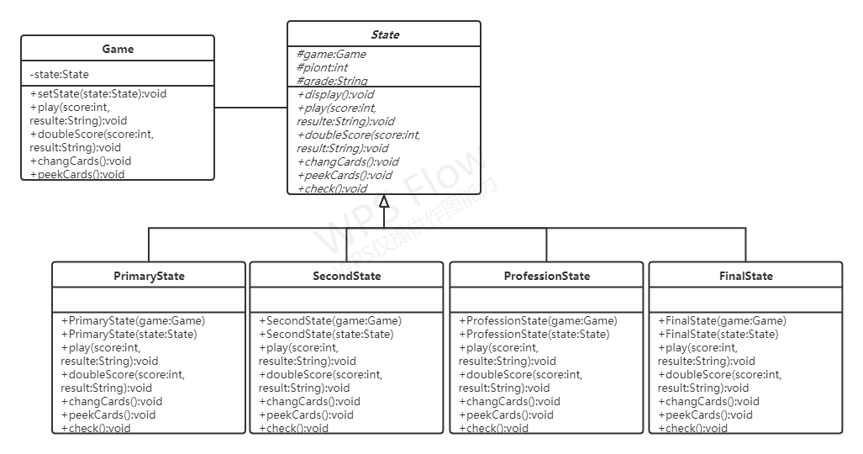

实验结果分析：
Game充当环境类，State为抽象状态类，PrimaryState,SecondState,ProfessionState,FinalState继承State为具体状态类。每一次积分改变时调用check方法检查是否需要改变状态。
实验内容第（3）题--综合题第9题：
源代码：
package experiment7.stratege;
public class Data {
private Decode decode;
private String name;
public Data(Decode decode,String name){
this.decode = decode;
this.name = name;
}
public void setDecode(Decode decode) {
this.decode = decode;
}
public void display(){
System.out.println("我是"+name);
decode.display();
}
}
interface Decode{
public void display();
}
class Kaisa implements Decode{
@Override
public void display() {
System.out.println("凯撒加密");
}
}
class EDS implements Decode{
@Override
public void display() {
System.out.println("EDS加密");
}
}
class Client{
public static void main(String[] args) {
Kaisa kaisa = new Kaisa();
EDS eds = new EDS();
Data data = new Data(kaisa,"数据1");
data.display();
System.out.println("---------第二种加密方式-------");
data.setDecode(eds);
data.display();
}
}

运行结果：
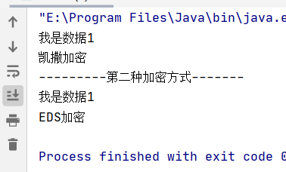

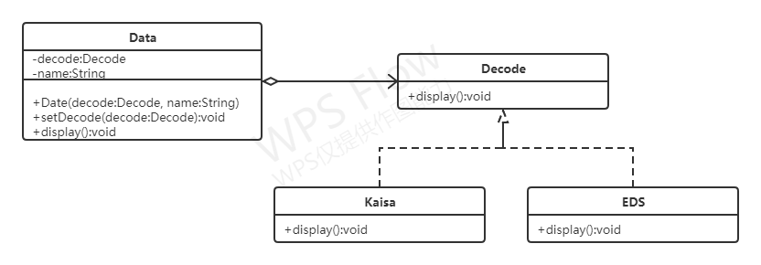
实验结果分析：
Decode为加密接口，Kaisa，EDS实现Decode实现具体加密方法，在Data中通过改变具体的Decode
子类实例，来改变加密方式。
实验内容第（3）题--综合题第10题：
源代码：
package experiment7.template;
public abstract class Bank {
public void display() {
openAccount();
count();
close();
}
public abstract void openAccount();
public abstract void count();
public abstract void close();
}
class CurrentAccount extends Bank{
@Override
public void openAccount() {
System.out.println("活期账户打开账户");
}
@Override
public void count() {
System.out.println("活期账户计算利息");
}
@Override
public void close() {
System.out.println("活期账户关闭账户");
}
}
class SavingAccount extends Bank{
@Override
public void openAccount() {
System.out.println("定期账户不打开账户");
}
@Override
public void count() {
System.out.println("定期账户计算利息");
}
@Override
public void close() {
System.out.println("定期账户不用关闭账户");
}
}
class Client{
public static void main(String[] args) {
Bank account = new CurrentAccount();
account.display();
System.out.println("---------定期账户-----------");
account = new SavingAccount();
account.display();
}
}

运行结果：
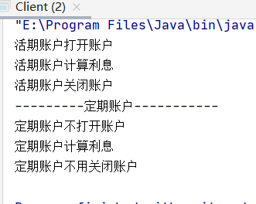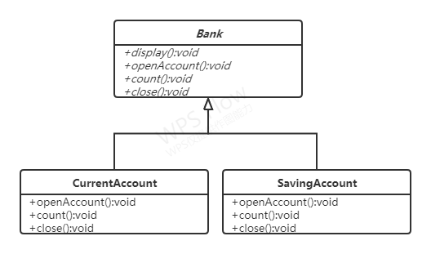

实验结果分析：
Bank为抽象类，定义模板方法display，CurrentAccount,SaviingAccount继承Bank，分别实现自己的openAccount，count，close方法。
实验内容第（3）题--综合题第11题：
源代码：
package experiment7.visitor;
import java.util.ArrayList;
import java.util.List;
public abstract class Department {
public abstract void visit(FulltimeEmployee employee);
public abstract void visit(ParttimeEmployee employee);
}
class FADepartment extends Department {
@Override
public void visit(FulltimeEmployee employee) {
int workTime = employee.getWorkTime();
double weekSlary = employee.getWeekSalary();
String name = employee.getName();
if (workTime > 40)
weekSlary = weekSlary + (workTime - 40) * 100;
else {
weekSlary = weekSlary - (40 - workTime) * 80;
if (weekSlary < 0) {
weekSlary = 0;
}
}
System.out.println("正式员工：" + name + "实际工资为：" + weekSlary);
}
@Override
public void visit(ParttimeEmployee employee) {
int workTime = employee.getWorkTime();
double hourSlary = employee.getHourSalary();
String name = employee.getName();
System.out.println("临时员工：" + name + "实际工资为：" + (workTime * hourSlary));
}
}
class HRDepartment extends Department {
@Override
public void visit(FulltimeEmployee employee) {
int workTime = employee.getWorkTime();
String name = employee.getName();
System.out.println("正式员工：" + name + "实际工作时间：" + workTime);
if (workTime > 40)
System.out.println("正式员工：" + name + "加班时间：" + (workTime - 40));
else {
System.out.println("正式员工：" + name + "请假时间：" + (40 - workTime));
}
}
@Override
public void visit(ParttimeEmployee employee) {
int workTime = employee.getWorkTime();
String name = employee.getName();
System.out.println("临时员工：" + name + "实际工作时间：" + workTime);
}
}
interface Employee {
public void accept(Department handler);
}
class FulltimeEmployee implements Employee {
private String name;
private double weekSalary;
private int workTime;
public FulltimeEmployee(String name, double weekSalary, int workTime) {
this.name = name;
this.weekSalary = weekSalary;
this.workTime = workTime;
}
public String getName() {
return name;
}
public void setName(String name) {
this.name = name;
}
public double getWeekSalary() {
return weekSalary;
}
public void setWeekSalary(double weekSalary) {
this.weekSalary = weekSalary;
}
public int getWorkTime() {
return workTime;
}
public void setWorkTime(int workTime) {
this.workTime = workTime;
}
@Override
public void accept(Department handler) {
handler.visit(this);
}
}
class ParttimeEmployee implements Employee {
private String name;
private double hourSalary;
private int workTime;
public ParttimeEmployee(String name, double hourSalary, int workTime) {
this.name = name;
this.hourSalary = hourSalary;
this.workTime = workTime;
}
public String getName() {
return name;
}
public void setName(String name) {
this.name = name;
}
public double getHourSalary() {
return hourSalary;
}
public void setHourSalary(double hourSalary) {
this.hourSalary = hourSalary;
}
public int getWorkTime() {
return workTime;
}
public void setWorkTime(int workTime) {
this.workTime = workTime;
}
@Override
public void accept(Department handler) {
handler.visit(this);
}
}
class EmployList {
private List<Employee> list = new ArrayList();
public void addList(Employee employee) {
list.add(employee);
}
public void accept(Department handler) {
for (Employee employee : list) {
employee.accept(handler);
}
}
}
class Client{
public static void main(String[] args) {
EmployList list = new EmployList();
Employee employee1 = new FulltimeEmployee("张三",400,43);
Employee employee2 = new FulltimeEmployee("李四",450,40);
Employee employee3 = new ParttimeEmployee("Lily",20,30);
Employee employee4 = new FulltimeEmployee("Mark",430,35);
Employee employee5 = new ParttimeEmployee("Jack",30,20);
list.addList(employee1);
list.addList(employee2);
list.addList(employee3);
list.addList(employee4);
list.addList(employee5);
FADepartment faDepartment = new FADepartment();
HRDepartment hrDepartment = new HRDepartment();
System.out.println("------财务部处理数据---------");
list.accept(faDepartment);
System.out.println("------人力资源部处理数据-------");
list.accept(hrDepartment);
}
}

运行结果：
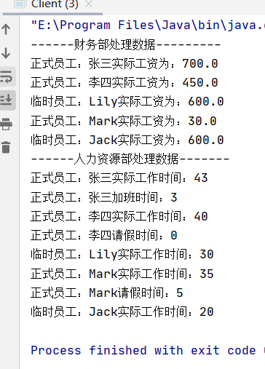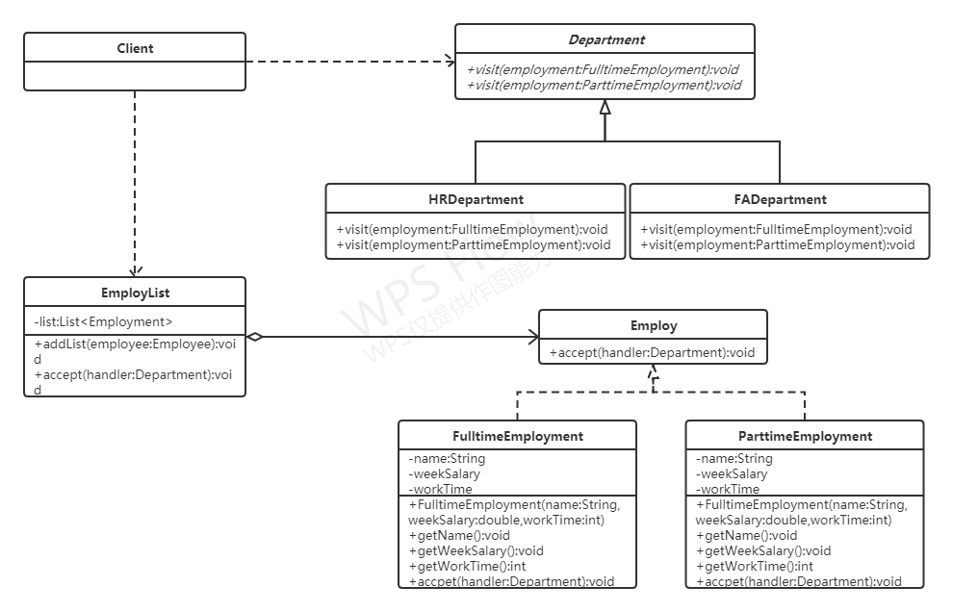

实验结果分析：
FADepartment表示财务部，HRDpartment表示人力资源部，他们充当具体访问者，Department充当抽象访问者，EmployList充当对象结构，存储员工列表，FulltimeEmployment充当正式员工，ParttimeEmployment充当临时员工，为具体元素角色Employ为抽象元素角色。
实验内容：
上课铃响了，同学们跑进教室去上课,老师走进了教室！你认为采用什么设计模式较合适，请说明理由。写出设计结果。

模式：使用观察者模式合适，铃声是被观察者，老师和学生是观察者，铃响则通知老师学生做出对应行为。
源代码：
package experiment7.Observe;
import java.util.ArrayList;
import java.util.List;
public class Bell {
private List<People> list = new ArrayList<>();
public void register(People people){
list.add(people);
}
public void trigger(){
for (People people : list) {
people.alarm();
}
}
}
interface People{
public void alarm();
}
class Teacher implements People{
@Override
public void alarm() {
System.out.println("我是老师我走进教师");
}
}
class Student implements People{
@Override
public void alarm() {
System.out.println("我是学生我跑进教师");
}
}
class Test{
public static void main(String[] args) {
Bell bell = new Bell();
Teacher teacher1= new Teacher();
Teacher teacher2 = new Teacher();
Student student1 = new Student();
Student student2 = new Student();
Student student3 = new Student();
Student student4 = new Student();
Student student5 = new Student();
bell.register(teacher1);
bell.register(teacher2);
bell.register(student1);
bell.register(student2);
bell.register(student3);
bell.register(student4);
bell.register(student5);
bell.trigger();
}
}

运行结果：
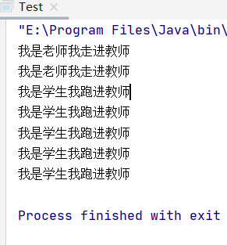
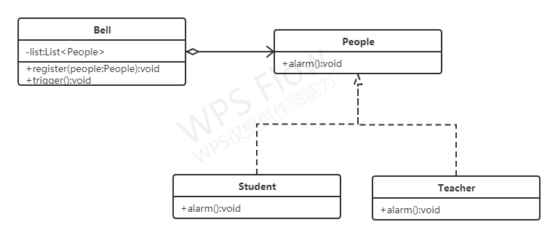
实验结果分析：
Bell为被观察者私有变量list存储观察者，register方法注册观察者，trigger方法通知观察者，接口Student,Teacher实现接口People的alarm方法为具体观察者。

