目录

Postman测试截图 2

查询结果 2

添加学生截图 3

添加成功 4

学生如果已经存在添加会报错 5

删除学生 6

删除成功 7

学生不存在删除失败 8

修改信息 9

修改成功 10

修改失败 11

查看学生 12

代码 12

Student 12

StudentDao 14

Store 14

StudentService 15

StudentServiceImpl 16

Controller 17

DemoApplication 19

# Postman测试截图

## 查询结果

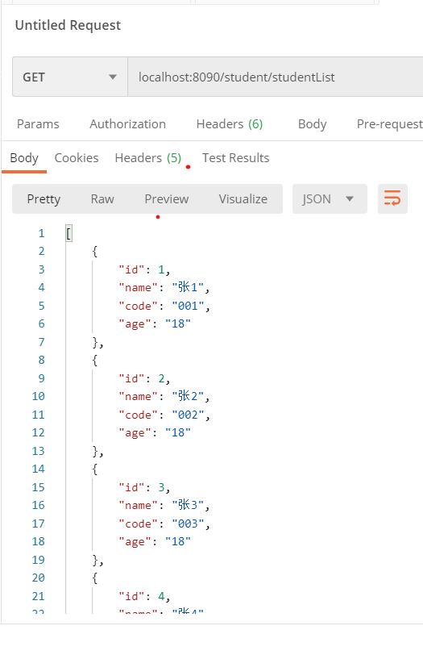

## 添加学生截图

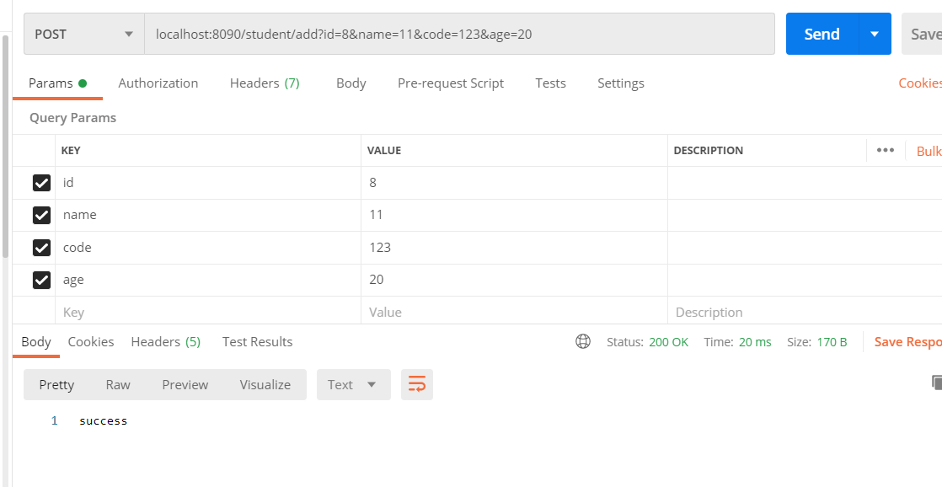

## 添加成功

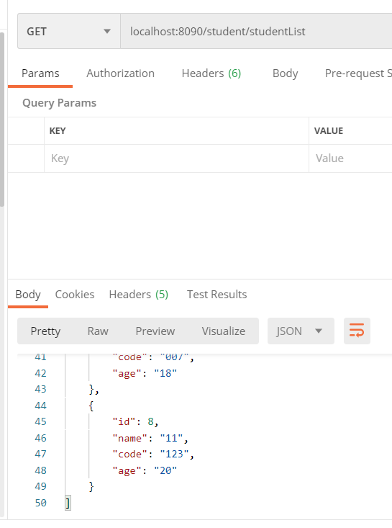

## 学生如果已经存在添加会报错

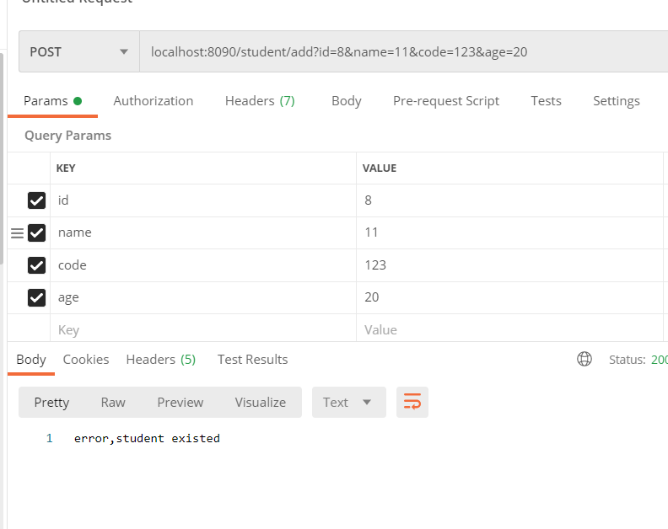

## 删除学生

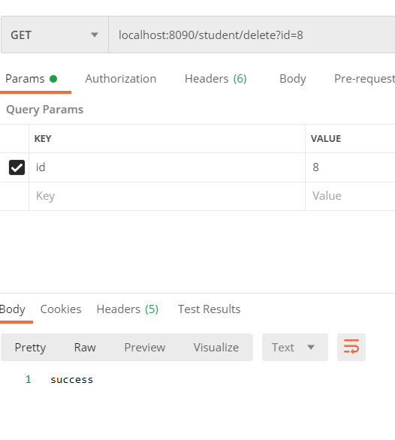

## 删除成功

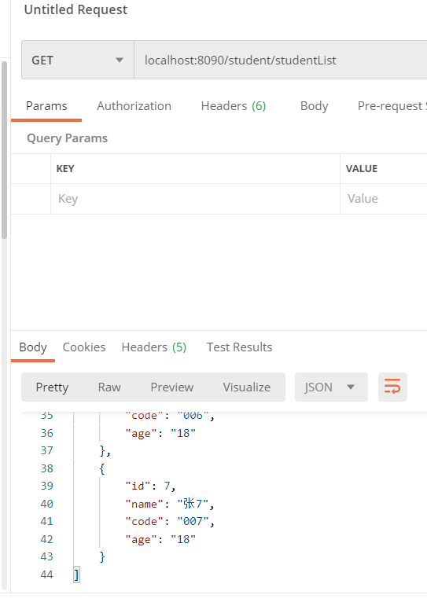

## 学生不存在删除失败

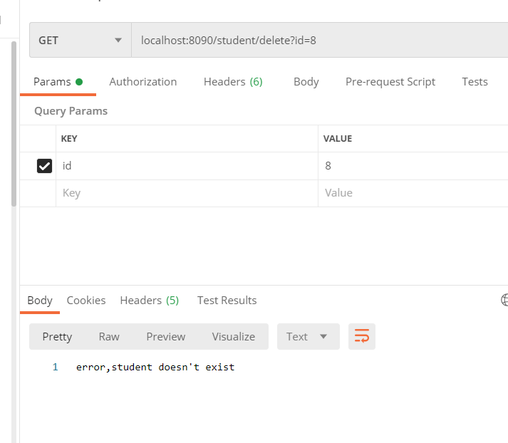

## 修改信息

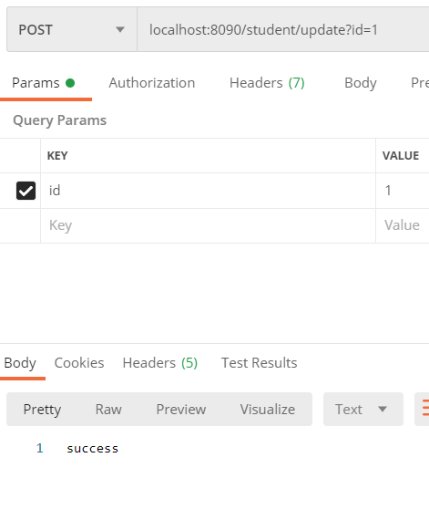

## 修改成功

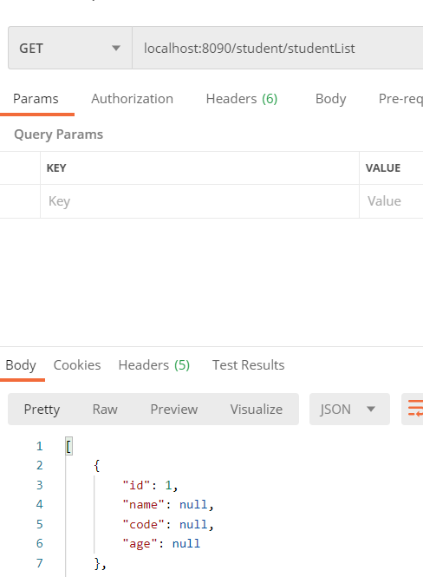

## 修改失败

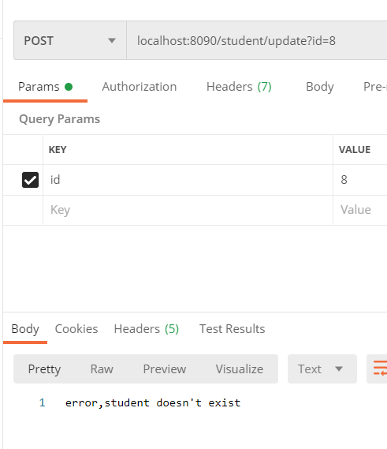

## 查看学生

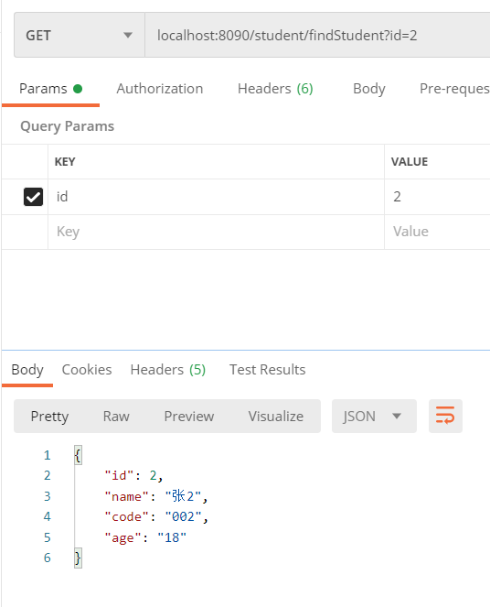

# 代码

## Student

package com.example.demo.module1.entity;  
  
public class Student {  
 private int id;  
 private String name;  
 private String code;  
 private String age;  
  
 public Student(int id, String name, String code, String age) {  
 this.id = id;  
 this.name = name;  
 this.code = code;  
 this.age = age;  
 }  
  
 public int getId() {  
 return id;  
 }  
  
 public void setId(int id) {  
 this.id = id;  
 }  
  
 public String getName() {  
 return name;  
 }  
  
 public void setName(String name) {  
 this.name = name;  
 }  
  
 public String getCode() {  
 return code;  
 }  
  
 public void setCode(String code) {  
 this.code = code;  
 }  
  
 public String getAge() {  
 return age;  
 }  
  
 public void setAge(String age) {  
 this.age = age;  
 }  
}

## StudentDao

package com.example.demo.module1.dao;  
  
import com.example.demo.module1.entity.Student;  
  
import java.util.List;  
  
public interface StudentDao {  
 public List<Object> findAll() ;  
 public Object findById(int id);  
 public Student add(Student student) ;  
 public void update(Student student);  
 public void delete(Student student);  
 public void delete(int id);  
  
  
}

## Store

package com.example.demo.module1.dao;  
  
import com.example.demo.module1.entity.Student;  
  
import java.util.*;  
  
public class Store implements StudentDao {  
 private static Map<Integer, Student> *Students* = new HashMap<>();  
  
 static {  
 *Students*.put(1, new Student(1, "张1", "001", "18"));  
 *Students*.put(2, new Student(2, "张2", "002", "18"));  
 *Students*.put(3, new Student(3, "张3", "003", "18"));  
 *Students*.put(4, new Student(4, "张4", "004", "18"));  
 *Students*.put(5, new Student(5, "张5", "005", "18"));  
 *Students*.put(6, new Student(6, "张6", "006", "18"));  
 *Students*.put(7, new Student(7, "张7", "007", "18"));  
 }  
  
  
 @Override  
 public List<Object> findAll() {  
 List<Object> students = new ArrayList<>();  
 Iterator<Student> iterator = *Students*.values().iterator();  
 while (iterator.hasNext()) {  
 students.add(iterator.next());  
 }  
 return students;  
 }  
  
 @Override  
 public Object findById(int id) {  
 return *Students*.get(id);  
 }  
  
 @Override  
 public Student add(Student student) {  
 return *Students*.put(student.getId(),student);  
 }  
  
 @Override  
 public void update(Student student) {  
 *Students*.put(student.getId(), student);  
 }  
  
 @Override  
 public void delete(Student student) {  
 *Students*.remove(student.getId());  
 }  
  
  
 @Override  
 public void delete(int id) {  
 *Students*.remove(id);  
 }  
}

## StudentService

package com.example.demo.module1.service;  
  
import com.example.demo.module1.entity.Student;  
import java.util.List;  
  
public interface StudentService {  
 public List<Object> findAll() ;  
 public Object findById(int id);  
 public String add(Student student) ;  
 public String update(Student student) ;  
 public String delete(Student student) ;  
 public String delete(int id);  
}

## StudentServiceImpl

package com.example.demo.module1.service;  
  
import com.example.demo.module1.dao.Store;  
import com.example.demo.module1.dao.StudentDao;  
import com.example.demo.module1.entity.Student;  
  
  
import java.util.List;  
  
public class StudentServiceImpl implements StudentService {  
 @Override  
 public List<Object> findAll() {  
 StudentDao dao = new Store();  
 return dao.findAll();  
 }  
  
 @Override  
 public Object findById(int id) {  
 StudentDao dao = new Store();  
 return dao.findById(id);  
 }  
  
 @Override  
 public String add(Student student) {  
 StudentDao dao = new Store();  
 Object student1 = dao.findById(student.getId());  
 if(student1!=null){  
 return "error,student existed";  
 }  
  
 dao.add(student);  
 return "success";  
 }  
  
 @Override  
 public String update(Student student) {  
 StudentDao dao = new Store();  
 Object student1 = dao.findById(student.getId());  
 if(student1 ==null){  
 return "error,student doesn't exist";  
 }  
 dao.update(student);  
  
 return "success";  
 }  
  
 @Override  
 public String delete(Student student) {  
 StudentDao dao = new Store();  
 Object student1= dao.findById(student.getId());  
 if(student1==null){  
 return "error,student doesn't exist";  
 }  
 dao.delete(student);  
 return "success";  
 }  
  
 @Override  
 public String delete(int id) {  
 StudentDao dao = new Store();  
 Object student1= dao.findById(id);  
 if(student1==null){  
 return "error,student doesn't exist";  
 }  
 dao.delete(id);  
 return "success";  
 }  
}

## Controller

package com.example.demo.module1.service;  
  
import com.example.demo.module1.dao.Store;  
import com.example.demo.module1.dao.StudentDao;  
import com.example.demo.module1.entity.Student;  
  
  
import java.util.List;  
  
public class StudentServiceImpl implements StudentService {  
 @Override  
 public List<Object> findAll() {  
 StudentDao dao = new Store();  
 return dao.findAll();  
 }  
  
 @Override  
 public Object findById(int id) {  
 StudentDao dao = new Store();  
 return dao.findById(id);  
 }  
  
 @Override  
 public String add(Student student) {  
 StudentDao dao = new Store();  
 Object student1 = dao.findById(student.getId());  
 if(student1!=null){  
 return "error,student existed";  
 }  
  
 dao.add(student);  
 return "success";  
 }  
  
 @Override  
 public String update(Student student) {  
 StudentDao dao = new Store();  
 Object student1 = dao.findById(student.getId());  
 if(student1 ==null){  
 return "error,student doesn't exist";  
 }  
 dao.update(student);  
  
 return "success";  
 }  
  
 @Override  
 public String delete(Student student) {  
 StudentDao dao = new Store();  
 Object student1= dao.findById(student.getId());  
 if(student1==null){  
 return "error,student doesn't exist";  
 }  
 dao.delete(student);  
 return "success";  
 }  
  
 @Override  
 public String delete(int id) {  
 StudentDao dao = new Store();  
 Object student1= dao.findById(id);  
 if(student1==null){  
 return "error,student doesn't exist";  
 }  
 dao.delete(id);  
 return "success";  
 }  
}

## DemoApplication

package com.example.demo;  
  
import org.springframework.boot.SpringApplication;  
import org.springframework.boot.autoconfigure.SpringBootApplication;  
import org.springframework.stereotype.Controller;  
import org.springframework.web.bind.annotation.RequestMapping;  
import org.springframework.web.bind.annotation.ResponseBody;  
  
@SpringBootApplication  
@Controller  
public class DemoApplication {  
  
 @RequestMapping("/")  
 @ResponseBody  
 String home() {  
 return "Hello World!";  
 }  
  
 public static void main(String[] args) {  
 SpringApplication.*run*(DemoApplication.class, args);  
 }  
  
}