材料的超导性质2（笔记）

零电阻：因为这对电子有相反的动量，其合成动量也是零。如果有许多库柏对形成，它们都将处于相同的状态——零动量。对于普通金属来说，单个电子会因电流而分散和丢失。对于超导体，只能同时改变所有Cooper对中的k。Cooper对可以分开，但这需要耗费2Δ，而且它们可能很快再次凝聚。在高电流密度下，有足够的能量将它们分解，在高磁场密度下也是如此。

超导能隙的测量：远红外波段光子的吸收。

Cooper对—--磁通量子化（正则动量）：应用于弱磁场的探测。平行磁场下超导圆筒的超导临界温度会出现周期振荡，即证明一个磁通量子需要两个电子来维持，即Cooper对的存在。

BCS理论的临界温度上限只能达到40K！

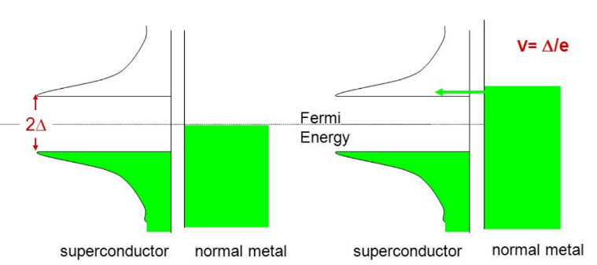

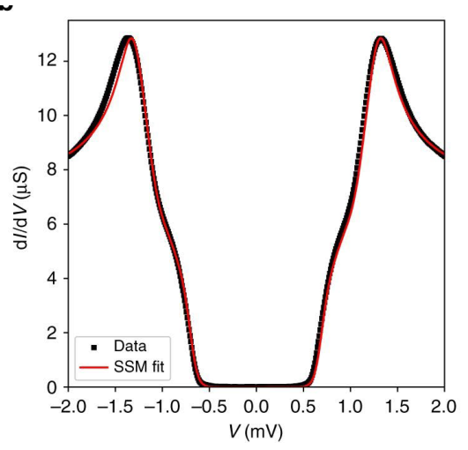

迈斯纳效应：磁场的穿透深度大约为100nm左右。穿透深度越大，Cooper对相干长度越小，超导临界温度越大。穿透深度与Cooper对相干长度之比小于0.71，为第一类超导体；之比大于0.71，为第二类超导体。其中第二类超导体可以允许以磁通量子形式穿过超导体。

约瑟夫森效应：一种横跨约瑟夫森结的超电流现象。约瑟夫森结由二个互相微弱连接的超导体组成，而这个微弱连结的组成结构可以是一个薄的绝缘层，一小段非超导金属或者是可弱化接触点超导性的狭窄部分。（可以用来测量普朗克常数，可连接起来作为电阻标准）

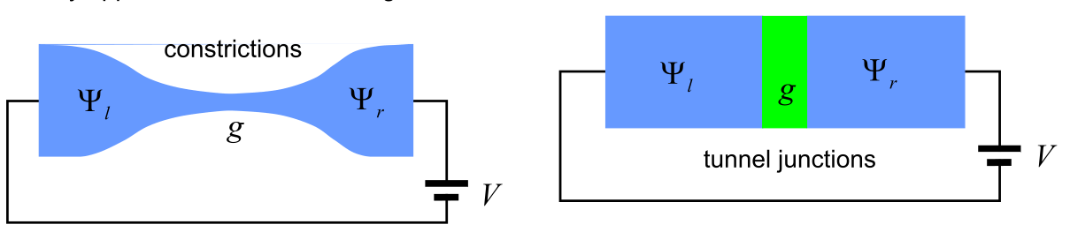

弱连接情况下电流与距离呈现指数衰减效应。直流电流测量I-V曲线会出现量子化的台阶。

超导量子干涉仪：两个约瑟夫森结构成的一个环。

高温超导体：临界温度超过MCMillan极限（40K）的超导体称为高温超导体。

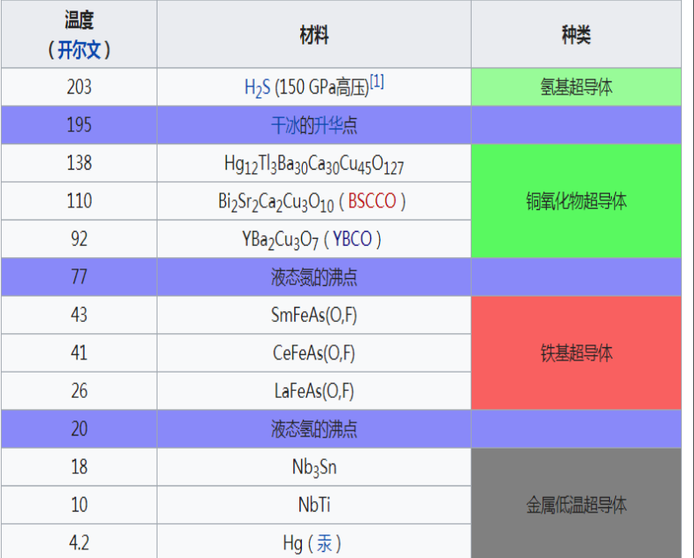

钙钛矿铁电材料（ABX3结构）

人民日报：

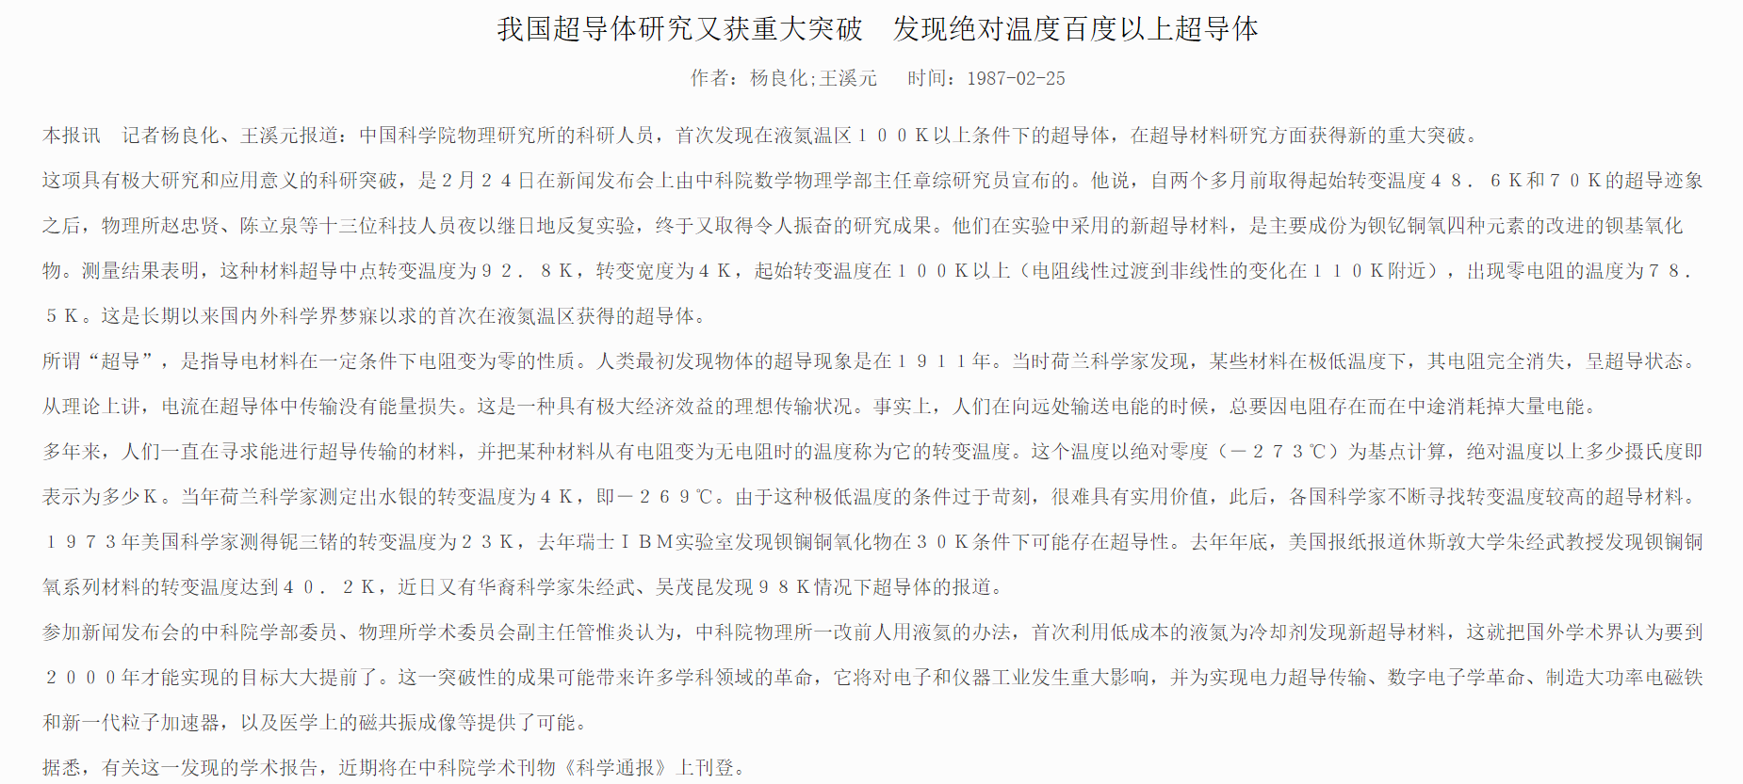

Bednorz[1]

I was born in Neuenkirchen, North-Rhine Westphalia, in the Federal Republic of Germany on May 16, 1950, as the fourth child of Anton and Elisabeth Bednorz. My parents, originating from Silesia, had lost sight of each other during the turbulences of World War II, when my sister and two brothers had to leave home and were moved westwards. I was a latecomer completing our family after its joyous reunion in 1949.

During my childhood, my father, a primary school teacher and my mother, a piano teacher, had a hard time to direct my interest to classical music. I was more practical-minded and preferred to assist my brothers in fixing their motorcycles and cars, rather than performing solo piano exercises. At school it was our teacher of arts who cultivated that practical sense and helped to develop creativity and team spirit within the class community, inspiring us to theater and artistic performances even outside school hours. I even discovered my interest in classical music at the age of 13 and started playing the violin and later the trumpet in the school orchestra.

My fascination in the natural sciences was roused while learning about chemistry rather than physics. The latter was taught in a more theoretical way, whereas in chemistry, the opportunity to conduct experiments on our own, sometimes even with unexpected results, was addressing my practical sense.

In 1968, I started my studies in chemistry at the University of Münster, but somehow felt lost due to the impersonal atmosphere created by the large number of students. Thus I soon changed my major to cristallography, that field of mineralogy which is located between chemistry and physics.

In 1972, Prof. Wolfgang Hoffmann and Dr. Horst Böhm, my teachers, arranged for me to join the IBM Zürich Research Laboratory for three months as a summer student. It was a challenge for me to experience how my scientific education could be applied in reality. The decision to go to Switzerland set the course for my future. The physics department of which I became a member was headed by K. Alex Müller, whom I met with deep respect. I was working under the guidance of Hans Jörg Scheel, learning about different methods of crystal growth, materials characterization and solid state chemistry. I soon was impressed by the freedom even I as a student was given to work on my own, learning from mistakes and thus losing the fear of approaching new problems in my own way.

After my second visit in 1973, I came to Rüschlikon for six months in 1974 to do the experimental part of my diploma work on crystal growth and characterization of SrTiO3, again under the guidance of Hans Jörg Scheel. The perovskites were Alex Müller’s field of interest and, having followed my work, he encouraged me to continue my research on this class of materials.

In 1977, after an additional year in Münster, I joined the Laboratory of Solid State Physics at the Swiss Federal Institute of Technology (ETH) in Zürich and started my Ph.D. thesis under the supervision of Prof. Heini Gränicher and K. Alex Müller. I gratefully remember the time at the ETH and the family-like atmosphere in the group, where Hanns Arend provided a continuous supply of ideas. It was also the period during which I began to interact more closely with Alex and reamed about his intuitive way of thinking and his capability of combining ideas to form a new concept.

In 1978, Mechthild Wennemer followed me to Zürich to start her Ph.D. at the ETH, but more importantly to be my partner in life. I had met her in 1974 during our time together at the University of Münster. Since then she has acted as a stabilizing element in my life and is the best adviser for all decisions I make, sharing the up’s and down’s in an unselfish way.

I completed my work on the crystal growth of perovskite-type solid solutions and investigating them with respect to structural, dielectric and ferroelectric properties, and joined IBM in 1982. This was the end of a ten-year approach which had begun in 1972.

The intense collaboration with Alex started in 1983 with the search for a high-TC superconducting oxide; in my view, a long and thorny but ultimately successful path. We both realized the importance of our discovery in 1986, but were surprised by the dramatic development and changes in both the field of science and in our personal lives.

This autobiography/biography was written at the time of the award and first published in the book series [*Les Prix Nobel*](https://www.nobelprize.org/nobel_organizations/nobelfoundation/publications/lesprix.html). It was later edited and republished in [*Nobel Lectures*](https://www.nobelprize.org/nobel_organizations/nobelfoundation/publications/lectures/index.html). To cite this document, always state the source as shown above.

即J. Georg Bednorz在1974年开始做钙钛矿氧化物晶体的生长与表征工作，1982年加入IBM，1983年开始与Muller一起研究其此类氧化物的超导特性。

K. Alex Müller[2]

Iwas born in Basel, Switzerland, on 20th April 1927. The first years of my life were spent with my parents in Salzburg, Austria, where my father was studying music. Hereafter, my mother and I moved to Dornach near Basle to the home of my grandparents, and from there to Lugano in the italian-speaking part of Switzerland. Here, I attended school and thus became fluent in the Italian language.

My mother died when I was eleven years old, and I attended the Evangelical College in Schiers, situated in a mountain valley in eastern Switzerland. I remained there until I obtained my baccalaureate (Mature) seven years later. This means I arrived in Schiers just before the Second World War started, and left just after it terminated. This was indeed quite a unique situation for us youngsters. Here, in a neutral country, we followed the events of the war worldwide, even in discussion groups in the classes. These college years in Schiers were of significance for my career.

The school was liberal in the spirit of the nineteenth century, and intellectually quite demanding. We were also very active in sports, I especially so in alpine skiing. In my spare time, I became quite involved in building radios and was so fascinated that I really wanted to become an electrical engineer. However, in view of my abilities, my chemistry tutor, Dr. Saurer, eventually convinced me to study physics.

At the age of 19, I did my basic military training in the Swiss army. Upon its completion, I enrolled in the famous Physics and Mathematics Department of the Swiss Federal Institute of Technology (ETH) in Zürich. Our freshman group was more than three times the normal size. We were called the “atombomb semester”, as just prior to our enrollment nuclear weapons had been used for the first time, and many students had become interested in nuclear physics. The basic course was taught by Paul Scherrer and his vivid demonstrations had a lasting effect on my approach to physics. Other courses were in part not as illuminating, so that, despite good grades, I once seriously considered switching to electrical engineering. However, Dr. W. Kanzig, responsible for the advanced physics practicum, convinced me to continue. In the later semesters, [Wolfgang Pauli](https://www.nobelprize.org/nobel_prizes/physics/laureates/1945/index.html), whose courses and examinations I took, formed and impressed me. He was truly a wise man with a deep understanding of nature and the human being. I did my diploma work under Prof. G. Busch on the Hall effect of grey tin, now known as a semimetal, and, prompted by his fine lectures, also became acquainted with modern solid-state physics.

After obtaining my diploma, following my interest in applications, I worked for one year in the Department of Industrial Research (AFIF) of the ETH on the Eidophor large-scale display system. Then I returned to Prof. Busch’s group as an assistant and started my thesis on paramagnetic resonance (EPR). At one point, Dr. H. Granicher suggested I look into the, at that time, newly synthesized double-oxide SrTiO3. I found and identified the EPR lines of impurity present in Fe3+.

In spring of 1956, just before starting the latter work, Ingeborg Marie Louise Winkler became my wife. She has always had a substantial influence in giving me confidence in all my undertakings, and over the past 30 years has been my mentor and good companion, always showing interest in my work. Our son Eric, now a dentist, was born in the summer of 1957, six months before I submitted my thesis.

After my graduation in 1958, I accepted the offer of the Battelle Memorial Institute in Geneva to join the staff. I soon became the manager of a magnetic resonance group. Some of the more interesting investigations were conducted on layered compounds, especially on radiation damage in graphite and alkalimetal graphites. The general manager in Geneva, Dr. H. Thiemann, had a strong personality, and his ever-repeated words “one should look for the extraordinary” made a lasting impression on me. Our stay in Geneva was most enjoyable for the family, especially for two reasons: the charm of the city and the birth of our daughter Silvia, now a kindergarten teacher.

While in Geneva, I became a Lecturer (with the title of Professor in 1970) at the University of Zürich on the recommendation of Prof. E. Brun, who was forming a strong NMR group. Owing to this lectureship, Prof. A.P. Speiser, on the suggestion of Dr. B. Luthi, offered me a position as a research staff member at the IBM Zürich Research Laboratory, Rüschlikon, in 1963. With the exception of an almost two-year assignment, which Dr. J. Armstrong invited me to spend at IBM’s Thomas J. Watson Research Center in Yorktown Heights, N.Y., I have been here ever since. For almost 15 years, research on SrTiO3 and related perovskite compounds absorbed my interest: this work, performed with Walter Berlinger, concerned the photochromic properties of various doped transition-metal ions and their chemical binding, ferroelectric and soft-mode properties, and later especially critical and multicritical phenomena of structural phase transitions. In parallel, Dr. Heinrich Rohrer was studying such effects in the antiferromagnetic system of GdAlO3. It was an intense and also, from a personal point of view, happy and satisfying time. While I was on sabbatical leave at the Research Center, he and [Dr. Gerd Binnig](https://www.nobelprize.org/nobel_prizes/physics/laureates/1986/index.html) started the Scanning Tunneling Microscope (STM) project. Just before leaving for the USA, I had been involved in the hiring of Dr. Binnig. Upon my return to Rüschlikon, I closely followed the great progress of the STM project, especially as from 1972 onwards, I was in charge of the physics groups.

The desire to devote more time to my own work prompted me to step down as manager in 1985. This was possible because in 1982 the company had honored me with the status of IBM Fellow. The ensuing work is summarized in Georg Bednorz’s part of the Lecture. As he describes there, he joined our Laboratory to pursue his diploma work, on SrTiO3 of course! Ever since making his acquaintance, I have deeply respected his fundamental insight into materials, his human kindness, his working capacity and his tenacity of purpose!

即Muller一直在研究高温超导体，然后1983年Bednorz加入课题过后开始研究之前Bednorz研究过的氧化物的超导特性，因此发现了高温超导体。

1. 1987年诺贝尔物理学奖得主J. Georg Bednorz演讲
2. 1987年诺贝尔奖得主K. Alex Müller演讲