# **RPI Events**

Organizing and promoting events on campus often poses a significant challenge. Traditional methods such as discord announcements and physical posters, while prevalent, fall short in providing an effective and streamlined approach to event advertising. In response to these challenges, our project, RPI Events, aims to revolutionize campus event management by creating a centralized platform that caters to the diverse needs of the RPI community. The existing methods of advertising events on campus are cumbersome and inefficient. Discord announcements may get lost in the constant flow of messages, and physical posters have limited reach. This results in a lack of visibility for events and can hinder the overall success of these gatherings. Additionally, event organizers face difficulties in estimating attendance, leading to challenges in planning logistics effectively. The existing methods of advertising events on campus are cumbersome and inefficient. Discord announcements may get lost in the constant flow of messages, and physical posters have limited reach. This results in a lack of visibility for events and can hinder the overall success of these gatherings. Additionally, event organizers face difficulties in estimating attendance, leading to challenges in planning logistics effectively. Through our project, we aim to create a comprehensive online hub where club members, board members, sports clubs, organizations, faculty, staff, and students can post and discover upcoming events on campus. By providing a dedicated platform, RPI Events will significantly improve the visibility of events, ensuring that important information reaches a wider audience in a more organized manner. The website will be designed with a user-friendly interface, making it easy for event organizers to post details and for students to discover and register for events of interest. Students will have the ability to register for events, enabling organizers to gauge interest and plan accordingly. This feature will contribute to more accurate event planning and execution. By restricting access to RPI students only, RPI Events ensures a secure and trustworthy environment. This measure not only enhances user safety but also fosters a sense of community within the platform. Through this project, we hope to elevate the visibility of events on campus, by reaching a broader audience and increasing attendance. The ability to estimate attendance through student registrations will empower event organizers to plan logistics more effectively, leading to better-executed events. Creating a centralized platform for RPI students fosters a sense of community, bringing together diverse groups and individuals with shared interests. RPI Events is not just a website; it's a solution to the challenges faced by the RPI community in event management. By leveraging technology to create a user-friendly and secure platform, we aim to transform the way events are organized and promoted on campus, ultimately enriching the overall campus experience for RPI students.

**Stakeholders**

In this web application the stakeholders and the users are the same. This is because we want to limit the usage outside of RPI. Thus the only people we expect to use this site are RPI students, parents, faculty, and potential RPI outsiders that were invited to hold a one time event.

The students will greatly benefit from this site by being able to know what events are happening which day. These opportunities allow the students to socialize with people of similar interests and allow the student to pursue workshops to supplement their classes. Furthermore, this will allow the student to plan ahead knowing that an assignment is due on Friday, but they also want to go to an event on Thursday. Thus a reasonable goal is to finish that assignment before the event on Thursday. Our web app will foster learning, socializing, and time management in RPI students.

Club officers, too, would benefit greatly from this web application. They can promote their events to all of RPI quickly without stepping out into the freezing cold to put up posters. Moreover, club officers can see what other clubs are happening at the same time to avoid losing attendance. For example, if ITWS has a pizza party going on, and ACM-W invited a professor to speak about AI and blockchains, then the attendance would be split between the two events. Instead of splitting the attendance, the club officer could simply schedule the event for a different day allowing people interested in both events to be able to attend both, and allowing the officer’s event to be more successful.

Lastly, parents always worry about their kids, and being able to see the things that are happening on campus allows them to worry less. On top of that, they are able to be a little more involved in the children’s life. Then instead of asking questions that lead to dry responses such as “How was school?” they can ask about the different events their kid has attended. RPI events is extraordinarily beneficial for RPI students, parents, and club officers.

**Technologies**

For our frontend, we will be using HTML, CSS, Bootstrap, JavaScript, jQuery, Shibboleth/OAuth, and one of React and Angular. HTML will be used to layout our pages, and one of React and Angular will aid in that by letting us packaging HTML into components instead. CSS and Bootstrap will be used to style all of our pages. We will mainly be using Bootstrap to style everything, using CSS whenever there's any particular changes that we want to make. JavaScript and jQuery will be used for any front-end logic that we need to enhance the user experience and aid in updating our page. Along with that, we will also be using RPI's Shibboleth/OAuth service to restrict users of RPI Events and the Nylas Calendar API to create and update the calendar in the user dashboard.

For our backend, we will be using Node.js, Express.js, and MongoDB. We will use Node.js as our server, Express.js to handle API requests, and MongoDB to store all data relating to RPI Events.

To manage this project, we will be using GitHub Issues and GitHub Projects to keep track of what features need to be implemented, who's working on what feature, and what features have already been completed.

**Functional Requirements**

The functional requirements of RPI Events include a login system, an events and sign up form, a general events page, a user feed, a user dashboard, and an events rating system.

A login system will be needed since only users should be allowed to sign up for and create events. Once users are logged in, in order to sign up for events and create events, there will need to be forms that the user can fill out to give any necessary details about themselves to event organizers (name, RIN/RCS, etc) or to give details about the event being held (time, location, duration, description, is it a recurring event, etc).

To view all the events on RPI Events, there needs to be a general events page where users can view any events happening on campus. But since a user may only be interested in certain kinds of events, there will also be a user feed showing events that the user may find interesting. Once users have signed up for events, they will be able to view what they've signed up for on the user dashboard. On the dashboard, users can view events they've signed up for either as a list or on a calendar, similar to RPI EMS. This will also allow the user to see any events they've signed up for with conflicting/overlapping times.

To give event organizers feedback on the events they've hosted, there will be a ratings system that attendees can use to rate an event once the event has concluded. This way, organizers can know how to improve and what they've been doing right.

Lastly, we will have an API that developers can query to get data about events at RPI. They will be able to get data about events during a time period, how many people have registered, the location of the event, and more. They will also be able to query the API to get events in specific locations or events hosted by specific organizers.

**Nonfunctional Requirements**

In order to restrict users to RPI students and staff, the login system will be implemented with RPI OAuth/Shibboleth. This way, only users with active RINs will be able to sign up for events. Furthermore, to verify event organizers, we will have a place for logged in users to submit a request to be verified as an organizer. There, they will have to fill out details about what organization they're a part of (clubs, teams, etc) and who we can contact to verify them (faculty advisors, coaches, etc). Event organizers would have to be verified at the beginning of each year to ensure that they're still a part of their organization(s).

Once users are logged in, they will be greeted with their dashboard. The user will be able to see all the events they've signed up for on a calendar, which will be made with the Nylas Calendar API. If the user is also an event organizer, they will be able to see any events they're hosting on the calendar.

On the general events page, users will be able to view events in different ways. By default, events will be shown by popularity, but these events can be sorted by a tag. All events will be required to have at least on tag, such as "Club", "Sports", "Academics", etc. Then once a user has signed up for an event, we can keep track of that and use the tags of events that the user has signed up for to determine events they may be interested in to show on their feed.

When event organizers create events on RPI Events, they may have other places where they want people to sign up for their event, such as Handshake or a Google form. So, they will have the option to have users sign up externally and have a link to their sign up form, similar to LinkedIn and external applications.

**Estimated Project Schedule**

* **Jan**
  + **Early**
    - **Brainstorming session to gather and refine ideas**
    - **Identify key features and functionalities for the web app**
  + **Mid**
    - **Finalize the project idea based on the brainstorming session.**
    - **Complete the project proposal document, including the project summary, user requirements, stakeholders, technology stack, and initial wireframes.**
* **Feb**
  + **Early**
    - **Start coding the front end of the web app.**
    - **Develop the initial version of key pages, including index, login page, user profile, home page, and friend log.**
  + **Mid**
    - **Continue front-end development to complete the functional front end.**
    - **Implement additional pages as needed, ensuring a user-friendly interface.**
    - **Begin implementing the back end of the web app**
* **March**
  + **Early**
    - **Develop the necessary APIs to support user authentication, event creation, sign-up, and other core functionalities.**
    - **Set up the database (MongoDB) and establish connections with the backend.**
    - **Work on the calendar dashboard, ensuring it accurately displays events and conflicts.**
  + **Mid**
    - **Implement features to support organizers, allowing them to create events, manage attendees, and access event-related data.**
    - **Create endpoints for user registration, login, and user profile management.**
    - **Implement data validation and input sanitations and error handling to ensure robustness.**
* **April**
  + **Early**
    - **Enhance the backend to include features like a notification system for event updates.**
    - **Implement logic for the user feed, ensuring it dynamically populates with relevant event suggestions.**
    - **Conduct thorough testing of the backend components to identify and address any issues.**
  + **Mid**
    - **Finalize backend development, addressing any remaining bugs or performance issues.**
    - **Prepare for the final presentation by creating comprehensive documentation and presentation materials.**
    - **Create documentation for the web app, including user guides and developer documentation.**

**Site Map**

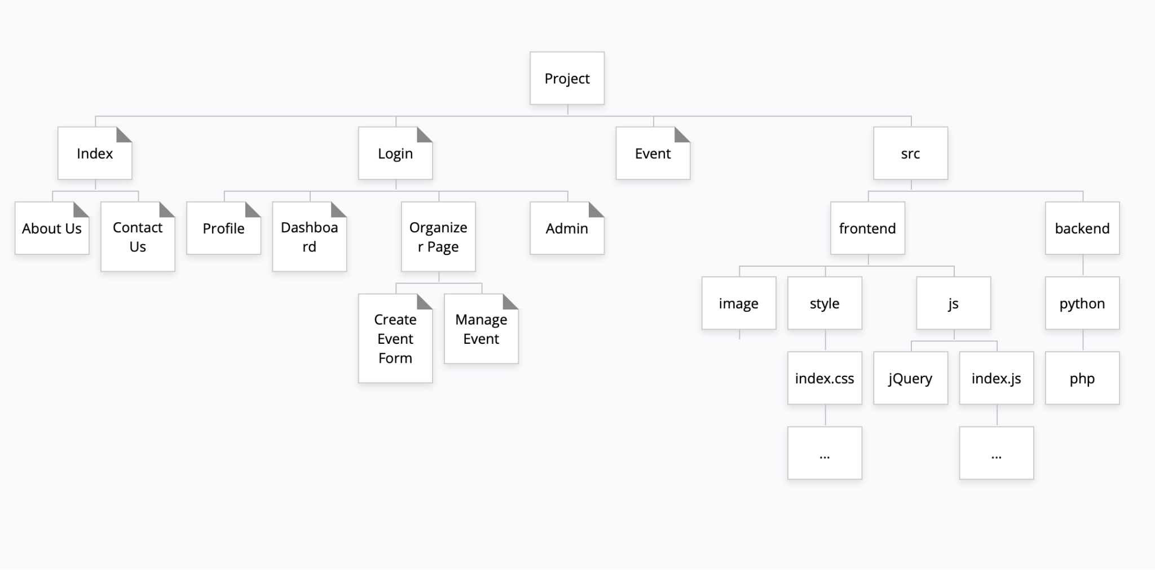

**Wire Frames**

