 | FPT ACADEMY INTERNATIONAL  FPT – APTECH COMPUTER EDUCATION
_________________________________________________________________________________________________________

[PROJECT NAME]

Supervisor. | [TO BE FILLED]
Batch. | [TO BE FILLED]
Group. | [TO BE FILLED]
Serial No. | Student Name | Enrollment Number
1 | [TO BE FILLED] | [TO BE FILLED]
2 | [TO BE FILLED] | [TO BE FILLED]
3 | [TO BE FILLED] | [TO BE FILLED]
4 | [TO BE FILLED] | [TO BE FILLED]

Month [TO BE FILLED] Year [TO BE FILLED]

CONTENT
REVIEW 1........................................................................3
ACKNOWLEDGE.....................................................................3
INTRODUCTION....................................................................3
PROBLEM DEFINITION..............................................................4
CUSTOMER'S REQUIREMENTS SPECIFICATIONS (CRS)....................................4
SCOPE OF WORK...................................................................6
HARDWARE / SOFTWARE REQUIREMENTS................................................6
TASK SHEET REVIEW 1.............................................................8
REVIEW 2........................................................................9
DATA FLOW DIAGRAMS..............................................................9
ENTITY RELATIONSHIP DIAGRAM.....................................................15
DATA MODEL DESIGN...............................................................16
PAGE AND ROUTE SPECIFICATIONS...................................................22
TASK SHEET REVIEW 2.............................................................23

REVIEW 1
ACKNOWLEDGE
Our group would like to express sincere appreciation to our instructor, [TO BE FILLED], for guidance and encouragement during this project. We also thank FPT Aptech for the opportunity to apply React, Node.js, MongoDB and 3D web technologies in a practical product.
We appreciate the support of our classmates and all team members. Their feedback helps the group improve both the user experience and the technical quality of the system.
INTRODUCTION
[PROJECT NAME] is an online furniture and decoration website designed mainly for students, learners and people with small private rooms. The website combines a traditional product catalog and cart with a 3D room where users can preview furniture before making a decision.
- Visitors can browse the homepage and product list.
- Visitors can search and filter furniture products.
- Users can add, update or remove products in the cart.
- Login is displayed as a modal on the current page; it does not open a separate login page.
- Users can open the 3D room to place supported furniture models.
- Administrators can access the management page only after an admin account is authenticated.
- Unknown routes display the 404 page.

PROBLEM DEFINITION
Students and people living in small rooms often find it difficult to determine whether furniture is suitable in size, style and arrangement. Standard stores show product images but do not help users understand the product in a room context. The system therefore combines clear shopping functions with a simple 3D preview.
FROM THE VIEW POINT OF VISITORS
- The homepage introduces suitable furniture and featured categories.
- The product page supports search, filter and product information.
- The cart allows quantity updates and item removal.
- The login modal opens on top of the current page.
- The 3D room displays supported furniture models.
- A clear 404 page handles invalid routes.
FROM THE VIEW POINT OF THE ADMINISTRATOR
- Admin can manage products, categories, stock and 3D model links.
- Admin can view and manage user accounts.
- The admin route is protected by authentication and role checking.
CUSTOMER'S REQUIREMENTS SPECIFICATIONS (CRS)
Client: [TO BE FILLED]. Business objective: build an easy-to-use furniture website that helps users find products, manage a cart and preview supported items in a 3D room.

INPUT, PROCESS AND OUTPUT
INPUT TO THE SYSTEM
- Admin provides product names, prices, stock, category, images, dimensions and optional GLB/GLTF model URLs.
- Customer provides login credentials and cart actions.
- Room 3D receives room dimensions and product placement values.
PROCESS FROM THE SYSTEM
- Authenticate accounts and identify customer/admin role.
- Load and search product data from MongoDB.
- Add, update and remove cart items.
- Load 3D models and update position, rotation and color.
- Allow admin CRUD operations on managed data.
OUTPUT FROM THE SYSTEM
- Homepage and filtered product list.
- Current cart information.
- Interactive 3D room preview.
- Admin management information.
- 404 response for unknown pages.

SCOPE OF WORK
LOGIN
There are two account roles: customer and admin. Login is a modal component displayed over the current page. A successful admin login reveals the Admin navigation item and permits access to /admin. Customer accounts cannot access this route.
PRODUCTS AND CART
Visitors can browse products. The cart supports adding products, viewing quantity and removing items. Checkout is not defined as a separate page in the current scope.
3D ROOM
The 3D room loads approved GLB/GLTF assets. Supported products can be placed, moved, rotated and recolored. Product dimensions use centimeters while scene dimensions use meters.
DATABASE
MongoDB stores users, categories, products, carts and saved room designs. Image and 3D asset URLs are stored as strings; large asset files should be served from public storage or a CDN.
HARDWARE REQUIREMENTS
Area | Processor | Memory | Display / Network
Web server | 2 cores or higher | 4 GB or higher | Internet access
Client | Intel Core i3 or equivalent | 4 GB or higher | 1280×720, WebGL, Internet

SOFTWARE REQUIREMENTS
Area | Requirement
Server OS | Windows 11, Linux or supported cloud platform
Client browser | Google Chrome, Microsoft Edge or another modern WebGL browser
Database | MongoDB / MongoDB Atlas
Frontend | React, Vite, Tailwind CSS, Three.js / React Three Fiber
Backend | Node.js, Express, Mongoose, JWT
Development | Visual Studio Code, Git, npm
TECHNOLOGY
- ReactJS and React Router for pages and routes.
- Tailwind CSS and theme.css for interface standards.
- Three.js, React Three Fiber and Drei for the 3D room.
- Node.js and Express for the REST API.
- MongoDB and Mongoose for data storage.
- JWT and bcrypt for authentication.

TASK SHEET REVIEW 1
No. | Task | Start Date | Days | Team Member | Status
1 | Acknowledgment and Introduction | [TO BE FILLED] | [TO BE FILLED] | [TO BE FILLED] | Planned
2 | Problem Definition and CRS | [TO BE FILLED] | [TO BE FILLED] | [TO BE FILLED] | Planned
3 | Scope and Requirements | [TO BE FILLED] | [TO BE FILLED] | [TO BE FILLED] | Planned
4 | Task Sheet | [TO BE FILLED] | [TO BE FILLED] | [TO BE FILLED] | Planned
Date: [TO BE FILLED]
Signature of Instructor: [TO BE FILLED]
Signature of Team Leader: [TO BE FILLED]

REVIEW 2
1. DATA FLOW DIAGRAM (DFD)
LEVEL 0 — CONTEXT DIAGRAM
The context diagram presents the system as one process and shows data exchanged with Guests, Customers and Administrators.
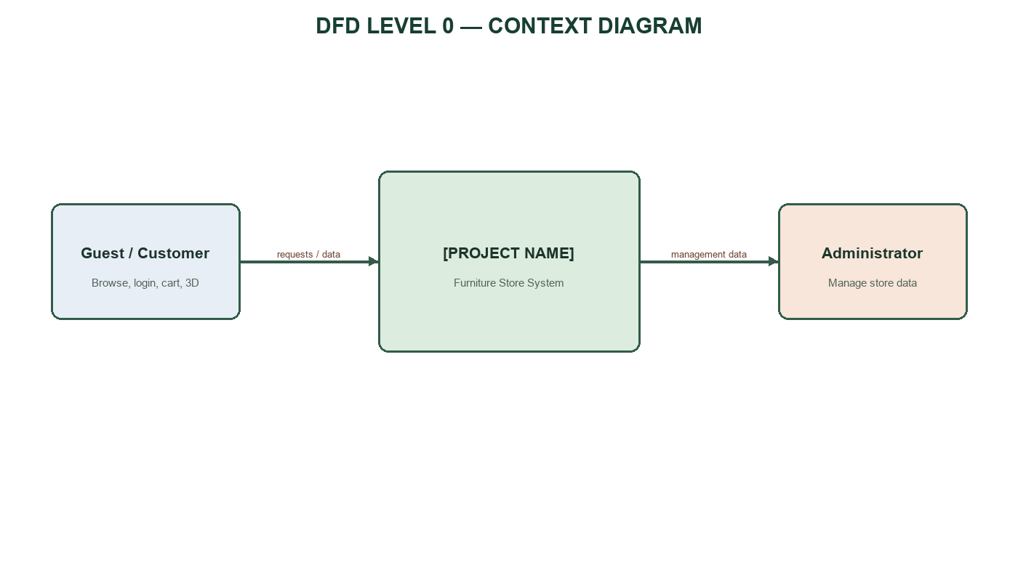

LEVEL 1 — FUNCTIONAL OVERVIEW
The system is decomposed into user authentication, product browsing, cart management, 3D room and administration.
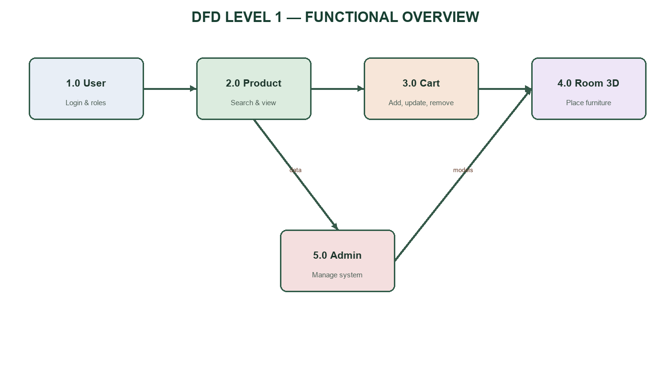

LEVEL 2 — USER & ROLE MANAGEMENT
The login form is a modal on the current page. The backend verifies credentials and returns the user role.
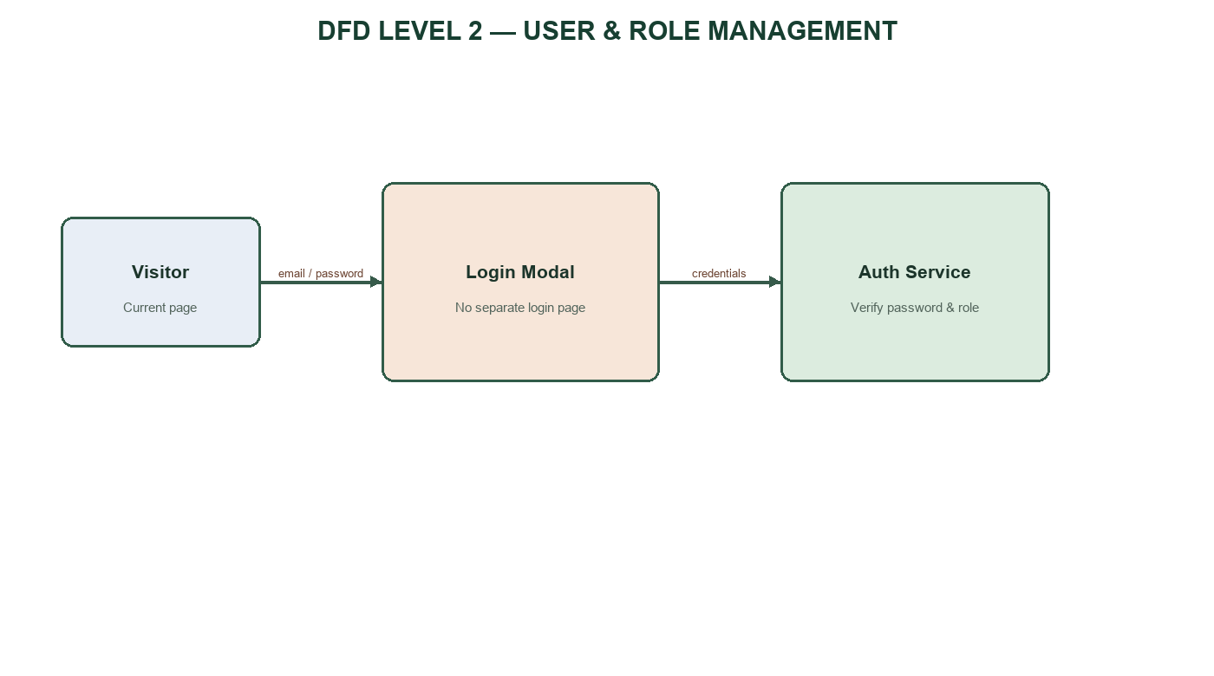

LEVEL 2 — SEARCH AND VIEW PRODUCTS
Visitors browse, search and view product information before adding a product to the cart.
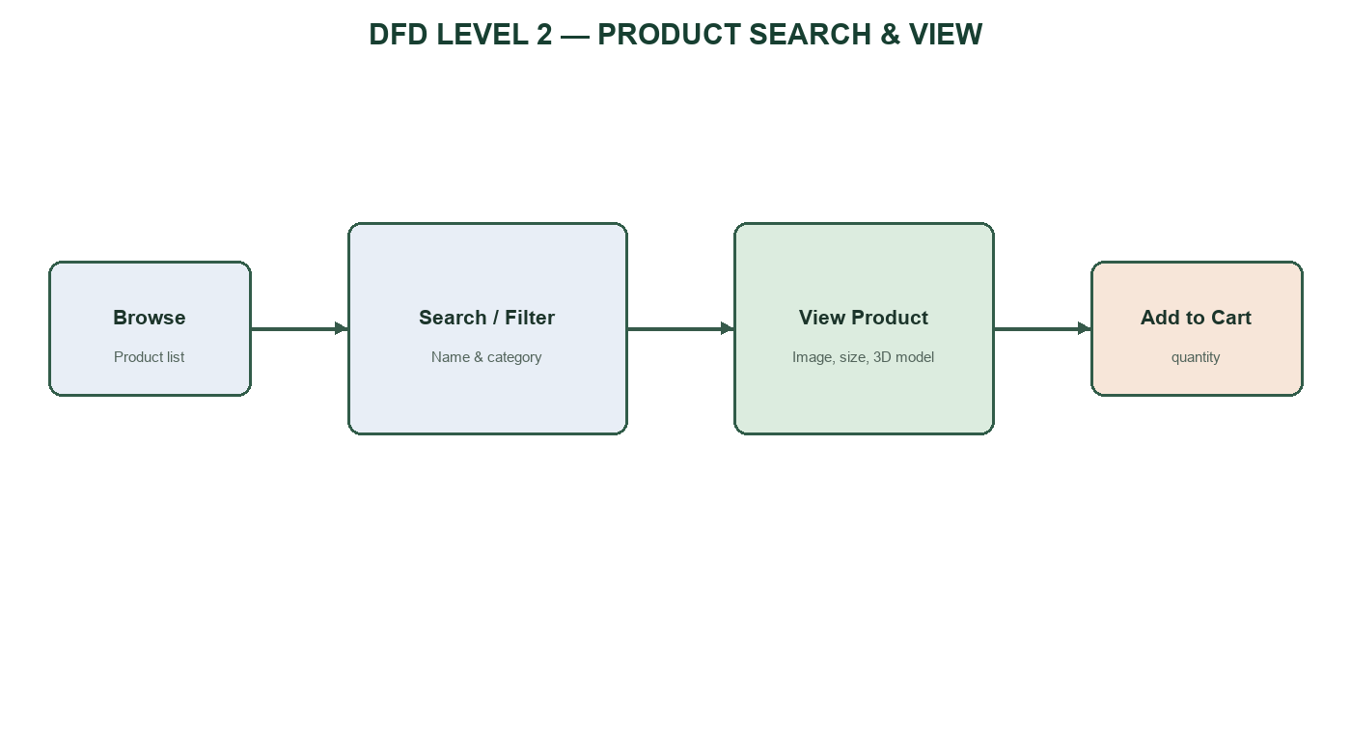

LEVEL 2 — CART MANAGEMENT
The cart receives selected products and supports viewing, updating quantity and removing items.
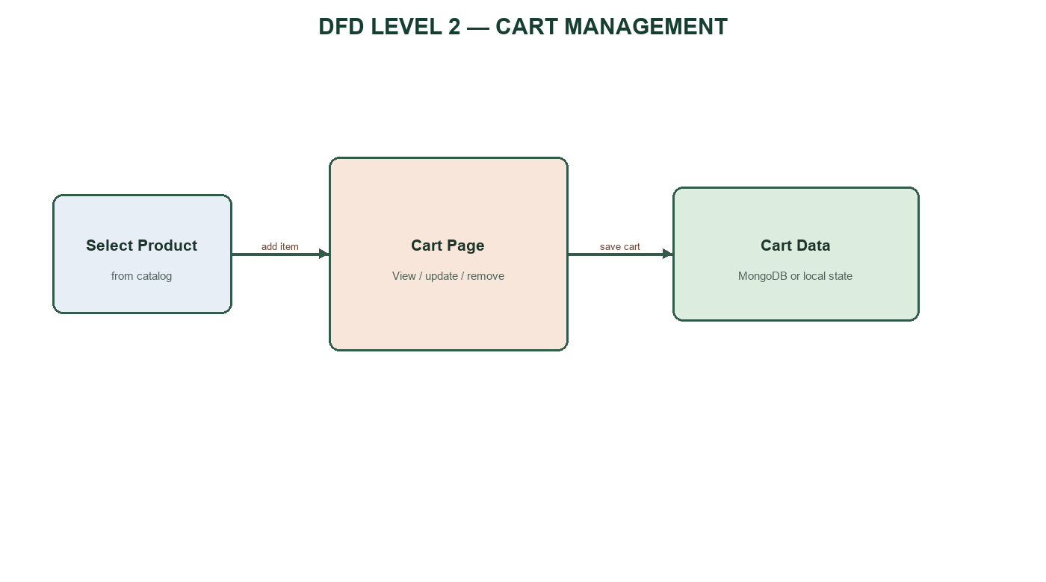

LEVEL 2 — 3D ROOM AND ADMIN MANAGEMENT
The 3D room uses product dimensions and model assets. The admin process is available only after role validation.
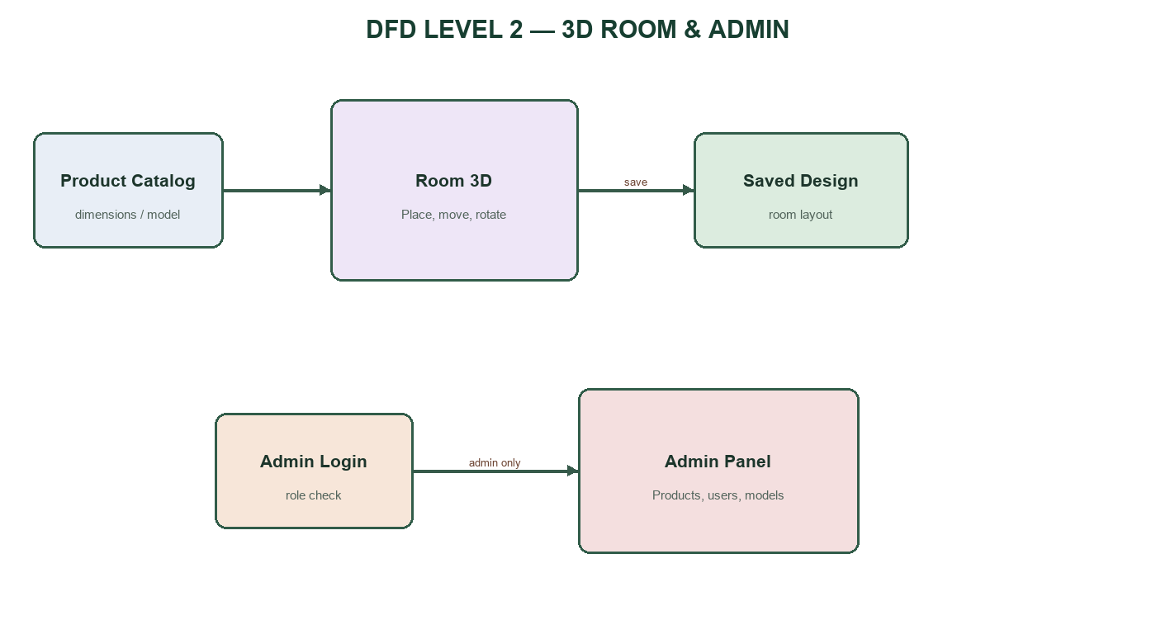

3. ENTITY RELATIONSHIP DIAGRAM (ERD)
The ERD reflects MongoDB collections and embedded cart/design items used by the furniture system.
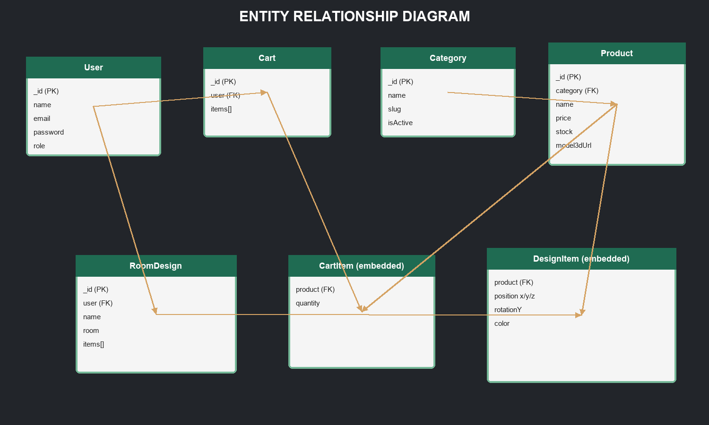

4. DATA MODEL DESIGN
4.1 USER AND CATEGORY
Collection: users
Field | Type | Description | Constraint
name | String | Full name | Required
email | String | Login email | Required, unique
password | String | Hashed password | Required
role | Enum | customer or admin | Default 'customer'
isActive | Boolean | Account status | Default true
createdAt / updatedAt | Date | Timestamps | Automatic
Collection: categories
Field | Type | Description | Constraint
name | String | Category name | Required, unique
slug | String | URL-safe name | Required, unique
description | String | Description | Optional
isActive | Boolean | Display status | Default true

4.2 PRODUCT
Field | Type | Description | Constraint
name | String | Product name | Required
slug | String | Unique URL key | Required, unique
description | String | Product description | Optional
price | Number | VND price | Required, min 0
stock | Number | Available quantity | Default 0
category | ObjectId | Category reference | Required, FK
images | String[] | Product image URLs | Optional
model3dUrl | String | GLB/GLTF asset URL | Optional
dimensions | Object | width/depth/height cm | Positive values
colors | String[] | Available colors | Optional
isActive | Boolean | Public status | Default true

4.3 CART AND CART ITEMS
Collection: carts
Field | Type | Description | Constraint
_id | ObjectId | Cart identifier | Primary key
user | ObjectId | Cart owner | Required, unique, FK
items | Array | Embedded CartItem records | Default []
createdAt / updatedAt | Date | Timestamps | Automatic
Embedded document: CartItem
Field | Type | Description | Constraint
product | ObjectId | Selected product | Required, FK
quantity | Number | Selected quantity | Required, min 1

4.4 ROOM DESIGNS
Collection: roomdesigns
Field | Type | Description | Constraint
user | ObjectId | Design owner | Required, FK
name | String | Design name | Required
room | Object | width/length/height m | Optional
items | Array | Embedded DesignItem records | Default []
createdAt / updatedAt | Date | Timestamps | Automatic
Embedded document: DesignItem
Field | Type | Description | Constraint
product | ObjectId | Placed product | Required, FK
position | Object | x/y/z coordinates | Required
rotationY | Number | Y-axis rotation | Default 0
color | String | Selected color | Optional

4.5 ADMIN AUDIT AND SETTINGS
Planned collection: adminlogs
Field | Type | Description | Constraint
admin | ObjectId | Admin account | Required, FK
action | String | Create/update/delete action | Required
targetType | String | Product, user, category or model | Required
targetId | ObjectId | Affected record | Optional
createdAt | Date | Action time | Automatic
Planned collection: settings
Field | Type | Description | Constraint
key | String | Setting key | Required, unique
value | Mixed | Setting value | Required
description | String | Meaning of setting | Optional

4.6 AUTHENTICATION SUPPORT
Planned collection: passwordresettokens
Field | Type | Description | Constraint
email | String | User email | Required, index
token | String | Hashed reset token | Required
expiresAt | Date | Expiration time | TTL index
Security rules
- Passwords are hashed with bcrypt.
- JWT contains the user identifier and expires after a configured period.
- The backend reloads the user before authorizing an admin request.
- Secrets are read from environment variables and never stored in source code.

4.7 PAGE AND ROUTE SPECIFICATIONS
Screen | Route | Implementation | Access
Home page | / | HomePage.jsx | Public
Product list | /products | ProductListPage.jsx | Public
Cart | /cart | CartPage.jsx | Public / customer
Login | No route | LoginModal.jsx over current page | Public
3D room | /room-3d | ThreeDShowroomPage.jsx | Public / customer
Admin | /admin | AdminPage.jsx + AdminRoute | Admin only
404 | * | NotFoundPage.jsx | Public
Important routing rule
Login must not redirect to a separate page. The modal is mounted in MainLayout so it can open from Home, Products, Cart or the 3D room. The wildcard route must be placed last and display the 404 page.

5. TASK SHEET REVIEW 2
No. | Task | Start Date | Days | Team Member | Status
1 | Data Flow Diagrams | [TO BE FILLED] | [TO BE FILLED] | [TO BE FILLED] | Planned
2 | Entity Relationship Diagram | [TO BE FILLED] | [TO BE FILLED] | [TO BE FILLED] | Planned
3 | Data Model Design | [TO BE FILLED] | [TO BE FILLED] | [TO BE FILLED] | Planned
4 | Review and Finalize Document | [TO BE FILLED] | [TO BE FILLED] | [TO BE FILLED] | Planned
Date: [TO BE FILLED]
Signature of Instructor: [TO BE FILLED]
Signature of Team Leader: [TO BE FILLED]

