FPT ACADEMY INTERNATIONAL
FPT – APTECH COMPUTER EDUCATION

[PROJECT NAME]
FURNITURE & ROOM PLANNING WEB APPLICATION
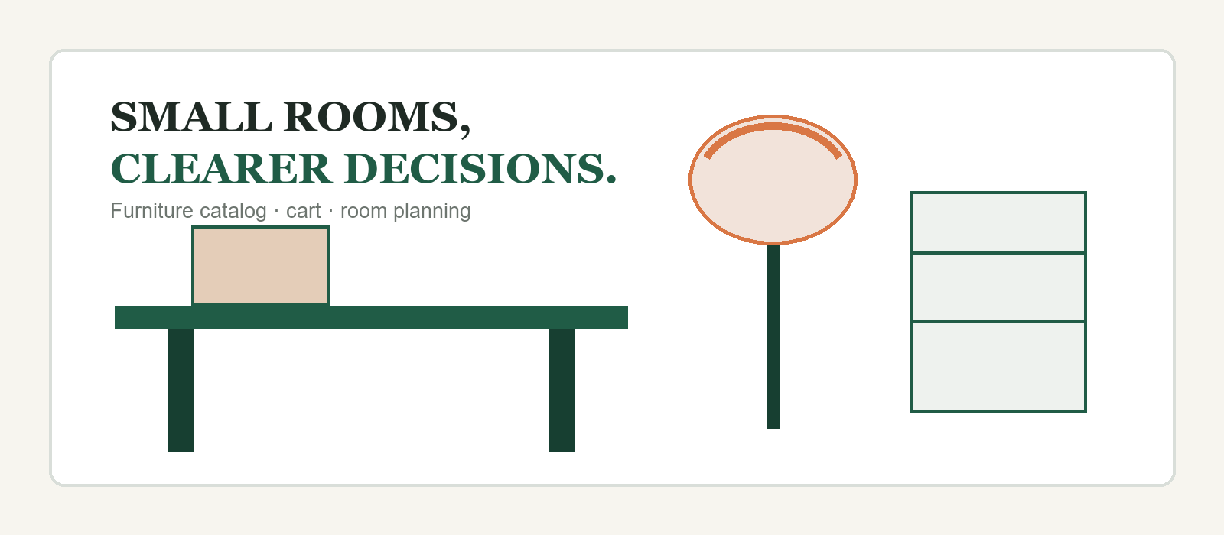
Project Information | Value
Supervisor | [TO BE FILLED]
Batch | [TO BE FILLED]
Group | [TO BE FILLED]
Team members | 1. [TO BE FILLED] 2. [TO BE FILLED]  3. [TO BE FILLED] 4. [TO BE FILLED]
Month [ ] Year 2026

CONTENTS
Review 1 and Review 2 only · 24-page submission draft
REVIEW 1 | 3
Acknowledgement & Introduction | 3
Problem Definition | 4
Customer Requirements Specification (CRS) | 5
Input · Process · Output | 6
Scope of Work | 7
Functional Pages | 8
Hardware / Software Requirements | 9
Task Sheet Review 1 | 10
REVIEW 2 | 11
DFD Level 0 — Context | 11
DFD Level 1 — Functional Overview | 12
DFD Level 2 — Authentication | 13
DFD Level 2 — Product Search | 14
DFD Level 2 — Cart | 15
DFD Level 2 — Room Design | 16
DFD Level 2 — Administration | 17
Entity Relationship Diagram | 18
Table Design — Users | 19
Table Design — Categories & Products | 20
Table Design — Carts | 21
Table Design — Room Designs | 22
API & Data Rules | 23
Task Sheet Review 2 | 24

REVIEW 1

REVIEW 1
Project purpose, customer requirements and agreed scope

ACKNOWLEDGEMENT
Our group would like to express sincere appreciation to our instructor and the FPT–Aptech Project Team for giving us the opportunity to apply React, Node.js and MongoDB in a practical project. Their guidance helped us turn a broad idea into a system that the whole team can understand, explain and improve.
We also thank our classmates and team members for their feedback during the planning and review process. Each suggestion helped us keep the project simple enough for an academic presentation while still aiming at a useful product for real users.

INTRODUCTION
[PROJECT NAME] is a furniture and decoration website designed mainly for students, young people and users with small private rooms. The platform helps users browse affordable furniture, keep selected products in a cart and preview products in a simple 3D room before making a decision.
- Visitors can browse and search active products without signing in.
- Customers can sign in from a modal that opens on the current page.
- Signed-in customers can manage a cart and save their own room designs.
- Administrators can manage products and view customer accounts.
Project principle
The basic shopping flow must remain easy to demonstrate. The 3D room supports the decision; it does not replace the product catalog or cart.

REVIEW 1

PROBLEM DEFINITION
Why the system is needed
Students and users living in small rooms often find it difficult to judge whether a desk, shelf, lamp or other item will fit the available space. Product websites show isolated photographs and dimensions, but users still need a clearer way to compare products and imagine a possible arrangement.

FROM THE CUSTOMER'S VIEWPOINT
- Product names and descriptions should be searchable using familiar words.
- Product cards should show price, category, stock, images and real dimensions.
- The cart should keep the selected product and quantity in one clear place.
- The room page should use room dimensions and product dimensions to support a realistic scale.
- Login should not interrupt browsing by moving the user to a separate page.
- Invalid addresses should lead to a clear 404 page with a way back to the website.

FROM THE ADMINISTRATOR'S VIEWPOINT
- Only an authenticated admin account may open protected management functions.
- The product catalog must support create, update and delete operations.
- The admin should be able to review users without exposing password data.
- Product information must contain the fields needed by both the catalog and the 3D room.

REVIEW 1

CUSTOMER REQUIREMENTS SPECIFICATION
Client: [TO BE FILLED]

BUSINESS / PROJECT OBJECTIVE
The objective of [PROJECT NAME] is to create a simple furniture catalog and room-planning website that helps users make more confident choices. The application combines a traditional product flow with a focused 3D preview and keeps the implementation understandable for a four-member student team.
Stakeholder | Main need | System response
Visitor | Find suitable products quickly | Search, category filter, product list and details
Customer | Keep choices and plan a room | Login modal, cart, 3D room and saved designs
Administrator | Maintain usable data | Protected product CRUD and user list
Project team | Explain and maintain the source | Simple React pages and route → controller → service → model backend

SUCCESS CONDITIONS
- All agreed routes open correctly, including the protected admin route and 404 route.
- The same product data supports search, cart display and 3D placement.
- Customer and admin permissions are clearly separated.
- MongoDB documents can grow from sample data to a larger catalog without storing image files inside the database.

REVIEW 1

INPUT · PROCESS · OUTPUT
The main information handled by the system
INPUT | PROCESS | OUTPUT
Email and password | Verify active user and compare password hash | JWT token and safe user profile
Search text and category | Build MongoDB filter and text query | Active matching products
Product IDs and quantities | Validate and upsert one cart per user | Cart populated with product data
Room width, length and height | Create a room using metre-based dimensions | Room canvas with a meaningful scale
Product, position, rotation and color | Save embedded placement data | Reusable room design owned by the customer
Admin product form | Check admin role and apply CRUD operation | Updated product catalog
Common API response
The backend uses one readable shape: { success, message, data }. Errors are forwarded to the central error handler.

DATA QUALITY RULES
- Prices and stock values cannot be negative.
- A product must belong to one category and has a unique slug.
- Cart quantity must be at least one.
- Email and slug fields are normalized and unique where required.
- Images and 3D models are stored as URLs; MongoDB stores their references and metadata.

REVIEW 1

SCOPE OF WORK
Functions included in Review 1–2
Area | Customer / Visitor | Administrator
Authentication | Open login modal and sign in | Sign in with an admin account
Products | Browse, search and filter active products | Create, update and delete products
Cart | View and update own cart | No customer-cart management in current scope
Room 3D | Set room size, place products and save designs | Provides product data and 3D model references
Users | Own safe profile returned after login | View user list without passwords
Navigation | Home, products, cart, room 3D and 404 | Protected admin page

CURRENTLY OUT OF SCOPE
- Online payment, shipping, order tracking and warehouse operations.
- Automatic reconstruction of a complete room from one photograph.
- Community marketplace, subscription plans and revenue sharing.
- Advanced vector search; the current version uses MongoDB text search and category filtering.
Reason for the boundary
These functions can be added later, but they are not presented as completed features in this document.

REVIEW 1

FUNCTIONAL PAGES
Routes agreed for the React application
Page / interface | Route | Who can use it | Purpose
Home | / | Everyone | Introduce the project and direct users to core functions
Product List | /products | Everyone | Search, filter and display product cards
Cart | /cart | Customer | Review selected products and quantities
Login Modal | No separate route | Everyone | Open above the current page and close without navigation
3D Room | /room-3d | Customer | Preview products in a room and save a design
Admin | /admin | Admin only | Manage products and view users
404 | Any unknown route | Everyone | Explain that the page does not exist and provide recovery navigation

LOGIN BEHAVIOUR
The login form is implemented as a modal component mounted by the main layout. It appears above whichever page the visitor is viewing. After a successful login, the authentication context stores the token and safe user data. If a non-admin user attempts to open /admin, the router redirects the user to the home page.
Important presentation point
There is no LoginPage route. The source of this behaviour is client/src/components/auth/LoginModal.jsx and client/src/context/AuthContext.jsx.

REVIEW 1

HARDWARE / SOFTWARE REQUIREMENTS
Development and demonstration environment

HARDWARE
Component | Development computer | Client computer
Processor | Intel Core i5 / AMD equivalent or higher | Modern dual-core processor or higher
Memory | 8 GB RAM minimum; 16 GB recommended | 4 GB RAM or higher
Graphics | WebGL-capable integrated or dedicated GPU | WebGL-capable browser and GPU
Network | Internet for packages and optional external assets | Internet or local network access

SOFTWARE AND TECHNOLOGY
Layer | Technology | Purpose
Frontend | React 19, Vite, React Router | Pages, navigation and reusable components
Styling | Tailwind CSS + theme.css | Simple utility styling and shared design tokens
3D | Three.js, React Three Fiber, Drei | Render the room and product models
Backend | Node.js, Express | REST API and business flow
Database | MongoDB, Mongoose | Users, categories, products, carts and room designs
Security | JWT, bcryptjs | Session token and password verification
Tools | VS Code, Git, Chrome | Development, collaboration and testing

REVIEW 1

TASK SHEET REVIEW 1
Planning record — values may be completed by the team
No. | Task | Prepared by | Start date | Days | Member | Status
1 | Acknowledgement & Introduction | [TO BE FILLED] | [DATE] | 1 | [MEMBER] | Completed
2 | Problem Definition | [TO BE FILLED] | [DATE] | 1 | [MEMBER] | Completed
3 | Customer Requirements Specification | [TO BE FILLED] | [DATE] | 1 | [MEMBER] | Completed
4 | Input · Process · Output | [TO BE FILLED] | [DATE] | 1 | [MEMBER] | Completed
5 | Scope and Functional Pages | [TO BE FILLED] | [DATE] | 1 | [MEMBER] | Completed
6 | Hardware / Software Requirements | [TO BE FILLED] | [DATE] | 1 | [MEMBER] | Completed
7 | Review and formatting | [TO BE FILLED] | [DATE] | 1 | All members | Completed

Confirmation | Information
Date | [TO BE FILLED]
Instructor | Signature: ____________________ Name: [TO BE FILLED]
Team leader | Signature: ____________________ Name: [TO BE FILLED]

REVIEW 2

REVIEW 2
Data flow, entity relationships and MongoDB document design

DATA FLOW DIAGRAM (DFD)
The Context Diagram presents the entire application as one system. It defines the system boundary and the main information exchanged with the two external actors: Customer and Administrator.
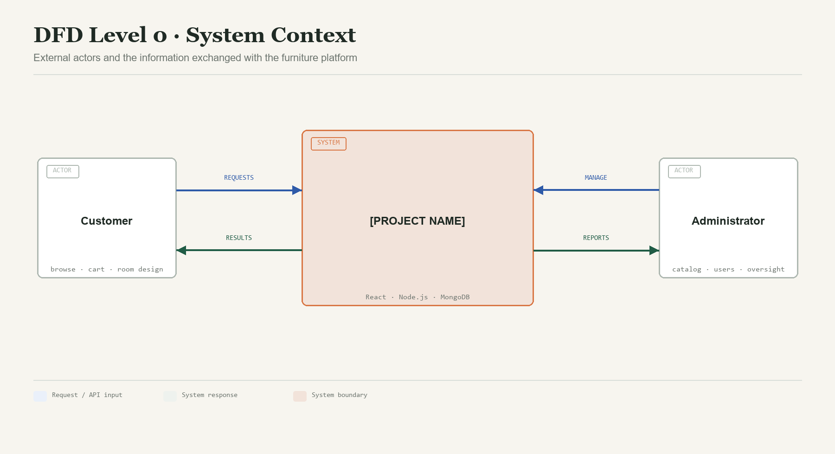
Figure 1. DFD Level 0 — Context diagram
Reading the diagram
Blue arrows are user or API inputs. Green arrows are system results. The orange outline identifies the single system boundary.

REVIEW 2

DFD LEVEL 1
Functional overview
Level 1 decomposes the system into the main processes used in the current source code: authentication, product catalog, cart, room design and administration. MongoDB stores the shared data. Product browsing connects the traditional shopping flow to the optional room-planning flow.
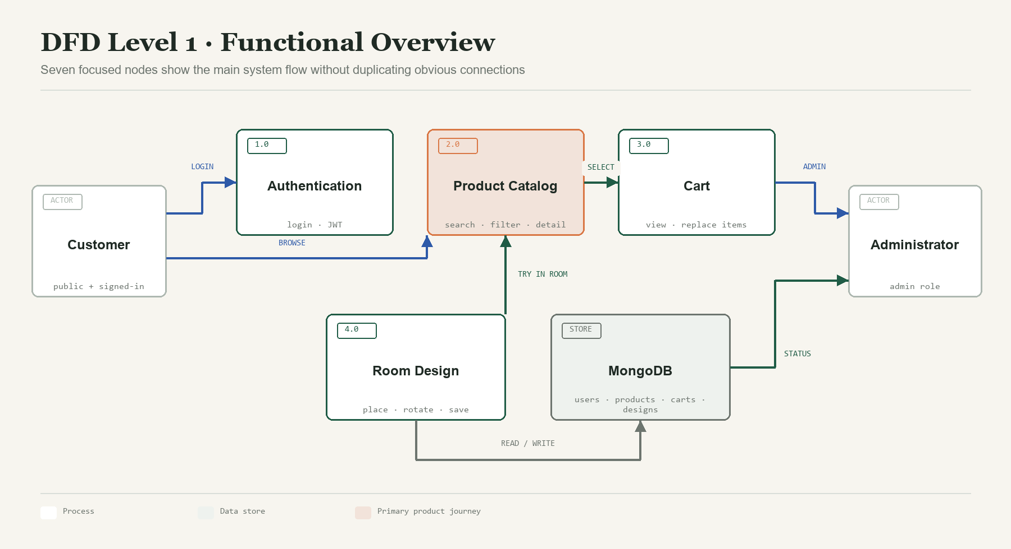
Figure 2. DFD Level 1 — Main functions and shared data
- Authentication supplies the token and role used by protected routes.
- The product catalog is the focal process because cart and room design both depend on product data.
- Customer records, products, carts and room designs are stored as MongoDB documents.

REVIEW 2

DFD LEVEL 2 — AUTHENTICATION
Process 1.0
The login modal collects email and password without changing the current route. The server finds an active account, verifies the password hash and returns a seven-day JWT with a safe user profile. The server checks the token again for every protected request.
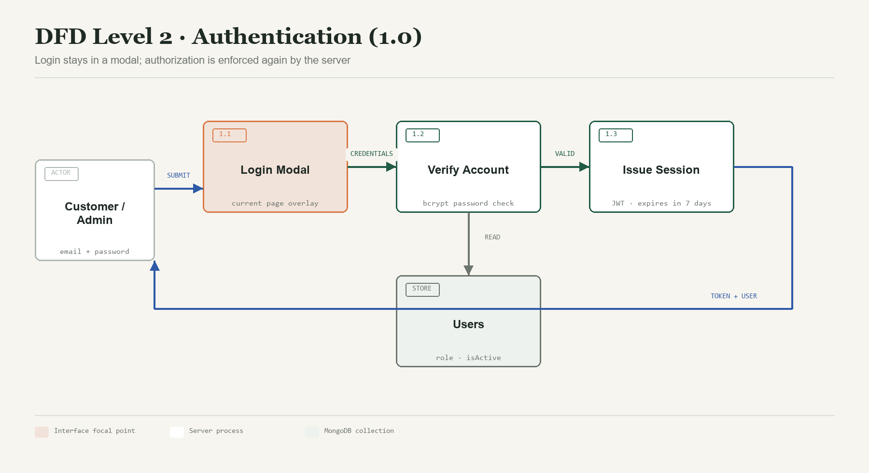
Figure 3. Detailed authentication flow
Step | Rule
1.1 Login Modal | Required email and password; modal can close without route change
1.2 Verify Account | Email normalized to lowercase; user must be active; bcrypt comparison
1.3 Issue Session | JWT contains userId; response excludes password

REVIEW 2

DFD LEVEL 2 — PRODUCT SEARCH
Process 2.0
Visitors enter familiar product words or choose a category. The backend creates a filter for active products and uses MongoDB text search across product name and description. Category information is populated so the frontend can display readable labels.
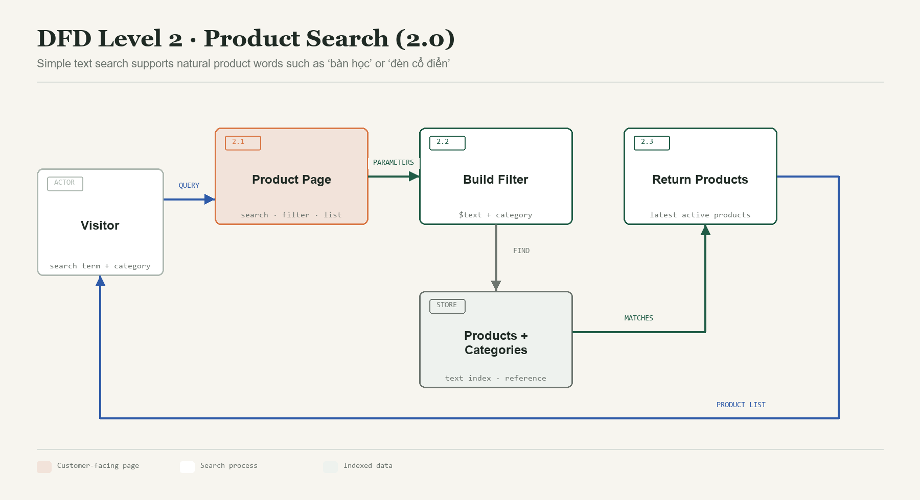
Figure 4. Product search and result flow
Search scope
The current implementation is intentionally explainable: text index + category filter. Vector or hybrid search may be evaluated later, but it is not claimed as completed here.

REVIEW 2

DFD LEVEL 2 — CART
Process 3.0
A signed-in customer can request the current cart or replace its item list. The server associates the cart with the authenticated user, upserts the document and populates product references before returning the response.
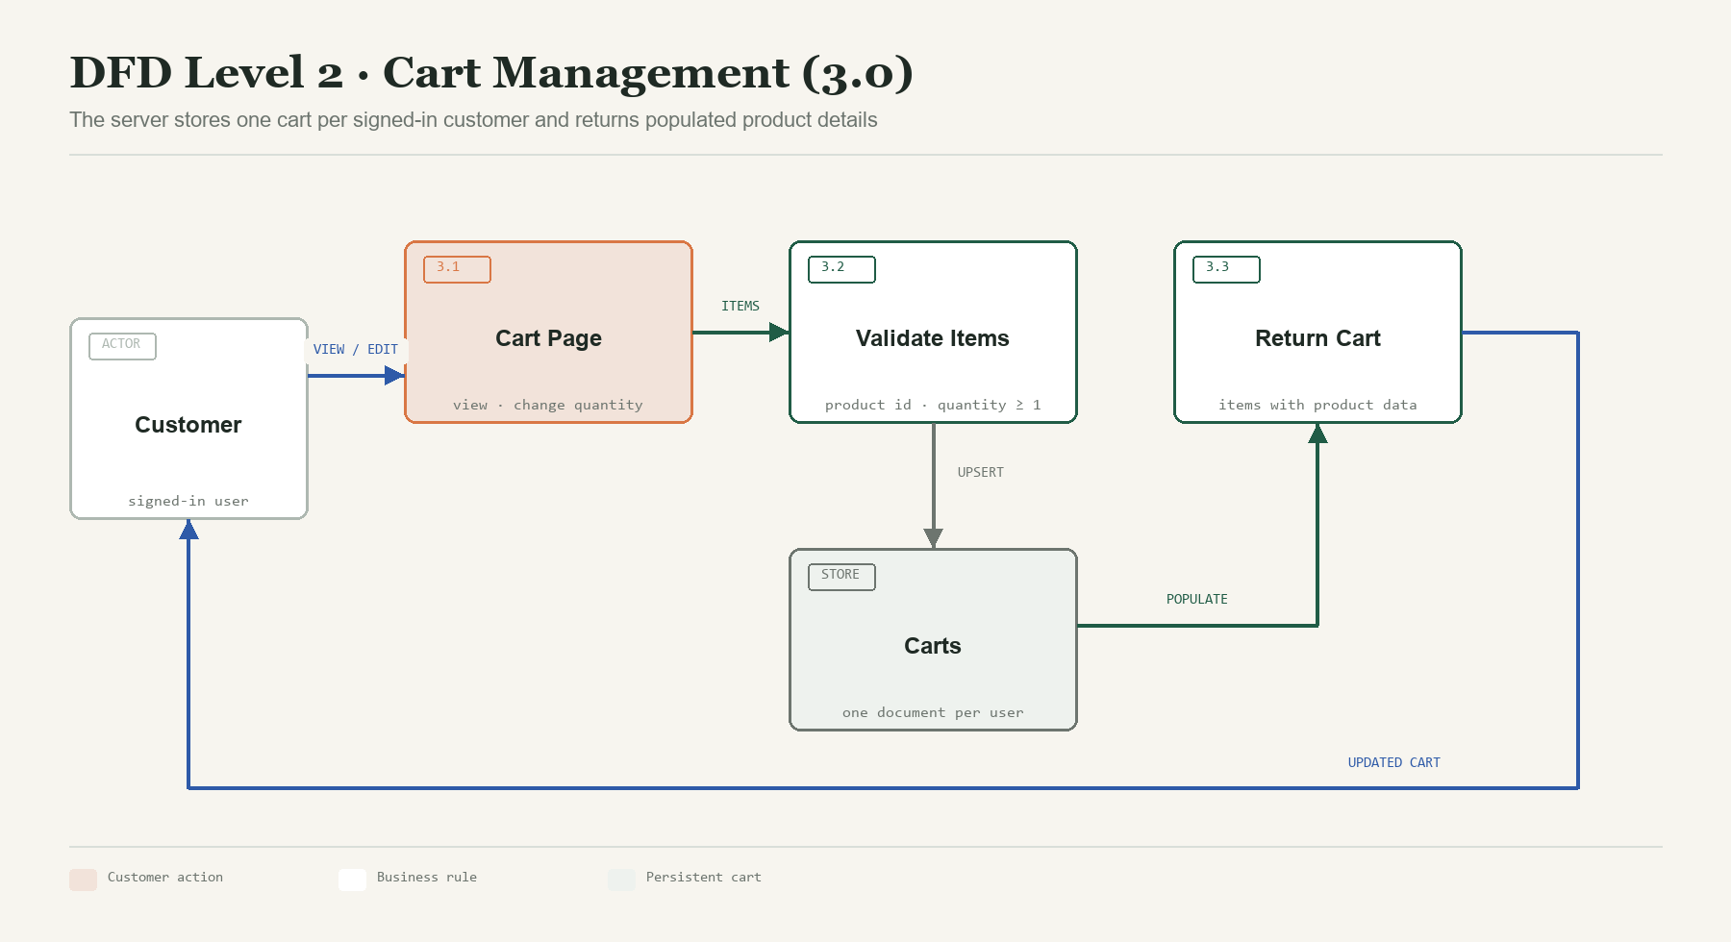
Figure 5. Cart retrieval and update flow
Operation | Endpoint | Result
Load cart | GET /api/cart | One cart for the authenticated user
Update cart | PUT /api/cart | Upserted cart with populated product records

REVIEW 2

DFD LEVEL 2 — ROOM DESIGN
Process 4.0
The room page accepts simple room dimensions. Products bring their own real dimensions and optional 3D model URL. The customer can place an item, rotate it around the vertical axis, select a color and save the arrangement as a named design.
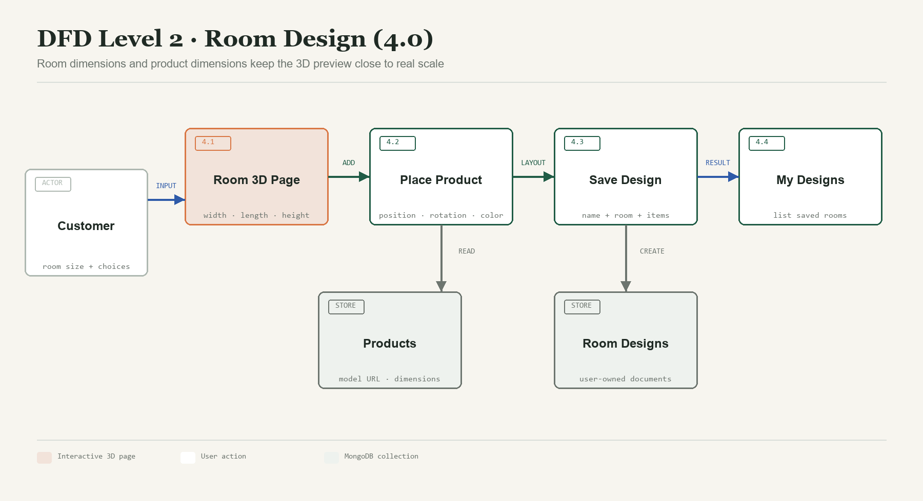
Figure 6. Room planning and saved-design flow
- Room measurements are stored in metres: widthM, lengthM and heightM.
- Product measurements are stored in centimetres and converted by the presentation layer when needed.
- Every saved design belongs to the authenticated customer.

REVIEW 2

DFD LEVEL 2 — ADMINISTRATION
Process 5.0
The admin page is protected twice: the frontend route checks the signed-in role for navigation, and the backend middleware independently verifies the JWT and admin role before returning or modifying data.
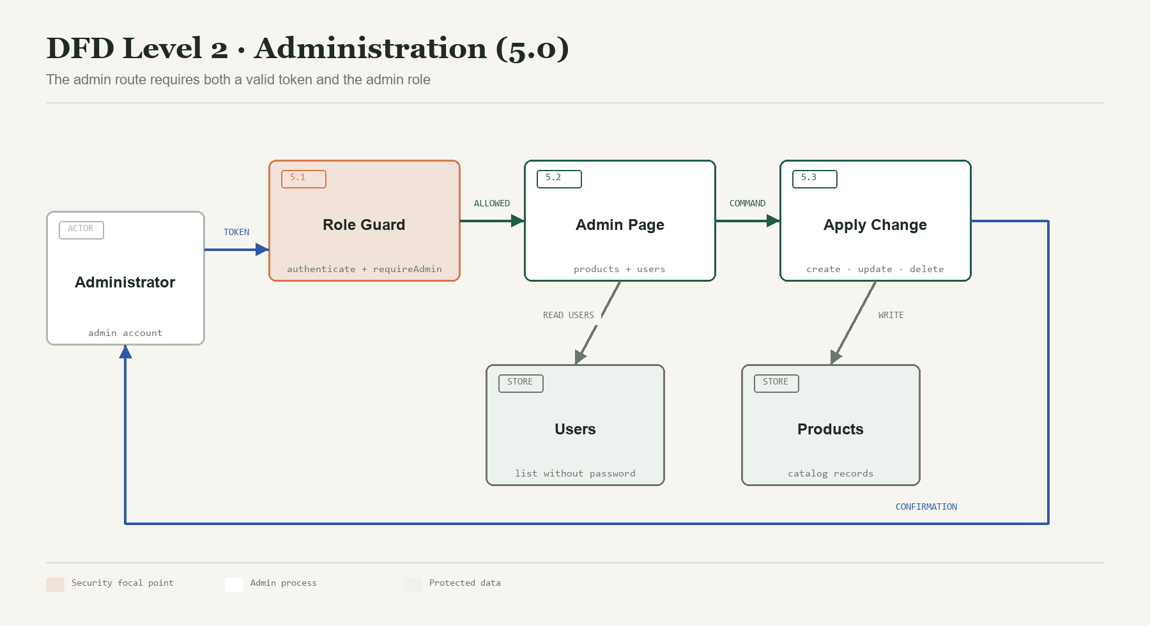
Figure 7. Protected administrator flow
Security boundary
Frontend protection improves user experience; backend protection provides the actual access control.

REVIEW 2

ENTITY RELATIONSHIP DIAGRAM
MongoDB data model
The data model uses five main collections. Small item records are embedded inside Cart and RoomDesign documents, while reusable entities such as User, Product and Category remain separate and are connected by ObjectId references.
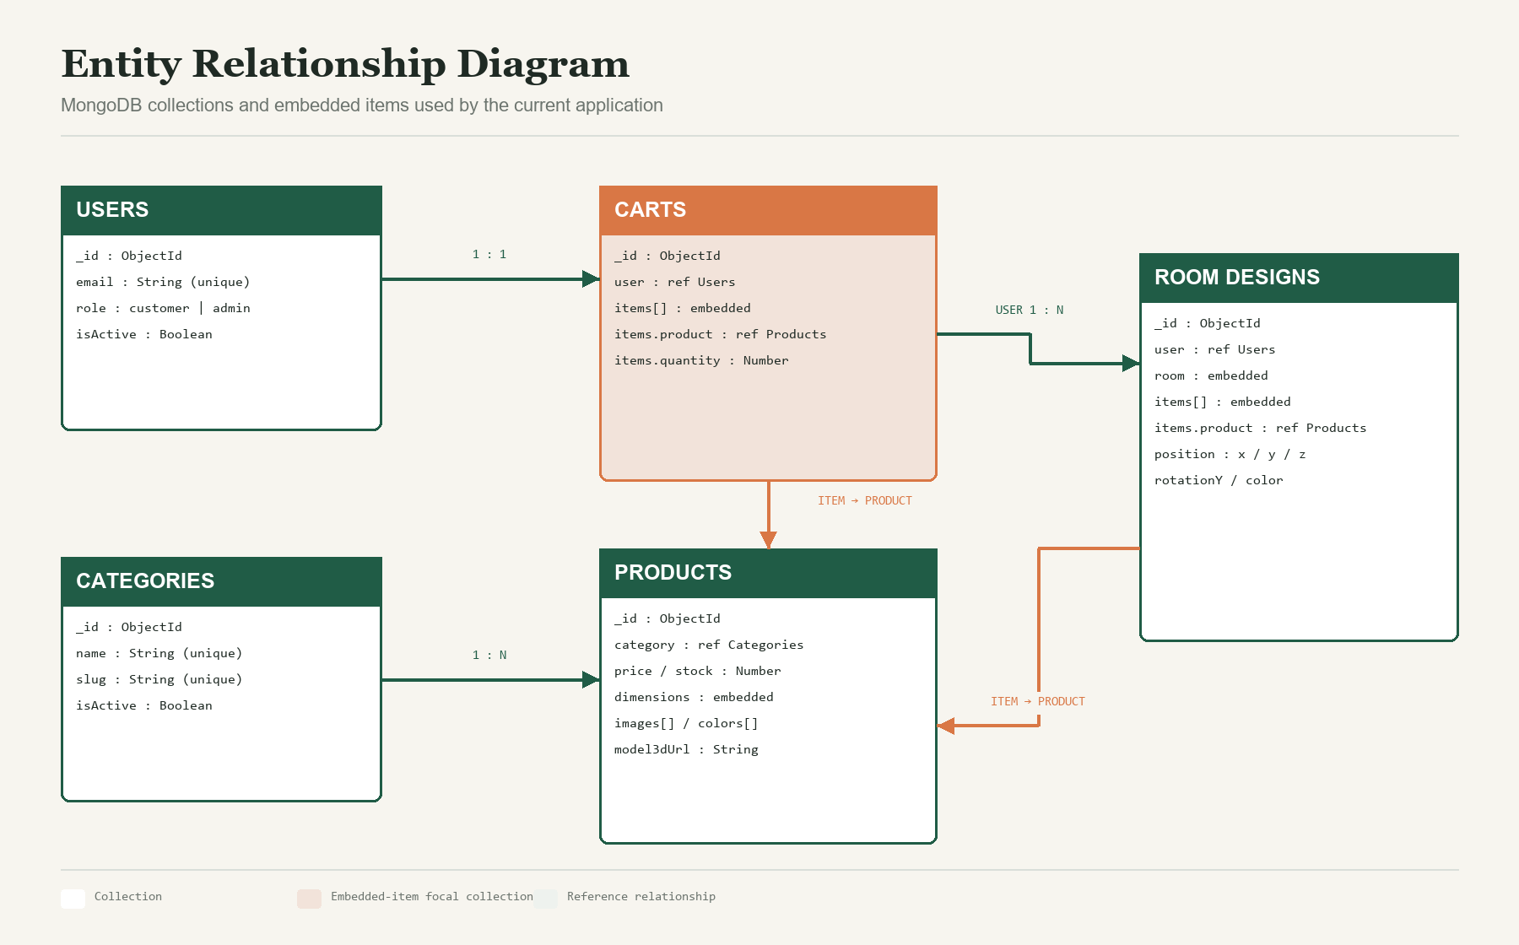
Figure 8. Collections, embedded structures and reference relationships
Why embed items?
Cart items and room placements are meaningful only inside their parent document. Embedding keeps these small structures easy to read and update.

REVIEW 2

TABLE DESIGN
MongoDB collections and Mongoose schemas

Collection: users
Stores login credentials, roles and the active state for customer and administrator accounts.
Field | BSON / Mongoose Type | Rule | Meaning
_id | ObjectId | Primary key | Automatically generated identifier
name | String | Required, trim | Display name
email | String | Required, unique, lowercase | Login email
password | String | Required | bcrypt password hash
role | String enum | customer | admin | Access role; default customer
isActive | Boolean | Default true | Controls whether login is allowed
createdAt / updatedAt | Date | Automatic | Mongoose timestamps
Privacy rule
Password is never returned by the admin user-list endpoint and is never included in the login response.

REVIEW 2

TABLE DESIGN — PRODUCT CATALOG
Categories and products

Collection: categories
Stores reusable product groups for filtering and display.
Field | BSON / Mongoose Type | Rule | Meaning
_id | ObjectId | Primary key | Category identifier
name | String | Required, unique, trim | Readable category name
slug | String | Required, unique, trim | Stable URL-friendly key
description | String | Default empty | Short explanation
isActive | Boolean | Default true | Visibility status

Collection: products
Stores catalog data shared by product pages, cart and room planning.
Field | BSON / Mongoose Type | Rule | Meaning
name / slug | String | Required; slug unique | Product identity
description | String | Text indexed | Searchable information
price / stock | Number | Required or default; min 0 | Commercial data
category | ObjectId ref | Required → categories | Product group
images[] / colors[] | String arrays | Optional | Available visual choices
model3dUrl | String | Optional | GLB / GLTF model URL
dimensions | Embedded object | Values min 1 | widthCm, depthCm, heightCm
isActive | Boolean | Default true | Catalog visibility

REVIEW 2

TABLE DESIGN — CART
One active cart per customer

Collection: carts
Stores selected products and quantities. Items are embedded; products are referenced.
Field | BSON / Mongoose Type | Rule | Meaning
_id | ObjectId | Primary key | Cart identifier
user | ObjectId ref | Required, unique → users | Owner of the cart
items | Embedded array | Default empty | Selected product entries
items.product | ObjectId ref | Required → products | Selected product
items.quantity | Number | Required, min 1 | Selected quantity
createdAt / updatedAt | Date | Automatic | Mongoose timestamps

DOCUMENT EXAMPLE
{
"user": ObjectId("..."),
"items": [
{ "product": ObjectId("..."), "quantity": 1 }
]
}
Update behaviour
PUT /api/cart replaces the submitted item array and uses upsert so the first update can also create the customer's cart.

REVIEW 2

TABLE DESIGN — ROOM DESIGNS
Saved 3D arrangements

Collection: roomdesigns
Stores a named room and the customer's placed furniture items.
Field | BSON / Mongoose Type | Rule | Meaning
_id | ObjectId | Primary key | Design identifier
user | ObjectId ref | Required → users | Owner of the design
name | String | Required, trim | Customer's design name
room | Embedded object | Optional numeric fields | widthM, lengthM, heightM
items | Embedded array | Default empty | Placed furniture entries
items.product | ObjectId ref | Required → products | Furniture reference
items.position | Embedded object | x, y, z numbers | Position in the 3D scene
items.rotationY | Number | Default 0 | Rotation around vertical axis
items.color | String | Optional | Selected visual variant
createdAt / updatedAt | Date | Automatic | Mongoose timestamps
Ownership rule
The server ignores any user field sent by the browser and assigns req.user._id from the verified token.

REVIEW 2

API & DATA RULES
Routes implemented by the current backend
Method | Endpoint | Access | Purpose
POST | /api/auth/login | Public | Verify credentials and return token + user
GET | /api/products | Public | List active products; search and category query
POST | /api/products | Admin | Create a product
PUT | /api/products/:id | Admin | Update and validate a product
DELETE | /api/products/:id | Admin | Delete a product
GET | /api/cart | Customer | Load own cart
PUT | /api/cart | Customer | Replace own cart items
GET | /api/room-designs | Customer | List own saved designs
POST | /api/room-designs | Customer | Save a new room design
GET | /api/admin/users | Admin | List users without passwords

INDEXES AND STORAGE
- products: text index on name and description; unique index on slug.
- users: unique email; carts: unique user; categories: unique name and slug.
- Image and 3D model files are referenced by URL instead of being stored as MongoDB binary data.
- Secrets such as MongoDB URI and JWT secret are read from .env and are not committed to source code.

REVIEW 2

TASK SHEET REVIEW 2
DFD, ERD and data design record
No. | Task | Prepared by | Start date | Days | Member | Status
1 | DFD Level 0 | [TO BE FILLED] | [DATE] | 1 | [MEMBER] | Completed
2 | DFD Level 1 | [TO BE FILLED] | [DATE] | 1 | [MEMBER] | Completed
3 | DFD Level 2 — Authentication | [TO BE FILLED] | [DATE] | 1 | [MEMBER] | Completed
4 | DFD Level 2 — Product and Cart | [TO BE FILLED] | [DATE] | 2 | [MEMBER] | Completed
5 | DFD Level 2 — Room and Admin | [TO BE FILLED] | [DATE] | 2 | [MEMBER] | Completed
6 | Entity Relationship Diagram | [TO BE FILLED] | [DATE] | 1 | [MEMBER] | Completed
7 | MongoDB Table Design | [TO BE FILLED] | [DATE] | 2 | All members | Completed
8 | Review and formatting | [TO BE FILLED] | [DATE] | 1 | All members | Completed

Submission confirmation | Information
Project | [PROJECT NAME]
Date | [TO BE FILLED]
Instructor | Signature: ____________________ Name: [TO BE FILLED]
Team leader | Signature: ____________________ Name: [TO BE FILLED]
End of Review 2
This document ends after the completed Review 2 task sheet.

