FPT ACADEMY INTERNATIONAL
FPT APTECH COMPUTER EDUCATION

Furniture-store (Furnee)
FURNITURE AND ROOM PLANNING WEB APPLICATION
REVIEW 1 - REVIEW 2 - REVIEW 3

Project Information | Value
Supervisor | Lê Mộng Thúy
Batch | T3.2603.E0
Group | 1
Team members | 1. Vũ Lương Hiệp - Student1728090  2. Nguyễn Hồng Phúc - Student1717002  3. Mai Chí Dũng - Student1727846  4. Lê Thanh Hoàng Triều - Student1726524

Academic submission document

CONTENTS
REVIEW 1
1. Problem Statement
2. Project Objectives
3. Target Users
4. Problems Addressed
5. Customer Requirements Specification
6. General Process: Input -> Process -> Output
7. Client Hardware and Software Requirements
8. System Function Description
9. Task Assignment
REVIEW 2
1. Functional Requirements: Text and Flowchart
2. Data Flow Diagram
3. Functional Diagram
4. Data Structure - MongoDB
5. Site Map
REVIEW 3
1. Review 3 Scope
2. Route and Page Inventory
3. Shared Layout and Authentication Modal
4. Home Page - /
5. Product List Page - /products
6. Room Studio Page - /room-studio
7. Collection Page - /collection
8. Administration Page - /admin
9. Not Found Page - *
10. Compatibility Redirects

REVIEW 1
Project background, objectives, users, customer requirements, operating process, client requirements, system functions and task ownership.

1. PROBLEM STATEMENT
Students, young workers and people living in small rooms often have difficulty deciding whether a furniture item will fit the available space and look suitable in the room. A normal product listing provides photographs, dimensions and prices, but it does not show the item at a chosen position in the user's own room photograph. This uncertainty can lead to unsuitable choices, wasted time and repeated searching.

2. PROJECT OBJECTIVES
- Provide a simple furniture catalog for small rooms.
- Allow users to search, filter and sort furniture products.
- Let users upload a room photograph, mark useful room corners and choose a product position.
- Create a visual room preview and keep useful products or room results in a Collection.
- Provide protected product management for administrators.
- Keep the solution simple enough for an academic team to explain, maintain and demonstrate.

3. TARGET USERS
User group | Main need | System support
Visitor | Understand the service and explore products | Home, Product List, search, filters and Room Studio trial
Customer | Keep ideas and generate room previews | Authentication modal, Collection, saved Room Studio session and room results
Administrator | Maintain accurate product information | Protected administration page and backend product CRUD
Project team | Demonstrate and maintain the project | Simple client-server structure, clear routes and MongoDB models

4. PROBLEMS ADDRESSED
Observed problem | System response | Expected benefit
Product information is scattered or difficult to compare | One searchable and filterable catalog | Faster product discovery
Users cannot imagine a product in their own room | Photo-based Room Studio with a selected target | Better visual understanding before purchase
Useful products and room ideas are easily lost | Collection for saved products and generated room templates | Easy return to previous ideas
Product data requires controlled maintenance | Admin-only create, edit, delete and refresh functions | More consistent catalog data
Invalid pages cause confusion | Dedicated 404 recovery page and compatibility redirects | Clear navigation recovery

5. CUSTOMER REQUIREMENTS SPECIFICATION
ID | Requirement | Priority | Acceptance condition
CR-01 | The visitor can open the Home, Product List, Room Studio and Collection pages. | Must | Each canonical route shows the intended page.
CR-02 | The Product List supports keyword search, category filtering and price sorting. | Must | The visible product grid changes according to the selected controls.
CR-03 | Authentication opens as a modal without leaving the current page. | Must | Login and registration can be opened, switched and closed on the same route.
CR-04 | Room Studio accepts a room photo and marked room corners. | Must | The user can add, remove and clear visible corner markers.
CR-05 | The user can select a product and a target position before preview generation. | Must | A product overlay appears at the selected location.
CR-06 | A successful preview can be kept as a room template. | Must | The Collection shows the generated resultImage and related product data.
CR-07 | The Collection can save products and remove saved items. | Must | Saved state and empty state are both displayed correctly.
CR-08 | Only an administrator can use product management functions. | Must | The frontend blocks the page and the backend checks JWT and role.
CR-09 | Unknown routes show a clear recovery page. | Should | The 404 page provides navigation back to valid pages.
CR-10 | The interface adapts to desktop, tablet and mobile widths. | Should | Navigation, grids, forms and Room Studio change layout at responsive breakpoints.

6. GENERAL PROCESS: INPUT -> PROCESS -> OUTPUT
Input | Process | Output
Route or navigation action | React Router selects a page or redirect | Requested page, redirected page or 404 page
Email, password and optional registration name | Validate fields, call authentication API, verify password and issue JWT | Safe user profile, token or readable error
Search keyword, category and sort option | Normalize text, filter products and sort a copied result list | Matching product cards and result count
Room photo, marked corners, product and target | Store coordinates, build guide images and send a preview request | Positioned product overlay and generated preview
Favourite product or generated room result | Store Collection record in browser state and normalize placement data | Saved product or room template
Admin product form | Validate fields, authorize role and run MongoDB CRUD | Updated authoritative product list

7. CLIENT HARDWARE AND SOFTWARE REQUIREMENTS
Component | Minimum | Recommended
Processor | Modern dual-core CPU | Recent four-core CPU or better
Memory | 4 GB RAM | 8 GB RAM or more
Display | 1280 x 720 | 1920 x 1080 for easier Room Studio work
Storage | At least 200 MB free for browser cache and temporary images | 1 GB free when testing many room images
Network | Internet connection for API and external AI preview | Stable broadband connection
Input | Mouse, touchpad or touch screen; file/photo access | Mouse on desktop or a tablet with a large screen

Software area | Support
Best supported browsers | Latest stable Google Chrome and Microsoft Edge.
Other supported browsers | Recent Firefox and Safari with JavaScript, local storage, file upload and modern CSS enabled.
Not supported | Internet Explorer and very old browser versions are not supported.
Mobile support | Yes. Responsive CSS supports tablet and mobile layouts. Product browsing and Collection work well on mobile; Room Studio is supported but is easier on a larger screen because it requires precise photo marking and product placement.
Browser permissions | The user must allow local file selection when uploading a room photograph. JavaScript and site storage must be enabled.
Native application | No installation is required. The project is a responsive web application, not a native mobile application.

8. SYSTEM FUNCTION DESCRIPTION
ID | Function | Main behaviour | User
F-01 | Home | Introduces the project and links to Products and Room Studio. | Everyone
F-02 | Authentication | Login and registration modal; token and safe profile handling. | Visitor / Customer / Admin
F-03 | Product Catalog | Search, category filter, price sort, product source, save and try-in-room actions. | Everyone
F-04 | Room Studio | Upload a room photo, mark corners, choose product and target, generate preview and keep stacked cards. | Everyone
F-05 | Collection | Display saved products and generated room templates; reopen or remove items. | Current browser / signed-in user
F-06 | Administration | Protected product create, update, delete and refresh workflow. | Admin
F-07 | Navigation and Recovery | Canonical routes, compatibility redirects and a Not Found page. | Everyone

9. TASK ASSIGNMENT
Member | Role | Main responsibility | Review document responsibility
Vũ Lương Hiệp | Team Leader | Team leadership, overall system integration, Room Studio workflow, AI preview integration, deployment coordination and final document review | Control the complete project, integrate the main components and handle the most technically difficult functions
Nguyễn Hồng Phúc | Frontend Member | Backend development, authentication, authorization, administrator functions, product CRUD operations and MongoDB integration | Maintain the main server-side functions and protected data-management workflow
Mai Chí Dũng | Feature Member | Product Catalog, search, category filtering, price sorting, Collection functions and responsive interface support | Develop and verify the main customer-facing product and saved-item functions
Lê Thanh Hoàng Triều | Data Member | DFD diagrams, Functional Diagram, Site Map, UI wireframes, test data preparation, smoke testing and document formatting support | Prepare supporting system diagrams, verify basic functions and assist with the final documentation
All members | Reviewers | Smoke testing and presentation preparation | Final spelling, layout and content review

REVIEW 2
Functional requirements, data flows, functional decomposition, MongoDB data structure and site navigation.

1. FUNCTIONAL REQUIREMENTS: TEXT AND FLOWCHART
Function | Input | Processing | Output
Authentication | Login or registration form | Validate and call auth service | Token, user profile or error
Product Catalog | Keyword, category and sort | Normalize, filter and sort | Product result grid
Room Studio | Photo, corners, product and target | Prepare guide images and preview request | Live overlay and AI result
Collection | Saved product or room result | Store and normalize Collection item | Saved-item list or empty state
Administration | Protected product form/action | Authorize and perform CRUD | Updated MongoDB product list
Navigation | Route | Match canonical page or redirect | Page, redirect or 404 recovery

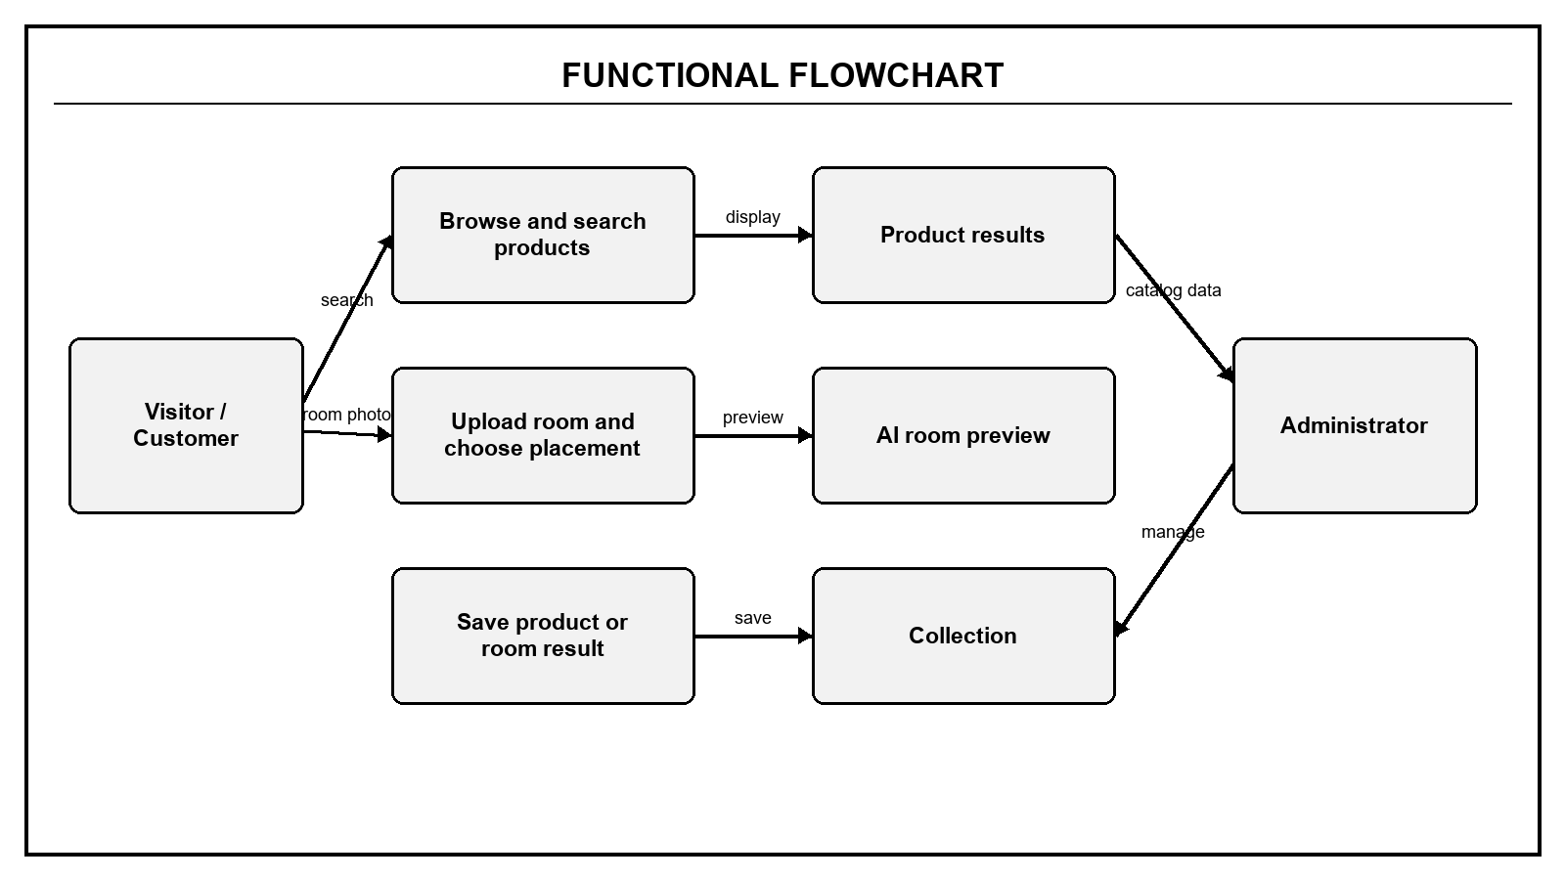
Figure 1. Functional text flow: user actions, system processing and visible outputs

2. DATA FLOW DIAGRAM

2.1 DFD Level 0 - Context
Level 0 treats FurneeHome as one system and shows the main external actors and services.
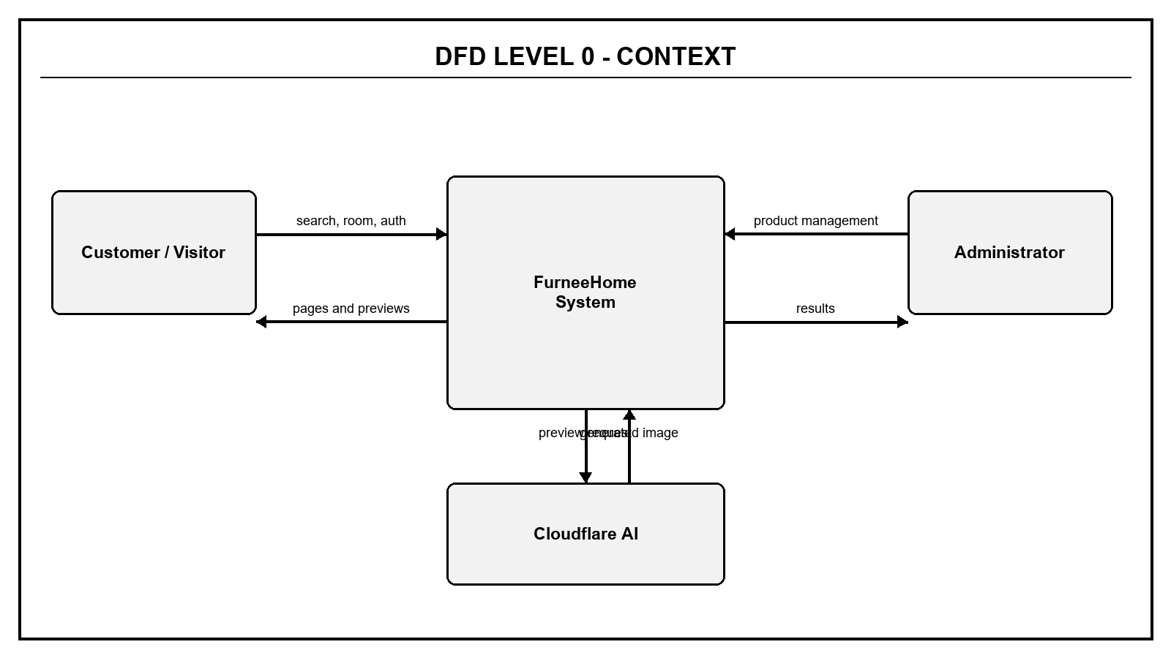
Figure 2. DFD Level 0 - Context

2.2 DFD Level 1 - Main Processes
Level 1 decomposes the system into authentication, product catalog, Room Studio, Collection and administration.
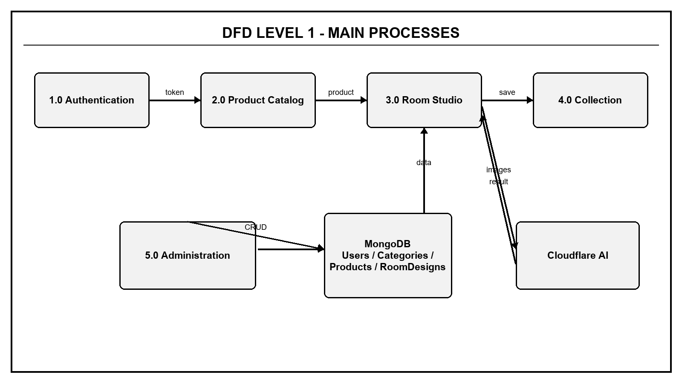
Figure 3. DFD Level 1 - Main processes and data stores

2.3 DFD Level 2 - Authentication
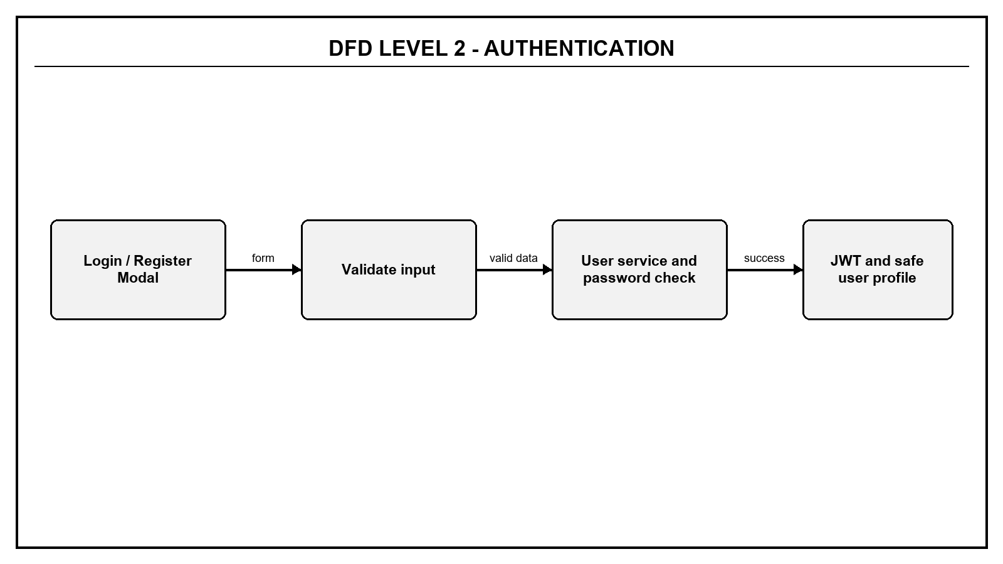
Figure 4. DFD Level 2 - Authentication

2.4 DFD Level 2 - Product Catalog
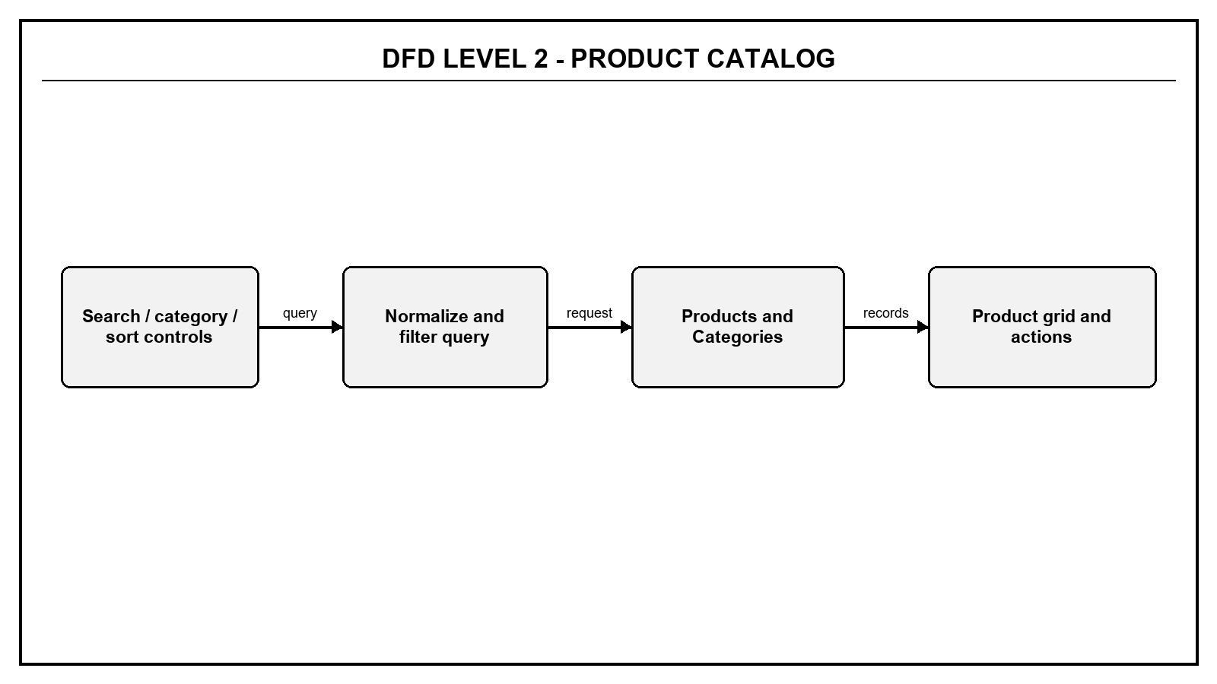
Figure 5. DFD Level 2 - Product Catalog

2.5 DFD Level 2 - Room Studio and Collection
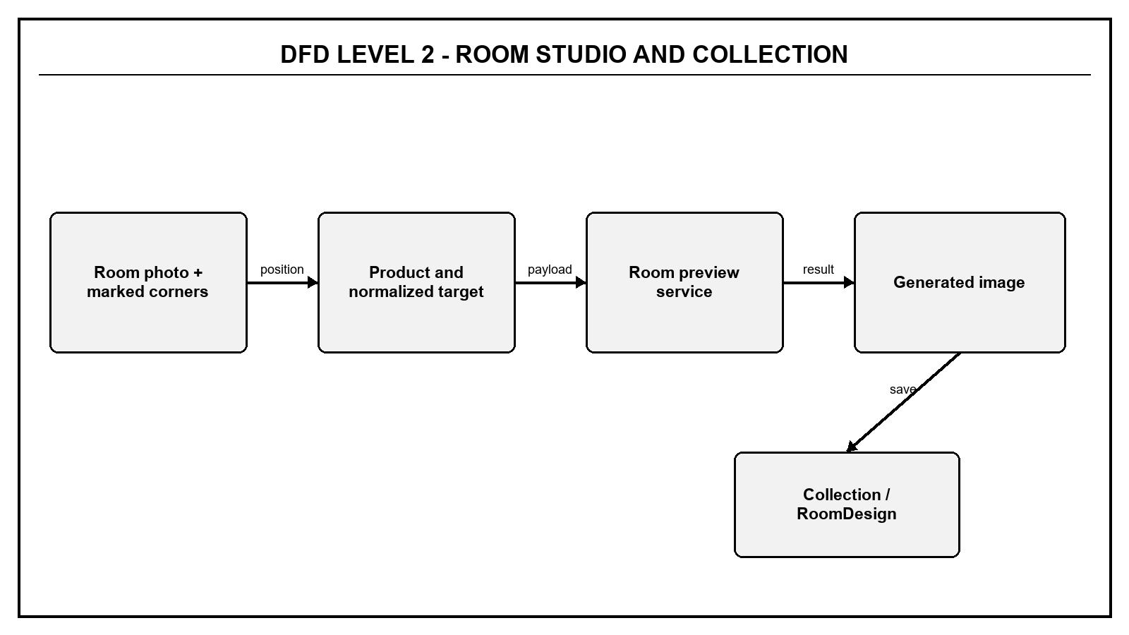
Figure 6. DFD Level 2 - Room Studio and Collection

2.6 DFD Level 2 - Administration
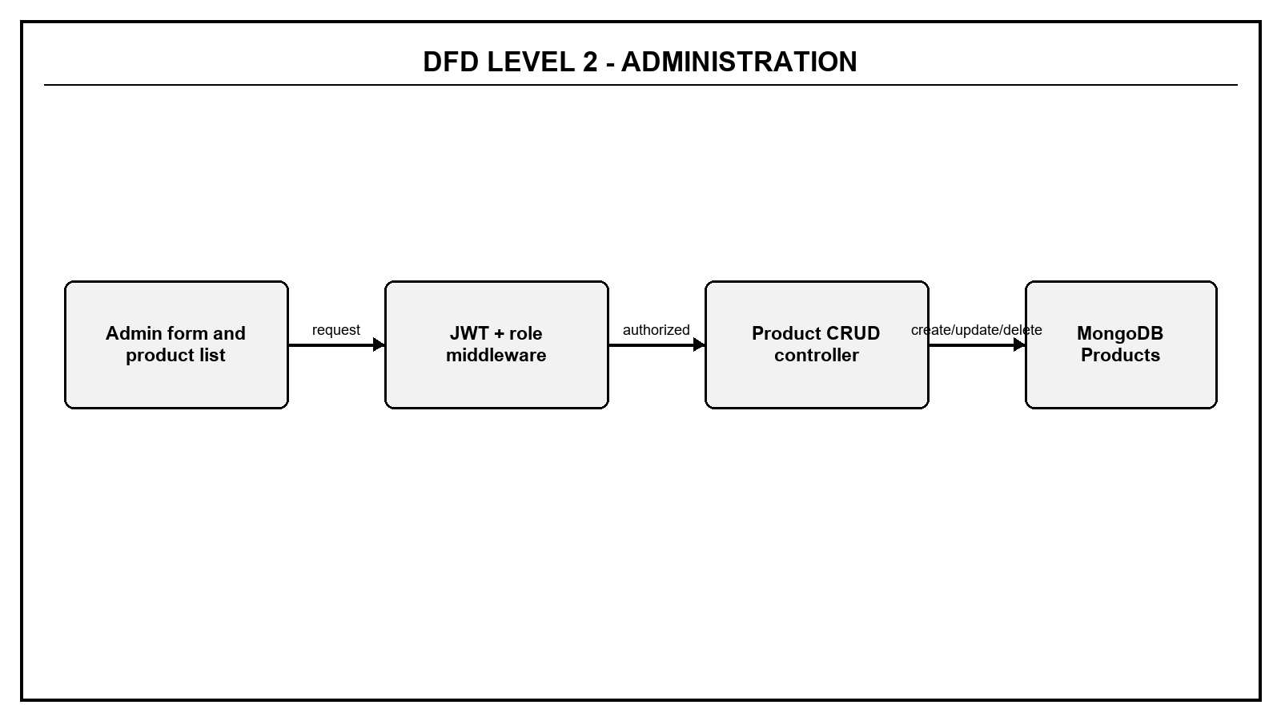
Figure 7. DFD Level 2 - Administration

3. FUNCTIONAL DIAGRAM
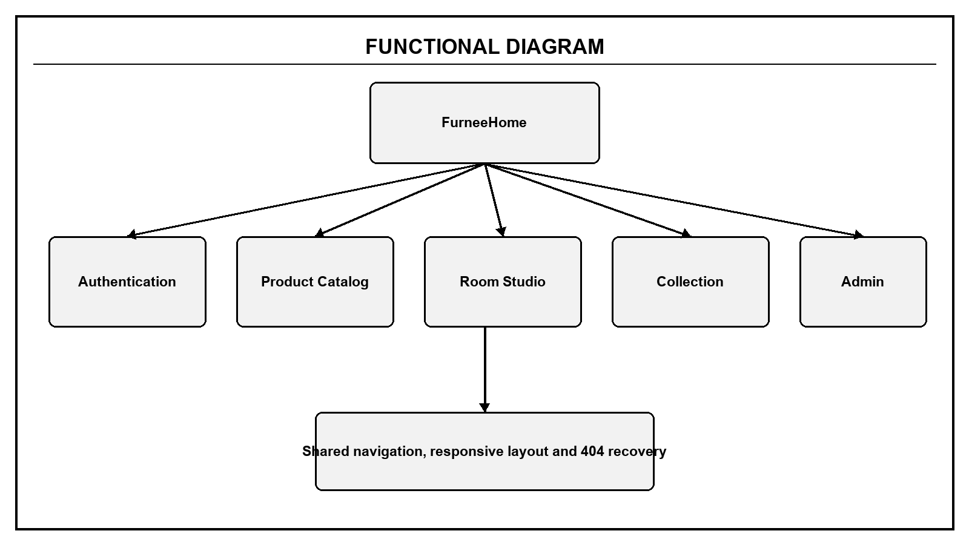
Figure 8. Functional decomposition of FurneeHome

4. DATA STRUCTURE - MONGODB
The current backend uses four Mongoose models. Collection favourites may also be kept in browser storage; MongoDB remains the backend data store for users, categories, products and saved room designs.
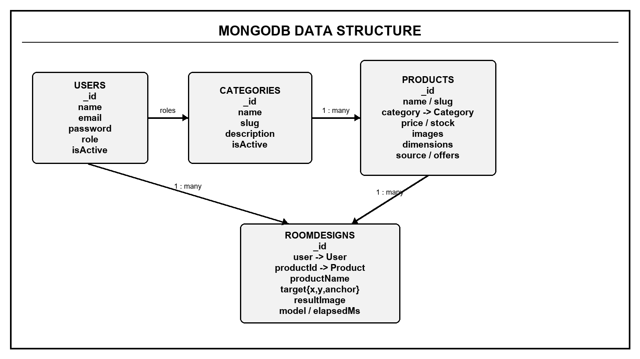
Figure 9. MongoDB collections and references

4.1 Users Collection
Field | Type | Rule | Purpose
name | String | Required, trimmed | Display name
email | String | Required, unique, lowercase | Login identifier
password | String | Required | bcrypt hash
role | String enum | customer or admin | Authorization role
isActive | Boolean | Default true | Login status
timestamps | Date | Automatic | Created and updated time

4.2 Categories Collection
Field | Type | Rule | Purpose
name | String | Required, unique | Readable category
slug | String | Required, unique | Stable key
description | String | Default empty | Explanation
isActive | Boolean | Default true | Visibility
timestamps | Date | Automatic | Created and updated time

4.3 Products Collection
Field group | Type | Rule | Purpose
name / slug | String | Name required; slug unique | Product identity
description / searchKeywords | String / array | Text indexed | Search
price / stock | Number | Minimum 0 | Reference price and stock
category | ObjectId -> Category | Required | Product category
images / transparentImage | String paths or URLs | Optional | Catalog and Room Studio artwork
dimensions | Embedded object | Positive centimetre values | Width, depth and height
sourceUrl / offers | String / embedded array | Optional | External source references
isActive | Boolean | Default true | Catalog visibility

4.4 RoomDesigns Collection
Field | Type | Rule | Purpose
user | ObjectId -> User | Required | Owner
name | String | Required, trimmed | Room design name
productId | ObjectId -> Product | Optional | Selected product
target | Embedded object | x and y from 0 to 1 | Normalized placement
resultImage | String | Default empty | Generated preview
model / elapsedMs | String / Number | Optional | Preview diagnostics
imageSize | Embedded object | Optional | Original image width and height
timestamps | Date | Automatic | Created and updated time

5. SITE MAP
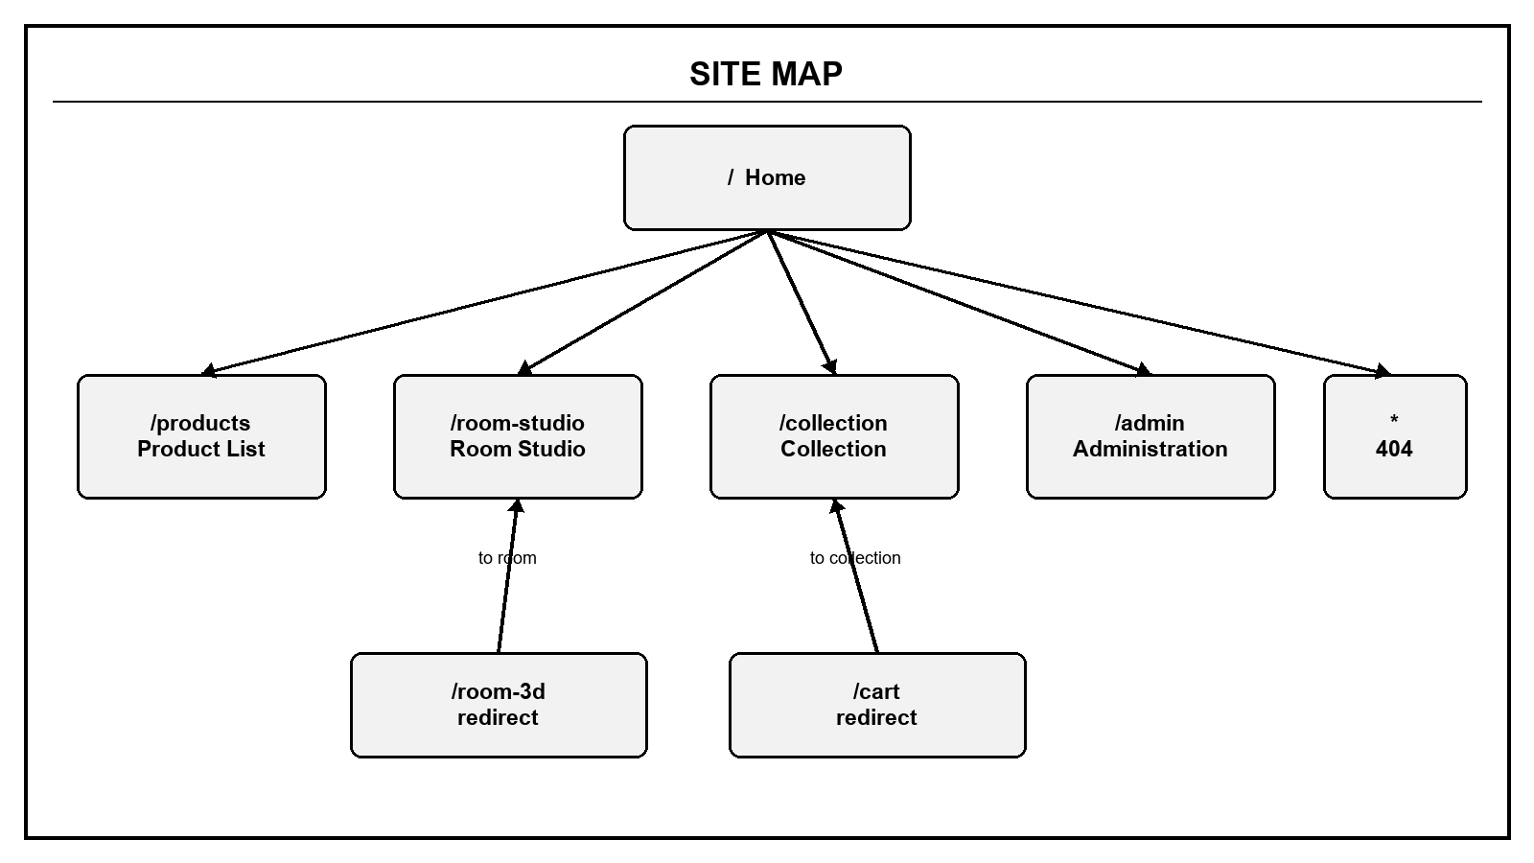
Figure 10. Site Map and compatibility redirects
Route | Page | Access | Purpose
/ | Home | Everyone | Introduce FurneeHome and direct users to core functions
/products | Product List | Everyone | Search, filter, sort, save and try products
/room-studio | Room Studio | Everyone | Upload room, choose placement and generate preview
/collection | Collection | Current browser / user | Review saved products and room results
/admin | Administration | Admin | Manage products
* | Not Found | Everyone | Recover from an invalid route
/cart | Redirect | Everyone | Redirect to /collection
/room-3d | Redirect | Everyone | Redirect to /room-studio
No route | Authentication Modal | Everyone | Login or register above the current page

REVIEW 3
UI/UX wireframes for every current application page. This review intentionally does not include code-level function explanations; those will be added only after the project is finalized.

1. REVIEW 3 SCOPE
- Document every canonical page route and the authentication overlay.
- Show the intended desktop arrangement using black-and-white wireframes that resemble the final website structure.
- State the purpose, visible regions, user actions and expected navigation for each page.
- Record compatibility redirects without inventing separate pages.
- Exclude code snippets, function-by-function explanations, API implementation details and test results from this Review 3 version.

2. ROUTE AND PAGE INVENTORY
Route | Wireframe | Primary user | Page outcome
/ | Home | Everyone | Understand the service and choose Products or Room Studio
/products | Product List | Everyone | Find and act on a suitable product
/room-studio | Room Studio | Everyone | Create a positioned room preview
/collection | Collection | Current browser / user | Review saved products and room results
/admin | Administration and denied state | Admin / non-admin | Manage products or request administrator login
* | Not Found | Everyone | Recover from an invalid URL
No separate route | Authentication modal | Everyone | Login or register without leaving the current page

3. SHARED LAYOUT AND AUTHENTICATION MODAL
All canonical pages use the shared header, navigation and footer. The active navigation item identifies the current page. On smaller screens the navigation and multi-column areas wrap or collapse into fewer columns.
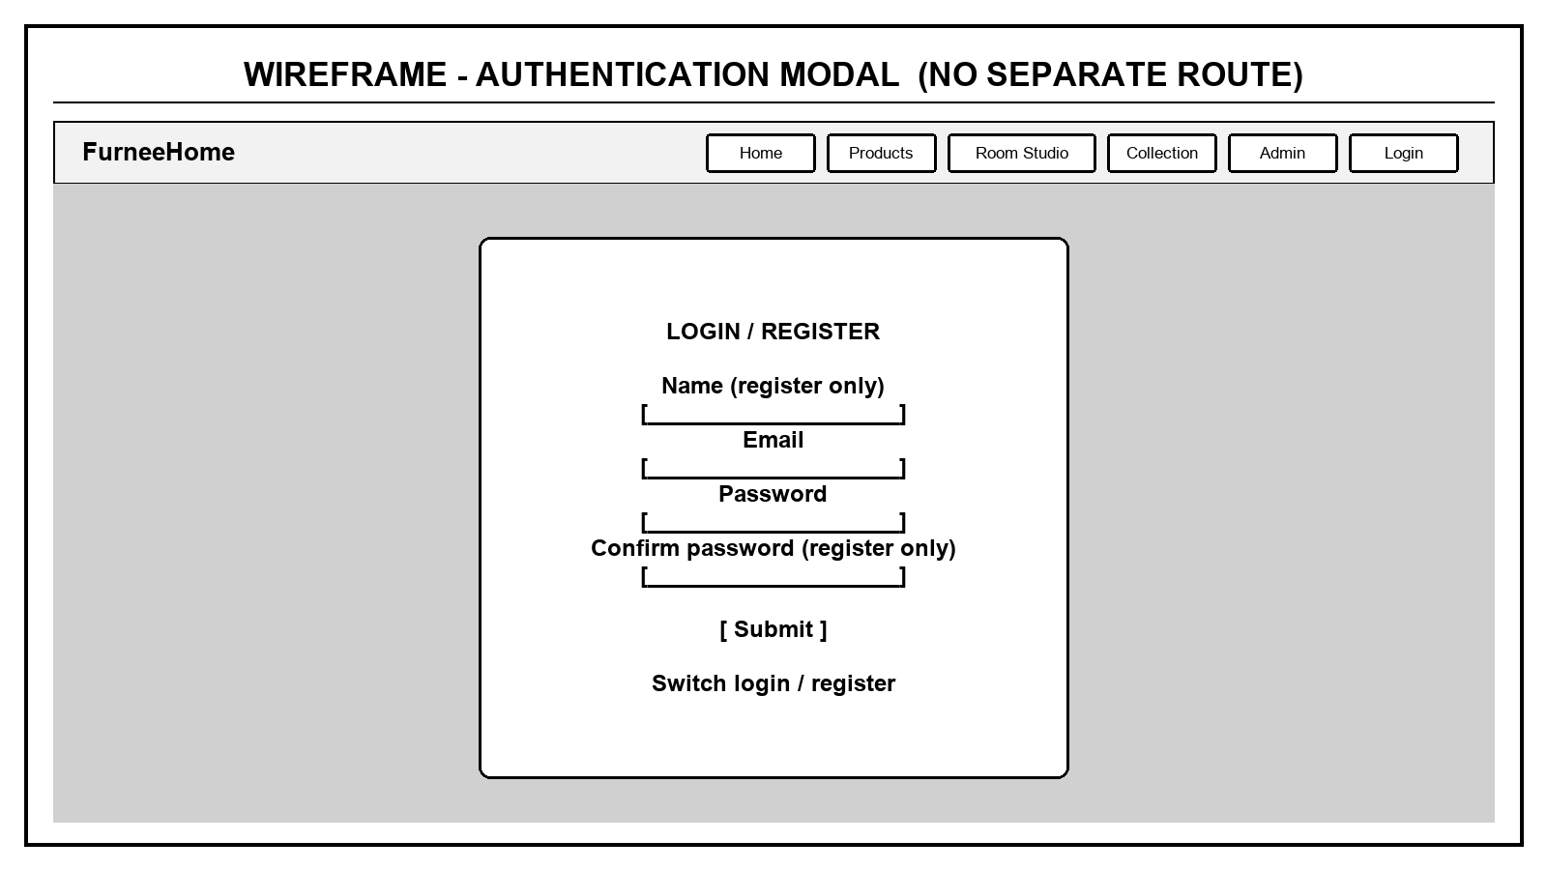
Figure 11. Authentication modal displayed above the current route
Region | Content | Main interaction
Header | Brand, Home, Products, Room Studio, Collection, Admin and account actions | Navigate without losing the application shell
Login mode | Email and password | Submit credentials or switch to registration
Registration mode | Name, email, password and confirmation | Create a customer account
Backdrop and close | Current page remains visible behind the modal | Close without changing the current route
Footer | Project identity and supporting links | Shared page ending

4. HOME PAGE - /
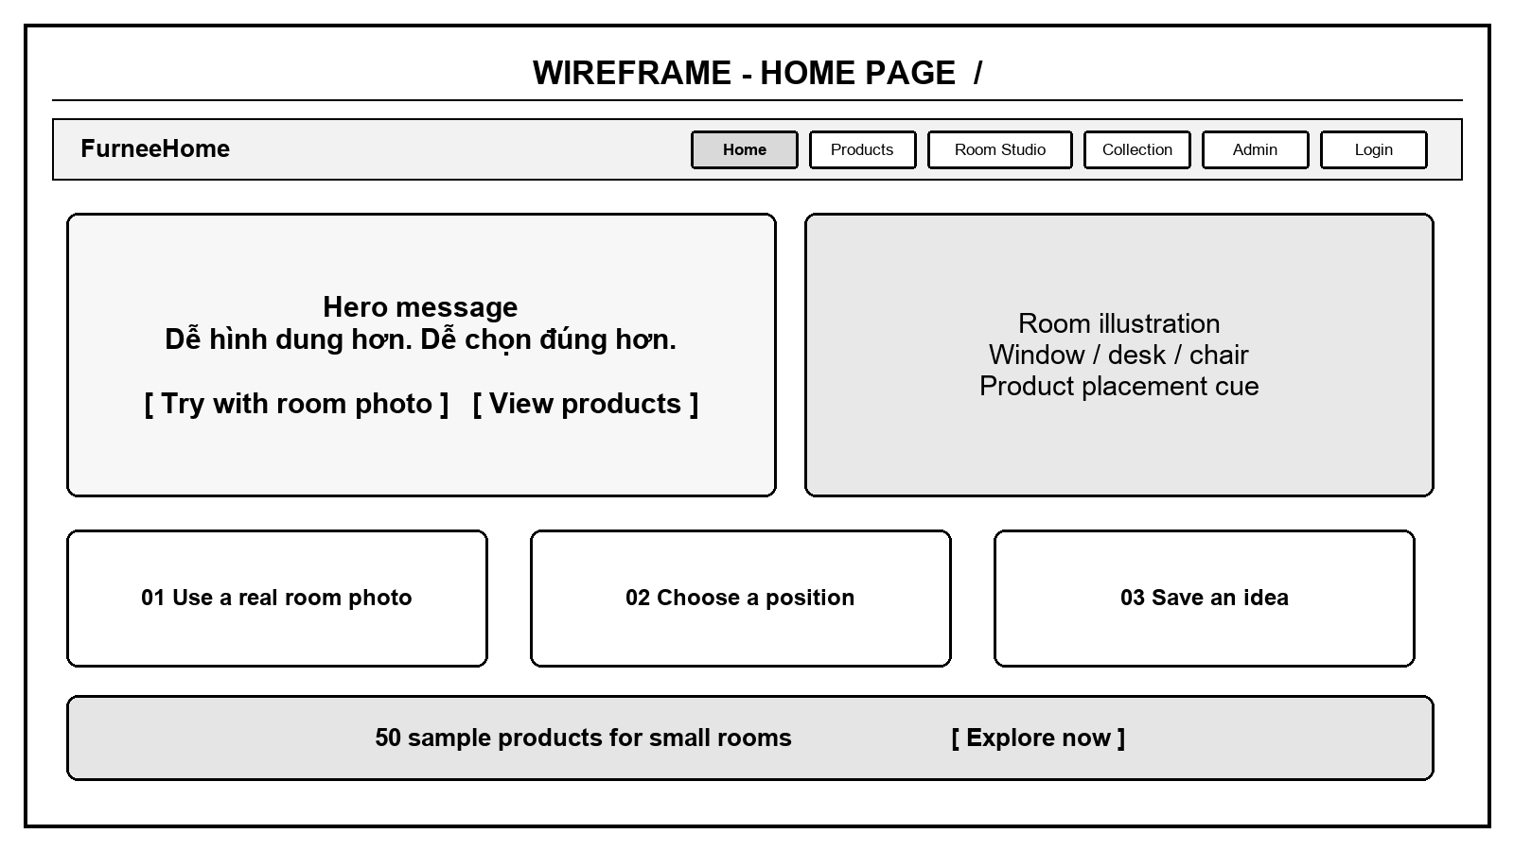
Figure 12. Home Page wireframe
Area | Purpose | Primary action
Hero | Explain the room-preview benefit | Open Room Studio or Product List
Hero visual | Show the relationship between a room and product placement | Support understanding
Three feature cards | Summarize the real-photo, target and save workflow | Prepare the user for Room Studio
Product callout | Present the available sample catalog | Open Product List

5. PRODUCT LIST PAGE - /products
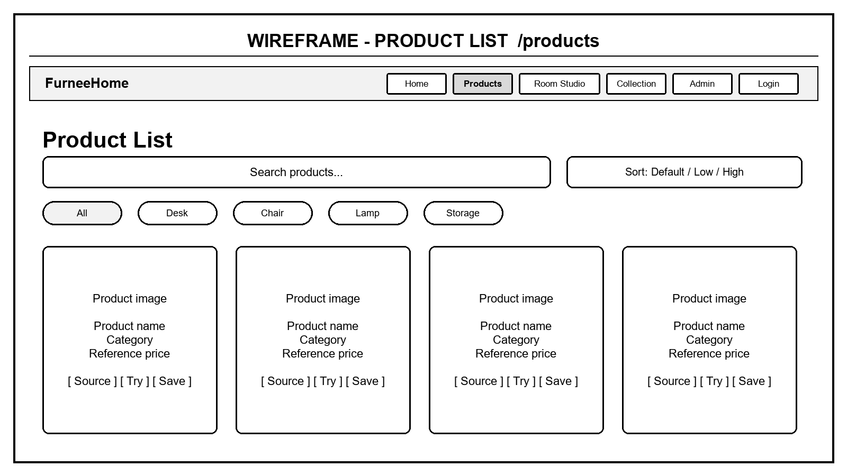
Figure 13. Product List Page wireframe
Area | Control | Visible result
Page heading | No input | Catalog title, description and result count
Toolbar | Search and price sort | Filtered and ordered products
Category pills | Select one category | Only matching product cards
Product card | Source, Try and Save actions | External source, Room Studio selection or Collection item
Empty state | No matching products | Recovery message and changed filters

6. ROOM STUDIO PAGE - /room-studio
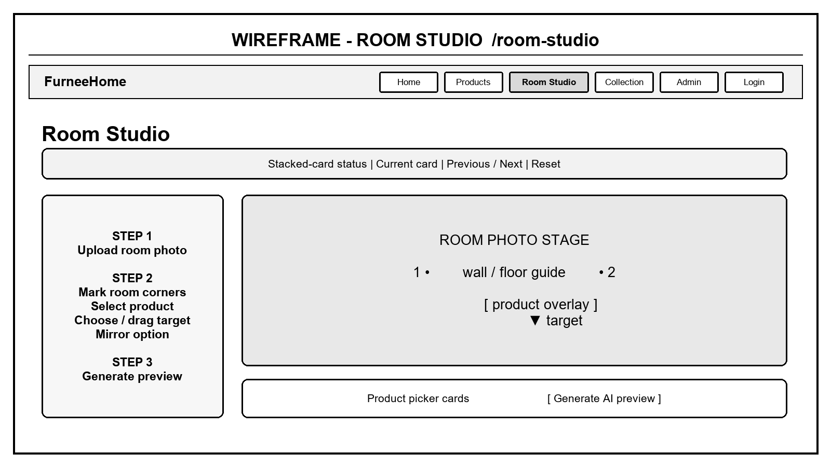
Figure 14. Room Studio Page wireframe
Area | Input or state | Visible result
Stacked-card bar | Current result card and navigation | Move between the working room and generated results
Room setup | Upload JPG or PNG and mark corners | Room image with numbered corner points and guide lines
Placement | Choose product, corner/free target and mirror option | Live product overlay at the selected position
Preview action | Generate preview | Generated image, elapsed time and Collection save
Session state | Guest or signed-in user | Session storage warning or persistent local save message
Product picker | Select a product card | The active product becomes the Room Studio preview item

7. COLLECTION PAGE - /collection
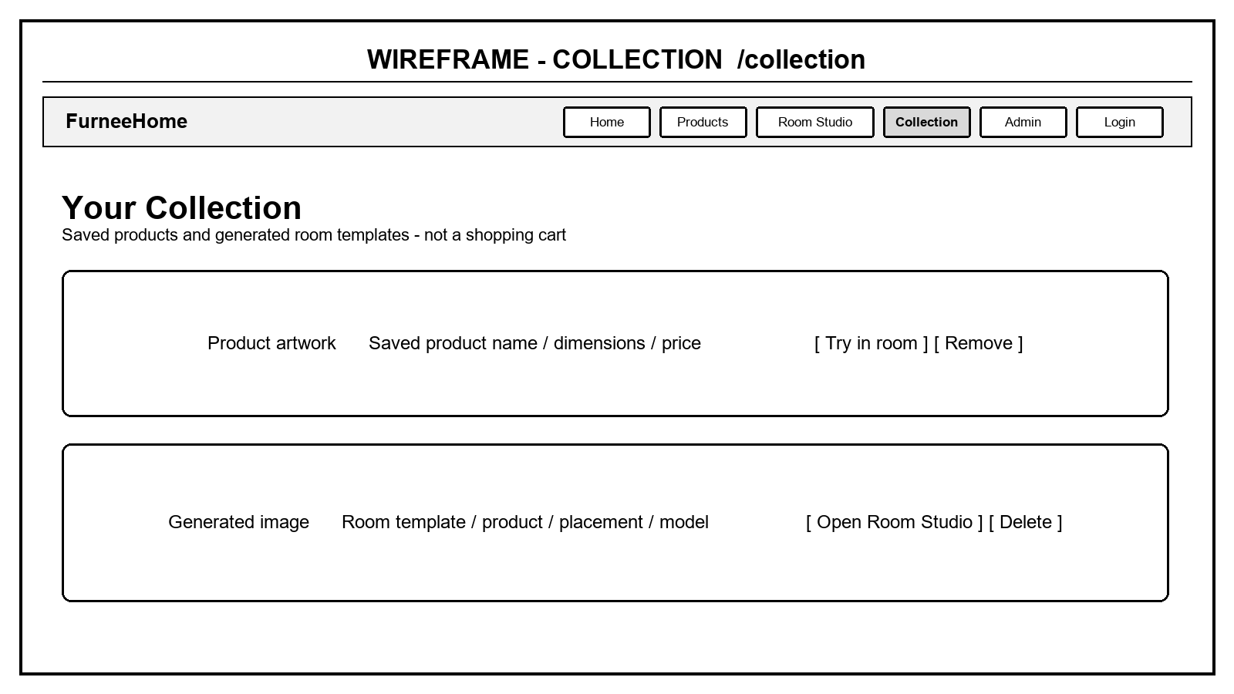
Figure 15. Collection Page wireframe
Item state | Displayed content | Available action
Empty | Explanation that the Collection is not a cart | Open Product List
Saved product | Artwork, name, dimensions and reference price | Try in Room Studio or remove
Saved room template | Generated image, product and placement | Open Room Studio or delete
Legacy placement | Percentage or normalized coordinates | Normalize for a consistent display

8. ADMINISTRATION PAGE - /admin
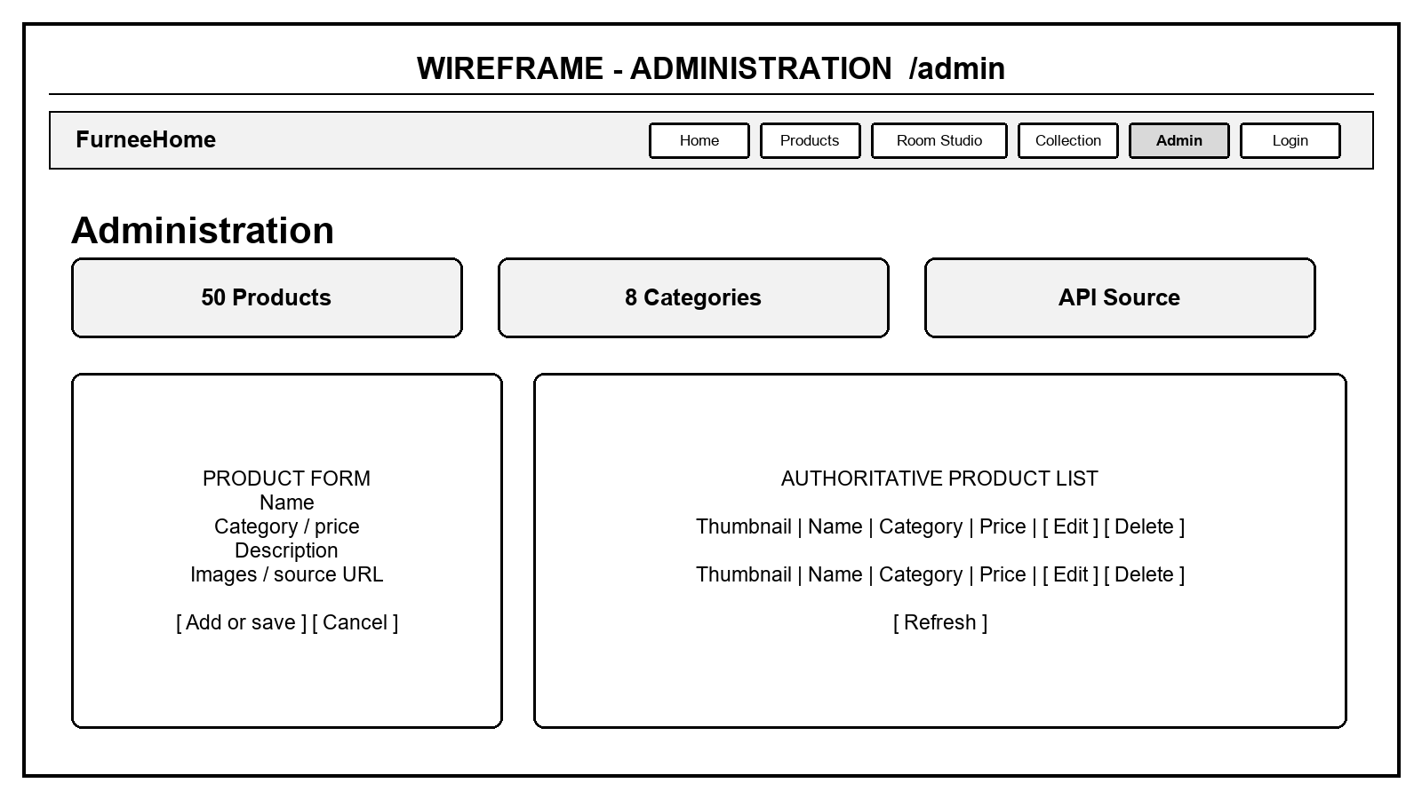
Figure 16. Administration Page wireframe - authorized state
Area | Control | Result
Statistics | No input | Product, category and data-source summary
Product form | Name, category, price, description, images and source | Create or update a product
Product list | Edit, delete and refresh | Selected form data or updated authoritative list
Authorization | Admin account | Management controls are available

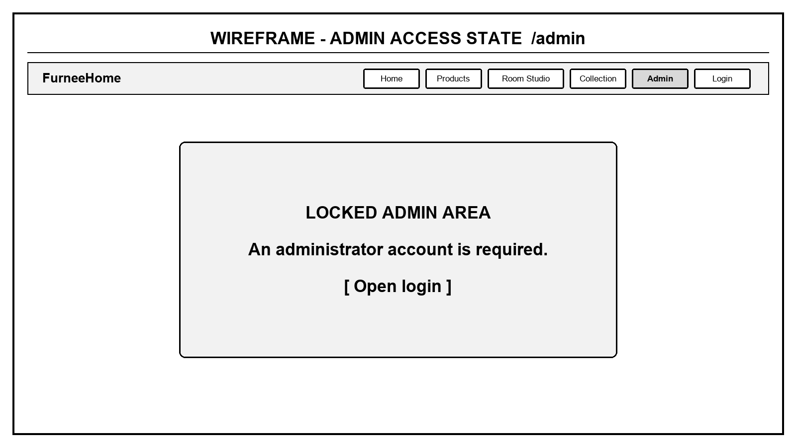
Figure 17. Administration Page wireframe - visitor or non-admin state
A visitor or customer who opens /admin sees an access message and a button that opens the authentication modal. This screen is a user-experience guard; protected backend actions still require an administrator token and role.

9. NOT FOUND PAGE - *
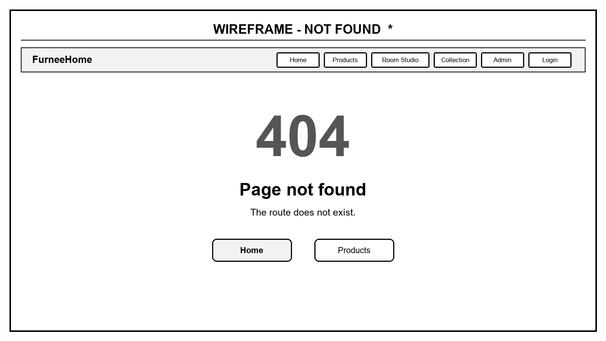
Figure 18. Not Found Page wireframe
The Not Found page shows a large 404 status, explains that the route does not exist and provides direct recovery actions to Home and Product List.

10. COMPATIBILITY REDIRECTS
Entered route | Redirect target | Reason no separate wireframe is created
/cart | /collection | The implemented project uses Collection instead of a shopping cart page.
/room-3d | /room-studio | The implemented project uses the photo-based Room Studio as the canonical page.

