**ECE 466 Lab 1**

Xin Chen

1004391865

**Part 1. Poisson Traffic**

Exercise 1.1 Scaling Poisson Traffic Arrivals

1. Theoretically bit rate: 1Mbps
2. Theoretically arrival time: $\frac{Packet Size}{Rate}= \frac{1000bytes×\frac{8bits}{byte}}{1Mbps}=800us$
3. Actual bit rate: $\frac{Packet Size}{Average Time}= \frac{125000×1000bytes×\frac{8bits}{byte}}{99938887us}=1.0006Mbps$
4. Mean time between consecutive arrival events: 799.5051us
5. Variance of times between consecutive arrival events: 6.4054105 us2

The mean time between arrival events is 799.5us, which is very close to the theoretically arrival time been calculated. But the variance of time between the arrival events are large, meaning there are big difference of traffic arrivals between time slot.

Following is the three plots of data generated by the trace, viewed at different time scale.

**Plot1. Poisson Traffic Arrivals Plots, using the given poisson1.data to plot the arrival traffic number of bytes data with different time scale (1s, 0.1s, 0.01s respectively)**

From the three plots of data, we can find that in the big time scale (1s time period), the number of bytes arrival are almost the same at every period. While with small time interval (0.1s or 0.01 time period), the number of bytes arrival are vary different for each period, which is also shown by the large actual variance calculated above.

Exercise 1.3 Compound Poisson Arrival Process

1. Theoretically bit rate: $1250\frac{packets}{sec}×100bytes ×8bits=1Mbps$
2. Theoretically arrival time: 800us
3. Actual bit rate: 1.0089Mbps
4. Mean time between consecutive arrival events: 795.2037us
5. Variance of times between consecutive arrival events: 6.3184105 us2

Below is the traffic arrival flows of poisson3.data

**Plot2. Poisson Traffic Arrivals Plots, using the given poisson3.data to plot the arrival traffic number of bytes of data with different time scale (1s, 0.1s, 0.01s respectively)**

Comparing with exercise1.1, the behavior of the traffic arrivals is similar. But poisson3.data has a larger difference between the number of bytes arrived.

**Part 2. Compressed Video Traffic**

Exercise 2.2 Determine statistical properties of the video trace

1. Number of frames: 53996 frames

Total number of bytes: 3.21109 bytes

1. Smallest frame: 136 bytes

Largest frame: 657824 bytes

Mean frame: 59447 bytes

|  |  |  |  |
| --- | --- | --- | --- |
|  | I (BYTES) | p(BYTES) | b(BYTES) |
| Smallest frame | 528 | 152 | 136 |
| Largest frame | 657824 | 493176 | 368976 |
| mean frame | 183780 | 111410 | 36093 |

1. Mean bit rate = $\frac{Mean Frame Size}{Frame Duration}= \frac{59447 bytes ×8\frac{bites}{byte}}{33ms}=14.411Mbps$
2. Peak bit rate = $\frac{Max Frame Size}{Frame Duration}= \frac{657824 bytes ×8\frac{bites}{byte}}{33ms}=159.472Mbps$
3. Peak-to-Average Rate = $\frac{159.472 Mbps}{14.411 Mbps}=11.066$
4. Generate a graph that shows the frame size as a function of the frame sequence number

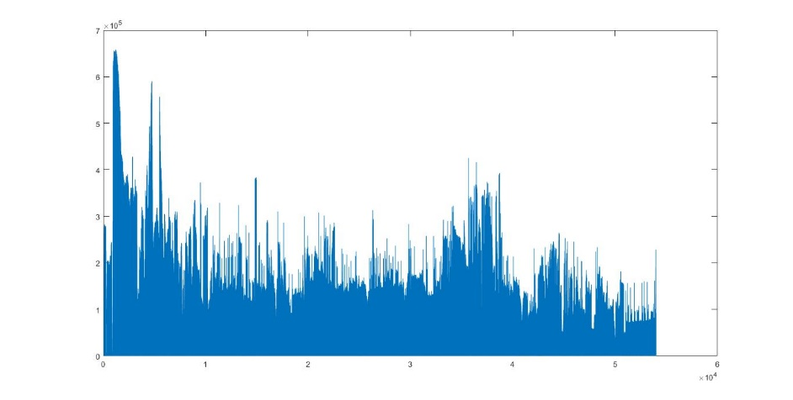

**Plot3. Frame size as a function of the frame sequence number**

1. Generate a graph that shows the distribution of I frames, P frames, and B frames.

**Plot4. Distribution of I frames, P frames, and B frames**

Exercise 2.3 Scaling Video Traffic

**Plot5. Video Traffic Arrivals Plots, using the given movietrace.data to plot the arrival traffic number of bytes of data with different time scale (1s, 0.1s, 0.01s respectively, x-aixs shows the number of data points)**

For the video traffic, the arrival traffic in different time scale are different. Part 1 shows that Poisson Traffic in the big time scale (1s time period), the number of bytes arrival are almost the same at every period, but giving the same time scale in video traffic, the number of bytes arrival still have a big difference. This is because video traffic is depends on the content of screen and it’s a self-similar process.

**Part 3. Aggregate Traffic on an Ethernet Network**

Exercise 3.2 Determine Statistical Properties of the Ethernet

1. Number of captured packets: 1000000packets
2. Total Number of bytes: 434292031 bytes
3. Mean bit rate: $\frac{434292031bytes×\frac{8bits}{byte}}{3142.82s}=1.1055Mbps$
4. Peak bit rate: 43.5Mbps
5. Ratio of the peak rate and average rate: $\frac{43.5Mbps }{1.1055Mbps}=39.35$
6. Generate a graph that depicts the packet size as a function of time

**Plot6. Packet size as a function of time**

1. Generate a graph that shows the distribution of packet sizes

**Plot7. Distribution of packet sizes**

Exercise 3.3 Scaled Depiction of Ethernet Traffic

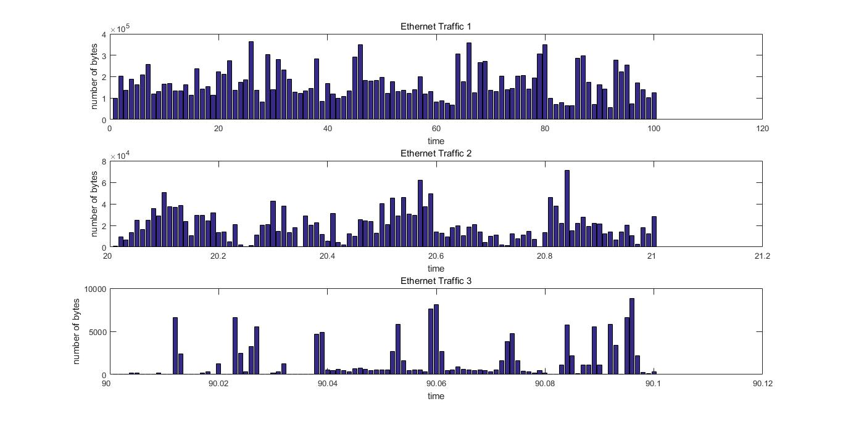

**Plot8. Ethernet Traffic Arrivals Plots, using the given datapoint to plot the arrival traffic number of bytes of data with different time scale (1s, 0.1s, 0.01s respectively)**

For the network traffic, the arrival traffic in different time scale are unlike Poisson traffic. It depends on the actual data needed to be transmitted through internet. So the ethernet traffic has self-similar nature, and cannot use any commonly used traffic models to predict its behavior