Localization and classification

Localization:

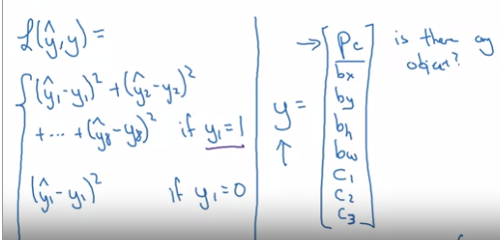

Detection

Slide windows algorithm but too slow

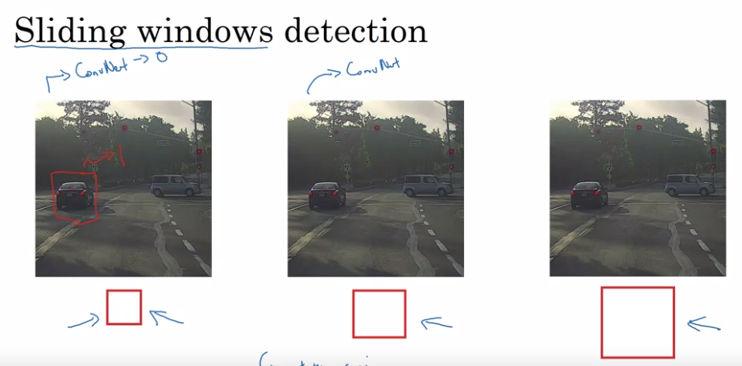

Convolutional implementation of sliding windows

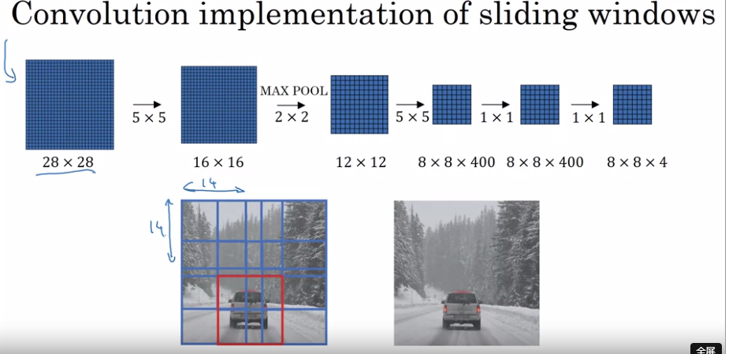

YOLO algorithm

Intersection(IOU)

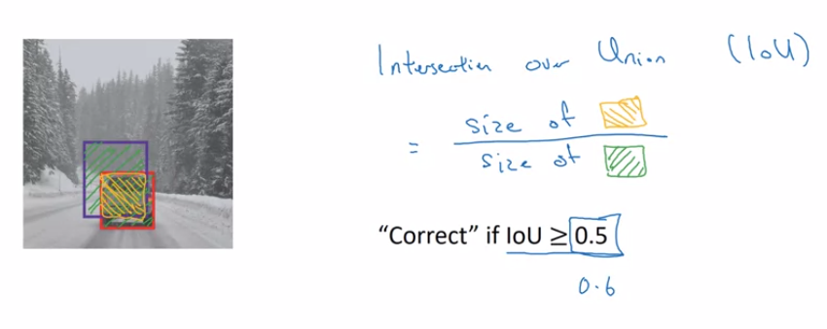

NON-MAX suppression

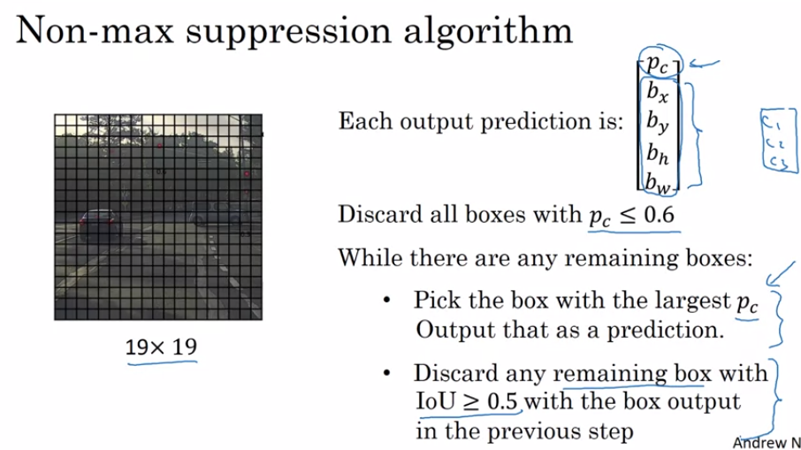

Anchor boxes

用于每一个细胞中有多个物体

最后的YOLO algorithm