# 模型选择与评估方法

1. **模型选择**

**说明：**对于同一个问题，可以以有多种模型来解决。如一个分类问题，可以用logistic回归、SVM、朴素贝叶斯等，那么如何选择一个最好的模型呢。 首先会想到的是，对每个模型，用训练集合去训练他们，取训练误差最小的模型。 但是这有明显的缺陷，因为这将会得到一个最复杂的模型（比如一个10次多项式），产生严重的过拟合。给出下面三种方法。

* 1. **留出法:**

数据集划分成互斥的训练集和测试集，随机划分，划分要保持数据分布的一致性。常用做法: 2/3-4/5样本用作训练，剩余样本用作测试

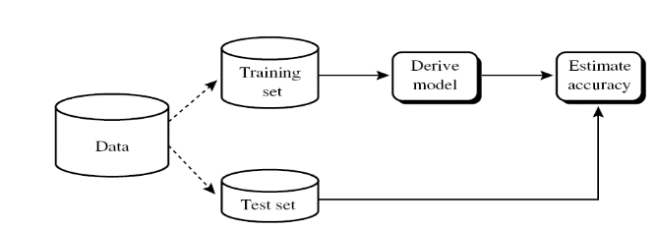

* 1. **K-折交叉验证**

常用做法：5折-交叉，10折-交叉， 20折-交叉

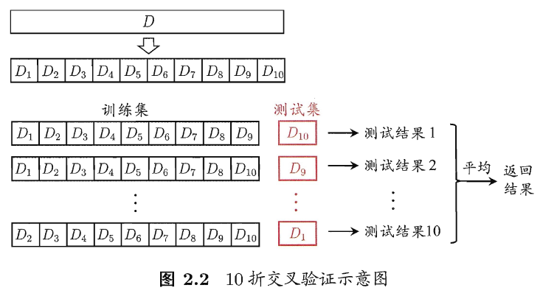

* 1. **留一法**

K-折交叉验证的特例，如果样本数为N，则为N-折交叉验证

**R程序：**

|  |
| --- |
| *library(ggplot2)*  *# 曲线函数*  *plusModel<-function(xita,x){*  *h0 = xita[1]*  *h1 = xita[2]*  *h2 = xita[3]*  *t1 = xita[4]*  *t2 = xita[5] + t1*  *beta=xita[6]*  *( h0 + (h1-h0)/(1+exp(-beta*(x-t1))) ) * ( h2 + (h1-h2)/(1+exp(beta*(x-t2))) ) / h1*  *}*  *#创建样本数据*  *x=seq(0,300,by=1)*  *#添加噪声*  *par = c(2.6170019, 20.8858480, 8.2183875,128.3199316, 33.8561940,0.0570245,840.6384970)*  *y=plusModel(par, x) +rnorm(length(x),0,0.6)*  *data1=data.frame(x,true_y=plusModel(par, x), y=y)*  *#查看数据*  *ggplot(data1,aes(x,y))+geom_point()+geom_line(aes(y=true_y), color='red', size=2)* |

|  |
| --- |
| *# 这里采用多种模型*  *# y=a+bx+cx^2+dx^3+ex^4…*  *#曲线拟合*  *poly3=lm(y~poly(x,degree = 3),data=data1)*  *polydata = cbind(p2=predict(lm(y~poly(x,degree = 2),data=data1)),*  *p4=predict(lm(y~poly(x,degree = 4),data=data1)),*  *p6=predict(lm(y~poly(x,degree = 6),data=data1)),*  *p8=predict(lm(y~poly(x,degree = 8),data=data1)),*  *p10=predict(lm(y~poly(x,degree = 10),data=data1)),*  *p12=predict(lm(y~poly(x,degree = 12),data=data1)),*  *p14=predict(lm(y~poly(x,degree = 14),data=data1)))*  *polydata = melt(polydata)*  *ggplot(data1,aes(x,y))+geom_point()+*  *geom_line(aes(y=true_y), color='red', size=2)+*  *geom_line(data=polydata, aes(x=Var1,y=value, color=Var2), size=1)* |

|  |
| --- |
| *#计算均方误差 RMSE*  *RMSE=function(t,p){*  *return(sqrt(mean((t-p)^2)))*  *}*  *#随着自由度的增加，查看均方误差的变化*  *Performance=data.frame()*  *for (d in 1:20) {*  *polyfit=lm(y~poly(x,degree = d),data=data1)*  *mean.rmse=RMSE(data1$y,mean(data1$y))*  *model.rmse=RMSE(data1$y,predict(polyfit))*  *Performance=rbind(Performance, data.frame(Degree=d,model.rmse,Rsqr=1-model.rmse/mean.rmse))*  *}*  *ggplot(Performance,aes(Degree,model.rmse))+geom_line()+geom_point()* |

|  |
| --- |
| *#1.交叉验证法*  *# 所谓交叉验证方法即把数据集分为两部分，Training data 和 testing data.用Training data建模，*  *# 用testing data来验证模型的泛化能力。从而避免过拟合。*  *#1.把数据分为trainingdata and testingdata*  *index=nrow(data1)*  *#随机抽取一部分为训练样本，一部分为测试样本*  *index1=sample(index,round(0.5*index))*  *trainingdata=data1[index1,]*  *testingdata=data1[-index1,]*  *#做一个循环得到traindata 和testdata 的rmse.*  *Performance=data.frame()*  *for(d in 1:20){*  *polyfit=lm(y~poly(x,degree = d),data=trainingdata)*  *Performance=rbind(Performance,data.frame(Degree=d, Data='Train', rmse=RMSE(trainingdata$y,predict(polyfit))))*  *Performance=rbind(Performance,data.frame(Degree=d, Data='Test', rmse=RMSE(testingdata$y,predict(polyfit,newdata = testingdata))))*  *}*  *ggplot(Performance,aes(Degree,rmse,linetype=Data,color=Data))+geom_point()+geom_line()* |

|  |
| --- |
| *#10折交叉验证法*  *library(caret)*  *folds<-createFolds(y=data1$y,k=10) #根据data1的y把数据集切分成10等份*  *re<-{}*  *Performance=data.frame()*  *for(i in 1:10){*  *traindata<-data1[-folds[[i]],]*  *testdata<-data1[folds[[i]],]*  *p6=lm(y~poly(x,degree = 6),data=traindata)*  *p8=lm(y~poly(x,degree = 8),data=traindata)*  *p10=lm(y~poly(x,degree = 10),data=traindata)*  *pre6 = predict(p6,newdata=testdata)*  *pre8 = predict(p8,newdata=testdata)*  *pre10 = predict(p10,newdata=testdata)*  *Performance<- rbind(Performance,c(RMSE(as.numeric(testdata$y),pre6),*  *RMSE(as.numeric(testdata$y),pre8),*  *RMSE(as.numeric(testdata$y),pre10)))*  *}*  *apply(Performance,2,mean)*  *>0.8934863 0.7272538 0.6921159* |

1. **评估方法**
2. 计算准确率，错误率，精度，召回率，F1度量，加权F1度量， 宏查准率，宏查全率， 微查准率，微查全率
3. P-R图
4. ROC-AUC
5. 统计检验
6. 偏差方差分解

|  |
| --- |
| *#*  *class1 = data.frame(x=sample(seq(0,2,0.1),20),y=sample(seq(2,4,0.01),100), label=1)*  *class2 = data.frame(x=sample(seq(1,3,0.1),20),y=sample(seq(0,3,0.01),100), label=0)*  *data = rbind(class1,class2)*  *#md = melt(data,id=c,measure=c("y1","y2","x1","x2"))*  *ggplot(data=data, aes(x,y, color=as.factor(label)))+geom_point(aes(shape = factor(label)),size=3)*    *#######*  *index=nrow(data)*  *#随机抽取一部分为训练样本，一部分为测试样本*  *index1=sample(index,round(0.6*index))*  *trainingdata=data[index1,]*  *testingdata=data[-index1,]*  *logi <- glm(label ~ x+y, family= binomial(link="logit"), trainingdata)*  *fitt.pi<-predict(glm.safe1,testingdata[,1:2],type="resp")#fitted(logi)*  *#ypred<-1*(fitt.pi>0.5) #1*逻辑变量就变成了0和1变量*  *library(plotROC)*  *r1=plot.roc(testingdata[,3],fitt.pi, col='red', lwd=4)*  *library(e1071)*  *svm1 <- svm(label ~ x+y, data=data )*  *svm.pi<-predict(svm1,testingdata[,1:2],type="resp")*  *r2=plot.roc(testingdata[,3],svm.pi, col='deepskyblue', lwd=4, add=TRUE)*  *legend('bottomright',*  *legend= paste(c('logit', 'svm'),*  *' - AUC=',signif(c(as.numeric(r1$auc), as.numeric(r2$auc))),*  *sep=''),*  *col=c('red', 'deepskyblue'), lty=1, lwd=* |