EQUITY RESEARCH · CHINA & HONG KONG · INITIATION OF COVERAGE
China & Hong Kong: 17 Initiations
Resources, batteries, semiconductors, robotics, medtech and AI models. Company background, the business, competition, TAM, a three-statement financial analysis and valuation in up to five pages each.
12 October 2026 · Prices as of the 12-Oct-2026 close
7  Buy |  | 9  Hold |  | 1  Sell

Our highest-conviction Buys are Zijin Mining (+37%), CATL (+36%), Han's Laser (+35%). Each pairs earnings growth with a valuation the market cut during the September sell-off.
We rate Leaderdrive a Sell. It is a good company, but at ~200x+ forward earnings the shares price in a humanoid-robot future that does not yet show up in its numbers.
The Holds are a mixed group. In lithium and nickel (Tianqi, Ganfeng, Huayou), prices are turning down. GigaDevice and China Jushi are cyclical winners whose peak earnings look priced in, while Sungrow and Sieyuan still have to prove their turnaround or mix shift. We see the two LLM developers, Z.AI and MiniMax, as binary bets trading close to our risk-weighted value.
Built from the source pack "17 China/HK Stocks: Business Model, Performance and Outlook" (6 Oct 2026), updated with company filings, consensus data and market prices to 12 Oct 2026. AI-assisted research for information only; not investment advice. See the methodology and disclosures at the end.

Summary of ratings and valuation
# | Company | Rating | Price | Target | Return | Mkt cap US$bn | FY26E | FY27E | One-line view
1 | Zijin Mining  601899.SH | Buy | RMB30.22 | RMB41.50 | +37% | 117.1 | P/E 9.8x | 8.7x | Volume growth few miners can match, at a single-digit multiple
2 | Sany Heavy Industry  600031.SH | Buy | RMB17.52 | RMB22.50 | +28% | 23.6 | P/E 15.6x | 12.5x | A global share-taker at a trough multiple, with overseas now driving earnings
3 | CATL  300750.SZ | Buy | RMB298.38 | RMB405.00 | +36% | 209.1 | P/E 14.6x | 12.6x | Still the cost and technology leader; second-sourcing fears have created an entry point
4 | Han's Laser  002008.SZ | Buy | RMB70.18 | RMB95.00 | +35% | 10.8 | P/E 26.3x | 18.5x | An AI-capex winner with clear order visibility; the sell-off is an entry point
5 | JL Mag Rare-Earth  6680.HK | Buy | HK$14.75 | HK$18.50 | +25% | 4.4 | P/E 19.2x | 15.0x | The global magnet leader; own it through the discounted H-share
6 | Sungrow Power  300274.SZ | Hold | RMB82.35 | RMB95.00 | +15% | 25.3 | P/E 13.8x | 11.7x | Margins are recovering; revenue has to follow before we turn constructive
7 | Sieyuan Electric  002028.SZ | Hold | RMB120.65 | RMB140.00 | +16% | 14.1 | P/E 25.9x | 20.8x | A quality private-sector grid franchise; storage mix and valuation cap the upside
8 | GigaDevice  603986.SH | Hold | RMB310.84 | RMB360.00 | +16% | 32.6 | P/E 16.2x | 15.6x | Exceptional earnings, but we would be paying for the top of the memory cycle
9 | Edge Medical  2675.HK | Buy | HK$32.88 | HK$42.00 | +28% | 1.6 | EV/S 11.7x | 8.3x | An export-led surgical-robot challenger at breakeven: small and volatile, but worth owning
10 | Leaderdrive  688017.SH | Sell | RMB252.02 | RMB176.00 | −30% | 6.9 | P/E 308x | 205x | A good company priced for a humanoid future that has not yet arrived
11 | Huayou Cobalt  603799.SH | Hold | RMB34.53 | RMB38.50 | +11% | 9.8 | P/E 11.1x | 9.4x | The integration is genuine, but slipping earnings quality explains the low valuation
12 | Tianqi Lithium  9696.HK | Hold | HK$25.92 | HK$30.00 | +16% | 9.4 | P/E 5.8x | 7.8x | A world-class asset in a commodity-price trade, with the H-share discount as a cushion
13 | Ganfeng Lithium  1772.HK | Hold | HK$27.96 | HK$31.50 | +13% | 12.2 | P/E 7.1x | 8.9x | More diversified than Tianqi, but management's own price view caps the upside
14 | China Jushi  600176.SH | Hold | RMB38.30 | RMB45.00 | +17% | 22.7 | P/E 22.2x | 17.0x | AI has turned a commodity producer into a growth story, but pricing still drives earnings
15 | Horizon Robotics  9660.HK | Buy | HK$3.995 | HK$4.85 | +21% | 8.1 | EV/S 8.6x | 6.3x | An 'ARM + Android' play on driver assistance, back at its IPO price; the market is overlooking licensing
16 | Z.AI (Zhipu AI)  2513.HK | Hold | HK$619.00 | HK$600.00 | −3% | 36.7 | EV/S 41.2x | 14.7x | Real traction and a large war chest, but the share price already assumes a great deal
17 | MiniMax  0100.HK | Hold | HK$214.00 | HK$200.00 | −7% | 9.5 | EV/S 31.6x | 14.2x | Global consumer reach and a fast-growing API business, but losses are three times revenue

Prices are 12-Oct-2026 closes (A-shares in RMB; H-shares in HK$). P/E for H-share-rated names uses the H-share price. EV/S = enterprise value / sales for loss-making companies. Ratings: Buy ≥ +20% implied return; Sell ≤ −10%; Hold otherwise.

Implied 12-month return to target price
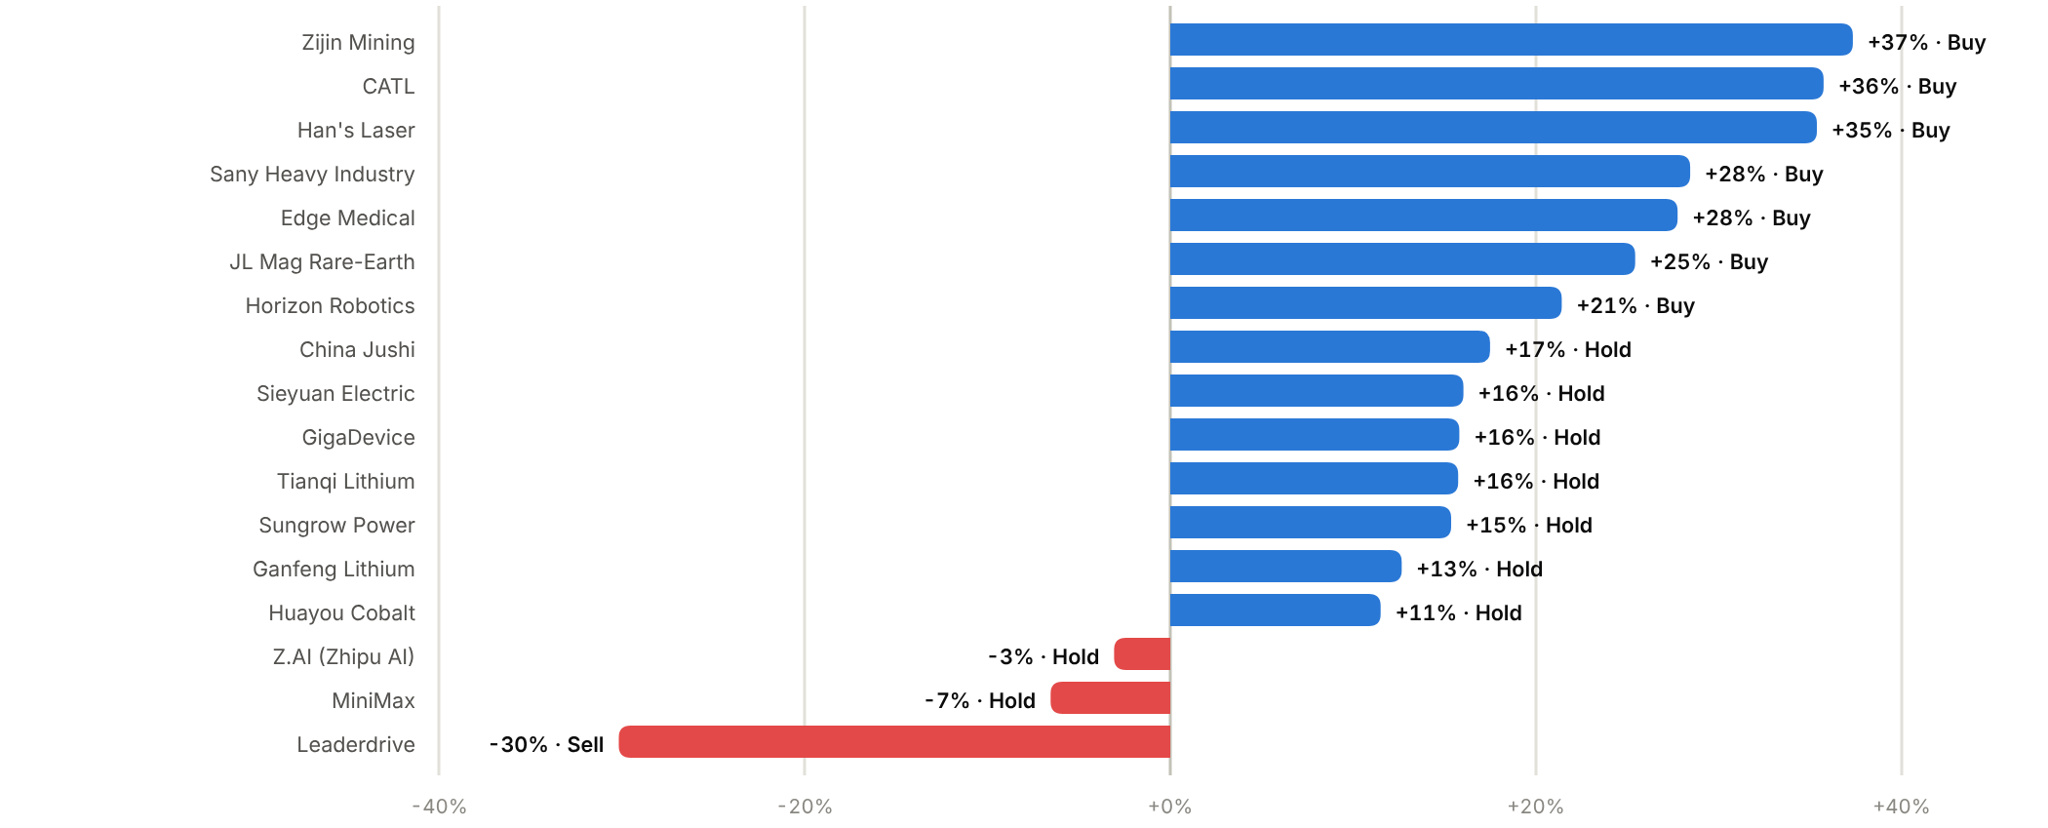

Cross-cutting themes
1. Strong H1 numbers, de-rated shares  Most of the 17 reported strong H1'26 results, yet the source pack notes every stock trades 28-81% below its 52-week high. China's CSI 300 fell 5.8% in September on worries about tighter policy in major economies and weak domestic demand. CATL, GigaDevice, Han's Laser and Sungrow now trade at or near multi-year-low multiples of forward earnings.  2. AI capex now reaches suppliers further down the chain  AI servers are pulling through demand for niche memory (GigaDevice), electronic glass-fibre cloth (China Jushi), PCB drilling equipment (Han's Laser), grid equipment (Sieyuan) and storage (CATL, Sungrow). For each, pricing power will last only until capacity catches up. We are Buy where order books give visibility (Han's) and Hold where earnings already look near peak (GigaDevice, Jushi).  3. Lithium has turned again  China lithium carbonate fell 24% in September to ~RMB122k/t; Wood Mackenzie expects 2026 supply to grow ~28%, and a revised SMM inventory methodology added ~175kt to stock estimates. We model lower H2'26 and FY27 prices for Tianqi and Ganfeng, below broker forecasts in the source pack. | 4. A strong CNY is costing exporters  USD/CNH is ~6.69. Exporters with dollar receivables (Sany, Sungrow, Sieyuan) booked FX finance losses in H1'26, and dollar-priced commodity producers (Zijin) translate fewer renminbi per unit.  5. A/H spreads are wide  Most H-shares trade at large discounts to their A-shares (JL Mag −46%, Ganfeng −45%, Tianqi −44%, Sany −18%), but CATL's H-share trades at a ~41% premium. Where both lines exist we name our preferred line in each report.  6. Robotics and AI models: fast growth at high prices  Horizon Robotics and Edge Medical are growing fast and the market has already cut their valuations sharply, so we rate them Buy. Leaderdrive (Sell), Z.AI and MiniMax (Hold) price in outcomes several years away.  Upcoming dates  Q3 results: Ganfeng (mid-Oct), China Jushi 20 Oct, Han's Laser 23 Oct, Sieyuan and Huayou 24 Oct, Tianqi 26 Oct, JL Mag 28 Oct, Sungrow and GigaDevice 30 Oct, Leaderdrive 31 Oct.

01 · INDUSTRIALS & RESOURCES · METALS & MINING
Zijin Mining 紫金矿业  601899.SH · Initiation of coverage · 12 October 2026 | BUY  TP RMB41.50  Price RMB30.22 · +37%
Volume growth few miners can match, at a single-digit multiple
Zijin is China's largest diversified miner and one of the few majors still growing mined copper and gold output by double digits. At 9.8x FY26E and 8.7x FY27E P/E it trades at a steep discount to global peers despite superior growth and moderate leverage. We initiate at Buy with a TP of RMB41.50 (+37% upside), based on 12x FY27E EPS.  - Few majors can match Zijin's output growth. The 2026 plan targets ~105t of mined gold (+17%) and 1.2Mt of copper (+10%), rising to 130-140t and 1.5-1.6Mt by 2028, a ~13% copper CAGR while most Western peers are flat.  - Metal prices and cash generation are both at records. Gold at ~US$4,200/oz and COMEX copper at ~US$6.77/lb (~US$14,900/t) drove H1'26 net profit of RMB39.2bn (+68%) and operating cash flow of RMB55.5bn (+92%).  - The valuation gap to global peers looks unjustified. Zijin trades on 8.7x FY27E vs ~19x for Freeport and ~13x for Newmont, and a 35% payout target supports a ~3.6% FY26E dividend yield.  Catalysts  - Q3'26 results (late October) and 2027 production guidance.  - Ramp-up of Julong phase II, Kamoa-Kakula expansions and lithium projects.  - Dividend delivery against the 35% payout target.  Key risks  - Metal prices: a 15-20% fall in gold and copper would cut FY27E EPS by roughly a quarter.  - Jurisdiction and operating risk in the DRC, Serbia, Colombia and Suriname (permits, export rules, tax).  - CNY strength (USD/CNY ~6.69) compresses RMB-reported margins on dollar-priced metal.  - M&A discipline: acquisitive growth raises the risk of overpaying near cycle highs. | Key data  H1'26 revenue mix by product (%)  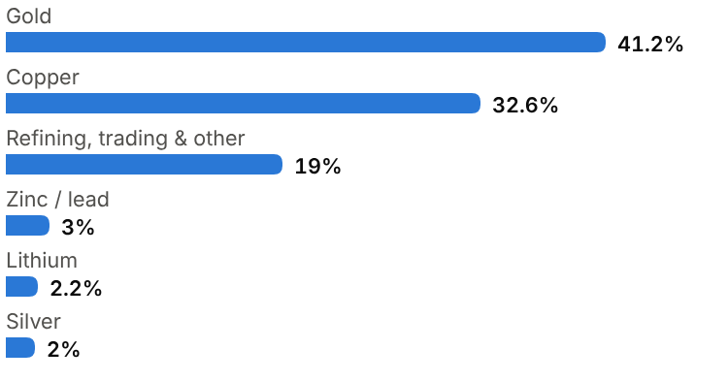
  Price (12 Oct 2026) | RMB30.22
  Target price (12m) | RMB41.50
  Implied return | +37.3%
  Market cap | RMB783.6bn / US$117.1bn
  Enterprise value | RMB904.5bn
  Net debt | RMB53.7bn
  Shares outstanding | 26.60bn
  52-week range | 24.42-44.29
  Performance | -11.5% YTD
  Dividend yield (FY26E) | 3.6%
  Consensus target | RMB47.90, 15 analysts
  Other listing | H-share 2899.HK at HK$32.58 (~8% discount to A)

Key financials and valuation
Year to December | FY23A | FY24A | FY25A | FY26E | FY27E | FY28E
Revenue (RMB bn) | 293 | 304 | 349 | 405 | 435 | 465
YoY growth | – | +3% | +15% | +16% | +7% | +7%
Gross margin | 15.8% | 20.3% | 27.7% | 34.0% | 35.0% | 35.0%
Net profit, attributable (RMB bn) | 21.1 | 32.0 | 51.8 | 82.0 | 92.0 | 101
YoY growth | n.m. | +52% | +62% | +58% | +12% | +10%
EPS (RMB) | 0.80 | 1.20 | 1.91 | 3.08 | 3.46 | 3.80
P/E (x) | 37.8x | 25.2x | 15.8x | 9.8x | 8.7x | 8.0x
DPS (RMB) | 0.25 | 0.38 | 0.60 | 1.08 | 1.21 | 1.33
Dividend yield | 0.8% | 1.3% | 2.0% | 3.6% | 4.0% | 4.4%

A = actual (company reports; StockAnalysis/S&P Global), E = our estimates. Multiples at the 12-Oct-2026 price.

Company background
Zijin Mining grew out of the Zijinshan gold-copper deposit in Shanghang county, western Fujian, a low-grade orebody that state geologists had explored in the 1980s and that larger operators considered uneconomic. The company was formally established in 1993. Under geologist Chen Jinghe it pioneered large-scale heap leaching of low-grade ore, and Zijinshan became one of China's largest gold mines. The group still works the way it learned to at Zijinshan: buy or develop deposits others overlook, then lower their cost through in-house geology, mining and metallurgical engineering. The company became a joint-stock company in 2000, listed H-shares in Hong Kong in 2003 and A-shares in Shanghai in 2008. Its largest shareholder is Minxi Xinghang, the investment vehicle of the Shanghang county government.
Overseas expansion began in the mid-2000s and accelerated after 2015 through counter-cyclical acquisitions bought when sellers were under pressure. These included a 49.5% stake in Ivanhoe's Kamoa-Kakula copper project in the DRC, Nevsun (owner of the Timok project) and the RTB Bor complex in Serbia, Continental Gold's Buriticá mine in Colombia, Guyana Goldfields, Neo Lithium's 3Q brine in Argentina, and Rosebel in Suriname. At home, the Julong copper project in Tibet became a major source of growth. In 2025 the group spun its overseas gold assets into Zijin Gold International, listed in Hong Kong, which it still controls. Zijin now operates on five continents and targets a global top-three position in both gold and copper by 2028.
Milestones | Ownership and listing
  1993 | Company established to develop the Zijinshan gold-copper deposit in Fujian.
  2003 / 2008 | H-share listing in Hong Kong; A-share listing in Shanghai.
  2015 | Acquires 49.5% of Kamoa Holding (Kamoa-Kakula copper, DRC) from Ivanhoe.
  2018 | Buys Nevsun (Timok, Serbia) and 63% of RTB Bor, Serbia's state copper complex.
  2019-23 | Adds Buriticá (Colombia), Guyana Goldfields, 3Q lithium (Argentina), Rosebel (Suriname).
  2025 | Lists Zijin Gold International in Hong Kong; net profit RMB51.8bn (+62%).
  2026 | Three-year plan: 130-140t gold and 1.5-1.6Mt copper by 2028; lithium up to 320kt LCE.
  Largest shareholder | Minxi Xinghang State-owned Assets Investment (Shanghang county), ~23%
  Share classes | A-share 601899.SH; H-share 2899.HK
  Main listed subsidiary | Zijin Gold International (2259.HK): overseas gold assets
  Dividend policy | Target payout of ~35% of net profit

The business
Zijin is an integrated miner. It owns and operates mines, processes ore into concentrate, doré or cathode, and runs smelting and refining plants that also treat third-party material. Revenue therefore mixes two very different businesses. Self-mined gold, copper, zinc, silver and lithium carry high margins and generate the large majority of gross profit. Refining and trading of purchased material (about 19% of H1'26 revenue) adds volume but earns thin margins. The jump in group gross margin from 15.8% in FY23 to 34.6% on a TTM basis reflects both higher metal prices and a rising share of self-mined output.
Zijin competes on cost and capital efficiency. Its in-house exploration teams, mine designers and metallurgists let it value deposits independently and build mines with its own engineering arm, and it can run difficult or low-grade orebodies profitably. Management describes this as an integrated 'ore-flow' model linking geology, mining, processing and refining. The company is willing to operate in frontier jurisdictions such as the DRC, Serbia, Colombia, Suriname and Tibet, where Western majors often hesitate, and Chinese policy-bank and bond-market funding lowers its cost of capital.
Copper is the strategic priority. Mined copper was 1.09Mt in 2025 and is targeted at 1.2Mt in 2026 and 1.5-1.6Mt by 2028, led by Julong (Tibet), the Serbian operations and Kolwezi (DRC). Zijin's ~40% interest in Kamoa-Kakula is equity-accounted, so its profits appear as investment income rather than revenue. Gold output (~90t in 2025) is growing toward 105t in 2026 and 130-140t by 2028. Lithium (3Q in Argentina, Lakkor Tso in Tibet, Manono North-East in the DRC and hard rock in Hunan) is the third leg, with output up ~5x in H1'26 but exposed to the 2026 lithium-price slide.
Capital allocation balances three uses: RMB25-35bn a year of capex on organic growth, opportunistic M&A (RMB15bn of acquisitions in FY25), and a payout target of ~35%. Large minority interests (RMB62bn at FY25) reflect partly owned mines and Zijin Gold International's outside shareholders.
Revenue mix and economics (H1'26)
Segment | Share of revenue | Key assets / products | Economics
Gold (mined + refined) | 41.2% | Mines in China, Colombia, Suriname, Guyana, Australia, Kazakhstan; refining of doré | Highest margin at current prices; overseas mines via Zijin Gold International
Copper | 32.6% | Julong (Tibet), Bor/Čukaru Peki (Serbia), Kolwezi (DRC), Duobaoshan (Heilongjiang) | 1.09Mt mined in 2025; Kamoa-Kakula equity-accounted
Refining, trading & other | 19.0% | Smelting and refining of third-party concentrate; metals trading | Low single-digit margins; inflates revenue
Zinc/lead and silver | 5.0% | Polymetallic mines and by-products | Small, high-margin by-products
Lithium | 2.2% | 3Q brine (Argentina), Lakkor Tso (Tibet), Manono NE (DRC), Hunan | Ramping up; exposed to falling lithium prices

Competitive landscape
Mining is a price-taking business, so competition is about cost position, reserve life and the ability to grow volumes. In copper, Zijin's 1.09Mt places it among the top five global producers alongside Freeport-McMoRan, BHP and Codelco; in gold its ~90t (~2.9Moz) ranks it in the global top ten behind Newmont, Barrick and Agnico Eagle. Few of those peers are growing. Western majors face declining grades, permitting delays and shareholder pressure to return cash rather than build. Zijin's copper output is planned to rise by ~40-50% by 2028.
Its main competitive disadvantages are jurisdictional and reputational. Several important assets sit in countries with resource nationalism (DRC export rules, Serbian environmental scrutiny, Colombian security), and Chinese ownership can complicate approvals in OECD markets. Domestically, CMOC (copper/cobalt in the DRC) is the closest comparable and a rival for African assets; Shandong Gold and Zhaojin are larger domestic gold peers by reserves in China but have little overseas growth.
Main competitors
Competitor | Base | Focus | Position vs Zijin Mining
Freeport-McMoRan | US | Copper (Grasberg, Americas), gold by-product | Larger copper producer; slower growth; premium valuation
BHP / Codelco | Australia / Chile | Copper (Escondida; Chilean state mines) | Scale leaders; flat volumes; Codelco constrained by grades
Newmont / Barrick | US / Canada | Gold (plus copper at Barrick) | Bigger gold output; mature portfolios; higher payouts
CMOC Group | China | Copper and cobalt (DRC), molybdenum | Closest Chinese peer; competes for African assets
Shandong Gold / Zhaojin | China | Domestic gold mining | Strong local reserves; limited overseas growth

Industry structure: five forces
Force | Intensity | Assessment
Rivalry | Medium | Metals sell at exchange prices, so producers are price-takers and compete on cost and volume growth. Rivalry shows up in bidding for deposits, where Zijin meets CMOC, the majors and sovereign funds.
New entrants | Low | A new copper or gold mine takes 10-15+ years from discovery to output and billions of dollars; permitting and falling grades keep new supply scarce.
Supplier power | Medium | Host governments own the ore. Royalties, export rules and resource nationalism (DRC, Serbia, Colombia) can claim a rising share of the rent; energy and labour costs are inflationary.
Buyer power | Low | Smelters, refiners and bullion banks buy at benchmark prices. Copper concentrate treatment charges are near record lows, which shifts value from smelters to miners.
Substitutes | Low | Aluminium replaces copper in some wiring and cooling at high prices, but grids, EVs and data centres have few alternatives; gold demand is monetary.

Moat and vulnerabilities
- Low-cost, long-life orebodies plus in-house exploration and engineering that cut capital intensity.
- Willingness and ability to operate in frontier jurisdictions with state-bank and bond-market funding.
- A visible volume-growth pipeline (copper +40-50% by 2028) that few peers have.
- Vulnerabilities: geopolitical, permitting and ESG risk; acquisitions bought near cycle highs.

Addressable market (TAM)
Zijin's addressable market is the global supply of mined copper, gold and lithium. Refined copper consumption runs at about 27Mt a year, worth ~US$400bn at the current COMEX price of ~US$6.77/lb (~US$14,900/t). Demand is growing at 2-3% a year from electrification, grids, renewables and AI data centres, while mine supply is constrained by falling grades and a decade of under-investment, which supports the case for a structural deficit and high prices.
Annual gold mine supply of ~3,600t is worth ~US$485bn at US$4,195/oz. Supply is broadly flat, and central-bank buying and ETF inflows have driven prices. Lithium is a smaller (~1.5Mt LCE, ~US$27bn) but faster-growing market that is currently oversupplied. Zijin's 2026 targets equal roughly 4-5% of world copper and ~3% of world gold mine supply, so its growth depends on adding its own volume.
Market | Size | Growth / dynamics | Source
Refined copper | ~27Mt / ~US$400bn | Volume +2-3% a year; deficit risk from grade decline | Industry estimates; our calc. at US$14.9k/t
Gold mine supply | ~3,600t / ~US$485bn | Flat supply; price set by central-bank and ETF demand | Industry estimates; our calc. at US$4,195/oz
Lithium (LCE) | ~1.5Mt / ~US$27bn | Demand +20-25% a year; supply +28% in 2026 | Wood Mackenzie; our estimate
Zijin share | ~4-5% copper; ~3% gold | Targets top-three in both by 2028 | Company plan (Feb 2026)

~US$400bn  Global refined copper market (~27Mt at ~US$14.9k/t) | ~US$485bn  Annual gold mine supply (~3,600t at ~US$4,195/oz) | 130-140t / 1.5-1.6Mt  Zijin's 2028 gold / copper output targets

Financial analysis
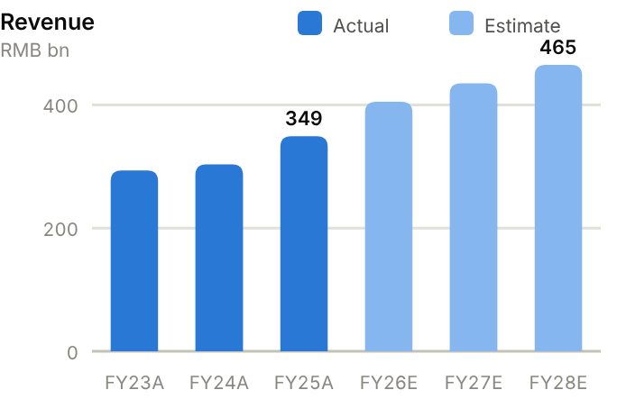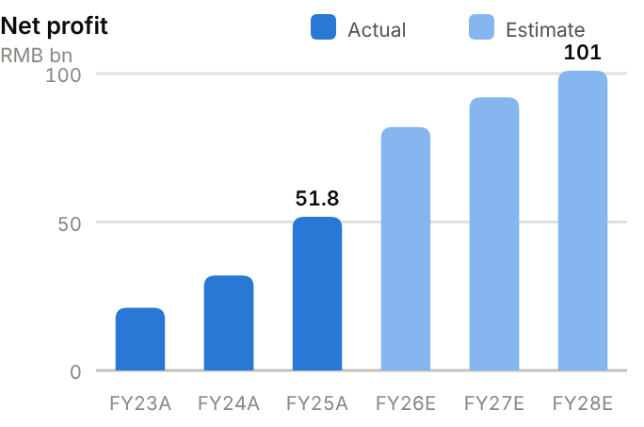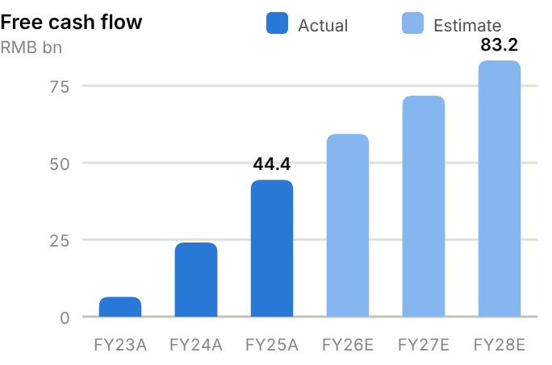
Income statement. Revenue rose from RMB293bn (FY23) to RMB349bn (FY25, +15%) and RMB376bn TTM. Most of the profit growth came from margins: gross margin expanded from 15.8% to 27.7% in FY25 and 34.6% TTM, and operating profit more than doubled from RMB31.6bn to RMB75.0bn as gold and copper prices rose and self-mined volumes grew. Net profit attributable rose 2.5x in two years to RMB51.8bn (14.8% net margin). H1'26 brought RMB39.2bn (+68%). We forecast net profit of RMB82.0bn/92.0bn/101bn for FY26-28E on volume growth and flat-to-slightly-lower metal prices, with net margin around 20-22%.
Source: company filings via StockAnalysis/S&P Global. Jun-26 = latest interim balance sheet. Debt includes leases. | Balance sheet. Total assets grew from RMB343bn to RMB512bn over FY23-25, led by PP&E (RMB165bn) and mining rights, as new mines were built and acquired. Leverage has fallen fast. Net debt dropped from RMB117bn (FY23) to RMB82.6bn (FY25) and RMB53.7bn at June 2026, taking net debt/equity from ~109% to 45% and net debt/EBITDA to 0.91x. Liquidity is adequate (current ratio 1.14x) with RMB111bn of cash and short-term investments at June 2026 against RMB165bn of debt, much of it long-term. Minority interests (RMB62bn) are large, so investors should focus on attributable figures. Inventory days have drifted up to 57 as lithium and concentrate stocks build.
  Balance sheet (RMB bn) | FY23A | FY24A | FY25A | Jun-26A
  Cash & short-term investments | 24.5 | 41.0 | 80.9 | 110.9
  Receivables | 18.1 | 16.4 | 18.1 | 19.3
  Inventory | 29.3 | 33.3 | 39.6 | 39.7
  PP&E | 120.3 | 136.1 | 165.0 | 169.4
  Total assets | 343.0 | 396.6 | 512.0 | 541.4
  Accounts payable | 16.3 | 20.8 | 27.5 | 27.7
  Total debt | 141.7 | 148.5 | 163.5 | 164.6
  Equity (attributable) | 107.5 | 139.8 | 185.5 | 205.9
  Minority interests | 30.9 | 37.9 | 62.5 | 67.2
  Net cash / (net debt) | (117.2) | (107.4) | (82.6) | (53.7)

Cash flow (RMB bn) | FY23A | FY24A | FY25A | TTM Jun-26 | FY26E | FY27E | FY28E
Net profit (attributable) | 21.1 | 32.0 | 51.8 | – | 82.0 | 92.0 | 101.0
D&A | 9.9 | 10.1 | 16.2 | 18.8 | 18.2 | 20.3 | 22.8
Operating cash flow | 36.9 | 48.9 | 75.4 | 102.1 | 95.3 | 109.7 | 121.2
Capex | (30.4) | (24.8) | (31.0) | (33.8) | (36.0) | (38.0) | (38.0)
Free cash flow | 6.4 | 24.1 | 44.4 | 68.3 | 59.3 | 71.7 | 83.2
Dividends paid | (12.1) | (13.4) | (17.8) | (18.1) | (16.0) | (28.7) | (32.2)
Net cash / (debt), period-end | (117.2) | (107.4) | (82.6) | (53.7) | (39.3) | 3.8 | 54.8
OCF / net profit (x) | 1.75 | 1.52 | 1.46 | n.m. | 1.16 | 1.19 | 1.20

TTM = twelve months to June 2026; Jun-26 net cash in the TTM column. E = our estimates: OCF = net profit + D&A − increase in working capital; net cash rolls forward FCF less dividends plus equity raised.
Cash flow. Operating cash flow doubled from RMB36.9bn (FY23) to RMB75.4bn (FY25) and RMB102bn TTM, comfortably above net profit (OCF/net profit 1.46x in FY25) thanks to RMB16bn of D&A. Capex has run at RMB25-34bn a year (8-10% of revenue), so free cash flow rose from RMB6.4bn to RMB44.4bn and RMB68.3bn TTM. That funded RMB17.8bn of dividends and RMB15.4bn of acquisitions in FY25 while still cutting net debt. We forecast FCF of RMB59.3bn/71.7bn/83.2bn after capex of RMB36-38bn a year. On those numbers Zijin moves to a net cash position of ~RMB54.8bn by FY28E, before any acquisitions.
ROE/ROA on average balances. Days on year-end balances: receivables on revenue, inventory and payables on cost of sales. Net debt/equity below zero = net cash. Payout = DPS/EPS. n.m./– = not meaningful or not modelled. | Key ratios. ROE has climbed from 19.6% (FY23) to 31.8% (FY25) and should peak around 37.5% in FY26E before easing as equity builds. ROA of 11.4% is high for a miner. Asset turnover is falling (larger, capital-heavy asset base), while receivable days are short (19 days) because metals are sold for cash. The payout ratio of 31% on FY25 EPS leaves room to raise dividends toward the 35% target.
  Key ratios | FY23A | FY24A | FY25A | FY26E | FY27E | FY28E
  Revenue growth | – | 3% | 15% | 16% | 7% | 7%
  Gross margin | 15.8% | 20.3% | 27.7% | 34.0% | 35.0% | 35.0%
  Net margin | 7.2% | 10.6% | 14.8% | 20.2% | 21.1% | 21.7%
  ROE (avg. equity) | 19.6% | 25.9% | 31.8% | 37.5% | 32.5% | 28.9%
  ROA (avg. assets) | 6.2% | 8.7% | 11.4% | – | – | –
  Asset turnover (x) | 0.86 | 0.82 | 0.77 | – | – | –
  Receivable days | 23 | 20 | 19 | – | – | –
  Inventory days | 43 | 50 | 57 | – | – | –
  Payable days | 24 | 31 | 40 | – | – | –
  Current ratio (x) | 0.92 | 0.99 | 1.14 | – | – | –
  Net debt / equity | 109% | 77% | 45% | 16% | −1% | −14%
  Net debt / EBITDA (x) | 2.8 | 1.9 | 0.9 | – | – | –
  Capex / revenue | 10.4% | 8.2% | 8.9% | 8.9% | 8.7% | 8.2%
  FCF margin | 2.2% | 7.9% | 12.7% | 14.6% | 16.5% | 17.9%
  Dividend payout | 31% | 32% | 31% | 35% | 35% | 35%

Valuation
Source: StockAnalysis/S&P Global, 12 Oct 2026 (trailing EV/EBITDA and EV/sales; consensus forward P/E). | 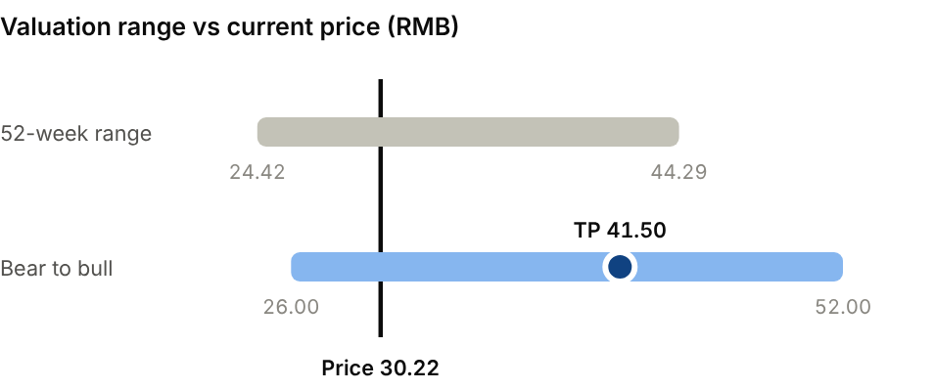  Bear (Gold US$3,500/oz, copper US$11,000/t): RMB26.00. Bull (Gold US$4,800/oz, copper US$16,000/t): RMB52.00.
  Company | Ticker | Fwd P/E | EV/EBITDA | EV/sales
  Freeport-McMoRan | FCX US | 19.3x | 11.7x | 4.3x
  Newmont | NEM US | 13.4x | 7.0x | 4.6x
  CMOC Group | 603993 CH | 11.0x | 6.0x | 1.5x
  Zijin Mining | 601899 CH | 9.1x | 7.4x | 2.4x

Our TP of RMB41.50 is 12x FY27E EPS of RMB3.46, roughly a 20% discount to the average forward P/E of Freeport, Newmont and CMOC (~14.6x) to reflect jurisdictional risk. It still implies only ~8x FY27E EV/EBITDA versus ~12x for Freeport. The consensus average target is RMB47.90 (15 analysts, all Buy-rated). Our bear case (RMB26.00) assumes gold at US$3,500/oz and copper at US$11,000/t; our bull case (RMB52.00) assumes US$4,800/oz and US$16,000/t. The H-share (2899.HK) gives the same exposure at an ~8% discount.
Sources: Company interim/annual reports and 2026-28 production plan; S&P Global Ratings; StockAnalysis/S&P Global (consensus, multiples); IBKR (prices, gold/copper futures); source pack.
02 · INDUSTRIALS & RESOURCES · MACHINERY
Sany Heavy Industry 三一重工  600031.SH · Initiation of coverage · 12 October 2026 | BUY  TP RMB22.50  Price RMB17.52 · +28%
A global share-taker at a trough multiple, with overseas now driving earnings
Sany is China's largest construction-machinery maker and one of the world's top five or six OEMs, with 61% of H1'26 revenue earned outside China. Profit quality is improving (H1'26 EBIT +56%), but FX finance costs masked it at the net line. At 12.5x FY27E P/E with ~RMB38bn of net cash, we initiate at Buy with a TP of RMB22.50 (+28% upside) on 16x FY27E EPS.  - The overseas expansion is structural. Sales outside China were ~64% of FY25 revenue and earned a 32.5% gross margin in H1'26, above domestic, as Sany takes share from Caterpillar and Komatsu in Asia, Africa and Latin America.  - The domestic market is bottoming. Excavator sales rose 17% in 2025 and 24% in Jan-Aug 2026 (CCMA), helped by replacement of the 2016-21 fleet.  - Sany combines operating leverage with cash returns. FY25 operating cash flow rose 35%, a RMB400-800m buyback is under way, and the payout is ~50%. We expect FY27E EPS of RMB1.40 (+24% YoY).  Catalysts  - Monthly CCMA excavator sales and export data.  - Q3'26 results (late October).  - Buyback execution (RMB400-800m) and dividend.  Key risks  - China property and infrastructure relapse.  - Trade barriers (tariffs, anti-dumping actions) against Chinese machinery.  - FX: a stronger CNY creates translation and finance losses.  - Credit risk on customer financing and receivables. | Key data  FY25 revenue by region (%, approx.)  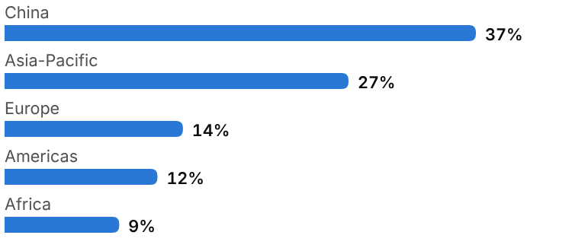
  Price (12 Oct 2026) | RMB17.52
  Target price (12m) | RMB22.50
  Implied return | +28.4%
  Market cap | RMB158.1bn / US$23.6bn
  Enterprise value | RMB121.1bn
  Net cash | RMB38.1bn
  Shares outstanding | 9.15bn
  52-week range | 16.68-24.29
  Performance | -17.2% YTD
  Dividend yield (FY26E) | 3.2%
  Consensus target | RMB26.72, 19 analysts
  Other listing | H-share 6031.HK at HK$16.93 (~18% discount to A)

Key financials and valuation
Year to December | FY23A | FY24A | FY25A | FY26E | FY27E | FY28E
Revenue (RMB bn) | 74.0 | 78.4 | 89.7 | 104 | 117 | 128
YoY growth | – | +6% | +14% | +16% | +12% | +9%
Gross margin | 27.0% | 26.9% | 27.8% | 28.0% | 28.5% | 29.0%
Net profit, attributable (RMB bn) | 4.53 | 5.96 | 8.41 | 10.3 | 12.8 | 14.8
YoY growth | n.m. | +32% | +41% | +22% | +24% | +16%
EPS (RMB) | 0.53 | 0.70 | 0.98 | 1.13 | 1.40 | 1.62
P/E (x) | 33.1x | 25.0x | 17.9x | 15.6x | 12.5x | 10.8x
DPS (RMB) | 0.22 | 0.36 | 0.49 | 0.56 | 0.70 | 0.81
Dividend yield | 1.3% | 2.1% | 2.8% | 3.2% | 4.0% | 4.6%

A = actual (company reports; StockAnalysis/S&P Global), E = our estimates. Multiples at the 12-Oct-2026 price.

Company background
Sany was founded in 1989 in Lianyuan, Hunan, by Liang Wengen and three partners (Tang Xiuguo, Mao Zhongwu and Yuan Jinhua) as a welding-materials business. In the 1990s it moved to Changsha and into construction machinery, starting with truck-mounted concrete pumps, a market then dominated by imported German and Japanese equipment. Sany won share by selling reliable machines at lower prices with fast service, then broadened into excavators, crawler and truck cranes, rotary piling rigs and road machinery.
Sany Heavy Industry listed on the Shanghai Stock Exchange in 2003. It became China's best-selling excavator brand in 2011, overtaking Japanese and Korean rivals, and in 2012 bought Putzmeister, the German concrete-pump leader, which gave it a European base and technology. The 2012-16 downturn after China's stimulus boom forced deep cost cuts. The following upcycle took revenue to a record RMB107bn in FY21 before the property-led slump. Since then Sany has focused on exports, electrification and 'lighthouse' digital factories, and in 2025 it completed a Hong Kong H-share listing to fund globalisation. Related businesses (Sany Heavy Energy in wind turbines and Sany International in mining and port machinery) are separately listed and are not part of this entity.
Milestones | Ownership and listing
  1989 | Founded in Lianyuan, Hunan by Liang Wengen and partners.
  1990s | Moves to Changsha; launches concrete pumps, then excavators and cranes.
  2003 | Lists on the Shanghai Stock Exchange (600031.SH).
  2011 | Becomes China's No.1 excavator brand.
  2012 | Acquires Putzmeister (Germany), the global concrete-pump leader.
  2021 | Record revenue of RMB107bn at the peak of China's construction cycle.
  2025 | Hong Kong H-share listing (6031.HK); net profit +41% to RMB8.4bn; overseas ~64% of sales.
  Controlling shareholder | Sany Group, controlled by founder Liang Wengen
  Share classes | A-share 600031.SH; H-share 6031.HK (listed 2025)
  Sister companies (not consolidated) | Sany Heavy Energy (688349.SH); Sany International (0631.HK)
  Capital returns | RMB400-800m buyback in progress; ~50% payout

The business
Sany designs, manufactures and sells construction machinery. Excavators are the largest line (~40% of H1'26 revenue), followed by concrete machinery (pumps, mixer trucks), cranes, piling rigs and road machinery. Machines are sold through a network of independent dealers in China and abroad, supplemented by direct sales to large contractors and miners. To support demand, Sany offers customer financing through instalment sales and finance leases. This lifts volumes but leaves sizeable receivables and credit risk on the balance sheet (receivables of RMB40bn, ~164 days of sales, at FY25).
Profitability depends on volume, mix and pricing. Volume drives fixed-cost absorption in large plants. Large excavators, mining equipment and overseas units carry higher margins (H1'26 overseas gross margin 32.5%), so shifts in mix move group margin. Pricing discipline in China depends on how aggressively XCMG, Zoomlion and others chase share. After-market parts and services earn higher margins and are less cyclical, and this revenue grows as the installed base ages.
Globalisation is Sany's main strategic priority. Overseas revenue was ~US$7.8bn in FY25 (+15%), about 64% of sales, led by Asia-Pacific and fast-growing Africa (+55%). Sany localises production in India, Indonesia, the US, Germany (Putzmeister) and Brazil to shorten delivery times and reduce tariff exposure. Electrification (electric excavators, mixers and trucks) and digitalised 'lighthouse' factories set Sany apart from rivals, lower its costs and prepare it for emission rules in developed markets.
Domestic demand now rests on equipment replacement and infrastructure spending. China's 2016-21 boom left a large fleet that is now reaching replacement age, and water-conservancy, urban-renewal and mining spending also support demand. As a result, China excavator sales grew 17% in 2025 despite a weak property market.
FY25 revenue by region (main business, company release)
Region | US$bn | Growth / share | Comment
Mainland China | ~4.7 | ~37% of sales | Replacement cycle, infrastructure, mining; recovering from 2021-23 trough
Asia-Pacific | 3.34 | +16.2% YoY | Largest overseas region; India and Indonesia plants
Europe | 1.75 | +1.5% YoY | Putzmeister base; mature, price-competitive market
Americas | 1.56 | +8.5% YoY | US plant in Georgia; Brazil; tariff exposure in the US
Africa | 1.16 | +55.3% YoY | Fastest-growing; mining and infrastructure demand

Competitive landscape
Construction machinery is a global oligopoly at the top with a long tail of regional players. Caterpillar and Komatsu lead on brand, dealer density and after-market. Deere, Volvo CE, Hitachi Construction Machinery and Liebherr follow, with Sany and XCMG now in the same revenue league. In China, foreign brands' share of excavators has collapsed over the past decade as Sany, XCMG, LiuGong, SDLG and Sunward improved quality while keeping a price advantage.
Sany's advantages are cost (Chinese machines typically sell at a meaningful discount to Japanese and US brands), breadth across product lines, and speed of dealer expansion and localisation. Its main gaps are brand perception and service density in North America and Western Europe, where buyers value resale prices and uptime, and exposure to trade barriers (tariffs and anti-dumping actions against Chinese machinery). The domestic market remains prone to price wars when demand falls.
Main competitors
Competitor | Base | Focus | Position vs Sany Heavy Industry
Caterpillar | US | Full line; mining; dominant dealer network | Premium brand and after-market; far higher valuation
Komatsu | Japan | Excavators, mining equipment | Strong in Asia and mining; Sany's main overseas excavator rival
XCMG | China | Cranes, excavators, road machinery | Largest domestic rival; similar export push; lower valuation
Zoomlion | China | Concrete machinery, cranes | Strong in cranes and concrete; competes in exports
Volvo CE / Hitachi CM / Liebherr | Europe / Japan | Excavators, wheel loaders, cranes | Established in developed markets; higher cost base

Industry structure: five forces
Force | Intensity | Assessment
Rivalry | High | XCMG, Zoomlion, LiuGong and Sunward compete hard on price and credit terms at home; overseas, Caterpillar and Komatsu defend share through dense dealer networks.
New entrants | Low | Scale manufacturing, dealer and service networks and the balance sheet to offer customer finance are hard to copy; no meaningful new entrant has emerged in a decade.
Supplier power | Low | Steel is a commodity. Hydraulics, engines and controllers once came from Kawasaki, Rexroth and Cummins; Sany now makes many of these in-house.
Buyer power | Medium | Contractors and rental firms are fragmented but price-sensitive and reliant on vendor finance; large mining and infrastructure buyers negotiate hard.
Substitutes | Low | There is no substitute for earth-moving equipment. Demand risk comes from the construction cycle and the stock of used machines.

Moat and vulnerabilities
- Cost leadership from scale, localised supply chains and highly automated plants.
- Broad product line and a dealer network now spanning 180+ countries.
- Customer financing and after-market service that lock in dealers and fleets.
- Vulnerabilities: cyclical demand, receivable credit risk, trade barriers, weaker brand in developed markets.

Addressable market (TAM)
Global construction equipment is a roughly US$200-250bn market in annual OEM sales and highly cyclical. China is the largest single market by units. It sold 235,257 excavators in 2025 (+17%), of which 116,739 were exported, and 191,557 in Jan-Aug 2026 (+24%), with exports again outgrowing domestic sales. Emerging markets (Southeast Asia, Africa, the Middle East, Latin America) are growing fastest, driven by mining, infrastructure and urbanisation, and are where Chinese brands are gaining most share.
Two structural shifts expand the addressable market. Electrification, first in China and then in emission-regulated developed markets, raises content per machine and favours manufacturers with in-house batteries and drivetrains. Mining equipment (large excavators, mining trucks) has higher margins and stickier customers. Sany's ~US$12.5bn of FY25 revenue implies a mid-single-digit global share, so it has plenty of room to gain share abroad.
Sany has plenty of room to gain share abroad. Caterpillar and Komatsu still hold the largest shares of global sales, and Chinese brands remain small in North America, Western Europe and Japan, where buyers weigh dealer networks, brand and resale values most heavily. Sany's overseas growth has therefore come first from emerging markets, where price, delivery time and financing decide most purchases.
Market | Size | Growth / dynamics | Source
Global construction equipment | ~US$200-250bn OEM sales | Cyclical; mid-single-digit long-run growth | Industry estimates
China excavators | 235,257 units (2025, +17%) | Jan-Aug 2026 +24%; replacement cycle | CCMA
of which exports | 116,739 units (2025, +16%) | Aug-26 exports +33% | CCMA
Electric construction machinery | Early stage | Policy-driven adoption, China first | Qualitative
Sany share | ~5% of global OEM sales | Gaining share overseas | Our estimate

235,257  China excavator sales in 2025 (+17%), about half exported | +24%  China excavator sales growth, Jan-Aug 2026 (CCMA) | ~64%  Overseas share of Sany revenue, FY25

Financial analysis
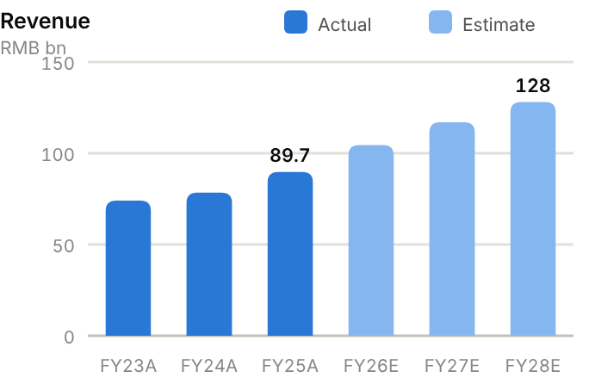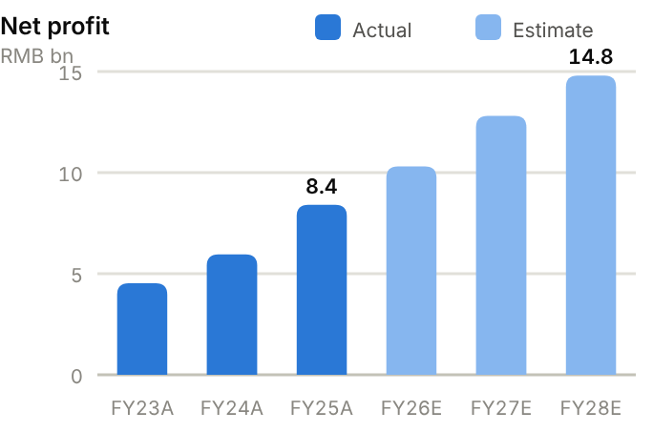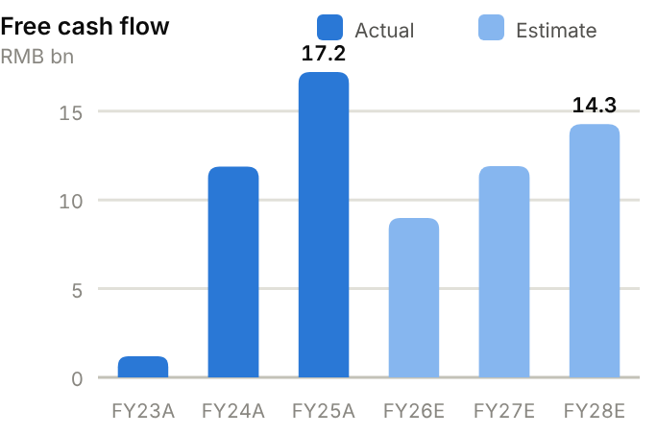
Income statement. Revenue fell from RMB107bn (FY21) to RMB74bn (FY23) in China's downturn and has since recovered to RMB89.7bn (FY25, +14.7%) and RMB98.4bn TTM. Gross margin has held at 27-28% through the cycle. Operating profit nearly doubled from RMB5.1bn (FY23) to RMB10.0bn (FY25) on operating leverage and mix, and net profit rose 41% to RMB8.4bn. In H1'26, EBIT rose 56% but net profit only 9% because CNY appreciation created FX finance losses on dollar receivables. We forecast revenue of RMB104bn/117bn/128bn and net profit of RMB10.3bn/12.8bn/14.8bn for FY26-28E.
Source: company filings via StockAnalysis/S&P Global. Jun-26 = latest interim balance sheet. Debt includes leases. | Balance sheet. Sany has moved from net debt of RMB3.3bn at FY23 to net cash of RMB31.2bn at FY25 and RMB38.1bn at June 2026, helped by strong cash generation and ~RMB14.5bn of H-share proceeds. Total debt fell from RMB37.2bn to RMB20.6bn. Working capital is the main item to watch. Receivables of RMB40.2bn equal 164 days of sales because of customer financing, while inventory days are 127 and payable days have stretched to 203. Equity attributable rose to RMB88.3bn (BVPS ~RMB10), and the current ratio is a comfortable 1.73x.
  Balance sheet (RMB bn) | FY23A | FY24A | FY25A | Jun-26A
  Cash & short-term investments | 33.8 | 36.8 | 57.1 | 58.7
  Receivables | 40.4 | 40.8 | 40.2 | 44.4
  Inventory | 19.8 | 19.9 | 22.5 | 24.3
  PP&E | 25.6 | 24.2 | 23.1 | 22.3
  Total assets | 151.2 | 152.1 | 173.3 | 181.2
  Accounts payable | 22.7 | 28.7 | 36.1 | 44.5
  Total debt | 37.2 | 28.9 | 25.9 | 20.6
  Equity (attributable) | 68.0 | 71.9 | 88.3 | 92.1
  Minority interests | 1.1 | 1.1 | 1.1 | 1.1
  Net cash / (net debt) | (3.3) | 7.9 | 31.2 | 38.1

Cash flow (RMB bn) | FY23A | FY24A | FY25A | TTM Jun-26 | FY26E | FY27E | FY28E
Net profit (attributable) | 4.5 | 6.0 | 8.4 | – | 10.3 | 12.8 | 14.8
D&A | 3.1 | 3.5 | 3.1 | 3.0 | 3.5 | 3.8 | 4.2
Operating cash flow | 5.7 | 14.8 | 20.0 | 19.6 | 12.0 | 15.1 | 17.7
Capex | (4.5) | (2.9) | (2.8) | (2.9) | (3.0) | (3.2) | (3.4)
Free cash flow | 1.2 | 11.9 | 17.2 | 16.7 | 9.0 | 11.9 | 14.3
Dividends paid | (2.5) | (2.9) | (6.1) | (3.2) | (4.5) | (5.2) | (6.4)
Net cash / (debt), period-end | (3.3) | 7.9 | 31.2 | 38.1 | 35.7 | 42.5 | 50.3
OCF / net profit (x) | 1.26 | 2.49 | 2.38 | n.m. | 1.16 | 1.18 | 1.19

TTM = twelve months to June 2026; Jun-26 net cash in the TTM column. E = our estimates: OCF = net profit + D&A − increase in working capital; net cash rolls forward FCF less dividends plus equity raised.
Cash flow. Operating cash flow rose from RMB5.7bn (FY23) to RMB20.0bn (FY25), or 2.38x net profit, as receivables were collected and payables extended. Capex has fallen to ~RMB2.8bn (3.1% of revenue) after the 2019-22 factory build-out, so FY25 free cash flow reached RMB17.2bn. Dividends of RMB6.1bn and buybacks were well covered. We expect OCF to fall back below FY25's level as working capital rebuilds with growth, and forecast FCF of RMB9.0bn/11.9bn/14.3bn, still enough to grow net cash to ~RMB50.3bn by FY28E after dividends.
ROE/ROA on average balances. Days on year-end balances: receivables on revenue, inventory and payables on cost of sales. Net debt/equity below zero = net cash. Payout = DPS/EPS. n.m./– = not meaningful or not modelled. | Key ratios. ROE recovered from 6.7% (FY23) to 10.5% (FY25) and we expect 13.1% by FY27E. That is still below the 20%+ of the last upcycle, so returns could rise further if China recovers. ROA is 5.2% and asset turnover 0.55x. Net cash is equal to ~35% of equity. The payout ratio on FY25 EPS was 50%, including a special element.
  Key ratios | FY23A | FY24A | FY25A | FY26E | FY27E | FY28E
  Revenue growth | – | 6% | 14% | 16% | 12% | 9%
  Gross margin | 27.0% | 26.9% | 27.8% | 28.0% | 28.5% | 29.0%
  Net margin | 6.1% | 7.6% | 9.4% | 9.9% | 10.9% | 11.6%
  ROE (avg. equity) | 6.7% | 8.5% | 10.5% | 11.3% | 13.1% | 14.0%
  ROA (avg. assets) | 3.0% | 3.9% | 5.2% | – | – | –
  Asset turnover (x) | 0.49 | 0.52 | 0.55 | – | – | –
  Receivable days | 199 | 190 | 164 | – | – | –
  Inventory days | 134 | 127 | 127 | – | – | –
  Payable days | 153 | 183 | 203 | – | – | –
  Current ratio (x) | 1.79 | 1.59 | 1.73 | – | – | –
  Net debt / equity | 5% | −11% | −35% | −38% | −42% | −46%
  Net debt / EBITDA (x) | 0.4 | -0.8 | -2.4 | – | – | –
  Capex / revenue | 6.1% | 3.7% | 3.1% | 2.9% | 2.7% | 2.7%
  FCF margin | 1.6% | 15.2% | 19.2% | 8.6% | 10.2% | 11.1%
  Dividend payout | 42% | 51% | 50% | 50% | 50% | 50%

Valuation
Source: StockAnalysis/S&P Global, 12 Oct 2026 (trailing EV/EBITDA and EV/sales; consensus forward P/E). | 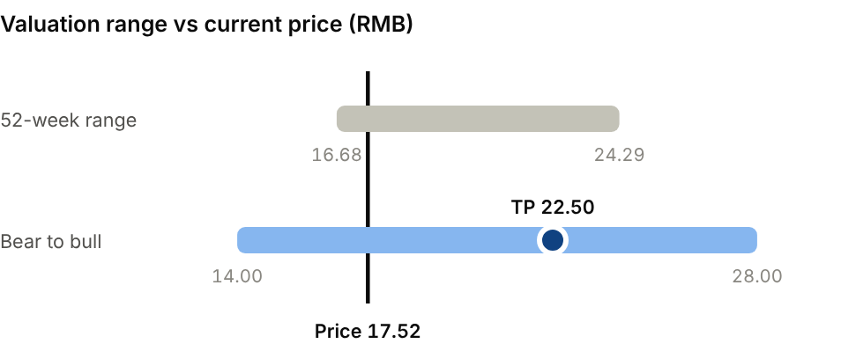  Bear (Domestic relapse; FX losses persist): RMB14.00. Bull (China upcycle plus 20%+ overseas growth): RMB28.00.
  Company | Ticker | Fwd P/E | EV/EBITDA | EV/sales
  Caterpillar | CAT US | 27.8x | 25.4x | 5.5x
  Komatsu | 6301 JP | 15.7x | 10.4x | 1.8x
  XCMG | 000425 CH | 8.5x | 8.9x | 1.0x
  Sany Heavy Industry | 600031 CH | 15.2x | 8.4x | 1.2x

Our TP of RMB22.50 is 16x FY27E EPS of RMB1.40: in line with Komatsu (~15.7x forward), above XCMG (~8.5x) and well below Caterpillar (~28x). Faster overseas growth and the net-cash balance sheet justify that level. The H-share (6031.HK) trades at an ~18% discount to the A-share. The consensus average target is RMB26.72 (19 analysts, 18 Buy-rated). Bear case RMB14.00: domestic relapse and persistent FX losses. Bull case RMB28.00: China upcycle plus 20%+ overseas growth.
Sources: Company FY25 results release and H1'26 HKEX results; CMBI; CCMA via Mysteel/Yieh; StockAnalysis/S&P Global; IBKR; source pack.
03 · BATTERY, LITHIUM & STORAGE · BATTERIES
CATL 宁德时代  300750.SZ · Initiation of coverage · 12 October 2026 | BUY  TP RMB405  Price RMB298.38 · +36%
Still the cost and technology leader; second-sourcing fears have created an entry point
CATL is the world's largest battery maker, with ~39% of the global EV battery market and a fast-growing storage business. The A-share fell 24% in September as Chinese automakers added second-source suppliers. It now trades on 12.6x FY27E P/E, or ~9.9x excluding RMB291bn of net cash. We initiate at Buy with a TP of RMB405 (+36% upside) on 17x FY27E EPS. We prefer the A-share to the H-share, which trades at a ~41% premium.  - CATL leads the industry on scale and cost. It sold 661GWh in 2025 (+39%), ran at 95% utilisation in Q2'26 and targets 1.2TWh of 2026 production. Its ~24-25% gross margin is several points above Korean and Chinese peers.  - Storage is now the second growth driver. Revenue from it grew 87.5% in H1'26 to 19% of sales on grid and AI data-centre demand; China's storage-battery sales rose 83% in the half.  - Second-sourcing erodes share, but the franchise is intact. Volumes keep growing with the market even as Li Auto, Xiaomi and Xpeng dual-source, and RMB291bn of net cash funds buybacks and a ~50% payout.  Catalysts  - Q3'26 results (late October).  - Sodium-ion and next-generation LFP launches; storage order wins.  - Buyback execution; ramp-up of Hungarian and Spanish plants.  Key risks  - Customer second-sourcing and domestic price competition.  - Geopolitics: US 1260H listing, FEOC sourcing rules, EU tariffs and investment screening.  - Lithium price swings that disrupt pass-through timing.  - H-share premium could compress as new supply arrives. | Key data  H1'26 revenue mix (%)  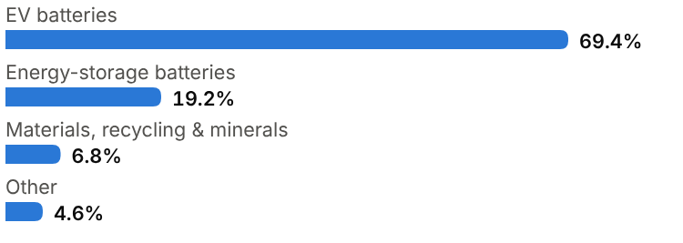
  Price (12 Oct 2026) | RMB298.38
  Target price (12m) | RMB405.00
  Implied return | +35.7%
  Market cap | RMB1.40tn / US$209.1bn
  Enterprise value | RMB1,140.0bn
  Net cash | RMB291.2bn
  Shares outstanding | 4.56bn
  52-week range | 285.17-468.75
  Performance | -17.5% YTD
  Dividend yield (FY26E) | 3.4%
  Consensus target | RMB548.16, 29 analysts
  Other listing | H-share 3750.HK at HK$494.80 (~41% premium to A)

Key financials and valuation
Year to December | FY23A | FY24A | FY25A | FY26E | FY27E | FY28E
Revenue (RMB bn) | 401 | 362 | 424 | 600 | 700 | 790
YoY growth | – | −10% | +17% | +42% | +17% | +13%
Gross margin | 19.1% | 23.8% | 25.1% | 24.0% | 24.3% | 24.5%
Net profit, attributable (RMB bn) | 44.1 | 50.8 | 72.2 | 93.0 | 108 | 122
YoY growth | n.m. | +15% | +42% | +29% | +16% | +13%
EPS (RMB) | 10.05 | 11.58 | 16.14 | 20.39 | 23.68 | 26.75
P/E (x) | 29.7x | 25.8x | 18.5x | 14.6x | 12.6x | 11.2x
DPS (RMB) | 5.03 | 4.55 | 8.37 | 10.20 | 11.84 | 13.38
Dividend yield | 1.7% | 1.5% | 2.8% | 3.4% | 4.0% | 4.5%

A = actual (company reports; StockAnalysis/S&P Global), E = our estimates. Multiples at the 12-Oct-2026 price.

Company background
Contemporary Amperex Technology (CATL) was founded in December 2011 in Ningde, Fujian, by Robin Zeng (Zeng Yuqun) and colleagues from ATL, the consumer-battery maker they had built and sold to Japan's TDK. CATL took over ATL's nascent EV-battery team and won BMW as an early customer, which forced it to meet German quality standards from the start. When Beijing's EV subsidies and battery 'white list' favoured domestic suppliers in 2015-19, CATL scaled faster than any rival, and it has been the world's largest EV-battery supplier since 2017. SNE Research ranks it No.1 for nine consecutive years, with a 39.2% global share in 2025.
CATL listed on Shenzhen's ChiNext board in 2018. In May 2025 it raised about HK$41bn in a Hong Kong listing, the year's largest global listing at the time, mainly to fund European capacity. Capacity reached 772GWh at end-2025, with 321GWh under construction. Plants are in China, Germany (Thuringia), Hungary (Debrecen), Spain (a joint venture with Stellantis) and Indonesia (an integrated mine-to-battery project). The founder-chairman remains the largest shareholder. In 2025 the US Department of Defense added CATL to its 1260H list of 'Chinese military companies', and US sourcing rules limit its direct presence in the US market. CATL has therefore developed a licensing model, under which Ford builds LFP cells in Michigan with CATL technology.
Milestones | Ownership and listing
  2011 | Founded in Ningde by Robin Zeng and the ATL EV-battery team; BMW becomes an early customer.
  2017 | Becomes the world's largest EV-battery supplier (SNE Research), a rank it has held since.
  2018 | IPO on Shenzhen's ChiNext board (300750.SZ).
  2022 | First European plant (Thuringia) starts output; launches Qilin cell-to-pack battery.
  2023 | Shenxing fast-charging LFP cell; technology-licensing deal with Ford (US).
  2025 | Hong Kong listing (~HK$41bn); sells 661GWh; net profit RMB72.2bn (+42%).
  2026 | Targets 1.2TWh of production; automakers add second-source suppliers.
  Largest shareholder | Founder-chairman Robin Zeng; co-founders hold further large stakes
  Share classes | A-share 300750.SZ; H-share 3750.HK (small float, ~41% premium to A)
  Capital returns | ~50% payout; buybacks under way (Sept 2026)

The business
CATL makes lithium-ion battery cells and packs. EV batteries were 69% of H1'26 revenue, energy-storage batteries 19%, and materials, recycling and mining 7%. It supplies virtually every major global automaker other than BYD, including European premium brands and leading Chinese EV makers, and sells storage cells and containerised systems (TENER) to integrators and utilities. Contracts run for several years, with formula pricing that passes lithium, nickel and cobalt costs through with a lag. Margins therefore swing temporarily when raw material prices move sharply, but gross margin has stayed within 19-25% over the cycle.
Its edge is cost and technology at scale. CATL buys more battery materials than anyone, runs highly automated plants at high utilisation (95% in Q2'26), and spends heavily on R&D (RMB22bn in FY25). The product ladder spans fast-charging LFP (Shenxing), high-energy NCM cell-to-pack (Qilin), sodium-ion (Naxtra) and long-life storage cells, so it can serve mass-market and premium EVs and grid storage from one platform. Upstream stakes (lithium in Yichun, nickel in Indonesia) and recycling through Brunp reduce supply risk.
CATL operates with negative working capital. Customers pay deposits and suppliers are paid on long terms (payables ~300 days of cost of sales at FY25), so the company takes in cash from working capital as it grows. Together with ~RMB290bn of net cash, this funds capacity expansion, overseas plants and a ~50% payout without leverage. New revenue streams include licensing (LRS), battery-swapping (Choco-swap) and materials sales to third parties.
Growth is shifting toward storage and overseas. Storage revenue grew 87.5% in H1'26 as utilities and data centres add batteries, and overseas customers made up 31.5% of revenue. The main near-term challenge is domestic customer diversification: Li Auto, Xiaomi and Xpeng are adding second-source suppliers to gain pricing leverage.
Revenue mix and economics (H1'26)
Segment | Share of revenue | Key assets / products | Economics
EV batteries | 69.4% | Cells and packs for passenger, commercial vehicles; global OEMs | Formula pricing; volume +55% in Q2'26
Energy-storage batteries | 19.2% | Storage cells and TENER systems for utilities, C&I, data centres | Revenue +87.5% in H1'26; margins at least group average
Materials, recycling, minerals | 6.8% | Brunp recycling, precursors, lithium/nickel resources | Cycle-sensitive; strategic supply security
Other | 4.6% | Licensing, swapping, services | Small but growing; asset-light

Competitive landscape
The battery industry is highly concentrated at the top. CATL holds about 39% of global EV battery installations. BYD's FinDreams is a clear No.2, supplying mainly BYD vehicles but increasingly third parties. LG Energy Solution, Panasonic, Samsung SDI and SK On are the non-Chinese contenders, strongest in the US where Chinese cells face tariffs and sourcing rules. Second-tier Chinese makers (CALB, Gotion, EVE, Sunwoda, REPT) compete hard on price and are the main beneficiaries of automakers' dual-sourcing. In storage, EVE, Hithium, BYD and REPT have pushed cell prices to record lows.
CATL's advantages are cost per kWh, quality record (important to automakers facing recall risk) and technology breadth. Its margins (~24-25% gross) remain well above second-tier Chinese peers and Korean makers, whose forward P/Es (LGES ~43x) reflect depressed earnings. The risks are a structural loss of share in China as OEMs diversify, and exclusion from the US market, which favours LGES, Panasonic and Samsung SDI there.
Main competitors
Competitor | Base | Focus | Position vs CATL
BYD (FinDreams) | China | LFP Blade batteries; vertically integrated | No.2 globally; mostly captive; strong cost position
LG Energy Solution | Korea | NCM/LFP cells; US and EU plants | Leading non-Chinese supplier; US policy advantage; low margins
CALB / Gotion / EVE | China | EV and storage cells | Price challengers; main winners from dual-sourcing
Panasonic / Samsung SDI / SK On | Japan / Korea | Premium NCM cells; US plants | Tesla/US OEM focus; sub-scale vs CATL
Hithium / REPT | China | Storage cells | Aggressive storage pricing; limited EV presence

Industry structure: five forces
Force | Intensity | Assessment
Rivalry | High | BYD, LG Energy Solution, CALB, Gotion, EVE and Sunwoda compete aggressively; carmakers dual-source and cell prices fell sharply over 2023-25.
New entrants | Medium | Carmakers and state-backed newcomers can build cell plants, but cost, quality and scale take years and Chinese overcapacity deters entry.
Supplier power | Low | Cathode, anode, separator and electrolyte are oversupplied in China. CATL's scale and upstream stakes give it leverage, and lithium costs are largely passed through.
Buyer power | Medium | Large carmakers negotiate hard and dual-source, but CATL's technology and cost lead keep it the default supplier for most global programmes.
Substitutes | Low | Fuel cells have not scaled. Sodium-ion and solid-state are battery technologies CATL itself leads; pumped hydro competes with storage only at the margin.

Moat and vulnerabilities
- The industry's largest purchasing and manufacturing scale; ~95% utilisation and best-in-class yields.
- Technology breadth (LFP, NCM, sodium-ion, storage) and a decade-long quality record with global OEMs.
- Negative working capital and ~RMB290bn of net cash fund growth and returns without leverage.
- Vulnerabilities: OEM dual-sourcing, US/EU policy barriers, price wars in storage.

Addressable market (TAM)
Global battery demand from EVs and stationary storage was roughly 2TWh in 2025; CATL's 661GWh of sales equates to about a third. China produced 1,069GWh in H1'26 alone (+53%), and storage-battery sales rose 83%. Industry forecasts point to 4-5TWh of global demand by 2030, about twice today's level. EV penetration keeps rising, commercial vehicles and ships are electrifying, and grid and data-centre storage are scaling quickly.
At ~US$70-80/kWh for cells, the global market is already worth ~US$150bn a year and should keep growing in value despite price deflation. Storage is the fastest-growing segment and is less concentrated than EVs, so CATL has room to gain share there. Sodium-ion and solid-state chemistries could open new niches (cold-climate vehicles, low-cost storage, premium EVs), though they will also bring in new competitors.
Market | Size | Growth / dynamics | Source
EV + storage batteries | ~2TWh (2025); ~US$150bn | 4-5TWh by 2030 (industry forecasts) | Our estimate; industry
China battery output | 1,069GWh (H1'26) | +53% YoY | Industry data
Stationary storage | Fastest-growing segment | China storage-battery sales +83% in H1'26 | Industry data
CATL share | 39.2% of global EV batteries | No.1 for nine years | SNE Research

661GWh  CATL battery sales in 2025 (+39%) | 39.2%  Global EV battery share in 2025 (SNE Research); No.1 for nine years | 1,069GWh  China battery output in H1'26 (+53%)

Financial analysis
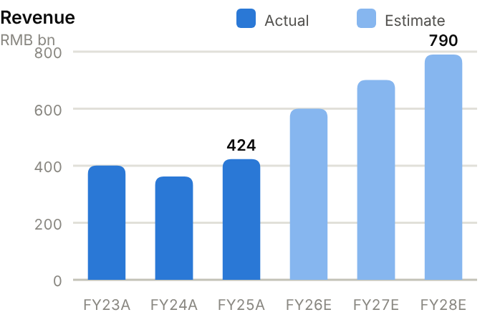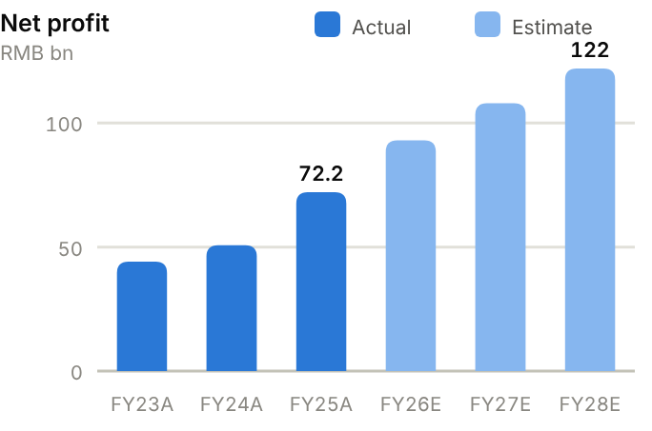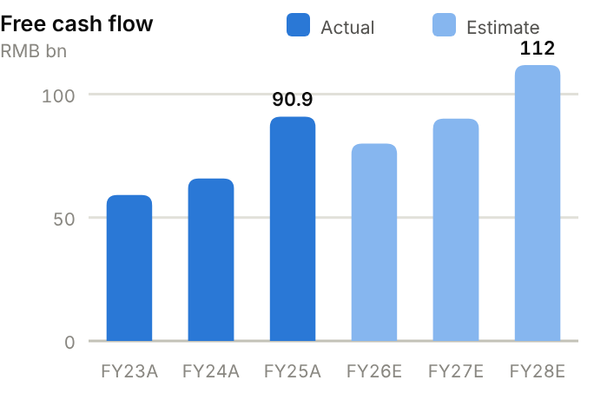
Income statement. Revenue fell from RMB401bn (FY23) to RMB362bn (FY24) as lithium deflation cut selling prices, then recovered to RMB424bn (FY25) and RMB522bn TTM on volume. Gross margin rose from 19.1% (FY23) to 25.1% (FY25), and operating profit grew from RMB51bn to RMB76bn. Net profit reached RMB72.2bn (FY25, +42%), a 17% net margin, and RMB43.3bn in H1'26 (+42%). We forecast revenue of RMB600bn/700bn/790bn and net profit of RMB93.0bn/108bn/122bn for FY26-28E, with gross margin of ~24%.
Source: company filings via StockAnalysis/S&P Global. Jun-26 = latest interim balance sheet. Debt includes leases. | Balance sheet. Total assets reached RMB975bn at FY25 and RMB1.14tn at June 2026. Cash and short-term investments of RMB440bn exceed total debt of RMB149bn, leaving net cash of RMB291bn (vs RMB139bn at FY23), about 81% of equity. Working capital is structurally negative: receivables equal 107 days of sales and inventory 109 days (inventory rose to RMB131bn by June 2026 ahead of storage deliveries), but payables run at 303 days of cost of sales. Equity attributable rose to RMB337bn at FY25 (BVPS ~RMB74), including RMB39bn of H-share proceeds. The current ratio is 1.60x.
  Balance sheet (RMB bn) | FY23A | FY24A | FY25A | Jun-26A
  Cash & short-term investments | 264.3 | 317.8 | 392.5 | 440.2
  Receivables | 124.8 | 120.3 | 123.7 | 144.2
  Inventory | 45.4 | 59.8 | 94.5 | 130.8
  PP&E | 140.8 | 143.2 | 179.4 | 206.3
  Total assets | 717.2 | 786.7 | 974.8 | 1,138.9
  Accounts payable | 194.6 | 198.3 | 263.6 | 355.5
  Total debt | 125.1 | 136.3 | 119.6 | 149.0
  Equity (attributable) | 197.7 | 246.9 | 337.1 | 379.4
  Minority interests | 22.2 | 26.5 | 33.9 | 34.6
  Net cash / (net debt) | 139.2 | 181.4 | 272.9 | 291.2

Cash flow (RMB bn) | FY23A | FY24A | FY25A | TTM Jun-26 | FY26E | FY27E | FY28E
Net profit (attributable) | 44.1 | 50.8 | 72.2 | – | 93.0 | 108.0 | 122.0
D&A | 21.5 | 23.1 | 25.0 | 28.0 | 28.0 | 31.4 | 35.1
Operating cash flow | 92.8 | 97.0 | 133.2 | 134.8 | 139.9 | 150.1 | 166.8
Capex | (33.6) | (31.2) | (42.3) | (47.2) | (60.0) | (60.0) | (55.0)
Free cash flow | 59.2 | 65.8 | 90.9 | 87.5 | 79.9 | 90.1 | 111.8
Dividends paid | (9.0) | (25.3) | (32.6) | (38.7) | (38.2) | (46.5) | (54.0)
Net cash / (debt), period-end | 139.2 | 181.4 | 272.9 | 291.2 | 314.7 | 358.2 | 416.0
OCF / net profit (x) | 2.10 | 1.91 | 1.85 | n.m. | 1.50 | 1.39 | 1.37

TTM = twelve months to June 2026; Jun-26 net cash in the TTM column. E = our estimates: OCF = net profit + D&A − increase in working capital; net cash rolls forward FCF less dividends plus equity raised.
Cash flow. Operating cash flow rose from RMB92.8bn (FY23) to RMB133.2bn (FY25), 1.85x net profit, because growth releases working capital. Capex of RMB31-42bn a year (~10% of revenue) left free cash flow of RMB59.2bn, 65.8bn and 90.9bn over FY23-25, which funded RMB32.6bn of dividends and RMB4.4bn of buybacks in FY25. With capex stepping up to ~RMB60bn for the 1.2TWh plan, we forecast FCF of RMB79.9bn/90.1bn/112bn, and net cash rising to ~RMB416bn by FY28E after dividends.
ROE/ROA on average balances. Days on year-end balances: receivables on revenue, inventory and payables on cost of sales. Net debt/equity below zero = net cash. Payout = DPS/EPS. n.m./– = not meaningful or not modelled. | Key ratios. ROE has held steady between 22.3% and 24.7% even as a growing cash pile dilutes returns, and we expect ~25.6% in FY27E. ROA is 8.2%. Excluding net cash, returns on operating capital are far higher, because working capital is negative. The FY25 payout ratio was 52%.
  Key ratios | FY23A | FY24A | FY25A | FY26E | FY27E | FY28E
  Revenue growth | – | −10% | 17% | 42% | 17% | 13%
  Gross margin | 19.1% | 23.8% | 25.1% | 24.0% | 24.3% | 24.5%
  Net margin | 11.0% | 14.0% | 17.0% | 15.5% | 15.4% | 15.4%
  ROE (avg. equity) | 22.3% | 22.8% | 24.7% | 25.5% | 25.6% | 25.0%
  ROA (avg. assets) | 6.2% | 6.7% | 8.2% | – | – | –
  Asset turnover (x) | 0.56 | 0.48 | 0.48 | – | – | –
  Receivable days | 114 | 121 | 107 | – | – | –
  Inventory days | 51 | 79 | 109 | – | – | –
  Payable days | 219 | 262 | 303 | – | – | –
  Current ratio (x) | 1.57 | 1.61 | 1.60 | – | – | –
  Net debt / equity | −70% | −73% | −81% | −80% | −79% | −80%
  Net debt / EBITDA (x) | -1.9 | -2.1 | -2.7 | – | – | –
  Capex / revenue | 8.4% | 8.6% | 10.0% | 10.0% | 8.6% | 7.0%
  FCF margin | 14.8% | 18.2% | 21.4% | 13.3% | 12.9% | 14.2%
  Dividend payout | 50% | 39% | 52% | 50% | 50% | 50%

Valuation
Source: StockAnalysis/S&P Global, 12 Oct 2026 (trailing EV/EBITDA and EV/sales; consensus forward P/E). | 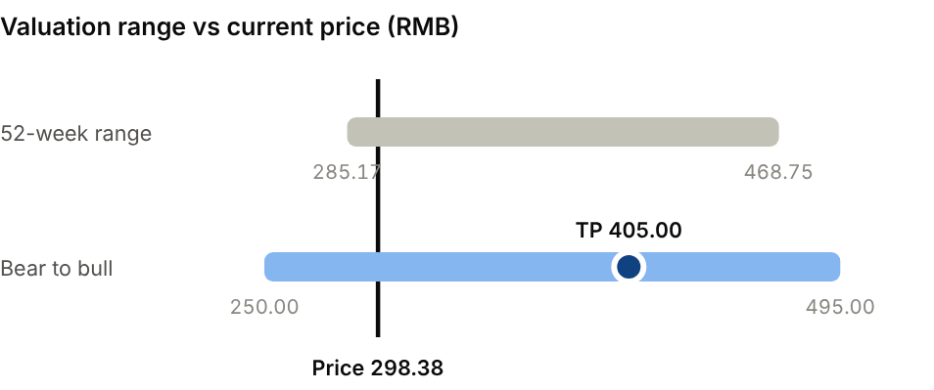  Bear (Share loss to second sources; price war): RMB250.00. Bull (Storage boom; overseas share gains): RMB495.00.
  Company | Ticker | Fwd P/E | EV/EBITDA | EV/sales
  BYD | 002594 CH | 15.5x | n.m. | n.m.
  LG Energy Solution | 373220 KS | 43.1x | 27.1x | 4.9x
  EVE Energy | 300014 CH | 13.0x | 16.3x | 1.6x
  CATL | 300750 CH | 12.6x | 9.4x | 2.2x

Our TP of RMB405 is 17x FY27E EPS of RMB23.68, below CATL's five-year average but above BYD (~15.5x) and EVE (~13x) forward; superior margins and ~25% ROE justify the premium. Ex-cash, the stock trades on ~9.9x FY27E. The consensus average target of RMB548 (29 analysts, all Buy-rated) predates the September sell-off. For the H-share (3750.HK), a 20% premium to our A-share TP implies ~HK$570, only ~15% upside, so we prefer the A-share. Bear case RMB250: share loss and a price war. Bull case RMB495: storage boom and overseas share gains.
Sources: CATL 2025 annual and H1'26 interim reports; SNE Research; Longbridge; Seoul Economic Daily; JPMorgan/CLSA (via Tiger); StockAnalysis/S&P Global; IBKR; source pack.
04 · EQUIPMENT, ROBOTICS & MEDTECH · INDUSTRIAL EQUIPMENT
Han's Laser 大族激光  002008.SZ · Initiation of coverage · 12 October 2026 | BUY  TP RMB95.00  Price RMB70.18 · +35%
An AI-capex winner with clear order visibility; the sell-off is an entry point
Han's Laser is Asia's largest laser and smart-manufacturing equipment maker. AI-server PCBs need far more drilling and processing, and its PCB-equipment arm now leads the group's growth: H1'26 revenue rose 76% and net profit 164%. The stock is ~58% below its high (−7% on 12 October). At 18.5x FY27E P/E, with RMB28bn of new orders and backlog, we initiate at Buy, TP RMB95.00 (+35% upside).  - AI-server PCBs are a multi-year growth driver. High-layer, high-density boards need more mechanical and laser drilling, exposure and testing; FY25 PCB-equipment revenue rose 73% to RMB5.8bn.  - Order visibility is unusually good. Management guides FY26 revenue of at least RMB27bn (+44%) and cites RMB19bn of new orders plus a RMB9bn backlog.  - Operating leverage is lifting margins. H1'26 gross margin rose 4pt to 34.9%; we forecast FY27E EPS of RMB3.79 (+42%).  Catalysts  - Q3'26 results on 23 October.  - Large PCB-equipment orders.  - FY27 guidance and AI-server PCB capex data.  Key risks  - AI capex slowdown or PCB capacity digestion.  - Apple and consumer-electronics cycle.  - Further share sales by the controlling shareholder.  - Minority leakage from listed subsidiaries. | Key data  FY25 revenue mix (%)  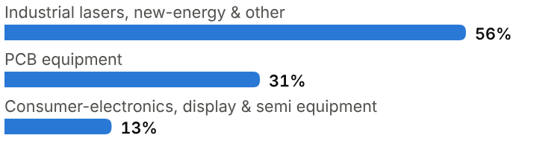
  Price (12 Oct 2026) | RMB70.18
  Target price (12m) | RMB95.00
  Implied return | +35.4%
  Market cap | RMB72.3bn / US$10.8bn
  Enterprise value | RMB70.4bn
  Net cash | RMB5.8bn
  Shares outstanding | 1.03bn
  52-week range | 34.43-168.08
  Performance | +70.8% YTD
  Dividend yield (FY26E) | 0.6%
  Consensus target | RMB157.23, 11 analysts
  Other listing | A-share; PCB-equipment arm Han's CNC listed separately

Key financials and valuation
Year to December | FY23A | FY24A | FY25A | FY26E | FY27E | FY28E
Revenue (RMB bn) | 14.1 | 14.8 | 18.8 | 27.5 | 34.0 | 39.0
YoY growth | – | +5% | +27% | +47% | +24% | +15%
Gross margin | 31.4% | 30.4% | 32.2% | 34.5% | 35.0% | 35.0%
Net profit, attributable (RMB bn) | 0.82 | 1.69 | 1.19 | 2.75 | 3.90 | 4.60
YoY growth | n.m. | +106% | −30% | +131% | +42% | +18%
EPS (RMB) | 0.78 | 1.62 | 1.15 | 2.67 | 3.79 | 4.47
P/E (x) | 90.0x | 43.3x | 61.0x | 26.3x | 18.5x | 15.7x
DPS (RMB) | 0.20 | 0.35 | 0.20 | 0.40 | 0.57 | 0.67
Dividend yield | 0.3% | 0.5% | 0.3% | 0.6% | 0.8% | 1.0%

A = actual (company reports; StockAnalysis/S&P Global), E = our estimates. Multiples at the 12-Oct-2026 price.

Company background
Han's Laser was founded in Shenzhen in 1996 by Gao Yunfeng, who started by selling laser marking machines to the Pearl River Delta's electronics factories. It listed on the Shenzhen SME board in 2004 and grew into Asia's largest industrial-laser equipment group by following its customers. It moved into laser cutting and welding for metal fabricators, then PCB drilling and processing, consumer-electronics production lines (it has long been an Apple supply-chain vendor), lithium-battery equipment, and display and semiconductor equipment.
The group is organised as a holding company with several specialist subsidiaries. The most important today is Han's CNC, the PCB-equipment maker listed separately on ChiNext since 2022. Han's sold more than 54,000 machines in FY25. FY24 reported profit was inflated by ~RMB1.25bn of one-off disposal gains, which makes FY25's reported decline misleading; core profit rose 82%. The founder's holding company remains the controlling shareholder but trimmed its stake in September 2026. AI servers have changed the company's growth profile: high-layer, high-density boards require far more drilling, exposure and testing equipment, and Han's entered 2026 with RMB19bn of new orders and a RMB9bn backlog.
Milestones | Ownership and listing
  1996 | Founded in Shenzhen by Gao Yunfeng; laser marking machines.
  2004 | Listed on the Shenzhen SME board (002008.SZ).
  2000s-10s | Expands into cutting/welding, PCB equipment and Apple-chain automation.
  2022 | PCB-equipment subsidiary Han's CNC lists on ChiNext (301200.SZ).
  2024 | One-off disposal gains (~RMB1.25bn) lift reported net profit to RMB1.69bn.
  2025 | Revenue +27% to RMB18.8bn; PCB equipment +73% to RMB5.8bn.
  2026 | Guides revenue ≥RMB27bn (+44%); H1 net profit +164%; founder trims stake (Sept).
  Controlling shareholder | Han's Holding Group, controlled by founder Gao Yunfeng (trimmed stake Sept 2026)
  Listed subsidiary | Han's CNC (301200.SZ): PCB drilling and processing equipment
  Dividend policy | Low payout (~15-20%)

The business
Han's makes capital equipment built around lasers and precision motion control. FY25 revenue split into information-industry equipment (RMB8.2bn, 44%) and industrial lasers, new-energy and other equipment (RMB10.5bn, 56%). Within the first, PCB equipment (RMB5.8bn, 31% of group revenue) covers mechanical and laser drilling, exposure, routing and testing for printed circuit boards. Consumer-electronics, display and semiconductor equipment made up the remaining 13%. The second group spans high-power fibre-laser cutting and welding systems for sheet-metal fabricators, equipment for lithium-battery production, and small and medium-power lasers for marking and micro-processing.
Revenue tracks customers' capex cycles, so visibility comes from orders and backlog. PCB makers are investing heavily in capacity for AI-server and high-speed networking boards in China, Taiwan and Southeast Asia, which needs more and more precise drilling. Consumer-electronics line orders follow Apple product cycles and new-energy equipment follows battery makers' expansion, while the cutting-laser business depends on general industry.
Margins depend on mix. PCB and precision equipment earn higher gross margins than commoditised cutting lasers, and group gross margin rose 4pt to 34.9% in H1'26. Working capital is heavy, because customers pay in instalments with acceptance-based final payments: receivables run at ~230 days of sales. The holding structure means some profit leaks to minorities in listed subsidiaries.
Revenue mix and economics (FY25)
Segment | Share of revenue | Key assets / products | Economics
PCB equipment (Han's CNC) | 31% (RMB5.8bn, +73%) | Mechanical/laser drilling, exposure, testing for PCBs | Highest growth; AI-server driven
Consumer-electronics, display & semi equipment | 13% | Automation lines for smartphones/wearables; display, semi tools | Apple-cycle dependent
Industrial lasers, new-energy & other | 56% | High-power cutting/welding; battery equipment; marking | Competitive; lower margins

Competitive landscape
In PCB equipment, Han's CNC competes with Japan's Via Mechanics (mechanical drilling leader) and Mitsubishi Electric (laser drilling), Germany's Schmoll and several Taiwanese makers. It is the leader in China and has been taking share in high-end drilling as Chinese PCB makers win AI-server work. The top-end laser-drilling segment for advanced substrates remains dominated by Japanese suppliers.
In industrial lasers, the global leaders are Trumpf, Coherent, IPG Photonics and Bystronic. Domestic competition is fierce from HGTECH (Huagong), Hymson, Golden Laser and Raycus (laser sources), and has pushed down prices of fibre-laser cutting systems. In battery equipment, Lead Intelligent and Yinghe are the main rivals. Han's advantages are breadth, its installed base, closeness to customers in Shenzhen's electronics cluster and cost. Its weaknesses are exposure to cyclical capex and a still-small presence at the very high end of semiconductor and substrate equipment.
Main competitors
Competitor | Base | Focus | Position vs Han's Laser
Via Mechanics / Mitsubishi Electric | Japan | PCB mechanical and laser drilling | High-end leaders
HGTECH (Huagong) | China | Lasers, sensors, optical modules | Domestic laser rival; ~39x forward P/E
Trumpf / Coherent / IPG | Germany / US | Industrial lasers and systems | Technology leaders; premium pricing
Lead Intelligent / Yinghe | China | Lithium-battery equipment | Leaders in battery lines
Bystronic / Golden Laser | Switzerland / China | Sheet-metal laser cutting | Price competition

Industry structure: five forces
Force | Intensity | Assessment
Rivalry | High | Via Mechanics and Mitsubishi Electric in PCB drilling; Trumpf, HGTech and Hymson in laser processing; Lead Intelligent and others in battery equipment.
New entrants | Medium | Low-power laser markers and cutters are commoditised, but high-end PCB drilling and semiconductor tools need years of process know-how.
Supplier power | Medium | Laser sources, scanners and controllers come partly from third parties (IPG, Raycus); falling fibre-laser prices have helped margins.
Buyer power | High | PCB, battery and consumer-electronics makers are concentrated, cyclical capex buyers that run competitive bids.
Substitutes | Medium | Mechanical and laser drilling substitute for each other (Han's sells both); plasma and waterjet compete in cutting.

Moat and vulnerabilities
- Broadest laser and precision-equipment portfolio in Asia, with a large installed base and service network.
- Leadership in China PCB equipment as AI-server boards drive capacity investment.
- Close relationships with Apple-chain and Shenzhen electronics makers.
- Vulnerabilities: capex cyclicality, price competition in lasers, controlling-shareholder selling.

Addressable market (TAM)
Global printed-circuit-board output is roughly US$75-80bn a year (Prismark), and AI servers and high-speed networking are the fastest-growing segments. They need more layers, finer features and more holes per board. That is prompting large capacity additions by Chinese, Taiwanese and Southeast Asian PCB makers, and equipment spending is growing much faster than PCB output.
China is also the world's largest market for industrial laser processing, where fibre lasers are displacing plasma and mechanical cutting, though it is mature and price-competitive. Han's FY26E revenue of ~RMB27bn (~US$4bn) makes it a top-tier participant in both markets. Further upside depends on share gains in high-end PCB drilling and semiconductor equipment, on top of market growth.
Semiconductor and advanced-packaging equipment is the next adjacency. Laser dicing, grooving and annealing tools are dominated by Japanese and European suppliers, and Chinese chipmakers want domestic alternatives. Han's revenue there is still small, so this is upside to our forecasts rather than part of them.
Market | Size | Growth / dynamics | Source
Global PCB output | ~US$75-80bn | AI-server/networking boards fastest-growing | Prismark
PCB equipment capex | Rising faster than PCB output | AI-driven capacity additions | Company/industry
Industrial laser equipment | China is the largest market | Mature; price-competitive | Industry
Han's order book | RMB19bn new orders + RMB9bn backlog | FY26 revenue ≥RMB27bn | Company

RMB27bn+  Han's 2026 revenue guidance (+44%) | RMB19bn + RMB9bn  New orders plus backlog cited by management | +73%  PCB-equipment revenue growth in FY25 (to RMB5.8bn)

Financial analysis
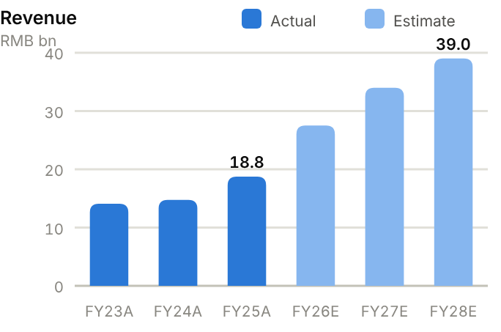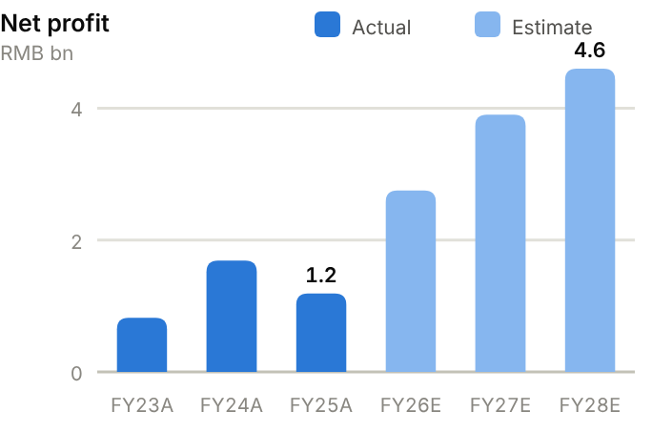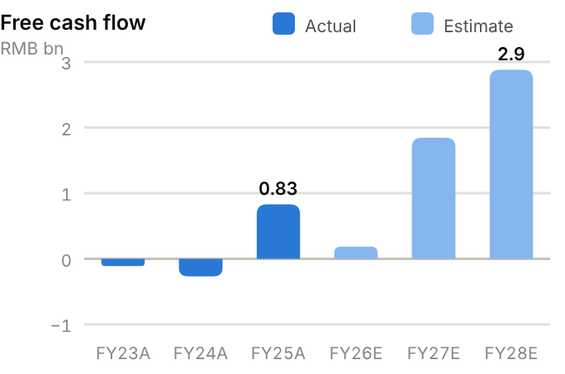
Income statement. Revenue moved from RMB14.1bn (FY23) to RMB14.8bn (FY24), RMB18.8bn (FY25) and RMB24.6bn TTM. Gross margin improved from 30.4% (FY24) to 32.2% (FY25) and 34.1% TTM. Operating profit tripled from RMB0.4bn (FY24) to RMB1.35bn (FY25) and RMB3.0bn TTM. Reported net profit (RMB0.82bn/1.69bn/1.19bn over FY23-25) was distorted by FY24 one-offs; H1'26 net profit was RMB1.29bn (+164%). We forecast revenue of RMB27.5bn/34.0bn/39.0bn and net profit of RMB2.75bn/3.90bn/4.60bn for FY26-28E.
Source: company filings via StockAnalysis/S&P Global. Jun-26 = latest interim balance sheet. Debt includes leases. | Balance sheet. Total assets jumped from RMB38.2bn (FY25) to RMB47.4bn (June 2026) as receivables (RMB16.1bn) and inventory (RMB7.2bn) grew with orders. At FY25, receivable days were 228 and inventory days 150, partly offset by payable days of 289. Debt fell to RMB4.4bn and cash rose to RMB10.1bn, so net cash is RMB5.8bn (RMB3.1bn at FY25), ~18% of equity. Equity attributable rose to RMB21.5bn (BVPS ~RMB21), and minority interests jumped to RMB3.9bn after capital raising at subsidiaries. The current ratio is 1.58x.
  Balance sheet (RMB bn) | FY23A | FY24A | FY25A | Jun-26A
  Cash & short-term investments | 10.8 | 8.3 | 8.0 | 10.1
  Receivables | 9.2 | 10.4 | 11.7 | 16.1
  Inventory | 4.4 | 4.0 | 5.2 | 7.2
  PP&E | 5.1 | 6.4 | 6.7 | 6.8
  Total assets | 34.2 | 34.2 | 38.2 | 47.4
  Accounts payable | 6.8 | 7.8 | 10.1 | 12.4
  Total debt | 7.1 | 5.3 | 4.9 | 4.4
  Equity (attributable) | 15.0 | 16.1 | 17.3 | 21.5
  Minority interests | 1.4 | 1.4 | 1.6 | 3.9
  Net cash / (net debt) | 3.7 | 2.9 | 3.1 | 5.8

Cash flow (RMB bn) | FY23A | FY24A | FY25A | TTM Jun-26 | FY26E | FY27E | FY28E
Net profit (attributable) | 0.8 | 1.7 | 1.2 | – | 2.8 | 3.9 | 4.6
D&A | 0.5 | 0.4 | 0.5 | 0.5 | 0.5 | 0.6 | 0.6
Operating cash flow | 1.4 | 1.1 | 1.5 | 1.5 | 1.1 | 2.8 | 4.0
Capex | (1.5) | (1.4) | (0.6) | (0.7) | (0.9) | (1.0) | (1.1)
Free cash flow | (0.1) | (0.3) | 0.8 | 0.8 | 0.2 | 1.8 | 2.9
Dividends paid | (0.3) | (0.3) | (0.5) | (0.6) | (0.2) | (0.4) | (0.6)
Net cash / (debt), period-end | 3.7 | 2.9 | 3.1 | 5.8 | 3.1 | 4.5 | 6.8
OCF / net profit (x) | 1.66 | 0.67 | 1.23 | n.m. | 0.39 | 0.73 | 0.86

TTM = twelve months to June 2026; Jun-26 net cash in the TTM column. E = our estimates: OCF = net profit + D&A − increase in working capital; net cash rolls forward FCF less dividends plus equity raised.
Cash flow. Operating cash flow has been steady at RMB1.1-1.5bn a year and has lagged profit growth because working capital absorbs cash. Capex fell from RMB1.4-1.5bn (FY23-24) to RMB0.6bn (FY25), so FCF turned positive at RMB0.83bn in FY25 after −RMB0.11bn/−RMB0.27bn in FY23-24. Dividends are small. We forecast FCF of RMB0.18bn/1.8bn/2.9bn as working-capital growth slows relative to profits. Net cash would then rise to ~RMB6.8bn by FY28E.
ROE/ROA on average balances. Days on year-end balances: receivables on revenue, inventory and payables on cost of sales. Net debt/equity below zero = net cash. Payout = DPS/EPS. n.m./– = not meaningful or not modelled. | Key ratios. ROE was 5.5%, 10.9% and 7.1% over FY23-25; we expect it to more than double to ~18.1% by FY27E on higher margins and volumes. ROA was 3.3% in FY25. Receivable days of 228 are the main working-capital risk in an AI capex slowdown. Payout was 17% on FY25 EPS.
  Key ratios | FY23A | FY24A | FY25A | FY26E | FY27E | FY28E
  Revenue growth | – | 5% | 27% | 47% | 24% | 15%
  Gross margin | 31.4% | 30.4% | 32.2% | 34.5% | 35.0% | 35.0%
  Net margin | 5.8% | 11.4% | 6.3% | 10.0% | 11.5% | 11.8%
  ROE (avg. equity) | 5.5% | 10.9% | 7.1% | 14.8% | 18.1% | 18.2%
  ROA (avg. assets) | 2.4% | 4.9% | 3.3% | – | – | –
  Asset turnover (x) | 0.41 | 0.43 | 0.52 | – | – | –
  Receivable days | 238 | 256 | 228 | – | – | –
  Inventory days | 166 | 141 | 150 | – | – | –
  Payable days | 256 | 278 | 289 | – | – | –
  Current ratio (x) | 1.65 | 1.81 | 1.58 | – | – | –
  Net debt / equity | −25% | −18% | −18% | −16% | −19% | −25%
  Net debt / EBITDA (x) | -4.6 | -3.9 | -1.8 | – | – | –
  Capex / revenue | 10.5% | 9.4% | 3.4% | 3.3% | 2.9% | 2.8%
  FCF margin | −0.8% | −1.8% | 4.4% | 0.7% | 5.4% | 7.4%
  Dividend payout | 26% | 22% | 17% | 15% | 15% | 15%

Valuation
Source: StockAnalysis/S&P Global, 12 Oct 2026 (trailing EV/EBITDA and EV/sales; consensus forward P/E). | 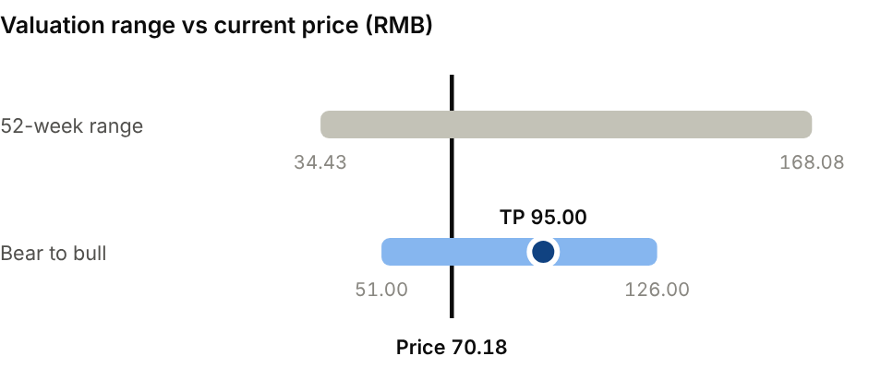  Bear (AI capex pause; PCB orders digest): RMB51.00. Bull (AI PCB capex keeps accelerating): RMB126.00.
  Company | Ticker | Fwd P/E | EV/EBITDA | EV/sales
  HGTECH (Huagong) | 000988 CH | 38.6x | 61.6x | 5.9x
  Wuxi Lead Intelligent | 300450 CH | 19.8x | 20.3x | 3.1x
  IPG Photonics | IPGP US | 38.1x | 23.7x | 2.3x
  Han's Laser | 002008 CH | 16.9x | 19.7x | 2.9x

Our TP of RMB95.00 is 25x FY27E EPS of RMB3.79: a premium to Lead Intelligent (~20x forward) for AI exposure, but below HGTECH (~39x). UOB's target is RMB153.2 and the consensus average RMB157, both on higher FY27 earnings. Bear case RMB51.00: an AI capex pause and PCB order digestion. Bull case RMB126: AI PCB capex keeps accelerating.
Sources: Company FY25 results release and H1'26 report; Longbridge; UOB Kay Hian; Futu; MarketScreener; StockAnalysis/S&P Global; IBKR; source pack.
05 · SEMICONDUCTORS & MATERIALS · RARE-EARTH MAGNETS
JL Mag Rare-Earth 金力永磁  6680.HK · Initiation of coverage · 12 October 2026 | BUY  TP HK$18.50  Price HK$14.75 · +25%
The global magnet leader; own it through the discounted H-share
JL Mag is the world's largest maker of high-performance NdFeB rare-earth magnets for EV motors, efficient air-conditioners, wind turbines and, increasingly, robots. H1'26 net profit rose 52% and gross margin 5.3pt. The H-share trades at a ~46% discount to the A-share, on 15.0x FY27E P/E with a ~2.6% yield. We initiate on the H-share at Buy, TP HK$18.50 (+25% upside).  - JL Mag's position is strategic. China makes ~90% of the world's sintered NdFeB magnets and controls rare-earth exports. JL Mag leads on scale and technology; its grain-boundary diffusion process cuts heavy rare-earth use.  - New capacity drives growth: it rises from ~40kt (2025) to 60kt by end-2027. Robot-related sales rose 96% in H1'26, and small-batch humanoid rotor deliveries have started.  - The H-share is the cheaper line, on 15.0x FY27E against ~28x for the A-share, with the same earnings and a dividend yield near 2.6%.  Catalysts  - Q3'26 results on 28 October.  - Humanoid-robot rotor orders.  - Capacity ramp toward 60kt; dividends.  Key risks  - Rare-earth price volatility (inventory gains and losses).  - Export licensing and trade policy.  - Customer concentration in NEVs; overseas plant execution.  - The A/H discount could persist or widen. | Key data  H1'26 revenue by end-market (%)  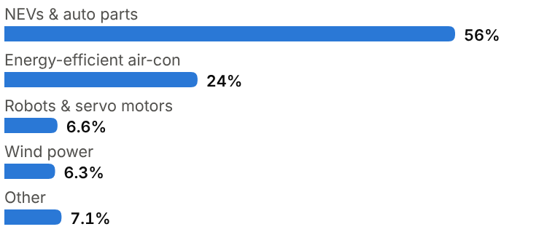
  Price (12 Oct 2026) | HK$14.75
  Target price (12m) | HK$18.50
  Implied return | +25.4%
  Market cap | RMB29.6bn (A+H) / US$4.4bn
  Enterprise value | RMB27.5bn
  Net cash | RMB2.3bn
  Shares outstanding | 1.37bn
  52-week range | 14.33-28.71
  Performance | -20.1% YTD
  Dividend yield (FY26E) | 2.6%
  Consensus target | RMB37.28 (A-share), 10 analysts
  Other listing | A-share 300748.SZ at RMB23.47 (H at ~46% discount)

Key financials and valuation
Year to December | FY23A | FY24A | FY25A | FY26E | FY27E | FY28E
Revenue (RMB bn) | 6.69 | 6.76 | 7.72 | 9.80 | 12.0 | 14.2
YoY growth | – | +1% | +14% | +27% | +22% | +18%
Gross margin | 15.6% | 10.4% | 20.3% | 21.5% | 22.0% | 22.5%
Net profit, attributable (RMB bn) | 0.56 | 0.29 | 0.71 | 0.90 | 1.15 | 1.40
YoY growth | n.m. | −48% | +143% | +27% | +28% | +22%
EPS (RMB) | 0.42 | 0.22 | 0.52 | 0.66 | 0.84 | 1.02
P/E on H-share price (x) | 30.0x | 57.2x | 24.2x | 19.2x | 15.0x | 12.3x
DPS (RMB) | 0.26 | – | 0.40 | 0.33 | 0.42 | 0.51
Dividend yield | 2.1% | – | 3.2% | 2.6% | 3.3% | 4.1%

A = actual (company reports; StockAnalysis/S&P Global), E = our estimates. Multiples at the 12-Oct-2026 price, converted at HK$1 = RMB0.853.

Company background
JL Mag Rare-Earth was founded in 2008 in Ganzhou, Jiangxi, by Cai Baogui, who remains chairman and controls the company. Ganzhou is the centre of China's ionic-clay deposits of heavy rare earths (dysprosium, terbium), which high-temperature magnets need. JL Mag set out to make the highest grades of sintered neodymium-iron-boron (NdFeB) magnets for demanding applications and to stay out of commodity grades.
The bet paid off as EVs, inverter air-conditioners and direct-drive wind turbines took off. JL Mag qualified with global automakers and Tier-1 suppliers, wind-turbine OEMs and appliance makers, and built a reputation for grain-boundary diffusion. This process deposits heavy rare earths only at grain boundaries, cutting their use and cost while keeping performance. JL Mag listed on Shenzhen's ChiNext board in 2018 and in Hong Kong in January 2022. Its bases are now in Ganzhou, Ningbo and Baotou (Inner Mongolia, near light rare-earth supply), and it is building overseas capacity. Capacity reached ~40kt in 2025 and is targeted at 60kt by end-2027. Small-batch deliveries of humanoid-robot rotors began in 2026.
Milestones | Ownership and listing
  2008 | Founded in Ganzhou, Jiangxi by Cai Baogui.
  2018 | ChiNext IPO (300748.SZ).
  2022 | Hong Kong listing (6680.HK).
  2023-25 | Baotou and Ningbo bases expand; capacity ~40kt in 2025.
  2025 | Net profit +142% to RMB0.71bn as rare-earth prices recover.
  2026 | Small-batch humanoid-robot rotor deliveries; robot sales +96% in H1; 60kt target for 2027.
  Controlling shareholder | Founder-chairman Cai Baogui
  Share classes | A-share 300748.SZ; H-share 6680.HK (~46% discount to A)
  Raw-material suppliers | China Northern Rare Earth, China Rare Earth Group (state-controlled)

The business
JL Mag makes sintered NdFeB permanent magnets, the strongest commercially available magnets, which allow smaller, lighter and more efficient electric motors and generators. The process runs from alloy melting and strip casting through hydrogen decrepitation, jet milling, pressing in a magnetic field, sintering, machining and coating, with grain-boundary diffusion for high-coercivity grades. Each customer program needs custom specifications and lengthy qualification, especially in automotive.
End-markets in H1'26 were NEVs and auto parts (56% of revenue: traction motors, EPS, other motors), energy-efficient air-conditioners (24%: inverter compressors), robots and industrial servo motors (6.6%), wind power (6.3%), and consumer electronics and others. Robot-related sales nearly doubled (+96%) and are the fastest-growing line.
Pricing is broadly raw-material cost (PrNd, Dy, Tb oxides and metals) plus a processing fee, adjusted periodically. JL Mag's profit therefore comes from volume and processing margin, plus inventory gains or losses when rare-earth prices move. That explains the swing from a 10.4% gross margin in FY24, when prices fell, to 21.7% in H1'26. Raw materials come from China's state-controlled rare-earth groups. Export licensing since 2025 adds administrative friction for overseas customers but reinforces China's dominance. Working capital is substantial: receivables and inventory each run at ~160 days.
JL Mag plans to lift capacity from ~40kt in 2025 to 60kt by end-2027, including the Baotou base next to light rare-earth supply and overseas capacity for customers that want supply outside China. It is shifting output toward robots, servo motors and humanoid joint motors, where specifications are tighter and processing fees higher. Its grain-boundary diffusion process and low-heavy-rare-earth grades also cut its need for dysprosium and terbium, the materials most exposed to export controls.
Revenue by end-market and economics (H1'26)
Segment | Share of revenue | Key assets / products | Economics
NEVs & auto parts | 56.0% | Traction motors, EPS and auxiliary motors | Largest; long qualification cycles
Energy-efficient air-conditioners | 24.0% | Inverter compressor motors | Stable volume
Robots & servo motors | 6.6% | Industrial servo, humanoid joints/rotors | +96% in H1'26; highest growth
Wind power | 6.3% | Direct-drive / semi-direct generators | Lumpy; large magnets
Other | 7.1% | Consumer electronics, elevators, industrial motors | Diversified

Competitive landscape
China makes roughly 90% of the world's sintered NdFeB magnets. Domestic competitors include Ningbo Yunsheng, Zhong Ke San Huan, Ningbo Jintian, Yantai Zhenghai, Innuovo (Hengdian DMEGC) and Galaxy Magnetic, plus many smaller producers of lower grades. JL Mag is the largest in high-performance grades and has the deepest automotive qualification list.
Outside China, Proterial (formerly Hitachi Metals) and Shin-Etsu in Japan, TDK and VAC (Germany, building in the US) are established; MP Materials (US) and Neo Performance (Estonia) are building Western supply chains with government support. Those efforts are small relative to China and much higher-cost, but over time they will take share of Western automakers' purchases. JL Mag's counter-strategy is overseas capacity and long-term contracts.
Since April 2025 China has required export licences for seven medium and heavy rare earths and for magnets that contain them. Over time that pushes Western automakers to qualify non-Chinese suppliers. In the near term it favours established Chinese producers with licences, long customer relationships and overseas plants, such as JL Mag.
Main competitors
Competitor | Base | Focus | Position vs JL Mag Rare-Earth
Ningbo Yunsheng | China | Sintered NdFeB, broad grades | Smaller; ~21x forward P/E
Zhong Ke San Huan | China | NdFeB (Chinese Academy of Sciences roots) | Lower margins; ~57x forward P/E
Proterial / Shin-Etsu / TDK | Japan | High-grade NdFeB | Technology peers; higher cost
VAC | Germany/US | NdFeB and specialty alloys | Building US plant for automakers
MP Materials | US | Mine-to-magnet (Texas) | Policy-backed Western supply; ~18x EV/sales

Industry structure: five forces
Force | Intensity | Assessment
Rivalry | High | Ningbo Yunsheng, Zhong Ke San Huan, AT&M and Zhenghai at home, and Shin-Etsu, TDK and Proterial in Japan; Chinese capacity is growing fast.
New entrants | Medium | US and EU policy supports ex-China magnet plants (MP Materials, Neo, VAC), while Chinese entrants need rare-earth allocations and auto qualification.
Supplier power | High | Feedstock (NdPr, dysprosium, terbium) is controlled by state groups under quotas; JL Mag's grain-boundary diffusion cuts its heavy rare-earth use.
Buyer power | Medium | Buyers in EVs, wind, appliances and industrial motors are large and negotiate processing fees; pricing is largely cost-plus on raw materials.
Substitutes | Medium | Ferrite magnets and rare-earth-free motors can replace NdFeB where performance allows; China's 2025 export controls have accelerated substitution work abroad.

Moat and vulnerabilities
- Scale leader in high-performance NdFeB, with grain-boundary diffusion know-how.
- Deep qualification with global automakers and Tier-1s; robot and humanoid design wins.
- Location near both heavy (Ganzhou) and light (Baotou) rare-earth supply.
- Vulnerabilities: rare-earth price swings, export licensing, Western supply-chain diversification.

Addressable market (TAM)
Industry estimates put high-performance NdFeB demand growth at ~10-15% a year to 2030. EV traction motors use 2-3kg of magnet per car; inverter air-conditioners and industrial motors are switching to permanent-magnet designs for efficiency; direct-drive wind turbines use hundreds of kilograms per MW; and humanoid robots could each need roughly 2-4kg in joint motors on industry estimates.
The value of the market also depends on rare-earth prices, since magnets are priced cost-plus. NdPr oxide peaked near US$98k/t in January 2026 (Baotou February average RMB850k/t) and eased to ~RMB750k/t by July. JL Mag's planned 60kt capacity would be a high-teens share of global high-performance supply on our rough estimates.
Humanoid robots will add little tonnage. At 2-4kg of magnets per robot, one million humanoids a year would add only 2-4kt of magnet demand, small next to EVs. The money is in the higher processing fees for precision rotor assemblies, which is why JL Mag sells finished rotors as well as magnet blocks into this market.
Market | Size | Growth / dynamics | Source
High-performance NdFeB demand | – | ~10-15% a year to 2030 | Industry estimates
China share of sintered NdFeB | ~90% | Stable; export licensing since 2025 | Industry estimates
NdPr oxide price | ~RMB750k/t (Jul 2026) | Peak ~US$98k/t in Jan 2026 | SMM; Benchmark
JL Mag capacity | ~40kt (2025) → 60kt (2027E) | +50% | Company

60kt  JL Mag magnet capacity target by end-2027 (~40kt in 2025) | +96%  Growth in robot-related sales, H1'26 | ~90%  China's share of global sintered NdFeB magnet production

Financial analysis
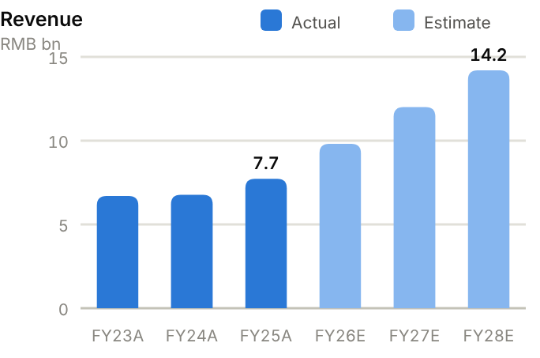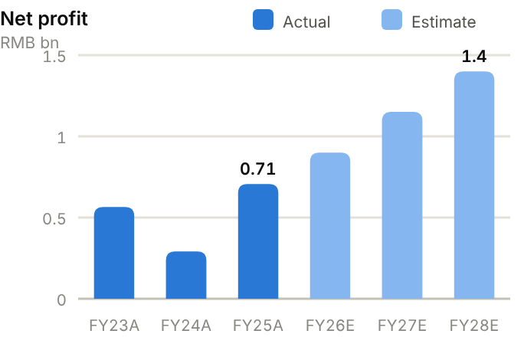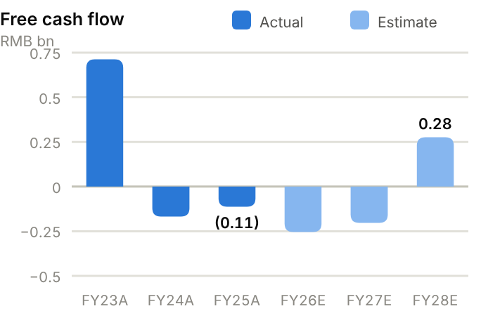
Income statement. Revenue was flat at ~RMB6.7bn in FY23-24 as rare-earth prices fell, then rose to RMB7.7bn (FY25) and RMB8.9bn TTM. Gross margin troughed at 10.4% (FY24) and recovered to 20.3% (FY25) and 22.7% TTM. Net profit fell to RMB0.29bn in FY24 before rebounding to RMB0.71bn (FY25) and RMB0.46bn in H1'26 (+52%). We forecast revenue of RMB9.80bn/12.0bn/14.2bn and net profit of RMB0.90bn/1.15bn/1.40bn for FY26-28E, as capacity growth offsets softer rare-earth prices.
Source: company filings via StockAnalysis/S&P Global. Jun-26 = latest interim balance sheet. Debt includes leases. | Balance sheet. Total assets are RMB16.5bn (June 2026), dominated by working capital. Receivables of RMB3.4bn (160 days at FY25) and inventory of RMB2.8-3.6bn (165 days) are partly funded by payables (212 days). PP&E is modest at RMB3.3bn. Net cash shrank from RMB3.1bn (FY23) to RMB1.2bn (FY25) as borrowing rose to fund inventory, then recovered to RMB2.3bn in June 2026. Equity attributable is RMB7.8bn (BVPS ~RMB5.7) and the current ratio is 1.80x.
  Balance sheet (RMB bn) | FY23A | FY24A | FY25A | Jun-26A
  Cash & short-term investments | 4.1 | 2.9 | 4.3 | 4.7
  Receivables | 2.4 | 2.4 | 3.4 | 3.4
  Inventory | 2.2 | 2.2 | 2.8 | 3.6
  PP&E | 2.5 | 3.1 | 3.3 | 3.4
  Total assets | 11.8 | 12.3 | 15.3 | 16.5
  Accounts payable | 2.9 | 3.1 | 3.6 | 5.1
  Total debt | 1.0 | 1.4 | 3.2 | 2.4
  Equity (attributable) | 7.0 | 7.0 | 7.6 | 7.8
  Minority interests | 0.0 | 0.1 | 0.1 | 0.1
  Net cash / (net debt) | 3.1 | 1.5 | 1.2 | 2.3

Cash flow (RMB bn) | FY23A | FY24A | FY25A | TTM Jun-26 | FY26E | FY27E | FY28E
Net profit (attributable) | 0.6 | 0.3 | 0.7 | – | 0.9 | 1.1 | 1.4
D&A | 0.1 | 0.2 | 0.2 | 0.3 | 0.3 | 0.3 | 0.3
Operating cash flow | 1.5 | 0.5 | 0.4 | 2.1 | 0.7 | 1.0 | 1.3
Capex | (0.8) | (0.7) | (0.5) | (0.3) | (1.0) | (1.2) | (1.0)
Free cash flow | 0.7 | (0.2) | (0.1) | 1.8 | (0.3) | (0.2) | 0.3
Dividends paid | (0.3) | (0.5) | (0.5) | (0.6) | (0.5) | (0.5) | (0.6)
Net cash / (debt), period-end | 3.1 | 1.5 | 1.2 | 2.3 | 0.4 | (0.3) | (0.6)
OCF / net profit (x) | 2.69 | 1.75 | 0.50 | n.m. | 0.83 | 0.87 | 0.91

TTM = twelve months to June 2026; Jun-26 net cash in the TTM column. E = our estimates: OCF = net profit + D&A − increase in working capital; net cash rolls forward FCF less dividends plus equity raised.
Cash flow. Operating cash flow fell from RMB1.5bn (FY23) to RMB0.35bn (FY25) as rising rare-earth prices inflated inventory and receivables (OCF/net profit 0.50x in FY25), then recovered to RMB2.1bn TTM. With capex of RMB0.5-0.8bn, FCF was slightly negative in FY24-25 (FY25 −RMB0.11bn) but RMB1.8bn TTM. Dividends of RMB0.45-0.63bn a year are generous for this cash flow. We forecast FCF of −RMB0.26bn, −RMB0.20bn and RMB0.28bn in FY26-28E as capex rises toward 60kt, so the company moves to small net debt (~RMB0.58bn by FY28E).
ROE/ROA on average balances. Days on year-end balances: receivables on revenue, inventory and payables on cost of sales. Net debt/equity below zero = net cash. Payout = DPS/EPS. n.m./– = not meaningful or not modelled. | Key ratios. ROE fell from 8.0% (FY23) to 4.1% (FY24) and recovered to 9.7% (FY25); we expect ~13.9% by FY27E and ~15.5% by FY28E. ROA is 5.1%. Cash conversion is the weak spot (0.50x in FY25, ~0.6-0.7x in our forecasts). Payout was 77% on FY25 EPS.
  Key ratios | FY23A | FY24A | FY25A | FY26E | FY27E | FY28E
  Revenue growth | – | 1% | 14% | 27% | 22% | 18%
  Gross margin | 15.6% | 10.4% | 20.3% | 21.5% | 22.0% | 22.5%
  Net margin | 8.4% | 4.3% | 9.1% | 9.2% | 9.6% | 9.9%
  ROE (avg. equity) | 8.0% | 4.1% | 9.7% | 11.6% | 13.9% | 15.5%
  ROA (avg. assets) | 4.8% | 2.4% | 5.1% | – | – | –
  Asset turnover (x) | 0.57 | 0.56 | 0.56 | – | – | –
  Receivable days | 130 | 130 | 160 | – | – | –
  Inventory days | 143 | 131 | 165 | – | – | –
  Payable days | 188 | 184 | 212 | – | – | –
  Current ratio (x) | 2.22 | 1.88 | 1.80 | – | – | –
  Net debt / equity | −45% | −22% | −16% | −5% | 3% | 6%
  Net debt / EBITDA (x) | -5.1 | -5.1 | -1.3 | – | – | –
  Capex / revenue | 12.0% | 10.0% | 6.0% | 10.2% | 10.0% | 7.0%
  FCF margin | 10.6% | −2.5% | −1.5% | −2.6% | −1.7% | 1.9%
  Dividend payout | 62% | – | 77% | 50% | 50% | 50%

Valuation
Source: StockAnalysis/S&P Global, 12 Oct 2026 (trailing EV/EBITDA and EV/sales; consensus forward P/E). | 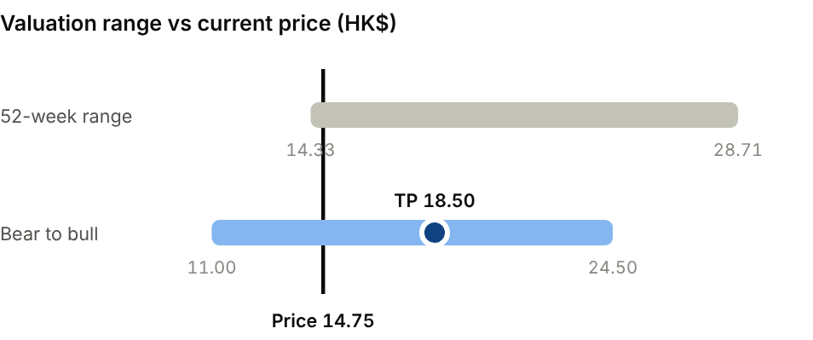  Bear (Rare-earth prices slide; robot demand slips): HK$11.00. Bull (Humanoid volumes and export recovery): HK$24.50.
  Company | Ticker | Fwd P/E | EV/EBITDA | EV/sales
  Ningbo Yunsheng | 600366 CH | 20.9x | 16.3x | 1.6x
  Zhong Ke San Huan | 000970 CH | 56.5x | 33.2x | 1.8x
  MP Materials | MP US | 130x | 184x | 17.9x
  JL Mag (A-share) | 6680 HK | 24.7x | 24.4x | 3.1x

Our H-share TP of HK$18.50 is 19x FY27E EPS of RMB0.84, a discount to Ningbo Yunsheng (~21x) and to the A-share (~28x) that reflects the persistent A/H gap. Even at our TP the H-share would sit ~33% below the A-share. The A-share consensus target is RMB37.3, but at RMB23.47 we see the A-share as fairly valued. Bear case HK$11.00: rare-earth prices slide and robot demand slips. Bull case HK$24.50: humanoid volumes and an export recovery.
Sources: Company H1'26 HKEX interim results; SMM; Benchmark Mineral Intelligence; Simply Wall St; StockAnalysis/S&P Global; IBKR; source pack.
06 · BATTERY, LITHIUM & STORAGE · SOLAR & STORAGE EQUIPMENT
Sungrow Power 阳光电源  300274.SZ · Initiation of coverage · 12 October 2026 | HOLD  TP RMB95.00  Price RMB82.35 · +15%
Margins are recovering; revenue has to follow before we turn constructive
Sungrow is the world's No.2 solar-inverter maker and a top-tier storage integrator; storage is now half of revenue and 73% of sales are overseas. H1'26 revenue fell 29% on domestic solar weakness and lower shipments, yet gross margin rose to 35.9%. At 11.7x FY27E P/E with net cash the stock is inexpensive, but we want evidence of an H2 storage ramp. We initiate at Hold, TP RMB95.00 (+15% upside).  - Storage has overtaken inverters. Shipments rose 54% to 43GWh in 2025, and the business made up ~50% of H1'26 revenue, with demand from utility-scale, C&I and data-centre projects.  - Gross margin is improving. It reached 35.9% in H1'26 and 38.6% in Q2 on overseas mix and cheaper cells; price increases of 5-15% took effect from 20 September.  - Revenue is the main uncertainty. H1'26 revenue fell 29%, and our FY26E EPS of RMB5.97 is ~13% below consensus. Q3 results (30 October) need to show storage deliveries accelerating.  Catalysts  - Q3'26 results on 30 October.  - Storage order announcements and shipment data.  - H-share listing; data-centre power products.  Key risks  - Price war among Chinese storage integrators.  - US tariffs and foreign-entity-of-concern sourcing rules.  - Domestic solar demand and FX losses.  - Dilution from the H-share listing. | Key data  H1'26 revenue mix (%)  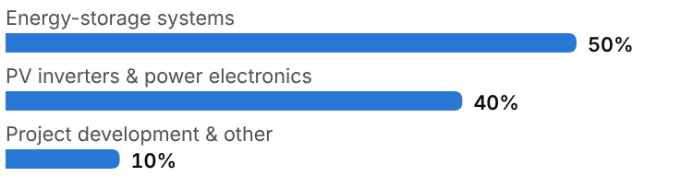
  Price (12 Oct 2026) | RMB82.35
  Target price (12m) | RMB95.00
  Implied return | +15.4%
  Market cap | RMB169.7bn / US$25.3bn
  Enterprise value | RMB144.7bn
  Net cash | RMB28.1bn
  Shares outstanding | 2.06bn
  52-week range | 78.00-208.88
  Performance | -51.8% YTD
  Dividend yield (FY26E) | 1.8%
  Consensus target | RMB146.50, 20 analysts
  Other listing | Hong Kong H-share IPO filed (refiled April 2026)

Key financials and valuation
Year to December | FY23A | FY24A | FY25A | FY26E | FY27E | FY28E
Revenue (RMB bn) | 72.2 | 77.9 | 89.2 | 82.0 | 98.0 | 112
YoY growth | – | +8% | +15% | −8% | +20% | +14%
Gross margin | 25.5% | 29.1% | 30.5% | 34.5% | 33.0% | 32.5%
Net profit, attributable (RMB bn) | 9.44 | 11.0 | 13.5 | 12.3 | 14.5 | 16.3
YoY growth | n.m. | +17% | +22% | −9% | +18% | +12%
EPS (RMB) | 4.55 | 5.32 | 6.53 | 5.97 | 7.04 | 7.91
P/E (x) | 18.1x | 15.5x | 12.6x | 13.8x | 11.7x | 10.4x
DPS (RMB) | 0.69 | 1.08 | 1.64 | 1.49 | 1.76 | 1.98
Dividend yield | 0.8% | 1.3% | 2.0% | 1.8% | 2.1% | 2.4%

A = actual (company reports; StockAnalysis/S&P Global), E = our estimates. Multiples at the 12-Oct-2026 price.

Company background
Sungrow Power Supply was founded in 1997 in Hefei, Anhui, by Cao Renxian, then an associate professor of power electronics at Hefei University of Technology, to make inverters for small wind and solar systems in rural China. It grew with China's solar industry and listed on Shenzhen's ChiNext board in 2011. Exports drove its rise to the front rank of global inverter suppliers. Sungrow and Huawei now consistently occupy the top two positions in Wood Mackenzie's global inverter rankings, with Sungrow holding about a quarter of global shipments by volume.
Sungrow moved early into battery energy storage, integrating bought-in cells with its own power-conversion, control and thermal systems. Products such as the liquid-cooled PowerTitan let it win large utility projects in the Middle East, Europe, Australia and the Americas. Cumulative storage shipments passed 93GWh by end-2025, and storage overtook inverters as its largest segment that year. The founder remains the largest shareholder. Sungrow filed for a Hong Kong H-share listing in October 2025 and refiled in April 2026. It also develops solar and storage plants in China and makes EV motor drives and hydrogen electrolysers.
Milestones | Ownership and listing
  1997 | Founded in Hefei by Cao Renxian, a power-electronics academic.
  2011 | Lists on Shenzhen's ChiNext board (300274.SZ).
  2015-16 | Joins the top tier of global PV inverter suppliers by shipments.
  2021-23 | Liquid-cooled PowerTitan storage systems; large utility projects in the Middle East and Europe.
  2025 | Storage (43GWh, +54%) overtakes inverters; net profit RMB13.5bn; files for HK listing.
  2026 | Refiles HK IPO (April); H1 revenue −29%; prices raised 5-15% from 20 September.
  Largest shareholder | Founder Cao Renxian
  Share classes | A-share 300274.SZ; Hong Kong H-share listing pending
  Dividend policy | Payout ~25% of net profit (FY25 DPS RMB1.64)

The business
Sungrow has three businesses. Energy-storage systems (about 50% of H1'26 revenue) combine purchased lithium-iron-phosphate cells with Sungrow's own power-conversion systems, battery management, thermal management and energy-management software, delivered as containerised blocks for utility-scale, commercial and residential use. PV inverters and power electronics (about 40%) cover central and string inverters for utility plants and residential inverters sold through distributors. Renewable project development and other businesses (about 10%) build and sell solar and storage plants in China and include EV drives and electrolysers.
Sungrow earns its margin on power electronics. Cells are largely a pass-through cost, so the 2024-26 collapse in LFP cell prices widened storage margins even as selling prices fell. Group gross margin rose from 25.5% (FY23) to 35.9% in H1'26, and 38.6% in Q2. Overseas utility storage projects carry the richest margins; domestic solar and project development the thinnest. Overseas sales made up 73% of H1'26 revenue.
Customers are utilities, independent power producers and EPC contractors for large projects, plus installers and distributors for residential products. Projects are lumpy and delivery-driven, so revenue swings with shipment timing. That, together with the slump in China's domestic solar market after the 2025 shift to market-based renewable tariffs, explains the 29% fall in H1'26 revenue. Working capital is large: inventory of RMB32bn at June 2026 reflects systems awaiting delivery, and receivables include project milestone payments.
New growth avenues include data-centre power (solid-state transformers, HVDC), where Sungrow's power-electronics know-how is directly relevant, and grid-forming storage for weak grids.
Revenue mix and economics (H1'26)
Segment | Share of revenue | Key assets / products | Economics
Energy-storage systems | ~50% | PowerTitan/PowerStack utility & C&I systems; residential storage | Highest-margin overseas; cell cost pass-through
PV inverters & power electronics | ~40% | Central, string and residential inverters | Mature, ~30% gross margin range
Project development & other | ~10% | Solar/storage plant development in China; EV drives; hydrogen | Lower margin; lumpy

Competitive landscape
In inverters, Huawei and Sungrow lead globally, followed by Ginlong (Solis), GoodWe, Sineng and TBEA in China and SMA, Enphase and SolarEdge in the West. Chinese makers dominate utility-scale and much of the residential market outside the US. Residential demand in Europe has been weak since 2024, which hit Western peers hardest. Sungrow's breadth (utility to residential) and bankability with utilities set it apart from smaller Chinese rivals.
In storage integration, Tesla (Megapack) is the global leader. Sungrow sits in the top tier with BYD, Fluence, Hithium, Envision, Wärtsilä, Trina Storage and CATL's own system business. Competition is intense: battery makers are integrating forward and pushing system prices down. Sungrow's moat is power electronics and grid-integration capability (grid-forming, safety certification, long-term service), which buyers value for multi-hundred-MWh projects. Its weaknesses are dependence on bought-in cells and limited access to the US, where tariffs and foreign-entity-of-concern rules favour Tesla and Fluence.
Main competitors
Competitor | Base | Focus | Position vs Sungrow Power
Huawei Digital Power | China (private) | Inverters; storage; data-centre power | Inverter No.1; strong brand and tech
Tesla Energy | US | Megapack utility storage | Storage No.1; US policy advantage; in-house cells
Ginlong / GoodWe | China | String and residential inverters | Smaller; residential focus
Fluence | US | Storage integration | US-focused; thin margins (EV/sales ~0.6x)
BYD / CATL / Hithium | China | Storage systems from cell makers | Integrating forward; price pressure

Industry structure: five forces
Force | Intensity | Assessment
Rivalry | High | Huawei, Tesla, BYD and many Chinese integrators compete in storage, where system prices have fallen sharply; in inverters Huawei, Sineng, Ginlong and GoodWe are the main rivals.
New entrants | Medium | Cell makers (CATL, BYD, EVE) are moving into storage systems. Inverter entry is harder because utility buyers demand bankability, certification and service history.
Supplier power | Low | Battery cells, the largest cost in a storage system, are oversupplied, and Sungrow sources from several cell makers; power-semiconductor supply has normalised.
Buyer power | High | Utility-scale developers run competitive tenders and overseas IPPs are sophisticated buyers; bankability and track record are what protect margins.
Substitutes | Low | Inverters are essential to solar. Storage competes with gas peakers and grid upgrades but is winning on cost in most markets.

Moat and vulnerabilities
- In-house power electronics and grid-integration know-how across inverters and storage.
- Two decades of overseas channels, bankability and service with utilities and IPPs.
- Net cash and scale procurement of cells.
- Vulnerabilities: cell makers integrating forward; US access; China domestic solar slump.

Addressable market (TAM)
Stationary storage is the growth market. Utilities need batteries to absorb solar output and stabilise grids, commercial users buy them for peak shaving, and AI data centres need them for backup and power quality. China's storage-battery sales rose 83% in H1'26, and global grid-scale deployments are growing rapidly from a base of several hundred GWh a year. Sungrow's 43GWh of 2025 shipments suggests a high-single to low-double-digit share of global system deliveries.
The solar-inverter market is larger in units but more mature. Global solar additions are running at several hundred GW a year, but China, the biggest market, has slowed since the 2025 pricing reform, and European residential demand is weak. Data-centre power electronics and grid-forming equipment are new adjacent markets. Policy risk is significant: US tariffs and sourcing rules effectively ring-fence much of the US market.
In storage, revenue per GWh matters as much as GWh installed. A utility storage system now sells for a fraction of its 2023 price because cell prices have collapsed, so industry revenue grows more slowly than installations. The power-conversion and software content that Sungrow makes itself holds its value better than cells, which is why its margins rose while system prices fell. We expect growth in the storage market over the next few years to come from volume, with prices flat to lower.
Market | Size | Growth / dynamics | Source
Stationary storage systems | Several hundred GWh a year | Rapid growth; China storage sales +83% (H1'26) | Industry data; our estimate
PV inverters | Several hundred GW a year | Mature; China slowing after 2025 reform | Industry data
Data-centre power electronics | Emerging | AI load growth | Qualitative
Sungrow position | ~25% of inverter volumes; 43GWh storage (2025) | Top-two inverter; top-tier storage | Wood Mackenzie; company

43GWh  Sungrow storage shipments in 2025 (+54%) | ~25%  Sungrow share of global PV inverter shipments (2024 volumes) | 73%  Overseas share of H1'26 revenue

Financial analysis
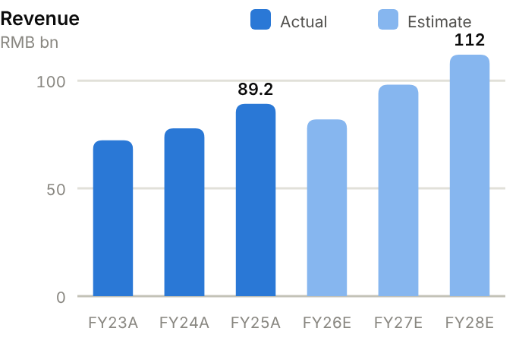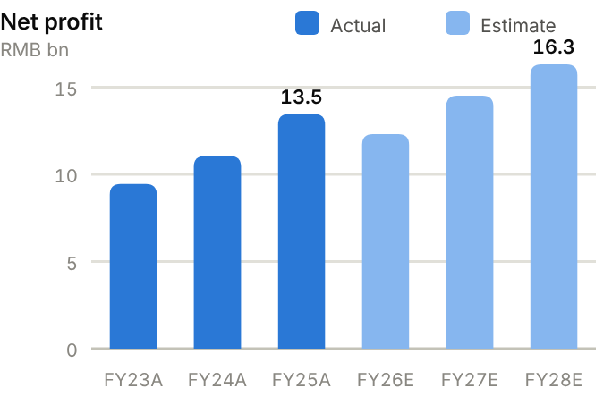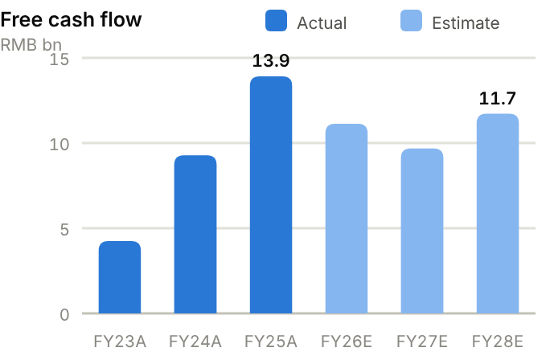
Income statement. Revenue grew from RMB72.3bn (FY23) to RMB89.2bn (FY25), then fell to RMB76.6bn TTM. Gross margin has expanded every year, from 25.5% (FY23) to 30.5% (FY25), 30.9% TTM and 35.9% in H1'26, as storage mix and cheaper cells offset falling inverter prices. Net profit rose from RMB9.4bn to RMB13.5bn (FY25), a 15% net margin, but fell 32% in H1'26 to RMB5.3bn on lower volumes and FX losses. We forecast revenue of RMB82.0bn/98.0bn/112bn and net profit of RMB12.3bn/14.5bn/16.3bn for FY26-28E.
Source: company filings via StockAnalysis/S&P Global. Jun-26 = latest interim balance sheet. Debt includes leases. | Balance sheet. Total assets are RMB119bn (FY25), of which working capital is the largest component: receivables of RMB30.1bn (123 days of sales) and inventory of RMB27.3bn (161 days), rising to RMB32bn in June 2026, partly funded by payables of RMB36.6bn (216 days). Debt was cut from RMB14.2bn (FY24) to RMB7.2bn, so net cash rose from RMB11.3bn (FY23) to RMB26.6bn (FY25) and RMB28.0bn (June 2026), ~57% of equity. Equity attributable is RMB46.6bn (BVPS ~RMB23), and the current ratio is 1.67x.
  Balance sheet (RMB bn) | FY23A | FY24A | FY25A | Jun-26A
  Cash & short-term investments | 20.1 | 30.0 | 33.8 | 35.8
  Receivables | 26.1 | 33.2 | 30.1 | 27.2
  Inventory | 21.4 | 29.0 | 27.3 | 32.2
  PP&E | 8.5 | 11.6 | 14.1 | 14.9
  Total assets | 82.9 | 115.1 | 118.7 | 127.1
  Accounts payable | 28.5 | 36.8 | 36.6 | 40.5
  Total debt | 8.8 | 14.2 | 7.2 | 7.7
  Equity (attributable) | 27.7 | 36.9 | 46.6 | 50.1
  Minority interests | 1.7 | 3.3 | 3.2 | 3.0
  Net cash / (net debt) | 11.3 | 15.8 | 26.6 | 28.0

Cash flow (RMB bn) | FY23A | FY24A | FY25A | TTM Jun-26 | FY26E | FY27E | FY28E
Net profit (attributable) | 9.4 | 11.0 | 13.5 | – | 12.3 | 14.5 | 16.3
D&A | 0.6 | 0.8 | 1.1 | 1.3 | 1.3 | 1.4 | 1.5
Operating cash flow | 7.0 | 12.1 | 16.9 | 17.2 | 14.6 | 13.5 | 15.7
Capex | (2.7) | (2.8) | (3.0) | (2.7) | (3.5) | (3.8) | (4.0)
Free cash flow | 4.2 | 9.3 | 13.9 | 14.5 | 11.1 | 9.7 | 11.7
Dividends paid | (0.6) | (1.7) | (4.4) | (3.5) | (3.4) | (3.1) | (3.6)
Net cash / (debt), period-end | 11.3 | 15.8 | 26.6 | 28.0 | 34.4 | 41.0 | 49.1
OCF / net profit (x) | 0.74 | 1.09 | 1.26 | n.m. | 1.19 | 0.93 | 0.96

TTM = twelve months to June 2026; Jun-26 net cash in the TTM column. E = our estimates: OCF = net profit + D&A − increase in working capital; net cash rolls forward FCF less dividends plus equity raised.
Cash flow. Cash conversion has improved markedly: OCF rose from RMB7.0bn (FY23) to RMB16.9bn (FY25), 1.26x net profit, and held at RMB17.2bn TTM despite the profit decline. Capex is light at RMB2.7-3.0bn a year (~3.4% of revenue), so FCF reached RMB13.9bn in FY25 and RMB14.5bn TTM. Dividends rose to RMB4.4bn. We forecast FCF of RMB11.1bn/9.7bn/11.7bn, lifting net cash to ~RMB49.1bn by FY28E before any H-share proceeds.
ROE/ROA on average balances. Days on year-end balances: receivables on revenue, inventory and payables on cost of sales. Net debt/equity below zero = net cash. Payout = DPS/EPS. n.m./– = not meaningful or not modelled. | Key ratios. ROE has been very high (34.1% in FY23, 32.2% in FY25) but is falling as profits dip and cash builds; we expect ~23.7% in FY27E. ROA is 11.5%. Inventory days (161) are the ratio to watch: they will fall quickly if H2 storage deliveries accelerate. The FY25 payout ratio was 25%.
  Key ratios | FY23A | FY24A | FY25A | FY26E | FY27E | FY28E
  Revenue growth | – | 8% | 15% | −8% | 20% | 14%
  Gross margin | 25.5% | 29.1% | 30.5% | 34.5% | 33.0% | 32.5%
  Net margin | 13.1% | 14.2% | 15.1% | 15.0% | 14.8% | 14.6%
  ROE (avg. equity) | 34.1% | 34.2% | 32.2% | 24.1% | 23.7% | 22.2%
  ROA (avg. assets) | 11.4% | 11.2% | 11.5% | – | – | –
  Asset turnover (x) | 0.87 | 0.79 | 0.76 | – | – | –
  Receivable days | 132 | 156 | 123 | – | – | –
  Inventory days | 145 | 192 | 161 | – | – | –
  Payable days | 193 | 243 | 216 | – | – | –
  Current ratio (x) | 1.51 | 1.58 | 1.67 | – | – | –
  Net debt / equity | −41% | −43% | −57% | −62% | −61% | −62%
  Net debt / EBITDA (x) | -0.9 | -1.1 | -1.6 | – | – | –
  Capex / revenue | 3.8% | 3.6% | 3.4% | 4.3% | 3.9% | 3.6%
  FCF margin | 5.9% | 11.9% | 15.6% | 13.6% | 9.9% | 10.5%
  Dividend payout | 15% | 20% | 25% | 25% | 25% | 25%

Valuation
Source: StockAnalysis/S&P Global, 12 Oct 2026 (trailing EV/EBITDA and EV/sales; consensus forward P/E). | 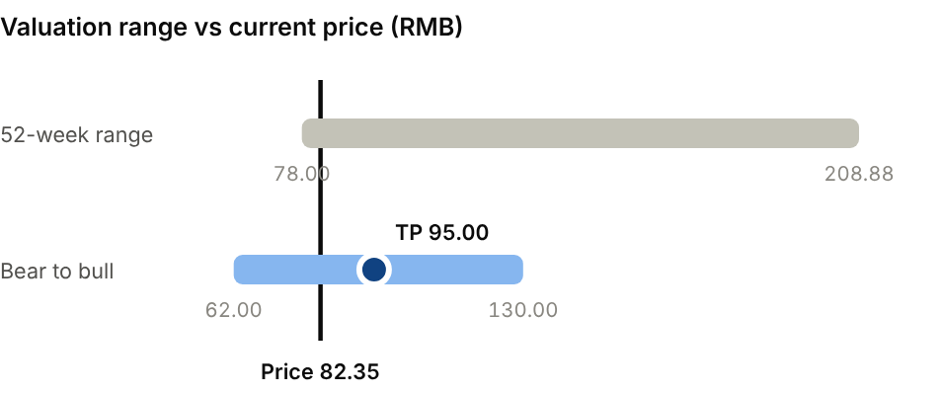  Bear (Storage price war; US access closes): RMB62.00. Bull (H2 storage ramp; margins hold): RMB130.00.
  Company | Ticker | Fwd P/E | EV/EBITDA | EV/sales
  Ginlong (Solis) | 300763 CH | 14.9x | 15.5x | 3.7x
  Enphase Energy | ENPH US | 16.7x | 20.9x | 3.0x
  Fluence Energy | FLNC US | n.m. | n.m. | 0.6x
  Sungrow Power | 300274 CH | 11.3x | 10.0x | 1.9x

Our TP of RMB95.00 is 13.5x FY27E EPS of RMB7.04, a modest discount to Ginlong (~15x) and Enphase (~17x) forward to reflect the revenue decline. The stock is down 52% YTD and trades on 11.7x FY27E, so downside is partly cushioned. We would turn more positive on evidence of H2 storage deliveries and order growth. The consensus average target is RMB146.5 (20 analysts). Bear case RMB62.00: storage price war and US access closes. Bull case RMB130: H2 ramp and margins hold.
Sources: Company 2025 annual and H1'26 reports; pv magazine; Energy-Storage.news; Wood Mackenzie; Bloomberg; Simply Wall St; StockAnalysis/S&P Global; IBKR; source pack.
07 · INDUSTRIALS & RESOURCES · ELECTRICAL EQUIPMENT
Sieyuan Electric 思源电气  002028.SZ · Initiation of coverage · 12 October 2026 | HOLD  TP RMB140  Price RMB120.65 · +16%
A quality private-sector grid franchise; storage mix and valuation cap the upside
Sieyuan is China's leading privately owned transmission-and-distribution equipment maker and benefits from record grid investment at home and a global transformer shortage abroad. Revenue grew 27% in H1'26 but profit only 13% as low-margin storage diluted the mix. At 20.8x FY27E P/E much of the growth is priced in; we initiate at Hold with a TP of RMB140 (+16% upside).  - Demand for grid equipment is structural. China's grid capex is at record levels (more than RMB5tn planned for 2026-30), and overseas utilities face multi-year transformer lead times.  - Sieyuan has a consistent execution record. Revenue grew at a 27% CAGR and net profit at 37% over FY22-25, with a steady ~30% gross margin and net cash throughout.  - The mix is turning against margins. Storage revenue (10.5% gross margin) grew 231% in H1'26 and FX losses weighed. Our FY26E EPS of RMB4.66 is ~9% below consensus.  Catalysts  - Q3'26 results on 24 October.  - Completion of the Hong Kong H-share listing.  - State Grid UHV/transformer tender awards and overseas orders.  Key risks  - Storage-mix dilution and price competition in domestic tenders.  - FX and execution risk on overseas EPC projects.  - Dilution from the planned H-share issue (up to 15%).  - Upside risk: faster overseas order conversion and richer UHV/GIS mix. | Key data  H1'26 revenue mix by product (%)  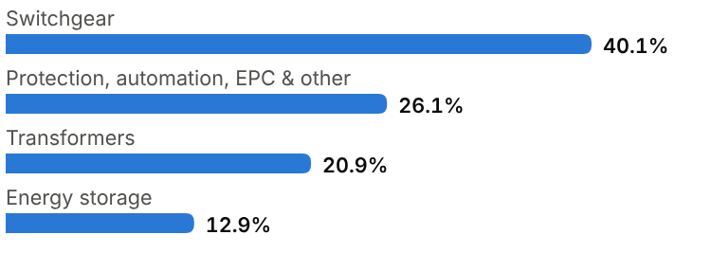
  Price (12 Oct 2026) | RMB120.65
  Target price (12m) | RMB140.00
  Implied return | +16.0%
  Market cap | RMB94.4bn / US$14.1bn
  Enterprise value | RMB87.7bn
  Net cash | RMB7.0bn
  Shares outstanding | 0.78bn
  52-week range | 100.32-239.12
  Performance | -22.0% YTD
  Dividend yield (FY26E) | 0.7%
  Consensus target | RMB209.54, 12 analysts
  Other listing | H-share listing (up to 15% of share capital) pending

Key financials and valuation
Year to December | FY23A | FY24A | FY25A | FY26E | FY27E | FY28E
Revenue (RMB bn) | 12.5 | 15.5 | 21.5 | 26.5 | 32.5 | 38.5
YoY growth | – | +24% | +39% | +23% | +23% | +18%
Gross margin | 29.4% | 31.1% | 30.8% | 29.3% | 29.5% | 29.8%
Net profit, attributable (RMB bn) | 1.56 | 2.05 | 3.15 | 3.65 | 4.55 | 5.50
YoY growth | n.m. | +31% | +54% | +16% | +25% | +21%
EPS (RMB) | 2.02 | 2.64 | 4.01 | 4.66 | 5.81 | 7.03
P/E (x) | 59.7x | 45.7x | 30.1x | 25.9x | 20.8x | 17.2x
DPS (RMB) | 0.40 | 0.50 | 0.70 | 0.84 | 1.05 | 1.27
Dividend yield | 0.3% | 0.4% | 0.6% | 0.7% | 0.9% | 1.0%

A = actual (company reports; StockAnalysis/S&P Global), E = our estimates. Multiples at the 12-Oct-2026 price.

Company background
Sieyuan Electric was founded in Shanghai in 1993 by Dong Zengping and a group of power-engineering colleagues. From a narrow initial range of grid products it expanded, mostly through in-house development, into one of the broadest transmission-and-distribution (T&D) portfolios in China. That portfolio now spans high-voltage gas-insulated switchgear (GIS) and circuit breakers, power and special transformers, reactors and capacitors, reactive-power compensation (SVG/STATCOM), protection and substation automation, battery energy-storage systems and turnkey EPC. It listed on the Shenzhen Stock Exchange in 2004 (002028.SZ).
Sieyuan's ownership is unusual. China's grid-equipment industry is dominated by State Grid-affiliated and central SOEs such as Pinggao, XJ Electric, NARI and China XD, whereas Sieyuan is privately controlled by its founder. It has won share on product quality, delivery speed and cost, and is now a sizeable exporter, with equipment and EPC projects in Mexico, Saudi Arabia, the Philippines, Belgium, Brazil, Italy, Ecuador and Australia. In December 2025 it announced a Hong Kong H-share listing of up to 15% of its share capital to fund overseas expansion. In 2026 it is investing RMB480m to expand special-transformer capacity in Jiangsu.
Milestones | Ownership and listing
  1993 | Founded in Shanghai by Dong Zengping.
  2004 | Lists on the Shenzhen Stock Exchange (002028.SZ).
  2010s | Builds out GIS, transformers, SVG and protection/automation lines.
  2020s | Expands overseas and enters battery energy storage.
  2025 | Revenue RMB21.5bn (+39%), net profit RMB3.15bn (+54%); announces H-share plan.
  2026 | Targets RMB37.5bn of new orders (+30%); RMB480m transformer capacity expansion.
  Control | Privately controlled; founder Dong Zengping is the largest shareholder
  Share classes | A-share 002028.SZ; H-share listing (≤15% of capital) pending
  Dividend policy | Payout ~15-18% of net profit

The business
Sieyuan sells grid equipment to four customer groups. State Grid and China Southern Grid buy through centralised competitive tenders. Power generators and renewables developers need substations and grid connections. Industrial users and data centres buy in-house substations. Overseas utilities and EPC contractors made up 29.5% of H1'26 revenue. Revenue follows orders with a 6-18-month lag, so management's 2026 targets of RMB37.5bn of new orders (+30%) and RMB27bn of revenue (+25%) give reasonable visibility.
Primary equipment (switchgear and transformers) is the main source of profit. Switchgear was 40% of H1'26 revenue and transformers 21%, both with gross margins around or above 30%. Secondary equipment (protection, automation, compensation) adds higher-value technology content. Energy storage (13% of revenue) is a newer integration business with a gross margin of only 10.5%. It grew 231% in H1'26 and is diluting group margins. EPC projects carry lower margins but help win overseas equipment orders.
The business is asset-light relative to its revenue (PP&E of RMB3.4bn against RMB21.5bn of sales) but working-capital intensive. Grid customers pay in stages, with retention money held until warranty expiry, so receivables run at ~190 days of sales. Sieyuan offsets this with supplier credit (payables ~200 days of cost of sales), and it has remained net cash throughout its growth phase.
In China, management wants to push further into higher-voltage products, where qualification is hardest and margins are best. Abroad, the planned H-share listing is meant to fund overseas plants and service networks so that project exports become local market positions in the Middle East, Latin America and Europe. The company is also adding products that sell to the same customers: storage, reactive-power compensation for renewables and data-centre power distribution. That last push carries the most risk. Storage earns a 10.5% gross margin, so its growth dilutes group returns until the business reaches scale.
Revenue mix and economics (H1'26)
Segment | Share of revenue | Key assets / products | Economics
Switchgear (GIS, breakers) | 40.1% | High-voltage switchgear for grid and industrial substations | ~30%+ gross margin; core State Grid tender product
Protection, automation, SVG, EPC & other | 26.1% | Secondary systems, reactive compensation, turnkey projects | Mixed margins; EPC supports overseas wins
Transformers & reactors | 20.9% | Power and special transformers, reactors | Tight global supply; capacity being expanded
Energy storage | 12.9% | PCS and integrated battery systems | 10.5% gross margin; +231% in H1'26

Competitive landscape
In China, Sieyuan competes in State Grid tenders against affiliated or state-owned suppliers: Pinggao and XJ Electric (both State Grid subsidiaries), China XD Electric (switchgear and transformers), TBEA (transformers) and NARI (protection and automation). Tender rules weight price and technical scores, so share moves with product breadth, quality record and willingness to bid aggressively. Sieyuan has steadily gained share as a private challenger.
Overseas, the incumbents are Hitachi Energy, Siemens Energy, GE Vernova, Schneider and ABB, plus Korean exporters HD Hyundai Electric, Hyosung and LS Electric, which have been the main winners from the US transformer shortage. Chinese suppliers win on delivery time and price, especially in the Middle East, Latin America and Southeast Asia. Access to the US is limited by tariffs and security concerns. In storage, Sieyuan faces dozens of Chinese integrators and battery makers, and margins are commodity-like.
Main competitors
Competitor | Base | Focus | Position vs Sieyuan Electric
Pinggao / XJ Electric | China (State Grid) | GIS, DC equipment, protection | Parent-affiliated; strong in UHV tenders
China XD Electric | China (SOE) | Switchgear, transformers | Large UHV supplier; slower-growing
TBEA | China | Transformers, cables (plus polysilicon) | Transformer scale leader; diversified
Hitachi Energy / Siemens Energy | Switzerland/Japan / Germany | Full T&D portfolio worldwide | Global brand and HVDC leadership; capacity-constrained
HD Hyundai Electric / Hyosung | Korea | Transformers, switchgear | Main winners in the US shortage; premium valuations

Industry structure: five forces
Force | Intensity | Assessment
Rivalry | Medium | China's grid tenders are crowded (TBEA, XJ Electric, Pinggao, China XD, Hitachi Energy, Siemens Energy), which caps domestic margins; overseas markets are tighter.
New entrants | Low | Utilities require type tests, long qualification and a track record, especially for high-voltage products and overseas grids; qualification takes years.
Supplier power | Medium | Copper, silicon steel and insulation materials are a large share of cost; Sieyuan passes changes through with a lag.
Buyer power | High | State Grid and China Southern Grid are near-monopsony buyers at home. Overseas utilities and data-centre developers face equipment shortages, so suppliers have more pricing power there.
Substitutes | Low | Switchgear, transformers and reactive-power compensation have no substitutes; new technology (e.g. SF6-free switchgear) favours incumbents that can fund R&D.

Moat and vulnerabilities
- Broadest private-sector T&D portfolio in China, from primary to secondary equipment.
- Track record in State Grid tenders plus growing overseas references and certifications.
- Agility and cost discipline of a founder-led private company; net cash balance sheet.
- Vulnerabilities: tender price pressure, low-margin storage growth, overseas execution and FX.

Addressable market (TAM)
Grid spending is the demand driver. State Grid has been investing more than RMB650bn a year, and the 15th Five-Year Plan points to more than RMB5tn of grid investment over 2026-30, covering ultra-high-voltage lines that carry western renewables east, distribution upgrades, and connections for new energy and data centres. China Southern Grid, provincial utilities and industrial users add to this.
Abroad, renewables integration, electrification and AI data-centre load are driving a multi-year upcycle in transformers and switchgear, with lead times of two years or more in the US and Europe. China's transformer exports rose 35% to US$9.0bn in 2025. The storage market is growing even faster (China's storage-battery sales +83% in H1'26) but is fiercely competitive. Sieyuan's FY25 revenue of RMB21.5bn is a small share of these pools, so its growth depends on winning share.
Market | Size | Growth / dynamics | Source
China grid investment | >RMB650bn a year (State Grid); >RMB5tn over 2026-30 | Rising; UHV and distribution upgrades | State Grid; source pack
China transformer exports | US$9.0bn (2025) | +35% in 2025 | Industry data
Global transformers & switchgear | Structural shortage | ≥2-year lead times in US/EU | Industry reports
China storage batteries | Fast-growing | Sales +83% in H1'26 | Industry data (via Ganfeng)
Sieyuan order target | RMB37.5bn (2026) | +30% YoY | Company

RMB5tn+  China grid investment planned for 2026-30 (source pack) | US$9.0bn  China transformer exports in 2025 (+35%) | RMB37.5bn  Sieyuan 2026 new-order target (+30%)

Financial analysis
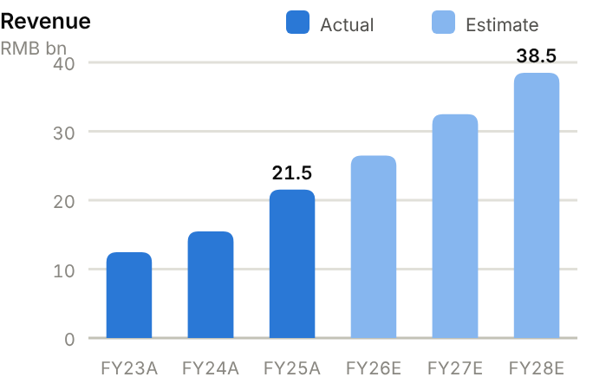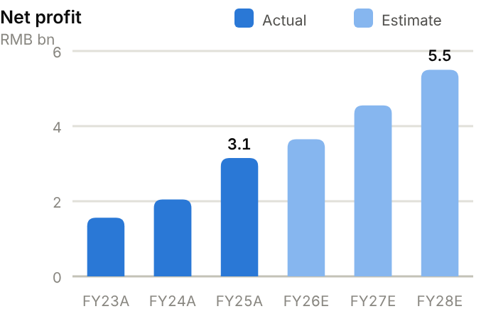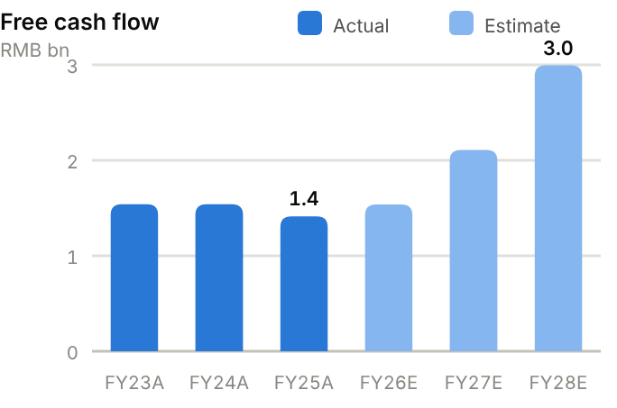
Income statement. Revenue compounded at ~27% a year from RMB10.5bn (FY22) to RMB21.5bn (FY25), with gross margin steady at 29-31% and net margin rising from 12.5% (FY23) to 14.6% (FY25). FY25 net profit rose 54% to RMB3.15bn. Profit growth slowed in H1'26: revenue grew 27% but net profit only 13%, as low-margin storage surged and FX losses weighed. We forecast revenue of RMB26.5bn/32.5bn/38.5bn and net profit of RMB3.65bn/4.55bn/5.50bn for FY26-28E, with gross margin ~1pt lower than FY25.
Source: company filings via StockAnalysis/S&P Global. Jun-26 = latest interim balance sheet. Debt includes leases. | Balance sheet. Total assets rose from RMB18.7bn to RMB29.8bn over FY23-25, mostly working capital: receivables reached RMB11.0bn (187 days) and inventory RMB4.1bn (100 days), rising to RMB6.0bn by June 2026 as storage projects built. Supplier credit (payables RMB8.2bn, 200 days) funds much of this. Debt is negligible (RMB0.5bn), so net cash was RMB7.3bn at FY25 and RMB7.0bn at June 2026, ~47% of equity. The current ratio is 1.75x. Equity attributable has grown to RMB15.5bn (BVPS ~RMB20).
  Balance sheet (RMB bn) | FY23A | FY24A | FY25A | Jun-26A
  Cash & short-term investments | 4.9 | 6.7 | 7.8 | 7.9
  Receivables | 6.4 | 8.0 | 11.0 | 11.6
  Inventory | 2.9 | 3.5 | 4.1 | 6.0
  PP&E | 1.7 | 2.7 | 3.4 | 3.7
  Total assets | 18.7 | 23.5 | 29.8 | 33.1
  Accounts payable | 5.0 | 6.5 | 8.2 | 9.3
  Total debt | 0.2 | 0.2 | 0.5 | 0.9
  Equity (attributable) | 10.4 | 12.4 | 15.5 | 16.5
  Minority interests | 0.3 | 0.3 | 0.3 | 0.4
  Net cash / (net debt) | 4.8 | 6.5 | 7.3 | 7.0

Cash flow (RMB bn) | FY23A | FY24A | FY25A | TTM Jun-26 | FY26E | FY27E | FY28E
Net profit (attributable) | 1.6 | 2.0 | 3.1 | – | 3.6 | 4.5 | 5.5
D&A | 0.2 | 0.2 | 0.3 | 0.3 | 0.3 | 0.4 | 0.4
Operating cash flow | 2.3 | 2.5 | 2.2 | 3.2 | 2.7 | 3.4 | 4.4
Capex | (0.7) | (0.9) | (0.8) | (0.8) | (1.2) | (1.3) | (1.4)
Free cash flow | 1.5 | 1.5 | 1.4 | 2.3 | 1.5 | 2.1 | 3.0
Dividends paid | (0.2) | (0.3) | (0.4) | (0.4) | (0.5) | (0.7) | (0.8)
Net cash / (debt), period-end | 4.8 | 6.5 | 7.3 | 7.0 | 8.3 | 9.7 | 11.9
OCF / net profit (x) | 1.46 | 1.20 | 0.71 | n.m. | 0.75 | 0.75 | 0.80

TTM = twelve months to June 2026; Jun-26 net cash in the TTM column. E = our estimates: OCF = net profit + D&A − increase in working capital; net cash rolls forward FCF less dividends plus equity raised.
Cash flow. Operating cash flow has not kept pace with profits: RMB2.3bn/2.5bn/2.2bn over FY23-25 against net profit of RMB1.6bn/2.0bn/3.2bn, so OCF/net profit fell to 0.71x in FY25 as receivables grew 39%. TTM OCF recovered to RMB3.2bn. Capex of RMB0.7-0.9bn a year keeps FCF at ~RMB1.4-1.5bn (RMB1.4bn in FY25), and dividends absorb only ~RMB0.4bn. We forecast FCF of RMB1.5bn/2.1bn/3.0bn as capacity spending rises, with net cash growing to ~RMB11.9bn by FY28E before any H-share proceeds.
ROE/ROA on average balances. Days on year-end balances: receivables on revenue, inventory and payables on cost of sales. Net debt/equity below zero = net cash. Payout = DPS/EPS. n.m./– = not meaningful or not modelled. | Key ratios. ROE has risen from 15.0% (FY23) to 22.6% (FY25), and we expect it to hold at ~22.2%. ROA is 11.8% and asset turnover has improved to 0.81x. Cash conversion is the weak point: OCF/net profit of 0.71x in FY25, and our forecasts assume ~0.7x. Payout is low (17% on FY25 EPS), so the company can fund growth internally.
  Key ratios | FY23A | FY24A | FY25A | FY26E | FY27E | FY28E
  Revenue growth | – | 24% | 39% | 23% | 23% | 18%
  Gross margin | 29.4% | 31.1% | 30.8% | 29.3% | 29.5% | 29.8%
  Net margin | 12.5% | 13.3% | 14.6% | 13.8% | 14.0% | 14.3%
  ROE (avg. equity) | 15.0% | 18.0% | 22.6% | 21.4% | 22.2% | 22.2%
  ROA (avg. assets) | 8.3% | 9.7% | 11.8% | – | – | –
  Asset turnover (x) | 0.67 | 0.73 | 0.81 | – | – | –
  Receivable days | 188 | 188 | 187 | – | – | –
  Inventory days | 119 | 119 | 100 | – | – | –
  Payable days | 206 | 222 | 200 | – | – | –
  Current ratio (x) | 1.88 | 1.78 | 1.75 | – | – | –
  Net debt / equity | −46% | −52% | −47% | −44% | −43% | −44%
  Net debt / EBITDA (x) | -2.5 | -2.5 | -1.9 | – | – | –
  Capex / revenue | 5.9% | 6.0% | 3.8% | 4.5% | 4.0% | 3.6%
  FCF margin | 12.4% | 10.0% | 6.6% | 5.8% | 6.5% | 7.8%
  Dividend payout | 20% | 19% | 17% | 18% | 18% | 18%

Valuation
Source: StockAnalysis/S&P Global, 12 Oct 2026 (trailing EV/EBITDA and EV/sales; consensus forward P/E). | 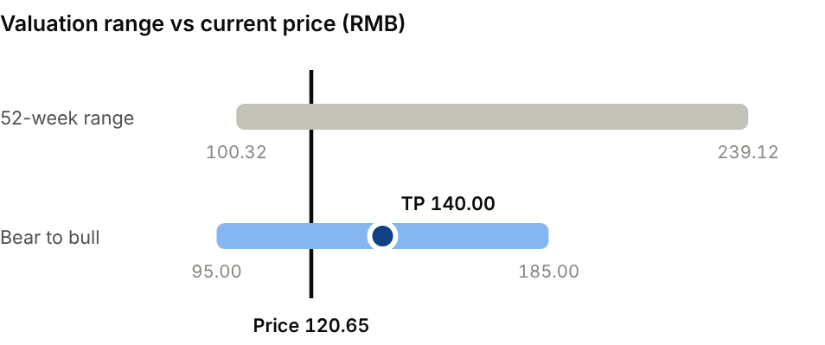  Bear (Storage dilution deepens; tender prices fall): RMB95.00. Bull (Orders beat target; overseas margins hold): RMB185.00.
  Company | Ticker | Fwd P/E | EV/EBITDA | EV/sales
  GE Vernova | GEV US | 47.8x | 65.9x | 6.3x
  HD Hyundai Electric | 267260 KS | 18.4x | 16.9x | 4.6x
  XJ Electric | 000400 CH | 16.1x | 11.9x | 1.1x
  TBEA | 600089 CH | 12.3x | 10.4x | 1.4x
  Sieyuan Electric | 002028 CH | 20.3x | 21.3x | 3.7x

Our TP of RMB140 is 24x FY27E EPS of RMB5.81. That is a premium to domestic SOE peers (XJ Electric ~16x, TBEA ~12x forward) and HD Hyundai Electric (~18x) for Sieyuan's ~25% EPS CAGR, net cash and overseas growth, but far below GE Vernova (~48x). It is close to UBS's RMB142 target; the consensus average of RMB209.5 looks stale after cuts to ratings. Bear case RMB95.00: deeper storage dilution and weaker tender pricing. Bull case RMB185: orders beat the RMB37.5bn target and overseas margins hold.
Sources: Company 2025 performance express and H1'26 report; Gawin Research; CITIC (via Futu); UBS (via MarketScreener); SCMP; StockAnalysis/S&P Global; IBKR; source pack.
08 · SEMICONDUCTORS & MATERIALS · SEMICONDUCTORS
GigaDevice 兆易创新  603986.SH · Initiation of coverage · 12 October 2026 | HOLD  TP RMB360  Price RMB310.84 · +16%
Exceptional earnings, but we would be paying for the top of the memory cycle
GigaDevice is China's leading fabless designer of NOR flash, niche DRAM and microcontrollers. A memory shortage, as global majors divert capacity to HBM and DDR5, lifted H1'26 net profit twelve-fold to RMB6.9bn. The shares are already ~63% below their high and 16.2x FY26E P/E is undemanding, but earnings are near a cyclical peak. We initiate at Hold, TP RMB360 (+16% upside).  - Legacy memory is in short supply as leading makers exit NOR, SLC NAND and DDR4 to chase HBM/DDR5. TrendForce sees high-capacity NOR prices rising another 90-110% in H2'26, and mid-year backlog was RMB9.8bn.  - Operating leverage is extreme: memory gross margin jumped to 67.6% from 42.8% in FY25, and TTM group gross margin is 56%.  - Earnings quality and durability are open to question. More than RMB2bn of H1 profit came from fair-value gains, and we expect earnings to fall in FY28E as new capacity arrives, so we value on a cycle-adjusted 18x FY27E P/E.  Catalysts  - Q3'26 results on 30 October.  - Monthly NOR/DRAM contract prices (TrendForce).  - Index inclusion of the H-share; MCU recovery.  Key risks  - Memory price reversal as new capacity arrives (peak-cycle risk).  - Volatile fair-value gains on equity holdings.  - Dependence on CXMT and escalation of US export controls.  - Sentiment swings, e.g. September reports that Beijing may allow Nvidia chip purchases. | Key data  Revenue mix by product (%, approx.)  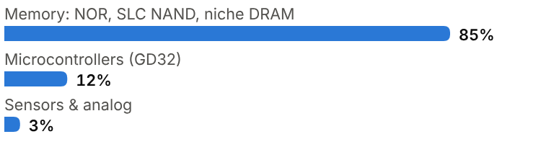
  Price (12 Oct 2026) | RMB310.84
  Target price (12m) | RMB360.00
  Implied return | +15.8%
  Market cap | RMB218.5bn / US$32.6bn
  Enterprise value | RMB201.4bn
  Net cash | RMB17.4bn
  Shares outstanding | 0.70bn
  52-week range | 176.00-846.66
  Performance | +44.3% YTD
  Dividend yield (FY26E) | 1.2%
  Consensus target | RMB631.74, 11 analysts
  Other listing | H-share 3986.HK at HK$375.60 (~3% premium to A)

Key financials and valuation
Year to December | FY23A | FY24A | FY25A | FY26E | FY27E | FY28E
Revenue (RMB bn) | 5.76 | 7.36 | 9.20 | 27.0 | 31.0 | 26.0
YoY growth | – | +28% | +25% | +193% | +15% | −16%
Gross margin | 30.3% | 35.7% | 39.1% | 55.0% | 56.0% | 48.0%
Net profit, attributable (RMB bn) | 0.16 | 1.10 | 1.65 | 13.5 | 14.0 | 10.0
YoY growth | n.m. | +588% | +50% | +718% | +4% | −29%
EPS (RMB) | 0.24 | 1.66 | 2.47 | 19.24 | 19.95 | 14.25
P/E (x) | n.m. | 187x | 126x | 16.2x | 15.6x | 21.8x
DPS (RMB) | 0.00 | 0.34 | 0.75 | 3.85 | 3.99 | 2.85
Dividend yield | 0.0% | 0.1% | 0.2% | 1.2% | 1.3% | 0.9%

A = actual (company reports; StockAnalysis/S&P Global), E = our estimates. Multiples at the 12-Oct-2026 price.

Company background
GigaDevice was founded in Beijing's Zhongguancun district in 2005 by Zhu Yiming, a Tsinghua-trained engineer who had worked in Silicon Valley. The company started in serial (SPI) NOR flash, the small memory chips that store boot code in almost every electronic device, and took share from Taiwanese and US suppliers by competing on price and service for China's electronics makers. In 2013 it launched the GD32 family, one of China's first 32-bit Arm Cortex-M microcontroller lines, which grew into its second main business. GigaDevice listed on the Shanghai Stock Exchange in 2016.
From 2017 Zhu also led the creation of ChangXin Memory (CXMT), the Hefei-based DRAM maker, and GigaDevice became CXMT's partner for niche DRAM. Since 2021 it has designed and sold DDR3/DDR4 and low-power DRAM under its own brand using CXMT wafers. The 2019 acquisition of Silead brought in fingerprint and touch sensors, and the range also includes analog and power-management chips. GigaDevice is now the world's No.2 NOR flash supplier with ~18% share, behind Winbond, and China's largest general-purpose MCU vendor. It completed a Hong Kong H-share listing in January 2026, just as a shortage of legacy memory, created by global majors moving capacity to HBM and DDR5, sent its profits to record highs.
Milestones | Ownership and listing
  2005 | Founded in Beijing by Zhu Yiming; focuses on SPI NOR flash.
  2013 | Launches GD32, one of China's first Arm Cortex-M MCU families.
  2016 | Lists on the Shanghai Stock Exchange (603986.SH).
  2017 | Partners with the Hefei DRAM project that becomes CXMT.
  2019 | Acquires sensor designer Silead.
  2021 | Launches own-brand DDR4 DRAM made on CXMT wafers.
  2026 | Hong Kong H-share listing (3986.HK); H1 net profit RMB6.9bn (+1,092%).
  Founder | Zhu Yiming (also founder and chairman of CXMT), largest individual shareholder
  Share classes | A-share 603986.SH; H-share 3986.HK (near parity with A)
  Related party | CXMT: DRAM wafer supply partner

The business
GigaDevice is a fabless chip designer. It designs memory, microcontroller, sensor and analog chips, outsources wafer fabrication (NOR and MCU wafers to foundries such as SMIC and Hua Hong, DRAM wafers to CXMT) and outsources packaging and testing. Its costs are therefore mostly wafer purchases and R&D, and capital intensity is low (capex ~6% of revenue). It sells through distributors and directly to consumer-electronics, industrial, automotive, PC/server and communications customers, with a large and loyal customer base in China.
Memory, about 85% of revenue, is a price-taker business. NOR flash (from 512Kb to 2Gb) stores boot code and firmware for PCs, servers, AI accelerators, displays, wearables, IoT and cars. SLC NAND and niche DRAM serve set-top boxes, networking, industrial and automotive systems that cannot use leading-edge memory. When prices rise, as they did in 2026 when Samsung, SK Hynix and Micron exited legacy products, revenue and margins climb steeply: memory gross margin jumped to 67.6% in H1'26 from 42.8% in FY25. Falling prices work the other way, as in FY23, when net profit fell to RMB0.16bn.
Microcontrollers (~12% of revenue) are a steadier, design-win business. GD32 offers hundreds of Arm and RISC-V parts for industrial control, motor drives, consumer devices and increasingly automotive, where qualification cycles are long but customers are sticky. Domestic substitution of STMicro, NXP and Renesas parts is the main growth driver. Sensors and analog chips (~3%) are small.
GigaDevice carries large inventories (~220 days of cost of sales) as a strategic buffer and holds equity stakes in other chip companies. Those stakes generate volatile fair-value gains: more than RMB2bn of H1'26 profit came from this source.
Management is using the 2026 memory upcycle to fund higher-value products: higher-density NOR for AI servers, automotive-grade memory, and DDR4/LPDDR4 parts as the majors exit. In MCUs it is pushing into automotive and high-performance industrial uses, including RISC-V cores, where a design win can last a decade. The H-share proceeds go to R&D and strategic stakes. With record cash flow on top, we estimate net cash reaches ~RMB22.8bn by FY26E.
Revenue mix and economics
Segment | Share of revenue | Key assets / products | Economics
Memory: NOR, SLC NAND, niche DRAM | ~85% | Boot/code storage for PCs, servers, IoT, auto; DDR3/DDR4/LPDDR4 | Price-taker; memory GM 67.6% in H1'26 vs 42.8% FY25
Microcontrollers (GD32) | ~12% | Arm/RISC-V MCUs for industrial, consumer, automotive | Sticky design wins; domestic substitution
Sensors & analog | ~3% | Fingerprint/touch sensors (Silead), PMIC | Small; competitive

Competitive landscape
Specialty memory is an oligopoly of mid-sized Asian suppliers. Winbond (No.1), GigaDevice (No.2, ~18%) and Macronix lead NOR flash, with Puya, XMC and ISSI behind. Kioxia, Winbond and Macronix are the main SLC NAND rivals, and in niche DRAM Nanya, Winbond and ESMT compete as the big three DRAM makers exit DDR4. Products differ little from one supplier to the next, so share depends on cost, capacity access and customer relationships. Taiwanese peers trade at ~4x forward earnings, which shows how cautiously the market values peak memory profits.
In MCUs, GigaDevice competes with STMicroelectronics, NXP, Infineon, Renesas, Microchip and TI globally, and with Chinese rivals such as Nations Technologies, Chipsea and Artery at home. Its advantages are breadth (one of the largest Arm MCU catalogues in China), pin-compatibility with Western parts, and price; it is weaker in automotive qualification depth and global sales coverage. The CXMT link is both a strength (secure DRAM supply) and a risk (related-party dependence, US export-control exposure).
Shortages also reshape customer behaviour. When legacy memory is scarce, buyers put supply security first and qualify second sources. GigaDevice's domestic wafer partners give Chinese customers a local supply chain that is insulated from export controls. Our bull case assumes the share GigaDevice gains in the shortage stays with it after prices normalise, which would make the memory franchise worth more than its peak-cycle earnings suggest.
Main competitors
Competitor | Base | Focus | Position vs GigaDevice
Winbond | Taiwan | NOR, SLC NAND, niche DRAM | NOR No.1; own fabs; ~4x forward P/E
Macronix | Taiwan | NOR, ROM, SLC NAND | Strong in automotive/industrial NOR; own fabs
Nanya / ESMT | Taiwan | Niche/legacy DRAM | Direct niche-DRAM rivals
STMicro / NXP / Renesas | Europe / Japan | General-purpose MCUs | Global MCU leaders; GigaDevice substitutes
Puya / XMC / Nations | China | NOR flash; MCUs | Domestic price competitors

Industry structure: five forces
Force | Intensity | Assessment
Rivalry | High | Winbond, Macronix and Puya in NOR; ST, NXP, Renesas, Microchip and many Chinese start-ups in MCUs; Nanya, Winbond and ESMT in niche DRAM.
New entrants | Medium | The fabless model lowers barriers and state funds created many MCU and NOR start-ups, but auto and industrial qualification takes years.
Supplier power | High | GigaDevice relies on foundries (SMIC, Hua Hong, TSMC) and on CXMT for DRAM wafers; foundry capacity and pricing drive its gross margin.
Buyer power | Medium | Customers are spread across consumer, industrial, auto and computing and mostly served through distributors; large handset and PC makers negotiate hard.
Substitutes | Medium | NOR competes with embedded flash in SoCs and with NAND for larger code storage; MCUs compete with SoCs; niche DRAM competes with legacy DRAM from the majors.

Moat and vulnerabilities
- No.2 global NOR position and China's broadest MCU catalogue, with deep local customer relationships.
- Fabless model with diversified foundry access plus secure DRAM supply via CXMT.
- Net cash of ~RMB17bn and almost no debt.
- Vulnerabilities: memory price cycles, related-party and export-control exposure, fair-value volatility.

Addressable market (TAM)
Frost & Sullivan estimates the global specialty-memory market (NOR, SLC NAND, niche DRAM) at US$15.7bn in 2025, including US$3.1bn for NOR flash. Both are rising sharply in value in 2026: TrendForce expects high-capacity NOR prices to rise another 90-110% in H2'26, as AI servers and AI PCs need more and larger code-storage chips and supply shrinks. The general-purpose MCU market is larger (roughly US$20-25bn) and grows with industrial automation, EVs and IoT.
GigaDevice's TTM revenue of RMB16.6bn (~US$2.5bn) implies a mid-teens share of its combined addressable markets. How long prices hold matters more here than market size. The legacy-memory shortage will last only until supply responds, from Chinese and Taiwanese capacity or from majors returning to profitable niches.
Market | Size | Growth / dynamics | Source
Specialty memory | US$15.7bn (2025) | Sharp price-led growth in 2026 | Frost & Sullivan
NOR flash | US$3.1bn (2025) | High-capacity NOR +90-110% in H2'26 | Frost & Sullivan; TrendForce
General-purpose MCUs | ~US$20-25bn | Mid-single-digit growth; domestic substitution | Industry estimates
GigaDevice NOR share | ~18% (No.2) | Gaining with AI-server NOR | Industry estimate

US$15.7bn  Global specialty-memory market, 2025 (Frost & Sullivan) | US$3.1bn  Global NOR flash market, 2025; GigaDevice ~18% share (No.2) | +90-110%  TrendForce forecast for high-capacity NOR price rises in H2'26

Financial analysis
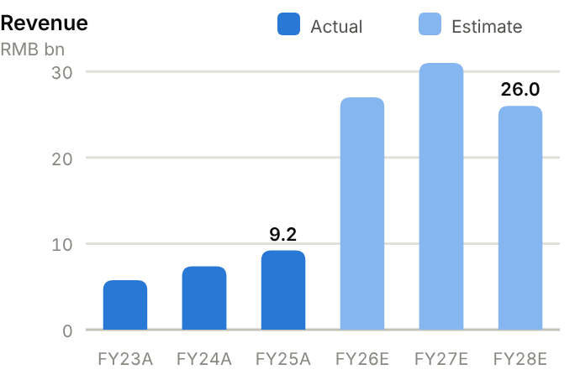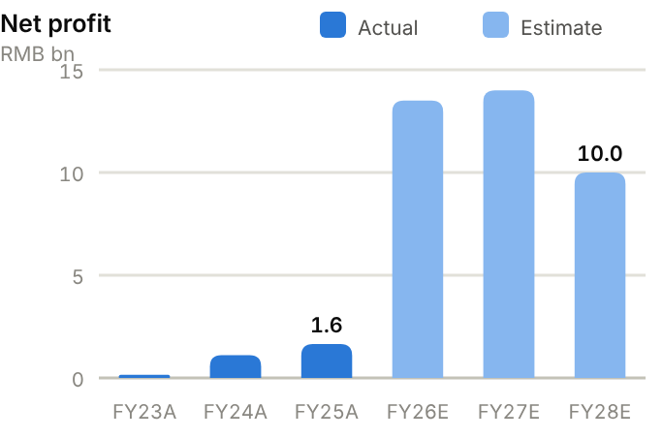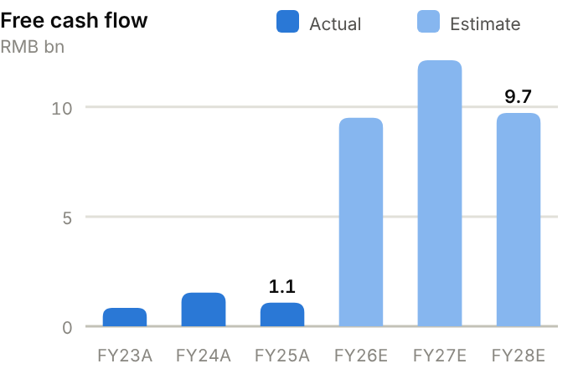
Income statement. Revenue fell from RMB8.1bn (FY22) to RMB5.8bn (FY23) in the memory downturn, then recovered to RMB9.2bn (FY25) and RMB16.6bn TTM. Gross margin moved from 30.3% (FY23) to 39.1% (FY25) and 56.1% TTM. The operating leverage of a fabless memory model took operating profit from RMB0.1bn (FY23) to RMB1.4bn (FY25) and RMB6.7bn TTM. Net profit of RMB6.9bn in H1'26 included >RMB2bn of fair-value gains. We forecast revenue of RMB27.0bn/31.0bn/26.0bn and net profit of RMB13.5bn/14.0bn/10.0bn, peaking in FY27E.
Source: company filings via StockAnalysis/S&P Global. Jun-26 = latest interim balance sheet. Debt includes leases. | Balance sheet. Total assets doubled from RMB21.4bn (FY25) to RMB42.4bn (June 2026) on H1 profits, H-share proceeds and revalued equity investments. Cash and short-term investments rose to RMB17.4bn against only RMB0.1bn of debt, so net cash is RMB17.4bn (RMB9.0bn at FY25). Inventory is the main operating asset: RMB3.4bn at FY25 (220 days of cost of sales) and RMB4.2bn in June 2026. Receivables are tiny (16 days) because distributors pay quickly. Equity attributable reached RMB37.3bn (BVPS ~RMB53), and the current ratio of 6.90x is very high.
  Balance sheet (RMB bn) | FY23A | FY24A | FY25A | Jun-26A
  Cash & short-term investments | 9.1 | 9.2 | 9.3 | 17.4
  Receivables | 0.1 | 0.4 | 0.4 | 0.6
  Inventory | 2.2 | 2.6 | 3.4 | 4.2
  PP&E | 1.2 | 1.2 | 1.6 | 2.1
  Total assets | 16.5 | 19.2 | 21.4 | 42.4
  Accounts payable | 0.5 | 0.7 | 0.8 | 1.6
  Total debt | 0.1 | 1.0 | 0.3 | 0.1
  Equity (attributable) | 15.2 | 16.5 | 19.0 | 37.3
  Minority interests | 0.0 | 0.2 | 0.2 | 0.3
  Net cash / (net debt) | 9.0 | 8.2 | 9.0 | 17.4

Cash flow (RMB bn) | FY23A | FY24A | FY25A | TTM Jun-26 | FY26E | FY27E | FY28E
Net profit (attributable) | 0.2 | 1.1 | 1.6 | – | 13.5 | 14.0 | 10.0
D&A | 0.4 | 0.4 | 0.4 | 0.5 | 0.5 | 0.5 | 0.6
Operating cash flow | 1.2 | 2.0 | 2.1 | 7.2 | 11.3 | 13.9 | 11.3
Capex | (0.3) | (0.5) | (1.0) | (1.6) | (1.8) | (1.8) | (1.6)
Free cash flow | 0.8 | 1.5 | 1.1 | 5.6 | 9.5 | 12.1 | 9.7
Dividends paid | (0.4) | (0.0) | (0.2) | (0.5) | (0.5) | (2.7) | (2.8)
Net cash / (debt), period-end | 9.0 | 8.2 | 9.0 | 17.4 | 22.8 | 32.2 | 39.1
OCF / net profit (x) | 7.42 | 1.85 | 1.29 | n.m. | 0.84 | 0.99 | 1.13

TTM = twelve months to June 2026; Jun-26 net cash in the TTM column. E = our estimates: OCF = net profit + D&A − increase in working capital; net cash rolls forward FCF less dividends plus equity raised.
Cash flow. Operating cash flow was RMB1.2-2.1bn a year over FY23-25 (OCF/net profit 1.29x in FY25) and jumped to RMB7.2bn TTM. Capex is modest (RMB0.3-1.6bn), so FCF rose from RMB0.84bn (FY23) to RMB5.6bn TTM. Dividends are small (FY25 DPS RMB0.75). We forecast FCF of RMB9.5bn/12.1bn/9.7bn; net cash would reach ~RMB39.1bn by FY28E. That leaves room for buybacks, M&A or higher payouts after the cycle peaks.
ROE/ROA on average balances. Days on year-end balances: receivables on revenue, inventory and payables on cost of sales. Net debt/equity below zero = net cash. Payout = DPS/EPS. n.m./– = not meaningful or not modelled. | Key ratios. ROE swung from 1.1% (FY23) to 9.3% (FY25) and should spike to ~48.4% in FY26E before normalising to ~19.3% in FY28E, the usual pattern for a cyclical business. ROA is 8.1%. Inventory days (220) are high by design. Payout was only 30% on FY25 EPS.
  Key ratios | FY23A | FY24A | FY25A | FY26E | FY27E | FY28E
  Revenue growth | – | 28% | 25% | 193% | 15% | −16%
  Gross margin | 30.3% | 35.7% | 39.1% | 55.0% | 56.0% | 48.0%
  Net margin | 2.8% | 14.9% | 17.9% | 50.0% | 45.2% | 38.5%
  ROE (avg. equity) | 1.1% | 6.9% | 9.3% | 48.4% | 33.0% | 19.3%
  ROA (avg. assets) | 1.0% | 6.2% | 8.1% | – | – | –
  Asset turnover (x) | 0.35 | 0.41 | 0.45 | – | – | –
  Receivable days | 9 | 22 | 16 | – | – | –
  Inventory days | 203 | 200 | 220 | – | – | –
  Payable days | 46 | 57 | 53 | – | – | –
  Current ratio (x) | 11.77 | 5.33 | 6.90 | – | – | –
  Net debt / equity | −59% | −50% | −47% | −62% | −67% | −71%
  Net debt / EBITDA (x) | -19.7 | -8.4 | -5.1 | – | – | –
  Capex / revenue | 6.0% | 6.8% | 11.4% | 6.7% | 5.8% | 6.2%
  FCF margin | 14.6% | 20.8% | 11.7% | 35.2% | 39.1% | 37.4%
  Dividend payout | 0% | 20% | 30% | 20% | 20% | 20%

Valuation
Source: StockAnalysis/S&P Global, 12 Oct 2026 (trailing EV/EBITDA and EV/sales; consensus forward P/E). Winbond and Macronix forward P/Es reflect consensus peak-cycle earnings. | 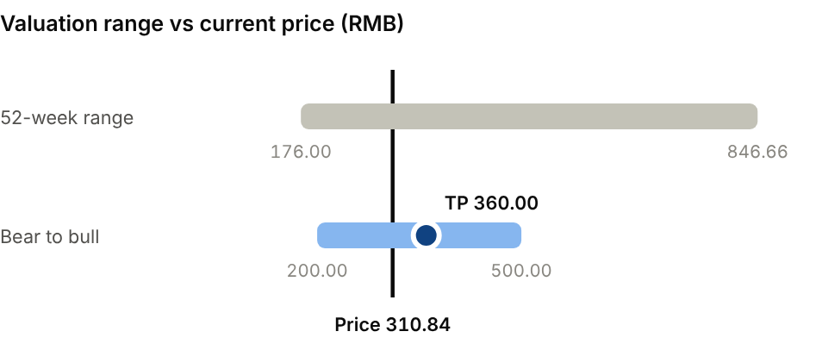  Bear (Prices roll over in 2027; mid-cycle EPS): RMB200.00. Bull (Shortage extends through 2027): RMB500.00.
  Company | Ticker | Fwd P/E | EV/EBITDA | EV/sales
  Winbond | 2344 TT | 4.2x | 13.2x | 5.6x
  Macronix | 2337 TT | 3.8x | 15.9x | 5.0x
  NXP Semiconductors | NXPI US | 13.6x | 12.7x | 4.9x
  GigaDevice | 603986 CH | 16.3x | 29.8x | 12.1x

Our TP of RMB360 applies 18x to FY27E EPS of RMB19.95. This cycle-adjusted multiple is above NXP (~14x) for growth and well above Taiwanese memory peers (~4x peak earnings) for MCU diversification and domestic substitution. At the TP the stock would trade on ~25x our post-peak FY28E EPS. The consensus target of RMB632 assumes a longer cycle. The H-share (3986.HK) trades close to parity. Bear case RMB200: mid-cycle EPS of RMB12 at ~17x. Bull case RMB500: the shortage extends through 2027.
Sources: Company FY25 results and H1'26 report; 36Kr; China Biz Insider; TrendForce/Taipei Times; Frost & Sullivan (via Cailian); StockAnalysis/S&P Global; IBKR; source pack.
09 · EQUIPMENT, ROBOTICS & MEDTECH · MEDICAL DEVICES
Edge Medical 精锋医疗  2675.HK · Initiation of coverage · 12 October 2026 | BUY  TP HK$42.00  Price HK$32.88 · +28%
An export-led surgical-robot challenger at breakeven: small and volatile, but worth owning
Edge Medical makes multi-port and single-port laparoscopic surgical robots and, unusually for a Chinese medtech, sells most of them abroad (70% of H1'26 revenue). Revenue more than doubled in H1'26 and losses all but disappeared. The stock trades 24% below its January IPO price, at ~8.3x FY27E EV/sales versus ~13x for Intuitive Surgical. We initiate at Buy, TP HK$42.00 (+28% upside).  - Exports drive growth: 49 of the 58 robots placed in H1'26 went overseas (Asia, Europe, the Middle East, Latin America), and MP1000 is approved in 37 overseas jurisdictions.  - Edge is close to turning a profit. Gross margin is ~64% and the H1 net loss narrowed 78% to RMB19m; we expect breakeven in FY26E and RMB250m of profit in FY28E.  - The long-term upside is in recurring revenue. Instruments and service are <1% of revenue today. As the installed base (158 units) grows, an Intuitive-style razor-and-blade model should lift earnings quality.  Catalysts  - Progress on the A-share listing.  - New country approvals, including US/EU registrations.  - FY26 results confirming a first full-year profit.  Key risks  - Small cap (~US$1.6bn), thin liquidity and post-IPO volatility.  - Competition from Intuitive and MicroPort; pricing pressure.  - Overseas regulatory, reimbursement and distributor execution risk.  - Slow build-up of recurring revenue. | Key data  H1'26 revenue by region (%)  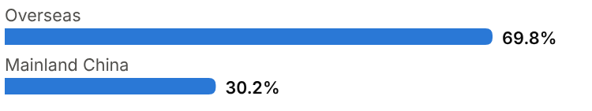
  Price (12 Oct 2026) | HK$32.88
  Target price (12m) | HK$42.00
  Implied return | +27.7%
  Market cap | HK$12.8bn / US$1.6bn
  Enterprise value | RMB9.1bn
  Net cash | RMB1.8bn
  Shares outstanding | 389.6m
  52-week range | 31.26-73.70
  Performance | -24% since IPO
  Consensus target | HK$60.65, 5 analysts
  Other listing | Hong Kong (IPO 8 Jan 2026 at HK$43.24); A-share listing in preparation

Key financials and valuation
Year to December | FY23A | FY24A | FY25A | FY26E | FY27E | FY28E
Revenue (RMB m) | 48 | 160 | 456 | 780 | 1,100 | 1,500
YoY growth | – | +233% | +185% | +71% | +41% | +36%
Gross margin | – | – | 66.0% | 64.5% | 65.0% | 66.0%
Net profit (loss) (RMB m) | (213) | (218) | (89) | 15 | 130 | 250
Margin | -444% | -137% | -19% | 2% | 12% | 17%
EV/sales at current price (x) | 190x | 57.1x | 20.0x | 11.7x | 8.3x | 6.1x

A = actual (company reports; StockAnalysis/S&P Global), E = our estimates. Multiples at the 12-Oct-2026 price, converted at HK$1 = RMB0.853.

Company background
Shenzhen Edge Medical was founded in May 2017 in Longgang, Shenzhen, by Dr Wang Jianchen, who remains chairman and CEO. The company set out to build a full family of endoscopic surgical robots for laparoscopic surgery, a market that in China and globally has been dominated by Intuitive Surgical's da Vinci. Edge developed a multi-port robot (MP1000), a single-port robot (SP1000) and a natural-orifice (bronchoscopy) robot. It became the first Chinese company, and only the second globally, to have all three types approved.
Hospital purchase quotas slow placements in China, so Edge pursued overseas registrations aggressively. By mid-2026 MP1000 was approved in 37 overseas jurisdictions, and most placements were going abroad. Edge also built a telesurgery capability, with more than 500 remote procedures by end-2025, a selling point in geographically dispersed markets. After two earlier Hong Kong IPO filings (2022, 2023), Edge listed on 8 January 2026 at HK$43.24, raising ~HK$1.1bn with cornerstones including ADIA, UBS Asset Management, OrbiMed and Tencent. It is preparing an A-share listing. By June 2026 it had installed or delivered 158 robots (55 in China, 103 overseas).
Milestones | Ownership and listing
  2017 | Founded in Shenzhen by Dr Wang Jianchen.
  2022-23 | Multi-port (MP1000) and China's first single-port (SP1000) endoscopic robots approved.
  2024-25 | CE mark and overseas launches; FY25 revenue RMB456m (+185%); >500 telesurgery cases.
  Jan 2026 | Hong Kong IPO at HK$43.24 (~HK$1.1bn); cornerstones ADIA, UBS AM, OrbiMed, Tencent.
  H1 2026 | 58 robots placed (49 overseas); revenue +114%; net loss narrows 78% to RMB19m.
  2026 | ~350-unit plant under construction; A-share listing in preparation.
  Founder | Dr Wang Jianchen (chairman and CEO)
  Notable investors | Tencent, OrbiMed, LYFE Capital; IPO cornerstones ADIA, UBS AM
  Listing | H-share 2675.HK; A-share listing in preparation

The business
Edge designs, manufactures and sells endoscopic surgical robots, used mainly in urology, gynaecology, general and thoracic surgery. Systems made up 99.6% of H1'26 revenue, sold directly to hospitals in China and through distributors abroad (Italy, Spain and other European markets, Asia, the Middle East, Africa and Latin America). Overseas sales were 69.8% of H1'26 revenue (RMB223m), unusual for a Chinese medtech company.
The long-term model is razor and blade. Each robot placed generates recurring revenue from instruments (limited-use, replaced every few procedures), consumables and service contracts, as at Intuitive, where most revenue is recurring. Edge is still early: recurring revenue is below 1% of sales, so revenue today is lumpy and driven by system placements. On our calculation, H1'26 revenue averaged ~RMB5.5m per robot placed, well below typical da Vinci list prices, which is central to Edge's pitch to price-sensitive hospitals.
Gross margin is already high (~64-66%) for a company of its size, and operating costs have fallen as development programmes matured (H1'26 R&D −44%), and the company is now close to breakeven. Production capacity is more than 100 units a year, and a ~350-unit plant is under construction. Working capital is meaningful because overseas distributors receive credit terms: receivables were ~196 days of sales at FY25.
Over the next three years Edge wants to turn placements into recurring revenue. It plans to raise procedure volumes per robot through surgeon training and clinical programmes and to sell more instruments and service. The ~350-unit plant adds capacity, so system prices can fall further without hurting margins. The planned A-share listing would add domestic capital and raise Edge's profile with Chinese hospitals.
Revenue mix and installed base (H1'26)
Segment | Share of revenue | Key assets / products | Economics
Overseas | 69.8% (RMB223m) | 49 units placed in H1; 103 cumulative; distributors in Europe, Asia, ME, LatAm | Faster approvals; price-sensitive markets
Mainland China | 30.2% (RMB96m) | 9 units placed in H1; 55 cumulative; direct hospital sales | Purchase quotas limit placements
Instruments, consumables, service | <1% | Per-procedure instruments; service contracts | Recurring; grows with installed base

Competitive landscape
Intuitive Surgical dominates the global market with da Vinci, including the da Vinci 5 and the single-port SP, backed by a vast installed base, training ecosystem and clinical evidence. Medtronic (Hugo), Johnson & Johnson (Ottava, in development) and CMR Surgical (Versius) are the main Western challengers. None has yet dented Intuitive's position in its core markets.
In China, MicroPort MedBot (Toumai) is Edge's main domestic rival and is also exporting aggressively, including telesurgery. Kangduo, Shurui and other start-ups compete in niches. Edge differentiates on price, the breadth of its multi-port/single-port/bronchoscopy family, telesurgery, and speed of overseas registration. Its disadvantages are a small installed base, limited long-term clinical data and a recurring-revenue stream that is barely started. Distributor-led sales abroad also mean less control over service quality.
Main competitors
Competitor | Base | Focus | Position vs Edge Medical
Intuitive Surgical (da Vinci) | US | Multi-port and single-port robots; global | Dominant; ~13x EV/sales
MicroPort MedBot (Toumai) | China | Laparoscopic, orthopaedic robots; telesurgery | Main domestic rival; ~30x trailing sales
Medtronic (Hugo) / J&J (Ottava) | US | Multi-port robots | Large medtech challengers
CMR Surgical (Versius) | UK (private) | Modular robots | Emerging-market focus
Kangduo / Shurui | China | Laparoscopic, single-port robots | Smaller domestic rivals

Industry structure: five forces
Force | Intensity | Assessment
Rivalry | High | Intuitive Surgical dominates globally; MicroPort MedBot, Shurui and Kangduo compete in China, and Medtronic (Hugo) and J&J are entering.
New entrants | Medium | Regulatory approval and clinical evidence take years, but well-funded start-ups and medtech majors keep entering.
Supplier power | Medium | Precision motors, optics and some electronics are imported or specialised; Edge's scale is still small.
Buyer power | High | Hospitals buy through tenders and budget approvals; provincial pricing rules and possible volume-based procurement of instruments can cut consumable prices.
Substitutes | Medium | Conventional laparoscopy and open surgery remain cheaper; robots must prove outcome and efficiency benefits to win share.

Moat and vulnerabilities
- Full robot family (multi-port, single-port, bronchoscopy) with approvals in China and 37 overseas jurisdictions.
- Cost structure that allows pricing well below da Vinci while keeping ~65% gross margin.
- Telesurgery capability and an export-led channel that avoids China's purchase quotas.
- Vulnerabilities: small scale, distributor reliance, early-stage recurring revenue, Intuitive and MicroPort competition.

Addressable market (TAM)
Intuitive's annual revenue of roughly US$10bn and installed base of ~10,000 systems are the best gauge of today's global robotic-surgery market. Penetration of eligible laparoscopic procedures remains low outside the US, especially in emerging markets where da Vinci's price is a barrier. China is still early: large-equipment purchase quotas have limited placements, but domestic robots are now eligible and cheaper.
For Edge, the most relevant addressable market is price-sensitive hospitals in Asia, Europe, the Middle East and Latin America, plus China as quotas loosen. DBS projects a 49% revenue CAGR to 2030 (source pack). Over time, the market's value should depend more on instruments and service revenue per installed robot than on system sales.
On illustrative numbers, an installed base of 1,000 robots, each performing ~300 procedures a year with ~RMB10,000 of instruments and service per procedure, would generate ~RMB3bn of recurring revenue a year, several times Edge's FY25 revenue of RMB456m. Most of Intuitive's revenue already comes from instruments and service, and Edge is trying to copy that model.
Market | Size | Growth / dynamics | Source
Global robotic surgery | ~US$10bn (Intuitive revenue proxy) | Double-digit growth | Intuitive disclosures
Installed base | ~10,000 da Vinci systems | Low penetration outside US | Intuitive
Edge installed base | 158 robots (Jun 2026) | 58 placed in H1'26 | Company
Edge revenue CAGR | ~49% to 2030 (DBS) | – | Source pack

158  Robots installed or delivered by June 2026 (103 overseas) | 37  Overseas jurisdictions with MP1000 approval | ~350 units  Annual capacity of the new plant under construction (>100 today)

Financial analysis
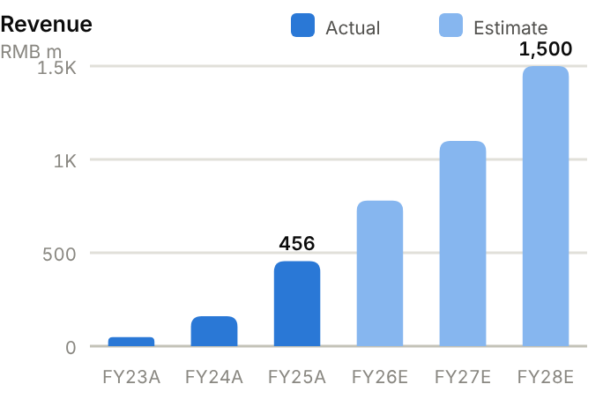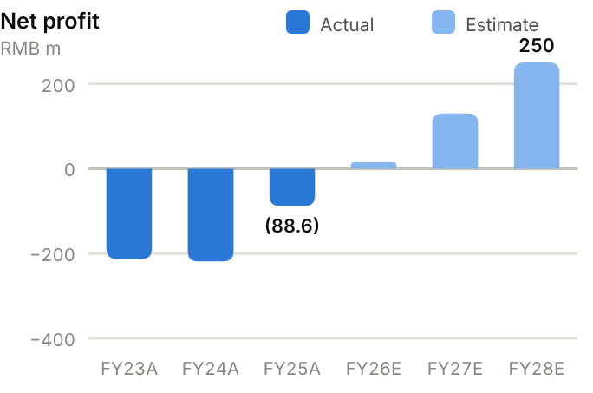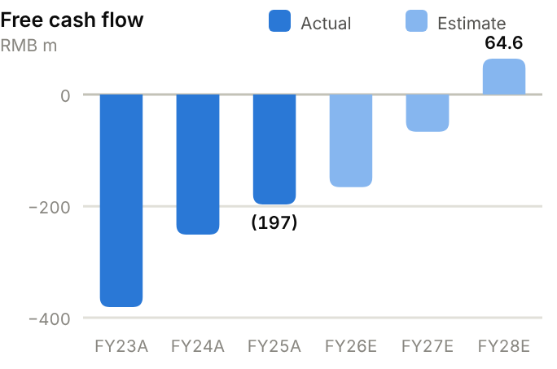
Income statement. Revenue grew from RMB48m (FY23) to RMB160m (FY24) and RMB456m (FY25), and RMB319m in H1'26 (+114%), as overseas placements took off. Gross margin was ~66% in FY25 and 64.1% in H1'26. Operating costs have stabilised, so the net loss narrowed from RMB219m (FY24) to RMB89m (FY25) and RMB19m in H1'26. We forecast revenue of RMB780m/1,100m/1,500m and net profit of RMB15m/130m/250m, with breakeven in FY26E.
Source: company filings via StockAnalysis/S&P Global. Jun-26 = latest interim balance sheet. Debt includes leases. | Balance sheet. IPO proceeds doubled the balance sheet: cash and short-term investments rose from RMB923m (FY25) to RMB1.86bn (June 2026), and equity from RMB1.2bn to RMB2.3bn. Debt is negligible, so net cash is RMB1,814m. Receivables have grown with overseas distributor sales (RMB245m at FY25, 196 days; RMB286m by June 2026), and inventory is RMB158m. The current ratio was 8.13x at FY25. The company is lightly capitalised in fixed assets (PP&E ~RMB95m) ahead of the new plant.
  Balance sheet (RMB m) | FY23A | FY24A | FY25A | Jun-26A
  Cash & short-term investments | 1,222 | 1,104 | 923 | 1,857
  Receivables | 34 | 76 | 245 | 286
  Inventory | 77 | 74 | 136 | 158
  PP&E | 89 | 92 | 42 | 95
  Total assets | 1,556 | 1,361 | 1,386 | 2,483
  Accounts payable | 6 | 8 | 23 | 20
  Total debt | 27 | 18 | 10 | 43
  Equity (attributable) | 1,438 | 1,260 | 1,199 | 2,310
  Minority interests | 0 | 0 | 0 | 0
  Net cash / (net debt) | 1,195 | 1,086 | 913 | 1,814

Cash flow (RMB m) | FY23A | FY24A | FY25A | TTM Jun-26 | FY26E | FY27E | FY28E
Net profit (loss) | (213) | (218) | (89) | – | 15 | 130 | 250
D&A | 17 | 28 | 26 | 25 | 29 | 31 | 35
Operating cash flow | (320) | (225) | (194) | (214) | (86) | 33 | 125
Capex | (61) | (26) | (3) | (14) | (80) | (100) | (60)
Free cash flow | (381) | (251) | (197) | (228) | (166) | (67) | 65
Net cash / (debt), period-end | 1,195 | 1,086 | 913 | 1,814 | 1,731 | 1,664 | 1,729
OCF / net profit (x) | n.m. | n.m. | n.m. | n.m. | n.m. | 0.26 | 0.50

TTM = twelve months to June 2026; Jun-26 net cash in the TTM column. E = our estimates: OCF = net profit + D&A − increase in working capital; net cash rolls forward FCF less dividends plus equity raised.
Cash flow. Operating cash outflow narrowed from RMB320m (FY23) to RMB194m (FY25) but remained −RMB214m TTM, because receivables absorb cash even as losses shrink. Capex has been minimal. FCF was −RMB197m in FY25. We forecast FCF of −RMB166m and −RMB67m in FY26-27E, turning positive at RMB65m in FY28E as profits grow and the new plant is completed. Net cash stays comfortably above RMB1.6bn (~RMB1,729m by FY28E).
ROE/ROA on average balances. Days on year-end balances: receivables on revenue, inventory and payables on cost of sales. Net debt/equity below zero = net cash. n.m./– = not meaningful or not modelled. | Key ratios. Edge's ratios are those of a company crossing breakeven: gross margin ~64-66%, net margin rising from −19% (FY25) to ~12% in FY27E and ~17% in FY28E on our forecasts, and ROE turning positive from FY26E. Receivable days (196 at FY25) and recurring-revenue share are the metrics to watch.
  Key ratios | FY23A | FY24A | FY25A | FY26E | FY27E | FY28E
  Revenue growth | – | 233% | 185% | 71% | 41% | 36%
  Gross margin | – | – | 66.0% | 64.5% | 65.0% | 66.0%
  Net margin | −444% | −137% | −19.4% | 1.9% | 11.8% | 16.7%
  ROE (avg. equity) | −14.8% | −16.2% | −7.2% | – | – | –
  ROA (avg. assets) | −13.7% | −15.0% | −6.5% | – | – | –
  Asset turnover (x) | 0.03 | 0.11 | 0.33 | – | – | –
  Receivable days | 259 | 173 | 196 | – | – | –
  Inventory days | – | – | 320 | – | – | –
  Payable days | – | – | 54 | – | – | –
  Current ratio (x) | 17.31 | 14.54 | 8.13 | – | – | –
  Net debt / equity | −83% | −86% | −76% | −75% | −68% | −64%
  Capex / revenue | 127% | 16.2% | 0.7% | 10.3% | 9.1% | 4.0%
  FCF margin | −794% | −157% | −43.2% | −21.3% | −6.0% | 4.3%

Valuation
Source: StockAnalysis/S&P Global, 12 Oct 2026 (trailing EV/EBITDA and EV/sales; consensus forward P/E). EV/sales on trailing revenue; MicroPort MedBot approximated by P/S at its last available price (31 Aug). | 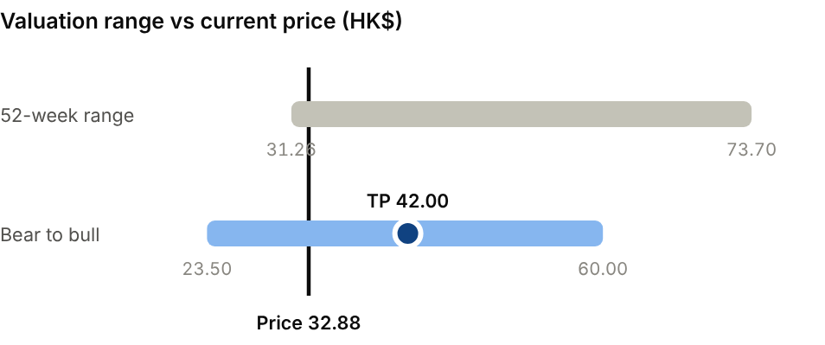  Bear (7x on FY27E revenue of RMB850m): HK$23.50. Bull (14x on FY27E revenue of RMB1.3bn): HK$60.00.
  Company | Ticker | Fwd P/E | EV/EBITDA | EV/sales
  Intuitive Surgical | ISRG US | 37.5x | 34.6x | 13.1x
  MicroPort MedBot | 2252 HK | n.m. | n.m. | 30.0x
  Edge Medical | 2675 HK | 75.3x | n.m. | 13.3x

Our TP of HK$42.00 applies 11x EV/sales to FY27E revenue of RMB1,100m and adds net cash. That is a discount to Intuitive (~13x) for scale and recurring-revenue mix, and far below MicroPort MedBot (~30x trailing sales). The consensus target is ~HK$61 (5 analysts). Bear case HK$23.50: 7x on lower FY27E revenue (RMB850m). Bull case HK$60.00: 14x on RMB1.3bn.
Sources: Company H1'26 HKEX interim results and prospectus-era disclosures; Cleary Gottlieb; MassDevice; Simply Wall St; Bitget (DBS); StockAnalysis; IBKR; source pack.
10 · EQUIPMENT, ROBOTICS & MEDTECH · ROBOTICS COMPONENTS
Leaderdrive 绿的谐波  688017.SH · Initiation of coverage · 12 October 2026 | SELL  TP RMB176  Price RMB252.02 · −30%
A good company priced for a humanoid future that has not yet arrived
Leaderdrive is China's leading maker of harmonic reducers, the precision gears in robot joints, and a major supplier to humanoid-robot developers. Growth is solid (H1'26 revenue +39%), but at ~308x FY26E and ~205x FY27E P/E the shares discount mass humanoid adoption years ahead of the evidence. We initiate at Sell with a TP of RMB176 (30% downside).  - Leaderdrive's franchise is strong. With an estimated 30-40% of China's harmonic-reducer market, it has displaced Japanese imports at materially lower prices and supplies humanoid makers such as Agibot and UBTech.  - The absolute numbers are still small. FY25 revenue was RMB571m and H1'26 net profit RMB70m. In Q2, margins fell and results missed forecasts.  - The shares are priced for perfection. Our TP capitalises FY30E net profit of RMB1.0bn (8x FY25) at 40x and discounts it back three years, and even our bull case (RMB345) needs a humanoid boom.  Catalysts  - Q3'26 results on 31 October.  - Hong Kong H-share listing.  - Humanoid-robot order announcements.  Risks to our Sell call  - Faster humanoid mass production (e.g. Tesla Optimus, Unitree, Agibot) re-rates the theme.  - The H-share listing and SKF joint venture broaden the investor base.  - Thematic liquidity in STAR-market robotics names.  - Downside: price competition; a Q3 miss on 31 October. | Key data  H1'26 revenue mix (%)  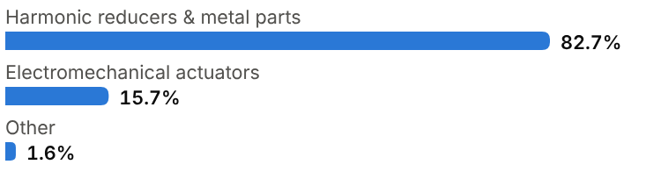
  Price (12 Oct 2026) | RMB252.02
  Target price (12m) | RMB176.00
  Implied return | −30.2%
  Market cap | RMB46.2bn / US$6.9bn
  Enterprise value | RMB44.0bn
  Net cash | RMB2.2bn
  Shares outstanding | 183.3m
  52-week range | 139.62-495.66
  Performance | +31.2% YTD
  Dividend yield (FY26E) | 0.1%
  Consensus target | RMB322.66, 15 analysts
  Other listing | STAR Market; Hong Kong H-share listing planned

Key financials and valuation
Year to December | FY23A | FY24A | FY25A | FY26E | FY27E | FY28E
Revenue (RMB m) | 356 | 387 | 571 | 780 | 1,100 | 1,550
YoY growth | – | +9% | +47% | +37% | +41% | +41%
Gross margin | 36.1% | 28.7% | 31.7% | 31.0% | 32.0% | 33.0%
Net profit, attributable (RMB m) | 84 | 56 | 124 | 150 | 225 | 330
YoY growth | n.m. | −33% | +121% | +21% | +50% | +47%
EPS (RMB) | 0.50 | 0.33 | 0.69 | 0.82 | 1.23 | 1.80
P/E (x) | 504x | 764x | 365x | 308x | 205x | 140x
DPS (RMB) | 0.30 | 0.10 | 0.21 | 0.25 | 0.37 | 0.54
Dividend yield | 0.1% | 0.0% | 0.1% | 0.1% | 0.1% | 0.2%

A = actual (company reports; StockAnalysis/S&P Global), E = our estimates. Multiples at the 12-Oct-2026 price.

Company background
Leader Harmonious Drive Systems (Leaderdrive) was founded in Suzhou in 2011 by Zuo Yuyu, who had spent years developing strain-wave (harmonic) gearing at a time when Chinese robot makers relied almost entirely on imports from Japan's Harmonic Drive Systems. Harmonic reducers are compact, zero-backlash gears that sit in the smaller joints of industrial robots, collaborative robots and, increasingly, humanoid robots. They require extremely precise machining of thin-walled flexible components. Leaderdrive mastered the tooth profile, materials and heat treatment, and built many of its own machine tools to control quality and cost.
As China became the world's largest industrial-robot market, Leaderdrive displaced imports with products priced materially below Japanese equivalents. It listed on Shanghai's STAR Market in August 2020. Profits peaked at RMB189m in FY21, fell to RMB56m in FY24 as robot demand slowed and prices were cut, and recovered in FY25 on humanoid-robot development and industrial share gains. A ~RMB1.4bn placement in 2024 funded new capacity. In 2026 the company announced plans for a Hong Kong H-share listing and a robotics joint venture with SKF. With humanoid makers such as Agibot and UBTech among its customers, the stock has become one of China's purest listed plays on humanoid robots.
Milestones | Ownership and listing
  2011 | Founded in Suzhou by Zuo Yuyu after years of in-house harmonic-drive development.
  2020 | IPO on Shanghai's STAR Market (688017.SH).
  2021 | Record net profit of RMB189m in the industrial-robot boom.
  2023-24 | Profit falls to RMB84m, then RMB56m, on weaker demand and price cuts; ~RMB1.4bn placement.
  2025 | Revenue +47% to RMB571m on industrial and humanoid demand.
  2026 | Plans HK H-share listing and SKF robotics JV; H1 revenue +39%; Q2 results miss.
  Control | Founder-chairman Zuo Yuyu and family
  Share classes | A-share 688017.SH (STAR); H-share listing planned
  Main customers | Industrial/collaborative robot makers; humanoid developers (e.g. Agibot, UBTech)

The business
Leaderdrive manufactures harmonic reducers (flexspline, circular spline and wave generator) in standard and custom sizes, plus precision metal parts. Together these were 82.7% of H1'26 revenue. Electromechanical actuators (15.7%) integrate reducer, frameless motor, encoder, brake and drive into a complete joint module, which raises content per joint and suits humanoid and collaborative-robot designers who want to buy modules rather than components.
Its edge is manufacturing. The company designs tooth profiles and processes in-house, builds much of its own precision grinding and machining equipment, and controls heat treatment. That lets it sell at materially lower prices than Harmonic Drive Systems while keeping gross margins around 30%. Margins have fallen from ~50% in FY21 as it cut prices to win share and absorbed new capacity.
Customers include Chinese industrial and collaborative robot makers, CNC machine-tool builders, semiconductor and medical equipment makers, and humanoid-robot developers. Humanoids are still a small share of revenue but dominate the investment case: a humanoid can use ~14-20 harmonic reducers. Revenue is small (RMB571m in FY25), so profit is sensitive to utilisation of new capacity and to interest income on its ~RMB2bn of cash, which makes up a meaningful share of pre-tax profit.
Leaderdrive is moving from selling components to selling modules, and electromechanical actuators already contribute ~16% of revenue. The SKF joint venture and the planned H-share listing are meant to fund capacity for humanoid and collaborative-robot joint modules, where content per robot is far higher than for a reducer alone. The trade-off is capital intensity: capex of ~RMB250m a year in our forecasts is large against FY26E revenue of RMB780m, so free cash flow stays negative until volumes arrive.
Revenue mix and economics (H1'26)
Segment | Share of revenue | Key assets / products | Economics
Harmonic reducers & metal parts | 82.7% | Strain-wave reducers for robot joints, machine tools, equipment | ~30% gross margin; price below Japanese rivals
Electromechanical actuators | 15.7% | Integrated joint modules (reducer + motor + encoder + drive) | Higher content per joint; humanoid focus
Other | 1.6% | Hydraulic and other precision parts | Small

Competitive landscape
The global benchmark is Harmonic Drive Systems (Japan), which invented commercial strain-wave gearing and still leads in premium industrial and aerospace applications. Nidec-Shimpo is another Japanese supplier. In China, Leaderdrive is the largest of a growing field that includes Laifual, Zhongda Leader, KOFON, Beijing CTKM and Han's Motion (part of Han's Laser). JPMorgan estimates Leaderdrive's share of China's harmonic-reducer market at 30-40%.
The humanoid opportunity carries two competitive risks. Designers may favour other transmissions for some joints, such as planetary gears, RV reducers (Nabtesco, Shuanghuan) or planetary roller screws. Large robot makers, including Tesla, may also produce reducers in-house or squeeze suppliers on price as volumes grow. Leaderdrive leads on precision, yield and scale, but more companies now compete to supply harmonic reducers.
Customer qualification is the main barrier to entry. Robot makers test reducers for accuracy, stiffness and life over thousands of hours, and humanoid developers now run similar programmes. Leaderdrive's long record with Chinese industrial-robot makers gives it a head start, but humanoid designers are qualifying several suppliers at once.
Main competitors
Competitor | Base | Focus | Position vs Leaderdrive
Harmonic Drive Systems | Japan | Harmonic reducers and actuators | Global leader; ~80x forward P/E
Nabtesco | Japan | RV reducers (large joints) | Complementary/alternative; ~22x forward P/E
Zhejiang Shuanghuan | China | RV reducers, gears | Domestic RV leader; ~20x forward P/E
Laifual / Zhongda Leader / KOFON | China | Harmonic reducers | Price challengers
Han's Motion (Han's Laser) | China | Harmonic reducers, motion control | Group-backed entrant

Industry structure: five forces
Force | Intensity | Assessment
Rivalry | High | Harmonic Drive Systems leads globally and Nabtesco dominates RV reducers; at home a long tail of makers (e.g. Laifual) competes on price.
New entrants | High | Humanoid-robot excitement has drawn many new reducer and actuator makers. Precision machining slows them down but does not keep them out.
Supplier power | Low | Inputs are specialty steel, bearings and machine tools; Leaderdrive builds much of its own grinding equipment and does its own heat treatment.
Buyer power | High | Robot makers (Estun, Inovance, Efort) and humanoid developers are price-sensitive and dual-source; large humanoid makers may integrate vertically.
Substitutes | Medium | Planetary gears, cycloidal drives, roller screws and quasi-direct-drive actuators compete for humanoid joints, and actuator designs are not yet settled.

Moat and vulnerabilities
- Largest Chinese harmonic-reducer maker (30-40% domestic share) with in-house machine tools and process know-how.
- Early design-ins with humanoid developers; integrated actuator modules.
- Net cash of ~RMB2bn funds capacity without leverage.
- Vulnerabilities: alternative transmissions, customer in-sourcing, price competition, small earnings base.

Addressable market (TAM)
China installs about 300k industrial robots a year (IFR), the world's largest market. Each uses several harmonic reducers in its wrist and smaller joints, alongside RV reducers in larger joints. Collaborative robots, semiconductor equipment and medical devices add further demand. This core market is growing at mid-single to low-double digits.
The bigger opportunity is humanoids. At ~14-20 harmonic reducers per robot, annual production of one million humanoids would require 14-20 million reducers, many times today's market. Humanoid output is still only in the tens of thousands, however, and timing, design choices and price points are uncertain. Leaderdrive's valuation depends mostly on that future market and much less on today's addressable one.
Today's humanoid pilot volumes are worth little to reducer makers: at an illustrative RMB1,000-2,000 per reducer, 50,000 humanoids a year would need RMB0.7-2.0bn of harmonic reducers across the whole industry. A million-unit market would be worth RMB14-40bn a year, but prices per reducer would probably fall as volumes rise. At ~205x FY27E P/E, Leaderdrive's share price already assumes something close to the million-unit market.
Market | Size | Growth / dynamics | Source
China industrial robots | ~300k units a year | Mid-single to low-double-digit growth | IFR
Harmonic reducers per humanoid | ~14-20 | Design-dependent | Industry estimates
Humanoid production | Tens of thousands today | Scenario: 1m a year → 14-20m reducers | Our scenario
Leaderdrive China share | 30-40% | Contested by new entrants | JPMorgan estimate

30-40%  Leaderdrive share of China's harmonic-reducer market (JPMorgan est.) | ~14-20  Harmonic reducers per humanoid robot (industry estimates) | ~300k  Industrial robots installed in China each year (IFR)

Financial analysis
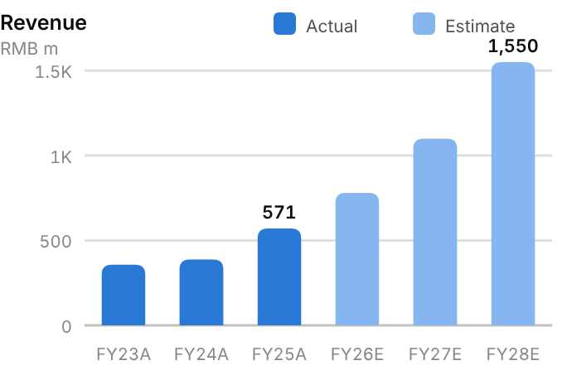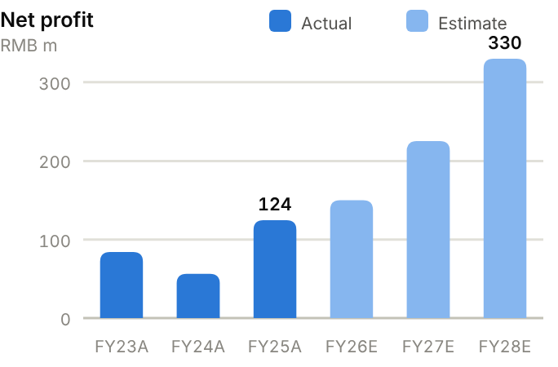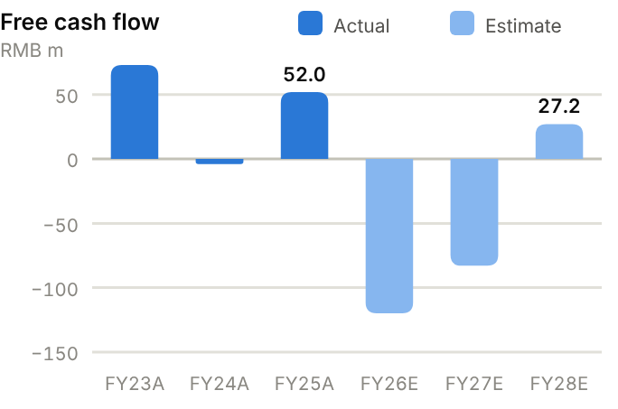
Income statement. Revenue fell from RMB446m (FY22) to RMB356m (FY23), then rose to RMB387m (FY24), RMB571m (FY25, +47%) and RMB668m TTM. Gross margin compressed from 49.5% (FY21) to 28.7% (FY24) before recovering to 31.7% (FY25). Operating profit was only RMB90m in FY25; net profit of RMB124m was helped by interest income and subsidies. H1'26 revenue rose 39% and net profit 31% to RMB70m, with Q2 margins down. We forecast revenue of RMB780m/1,100m/1,550m and net profit of RMB150m/225m/330m.
Source: company filings via StockAnalysis/S&P Global. Jun-26 = latest interim balance sheet. Debt includes leases. | Balance sheet. Leaderdrive is conservatively financed, with RMB2.17bn of cash and short-term investments (June 2026) against negligible debt, so net cash is RMB2,174m (RMB2,026m at FY25), ~57% of equity. PP&E is rising (RMB611m at FY25, RMB752m by June 2026) as capacity is built. Receivables (171 days) and inventory (267 days) are long for a component maker. Equity attributable is RMB3.6bn (BVPS ~RMB20), and the stock trades at ~13x book. The current ratio is 9.56x.
  Balance sheet (RMB m) | FY23A | FY24A | FY25A | Jun-26A
  Cash & short-term investments | 1,268 | 1,735 | 2,026 | 2,174
  Receivables | 132 | 209 | 267 | 291
  Inventory | 254 | 246 | 285 | 340
  PP&E | 490 | 494 | 611 | 752
  Total assets | 2,812 | 3,755 | 3,929 | 4,086
  Accounts payable | 42 | 67 | 168 | 299
  Total debt | 658 | 149 | 0 | 0
  Equity (attributable) | 2,013 | 3,425 | 3,537 | 3,607
  Minority interests | 5 | 5 | 6 | 8
  Net cash / (net debt) | 610 | 1,586 | 2,026 | 2,174

Cash flow (RMB m) | FY23A | FY24A | FY25A | TTM Jun-26 | FY26E | FY27E | FY28E
Net profit (attributable) | 84 | 56 | 124 | – | 150 | 225 | 330
D&A | 45 | 55 | 58 | 60 | 64 | 70 | 77
Operating cash flow | 149 | 28 | 152 | 88 | 130 | 167 | 227
Capex | (76) | (32) | (100) | (177) | (250) | (250) | (200)
Free cash flow | 73 | (4) | 52 | (89) | (120) | (83) | 27
Dividends paid | (27) | (63) | (22) | (1) | (38) | (45) | (68)
Net cash / (debt), period-end | 610 | 1,586 | 2,026 | 2,174 | 1,867 | 1,739 | 1,699
OCF / net profit (x) | 1.77 | 0.50 | 1.22 | n.m. | 0.87 | 0.74 | 0.69

TTM = twelve months to June 2026; Jun-26 net cash in the TTM column. E = our estimates: OCF = net profit + D&A − increase in working capital; net cash rolls forward FCF less dividends plus equity raised.
Cash flow. Operating cash flow is small and erratic (RMB149m, RMB28m and RMB152m over FY23-25), and capex has stepped up (RMB177m TTM), so FCF was RMB52m in FY25 and −RMB89m TTM. The 2024 placement (~RMB1.4bn) funds the expansion. We forecast FCF of −RMB120m, −RMB83m and RMB27m in FY26-28E, with net cash still ~RMB1,699m by FY28E.
ROE/ROA on average balances. Days on year-end balances: receivables on revenue, inventory and payables on cost of sales. Net debt/equity below zero = net cash. Payout = DPS/EPS. n.m./– = not meaningful or not modelled. | Key ratios. Returns are low: ROE was 4.2%, 2.1% and 3.6% over FY23-25, and we forecast only ~6.0% in FY27E and ~8.3% in FY28E because of the large cash and equity base. ROA is 3.2%. A P/E of ~205x FY27E on single-digit ROE is the core of our Sell call.
  Key ratios | FY23A | FY24A | FY25A | FY26E | FY27E | FY28E
  Revenue growth | – | 9% | 47% | 37% | 41% | 41%
  Gross margin | 36.1% | 28.7% | 31.7% | 31.0% | 32.0% | 33.0%
  Net margin | 23.6% | 14.5% | 21.8% | 19.2% | 20.5% | 21.3%
  ROE (avg. equity) | 4.2% | 2.1% | 3.6% | 4.2% | 6.0% | 8.3%
  ROA (avg. assets) | 3.0% | 1.7% | 3.2% | – | – | –
  Asset turnover (x) | 0.13 | 0.12 | 0.15 | – | – | –
  Receivable days | 135 | 197 | 171 | – | – | –
  Inventory days | 407 | 325 | 267 | – | – | –
  Payable days | 67 | 89 | 157 | – | – | –
  Current ratio (x) | 2.73 | 9.67 | 9.56 | – | – | –
  Net debt / equity | −30% | −46% | −57% | −51% | −45% | −42%
  Net debt / EBITDA (x) | -6.6 | -19.1 | -13.7 | – | – | –
  Capex / revenue | 21.3% | 8.3% | 17.5% | 32.1% | 22.7% | 12.9%
  FCF margin | 20.5% | −1.0% | 9.1% | −15.4% | −7.5% | 1.8%
  Dividend payout | 60% | 30% | 30% | 30% | 30% | 30%

Valuation
Source: StockAnalysis/S&P Global, 12 Oct 2026 (trailing EV/EBITDA and EV/sales; consensus forward P/E). | 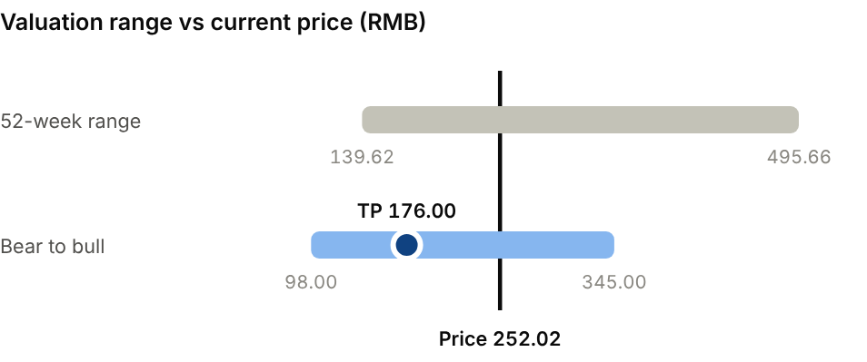  Bear (FY30E profit RMB0.6bn at 35x): RMB98.00. Bull (FY30E profit RMB1.8bn at 45x): RMB345.00.
  Company | Ticker | Fwd P/E | EV/EBITDA | EV/sales
  Harmonic Drive Systems | 6324 JP | 79.9x | 50.9x | 9.3x
  Nabtesco | 6268 JP | 21.9x | 11.8x | 1.7x
  Zhejiang Shuanghuan | 002472 CH | 19.9x | 13.3x | 3.4x
  Leaderdrive | 688017 CH | 226x | 278x | 65.9x

Our TP of RMB176 capitalises FY30E net profit of RMB1.0bn at 40x, discounts it back three years at 10% and adds net cash. Harmonic Drive Systems, the global leader, trades on ~80x forward earnings and ~9x EV/sales, against ~66x EV/sales for Leaderdrive. The consensus target is RMB323, but ratings are split (7 Buy, 4 Hold, 4 Sell). Bear case RMB98.00: FY30E profit of RMB0.6bn at 35x. Bull case RMB345: RMB1.8bn at 45x on a humanoid boom.
Sources: Company FY25 annual and H1'26 reports; Gasgoo; Investing.com; Simply Wall St; JPMorgan (via humanoid.guide); 36Kr; StockAnalysis/S&P Global; IBKR; source pack.
11 · BATTERY, LITHIUM & STORAGE · BATTERY MATERIALS & METALS
Huayou Cobalt 华友钴业  603799.SH · Initiation of coverage · 12 October 2026 | HOLD  TP RMB38.50  Price RMB34.53 · +11%
The integration is genuine, but slipping earnings quality explains the low valuation
Huayou is an integrated nickel, cobalt, lithium and battery-materials group whose operations run from Indonesian and African mining through refining to precursors and cathodes. The shares are down 49% YTD after Q2 profit fell 31% and consensus FY26 EPS was cut by a third. At 9.4x FY27E P/E and ~1x book the valuation is undemanding, but leverage and commodity headwinds keep us at Hold, TP RMB38.50 (+11% upside).  - Integration gives Huayou a genuine cost advantage. Low-cost Indonesian HPAL nickel (~300ktpa including Pomalaa) feeds precursor and cathode plants; cathode and precursor shipments nearly doubled in H1'26.  - Earnings quality weakened in Q2, when sulfur-cost spikes forced maintenance at Huafei and cobalt shipments fell 24% under DRC export quotas. Q2 net profit fell 31% YoY to ~RMB1.0bn.  - The balance sheet limits flexibility. Net debt of ~RMB54bn (~3x TTM EBITDA) and the Atlantic Lithium acquisition add risk as nickel and lithium prices soften.  Catalysts  - Q3'26 results on 24 October; any upstream nickel recovery.  - Pomalaa ramp-up and Huafei restart.  - Buyback completion; Atlantic Lithium deal terms.  Key risks  - Nickel oversupply from Indonesian capacity additions.  - Indonesian policy (ore quotas, royalties) and DRC cobalt export quotas.  - Input costs (sulfur, sulfuric acid) and high leverage.  - LFP substituting for nickel-based cathodes. | Key data  FY25 revenue mix by product (%)  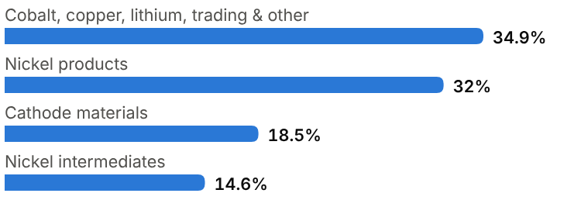
  Price (12 Oct 2026) | RMB34.53
  Target price (12m) | RMB38.50
  Implied return | +11.5%
  Market cap | RMB65.4bn / US$9.8bn
  Enterprise value | RMB134.7bn
  Net debt | RMB53.8bn
  Shares outstanding | 1.90bn
  52-week range | 33.89-82.17
  Performance | -49.4% YTD
  Dividend yield (FY26E) | 1.5%
  Consensus target | RMB61.06, 6 analysts
  Other listing | A-share only

Key financials and valuation
Year to December | FY23A | FY24A | FY25A | FY26E | FY27E | FY28E
Revenue (RMB bn) | 66.3 | 61.0 | 81.0 | 106 | 118 | 128
YoY growth | – | −8% | +33% | +31% | +11% | +8%
Gross margin | 13.6% | 16.7% | 17.4% | 18.0% | 18.5% | 18.8%
Net profit, attributable (RMB bn) | 3.35 | 4.16 | 6.11 | 5.90 | 7.00 | 8.00
YoY growth | n.m. | +24% | +47% | −3% | +19% | +14%
EPS (RMB) | 2.05 | 2.39 | 3.33 | 3.11 | 3.68 | 4.21
P/E (x) | 16.8x | 14.4x | 10.4x | 11.1x | 9.4x | 8.2x
DPS (RMB) | 1.00 | 0.50 | 0.50 | 0.53 | 0.63 | 0.72
Dividend yield | 2.9% | 1.4% | 1.4% | 1.5% | 1.8% | 2.1%

A = actual (company reports; StockAnalysis/S&P Global), E = our estimates. Multiples at the 12-Oct-2026 price.

Company background
Zhejiang Huayou Cobalt was founded in 2002 in Tongxiang, Zhejiang, by Chen Xuehua, who still chairs the company. It began as a cobalt refiner. Its early bet was to secure ore at the source: in the 2000s it built cobalt-copper mining and processing operations in the Democratic Republic of Congo, the world's dominant cobalt supplier. Huayou listed on the Shanghai Stock Exchange in 2015 and used the EV boom to move downstream into battery materials.
From 2018, in partnership with Tsingshan, Huayou built high-pressure acid leaching (HPAL) plants in Indonesia that turn low-grade laterite nickel into mixed hydroxide precipitate (MHP) for batteries: Huayue (60ktpa) and Huafei (120ktpa) in the IMIP and IWIP industrial parks. A third project at Pomalaa with Vale and Ford (120ktpa) is starting up, and a fourth (Sorowako, with Vale) is planned. Huayou bought the Arcadia lithium mine in Zimbabwe and control of cathode maker Bamo in 2021. It also runs precursor and cathode joint ventures with Korean partners and a recycling arm, and has agreed to acquire Atlantic Lithium (Ghana). That makes it one of the most vertically integrated battery-materials groups in the world, and one of the most capital-intensive.
Milestones | Ownership and listing
  2002 | Founded in Tongxiang, Zhejiang by Chen Xuehua as a cobalt refiner.
  2000s | Builds cobalt-copper mining and processing in the DRC.
  2015 | Lists on the Shanghai Stock Exchange (603799.SH).
  2018-23 | Indonesian HPAL nickel with Tsingshan: Huayue (60ktpa), Huafei (120ktpa).
  2021 | Acquires Arcadia lithium (Zimbabwe) and control of cathode maker Bamo.
  2025 | Record net profit of RMB6.1bn (+47%).
  2026 | Pomalaa HPAL (Vale, Ford) ramps; Huafei maintenance; agrees to buy Atlantic Lithium.
  Largest shareholder | Founder-chairman Chen Xuehua and affiliates
  Main partners | Tsingshan, Vale, Ford (Indonesia); Korean cathode/precursor JV partners
  Capital returns | Buying back ~0.8% of shares; DPS RMB0.50

The business
Huayou earns money at each step from mine to cathode. Upstream, it mines cobalt and copper in the DRC and lithium in Zimbabwe, and processes Indonesian laterite nickel into MHP. Midstream, it refines nickel, cobalt and lithium into battery-grade chemicals. Downstream, it makes ternary (NCM) precursors and cathodes, and some LFP, for cell makers. Recycling feeds used battery metals back into the chain. In FY25, nickel products were RMB25.9bn of revenue, cathode materials RMB15.0bn, and nickel intermediates RMB11.8bn, with cobalt, copper, lithium, precursors and trading making up the rest.
Upstream assets earn most of the profit. Indonesian HPAL produces nickel at among the lowest cash costs globally, and when nickel or cobalt prices rise, Huayou's mining and refining margins expand quickly. Processing earns steadier fees but thinner margins. Integration lowers cost and secures supply, but it also concentrates risk. Results depend on four commodity prices (nickel, cobalt, lithium, copper) and on input costs, notably sulfur and sulfuric acid for HPAL. Sulfur spikes forced maintenance at Huafei in 2026. Cobalt volumes are subject to DRC export quotas, and shipments fell 24% in H1'26.
The model is capital-hungry. PP&E has grown to RMB74bn, capex reached RMB16bn TTM for Pomalaa, and net debt is ~RMB54bn, about 3x EBITDA. Minority interests are sizeable because Indonesian projects are jointly owned. Customers are major Korean and Chinese cell makers. Many of the relationships are formalised in joint ventures, which give Huayou volume visibility but limit pricing power.
The plan for the next three years is to finish the Indonesian build-out and then harvest it. Pomalaa adds 120ktpa of MHP capacity as it ramps through 2026-27. We assume capex falls from ~RMB15bn in FY26E to ~RMB8bn by FY28E once it is complete, which is what turns free cash flow positive in our model. The second priority is selling more nickel outside China's LFP-dominated market, mainly to Korean and European cell makers. US foreign-entity sourcing rules limit how much Huayou can sell into US supply chains.
FY25 revenue by product
Product | RMB bn / share | What it is | Economics
Nickel products | 25.9 / 32% | Battery-grade nickel sulfate and refined nickel | Margin tied to nickel price; HPAL cost advantage
Cathode materials | 15.0 / 18.5% | NCM (and some LFP) cathodes via Bamo and JVs | Processing fees; volume growth
Nickel intermediates | 11.8 / 14.6% | MHP from Indonesian HPAL | Low cash cost; main profit driver
Cobalt, copper, lithium, other | 28.3 / 34.9% | DRC cobalt/copper; Zimbabwe lithium; precursors; trading | Cobalt quota-dependent; lithium price-exposed

Competitive landscape
Huayou competes in several overlapping arenas. In Indonesian nickel, the main players are Tsingshan (its partner and the world's largest nickel producer), Nickel Industries, Harita (with Lygend), GEM and CNGR. Several of them are adding HPAL capacity, which Argus expects to nearly double Indonesian MHP capacity in 2026. In cobalt, CMOC is the world's largest producer and Glencore the other major. In precursors and cathodes, CNGR, GEM, Ronbay and Easpring are direct rivals.
The structural problem is that LFP, which needs no nickel or cobalt, now accounts for roughly 80% of China's EV battery installations, so nickel-based cathodes are growing only in premium and overseas EVs. Huayou's response is to sell nickel to Korean and Western cell makers, add LFP and lithium, and lean on its cost advantage. Integration and low upstream cost are its competitive strengths; leverage, complexity and exposure to Indonesian policy (ore quotas and royalties) are its weaknesses.
Main competitors
Competitor | Base | Focus | Position vs Huayou Cobalt
Tsingshan | China (private) | Indonesian nickel (NPI, HPAL), stainless | World's largest nickel producer; partner and rival
CMOC Group | China | Cobalt and copper (DRC) | Cobalt No.1; lower leverage
GEM / CNGR | China | Indonesian HPAL; precursors; recycling | Direct precursor rivals; similar integration
Harita / Lygend | Indonesia / China | HPAL nickel (Obi island) | Low-cost MHP; capacity growth
Glencore / Vale | Switzerland / Brazil | Nickel, cobalt, copper | Western majors; Vale also a Huayou partner

Industry structure: five forces
Force | Intensity | Assessment
Rivalry | High | Tsingshan, GEM, Lygend, CNGR and Nickel Industries keep adding Indonesian capacity, and Chinese overcapacity squeezes precursor and cathode processing fees.
New entrants | Medium | HPAL plants cost billions and need know-how, yet Chinese groups with Indonesian partners have built them quickly; Indonesia's ore quotas (RKAB) are now the main gate.
Supplier power | High | Indonesia sets ore quotas, royalties and export policy, and the DRC's 2025 cobalt export suspension and quotas show how quickly host governments can change the economics.
Buyer power | Medium | Battery and cathode makers such as LGES, POSCO and CATL are concentrated buyers; long-term supply agreements and joint ventures soften this.
Substitutes | Medium | LFP chemistry (no nickel or cobalt) dominates China's EV and storage markets, and sodium-ion is a further threat; high-nickel holds in premium and ex-China EVs.

Moat and vulnerabilities
- Mine-to-cathode integration with low-cost Indonesian HPAL nickel.
- Long-term partnerships with Tsingshan, Vale, Ford and Korean cell makers.
- Scale in cobalt refining and a recycling loop.
- Vulnerabilities: commodity prices, LFP substitution, leverage and Indonesian/DRC policy.

Addressable market (TAM)
Huayou's markets are large but cyclical. Global nickel demand is ~3.5-3.7Mt a year (worth ~US$60bn at ~US$16.9k/t), driven by stainless steel with batteries the growth segment. Indonesia supplies more than half and is expanding further. Cobalt is a ~250-300kt market (mostly DRC), tightened by export quotas since 2025. Lithium is ~1.5Mt LCE and oversupplied in 2026.
Downstream, cathode and precursor demand grows with EV and storage batteries, but nickel-based chemistries are losing share to LFP in China. Huayou's addressable market is therefore growing more slowly than the overall battery market. Its growth comes from Indonesian volume and from share gains with overseas cell makers; nickel intensity in batteries is not rising.
Huayou's three HPAL projects total ~300ktpa of nickel-in-MHP capacity at 100% ownership (less on an attributable basis), equal to roughly 8% of global nickel supply. That is enough to matter to the market, though not enough to set prices. Indonesian supply growth has pushed nickel prices down toward the costs of higher-cost producers elsewhere, so Huayou's returns depend on staying at the bottom of the cost curve rather than on a price recovery.
Market | Size | Growth / dynamics | Source
Nickel | ~3.5-3.7Mt / ~US$60bn | Batteries growing; Indonesian oversupply | Industry; our calc. at US$16.9k/t
Indonesian MHP capacity | 862ktpa (2026E) | Nearly double 2025 | Argus
Cobalt | ~250-300kt | Tighter on DRC export quotas | Industry estimates
Ternary cathode share (China EV) | ~20% | Losing share to LFP (~80%) | Industry data

~300ktpa  Huayou Indonesian HPAL nickel capacity incl. Pomalaa (Ni in MHP) | 862ktpa  Indonesian MHP capacity expected in 2026, nearly double 2025 (Argus) | ~80%  LFP share of China EV battery installations, a headwind for nickel cathodes

Financial analysis
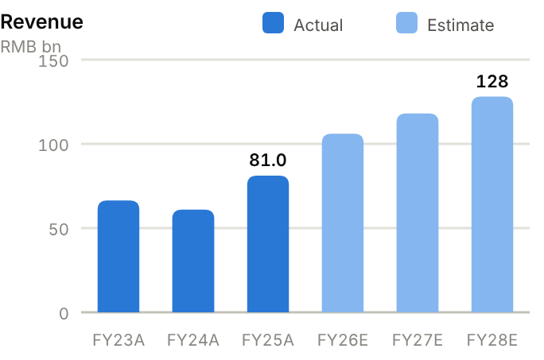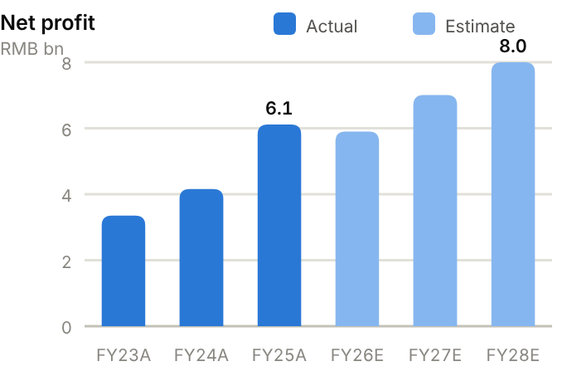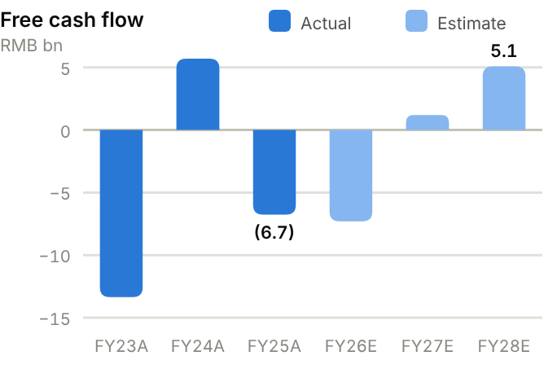
Income statement. Revenue moved from RMB66.3bn (FY23) to RMB60.9bn (FY24) on lower nickel and cobalt prices, then to RMB81.0bn (FY25, +33%) and RMB99.4bn TTM as Indonesian volumes ramped. Gross margin improved from 13.6% to 17.4% (FY25) and 19.0% TTM, and operating profit doubled from RMB5.0bn to RMB9.7bn. Net profit rose 47% to RMB6.1bn in FY25. H1'26 net profit of RMB3.5bn (+29%) masks a sharp slowdown: Q1 earned RMB2.5bn, Q2 RMB1.0bn. We forecast revenue of RMB106bn/118bn/128bn and net profit of RMB5.90bn/7.00bn/8.00bn.
Source: company filings via StockAnalysis/S&P Global. Jun-26 = latest interim balance sheet. Debt includes leases. | Balance sheet. Total assets rose from RMB126bn (FY23) to RMB186bn (June 2026), a heavy base that includes PP&E of RMB74bn and inventory of RMB32bn (140 days of cost of sales at FY25, up from 100). Leverage is high: total debt is RMB75.8bn against cash of RMB22.0bn, giving net debt of RMB53.8bn (RMB46.5bn at FY25), ~96% of equity and 3.19x EBITDA. The current ratio is below 1 (0.95x). Equity attributable is RMB48.3bn (FY25; BVPS ~RMB26), and minority interests of RMB12.5bn reflect jointly owned Indonesian projects.
  Balance sheet (RMB bn) | FY23A | FY24A | FY25A | Jun-26A
  Cash & short-term investments | 15.4 | 19.7 | 17.7 | 22.0
  Receivables | 10.8 | 8.5 | 11.4 | 16.2
  Inventory | 15.8 | 17.3 | 25.6 | 32.2
  PP&E | 57.3 | 61.1 | 66.5 | 73.7
  Total assets | 125.5 | 136.6 | 159.4 | 186.0
  Accounts payable | 20.0 | 16.3 | 25.4 | 33.8
  Total debt | 57.3 | 64.8 | 64.2 | 75.8
  Equity (attributable) | 34.3 | 36.9 | 48.3 | 50.9
  Minority interests | 10.5 | 11.7 | 12.5 | 15.6
  Net cash / (net debt) | (41.9) | (45.0) | (46.5) | (53.8)

Cash flow (RMB bn) | FY23A | FY24A | FY25A | TTM Jun-26 | FY26E | FY27E | FY28E
Net profit (attributable) | 3.4 | 4.2 | 6.1 | – | 5.9 | 7.0 | 8.0
D&A | 3.3 | 4.6 | 4.9 | 5.1 | 5.4 | 5.9 | 6.5
Operating cash flow | 3.5 | 12.4 | 4.0 | 4.5 | 7.7 | 11.2 | 13.1
Capex | (16.8) | (6.7) | (10.8) | (16.2) | (15.0) | (10.0) | (8.0)
Free cash flow | (13.4) | 5.7 | (6.7) | (11.6) | (7.3) | 1.2 | 5.1
Dividends paid | (2.2) | (3.8) | (2.7) | (3.1) | (0.9) | (1.0) | (1.2)
Net cash / (debt), period-end | (41.9) | (45.0) | (46.5) | (53.8) | (54.8) | (54.6) | (50.7)
OCF / net profit (x) | 1.04 | 2.99 | 0.66 | n.m. | 1.30 | 1.60 | 1.63

TTM = twelve months to June 2026; Jun-26 net cash in the TTM column. E = our estimates: OCF = net profit + D&A − increase in working capital; net cash rolls forward FCF less dividends plus equity raised.
Cash flow. Operating cash flow is volatile and often below profit plus D&A because of inventory build: RMB3.5bn, RMB12.4bn and RMB4.0bn over FY23-25 (OCF/net profit 0.66x in FY25). Capex has been heavy (RMB16.8bn in FY23, RMB10.8bn in FY25, RMB16.2bn TTM), so free cash flow was negative in two of the last three years (FY25: −RMB6.7bn; TTM −RMB11.6bn), funded by debt. We forecast FCF of −RMB7.3bn in FY26E, turning positive at RMB1.2bn/5.1bn in FY27-28E as Pomalaa capex ends. Net debt only edges down to ~RMB50.7bn by FY28E.
ROE/ROA on average balances. Days on year-end balances: receivables on revenue, inventory and payables on cost of sales. Net debt/equity below zero = net cash. Payout = DPS/EPS. n.m./– = not meaningful or not modelled. | Key ratios. ROE improved from 9.8% (FY23) to 14.3% (FY25), and we expect ~12.4% by FY27E: respectable, but earned with high leverage. ROA is only 4.1%. Net debt/EBITDA of 3.19x and a current ratio below 1 are the main constraints; any further acquisitions (Atlantic Lithium) would delay deleveraging. Payout was 15% on FY25 EPS.
  Key ratios | FY23A | FY24A | FY25A | FY26E | FY27E | FY28E
  Revenue growth | – | −8% | 33% | 31% | 11% | 8%
  Gross margin | 13.6% | 16.7% | 17.4% | 18.0% | 18.5% | 18.8%
  Net margin | 5.1% | 6.8% | 7.5% | 5.6% | 5.9% | 6.2%
  ROE (avg. equity) | 9.8% | 11.7% | 14.3% | 11.6% | 12.4% | 12.8%
  ROA (avg. assets) | 2.7% | 3.2% | 4.1% | – | – | –
  Asset turnover (x) | 0.53 | 0.47 | 0.55 | – | – | –
  Receivable days | 59 | 51 | 51 | – | – | –
  Inventory days | 100 | 124 | 140 | – | – | –
  Payable days | 128 | 117 | 139 | – | – | –
  Current ratio (x) | 1.01 | 1.03 | 0.95 | – | – | –
  Net debt / equity | 122% | 122% | 96% | 103% | 92% | 77%
  Net debt / EBITDA (x) | 5.0 | 4.1 | 3.2 | – | – | –
  Capex / revenue | 25.4% | 11.0% | 13.3% | 14.2% | 8.5% | 6.2%
  FCF margin | −20.2% | 9.4% | −8.3% | −6.9% | 1.0% | 4.0%
  Dividend payout | 49% | 21% | 15% | 17% | 17% | 17%

Valuation
Source: StockAnalysis/S&P Global, 12 Oct 2026 (trailing EV/EBITDA and EV/sales; consensus forward P/E). | 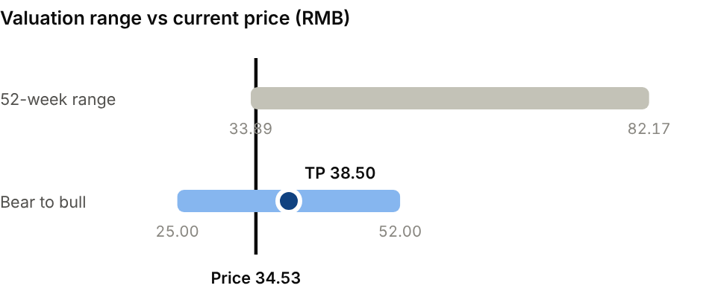  Bear (Nickel oversupply; sulfur costs persist): RMB25.00. Bull (Pomalaa ramps smoothly; cobalt stays tight): RMB52.00.
  Company | Ticker | Fwd P/E | EV/EBITDA | EV/sales
  CMOC Group | 603993 CH | 11.0x | 6.0x | 1.5x
  GEM | 002340 CH | 13.4x | 10.6x | 1.7x
  CNGR Advanced Material | 300919 CH | 18.0x | 9.1x | 1.1x
  Huayou Cobalt | 603799 CH | 8.8x | 7.4x | 1.4x

Our TP of RMB38.50 is 10.5x FY27E EPS of RMB3.68, a discount to CMOC (~11x) and GEM (~13x) forward for higher leverage and weaker earnings momentum. On EV/EBITDA the stock already trades at ~7.4x TTM, between CMOC (~6x) and GEM (~11x). The consensus average target (RMB61) has not caught up with the estimate cuts. Bear case RMB25.00: nickel oversupply and sulfur costs persist. Bull case RMB52.00: Pomalaa ramps smoothly and cobalt stays tight.
Sources: Company FY25 and H1'26 results; Stock Analysis; Simply Wall St; SMM; Argus; Project Blue; StockAnalysis/S&P Global; IBKR; source pack.
12 · BATTERY, LITHIUM & STORAGE · LITHIUM
Tianqi Lithium 天齐锂业  9696.HK · Initiation of coverage · 12 October 2026 | HOLD  TP HK$30.00  Price HK$25.92 · +16%
A world-class asset in a commodity-price trade, with the H-share discount as a cushion
Tianqi owns about a quarter of Greenbushes, the world's largest and highest-grade hard-rock lithium mine, plus ~22% of Chile's SQM. H1'26 profit rebounded to RMB4.2bn on higher lithium prices, but lithium carbonate fell 24% in September and supply is set to grow ~28% in 2026. The H-share trades on only 7.8x FY27E P/E, a ~44% discount to the A-share. We initiate at Hold with a TP of HK$30.00 (+16% upside).  - Tianqi has a bottom-quartile cost position through Greenbushes, which delivered a 74% mining gross margin in H1'26 and generates cash even at much lower lithium prices.  - Operating leverage works in both directions. Revenue rose 154% and profit swung from RMB87m to RMB4.2bn in H1'26; we expect FY27E EPS to fall ~26% as prices normalise.  - The H-share has a valuation cushion. At ~0.6x book and 7.8x FY27E P/E it discounts a lot of bad news; the A-share (~14x FY27E) looks fuller.  Catalysts  - Q3'26 results on 26 October.  - Greenbushes CGP3 restart and Kwinana fixes.  - Chinese inventory data and GFEX lithium futures.  Key risks  - Lithium price: each RMB10k/t moves annual net profit by roughly RMB0.7-0.9bn (our estimate).  - Greenbushes operations (CGP3 fire in June) and Kwinana under-performance.  - SQM/Codelco outcome and Chilean policy.  - Upside risk: supply discipline or a demand surprise reverses the price slide. | Key data  H1'26 revenue mix (%)  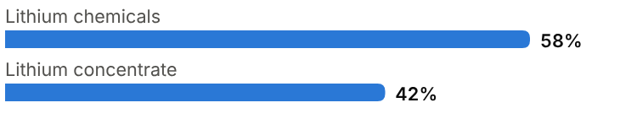
  Price (12 Oct 2026) | HK$25.92
  Target price (12m) | HK$30.00
  Implied return | +15.7%
  Market cap | RMB63.1bn (A+H) / US$9.4bn
  Enterprise value | RMB79.9bn
  Net debt | RMB5.7bn
  Shares outstanding | 1.70bn
  52-week range | 25.92-69.15
  Performance | -50.8% YTD
  Dividend yield (FY26E) | 0.0%
  Consensus target | RMB64.20 (A-share), 17 analysts
  Other listing | A-share 002466.SZ at RMB39.23 (H at ~44% discount)

Key financials and valuation
Year to December | FY23A | FY24A | FY25A | FY26E | FY27E | FY28E
Revenue (RMB bn) | 40.5 | 13.1 | 10.3 | 23.0 | 21.0 | 22.5
YoY growth | – | −68% | −21% | +122% | −9% | +7%
Gross margin | 83.2% | 40.6% | 36.6% | 58.0% | 52.0% | 52.0%
Net profit, attributable (RMB bn) | 7.30 | (7.91) | 0.46 | 6.50 | 4.80 | 5.20
YoY growth | n.m. | −208% | n.m. | +1313% | −26% | +8%
EPS (RMB) | 4.45 | (4.82) | 0.28 | 3.82 | 2.82 | 3.06
P/E on H-share price (x) | 5.0x | n.m. | 79.0x | 5.8x | 7.8x | 7.2x
DPS (RMB) | 1.35 | 0.00 | 0.00 | 0.00 | 0.30 | 0.40
Dividend yield | 6.1% | 0.0% | 0.0% | 0.0% | 1.4% | 1.8%

A = actual (company reports; StockAnalysis/S&P Global), E = our estimates. Multiples at the 12-Oct-2026 price, converted at HK$1 = RMB0.853.

Company background
Tianqi Lithium traces its roots to the state-owned Shehong lithium-salt plant in Sichuan, set up in 1992. Entrepreneur Jiang Weiping took control in 2004, and the company listed in Shenzhen in 2010. In 2013 it acquired a controlling stake in Talison Lithium, owner of the Greenbushes mine in Western Australia, which is still its main asset. Greenbushes is the world's largest and highest-grade hard-rock lithium deposit, with Rockwood (now Albemarle) holding the remaining 49%.
In 2018, at the top of the previous lithium cycle, Tianqi bought ~24% of Chile's SQM from Nutrien for ~US$4.1bn, largely with debt. When lithium prices collapsed in 2019-20, it faced a liquidity crisis. It restructured by selling 49% of its Australian holding company (which owns its Greenbushes interest and the Kwinana hydroxide plant) to IGO for ~US$1.4bn in 2021, and by listing H-shares in Hong Kong in July 2022, near the peak of the next upcycle. Profit hit RMB24.1bn in FY22 before another collapse produced a RMB7.9bn loss in FY24. The company today is leaner but still exposed: its effective Greenbushes interest is ~26%, Kwinana has under-performed, and Chile's Supreme Court rejected its challenge to SQM's partnership with Codelco.
Milestones | Ownership and listing
  1992 | Shehong lithium-salt plant established in Sichuan (state-owned).
  2004 / 2010 | Jiang Weiping takes control; Shenzhen listing (002466.SZ).
  2013 | Acquires 51% of Talison (Greenbushes); Rockwood/Albemarle holds 49%.
  2018 | Buys ~24% of SQM for ~US$4.1bn, largely debt-funded.
  2021 | Sells 49% of its Australian holding company to IGO (~US$1.4bn) to deleverage.
  2022 | Hong Kong listing (9696.HK); record net profit RMB24.1bn.
  2024-26 | RMB7.9bn loss in FY24; H1'26 profit RMB4.2bn; H-share placement and CB.
  Controlling shareholder | Jiang Weiping and family
  Main associates | Greenbushes (~26% effective, with IGO and Albemarle); SQM (~22%)
  Share classes | A-share 002466.SZ; H-share 9696.HK (~44% discount to A)

The business
Tianqi has three earnings streams. First, its share of Greenbushes mining profits. The mine sells spodumene concentrate to its two owners at market-linked prices, and Tianqi resells part of its share as concentrate (42% of H1'26 revenue). Second, conversion. Tianqi turns the rest into lithium carbonate and hydroxide at plants in Shehong (Sichuan), Zhangjiagang (Jiangsu) and Kwinana (Australia), and sells them to cathode and battery makers (58% of revenue). Third, equity income from its SQM stake, which taps Chile's low-cost Atacama brine.
Mining generates most of the profit. Greenbushes delivered a 74% mining gross margin in H1'26, and its cash cost sits in the bottom quartile of the industry. Conversion margins are thinner and volatile. Because Tianqi buys concentrate at lagged market prices and sells chemicals at spot, falling prices can generate inventory losses, as in FY24. Kwinana, Australia's first lithium hydroxide plant, has struggled with commissioning and ran at ~15% of nameplate in the June 2026 quarter.
Earnings are almost entirely a function of the lithium price, volumes at Greenbushes (where the CGP3 expansion was interrupted by a fire in June 2026), and SQM's results. Development projects include the Cuola spodumene mine in Sichuan. The balance sheet has been repaired since 2021, but the A-share and H-share valuations differ widely (H at a ~44% discount).
Revenue mix and economics (H1'26)
Segment | Share of revenue | Key assets / products | Economics
Lithium chemicals | 58% | Carbonate and hydroxide from Sichuan, Jiangsu and Kwinana plants | Conversion margin; inventory-lag risk
Lithium concentrate | 42% | Spodumene from Greenbushes (~26% effective interest) | 74% gross margin in H1'26
Equity income (not in revenue) | – | ~22% of SQM (Chile brine); associates | Lithium-price driven

Competitive landscape
Lithium supply is split between hard-rock spodumene (Australia, Africa, China) and brine (Chile, Argentina, China's Qinghai and Tibet), with lepidolite in Jiangxi as a high-cost swing source. Tianqi's peers include Albemarle (its Greenbushes partner), SQM, Pilbara Minerals, Mineral Resources and Rio Tinto (which bought Arcadium). In China its rivals are Ganfeng, Yahua, Zangge, Sinomine and battery makers that have integrated upstream, such as CATL in Yichun.
Producers are price-takers, so their returns depend on cost position. Greenbushes is among the lowest-cost sources worldwide, which protects Tianqi in downturns and gives it high leverage in upturns. Its relative weaknesses are a minority position in its main asset (Albemarle and IGO are co-owners), under-performing downstream conversion, and limited growth projects of its own compared with Ganfeng or Pilbara. African supply (Zimbabwe, Mali, Ghana) and Chinese lepidolite restarts are the marginal tonnes that set prices.
Position on the cost curve decides who survives a downturn. Greenbushes concentrate is among the cheapest spodumene in the world to produce, while Jiangxi lepidolite and many African and Australian hard-rock mines sit at the top of the curve. When prices fall, those high-cost tonnes are the first to close, as they did in 2024. Tianqi's conversion plants are less advantaged: Chinese converters run on thin processing margins, and Kwinana's problems have made Western conversion look expensive.
Main competitors
Competitor | Base | Focus | Position vs Tianqi Lithium
Albemarle | US | Greenbushes (49%), Chile brine, conversion | Largest Western producer; co-owner of Greenbushes
SQM | Chile | Atacama brine (with Codelco from 2025) | Lowest-cost brine; Tianqi owns ~22%
Pilbara Minerals | Australia | Pilgangoora spodumene | Pure-play hard rock; growth projects
Ganfeng Lithium | China | Diversified resources, chemicals, batteries | More diversified; higher debt
Zangge / Yahua / CATL (Yichun) | China | Brine, conversion, lepidolite | Domestic cost-curve swing supply

Industry structure: five forces
Force | Intensity | Assessment
Rivalry | High | Lithium is a commodity. Ganfeng, Albemarle, SQM, Rio Tinto, Pilbara Minerals and many Chinese lepidolite and brine producers compete, and in surplus the marginal cost sets the price.
New entrants | Medium | African hard rock, Argentine brine and Chinese lepidolite added supply within 2-4 years in 2022-25; high prices quickly invite new projects.
Supplier power | Low | Greenbushes gives Tianqi its own low-cost spodumene, so the main 'supplier' is its own joint venture; Western Australian royalties are the external claim.
Buyer power | Medium | Cathode and battery makers (CATL, BYD, LG) are concentrated buyers on index-linked contracts and control qualification.
Substitutes | Medium | Sodium-ion can replace LFP in storage and small EVs if lithium prices spike; there is no substitute in high-energy-density cells.

Moat and vulnerabilities
- Interest in Greenbushes, the world's largest high-grade hard-rock lithium mine (bottom-quartile cost).
- Exposure to SQM's low-cost Atacama brine through its ~22% stake.
- Repaired balance sheet (net debt ~RMB6bn at June 2026).
- Vulnerabilities: price-taker economics, Kwinana under-performance, minority position in its main assets.

Addressable market (TAM)
The lithium market is driven by batteries. We estimate demand of ~1.5Mt LCE in 2026, growing 20-25% a year with EVs and storage. At China's spot price of RMB122k/t (~US$18k/t), the market is worth roughly US$27bn. Prices fell 24% in September as Wood Mackenzie forecast 2026 supply growth of ~28%, and as a revised SMM inventory methodology added ~175kt to China's stock estimates. Prices are nonetheless still ~66% higher than a year ago.
Over the long run, demand growth looks secure, but supply responds quickly when prices rise: African spodumene, Chinese lepidolite and Argentine brine can add tonnes within 1-3 years. Tianqi's earnings therefore track the lithium price more than market growth. On our estimates, each RMB10k/t move in price changes annual net profit by roughly RMB0.7-0.9bn.
EV batteries account for the majority of lithium demand. Stationary storage is now the fastest-growing segment, and consumer electronics and industrial uses (glass, ceramics, greases) make up the rest. The rise of storage and of LFP cells in EVs shifts demand toward lithium carbonate and away from hydroxide, which is used in high-nickel cathodes. That matters for Tianqi, because Kwinana was built to make hydroxide.
Market | Size | Growth / dynamics | Source
Lithium demand (LCE) | ~1.5Mt / ~US$27bn (2026E) | +20-25% a year | Our estimate
Lithium supply | – | +27.9% in 2026 | Wood Mackenzie
China lithium carbonate | RMB122,350/t (9 Oct 2026) | +66% YoY; −24% in Sept | Trading Economics/SMM
Tianqi sensitivity | ~RMB0.7-0.9bn net profit per RMB10k/t | – | Our estimate

~26%  Tianqi's effective stake in Greenbushes, the largest hard-rock lithium mine | RMB122k/t  China lithium carbonate, 9 Oct 2026 (+66% YoY, −24% in Sept) | +28%  2026 global lithium supply growth (Wood Mackenzie)

Financial analysis
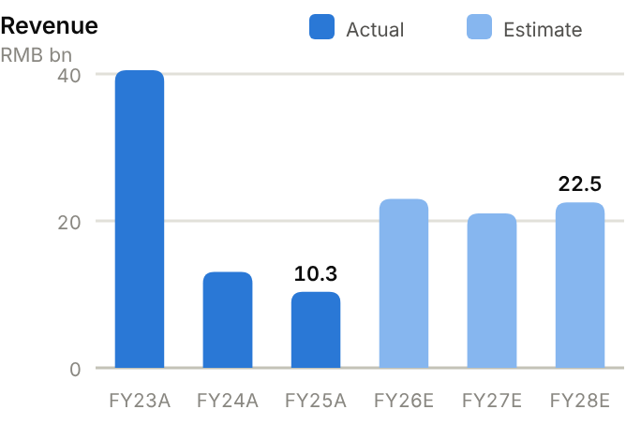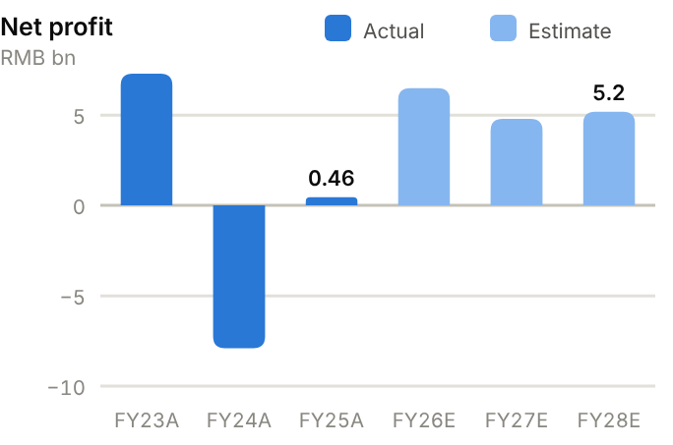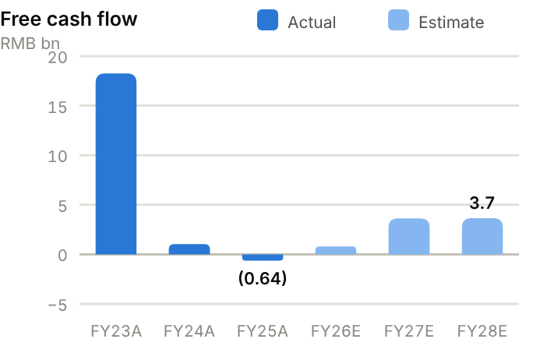
Income statement. Tianqi's P&L follows the lithium price. Revenue fell from RMB40.5bn (FY23) to RMB13.1bn (FY24) and RMB10.3bn (FY25) before rebounding to RMB17.8bn TTM. Gross margin swung from 83% to 37% and back to 57% TTM. Net profit went from RMB7.3bn (FY23) to a RMB7.9bn loss (FY24, inventory write-downs and impairments), RMB0.46bn (FY25) and RMB4.2bn in H1'26 alone. We forecast net profit of RMB6.50bn/4.80bn/5.20bn for FY26-28E on lithium carbonate averaging ~RMB130k/t in 2026 and ~RMB110k/t in 2027.
Source: company filings via StockAnalysis/S&P Global. Jun-26 = latest interim balance sheet. Debt includes leases. | Balance sheet. Total assets are RMB83bn (June 2026). About half are long-term investments: the SQM stake and Greenbushes-related assets. PP&E is RMB22bn. Debt rose from RMB11.8bn (FY23) to RMB17.5bn, but cash recovered to RMB11.8bn after the 2026 H-share placement, so net debt fell from RMB9.6bn (FY25) to RMB5.7bn (June 2026), ~23% of equity at FY25. Liquidity is strong (current ratio 2.78x). Equity attributable is RMB48.3bn (BVPS ~RMB28, A-share P/B ~1.1x, H-share ~0.6x). Minority interests (RMB11.1bn) represent IGO's share of the Australian holding company.
  Balance sheet (RMB bn) | FY23A | FY24A | FY25A | Jun-26A
  Cash & short-term investments | 9.6 | 6.4 | 5.7 | 11.8
  Receivables | 4.9 | 2.6 | 2.1 | 7.0
  Inventory | 3.2 | 2.3 | 2.4 | 2.8
  PP&E | 17.6 | 18.7 | 21.8 | 22.1
  Total assets | 73.2 | 68.7 | 72.1 | 83.1
  Accounts payable | 2.5 | 1.6 | 1.4 | 1.3
  Total debt | 11.8 | 14.9 | 15.3 | 17.5
  Equity (attributable) | 51.5 | 41.9 | 42.4 | 48.3
  Minority interests | 2.7 | 7.3 | 9.5 | 11.1
  Net cash / (net debt) | (2.2) | (8.5) | (9.6) | (5.7)

Cash flow (RMB bn) | FY23A | FY24A | FY25A | TTM Jun-26 | FY26E | FY27E | FY28E
Net profit (attributable) | 7.3 | (7.9) | 0.5 | – | 6.5 | 4.8 | 5.2
D&A | 0.8 | 1.1 | 1.4 | 1.5 | 1.6 | 1.7 | 1.9
Operating cash flow | 22.7 | 5.6 | 3.0 | 3.4 | 4.3 | 7.1 | 6.7
Capex | (4.4) | (4.5) | (3.6) | (2.9) | (3.5) | (3.5) | (3.0)
Free cash flow | 18.2 | 1.0 | (0.6) | 0.5 | 0.8 | 3.6 | 3.7
Dividends paid | (5.6) | (2.9) | (0.8) | (0.7) | 0.0 | 0.0 | (0.5)
Net cash / (debt), period-end | (2.2) | (8.5) | (9.6) | (5.7) | (6.2) | (2.6) | 0.5
OCF / net profit (x) | 3.11 | n.m. | 6.44 | n.m. | 0.66 | 1.48 | 1.28

TTM = twelve months to June 2026; Jun-26 net cash in the TTM column. E = our estimates: OCF = net profit + D&A − increase in working capital; net cash rolls forward FCF less dividends plus equity raised.
Cash flow. Operating cash flow collapsed from RMB22.7bn (FY23) to RMB5.6bn (FY24) and RMB3.0bn (FY25). With capex of RMB3.6-4.5bn a year, free cash flow fell from RMB18.2bn to roughly break-even (FY25: −RMB0.64bn), and dividends were cut from RMB5.6bn to RMB0.75bn. The H-share placement added ~RMB2.6bn of equity in 2026. We forecast FCF of RMB0.79bn/3.6bn/3.7bn as H1'26 profits turn into cash, taking the company to roughly net-cash neutral by FY28E.
ROE/ROA on average balances. Days on year-end balances: receivables on revenue, inventory and payables on cost of sales. Net debt/equity below zero = net cash. Payout = DPS/EPS. n.m./– = not meaningful or not modelled. | Key ratios. ROE swung from 14.2% (FY23) to 16.9% (FY24) and 1.1% (FY25); we expect 13.9% in FY26E, easing to ~8.9%. Asset turnover is very low (0.15x in FY25) because of the SQM stake. Net debt/EBITDA was 2.23x at FY25 but falls below 1x on TTM EBITDA (~RMB10.5bn). Receivable and inventory days rose in FY25 (75 and 134).
  Key ratios | FY23A | FY24A | FY25A | FY26E | FY27E | FY28E
  Revenue growth | – | −68% | −21% | 122% | −9% | 7%
  Gross margin | 83.2% | 40.6% | 36.6% | 58.0% | 52.0% | 52.0%
  Net margin | 18.0% | −60.6% | 4.4% | 28.3% | 22.9% | 23.1%
  ROE (avg. equity) | 14.2% | −16.9% | 1.1% | 13.9% | 8.9% | 8.9%
  ROA (avg. assets) | 10.0% | −11.1% | 0.7% | – | – | –
  Asset turnover (x) | 0.55 | 0.18 | 0.15 | – | – | –
  Receivable days | 45 | 71 | 75 | – | – | –
  Inventory days | 169 | 108 | 134 | – | – | –
  Payable days | 135 | 75 | 80 | – | – | –
  Current ratio (x) | 2.95 | 2.55 | 2.78 | – | – | –
  Net debt / equity | 4% | 20% | 23% | 12% | 5% | −1%
  Net debt / EBITDA (x) | 0.1 | 1.6 | 2.2 | – | – | –
  Capex / revenue | 11.0% | 34.6% | 34.8% | 15.2% | 16.7% | 13.3%
  FCF margin | 45.0% | 7.9% | −6.2% | 3.5% | 17.2% | 16.2%
  Dividend payout | 30% | – | 0% | 0% | 11% | 13%

Valuation
Source: StockAnalysis/S&P Global, 12 Oct 2026 (trailing EV/EBITDA and EV/sales; consensus forward P/E). | 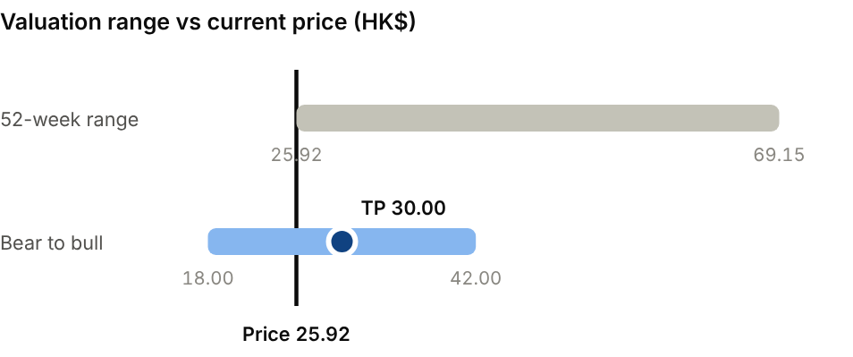  Bear (Lithium carbonate ~RMB80k/t): HK$18.00. Bull (Lithium carbonate ~RMB160k/t): HK$42.00.
  Company | Ticker | Fwd P/E | EV/EBITDA | EV/sales
  Albemarle | ALB US | 10.9x | 8.3x | 2.1x
  SQM | SQM US | 8.2x | 6.4x | 2.9x
  Pilbara Minerals | PLS AU | 11.5x | 9.4x | 5.3x
  Ganfeng Lithium (A) | 002460 CH | 13.3x | 12.9x | 3.0x
  Tianqi (A-share) | 9696 HK | 10.1x | 7.8x | 4.5x

Our TP of HK$30.00 is 9x FY27E EPS of RMB2.82 (at HK$1 = RMB0.853), in line with SQM (~8x) and below Albemarle and Pilbara (~11x forward), to reflect conversion-asset risk. Even at the TP the H-share is only ~0.7x book. The A-share consensus target is RMB64.2, and a broker H-share target in the source pack is HK$49.42; both assume higher prices than we do. Bear case HK$18.00: carbonate ~RMB80k/t. Bull case HK$42.00: ~RMB160k/t.
Sources: Company H1'26 HKEX results; IGO ASX quarterlies; Wood Mackenzie; Trading Economics/SMM; StockAnalysis/S&P Global; IBKR; source pack (Futu broker forecasts).
13 · BATTERY, LITHIUM & STORAGE · LITHIUM & BATTERIES
Ganfeng Lithium 赣锋锂业  1772.HK · Initiation of coverage · 12 October 2026 | HOLD  TP HK$31.50  Price HK$27.96 · +13%
More diversified than Tianqi, but management's own price view caps the upside
Ganfeng is China's most diversified lithium group: chemicals from mines in Australia, Argentina and Mali, plus a fast-growing battery business. H1'26 revenue rose 177% and profit swung to RMB4.3bn, but management now expects only a balanced market in 2027 and net debt is rising. The H-share trades on 8.9x FY27E P/E at a ~45% discount to the A-share. We initiate at Hold, TP HK$31.50 (+13% upside).  - Batteries give Ganfeng real diversification. The battery business (consumer, storage and power; ~20GWh in H1'26) was 34% of revenue, which cushions lithium-price swings, and 400-500Wh/kg solid-state cells are entering small-batch production.  - The resource ramp-up is lifting feedstock self-sufficiency. Goulamina (Mali) and Mariana/Cauchari-Olaroz (Argentina) are ramping, which cuts third-party concentrate purchases.  - The lithium cycle is turning. Management has dropped its earlier >RMB200k/t price view and now expects a balanced 2027 with 20-25% supply growth; we model FY27E EPS down ~20%.  Catalysts  - Q3'26 results (mid-October).  - Goulamina and Mariana ramp-up data.  - Solid-state battery customer orders.  Key risks  - Lithium prices and rising leverage.  - Political and fiscal risk in Mali, Argentina and Mexico.  - Battery price competition.  - Upside: faster solid-state commercialisation or industry supply cuts. | Key data  H1'26 revenue mix (%)  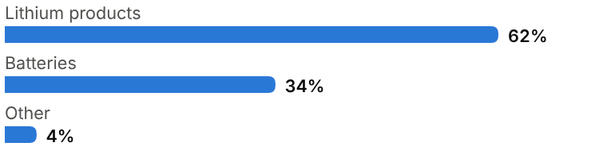
  Price (12 Oct 2026) | HK$27.96
  Target price (12m) | HK$31.50
  Implied return | +12.7%
  Market cap | RMB81.5bn (A+H) / US$12.2bn
  Enterprise value | RMB115.2bn
  Net debt | RMB27.1bn
  Shares outstanding | 2.08bn
  52-week range | 27.96-91.20
  Performance | -48.8% YTD
  Dividend yield (FY26E) | 1.3%
  Consensus target | RMB77.92 (A-share), 20 analysts
  Other listing | A-share 002460.SZ at RMB43.68 (H at ~45% discount)

Key financials and valuation
Year to December | FY23A | FY24A | FY25A | FY26E | FY27E | FY28E
Revenue (RMB bn) | 33.0 | 18.9 | 23.1 | 46.0 | 48.0 | 54.0
YoY growth | – | −43% | +22% | +99% | +4% | +12%
Gross margin | 8.7% | 9.0% | 14.6% | 27.0% | 24.0% | 24.0%
Net profit, attributable (RMB bn) | 4.95 | (2.07) | 1.61 | 7.00 | 5.60 | 6.40
YoY growth | n.m. | −142% | n.m. | +335% | −20% | +14%
EPS (RMB) | 2.46 | (1.03) | 0.79 | 3.37 | 2.69 | 3.08
P/E on H-share price (x) | 9.7x | n.m. | 30.2x | 7.1x | 8.9x | 7.8x
DPS (RMB) | 0.80 | 0.15 | 0.15 | 0.30 | 0.30 | 0.35
Dividend yield | 3.4% | 0.6% | 0.6% | 1.3% | 1.3% | 1.5%

A = actual (company reports; StockAnalysis/S&P Global), E = our estimates. Multiples at the 12-Oct-2026 price, converted at HK$1 = RMB0.853.

Company background
Ganfeng Lithium was founded in 2000 in Xinyu, Jiangxi, by Li Liangbin (chairman) and Wang Xiaoshen. It started as a maker of lithium metal and specialty lithium compounds, and it remains the world's largest lithium-metal producer, a material used in pharmaceuticals, alloys and next-generation batteries. It listed in Shenzhen in 2010 and in Hong Kong in 2018, and used both markets to fund a decade of resource acquisitions.
Ganfeng built one of the most diversified lithium resource portfolios worldwide. It holds Mt Marion spodumene in Australia (with Mineral Resources), the Cauchari-Olaroz brine in Argentina (with Lithium Argentina; first production in 2023), the Mariana brine (Argentina), the Goulamina spodumene mine in Mali (fully owned after buying out Leo Lithium in 2024; production from late 2024), and lepidolite and brine assets in China. Some bets have run into trouble: Mexico revoked its Sonora lithium-clay concessions in 2023, and Mali's military government has tightened mining rules. In parallel, Ganfeng LiEnergy has grown into a sizeable battery business making consumer cells, storage systems and power batteries. It is one of China's leading developers of solid-state batteries, with 400Wh/kg cells validated and 500Wh/kg cells in small-batch production in 2026.
Milestones | Ownership and listing
  2000 | Founded in Xinyu, Jiangxi; starts with lithium metal and compounds.
  2010 / 2018 | Shenzhen listing (002460.SZ); Hong Kong listing (1772.HK).
  2015-17 | Secures Mt Marion (Australia) and Cauchari-Olaroz (Argentina) interests.
  2023 | Cauchari-Olaroz produces first carbonate; Mexico revokes Sonora concessions.
  2024 | Takes full control of Goulamina (Mali); first spodumene; FY24 loss RMB2.1bn.
  2026 | 400Wh/kg solid-state cell validated; 500Wh/kg small-batch production; H1 profit RMB4.3bn.
  Founders | Li Liangbin (chairman) and Wang Xiaoshen are the largest shareholders
  Share classes | A-share 002460.SZ; H-share 1772.HK (~45% discount to A)
  Battery subsidiary | Ganfeng LiEnergy (consumer, storage, power and solid-state cells)

The business
Ganfeng has two businesses. The lithium business (RMB14.2bn, 62% of H1'26 revenue) mines and buys spodumene, brine and lepidolite and converts it into lithium carbonate, hydroxide, chloride, metal and organolithium compounds for cathode, battery, pharmaceutical and industrial customers. It earns a conversion margin on everything it processes and a mining margin on the share it mines itself. Self-sufficiency is rising as Goulamina, Mariana and Cauchari-Olaroz ramp.
The battery business (RMB7.8bn, 34% of revenue; about 20GWh in H1'26) makes small-format consumer cells (1.5m cells a day across two bases), storage cells and 5MWh containerised systems, and power batteries for commercial vehicles and two-wheelers. Margins are lower than in lithium at the top of the cycle but more stable, and the business gives Ganfeng a captive outlet for its lithium. The solid-state programme (lithium-metal anodes, sulfide electrolytes) targets premium EVs, eVTOLs and robots; it is strategically important but does not yet earn revenue at scale.
Economically, Ganfeng is more diversified than Tianqi but has a higher-cost, more geopolitically exposed resource base and more debt. FY25 gross margin was only 14.6%, recovering to 31.2% in H1'26. Heavy development capex in Mali and Argentina (RMB7-9bn a year over FY23-25) pushed net debt to ~RMB29bn. Recycling and lithium-sulfide supply for solid-state electrolytes add smaller revenue streams.
Ganfeng is integrating in both directions. Upstream, it is lifting self-sufficiency in lithium resources as Goulamina, Mariana and Cauchari-Olaroz ramp, which should lower its cost position through the cycle. Downstream, it uses the battery business and solid-state technology to capture more of the value chain, accepting lower margins today for a position in next-generation cells. We assume capex slows to RMB5-6bn a year in FY26-28E, from RMB7-9bn in FY23-25, which is what allows free cash flow to turn positive.
Revenue mix and economics (H1'26)
Segment | Share of revenue | Key assets / products | Economics
Lithium products | 62% (RMB14.2bn) | Carbonate, hydroxide, metal, compounds; own mines in Mali, Argentina, Australia | Price-driven; rising self-sufficiency
Batteries | 34% (RMB7.8bn) | Consumer cells, storage systems, power batteries (~20GWh) | Lower, steadier margins
Other | 4% | Recycling, materials | Small

Competitive landscape
In lithium chemicals Ganfeng competes with Tianqi, Albemarle, SQM, Rio Tinto (Arcadium), Yahua and Zangge, and with integrated battery makers such as CATL. Its scale and product breadth (especially lithium metal and specialty compounds) are distinctive. Its resource portfolio is diversified but on average higher-cost than Greenbushes, and it carries more country risk.
In batteries, Ganfeng is a mid-sized player competing with CATL, BYD, EVE, Gotion and many smaller firms for storage and consumer cells. Ganfeng's edge is upstream integration and its solid-state technology, where it is among China's leaders alongside CATL, WeLion and QingTao. The risk is that storage price wars compress margins before scale benefits arrive.
Ganfeng's position is stronger in lithium metal than in mainstream chemicals. It is the world's largest producer of lithium metal, which feeds pharmaceutical, alloy and next-generation battery uses, and its high-purity metal and organolithium compounds face fewer competitors and steadier prices. Solid-state batteries with lithium-metal anodes would turn that niche into a much larger market, an option that pure miners do not have.
Main competitors
Competitor | Base | Focus | Position vs Ganfeng Lithium
Tianqi Lithium | China | Greenbushes interest, conversion, SQM stake | Lower-cost resource; less diversified
Albemarle / SQM | US / Chile | Hard rock and brine; conversion | Global incumbents; SQM lowest cost
Rio Tinto (Arcadium) | UK/Australia | Argentina brine, Australian/Canadian hard rock | Major's balance sheet; long-term builder
CATL / EVE | China | Batteries; CATL also upstream lithium | Battery scale leaders
WeLion / QingTao | China | Solid-state batteries | Rivals in next-generation cells

Industry structure: five forces
Force | Intensity | Assessment
Rivalry | High | The same commodity rivalry as Tianqi in lithium chemicals, plus a crowded battery market where CATL, BYD, EVE and Gotion set the price of storage and consumer cells.
New entrants | Medium | New lithium supply arrives within 2-4 years when prices rise, and battery capacity in China is already in surplus.
Supplier power | Medium | Ganfeng still buys part of its feedstock, and its own resources depend on host governments; Mexico revoked its Sonora concessions and Mali has tightened mining rules.
Buyer power | Medium | Global cathode makers, battery makers and carmakers buy on index-linked long-term agreements; battery buyers run competitive tenders.
Substitutes | Medium | Sodium-ion threatens lithium demand at the low end; in batteries, Ganfeng's solid-state work is a hedge against being substituted itself.

Moat and vulnerabilities
- Broadest lithium product range (metal, compounds) and diversified global resources.
- Captive battery business and leadership in solid-state development.
- Long relationships with global cathode and battery customers.
- Vulnerabilities: higher-cost/riskier resources (Mali, Argentina), net debt ~RMB27-29bn, price-taker economics.

Addressable market (TAM)
Ganfeng shares Tianqi's lithium market, ~1.5Mt LCE (~US$27bn) in 2026 on our estimates, growing 20-25% a year in demand but oversupplied near term. Management itself now expects a balanced market in 2027 with 20-25% supply growth, a retreat from its earlier view of prices above RMB200k/t.
The battery arm opens additional markets: storage (China storage-battery sales +83% in H1'26), consumer cells, and potentially solid-state batteries for premium EVs, eVTOLs and humanoid robots. These have much larger revenue pools than lithium chemicals, but Ganfeng is a small participant today.
At around RMB122k/t, much higher-cost lepidolite and African supply is profitable again, and restarts could cap prices over the next 18 months. Ganfeng's earnings are less sensitive to the lithium price than Tianqi's: it buys more of its feedstock at market-linked prices, and its battery business dilutes the commodity exposure.
Market | Size | Growth / dynamics | Source
Lithium demand (LCE) | ~1.5Mt / ~US$27bn (2026E) | Supply +20-25% into 2027 (mgmt) | Our estimate; company
Storage batteries | Fast-growing | China sales +83% (H1'26) | Industry data
Solid-state batteries | Pre-commercial | Small-batch 500Wh/kg cells (2026) | Company
Ganfeng battery output | ~20GWh (H1'26) | Growing | UOB Kay Hian

~20GWh  Ganfeng battery output in H1'26 (RMB7.8bn revenue) | +20-25%  Supply growth management expects into a 'balanced' 2027 | 500Wh/kg  Solid-state cells in small-batch production (May 2026)

Financial analysis
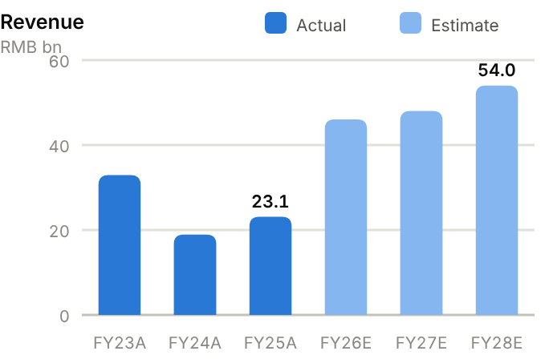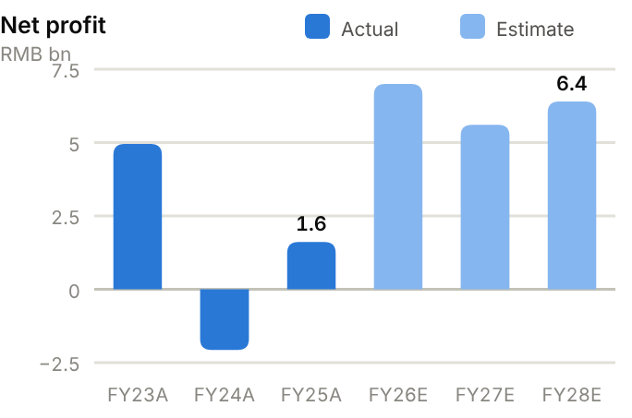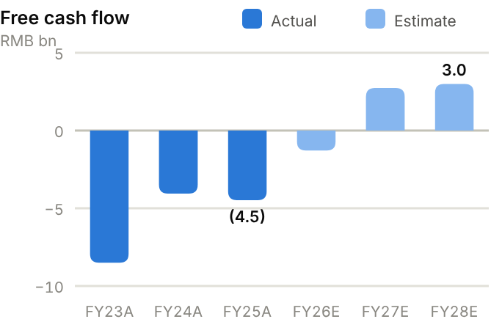
Income statement. Revenue fell from RMB33.0bn (FY23) to RMB18.9bn (FY24), with a RMB2.1bn loss, then recovered to RMB23.1bn and a RMB1.6bn profit in FY25 and RMB37.8bn TTM. FY23 profit (RMB4.9bn) was flattered by investment gains; operating profit was only RMB0.4bn. Gross margin troughed at ~9% in FY23-24, then recovered to 14.6% (FY25) and 31.2% in H1'26, when net profit reached RMB4.3bn. We forecast revenue of RMB46.0bn/48.0bn/54.0bn and net profit of RMB7.00bn/5.60bn/6.40bn, below UOB's RMB9.2bn for FY26E.
Source: company filings via StockAnalysis/S&P Global. Jun-26 = latest interim balance sheet. Debt includes leases. | Balance sheet. Total assets grew from RMB92bn (FY23) to RMB122bn (June 2026), driven by PP&E (RMB37.6bn) for Mali and Argentina and by working capital. Inventory reached RMB15.2bn and receivables RMB12.7bn (FY25: 241 and 162 days). Debt rose from RMB27.6bn to RMB40.1bn, so net debt is RMB27.1bn (June 2026), ~63% of FY25 equity and 10.2x FY25 EBITDA. The current ratio is 0.92x. Equity attributable is RMB48.2bn (BVPS ~RMB23; H-share P/B ~1.0x).
  Balance sheet (RMB bn) | FY23A | FY24A | FY25A | Jun-26A
  Cash & short-term investments | 9.9 | 6.5 | 9.3 | 13.0
  Receivables | 6.8 | 5.1 | 10.2 | 12.7
  Inventory | 8.3 | 8.6 | 13.0 | 15.2
  PP&E | 23.7 | 35.9 | 36.9 | 37.6
  Total assets | 91.7 | 100.8 | 113.3 | 122.3
  Accounts payable | 8.9 | 12.2 | 16.1 | 17.1
  Total debt | 27.6 | 35.8 | 38.0 | 40.1
  Equity (attributable) | 47.0 | 41.8 | 45.1 | 48.2
  Minority interests | 5.3 | 5.8 | 6.7 | 6.7
  Net cash / (net debt) | (17.7) | (29.3) | (28.6) | (27.1)

Cash flow (RMB bn) | FY23A | FY24A | FY25A | TTM Jun-26 | FY26E | FY27E | FY28E
Net profit (attributable) | 5.0 | (2.1) | 1.6 | – | 7.0 | 5.6 | 6.4
D&A | 0.9 | 1.3 | 2.1 | 2.3 | 2.3 | 2.5 | 2.8
Operating cash flow | 0.1 | 5.2 | 2.9 | 4.0 | 4.7 | 7.7 | 8.0
Capex | (8.6) | (9.2) | (7.4) | (4.9) | (6.0) | (5.0) | (5.0)
Free cash flow | (8.5) | (4.1) | (4.5) | (0.9) | (1.3) | 2.7 | 3.0
Dividends paid | (2.5) | (2.5) | (1.4) | (1.4) | (0.3) | (0.6) | (0.6)
Net cash / (debt), period-end | (17.7) | (29.3) | (28.6) | (27.1) | (30.2) | (28.1) | (25.8)
OCF / net profit (x) | 0.03 | n.m. | 1.83 | n.m. | 0.67 | 1.38 | 1.25

TTM = twelve months to June 2026; Jun-26 net cash in the TTM column. E = our estimates: OCF = net profit + D&A − increase in working capital; net cash rolls forward FCF less dividends plus equity raised.
Cash flow. Ganfeng has burned cash for three years. OCF was RMB0.1bn, RMB5.2bn and RMB2.9bn over FY23-25, against capex of RMB8.6bn, 9.2bn and 7.4bn, so FCF was negative each year (FY25 −RMB4.5bn), funded by debt and a RMB2.3bn equity raise. TTM FCF improved to −RMB0.88bn as capex fell. We forecast FCF of −RMB1.3bn in FY26E, then RMB2.7bn/3.0bn as capex normalises at ~RMB5bn, trimming net debt to ~RMB25.8bn by FY28E.
ROE/ROA on average balances. Days on year-end balances: receivables on revenue, inventory and payables on cost of sales. Net debt/equity below zero = net cash. Payout = DPS/EPS. n.m./– = not meaningful or not modelled. | Key ratios. ROE was 10.5%, 4.7% and 3.7% over FY23-25; we expect 14.4% in FY26E and ~10.3% thereafter. ROA is low (1.5% in FY25) because of the large asset base. Net debt/EBITDA of 10.2x (FY25) is the main risk metric, though it falls to ~3x on TTM EBITDA. Inventory days (241) are elevated.
  Key ratios | FY23A | FY24A | FY25A | FY26E | FY27E | FY28E
  Revenue growth | – | −43% | 22% | 99% | 4% | 12%
  Gross margin | 8.7% | 9.0% | 14.6% | 27.0% | 24.0% | 24.0%
  Net margin | 15.0% | −10.9% | 7.0% | 15.2% | 11.7% | 11.9%
  ROE (avg. equity) | 10.5% | −4.7% | 3.7% | 14.4% | 10.3% | 10.7%
  ROA (avg. assets) | 5.4% | −2.2% | 1.5% | – | – | –
  Asset turnover (x) | 0.36 | 0.20 | 0.22 | – | – | –
  Receivable days | 75 | 98 | 162 | – | – | –
  Inventory days | 100 | 183 | 241 | – | – | –
  Payable days | 108 | 259 | 299 | – | – | –
  Current ratio (x) | 1.39 | 0.69 | 0.92 | – | – | –
  Net debt / equity | 38% | 70% | 63% | 58% | 50% | 41%
  Net debt / EBITDA (x) | 14.4 | 29.0 | 10.2 | – | – | –
  Capex / revenue | 26.2% | 48.8% | 32.2% | 13.0% | 10.4% | 9.3%
  FCF margin | −25.8% | −21.5% | −19.4% | −2.8% | 5.7% | 5.5%
  Dividend payout | 33% | – | 19% | 9% | 11% | 11%

Valuation
Source: StockAnalysis/S&P Global, 12 Oct 2026 (trailing EV/EBITDA and EV/sales; consensus forward P/E). | 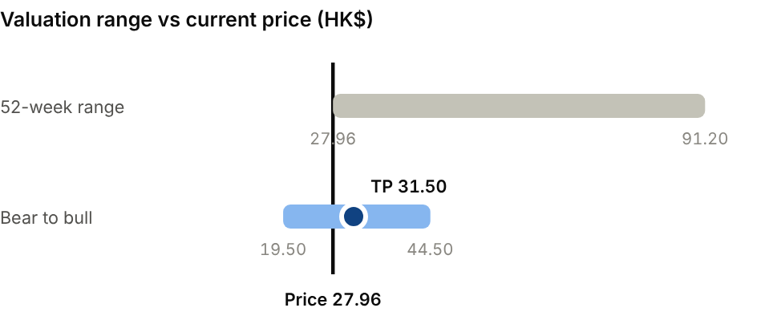  Bear (Lithium carbonate ~RMB80k/t): HK$19.50. Bull (~RMB160k/t plus solid-state traction): HK$44.50.
  Company | Ticker | Fwd P/E | EV/EBITDA | EV/sales
  Albemarle | ALB US | 10.9x | 8.3x | 2.1x
  SQM | SQM US | 8.2x | 6.4x | 2.9x
  Pilbara Minerals | PLS AU | 11.5x | 9.4x | 5.3x
  Tianqi Lithium (A) | 002466 CH | 10.1x | 7.8x | 4.5x
  Ganfeng (A-share) | 1772 HK | 13.3x | 12.9x | 3.0x

Our TP of HK$31.50 is 10x FY27E EPS of RMB2.69: a small premium to our Tianqi multiple for diversification, and in line with Albemarle (~11x) and Pilbara (~11.5x) forward. It implies ~0.9x book for the H-share. UOB's HK$75 target and the A-share consensus (RMB77.9) both embed higher lithium prices. Bear case HK$19.50: carbonate ~RMB80k/t. Bull case HK$44.50: ~RMB160k/t plus solid-state traction.
Sources: Company H1'26 interim report; UOB Kay Hian; CnEVPost/CarNewsChina; Tiger Brokers; StockAnalysis/S&P Global; IBKR; source pack.
14 · SEMICONDUCTORS & MATERIALS · ADVANCED MATERIALS
China Jushi 中国巨石  600176.SH · Initiation of coverage · 12 October 2026 | HOLD  TP RMB45.00  Price RMB38.30 · +17%
AI has turned a commodity producer into a growth story, but pricing still drives earnings
China Jushi is the world's largest glass-fibre maker. AI-server demand for high-layer PCBs has tightened supply of electronic yarn and cloth, which lifted H1'26 net profit 74%. The stock more than doubled, then halved from its peak. At 17.0x FY27E P/E the valuation is fair for a business whose earnings still hinge on e-cloth pricing. We initiate at Hold, TP RMB45.00 (+17% upside).  - Electronic cloth is the main profit driver. The price of 7628 e-fabric averaged RMB6.02/m in H1'26 (+49%) and rose another 15-20% in September, while roving prices were flat.  - New capacity is arriving on time. The 100kt Huai'an e-glass line (with 390m metres of cloth) hit full output by June. A 50kt/320m-metre line and a Tongxiang project follow and will take global e-glass share from ~23% toward ~28%.  - Much of this is priced in, and supply is responding. Kingboard, Taishan (Sinoma) and others are adding e-yarn capacity, and Zhenshi Group, the second-largest shareholder, is selling.  Catalysts  - Q3'26 results on 20 October.  - E-cloth price announcements.  - Certification of low-dielectric products.  Key risks  - E-yarn and e-cloth capacity additions by peers.  - Roving price war; energy costs.  - Share overhang from Zhenshi Group selling.  - Trade actions on Chinese or Egyptian glass fibre. | Key data  Key operating indicators
  Price (12 Oct 2026) | RMB38.30
  Target price (12m) | RMB45.00
  Implied return | +17.5%
  Market cap | RMB152.0bn / US$22.7bn
  Enterprise value | RMB165.0bn
  Net debt | RMB11.5bn
  Shares outstanding | 4.00bn
  52-week range | 14.78-77.20
  Performance | +124.0% YTD
  Dividend yield (FY26E) | 1.8%
  Consensus target | RMB63.27, 16 analysts
  Other listing | A-share only
  7628 e-cloth price, H1'26 | RMB6.02/m (+49%)
  Roving price, H1'26 | Flat YoY
  Huai'an e-glass line (2026) | 100kt yarn + 390m m cloth
  Next Huai'an line | 50kt + 320m m (1.5-yr build)
  Global e-glass fibre share | ~23% → ~28%

Key financials and valuation
Year to December | FY23A | FY24A | FY25A | FY26E | FY27E | FY28E
Revenue (RMB bn) | 14.9 | 15.9 | 18.9 | 25.0 | 30.5 | 33.0
YoY growth | – | +7% | +19% | +32% | +22% | +8%
Gross margin | 27.9% | 24.8% | 33.0% | 39.0% | 41.0% | 40.0%
Net profit, attributable (RMB bn) | 3.04 | 2.45 | 3.29 | 6.90 | 9.00 | 9.80
YoY growth | n.m. | −19% | +34% | +110% | +30% | +9%
EPS (RMB) | 0.76 | 0.61 | 0.82 | 1.73 | 2.25 | 2.45
P/E (x) | 50.4x | 62.8x | 46.7x | 22.2x | 17.0x | 15.6x
DPS (RMB) | 0.28 | 0.24 | 0.36 | 0.69 | 0.90 | 0.98
Dividend yield | 0.7% | 0.6% | 0.9% | 1.8% | 2.3% | 2.6%

A = actual (company reports; StockAnalysis/S&P Global), E = our estimates. Multiples at the 12-Oct-2026 price.

Company background
China Jushi traces its roots to a township glass-fibre workshop in Tongxiang, Zhejiang, in the 1970s that grew into Jushi Group, formally established in 1993. The listed entity joined the Shanghai Stock Exchange in 1999 as China Fiberglass, with state-owned China National Building Material (CNBM) as its controlling shareholder, and was renamed China Jushi in 2016. The Zhenshi Group, the vehicle of Jushi's founding management, is the second-largest shareholder and has been selling shares.
Jushi grew into the world's largest glass-fibre producer by building ever-larger tank furnaces and pushing down energy and raw-material costs. It went abroad early, building a plant in Egypt's Suez economic zone from the early 2010s to serve Europe and the Middle East tariff-free, then a plant in South Carolina, US, in 2019. Its Chinese bases are in Tongxiang, Jiujiang, Chengdu and Huai'an. A long-standing issue is horizontal competition with Taishan Fiberglass, owned by sister company Sinoma Science & Technology, which is also controlled by CNBM. In 2026 Jushi started a 100kt electronic-grade glass-fibre line in Huai'an (with 390m metres of cloth capacity) and approved further e-cloth investments to serve AI-server circuit boards.
Milestones | Ownership and listing
  1993 | Jushi Group established in Tongxiang, Zhejiang (roots in a 1970s township plant).
  1999 | Listed in Shanghai as China Fiberglass (600176.SH); CNBM is the controlling shareholder.
  Early 2010s | First overseas plant in Egypt (Suez) to serve Europe and the Middle East.
  2016 | Renamed China Jushi.
  2019 | US plant in South Carolina starts production.
  2021-22 | Cycle peak: net profit RMB6.0bn and RMB6.6bn.
  2026 | 100kt Huai'an e-glass line at full output; e-cloth price +49%; RMB2.4bn e-cloth project.
  Controlling shareholder | China National Building Material (CNBM, state-owned), ~29%
  Second-largest shareholder | Zhenshi Group (founding management), ~15%, selling
  Sister company | Sinoma Science & Technology (Taishan Fiberglass), also CNBM-controlled

The business
Glass fibre is made by melting silica-rich minerals in continuous tank furnaces and drawing the melt through platinum-rhodium bushings into fine filaments. Furnaces run non-stop for 8-10 years before a cold repair, so the business is capital- and energy-intensive with high fixed costs. Scale, furnace efficiency, energy prices and utilisation determine cost position, and Jushi is the industry cost leader with its own mineral mines, large furnaces and automated lines.
Products fall into two families. Reinforcement fibre (direct and assembled roving, chopped strands, mats and fabrics), the bulk of volume, goes into wind-turbine blades, construction materials, pipes and tanks, automotive thermoplastics and consumer goods. Its pricing follows the capacity cycle and was flat in H1'26. Electronic yarn and woven electronic cloth go to copper-clad-laminate makers (Kingboard, Shengyi, Nan Ya and others), who make the base material for printed circuit boards. This second family is the profit engine today. AI servers and high-speed networking boards use more layers and more cloth; standard 7628 cloth averaged RMB6.02/m in H1'26 (+49%), and prices rose a further 15-20% in September.
Jushi sells mostly direct to industrial customers in China and abroad (Egypt and US plants serve Europe and North America). Working capital is moderate (receivables ~116 days, inventory ~100 days at FY25), and the balance sheet carries ~RMB11bn of net debt from successive capacity builds. Jushi now needs to move up the e-cloth value chain into thin and low-dielectric grades, where Japan's Nittobo leads. Its low-dielectric products are in customer certification.
Products, end-markets and 2026 price trend
Product family | End-markets | 2026 price trend | Economics
Direct / assembled roving | Wind blades, pipes, construction | Flat (H1'26) | Bulk volume; cost leadership decisive
Chopped strands & thermoplastics | Autos, appliances, consumer goods | Stable | Mid margins
Electronic yarn & cloth | Copper-clad laminates → PCBs (AI servers) | 7628 cloth +49%; +15-20% in Sept | Profit engine; capacity expanding
Low-dielectric e-cloth | High-speed / AI server boards | Premium | In certification; Nittobo leads

Competitive landscape
China produces the large majority of the world's glass fibre, and the industry is concentrated: Jushi, Taishan Fiberglass (Sinoma S&T) and Chongqing Polycomp (CPIC) are the big three. Outside China, the main producers are Saint-Gobain/Vetrotex, Johns Manville and Nippon Electric Glass. Competition is mostly on price and delivery for standard roving, and cost leadership lets Jushi win share in downturns. The main risk is capacity additions: every price spike draws new furnaces, which then depress prices for years.
Electronic yarn and cloth have a different set of rivals: Kingboard (which commissioned a 70kt e-yarn line and is adding cloth), Taiwan Glass, Grace Fabric and Honghe at the standard end, and Nittobo (Japan) in premium low-dielectric and low-CTE cloth. Jushi expects to lift its share of global electronic-grade fibre from ~23% to ~28% with Huai'an. Jushi leads on scale and cost but lags in the top-end grades used in the most advanced AI boards.
Main competitors
Competitor | Base | Focus | Position vs China Jushi
 | China (CNBM) | Roving, e-yarn, wind materials | No.2; sister company under CNBM
Chongqing Polycomp (CPIC) | China | Roving, e-yarn | No.3; regional cost base
Nitto Boseki (Nittobo) | Japan | Premium low-Dk / low-CTE e-cloth | Technology leader in AI-grade cloth
Kingboard / Taiwan Glass / Grace Fabric | HK / Taiwan / China | E-yarn and e-cloth | Adding capacity
Saint-Gobain / Johns Manville / NEG | Europe / US / Japan | Reinforcement fibre | Higher cost; regional strongholds

Industry structure: five forces
Force | Intensity | Assessment
Rivalry | Medium | Taishan Fiberglass (Sinoma), Chongqing Polycomp, Owens Corning and NEG are the main rivals; capacity additions in China periodically trigger price wars.
New entrants | Low | A tank furnace costs over RMB1bn and takes about two years to build, and electronic-grade yarn needs process know-how; new capacity mostly comes from incumbents.
Supplier power | Low | Pyrophyllite, kaolin and limestone are abundant and partly self-supplied; natural gas and electricity are the main cost variables.
Buyer power | Medium | Wind-blade and copper-clad-laminate makers are large and negotiate; construction, auto and industrial demand is fragmented.
Substitutes | Low | Carbon fibre substitutes at the top end (e.g. long blade spars) at a large cost premium; steel and aluminium compete in some composite uses.

Moat and vulnerabilities
- Industry-lowest cost from scale, large furnaces, own minerals and automation.
- Global footprint (Egypt, US) that mitigates trade barriers.
- Integrated yarn-to-cloth chain and fast capacity execution in electronic grades.
- Vulnerabilities: capacity cycles, energy costs, Zhenshi share overhang, lag in premium low-Dk cloth.

Addressable market (TAM)
China produced 8.43Mt of glass-fibre yarn in 2025 (+11.5%), most of global output. Demand grows roughly with industrial production plus structural drivers: lightweighting in autos, wind-turbine blades, infrastructure composites and electronics. The reinforcement market is large but low-growth and cyclical. At a few thousand RMB per tonne, it is a market worth tens of billions of RMB, where share is won on cost.
Electronic-grade fibre is a smaller but faster-growing and higher-value segment. AI servers, 800G networking and automotive electronics use thicker, multi-layer boards with more and better cloth. Jushi's Huai'an line alone represents ~9% of global e-cloth capacity, and its share of electronic-grade fibre should rise to ~28%. Price is driving the value of the addressable market as much as volume is, so the outlook is sensitive to capacity additions by peers.
Market | Size | Growth / dynamics | Source
China glass-fibre yarn output | 8.43Mt (2025) | +11.5% in 2025 | Industry data
Electronic-grade glass fibre | Jushi ~23% → ~28% share | AI-server and networking boards | Company/press
7628 electronic cloth price | RMB6.02/m (H1'26) | +49% YoY; +15-20% in Sept | Futu/industry
Huai'an e-glass line | 100kt + 390m metres | ~9% of global e-cloth capacity | China Daily/company

8.43Mt  China glass-fibre yarn output in 2025 (+11.5%) | ~23% → 28%  Jushi share of global electronic-grade glass fibre after Huai'an | +15-20%  E-cloth price increases announced in September 2026

Financial analysis
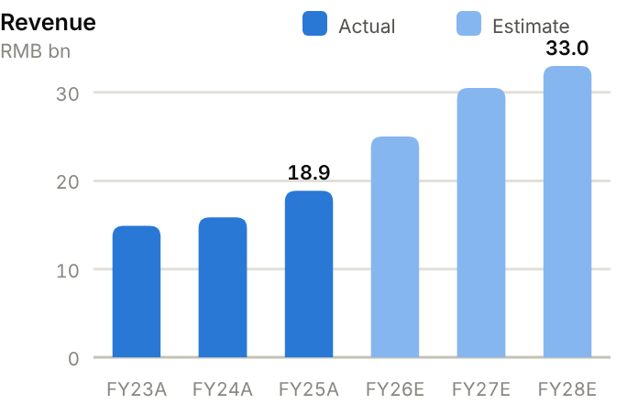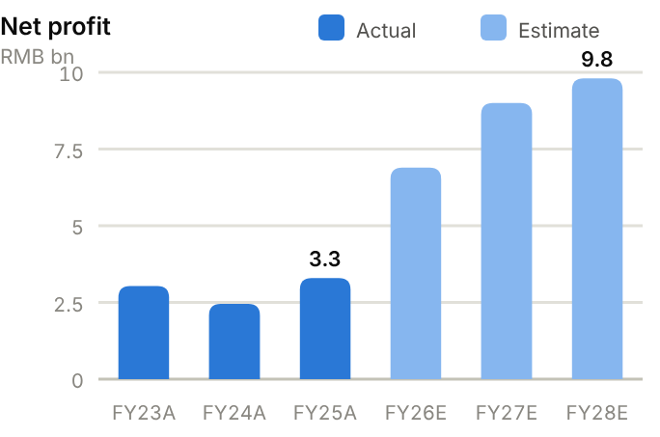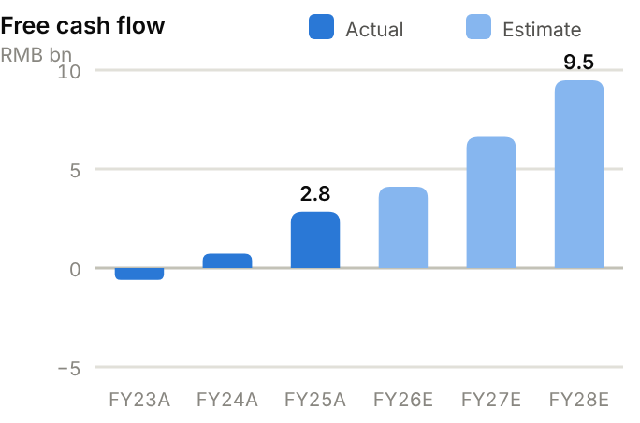
Income statement. Revenue fell from RMB20.2bn (FY22) to RMB14.9bn (FY23) as glass-fibre prices slumped, then recovered to RMB18.9bn (FY25) and RMB20.9bn TTM. Gross margin bottomed at 24.8% (FY24) and rebounded to 33.0% (FY25) and 38.1% TTM. Operating profit rose from RMB2.6bn (FY23) to RMB4.6bn (FY25), and net profit from RMB2.4bn (FY24) to RMB3.3bn (FY25) and RMB2.9bn in H1'26 alone (+74%). We forecast revenue of RMB25.0bn/30.5bn/33.0bn and net profit of RMB6.90bn/9.00bn/9.80bn for FY26-28E.
Source: company filings via StockAnalysis/S&P Global. Jun-26 = latest interim balance sheet. Debt includes leases. | Balance sheet. Jushi is asset-heavy: PP&E of RMB36-38bn is two-thirds of total assets (RMB57.6bn in June 2026). Debt has been stable at ~RMB14.6bn and cash at ~RMB3bn, so net debt has held around RMB11.1bn (FY25) and RMB11.5bn (June 2026), ~36% of equity and 1.57x EBITDA. Working capital improved as inventory days fell from 154 (FY23) to 103 (FY25) while receivable days are 116. The current ratio is only 1.05x because of short-term borrowings. Equity attributable is RMB33.2bn (BVPS ~RMB8.3).
  Balance sheet (RMB bn) | FY23A | FY24A | FY25A | Jun-26A
  Cash & short-term investments | 3.1 | 3.1 | 3.5 | 3.1
  Receivables | 5.3 | 5.3 | 6.0 | 7.3
  Inventory | 4.5 | 4.2 | 3.6 | 3.4
  PP&E | 35.0 | 35.8 | 36.3 | 38.0
  Total assets | 52.1 | 53.4 | 54.6 | 57.6
  Accounts payable | 1.6 | 1.2 | 1.8 | 2.1
  Total debt | 14.5 | 14.9 | 14.6 | 14.6
  Equity (attributable) | 28.6 | 30.0 | 31.1 | 33.2
  Minority interests | 1.4 | 1.4 | 1.5 | 1.5
  Net cash / (net debt) | (11.4) | (11.8) | (11.1) | (11.5)

Cash flow (RMB bn) | FY23A | FY24A | FY25A | TTM Jun-26 | FY26E | FY27E | FY28E
Net profit (attributable) | 3.0 | 2.5 | 3.3 | – | 6.9 | 9.0 | 9.8
D&A | 2.1 | 2.3 | 2.5 | 2.4 | 2.7 | 3.0 | 3.3
Operating cash flow | 0.9 | 2.0 | 4.2 | 5.2 | 8.1 | 10.6 | 12.5
Capex | (1.5) | (1.3) | (1.4) | (3.2) | (4.0) | (4.0) | (3.0)
Free cash flow | (0.6) | 0.7 | 2.8 | 2.0 | 4.1 | 6.6 | 9.5
Dividends paid | (2.5) | (1.4) | (1.6) | (1.4) | (1.4) | (2.8) | (3.6)
Net cash / (debt), period-end | (11.4) | (11.8) | (11.1) | (11.5) | (8.4) | (4.6) | 1.3
OCF / net profit (x) | 0.29 | 0.83 | 1.28 | n.m. | 1.17 | 1.18 | 1.27

TTM = twelve months to June 2026; Jun-26 net cash in the TTM column. E = our estimates: OCF = net profit + D&A − increase in working capital; net cash rolls forward FCF less dividends plus equity raised.
Cash flow. Operating cash flow rose from RMB0.9bn (FY23) to RMB4.2bn (FY25) and RMB5.2bn TTM as prices recovered and inventory was released. With maintenance-level capex of RMB1.3-1.5bn, FCF went from −RMB0.59bn (FY23) to RMB2.8bn (FY25), but capex has since stepped up to RMB3.2bn TTM for the new e-glass lines. Dividends (RMB1.4-2.5bn) and a RMB0.54bn buyback absorbed most FCF. We forecast FCF of RMB4.1bn/6.6bn/9.5bn with capex of RMB3-4bn, and expect net debt to be gone by FY28E.
ROE/ROA on average balances. Days on year-end balances: receivables on revenue, inventory and payables on cost of sales. Net debt/equity below zero = net cash. Payout = DPS/EPS. n.m./– = not meaningful or not modelled. | Key ratios. ROE was 10.6%, 8.3% and 10.8% over FY23-25, well below the ~20%+ of the 2021-22 peak. We expect ~20.4% in FY26E and ~22.7% in FY27E as e-cloth profits flow through. ROA is 6.1%, and asset turnover is low (0.35x), typical for a furnace-based business. The payout ratio was 44% on FY25 EPS.
  Key ratios | FY23A | FY24A | FY25A | FY26E | FY27E | FY28E
  Revenue growth | – | 7% | 19% | 32% | 22% | 8%
  Gross margin | 27.9% | 24.8% | 33.0% | 39.0% | 41.0% | 40.0%
  Net margin | 20.4% | 15.4% | 17.4% | 27.6% | 29.5% | 29.7%
  ROE (avg. equity) | 10.6% | 8.3% | 10.8% | 20.4% | 22.7% | 21.4%
  ROA (avg. assets) | 5.8% | 4.6% | 6.1% | – | – | –
  Asset turnover (x) | 0.29 | 0.30 | 0.35 | – | – | –
  Receivable days | 130 | 123 | 116 | – | – | –
  Inventory days | 154 | 129 | 103 | – | – | –
  Payable days | 54 | 36 | 53 | – | – | –
  Current ratio (x) | 0.93 | 0.90 | 1.05 | – | – | –
  Net debt / equity | 40% | 39% | 36% | 23% | 11% | −3%
  Net debt / EBITDA (x) | 2.4 | 2.3 | 1.6 | – | – | –
  Capex / revenue | 9.8% | 8.2% | 7.2% | 16.0% | 13.1% | 9.1%
  FCF margin | −4.0% | 4.6% | 15.0% | 16.4% | 21.7% | 28.7%
  Dividend payout | 36% | 39% | 44% | 40% | 40% | 40%

Valuation
Source: StockAnalysis/S&P Global, 12 Oct 2026 (trailing EV/EBITDA and EV/sales; consensus forward P/E). | 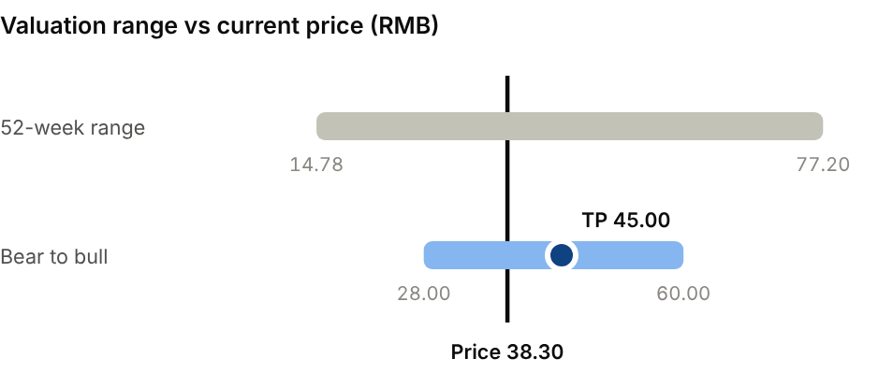  Bear (E-cloth prices fade; roving price war): RMB28.00. Bull (AI-driven e-cloth tightness persists): RMB60.00.
  Company | Ticker | Fwd P/E | EV/EBITDA | EV/sales
  Sinoma Science & Tech | 002080 CH | 24.9x | 22.5x | 3.4x
  Nitto Boseki | 3110 JP | 26.6x | 18.5x | 5.1x
  China Jushi | 600176 CH | 16.1x | 19.5x | 7.9x

Our TP of RMB45.00 is 20x FY27E EPS of RMB2.25, a discount to Sinoma Science & Technology (~25x) and Nittobo (~27x) forward because more of Jushi's profit comes from commodity roving. The stock is up 124% YTD but 50% below its RMB77.20 high. The consensus target (RMB63.3) assumes stronger pricing. Bear case RMB28.00: e-cloth prices fade and roving enters a price war. Bull case RMB60.00: AI-driven tightness persists into 2028.
Sources: Company FY25 and H1'26 results; Futu; Yicai Global; CompositesWorld; JEC; StockAnalysis/S&P Global; IBKR; source pack.
15 · EQUIPMENT, ROBOTICS & MEDTECH · AUTO SEMICONDUCTORS & SOFTWARE
Horizon Robotics 地平线机器人  9660.HK · Initiation of coverage · 12 October 2026 | BUY  TP HK$4.85  Price HK$3.995 · +21%
An 'ARM + Android' play on driver assistance, back at its IPO price; the market is overlooking licensing
Horizon designs automotive AI processors and licenses its chip IP, algorithms and software to automakers and Tier-1s. Licensing reached 55% of H1'26 revenue at a 90% gross margin even as China car sales fell 20%. The shares are back at the 2024 IPO price, which values the company at ~6.3x FY27E EV/sales. We initiate at Buy, TP HK$4.85 (+21% upside), though losses run to 2028 and the H1 cash draw was steep.  - Horizon is taking share in a falling market. Journey SoC shipments rose 12% to 2.2m in H1'26 while China passenger-car retail fell 20%, and design wins are near 500 models, including ~130 with advanced NOA.  - Licensing changes the economics of the business. Licence and service revenue rose 53% to RMB1.13bn at a 90% gross margin, and Toyota programmes and global Tier-1s (Denso, AUMOVIO) are adopting Journey 6B.  - Several catalysts fall in 2026-27: HSD urban NOA is ramping, integrated cockpit-driving mass production starts in Q4, Journey 7 is due in 2027, and FY26 revenue guidance is above RMB5bn.  Catalysts  - Q4'26 start of integrated cockpit-driving mass production.  - HSD model launches and shipment updates.  - Journey 7 tape-out; L4 robotaxi pilot.  Key risks  - China auto price war and OEM in-house chips.  - Competition from Nvidia, Qualcomm and Huawei.  - Cash burn and dilution; foundry or export-control restrictions.  - Execution on HSD and Journey 7. | Key data  H1'26 revenue mix (%)  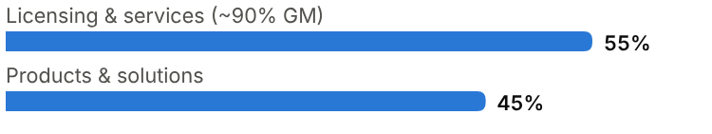
  Price (12 Oct 2026) | HK$3.995
  Target price (12m) | HK$4.85
  Implied return | +21.4%
  Market cap | HK$63.4bn / US$8.1bn
  Enterprise value | RMB44.1bn
  Net cash | RMB10.0bn (adj.)
  Shares outstanding | 15.87bn
  52-week range | 3.60-9.80
  Performance | -54.1% YTD
  Consensus target | HK$8.15
  Other listing | Hong Kong only (IPO October 2024 at HK$3.99)

Key financials and valuation
Year to December | FY23A | FY24A | FY25A | FY26E | FY27E | FY28E
Revenue (RMB bn) | 1.55 | 2.38 | 3.76 | 5.10 | 7.00 | 9.30
YoY growth | – | +54% | +58% | +36% | +37% | +33%
Gross margin | 70.5% | 77.3% | 64.5% | 64.0% | 63.0% | 62.0%
Adj. net profit (loss) (RMB bn) | – | (1.68) | (2.81) | (3.00) | (1.80) | (0.20)
Margin | – | -71% | -75% | -59% | -26% | -2%
EV/sales at current price (x) | 28.5x | 18.5x | 11.7x | 8.6x | 6.3x | 4.7x

A = actual (company reports; StockAnalysis/S&P Global), E = our estimates. Multiples at the 12-Oct-2026 price, converted at HK$1 = RMB0.853.

Company background
Horizon Robotics was founded in Beijing in July 2015 by Yu Kai, a machine-learning researcher who had built and led Baidu's Institute of Deep Learning, with co-founder and CTO Huang Chang. Its thesis was that autonomous driving would need purpose-built AI processors designed together with the algorithms they run. China, with no domestic automotive AI-chip supplier at the time, was the natural first market. Its first automotive-grade processor, Journey 2, entered mass production in 2019-20, and successive generations (Journey 3, 5 and the 2024 Journey 6 family) moved it from entry-level driver assistance to highway and urban navigate-on-autopilot (NOA).
Horizon raised capital from automakers, Tier-1s and global investors. In 2022 it formed CARIZON, a software joint venture with Volkswagen's CARIAD, one of the largest foreign investments in China's auto-tech sector. It listed in Hong Kong in October 2024 at HK$3.99 under a weighted-voting-rights structure that keeps control with the founder, and raised about RMB10bn more through placements in 2025. Horizon shipped more than 4 million Journey chip sets in 2025 (+39%), launched its full-stack urban driving system HSD in November 2025, and has nearly 500 model design wins. In March 2026 it deconsolidated its robotics affiliate, D-Robotics, which licenses its technology to more than 400 robot makers. The shares are back at the IPO price.
Milestones | Ownership and listing
  2015 | Founded in Beijing by Yu Kai (ex-Baidu IDL) and Huang Chang.
  2019-20 | Journey 2, its first automotive-grade AI chip, enters mass production.
  2022 | Journey 5 in production; CARIZON software JV with Volkswagen's CARIAD.
  2024 | Journey 6 family launched; Hong Kong IPO at HK$3.99 (October).
  2025 | >4m Journey sets shipped (+39%); HSD urban NOA in production (Nov); ~RMB10bn placements.
  2026 | D-Robotics deconsolidated; Journey 6B wins Toyota, Denso, AUMOVIO; Journey 7 for 2027.
  Control | Founder-CEO Yu Kai, via weighted voting rights
  Strategic shareholders | Chinese automakers and Tier-1s; Volkswagen (via CARIAD JV)
  Listing | Hong Kong only (9660.HK)

The business
Horizon calls its model 'ARM + Android' for intelligent driving. It sells three layers that customers can combine as they wish. Journey system-on-chips are designed in-house and manufactured by foundries; they are sold with reference solutions for ADAS and highway/urban NOA. HSD (Horizon SuperDrive) is a complete urban driving system, software included, for automakers without large in-house teams. Licensing covers processor IP, algorithms, the toolchain and foundation models, for OEMs and Tier-1s that build their own stacks.
The economics differ sharply by layer. Products and solutions (45% of H1'26 revenue, RMB926m, +15%) carry hardware-like gross margins of roughly 35-40%. Licensing and services (55%, RMB1.13bn, +53%) earned a 90% gross margin in H1'26. Licence income scales with partners' vehicle volumes and new programmes, while unit shipments (2.22m Journey SoCs in H1'26, +12%) drive product revenue. Group gross margin was 66% in H1'26.
Customers are almost every major Chinese automaker plus a growing list of international brands and Tier-1s. Toyota programmes, Denso and AUMOVIO are developing on Journey 6B. Design wins for nearly 500 models (about 130 with advanced NOA) provide a multi-year revenue pipeline. The cost base is dominated by R&D (RMB5.2bn in FY25, more than 1.3x revenue), which funds new chip generations, HSD and foundation models. Management targets breakeven in 2028. Working capital is significant (receivables ~180 days and inventory ~290 days at FY25) because chips are built ahead of OEM ramps.
Management's priorities for 2026-28 are to scale HSD on mid-priced cars, keep licensing revenue growing faster than chip shipments, and widen the customer base outside China through Toyota programmes, Denso and AUMOVIO. Each raises content per vehicle and the share of high-margin software and licence revenue. The path to the 2028 breakeven target depends mostly on R&D: if spending stays near RMB5bn while revenue rises 2.5x to RMB9.30bn by FY28E, as we forecast, operating losses narrow sharply.
Revenue mix and economics (H1'26)
Segment | Share of revenue | Key assets / products | Economics
Licensing & services | 55% (RMB1.13bn, +53%) | Processor IP, algorithms, toolchain, foundation-model licences | 90.4% gross margin; scales with partner volumes
Products & solutions | 45% (RMB0.93bn, +15%) | Journey SoCs with ADAS/NOA reference solutions; HSD | ~36% gross margin; 2.22m units (+12%)

Competitive landscape
At the high end, Nvidia's Orin and Thor platforms power many premium Chinese EVs, often running software from Momenta or the automakers' own teams. Huawei sells a vertically integrated stack (chips, software, sensors) through its Qiankun brand and HIMA alliance. In mainstream ADAS, Mobileye and Qualcomm (Snapdragon Ride) compete globally, and Black Sesame is a smaller Chinese rival. Several leading EV makers (NIO, Xpeng, BYD and Li Auto) are developing in-house driving chips to control costs and differentiation.
Horizon's advantages are cost-optimised silicon designed for China's mass market, a large installed base and toolchain that lowers development costs for OEMs, and an open licensing model that lets automakers keep ownership of their software. Its strongest position is in cars priced below ~RMB200k, where Nvidia is too expensive and in-house chips are uneconomic. The main threats are price competition in a shrinking domestic car market, large OEMs going in-house, and Nvidia or Qualcomm pushing cheaper platforms.
Main competitors
Competitor | Base | Focus | Position vs Horizon Robotics
Nvidia (Orin/Thor) | US | High-end ADAS/AD compute | Performance leader; costly; export-control exposure
Huawei (Qiankun) | China (private) | Full-stack ADS; HIMA brands | Integrated rival; competes for OEM control
Mobileye / Qualcomm | Israel/US / US | Mainstream ADAS SoCs | Global incumbents; weaker in China NOA
OEM in-house (NIO, Xpeng, BYD, Li Auto) | China | Self-developed driving chips | Captive; limits Horizon's share at top OEMs
Black Sesame / Momenta | China | ADAS chips / driving software | Smaller chip rival; software partner/competitor

Industry structure: five forces
Force | Intensity | Assessment
Rivalry | High | Nvidia (Orin/Thor) at the high end, Mobileye at the low end, Huawei's full-stack offer and Black Sesame, plus carmakers' own chips.
New entrants | Medium | Xpeng, Nio and Li Auto design their own chips, and Chinese chip start-ups keep appearing, but an auto-grade SoC takes 3-5 years and heavy R&D.
Supplier power | High | As a fabless company Horizon depends on TSMC and on EDA tools; US export controls could restrict advanced-node access.
Buyer power | High | Chinese carmakers are concentrated, price-sensitive and increasingly able to design chips in-house.
Substitutes | Medium | In-house silicon and Nvidia or Huawei full-stack solutions substitute at the top end; cheaper camera-only systems compete at the low end.

Moat and vulnerabilities
- China's largest automotive AI-chip installed base, with nearly 500 model design wins.
- Licensing model (90% gross margin) that monetises IP across OEMs and Tier-1s.
- Cost-optimised hardware and toolchain tailored to China's mass-market price points.
- Vulnerabilities: OEM in-house chips, auto price war, cash burn, foundry and export-control risk.

Addressable market (TAM)
China sells more than 20m passenger cars a year, and driver assistance is moving rapidly down the price ladder. Highway NOA is now standard on many mid-priced EVs, and HSD targets urban NOA in cars around RMB70-150k. Frost & Sullivan, cited in Horizon's prospectus, projected China's ADAS/AD solutions market to grow from ~RMB60bn in 2023 to more than RMB1tn by 2030 as content per vehicle rises from a few hundred to several thousand RMB.
Horizon's revenue (RMB4.3bn TTM) is a single-digit share of today's market, so share gains plus rising content per car drive growth. International OEMs (Toyota, Volkswagen through CARIZON) and robotics (through D-Robotics licences) extend the addressable market beyond China.
Market | Size | Growth / dynamics | Source
China passenger cars | >20m units a year | Retail −20% in H1'26; NOA penetration rising | Industry data
China ADAS/AD solutions | ~RMB60bn (2023) → >RMB1tn (2030E) | ~50% CAGR | Frost & Sullivan via prospectus
Horizon shipments | 2.22m Journey SoCs (H1'26) | ~5m in 2026, >7m in 2027 (guidance) | Company
Robotics licensing | 400+ customers (D-Robotics) | Early stage | Company

2.22m  Journey SoC shipments in H1'26 (+12%) while China car retail fell 20% | ~500 / ~130  Cumulative design wins: all models / advanced-NOA models | RMB1tn+  China ADAS/AD solutions market by 2030 (F&S, via prospectus)

Financial analysis
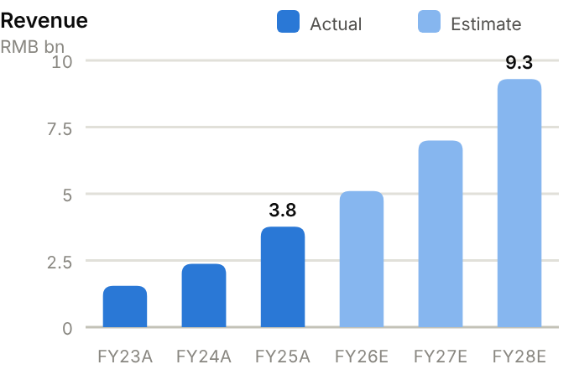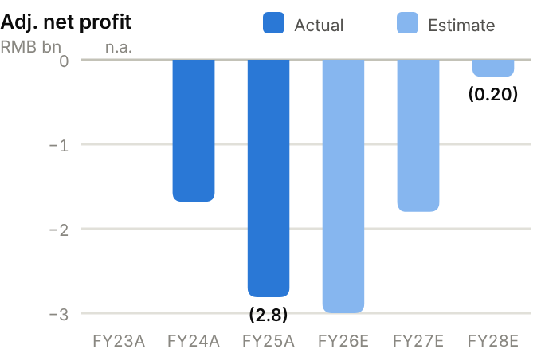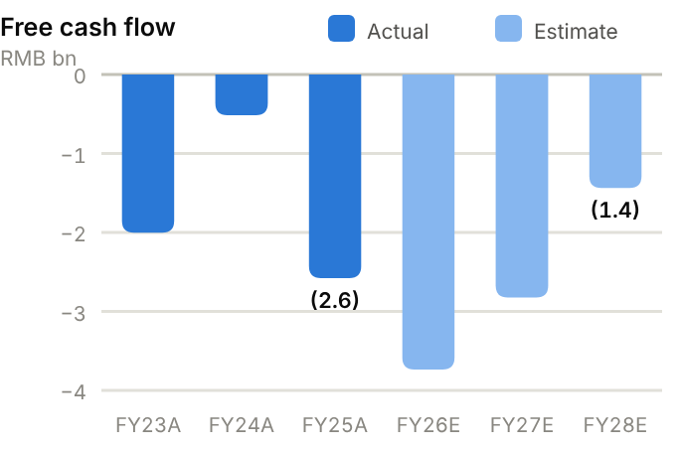
Income statement. Revenue grew from RMB1.55bn (FY23) to RMB2.38bn (FY24) and RMB3.76bn (FY25, +58%), and RMB2.06bn in H1'26 (+33%). Gross margin fell from 77% (FY24) to 64.5% (FY25) as hardware grew faster, then held at 66% in H1'26 as licensing recovered. R&D rose 63% to RMB5.2bn in FY25, so the adjusted operating loss widened from RMB1.5bn to RMB2.4bn and the adjusted net loss from RMB1.7bn to RMB2.8bn. Reported results swing with fair-value items: −RMB10.5bn in FY25, +RMB3.8bn in H1'26. We forecast revenue of RMB5.10bn/7.00bn/9.30bn and adjusted net losses of RMB3.00bn/1.80bn/0.20bn.
Source: company filings via StockAnalysis/S&P Global. Jun-26 = latest interim balance sheet. Debt includes leases and, pre-IPO, preferred shares carried as liabilities. | Balance sheet. Cash and short-term deposits fell from RMB20.8bn (FY25) to RMB15.0bn (June 2026). Reported 'debt' (RMB8.5bn) is mostly preferred shares and other financial liabilities at fair value; bank borrowings are only RMB1.4bn. On StockAnalysis's basis, net cash was RMB5.3bn at FY25 and RMB6.6bn at June 2026, plus RMB4.1bn of fair-value investments. We use ~RMB10bn in our valuation. Receivables rose to RMB2.5bn (180 days at FY25) and inventory to RMB1.3bn. Equity attributable is RMB16.4bn, and the current ratio was 1.43x at FY25.
  Balance sheet (RMB bn) | FY23A | FY24A | FY25A | Jun-26A
  Cash & short-term investments | 11.4 | 15.4 | 20.8 | 15.0
  Receivables | 0.6 | 0.7 | 1.9 | 2.5
  Inventory | 0.8 | 0.6 | 1.1 | 1.3
  PP&E | 0.7 | 1.0 | 1.2 | 1.5
  Total assets | 15.9 | 20.4 | 30.6 | 27.2
  Accounts payable | 0.0 | 0.0 | 0.2 | 0.2
  Total debt | 39.5 | 7.1 | 15.6 | 8.5
  Equity (attributable) | (24.7) | 11.9 | 12.6 | 16.4
  Minority interests | 0.0 | 0.0 | 0.0 | 0.0
  Net cash / (net debt) | (28.2) | 8.2 | 5.3 | 6.6

Cash flow (RMB bn) | FY23A | FY24A | FY25A | TTM Jun-26 | FY26E | FY27E | FY28E
Adj. net profit (loss) | – | (1.7) | (2.8) | – | (3.0) | (1.8) | (0.2)
D&A | 0.3 | 0.4 | 0.4 | 0.3 | 0.4 | 0.4 | 0.5
Operating cash flow | (1.7) | 0.0 | (2.1) | (2.8) | (3.1) | (2.1) | (0.6)
Capex | (0.3) | (0.5) | (0.5) | (0.5) | (0.6) | (0.7) | (0.8)
Free cash flow | (2.0) | (0.5) | (2.6) | (3.3) | (3.7) | (2.8) | (1.4)
Net cash / (debt), period-end | (28.2) | 8.2 | 5.3 | 6.6 | 4.7 | 1.9 | 0.4

TTM = twelve months to June 2026; Jun-26 net cash in the TTM column. E = our estimates: OCF = net profit + D&A − increase in working capital; net cash rolls forward FCF less dividends plus equity raised.
Cash flow. Horizon burns cash: OCF was −RMB1.7bn (FY23), roughly zero (FY24, helped by licence prepayments), −RMB2.1bn (FY25) and −RMB2.8bn TTM. With capex of RMB0.3-0.5bn, FCF was −RMB2.6bn in FY25 and −RMB3.3bn TTM, funded by RMB5.4bn of IPO proceeds (FY24) and RMB10.1bn of placements (FY25). We forecast FCF of −RMB3.7bn/−RMB2.8bn/−RMB1.4bn. On StockAnalysis's net cash basis that leaves ~RMB0.44bn by FY28E before monetising investments, so another capital raise before breakeven is likely.
ROE/ROA on average balances. Days on year-end balances: receivables on revenue, inventory and payables on cost of sales. Net debt/equity below zero = net cash. n.m./– = not meaningful or not modelled. | Key ratios. ROE and ROA are negative (FY25 ROA 11.0%), and R&D runs at ~137% of revenue. The ratios to watch are licensing share of revenue (55%), gross margin (~64-66%), receivable days (180) and cash burn relative to cash. Our forecasts imply the adjusted loss narrows from ~59% of revenue in FY26E to ~2% in FY28E.
  Key ratios | FY23A | FY24A | FY25A | FY26E | FY27E | FY28E
  Revenue growth | – | 54% | 58% | 36% | 37% | 33%
  Gross margin | 70.5% | 77.3% | 64.5% | 64.0% | 63.0% | 62.0%
  Net margin | – | −70.6% | −74.7% | −58.8% | −25.7% | −2.2%
  ROE (avg. equity) | – | – | −22.9% | – | – | –
  ROA (avg. assets) | – | −9.3% | −11.0% | – | – | –
  Asset turnover (x) | 0.10 | 0.13 | 0.15 | – | – | –
  Receivable days | 132 | 105 | 180 | – | – | –
  Inventory days | 631 | 395 | 292 | – | – | –
  Payable days | 9 | 10 | 64 | – | – | –
  Current ratio (x) | 0.34 | 13.46 | 1.43 | – | – | –
  Net debt / equity | – | −69% | −42% | −32% | −14% | −3%
  Capex / revenue | 16.7% | 22.5% | 12.6% | 11.8% | 10.0% | 8.6%
  FCF margin | −129% | −21.7% | −68.6% | −73.3% | −40.3% | −15.4%

Valuation
Source: StockAnalysis/S&P Global, 12 Oct 2026 (trailing EV/EBITDA and EV/sales; consensus forward P/E). EV/sales on trailing revenue; Black Sesame approximated by P/S. | 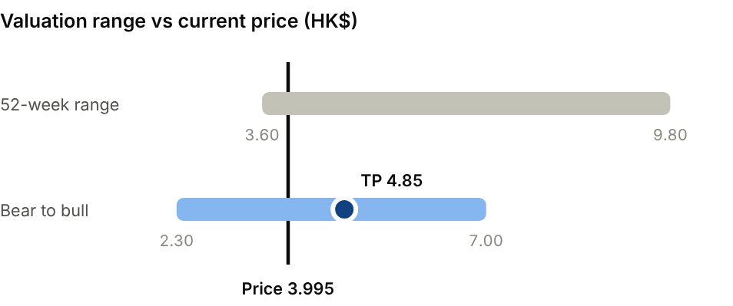  Bear (3.5x on FY27E revenue of RMB6.0bn): HK$2.30. Bull (10x on FY27E revenue of RMB8.5bn): HK$7.00.
  Company | Ticker | Fwd P/E | EV/EBITDA | EV/sales
  Mobileye | MBLY US | 16.6x | n.m. | 2.3x
  Ambarella | AMBA US | 73.0x | n.m. | 6.5x
  Black Sesame | 2533 HK | n.m. | n.m. | 4.5x
  Horizon Robotics | 9660 HK | n.m. | n.m. | 9.5x

Our TP of HK$4.85 applies 8x EV/sales to FY27E revenue of RMB7.00bn and adds net cash. The multiple is above Mobileye (~2.3x) and Ambarella (~6.5x) because over half of revenue is high-margin licensing growing more than 50%. The consensus target is ~HK$8.2-8.6. Bear case HK$2.30: 3.5x on lower FY27E revenue (RMB6.0bn). Bull case HK$7.00: 10x on RMB8.5bn.
Sources: Company FY25 annual results and H1'26 HKEX interim results; earnings call; Business Insider; Gasgoo; StockAnalysis; IBKR; source pack.
16 · AI LARGE-MODEL DEVELOPERS · AI FOUNDATION MODELS
Z.AI (Zhipu AI) 智谱  2513.HK · Initiation of coverage · 12 October 2026 | HOLD  TP HK$600  Price HK$619.00 · −3%
Real traction and a large war chest, but the share price already assumes a great deal
Z.AI (Zhipu) develops the GLM family of large language models and sells them mainly through cloud APIs and coding subscriptions, plus on-premise deployments for enterprises and government. H1'26 revenue rose 400% to RMB954m but missed expectations, and losses remain large. After raising ~US$9.5bn since its January IPO, it trades at ~14.7x FY27E EV/sales. We initiate at Hold, TP HK$600 (−3% vs current).  - Z.AI has commercial traction. Cloud/API is 86.5% of revenue, GLM-5.3 ships on AWS, Alibaba Cloud and Huawei Cloud under revenue-share deals, and management targets US$3.0bn of ARR by end-2026.  - The company is well funded. The ~US$9.5bn raised in nine months (IPO, July placement, September placement plus a RMB20bn convertible) pays for GLM-6.0 and compute, and domestic chips cut unit inference cost by 80%.  - The valuation already assumes success. H1 revenue missed (RMB954m vs RMB1.35bn expected), gross margin fell to 26% and each raise dilutes holders, so we see the risk/reward as balanced.  Catalysts  - GLM-6.0 release.  - ARR disclosures and quarterly revenue run-rate.  - Shanghai A-share listing.  Key risks  - Price war and rising compute costs.  - Further dilution (equity and convertible).  - US export controls and Entity-List constraints on chips.  - Execution on GLM-6.0 and the ARR target (upside if it is met). | Key data  H1'26 revenue mix (%)  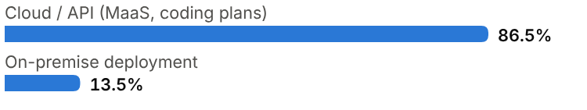
  Price (12 Oct 2026) | HK$619.00
  Target price (12m) | HK$600.00
  Implied return | −3.1%
  Market cap | HK$288.2bn / US$36.7bn
  Enterprise value | RMB205.9bn
  Net cash | RMB40.0bn (pro forma)
  Shares outstanding | 466.0m
  52-week range | 116.10-2,980
  Performance | +433% since IPO
  Consensus target | HK$1,565
  Other listing | Hong Kong (IPO 8 Jan 2026 at HK$116.20); Shanghai A-share listing planned

Key financials and valuation
Year to December | FY23A | FY24A | FY25A | FY26E | FY27E | FY28E
Revenue (RMB m) | 124 | 312 | 724 | 5,000 | 14,000 | 26,000
YoY growth | – | +151% | +132% | +590% | +180% | +86%
Gross margin | – | – | – | 28.0% | 32.0% | 38.0%
Adj. net profit (loss) (RMB m) | – | – | (3,180) | (5,500) | (4,500) | (1,500)
Margin | – | – | -439% | -110% | -32% | -6%
EV/sales at current price (x) | n.m. | 659x | 284x | 41.2x | 14.7x | 7.9x

A = actual (company reports; StockAnalysis/S&P Global), E = our estimates. Multiples at the 12-Oct-2026 price, converted at HK$1 = RMB0.853.

Company background
Knowledge Atlas Technology, better known as Zhipu AI and internationally as Z.AI, was spun out of Tsinghua University's Knowledge Engineering Group in 2019 by professors Tang Jie and Li Juanzi; Zhang Peng is CEO. The team had built AMiner, an academic knowledge graph, and developed the GLM (General Language Model) pre-training framework. In 2022 it open-sourced GLM-130B, one of the first large bilingual models, and in 2023 released ChatGLM-6B, an open-weight model that became widely used by Chinese developers, alongside a consumer chatbot (Qingyan).
Zhipu raised capital from Chinese internet groups (including Alibaba, Tencent and Meituan) and state-backed funds. In January 2025 the US added it to the Entity List, restricting access to US technology, which pushed it toward domestic chips such as Huawei Ascend. Its GLM-4.5/4.6/5 series (2025-26) became known for strong coding and agentic performance, and it rebranded internationally as Z.AI. On 8 January 2026 it became Hong Kong's first listed LLM developer (IPO at HK$116.20). It then raised money aggressively as the shares soared: ~US$4.0bn in July at HK$1,588 a share, and ~US$5bn in September (a US$2bn placement at HK$714 plus a RMB20.1bn zero-coupon convertible). A Shanghai A-share listing is planned.
Milestones | Ownership and listing
  2019 | Spun out of Tsinghua's Knowledge Engineering Group by Tang Jie and Li Juanzi.
  2022-23 | Open-sources GLM-130B and ChatGLM-6B; launches Qingyan chatbot.
  Jan 2025 | Added to the US Entity List; shifts toward domestic AI chips.
  2025 | GLM-4.5/4.6 coding and agent models; international Z.AI brand; revenue RMB724m.
  Jan 2026 | Hong Kong IPO at HK$116.20; first listed LLM developer.
  Jul-Sep 2026 | ~US$9bn raised via placements and a RMB20.1bn CB; GLM-5.3 on AWS, Alibaba, Huawei clouds.
  Founders / management | Tang Jie, Li Juanzi (Tsinghua); CEO Zhang Peng
  Pre-IPO investors | Chinese internet groups (incl. Alibaba, Tencent, Meituan) and state-backed funds
  Capital structure | RMB20.1bn zero-coupon CB due Sep-2027 (conversion HK$892.50)

The business
Z.AI develops and sells the GLM family of foundation models (language, coding, vision, agents). It monetises them in two main ways. The cloud/API business (86.5% of H1'26 revenue, up from 26% in FY25) charges developers and enterprises per token through its own platform, sells fixed-price coding subscription plans (popular with developers globally), and earns revenue shares when GLM is offered on hyperscaler clouds (AWS, Alibaba Cloud, Huawei Cloud). The on-premise business (13.5% of H1'26 revenue but 74% in FY25) installs models on customers' own servers for state-owned enterprises, government and regulated industries. These deals are larger but lumpier, and often run on domestic hardware.
The economics are those of a compute-intensive software business at an early stage. Gross margin fell from ~50% to 26.4% in H1'26 as low-margin cloud traffic grew. Every token served consumes GPU or NPU time, and price competition in China has been fierce. Moving inference to domestic chips cut unit cost by 80%, the main lever for margin recovery. R&D, mostly training compute and researcher pay, exceeded RMB3bn in FY25, about four times revenue.
Management targets annual recurring revenue (ARR) of US$3.0bn by end-2026, roughly ten times the H1'26 revenue run-rate. Whether that is reached depends on coding-plan subscriptions and international API demand. The ~US$9.5bn raised since the IPO gives Z.AI one of the largest war chests among Chinese AI labs, to fund GLM-6.0 and compute.
Z.AI's management plans to spend the war chest on next-generation models (GLM-6.0), domestic compute and international growth through coding plans and hyperscaler marketplaces. We model capex of RMB1.5-3.0bn a year and operating cash outflows of RMB4-6bn a year. On that basis the ~RMB38,314m of net cash we expect at FY26E covers several years of investment without further raises.
Revenue mix and economics
Business | H1'26 share (FY25) | What it is | Economics
Cloud / API (MaaS, coding plans) | 86.5% (26%) | Per-token API, coding subscriptions, hyperscaler revenue share | Fast growth; lower margin; GM fell to 26%
On-premise deployment | 13.5% (74%) | Private deployments for SOEs, government, regulated industries | Higher margin; lumpy contracts
Consumer (Qingyan) | Small | Chatbot app | Mostly free; brand and data

Competitive landscape
China's foundation-model market is crowded. DeepSeek's open-weight models set a low price benchmark in 2025. Alibaba (Qwen), ByteDance (Doubao/Seed), Tencent (Hunyuan) and Baidu (ERNIE) bundle models with cloud services and can subsidise them. Independent labs such as Moonshot (Kimi), MiniMax and StepFun compete for developers and enterprises. Globally, OpenAI, Anthropic and Google lead on frontier capability. The domestic API market has been in a price war, though DeepSeek's August 2026 price increase hints at rationalisation.
Z.AI's differentiation is coding and agentic capability, the trust of enterprise and government buyers (important for on-premise deals), its distribution through international hyperscalers, and now its balance sheet. Its disadvantages are the Entity-List constraint on hardware, dependence on expensive compute, and the risk that hyperscalers' own models commoditise third-party APIs.
Benchmark leads change hands every few weeks, so distribution, developer loyalty and cost per token last longer as advantages. Z.AI's coding subscriptions and integrations with developer tools give it a direct relationship with users, and its move to domestic inference chips cuts unit cost.
Main competitors
Competitor | Base | Focus | Position vs Z.AI (Zhipu AI)
DeepSeek | China (private) | Open-weight LLMs; low-price API | Price-setter; strong reasoning models
Alibaba (Qwen) / ByteDance (Doubao) | China | LLMs bundled with cloud/apps | Deep pockets; can subsidise
Moonshot (Kimi) / StepFun | China (private) | LLMs; consumer and API | Independent rivals
MiniMax | China (0100.HK) | Multimodal models; consumer apps; API | Listed peer; more consumer-oriented
OpenAI / Anthropic / Google | US | Frontier models and APIs | Global leaders; set capability frontier

Industry structure: five forces
Force | Intensity | Assessment
Rivalry | Very high | DeepSeek, Alibaba's Qwen, ByteDance's Doubao, Moonshot, MiniMax, Baidu and Tencent compete; open-weight releases and price wars push API prices toward cost.
New entrants | Medium | Frontier training costs keep rising, limiting new labs to well-funded players, but open models lower the bar for application-layer rivals.
Supplier power | High | GPUs, cloud capacity and AI talent are scarce; US export controls limit Nvidia supply, and Z.AI has been on the US Entity List since January 2025.
Buyer power | High | Government and enterprise customers run competitive procurement; consumers switch freely; on-premise deployments need costly customisation.
Substitutes | High | Free open-weight models (DeepSeek, Qwen) and in-house models at large platforms substitute for paid APIs.

Moat and vulnerabilities
- Strong coding/agentic models and early open-source developer community (ChatGLM).
- Enterprise and government trust for on-premise deployments; distribution via AWS, Alibaba and Huawei clouds.
- ~US$9.5bn raised since IPO: one of the best-funded Chinese AI labs.
- Vulnerabilities: price war, compute costs, Entity-List hardware constraints, dilution.

Addressable market (TAM)
Enterprise and developer spending on foundation models in China is at an early stage, but growing quickly as coding assistants, customer-service agents and document workflows move into production. Leading US labs report annualised revenues in the tens of billions of US dollars, which illustrates the potential scale of the global market once models become embedded in enterprise software.
Z.AI's ARR target of US$3bn (~RMB20bn) for end-2026 would make it one of the largest independent model providers outside the US. Distribution through AWS and Alibaba Cloud extends its reach internationally. The addressable market is large, but Z.AI's share and pricing against hyperscaler models and open-weight alternatives are uncertain.
Policy also shapes China's market. The State Council's 'AI+' initiative encourages adoption across industry and the public sector, and state-owned buyers often prefer domestic models deployed on their own servers, which plays to Z.AI's strengths in on-premise work.
Market | Size | Growth / dynamics | Source
Global LLM APIs and subscriptions | Tens of US$bn (leading US labs' annualised revenue) | Very rapid growth | Company disclosures (US labs)
China enterprise LLM spend | Early stage | Rapid growth; price competition | Qualitative
Z.AI ARR target | US$3.0bn (end-2026) | ~10x H1'26 run-rate | Management (source pack)
Z.AI H1'26 revenue | RMB954m | +400% YoY | Company

US$3.0bn  Management's end-2026 ARR target | ~US$9.5bn  Equity and convertible raised since the January 2026 IPO | −80%  Unit inference cost after moving to domestic chips

Financial analysis
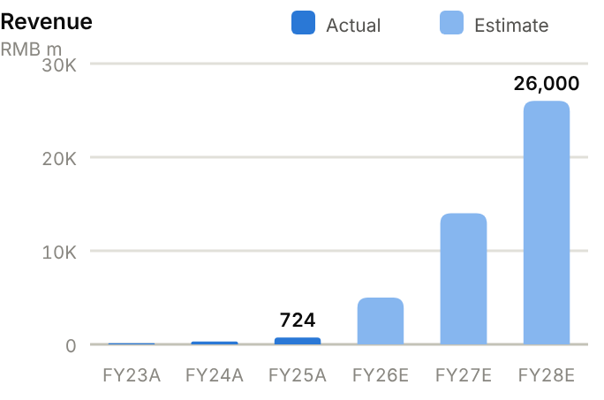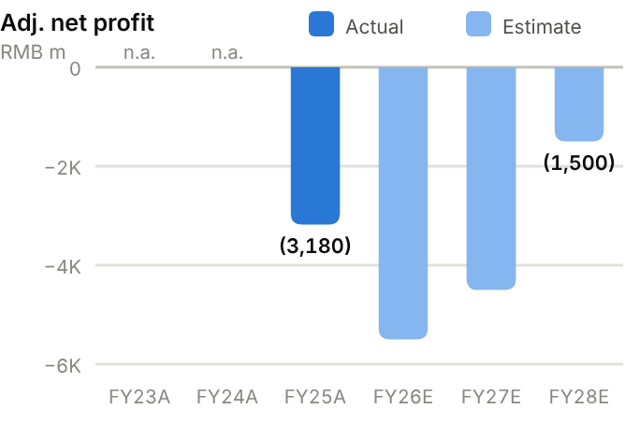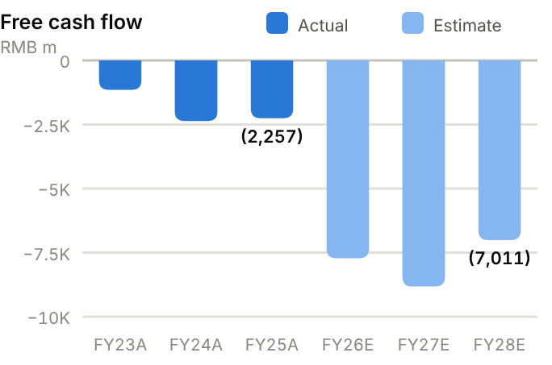
Income statement. Revenue rose from RMB124m (FY23) to RMB312m (FY24), RMB724m (FY25, +132%) and RMB954m in H1'26 (+400%), though H1 missed the ~RMB1.35bn consensus. Gross margin fell from ~50% to 26.4% as cloud volumes grew. The FY25 net loss was RMB4.7bn (adjusted RMB3.2bn) on R&D of RMB3.2bn, and the H1'26 adjusted loss was RMB1.96bn. We forecast revenue of RMB5,000m/14,000m/26,000m and adjusted net losses of RMB5,500m/4,500m/1,500m, with breakeven in 2028-29.
Source: company filings via StockAnalysis/S&P Global. Jun-26 = latest interim balance sheet. Debt includes leases. | Balance sheet. Before the IPO, Z.AI's preferred shares were carried as liabilities, so reported equity was negative (−RMB8.1bn at FY25). After conversion and the IPO, equity was RMB4.4bn at June 2026, with cash and short-term investments of RMB4.6bn and debt of RMB2.6bn (net cash RMB1,974m). The July and September raises added ~RMB40bn of equity plus the RMB20.1bn convertible. We estimate ~RMB38,314m of net cash at FY26E (cash of ~RMB60bn+ less ~RMB23bn of debt). Receivables jumped to RMB875m by June 2026 with on-premise contracts.
  Balance sheet (RMB m) | FY23A | FY24A | FY25A | Jun-26A
  Cash & short-term investments | 1,425 | 2,380 | 2,816 | 4,578
  Receivables | 237 | 378 | 345 | 875
  Inventory | 29 | 32 | 126 | 87
  PP&E | 788 | 866 | 656 | 855
  Total assets | 2,860 | 4,376 | 4,854 | 9,645
  Accounts payable | 7 | 58 | 297 | 242
  Total debt | 271 | 941 | 1,235 | 2,604
  Equity (attributable) | (983) | (3,955) | (8,111) | 4,430
  Minority interests | 0 | 0 | 0 | 0
  Net cash / (net debt) | 1,154 | 1,439 | 1,581 | 1,974

Cash flow (RMB m) | FY23A | FY24A | FY25A | TTM Jun-26 | FY26E | FY27E | FY28E
Adj. net profit (loss) | – | – | (3,180) | – | (5,500) | (4,500) | (1,500)
D&A | 69 | 279 | 279 | 275 | 307 | 338 | 371
Operating cash flow | (648) | (2,245) | (2,246) | (4,293) | (6,220) | (6,324) | (4,011)
Capex | (507) | (126) | (11) | (585) | (1,500) | (2,500) | (3,000)
Free cash flow | (1,155) | (2,371) | (2,257) | (4,878) | (7,720) | (8,824) | (7,011)
Net cash / (debt), period-end | 1,154 | 1,439 | 1,581 | 1,974 | 38,314 | 29,489 | 22,478

TTM = twelve months to June 2026; Jun-26 net cash in the TTM column. E = our estimates: OCF = net profit + D&A − increase in working capital; net cash rolls forward FCF less dividends plus equity raised.
Cash flow. Operating cash burn has accelerated: −RMB0.6bn (FY23), −RMB2.2bn (FY24 and FY25) and −RMB4.3bn TTM. Capex has been low but is rising for compute (RMB0.6bn TTM). We forecast FCF of −RMB7,720m, −RMB8,824m and −RMB7,011m in FY26-28E, so net cash declines from ~RMB38,314m to ~RMB22,478m by FY28E. That is still ample runway, but it assumes losses narrow. The convertible matures in September 2027 unless it converts (HK$892.50, ~44% above the current price).
ROE/ROA on average balances. Days on year-end balances: receivables on revenue, inventory and payables on cost of sales. Net debt/equity below zero = net cash. n.m./– = not meaningful or not modelled. | Key ratios. Conventional returns ratios are not meaningful. We focus instead on revenue growth (+400% in H1'26), gross margin (26% and falling), R&D intensity (~4x revenue in FY25), cash runway (more than three years at our forecast burn) and dilution (share count up ~10% since the IPO, plus potential CB conversion).
  Key ratios | FY23A | FY24A | FY25A | FY26E | FY27E | FY28E
  Revenue growth | – | 151% | 132% | 590% | 180% | 86%
  Gross margin | – | – | – | 28.0% | 32.0% | 38.0%
  Net margin | – | – | −439% | −110% | −32.1% | −5.8%
  ROA (avg. assets) | – | – | −68.9% | – | – | –
  Asset turnover (x) | 0.04 | 0.09 | 0.16 | – | – | –
  Receivable days | 695 | 442 | 174 | – | – | –
  Current ratio (x) | 0.52 | 0.38 | 0.29 | – | – | –
  Net debt / equity | – | – | – | −91% | −79% | −63%
  Capex / revenue | 407% | 40.3% | 1.5% | 30.0% | 17.9% | 11.5%
  FCF margin | −928% | −759% | −312% | −154% | −63.0% | −27.0%

Valuation
Source: StockAnalysis/S&P Global, 12 Oct 2026 (trailing EV/EBITDA and EV/sales; consensus forward P/E). EV/sales on trailing revenue; SenseTime approximated by P/S. | 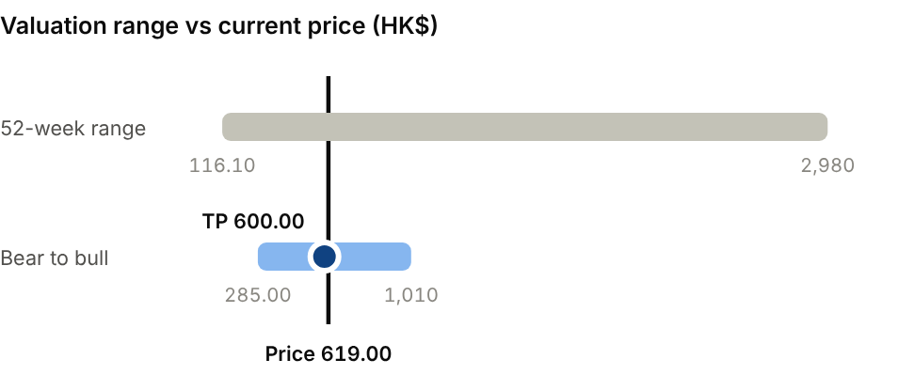  Bear (7x on FY28E revenue of RMB14bn): HK$285.00. Bull (12x on FY28E revenue of RMB40bn): HK$1,010.
  Company | Ticker | Fwd P/E | EV/EBITDA | EV/sales
  MiniMax | 0100 HK | n.m. | n.m. | 49.0x
  SenseTime | 0020 HK | n.m. | n.m. | 6.6x
  iFlytek | 002230 CH | 90.9x | n.m. | 3.4x
  Z.AI (Zhipu AI) | 2513 HK | n.m. | n.m. | 117x

We value Z.AI at 10x EV/sales on FY28E revenue of RMB26,000m, discounted back two years at 15%, plus net cash, for a TP of HK$600. Broker targets (Goldman HK$1,560, Morgan Stanley HK$1,700) assume much faster revenue growth. Bear case HK$285: RMB14bn of FY28E revenue at 7x. Bull case HK$1,010: RMB40bn at 12x, i.e. the ARR target is met and keeps growing.
Sources: Company FY25 results (via Reuters/SCMP) and H1'26 interim report; Magica; Futu; Tiger; The Standard; DealStreetAsia; Venture Atlas; StockAnalysis; IBKR; source pack.
17 · AI LARGE-MODEL DEVELOPERS · AI FOUNDATION MODELS
MiniMax 稀宇科技  0100.HK · Initiation of coverage · 12 October 2026 | HOLD  TP HK$200  Price HK$214.00 · −7%
Global consumer reach and a fast-growing API business, but losses are three times revenue
MiniMax builds text, video and voice foundation models and sells them through an API platform and consumer apps (Talkie, Hailuo, MiniMax Voice); ~61% of revenue comes from outside mainland China. H1'26 revenue rose 283% to US$117m, yet the adjusted loss was US$293m. After a 77% fall from June, the stock trades at ~14.2x FY27E EV/sales. We initiate at Hold, TP HK$200 (−7% vs current).  - The mix is shifting to enterprise: Open Platform and enterprise revenue grew 703% in H1'26 to 63% of sales.  - MiniMax has global distribution that most Chinese labs lack, with 236m users across 200+ countries and strong positions in AI video (Hailuo) and voice.  - Cash burn and the share overhang will dominate the near term. H1 R&D (US$297m) was 2.5x revenue, and the July lock-up expiry lifted free float from 5.4% to 54.4%. After M3's lukewarm reception, the next model (M3 Pro) is a binary swing factor.  Catalysts  - M3 Pro and next-generation video/voice model launches.  - FY26 results and enterprise customer wins.  - API pricing moves by DeepSeek and peers.  Key risks  - Model competitiveness (M3 Pro) and price war.  - Cash burn and potential dilution.  - Content regulation for companion apps; data rules abroad.  - Share overhang after the lock-up expiry (upside if enterprise API scales faster). | Key data  H1'26 revenue mix (%)  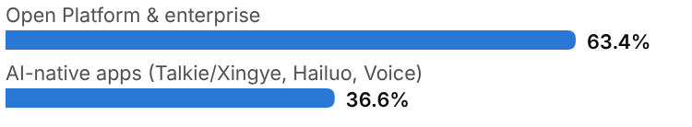
  Price (12 Oct 2026) | HK$214.00
  Target price (12m) | HK$200.00
  Implied return | −6.5%
  Market cap | HK$74.7bn / US$9.5bn
  Enterprise value | US$8.5bn
  Net cash | US$1.0bn
  Shares outstanding | 349.2m
  52-week range | 186.20-1,330
  Performance | +30% since IPO
  Consensus target | HK$588.71, 23 analysts
  Other listing | Hong Kong (IPO 9 Jan 2026 at HK$165)

Key financials and valuation
Year to December | FY23A | FY24A | FY25A | FY26E | FY27E | FY28E
Revenue (US$ m) | 4 | 30 | 79 | 270 | 600 | 1,050
YoY growth | – | +771% | +159% | +242% | +122% | +75%
Gross margin | – | 12.2% | 25.4% | 20.0% | 30.0% | 38.0%
Adj. net profit (loss) (US$ m) | – | (244) | (251) | (560) | (480) | (280)
Margin | – | -801% | -318% | -207% | -80% | -27%
EV/sales at current price (x) | n.m. | 279x | 108x | 31.6x | 14.2x | 8.1x

A = actual (company reports; StockAnalysis/S&P Global), E = our estimates. Multiples at the 12-Oct-2026 price, converted at US$1 = HK$7.8475.

Company background
MiniMax was founded in Shanghai in early 2022 by Yan Junjie, a computer-vision researcher who had been a vice-president at SenseTime. It set out to build general multimodal models (text, voice, video) and to monetise them through its own consumer products as well as an API. Its first hit was a companion-chat app, launched overseas as Talkie and in China as Xingye, which grew a large user base among young users. Hailuo AI, its video-generation product, followed in 2024, along with MiniMax Speech/Voice. Early backers included Chinese gaming company miHoYo, Tencent and Alibaba, which led a large 2024 funding round.
In 2025 MiniMax shifted toward open-weight frontier models. MiniMax-01 introduced a 'lightning attention' architecture with very long context, followed by the M1 reasoning model and M2. It listed in Hong Kong on 9 January 2026 at HK$165 (top of the range), raising ~HK$4.8bn. The shares more than doubled on debut and peaked above HK$1,300. They then fell as much as 77% from 1 June after a lukewarm reception for the M3 model, and as the July lock-up expiry lifted the free float from 5.4% to 54.4%. About 61% of revenue now comes from outside mainland China.
Milestones | Ownership and listing
  2022 | Founded in Shanghai by Yan Junjie (ex-SenseTime vice-president).
  2023 | Launches Talkie (overseas) and Xingye (China) companion apps.
  2024 | Hailuo AI video generation; Alibaba-led funding round.
  2025 | Open-weight MiniMax-01, M1 and M2; FY25 revenue US$79m (+159%); 236m users.
  Jan 2026 | Hong Kong IPO at HK$165 (~HK$4.8bn); shares later peak above HK$1,300.
  Jun-Jul 2026 | M3 reception lukewarm; shares −77% from 1 June; free float rises to 54% after lock-up.
  Founder | Yan Junjie (CEO)
  Pre-IPO investors | Including Alibaba, Tencent and miHoYo
  Free float | 54.4% after July 2026 lock-up expiry

The business
MiniMax runs two businesses on top of its own foundation models. The Open Platform and enterprise services (63.4% of H1'26 revenue, US$74m, +703%) sell API access to text, speech and video models, priced per token, per character of speech or per video, plus subscriptions and licences for developers and enterprises. AI-native consumer apps (36.6%, US$43m) monetise through subscriptions and in-app credits. These are Talkie and Xingye (AI companions), Hailuo AI (video generation) and MiniMax Voice/Audio.
The consumer apps gave MiniMax scale (236m users across 200+ countries by FY25) and data, but they are expensive: user acquisition and inference costs are high, and companion apps face content-regulation risk. The 2026 shift toward enterprise and API revenue is strategically sensible, because marginal costs are lower and customers stickier. Gross margin was 25.4% in FY25 and 17.9% in H1'26, still low because of heavy inference costs and price competition.
R&D (US$297m in H1'26) is about 2.5x revenue and the dominant cost, mostly training compute. MiniMax is known for cost-efficient architectures, but it competes against far larger budgets. Capex jumped in 2026 (US$188m TTM) as it built its own compute. Cash of ~US$1.2bn at June 2026 is modest against an annual burn of ~US$0.6bn.
Management aims to keep its models near the frontier at a fraction of rivals' budgets by using efficient architectures. It wants the higher-margin Open Platform to grow faster than consumer apps, and it is building some of its own compute to cut inference costs (capex of US$250-300m a year in our forecasts). Money limits all of this. With ~US$1,086m of net cash at June 2026 and annual burn of ~US$0.6bn, MiniMax will probably need to raise capital again by 2028 unless losses narrow faster than we expect.
Revenue mix and economics (H1'26)
Segment | Share of revenue | Key assets / products | Economics
Open Platform & enterprise | 63.4% (US$74m, +703%) | APIs for text, speech, video models; enterprise licences | Lower marginal cost; fastest growth
AI-native apps | 36.6% (US$43m) | Talkie/Xingye companions, Hailuo video, MiniMax Voice | Subscriptions/credits; high acquisition and inference cost
Geography | 60.8% outside mainland China | US, Europe, Asia users and developers | Global reach; regulatory exposure

Competitive landscape
MiniMax competes on two fronts. In models and APIs, its rivals are DeepSeek, Moonshot (Kimi), Z.AI and StepFun among independents, and Alibaba, ByteDance, Tencent and Kuaishou among large platforms in China. Globally it faces OpenAI, Google and Anthropic. JPMorgan (Neutral, HK$260) flags this competition, particularly from Kimi, DeepSeek, ByteDance and Kuaishou, as the main risk.
In consumer AI, Talkie competes with Character.AI and general chatbots. Hailuo competes with Kuaishou's Kling, ByteDance's Seedance/Jimeng, Google's Veo and OpenAI's Sora in video generation, and MiniMax Voice competes with ElevenLabs in speech. MiniMax's strengths are multimodal breadth, international distribution and efficient model design. Its weaknesses are scale of compute budget versus platform rivals, monetisation per user, and the binary nature of each model launch (M3's reception showed how quickly sentiment can turn).
Video generation is the most contested category. Kling, Seedance, Veo and Sora are backed by platforms with large video libraries and distribution, while Hailuo competes on model quality and price. Voice is a relative strength: MiniMax's speech models are among the better-regarded on public text-to-speech leaderboards, which gives the Open Platform a differentiated product.
Main competitors
Competitor | Base | Focus | Position vs MiniMax
ByteDance (Doubao, Seedance) / Kuaishou (Kling) | China | Chatbots, video generation | Platform scale; can subsidise
DeepSeek / Moonshot (Kimi) | China (private) | LLMs and APIs | Strong models; price pressure
Z.AI (Zhipu) | China (2513.HK) | LLMs; coding; on-premise | Listed peer; enterprise-oriented
Character.AI / ElevenLabs | US | AI companions / voice | Consumer and voice rivals abroad
OpenAI / Google | US | Frontier models; Sora/Veo video | Global leaders

Industry structure: five forces
Force | Intensity | Assessment
Rivalry | Very high | Domestic model labs plus Kuaishou's Kling and ByteDance's Seedance in video, and Character.AI and others in AI companions.
New entrants | Medium | Frontier training is costly, but open models let app-layer start-ups launch competing products quickly.
Supplier power | High | MiniMax rents much of its compute; US chip export controls and GPU scarcity raise costs and limit scale.
Buyer power | Medium | Consumer subscribers (Talkie, Hailuo) are fragmented but price-sensitive; API developers switch models easily.
Substitutes | High | Free apps from platforms with huge distribution (Doubao, Qwen) and open-weight models are close substitutes.

Moat and vulnerabilities
- Multimodal model breadth (text, voice, video) with efficient architectures and open-weight credibility.
- International consumer distribution (236m users; ~61% of revenue outside China).
- Fast-growing enterprise API business with lower marginal cost.
- Vulnerabilities: compute budget vs. platforms, burn rate, content regulation, share overhang.

Addressable market (TAM)
MiniMax addresses two growing pools. The first is the global market for foundation-model APIs and enterprise subscriptions, which leading US labs show can reach tens of billions of US dollars of annualised revenue. The second is consumer AI subscriptions in companions, video generation and voice, among the fastest-monetising categories in consumer software.
Both markets are early and growing rapidly, and MiniMax's FY25 revenue of US$79m is a tiny fraction of either, so its growth depends on how well it competes. Each model generation has to stay near the frontier at a fraction of rivals' compute budgets, and consumer products have to convert users into paying subscribers.
Market | Size | Growth / dynamics | Source
Global LLM APIs and subscriptions | Tens of US$bn | Very rapid growth | Company disclosures (US labs)
Consumer AI (companions, video, voice) | Multi-US$bn | Fast-monetising categories | Qualitative
MiniMax revenue | US$79m (FY25); US$117m (H1'26) | +283% in H1'26 | Company
MiniMax users | 236m in 200+ countries | – | Company (FY25)

236m  Users across 200+ countries and regions (FY25) | 60.8%  Share of H1'26 revenue from outside mainland China | 54.4%  Free float after the July lock-up expiry (from 5.4%)

Financial analysis
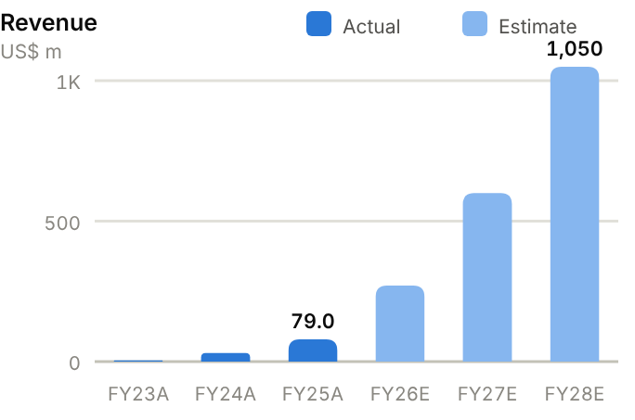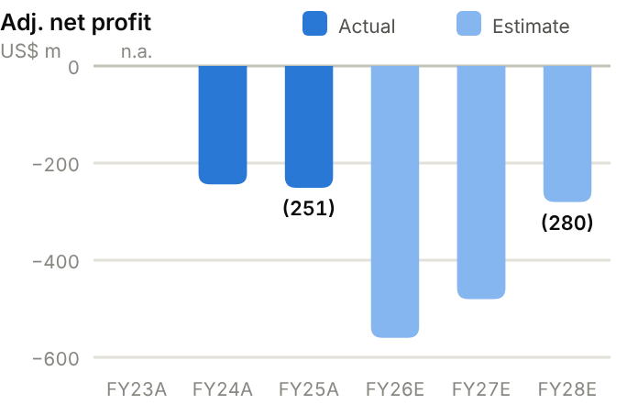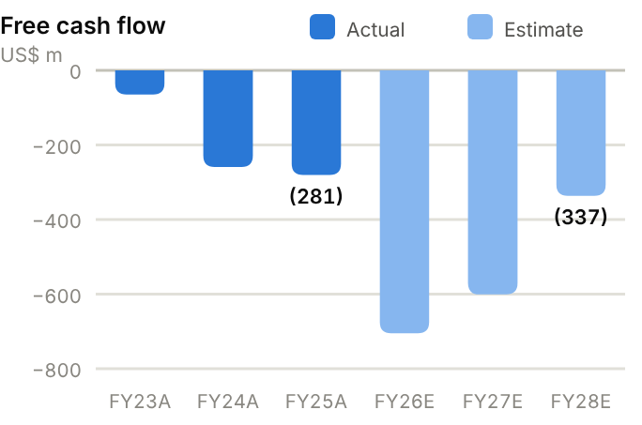
Income statement. Revenue rose from US$3.5m (FY23) to US$30.5m (FY24), US$79.0m (FY25, +159%) and US$116.6m in H1'26 (+283%). Gross margin improved from 12.2% (FY24) to 25.4% (FY25) but dipped to 17.9% in H1'26. The adjusted net loss was ~US$244m (FY24) and ~US$251m (FY25), and widened to US$293m in H1'26 alone. The IFRS loss (~US$1.9bn in FY25) was inflated by preferred-share revaluation. We forecast revenue of US$270m/600m/1,050m and adjusted net losses of US$560m/480m/280m.
Source: company filings via StockAnalysis/S&P Global. Jun-26 = latest interim balance sheet. Debt includes leases and, pre-IPO, preferred shares carried as liabilities. | Balance sheet. Pre-IPO preferred shares were carried as debt (US$3.6bn at FY25), giving negative equity (−US$2.6bn). After conversion and the IPO, equity was US$1.35bn at June 2026, with US$1.22bn of cash and short-term investments and US$137m of debt (net cash US$1,086m). PP&E jumped to US$79m as MiniMax began building its own compute. Working capital is small: receivables are minimal and payables include compute suppliers.
  Balance sheet (US$ m) | FY23A | FY24A | FY25A | Jun-26A
  Cash & short-term investments | 314 | 764 | 970 | 1,223
  Receivables | 5 | 14 | 16 | 39
  Inventory | 0 | 0 | 0 | 0
  PP&E | 4 | 4 | 4 | 79
  Total assets | 324 | 911 | 1,088 | 1,715
  Accounts payable | 17 | 51 | 58 | 170
  Total debt | 632 | 1,619 | 3,635 | 137
  Equity (attributable) | (342) | (799) | (2,648) | 1,347
  Minority interests | 0 | 0 | 0 | 0
  Net cash / (net debt) | (318) | (855) | (2,665) | 1,086

Cash flow (US$ m) | FY23A | FY24A | FY25A | TTM Jun-26 | FY26E | FY27E | FY28E
Adj. net profit (loss) | – | (244) | (251) | – | (560) | (480) | (280)
D&A | 1 | 2 | 3 | 5 | 3 | 4 | 4
Operating cash flow | (64) | (258) | (280) | (429) | (455) | (301) | (37)
Capex | (1) | (1) | (1) | (188) | (250) | (300) | (300)
Free cash flow | (65) | (259) | (281) | (617) | (705) | (601) | (337)
Net cash / (debt), period-end | (318) | (855) | (2,665) | 1,086 | 733 | 132 | (204)

TTM = twelve months to June 2026; Jun-26 net cash in the TTM column. E = our estimates: OCF = net profit + D&A − increase in working capital; net cash rolls forward FCF less dividends plus equity raised.
Cash flow. Operating cash burn rose from US$64m (FY23) to US$258m (FY24), US$280m (FY25) and US$429m TTM, and capex jumped to US$188m TTM, so FCF was −US$617m TTM. We forecast FCF of −US$705m, −US$601m and −US$337m in FY26-28E. On these numbers net cash falls to ~US$733m by FY26E and is effectively exhausted during FY28E, so MiniMax will probably need to raise capital in 2027 unless losses narrow faster than we assume.
ROE/ROA on average balances. Days on year-end balances: receivables on revenue, inventory and payables on cost of sales. Net debt/equity below zero = net cash. n.m./– = not meaningful or not modelled. | Key ratios. Returns ratios are not meaningful. The useful measures are revenue growth (+283% in H1'26), enterprise share of revenue (63%), gross margin (18-25%), R&D intensity (~2.5x revenue) and cash runway (~1.5-2 years at the current burn rate).
  Key ratios | FY23A | FY24A | FY25A | FY26E | FY27E | FY28E
  Revenue growth | – | 771% | 159% | 242% | 122% | 75%
  Gross margin | – | 12.2% | 25.4% | 20.0% | 30.0% | 38.0%
  Net margin | – | −801% | −318% | −207% | −80.0% | −26.7%
  ROA (avg. assets) | – | −39.5% | −25.1% | – | – | –
  Asset turnover (x) | 0.01 | 0.05 | 0.08 | – | – | –
  Receivable days | 521 | 168 | 74 | – | – | –
  Inventory days | – | 0 | 0 | – | – | –
  Payable days | – | 695 | 359 | – | – | –
  Current ratio (x) | 0.48 | 0.47 | 0.27 | – | – | –
  Net debt / equity | – | – | – | −69% | −23% | 67%
  Capex / revenue | 28.6% | 3.3% | 1.3% | 92.6% | 50.0% | 28.6%
  FCF margin | −1,857% | −849% | −356% | −261% | −100% | −32.1%

Valuation
Source: StockAnalysis/S&P Global, 12 Oct 2026 (trailing EV/EBITDA and EV/sales; consensus forward P/E). EV/sales on trailing revenue; SenseTime approximated by P/S. | 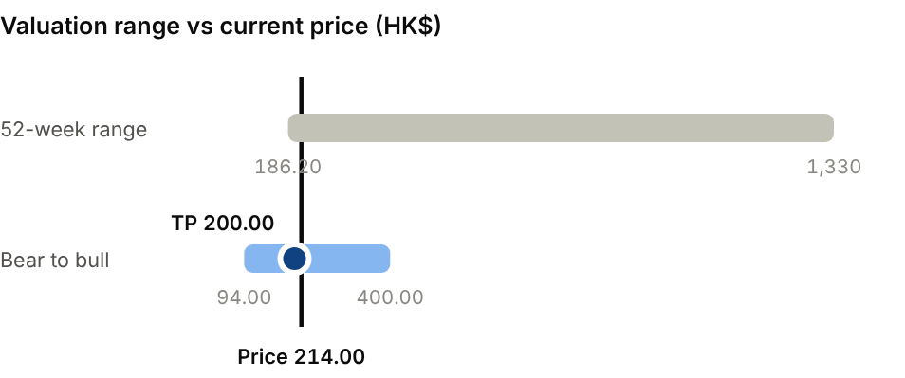  Bear (7x on FY28E revenue of US$0.6bn): HK$94.00. Bull (13x on FY28E revenue of US$1.7bn): HK$400.00.
  Company | Ticker | Fwd P/E | EV/EBITDA | EV/sales
  Z.AI (Zhipu) | 2513 HK | n.m. | n.m. | 117x
  SenseTime | 0020 HK | n.m. | n.m. | 6.6x
  iFlytek | 002230 CH | 90.9x | n.m. | 3.4x
  MiniMax | 0100 HK | n.m. | n.m. | 49.0x

We use the same method as for Z.AI: 10x EV/sales on FY28E revenue of US$1,050m, discounted back two years at 15%, plus net cash. That gives a TP of HK$200, below both JPMorgan (HK$260) and CMBI (HK$570). Bear case HK$94.00: US$0.6bn of FY28E revenue at 7x. Bull case HK$400: US$1.7bn at 13x.
Sources: Company FY25 results release and H1'26 interim report; CMBI; JPMorgan (via Futu); Tiger; DealStreetAsia; Jiemian; StockAnalysis; IBKR; source pack.

Methodology
Scope. Each of the 17 companies in the source pack gets an initiation of up to five pages: a summary page with rating, thesis, catalysts, risks and key financials; at least two pages on company background, the business, the competitive landscape and the addressable market (TAM); a financial analysis covering the income statement, balance sheet, cash flow statement and key ratios; and a valuation. The notes are concise and do not include full financial models.
Data. Historical financials (FY23-25 and TTM) come from company filings as compiled by StockAnalysis.com (S&P Global Market Intelligence data) and from H1'26 interim reports. Consensus estimates, consensus targets and peer multiples are from StockAnalysis/S&P Global as of 12 October 2026 unless a broker is named. Share prices, 52-week ranges, FX and gold/copper futures are from Interactive Brokers (12-Oct-2026). Industry figures (CCMA, SNE Research, Wood Mackenzie, Argus, TrendForce, Frost & Sullivan, IFR, Prismark) are cited as reported by the sources named in each note.
Estimates. FY26-28E figures are our own simplified projections of revenue, gross margin and attributable net profit (adjusted net profit for loss-makers). EPS uses current shares outstanding. Dividends assume the payout ratios stated in each report. Cash flow and balance sheet are projected with a simple roll-forward: operating cash flow = net profit + D&A (grown at 10-12% a year, faster for capacity builders) − the increase in net working capital (receivables + inventory − payables, at the FY25 ratio to revenue or a stated incremental intensity); free cash flow = OCF − our capex assumption; year-end net cash = prior net cash + FCF − dividends paid (prior-year DPS) + equity raised. For companies that listed or recapitalised in 2026 (Horizon, Edge Medical, Z.AI, MiniMax) the FY26E roll-forward starts from the June 2026 balance sheet. Historical ratios are computed from reported statements: ROE and ROA on average balances; working-capital days on year-end balances (receivables on revenue, inventory and payables on cost of sales); net debt = total debt (including leases) − cash and short-term investments.
Valuation. Profitable companies use target P/E multiples on FY27E EPS, cross-checked against listed peers and the bear/bull scenarios shown. Loss-making growth companies use EV/sales on FY27E (Horizon, Edge Medical) or FY28E revenue discounted two years at 15% (Z.AI, MiniMax), plus net cash. Leaderdrive uses capitalised FY30E earnings discounted three years at 10%. H-share targets convert RMB values at HK$1 = RMB0.8531; MiniMax at US$1 = HK$7.8475.
Ratings. Buy: implied 12-month return ≥ +20%. Hold: between −10% and +20%. Sell: ≤ −10%. Ratings are derived mechanically from the target price.

Key sources
- Source pack: "17 China/HK Stocks: Business Model, Performance and Outlook" (6 October 2026), including citations to CMBI, UOB Kay Hian, Futu/Moomoo, Longbridge, Tiger Brokers, Simply Wall St, Gasgoo, Gawin Research, Venture Atlas, Magica, The Standard and HKEX filings.
- Company results: Zijin (FY25, H1'26, 2026-28 plan), CATL (FY25, H1'26), Sany (FY25 release), GigaDevice (FY25, H1'26), Huayou (FY25, Q1'26), Sungrow (FY25), Sieyuan (FY25 express), Han's Laser (FY25), JL Mag, China Jushi, Tianqi, Ganfeng and Leaderdrive (H1'26), Horizon Robotics (FY25 annual results, H1'26 HKEX interim results), Edge Medical (H1'26 HKEX interim results), Z.AI (FY25 results via Reuters/SCMP; September 2026 placement and CB terms via DealStreetAsia/The Standard), MiniMax (FY25 results release).
- Market data: Interactive Brokers (equity prices, USD/CNH, USD/HKD, COMEX gold and copper); StockAnalysis.com (statistics, income statements, forecasts, peer multiples).
- Industry: CCMA excavator data (via Mysteel/Yieh), SNE Research (via company/press), Wood Mackenzie inverter rankings and lithium supply, Argus (Indonesian MHP), TrendForce (NOR prices), Frost & Sullivan (specialty memory), Trading Economics/SMM (lithium carbonate), Benchmark/SMM (NdPr), IGO ASX quarterlies (Greenbushes/Kwinana).

Important disclosures
This document was prepared with the assistance of an AI model, using public information and the source pack the user provided. It is research and analysis for information only, not personalised financial advice or an offer to buy or sell any security. Figures may contain errors, and some inputs (e.g. net cash for recently listed companies, segment splits, industry market sizes) are estimates, labelled as such. Estimates, targets and ratings are the author's views at the date of publication and may change without notice. Securities discussed may be volatile, illiquid or subject to foreign-exchange, regulatory and geopolitical risks; A- and H-share lines of the same company can trade at very different prices. Past performance is not a guide to future returns. Readers should verify key figures against primary filings and consult a qualified financial adviser before making investment decisions.

