INITIATING COVERAGE | Hong Kong | Industrials: container shipping 25 October 2026
SITC International Holdings (1308.HK)
Best in class, priced for a peak: rates normalise as the order book lands
SELL, with a 12-month price target of HK$36.50 (–23%)
Price change to target plus HK$3.63 of dividends expected in 12 months. *Market cap less YE2026E net cash and JVs, plus minorities.  Prepared by: Claude (AI-assisted equity research) for professional review. Prices as of the 23-Oct-2026 close. | Figure 1: Share price and our target (HK$)  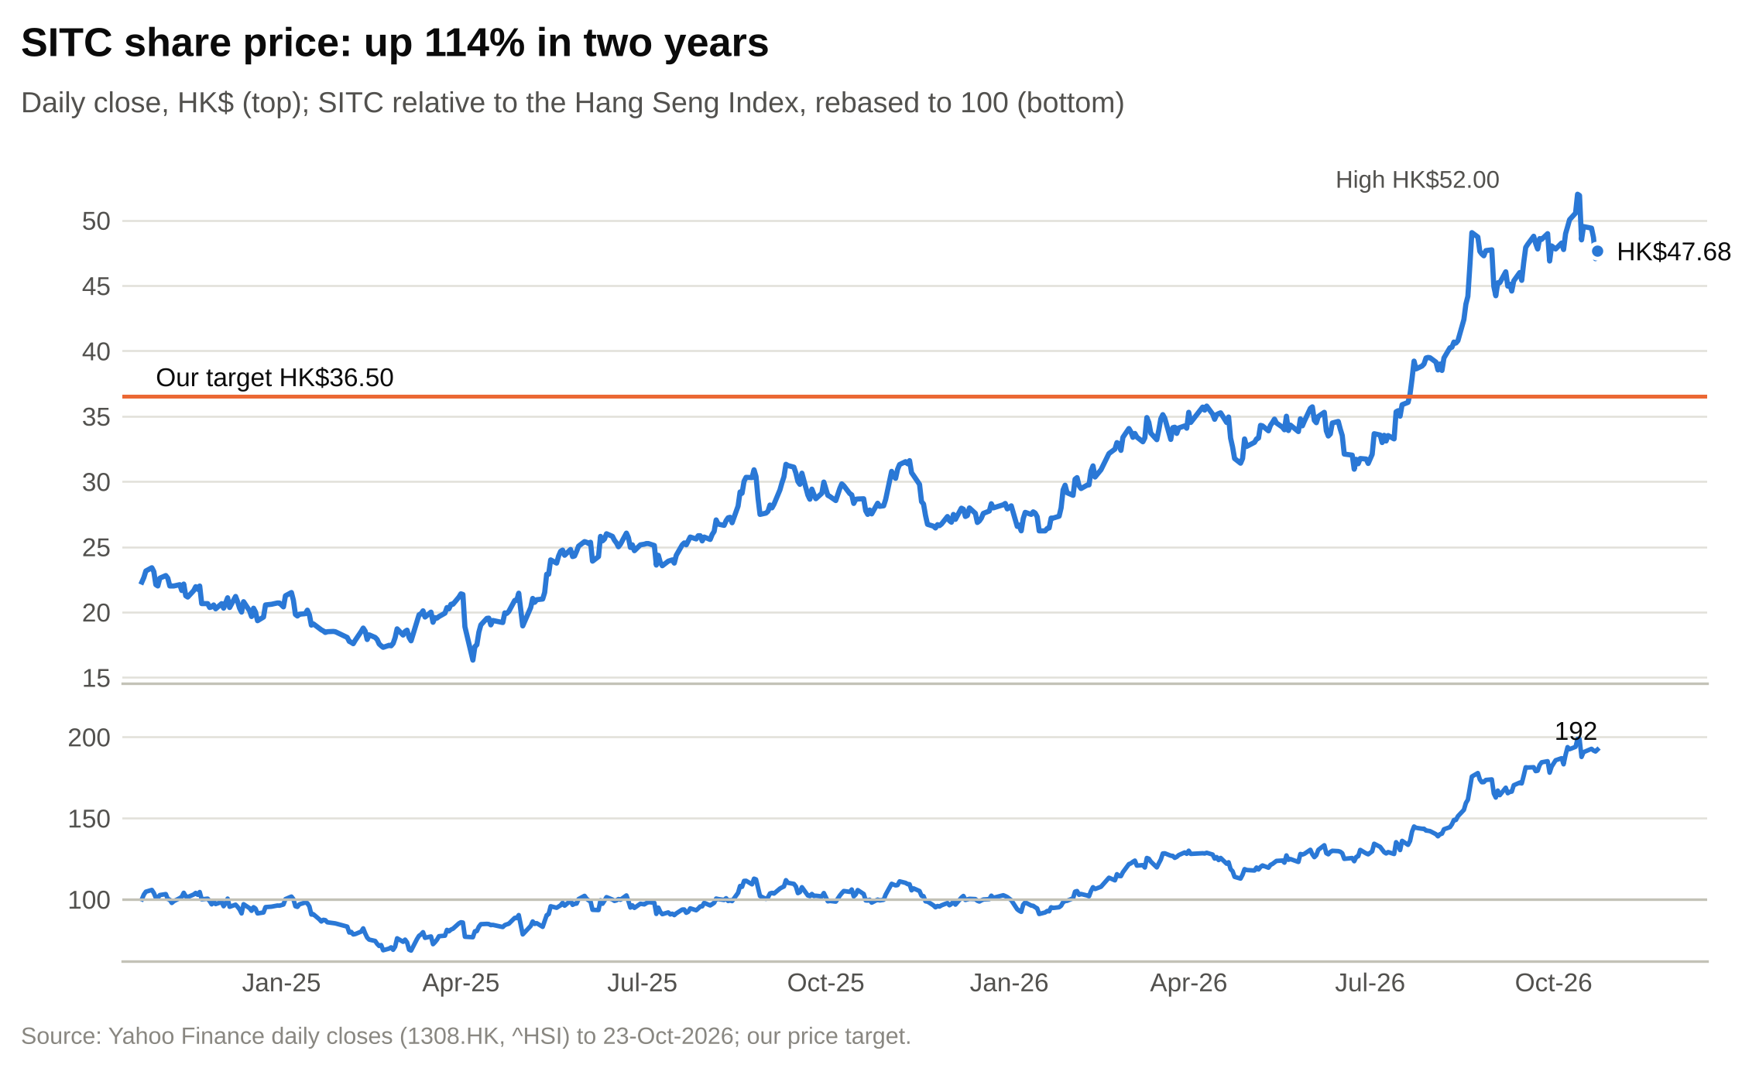  Source: Yahoo Finance, our price target.
  Stock data
  Rating | SELL
  12-month price target | HK$36.50
  Price (23-Oct-2026) | HK$47.68
  Downside to target | –23.4%
  Expected total return* | –15.8%
  52-week range | HK$26.22–52.00
  Market cap | HK$129.3bn / US$16.5bn
  Enterprise value** | US$15.5bn
  Net cash excl. leases (YE26E) | US$0.9bn
  FY2026E dividend yield | 7.6%
  Ticker / exchange | 1308.HK / HKEX
- 2026 is a disruption year, and the price treats it as the new normal. SITC's average freight rate reached about US$865/TEU in Q3 2026, 21% above Q3 2025, after the conflict around the Strait of Hormuz pushed up fuel and freight from late February. We forecast FY2026E attributable profit of US$1,472m (+20%) and EPS of HK$4.27. At HK$47.68 the stock trades on 11.2x that peak-year EPS and on 13.9x our FY2027E. At our base-case multiple of 10.9x, the price implies EPS of HK$4.39, which is above even our FY2026E.
- The order book lands in 2027-28, including SITC's own. The top 100 carriers have 13.6m TEU on order, 40% of their fleets, and SITC's regional peers have order books equal to 64% of theirs. SITC takes most of its own 66,000 TEU in the same two years. In our base case the average rate falls 10% in FY2027E and 5% in FY2028E, to US$711/TEU, close to the FY2024-25 average of US$737. EPS falls to HK$3.42 in FY2027E and HK$3.02 in FY2028E, 29% below FY2026E. Consensus expects a fall of about 2% a year.
- The quality is real but already paid for. SITC earns the highest return on equity among listed container lines (47% LTM against a peer median of 10%), holds US$0.9bn of net cash and pays out 80-85% of profit. It already trades on 5.8x book and above the top quartile of peer forward P/Es. Because the payout is a ratio, not a fixed amount, the dividend falls with earnings: we forecast HK$2.74 for FY2027E against HK$3.62 for FY2026E, a 5.7% yield at today's price.
- SELL, 12-month target HK$36.50. The target blends our DCF (HK$36.22; WACC 10.1%, terminal growth 2.0%) at 60% with 10.9x FY2027E EPS (HK$37.15) at 40%. With HK$3.63 of dividends over the next 12 months, the expected total return is –15.8%. Our bull case (rates hold near 2026 levels through the delivery wave) is worth HK$59.40; the bear case (a return to the 2023 trough) is worth HK$16.11. The probability-weighted value is HK$36.99. The FY2026 results in March 2027 are the first test.
Figure 2: Key financials and valuation
US$m / FY Dec | FY2024A | FY2025A | FY2026E | FY2027E | FY2028E
Revenue (US$m) | 3,058 | 3,412 | 3,894 | 3,727 | 3,740
YoY growth | +25.9% | +11.6% | +14.1% | –4.3% | +0.4%
Average freight rate (US$/TEU) | 721 | 753 | 831 | 748 | 711
EBITDA (US$m) | 1,180 | 1,376 | 1,633 | 1,336 | 1,218
EBITDA margin | 38.6% | 40.3% | 41.9% | 35.9% | 32.6%
Attributable profit (US$m) | 1,028 | 1,223 | 1,472 | 1,184 | 1,049
Diluted EPS (HK$) | 3.00 | 3.56 | 4.27 | 3.42 | 3.02
EPS growth | +93.5% | +18.9% | +20.4% | –19.6% | –11.4%
DPS declared (HK$) | 2.52 | 3.00 | 3.62 | 2.74 | 2.43
P/E at HK$47.68 (x) | 15.9x | 13.4x | 11.2x | 13.9x | 15.8x
EV/EBITDA (x) | 13.1x | 11.3x | 9.5x | 11.6x | 12.7x
Dividend yield | 5.3% | 6.3% | 7.6% | 5.7% | 5.1%
ROE | 47.6% | 50.1% | 56.2% | 40.7% | 33.3%
Net cash excl. leases (US$m) | 578 | 930 | 917 | 949 | 911
Note: multiples at HK$47.68 (23-Oct-2026 close) and HK$7.8413/US$. EV US$15,513m = market cap less YE2026E net cash and JVs, plus minorities. FY2026E DPS includes the HK$1.50 interim and HK$1.00 special already declared. Source: company filings, our estimates.

Contents
Investment thesis 3
Pillar 1: The 2026 rate spike is a disruption premium, not a new base 3
Pillar 2: Supply arrives in 2027-28, and SITC adds its own 3
Pillar 3: The price already assumes 2026 lasts 3
Pillar 4: The quality is real, and it is already in the multiple 3
The strongest case against us 4
Risks to our rating 5
Company-specific risks 5
Industry and market risks 5
Financial risks 5
Macroeconomic risks 5
Catalysts and what would change our view 7
Company 101 8
Company overview 8
Company history 9
Management team and governance 10
Products and services 12
Customers and go-to-market 12
Industry overview 13
Competition 14
Market opportunity 16
Financial analysis 17
Revenue and its drivers 17
The 2026 run-rate 19
Costs and unit economics 20
Margins 20
Cash flow, capital spending and dividends 21
Balance sheet 23
Projections and estimates 25
Fleet and volume 25
Freight rate 26
Slot exchange, logistics and other revenue 26
Revenue by geography 27
Costs and margins 27
Capital spending, cash flow and the balance sheet 28
Our estimates against consensus and the share price 29
Scenario analysis 30
How the scenarios are built 30
Bull case: the disruption premium lasts (25%) 30
Base case: the premium fades, rates normalise (50%) 30
Bear case: back to the 2023 trough (25%) 31
Scenario comparison 31
Valuation 33
Discounted cash flow 33
Comparable companies 35
Precedent transactions 37
Cross-checks and the football field 37
The stock's own history 38
Sanity checks 39
Price target and rating 39
Rating definitions 39
Appendix A: Financial statements 40
Appendix B: Model notes and data conventions 42
Appendix C: Glossary 42
Appendix D: Sources 43
Important disclosures 43

Investment thesis
SITC is the best-run company in intra-Asia container shipping, and we expect it to stay that way. Our SELL rating is about the price. The shares have risen 114% in two years and 74% in the past twelve months, and they now discount a level of freight rates that, in our judgement, comes from a temporary shock to supply. We set out four pillars below and then the strongest case against us.

Pillar 1: The 2026 rate spike is a disruption premium, not a new base
SITC's average freight rate rose 9.4% year on year in the first nine months of 2026, to US$825.9/TEU. The quarterly pattern matters more than the total. Deriving the quarters from the cumulative disclosures, the rate was up only 4.0% in the first half (US$807 against US$776) but up about 21% in the third quarter (US$865 against US$712) (Figure 22). Volume growth went the other way, from +7.8% in the first half to about +2% in Q3.
In our judgement, rates rising while volume slows points to a supply shock rather than stronger demand. The timing matches the disruption around the Strait of Hormuz from late February 2026. Drewry's intra-Asia index rose from US$616 per 40ft container in mid-March to US$1,008 by late May, about 83% above pre-conflict levels. Singapore very low sulphur fuel oil more than doubled, from about US$525 a tonne to above US$1,100. By late July, though, Drewry was reporting intra-Asia rates softening, and bunker prices eased through September.
Our base case assumes a Q4 2026 rate of US$845/TEU, below Q3 but 13% above Q4 2025, which gives a FY2026E rate of US$831 (+10.4%). For FY2027E we assume a 10% fall to US$748, which is the FY2025 level, and a further 5% in FY2028E to US$711. That is close to the post-COVID norm: the FY2023-25 average was US$699 (Figure 18). It is still 36% above the FY2017-20 average of US$524. Our forecast is simply that the 2026 premium goes away.
Each US$10/TEU on the FY2027E rate is worth about US$44m of revenue and HK$0.12 of EPS, because SITC's costs barely move with the rate. That operating leverage is what drove 2026 profits up, and it works the same way on the way down.

Pillar 2: Supply arrives in 2027-28, and SITC adds its own
On Alphaliner's 25 October 2026 table, the 100 largest container lines operate 34.1m TEU and have 13.6m TEU on order, 39.9% of their fleets. Linerlytica expected 2.9m TEU of deliveries in 2027 and 3.8m TEU in 2028 (September 2025 estimate). Most of this is large tonnage for east-west trades, but ships displaced from those trades cascade into regional ones. The regional carriers are also ordering for themselves: across 15 intra-Asia specialists, capacity on order equals 63.9% of the current fleet. Wan Hai has 78%, CULines 84% and RCL 148% (Figure 14).
SITC's own order book is the smallest relative to its fleet in that group, at 35%. In absolute terms it is still large: about 66,000 TEU (37 ships on Alphaliner's count; 30 contracted vessels on the company's) against a fleet of 187,297 TEU. The orders disclosed since August 2025 deliver between December 2027 and August 2028, and Alphaliner shows most of the rest due in 2027-28. We assume gross deliveries of 26,000 TEU in 2027 and 30,000 TEU in 2028, offset by 27,000 TEU of disposals and charter redeliveries, so the fleet grows from 187,000 TEU at the end of 2026 to 216,000 TEU at the end of 2028 (Figure 38).
That matters for unit costs. Vessel costs, which include depreciation and charter hire, scale with capacity rather than with cargo. If volume grows 5% a year and capacity 7.5%, liftings per slot fall and vessel cost per TEU lifted rises. In our base case gross profit per TEU falls from US$396 in FY2026E to US$268 in FY2028E, and the gross margin from 41.2% to 32.0%.

Pillar 3: The price already assumes 2026 lasts
We test what the market is pricing in three ways.
- Reverse DCF. Holding our FY2027E-30E cash flows, a 10.1% WACC and 2% terminal growth, the current price needs terminal free cash flow of US$1.43bn a year, 42% above our FY2030E estimate of US$1.00bn. Per TEU lifted, that is US$296, against US$209 in our FY2030E and US$336 in FY2026E, a year with the disruption premium in it.
- Implied earnings. At our base-case P/E of 10.9x, which is the 75th percentile of peer forward P/Es, the price implies EPS of HK$4.39. That is above our FY2026E EPS of HK$4.27.
- Consensus. The nine analysts in the S&P Global consensus rate SITC a Buy, with an average target of HK$46.20, 3% below the price. Consensus expects EPS to fall about 2% a year over three years. We expect EPS to fall 29% from FY2026E to FY2028E. The difference is almost all in the freight rate.
On our numbers the stock trades on 13.9x FY2027E and 15.8x FY2028E earnings, against a peer median forward P/E of 7.8x (Figure 53). For the shares to hold their value, rates would need to stay near 2026 levels through the delivery wave. That is our bull case, and we give it a 25% probability.

Pillar 4: The quality is real, and it is already in the multiple
Nothing in our view questions SITC's quality. It earned a 26% ROE in 2023, the trough of the last cycle, and stayed profitable in every year of the 2021-23 boom and bust. It owns 87% of its capacity, so its costs do not reset when charter rates spike. It runs a dense, high-frequency network on short lanes with small ships, which suits regional ports and fragmented cargo. Bank debt was US$33m at June 2026 against US$1.0bn of cash, deposits and liquid investments.
The market already pays for this. SITC trades on 5.8x book against a peer median of 0.91x, and 11.1x LTM EV/EBITDA against 5.3x (Figure 52). Its premium on P/B is roughly in line with what a Gordon model would justify for its returns: at a 41% FY2027E ROE, a 10.1% cost of equity and 2% growth, the justified P/B is 4.8x, or HK$38.15 a share. The return premium is real, but it does not leave room for upside at today's price.
The dividend will not hold the shares up. SITC pays a ratio of its profit, typically 80-85% including specials, so the dividend falls with earnings. FY2026E dividends of HK$3.62 (a 7.6% yield) fall to HK$2.74 in FY2027E (5.7%) and HK$2.43 in FY2028E (5.1%). Our dividend discount model, at a 10.1% cost of equity, values the shares at HK$31.46.

The strongest case against us
The best argument for owning SITC runs like this. Disruption premia last longer than people expect. The Red Sea diversions that began in late 2023 were still in place in 2026, and a premium tied to Hormuz could last as long. SITC's rate beat Drewry's intra-Asia index in 2025, rising 4.5% while the index ended the year roughly flat. It has the balance sheet to keep paying high dividends through a downturn. And its management has run the business through the last cycle without a loss.
We take this seriously, and it is our bull case: rates fall only 3% in 2027 and hold through 2028. That case is worth HK$59.40, 25% above the price. Our verdict is later, not wrong. The bull case needs rates to hold through a delivery wave of about 6.7m TEU in 2027-28 while regional peers add capacity equal to almost two-thirds of their fleets. We weight it at 25%. Even then the probability-weighted value, HK$36.99, is 22% below the price.
What would change our mind: a 2H26 average rate above US$870/TEU, a 1H27 rate above US$830/TEU, or consensus FY2027 EPS rising above HK$4.20 after the FY2026 results. Any of these would tell us the premium is more durable than we assume.

Risks to our rating
Because our rating is SELL, the main risks are upside risks to the shares. We list them first, then the risks that would add to the downside. Figure 3 summarises probability and estimated impact.
Figure 3: Risk matrix: probability and estimated impact
Risk | Category | Probability | Impact on value | Direction for our call
Hormuz / Red Sea disruption persists through 2027 | Industry | Medium | +63% vs target (bull DCF) | Against
Volumes absorb the new ships at stable unit costs | Company | Medium | +10-15% | Against
Higher payout, specials or buybacks | Financial | Medium | +3-5% total return | Against
Rates fall to the 2023 trough | Industry | Low-medium | –56% vs target (bear DCF) | With
Price competition from new regional capacity | Industry | Medium | –10-15% | With
Newbuild delays or cost overruns | Company | Low | –2-3% | With
Bunker price spike not passed on | Macro | Medium | –5-10% FY2027E EPS | With
US-China settlement reverses tariff-driven flows | Macro | Low-medium | –5-10% | With
Taiwan Strait / South China Sea disruption | Macro | Low | Severe, two-sided | Two-sided
Related-party dealings with Qingdao SITC | Governance | Low | Multiple discount | With
Key-person and succession risk | Company | Low | Multiple discount | With
Share-price momentum and index flows | Market | Medium | Timing risk | Against
"Against" = a risk that would make our SELL call wrong; "With" = a risk that adds to the downside. Source: our judgement; impacts from model scenarios where shown.

Company-specific risks
Volumes absorb the new ships at stable unit costs (upside risk). SITC grew volume 7.6% a year from 2019 to 2025, faster than the market's 3-5%. If it can fill its new ships at today's liftings per slot of about 21-22, vessel cost per TEU would stay flat, and the gross margin would fall less than we assume. Volume growth of 7% a year with stable unit costs would add 10-15% to our value (our estimate).
Higher payouts, specials or buybacks (upside risk to total return). The dividend policy allows payouts of up to 100% of distributable profit, and 2026 has already brought a HK$1.00 special. A 90% payout from FY2027E, as in our bull case, would add HK$0.30-0.40 a year to dividends and 3-5 points to total return.
Newbuild delays or cost overruns (downside). SITC has US$763m of vessel commitments at fixed prices with Chinese yards. Delays would push capacity into a weaker market. In our view the financial risk is small: the commitments equal less than one year of operating cash flow.
Key-person and succession risk (downside). The four executive directors joined SITC companies in the 1990s and have run the business through every cycle. The 2024 handover from the founder went smoothly, but the bench below them is less visible to outside investors.

Industry and market risks
The disruption premium persists (upside risk). This is the main risk to our view. If the conflict around Hormuz or the Red Sea diversions continue through 2027, rates could stay near 2026 levels. Our bull case puts the value at HK$59.40, 63% above our target.
Price competition from new capacity (downside). CULines, Zhonggu and other Chinese operators have order books of 84-172% of their fleets, and HMM plans 22 ships of 1,800-2,800 TEU from 2028, sizes that suit SITC's lanes. Price-led competition on China-Southeast Asia lanes could cut rates 5-10% below our base case (our estimate).
Rates fall to the 2023 trough (downside). In 2023 SITC's rate fell 43% and profit 73%. Our bear case, with the rate down 20% in 2027 and 8% in 2028, takes the FY2028E rate to US$605/TEU, close to the 2023 low of US$623, and is worth HK$16.11.
Share-price momentum and index flows (timing risk). The stock is up 74% in a year and sits near its high. Momentum and passive flows can keep a stock above fair value for longer than a 12-month horizon.

Financial risks
Bunker costs. Voyage costs rose 14.1% in 1H26 on higher bunker prices. SITC does not disclose how much of the increase it recovers through surcharges. A renewed fuel spike without full recovery would cut FY2027E EPS by 5-10%.
Related-party dealings. Qingdao SITC, owned by the executives' families and employees, sits outside the group and trades with it. Recent transactions have been small and exempt under the Listing Rules, but they put the executives' families on both sides of some deals. A larger transaction on unfavourable terms would warrant a discount.

Macroeconomic risks
Trade policy. Part of recent intra-Asia growth comes from supply chains moving out of China around US tariffs. A US-China settlement or tighter rules of origin could slow those flows and, in our estimate, cut volume growth by 1-2 points a year.
Geopolitics in the region. SITC's network runs through the Taiwan Strait and the South China Sea, and it holds mainland China-Taiwan services through a connected company. A conflict or sanctions would disrupt its core lanes. The effect on value could go either way: rates would rise, but volumes and access to ports could fall.
China's economy. Greater China accounts for 48.5% of revenue. A sharp slowdown in Chinese exports would hit volumes and rates together.

Catalysts and what would change our view
Figure 4: Upcoming catalysts
Date | Event | Confidence | What we look for
4-Dec-2026 | HK$1.00 special dividend goes ex | Scheduled | Price adjusts by the dividend
Dec-26 to Feb-27 | Weekly SCFI / Drewry intra-Asia rates; Chinese New Year 6-Feb-2027 | Scheduled data | Rates below the same weeks of 2025
Early-mid Mar-2027 | FY2026 results and final dividend | Likely | 2H26 rate and margin; final DPS; 2027 outlook
2027-28 | Newbuild deliveries (2,700 and 1,100 TEU series) | Likely | Charter redeliveries and disposals alongside
Mid-Aug-2027 | 1H27 interim results | Likely | First half-year on the post-disruption rate base
Any time | De-escalation or escalation around Hormuz and the Red Sea | Speculative | De-escalation releases capacity; escalation is the main upside risk
Source: company announcements; our judgement.
The FY2026 results, expected in early to mid March 2027 (FY2023-25 results came out between 7 and 10 March), are the key event. They will show the second-half rate and margin and the final dividend, and management will comment on the 2027 market. We expect a strong set of numbers: 2H26E attributable profit of US$796m, 34% above 2H25. The share price reaction will depend on the outlook. The first half of 2027 will be the first period without the disruption premium in the comparison base.
We would revisit our rating if the monitoring items below cross their thresholds.
Figure 5: Monitoring items
Metric | Threshold | Source | Window | If crossed | If not
SITC 2H26 average rate | > US$870/TEU | FY2026 results | Mar-2027 | Raise FY2027E rates; review rating | Keep SELL
SCFI Shanghai-Southeast Asia | Above 2025 level for 8 weeks | SSE weekly | Dec-26 to Feb-27 | Move towards bull case | Keep base
FY2026 final DPS | > HK$1.30 | FY2026 results | Mar-2027 | Raise payout | Keep 80%
Consensus FY2027 EPS | < HK$3.60 | S&P Global MI | After FY26 results | Reassess downside | Thesis open
Vessel cost per slot | < US$1,850 | FY2027 results | Mar-2028 | Raise margins | Keep base
Source: our judgement.
Falsifiable claims. Our thesis rests on four claims that the next 12 months can test:
- The Q3 2026 rate of about US$865/TEU was a peak. It is falsified if the 2H26 average is above US$870 and the 1H27 average above US$830.
- Fleet growth outpaces volume in 2027-28. It is falsified if FY2027 vessel cost per average TEU slot falls below US$1,850.
- The market is capitalising 2026 earnings. It is falsified if consensus FY2027 EPS rises above HK$4.20 after the FY2026 results.
- The dividend falls with earnings. It is falsified if the 1H27 interim dividend is HK$1.50 or more.

Company 101

Company overview
SITC is a Hong Kong-listed container shipping and logistics company that moves containers only within Asia. It runs short-haul liner services between China, Japan, South Korea, Taiwan, Hong Kong and Southeast Asia, and has recently extended into India, Bangladesh and Myanmar. Management describes the business as focused "exclusively on servicing the Asia trade market". It does not serve the long-haul east-west trades at all.
Alongside the ships, SITC sells the land-side services a shipper needs to move a box from factory to consignee: freight forwarding, shipping agency and customs clearance, container depots, warehousing and land leasing. These run mostly in China and Southeast Asia, partly through joint ventures. At June 2026 the group, including joint ventures, operated about 2.23m m² of depots and 180,412 m² of warehousing.
Figure 6: SITC at a glance
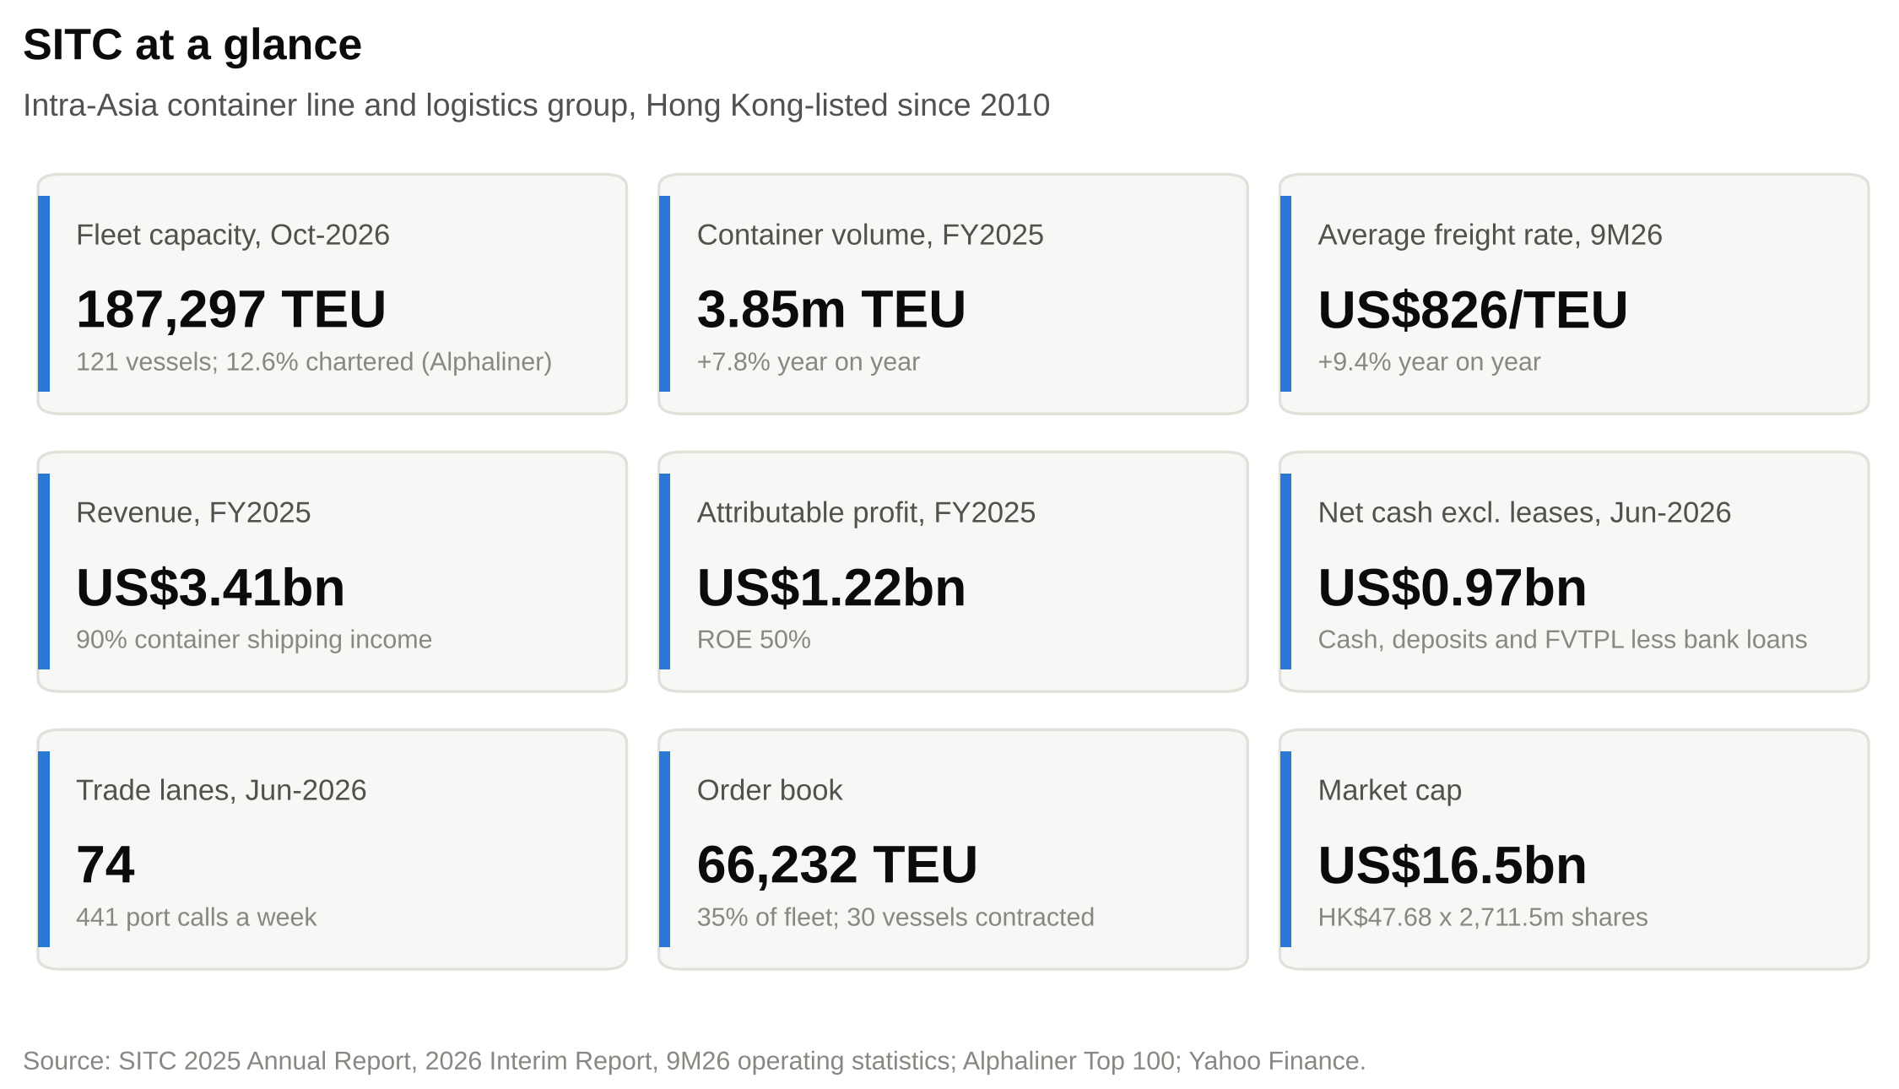

Fleet. SITC runs small ships that it mostly owns. At 30 June 2026 it operated 120 vessels with 185,365 TEU of capacity. It owned 98 of them, 87% of capacity, and chartered 22. Ninety-six ships were below 2,000 TEU and 24 between 2,000 and 3,000 TEU, an average of about 1,545 TEU per ship. The average age was 10.6 years. On Alphaliner's 25 October 2026 table the fleet was 187,297 TEU across 121 ships, the 14th largest in the world.
Network. Small ships suit the shallower drafts, shorter berths and smaller cargo parcels of many regional ports, and they let SITC run frequent fixed-day services. At June 2026 it ran 74 trade lanes and 441 port calls a week, covering 79 ports in 16 countries and regions. Of the 74 lanes, 42 were its own, 10 were joint services with other carriers and 22 ran through slot exchanges.
How it makes money. Almost all revenue is freight. SITC charges a rate per container, so revenue moves with volume and the average freight rate. In FY2025 it carried 3.85m TEU at an average of US$753 per TEU (excluding slot exchange) and earned revenue of US$3,411.6m. Container shipping and supporting logistics income was 90% of that; other container logistics income (forwarding, depots, warehousing) was 10%. SITC reports a single operating segment.
Returns. FY2025 profit was US$1,230.4m, a 36.1% net margin, and return on equity was 50%. Operating cash flow was US$1,401m. Bank borrowings fell from US$166.9m to US$18.9m during the year. At 30 June 2026 the group held US$932m of cash and time deposits and US$74m of liquid investments against US$33m of bank loans.
The company is incorporated in the Cayman Islands and headquartered in Wanchai, Hong Kong. Its operating roots, and much of its land-side business, are in Qingdao and Shanghai.
Figure 7: FY2025 revenue by service line
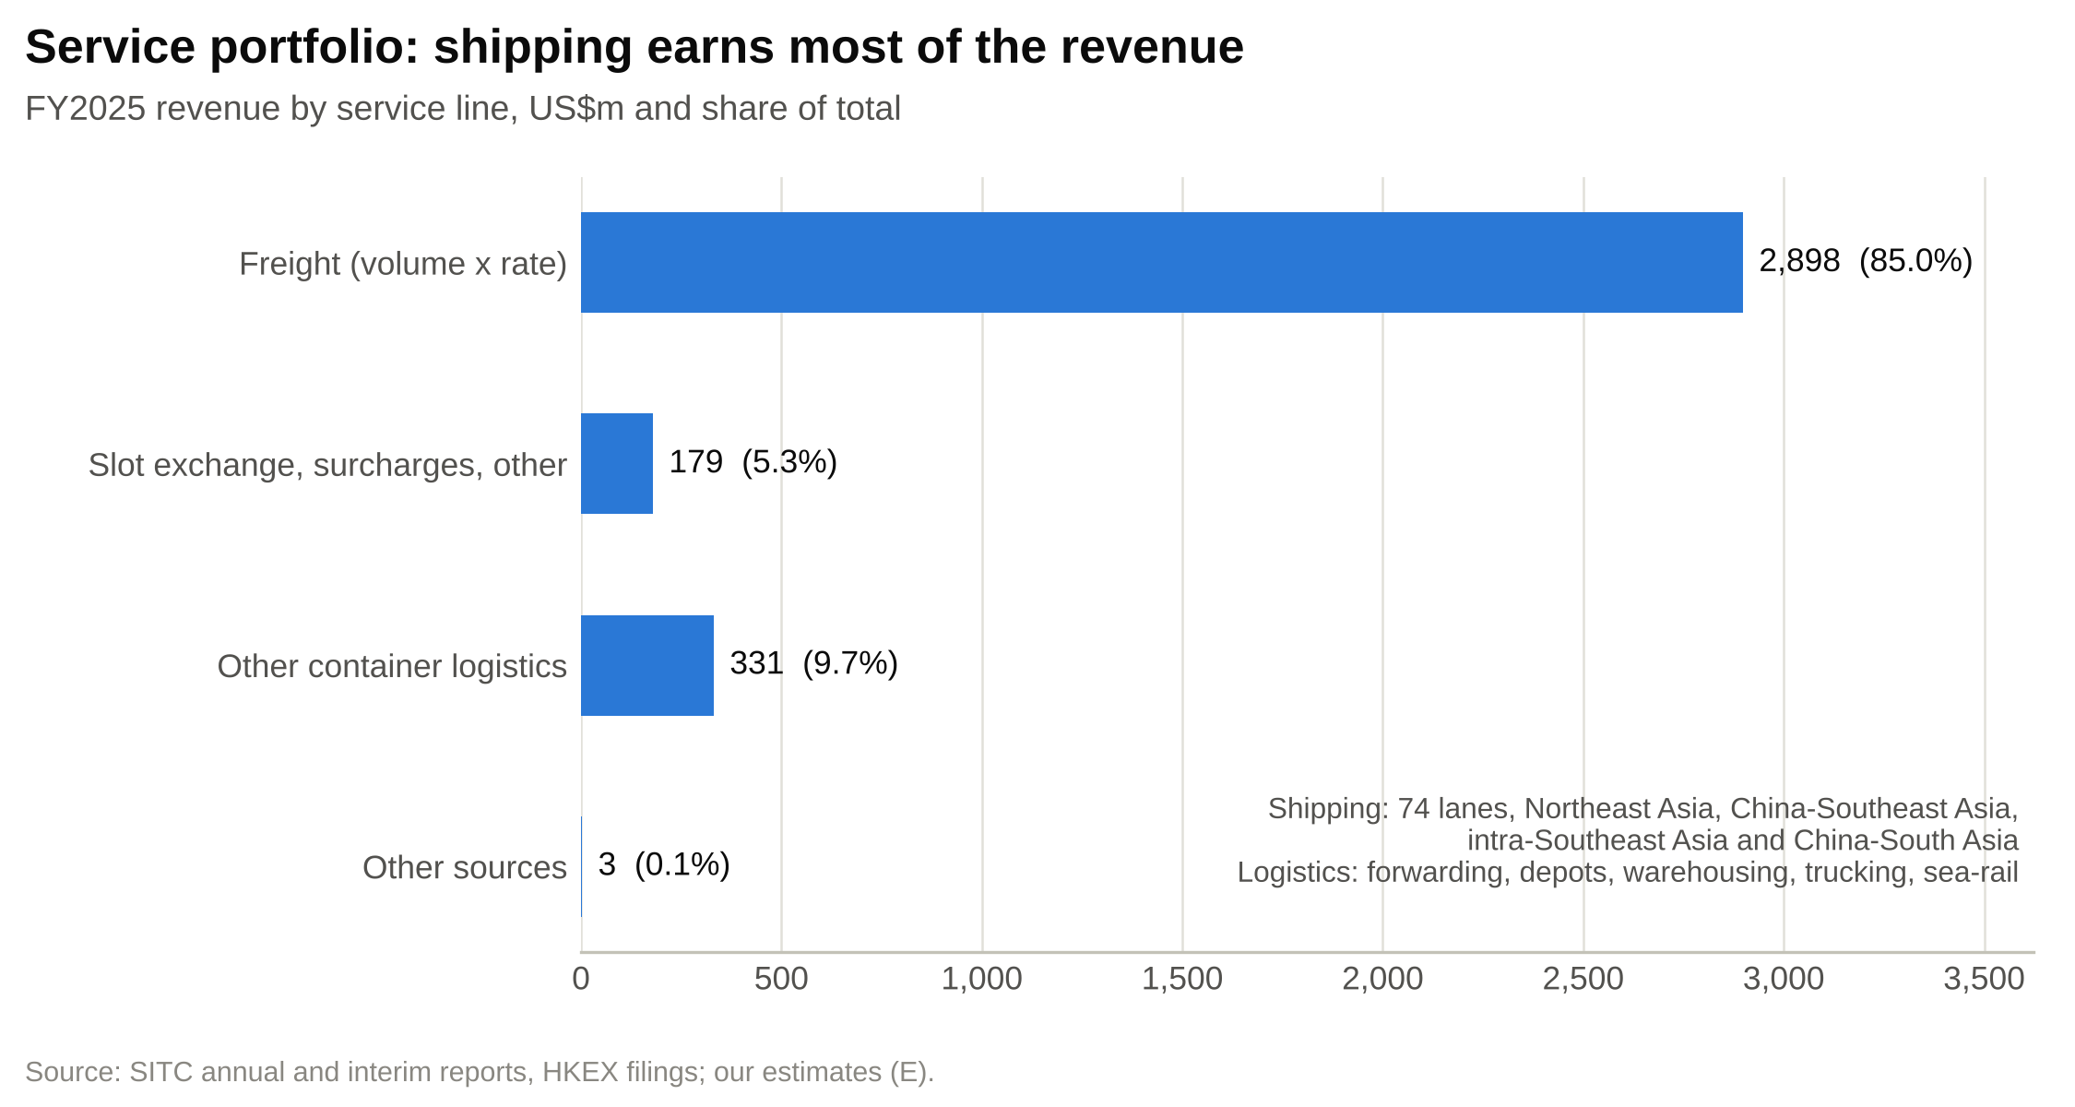

Company history
SITC began in May 1991 as Shandong International Transportation Corporation, a state-owned freight forwarder set up by Shandong Foreign Trade Corporation with RMB5m of capital. Yang Shaopeng, later chairman and still the controlling shareholder, was its deputy general manager. The company bought its first vessel and started China-Japan services in May 1992, added China-Korea in 1994, and set up SITC Japan, its first overseas subsidiary, in 1995.
In December 2000 the group moved to majority private ownership through an employee shareholding association that included Yang Shaopeng. In September 2001 the state shareholder sold its remaining 20% to a management-controlled company for RMB6m, its original investment.
The 2000s built the regional network. SITC formed logistics joint ventures with Maersk Logistics, Itochu and Tsingtao Beer in 2002, opened the Qingdao Logistics Park in 2003 and began China-ASEAN services in 2004. By 2008, according to its prospectus, its China-Japan routes were the largest of any carrier by volume. Yang Xianxiang became chief executive in January 2008.
SITC listed on the Hong Kong Stock Exchange on 6 October 2010 at HK$4.78 a share, raising about HK$3.1bn. At the time it carried 1.19m TEU a year and operated 42 ships, only 15 of them owned. Raising the owned share of the fleet was the main stated use of the proceeds, and it is the main thing that has changed since: by June 2026, 98 of 120 ships were owned. In December 2012 the business was reorganised under two presidents, Xue Mingyuan for shipping and Lai Zhiyong for logistics, a structure that still stands.
The pandemic years brought a boom and a bust. The average rate rose 52% in 2021 and another 33% in 2022, to US$1,100/TEU, and profit peaked at US$1,950m in 2022. In 2023 the rate fell 43% and profit 73%, to US$536m. The company stayed profitable throughout. Red Sea diversions lifted rates again in 2024, and 2025 brought record volume of 3.85m TEU.
In March 2024 the founder stepped down as chairman and became Honorary Life Chairman. Yang Xianxiang became chairman, Xue Mingyuan chief executive and Yang Xin, the founder's daughter, vice chairman. Since August 2025 SITC has ordered six 2,700 TEU and ten 1,100 TEU ships for delivery in 2027-28.
Figure 8: Milestones, 1991-2026
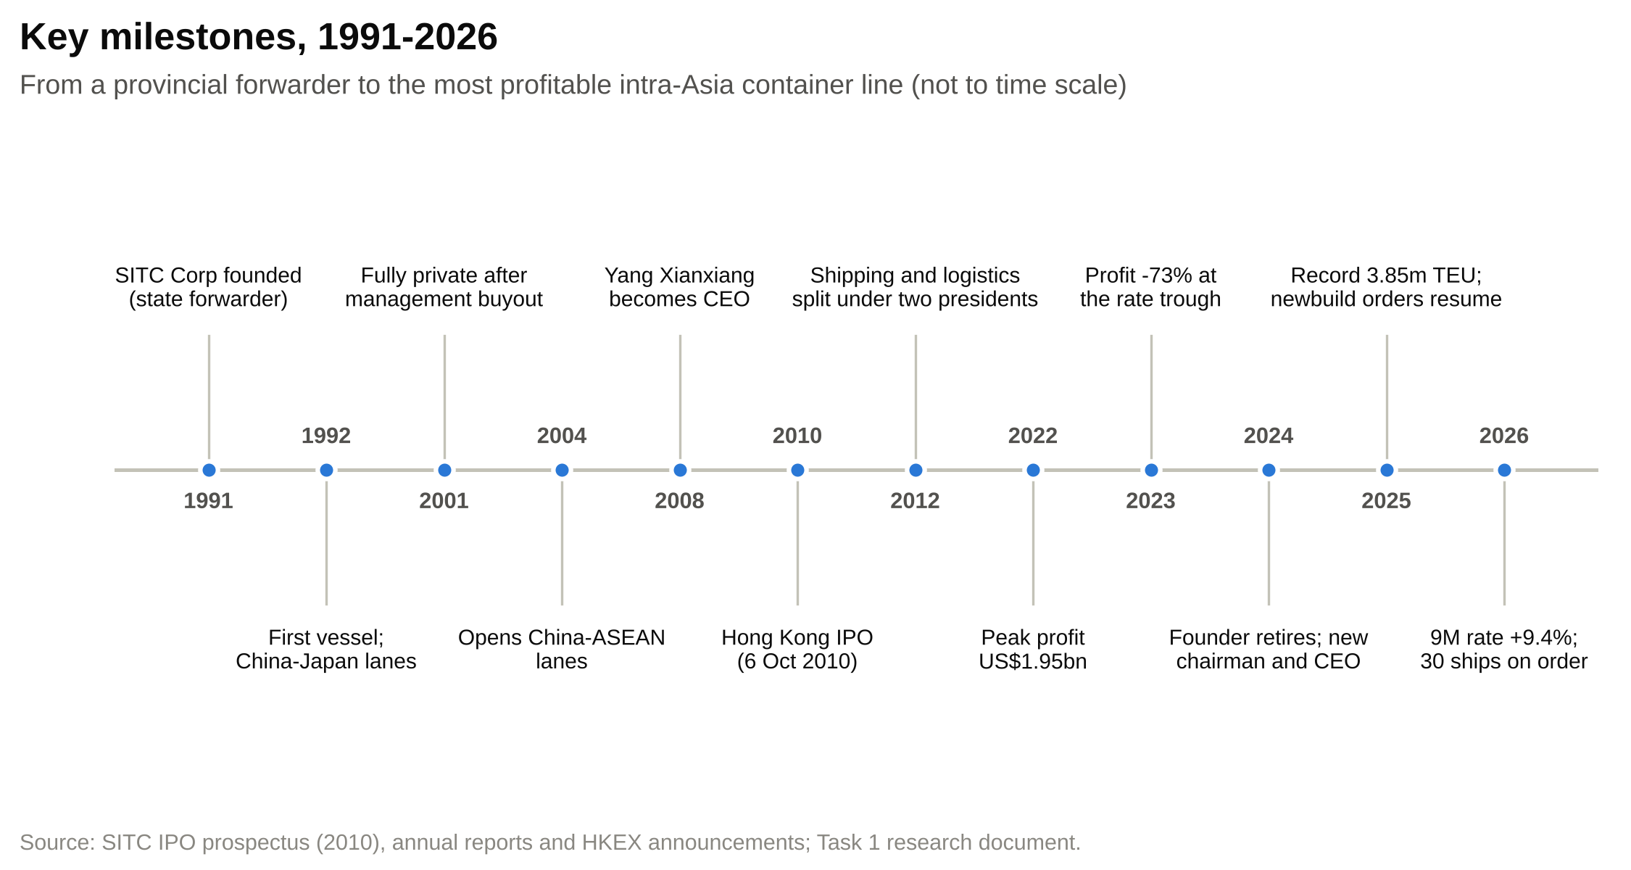

Management team and governance
SITC is run by executives who have spent their careers inside the group. All four executive directors joined SITC companies in the 1990s, and each holds an MBA from China Europe International Business School (CEIBS). The founder no longer sits on the board, but his family trust holds 40.49% of the shares.
Figure 9: Group, ownership and board structure
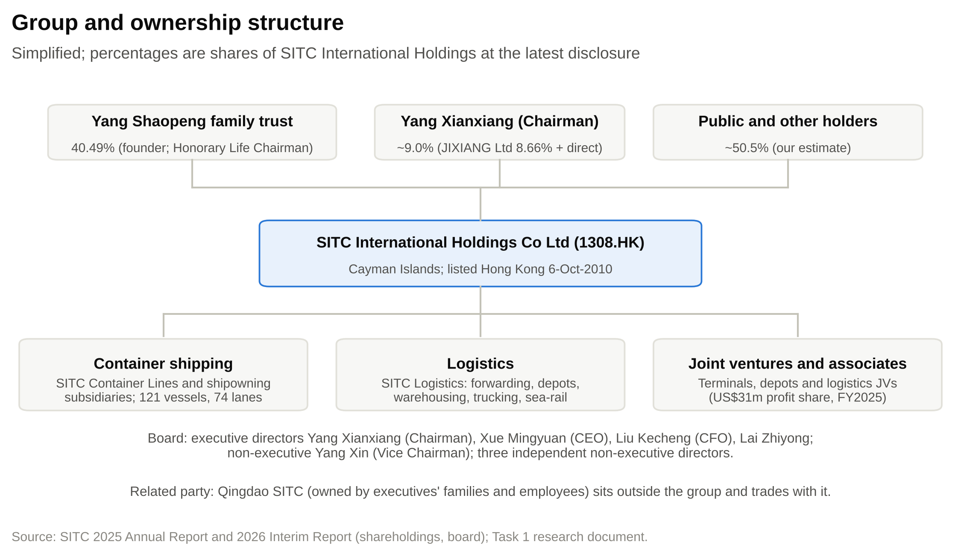

Yang Xianxiang, Chairman and Executive Director (age 59)
Yang Xianxiang has chaired the board since March 2024. He has been a director since January 2008 and was chief executive for sixteen years, from January 2008 to March 2024, which makes him the main architect of the listed company. His shipping career spans 39 years: ten years at Lufeng Shipping from 1987, then general manager of SITC Container Lines (Shandong) from 1997, executive vice president and then president of SITC Maritime Group between 2002 and 2007, and president of SITC Container Lines before taking the group CEO role.
He holds MBAs from Asia International Open University (Macau) and CEIBS and has completed executive programmes at Tsinghua, Fudan, Cheung Kong Graduate School of Business and CEIBS. He is an independent director of JS Global Lifestyle and a director of Shanghai Fortune Techgroup.
He is SITC's second-largest shareholder: at the end of 2025 his company, JIXIANG Limited, held 8.66% of the shares and he held 9.7m shares directly. His spouse owns 18.75% of Qingdao SITC, a connected company. His 2025 pay was US$6.22m, 84% of it performance-related.
During his tenure as chief executive, volume rose from 1.19m TEU in 2009 to 3.22m TEU in 2023, the fleet grew from 37,256 TEU to 162,851 TEU, and the owned share of the fleet went from about a third of vessels to most of it. The strategy he set, a regional focus with owned small tonnage and sea-land integration, is unchanged under his successor.

Xue Mingyuan, Chief Executive Officer and Executive Director (age 52)
Xue Mingyuan became chief executive in March 2024. He has been an executive director since 2013 and, since December 2012, president of SITC Shipping Group and general manager of SITC Container Lines, the operating core of the business. In practice he has run the liner operation for more than a decade.
All of his 29 years in shipping have been at SITC companies. Between 1997 and 2012 he moved from export supervisor at SITC Lianji (Shandong) to customer service and sales management at SITC Container Lines, then to deputy general manager and general manager of SITC Container Lines (Korea), and finally to general manager of the whole liner company. He holds a master's degree in international shipping and logistics management from The Hong Kong Polytechnic University and a CEIBS MBA.
His record as group chief executive is short but encouraging. In 2025 volume grew 7.8% and the average rate 4.5%, while Drewry's intra-Asia index ended the year roughly flat. In the first half of 2026 volume rose 7.8% even though the number of trade lanes fell from 82 to 74 and weekly port calls from 489 to 441, which we read as deliberate pruning towards denser, fuller services. The test ahead is how he deploys the ships arriving in 2027-28 into a market where competitors are adding much more capacity. His 2025 pay was US$4.09m; his spouse owns 3.12% of Qingdao SITC.

Liu Kecheng, Chief Financial Officer and Executive Director (age 52)
Liu Kecheng has been chief financial officer since May 2013 and also runs the group's finance and investment centres. He has been a director since 2006. He started his career in 1994 in the finance department of Shandong Foreign Trade Corporation, SITC's original state shareholder, and joined SITC as finance manager in 1998. He was joint company secretary around the IPO and then director for investment and securities. He holds a CEIBS MBA and has been a director of Hisense Group Holding since December 2020. Hisense is also a customer of SITC's logistics arm.
He has run the balance sheet conservatively. Bank borrowings were US$18.9m at the end of 2025 and the gearing ratio was 0%. Management expects internal resources and bank borrowings to cover the newbuild programme. The dividend policy allows payouts of up to 100% of distributable profit, and FY2025 dividends of HK$3.00 were about 84% of EPS. The trade-off is a thinner buffer if rates fall sharply. His 2025 pay was US$2.13m; his spouse owns 5.33% of Qingdao SITC.

Lai Zhiyong, President of SITC Logistics Group and Executive Director (age 53)
Lai Zhiyong has run SITC Logistics since December 2012 and has been an executive director since 2013. He is responsible for the land-side half of the "sea-land integrated" model: forwarding, agency, depots, warehousing and the logistics joint ventures that date back to the 2009 partnerships in Vietnam, the Philippines and Thailand. Like Xue Mingyuan, he came up through the liner business, as import supervisor, department manager at SITC Container Lines and general manager of SITC Container Lines (Hong Kong). He graduated in international trade from Ocean University of China and holds a CEIBS MBA.
The business he runs is small next to shipping but growing quickly. Other container logistics income was US$331.2m in 2025 and rose 28.5% in 1H26; joint-venture profits were US$31.1m in 2025 and rose 26% in 1H26. Recent projects include a Thai logistics joint venture, a Qinzhou-Jakarta-Semarang sea-rail trial and an automated double-layer container yard. Because SITC does not report logistics margins separately, his record can be judged on growth but not yet on returns. His 2025 pay was US$1.62m.

Board, governance and ownership
The board has eight members: the four executive directors; Yang Xin, the founder's daughter, as non-executive vice chairman; and three independent non-executive directors, the Hong Kong minimum. The lead independent director, Tse Siu Ngan, is a former technology executive. Dr Rebecca Liu Ka Ying, a certified public accountant, chairs the audit committee, and Dr Mandy Hu Mantian of the Chinese University of Hong Kong chairs the nomination and disclosure committees. The board was paid US$14.9m in 2025, about 1.2% of profit.
Insider ownership is high. The founder's trust holds 40.49% and the chairman about 9%, so together they control about half of the shares (Figure 10). That aligns management with minority holders on dividends, which have been generous, but it also means minority holders have little influence.
The main governance issue is SITC Maritime Group (Qingdao SITC), a company outside the listed group. The founder's wife owns 44.75% of it, the executive directors' wives 29.27% between them and current and former employees the rest. Its subsidiary holds the mainland China-Taiwan route licences, using ships chartered from SITC. In April 2026 SITC sold a single-vessel company to a Qingdao SITC subsidiary for US$12.16m and chartered the ship back for 15 years, with the charter hire paid up front. Such deals are small and exempt under the Listing Rules, but they put the executives' families on both sides of some transactions.
Figure 10: Ownership structure
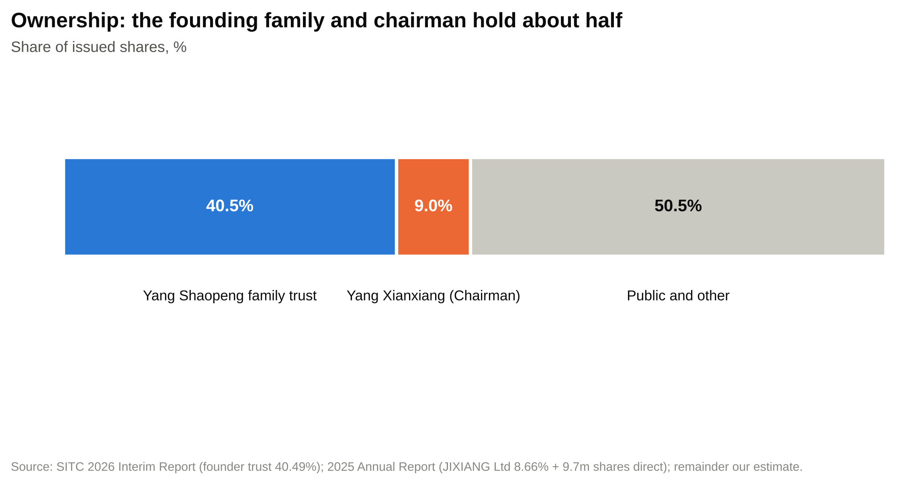

Products and services

Container liner services
SITC's core product is scheduled, fixed-day container services within Asia. The network has three parts: Northeast Asia (China-Japan and China-Korea, SITC's original markets, plus Taiwan and Hong Kong), Southeast Asia (China to and within Vietnam, Thailand, the Philippines, Indonesia, Malaysia, Singapore, Cambodia, Brunei and Myanmar) and South Asia (China to Bangladesh and India, including a China-East India service through Chennai that began in 2025).
The fleet is built for these lanes. On a typical intra-Asia route cargo is spread across many small ports, so frequent calls with small ships serve customers better than occasional calls with large ones. Standardisation is an old habit: at the IPO 86% of the fleet was a single 1,000 TEU design, and the current order book continues the pattern with batches of identical 1,100 TEU and 2,700 TEU ships. Interchangeable ships can be moved between lanes and share crews, spares and maintenance.
Owning most of the fleet gives SITC a cost base that does not reset when charter rates rise. Management's stated approach is to buy and order ships when prices are low, "to secure a long-term cost competitive position".
Rates are quoted per box. SITC discloses one average rate across all lanes: US$753.3/TEU in 2025, US$807.2 in 1H26 and US$825.9 for the first nine months of 2026. It does not disclose its split between contract and spot cargo, its revenue by lane or how it passes fuel costs through, which limits how precisely the rate can be modelled.

Logistics services
SITC Logistics provides the services around the ocean leg: international freight forwarding and shipping agency, customs declaration, less-than-container-load consolidation, container depots and yards, warehousing, project logistics, multimodal and sea-rail transport, cross-border e-commerce logistics and land leasing. Logistics income was 10% of revenue in 2025 and grew 28.5% in 1H26. Joint ventures in forwarding and depots added US$31.1m of profit in 2025.

What sets the offer apart
SITC's offer to a shipper rests on four things: port coverage and sailing frequency within Asia; the reliability that comes from controlling owned ships; door-to-door service through its own forwarding and depot network; and a low unit cost that lets it price competitively and still earn margins well above the large carriers'. It does not compete on ship size, long-haul connectivity or alliance membership.

Customers and go-to-market
SITC's customers are cargo owners (manufacturers, exporters and importers) and the forwarders that book on their behalf. It does not publish a customer count or the split between direct shippers and forwarders. Its five largest customers account for less than 30% of revenue.
The cargo follows Asian manufacturing supply chains. Components and intermediate goods move from China to assembly plants in Southeast Asia, and finished goods move within the region. Management attributes 2025 demand to "Chinese exports, industrial relocation, and the uncertainty of trade policies". The Japan and Korea trades are SITC's original, mature markets.
SITC sells through its own country subsidiaries and agencies in Japan, Korea, Hong Kong, Taiwan, Thailand, Indonesia, Vietnam and the Philippines, several of them joint ventures, and through its forwarding arm. Cargo is booked shipment by shipment or under short-term rate agreements, so customers can switch quickly if service or price slips. Ten lanes run as joint services and 22 through slot exchanges, which extends the network without extra ships but leaves part of it dependent on partners.
SITC's average rate tends to move less than market indices. In 2025 it rose 4.5% while Drewry's index ended the year roughly flat, which fits a customer base built on frequency and bundled land-side service. The 43% fall in 2023 shows the limits of that insulation.
Figure 11: Container volume lifted, FY2017A-FY2030E (TEU '000)
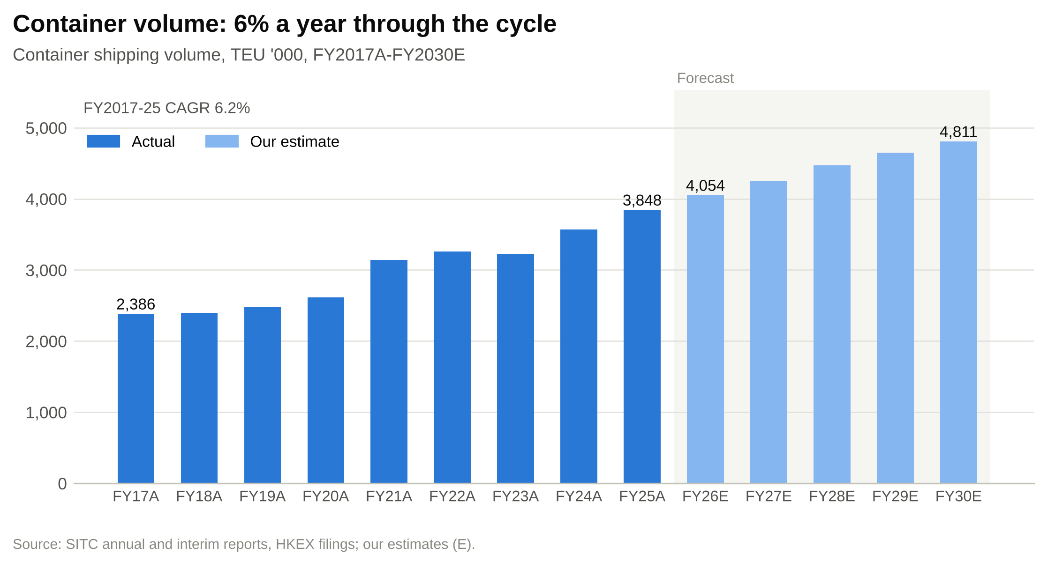

Industry overview
SITC competes in intra-Asia container shipping: containerised cargo whose origin and destination are both in Asia. On Container Trades Statistics (CTS) data, intra-Asia volume was 45.8m TEU in 2024 and grew about 5% in 2025, to roughly 48m TEU. It is the largest single container trade, more than twice the size of Far East-North America. Global volume reached a record 192.9m TEU in 2025. Other providers define the trade differently: Drewry put it at 52m TEU in 2023, growing 3.6% a year from 2019 to 2023.
Figure 12: Intra-Asia container market and SITC's share
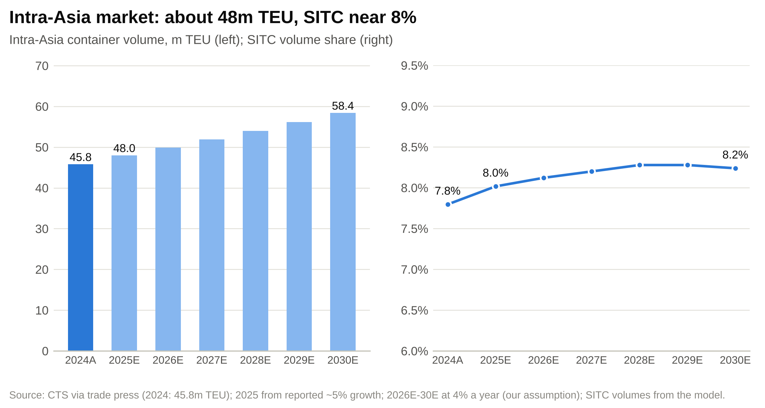

Demand drivers. Four forces support demand. Manufacturers moving assembly from China to Vietnam, Thailand, Indonesia, Malaysia and India add intra-Asia legs to supply chains. US tariffs on Chinese goods have accelerated that relocation and added transshipment through Southeast Asia, although tighter rules of origin could reverse some of it. Consumption in Southeast and South Asia is rising. And new terminals across Southeast Asia and India open new direct port pairs. We assume market volume growth of 3-5% a year over 2026-30.
Supply. The top 100 carriers have 13.6m TEU on order, 39.9% of their fleets. Most of it is large tonnage for east-west trades, but ships displaced from those trades tend to cascade into regional ones. Within the sub-3,000 TEU feeder sizes SITC uses, ordering was historically low and the fleet is ageing, which is why SITC keeps ordering. Regional carriers are now ordering heavily too.
Rates and costs. Intra-Asia rates are volatile and seasonal. Volume usually dips around Lunar New Year and builds through a July-October peak, so a single quarter is a weak guide. Fuel is the swing cost. In 2026 the conflict around Hormuz pushed the Drewry index up 83% between mid-March and late May and more than doubled the price of very low sulphur fuel oil. Both had eased by the third quarter.
Structure and regulation. The market is far less concentrated than the east-west trades. Global carriers run large regional networks (COSCO and OOCL carried 4.74m TEU intra-Asia in 1H26); regional specialists such as SITC, Wan Hai, KMTC, Sinokor, TS Lines and RCL compete with them; and feeder operators and fast-growing Chinese lines add capacity at the margin. Barriers to entry are moderate because ships can be chartered quickly; dense port coverage, terminal and depot access and local sales offices are harder to copy. Ships in the trade face the IMO's efficiency rules and the coming shift to low-carbon fuels. Cabotage rules restrict foreign carriers within China and some Southeast Asian countries.

Competition
The table compares SITC with ten carriers active in intra-Asia.
Figure 13: Intra-Asia carriers: fleet, charter share and order book
Carrier | Rank | Capacity (TEU) | Ships | Chartered | Order book | Base
COSCO Group (incl. OOCL) | 4 | 3,673,704 | 566 | 39.4% | 51.3% | China / Hong Kong
Wan Hai Lines | 11 | 633,064 | 125 | 0.0% | 78.3% | Taiwan
PIL | 12 | 470,419 | 101 | 26.3% | 65.0% | Singapore
X-Press Feeders | 13 | 191,458 | 104 | 39.0% | 49.5% | Singapore
SITC | 14 | 187,297 | 121 | 12.6% | 35.4% | China / Hong Kong
KMTC | 15 | 172,576 | 67 | 40.1% | 37.5% | Korea
Sinokor (incl. Heung-A) | 19 | 132,526 | 69 | 1.3% | 39.2% | Korea
TS Lines | 20 | 129,100 | 46 | 17.8% | 51.5% | Taiwan
CULines | 22 | 109,433 | 47 | 83.4% | 83.8% | China
RCL | 23 | 100,409 | 34 | 10.6% | 148.3% | Thailand
Interasia Lines | 25 | 85,077 | 28 | 24.1% | 76.5% | Taiwan
Source: Alphaliner Top 100, 25-Oct-2026. Order book is capacity on order as a share of the current fleet.
COSCO Group (with OOCL) is the scale competitor. Its intra-Asia volume in 1H26 was about 2.4 times SITC's, at a higher reported revenue per TEU (US$883, on its own definitions), and it can sell long-haul and regional services to the same customers. Wan Hai is the specialist closest to SITC's model: it owns its whole fleet and has a long intra-Asia history. It is more than three times SITC's size and has the largest order book in the group, 78% of its fleet. PIL overlaps on Southeast Asian lanes but also serves Africa, the Middle East and Oceania. X-Press Feeders mainly moves cargo for the large carriers and competes with SITC for ships and port slots more than for shippers. KMTC and Sinokor lead the Korean trades. TS Lines, listed in Hong Kong since 2024, has a similar regional focus but more long-haul ambition. CULines and Zhonggu, fast-growing Chinese lines with mostly chartered fleets and very large order books, are the most likely source of price-led competition on China-Southeast Asia lanes.
Figure 14: Competitive positioning: chartered share vs order book
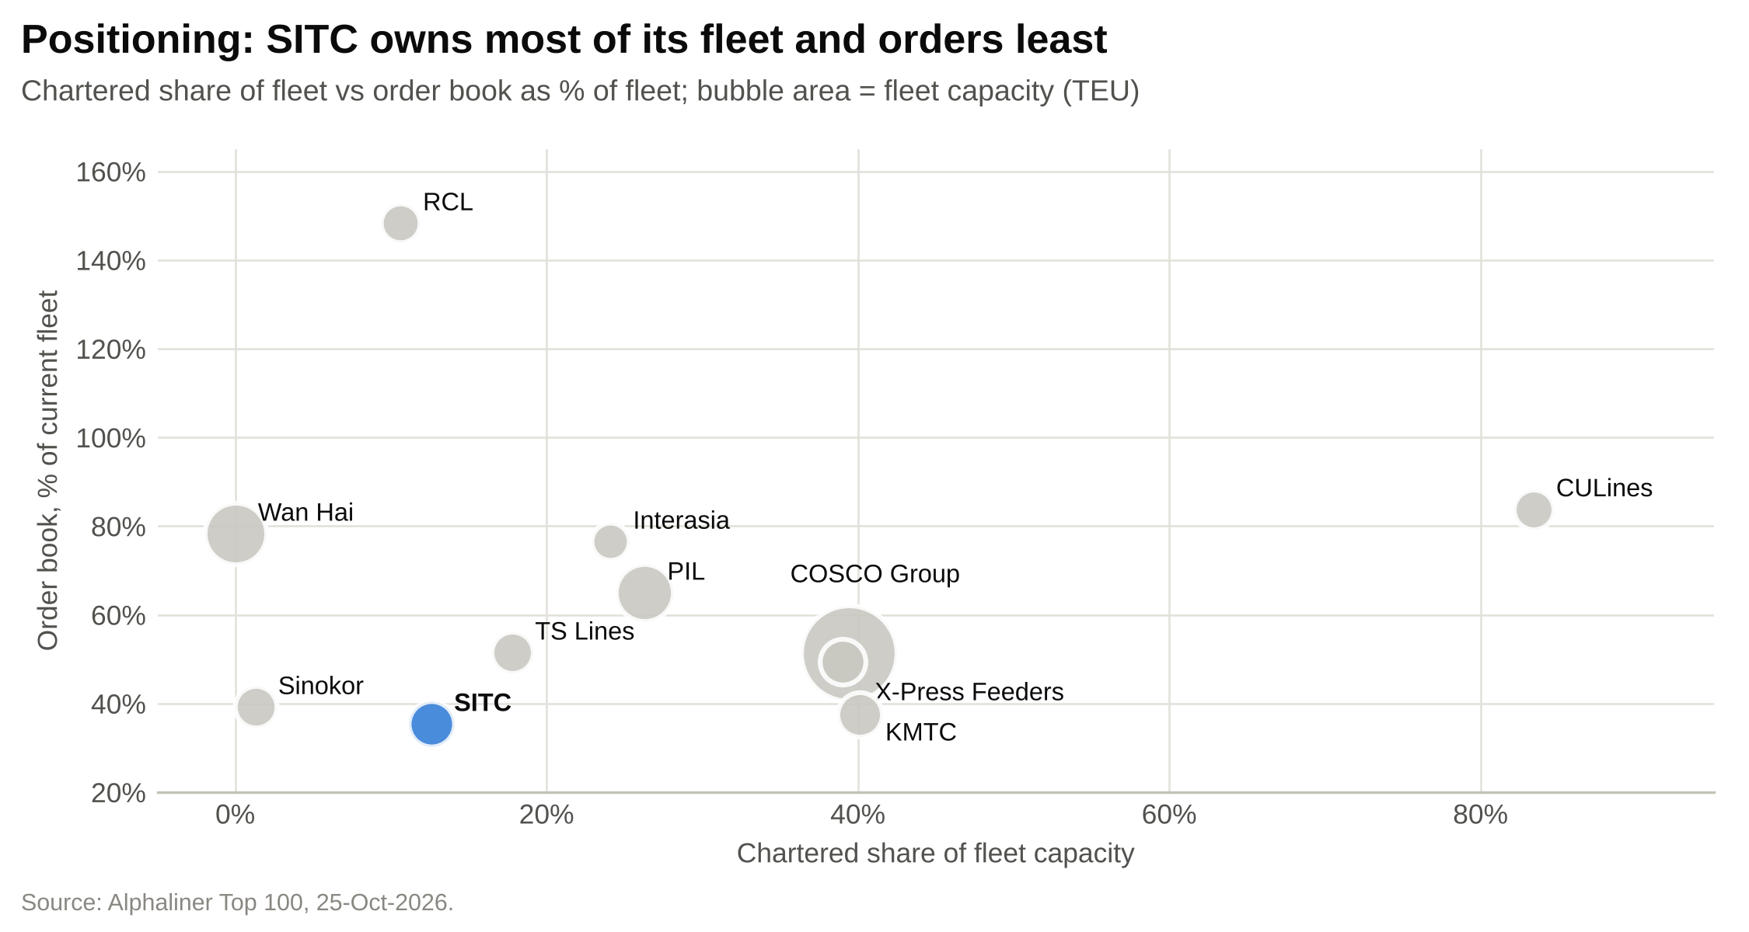

On three measures SITC sits at the conservative end of its peer group. It owns 87% of its capacity; only Wan Hai, Sinokor and RCL own more. Its average ship, about 1,550 TEU, is the smallest in the table. And its order book, at 35% of its fleet, is the lowest. It will grow its fleet more slowly than its competitors, which protects returns if new capacity depresses rates but costs share if demand absorbs it.
Figure 15: Fleet capacity of intra-Asia regional carriers (TEU '000)
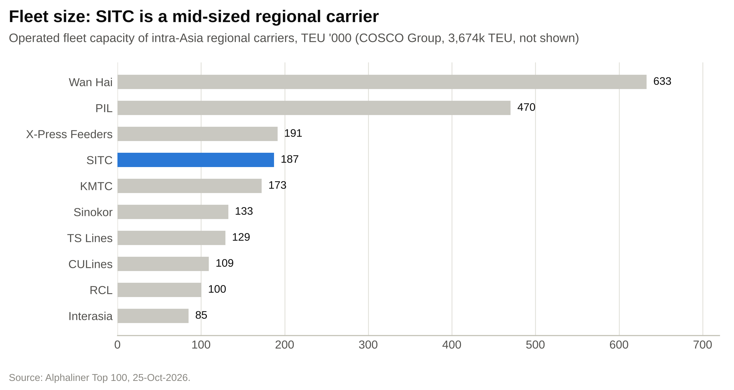

SITC's advantages are an owned, paid-for fleet of small ships, a dense network with more than 30 years of customer relationships in China-Japan and China-Korea, land-side logistics and a net cash balance sheet. Its vulnerabilities are scale (a fraction of COSCO's size), competitors' capacity growth, heavy exposure to Chinese trade, and a fleet averaging 10.6 years old whose replacements only arrive in 2027-28. The return gap is wide (Figure 16): SITC's LTM ROE of 47% is almost five times the peer median.
Figure 16: ROE and EBITDA margin against listed peers (LTM)
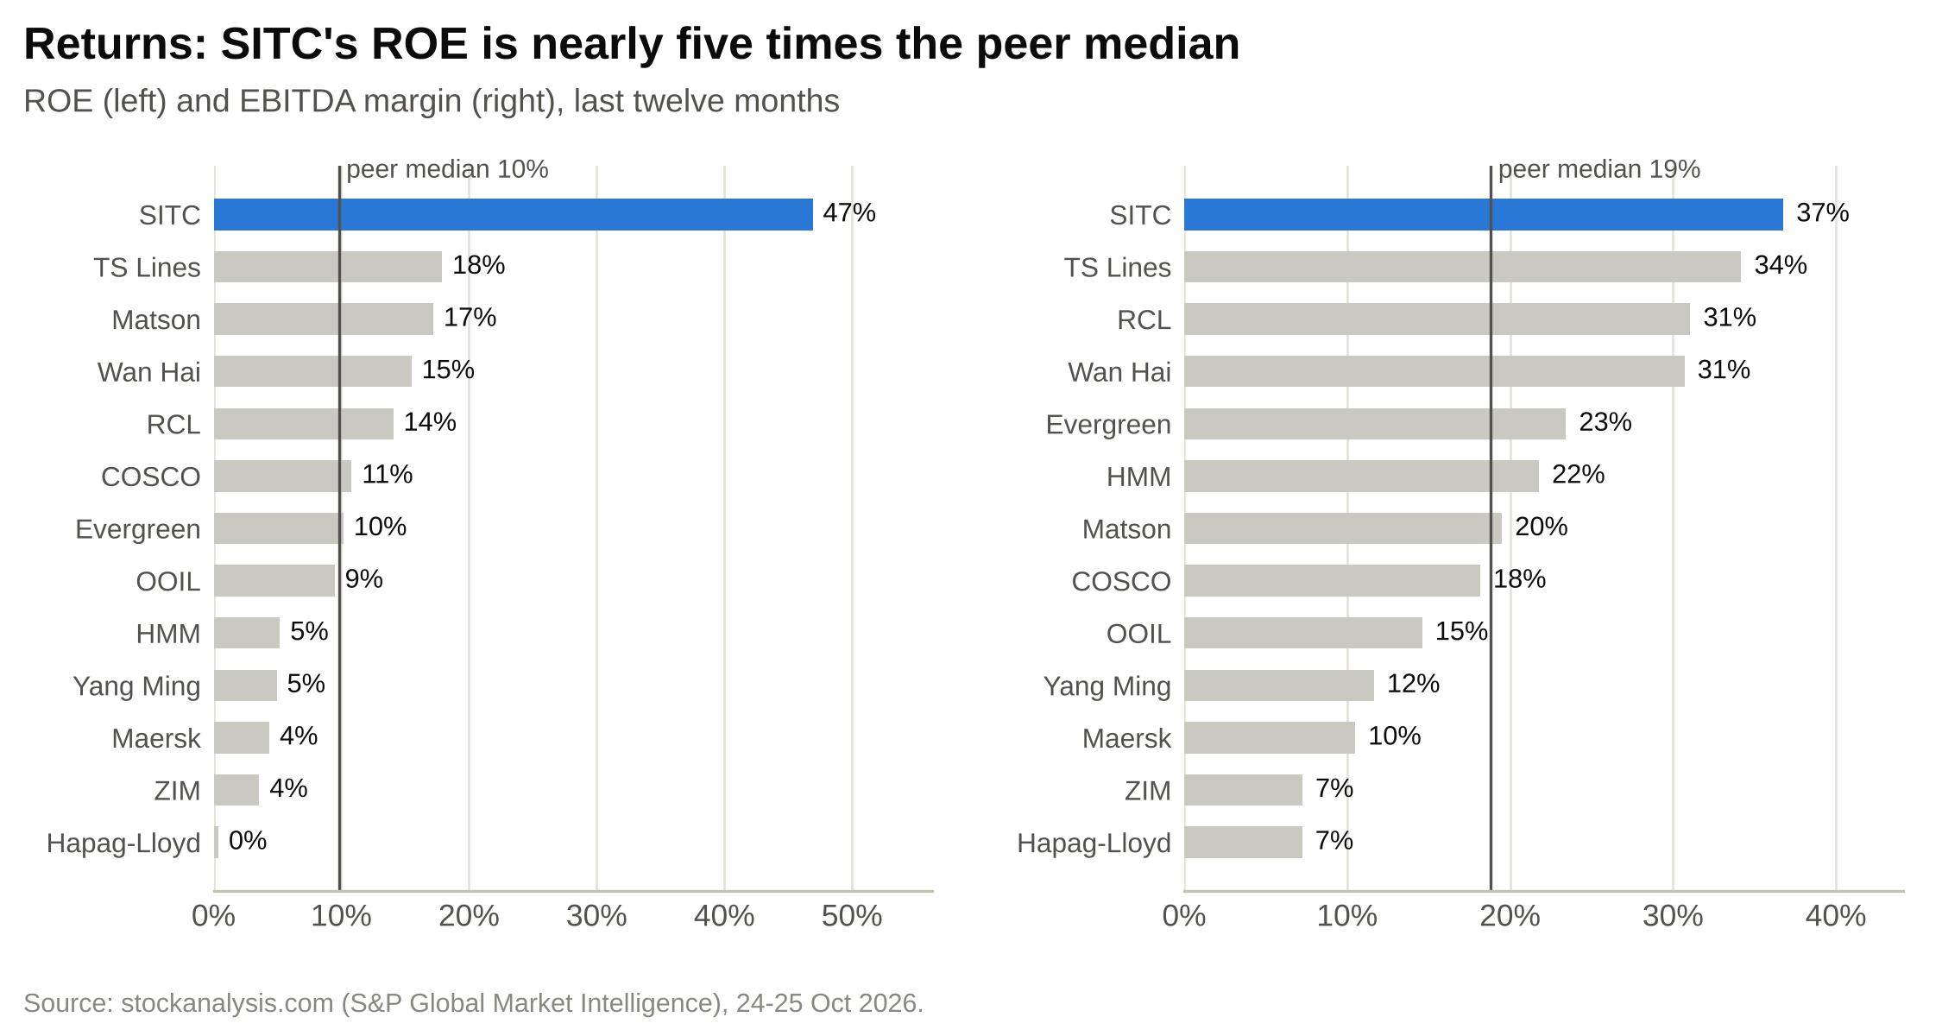

Market opportunity
We size SITC's addressable market as intra-Asia container freight revenue. About 48m TEU of 2025 volume at US$750-885 per TEU, bounded by SITC's own US$753 and COSCO's reported US$883 for intra-Asia in 1H26, gives a market of roughly US$36-42bn. Every input is a range or an estimate, so this is a sizing, not a measurement. SITC's network serves Northeast Asia, China-Southeast Asia, intra-Southeast Asia and China-South Asia but not the Gulf or most of the Indian subcontinent's own trades. If 70-85% of the market is within reach, the serviceable market is about US$25-36bn.
SITC's 2025 container shipping income of US$3,078m was about 8% of the total market by value, and its 3.85m TEU about 8% by volume. At its IPO it carried about 5% of Drewry's 2009 market, so it has gained share over 16 years, growing volume 7.6% a year from 2019 to 2025 against roughly 3.6% for the market. In our base case SITC's share edges up from 8.0% in 2025 to 8.2% in 2030.
Two things bound the opportunity. Each percentage point of a 48m TEU market is about 0.48m TEU, or roughly US$360m of revenue at 2025 rates. And SITC's 66,000 TEU order book, at its 2025 lifting rate of about 21 TEU per slot, could carry about 1.4m TEU a year, close to three share points, if none of it replaced older ships. Filling those ships at today's rates would require share gains at a time when competitors are growing their fleets faster. That is the core of our caution on 2027-28.

Financial analysis

Revenue and its drivers
SITC's revenue is mostly volume times rate. Over FY2017-25 volume grew at a steady 6.2% a year, from 2.39m TEU to 3.85m TEU, with only one down year (2023, –1.1%). The rate did the swinging: from US$490/TEU in 2017 it rose to US$1,100 in 2022, fell 43% to US$623 in 2023 and recovered to US$753 by 2025 (Figure 18). Revenue followed the rate: up 37% in 2022, down 41% in 2023, then up 26% and 12% in 2024 and 2025 (Figure 17).
Figure 17: Revenue, FY2021A-FY2030E (US$m), and year-on-year growth
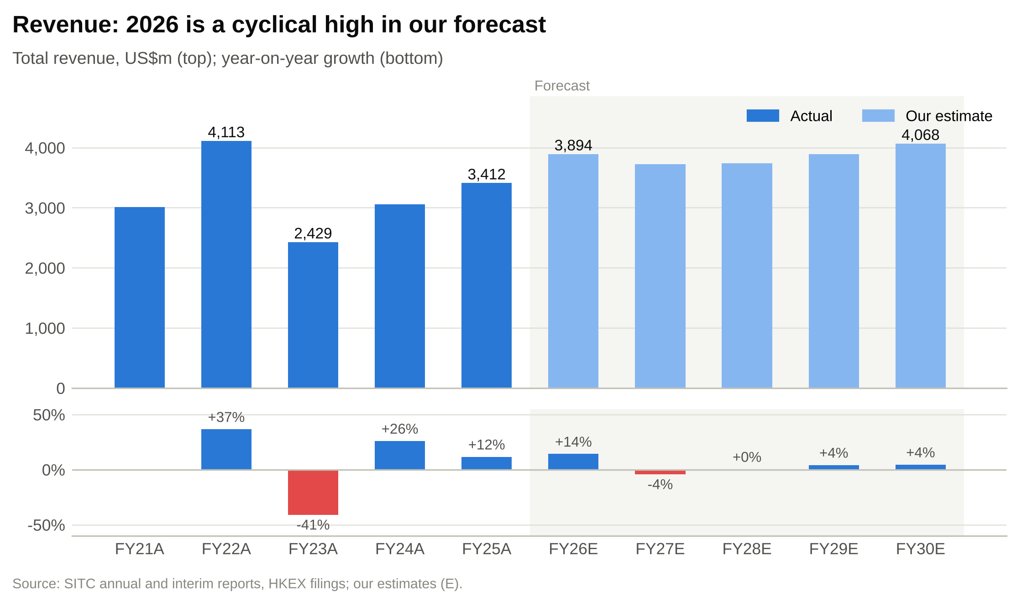

Figure 18: Average freight rate, FY2017A-FY2030E, against cycle averages (US$/TEU)
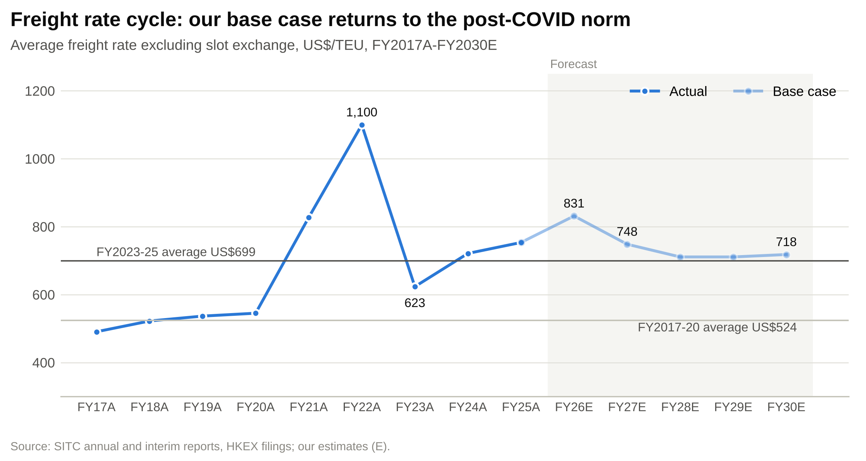

Freight revenue (volume times the average rate) is about 85% of the total. Slot exchange income, surcharges and other shipping income make up the rest of container shipping income; we calculate them as a residual. They were 4-9% of freight revenue in FY2021-25 but only 3.5% in 1H26, when SITC cut its trade lanes from 82 to 74. Other container logistics income grew from US$279m in FY2021 to US$331m in FY2025, about 10% of revenue, and rose 28.5% in 1H26 (Figure 19).
Figure 19: Revenue by stream, FY2021A-FY2030E (US$m)
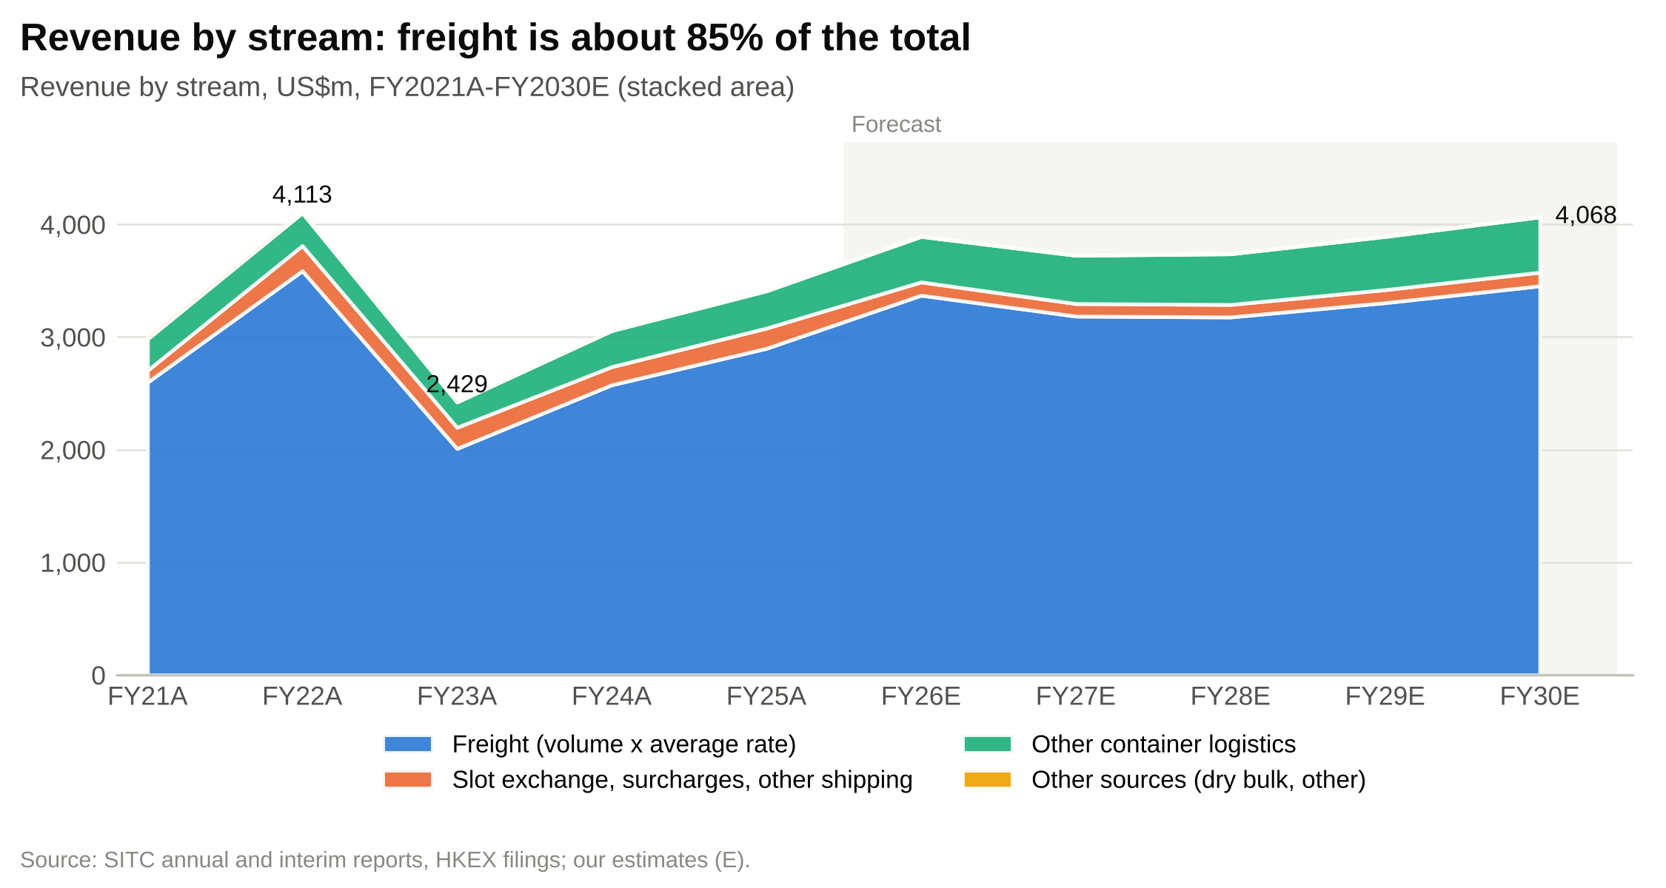

By geography, Greater China is the largest market at 48.5% of FY2025 revenue, followed by Southeast Asia (28.8%), Japan (17.5%) and others (5.2%) (Figure 20). The mix shifts with the cycle: Greater China's share fell to 38.8% in 2023, when China-origin rates fell hardest, and recovered to 48.5% by 2025.
Figure 20: Revenue by geography, FY2021A-FY2030E (US$m)
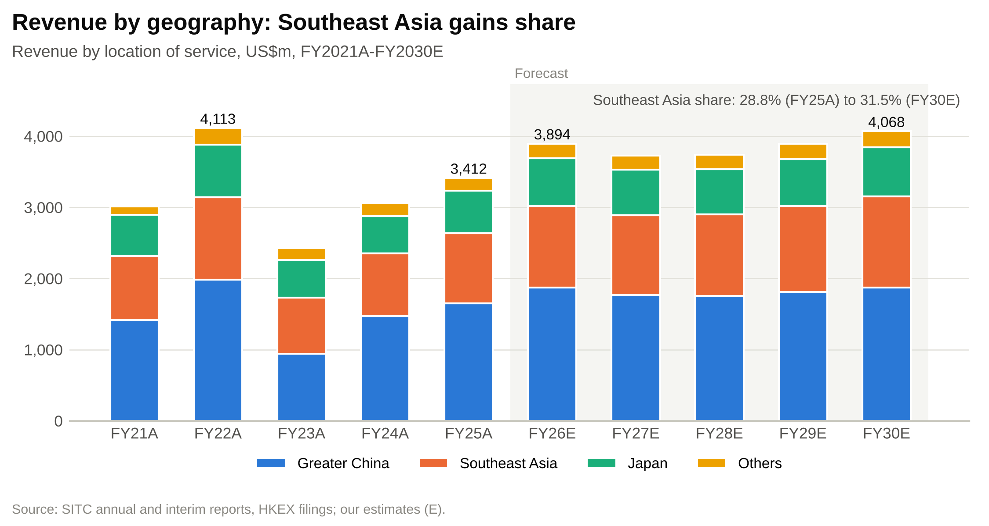

Figure 21: Historical income statement, FY2021A-FY2025A
US$m | FY2021A | FY2022A | FY2023A | FY2024A | FY2025A
Container shipping and supporting logistics | 2,704 | 3,811 | 2,197 | 2,735 | 3,078
Other container logistics | 279 | 291 | 225 | 320 | 331
Other sources | 29 | 11 | 7 | 2 | 3
Revenue | 3,012 | 4,113 | 2,429 | 3,058 | 3,412
Equipment and cargo transportation | (854) | (1,010) | (926) | (973) | (1,093)
Voyage costs | (351) | (542) | (408) | (422) | (402)
Container shipping vessel costs | (259) | (356) | (297) | (257) | (329)
Other logistics and other costs | (230) | (226) | (175) | (262) | (276)
Gross profit | 1,319 | 1,979 | 623 | 1,143 | 1,310
Gross margin | 43.8% | 48.1% | 25.7% | 37.4% | 38.4%
Other income and gains (excl. interest) | 18 | 138 | 38 | 18 | 45
Administrative and other expenses | (159) | (171) | (140) | (145) | (159)
EBIT | 1,178 | 1,946 | 521 | 1,016 | 1,196
Share of JVs and associates | 16 | 22 | 20 | 26 | 33
Interest income less finance costs | (9) | 5 | 13 | 11 | 22
Profit before tax | 1,185 | 1,973 | 553 | 1,054 | 1,251
Tax and minorities | (22) | (29) | (22) | (25) | (28)
Attributable profit | 1,163 | 1,944 | 531 | 1,028 | 1,223
Diluted EPS (US cents) | 43.3 | 72.5 | 19.8 | 38.3 | 45.4
DPS declared (HK$) | 3.20 | 4.00 | 1.10 | 2.52 | 3.00
Volume (TEU '000) | 3,142 | 3,262 | 3,224 | 3,570 | 3,848
Average rate (US$/TEU) | 826.9 | 1,099.6 | 623.3 | 721.1 | 753.3
Source: SITC annual results FY2021-FY2025 (US$'000, shown in US$m). EBIT excludes JVs, associates and interest income; segment results = EBIT + JVs and associates.

The 2026 run-rate
The first half of 2026 was solid rather than spectacular: volume +7.8%, rate +4.0%, revenue +10.7% and attributable profit +7.4% to US$676.5m. The third quarter was much stronger. Deriving it from the 9M and 1H figures, volume rose about 2% to 940,000 TEU, the rate rose about 21% to US$865 and revenue rose about 22% to US$966m (Figure 22).
Figure 22: Half-year and quarterly average freight rate, 1H25-Q4 26E (US$/TEU)
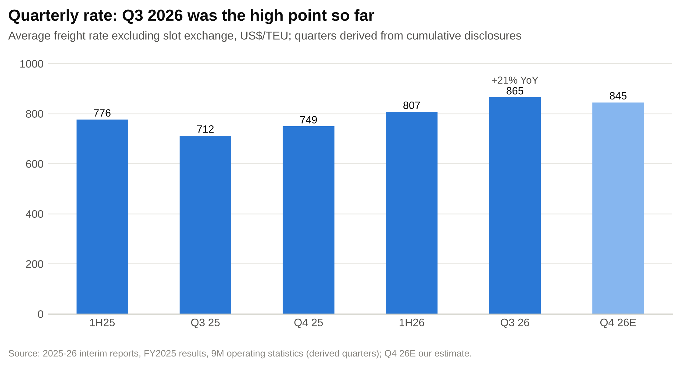

Figure 23: Volume, rate and revenue by period
 | 1H25A | Q3 25A | Q4 25A | 1H26A | Q3 26A | Q4 26E
Volume (TEU '000) | 1,830 | 920 | 1,098 | 1,972 | 940 | 1,142
Average rate (US$/TEU) | 776 | 712 | 749 | 807 | 865 | 845
Revenue (US$m) | 1,664 | 794 | 953 | 1,842 | 966 | 1,086
Source: interim reports and 9M operating statistics (22-Oct-2025 and 22-Oct-2026); quarters derived from cumulative figures; Q4 26E our estimate.
Our FY2026E builds on these actuals. For Q4 we assume volume up 4% on Q4 2025 and a rate of US$845, below Q3 but 13% above Q4 2025, when the rate was US$749. That gives FY2026E volume of 4.05m TEU (+5.4%), a rate of US$831 (+10.4%) and revenue of US$3,894m (+14.1%). The implied second half has revenue of US$2,052m and attributable profit of US$796m, 34% above 2H25 (Figure 24).
Figure 24: Half-year bridge, 1H25A-2H26E
US$m | 1H25A | 2H25A | FY2025A | 1H26A | 2H26E | FY2026E
Volume (TEU '000) | 1,830 | 2,018 | 3,848 | 1,972 | 2,082 | 4,054
YoY growth | – | – | – | +7.8% | +3.2% | +5.4%
Average freight rate (US$/TEU) | 776 | 732 | 753 | 807 | 854 | 831
YoY change | – | – | – | +4.0% | +16.6% | +10.4%
Revenue | 1,664 | 1,747 | 3,412 | 1,842 | 2,052 | 3,894
Cost of sales | (995) | (1,106) | (2,101) | (1,109) | (1,180) | (2,289)
Gross profit | 669 | 641 | 1,310 | 733 | 872 | 1,606
Gross margin | 40.2% | 36.7% | 38.4% | 39.8% | 42.5% | 41.2%
Segment results | 632 | 597 | 1,229 | 683 | 805 | 1,488
Profit attributable | 630 | 593 | 1,223 | 677 | 796 | 1,472
Cost of sales per TEU (US$) | 544 | 548 | 546 | 562 | 567 | 565
Gross profit per TEU (US$) | 366 | 318 | 341 | 372 | 419 | 396
Source: 2025 and 2026 interim reports, FY2025 results; 2H figures are full year less first half; 2H26E and FY2026E are our estimates.

Costs and unit economics
SITC reports four cost lines, and three of them scale with volume rather than rate. In FY2025, per TEU lifted:
- Equipment and cargo transportation (container leasing and repositioning, terminal handling, trucking): US$284, 52% of cost of sales.
- Voyage costs (bunker and port charges): US$105, down from US$118 in 2024 as bunker prices fell, then back up to US$115 in 1H26.
- Vessel costs (depreciation of owned ships, charter hire, crew and maintenance): US$1,804 per average TEU slot of capacity, or US$86 per TEU lifted.
- Other logistics costs run at about 83% of logistics income, a thin margin that SITC makes up through joint-venture profits.
Total cost of sales per TEU has been stable: US$539 in 2021, US$536 in 2024, US$546 in 2025 and US$562 in 1H26. Revenue per TEU is what moves, from US$1,261 in 2022 to US$753 in 2023 and US$887 in 2025 (Figure 25). This is why SITC's earnings are so sensitive to the rate.
Figure 25: Revenue and cost of sales per TEU lifted (US$)
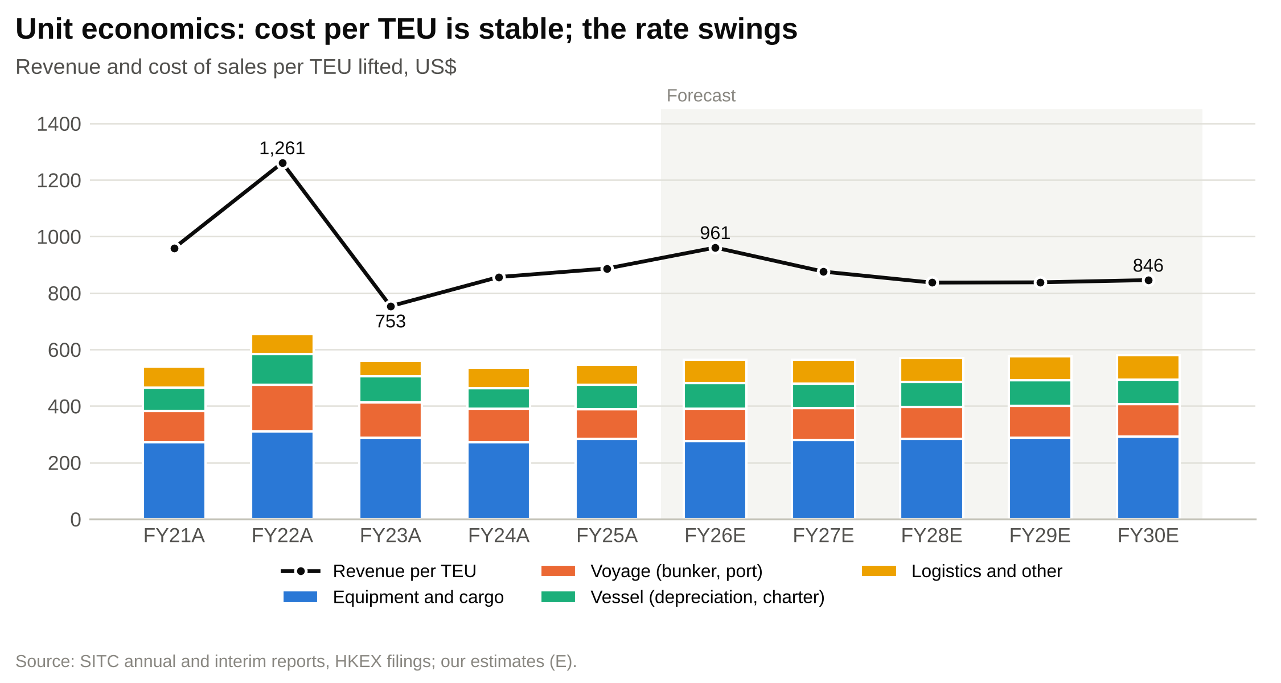

Margins
The gross margin ranged from 25.7% in 2023 to 48.1% in 2022 and was 38.4% in 2025 (Figure 26). Below gross profit, the cost base is light. Administrative expenses were US$154m in 2025, 4.5% of revenue. Depreciation is mostly inside vessel costs. The tax rate is about 1.7% because shipping income is largely exempt. Joint ventures added US$16-31m a year over FY2021-25, and interest income on the cash pile US$27-38m a year over FY2023-25. The EBITDA margin was 40.3% in 2025 and the net margin 36.1% (Figure 27).
Figure 26: Gross margin and gross profit per TEU lifted
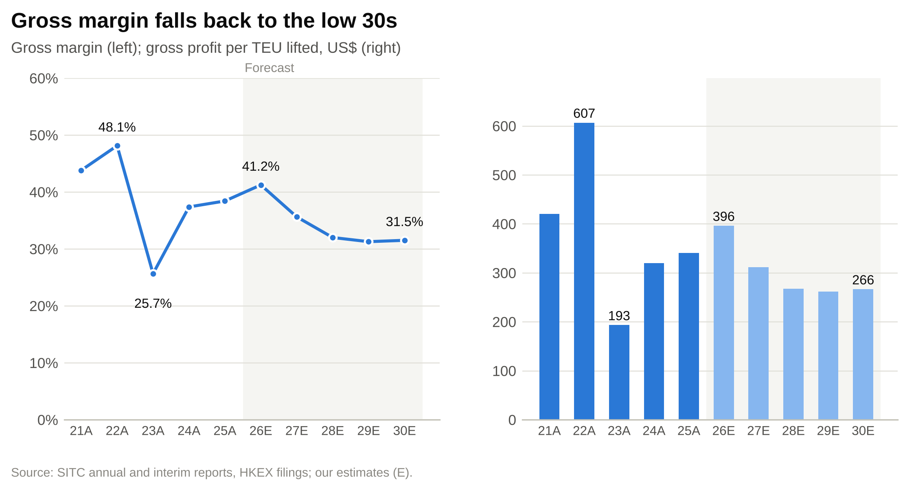

Figure 27: EBITDA, EBIT and net margins, FY2021A-FY2030E
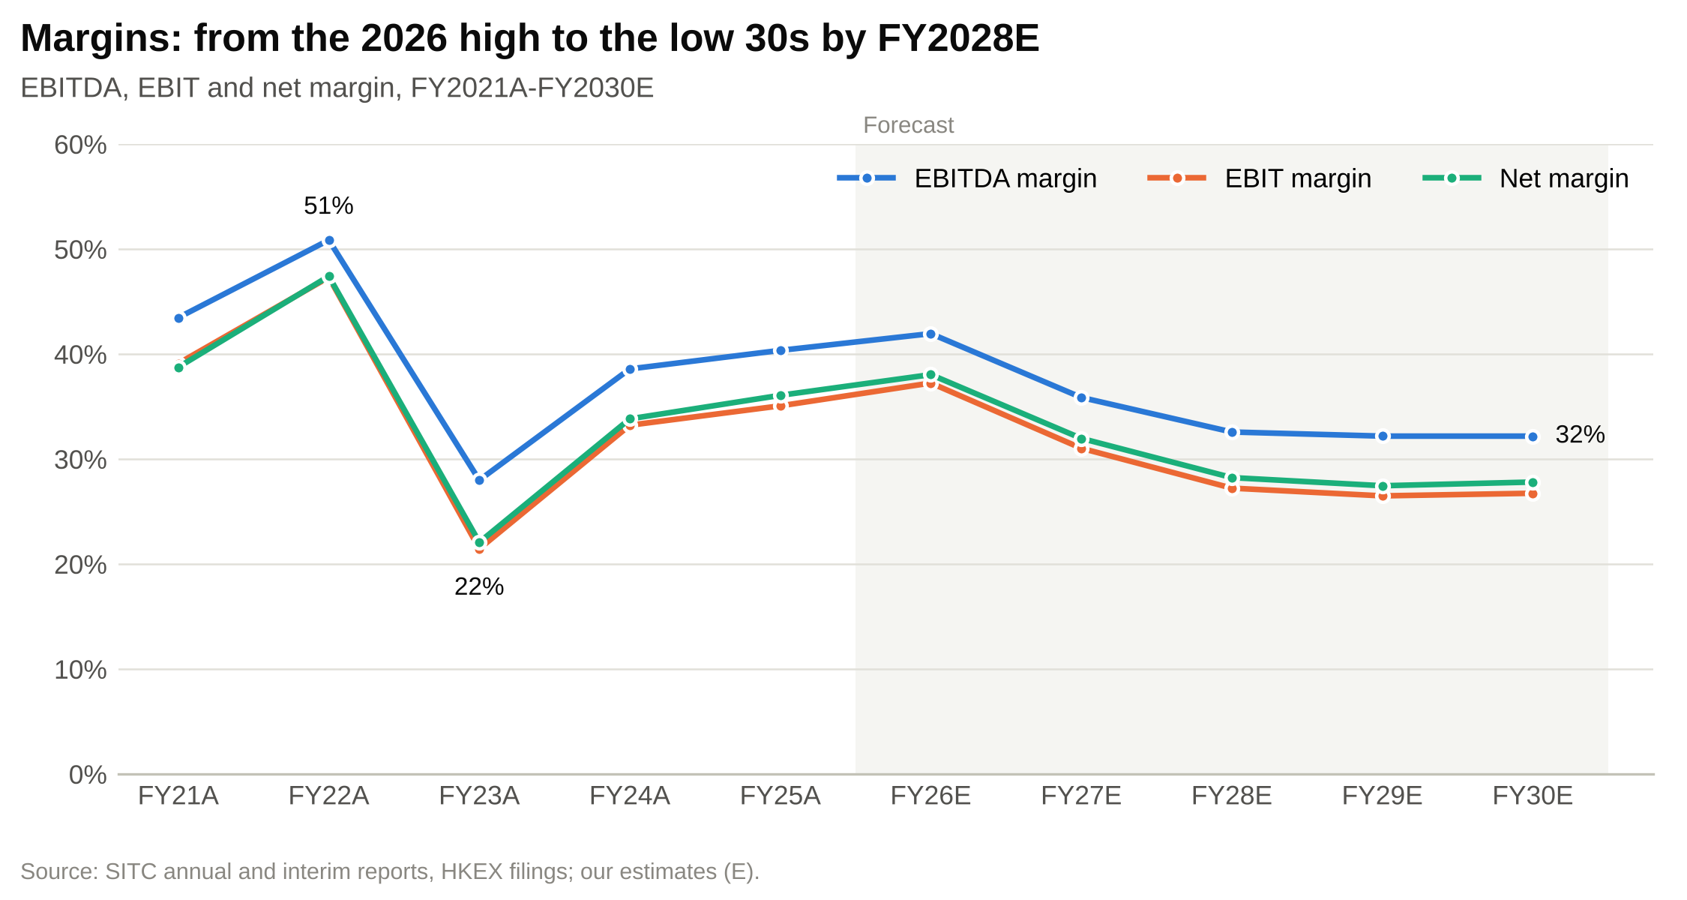

Cash flow, capital spending and dividends
SITC converts profit to cash almost one for one. Operating cash flow was US$1,401m in 2025 against profit of US$1,230m, and free cash flow after lease payments was US$1,286m. Capital spending has been low since 2022: US$135m in 2025, against depreciation of US$180m (Figure 28). That changes in 2027-28, when the newbuild instalments fall due.
Figure 28: Capex including newbuild instalments vs depreciation (US$m)
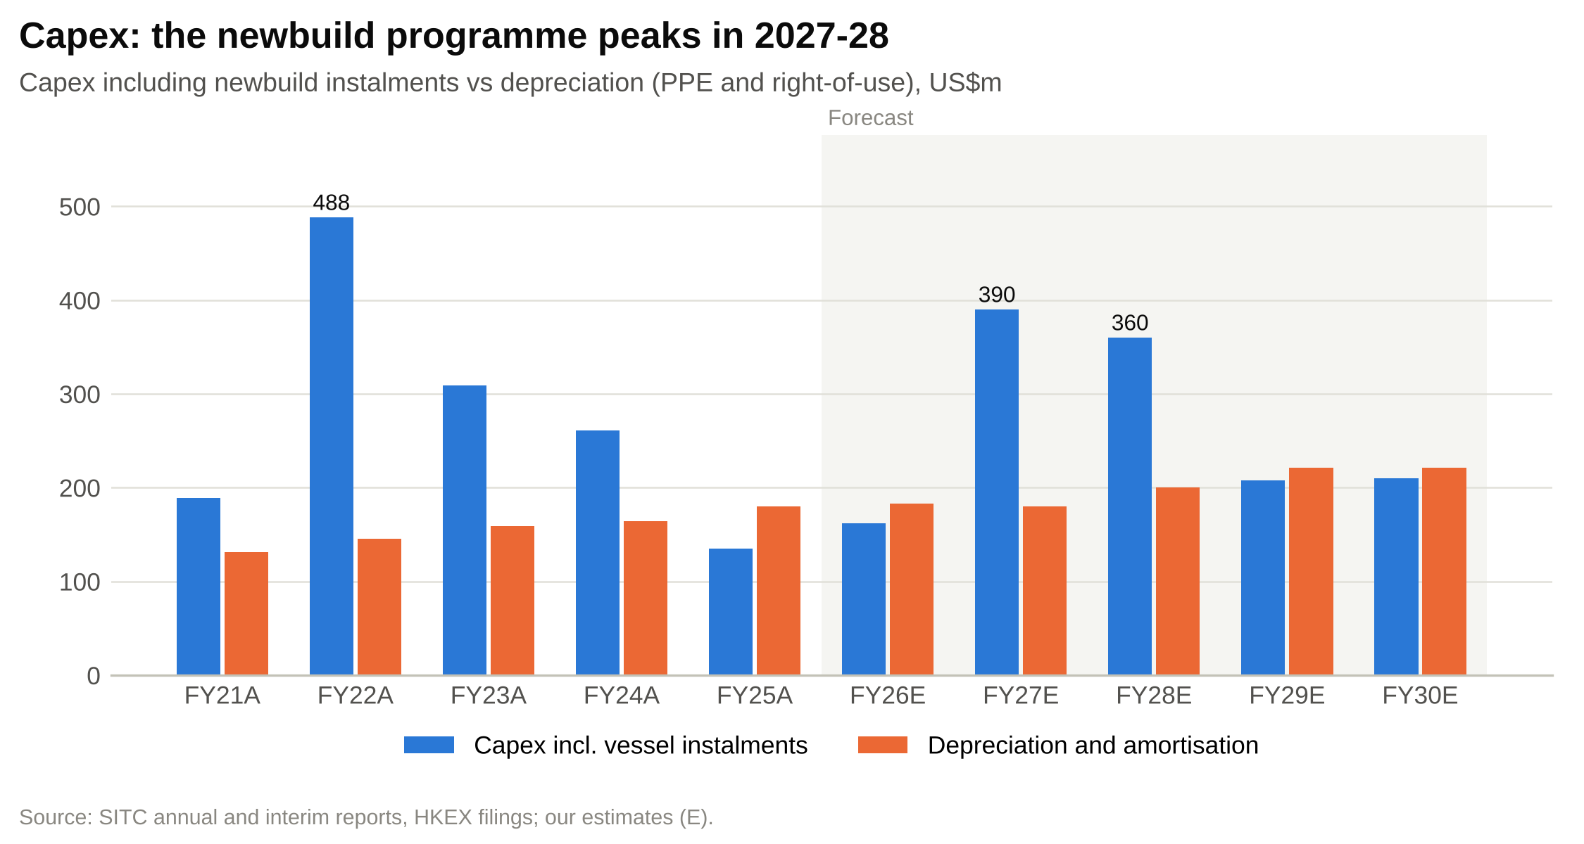

Most of the cash goes back to shareholders. Dividends paid were US$938m in 2025, 73% of free cash flow, and the declared dividend for FY2025 was HK$3.00 a share, about 84% of EPS. Over FY2021-25 the payout has ranged from 70% to 94% of EPS including specials (Figure 30). We expect FY2026 dividends paid in cash to reach US$1,452m, slightly more than free cash flow, because the year carries the FY2025 final and a special declared in December 2025 as well as the FY2026 interim and a HK$1.00 special (Figure 29).
Figure 29: Free cash flow after leases vs dividends paid (US$m)
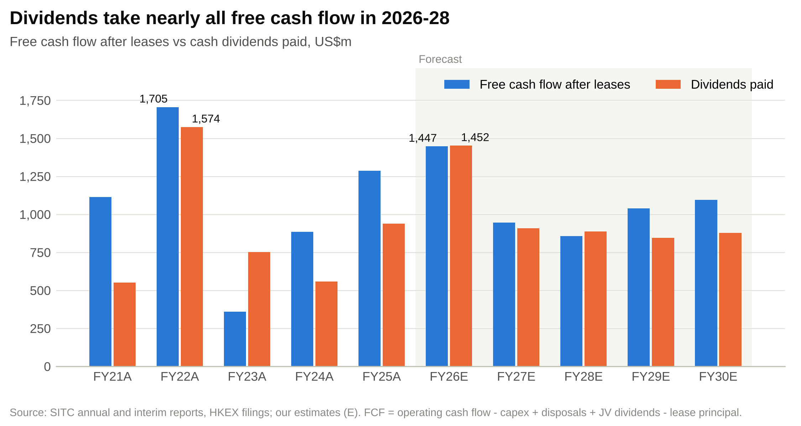

Figure 30: Dividend per share declared for each year, FY2017A-FY2030E (HK$)
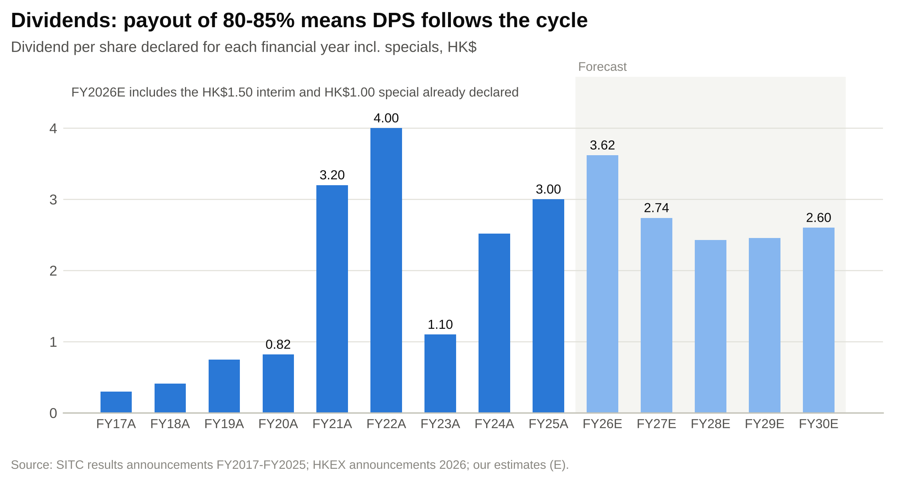

Balance sheet
SITC has had net cash, excluding leases, in every year we model: US$262m at the 2023 low and US$930m at the end of 2025 (Figure 31). Lease liabilities were US$305m. Working capital is small and stable: receivables at about 20 days of revenue, payables at about 41 days of cost of sales and bunker stocks at 39-47 days of voyage costs (Figure 32). Return on equity was 50% in 2025, and has not been below 26% since 2021.
Figure 31: Net cash excluding leases and lease liabilities (US$m)
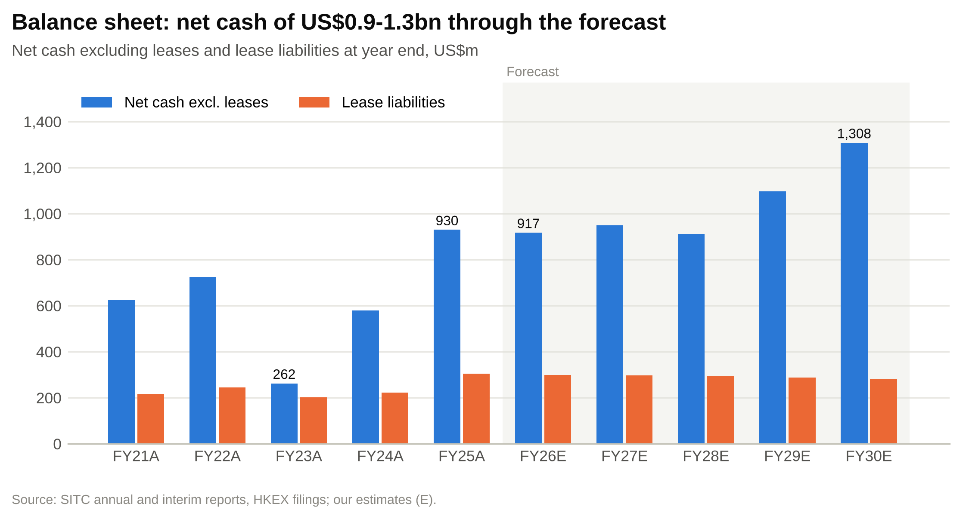

Figure 32: Receivable, payable and bunker days
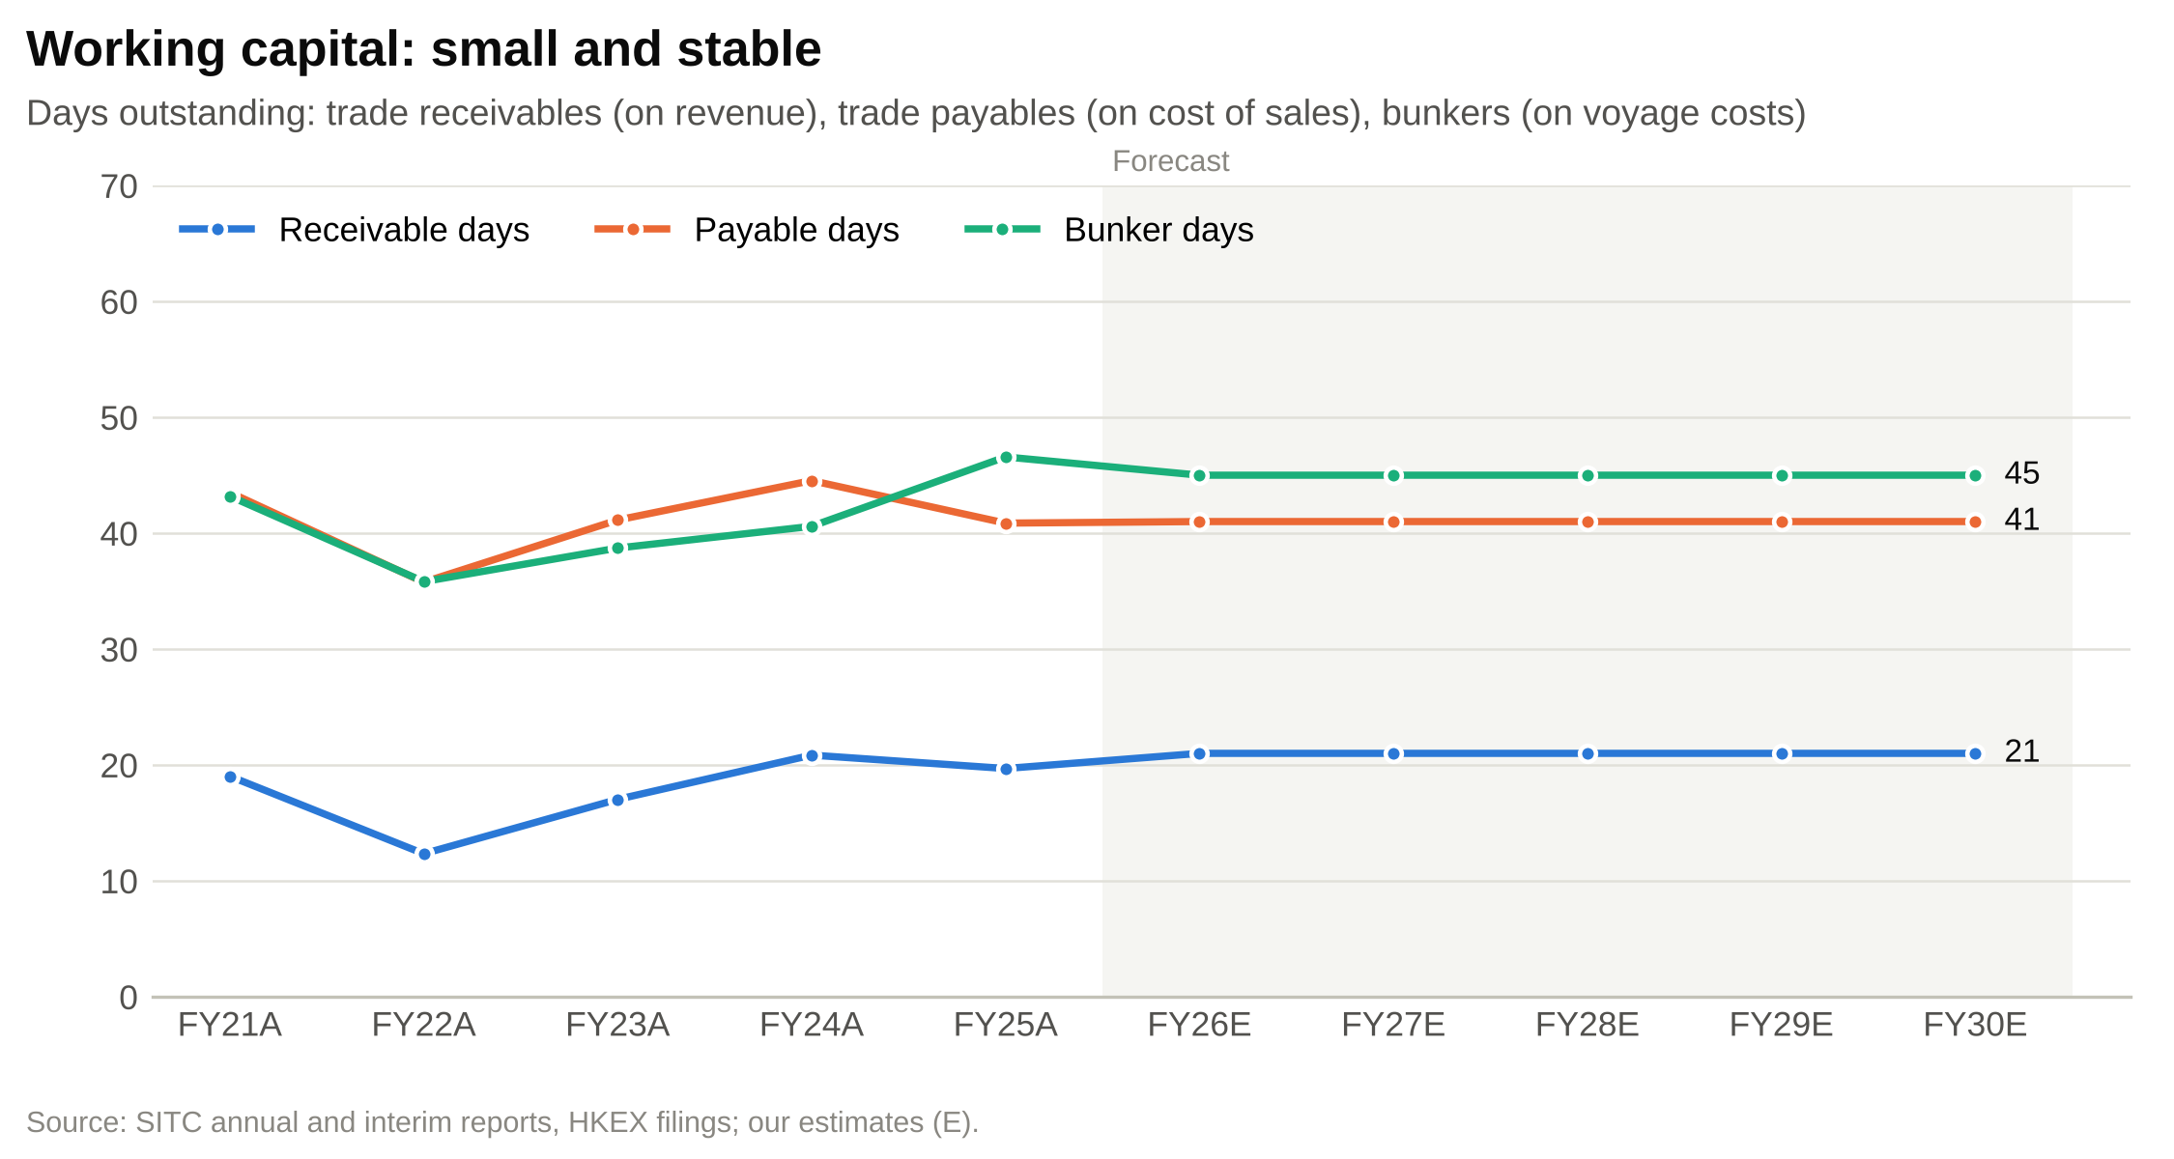

Projections and estimates
Our model projects FY2026E-FY2030E from operating drivers: fleet capacity, volume, the average freight rate, unit costs and capital spending. FY2026E starts from the reported 9M26 volume and rate. Everything below is our base case; the Scenarios section covers the alternatives. All historical figures tie to the filings, and the balance sheet balances in every year and every scenario.
Figure 33: Revenue model, FY2024A-FY2030E
US$m unless stated | FY2024A | FY2025A | FY2026E | FY2027E | FY2028E | FY2029E | FY2030E
Fleet capacity, year end (TEU '000) | 180.3 | 185.0 | 187.3 | 201.3 | 216.3 | 216.5 | 212.5
Newbuild deliveries (TEU '000) | – | – | 4.0 | 26.0 | 30.0 | 6.2 | –
Disposals and redeliveries (TEU '000) | – | – | 1.7 | 12.0 | 15.0 | 6.0 | 4.0
Average fleet capacity (TEU '000) | 171.6 | 182.6 | 186.1 | 194.3 | 208.8 | 216.4 | 214.5
Container volume (TEU '000) | 3,570 | 3,848 | 4,054 | 4,256 | 4,469 | 4,648 | 4,811
Volume growth | +10.7% | +7.8% | +5.4% | +5.0% | +5.0% | +4.0% | +3.5%
Liftings per average TEU slot (x) | 20.8 | 21.1 | 21.8 | 21.9 | 21.4 | 21.5 | 22.4
Average freight rate (US$/TEU) | 721 | 753 | 831 | 748 | 711 | 711 | 718
Rate change | +15.7% | +4.5% | +10.4% | –10.0% | –5.0% | +0.0% | +1.0%
Freight revenue (volume x rate) | 2,574 | 2,898 | 3,370 | 3,184 | 3,176 | 3,304 | 3,453
Slot exchange and other, % of freight | 6.3% | 6.2% | 3.5% | 3.5% | 3.5% | 3.5% | 3.5%
Slot exchange, surcharges, other shipping | 161 | 179 | 118 | 111 | 111 | 116 | 121
Container shipping income | 2,735 | 3,078 | 3,488 | 3,296 | 3,288 | 3,419 | 3,574
Shipping income per TEU (US$) | 766 | 800 | 860 | 774 | 736 | 736 | 743
Other container logistics income | 320 | 331 | 404 | 428 | 450 | 472 | 491
Growth | +42.6% | +3.4% | +22.0% | +6.0% | +5.0% | +5.0% | +4.0%
Other sources | 2.2 | 2.7 | 2.6 | 2.6 | 2.6 | 2.6 | 2.6
Total revenue | 3,058 | 3,412 | 3,894 | 3,727 | 3,740 | 3,894 | 4,068
Revenue growth | +25.9% | +11.6% | +14.1% | –4.3% | +0.4% | +4.1% | +4.5%
Source: company filings; our estimates. FY2026E volume and rate are 9M26 actuals plus our Q4 estimate.

Fleet and volume
Fleet. We start from 184,961 TEU at the end of 2025 and add newbuild deliveries of 4,000 TEU in 2026, 26,000 TEU in 2027, 30,000 TEU in 2028 and 6,200 TEU in 2029, a total of about 66,000 TEU in line with Alphaliner's order book. We take out 1,700, 12,000, 15,000, 6,000 and 4,000 TEU in 2026-30 for disposals of older ships and returned charters. The fleet reaches 187,300 TEU at the end of 2026 (Alphaliner shows 187,297 TEU in October), 216,300 TEU at the end of 2028 and 212,500 TEU in 2030. Year-end capacity grows 7.5% in each of 2027 and 2028 (Figure 34).
Volume. We forecast volume of 4.05m TEU in FY2026E (+5.4%), then growth of 5% in 2027 and 2028, 4% in 2029 and 3.5% in 2030, reaching 4.81m TEU. That is a little below SITC's FY2017-25 average of 6.2% and above our assumed market growth of 3-5%, so SITC keeps gaining share slowly. The drivers are:
- new capacity that SITC must fill, which in our view it will do partly through price;
- continued supply-chain relocation into Southeast Asia and India;
- growth in the South Asia lanes opened in 2025;
- offset by slower Japan and Korea trades and tighter competition on China-Southeast Asia lanes.
Liftings per slot. Volume divided by average capacity measures how hard the fleet works. It was 21.1 in 2025 and rises to 21.8 in 2026E as the fleet barely grows. With capacity up 7.5% a year in 2027-28 and volume up 5%, it falls to 21.4 in 2028 before recovering to 22.4 in 2030 as deliveries stop.
Figure 34: Operating dashboard: volume, rate, fleet and liftings per slot (base case)
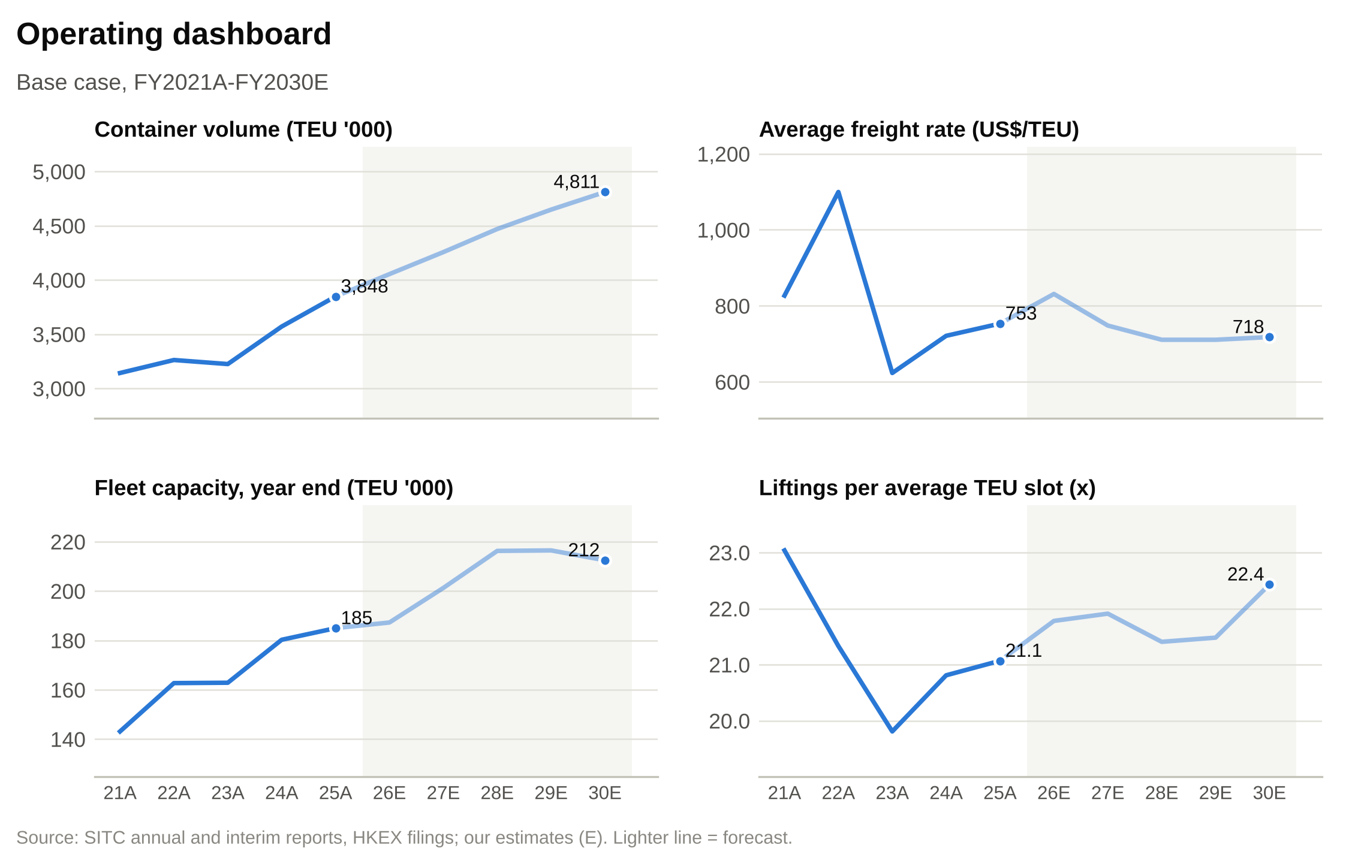

Freight rate
The rate is the decisive assumption. Our base case path is:
- FY2026E: US$831 (+10.4%). Nine-month actual of US$825.9 plus a Q4 estimate of US$845, below the Q3 level of about US$865 as the Hormuz fuel premium fades, but 13% above Q4 2025.
- FY2027E: US$748 (–10%). The premium unwinds and the first newbuilds arrive across the industry. The rate returns to its FY2025 level.
- FY2028E: US$711 (–5%). Peak deliveries industry-wide (3.8m TEU on Linerlytica's estimate) and for SITC. The rate settles near the FY2024 level and the FY2023-25 average of US$699.
- FY2029E-30E: flat, then +1%. Deliveries slow and the market absorbs the new ships.
Our rate path never goes below the 2023 trough of US$623 and stays 36% above the FY2017-20 average of US$524. We think that is a fair reflection of a structurally higher cost base (labour, port charges and fuel) since the pandemic, and of the relative discipline of the intra-Asia market in 2023.

Slot exchange, logistics and other revenue
Slot exchange and other shipping income. We hold this at 3.5% of freight revenue, the 1H26 level, against 6.2% in 2025. It gives US$118m in FY2026E, down from US$180m, and US$121m in 2030. The cut in trade lanes from 82 to 74 suggests SITC is relying less on slot exchanges, and we do not assume a reversal.
Other container logistics income. We forecast growth of 22% in FY2026E (1H26: +28.5%), then 6%, 5%, 5% and 4% a year, reaching US$491m in 2030, an 8.2% CAGR from FY2025. Growth slows because part of the 2026 increase reflects higher forwarding rates during the disruption, and because logistics volumes follow shipping volumes.
Other sources. We hold dry bulk and other income at US$2.6m a year.
Total revenue. Revenue rises 14.1% to US$3,894m in FY2026E, falls 4.3% to US$3,727m in FY2027E, is flat in FY2028E at US$3,740m and grows 4% a year to US$4,068m in FY2030E. The FY2025-30 CAGR is 3.6%.

Revenue by geography
Figure 35: Revenue by geography, FY2024A-FY2030E
US$m | FY2024A | FY2025A | FY2026E | FY2027E | FY2028E | FY2029E | FY2030E
Greater China | 1,474 | 1,654 | 1,869 | 1,770 | 1,758 | 1,811 | 1,871
Southeast Asia | 879 | 983 | 1,149 | 1,118 | 1,141 | 1,207 | 1,281
Japan | 521 | 597 | 674 | 641 | 640 | 662 | 692
Others | 184 | 178 | 203 | 198 | 202 | 214 | 224
Total | 3,058 | 3,412 | 3,894 | 3,727 | 3,740 | 3,894 | 4,068
Greater China share | 48.2% | 48.5% | 48.0% | 47.5% | 47.0% | 46.5% | 46.0%
Southeast Asia share | 28.8% | 28.8% | 29.5% | 30.0% | 30.5% | 31.0% | 31.5%
Japan share | 17.0% | 17.5% | 17.3% | 17.2% | 17.1% | 17.0% | 17.0%
Others share | 6.0% | 5.2% | 5.2% | 5.3% | 5.4% | 5.5% | 5.5%
Greater China growth | +56.4% | +12.2% | +13.0% | –5.3% | –0.7% | +3.0% | +3.3%
Southeast Asia growth | +11.3% | +11.8% | +16.9% | –2.7% | +2.0% | +5.8% | +6.2%
Japan growth | –1.1% | +14.6% | +12.9% | –4.9% | –0.2% | +3.5% | +4.5%
Source: annual reports (revenue by location of service); our estimates. Forecast shares are inputs on the Scenarios tab.
We model geography as a share of total revenue, because SITC discloses revenue by location of service but not by lane or volume.
- Greater China (48.5% in 2025) drifts down to 46.0% by 2030. Revenue grows from US$1,654m to US$1,871m, a 2.5% CAGR. China remains the origin of most of SITC's cargo, but more of the value is booked at the Southeast Asian end as supply chains move.
- Southeast Asia (28.8% in 2025) rises to 31.5% by 2030, from US$983m to US$1,281m, a 5.4% CAGR. This is where supply-chain relocation adds volume, and where SITC's depots and joint ventures are expanding.
- Japan (17.5%) eases to 17.0%, from US$597m to US$692m, a 3.0% CAGR. These are mature trades where SITC has served shippers since 1992.
- Others (5.2%), including South Asia, rise to 5.5%, from US$178m to US$224m, a 4.7% CAGR, helped by the India and Bangladesh services.

Costs and margins
Figure 36: Cost and margin assumptions, FY2024A-FY2030E
US$ per unit unless stated | FY2024A | FY2025A | FY2026E | FY2027E | FY2028E | FY2029E | FY2030E
Equipment and cargo cost per TEU | 272.6 | 284.1 | 276.0 | 280.1 | 284.3 | 288.6 | 292.9
Voyage cost per TEU | 118.3 | 104.6 | 115.5 | 112.0 | 112.0 | 113.2 | 114.3
Vessel cost per average TEU slot | 1,501 | 1,804 | 1,960 | 1,921 | 1,902 | 1,921 | 1,949
Other logistics costs, % of logistics income | 81.6% | 82.9% | 83.0% | 83.0% | 83.0% | 83.0% | 83.0%
Total cost of sales per TEU | 536.5 | 546.1 | 564.6 | 563.7 | 569.1 | 575.8 | 579.2
Gross profit per TEU | 320.1 | 340.6 | 396.1 | 311.8 | 267.8 | 261.9 | 266.4
Gross margin | 37.4% | 38.4% | 41.2% | 35.6% | 32.0% | 31.3% | 31.5%
Administrative expenses (US$m) | 144 | 154 | 174 | 182 | 190 | 197 | 205
% of revenue | 4.7% | 4.5% | 4.5% | 4.9% | 5.1% | 5.1% | 5.0%
D&A (US$m) | 164 | 180 | 183 | 180 | 200 | 222 | 221
EBITDA margin | 38.6% | 40.3% | 41.9% | 35.9% | 32.6% | 32.2% | 32.2%
EBIT margin | 33.2% | 35.1% | 37.2% | 31.0% | 27.2% | 26.5% | 26.7%
Share of JV profits (US$m) | 24.5 | 31.1 | 36.1 | 37.5 | 38.6 | 39.8 | 41.0
Effective tax rate | 1.8% | 1.7% | 1.7% | 1.7% | 1.7% | 1.7% | 1.7%
Net margin | 33.8% | 36.1% | 38.0% | 32.0% | 28.2% | 27.5% | 27.8%
Source: company filings; our estimates. Vessel cost covers depreciation of owned ships, charter hire, crew and maintenance.
Equipment and cargo costs. We assume US$276/TEU in FY2026E, close to the 1H26 figure of US$273.5, rising 1.5% a year for port and trucking inflation to US$293 in 2030.
Voyage costs. We assume US$115.5/TEU in FY2026E (1H26: US$115.0) as bunker prices stay above their 2025 level, then a 3% fall in 2027 as fuel normalises and newer, more efficient ships arrive, and 1% a year increases after 2028.
Vessel costs. These are driven by average capacity, not volume. We assume US$1,960 per average TEU slot in FY2026E (1H26 annualised: US$1,946; FY2025: US$1,804), then changes of –2%, –1%, +1% and +1.5% a year. Charter rates ease as global deliveries arrive, but depreciation on the new ships rises. Vessel costs grow from US$365m in FY2026E to US$416m in FY2029E.
Other logistics costs. We hold them at 83% of logistics income (1H26: 83.4%).
Gross margin. Cost of sales per TEU rises gently from US$565 in FY2026E to US$579 in 2030, while revenue per TEU falls from US$961 to US$846. The gross margin falls from 41.2% in FY2026E to 35.6% in FY2027E and 32.0% in FY2028E, then stabilises at 31-32%. That is below the 37-38% of FY2024-25 because the rate is lower and the fleet bigger, and well above the 25.7% of 2023.
Overheads. Administrative expenses rise 13% in FY2026E (1H26: +17%, on staff costs) and 4-5% a year after that, staying at about 5% of revenue. Other expenses are about US$4m a year.
Other items. Disposal gains are US$10m in FY2026E (1H26: US$6.2m) and US$5m a year after. Interest income is 3.5% of opening cash, deposits and liquid investments in FY2026E, easing to 3.0%. Finance costs, mostly on leases, run at 4.3% of opening leases and bank debt. Joint-venture profits grow 16% in FY2026E (1H26: +26%) and 3-4% a year after. The tax rate is 1.7% and minorities take 0.6% of profit.
Earnings. Attributable profit rises 20.4% to US$1,472m in FY2026E (EPS HK$4.27), falls 19.6% to US$1,184m in FY2027E (HK$3.42) and 11.4% to US$1,049m in FY2028E (HK$3.02), then recovers to US$1,124m in FY2030E (HK$3.22). Diluted shares are 2,706m in FY2026E, rising by about 8m a year as share awards vest.

Capital spending, cash flow and the balance sheet
Figure 37: Capital spending, cash flow, dividends and balance sheet, FY2024A-FY2030E
US$m | FY2024A | FY2025A | FY2026E | FY2027E | FY2028E | FY2029E | FY2030E
Newbuild instalments | 18 | 35 | 132 | 330 | 300 | 148 | 150
Other capex (containers, equipment) | 243 | 100 | 30 | 60 | 60 | 60 | 60
Total capex | 261 | 135 | 162 | 390 | 360 | 208 | 210
Depreciation and amortisation | 164 | 180 | 183 | 180 | 200 | 222 | 221
Operating cash flow | 1,158 | 1,401 | 1,625 | 1,367 | 1,248 | 1,278 | 1,335
Free cash flow after leases | 886 | 1,286 | 1,447 | 947 | 857 | 1,039 | 1,095
Dividends paid | 558 | 938 | 1,452 | 908 | 888 | 845 | 877
DPS declared (HK$) | 2.52 | 3.00 | 3.62 | 2.74 | 2.43 | 2.46 | 2.60
Payout ratio | 83.9% | 84.3% | 85.0% | 80.0% | 80.0% | 80.0% | 80.0%
Net cash excl. leases | 578 | 930 | 917 | 949 | 911 | 1,098 | 1,308
Lease liabilities | 222 | 305 | 299 | 297 | 293 | 288 | 283
Shareholders' equity | 2,404 | 2,479 | 2,762 | 3,058 | 3,239 | 3,477 | 3,744
ROE | 47.6% | 50.1% | 56.2% | 40.7% | 33.3% | 31.6% | 31.1%
Source: company filings; our estimates. FCF = operating cash flow - capex + disposals + JV dividends - lease principal.
Figure 38: Fleet capacity, newbuild deliveries and disposals (TEU '000)
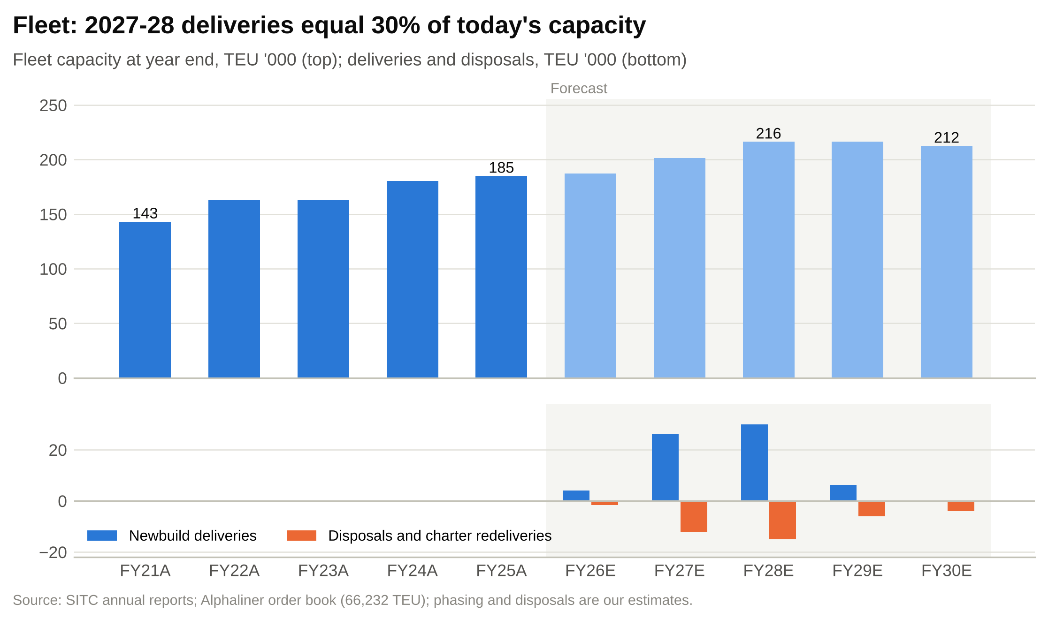

Newbuild instalments. SITC had US$763.3m of vessel commitments at June 2026 and US$124.3m already paid in advances. We assume instalments of US$132m in FY2026E (US$71.9m was paid in 1H26), US$330m in FY2027E, US$300m in FY2028E and US$73m in FY2029E, which clears the current book. We add US$75m in FY2029E and US$150m in FY2030E for a future renewal programme, since the fleet's average age is over ten years.
Other capex. Containers, equipment and dry-docking take US$30m in FY2026E (1H26: US$5.5m) and US$60m a year after. Total capex peaks at US$390m in FY2027E and US$360m in FY2028E, then settles at about US$210m, close to depreciation.
Leases. We assume new leases of US$70-75m a year, which keeps the chartered fleet roughly flat, and lease principal payments of 1.12 times right-of-use depreciation (FY2023-25: 1.08-1.21 times). Lease liabilities stay near US$290-300m.
Free cash flow. Free cash flow after leases falls from US$1,447m in FY2026E to US$947m in FY2027E and US$857m in FY2028E, then recovers to about US$1.1bn as capex normalises.
Dividends. We assume a payout of 85% of FY2026E attributable profit, which with the HK$2.50 already paid or declared in 2026 implies a final dividend of HK$1.12, and 80% from FY2027E. DPS is HK$3.62 for FY2026E, HK$2.74 for FY2027E and HK$2.43 for FY2028E. Cash dividends are US$1,452m in FY2026E, then US$845-910m a year.
Balance sheet. Net cash excluding leases stays at about US$0.9bn through 2028, then builds to US$1.3bn by 2030 as capex falls. Time deposits and liquid investments are held at US$725m and the model never needs to draw its revolving facility. ROE falls from 56% in FY2026E to 33% in FY2028E and 31% in FY2030E as profit falls and equity grows.

Our estimates against consensus and the share price
We do not have the full consensus by year, but the S&P Global consensus implies forward EPS of about HK$4.08 (from the 11.7x forward P/E at HK$47.68) and forecasts EPS falling about 2% a year over three years. Our FY2026E EPS of HK$4.27 is above that, because the Q3 rate was strong. Our FY2027E (HK$3.42) and FY2028E (HK$3.02) are well below the consensus path, which by our reading sits near HK$3.8-4.0 for FY2028. That gap is the core of our call, and it comes almost entirely from the rate assumption: our FY2027E rate is 10% below FY2026E; consensus appears to assume a much smaller fall.

Scenario analysis

How the scenarios are built
Each scenario is a full re-run of the model: the income statement, balance sheet, cash flow and DCF all recalculate when the selector on the Scenarios tab changes. The scenarios differ in the freight rate, volume, vessel cost per slot, logistics growth and the payout ratio. Fleet, capex, the other unit costs and working capital are common to all three.
We define the scenarios by the FY2027E rate outcome: a fall of more than 15% (bear), a fall of 5-15% (base) and a fall of less than 5% or a rise (bull). These buckets are mutually exclusive and cover every outcome, so probabilities of 25%, 50% and 25% form a complete set.
Figure 39: Scenario assumptions
Driver | Bear | Base | Bull
Q4 2026 average rate (US$/TEU) | 810 | 845 | 870
Q4 2026 volume growth (YoY) | +1% | +4% | +6%
Freight rate change FY2027E | –20% | –10% | –3%
Freight rate change FY2028E | –8% | –5% | 0%
Freight rate change FY2029E / FY2030E | 0% / +2% | 0% / +1% | +1% / +2%
Volume growth FY2027E / FY2028E | +2% / +3% | +5% / +5% | +7% / +6%
Volume growth FY2029E / FY2030E | +3% / +3% | +4% / +3.5% | +5% / +4%
Vessel cost per slot FY2027E / FY2028E | 0% / 0% | –2% / –1% | –3% / –2%
Logistics income growth FY2027E | 0% | +6% | +10%
Payout ratio FY2026E / FY2027E on | 80% / 70% | 85% / 80% | 90% / 90%
Probability | 25% | 50% | 25%
All other assumptions (fleet, unit costs except vessel cost, capex, working capital) are common to the three cases. Source: our estimates.

Bull case: the disruption premium lasts (25%)
In the bull case the factors that lifted rates in 2026 persist. Shipping through the Strait of Hormuz and the Red Sea stays disrupted into 2027, fuel stays expensive, and the global order book is absorbed by longer voyages and slower steaming. Intra-Asia demand stays firm as supply chains keep moving out of China.
Assumptions. The Q4 2026 rate is US$870/TEU, so the FY2026E rate is US$838. The rate falls only 3% in FY2027E to US$813 and holds there in FY2028E, then rises 1-2% a year. Volume grows 7% in FY2027E and 6% in FY2028E, so SITC fills its new ships at today's liftings per slot. Vessel cost per slot falls 3% and 2% as charter rates ease. Logistics income grows 10% in FY2027E. SITC pays out 90% of profit.
Outputs. Revenue grows at 7.7% a year to US$4,938m in FY2030E. Attributable profit is US$1,520m in FY2027E and US$1,596m in FY2028E, above FY2026E, and EPS reaches HK$4.39 and HK$4.60. The FY2028E gross margin is 40.0% and ROE 49.9%. Cumulative free cash flow over FY2026E-30E is US$7.7bn. FY2027E DPS is HK$3.96.
What it would take. Three things would have to happen: the Hormuz and Red Sea disruptions continue through 2027 (timing: any point in the next 12 months would tell us); the 2H26 and 1H27 rates hold above US$830/TEU (FY2026 results in March 2027 and interim results in August 2027); and competitors' new tonnage is absorbed without rate cuts on China-Southeast Asia lanes.
Valuation. The bull-case DCF is HK$59.40, 25% above the price. At 10.9x FY2027E EPS the P/E method gives HK$47.70, and the 60/40 blend is about HK$54.70. Even in this case the upside to a blended value is about 15% before dividends, so the bull case alone would justify a HOLD or a marginal BUY rather than a strong one.

Base case: the premium fades, rates normalise (50%)
In the base case the 2026 premium unwinds over 2027 and the delivery wave pushes rates down to the post-COVID norm in 2028. Demand keeps growing throughout.
Assumptions. The Q4 2026 rate is US$845, giving US$831 for FY2026E. The rate falls 10% in FY2027E to US$748, the FY2025 level, and 5% in FY2028E to US$711, close to the FY2023-25 average. Volume grows 5% a year in FY2027-28E. Vessel cost per slot falls 2% and 1%. SITC pays out 85% of FY2026E profit and 80% after that.
Outputs. Revenue is US$3,727m in FY2027E and US$3,740m in FY2028E. Attributable profit falls to US$1,184m and US$1,049m, and EPS to HK$3.42 and HK$3.02. The FY2028E gross margin is 32.0% and ROE 33.3%. Cumulative free cash flow over FY2026E-30E is US$5.4bn.
Why it is the most likely case. The global delivery schedule is known and large, and the 2026 premium came from a specific shock that was already fading by late July. A 10% fall in the FY2027E rate leaves it at SITC's own FY2025 level, which was itself a good year. And SITC's own fleet growth means it needs to win volume, which is rarely done at higher prices.
Valuation. The DCF value is HK$36.22 and the P/E method HK$37.15, a blended HK$36.59, which we round to our HK$36.50 target.

Bear case: back to the 2023 trough (25%)
In the bear case the disruptions end quickly, fuel falls and the global order book floods the market at the same time as SITC's regional competitors take delivery of their own ships. Rates fall as they did in 2023.
Assumptions. The Q4 2026 rate is US$810, giving US$822 for FY2026E. The rate falls 20% in FY2027E to US$657 and 8% in FY2028E to US$605, close to the 2023 low of US$623. Volume grows only 2% and 3% as SITC protects price. Vessel cost per slot does not fall, because owned ships carry fixed depreciation. Logistics income is flat in FY2027E. The payout falls to 70%.
Outputs. Attributable profit falls to US$735m in FY2027E and US$490m in FY2028E; EPS falls to HK$2.12 and HK$1.41. The FY2028E gross margin is 20.6% and ROE 16.6%. Revenue shrinks at 0.7% a year to FY2030E. SITC stays profitable and keeps net cash of about US$0.9bn, so the balance sheet is never at risk. FY2027E DPS is HK$1.49.
Downside triggers. A ceasefire that reopens normal routes through Hormuz and the Red Sea (likelihood over 12 months: low to medium, in our judgement); price-led competition from CULines, Zhonggu and other new regional capacity (medium); and a slowdown in Chinese exports (low to medium).
Valuation. The bear-case DCF is HK$16.11, 66% below the price. At 10.9x FY2027E EPS the P/E method gives HK$23.05, and the blend is about HK$18.90.

Scenario comparison
Figure 40: Scenario outputs (full-model re-runs)
Output | Bear | Base | Bull
FY2026E attributable profit (US$m) | 1,417 | 1,472 | 1,514
FY2027E revenue (US$m) | 3,190 | 3,727 | 4,129
FY2027E attributable profit (US$m) | 735 | 1,184 | 1,520
FY2027E diluted EPS (HK$) | 2.12 | 3.42 | 4.39
FY2027E DPS (HK$) | 1.49 | 2.74 | 3.96
FY2028E average rate (US$/TEU) | 605 | 711 | 813
FY2028E gross margin | 20.6% | 32.0% | 40.0%
FY2028E EBITDA (US$m) | 651 | 1,218 | 1,776
FY2028E attributable profit (US$m) | 490 | 1,049 | 1,596
FY2028E diluted EPS (HK$) | 1.41 | 3.02 | 4.60
FY2028E ROE | 16.6% | 33.3% | 49.9%
FY2030E revenue (US$m) | 3,293 | 4,068 | 4,938
Revenue CAGR FY2025A-30E | –0.7% | +3.6% | +7.7%
FY2030E EBITDA margin | 21.4% | 32.2% | 41.3%
Cumulative FCF FY2026E-30E (US$m) | 3,111 | 5,384 | 7,667
Net cash YE2030E (US$m) | 903 | 1,308 | 1,365
DCF value per share (HK$) | 16.10 | 36.22 | 59.40
vs current price | –66% | –24% | +25%
P/E on FY2027E EPS at HK$47.68 (x) | 22.5x | 13.9x | 10.9x
Each column is a full re-run of the three statements and the DCF with the scenario selector set to that case. Source: our model.
Figure 41: Bull, base and bear freight-rate and EPS paths
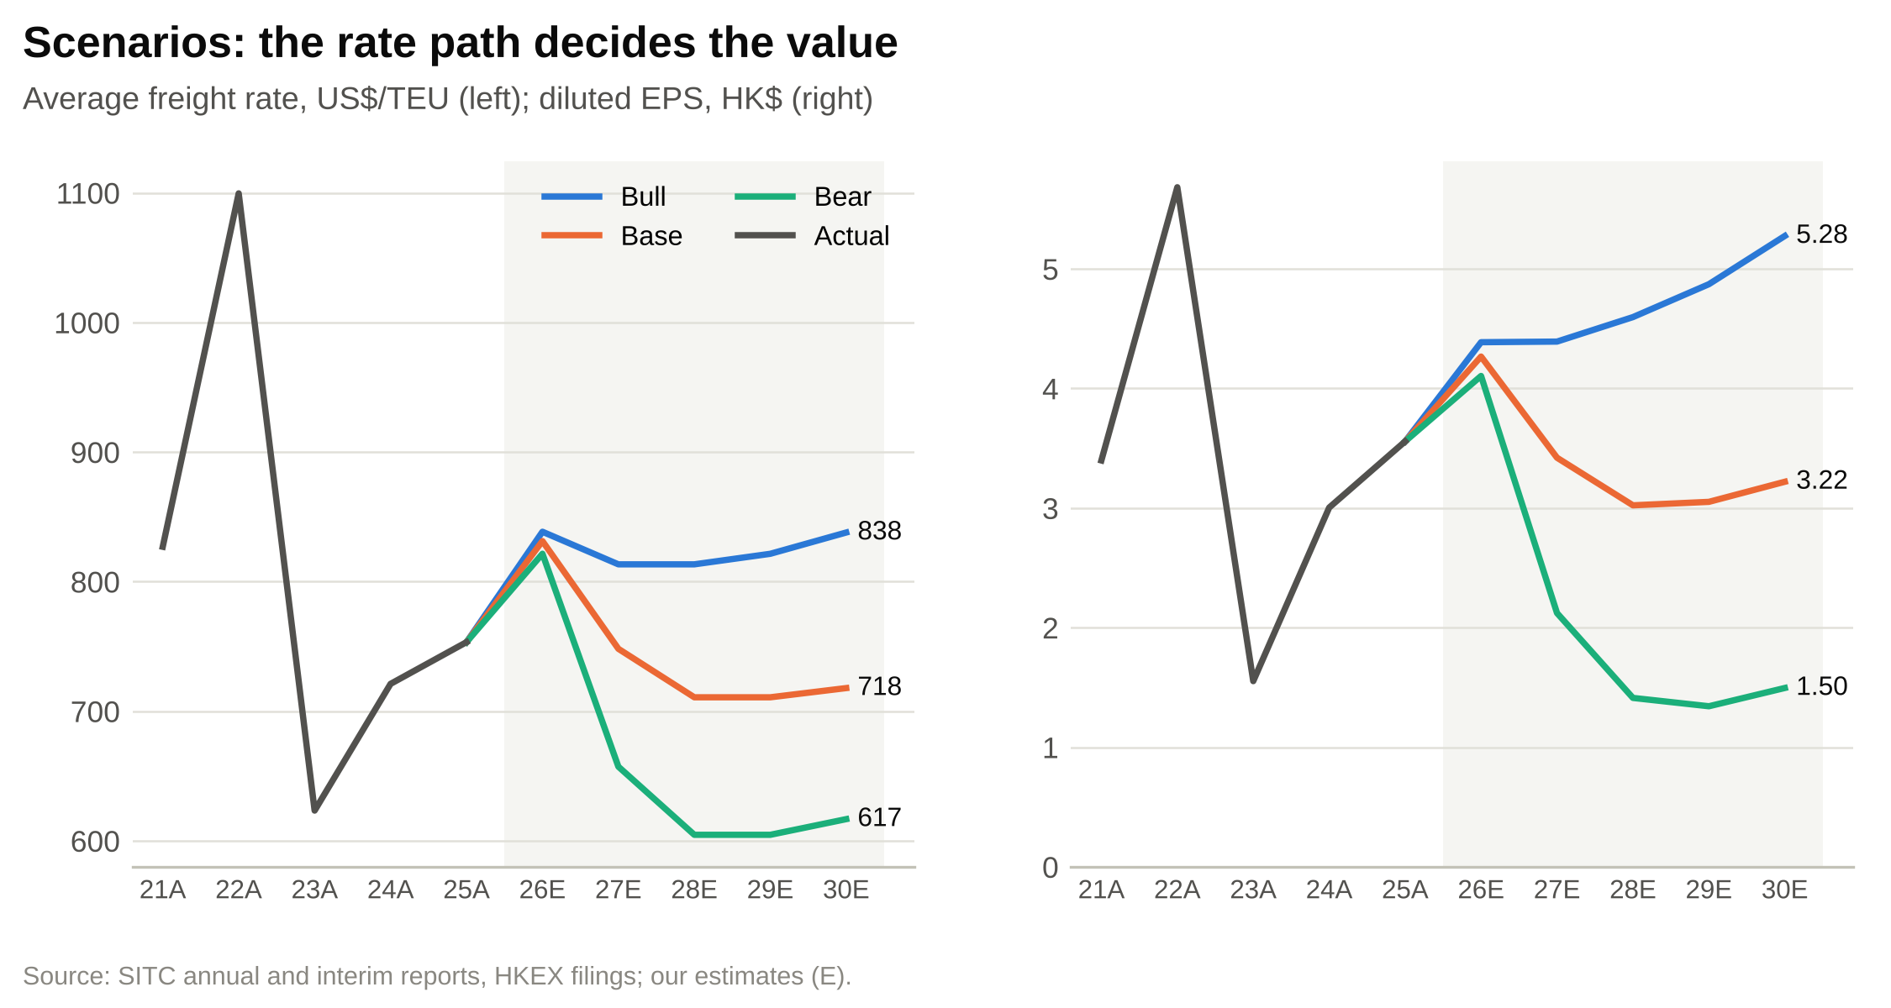

The distribution is skewed to the downside from today's price. The bull case is worth 25% more than the price, the base case 24% less and the bear case 66% less. With weights of 25%, 50% and 25%, the probability-weighted DCF value is HK$36.99, 22% below the price (Figure 42). For the probability-weighted value to equal the price, the bull case would need a probability of about 65% with the rest split evenly.
Figure 42: DCF value per share by scenario and probability-weighted (HK$)
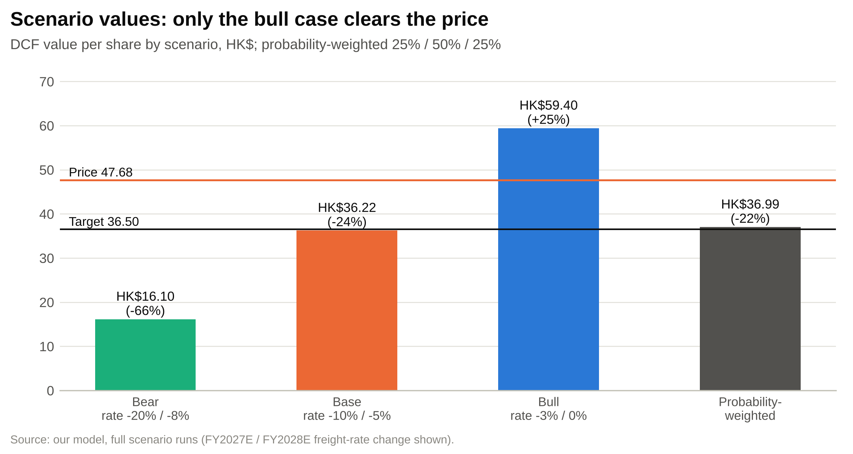

The path matters as much as the end point. In all three cases FY2026E is a strong year: attributable profit is US$1.42-1.51bn and the second half beats the first. The scenarios separate in 2027, and the first hard evidence will be the FY2026 results commentary in March 2027 and the 1H27 rate in August 2027. Investors who hold through the FY2026 results and the HK$1.00 special dividend will learn a lot before the main divergence shows up in the numbers.

Valuation
Our 12-month price target of HK$36.50 is a 60/40 blend of a DCF and a P/E multiple on FY2027E earnings. Every method we use gives a value below the current price.
Figure 43: Price target derivation (HK$ per share)
HK$ per share | Low | Base | High | Weight | Weighted
DCF (WACC ±1pp, g ∓0.5pp) | 31.34 | 36.22 | 43.31 | 60% | 21.73
P/E on FY2027E EPS (7.8x / 10.9x / 13x) | 26.68 | 37.15 | 44.47 | 40% | 14.86
Blended value | 29.48 | 36.59 | 43.78 | 100% | 36.59
12-month price target (rounded) |  | 36.50
Current price (23-Oct-2026) |  | 47.68
Downside to target |  | –23.4%
Dividends expected in 12 months |  | 3.63
Expected 12-month total return |  | –15.8%
Rating framework: BUY above +15% expected 12-month total return, SELL below –10%, HOLD in between. Source: our estimates.

Discounted cash flow

Method
Unlevered free cash flow is EBIT excluding disposal gains, after tax at 1.7%, plus depreciation, less capex including newbuild instalments, plus disposal proceeds, less the increase in working capital, less lease payments (principal and interest). We treat leases as operating costs: lease payments are deducted from cash flow and lease liabilities are not deducted in the equity bridge. The valuation date is 31 December 2026. Cash flows from FY2027E are discounted mid-year, and net cash is taken at the end of 2026, after the HK$1.00 special dividend paid on 17 December 2026. We do not discount FY2026E itself because ten of its twelve months have passed and its cash is in the year-end net cash.

Discount rate
Figure 44: Discount-rate assumptions
Input | Value | Source / basis
Risk-free rate | 5.00% | US 10-year Treasury 4.99%, 23-Oct-2026 (Yahoo Finance)
Raw beta (5-year) / adjusted | 1.03 / 1.02 | stockanalysis.com; Blume adjustment
Equity risk premium | 5.00% | Mature market ~4.3% + ~0.7% China/HK premium (assumed)
Cost of equity | 10.1% | CAPM
Debt weight | 0% | Net cash; leases inside free cash flow
WACC | 10.1%
Terminal growth | 2.0% | Below 3-4% intra-Asia trade growth
Valuation date | 31-Dec-2026 | Mid-year discounting from FY2027E
Source: our estimates.
SITC has no net debt, so its WACC equals its cost of equity. A 5.0% risk-free rate, the US 10-year Treasury yield on 23 October 2026, reflects SITC's US-dollar cash flows and the Hong Kong dollar's peg. The 5-year beta of 1.03, adjusted to 1.02, is in line with the market. We use a 5.0% equity risk premium, which includes about 0.7 points for China and Hong Kong. The result is a 10.1% cost of equity. Terminal growth of 2.0% sits below intra-Asia trade growth of 3-5% to allow for pressure on rates over the long run.

Free cash flow, terminal value and enterprise value
Figure 45: DCF: unlevered free cash flow (US$m)
US$m | FY2027E | FY2028E | FY2029E | FY2030E
Revenue | 3,727 | 3,740 | 3,894 | 4,068
EBITDA excl. disposal gains | 1,331 | 1,213 | 1,248 | 1,304
Depreciation and amortisation | 180 | 200 | 222 | 221
EBIT excl. disposal gains | 1,151 | 1,013 | 1,026 | 1,083
NOPAT (tax 1.7%) | 1,132 | 996 | 1,009 | 1,064
Capex net of disposals | (375) | (345) | (193) | (195)
Change in working capital | 14 | 12 | 8 | 6
Lease payments (principal and interest) | (90) | (91) | (92) | (93)
Unlevered free cash flow | 861 | 772 | 953 | 1,003
Discount factor (mid-year, 10.1%) | 0.953 | 0.866 | 0.786 | 0.714
Present value | 821 | 668 | 750 | 716
Source: our model (DCF tab).
Free cash flow dips in FY2027-28E as newbuild instalments of US$300-330m a year fall due, then recovers to about US$1.0bn in FY2030E. The terminal year carries a freight rate of about US$718/TEU, close to the FY2023-25 average, and an EBITDA margin of 32%. The terminal value of US$12.6bn equals 9.7x FY2030E EBITDA and 74% of enterprise value.
Figure 46: DCF: enterprise value to equity value
31-Dec-2026E | US$m | HK$ per share
Sum of PV of FCF, FY2027E-30E | 2,955 | 8.55
PV of terminal value (TV US$12,631m; 9.7x FY2030E EBITDA) | 8,596 | 24.86
Enterprise value | 11,551 | 33.40
Net cash excl. leases | 917 | 2.65
JVs and associates (book) | 86 | 0.25
Non-controlling interests | (29) | -0.08
Equity value | 12,526 | 36.22
2,711.5m shares in issue; HK$7.8413/US$. Terminal value is 74% of enterprise value. Source: our model.
Figure 47: DCF value per share build-up (HK$)
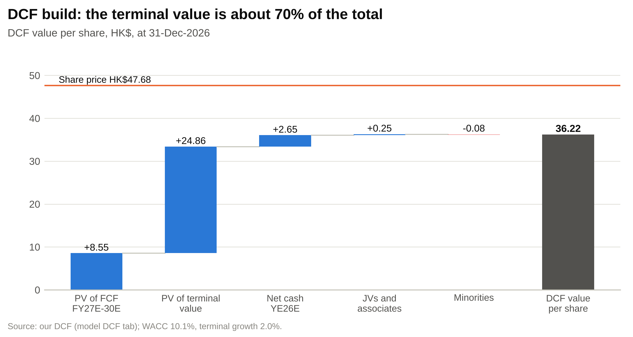

Sensitivity
Figure 48: DCF value per share (HK$): WACC vs terminal growth
WACC \ g | 1.0% | 1.5% | 2.0% | 2.5% | 3.0%
8.1% | 41.90 | 44.35 | 47.20 | 50.56 | 54.58
8.6% | 39.31 | 41.41 | 43.83 | 46.64 | 49.95
9.1% | 37.05 | 38.86 | 40.93 | 43.31 | 46.09
9.6% | 35.05 | 36.63 | 38.42 | 40.46 | 42.81
10.1% | 33.27 | 34.66 | 36.22 | 37.99 | 40.00
10.6% | 31.68 | 32.91 | 34.28 | 35.82 | 37.56
11.1% | 30.25 | 31.34 | 32.55 | 33.91 | 35.42
11.6% | 28.96 | 29.93 | 31.01 | 32.20 | 33.54
12.1% | 27.78 | 28.66 | 29.62 | 30.68 | 31.86
DCF value per share, HK$. Base case WACC 10.1%, g 2.0%: HK$36.22. Source: our model (Sensitivity tab).
Figure 49: DCF sensitivity heatmap: WACC vs terminal growth (HK$ per share)
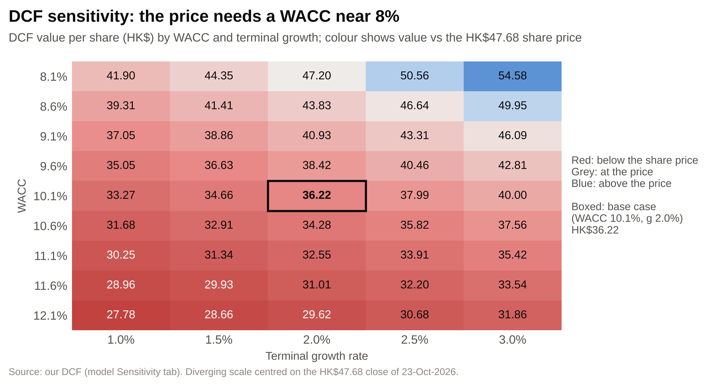

The current price needs a WACC of about 8% with 2% growth, or about 9% with 3% growth. With a 5% risk-free rate, an 8% WACC implies an equity risk premium of about 3% for a cyclical shipping company, which we think is too low. At a 4% risk-free rate the WACC would be 9.1% and the DCF value HK$40.93, still 14% below the price.
Figure 50: DCF value per share (HK$): FY2025A-30E revenue CAGR vs FY2030E EBITDA margin
Rev. CAGR \ EBITDA margin | 24.1% | 28.1% | 32.1% | 36.1% | 40.1%
0.6% | 24.11 | 27.81 | 31.52 | 35.23 | 38.93
2.1% | 25.82 | 29.81 | 33.80 | 37.79 | 41.78
3.6% | 27.63 | 31.93 | 36.22 | 40.52 | 44.81
5.1% | 29.56 | 34.17 | 38.79 | 43.40 | 48.01
6.6% | 31.60 | 36.55 | 41.50 | 46.45 | 51.41
DCF value per share, HK$; FY2030E terminal year varied only. Source: our model (Sensitivity tab).
The second grid changes the terminal year only. The price needs about 5% revenue growth a year to 2030 with a 40% terminal EBITDA margin, or 6.6% growth with a 36% margin. FY2025's EBITDA margin was 40.3%. The FY2021-25 average was also about 40%, but that period includes the 2021-22 boom; FY2023-25 averaged 35.6%.

Comparable companies

Peer selection
We compare SITC with twelve listed container lines: eight Asian carriers, including the intra-Asia specialists Wan Hai, T.S. Lines and RCL, and four global ones. We leave out NYK, MOL and K Line because their earnings are dominated by bulk shipping, car carriers and their stake in ONE. Several large regional competitors (PIL, KMTC, Sinokor, X-Press Feeders, CULines) are private.

Trading multiples
Figure 51: Trading comparables (market data 24-25 Oct 2026)
Company | Ticker | Mkt cap US$bn | EV/Sales LTM | EV/EBITDA LTM | P/E LTM | P/E fwd | P/B | Div. yield | ROE | EBITDA margin
COSCO Shipping Holdings | 1919.HK | 34.9 | 0.98x | 4.2x | 8.0x | 7.8x | 0.83x | 7.2% | 10.8% | 18.2%
Orient Overseas (OOIL) | 0316.HK | 12.7 | 0.81x | 4.2x | 9.8x | 7.8x | 0.91x | 5.9% | 9.5% | 14.6%
Evergreen Marine | 2603.TW | 17.3 | 1.59x | 5.6x | 10.3x | 5.3x | 0.96x | 6.2% | 10.2% | 23.4%
Yang Ming Marine | 2609.TW | 6.6 | 0.65x | 3.5x | 13.9x | 7.1x | 0.66x | 3.2% | 5.0% | 11.6%
Wan Hai Lines | 2615.TW | 10.3 | 1.86x | 5.7x | 8.2x | 6.5x | 1.16x | 2.9% | 15.5% | 30.7%
HMM | 011200.KS | 16.1 | 1.29x | 5.7x | 15.2x | 12.0x | 0.74x | 3.1% | 5.2% | 21.8%
T.S. Lines | 2510.HK | 2.6 | 1.70x | 4.3x | 7.0x | 6.2x | 1.20x | 8.9% | 17.9% | 34.2%
Regional Container Lines | RCL.BK | 1.2 | 1.00x | 3.1x | 5.0x | n/a | 0.67x | 5.3% | 14.1% | 31.1%
A.P. Moller-Maersk | MAERSK-B.CO | 48.6 | 0.88x | 5.1x | 22.6x | 9.7x | 0.88x | 2.1% | 4.4% | 10.5%
Hapag-Lloyd | HLAG.DE | 25.3 | 1.34x | 9.7x | 389.2x | 23.9x | 1.24x | 2.3% | 0.4% | 7.2%
ZIM Integrated Shipping | ZIM | 3.5 | 1.12x | 15.4x | 25.5x | 3.2x | 0.91x | 4.1% | 3.6% | 7.2%
Matson | MATX | 6.8 | 2.15x | 11.0x | 15.3x | 12.7x | 2.47x | 0.7% | 17.2% | 19.5%
Maximum |  | 48.6 | 2.15x | 15.4x | 389.2x | 23.9x | 2.47x | 8.9% | 17.9% | 34.2%
75th percentile |  | 19.3 | 1.62x | 6.7x | 17.1x | 10.9x | 1.17x | 6.0% | 14.4% | 25.2%
Median |  | 11.5 | 1.21x | 5.3x | 12.1x | 7.8x | 0.91x | 3.6% | 9.8% | 18.8%
25th percentile |  | 5.9 | 0.95x | 4.2x | 8.2x | 6.3x | 0.81x | 2.8% | 4.8% | 11.4%
Minimum |  | 1.2 | 0.65x | 3.1x | 5.0x | 3.2x | 0.66x | 0.7% | 0.4% | 7.2%
SITC (market data) | 1308.HK | 16.5 | 4.41x | 11.1x | 12.9x | 11.7x | 5.77x | 6.8% | 46.9% | 36.8%
SITC (our FY2026E) |  | 16.5 | 3.98x | 9.5x | – | 11.2x | 5.97x | 7.6% | 56.2% | 41.9%
SITC (our FY2027E) |  | 16.5 | 4.15x | 11.6x | – | 13.9x | 5.39x | 5.7% | 40.7% | 35.9%
Source: stockanalysis.com (S&P Global Market Intelligence), 24-25 Oct 2026; SITC estimate rows use our forecasts at HK$47.68. Forward P/E is the source's consensus-based figure; NTM EV multiples were not available from public sources.
SITC is not like its peers on any measure. Its ROE is almost five times the peer median, its EBITDA margin twice, and its P/B more than six times. On P/B and EV/EBITDA the peer set says little about SITC's value: the peer median P/B on our YE2026E book value would give HK$7.27 a share, and the peer median EV/EBITDA on FY2026E EBITDA HK$28.07.
Figure 52: Price to book against return on equity
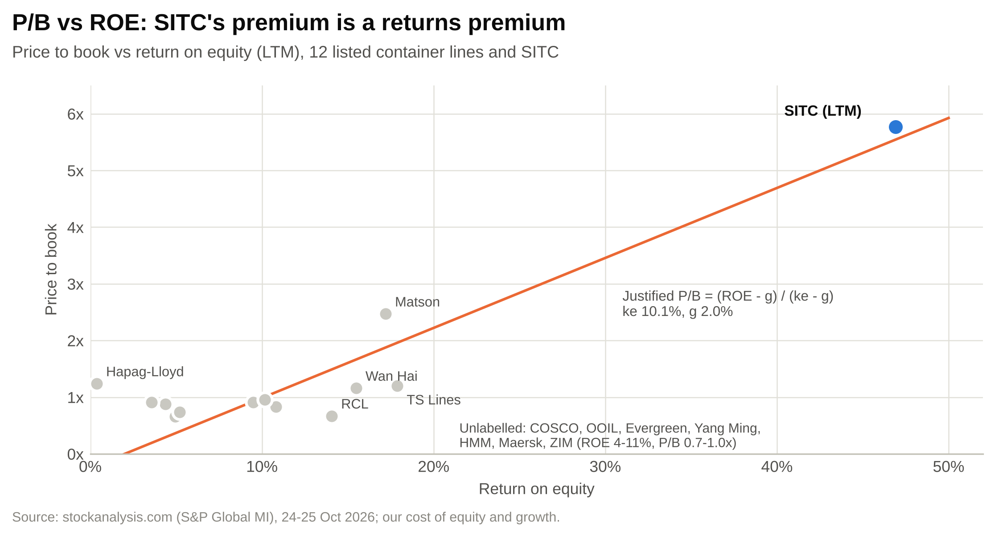

Earnings are the fairer basis, because they capture SITC's returns directly. On forward P/E, SITC's 11.7x (consensus) is already above the peer 75th percentile of 10.9x and 50% above the median of 7.8x (Figure 53). On our lower FY2027E EPS it is 13.9x.
Figure 53: Forward P/E: SITC against peers
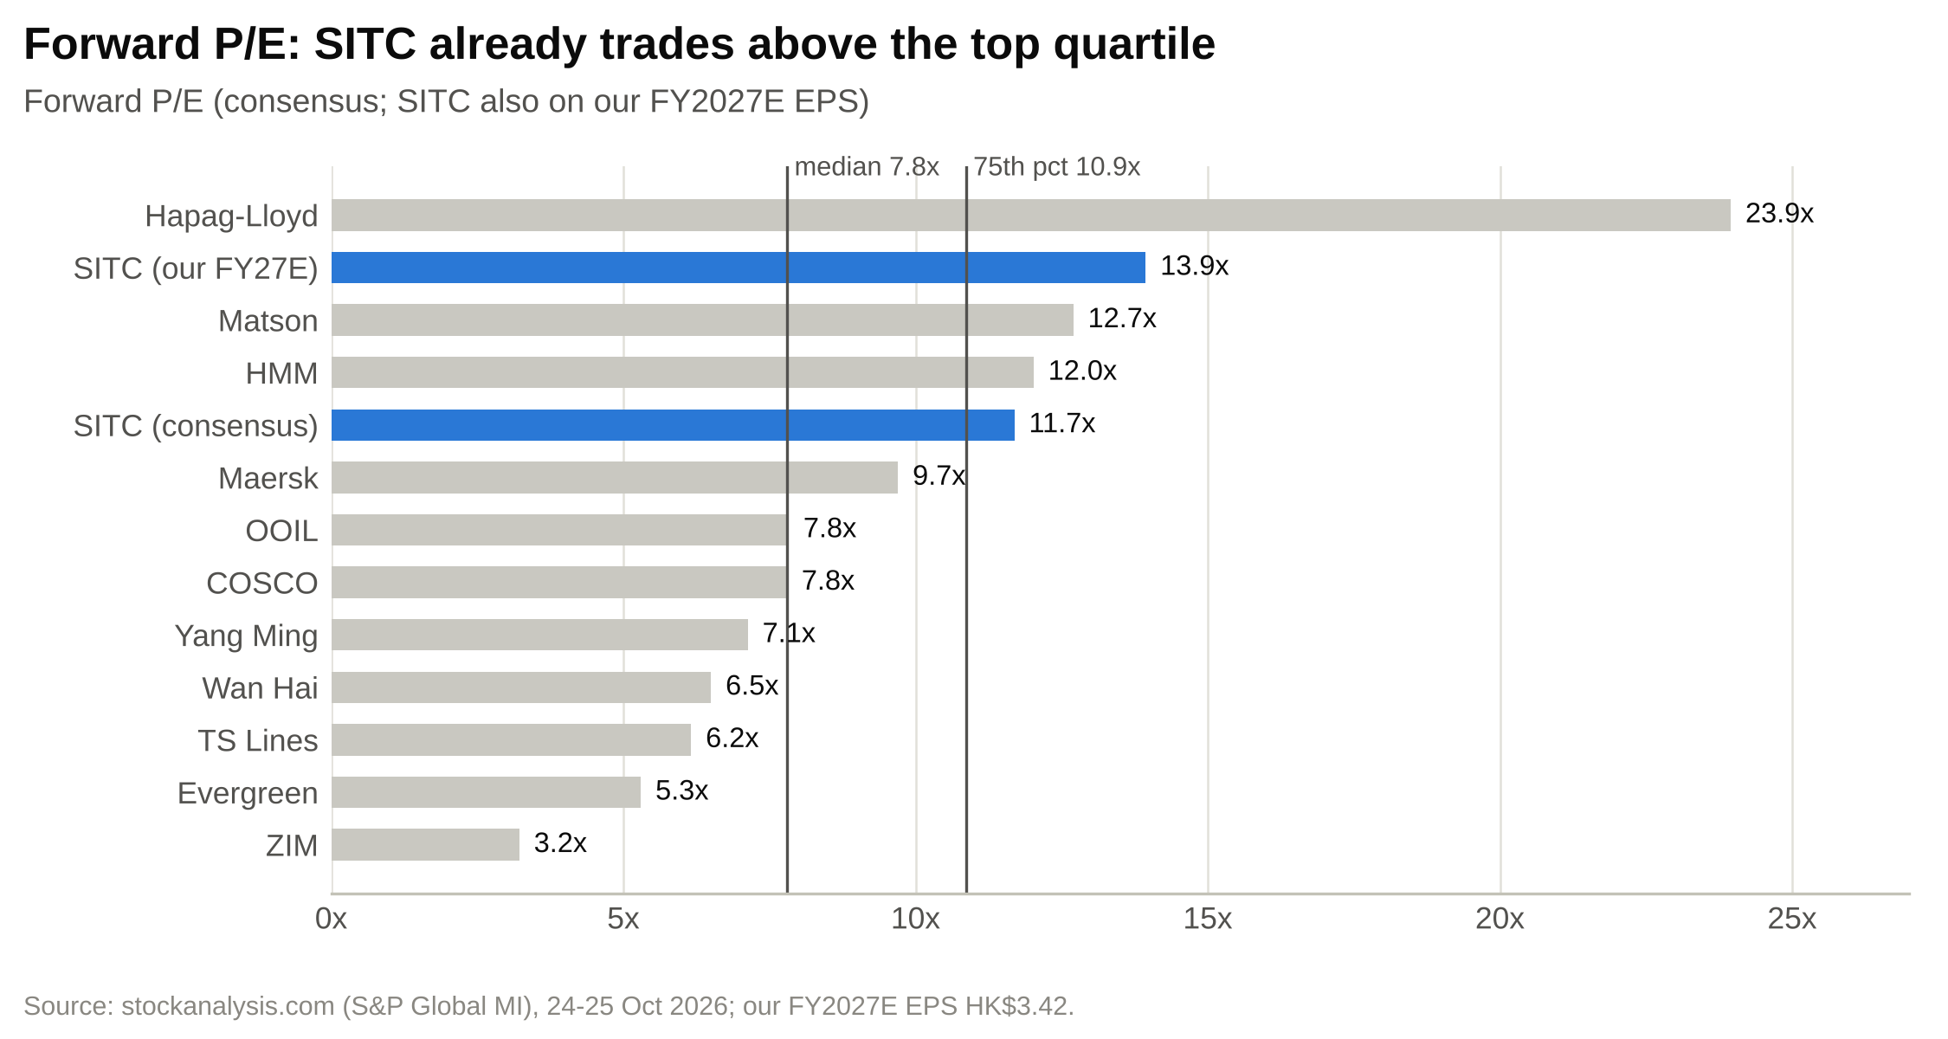

Figure 54: Implied values from peer multiples (HK$ per share)
Method | Multiple | SITC metric | Value (HK$) | vs price
Peer median forward P/E on FY2027E EPS | 7.8x | HK$3.42 | 26.68 | –44%
Peer 75th percentile forward P/E on FY2027E EPS | 10.9x | HK$3.42 | 37.15 | –22%
SITC trailing P/E on FY2027E EPS | 13.0x | HK$3.42 | 44.47 | –7%
Peer median EV/EBITDA on FY2026E EBITDA | 5.3x | US$1,633m | 28.07 | –41%
Peer median P/B on YE2026E book | 0.91x | HK$7.99 | 7.27 | –85%
Peer median P/B scaled by ROE | 3.77x | HK$7.99 | 30.10 | –37%
Source: our model (Comps tab).
We value SITC at the 75th percentile forward P/E of 10.9x on FY2027E EPS of HK$3.42, which gives HK$37.15. The top-quartile multiple reflects the highest ROE and payout in the group and the most conservative balance sheet. It is also close to the P/E a Gordon model gives for an 80% payout at a 10.1% cost of equity and 2% growth: 0.80 × 1.02 / 0.081 = 10.1x. Our range runs from the median (7.8x, HK$26.68) to 13x (HK$44.47), SITC's trailing P/E.

Precedent transactions
We do not use precedent transactions. The founder's family trust holds 40.49% and the chairman about 9%, so a change of control would need their agreement, and no listed regional container line has changed hands in recent years. The last large deal in the sector, COSCO's acquisition of OOIL in 2017-18, was priced at a different point in the cycle and for a long-haul network.

Cross-checks and the football field
Figure 55: Valuation cross-checks (not weighted)
Cross-check (not weighted), HK$ per share | Low | Base | High | vs price
Dividend discount (cost of equity ±1pp) | 28.13 | 31.46 | 35.72 | –34%
Justified P/B, (ROE – g)/(ke – g) | – | 38.15 | – | –20%
Peer median EV/EBITDA on FY2026E | – | 28.07 | – | –41%
DCF by scenario (bear / base / bull) | 16.10 | 36.22 | 59.40 | –24%
Probability-weighted DCF (25/50/25) | – | 36.99 | – | –22%
52-week range | 26.22 | – | 52.00 | –
Consensus target (third party) | – | 46.20 | – | –3%
Consensus: stockanalysis.com (S&P Global Market Intelligence), 24-Oct-2026, 9 analysts, consensus rating Buy; not our estimate.
The dividend discount model gives HK$31.46: FY2026E's final dividend plus FY2027-30E DPS, a Gordon terminal value at 2% growth, and a 10.1% cost of equity. It is lower than the DCF because SITC pays out 80% of profit rather than all of its free cash flow, so cash builds on the balance sheet. The justified P/B, (ROE – g)/(ke – g) at a FY2027E ROE of 41%, gives 4.8x book, or HK$38.15. The consensus target of HK$46.20 is the only figure near the price, and it is a third-party number, not ours.
Figure 56: Valuation football field (HK$ per share)
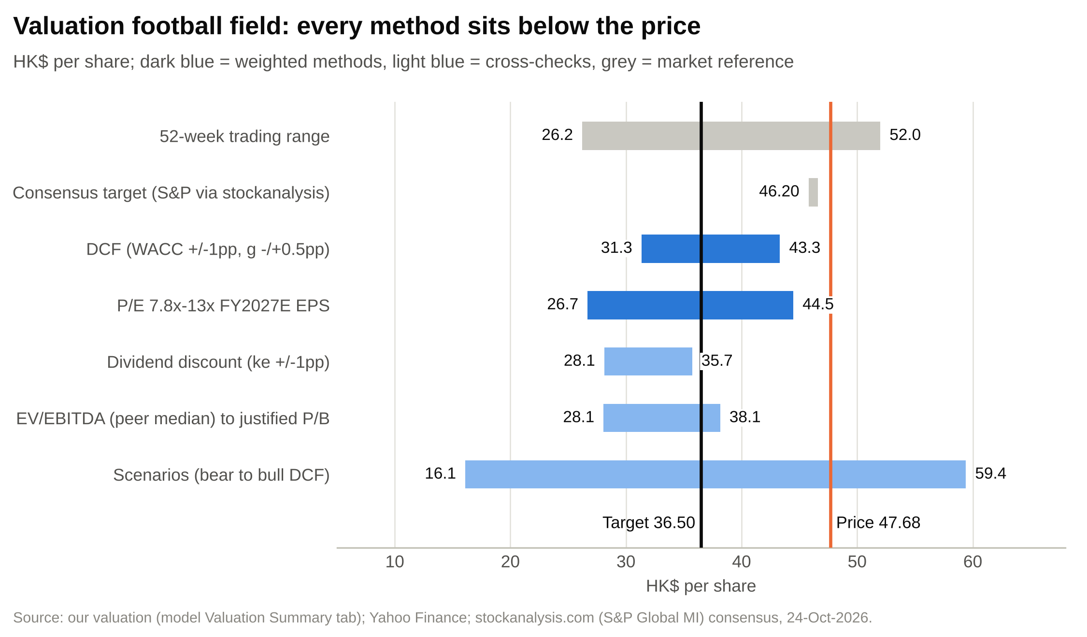

The stock's own history
On the last reported annual EPS, SITC's month-end trailing P/E has ranged from about 2x (2023, on peak 2022 earnings) to over 40x (2021, on 2020 earnings) since April 2018, with a median of 12.1x. It is 13.5x now, on FY2025 EPS. The trailing dividend yield has a median of 6.3% and is 6.3% now (Figure 57). On trailing numbers the stock looks fairly priced. The problem is that the trailing numbers include a year we think will not be repeated: on our FY2027E EPS the P/E is 13.9x and the yield 5.7%.
Figure 57: Trailing P/E and dividend yield, April 2018 to October 2026
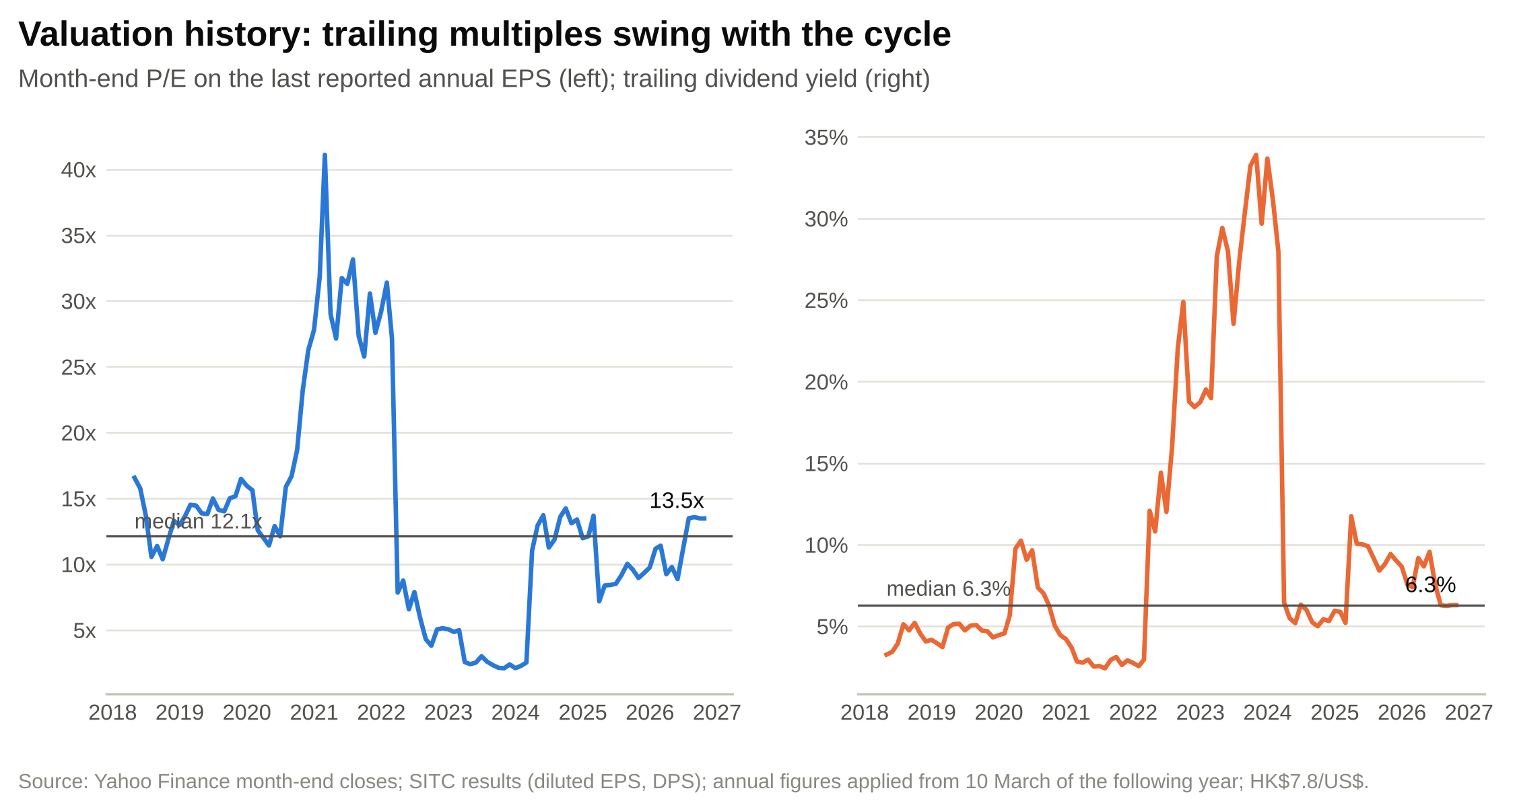

Figure 58: FY2027E EPS and P/E against changes in the freight rate
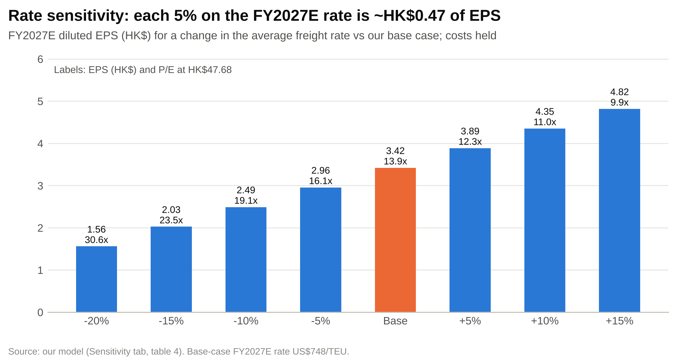

The rate sensitivity is the clearest way to see what the price assumes (Figure 58). If FY2027E rates were 10% higher than our base case, at about US$823/TEU (roughly the FY2026E level), EPS would be HK$4.35 and the P/E 11.0x, close to where the stock trades on consensus. If they were 10% lower, at US$673, EPS would be HK$2.49 and the P/E 19.1x.

Sanity checks
- Model integrity. The balance sheet balances in every year and scenario, and every historical total ties to the filings. The DCF cash flows tie to the model, and the centre of each sensitivity grid equals the DCF value.
- WACC. 10.1% is within the 7-12% range for a mature cyclical. The 5% risk-free rate is high by recent standards; at 4% our target would rise by about HK$3.
- Terminal assumptions. A 9.7x terminal EV/EBITDA and 2% growth are generous for a cyclical shipping company and conservative for a net-cash business with a 30% margin. The sensitivity grids show the range.
- Peer data. The multiples come from one public aggregator and we have not checked them against each company's filings. Outliers (Hapag-Lloyd's 389x LTM P/E, ZIM's 3.2x forward P/E) are why we use medians and percentiles.
- What the target implies. At HK$36.50 SITC would trade on 8.6x FY2026E and 10.7x FY2027E EPS, 8.7x FY2027E EV/EBITDA and 4.6x YE2026E book, with a 7.5% FY2027E yield. That is still a premium to every peer on every measure.

Price target and rating
We initiate on SITC with a SELL rating and a 12-month price target of HK$36.50, 23.4% below the 23 October 2026 close of HK$47.68. Including HK$3.63 of dividends expected over the next twelve months (the HK$1.00 special in December, a FY2026 final of about HK$1.12 in mid-2027 and FY2027 interim and special dividends of about HK$1.51), the expected total return is –15.8%.
The rating rests on the freight rate. We think the 2026 rate includes a disruption premium that will fade over 2027, while a large delivery wave, including SITC's own ships, arrives in 2027-28. SITC remains the best operator in its market, with the highest returns and the strongest balance sheet, but the share price already pays for that and for 2026-level earnings as well.

Rating definitions
Our ratings are based on expected 12-month total return (price change to target plus expected dividends): BUY above +15%, HOLD between –10% and +15%, and SELL below –10%. Price targets are 12-month targets, rounded to the nearest HK$0.50.

Appendix A: Financial statements
Figure 59: Income statement, FY2023A-FY2030E (US$m)
US$m | FY2023A | FY2024A | FY2025A | FY2026E | FY2027E | FY2028E | FY2029E | FY2030E
Revenue | 2,429 | 3,058 | 3,412 | 3,894 | 3,727 | 3,740 | 3,894 | 4,068
Growth | –40.9% | 25.9% | 11.6% | 14.1% | –4.3% | 0.4% | 4.1% | 4.5%
Equipment and cargo costs | (926) | (973) | (1,093) | (1,119) | (1,192) | (1,271) | (1,341) | (1,409)
Voyage costs | (408) | (422) | (402) | (468) | (477) | (501) | (526) | (550)
Vessel costs | (297) | (257) | (329) | (365) | (373) | (397) | (416) | (418)
Other logistics costs | (172) | (261) | (275) | (335) | (355) | (373) | (392) | (408)
Other costs | (2.7) | (0.7) | (1.6) | (1.6) | (1.6) | (1.6) | (1.6) | (1.6)
Gross profit | 623 | 1,143 | 1,310 | 1,606 | 1,327 | 1,197 | 1,218 | 1,282
Gross margin | 25.7% | 37.4% | 38.4% | 41.2% | 35.6% | 32.0% | 31.3% | 31.5%
Gain on disposals | 22.1 | 9.5 | 35.5 | 10.0 | 5.0 | 5.0 | 5.0 | 5.0
Other income and gains | 16.1 | 8.5 | 9.5 | 12.0 | 10.0 | 10.0 | 10.0 | 10.0
Administrative expenses | (136) | (144) | (154) | (174) | (182) | (190) | (197) | (205)
Other expenses | (4.1) | (1.0) | (5.7) | (4.0) | (4.0) | (4.0) | (4.0) | (4.0)
EBIT | 521 | 1,016 | 1,196 | 1,450 | 1,156 | 1,018 | 1,031 | 1,088
D&A | 159 | 164 | 180 | 183 | 180 | 200 | 222 | 221
EBITDA | 680 | 1,180 | 1,376 | 1,633 | 1,336 | 1,218 | 1,253 | 1,309
Share of JVs | 20.0 | 24.5 | 31.1 | 36.1 | 37.5 | 38.6 | 39.8 | 41.0
Share of associates | (0.2) | 1.9 | 1.7 | 1.5 | 1.5 | 1.5 | 1.5 | 1.5
Interest income | 31.3 | 27.0 | 37.8 | 33.2 | 30.8 | 28.5 | 27.3 | 32.9
Finance costs | (18.8) | (15.7) | (15.6) | (13.9) | (14.1) | (12.8) | (12.6) | (12.4)
Profit before tax | 553 | 1,054 | 1,251 | 1,507 | 1,212 | 1,074 | 1,087 | 1,151
Income tax | (17.2) | (19.2) | (20.9) | (25.6) | (20.6) | (18.3) | (18.5) | (19.6)
Non-controlling interests | (4.8) | (6.0) | (7.5) | (8.9) | (7.1) | (6.3) | (6.4) | (6.8)
Attributable profit | 531 | 1,028 | 1,223 | 1,472 | 1,184 | 1,049 | 1,063 | 1,124
Diluted shares (m) | 2,683 | 2,684 | 2,696 | 2,706 | 2,714 | 2,722 | 2,730 | 2,738
Diluted EPS (HK$) | 1.55 | 3.00 | 3.56 | 4.27 | 3.42 | 3.02 | 3.05 | 3.22
DPS (HK$) | 1.10 | 2.52 | 3.00 | 3.62 | 2.74 | 2.43 | 2.46 | 2.60
Source: company filings (FY2023A-FY2025A); our estimates.
Figure 60: Balance sheet, FY2023A-FY2030E (US$m)
US$m, 31 December | FY2023A | FY2024A | FY2025A | FY2026E | FY2027E | FY2028E | FY2029E | FY2030E
Property, plant and equipment | 1,662 | 1,828 | 1,793 | 1,742 | 2,029 | 2,351 | 2,334 | 2,234
Right-of-use assets | 215 | 236 | 326 | 328 | 334 | 339 | 343 | 346
Advance payments for vessels | 71 | 31 | 52 | 131 | 112 | 10 | 75 | 225
JVs and associates | 58 | 61 | 66 | 71 | 77 | 83 | 88 | 95
Total non-current assets | 2,026 | 2,175 | 2,254 | 2,290 | 2,572 | 2,804 | 2,863 | 2,924
Bunkers | 43 | 47 | 51 | 58 | 59 | 62 | 65 | 68
Trade receivables | 113 | 175 | 184 | 224 | 214 | 215 | 224 | 234
Prepayments and other | 37 | 54 | 39 | 51 | 48 | 49 | 51 | 53
FVTPL assets | 15 | 1 | 167 | 75 | 75 | 75 | 75 | 75
Time deposits | 294 | 608 | 538 | 650 | 650 | 650 | 650 | 650
Cash and cash equivalents | 122 | 136 | 244 | 222 | 224 | 186 | 373 | 583
Total current assets | 627 | 1,024 | 1,223 | 1,280 | 1,271 | 1,237 | 1,437 | 1,663
Total assets | 2,652 | 3,198 | 3,478 | 3,570 | 3,842 | 4,041 | 4,300 | 4,587
Trade payables | 204 | 234 | 235 | 257 | 270 | 286 | 301 | 313
Other payables and accruals | 137 | 143 | 165 | 183 | 175 | 176 | 183 | 191
Bank borrowings, current | 104 | 115 | 19 | 30 | – | – | – | –
Lease liabilities, total | 202 | 222 | 305 | 299 | 297 | 293 | 288 | 283
Dividend payable | – | – | 243 | – | – | – | – | –
Total liabilities | 721 | 777 | 976 | 779 | 751 | 763 | 781 | 796
Shareholders' equity | 1,915 | 2,404 | 2,479 | 2,762 | 3,058 | 3,239 | 3,477 | 3,744
Non-controlling interests | 16.5 | 17.3 | 22.7 | 28.9 | 33.9 | 38.3 | 42.8 | 47.6
Total equity | 1,931 | 2,422 | 2,501 | 2,791 | 3,092 | 3,278 | 3,519 | 3,791
Net cash excl. leases | 262 | 578 | 930 | 917 | 949 | 911 | 1,098 | 1,308
ROE | 26.1% | 47.6% | 50.1% | 56.2% | 40.7% | 33.3% | 31.6% | 31.1%
BVPS (HK$) | 5.54 | 6.95 | 7.17 | 7.99 | 8.84 | 9.37 | 10.05 | 10.83
JVs and associates row shows JVs only; associates (US$14m at FY2025) are in total non-current assets. Source: company filings; our estimates.
Figure 61: Cash flow statement, FY2023A-FY2030E (US$m)
US$m | FY2023A | FY2024A | FY2025A | FY2026E | FY2027E | FY2028E | FY2029E | FY2030E
Profit for the year | 536 | 1,034 | 1,230 | 1,481 | 1,191 | 1,056 | 1,069 | 1,131
D&A | 159 | 164 | 180 | 183 | 180 | 200 | 222 | 221
Share award expense | 28.4 | 27.8 | 27.0 | 25.0 | 25.0 | 25.0 | 25.0 | 25.0
JV and associate profits | (19.8) | (26.4) | (32.8) | (37.6) | (39.0) | (40.1) | (41.3) | (42.5)
Disposal gains | (22.1) | (9.5) | (35.5) | (10.0) | (5.0) | (5.0) | (5.0) | (5.0)
Working capital and other | (9.3) | (31.8) | 31.7 | (16.8) | 14.3 | 12.4 | 8.3 | 5.5
Net cash from operations | 672 | 1,158 | 1,401 | 1,625 | 1,367 | 1,248 | 1,278 | 1,335
Capex (PPE) | (261) | (243) | (100) | (30) | (60) | (60) | (60) | (60)
Newbuild instalments | (49) | (18) | (35) | (132) | (330) | (300) | (148) | (150)
Disposal proceeds | 44.1 | 32.4 | 70.7 | 30.0 | 15.0 | 15.0 | 15.0 | 15.0
JV dividends | 15.2 | 17.3 | 27.6 | 30.6 | 31.9 | 32.8 | 33.8 | 34.8
Investing cash flow | (149) | (510) | (128) | (121) | (343) | (312) | (159) | (160)
Dividends paid | (752) | (558) | (938) | (1,452) | (908) | (888) | (845) | (877)
Lease principal | (63.7) | (61.2) | (77.9) | (76.7) | (77.1) | (78.5) | (79.7) | (80.6)
Financing cash flow | (945) | (634) | (1,171) | (1,525) | (1,022) | (973) | (932) | (965)
Net change in cash | (422) | 14 | 107 | (21) | 1 | (38) | 186 | 210
Free cash flow after leases | 359 | 886 | 1,286 | 1,447 | 947 | 857 | 1,039 | 1,095
Historical working capital and other items are residuals to reported operating cash flow. Source: company filings; our estimates.

Appendix B: Model notes and data conventions
- Units. The filings report in US$'000; we show US$m. Per-share figures in HK$ use HK$7.8413/US$ for every year, so historical HK$ EPS differ slightly from figures translated at the rates of the time.
- Share count. Per-share values use the 2,711.5m shares in issue (September 2026 monthly return). This includes about 34m shares held by the share-scheme trustee, which the company treats as dilutive. Share options had no dilutive effect in 1H26.
- Cost of sales. FY2023 equipment and cargo costs are derived as total cost of sales less the other lines; FY2021-22 dry bulk costs are shown as other costs.
- Revenue. Freight revenue is volume times the reported average rate; slot exchange and other shipping income is the residual of reported shipping income.
- Cash. For FY2021-23 we split "cash and bank balances" into cash equivalents and time deposits using the cash flow statement.
- Historical cash flow. Working capital and other operating items are shown as a residual to reported operating cash flow; investing and financing residuals cover deposits, investments, NCI dividends and option proceeds.
- Dividends. We separate dividends declared for a year from cash paid in it. FY2026 cash dividends include the FY2025 final (US$344.6m), the special declared in December 2025 (US$242.8m, a liability at year end), and the FY2026 interim and special (HK$2.50 a share).
- Data conflicts. The company reports 30 contracted vessels on order; Alphaliner shows 37 ships and 66,232 TEU. We use Alphaliner's capacity with our own phasing. The reported fleet average age rose from 9.4 to 10.6 years between December 2025 and June 2026, which is hard to reconcile; we do not use it in the model.
- Third-party data. Peer multiples, beta and the consensus target come from stockanalysis.com (S&P Global Market Intelligence) and were not verified against primary filings.
- Model. All figures come from SITC_Financial_Model_2026-10-25.xlsx, a formula-driven workbook with a scenario selector and a Checks tab.

Appendix C: Glossary
- TEU: twenty-foot equivalent unit, the standard measure of container volume and ship capacity.
- Average freight rate: SITC's reported revenue per TEU carried, excluding slot exchange income.
- Slot exchange: an arrangement in which carriers swap space on each other's ships.
- Liftings per slot: volume carried in a year divided by average fleet capacity.
- Charter / chartered ship: a ship hired from an owner for a period; it appears as a right-of-use asset and lease liability.
- Order book: ships contracted but not yet delivered, as a share of current fleet capacity.
- SCFI / Drewry index: published container freight-rate indices (Shanghai Containerized Freight Index; Drewry Intra-Asia Container Index).
- VLSFO: very low sulphur fuel oil, the main marine fuel since 2020.
- Cascading: moving ships displaced from larger trades into smaller ones.
- UFCF: unlevered free cash flow, cash flow available to all capital providers.
- WACC: weighted average cost of capital.
- LTM / NTM: last twelve months / next twelve months.
- FVTPL: financial assets at fair value through profit or loss.
- ROE: attributable profit divided by average shareholders' equity.

Appendix D: Sources
Company filings (HKEX, stock code 1308)
- Interim results announcement, six months to 30 June 2026 (19 Aug 2026)
- Interim Report 2026 (31 Aug 2026)
- Operating statistics for nine months to 30 September 2026 and special dividend (22 Oct 2026)
- Annual Report 2025 (24 Mar 2026)
- Annual results announcement, FY2025 (10 Mar 2026)
- Annual results announcement, FY2024 (10 Mar 2025)
- Global Offering prospectus (19 Sep 2010)
- Change of chairman, vice chairman and CEO (7 Mar 2024)
- Shipbuilding contracts, four 2,700 TEU vessels (3 Aug 2025)
- Exercise of options for two vessels (30 Jan 2026)
- Construction of 1,100 TEU vessels (26 Mar 2026)
- Connected transactions: disposal and lease arrangement (27 Apr 2026)
- Special dividend declaration (18 Dec 2025)
- Monthly return of equity issuer, September 2026 (6 Oct 2026)
- Annual results announcements FY2018-FY2023 and annual reports 2022 and 2023 (HKEX)
Market, fleet and peer data
- Alphaliner Top 100 (25 Oct 2026)
- Yahoo Finance: 1308.HK, ^HSI, ^TNX and FX (23 Oct 2026)
- stockanalysis.com: SITC statistics and consensus (S&P Global Market Intelligence data, 24 Oct 2026)
- stockanalysis.com statistics pages for the twelve peers listed in Figure 51 (24-25 Oct 2026)
Industry and trade press
- The Loadstar: "Buoyant SITC increases intra-Asia market share and profits" (28 Jan 2026)
- The Loadstar: "Intra-Asia rates soften but carriers continue to add capacity" (Jul 2026)
- The Loadstar: "Feeder segment still driving the newbuild box ship orderbook" (12 Sep 2025)
- Portcalls: "Global container volumes hit record 192.9M TEUs in 2025"
- India Seatrade News: "Intra-Asia container shipping market outpaces global growth" (Drewry)
- Hellenic Shipping News: Drewry Intra-Asia Container Index updates (2026)
- FreightWaves: "Ocean rates rise as Hormuz makes fuel top concern" (2026)
- Seatrade Maritime: "Bunker prices, Hormuz transits and oil supply shortages haunt owners" (2026)
- Container News: COSCO Shipping Holdings 1H26 results (6 Sep 2026)
- Container News: Wan Hai 1H26 results
- The Loadstar: Korean carriers' 2025 results
- Seatrade Maritime: T.S. Lines Hong Kong IPO

Important disclosures
This report was prepared with AI assistance (Claude) from public sources: SITC's HKEX filings, public market data and trade press. It is a draft for review by a qualified professional and is not investment advice, an offer or a solicitation to buy or sell any security. Forecasts, valuations and ratings are our estimates and judgements and may be wrong. Figures labelled as consensus or peer data come from third parties and have not been verified against primary sources.
Prices are as of the 23 October 2026 close unless stated. The author holds no position in the securities mentioned and has no relationship with the company. The company did not review this report.
The report should be read with the accompanying financial model (SITC_Financial_Model_2026-10-25.xlsx), research document and valuation analysis, which give the full calculations and sources.

