INITIATING COVERAGE | Hong Kong | Consumer Discretionary: Online Retail 6 October 2026
SHEIN Global Holdings Ltd (0625.HK)
The world's largest online fashion brand, priced as a cash box
BUY, with a 12-month price target of HK$45.00 (+35%)
Prepared by: Claude (AI-assisted equity research)  Initiated 30-Sep-2026; prices updated to the 6-Oct-2026 close | Figure 1: Share price since listing vs. IPO price and our target (HK$)  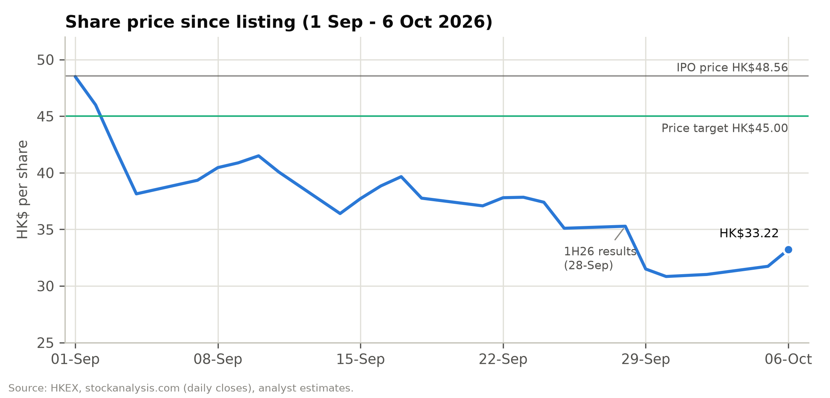
  Stock data
  Rating | BUY
  12-month price target | HK$45.00
  Price (6-Oct-2026) | HK$33.22
  Upside to target | +35.5%
  Est. FY26E dividend yield | 3.1%
  IPO price (1-Sep-2026) | HK$48.56
  Range since listing | HK$29.90-48.56
  Market cap (diluted) | US$18.8bn
  Pro forma cash & inv. | US$13.9bn
  Enterprise value | US$4.9bn
  Ticker / exchange | 0625.HK / HKEX

- Excluding its cash, the world's largest online fashion business is valued at US$4.9bn. At HK$33.22 SHEIN's fully diluted market value is US$18.8bn. The company holds US$13.9bn of pro forma unrestricted cash and investments, after the US$2.2bn Conversion Adjustment and US$0.6bn of preferred distributions paid at listing. The implied enterprise value of US$4.9bn is 0.12x LTM sales, 3.1x LTM EBITDA and 3.5x our FY2027E adjusted EBIT, for a business with US$41.8bn of 2025 revenue, 1.08bn orders and 291m active customers that ranks as the world's third-largest apparel and footwear company. After we deduct a US$1.5bn operating-cash buffer and a US$1.0bn regulatory reserve, net cash is still HK$20.1 per share, 61% of the share price.
- We expect 1H26 to be the low point for margins. 1H26 operating income fell 52.9% to US$493m (2.4% margin) after the Iran conflict drove up oil prices and freight and pushed fulfilment to 50.4% of 2Q26 revenue. SHEIN absorbed these costs instead of raising prices. Management says adjusted net margin would have been "broadly similar to a year ago" without the freight spike, and it is "cautiously optimistic" on 2H26. We forecast 2H26E adjusted net income of US$651m, against US$499m in 1H26. We expect the EBIT margin to rebuild to 3.0% in FY2027E and 4.6% by FY2031E, only slightly above the 4.3% SHEIN earned in FY2023.
- The US shows how SHEIN recovers after losing a duty exemption. The end of the de minimis and €150 exemptions raises landed costs on the direct-from-China model. Europe (35% of FY25 revenue) is going through this now: 2Q26 European revenue fell 13.9% ahead of the 1-Jul-2026 duty. In the US the decline narrowed from 14.3% in 1Q26 to 6.0% in 2Q26 as SHEIN passed on most of the duty and moved to formal customs entry. Meanwhile the rest of the world grew 21.6% in 2Q26, orders grew 7.6% and active customers rose 14.6% to 291m. We model Europe at –15% in 2H26E and –4% in FY2027E before it recovers, the US at +2% in FY2027E, and group revenue growth of 6.1% a year over FY2026-31E.
- BUY, with a HK$45.00 price target (+35%). The target blends DCF (HK$54.09; WACC 11.2%, g 2.5%) and 14x FY2027E adjusted EPS of HK$2.56 (HK$35.82), on 4,445.9m diluted shares including the 27.1m awards granted on 1 October. The policy of paying out at least 50% of net profit implies a first dividend of about HK$1.01 per share (3.1% yield) with the FY2026 results. Our scenarios put the downside well below the upside: HK$29.5 in the bear case (–11%), HK$45.0 in the base case and HK$61.0 in the bull case (+84%). The main near-term risks are the lock-up expiry for pre-IPO investors around 1-Mar-2027 (about 34% of shares), the outcomes of the EU Digital Services Act and FTC investigations, and the end of the US-China tariff truce on 10-Nov-2026.
Figure 2: Key financials and valuation
US$m / FY Dec | FY24A | FY25A | FY26E | FY27E | FY28E
Net revenues (US$m) | 38,748 | 41,847 | 41,883 | 43,890 | 46,960
YoY growth | 20.7% | 8.0% | 0.1% | 4.8% | 7.0%
Gross margin | 60.6% | 67.9% | 70.3% | 70.7% | 70.9%
Adj. EBITDA (US$m) | 1,361 | 2,190 | 1,589 | 1,892 | 2,378
Adj. EBIT (US$m) | 1,037 | 1,792 | 1,125 | 1,405 | 1,857
Adj. EBIT margin | 2.7% | 4.3% | 2.7% | 3.2% | 4.0%
Adj. net income (US$m) | 1,119 | 1,816 | 1,150 | 1,457 | 1,812
Adj. diluted EPS (HK$) | 1.97 | 3.20 | 2.03 | 2.56 | 3.17
DPS declared (HK$) | – | – | 1.01 | 1.28 | 1.58
P/E (x) | 16.8x | 10.4x | 16.4x | 13.0x | 10.5x
EV/Sales (x) | 0.13x | 0.12x | 0.12x | 0.11x | 0.10x
EV/adj. EBIT (x) | 4.8x | 2.8x | 4.4x | 3.5x | 2.7x
FCF yield | 8.0% | 15.4% | 5.6% | 8.3% | 10.7%
Dividend yield | 0.0% | 0.0% | 3.1% | 3.9% | 4.8%
Note: Priced at HK$33.22 (6-Oct-2026 close). EV = diluted market cap less US$13.9bn pro forma cash & investments. Adjusted = company non-IFRS definition (ex SBC, FV of preferred shares, associates).
Source: Company filings, analyst estimates.
Contents
Investment thesis 3
Pillar 1: Cash covers three-fifths to three-quarters of the market value 3
Pillar 2: LATR gives SHEIN a cost and inventory advantage that is hard to copy 3
Pillar 3: The revenue slowdown comes mostly from mix and trade policy 4
Pillar 4: Margins can recover to their FY2023-25 levels 4
Pillar 5: The dividend policy and founder lock-ups support the shares 5
Risks 5
Catalysts and what would change our view 7
Company 101 8
Company overview 8
Company history 9
Management team and governance 10
Products and services 13
Customers and go-to-market 15
Industry overview 16
Competition 17
Market opportunity 19
Financial analysis 21
Revenue growth and its drivers 21
Gross margin and contribution margin 23
Fulfilment 23
Marketing 24
Technology and G&A 24
Operating profit 25
Preferred shares, interest income and tax 26
Cash flow and working capital 27
Balance sheet after the listing 28
Projections and estimates 28
Revenue by region 28
Business model and operating KPIs 29
Costs and margins 31
Below-the-line and per-share estimates 32
Our estimates against guidance and the share price 32
Scenario analysis 33
Scenario definitions 33
Scenario outputs 33
Valuation 36
Discounted cash flow 36
Comparable companies 39
Precedent transactions 41
Valuation football field 42
Sanity checks 42
Rating definitions 42
Appendix A: Financial statements 43
Appendix B: Glossary 47
Appendix C: Sources 47
Important disclosures 48

Investment thesis
SHEIN listed on the Hong Kong Stock Exchange on 1 September 2026 at HK$48.56, about a quarter of the US$100bn private valuation it reached in 2022. The shares closed at a record low of HK$30.84 on 30 September and at HK$33.22 on 6 October, 31.6% below the offer price. We think the fall has gone well beyond what the fundamentals justify, for the five reasons below.

Pillar 1: Cash covers three-fifths to three-quarters of the market value
SHEIN reported US$15.25bn of cash resources at 30 June 2026: cash, restricted cash and short-term time deposits with highly rated international banks, mostly in US dollars. From that we deduct the US$2.2bn cash paid to Series Pre-D, D and D+ preferred holders under the Conversion Adjustment, the final US$357m instalment of the 8% p.a. distribution, the 12% p.a. distribution of about US$230m and the restricted cash, and we add HK$13.2bn (US$1.68bn) of IPO net proceeds. That leaves pro forma unrestricted cash of US$13.5bn, plus US$0.4bn of associates and fair-value investments. SHEIN has no bank borrowings or debt securities; its only debt-like obligation is US$1.1bn of warehouse and office lease liabilities.
Against a fully diluted market cap of US$18.8bn, pro forma cash and investments equal 74% of the share price (HK$24.5 per share). Our valuation deducts a US$1.5bn minimum operating-cash buffer and a US$1.0bn reserve for regulatory penalties, and net cash is still HK$20.1 per share, 61% of the current price.
Some investors argue the cash is "not really excess", because SHEIN runs on negative working capital: customers prepay, suppliers are paid in about 34 days, and inventory turns in about 36 days. The float is part of the operations; operating net working capital was –US$5.0bn at 30 June 2026 and –US$4.0bn at the end of 2025. It would only have to be paid back if the business shrank materially, and a growing online retailer keeps it permanently. Our DCF already includes the usual second-half unwind of about US$0.9bn, and treating the whole year-end float as debt would still leave about HK$16 per share of net cash.
The market is therefore valuing the operating business at about US$4.9bn, against our FY2027E adjusted EBIT of US$1.4bn. That is 3.5x EV/adjusted EBIT, where the peer median is 24.1x trailing EV/EBIT.
Figure 3: Pro forma cash bridge at listing vs market capitalisation (US$bn)
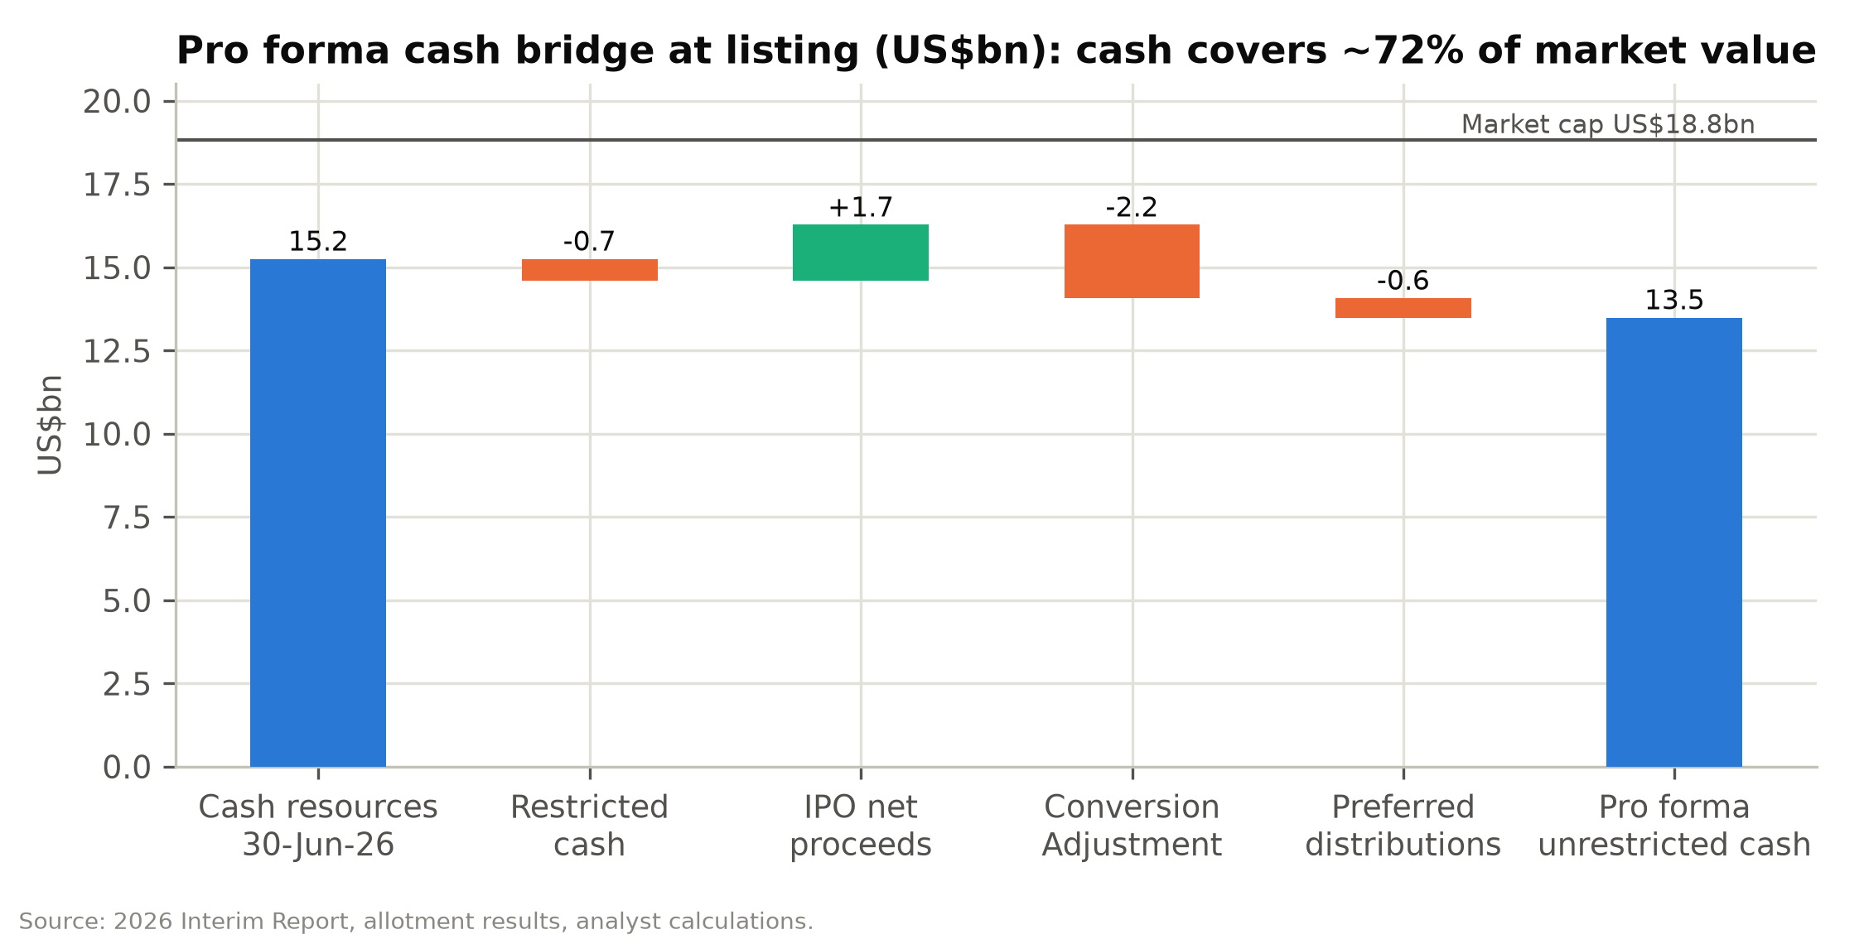

Pillar 2: LATR gives SHEIN a cost and inventory advantage that is hard to copy
SHEIN's Large-scale Automated Test and Reorder (LATR) model launches roughly 4,700 new apparel styles a day in first batches of 100-200 units. Styles that sell are reordered and restocked in as few as five days through more than 7,500 digitally connected contract manufacturers. Inventory turns in about 36 days, and write-downs run at only 1-2% of cost of sales, against fashion-industry inventory waste that the consultant hired for the IPO estimates can reach 30%. The result shows in contribution margin after fulfilment, which rose from 18.1% in FY2023 to 22.3% in FY2025 even as the marketplace share grew.
In FY2025 each order brought in net revenue of US$38.8. Cost of sales took US$12.5, fulfilment US$17.7, marketing US$5.7, and technology, content and G&A US$1.3, which left about US$1.58 of operating income per order.
Fulfilment is the largest cost per order. On the 1.2bn orders we forecast for FY2027E, every US$1 saved per order adds about US$1.2bn of EBIT, close to our entire FY2027E adjusted EBIT forecast of US$1.4bn. Freight rates, duty treatment and the density of local warehouses therefore matter a great deal to the equity, and we think the freight-driven margin squeeze of 2Q26 will reverse more than the market assumes.
Figure 4: FY2025 unit economics per order (US$)
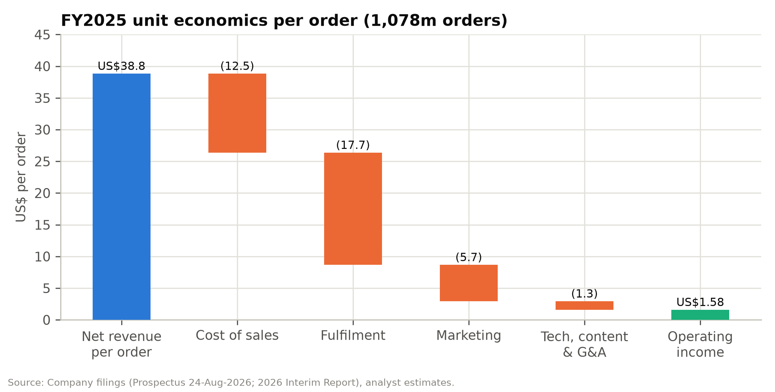

Pillar 3: The revenue slowdown comes mostly from mix and trade policy
Reported net revenue growth slowed from 41.1% in FY2023 to 8.0% in FY2025 and 1.0% in 1H26. Customers and orders kept growing: active customers rose from 254m to 291m over the twelve months to June 2026 (+14.6%), and orders rose 6.4% in 1H26 and 7.6% in 2Q26.
Revenue per order has been diluted by mix. The marketplace, where SHEIN books only its commission and fulfilment fees as revenue, rose to 13.4% of 1H26 revenue from 10.8% in 1H25. The fastest-growing region, the rest of the world (+16.0% in 1H26, led by Latin America), also has smaller baskets. As a result gross sales are growing faster than reported revenue. At an assumed 25% blended take rate, first-party revenue plus marketplace GMV grows about 4.9% in FY2026E, against 0.1% for reported revenue.
The two real weak spots are regional and caused by policy. US revenue fell 9.9% in 1H26 after the de minimis exemption ended in May 2025. European revenue fell 13.9% in 2Q26 after SHEIN raised prices and cut advertising ahead of the EU's €3-per-item duty on low-value parcels from 1-Jul-2026. The US example is useful: after a sharp first drop, the decline narrowed to 6.0% in 2Q26 as consumers adjusted. We expect Europe to follow a similar path over 2H26-1H27, helped by local inventory in 18 European warehouses (1.0m m²).

Pillar 4: Margins can recover to their FY2023-25 levels
Our base case takes the EBIT margin from 2.5% in FY2026E to 3.0% in FY2027E, 3.7% in FY2028E and 4.6% by FY2031E; the adjusted EBIT margin goes from 2.7% to 4.9% over the same period. SHEIN earned 4.3% in FY2023, 4.1% in FY2025 and 5.2% in 1H25.
Four things support the recovery. First, freight should normalise: 2Q26 fulfilment was 50.4% of revenue against 43.1% a year earlier, management attributes most of the gap to oil and freight, and SHEIN has long-term air-freight capacity agreements. Second, the chairman's top priority is to add higher-priced brands, which raises revenue per order while fulfilment cost per parcel stays largely fixed; the acquisitions of Everlane, MUSERA and Aloruh point that way. Third, brand enablement (SHEIN Xcelerator) earns operating margins about twice the group's, and marketplace commissions carry no cost of sales. Fourth, marketing rose from 10.7% of revenue in FY2024 to 14.8% in FY2025, and we assume it eases to 13.2% by FY2029E, still well above FY2024.
Our base case keeps fulfilment at 50.0-50.5% of revenue throughout, above the FY2025 level of 45.6%, and assumes duty costs are permanent.

Pillar 5: The dividend policy and founder lock-ups support the shares
SHEIN's board has adopted a policy of paying out at least 50% of annual net profit after significant capital expenditure. Applied to our adjusted net income, that gives a first dividend of about US$575m (HK$1.01 per share, a 3.1% yield), declared with the FY2026 results around March 2027 and rising to HK$1.28 (3.9%) for FY2027E. IFRS net income for FY2026E will include about US$5.9bn of non-cash fair-value gains on the preferred shares, so a payout based on reported earnings would be far larger; we assume the board uses adjusted earnings.
The company also has a general repurchase mandate from listing. With the shares 32% below the IPO price and cash covering most of the market value, a buyback would be an obvious step.
Governance is a real concern. The four founders control 83.3% of the votes through Class A shares, the CEO also chairs the board, and about US$3.5bn of cash went to preferred holders around the listing. Against that, the founders are locked up for 24 months, the independent directors are credible, and the dividend commitment ties the controlling shareholders' interests to minority holders' more closely than the share price suggests.
Figure 5: Valuation multiples since listing on our FY2027E estimates
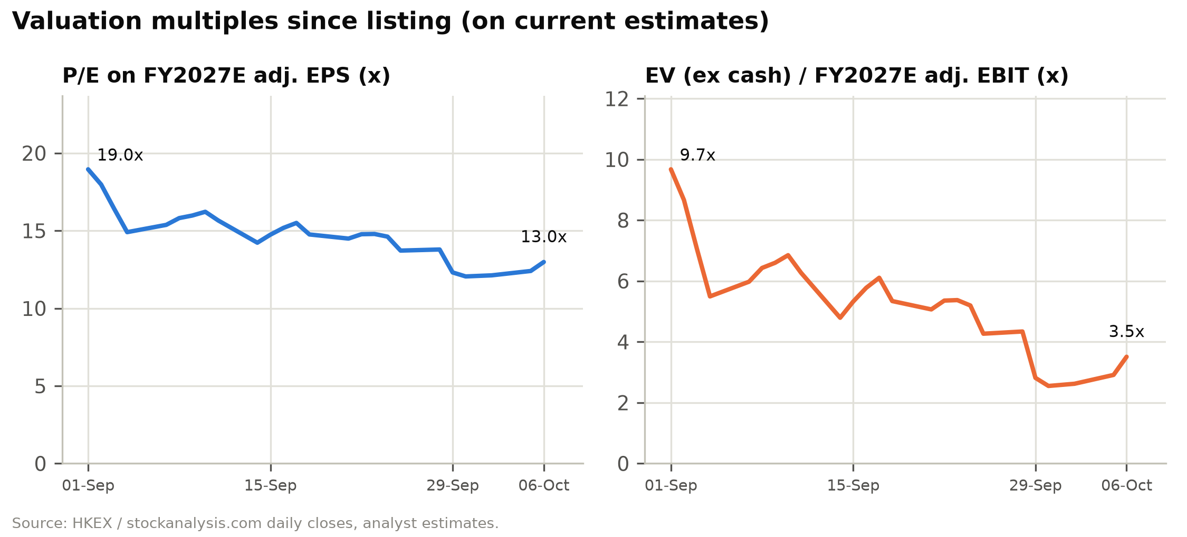

Risks
Figure 6: Risk matrix: probability and estimated share-price impact
Risk | Category | Probability | Impact on value | Mitigant / what we assume
EU duty impact worse than the US precedent | Trade policy | Medium | –15% | Bear case: Europe –10% in FY27E, –2% in FY28E
Large EU DSA or US FTC penalty | Regulatory | Medium | –10% to –20% | US$1.0bn reserve deducted in DCF; DSA cap 6% of turnover
Pre-IPO lock-up expiry (~1-Mar-2027) | Technical | High | –10% (temporary) | ~34% of shares; cost bases from US$0.01 to US$23.72
Margin fails to recover (freight, duties, competition) | Operating | Medium | –20% | Bear case 1.8% FY27E adj. EBIT margin → HK$29.5
US-China escalation (tariff truce ends 10-Nov-2026) | Geopolitical | Medium | –10% | US 22% of FY26E revenue
Supply-chain labour or forced-labour allegations | ESG | Low-Medium | –10% | 5,150 SRS audits in 2025; >99% third-party
Capital misallocation / large M&A | Governance | Low | –10% | Dividend policy; INED oversight
Competitive escalation (Temu, TikTok Shop, Amazon Haul) | Competition | Medium | –10% | Marketing held at 13.2-13.8% of revenue
Interest-rate cuts reduce interest income | Financial | Medium | –3% | Yield falls from 4.1% (FY26E) to 3.3% in our model
Upside: buyback / special dividend | Capital return | Low-Medium | +10% | Not in estimates
Upside: faster freight normalisation | Operating | Medium | +10-15% | 1pp of fulfilment ratio ≈ US$0.44bn EBIT

Company-specific risks
1. Trade-policy and duty risk (High). More than 90% of 2025 revenue shipped from Chinese warehouses. The US ended de minimis in 2025, and tariff rates on China-origin goods are now 10-87.5%, up from 0-62.5%. The EU abolished its €150 exemption from July 2026 and will add a handling fee. SHEIN warns that EU trends could be "in line with or exceed" the US experience, where revenue fell 9.9% in 1H26. Duties are booked in fulfilment expenses. Further escalation, such as the China-US tariff truce expiring on 10 November 2026, would hit margins directly.
2. Regulatory and legal risk (High). Open matters include an EU Digital Services Act formal investigation (opened February 2026; DSA fines can reach 6% of global turnover); an FTC investigation of US operations that could lead to a "significant" settlement; a €150m CNIL fine under appeal; €22.5m of DGCCRF fines (June 2026) that SHEIN is contesting; an Irish DPC inquiry into EU-to-China data transfers (April 2026); and litigation with Temu in the US and UK. Provisions were about US$80m at March 2026, plus the CNIL provision. We deduct a US$1.0bn contingency reserve in our valuation.
3. Margin-recovery risk (High). Operating margin fell to 2.4% in 1H26 (2.1% in 2Q26) from 5.2% in 1H25 as fulfilment costs rose to 50.4% of revenue. Our base case has margins recovering to about 3.0% in 2027 and about 4.6% by 2031. If SHEIN cannot pass on duties, or freight stays high, or local inventory costs more than expected, margins could stay near 2%.
4. Labour, supply-chain and ESG risk (Medium-High). SHEIN relies on thousands of small suppliers and their subcontractors, and audits cannot catch every violation. Allegations of labour abuse, forced labour in upstream cotton or chemical-safety failures could lead to import restrictions (for example under US forced-labour law), consumer boycotts or exclusion from institutional ESG portfolios.
5. Brand, IP and product-safety risk (Medium). SHEIN regularly faces IP-infringement claims and product-safety findings, particularly on the marketplace; French authorities pursued SHEIN in 2025 over inappropriate marketplace products. Bad publicity can erode customer trust.
6. Governance and capital-allocation risk (Medium). The WVR structure gives the founders 83% of the votes, the CEO also chairs the Board, and the pre-IPO arrangements paid about US$3.5bn of cash to preferred holders. Minority shareholders have little recourse if cash goes into low-return acquisitions (SPARC lost money; Everlane is small).

Industry and market risks
7. Competition (High). Temu, AliExpress, TikTok Shop and Amazon Haul compete for the same value customer. Heavy subsidies by better-funded platforms could force SHEIN to spend more on marketing, which was already 14.8% of revenue in 2025.
8. Fashion and consumer-demand risk (Medium). SHEIN's customers are young and price-sensitive, so a consumer slowdown or inflation shock in its main markets would hit order volumes. Management expects the "challenging global consumer environment" to persist in the near term.
9. Channel and platform-dependence risk (Medium). Customer acquisition depends on Google, Meta, TikTok and the app stores. Changes in algorithms, privacy rules (such as cookie-consent enforcement) or ad pricing could raise acquisition costs.

Financial risks
10. Freight, oil and currency risk (Medium). The Iran conflict raised oil prices and freight costs in 1H26 and disrupted demand in the Middle East, cutting 2026 revenue growth by a low single-digit number of percentage points. SHEIN does not hedge currency exposure; exchange losses were US$151m in 1H26.
11. Share-overhang and liquidity risk (High, near term). The IPO float was only 6.6% of shares, and much of it went to existing holders; stabilisation bought back another 15% of the offer. The six-month lock-up for pre-IPO investors (about 34% of shares, many with very low cost bases) and cornerstones ends around 1 March 2027, and selling then could weigh on the share price.
12. Tax risk (Medium). The OECD Pillar Two minimum tax, transfer-pricing scrutiny and possible challenges to tax residency could raise the effective tax rate (core ETR of about 26% in 1H26, against about 21% in 2025).

Macroeconomic risks
13. Geopolitical risk (High). US-China tensions, sanctions or data-security actions, as other China-linked apps have faced, could restrict SHEIN's business in the US, which is still 22% of revenue.
14. Recession and interest-rate risk (Medium). A recession would cut discretionary spending. Lower interest rates would reduce interest income, which is about 27% of 2027E adjusted pre-tax profit in our model.

Catalysts and what would change our view
Figure 7: Upcoming catalysts
Timing | Catalyst | Expected direction
Oct-Nov 2026 | 11.11, Black Friday and Cyber Monday trading; web-traffic and app data | Positive if order growth holds 6-8%
10-Nov-2026 | Expiry of the US-China tariff-reduction truce | Binary; extension positive
Nov-2026 onward | EU volume data after the 1-Jul-2026 duty; local-warehouse ramp | Tests our Europe forecast
Late 2026 / 2027 | EU Digital Services Act, FTC and Irish DPC outcomes | Resolution removes overhang even if costly
~Mar-2027 | FY2026 results; first dividend declaration (we estimate HK$1.01) | Positive
~1-Mar-2027 | Six-month lock-up expiry for pre-IPO and cornerstone investors | Negative technical; creates entry point
2027 | Potential Hang Seng Composite Index / Southbound Stock Connect eligibility | Positive (broader investor base)
Any time | Share repurchase under the general mandate | Positive

We would turn more negative if European revenue was still falling at double-digit rates in 2H27, which would suggest lasting damage to volumes; if fulfilment stayed above 51% of revenue after freight normalises; if a regulatory penalty came in well above our US$1.0bn reserve; or if SHEIN spent its cash on large, low-return acquisitions. We would turn more positive on a buyback, a payout above 50%, or evidence that 2H26 adjusted margins are recovering toward 3%.

Company 101
Sources are the Global Offering prospectus of 24 August 2026 and the 2026 Interim Report of 28 September 2026. Market data are from China Insights Consultancy (CIC), the industry consultant engaged for the IPO, as reproduced in the prospectus.

Company overview
SHEIN Global Holdings Ltd ("SHEIN", "the Company") is the world's largest online fashion destination by apparel and footwear retail sales value. China Insights Consultancy ("CIC"), the industry consultant engaged for the IPO, ranks it the third-largest apparel and footwear company globally, with a 1.9% share of a US$1.74trn market in 2025. Only a US athletic-wear leader (3.0%) and a Spanish fast-fashion group (2.5%) are larger; a German athletic brand (1.7%) and a Japanese casual-wear retailer (1.3%) follow. In 2025 SHEIN generated net revenues of US$41.8bn (+8.0% YoY), operating income of US$1.71bn (4.1% margin) and IFRS net income of US$2.06bn. It served about 273 million active customers across roughly 160 markets and fulfilled 1.08 billion orders. Net revenues compounded at 14.2% a year over 2023-25 and active customers at 21.2%.
The business is a vertically integrated online fashion brand collection, led by first-party sales, with a growing marketplace attached. SHEIN designs products with 370+ in-house designers and a network of contract manufacturers and independent designers. It commissions production from more than 7,500 contract manufacturers, mostly small and medium-sized firms in the Pearl River Delta, stores the output mainly in central warehouses in mainland China, and ships it directly to consumers through its own apps and websites. It does not run physical stores at scale. Revenue is recognised on delivery, and most customers pay in advance. Combined with supplier terms of about 34 days and inventory turnover of about 36 days, prepayment gives SHEIN negative working capital (–US$5.0bn at 30 June 2026) and a large cash balance.
SHEIN calls its core operating model LATR, for Large-scale Automated Test and Reorder. New styles launch in batches of roughly 100-200 units. The Company measures customer response in real time, reorders the styles that sell (restocking in as few as five days) and drops the ones that do not. SHEIN argues that LATR solves the fashion industry's "trilemma" of assortment breadth, design-refresh speed and inventory efficiency, and the numbers support the claim. More than 2 million apparel styles were live at 31 March 2026, customers could find about 4,700 new apparel styles a day in 1Q26, inventory turnover was 36 days in 2025, and inventory write-downs have run at only about 1-2% of cost of sales.
SHEIN earns revenue in two ways. Product revenues (US$37.1bn in 2025, 88.7% of the total) come from first-party sales of company brands (SHEIN, MOTF, Glowmode, SHEGLAM, MUSERA, Aloruh and others) and partnership brands. Service revenues (US$4.7bn, 11.3%) are commissions, generally 10-20% of transaction value, and fulfilment fees charged to third-party merchants on the marketplace launched in 2022-23, plus fees from brand-enablement partners. Service revenue is recognised net, so a rising marketplace mix lowers reported revenue per order and raises fulfilment costs as a percentage of revenue. Investors need to adjust for this when reading the margins.
Revenue is spread across regions. In 2025 the United States contributed 24.1% of net revenues (US$10.1bn), Europe 35.4% (US$14.8bn) and the rest of the world 40.5% (US$16.9bn, led by Latin America and the Middle East). By category, apparel was 63.8% and other categories (footwear, accessories, beauty, home and lifestyle) 36.2%. No customer exceeds 10% of revenue, and the top five suppliers account for about 16% of purchases.
SHEIN has been headquartered in Singapore since late 2021, is incorporated in the Cayman Islands, and operates through subsidiaries in China, Singapore, the US, Ireland, the UK and the UAE. It employed 17,585 people at 30 June 2026, about 79% of them in mainland China. The Company listed in Hong Kong on 1 September 2026 under a weighted-voting-rights (WVR) structure. It raised HK$13.6bn gross (HK$13.2bn net) by selling 279,992,500 new Class B shares at HK$48.56, a valuation of about US$26bn, roughly a quarter of the ~US$100bn private valuation it reached in 2022. The shares hit a record closing low of HK$30.84 on 30 September and closed at HK$33.22 on 6 October, 31.6% below the offer price, for a fully diluted market capitalisation of about US$18.8bn.
Investors are debating four issues:
1. The removal of de minimis and other low-value import exemptions in the US (May and August 2025) and the EU (1 July 2026), which raises landed costs on the direct-from-China model.
2. Margin compression in 2026. Operating margin fell to 2.4% in 1H26 from 5.2% in 1H25 as freight rates spiked during the Iran conflict and the Company chose to absorb the costs.
3. Regulatory exposure in the EU and US: the EU Digital Services Act investigation, the FTC investigation, and French and Irish data and consumer proceedings.
4. Governance and capital allocation, after about US$3.5bn of cash was paid to preferred shareholders around the listing.
Against this, SHEIN has US$13.5bn of pro forma unrestricted cash (about 72% of its market value; US$13.9bn including investments), order volumes that are still growing (+6.4% in 1H26), customers up 14.6% over the last twelve months to 291m, and a dividend policy targeting at least 50% of annual net profit.
Figure 8: SHEIN at a glance: scale, reach and financial profile
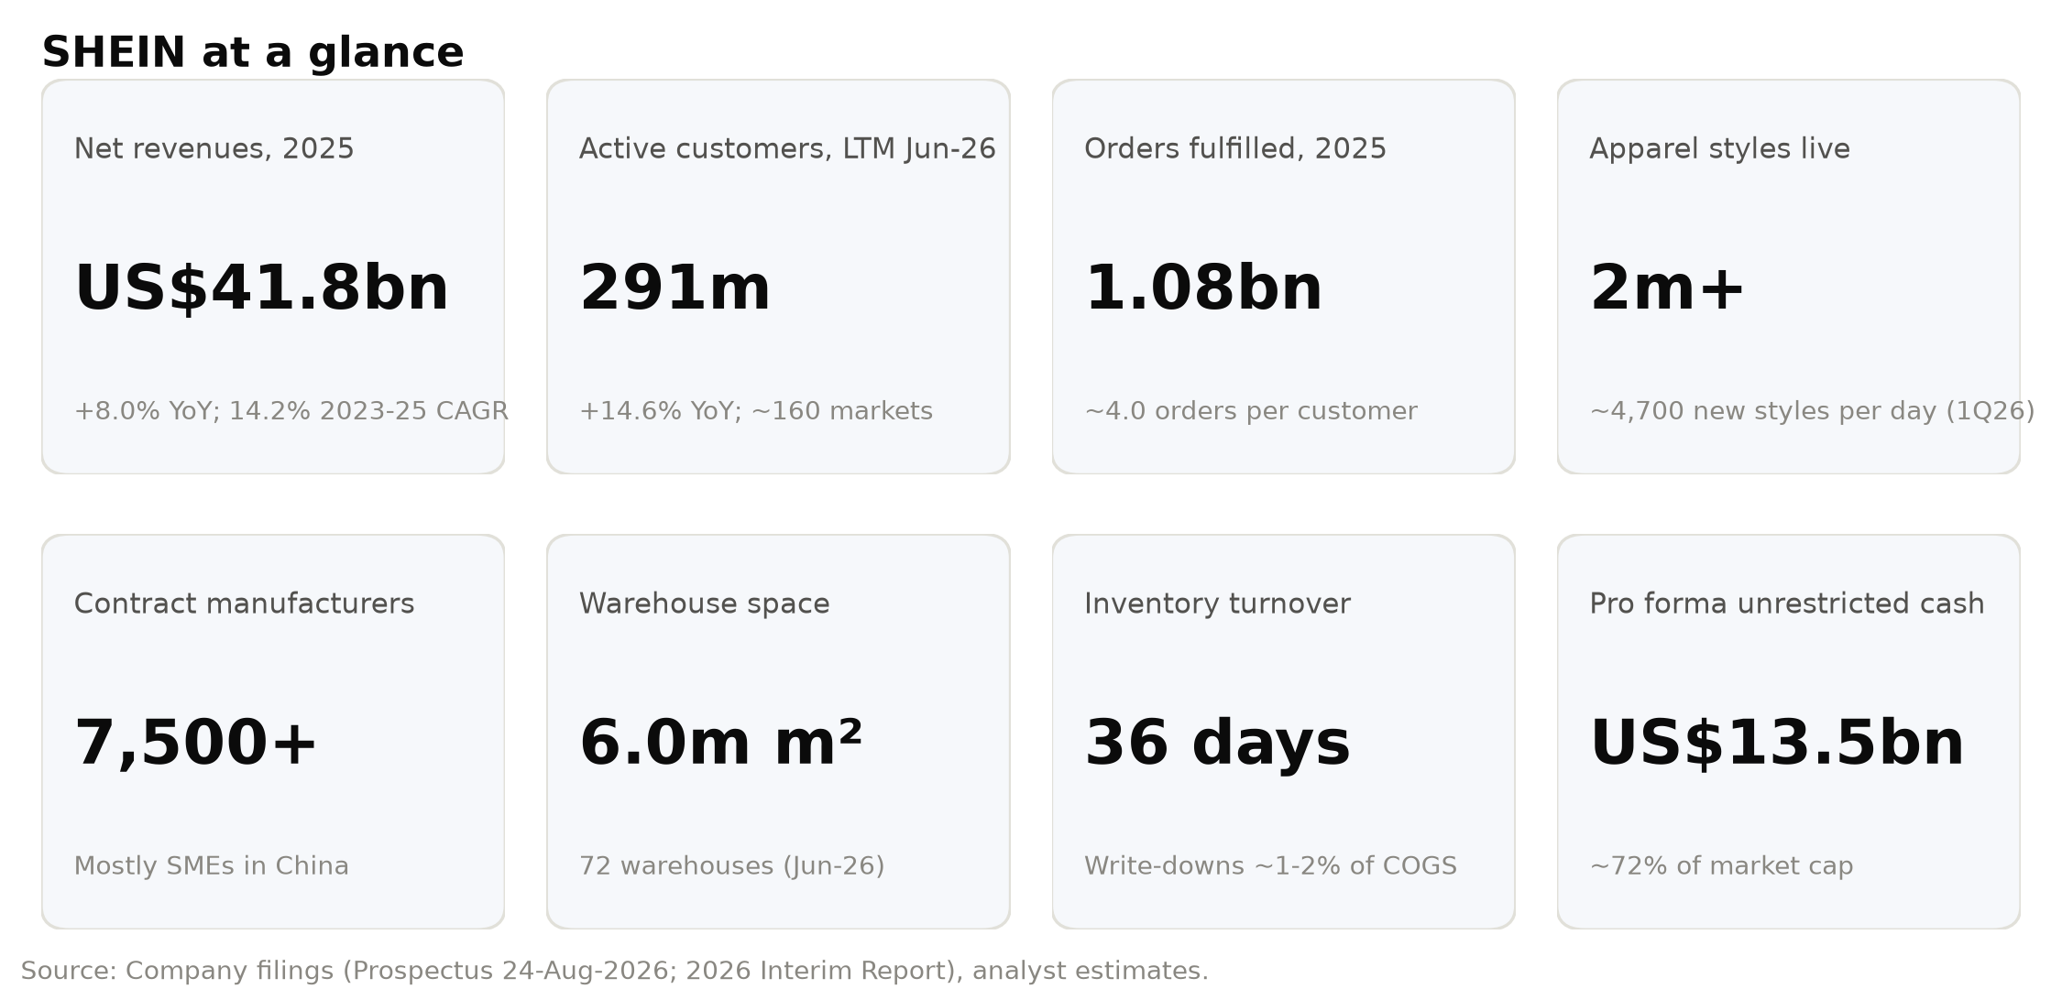

Company history
Origins (2008-2014). Press accounts trace SHEIN's roots to a cross-border e-commerce business that Xu Yangtian, a search-engine-marketing specialist, started in Nanjing in 2008 to sell apparel to overseas buyers online. The Prospectus dates the formal launch to 2012, when Mr Xu and three co-founders, Miao Miao, Gu Xiaoqing and Ren Xiaoqing, started the venture. All four had worked together at a company that provided search-engine marketing to Chinese exporters. SHEIN was therefore built by digital marketers rather than by merchants or designers, and its early edge came from performance marketing, social-media and influencer engagement, and data-driven merchandising. The SHEIN brand was introduced in 2013, and the Cayman holding company (then named Elite Depot Limited) was incorporated on 12 May 2014.
Building the machine (2014-2019). SHEIN pilot-tested LATR in 2014 and launched its mobile app in 2015. In these years it built its operations in Guangzhou, inside the dense garment-manufacturing cluster of the Pearl River Delta, and gradually digitised its suppliers by giving them free cloud-based production-management software. Funding followed the model's traction: a Series A in 2015 (US$5m at a US$53m pre-money valuation), a Series B from 2016 (RMB169m at RMB1.1bn) and a Series C in 2018-19 (US$243m at US$2.4bn). Annual active customers reached 10 million in 2018.
Hyper-growth (2020-2022). The pandemic shift to online shopping, combined with marketing built for TikTok and Instagram, made SHEIN a global brand. Active customers passed 50 million in 2020 and 100 million in 2021. That year SHEIN launched the SHEIN X designer-incubation programme and moved its headquarters to Singapore. A Series C+ in March 2020 valued the Company at US$5bn, and a Series D in 2022 raised US$1.8bn at a US$98.2bn pre-money valuation (US$23.72 per share, split-adjusted). Net revenues exceeded US$20bn in 2022. The valuation peaked that year.
Marketplace, scrutiny and re-rating (2023-2025). SHEIN formally launched its marketplace for third-party merchants in 2023 and raised US$1.7bn in a Series D+ at a US$64.0bn pre-money valuation, a 35% down-round. It also took a roughly one-third stake in SPARC Group, then the operator of brands including Forever 21, in exchange for Class B shares. The partnership was meant to combine SPARC's physical retail with SHEIN's on-demand supply chain; the investment has since produced cumulative associate losses. Temu's push into Western markets in 2023 led to litigation in both directions: Temu's US antitrust complaint and SHEIN's UK copyright claims. Revenue grew 41.1% in 2023 and 20.7% in 2024, and active customers passed 200 million in 2024. A planned New York listing stalled amid US political scrutiny, a London attempt also stalled, and the Company eventually filed in Hong Kong. Growth slowed to 8.0% in 2025 after the US removed the de minimis exemption for Chinese imports (effective 2 May 2025) and then for all countries (29 August 2025); US revenue fell 3.5%. In October 2025 SHEIN turned SHEIN X into the SHEIN Xcelerator Programme, a brand-enablement platform. Regulatory costs rose, with a €40m DGCCRF settlement in France (July 2025) and a €150m CNIL cookie-consent fine (September 2025, under appeal).
Road to listing (2026). In March 2026 the preferred shareholders agreed to move their redemption date from 4 March to 31 December 2026. In exchange they received about US$1.1bn of 8% p.a. distributions (paid March-September 2026), a 12% p.a. coupon from 5 March to listing (about US$230m) and a "Conversion Adjustment" for Series Pre-D, D and D+ holders, similar to a full ratchet. The adjustment was settled at listing with US$2.2bn of cash plus 19.6 million additional shares. The EU approved the end of the €150 customs-duty exemption in February 2026, effective 1 July 2026, with a flat €3 duty per item category. In the second quarter SHEIN acquired Everlane, a US premium basics brand, for US$78m (mostly repayment of Everlane debt). The Hong Kong IPO priced in late August 2026 at HK$48.56, near the mid-point of the HK$47.60-49.50 range. The retail tranche was 5.63x covered and the international book 2.59x. Seven cornerstone investors took 22.1% of the offer; most were existing shareholders (Boyu, Tiger Global, General Atlantic, a Tencent affiliate, Greenwoods), joined by Taikang Life and UBS AM Singapore. The shares opened flat and fell as low as HK$43.72 on the first day, then slid through September. The stabilising manager bought back the full 15% over-allocation at HK$35.90-48.56, and the over-allotment option lapsed on 26 September. On 28 September SHEIN reported its first interim results (1H26 revenue +1.0%, operating income –52.9%). The stock fell 10.7% the next day and closed at a record low of HK$30.84 on 30 September. It recovered to HK$33.22 by 6 October.
Figure 9: Milestones, 2012-2026
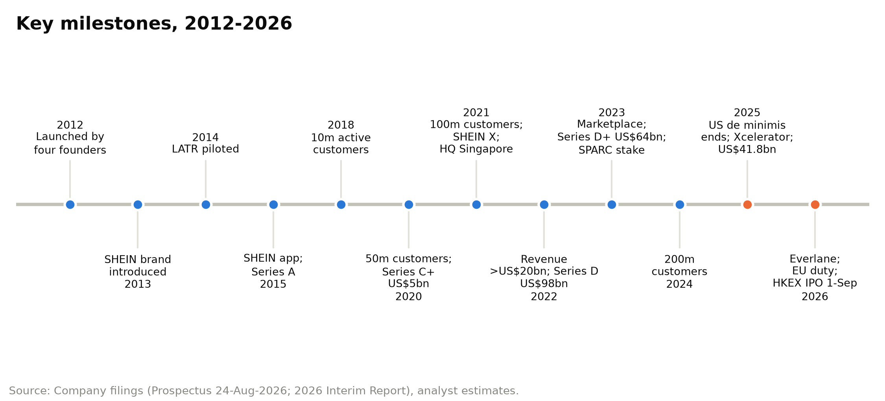

Management team and governance
SHEIN is still run and controlled by its founders. All four co-founders sit on the seven-member Board as executive directors, and their Class A shares, which carry ten votes each, give them 83.3% of the votes on ordinary resolutions. The CFO and CTO are the two professional executives named in the Prospectus as senior management.
Figure 10: Board, weighted-voting-rights control and senior management
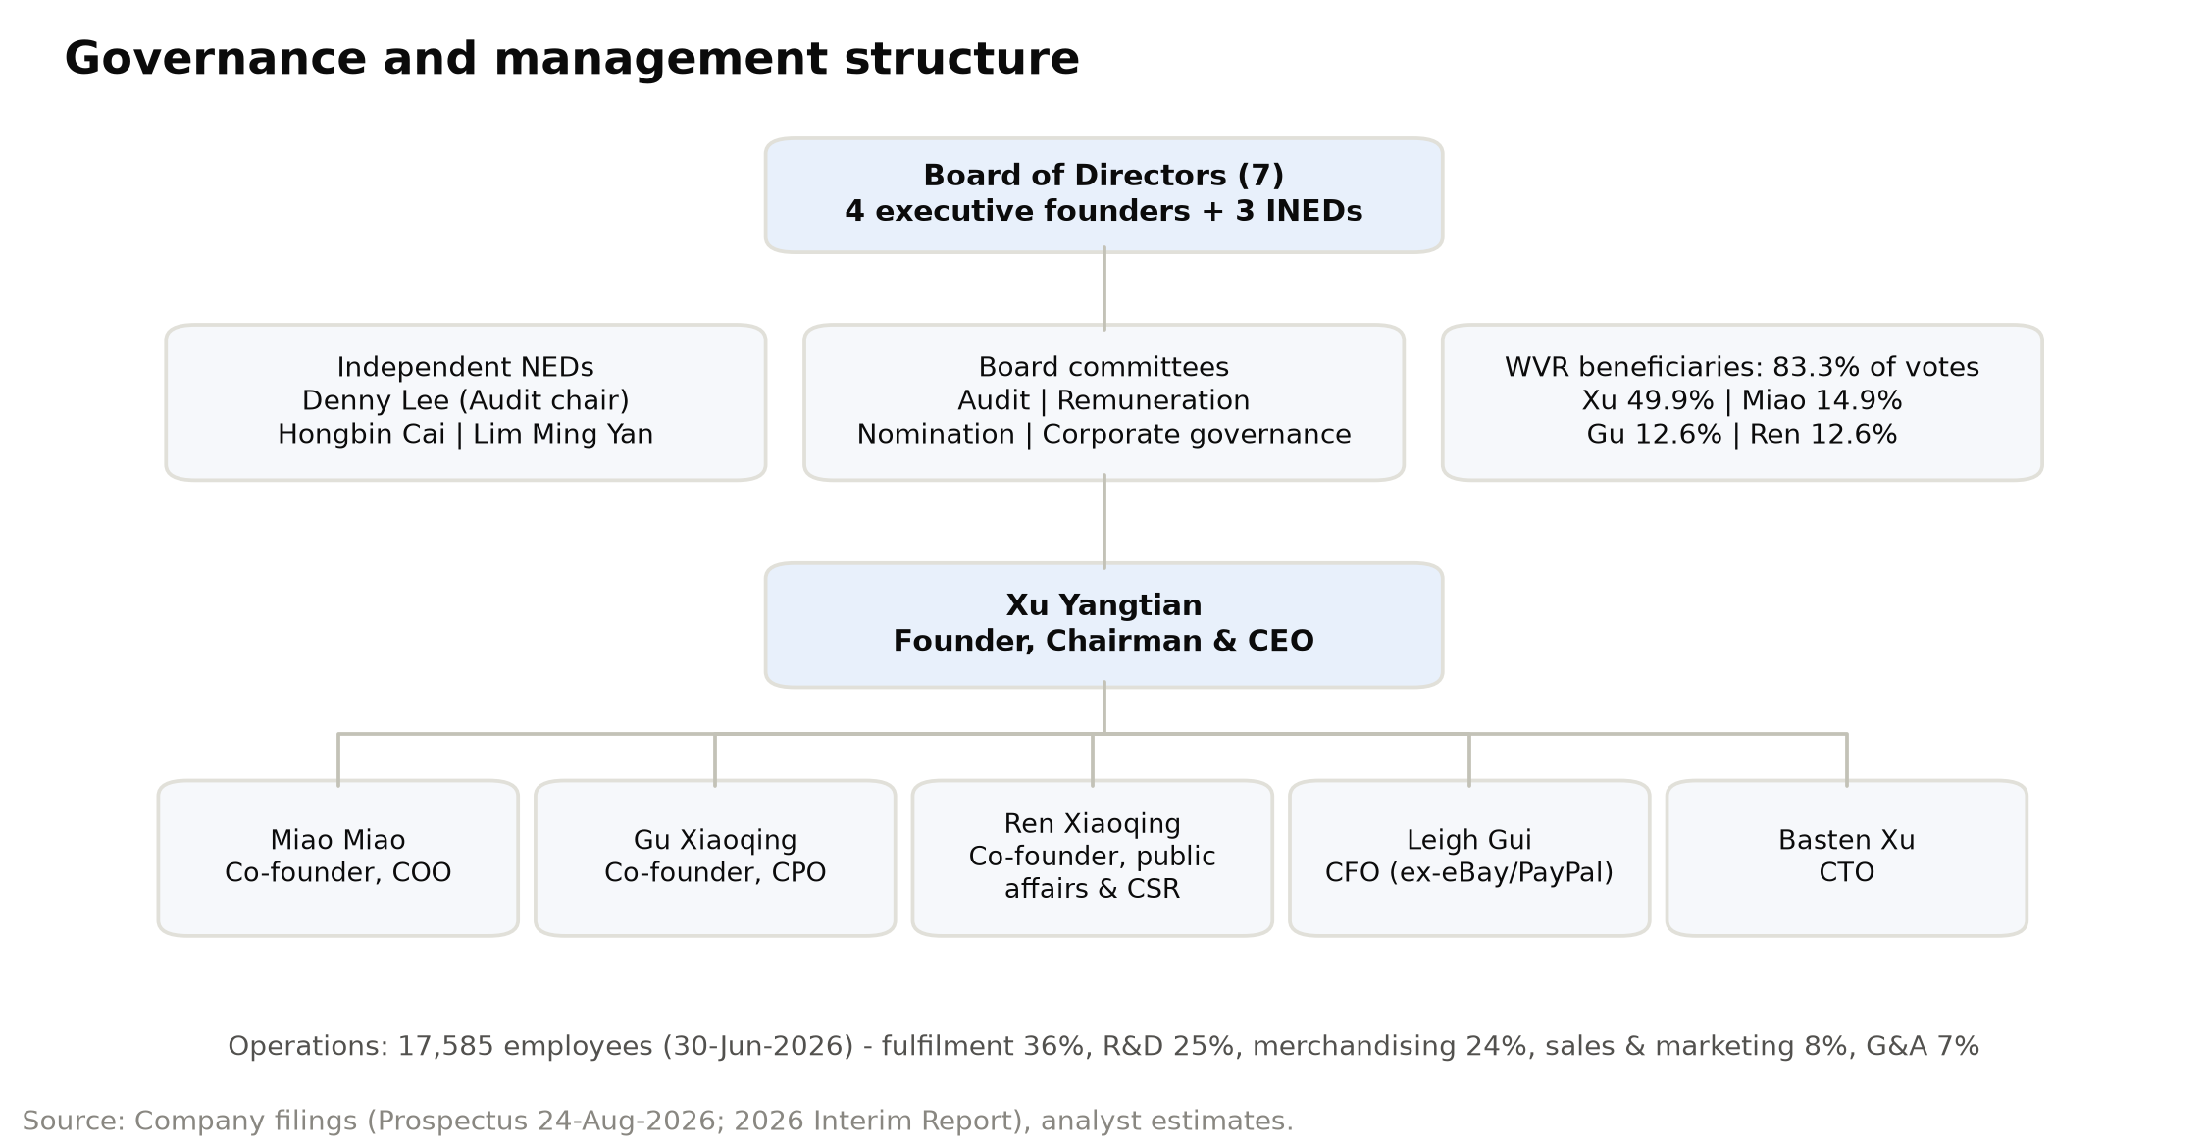

Xu Yangtian, Founder, Chairman and Chief Executive Officer (age 43)
Mr Xu founded SHEIN and has been chairman, executive director and CEO since the start, responsible for group strategy and business management. Before SHEIN he worked with his co-founders at a company that provided search-engine marketing to Chinese exporters. He holds a bachelor's degree in international trade from Qingdao University of Technology (2007). That background explains much of how SHEIN works: close attention to customer-acquisition cost, rapid A/B testing and data-driven decisions, later applied to merchandising through LATR. Mr Xu has given almost no interviews, and the Chairman's Statement in the Interim Report is one of his few public written statements. In it he describes SHEIN as a "richly diversified brand collection" built on a "vertically integrated, first-party-led" model and commits that the first-party business "will always remain at the core". He sets three priorities for the next one to two years: broadening the price range toward higher-priced brands, investing more in quality and compliance, and communicating more actively with consumers through brand marketing. He also defends the decision to absorb higher freight costs in 2Q26 instead of raising prices, calling the costs transitory. After the IPO Mr Xu beneficially owns 798,973,148 Class A and 487,090,102 Class B shares, 30.3% of the share capital and 49.9% of the votes, through Apex Sight Holdings, which he controls through a family trust. As the largest WVR beneficiary and the controlling shareholder, he effectively decides board composition and strategy. His holdings are locked up for 24 months. He has built a business with more than US$40bn of net revenues within about 13 years of the 2012 launch, and his style is private and controlling. Combining the CEO and chairman roles is a disclosed deviation from Hong Kong's Corporate Governance Code.

Miao Miao, Co-Founder, Executive Director and Chief Operating Officer (age 41)
Ms Miao is a co-founder, has been an executive director since the start and has been chief operating officer since 2017, overseeing day-to-day operations. She is also a director or senior manager of several subsidiaries. Like Mr Xu she previously worked at the search-engine-marketing firm where the founders met, and she holds a bachelor's degree in management from Nanjing University of Posts and Telecommunications (2007). As COO she runs the operations investors are paying for: the fulfilment network (6.0m m² of leased warehouse space across 72 warehouses), 25 customer-service centres, and the operating cadence that took orders from 715m in 2023 to 1.08bn in 2025 while fulfilment cost per order fell from US$18.9 to US$17.7. Her remit also covers the tariff response: the shift to formal customs entry in the US, local inventory in Europe and the trade-compliance function. This is the most important execution task over the next year. Ms Miao beneficially owns 205,579,906 Class A and 471,329,694 Class B shares. The Class B figure includes 393,169,450 shares held by Trendy Group Holdings, a trust whose beneficiaries are the four founders' holding vehicles and whose votes she controls. In total she has about 14.9% of the votes. She sits on the Board's remuneration and nomination committees. Running operations and controlling the founders' shared trust makes her the second most influential person in the Company. Her holdings are also locked up for 24 months.

Leigh Lei Gui, Chief Financial Officer (age 56)
Mr Gui joined SHEIN as CFO in March 2021 and oversees finance. He handles most of the Company's contact with public-market investors and has more public-company experience than anyone else on the team. Before SHEIN he was CFO of VIPKid (May 2020 to February 2021). From 2005 to 2020 he held finance roles at eBay and PayPal, including CFO of Greater China for eBay and PayPal, CFO of Asia-Pacific cross-border trade at eBay and CFO of international cross-border trade at eBay. That experience is directly relevant, since he has run finance for businesses exposed to customs regimes, currencies, payment platforms and tax in many jurisdictions. He holds a bachelor's degree in genetics from Wuhan University (1990), a master's in molecular biology from Rice University (1995) and an MBA from the University of Toronto (1999). SHEIN's treasury policy under him has been conservative: deposits and certificates of deposit with highly rated banks, no leverage, no speculative trading and no currency hedging. He also built the Hong Kong reporting and non-IFRS framework (adjusted EBIT, adjusted net income) introduced with the Interim Report. Investors will watch his influence on capital allocation most closely. That covers the dividend policy (at least 50% of net profit after significant capex) and the use of US$1.7bn of IPO proceeds: 40% for technology, 40% for brand and global presence, 10% for corporate responsibility and 10% for general purposes. Mr Gui is neither a director nor a WVR beneficiary.

Gu Xiaoqing, Co-Founder, Executive Director and Chief Product Officer (age 44)
Ms Gu is a co-founder, has been an executive director since the start and has been chief product officer since 2017. She oversees product management: the merchandising, design and category decisions at the centre of LATR. She previously worked with the other founders at the search-engine-marketing firm and holds a bachelor of arts from Nanjing Tech University (2005). Product is where SHEIN's strategy is changing most. The chairman's priority of moving up the price range is mainly a product-portfolio decision, and the Interim Report points to product results: MUSERA's expansion into sportswear; Aloruh's move into swimwear, sleepwear, sportswear and formal dresses; strong growth in childrenswear and sportswear; and the link between the LATR supply chain and the "Design X" AI creative system for partner brands. The Everlane acquisition and the Xcelerator partners (AiiRZ, KIZN, Baby Phat, Fashion SZN) also sit in her product and brand remit. She is also accountable for much of product compliance, which has repeatedly drawn regulatory action in France and the EU: chemical-safety testing (800,000+ apparel inspections in 2025), IP screening (multi-layer image-recognition review) and marketplace listing controls. She beneficially owns 205,579,906 Class A and 78,160,244 Class B shares (about 12.6% of votes), locked up for 24 months.

Other executives
Ren Xiaoqing (age 40), co-founder and executive director, was chief supply chain officer from 2017 and now oversees public affairs and corporate responsibility. The move reflects how much SHEIN's regulatory and ESG exposure now matters. He owns 205,579,906 Class A and 78,160,244 Class B shares (about 12.6% of votes).
Basten Hao Xu (age 38) has been Chief Technology Officer since the start. He is responsible for technology development, including the 1,700+ in-house software systems that run LATR, the supplier cloud tools and warehouse management. He holds a computer-science degree from Nanjing Agricultural University (2010).

Board, governance and ownership
- Board: seven directors, the four co-founders plus three independent non-executive directors (INEDs). Denny Lee is a former NetEase CFO and has chaired audit committees at NIO, New Oriental and Jianpu. Hongbin Cai is Dean of HKU Business School and a former Dean of Peking University's Guanghua School. Lim Ming Yan is Chairman of Changi Airport Group and a former Group CEO of CapitaLand. As Hong Kong requires for WVR issuers, the audit and corporate-governance committees consist entirely of INEDs.
- Voting control: only the founders hold Class A shares (ten votes each). On reserved matters, such as changes to constitutional documents, appointment or removal of INEDs and auditors, and winding up, all shares vote one-for-one.
- Economic ownership after the IPO (4,246.2m shares): the founders hold about 2,531m shares (about 59.6%, including Trendy Group). IDG holds about 7.2%, Sequoia China/HongShan-related entities about 3.8%, Sequoia Capital about 5.3% and Greenwoods about 3.9%. The IPO created a public float of about 6.6%.
- Lock-ups: 24 months for the founders, and six months (to about 1 March 2027) for pre-IPO and cornerstone investors. Pre-IPO investors from Series A-C, holding about 34% of the shares, bought at US$0.01-1.28 per share against HK$33.22 (about US$4.23) on 6 October, so they may sell heavily when the lock-up ends.
- Share awards: on 1 October 2026 SHEIN granted 27,118,035 nil-cost share awards (about 0.64% of issued shares) under the post-IPO share scheme, mostly to employees outside senior management, including 63,602 to each INED. Employee awards vest over up to 48 months, subject to performance conditions.
- Remuneration: directors' aggregate pay was about US$3m a year in 2023-25. The five highest-paid individuals (none of them directors in 2025) received US$14m in 2025.
- Compliance adviser: Somerley Capital (permanent, as required for WVR issuers). Auditor: Deloitte Touche Tohmatsu.
Governance is the weakest part of the equity story. The founders hold near-absolute control, the CEO is also chairman, management apart from the CFO has little public-market experience, and the pre-IPO restructuring paid about US$3.5bn of cash (the US$2.2bn Conversion Adjustment plus about US$1.3bn of distributions) to preferred holders. That cash would otherwise have belonged to all shareholders. On the other side are an experienced INED slate, a stated payout policy of at least 50%, and the founders' 24-month lock-up, which ties their horizon to that of minority holders.
Figure 11: Ownership structure after the IPO (% of share capital and % of votes)
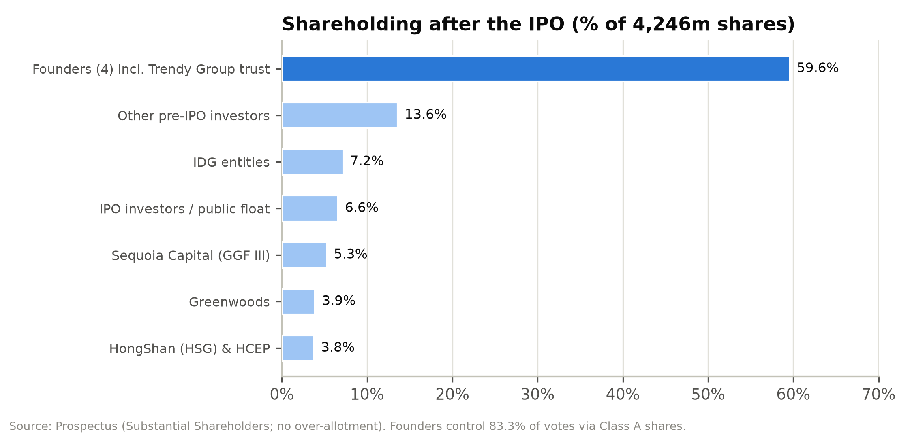

Products and services

First-party brand portfolio (88.7% of 2025 net revenues)
SHEIN's first-party business sells company brands and partnership brands made by contract manufacturers. The flagship SHEIN brand sells value women's fashion. Sub-brands extend the range: MOTF (premium), Glowmode (activewear), SHEGLAM (cosmetics), MUSERA (dresses, now sportswear) and Aloruh (women's fashion, expanding into swimwear, sleepwear and formal wear). Everlane, acquired in 2Q26, adds a US premium-basics brand with a sustainability positioning and an established US customer base. Categories span apparel (63.8% of 2025 revenues), footwear, accessories, beauty, home and living, childrenswear, sportswear and lifestyle. Apparel's share has fallen from 68.8% in 2023 as SHEIN moved into categories that raise order frequency and basket size, though some of them, such as home and living, carry lower margins.
Prices are set at cost plus a margin and adjusted dynamically. Management's stated plan is to keep the value core while adding higher-priced brands. That should lift the platform's average selling price and, because fulfilment costs about US$18 per order regardless of price, improve margins.
Figure 12: Brand and business-model portfolio
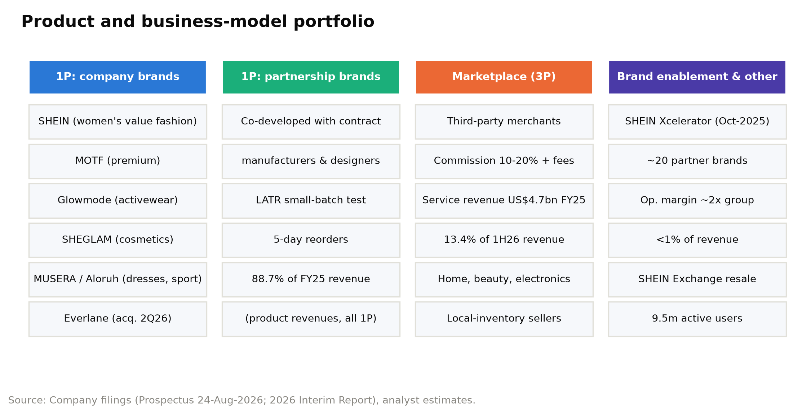

LATR: the operating system
LATR is the core of SHEIN's product offer. It has five steps:
1. Data-informed initial batches of 100-200 units per style.
2. Customer orders.
3. Real-time sales data and automated reorders, with orders allocated automatically to suppliers with spare capacity.
4. Restocking in as few as five days.
5. Traffic optimisation to put the best sellers in front of customers.
The economics are attractive: little upfront commitment per style, unsold inventory in the low single digits, and write-downs of about 1-2% of cost of sales, against industry inventory waste that CIC estimates can reach 30%. The chairman acknowledges the model's limit: it works best in categories "driven by diversity, where demand changes rapidly".

Marketplace (service revenues; 11.3% of 2025 net revenues, 13.4% in 1H26)
The marketplace, launched in 2H22 and formally in 2023, lets third-party merchants and brands sell to SHEIN's customers. SHEIN acts as agent and books service revenue: a commission of generally 10-20% of transaction value, plus fulfilment fees for warehousing and delivery. Service revenues grew from US$0.9bn in 2023 to US$4.7bn in 2025, then rose 24.9% in 1H26 (44.2% in 2Q26) as tariff changes pushed more volume through merchants with local inventory. Management calls the recent mix shift a "short-term effect" of trade-policy changes and says first-party remains the core. Because the marketplace has no cost of sales, reported gross margin rose from 60.2% (2023) to 67.9% (2025) and about 70% in 1H26. Only the take rate is booked as revenue, though, so the marketplace raises fulfilment and marketing costs as a percentage of revenue. SHEIN does not disclose GMV. At our assumed 25% blended take rate, 2025 marketplace GMV would be about US$19bn, and total gross sales (first-party revenue plus marketplace GMV) about US$56bn.
Figure 13: Net revenues by category: apparel vs. other categories (US$m)
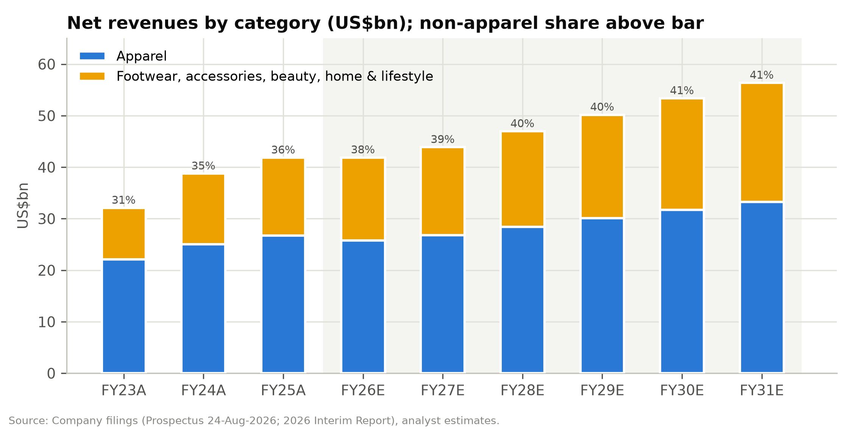

Brand enablement: SHEIN Xcelerator
The Xcelerator programme, upgraded from SHEIN X in October 2025, opens SHEIN's supply chain, design tools (including the Design X AI system), marketing and fulfilment to partner brands, from start-ups to established labels. The Prospectus cites one partner whose sales grew about 15x in its second year while its operating margin improved by 30+pp and its inventory days fell by two-thirds. It also says brand-enablement operating margin is roughly twice the group's. The business is small, no more than 1% of revenue in 2025, but it is SHEIN's clearest route to higher-margin, capital-light "infrastructure" revenue. Nearly 20 brands have joined.

Circularity and other services
SHEIN Exchange, a peer-to-peer resale platform for items bought from or through SHEIN in the US, France, the UK and Germany, had 9.5 million active users at the end of 2025. It supports SHEIN's sustainability case but is not financially material.

Supply chain and fulfilment infrastructure
- Suppliers: about 7,500 contract manufacturers in 2025 (5,800 in 2023), with no exclusivity, one-year renewable contracts and no minimum purchase commitments. Free cloud software manages orders, production, quality control and shipping. SHEIN ran 5,150 on-site social-responsibility (SRS) audits in 2025 (more than 99% by third-party auditors), covering suppliers that represent about 95% of company-brand procurement value.
- Warehouses: 6.0m m² leased at 30 June 2026, made up of 37 in China (4.1m m²), 6 in the US (0.4m m²), 18 in Europe (1.0m m²) and 11 elsewhere (0.5m m²). More than 90% of 2025 revenue shipped from central warehouses in mainland China, though local inventory is growing, especially in Europe.
- Delivery: third-party logistics; more than 90% of orders delivered within 10 business days of dispatch; long-term air-freight capacity agreements.
- Technology: 1,700+ proprietary software systems; data hosted on AWS (EU data in Spain) and Microsoft Azure (US data in the US); ISO 27001/27701 and PCI DSS certification; a cybersecurity team of about 190 people. R&D spending was US$451m in 1H26.

Customers and go-to-market
Customer base. SHEIN served about 273 million active customers in 2025 (291 million in the twelve months to June 2026), mainly young women. Order frequency has held at about four orders per customer a year (3.8 in 2023, 4.0 in 2024-25, 3.9 for the twelve months to March 2026), so growth has come from new customers, with spending per customer roughly flat. Net revenue per active customer fell from about US$173 in 2023 to about US$153 in 2025 because of marketplace mix, faster growth in markets with smaller baskets, and category mix.
Geographic mix. Growth has moved sharply away from the US. US revenue fell 3.5% in 2025 and 9.9% in 1H26. Europe grew 8.8% in 2025, then fell 13.9% in 2Q26 ahead of the EU duty change. The rest of the world grew 15.4% in 2025 and 21.6% in 2Q26, led by Latin America, and made up 44% of revenue in 1H26 against 39% in 2023.
Channels and marketing. SHEIN sells almost entirely through its own apps and websites, which have local-language versions, personalised recommendations and region-specific layouts, plus pop-ups, showrooms and events. Marketing is mostly digital: influencer partnerships (a practice SHEIN pioneered at scale), paid search, product-listing ads, paid social and SEO. Marketing spend rose from 10.7% of revenue in 2024 to 14.8% in 2025 (advertising rose from US$4.0bn to US$5.0bn) as SHEIN competed with Temu for customers' attention while raising prices to cover tariffs. It fell to 13.6% in 2Q26 when SHEIN cut European advertising ahead of the duty change. SHEIN plans to spend 40% of the IPO proceeds (about HK$5.3bn) on brand-building and performance marketing over 48 months.
Customer terms. Customers pay when they order. Shipping is free above set thresholds, returns are generous (free return shipping in selected regions), and refunds may be issued without a return. Prepayment drives the negative working-capital cycle, with turnover days for net revenues of –12 to –13.
Seasonality. The fourth quarter, with 11.11, Black Friday, Cyber Monday and Christmas, is the largest promotional window. Working capital builds in the first half and unwinds in the second: operating cash flow was US$2.9bn in 1H25 and –US$39m in 2H25.
Figure 14: Active customers and orders, FY2023A-FY2031E
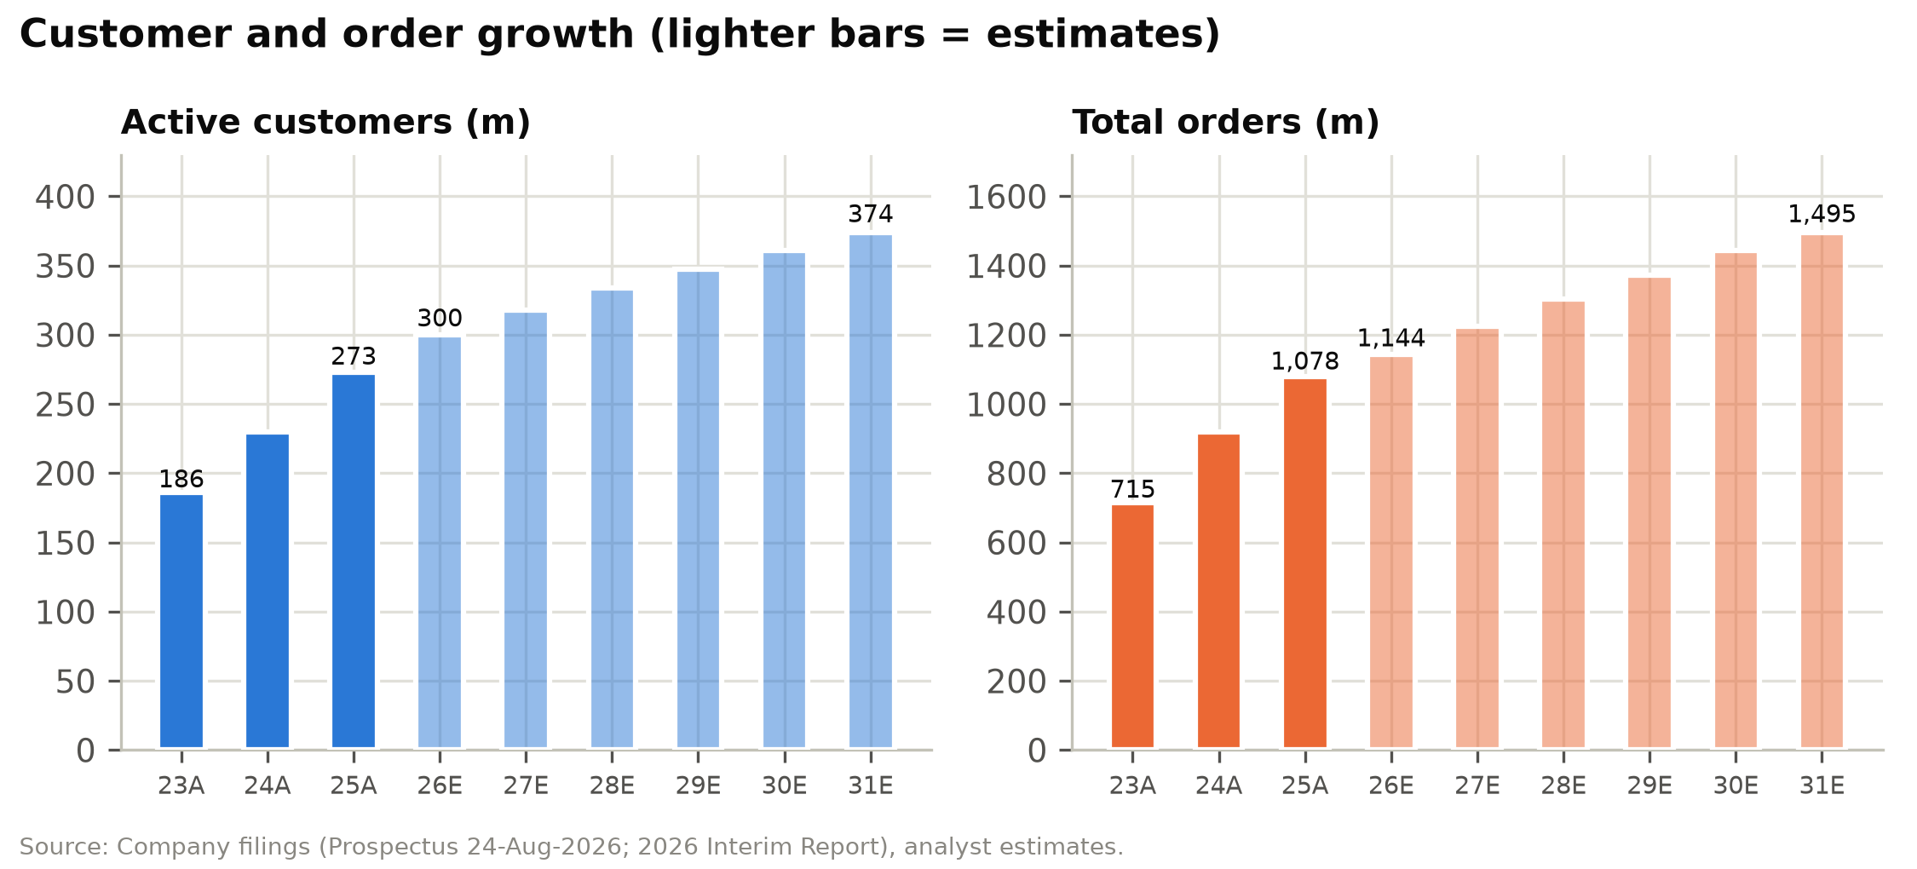

Industry overview
Market size. CIC sizes the global fashion industry (apparel, footwear and accessories, retail sales value excluding VAT) at US$1,737bn in 2025. It grew at a 2.7% CAGR over 2021-25 and CIC forecasts 3.4% growth to US$2,049bn by 2030. Apparel is US$1,370bn and footwear US$367bn. The online channel was US$606bn in 2025 (34.9% penetration) and is forecast to reach US$792bn by 2030 (38.7% penetration). That is a 5.5% CAGR, roughly twice offline growth (2.1%).
Structure. The industry is highly fragmented: the top 20 players held only about 20.5% of the market in 2025. CIC attributes this to the "trilemma": few players can offer broad assortment, rapid design refresh and efficient inventory at the same time, so most stay in narrow niches.
Trends.
1. Shopping continues to move online, helped by mobile payments, global fulfilment, social commerce and recommendation technology.
2. Social media speeds up trend cycles and splits demand into a long tail, which favours broad assortments that refresh quickly.
3. Consumers and regulators look harder at labour practices, environmental impact and transparency. The EU is legislating on textile waste, product safety and platform accountability.
4. Small-batch production, real-time inventory management and warehouse automation are becoming standard.
5. Governments are re-regulating cross-border e-commerce. The US ended de minimis for China (May 2025) and for all countries (August 2025). The EU abolished the €150 duty exemption from 1 July 2026, with a flat €3 duty per item category and a handling fee to follow, and other markets are reviewing similar thresholds. These changes permanently raise the landed cost of cross-border parcels sent direct to consumers relative to locally stocked inventory.
Adjacent categories. CIC sizes home and living at US$1,408bn (online US$282bn, rising to US$374bn by 2030), appliances and electronics at US$1,441bn (online US$659bn to US$1,067bn) and beauty and personal care at US$614bn (online US$171bn to US$264bn). These markets support SHEIN's category expansion and marketplace strategy.
Input costs. Polyester made up 82.7% of SHEIN's raw material by weight in 2025. China's man-made-fibre price index fell from 104.2 (2022) to 94.0 (2025), and China's apparel and footwear PPI was broadly flat (102.0 in 2025 against 100.0 in 2021). Input costs have therefore been benign; freight and duties are the variable costs that matter more.
Figure 15: Global fashion market size and online penetration, 2021-2030E
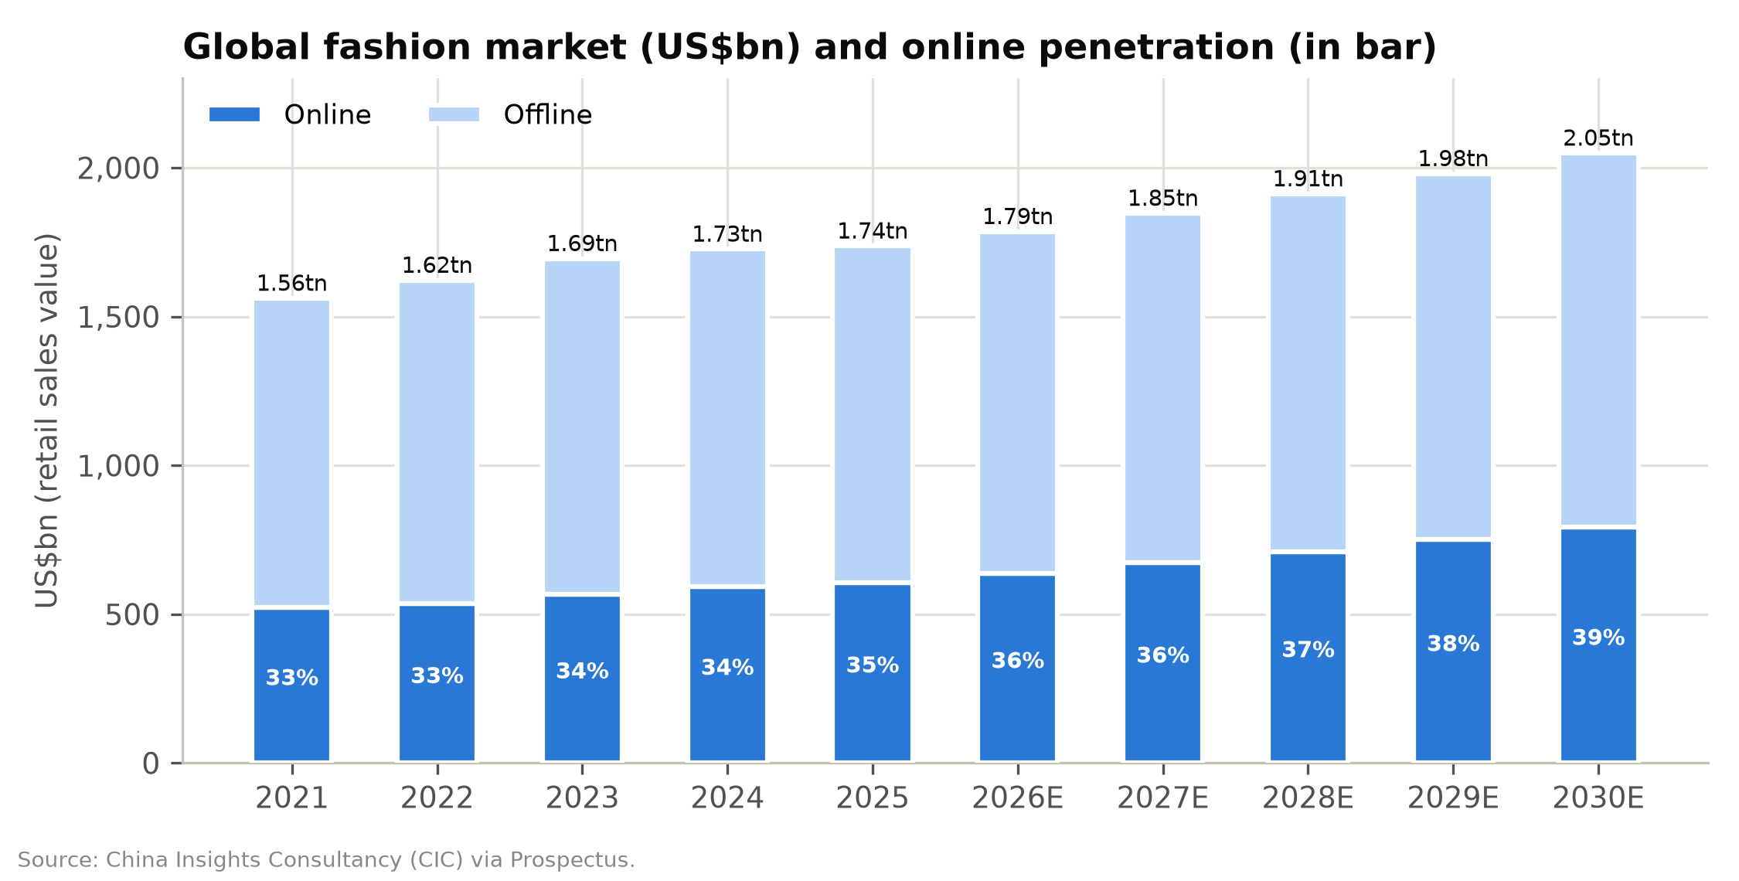

Figure 16: Global apparel and footwear market share, 2025 (CIC)
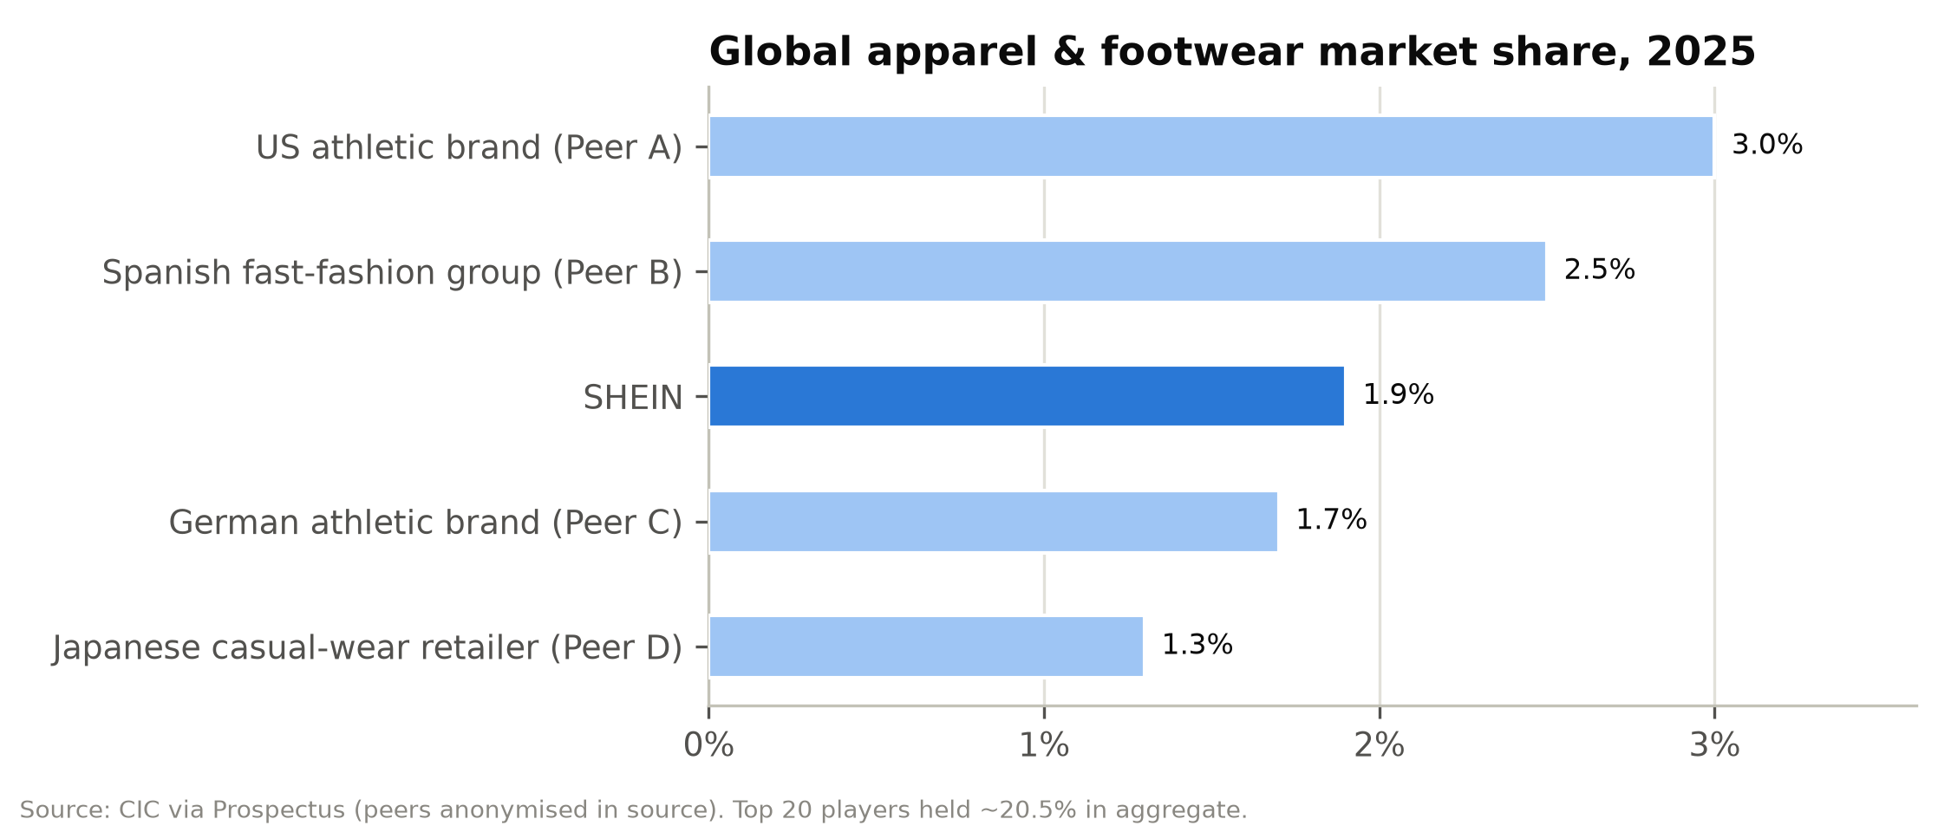

Competition
SHEIN competes mainly with global fashion retailers and, to a lesser extent, with general e-commerce platforms that sell fashion.
1. Inditex (Zara), the benchmark fast-fashion operator. Market share of about 2.5% (CIC). Trailing revenue of about €41bn, an EBITDA margin of about 24% and a net margin of about 16%; it trades at about 23.5x forward P/E. Inditex sources close to home (Spain, Portugal, Morocco, Turkey), which gives it two-to-four-week design-to-shelf cycles across stores and online. SHEIN offers a far larger assortment at lower prices. Inditex has stronger brand equity, a better reputation for quality, physical stores, and much higher margins and returns.
2. H&M Group. Revenue of about €19bn equivalent (SEK221bn), an EBITDA margin of about 11% and a forward P/E of about 19x. Longer lead times and a store-heavy model leave H&M more exposed to markdowns, and it has been losing share in value fashion to SHEIN and Primark.
3. Fast Retailing (Uniqlo). Market share of about 1.3% and revenue of ¥3.85trn. Its premium valuation (about 39x forward P/E and 22.6x EV/EBITDA) reflects a basics-led model with little fashion risk and strong growth in Asia. It overlaps little with SHEIN's trend-led assortment but shows what a global apparel franchise can be worth.
4. Athletic leaders (Nike, Adidas). Ranked first and fourth by CIC market share. They matter as share benchmarks and as competitors in sportswear, where SHEIN's MUSERA and Glowmode are growing.
5. PDD Holdings (Temu). SHEIN's most direct and aggressive competitor since 2023. Temu is a fully managed and semi-managed marketplace that ships low-priced Chinese goods worldwide, backed by PDD's net cash of about US$66bn. It competes on price in every category, including fashion, and has fought SHEIN in court (a US antitrust complaint, partially dismissed in September 2025; UK copyright and competition cases, with further trials in 2027). Temu faces the same de minimis changes. PDD trades at only about 6.8x forward P/E and about 3x EV/EBITDA, which anchors what investors expect to pay for China-linked cross-border platforms.
6. Alibaba (AliExpress) and other Chinese cross-border platforms. AliExpress's "Choice" programme competes on price and delivery. Alibaba trades at about 13.6x forward P/E.
7. Amazon (including Amazon Haul). Amazon's low-price storefront targets the same value shopper and has local fulfilment in the US and Europe. As duties erode the cost advantage of shipping direct from China, Amazon's logistics scale becomes a bigger threat.
8. TikTok Shop. Social-commerce platforms compete for the same young consumers and the same influencer budgets, and they have made it cheaper for small fashion brands to acquire customers.
9. Online fashion specialists: Zalando, ASOS, Boohoo, Revolve. Zalando (revenue of about €13.5bn; about 12.9x forward P/E) is the leading European online fashion platform and a direct competitor in Europe; it is expanding through its acquisition of About You. ASOS (loss-making, EV/Sales of about 0.5x) and Boohoo have lost share to SHEIN in UK and US value fashion. Revolve (about 21x forward P/E) is a US premium online retailer.
10. Primark (ABF) and off-price retailers. Physical value fashion with strong unit economics in Europe. They gain from any rise in cross-border landed costs.
SHEIN's competitive position. SHEIN's advantages are assortment breadth (2m+ styles), speed (5-day restocks), inventory efficiency (36-day turnover), low costs (value pricing made possible by LATR and the density of the Chinese supply chain) and a large, engaged customer base (291m). Its weaknesses are thin operating margins (2-4%, against 12-20% for Inditex and Fast Retailing); reliance on shipping from China (more than 90% of revenue ships from Chinese warehouses) just as duty regimes tighten; brand perception problems around quality, sustainability and IP; and regulatory scrutiny that physical-retail peers largely avoid. As duties rise, the main competitive threat is moving away from Temu, which competes on price, toward platforms with local fulfilment such as Amazon and toward local value retailers.
Figure 17: Competitive positioning: price point vs. assortment breadth and speed
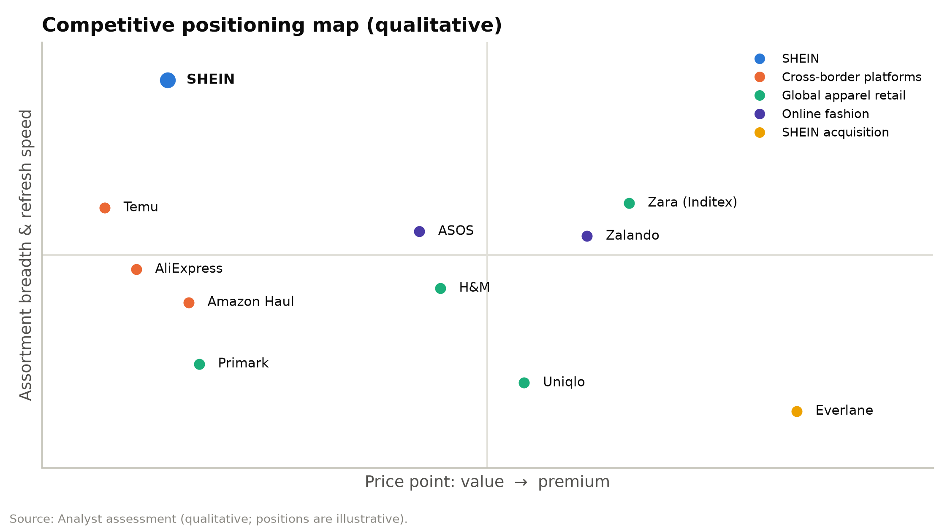

Figure 18: EBITDA margin benchmarking vs. peers (LTM)
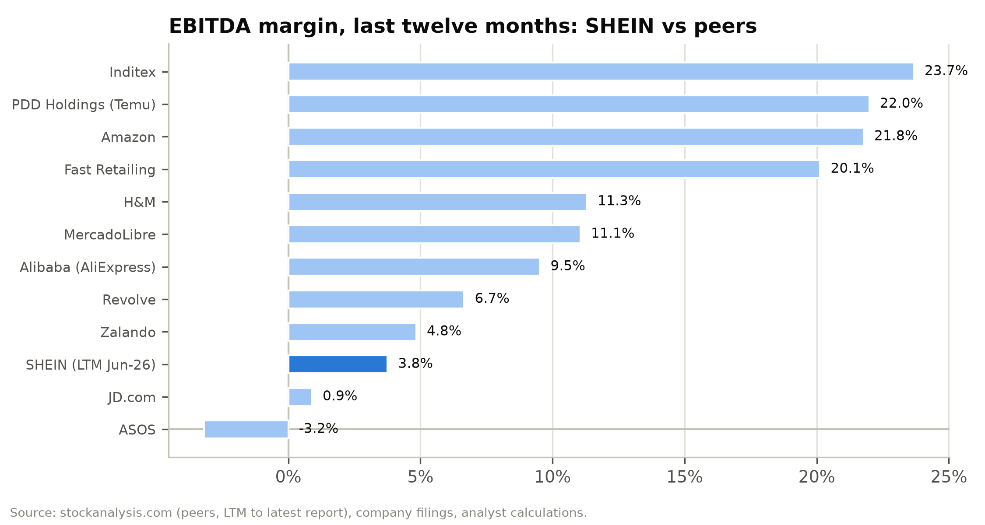

Market opportunity
We look at SHEIN's addressable market in three layers:
Figure 19: Addressable market layers, 2025 and 2030E (CIC)
Layer | 2025 size | 2030E size | CAGR | SHEIN 2025 revenue / share
Global fashion (apparel, footwear, accessories) | US$1,737bn | US$2,049bn | 3.4% | ~1.9% share (CIC, by RSV)
Global online fashion | US$606bn | US$792bn | 5.5% | Largest online player
Online home & living | US$282bn | US$374bn | 5.8% | Adjacent category
Online beauty & personal care | US$171bn | US$264bn | 9.1% | SHEGLAM + marketplace
Online appliances & electronics | US$659bn | US$1,067bn | 10.1% | Marketplace only

Source: CIC via Prospectus. RSV = retail sales value excluding VAT.
Serviceable market. SHEIN's core serviceable market is online fashion (US$606bn in 2025). Its apparel revenue of about US$27bn, plus part of its footwear and accessories revenue, implies a share in the high single digits. Adding online beauty and home and living takes the serviceable online market to about US$1.06trn in 2025, rising to about US$1.43trn by 2030 (6.2% CAGR).
Room to gain share. After a decade of very fast growth, SHEIN still holds under 2% of global fashion, a share management calls "relatively low". Our base case has net revenues growing at a 6.1% CAGR over 2026-31E to US$56bn, slightly faster than the online fashion market. Orders grow 5-7% a year, and revenue per order stabilises as the move to higher price points offsets marketplace mix. Our bull case (8.6% CAGR) assumes Europe re-accelerates after the duty shock and the rest of the world keeps growing at double-digit rates. Our bear case (2.8% CAGR) assumes a structural loss of share in the US and Europe.
Constraints. Trade policy and regulation limit SHEIN's growth more than market size does. The US and EU, SHEIN's two largest regions and about 60% of 2025 revenue, have removed their low-value exemptions. That raises the cost of the direct-from-China model and pushes SHEIN toward local inventory, which delivers faster but carries higher working capital, warehousing and duty costs.

Financial analysis
SHEIN reports under IFRS in US dollars with a December year-end. Our historical figures for FY2023-FY2025 come from the Accountants' Report in the prospectus; the first half of 2026 and the 1Q/2Q splits come from the 2026 Interim Report. Unless stated otherwise, "adjusted" figures follow the company's non-IFRS definitions. Adjusted EBIT is operating income excluding share-based compensation. Adjusted net income also excludes fair-value changes of the convertible redeemable preferred shares, the share of associates' results and impairments of long-term investments.

Revenue growth and its drivers
Net revenues grew from US$32.1bn in FY2023 to US$41.8bn in FY2025, a 14.2% CAGR. Growth slowed from 41.1% in FY2023 to 20.7% in FY2024, 8.0% in FY2025 and 1.0% in 1H26. Three causes explain the slowdown, and they matter differently for the forecasts.
1. Marketplace mix, which is an accounting effect. Service revenues rose from 2.7% of the total in FY2023 to 11.3% in FY2025 and 13.4% in 1H26. Marketplace sales are booked net, at the commission plus the fulfilment fee, so moving an order from first-party to the marketplace cuts reported revenue even when the customer pays the same price. This is the main reason net revenue per order fell from US$44.9 in FY2023 to US$38.8 in FY2025.
2. Regional mix. The rest of the world (Latin America, the Middle East and Asia-Pacific) grew 15.4% in FY2025 and 16.0% in 1H26 and became SHEIN's largest region, at 44% of 1H26 revenue. Baskets there are smaller than in the US and Europe.
3. Trade policy, which has cost real demand. US revenue fell 3.5% in FY2025 and 9.9% in 1H26 after the de minimis exemption was removed. Europe grew 8.8% in FY2025, then fell 13.9% in 2Q26 when SHEIN raised prices and cut advertising ahead of the EU duty.
Volumes held up better than revenue. Orders grew 17.3% to 1.08bn in FY2025 and 6.4% in 1H26 (7.6% in 2Q26), and active customers reached 291m in the twelve months to June 2026, up 14.6%. Order frequency has stayed at about four orders per customer a year, so the growth came from new customers; existing customers are not ordering more often.
Figure 20: Net revenue trajectory, FY2023A-FY2031E (US$m) and YoY growth
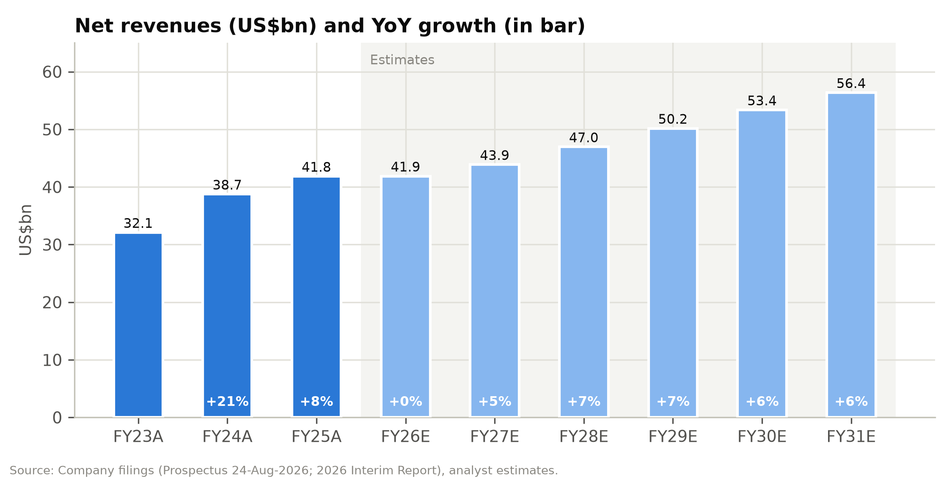

Figure 21: Historical income statement, FY2023A-FY2025A (US$m and % of revenue)
US$m | FY23A | FY24A | FY25A | % FY23 | % FY24 | % FY25
Net revenues | 32,103 | 38,748 | 41,847 | 100.0% | 100.0% | 100.0%
Product revenues | 31,235 | 35,351 | 37,107 | 97.3% | 91.2% | 88.7%
Service revenues | 868 | 3,397 | 4,740 | 2.7% | 8.8% | 11.3%
Cost of sales | (12,777) | (15,249) | (13,433) | (39.8%) | (39.4%) | (32.1%)
Gross profit | 19,326 | 23,499 | 28,414 | 60.2% | 60.6% | 67.9%
Fulfilment expenses | (13,501) | (16,847) | (19,072) | (42.1%) | (43.5%) | (45.6%)
Marketing expenses | (3,453) | (4,159) | (6,191) | (10.8%) | (10.7%) | (14.8%)
Technology & content | (668) | (849) | (896) | (2.1%) | (2.2%) | (2.1%)
General & administrative | (328) | (678) | (548) | (1.0%) | (1.7%) | (1.3%)
Operating income | 1,376 | 966 | 1,707 | 4.3% | 2.5% | 4.1%
FV changes of preferred shares | 1,231 | 2,431 | 328 | 3.8% | 6.3% | 0.8%
Interest income | 472 | 597 | 621 | 1.5% | 1.5% | 1.5%
Associates, FX & other | (84) | (225) | (142) | (0.3%) | (0.6%) | (0.3%)
Income before tax | 2,995 | 3,769 | 2,514 | 9.3% | 9.7% | 6.0%
Income tax | (206) | (404) | (450) | (0.6%) | (1.0%) | (1.1%)
Net income (IFRS) | 2,789 | 3,365 | 2,064 | 8.7% | 8.7% | 4.9%
Adjusted net income | 1,643 | 1,119 | 1,816 | 5.1% | 2.9% | 4.3%
Source: Prospectus (Accountants' Report), analyst calculations.
The quarterly data show how the tariff changes hit each region. In the US, the year-on-year decline narrowed from 14.3% in 1Q26 to 6.0% in 2Q26 as customers adjusted to higher prices and SHEIN moved to formal customs entry. European revenue was still up 2.3% in 1Q26 but fell 13.9% in 2Q26 after prices were raised ahead of the 1-Jul-2026 duty. Rest-of-world growth accelerated from 10.1% in 1Q26 to 21.6% in 2Q26.
Figure 22: Quarterly and half-year revenue by region (US$m)
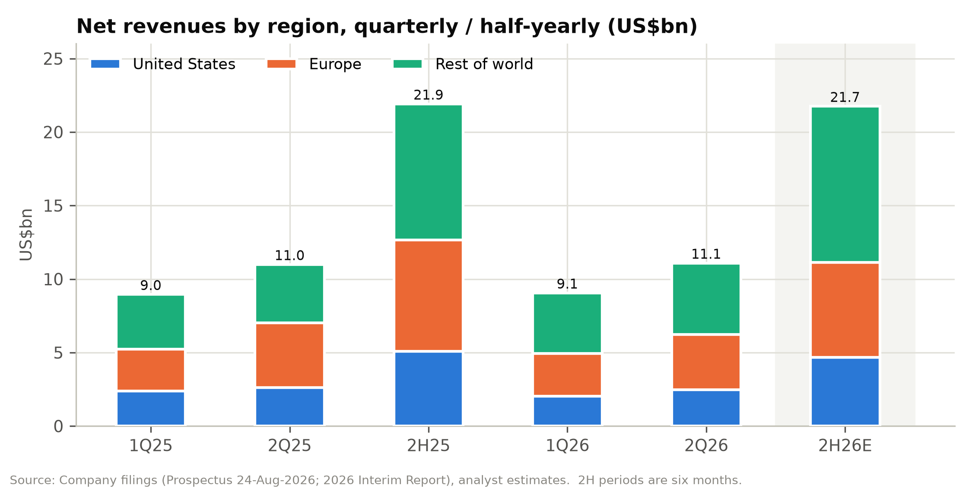

Figure 23: Revenue growth by region, FY2024A-FY2027E and 1H26
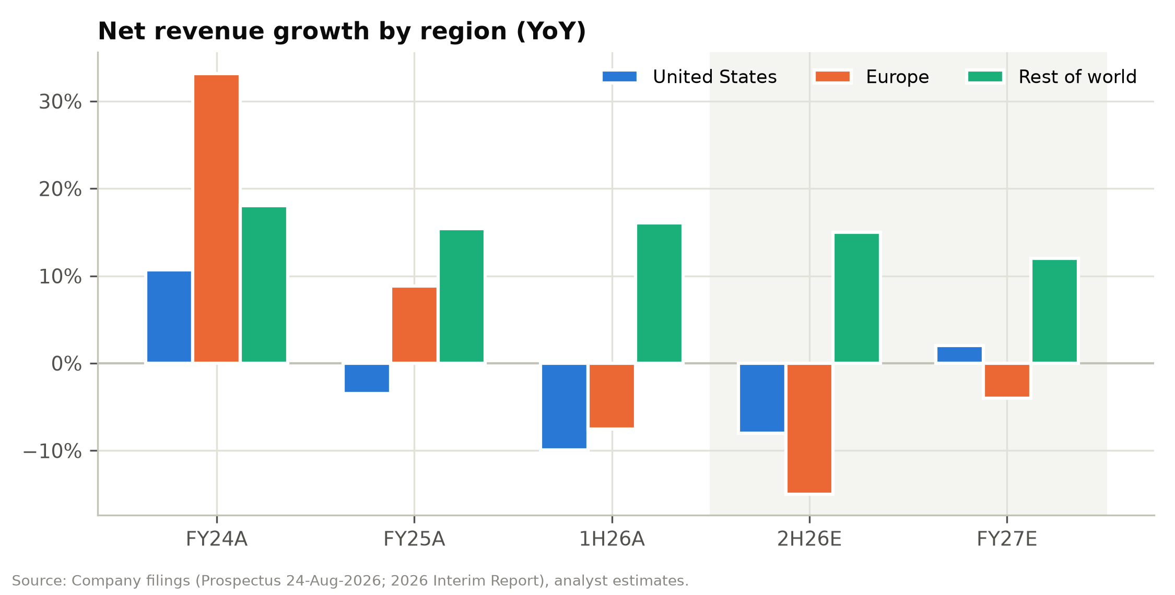

Gross margin and contribution margin
Gross margin rose from 60.2% in FY2023 to 67.9% in FY2025 and 70.1% in 1H26. Cost of sales fell 11.9% in FY2025 despite higher volumes, and the prospectus gives four reasons: the rising share of the marketplace, which has no cost of sales; pricing adjustments; cost optimisation; and currency movements. Cost of sales as a percentage of product revenue, a cleaner measure of first-party product margin, fell from 43.1% in FY2024 to 36.2% in FY2025 and about 34% in 1H26.
Because mix flatters gross margin, we track contribution margin after fulfilment: gross profit less fulfilment expenses, as a percentage of revenue. It rose from 18.1% in FY2023 to 22.3% in FY2025, then fell to 20.9% in 1H26 when freight costs spiked. We find it the most useful single measure of SHEIN's unit economics, because fulfilment is the cost line that the marketplace, duties and freight move most.
Figure 24: Gross margin and contribution margin after fulfilment, FY2023A-FY2031E
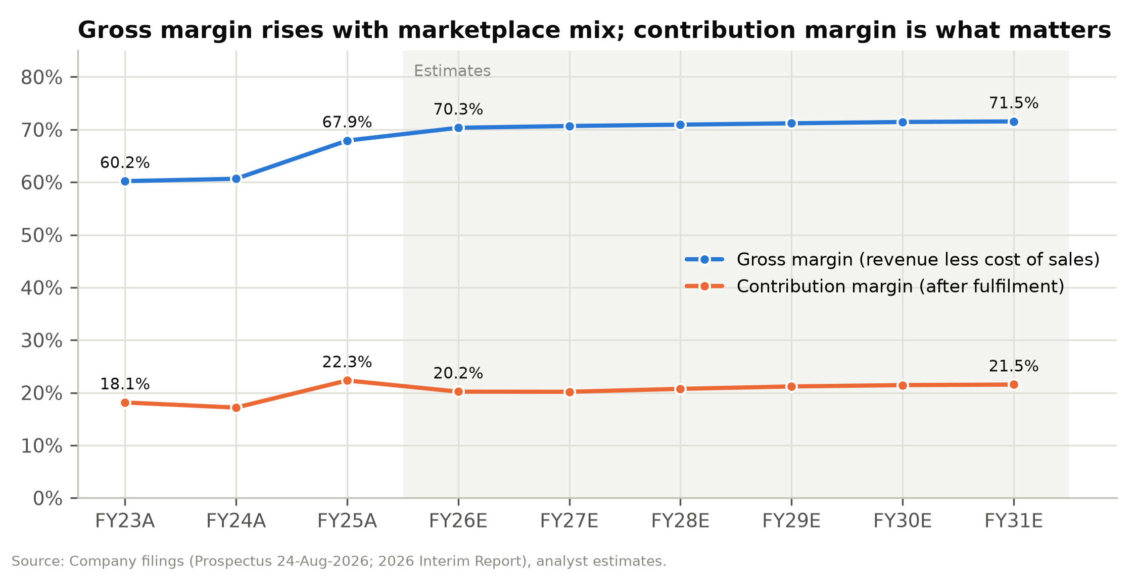

Fulfilment
Fulfilment expenses cover outbound logistics, warehousing and, since the de minimis exemptions ended, duties on direct shipments. They are SHEIN's largest cost: 45.6% of FY2025 revenue and 50.4% of 2Q26 revenue.
Two effects push the ratio in opposite directions. Fulfilment cost per order fell from US$18.9 in FY2023 to US$17.7 in FY2025 as scale, local warehousing and carrier negotiations improved. Revenue per order fell faster, because of marketplace mix and the growth of markets with smaller baskets, so fulfilment rose as a share of revenue even as the unit cost fell.
In 2Q26 the ratio jumped to 50.4% from 43.1% a year earlier. Management attributes most of the increase to higher oil prices and freight costs during the Iran conflict, with marketplace mix a smaller factor, and chose not to pass the costs on to customers.
Tariff costs also land in fulfilment, because duties on direct-to-consumer shipments into the US (and, from July 2026, the EU) are booked there and not in cost of sales. For that reason we keep the ratio at 50.0-51.0% throughout the forecast period and do not assume a return to the FY2025 level.

Marketing
Marketing expenses rose 48.9% to US$6.2bn in FY2025, or 14.8% of revenue against 10.7% in FY2024. Advertising grew from US$4.0bn to US$5.0bn "to drive better customer engagement" as SHEIN competed with Temu and raised prices to cover tariffs. In 2Q26 marketing fell 4.1% year on year to 13.6% of revenue, as SHEIN cut online advertising in Europe at the same time as it raised prices there.
We assume the ratio settles at 13.5% in FY2027E and 13.2% from FY2029E. That is still well above FY2023-24, so there is upside if competition eases.
Figure 25: Marketing spend (US$m) and marketing intensity (% of revenue)
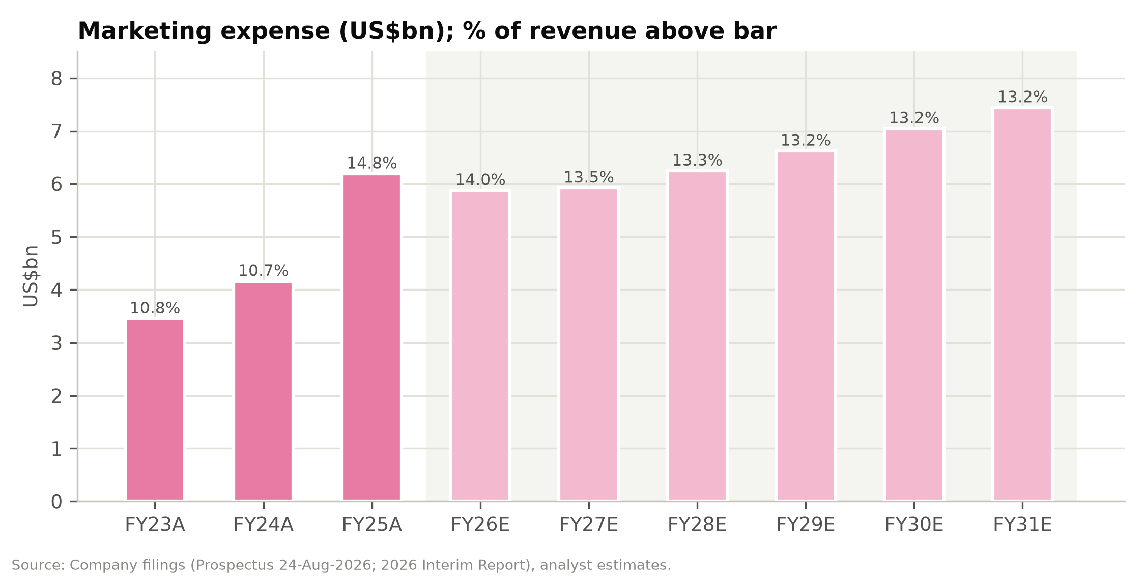

Technology and G&A
Technology and content expenses are 2.1-2.5% of revenue: US$896m in FY2025 and US$499m in 1H26, with 2Q26 up 16.7% on infrastructure investment. Research and development spending was US$451m in 1H26. G&A is 1.3% of revenue. Together these fixed costs are under 4% of revenue, so the operating margin depends almost entirely on three variable costs: product cost, fulfilment and marketing.
Figure 26: Technology and content investment (US$m and % of revenue)
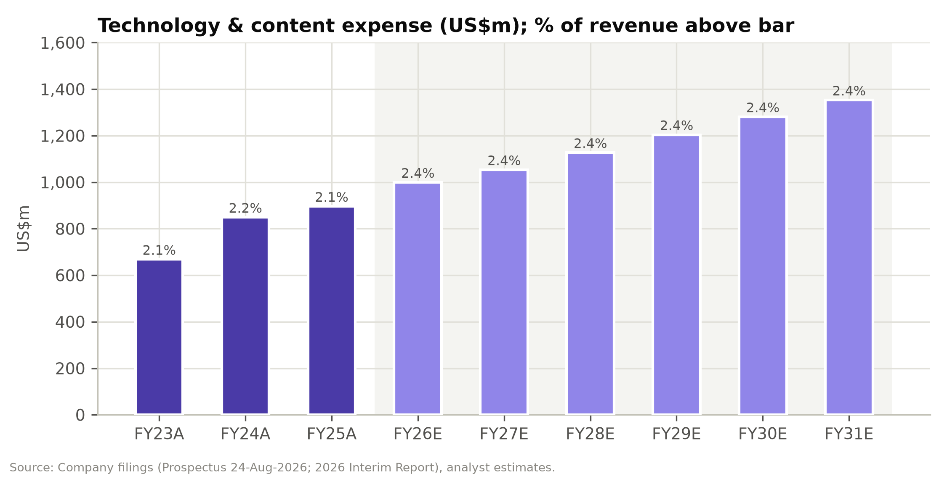

Operating profit
Operating income was US$1,376m in FY2023 (4.3% margin). It fell to US$966m (2.5%) in FY2024, when cost of sales rose to 43.1% of product revenue and fulfilment to 43.5% of revenue. It recovered to US$1,707m (4.1%) in FY2025, as the gross-margin gain more than covered the higher marketing spend. In 1H26 it fell 52.9% year on year to US$493m (2.4%), and 2Q26 alone was 2.1%. The adjusted EBIT margin, which excludes SBC (US$85m in FY2025), was 4.3% in FY2025 and 2.7% in 1H26.
Figure 27: EBITDA, adjusted EBIT and EBIT margins, FY2023A-FY2031E
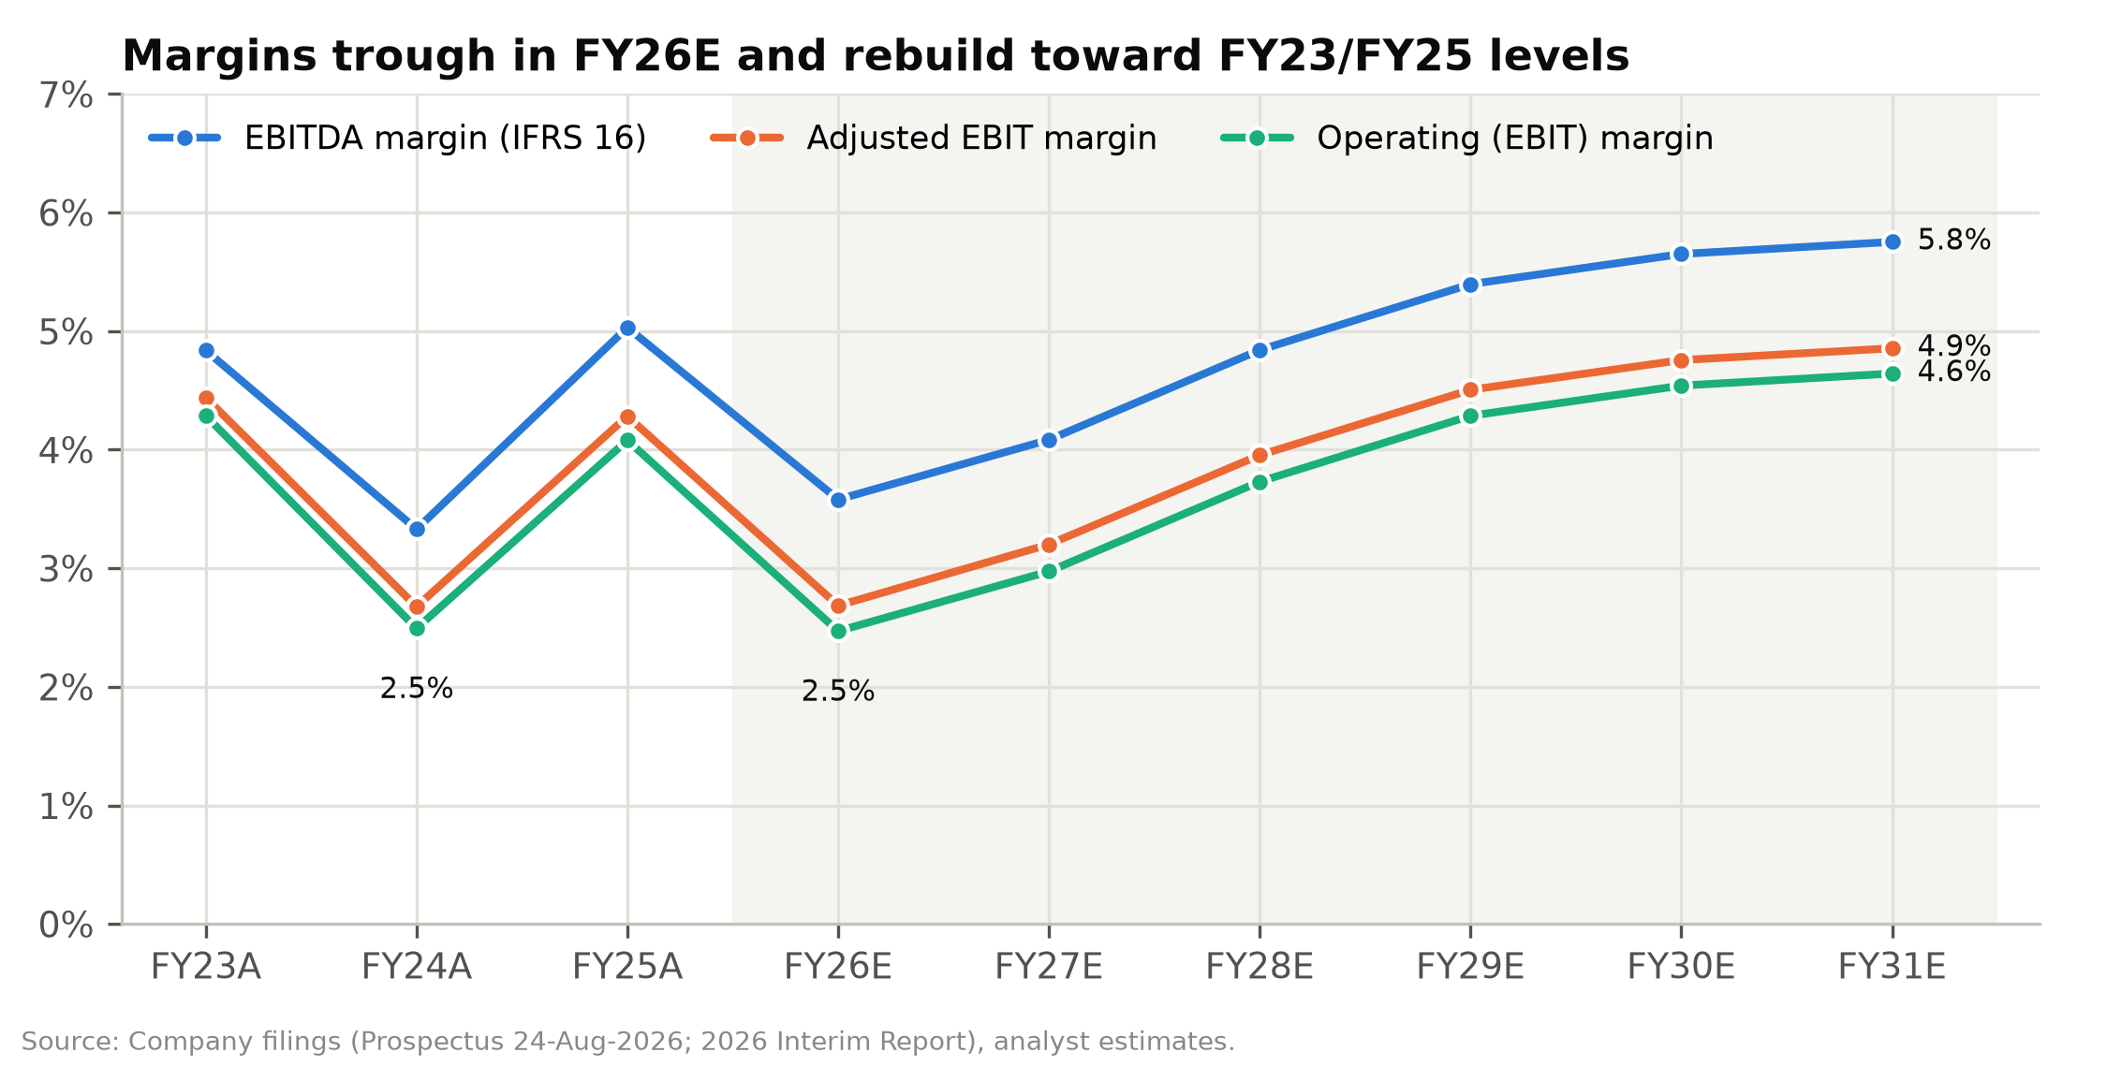

Figure 28: Half-year adjusted EBIT (US$m) and adjusted EBIT margin
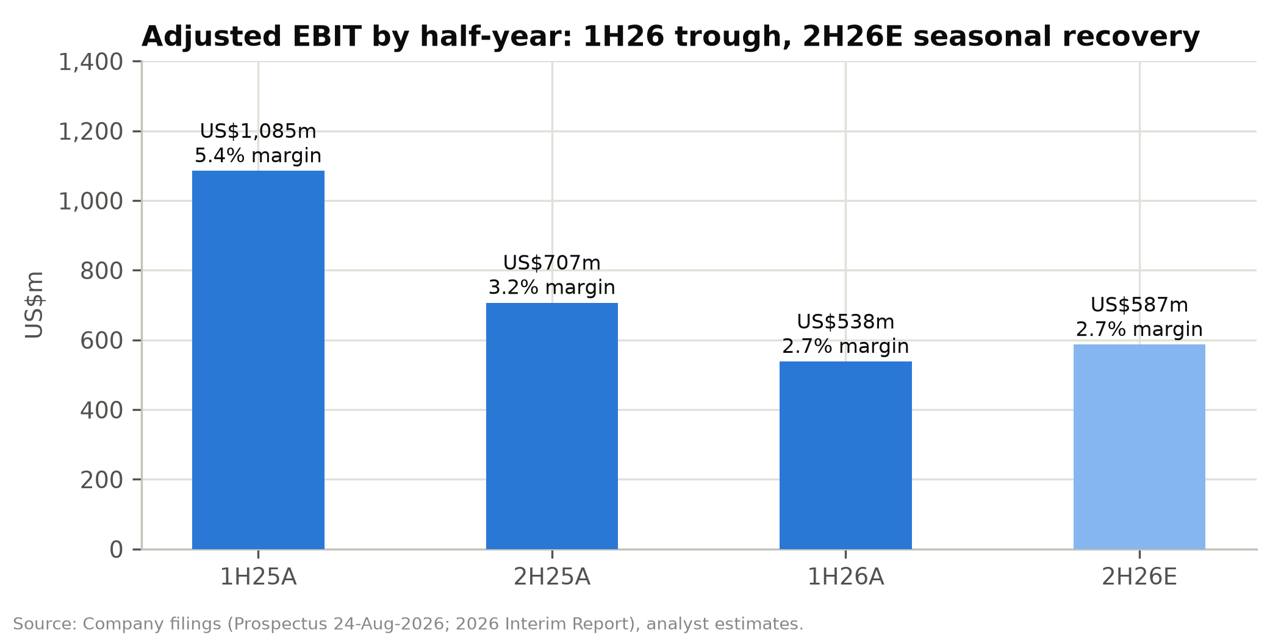

Preferred shares, interest income and tax
Three items account for most of the gap between operating income and IFRS net income.
Until the listing, the convertible redeemable preferred shares were carried as liabilities at fair value, so SHEIN booked gains when its valuation fell: US$1,231m in FY2023, US$2,431m in FY2024, US$328m in FY2025 and a net US$1,861m in 1H26 (a US$328m loss in 1Q26 and a US$2,189m gain in 2Q26). At listing the preferred shares converted into 1,397.7m Class B shares. Their carrying value was US$15.1bn at 30 June, against a conversion value of about US$11.1bn (the shares at the IPO price plus the cash compensation). We therefore book a further non-cash gain of about US$4.0bn in 2H26E, which takes FY2026E IFRS net income to about US$6.9bn. These gains bring in no cash and are excluded from adjusted earnings.
SHEIN earned US$621m of interest on its deposits in FY2025, a 4.7% yield on opening cash resources and about 28% of FY2025 pre-tax profit excluding fair-value gains. We model the yield falling to 3.3% by FY2029E as US dollar rates come down.
The core effective tax rate, which excludes fair-value changes and associates, has ranged from 11.4% (FY2023) to 26.8% (FY2024). It was 20.6% in FY2025 and about 26% in 1H26. We assume 22% from FY2027E, reflecting the Singapore headquarters, OECD Pillar Two and the spread of profits across jurisdictions.
Adjusted net income was US$1,643m in FY2023, US$1,119m in FY2024, US$1,816m in FY2025 and US$499m in 1H26, down 55.6%.
Figure 29: Quarterly and half-year results (US$m)
US$m | 1Q25 | 2Q25 | 1H25 | 2H25 | FY25 | 1Q26 | 2Q26 | 1H26 | 2H26E | FY26E
Net revenues | 8,952 | 10,988 | 19,940 | 21,907 | 41,847 | 9,052 | 11,082 | 20,134 | 21,749 | 41,883
YoY |  |  |  |  |  | 1.1% | 0.9% | 1.0% | (0.7%) | 0.1%
United States | 2,380 | 2,632 | 5,012 | 5,089 | 10,101 | 2,040 | 2,474 | 4,514 | 4,682 | 9,196
Europe | 2,843 | 4,379 | 7,222 | 7,580 | 14,802 | 2,908 | 3,770 | 6,678 | 6,443 | 13,121
Rest of world | 3,729 | 3,977 | 7,706 | 9,238 | 16,944 | 4,104 | 4,838 | 8,942 | 10,624 | 19,566
Service % of revenue | 13.3% | 8.9% | 10.8% | 11.8% | 11.3% | 14.3% | 12.7% | 13.4% | 13.5% | 13.5%
Orders (m) | 240 | 277 | 517 | 561 | 1,078 | 251 | 298 | 549 | 595 | 1,144
Gross margin | 62.7% | 67.0% | 65.1% | 70.5% | 67.9% | 70.4% | 69.8% | 70.1% | 70.6% | 70.3%
Fulfilment % revenue | 42.8% | 43.0% | 42.9% | 48.0% | 45.6% | 47.7% | 50.4% | 49.2% | 51.0% | 50.1%
Marketing % revenue | 12.2% | 14.3% | 13.4% | 16.1% | 14.8% | 15.8% | 13.6% | 14.6% | 13.5% | 14.0%
Operating income | 348 | 698 | 1,046 | 661 | 1,707 | 258 | 235 | 493 | 542 | 1,035
Operating margin | 3.9% | 6.4% | 5.2% | 3.0% | 4.1% | 2.9% | 2.1% | 2.4% | 2.5% | 2.5%
Adjusted EBIT | 370 | 715 | 1,085 | 707 | 1,792 | 284 | 254 | 538 | 587 | 1,125
Net income (IFRS) | 395 | 691 | 1,086 | 978 | 2,064 | (99) | 2,398 | 2,299 | 4,630 | 6,929
Adjusted net income | 440 | 683 | 1,123 | 693 | 1,816 | 271 | 228 | 499 | 651 | 1,150
Adj. net margin | 4.9% | 6.2% | 5.6% | 3.2% | 4.3% | 3.0% | 2.1% | 2.5% | 3.0% | 2.7%
Note: 2H25 derived as FY25 less 1H25. 2H26E and FY26E are analyst estimates. 2H26E IFRS net income includes an estimated US$4.0bn non-cash FV gain on conversion of preferred shares.
Source: Prospectus, 2026 Interim Report, analyst estimates.

Cash flow and working capital
SHEIN converts profit to cash well because its working capital is negative: customers pay when they order, suppliers are paid on terms of about 34 days, and inventory turns in about 36 days. Operating net working capital was –US$4.0bn in December 2025 (–9.6% of revenue) and –US$5.0bn in June 2026. The swing within the year is large. Payables and accruals build in the first half and unwind in the second, so operating cash flow was US$2.9bn in 1H25 and –US$39m in 2H25.
Free cash flow (operating cash flow less capex and lease payments) was US$1.3bn in FY2023, US$0.9bn in FY2024 and US$2.3bn in FY2025. Including interest received, FY2025 free cash flow was US$2.9bn, 160% of adjusted net income. Capex is low, at 0.5-1.0% of revenue, because SHEIN leases its warehouses and owns no factories, and D&A of property, equipment and intangibles is only 0.4% of revenue.
We forecast FY2026E free cash flow of only US$0.5bn (US$1.1bn with interest), because of the second-half working-capital unwind and lower profits. Including interest, it recovers to US$1.6bn in FY2027E and US$2.8bn by FY2031E.
Figure 30: Free cash flow (incl. interest received) vs. adjusted net income (US$m)
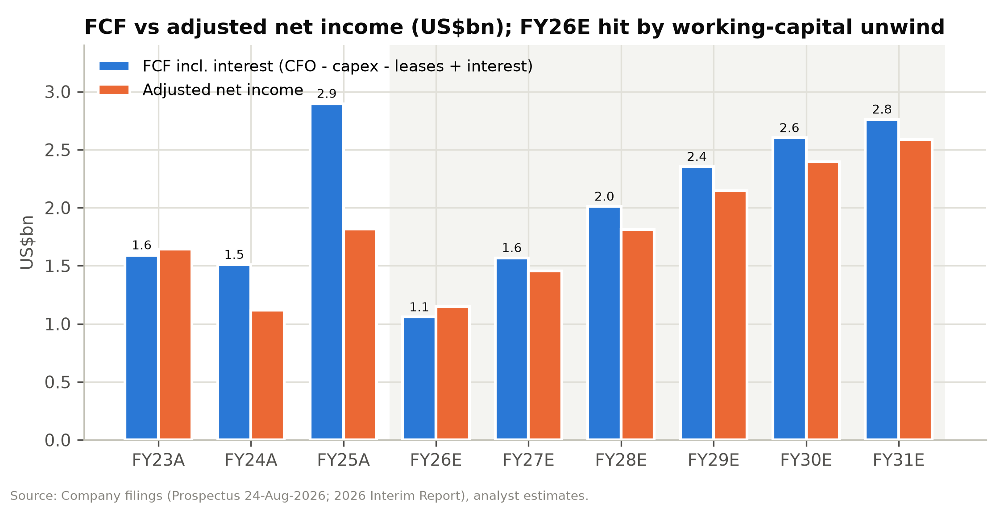

Figure 31: Operating net working capital (US$m and % of revenue)
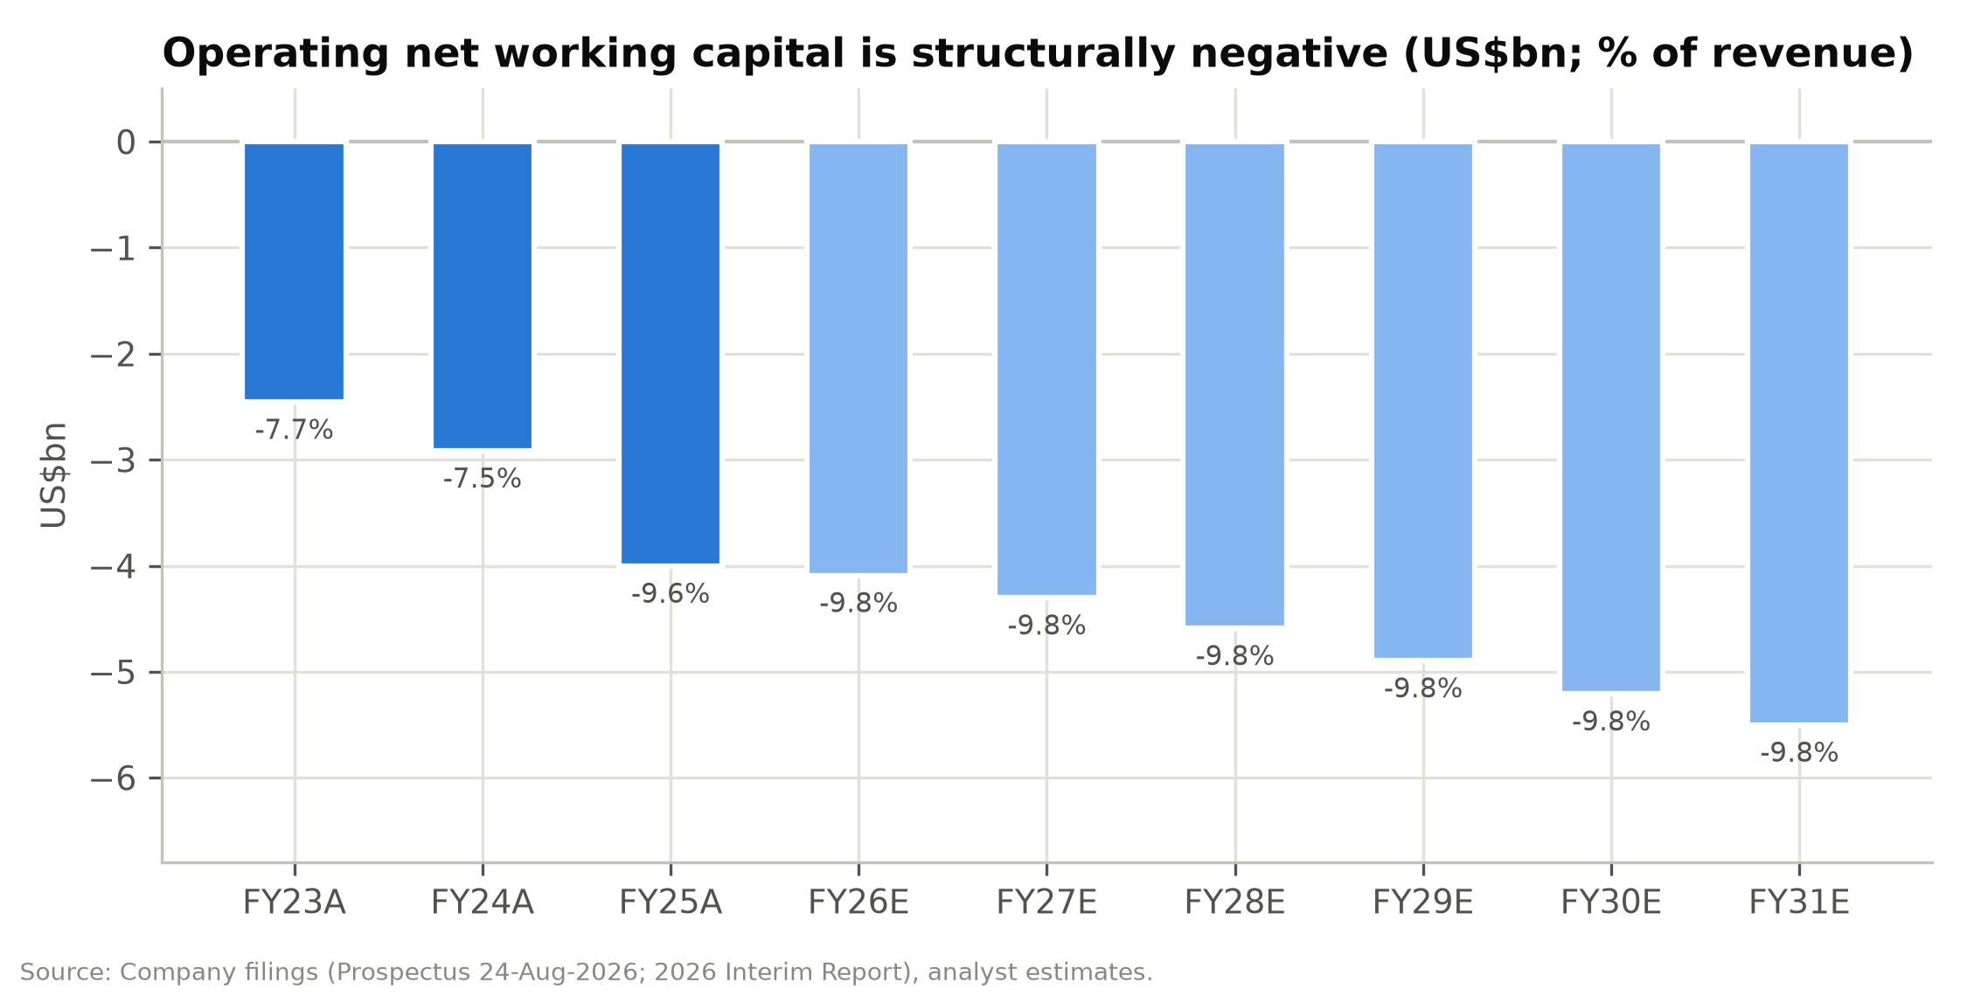

Balance sheet after the listing
SHEIN's balance sheet showed a shareholders' deficit of US$6.9bn at December 2025, because US$18.0bn of convertible redeemable preferred shares were classified as liabilities. The conversion at listing removes that liability. We forecast shareholders' equity of US$10.5bn at December 2026, after crediting US$11.1bn of conversion value and US$1.68bn of IPO proceeds, and deducting the US$2.2bn Conversion Adjustment cash and the US$0.23bn 12% distribution.
Cash resources (cash, restricted cash and time deposits) were US$15.2bn at 30 June 2026. After the listing-related outflows and the second-half working-capital unwind we forecast US$13.9bn at December 2026, rising to US$20.7bn by FY2031E even with a 50% payout. Lease liabilities of US$1.1bn are the only interest-bearing obligations. Adjusted return on equity is 13-17% in FY2027-31E, held down by the large cash balance, which earns only deposit rates.

Projections and estimates
Our model forecasts FY2026E-FY2031E. FY2026E combines reported 1H26 with explicit 2H26E drivers, and the drivers for each later year are set on the model's Scenarios tab. Figures below are for the base case unless noted; the bull and bear cases are in the scenario analysis.

Revenue by region
We forecast revenue by region, because trade policy affects each region differently, and cross-check the total against orders multiplied by revenue per order.
United States (22% of FY2026E revenue). We forecast a 9.0% decline in FY2026E. 1Q26 was –14.3% and 2Q26 –6.0%, and we assume –8% in 2H26E. The exemption ended for China-origin goods on 2 May 2025 and for all countries on 29 August 2025, so 3Q26 still compares with two months that predate the second change. We then forecast +2% in FY2027E and 3.5-4% a year after that, in line with US apparel e-commerce, helped by higher-priced brands such as Everlane and by domestic fulfilment from six US warehouses.
Europe (31% of FY2026E revenue). We forecast an 11.4% decline in FY2026E. The EU's €3 duty per item category on low-value parcels took effect on 1 July 2026, and management warns the impact could be "in line with or exceed" the US experience. After 2Q26's –13.9%, when prices were raised ahead of the duty, we assume –15% for 2H26E. We forecast –4% in FY2027E, since 1H27 compares with a period before the duty, and growth of 4-5% from FY2028E as local inventory (18 European warehouses, 1.0m m²) narrows the landed-cost gap.
Rest of world (47% of FY2026E revenue). We forecast +15.5% for FY2026E. Growth was 16.0% in 1H26 (21.6% in 2Q26), led by Brazil and Mexico, with a low single-digit drag from the Middle East conflict; we assume +15% for 2H26E. We forecast 12% in FY2027E, slowing to 7% by FY2031E, because several of these markets are also reviewing their low-value import thresholds.
Group revenue is therefore flat in FY2026E at US$41.9bn (+0.1%), grows 4.8% to US$43.9bn in FY2027E and reaches US$56.4bn by FY2031E, a 6.1% CAGR from FY2026E. The rest of the world rises from 40.5% of revenue in FY2025 to 54% in FY2031E.
Figure 32: Net revenues by region, FY2023A-FY2031E (US$m)
US$m | FY23A | FY24A | FY25A | FY26E | FY27E | FY28E | FY29E | FY30E | FY31E
United States | 9,454 | 10,464 | 10,101 | 9,196 | 9,380 | 9,755 | 10,145 | 10,551 | 10,920
YoY |  | 10.7% | (3.5%) | (9.0%) | 2.0% | 4.0% | 4.0% | 4.0% | 3.5%
% of total | 29.4% | 27.0% | 24.1% | 22.0% | 21.4% | 20.8% | 20.2% | 19.8% | 19.4%
Europe | 10,214 | 13,603 | 14,802 | 13,121 | 12,596 | 13,100 | 13,755 | 14,443 | 15,093
YoY |  | 33.2% | 8.8% | (11.4%) | (4.0%) | 4.0% | 5.0% | 5.0% | 4.5%
% of total | 31.8% | 35.1% | 35.4% | 31.3% | 28.7% | 27.9% | 27.4% | 27.1% | 26.8%
Rest of world | 12,435 | 14,681 | 16,944 | 19,566 | 21,914 | 24,105 | 26,274 | 28,376 | 30,363
YoY |  | 18.1% | 15.4% | 15.5% | 12.0% | 10.0% | 9.0% | 8.0% | 7.0%
% of total | 38.7% | 37.9% | 40.5% | 46.7% | 49.9% | 51.3% | 52.4% | 53.2% | 53.9%
Total net revenues | 32,103 | 38,748 | 41,847 | 41,883 | 43,890 | 46,960 | 50,175 | 53,370 | 56,376
YoY |  | 20.7% | 8.0% | 0.1% | 4.8% | 7.0% | 6.8% | 6.4% | 5.6%
Source: Company filings, analyst estimates.
Figure 33: Net revenues by geography, FY2023A-FY2031E (US$m)
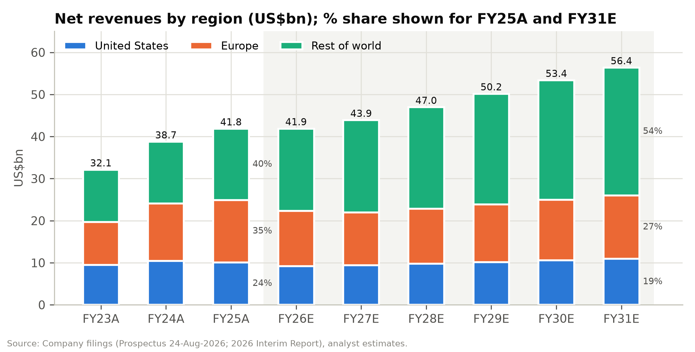

Business model and operating KPIs
We assume the marketplace share of revenue rises from 13.5% in FY2026E to 16.3% in FY2031E, more slowly than in FY2024-25, because management has committed that first-party "will always remain at the core". Service revenues grow from US$5.6bn to US$9.2bn over the period. SHEIN does not disclose GMV; at an assumed 25% blended take rate, implied marketplace GMV reaches about US$37bn by FY2031E. We use that figure only as a cross-check.
Active customers grow 6.0% in FY2027E, slowing to 3.5% by FY2031E, when they reach 374m. Order frequency recovers from 3.81 in FY2026E to 4.00 by FY2030E, within the historical range of 3.8-4.0. That implies 1.22bn orders in FY2027E and 1.50bn by FY2031E. Revenue per order falls to US$35.8 in FY2027E, then recovers to US$37.7 by FY2031E as higher price points offset marketplace mix. The regional build captures trade-policy effects better, so the order-based build serves as a check on it.
Non-apparel categories (footwear, accessories, beauty, home and lifestyle) rise from 36.2% of revenue in FY2025 to 41.0% in FY2031E, as SHEIN adds categories and the marketplace offers a wider assortment.
Figure 34: Operating KPIs, business model and category revenue, FY2023A-FY2031E
US$m unless stated | FY23A | FY24A | FY25A | FY26E | FY27E | FY28E | FY29E | FY30E | FY31E
Active customers (m) | 186 | 230 | 273 | 300 | 318 | 334 | 347 | 361 | 374
YoY |  | 23.7% | 18.7% | 9.9% | 6.0% | 5.0% | 4.0% | 4.0% | 3.5%
Orders per customer (x) | 3.84 | 4.00 | 3.95 | 3.81 | 3.85 | 3.90 | 3.95 | 4.00 | 4.00
Total orders (m) | 715 | 919 | 1,078 | 1,144 | 1,224 | 1,302 | 1,372 | 1,445 | 1,495
YoY |  | 28.5% | 17.3% | 6.1% | 7.1% | 6.4% | 5.3% | 5.3% | 3.5%
Net revenue per order (US$) | 44.9 | 42.2 | 38.8 | 36.6 | 35.8 | 36.1 | 36.6 | 36.9 | 37.7
Product revenues (1P) | 31,235 | 35,351 | 37,107 | 36,246 | 37,526 | 39,916 | 42,398 | 44,831 | 47,186
YoY |  | 13.2% | 5.0% | (2.3%) | 3.5% | 6.4% | 6.2% | 5.7% | 5.3%
Service revenues (marketplace) | 868 | 3,397 | 4,740 | 5,637 | 6,364 | 7,044 | 7,777 | 8,539 | 9,189
YoY |  | 291.4% | 39.5% | 18.9% | 12.9% | 10.7% | 10.4% | 9.8% | 7.6%
Service % of total | 2.7% | 8.8% | 11.3% | 13.5% | 14.5% | 15.0% | 15.5% | 16.0% | 16.3%
Implied marketplace GMV (est.) | 3,472 | 13,588 | 18,960 | 22,548 | 25,456 | 28,176 | 31,108 | 34,157 | 36,757
Apparel | 22,080 | 25,068 | 26,707 | 25,758 | 26,773 | 28,411 | 30,105 | 31,755 | 33,262
YoY |  | 13.5% | 6.5% | (3.6%) | 3.9% | 6.1% | 6.0% | 5.5% | 4.7%
Other categories | 10,023 | 13,680 | 15,140 | 16,125 | 17,117 | 18,549 | 20,070 | 21,615 | 23,114
YoY |  | 36.5% | 10.7% | 6.5% | 6.2% | 8.4% | 8.2% | 7.7% | 6.9%
Non-apparel % of total | 31.2% | 35.3% | 36.2% | 38.5% | 39.0% | 39.5% | 40.0% | 40.5% | 41.0%
Note: Implied marketplace GMV assumes a 25% blended take rate (commission plus fulfilment fees); GMV is not disclosed.
Source: Company filings, analyst estimates.
Figure 35: Revenue by business model: product (first-party) vs. service (marketplace), US$m
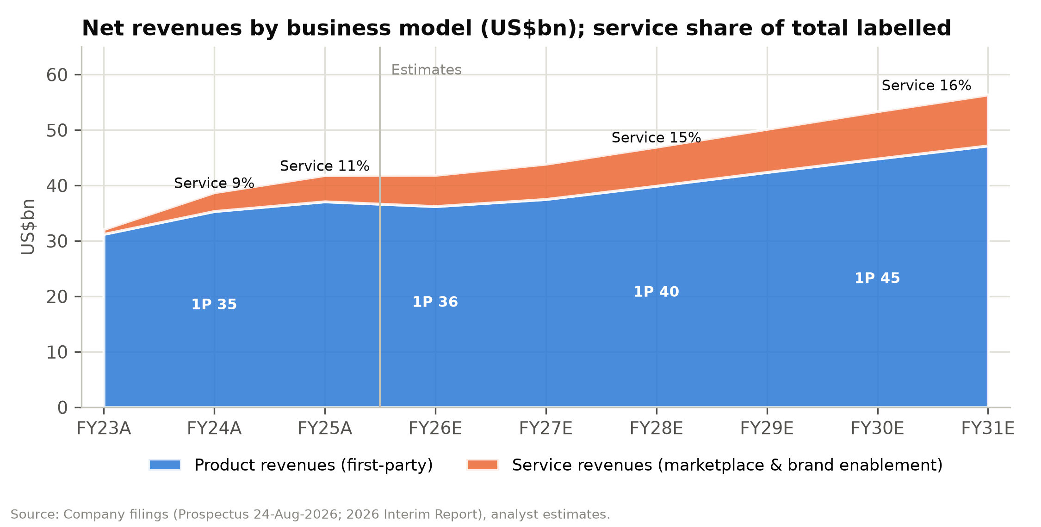

Figure 36: Operating KPI dashboard: customers, orders, frequency and revenue per order
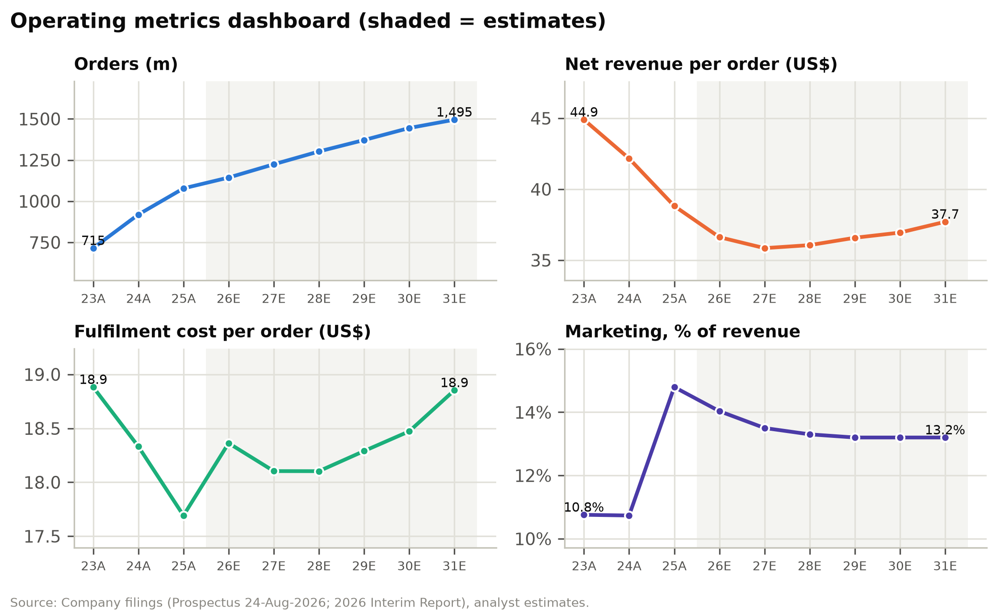

Costs and margins
We model cost of sales as a percentage of product revenue: 34.0% in 2H26E and 34.3% in FY2027E, easing to 34.0% by FY2030E, in line with about 34% in 1H26. Tariff costs on direct shipments sit in fulfilment, and input costs (polyester, China apparel PPI) are benign. Blended gross margin rises from 70.3% in FY2026E to 71.5% in FY2031E, mainly because of marketplace mix.
Fulfilment is the assumption that matters most. We set it at 51.0% of revenue in 2H26E, above 1H26's 49.2%, because the EU duty now applies and freight had not normalised by June. It eases to 50.5% in FY2027E and 50.0% from FY2029E. Fulfilment per order therefore stays at US$18.1-18.9, above FY2025's US$17.7. A return to the FY2025 ratio of 45.6% would add about US$2bn to FY2027E EBIT, which we treat as upside and leave out of the base case.
Marketing is 13.5% of revenue in 2H26E and FY2027E, easing to 13.2% by FY2029E. Technology and content stay at 2.4% of revenue as investment continues, and G&A at 1.3%. Share-based compensation rises from US$90m in FY2026E to US$120m by FY2031E. The 27.1m share awards granted on 1 October 2026 under the post-IPO scheme (worth about US$107m at the grant-date price and vesting over up to 48 months) could push it higher; adjusted earnings exclude it.
The EBIT margin comes out at 2.5% in FY2026E, 3.0% in FY2027E, 3.7% in FY2028E, 4.3% in FY2029E and 4.6% by FY2031E. The adjusted EBIT margin is 2.7% in FY2026E, 3.2% in FY2027E and 4.9% by FY2031E. Adjusted EBIT rises from US$1.13bn in FY2026E to US$1.41bn in FY2027E, US$1.86bn in FY2028E and US$2.74bn in FY2031E.
Figure 37: Margin, cost and capital assumptions, FY2023A-FY2031E
Driver | FY23A | FY24A | FY25A | FY26E | FY27E | FY28E | FY29E | FY30E | FY31E
Cost of sales % of product revenue | 40.9% | 43.1% | 36.2% | 34.3% | 34.3% | 34.2% | 34.1% | 34.0% | 34.0%
Gross margin | 60.2% | 60.6% | 67.9% | 70.3% | 70.7% | 70.9% | 71.2% | 71.4% | 71.5%
Fulfilment % of revenue | 42.1% | 43.5% | 45.6% | 50.1% | 50.5% | 50.2% | 50.0% | 50.0% | 50.0%
Fulfilment per order (US$) | 18.88 | 18.33 | 17.69 | 18.36 | 18.10 | 18.10 | 18.29 | 18.47 | 18.85
Contribution margin | 18.1% | 17.2% | 22.3% | 20.2% | 20.2% | 20.7% | 21.2% | 21.4% | 21.5%
Marketing % of revenue | 10.8% | 10.7% | 14.8% | 14.0% | 13.5% | 13.3% | 13.2% | 13.2% | 13.2%
Technology & content % of revenue | 2.1% | 2.2% | 2.1% | 2.4% | 2.4% | 2.4% | 2.4% | 2.4% | 2.4%
G&A % of revenue | 1.0% | 1.7% | 1.3% | 1.3% | 1.3% | 1.3% | 1.3% | 1.3% | 1.3%
Operating (EBIT) margin | 4.3% | 2.5% | 4.1% | 2.5% | 3.0% | 3.7% | 4.3% | 4.5% | 4.6%
SBC (US$m) | 49 | 71 | 85 | 90 | 100 | 105 | 110 | 115 | 120
Adjusted EBIT margin | 4.4% | 2.7% | 4.3% | 2.7% | 3.2% | 4.0% | 4.5% | 4.8% | 4.9%
EBITDA margin (IFRS 16) | 4.8% | 3.3% | 5.0% | 3.6% | 4.1% | 4.8% | 5.4% | 5.7% | 5.8%
Interest yield on cash |  | 5.4% | 4.7% | 4.1% | 3.6% | 3.4% | 3.3% | 3.3% | 3.3%
Interest income (US$m) | 472 | 597 | 621 | 585 | 501 | 507 | 534 | 582 | 633
Core effective tax rate | 11.4% | 26.8% | 20.6% | 24.2% | 22.0% | 22.0% | 22.0% | 22.0% | 22.0%
Capex % of revenue | 0.97% | 0.74% | 0.53% | 0.70% | 0.75% | 0.75% | 0.75% | 0.75% | 0.75%
Operating NWC % of revenue | (7.7%) | (7.5%) | (9.6%) | (9.8%) | (9.8%) | (9.8%) | (9.8%) | (9.8%) | (9.8%)
Source: Company filings, analyst estimates.

Below-the-line and per-share estimates
We model interest income at a yield on opening cash resources of 4.1% in FY2026E, 3.6% in FY2027E and 3.3% from FY2029E, which gives US$585m in FY2026E and US$501m in FY2027E. Interest is about 27% of FY2027E adjusted pre-tax profit, which is why the valuation section also looks at ex-cash multiples. We forecast no exchange gains or losses beyond the US$151m loss reported in 1H26, nothing from associates, and a small negative "others, net" line (lease interest and credit losses) of US$66-85m a year. Tax is 22% from FY2027E; FY2026E is 24.2%, combining the 1H26 rate with 23% for 2H26E.
Diluted shares are 4,445.9m: 4,246.2m in issue after the IPO, 156.6m options with near-nil exercise prices, 15.9m pre-IPO RSUs and the 27.1m share awards granted on 1 October 2026. We add 0.5% a year from FY2027E for further equity awards, and we show historical per-share figures on the post-IPO share base so the years compare.
Adjusted diluted EPS is HK$2.03 in FY2026E, HK$2.56 in FY2027E, HK$3.17 in FY2028E and HK$4.46 in FY2031E. The fair-value gains lift FY2026E IFRS diluted EPS to US$1.56. Assuming a 50% payout of adjusted net income, DPS is HK$1.01 for FY2026E (paid in 2027), HK$1.28 for FY2027E and HK$1.58 for FY2028E.

Our estimates against guidance and the share price
Five weeks after listing, little sell-side research has been published, so we compare our estimates with the company's guidance and with what the share price implies. Management is "cautiously optimistic" about 2H26 adjusted net income and expects the operating environment to stay difficult. Our 2H26E adjusted net income of US$651m (3.0% margin) is above 1H26's US$499m and well below 2H25's US$693m, which we think is a prudent reading of that guidance.
The share price implies that SHEIN's margins never recover. At HK$33.22 we estimate the market is pricing a steady-state EBIT margin of about 1.5-2.5% with no growth, no better than SHEIN's weakest year (2.5% in FY2024). Our base case has margins returning to around their FY2023 and FY2025 levels by FY2029E and going no higher.

Scenario analysis
SHEIN's equity value turns on two questions: whether Europe follows the US path after the duty change, and how much of the 2Q26 margin squeeze reverses. We run three full scenarios through the model to cover them. One selector on the Scenarios tab switches every FY2027E-FY2031E driver, and each scenario re-runs the three statements, the DCF and the P/E valuation. All three pass the model's integrity checks, including the balance-sheet balance and the cash reconciliation. The 2H26E assumptions are the same in every case because that half-year is already under way.

Scenario definitions
In the bull case, Europe follows the US and freight normalises. European revenue returns to growth in FY2027E (+2%) as local warehousing offsets the €3 duty, then grows 6%. The US recovers to +5%, and the rest of the world grows 16% in FY2027E, slowing to 9%. Fulfilment falls to 49.8% of revenue in FY2027E and 49.3% by FY2031E, marketing eases to 12.8%, and higher price points lift product margins. Revenue grows at an 8.6% CAGR over FY2026E-31E, and the adjusted EBIT margin reaches 6.6% by FY2031E, still well below Inditex's.
In the base case, margins grind slowly back to their historical level. Europe declines 4% in FY2027E as it laps a first half that predates the duty, then grows 4-5%. The US grows 2-4%, and the rest of the world grows 12%, slowing to 7%. Fulfilment is 50.5% of revenue in FY2027E, easing to 50.0%, and marketing eases to 13.2%. Revenue grows at a 6.1% CAGR, and the adjusted EBIT margin reaches 4.9% by FY2031E, around its FY2023 and FY2025 levels.
In the bear case, Europe keeps shrinking and margins stay near the trough. Europe falls another 10% in FY2027E and grows only 3% after that. The US declines 4% in FY2027E, and rest-of-world growth slows to 8% and then 4%. Fulfilment stays above 50.8% of revenue, marketing stays at 13.6-13.8%, and customer growth slows to 2-3%. Revenue grows at a 2.8% CAGR, and the adjusted EBIT margin is 1.8% in FY2027E and 3.0% by FY2031E, close to the 1H26 trough.
Figure 38: Scenario assumptions (FY2027E and FY2031E)
Driver | Bull 27E | Base 27E | Bear 27E | Bull 31E | Base 31E | Bear 31E
US growth | 5.0% | 2.0% | (4.0%) | 5.0% | 3.5% | 2.0%
Europe growth | 2.0% | (4.0%) | (10.0%) | 6.0% | 4.5% | 3.0%
Rest-of-world growth | 16.0% | 12.0% | 8.0% | 9.0% | 7.0% | 4.0%
COGS % product revenue | 34.0% | 34.3% | 34.6% | 33.5% | 34.0% | 34.6%
Fulfilment % revenue | 49.8% | 50.5% | 51.2% | 49.3% | 50.0% | 50.8%
Marketing % revenue | 13.3% | 13.5% | 13.8% | 12.8% | 13.2% | 13.6%
Tech & content % revenue | 2.3% | 2.4% | 2.5% | 2.3% | 2.4% | 2.5%
G&A % revenue | 1.2% | 1.3% | 1.4% | 1.2% | 1.3% | 1.4%
Active customer growth | 8.0% | 6.0% | 3.0% | 5.0% | 3.5% | 2.0%
Source: Company filings, analyst estimates.

Scenario outputs
FY2027E adjusted EPS ranges from HK$1.64 in the bear case to HK$3.48 in the bull case, more than a 2x spread around our HK$2.56 base case. The blended value per share has a much tighter floor, ranging from HK$29.48 to HK$61.00, because all three cases share about HK$20 per share of net cash after our US$2.5bn of haircuts.
The bear-case value is 11% below the current share price, while the base case is 35% above it and the bull case 84% above. That imbalance between downside and upside is the main reason we rate the stock BUY.
Cumulative unlevered free cash flow over 2H26E-FY2031E ranges from US$3.4bn in the bear case to US$12.8bn in the bull case. Even in the bear case, SHEIN generates enough cash to pay its 50% dividend without running down the balance sheet.
Figure 39: Scenario outputs (full-model re-runs)
Metric | Bull | Base | Bear
FY27E revenue (US$m) | 45,735 | 43,890 | 41,768
FY31E revenue (US$m) | 63,311 | 56,376 | 48,063
Revenue CAGR FY26E-31E | 8.6% | 6.1% | 2.8%
FY27E adj. EBIT margin | 4.5% | 3.2% | 1.8%
FY31E adj. EBIT margin | 6.6% | 4.9% | 3.0%
FY27E adj. net income (US$m) | 1,982 | 1,457 | 936
FY27E adj. EPS (HK$) | 3.48 | 2.56 | 1.64
FY31E adj. net income (US$m) | 3,749 | 2,589 | 1,514
Cumulative FCFF 2H26E-31E (US$m) | 12,843 | 8,082 | 3,370
DCF value (HK$/sh) | 73.29 | 54.09 | 35.94
P/E value @14x (HK$/sh) | 48.72 | 35.82 | 23.01
Blended value (HK$/sh) | 61.00 | 44.96 | 29.48
vs. current price | 84% | 35% | (11%)
Source: Company filings, analyst estimates.
Figure 40: Bull, base and bear revenue and operating (EBIT) margin paths
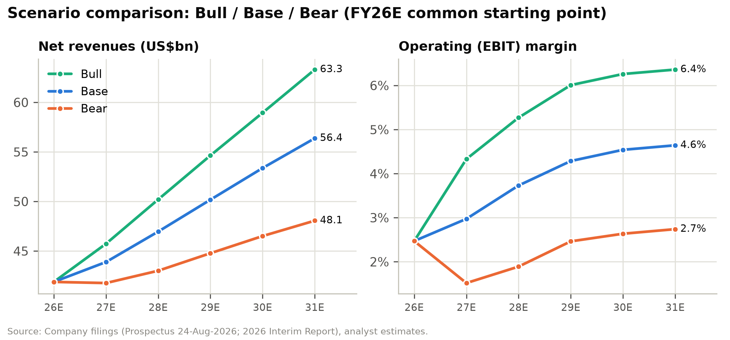

Figure 41: Bear, base and bull value per share vs. current price and target (HK$)
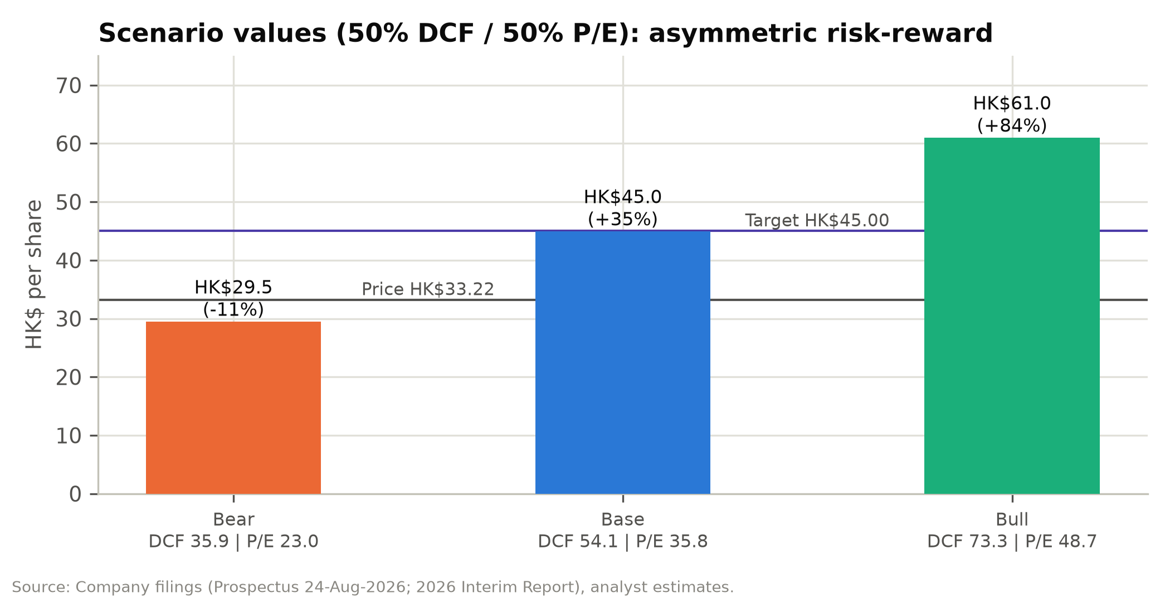

Our price target uses the base case only. A 25/50/25 bull/base/bear weighting would give HK$45.10, almost the same as the base-case blended value, because the bull and bear cases sit about the same distance from the base case in Hong Kong dollars. Measured against today's price, though, the bull case offers far more upside than the bear case has downside.

Valuation
We value SHEIN with a 50/50 blend of a discounted cash flow model and a P/E multiple on FY2027E adjusted EPS, and cross-check the result against trading comparables, SHEIN's private funding rounds and the expectations built into the current share price. Our 12-month price target is HK$45.00, 35.5% above the 6 October 2026 close of HK$33.22, and we rate the stock BUY.
Figure 42: Price target derivation (HK$ per share)
Method | Value | Weight | Contribution
DCF (WACC 11.2%, g 2.5%) | 54.09 | 50% | 27.04
P/E: 14.0x FY27E adj. EPS | 35.82 | 50% | 17.91
Weighted value |  |  | 44.96
Price target (rounded to HK$0.50) |  |  | 45.00
Current price (6-Oct-2026) |  |  | 33.22
Upside |  |  | 35.5%
Implied P/E FY26E / FY27E |  |  | 22.2x / 17.6x
Implied EV/FY27E adj. EBIT |  |  | 8.3x
Source: Company filings, analyst estimates.
At our target the implied market capitalisation is US$25.5bn, just below the IPO valuation of about US$26bn. The stock would then trade at 22.2x FY2026E and 17.6x FY2027E adjusted P/E, and at 8.3x FY2027E EV/adjusted EBIT after deducting pro forma cash. All three multiples are below the peer medians.

Discounted cash flow

Methodology
Unlevered free cash flow is EBIT × (1 − 22% tax) + D&A (PP&E and intangibles) − capex − the change in operating NWC. We treat share-based compensation as a real cost and do not add it back. We also treat IFRS 16 lease payments as operating costs: right-of-use depreciation is not added back, and lease liabilities are not deducted in the equity bridge.
The explicit forecast covers a 2H26E stub plus FY2027E-FY2031E, discounted to the 6-Oct-2026 valuation date on a mid-period convention. The cash starting point is the 30-Jun-2026 balance sheet. The stub FCFF includes the usual second-half working-capital unwind of US$0.9bn, which offsets the working-capital float in the June cash balance.

Discount rate
We use an 11.2% WACC. SHEIN has no financial debt, so the WACC equals the cost of equity, which we derive from CAPM. The 4.0% risk-free rate matches the rate the company's valuer used for the 30 June 2026 preferred-share valuation. The beta of 1.2 reflects Hong Kong-listed consumer-internet peers and the ~40% volatility assumed in the company's own option valuation. The 6.0% equity risk premium includes a premium for China-linked geopolitical risk.
Our 2.5% terminal growth rate is roughly nominal global GDP growth and well below CIC's forecast CAGR of 5.5% for online fashion over 2025-30E.
Figure 43: Discount-rate assumptions
Input | Value
Risk-free rate | 4.0%
Equity beta | 1.20
Equity risk premium | 6.0%
Cost of equity | 11.2%
Debt / capital | 0.0%
WACC | 11.2%
Terminal growth | 2.5%
Tax rate on EBIT | 22.0%
Source: Company filings, analyst estimates.

Free cash flow, terminal value and enterprise value
In the base case, unlevered free cash flow is –US$519m in the 2H26E stub, because the usual second-half working-capital unwind (US$0.9bn) is larger than NOPAT. It is US$1,089m in FY2027E and US$2,154m in FY2031E. Growth adds to cash flow, because negative working capital grows with revenue.
The present value of 2H26E-FY2031E FCFF is US$5.8bn and the present value of the Gordon-growth terminal value is US$13.5bn, 70% of the total. Operating enterprise value is US$19.3bn. The implied terminal multiples are 7.2x FY2031E EBITDA and 9.0x EBIT, both well below the peer median EV/EBITDA of 14.1x, so the terminal value is not stretched.
Figure 44: DCF - unlevered free cash flow (US$m)
US$m | 2H26E | FY27E | FY28E | FY29E | FY30E | FY31E
Net revenues | 21,749 | 43,890 | 46,960 | 50,175 | 53,370 | 56,376
EBIT (IFRS) | 542 | 1,305 | 1,752 | 2,150 | 2,423 | 2,617
EBIT margin | 2.5% | 3.0% | 3.7% | 4.3% | 4.5% | 4.6%
Taxes on EBIT (22%) | (119) | (287) | (385) | (473) | (533) | (576)
NOPAT | 422 | 1,018 | 1,366 | 1,677 | 1,890 | 2,041
+ D&A | 93 | 189 | 202 | 216 | 229 | 242
- Capex | (153) | (329) | (352) | (376) | (400) | (423)
- Increase in NWC | (881) | 211 | 288 | 305 | 312 | 294
FCFF | (519) | 1,089 | 1,504 | 1,822 | 2,031 | 2,154
Discount factor | 1.000 | 0.925 | 0.832 | 0.748 | 0.673 | 0.605
PV of FCFF | (519) | 1,007 | 1,251 | 1,363 | 1,367 | 1,303
Source: Company filings, analyst estimates.

Equity bridge
We start from the audited cash position at 30 June 2026 and adjust it for the listing-related flows: we add IPO net proceeds of HK$13.2bn (US$1.68bn) and deduct the US$2.2bn Conversion Adjustment cash paid to Series Pre-D, D and D+ holders, the US$587m of preferred distributions paid after 30 June, and restricted cash. That leaves US$13.5bn of pro forma unrestricted cash.
We then make two deductions on purpose. We hold back US$1.5bn of minimum operating cash, about 3.5% of revenue, because the business runs on negative working capital. We also set aside a US$1.0bn reserve for the open regulatory matters: the EU Digital Services Act investigation (maximum fine 6% of global turnover), the FTC investigation, the CNIL appeal and the Irish DPC inquiry.
Adding US$0.4bn of associates and investments gives an equity value of US$30.7bn, or HK$54.09 per diluted share, of which net cash and investments after the deductions are HK$20.11. We do not deduct lease liabilities (US$1.1bn), because lease costs are already inside FCFF.
Figure 45: DCF enterprise value to equity value (US$m)
Item | Value
Sum of PV of FCFF (2H26E-FY31E) | 5,772
PV of terminal value | 13,484
Operating enterprise value | 19,256
Terminal value % of EV | 70.0%
+ Cash resources, 30-Jun-2026 | 15,248
- Restricted cash | (660)
+ IPO net proceeds | 1,684
- Conversion Adjustment cash | (2,200)
- Preferred distributions after 30-Jun | (587)
- Minimum operating cash | (1,500)
- Regulatory contingency reserve | (1,000)
+ Associates & FVTPL investments | 411
Equity value | 30,652
Diluted shares (m) | 4,445.9
DCF value per share (US$) | 6.89
DCF value per share (HK$) | 54.09
Implied terminal EV/EBITDA | 7.2x
Implied P/E on FY27E adj. EPS | 21.1x
Source: Company filings, analyst estimates.
Figure 46: DCF value per share build-up (HK$)
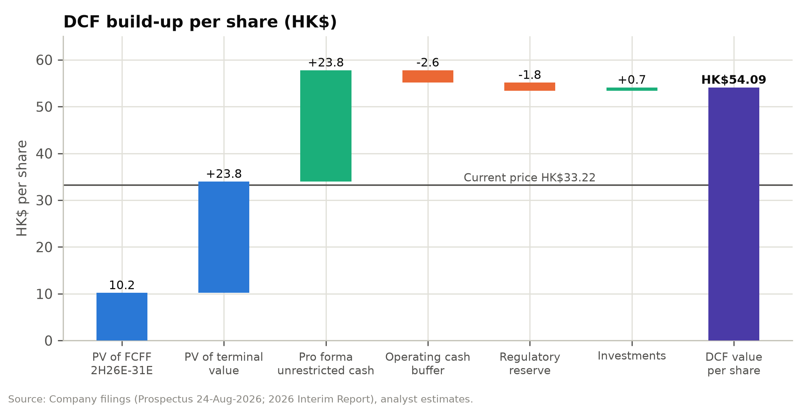

Sensitivity analysis
Across WACC of 9.7-12.7% and terminal growth of 1.5-3.5%, the DCF value ranges from HK$46.49 to HK$67.87. The second grid varies the two operating drivers that matter most, the revenue CAGR and the FY2031E EBIT margin, and gives HK$35.76-76.85. That grid is a simplified re-computation around the base case, so its central cell (HK$53.43) differs slightly from the full-model DCF value.
Every cell in both grids is above the current share price. The most pessimistic combination tested, a 2.1% revenue CAGR with a 2.6% terminal EBIT margin, still gives HK$35.76 per share. The balance sheet puts a floor close to today's price, and the market is valuing the operating business at close to zero.
Figure 47: DCF value per share (HK$) - WACC vs terminal growth
WACC \ g | 1.5% | 2.0% | 2.5% | 3.0% | 3.5%
9.7% | 56.86 | 59.08 | 61.60 | 64.50 | 67.87
10.2% | 54.63 | 56.57 | 58.77 | 61.27 | 64.14
10.7% | 52.65 | 54.36 | 56.28 | 58.46 | 60.93
11.2% | 50.87 | 52.39 | 54.09 | 55.99 | 58.15
11.7% | 49.26 | 50.62 | 52.13 | 53.81 | 55.70
12.2% | 47.81 | 49.03 | 50.38 | 51.87 | 53.54
12.7% | 46.49 | 47.59 | 48.80 | 50.13 | 51.61
Source: Company filings, analyst estimates.
Figure 48: DCF sensitivity heatmap: WACC vs. terminal growth (HK$ per share)
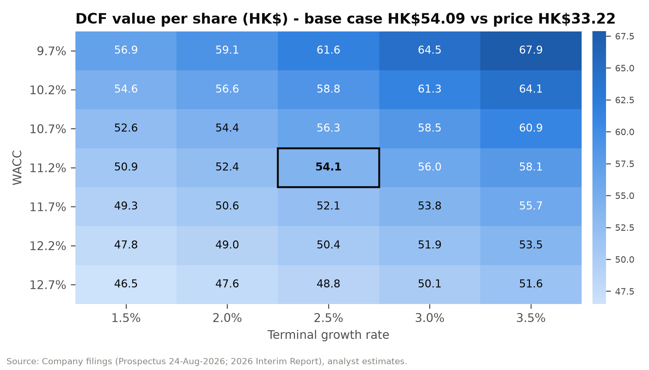

Figure 49: DCF value per share (HK$) - revenue CAGR FY26E-31E vs FY31E EBIT margin
CAGR \ margin | 2.6% | 3.6% | 4.6% | 5.6% | 6.6%
2.1% | 35.76 | 41.40 | 47.04 | 52.68 | 58.31
4.1% | 37.78 | 43.95 | 50.12 | 56.29 | 62.46
6.1% | 39.94 | 46.69 | 53.43 | 60.18 | 66.92
8.1% | 42.26 | 49.62 | 56.99 | 64.35 | 71.71
10.1% | 44.74 | 52.77 | 60.79 | 68.82 | 76.85
Source: Company filings, analyst estimates.

Comparable companies

Peer selection
No listed company matches SHEIN closely, so we use three peer groups. Global apparel retailers (Inditex, H&M, Fast Retailing) are vertically integrated fashion brands, which is how SHEIN describes itself. Online fashion retailers (Zalando, ASOS, Revolve) run digital fashion models with similar customer-acquisition economics. E-commerce platforms (PDD/Temu, Alibaba/AliExpress, JD.com, Amazon, MercadoLibre) are the marketplaces and China-linked cross-border sellers that investors compare SHEIN with in practice.

Trading multiples
SHEIN's enterprise value is US$4.9bn: the fully diluted market cap less pro forma cash and investments, before any deductions. On that basis it trades at 0.12x EV/Sales, 3.1x EV/EBITDA and 4.3x EV/EBIT on trailing figures, against peer medians of 1.4x, 14.1x and 24.1x. Among the peers, only PDD is valued at similar multiples of EBITDA and EBIT.
P/E includes the interest earned on SHEIN's cash. On that measure SHEIN trades at 15.8x LTM and 13.6x NTM adjusted earnings, discounts of 31% and 33% to the peer medians of 22.8x and 20.3x.
PDD Holdings (Temu) has the most similar valuation, at 3.0x EV/EBITDA and 6.8x NTM P/E. PDD's cash, though, is held largely in China, and it has no dividend commitment.
Figure 50: Trading comparables (peer prices 29/30-Sep-2026; SHEIN at 6-Oct-2026 close)
Company | Segment | Mkt cap US$bn | EV/Sales LTM | EV/EBITDA LTM | EV/EBIT LTM | P/E LTM | P/E NTM | EBITDA mgn
Inditex | Global apparel | 189.2 | 3.9x | 14.1x | 19.2x | 25.9x | 23.5x | 23.7%
H&M | Global apparel | 25.3 | 1.4x | 8.2x | 15.3x | 19.0x | 19.3x | 11.3%
Fast Retailing | Global apparel | 138.6 | 5.4x | 22.6x | 29.0x | 42.1x | 38.8x | 20.1%
Zalando | Online fashion | 6.0 | 0.4x | 6.4x | 12.4x | 59.3x | 12.9x | 4.8%
ASOS | Online fashion | 0.8 | 0.5x | n.m. | n.m. | n.m. | n.m. | (3.2%)
Revolve | Online fashion | 1.5 | 0.9x | 14.1x | 15.0x | 21.0x | 21.2x | 6.7%
PDD Holdings (Temu) | E-com platform | 110.3 | 0.7x | 3.0x | 3.0x | 8.5x | 6.8x | 22.0%
Alibaba (AliExpress) | E-com platform | 267.8 | 1.6x | 17.1x | 35.7x | 24.6x | 13.6x | 9.5%
JD.com | E-com platform | 35.4 | 0.1x | 7.2x | 39.0x | 18.1x | 6.4x | 0.9%
Amazon | E-com platform | 2,660.0 | 3.6x | 16.5x | 29.8x | 19.8x | 26.3x | 21.8%
MercadoLibre | E-com platform | 87.5 | 2.7x | 24.4x | 32.7x | 46.9x | 41.0x | 11.1%
SHEIN (at HK$33.22) | Subject | 18.8 | 0.12x | 3.1x | 4.3x | 15.8x | 13.6x | 3.8%
Maximum |  |  | 5.4x | 24.4x | 39.0x | 59.3x | 41.0x | 23.7%
75th percentile |  |  | 3.2x | 16.9x | 31.9x | 38.0x | 25.6x | 21.0%
Median |  |  | 1.4x | 14.1x | 24.1x | 22.8x | 20.3x | 11.1%
25th percentile |  |  | 0.6x | 7.5x | 15.1x | 19.2x | 13.1x | 5.7%
Minimum |  |  | 0.1x | 3.0x | 3.0x | 8.5x | 6.4x | (3.2%)
Source: stockanalysis.com (peers; LTM to latest report, NTM consensus), company filings, analyst estimates. FX approximate.
Figure 51: Trading comparables: EV/EBITDA vs. EBITDA margin (LTM)
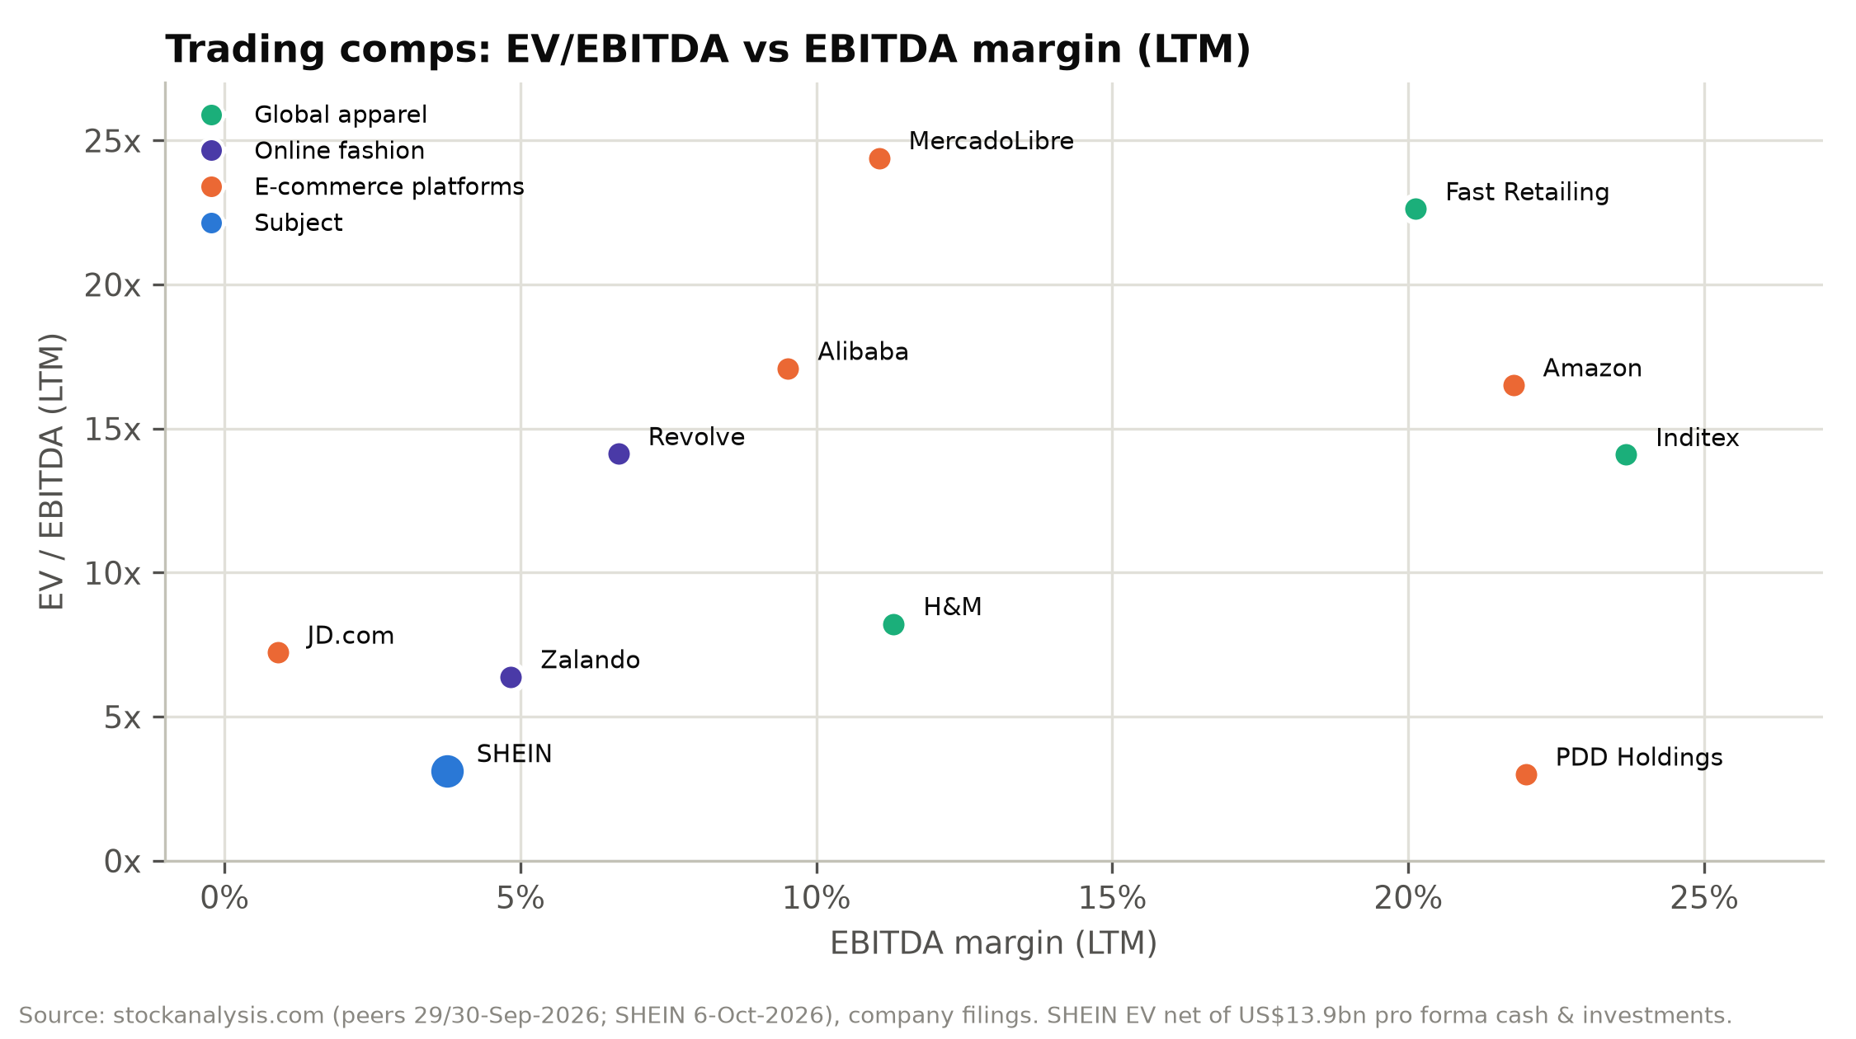

Figure 52: Peer NTM P/E comparison
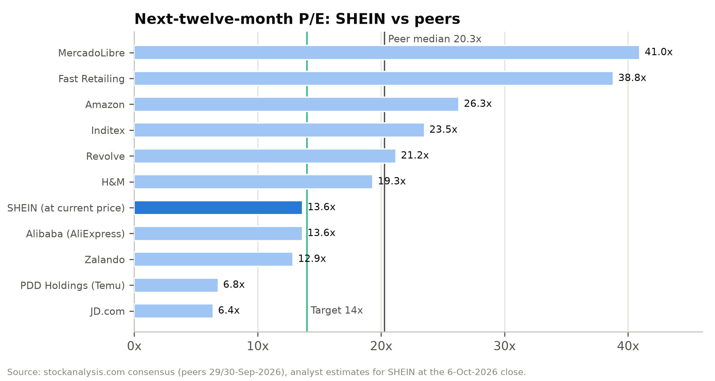

Figure 53: Implied values from peer multiples
Method | Multiple | HK$/share | vs. price
All-peer median P/E NTM × NTM EPS | 20.3x | 49.37 | +49%
Global apparel median P/E NTM | 23.5x | 57.27 | +72%
Online fashion median P/E NTM | 17.0x | 41.50 | +25%
E-commerce platforms median P/E NTM | 13.6x | 33.20 | 0%
EV/FY27E adj. EBIT 8x-12x + valuation net cash | 8-12x | 39.9-49.9 | +20-50%

We apply 14x to FY2027E adjusted EPS. That is the e-commerce-platform median and the 25th percentile of all peers, and well below the apparel retailers whose operating model SHEIN most resembles. The discount reflects SHEIN's lower margins (3-4% operating, against 12-20% for Inditex and Fast Retailing), its trade-policy and regulatory exposure, and its WVR governance. At 14x the implied ex-cash P/E is only about 8x (after deducting HK$20.1/share of net cash and the after-tax interest income), because roughly 27% of FY2027E adjusted pre-tax profit is interest income.
We do not use PDD's 7x. PDD trades at 3x EV/EBITDA partly because its cash is held largely in China and its core domestic business faces intense competition. SHEIN's cash is mostly US-dollar deposits held by a Singapore-headquartered group, and its board has committed to paying out at least 50% of profit.

Precedent transactions
No control transaction of comparable size exists. SHEIN's own private funding rounds are the most useful reference points:
Figure 54: SHEIN's private funding rounds vs. the current share price
Round | Date | Pre-money valuation | Price/share (split-adj.) | vs. HK$33.22 (US$4.23)
Series C+ | Mar-2020 | US$5.0bn | US$1.28 | Below
Series D | Mar/Apr-2022 | US$98.2bn | US$23.72 | 5.6x
Series D+ | May-Dec-2023 | US$64.0bn | US$15.02 | 3.6x
IPO | Sep-2026 | ~US$26bn | US$6.19 (HK$48.56) | 1.5x
Current | 6-Oct-2026 | ~US$18.8bn (diluted) | US$4.23 | n.a.

SHEIN's valuer carried the preferred shares at US$15.1bn at 30 June 2026. At listing, the 1,397.7m Class B shares issued on conversion were worth US$8.65bn at the IPO price. Adding the US$2.2bn of cash compensation and the US$0.23bn 12% distribution gives a conversion value of about US$11.1bn, so we expect a non-cash fair-value gain of about US$4.0bn in 2H26. The gain will lift FY2026E IFRS net income to about US$6.9bn (diluted EPS US$1.56). It has no effect on cash, equity or adjusted earnings, which we use throughout.

Valuation football field
The DCF range (HK$50.62-58.46), the IPO range and the upper half of the peer P/E range all sit above our HK$45 target. The 12x-16x P/E band (from HK$30.71), the post-listing low (HK$29.90) and the bear-case scenario (HK$29.48) sit close to today's price. Our target is near the mid-point of the combined ranges, and below both the IPO range (HK$47.60-49.50) and the DCF range.
Figure 55: Valuation ranges (HK$ per share)
Method | Low | High
Trading range since listing | 29.90 | 48.56
IPO indicative price range | 47.60 | 49.50
DCF (WACC +/-0.5pp, g +/-0.5pp) | 50.62 | 58.46
P/E 12x-16x FY2027E adj. EPS | 30.71 | 40.94
Peer P/E NTM, 25th-75th percentile x NTM EPS | 31.82 | 62.37
EV / FY2027E adj. EBIT 8x-12x + valuation net cash | 39.94 | 49.86
Scenario blended value (Bear to Bull) | 29.48 | 61.00
Source: Company filings, analyst estimates.
Figure 56: Valuation football field (HK$ per share)
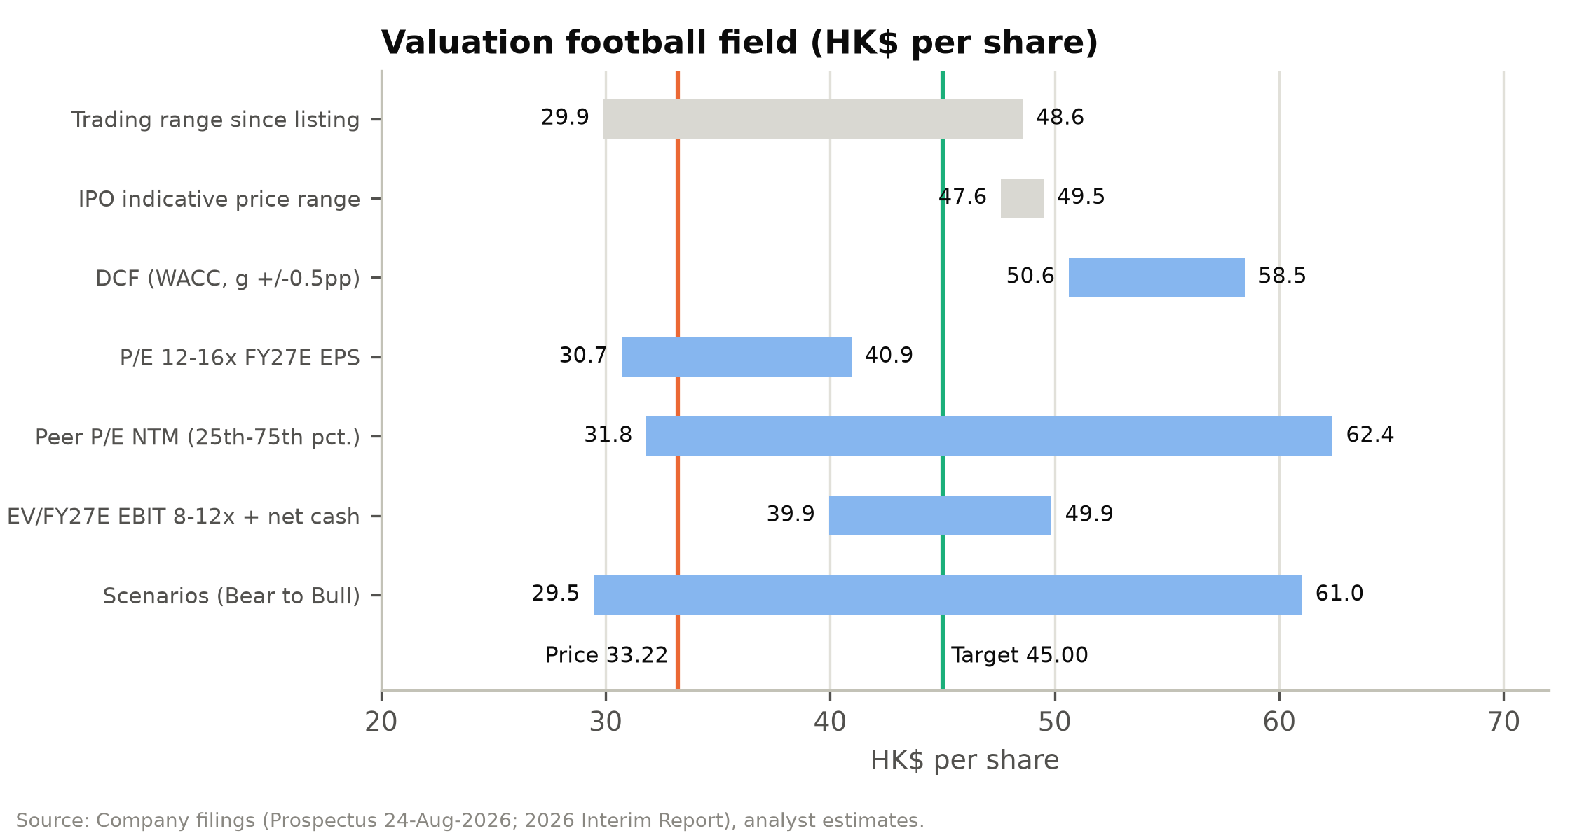

Sanity checks
- At HK$33.22 and an 11.2% WACC, the market price implies a steady-state EBIT margin of roughly 1.5-2.5% with no growth. SHEIN has reported annual margins of 2.5-4.3%, and its 1H26 trough was 2.4%.
- At our target, EV/FY27E adjusted EBIT is 8.3x and P/E is 17.6x. Both are below the peer medians of 24.1x EV/EBIT and 20.3x NTM P/E.
- The IPO priced at HK$48.56, and the 2023 Series D+ round at US$15.02 per share (split-adjusted). Our HK$45 target is below both.
- Pro forma unrestricted cash is HK$23.8/share, 72% of the current price (HK$24.5, or 74%, including investments). After our US$2.5bn of haircuts, net cash is still HK$20.1/share.

Rating definitions
Our ratings are based on expected total return (share price change plus dividends) over 12 months. BUY means more than 15%, HOLD between –10% and +15%, and SELL below –10%. SHEIN's expected return to our HK$45.00 target is 35.5% before dividends, or about 38.5% including the estimated FY2026E dividend, so we rate it BUY.

Appendix A: Financial statements
Source: SHEIN_Financial_Model_2026-10-06.xlsx, which also contains the 2H26E drivers, the scenario selector and the integrity checks. Historical years are from the Accountants' Report in the prospectus. Per-share data use the post-IPO share base for all years.
Income statement, FY2023A-FY2031E
US$m | FY23A | FY24A | FY25A | FY26E | FY27E | FY28E | FY29E | FY30E | FY31E
Net revenues (US$m)
Net revenues | 32,103 | 38,748 | 41,847 | 41,883 | 43,890 | 46,960 | 50,175 | 53,370 | 56,376
YoY growth |  | 20.7% | 8.0% | 0.1% | 4.8% | 7.0% | 6.8% | 6.4% | 5.6%
Product revenues | 31,235 | 35,351 | 37,107 | 36,246 | 37,526 | 39,916 | 42,398 | 44,831 | 47,186
Service revenues | 868 | 3,397 | 4,740 | 5,637 | 6,364 | 7,044 | 7,777 | 8,539 | 9,189
Operating expenses (US$m; shown as positive costs)
Cost of sales | 12,777 | 15,249 | 13,433 | 12,422 | 12,871 | 13,651 | 14,458 | 15,242 | 16,043
% of product revenues | 40.9% | 43.1% | 36.2% | 34.3% | 34.3% | 34.2% | 34.1% | 34.0% | 34.0%
% of net revenues | 39.8% | 39.4% | 32.1% | 29.7% | 29.3% | 29.1% | 28.8% | 28.6% | 28.5%
Gross profit | 19,326 | 23,499 | 28,414 | 29,460 | 31,018 | 33,309 | 35,717 | 38,128 | 40,332
Gross margin | 60.2% | 60.6% | 67.9% | 70.3% | 70.7% | 70.9% | 71.2% | 71.4% | 71.5%
Fulfilment expenses (logistics, warehousing, duties on direct shipments) | 13,501 | 16,847 | 19,072 | 21,001 | 22,164 | 23,574 | 25,087 | 26,685 | 28,188
% of net revenues | 42.1% | 43.5% | 45.6% | 50.1% | 50.5% | 50.2% | 50.0% | 50.0% | 50.0%
per order (US$) | 18.88 | 18.33 | 17.69 | 18.36 | 18.10 | 18.10 | 18.29 | 18.47 | 18.85
Contribution after fulfilment | 5,825 | 6,652 | 9,342 | 8,460 | 8,854 | 9,735 | 10,630 | 11,443 | 12,144
Contribution margin | 18.1% | 17.2% | 22.3% | 20.2% | 20.2% | 20.7% | 21.2% | 21.4% | 21.5%
Marketing expenses | 3,453 | 4,159 | 6,191 | 5,877 | 5,925 | 6,246 | 6,623 | 7,045 | 7,442
% of net revenues | 10.8% | 10.7% | 14.8% | 14.0% | 13.5% | 13.3% | 13.2% | 13.2% | 13.2%
Technology & content expenses | 668 | 849 | 896 | 999 | 1,053 | 1,127 | 1,204 | 1,281 | 1,353
% of net revenues | 2.1% | 2.2% | 2.1% | 2.4% | 2.4% | 2.4% | 2.4% | 2.4% | 2.4%
General & administrative expenses | 328 | 678 | 548 | 549 | 571 | 610 | 652 | 694 | 733
% of net revenues | 1.0% | 1.7% | 1.3% | 1.3% | 1.3% | 1.3% | 1.3% | 1.3% | 1.3%
Total operating expenses | 30,727 | 37,782 | 40,140 | 40,848 | 42,584 | 45,208 | 48,024 | 50,947 | 53,759
% of net revenues | 95.7% | 97.5% | 95.9% | 97.5% | 97.0% | 96.3% | 95.7% | 95.5% | 95.4%
Operating income (EBIT, IFRS) | 1,376 | 966 | 1,707 | 1,035 | 1,305 | 1,752 | 2,150 | 2,423 | 2,617
Operating margin | 4.3% | 2.5% | 4.1% | 2.5% | 3.0% | 3.7% | 4.3% | 4.5% | 4.6%
YoY growth |  | (29.8%) | 76.7% | (39.4%) | 26.1% | 34.2% | 22.8% | 12.7% | 8.0%
Share-based compensation (included above) | 49 | 71 | 85 | 90 | 100 | 105 | 110 | 115 | 120
Adjusted EBIT (non-IFRS) | 1,425 | 1,037 | 1,792 | 1,125 | 1,405 | 1,857 | 2,260 | 2,538 | 2,737
Adjusted EBIT margin | 4.4% | 2.7% | 4.3% | 2.7% | 3.2% | 4.0% | 4.5% | 4.8% | 4.9%
D&A of PP&E and intangibles, % of revenues | 0.18% | 0.32% | 0.36% | 0.43% | 0.43% | 0.43% | 0.43% | 0.43% | 0.43%
D&A of property, equipment & intangibles | 58 | 124 | 151 | 180 | 189 | 202 | 216 | 229 | 242
Right-of-use depreciation, % of revenues | 0.37% | 0.52% | 0.59% | 0.68% | 0.68% | 0.68% | 0.68% | 0.68% | 0.68%
Depreciation of right-of-use assets (warehouse & office leases) | 119 | 200 | 247 | 285 | 298 | 319 | 341 | 363 | 383
EBITDA (IFRS 16) | 1,553 | 1,290 | 2,105 | 1,499 | 1,792 | 2,273 | 2,707 | 3,015 | 3,243
EBITDA margin | 4.8% | 3.3% | 5.0% | 3.6% | 4.1% | 4.8% | 5.4% | 5.7% | 5.8%
Adjusted EBITDA (ex SBC) | 1,602 | 1,361 | 2,190 | 1,589 | 1,892 | 2,378 | 2,817 | 3,130 | 3,363
Adjusted EBITDA margin | 5.0% | 3.5% | 5.2% | 3.8% | 4.3% | 5.1% | 5.6% | 5.9% | 6.0%
Non-operating items (US$m)
FV changes of convertible redeemable preferred shares | 1,231 | 2,431 | 328 | 5,884 | – | – | – | – | –
Share of income/(losses) from associates | (36) | (171) | 3 | (15) | – | – | – | – | –
Interest yield on opening cash resources |  | 5.4% | 4.7% | 4.1% | 3.6% | 3.4% | 3.3% | 3.3% | 3.3%
Interest income | 472 | 597 | 621 | 585 | 501 | 507 | 534 | 582 | 633
Exchange gain/(loss) | (34) | (55) | (95) | (151) | – | – | – | – | –
Others, net as % of revenues |  |  |  |  | – | – | – | – | –
Others, net (lease interest, FV of investments, credit losses) | (14) | 1 | (50) | (70) | (66) | (70) | (75) | (80) | (85)
Income before income taxes | 2,995 | 3,769 | 2,514 | 7,268 | 1,740 | 2,188 | 2,609 | 2,925 | 3,165
Income tax expense | 206 | 404 | 450 | 339 | 383 | 481 | 574 | 644 | 696
Effective tax rate (ex FV changes & associates) | 11.4% | 26.8% | 20.6% | 24.2% | 22.0% | 22.0% | 22.0% | 22.0% | 22.0%
Net income (IFRS) | 2,789 | 3,365 | 2,064 | 6,929 | 1,357 | 1,707 | 2,035 | 2,282 | 2,469
Net margin | 8.7% | 8.7% | 4.9% | 16.5% | 3.1% | 3.6% | 4.1% | 4.3% | 4.4%
Non-IFRS adjusted earnings (company definition)
Impairment / FV changes on long-term investments | – | (57) | (2) | 1 | – | – | – | – | –
Adjusted net income | 1,643 | 1,119 | 1,816 | 1,150 | 1,457 | 1,812 | 2,145 | 2,397 | 2,589
Adjusted net margin | 5.1% | 2.9% | 4.3% | 2.7% | 3.3% | 3.9% | 4.3% | 4.5% | 4.6%
YoY growth |  | (31.9%) | 62.3% | (36.7%) | 26.7% | 24.3% | 18.4% | 11.7% | 8.0%
Per-share data (pro forma post-IPO share base, all years)
Basic shares (m) | 4,246.2 | 4,246.2 | 4,246.2 | 4,246.2 | 4,267.4 | 4,288.8 | 4,310.2 | 4,331.8 | 4,353.4
Diluted shares (m) | 4,445.9 | 4,445.9 | 4,445.9 | 4,445.9 | 4,468.1 | 4,490.4 | 4,512.9 | 4,535.4 | 4,558.1
Diluted EPS, IFRS (US$) | 0.63 | 0.76 | 0.46 | 1.56 | 0.30 | 0.38 | 0.45 | 0.50 | 0.54
Adjusted diluted EPS (US$) | 0.37 | 0.25 | 0.41 | 0.26 | 0.33 | 0.40 | 0.48 | 0.53 | 0.57
Adjusted diluted EPS (HK$) | 2.90 | 1.97 | 3.20 | 2.03 | 2.56 | 3.17 | 3.73 | 4.15 | 4.46
YoY growth |  | (31.9%) | 62.3% | (36.7%) | 26.1% | 23.7% | 17.8% | 11.2% | 7.5%
Dividend payout ratio (of adj. net income) | 0.0% | 0.0% | 0.0% | 50.0% | 50.0% | 50.0% | 50.0% | 50.0% | 50.0%
Dividend declared in respect of year (US$m) | – | – | – | 575 | 729 | 906 | 1,073 | 1,198 | 1,294
DPS declared (HK$) | – | – | – | 1.01 | 1.28 | 1.58 | 1.86 | 2.07 | 2.23
Source: Company filings, analyst estimates (SHEIN_Financial_Model_2026-10-06.xlsx).
Balance sheet, FY2023A-FY2031E
US$m | FY23A | FY24A | FY25A | FY26E | FY27E | FY28E | FY29E | FY30E | FY31E
Assets (US$m)
Cash and cash equivalents | 3,494 | 2,905 | 4,481 | 1,711 | 2,704 | 3,986 | 5,435 | 6,964 | 8,528
Restricted cash | 437 | 485 | 550 | 622 | 622 | 622 | 622 | 622 | 622
Short-term investments (time deposits) | 6,265 | 8,086 | 9,723 | 11,545 | 11,545 | 11,545 | 11,545 | 11,545 | 11,545
Receivables from payment platforms & service providers | 823 | 1,303 | 718 | 803 | 842 | 901 | 962 | 1,024 | 1,081
Other receivables and prepayments | 273 | 480 | 534 | 544 | 571 | 610 | 652 | 694 | 733
Inventories | 1,637 | 1,500 | 1,261 | 1,191 | 1,234 | 1,309 | 1,386 | 1,462 | 1,538
Other current assets | 88 | 127 | 326 | 335 | 351 | 376 | 401 | 427 | 451
Total current assets | 13,017 | 14,886 | 17,593 | 16,752 | 17,869 | 19,349 | 21,004 | 22,737 | 24,498
Property and equipment | 396 | 551 | 619 | 732 | 873 | 1,023 | 1,183 | 1,354 | 1,535
Right-of-use assets | 497 | 959 | 1,105 | 1,131 | 1,185 | 1,268 | 1,355 | 1,441 | 1,522
Intangible assets & goodwill | 40 | 39 | 38 | 135 | 135 | 135 | 135 | 135 | 135
Non-current restricted cash | 78 | 34 | 32 | 38 | 38 | 38 | 38 | 38 | 38
Deferred tax assets | 81 | 94 | 102 | 125 | 125 | 125 | 125 | 125 | 125
Investments in associates | 470 | 251 | 266 | 251 | 251 | 251 | 251 | 251 | 251
Investments at fair value through profit or loss | 82 | 169 | 158 | 162 | 162 | 162 | 162 | 162 | 162
Long-term time deposits | – | 211 | – | – | – | – | – | – | –
Other non-current assets | 157 | 127 | 120 | 109 | 109 | 109 | 109 | 109 | 109
Total non-current assets | 1,801 | 2,435 | 2,440 | 2,683 | 2,878 | 3,111 | 3,358 | 3,615 | 3,877
Total assets | 14,818 | 17,321 | 20,033 | 19,435 | 20,746 | 22,460 | 24,362 | 26,352 | 28,375
Liabilities (US$m)
Accounts payable | 2,749 | 2,935 | 3,019 | 3,113 | 3,264 | 3,468 | 3,684 | 3,906 | 4,120
Accrued expenses & other current liabilities (ex lease) | 1,836 | 2,623 | 3,035 | 3,057 | 3,204 | 3,428 | 3,663 | 3,896 | 4,115
Lease liabilities - current | 122 | 191 | 233 | 237 | 248 | 265 | 284 | 302 | 319
Contract liabilities (customer prepayments) | 694 | 770 | 789 | 796 | 834 | 892 | 953 | 1,014 | 1,071
Income tax payable | 707 | 771 | 933 | 838 | 878 | 939 | 1,003 | 1,067 | 1,128
Convertible redeemable preferred shares - current | – | – | 18,048 | – | – | – | – | – | –
Total current liabilities | 6,108 | 7,290 | 26,057 | 8,041 | 8,427 | 8,992 | 9,587 | 10,185 | 10,753
Convertible redeemable preferred shares - non-current | 20,807 | 18,376 | – | – | – | – | – | – | –
Deferred tax liabilities | 1 | 7 | 5 | 15 | 15 | 15 | 15 | 15 | 15
Lease liabilities - non-current | 407 | 744 | 868 | 890 | 933 | 998 | 1,067 | 1,135 | 1,199
Other long-term liabilities | 6 | 1 | – | 31 | 31 | 31 | 31 | 31 | 31
Total non-current liabilities | 21,221 | 19,128 | 873 | 936 | 979 | 1,044 | 1,113 | 1,181 | 1,245
Total liabilities | 27,329 | 26,418 | 26,930 | 8,977 | 9,406 | 10,037 | 10,700 | 11,366 | 11,998
Shareholders' equity (US$m)
Total shareholders' equity / (deficit) | (12,511) | (9,097) | (6,897) | 10,458 | 11,340 | 12,423 | 13,662 | 14,986 | 16,377
Total liabilities & shareholders' equity | 14,818 | 17,321 | 20,033 | 19,435 | 20,746 | 22,460 | 24,362 | 26,352 | 28,375
Balance check (assets less liabilities & equity) | – | – | – | – | – | – | – | – | –
Equity roll-forward (US$m)
Opening equity |  |  |  | (6,897) | 10,458 | 11,340 | 12,423 | 13,662 | 14,986
Net income |  |  |  | 6,929 | 1,357 | 1,707 | 2,035 | 2,282 | 2,469
Share-based compensation |  |  |  | 90 | 100 | 105 | 110 | 115 | 120
Conversion of preferred shares into Class B shares |  |  |  | 11,082 | – | – | – | – | –
Conversion Adjustment cash compensation |  |  |  | (2,200) | – | – | – | – | –
12% distribution to preferred holders |  |  |  | (230) | – | – | – | – | –
IPO net proceeds |  |  |  | 1,684 | – | – | – | – | –
Dividends paid |  |  |  | – | (575) | (729) | (906) | (1,073) | (1,198)
Other comprehensive income / other |  |  |  | – | – | – | – | – | –
Closing equity |  |  |  | 10,458 | 11,340 | 12,423 | 13,662 | 14,986 | 16,377
Memo items (US$m)
Total lease liabilities | 529 | 935 | 1,101 | 1,127 | 1,181 | 1,264 | 1,351 | 1,437 | 1,518
Cash resources (cash + restricted + ST & LT deposits) | 10,274 | 11,721 | 14,786 | 13,916 | 14,909 | 16,191 | 17,640 | 19,169 | 20,733
Net cash after lease liabilities | 9,745 | 10,786 | 13,685 | 12,789 | 13,728 | 14,927 | 16,289 | 17,732 | 19,215
Operating net working capital | (2,458) | (2,918) | (4,004) | (4,093) | (4,304) | (4,592) | (4,897) | (5,210) | (5,503)
% of net revenues | (7.7%) | (7.5%) | (9.6%) | (9.8%) | (9.8%) | (9.8%) | (9.8%) | (9.8%) | (9.8%)
Return on average equity (adj. NI) |  | n.m. | n.m. | n.m. | 13.4% | 15.2% | 16.4% | 16.7% | 16.5%
Source: Company filings, analyst estimates (SHEIN_Financial_Model_2026-10-06.xlsx).
Cash flow statement, FY2023A-FY2031E
US$m | FY23A | FY24A | FY25A | FY26E | FY27E | FY28E | FY29E | FY30E | FY31E
Operating activities (US$m; company presentation - interest received shown in investing)
Income before income taxes | 2,995 | 3,769 | 2,514 | 7,268 | 1,740 | 2,188 | 2,609 | 2,925 | 3,165
Inventory write-downs, credit losses, impairments & other | 120 | 157 | 181 | – | – | – | – | – | –
Depreciation of right-of-use assets | 119 | 200 | 247 | 285 | 298 | 319 | 341 | 363 | 383
D&A of property, equipment & intangibles | 58 | 124 | 151 | 180 | 189 | 202 | 216 | 229 | 242
Interest expense on lease liabilities | 25 | 44 | 56 | – | – | – | – | – | –
Interest income (reclassified to investing) | (472) | (597) | (621) | (585) | (501) | (507) | (534) | (582) | (633)
Share of (income)/losses from associates | 36 | 171 | (3) | 15 | – | – | – | – | –
Share-based compensation | 49 | 71 | 85 | 90 | 100 | 105 | 110 | 115 | 120
FV changes of convertible redeemable preferred shares | (1,231) | (2,431) | (328) | (5,884) | – | – | – | – | –
Change in receivables from payment platforms | (309) | (542) | 647 | (85) | (38) | (59) | (62) | (61) | (58)
Change in other receivables, prepayments & other assets | (163) | (286) | (204) | (32) | (42) | (64) | (68) | (67) | (63)
Change in inventories | (862) | (83) | 74 | 70 | (43) | (75) | (77) | (75) | (77)
Change in accounts payable | 927 | 228 | 36 | 94 | 150 | 204 | 216 | 222 | 215
Change in contract liabilities | 99 | 99 | (27) | 7 | 38 | 58 | 61 | 61 | 57
Change in accrued expenses & other current liabilities | 725 | 854 | 334 | 22 | 147 | 224 | 235 | 233 | 219
Change in other long-term liabilities & deferred taxes | 6 | (4) | (1) | 41 | – | – | – | – | –
Cash generated from operations | 2,122 | 1,774 | 3,141 | 1,486 | 2,038 | 2,596 | 3,047 | 3,363 | 3,572
Income taxes paid | (365) | (369) | (303) | (434) | (343) | (420) | (510) | (580) | (636)
Net cash from operating activities | 1,757 | 1,405 | 2,838 | 1,052 | 1,695 | 2,176 | 2,538 | 2,783 | 2,936
Investing activities (US$m)
Capex % of net revenues | 0.97% | 0.74% | 0.53% | 0.70% | 0.75% | 0.75% | 0.75% | 0.75% | 0.75%
Capital expenditure (PP&E, land use rights) | (311) | (285) | (222) | (293) | (329) | (352) | (376) | (400) | (423)
Interest received | 273 | 578 | 565 | 585 | 501 | 507 | 534 | 582 | 633
Net placement of short/long-term time deposits | (3,893) | (2,064) | (1,368) | (1,822) | – | – | – | – | –
Acquisitions (Everlane), investments, loans & other | 3 | (33) | 14 | (101) | – | – | – | – | –
Net change in restricted cash | (240) | (16) | (55) | (78) | – | – | – | – | –
Net cash used in investing activities | (4,168) | (1,820) | (1,066) | (1,709) | 172 | 155 | 158 | 182 | 210
Financing activities (US$m)
Issuance of preferred shares, net of costs | 1,737 | (18) | – | – | – | – | – | – | –
IPO net proceeds | – | – | – | 1,684 | – | – | – | – | –
Distributions to preferred holders (8% and 12% p.a.) | – | – | – | (1,312) | – | – | – | – | –
Conversion Adjustment cash compensation | – | – | – | (2,200) | – | – | – | – | –
Lease payments (principal and interest) | (127) | (188) | (284) | (285) | (298) | (319) | (341) | (363) | (383)
Dividends paid | (6) | – | – | – | (575) | (729) | (906) | (1,073) | (1,198)
Other financing | (5) | – | – | – | – | – | – | – | –
Net cash from/(used in) financing activities | 1,599 | (206) | (284) | (2,112) | (874) | (1,048) | (1,247) | (1,436) | (1,582)
Effect of exchange rate changes | 36 | 32 | 88 | – | – | – | – | – | –
Net change in cash and cash equivalents | (776) | (589) | 1,576 | (2,770) | 993 | 1,282 | 1,448 | 1,529 | 1,564
Cash and cash equivalents - beginning | 4,270 | 3,494 | 2,905 | 4,481 | 1,711 | 2,704 | 3,986 | 5,435 | 6,964
Cash and cash equivalents - ending | 3,494 | 2,905 | 4,481 | 1,711 | 2,704 | 3,986 | 5,435 | 6,964 | 8,528
Free cash flow (US$m)
Free cash flow (CFO - capex - lease payments) | 1,319 | 932 | 2,332 | 474 | 1,067 | 1,504 | 1,820 | 2,020 | 2,129
Free cash flow incl. interest received | 1,592 | 1,510 | 2,897 | 1,058 | 1,568 | 2,011 | 2,354 | 2,602 | 2,762
FCF (incl. interest) % of revenues | 5.0% | 3.9% | 6.9% | 2.5% | 3.6% | 4.3% | 4.7% | 4.9% | 4.9%
FCF (incl. interest) / adjusted net income | 96.9% | 134.9% | 159.5% | 92.0% | 107.6% | 111.0% | 109.7% | 108.6% | 106.7%
FCF yield on current market cap | 8.5% | 8.0% | 15.4% | 5.6% | 8.3% | 10.7% | 12.5% | 13.8% | 14.7%
Source: Company filings, analyst estimates (SHEIN_Financial_Model_2026-10-06.xlsx).
Revenue model, FY2023A-FY2031E
US$m | FY23A | FY24A | FY25A | FY26E | FY27E | FY28E | FY29E | FY30E | FY31E
Customer & order KPIs
Active customers (m) | 186 | 230 | 273 | 300 | 318 | 334 | 347 | 361 | 374
YoY growth |  | 23.7% | 18.7% | 9.9% | 6.0% | 5.0% | 4.0% | 4.0% | 3.5%
Orders per active customer (x) | 3.84 | 4.00 | 3.95 | 3.81 | 3.85 | 3.90 | 3.95 | 4.00 | 4.00
Total orders (m) | 715 | 919 | 1,078 | 1,144 | 1,224 | 1,302 | 1,372 | 1,445 | 1,495
YoY growth |  | 28.5% | 17.3% | 6.1% | 7.1% | 6.4% | 5.3% | 5.3% | 3.5%
Net revenue per order (US$) | 44.90 | 42.16 | 38.82 | 36.62 | 35.85 | 36.06 | 36.58 | 36.94 | 37.71
YoY growth |  | (6.1%) | (7.9%) | (5.7%) | (2.1%) | 0.6% | 1.4% | 1.0% | 2.1%
Net revenue per active customer (US$) | 172.6 | 168.5 | 153.3 | 139.6 | 138.0 | 140.6 | 144.5 | 147.8 | 150.8
Net revenues by geography (US$m)
United States | 9,454 | 10,464 | 10,101 | 9,196 | 9,380 | 9,755 | 10,145 | 10,551 | 10,920
YoY growth |  | 10.7% | (3.5%) | (9.0%) | 2.0% | 4.0% | 4.0% | 4.0% | 3.5%
% of net revenues | 29.4% | 27.0% | 24.1% | 22.0% | 21.4% | 20.8% | 20.2% | 19.8% | 19.4%
Europe | 10,214 | 13,603 | 14,802 | 13,121 | 12,596 | 13,100 | 13,755 | 14,443 | 15,093
YoY growth |  | 33.2% | 8.8% | (11.4%) | (4.0%) | 4.0% | 5.0% | 5.0% | 4.5%
% of net revenues | 31.8% | 35.1% | 35.4% | 31.3% | 28.7% | 27.9% | 27.4% | 27.1% | 26.8%
Rest of world (LatAm, Middle East, APAC & other) | 12,435 | 14,681 | 16,944 | 19,566 | 21,914 | 24,105 | 26,274 | 28,376 | 30,363
YoY growth |  | 18.1% | 15.4% | 15.5% | 12.0% | 10.0% | 9.0% | 8.0% | 7.0%
% of net revenues | 38.7% | 37.9% | 40.5% | 46.7% | 49.9% | 51.3% | 52.4% | 53.2% | 53.9%
Total net revenues | 32,103 | 38,748 | 41,847 | 41,883 | 43,890 | 46,960 | 50,175 | 53,370 | 56,376
YoY growth |  | 20.7% | 8.0% | 0.1% | 4.8% | 7.0% | 6.8% | 6.4% | 5.6%
Memo: net revenues outside the US | 22,649 | 28,284 | 31,746 | 32,687 | 34,510 | 37,205 | 40,029 | 42,819 | 45,455
YoY growth |  | 24.9% | 12.2% | 3.0% | 5.6% | 7.8% | 7.6% | 7.0% | 6.2%
Net revenues by business model (US$m)
Service revenues % of total | 2.7% | 8.8% | 11.3% | 13.5% | 14.5% | 15.0% | 15.5% | 16.0% | 16.3%
Service revenues (marketplace commissions, fulfilment & brand-enablement fees) | 868 | 3,397 | 4,740 | 5,637 | 6,364 | 7,044 | 7,777 | 8,539 | 9,189
YoY growth |  | 291.4% | 39.5% | 18.9% | 12.9% | 10.7% | 10.4% | 9.8% | 7.6%
Product revenues (first-party, own & partner brands) | 31,235 | 35,351 | 37,107 | 36,246 | 37,526 | 39,916 | 42,398 | 44,831 | 47,186
YoY growth |  | 13.2% | 5.0% | (2.3%) | 3.5% | 6.4% | 6.2% | 5.7% | 5.3%
% of net revenues | 97.3% | 91.2% | 88.7% | 86.5% | 85.5% | 85.0% | 84.5% | 84.0% | 83.7%
Total net revenues | 32,103 | 38,748 | 41,847 | 41,883 | 43,890 | 46,960 | 50,175 | 53,370 | 56,376
Assumed blended marketplace take rate (analyst estimate) | 25.0% | 25.0% | 25.0% | 25.0% | 25.0% | 25.0% | 25.0% | 25.0% | 25.0%
Memo: implied marketplace GMV (illustrative) | 3,472 | 13,588 | 18,960 | 22,548 | 25,456 | 28,176 | 31,108 | 34,157 | 36,757
Memo: implied gross sales (1P revenue + marketplace GMV) | 34,707 | 48,939 | 56,067 | 58,794 | 62,981 | 68,092 | 73,506 | 78,988 | 83,943
YoY growth |  | 41.0% | 14.6% | 4.9% | 7.1% | 8.1% | 8.0% | 7.5% | 6.3%
Net revenues by category (US$m)
Apparel % of net revenues | 68.8% | 64.7% | 63.8% | 61.5% | 61.0% | 60.5% | 60.0% | 59.5% | 59.0%
Apparel | 22,080 | 25,068 | 26,707 | 25,758 | 26,773 | 28,411 | 30,105 | 31,755 | 33,262
YoY growth |  | 13.5% | 6.5% | (3.6%) | 3.9% | 6.1% | 6.0% | 5.5% | 4.7%
Other categories (footwear, accessories, beauty, home & lifestyle) | 10,023 | 13,680 | 15,140 | 16,125 | 17,117 | 18,549 | 20,070 | 21,615 | 23,114
YoY growth |  | 36.5% | 10.7% | 6.5% | 6.2% | 8.4% | 8.2% | 7.7% | 6.9%
% of net revenues | 31.2% | 35.3% | 36.2% | 38.5% | 39.0% | 39.5% | 40.0% | 40.5% | 41.0%
Total net revenues | 32,103 | 38,748 | 41,847 | 41,883 | 43,890 | 46,960 | 50,175 | 53,370 | 56,376
Source: Company filings, analyst estimates (SHEIN_Financial_Model_2026-10-06.xlsx).

Appendix B: Glossary
Term | Definition
Active customer | A customer who placed at least one order in the period (company definition)
Adjusted EBIT | Operating income excluding share-based compensation (company non-IFRS measure)
Adjusted net income | Net income excluding SBC, fair-value changes of preferred shares, share of associates' results and impairments of long-term investments (company non-IFRS measure)
CIC | China Insights Consultancy, the industry consultant engaged for the prospectus
Contribution margin | Gross profit less fulfilment expenses, as a percentage of net revenues (analyst measure)
Conversion Adjustment | Compensation to Series Pre-D, D and D+ holders at listing: US$2.2bn cash plus 19.6m Class B shares
De minimis | Duty exemption for low-value imports (US: US$800, removed 2025; EU: €150, removed 1 July 2026)
DSA | EU Digital Services Act; fines of up to 6% of global annual turnover
FCFF | Unlevered free cash flow to the firm: NOPAT + D&A – capex – increase in net working capital
GMV | Gross merchandise value; SHEIN does not disclose marketplace GMV, so our estimate assumes a 25% take rate
LATR | Large-scale Automated Test and Reorder, SHEIN's small-batch, data-driven production model
LTM / NTM | Last twelve months / next twelve months
Marketplace (service revenue) | Third-party sales on SHEIN's platform, booked net as commission plus fulfilment fees
Pro forma cash | 30-Jun-2026 cash resources less restricted cash, plus IPO proceeds, less listing-related payments to preferred holders
SBC | Share-based compensation
WACC | Weighted average cost of capital
WVR | Weighted voting rights; SHEIN's Class A shares carry ten votes each
Xcelerator | SHEIN's brand-enablement programme offering supply chain, design, marketing and fulfilment to partner brands

Appendix C: Sources
Figures are from the company's public filings, the sources below, or the analyst's estimates in the model. SHEIN's share price is the 6 October 2026 close; peer prices are 29-30 September 2026 closes.
1. SHEIN Global Holdings Ltd, Global Offering Prospectus, 24 August 2026. HKEXnews: https://www1.hkexnews.hk/listedco/listconews/sehk/2026/0824/2026082400019.pdf
2. SHEIN, Formal notice / Global Offering, 24 August 2026: https://www1.hkexnews.hk/listedco/listconews/sehk/2026/0824/2026082400009.pdf
3. SHEIN, Announcement of Final Offer Price and Allotment Results, 31 August 2026: https://www1.hkexnews.hk/listedco/listconews/sehk/2026/0831/2026083102409.pdf
4. SHEIN, Stabilising Actions, End of Stabilisation Period and Lapse of Over-allotment Option, 27 September 2026: https://www1.hkexnews.hk/listedco/listconews/sehk/2026/0927/2026092700013.pdf
5. SHEIN, 2026 Interim Report, 28 September 2026: https://www1.hkexnews.hk/listedco/listconews/sehk/2026/0928/2026092801831.pdf
6. HKEX news release, "HKEX Enhances Product Offering with SHEIN Debut": https://www.hkex.com.hk/News/News-Release/2026/260828news?sc_lang=en
7. CNBC, "Fast-fashion giant Shein's shares drop 9% in Hong Kong market debut", 1 September 2026: https://www.cnbc.com/2026/09/01/shein-ipo-market-debut-hong-kong.html
8. CNBC, "Shein targets $27 billion Hong Kong IPO", 24 August 2026: https://www.cnbc.com/2026/08/24/shein-ipo-valuation-hong-kong.html
9. Just Style, "Shein posts 1% H1 revenue growth in first results since listing": https://www.just-style.com/news/shein-first-interim-result/
10. Jing Daily, "Shein's Q2 profit falls 67% in first post-IPO results", 30 September 2026: https://jingdaily.com/intels/2026-09/30/shein-s-q2-profit-falls-67-in-first-post-ipo-results
11. Irish Times / Bloomberg, "Shein drops to record low after profit plunge in debut earnings", 29 September 2026: https://www.irishtimes.com/business/2026/09/29/shein-drops-to-record-low-after-profit-plunge-in-debut-earnings/
12. Hong Kong Free Press, "Shein shares dive more than 11% after earnings disappoint", 29 September 2026: https://hongkongfp.com/2026/09/29/shein-shares-dive-more-than-11-after-earnings-disappoint/
13. Investing.com, "Shein shares hit record low as quarterly profit slumps 67%": https://www.investing.com/news/stock-market-news/shein-shares-hit-record-low-as-quarterly-profit-slumps-67-4921542
14. Douglas Kim, "Shein IPO Valuation Analysis" (Substack): https://douglasresearch.substack.com/p/shein-ipo-valuation-analysis
15. stockanalysis.com quote and statistics pages for 0625.HK and peers (Inditex, H&M, Fast Retailing, Zalando, ASOS, Revolve, PDD, Alibaba, JD.com, Amazon, MercadoLibre), 29-30 September 2026; 0625.HK price history to 6 October 2026: https://stockanalysis.com/quote/hkg/0625/history/
16. SHEIN, Grant of Share Awards, 2 October 2026: https://www1.hkexnews.hk/listedco/listconews/sehk/2026/1002/2026100200101.pdf
17. SHEIN, Monthly Return of Equity Issuer for the month ended 30 September 2026, 6 October 2026: https://www1.hkexnews.hk/listedco/listconews/sehk/2026/1006/2026100601055.pdf

Important disclosures
This initiation report was first published on 30 September 2026 and updated on 6 October 2026 for the closing share price and the share awards granted on 1 October 2026; the operating forecasts are unchanged. It was prepared with the help of an AI system (Claude, developed by Anthropic) from public information, including the SHEIN Global Offering prospectus, the 2026 Interim Report, HKEX announcements and media reports. Neither SHEIN Global Holdings Ltd nor any regulated research provider has reviewed it.
It is an analytical work product for discussion. It is not investment advice, a recommendation tailored to any individual's circumstances, or an offer or solicitation to buy or sell any security. Investors should do their own due diligence and consult a licensed adviser before making investment decisions.
The forecasts, price target and rating are the analyst's estimates and rest on assumptions that may prove wrong. Peer multiples are approximate and use third-party data that has not been independently verified. Currency conversions use approximate rates (HK$7.845 = US$1). Past performance does not indicate future results.
The preparer holds no position in the securities discussed and has received no compensation from any company mentioned.

