INITIATING COVERAGE | Hong Kong | Consumer Discretionary: Online Retail 30 September 2026
SHEIN Global Holdings Ltd (0625.HK)
The world's largest online fashion brand, priced as a cash box
Initiate at BUY with a 12-month price target of HK$45.00 (+46%)
Prepared by: Claude (AI-assisted equity research) | Figure 1: Share price since listing vs. IPO price and our target (HK$)  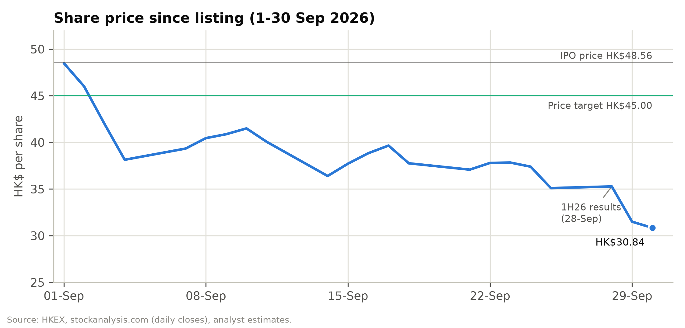
  Key data
  Rating | BUY
  12-month price target | HK$45.00
  Price (30-Sep-2026) | HK$30.84
  Upside to target | +45.9%
  Est. FY26E dividend yield | 3.3%
  IPO price (1-Sep-2026) | HK$48.56
  Range since listing | HK$29.90-48.56
  Market cap (diluted) | US$17.4bn
  Pro forma cash & inv. | US$13.9bn
  Enterprise value | US$3.5bn
  Ticker / exchange | 0625.HK / HKEX

- The market is paying almost nothing for the world's largest online fashion business. At HK$30.84 SHEIN's fully diluted market value is US$17.4bn. The company holds US$13.9bn of pro forma unrestricted cash and investments, measured after the US$2.2bn Conversion Adjustment and US$0.6bn of preferred distributions paid at listing. The implied enterprise value of US$3.5bn is 0.08x LTM sales, 2.2x LTM EBITDA and 2.5x our FY2027E adjusted EBIT. That is for a business with US$41.8bn of 2025 revenue, 1.08bn orders and 291m active customers, the world's third-largest apparel and footwear company. Even after deducting a US$1.5bn operating-cash buffer and a US$1.0bn regulatory reserve, net cash is still HK$20.2 per share, 66% of the share price.
- 1H26 was the margin trough; 2H26E should mark stabilisation. 1H26 operating income fell 52.9% to US$493m (2.4% margin) as the Iran-conflict spike in oil prices and freight pushed fulfilment to 50.4% of 2Q26 revenue. SHEIN chose to absorb these costs rather than raise prices. Management says adjusted net margin would have been "broadly similar to a year ago" excluding freight, and is "cautiously optimistic" on 2H26. We forecast 2H26E adjusted net income of US$651m vs. US$499m in 1H26. We expect the EBIT margin to rebuild to 3.0% in FY2027E and 4.6% by FY2031E, only slightly above the 4.3% achieved in FY2023.
- Trade-policy shocks are real but not existential; the US is the template. Removing the de minimis and €150 exemptions raises landed costs on the direct-from-China model, and Europe (35% of FY25 revenue) is now absorbing its shock: 2Q26 European revenue fell 13.9% ahead of the 1-Jul-2026 duty. In the US the decline narrowed from 14.3% in 1Q26 to 6.0% in 2Q26 as SHEIN passed on most of the duty and shifted to formal customs entry. Meanwhile the rest of the world grew 21.6% in 2Q26, orders grew 7.6% and active customers rose 14.6% to 291m. We model Europe –15% in 2H26E and –4% in FY2027E before recovering, US +2% in FY2027E, and group revenue CAGR of 6.1% over FY2026-31E.
- Initiate at BUY with a HK$45.00 price target (+46%). The target blends DCF (HK$54.35; WACC 11.2%, g 2.5%) and 14x FY2027E adjusted EPS of HK$2.57 (HK$36.04). The dividend policy of at least 50% of net profit implies a first dividend of about HK$1.02 per share (3.3% yield) with FY2026 results. Risk-reward is asymmetric: HK$29.6 bear (–4%), HK$45.2 base, HK$61.3 bull (+99%). The main near-term risks are the pre-IPO lock-up expiry around 1-Mar-2027 (~34% of shares), EU Digital Services Act and FTC outcomes, and the US-China tariff truce expiring on 10-Nov-2026.
Figure 2: Key financials and valuation
US$m / FY Dec | FY24A | FY25A | FY26E | FY27E | FY28E
Net revenues (US$m) | 38,748 | 41,847 | 41,883 | 43,890 | 46,960
YoY growth | 20.7% | 8.0% | 0.1% | 4.8% | 7.0%
Gross margin | 60.6% | 67.9% | 70.3% | 70.7% | 70.9%
Adj. EBITDA (US$m) | 1,361 | 2,190 | 1,589 | 1,892 | 2,378
Adj. EBIT (US$m) | 1,037 | 1,792 | 1,125 | 1,405 | 1,857
Adj. EBIT margin | 2.7% | 4.3% | 2.7% | 3.2% | 4.0%
Adj. net income (US$m) | 1,119 | 1,816 | 1,150 | 1,457 | 1,812
Adj. diluted EPS (HK$) | 1.99 | 3.22 | 2.04 | 2.57 | 3.18
DPS declared (HK$) | – | – | 1.02 | 1.29 | 1.59
P/E (x) | 15.5x | 9.6x | 15.1x | 12.0x | 9.7x
EV/Sales (x) | 0.09x | 0.08x | 0.08x | 0.08x | 0.07x
EV/adj. EBIT (x) | 3.4x | 1.9x | 3.1x | 2.5x | 1.9x
FCF yield | 8.7% | 16.7% | 6.1% | 9.0% | 11.6%
Dividend yield | 0.0% | 0.0% | 3.3% | 4.2% | 5.2%
Note: Priced at HK$30.84 (30-Sep-2026). EV = diluted market cap less US$13.9bn pro forma cash & investments. Adjusted = company non-IFRS definition (ex SBC, FV of preferred shares, associates).
Source: Company filings, analyst estimates.

Contents
Investment Thesis 3
Pillar 1: Cash covers two-thirds to four-fifths of the market value 3
Pillar 2: LATR is a genuine, hard-to-replicate operating advantage 4
Pillar 3: Demand is intact; the revenue slowdown is mostly mix and trade policy 4
Pillar 4: Margin recovery is plausible and not heroic 5
Pillar 5: Shareholder returns and governance commitments put a floor under the equity story 5
Key Risks 6
Catalysts and What Would Change Our View 8
Company 101 9
Company Overview 9
Company History 10
Management Team and Governance 11
Products and Services 14
Customers and Go-to-Market 16
Industry Overview 17
Competitive Landscape 18
Market Opportunity 20
Financial Analysis 22
Revenue: from hyper-growth to a trade-policy pause 22
Gross margin: structurally higher because of the marketplace 24
Fulfilment: the swing factor 25
Marketing: the FY2025 step-up is being reversed 25
Technology, G&A and operating leverage 25
Profitability: a volatile, low-single-digit margin 26
Below the line: preferred shares, interest income and tax 27
Cash flow and working capital 28
Balance sheet: a cash-rich, debt-free company after the listing 29
Projections and Estimates 29
Revenue build: region-driven, cross-checked against orders 29
Business model and operating KPIs 30
Cost structure and margins 32
Below-the-line and per-share estimates 33
Where we differ from the market 33
Scenario Analysis 35
Scenario definitions 35
Scenario outputs 36
Valuation 38
Discounted cash flow 38
Comparable companies 41
Precedent transactions 43
Valuation football field 44
Sanity checks 44
Rating definitions 45
Appendix A: Financial Statements 46
Appendix B: Glossary 50
Appendix C: Sources 50
Important Disclosures 50

Investment Thesis
SHEIN listed on the Hong Kong Stock Exchange on 1 September 2026 at HK$48.56, about a quarter of the US$100bn private valuation it reached in 2022. One month later the shares trade 36.5% below the offer price and at a record low. We think the de-rating has gone well beyond what the fundamentals justify. Our thesis rests on five pillars.

Pillar 1: Cash covers two-thirds to four-fifths of the market value
The most striking feature of SHEIN's valuation is the balance sheet:
- Cash at 30 June 2026. SHEIN reported US$15.25bn of cash resources: cash, restricted cash and short-term time deposits with highly rated international banks, predominantly in US dollars.
- Listing-related adjustments. We deduct the US$2.2bn cash compensation paid to Series Pre-D, D and D+ preferred holders under the Conversion Adjustment, the final US$357m instalment of the 8% p.a. distribution and the ~US$230m 12% p.a. distribution. We add the HK$13.2bn (US$1.68bn) of IPO net proceeds and exclude restricted cash.
- Result. Pro forma unrestricted cash is US$13.5bn, plus US$0.4bn of associate and fair-value investments.
- No debt. SHEIN has no bank borrowings or debt securities; its only indebtedness is US$1.1bn of warehouse and office lease liabilities.
Against a fully diluted market cap of US$17.4bn, pro forma cash and investments equal 80% of the share price (HK$24.7 per share). Our valuation deducts a US$1.5bn minimum operating-cash buffer and a US$1.0bn regulatory contingency reserve. Even so, net cash is HK$20.2 per share, 66% of the current price.
Some investors argue the cash is "not really excess" because SHEIN runs a structurally negative working-capital model:
- Customers prepay.
- Suppliers are paid in about 34 days.
- Inventory turns in about 36 days.
We agree the float is operational: operating net working capital was –US$5.0bn at 30 June 2026 and –US$4.0bn at year-end 2025. But negative working capital is a permanent feature of a growing online retailer, not a liability that falls due. It only unwinds if the business shrinks materially. Our DCF already captures the seasonal second-half unwind of ~US$0.9bn. Even treating the full year-end float as debt-like would still leave about HK$15 per share of net cash.
The market is effectively ascribing an enterprise value of about US$3.5bn to a business that will generate, on our estimates, US$1.4bn of adjusted EBIT in FY2027E. That is 2.5x EV/adjusted EBIT, vs. a peer median of 24.1x trailing EV/EBIT.
Figure 3: Pro forma cash bridge at listing vs market capitalisation (US$bn)
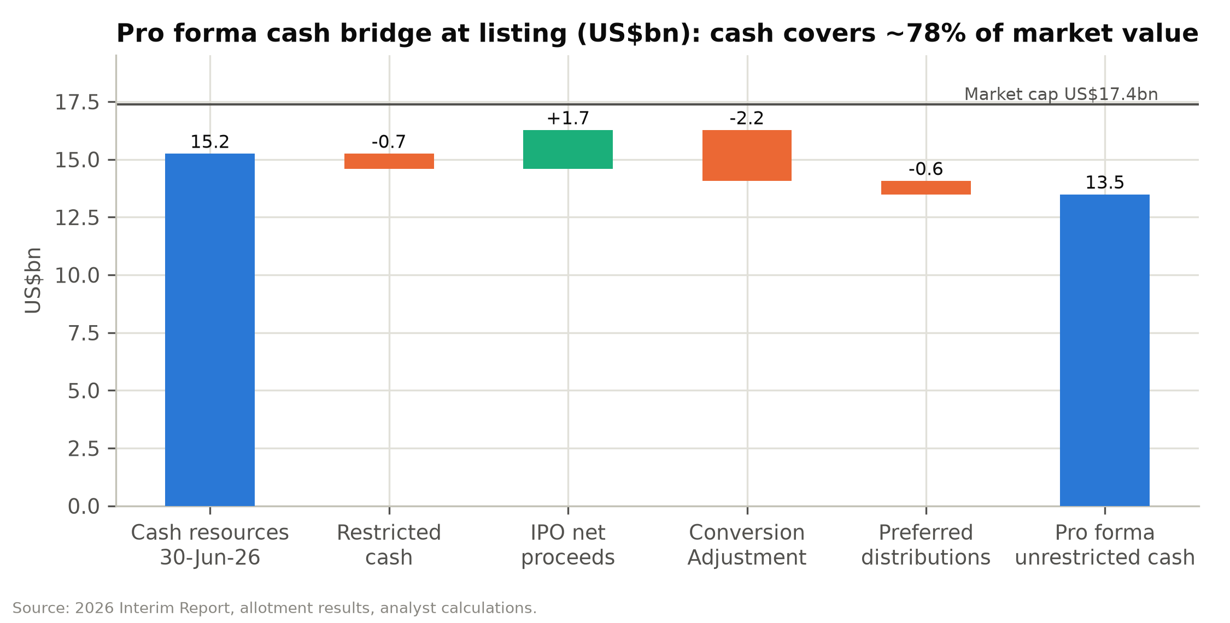

Pillar 2: LATR is a genuine, hard-to-replicate operating advantage
SHEIN's Large-scale Automated Test and Reorder (LATR) model does three things at once:
- Tests small. It launches roughly 4,700 new apparel styles per day in initial batches of 100-200 units.
- Reorders fast. Winners are restocked in as few as five days through more than 7,500 digitally integrated contract manufacturers.
- Keeps inventory lean. Inventory turns in about 36 days, with write-downs of only 1-2% of cost of sales.
The consultant hired for the IPO estimates that fashion-industry inventory waste can reach 30%. The economics show up in SHEIN's contribution margin after fulfilment, which rose from 18.1% in FY2023 to 22.3% in FY2025 even as the marketplace mix increased.
Per-order economics in FY2025 illustrate the model:
- Net revenue of US$38.8 per order.
- Cost of sales of US$12.5, fulfilment of US$17.7 and marketing of US$5.7.
- Technology, content and G&A of US$1.3.
- That leaves about US$1.58 of operating income per order.
Fulfilment is the dominant cost line. Every US$1 of per-order fulfilment savings on 1.2bn FY2027E orders adds ~US$1.2bn of EBIT, almost as much as our entire FY2027E adjusted EBIT forecast. This is why freight rates, duty treatment and local-warehouse density matter so much for the equity. It is also why we think the 2Q26 margin compression (freight) is more reversible than the market assumes.
Figure 4: FY2025 unit economics per order (US$)
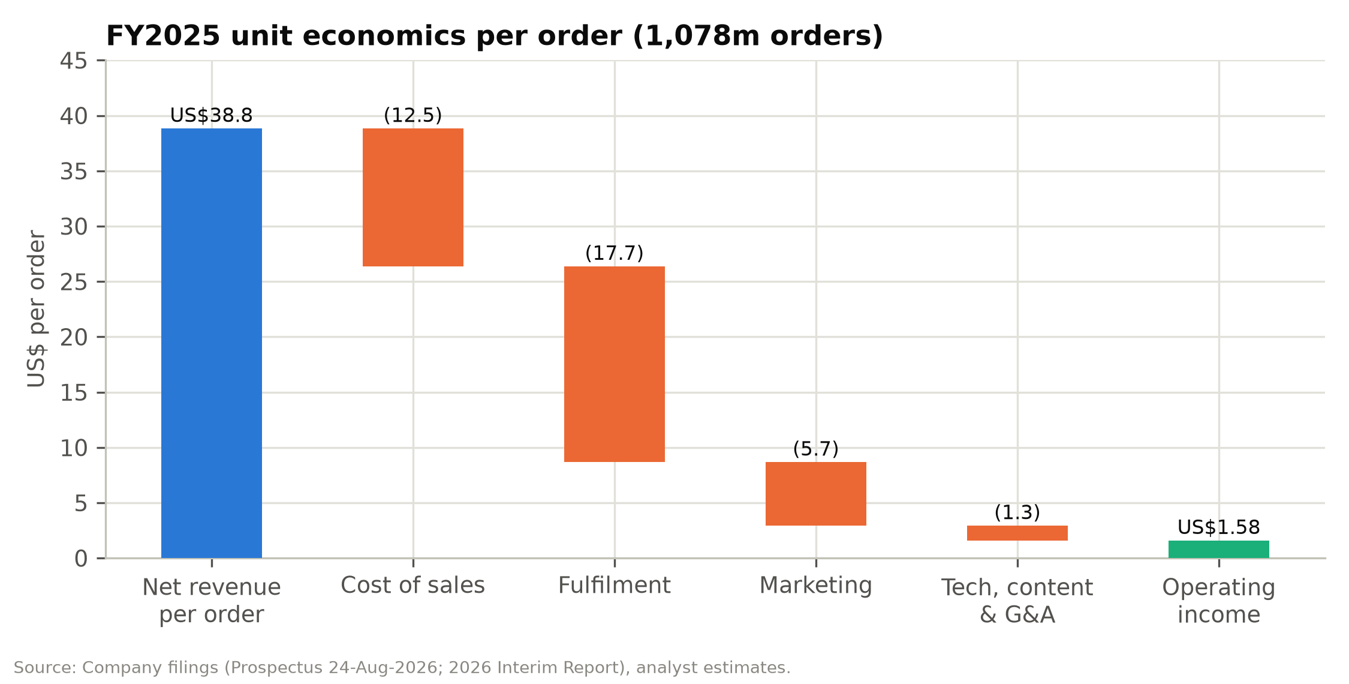

Pillar 3: Demand is intact; the revenue slowdown is mostly mix and trade policy
Reported net revenue growth slowed from 41.1% in FY2023 to 8.0% in FY2025 and 1.0% in 1H26. The underlying demand signals are healthier than the headline suggests:
- Customers and orders are still growing. Active customers rose from 254m to 291m over the twelve months to June 2026 (+14.6%). Orders rose 6.4% in 1H26 and 7.6% in 2Q26.
- Revenue per order is being diluted by mix, not weak demand.
  - The marketplace, where SHEIN books only its commission and fulfilment fees as revenue, rose to 13.4% of 1H26 revenue from 10.8% in 1H25.
  - The fastest-growing region (rest of the world, +16.0% in 1H26, led by Latin America) has lower basket values.
- Implied gross sales are growing faster than reported revenue. Using an assumed 25% blended take rate, first-party revenue plus marketplace GMV grew ~4.9% in FY2026E, vs. 0.1% reported revenue growth.
The two genuinely negative drivers are regional and policy-driven:
- US (–9.9% in 1H26). This reflects the May-2025 removal of the de minimis exemption.
- Europe (–13.9% in 2Q26). SHEIN raised prices and cut advertising ahead of the EU's €3-per-item duty on low-value parcels from 1-Jul-2026.
The US experience is instructive: after a sharp initial drop, the decline narrowed to 6.0% in 2Q26 as consumer behaviour normalised. We expect a similar path in Europe over 2H26-1H27, supported by localised inventory (18 European warehouses, 1.0m m²).

Pillar 4: Margin recovery is plausible and not heroic
Our base case takes the EBIT margin from 2.5% in FY2026E to 3.0% in FY2027E, 3.7% in FY2028E and 4.6% by FY2031E. Adjusted EBIT margins run from 2.7% to 4.9% over the same period. These are not heroic assumptions. SHEIN delivered 4.3% in FY2023 and 4.1% in FY2025, and 5.2% in 1H25.
The recovery rests on four levers:
- Freight normalisation. 2Q26 fulfilment was 50.4% of revenue vs. 43.1% a year earlier. Management attributes most of the gap to oil and freight, and has long-term air-freight capacity agreements.
- Higher price points. The chairman's first priority is to broaden the price range toward higher-priced brands, which lifts revenue per order against a largely fixed per-parcel fulfilment cost. The acquisitions of Everlane, MUSERA and Aloruh illustrate the direction.
- Higher-margin revenue streams. Brand-enablement (SHEIN Xcelerator) operating margins are about twice the group's. Marketplace commissions carry no cost of sales.
- Marketing discipline. Marketing rose from 10.7% of revenue in FY2024 to 14.8% in FY2025. We assume it eases to 13.2% by FY2029E, still well above FY2024.
Our base case keeps fulfilment at 50.0-50.5% of revenue throughout, above the 45.6% FY2025 level. Duty costs are assumed to be a permanent feature of the model.

Pillar 5: Shareholder returns and governance commitments put a floor under the equity story
SHEIN's board has adopted a dividend policy targeting at least 50% of annual net profit after significant capital expenditure. Applying 50% to our adjusted net income, the first dividend would be about US$575m (HK$1.02 per share, 3.3% yield), declared with FY2026 results around March 2027. It would rise to HK$1.29 (4.2%) for FY2027E. Note that IFRS net income in FY2026E will be inflated by ~US$5.9bn of non-cash fair-value gains on the preferred shares, so a payout based on reported earnings would be far larger. We assume the board uses adjusted earnings.
The company also has a general repurchase mandate from listing. With the shares 36% below the IPO price and cash covering most of the market value, a buyback would be an obvious lever.
We are not naive about governance:
- The four founders control 83.3% of the votes through Class A shares.
- The CEO also chairs the board.
- About US$3.5bn of cash went to preferred holders around the listing.
However, the founders' 24-month lock-up, a credible independent-director slate and the dividend commitment align the controlling shareholders with minorities more than the share price implies.
Figure 5: Valuation multiples since listing on our FY2027E estimates
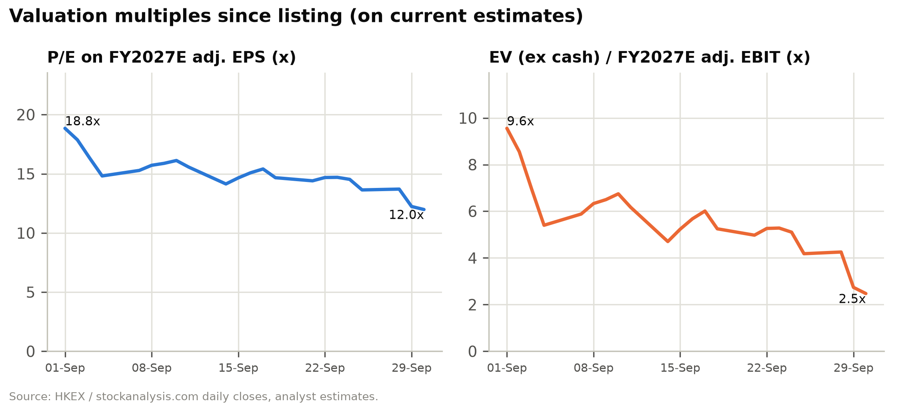

Key Risks
We categorise the principal risks below and give a probability and share-price impact assessment for each. A detailed discussion of each risk follows the table.
Figure 6: Risk matrix: probability and estimated share-price impact
Risk | Category | Probability | Impact on value | Mitigant / what we assume
EU duty impact worse than the US precedent | Trade policy | Medium | –15% | Bear case: Europe –10% in FY27E, –2% in FY28E
Large EU DSA or US FTC penalty | Regulatory | Medium | –10% to –20% | US$1.0bn reserve deducted in DCF; DSA cap 6% of turnover
Pre-IPO lock-up expiry (~1-Mar-2027) | Technical | High | –10% (temporary) | ~34% of shares; cost bases from US$0.01 to US$23.72
Margin fails to recover (freight, duties, competition) | Operating | Medium | –20% | Bear case 1.8% FY27E adj. EBIT margin → HK$29.6
US-China escalation (tariff truce ends 10-Nov-2026) | Geopolitical | Medium | –10% | US 22% of FY26E revenue
Supply-chain labour or forced-labour allegations | ESG | Low-Medium | –10% | 5,150 SRS audits in 2025; >99% third-party
Capital misallocation / large M&A | Governance | Low | –10% | Dividend policy; INED oversight
Competitive escalation (Temu, TikTok Shop, Amazon Haul) | Competition | Medium | –10% | Marketing held at 13.2-13.8% of revenue
Interest-rate cuts reduce interest income | Financial | Medium | –3% | Yield falls from 4.1% (FY26E) to 3.3% in our model
Upside: buyback / special dividend | Capital return | Low-Medium | +10% | Not in estimates
Upside: faster freight normalisation | Operating | Medium | +10-15% | 1pp of fulfilment ratio ≈ US$0.44bn EBIT

Company-specific risks
1. Trade-policy and duty risk (High). Over 90% of 2025 revenue shipped from Chinese warehouses. The US ended de minimis in 2025 (tariff rates on China-origin goods now 10-87.5% versus 0-62.5% earlier); the EU abolished its €150 exemption from July 2026 and will add a handling fee. SHEIN warns EU trends could be "in line with or exceed" the US experience, where revenue fell 9.9% in 1H26. Duties are booked in fulfilment expenses. Further escalation (e.g., the China-US tariff truce expiring on 10 November 2026) is a direct margin risk.
2. Regulatory and legal risk (High). Active matters include: an EU Digital Services Act formal investigation (opened February 2026; DSA fines can reach 6% of global turnover); an FTC investigation of US operations that could lead to a "significant" settlement; a CNIL €150m fine under appeal; €22.5m DGCCRF fines (June 2026) being contested; an Irish DPC inquiry into EU-to-China data transfers (April 2026); and Temu litigation in the US and UK. Provisions were ~US$80m at March 2026 plus the CNIL provision. We deduct a US$1.0bn contingency reserve in our valuation.
3. Margin-recovery execution risk (High). Operating margin fell to 2.4% in 1H26 (2Q26: 2.1%) from 5.2% in 1H25 as fulfilment costs rose to 50.4% of revenue. Our base case assumes margins recover to ~3.0% in 2027 and ~4.6% by 2031; failure to pass on duties, sustained high freight, or the costs of local inventory could keep margins near 2%.
4. Labour, supply-chain and ESG risk (Medium-High). SHEIN relies on thousands of SME suppliers and their subcontractors; audits cannot detect every violation. Allegations of labour abuses, forced labour in upstream cotton, or chemical-safety failures could trigger import restrictions (e.g., under US forced-labour law), consumer boycotts or ESG exclusions from institutional portfolios.
5. Brand, IP and product-safety risk (Medium). SHEIN is regularly subject to IP-infringement claims and product-safety findings (particularly on the marketplace); French authorities pursued SHEIN in 2025 over inappropriate marketplace products. Negative publicity can erode customer trust.
6. Governance and capital-allocation risk (Medium). WVR structure gives founders 83% of votes; CEO also chairs the Board; pre-IPO arrangements transferred ~US$3.5bn of cash to preferred holders. Minority shareholders have limited recourse if cash is deployed into low-return acquisitions (SPARC generated losses; Everlane is small).

Industry and market risks
7. Competitive intensity (High). Temu, AliExpress, TikTok Shop and Amazon Haul compete for the same value customer; aggressive subsidies by better-funded platforms could force higher marketing spend (already 14.8% of revenue in 2025).
8. Fashion and consumer-demand risk (Medium). SHEIN's customers are young and price-sensitive; a consumer slowdown or inflation shock in key markets would hit order volumes. Management expects the "challenging global consumer environment" to persist near term.
9. Channel and platform-dependence risk (Medium). Customer acquisition depends on Google, Meta, TikTok and app stores; changes in algorithms, privacy rules (e.g., cookie-consent enforcement) or ad pricing could raise acquisition costs.

Financial risks
10. Freight, oil and FX risk (Medium). The Iran conflict raised oil prices and freight costs in 1H26 and disrupted Middle East demand (a low-single-digit percentage-point drag on 2026 revenue). SHEIN does not hedge FX; exchange losses were US$151m in 1H26.
11. Share-overhang and liquidity risk (High, near term). The IPO float was only 6.6% of shares, much of it placed with existing holders; stabilisation absorbed another 15%. The six-month lock-up for pre-IPO investors (~34% of shares, many with very low cost bases) and cornerstones expires around 1 March 2027 and could weigh on the share price.
12. Tax risk (Medium). OECD Pillar Two minimum tax, transfer-pricing scrutiny and potential tax-residency challenges could raise the effective tax rate (core ETR ~26% in 1H26 versus ~21% in 2025).

Macroeconomic risks
13. Geopolitical risk (High). US-China tensions, sanctions or data-security actions (as seen with other China-linked apps) could restrict SHEIN's ability to operate in the US, which is still 22% of revenue.
14. Global recession / interest-rate risk (Medium). A recession would depress discretionary spending; conversely, lower interest rates would reduce interest income, which was ~27% of 2027E adjusted pre-tax profit in our model.

Catalysts and What Would Change Our View
Figure 7: Upcoming catalysts
Timing | Catalyst | Expected direction
Oct-Nov 2026 | 11.11, Black Friday and Cyber Monday trading; web-traffic and app data | Positive if order growth holds 6-8%
10-Nov-2026 | Expiry of the US-China tariff-reduction truce | Binary; extension positive
Nov-2026 onward | EU volume data after the 1-Jul-2026 duty; local-warehouse ramp | Key test of the Europe thesis
Late 2026 / 2027 | EU Digital Services Act, FTC and Irish DPC outcomes | Resolution removes overhang even if costly
~Mar-2027 | FY2026 results; first dividend declaration (we estimate HK$1.02) | Positive
~1-Mar-2027 | Six-month lock-up expiry for pre-IPO and cornerstone investors | Negative technical; creates entry point
2027 | Potential Hang Seng Composite Index / Southbound Stock Connect eligibility | Positive (broader investor base)
Any time | Share repurchase under the general mandate | Positive

What would make us more negative:
- Evidence that European volumes are structurally impaired, i.e. revenue declining double digits into 2H27.
- Fulfilment staying above 51% of revenue after freight normalises.
- A regulatory penalty well above our US$1.0bn reserve.
- Cash deployed into large, low-return acquisitions.
What would make us more positive:
- A buyback.
- A payout above 50%.
- Confirmation that 2H26 adjusted margins are recovering toward 3%.

Company 101
This section describes SHEIN's business, history, management, products, customers, industry and competitive position. It draws mainly on the Global Offering prospectus of 24 August 2026 and the 2026 Interim Report of 28 September 2026. Market data are from China Insights Consultancy (CIC), the industry consultant engaged for the IPO, as reproduced in the prospectus.

Company Overview
SHEIN Global Holdings Ltd ("SHEIN", "the Company") is the world's largest online fashion destination by apparel and footwear retail sales value and, according to the industry consultant engaged for the IPO (China Insights Consultancy, "CIC"), the third-largest apparel and footwear company globally with a 1.9% share of a US$1.74trn market in 2025 — behind only a US athletic-wear leader (3.0%) and a Spanish fast-fashion group (2.5%), and ahead of a German athletic brand (1.7%) and a Japanese casual-wear retailer (1.3%). In 2025 SHEIN generated net revenues of US$41.8bn (+8.0% YoY), operating income of US$1.71bn (4.1% margin) and IFRS net income of US$2.06bn, serving approximately 273 million active customers across roughly 160 markets and fulfilling 1.08 billion orders. Net revenues have compounded at 14.2% p.a. over 2023-25 and active customers at 21.2% p.a.
The business model is best described as a vertically integrated, first-party-led online fashion brand collection with a growing marketplace attached. SHEIN designs (with 370+ in-house designers and a network of contract manufacturers and independent designers), commissions production from more than 7,500 contract manufacturers (predominantly SMEs in the Pearl River Delta), stores the output mostly in central warehouses in mainland China, and ships it directly to consumers through its own apps and websites. It does not operate physical stores at scale. Revenue is recognised on delivery; the substantial majority of customers pay in advance, which, combined with ~34-day supplier terms and ~36-day inventory turnover, produces a structurally negative working capital position (–US$5.0bn at 30 June 2026) and a large cash pile.
The Company's core intellectual property is an operating model it calls LATR — Large-scale Automated Test and Reorder. New styles are launched in initial batches of roughly 100-200 units, customer response is measured in real time, and winners are reordered — restocking in as few as five days — while losers are dropped. SHEIN argues LATR resolves the fashion industry's "trilemma" of assortment breadth, design-refresh speed and inventory efficiency. The numbers support the claim: more than 2 million apparel styles were live at 31 March 2026, customers could discover ~4,700 new apparel styles per day in 1Q26, inventory turnover was 36 days in 2025 and inventory write-downs have run at only ~1-2% of cost of sales.
Revenue is generated in two ways. Product revenues (US$37.1bn in 2025, 88.7% of the total) come from first-party sales of company brands (SHEIN, MOTF, Glowmode, SHEGLAM, MUSERA, Aloruh and others) and partnership brands. Service revenues (US$4.7bn, 11.3%) are commissions (generally 10-20% of transaction value) and fulfilment fees charged to third-party merchants on the marketplace launched in 2022-23, plus fees from brand-enablement partners. Because service revenue is recognised net, the rising marketplace mix depresses reported revenue per order and inflates fulfilment costs as a percentage of revenue — a key analytical nuance for the stock.
Geographically SHEIN is diversified: in 2025 the United States contributed 24.1% of net revenues (US$10.1bn), Europe 35.4% (US$14.8bn) and the rest of the world 40.5% (US$16.9bn; led by Latin America and the Middle East). By category, apparel is 63.8% and "others" (footwear, accessories, beauty, home and lifestyle) 36.2%. No customer exceeds 10% of revenue and the top five suppliers account for ~16% of purchases.
SHEIN is headquartered in Singapore (since late 2021), incorporated in the Cayman Islands, and conducts operations through subsidiaries in China, Singapore, the US, Ireland, the UK and the UAE. It employed 17,585 people at 30 June 2026, ~79% of them in mainland China. The Company listed in Hong Kong on 1 September 2026 under a weighted-voting-rights (WVR) structure, raising HK$13.6bn gross (HK$13.2bn net) by selling 279,992,500 new Class B shares at HK$48.56, valuing it at ~US$26bn — roughly a quarter of the ~US$100bn private valuation reached in 2022. The shares have since fallen to HK$30.84 (–36.5%), taking the fully diluted market capitalisation to ~US$17.4bn.
The current investment debate centres on four issues: (1) the removal of de minimis/low-value import exemptions in the US (May/August 2025) and the EU (1 July 2026), which raises landed costs on the direct-from-China model; (2) margin compression in 2026 — operating margin fell to 2.4% in 1H26 from 5.2% in 1H25 as freight rates spiked during the Iran conflict and the Company chose to absorb costs; (3) regulatory exposure in the EU and US (EU Digital Services Act investigation, FTC investigation, French and Irish data/consumer proceedings); and (4) governance and capital allocation, following ~US$3.5bn of cash paid to preferred shareholders around the listing. Against this, SHEIN has US$13.5bn of pro forma unrestricted cash (~78% of its market value; US$13.9bn including investments), still-growing order volumes (+6.4% in 1H26) and customers (+14.6% LTM to 291m), and a dividend policy targeting at least 50% of annual net profit.
Figure 8: SHEIN at a glance: scale, reach and financial profile
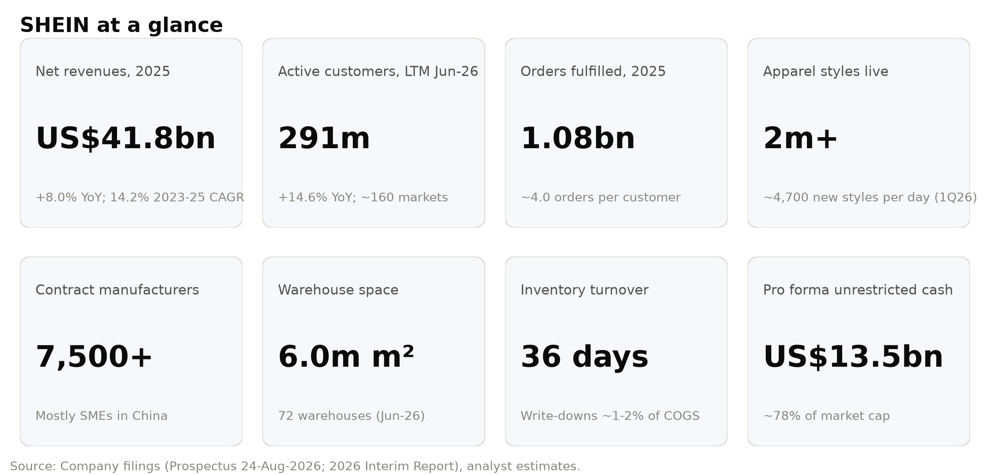

Company History
Origins (2008-2014). Press accounts trace SHEIN's roots to a cross-border e-commerce business started in Nanjing in 2008 by Xu Yangtian, a search-engine-marketing specialist who sold apparel to overseas buyers online. The Prospectus dates the business's formal launch to 2012, when Mr Xu and his three co-founders — Miao Miao, Gu Xiaoqing and Ren Xiaoqing, all former colleagues at a company providing search-engine marketing services to Chinese exporters — started the venture. The founders' background matters: SHEIN was built by digital marketers rather than by merchants or designers, and its early edge came from performance marketing, social-media and influencer engagement and data-driven merchandising. The SHEIN brand was introduced in 2013, and the Cayman holding company (then named Elite Depot Limited) was incorporated on 12 May 2014.
Building the machine (2014-2019). In 2014 SHEIN pilot-tested LATR, and in 2015 it debuted its mobile app. During this period the Company built its operational base in Guangzhou, embedding itself in the dense garment-manufacturing cluster of the Pearl River Delta and progressively digitising its suppliers through free cloud-based production-management software. Financing followed the model's traction: a Series A in 2015 (US$5m at a US$53m pre-money valuation), a Series B from 2016 (RMB169m at RMB1.1bn), and a Series C in 2018-19 (US$243m at US$2.4bn). Annual active customers reached 10 million in 2018.
Hyper-growth (2020-2022). The pandemic shift to online shopping, combined with SHEIN's TikTok- and Instagram-native marketing, turned the Company into a global phenomenon. Active customers passed 50 million in 2020 and 100 million in 2021, the year SHEIN launched the SHEIN X designer-incubation programme and moved its headquarters to Singapore. A Series C+ in March 2020 valued the Company at US$5bn; a Series D in 2022 raised US$1.8bn at a US$98.2bn pre-money valuation (US$23.72 per share, split-adjusted). Net revenues exceeded US$20bn in 2022. This was the valuation peak.
Marketplace, scrutiny and re-rating (2023-2025). In 2023 SHEIN officially launched its marketplace for third-party merchants and raised US$1.7bn in a Series D+ at a US$64.0bn pre-money valuation — a 35% down-round. It also took a roughly one-third stake in SPARC Group (then operator of brands including Forever 21) in exchange for Class B shares, a partnership intended to combine SPARC's physical retail with SHEIN's on-demand supply chain; the investment has since produced cumulative associate losses. Temu's aggressive entry into Western markets in 2023 triggered litigation in both directions (the US antitrust complaint by Temu, and SHEIN's UK copyright claims). Revenue grew 41.1% in 2023 and 20.7% in 2024; active customers passed 200 million in 2024. A planned New York listing stalled amid US political scrutiny, as did a London listing attempt; the Company ultimately filed in Hong Kong. In 2025 growth slowed to 8.0% as the US removed the de minimis exemption for Chinese imports (effective 2 May 2025) and then for all countries (29 August 2025); US revenue fell 3.5%. In October 2025 SHEIN upgraded SHEIN X into the SHEIN Xcelerator Programme, a brand-enablement platform. Regulatory costs rose: a €40m DGCCRF settlement in France (July 2025) and a €150m CNIL cookie-consent fine (September 2025, under appeal).
Road to listing (2026). In March 2026 the preferred shareholders' redemption date was extended from 4 March to 31 December 2026 in exchange for ~US$1.1bn of 8% p.a. distributions (paid March-September 2026), a 12% p.a. coupon from 5 March to listing (~US$230m), and a full-ratchet style "Conversion Adjustment" for Series Pre-D, D and D+ holders, settled at listing by US$2.2bn of cash plus 19.6 million additional shares. The EU approved the end of the €150 customs-duty exemption in February 2026 (effective 1 July 2026, with a €3 flat duty per item category). In the second quarter SHEIN acquired Everlane, a US premium basics brand, for US$78m (mostly repayment of Everlane debt). The Hong Kong IPO priced in late August 2026 at HK$48.56, near the mid-point of the HK$47.60-49.50 range; the retail tranche was 5.63x covered and the international book 2.59x, with seven cornerstone investors — mostly existing shareholders (Boyu, Tiger Global, General Atlantic, a Tencent affiliate, Greenwoods) plus Taikang Life and UBS AM Singapore — taking 22.1% of the offer. The shares opened flat, fell as low as HK$43.72 on day one, and slid through September; the stabilising manager bought back the full 15% over-allocation at HK$35.90-48.56 and the over-allotment option lapsed on 26 September. On 28 September SHEIN reported its first interim results (1H26 revenue +1.0%, operating income –52.9%); the stock fell 10.7% the next day and closed at a record low of HK$30.84 on 30 September.
Figure 9: Key milestones, 2012-2026
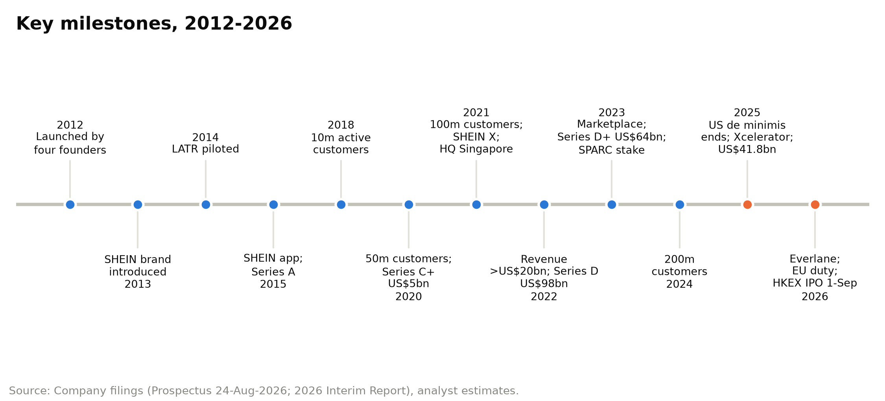

Management Team and Governance
SHEIN remains founder-led and founder-controlled. All four co-founders sit on the seven-member Board as executive directors, and together they control 83.3% of the votes on ordinary resolutions through Class A shares carrying ten votes each. Two professional executives — the CFO and CTO — complete the senior management team disclosed in the Prospectus.
Figure 10: Board, weighted-voting-rights control and senior management
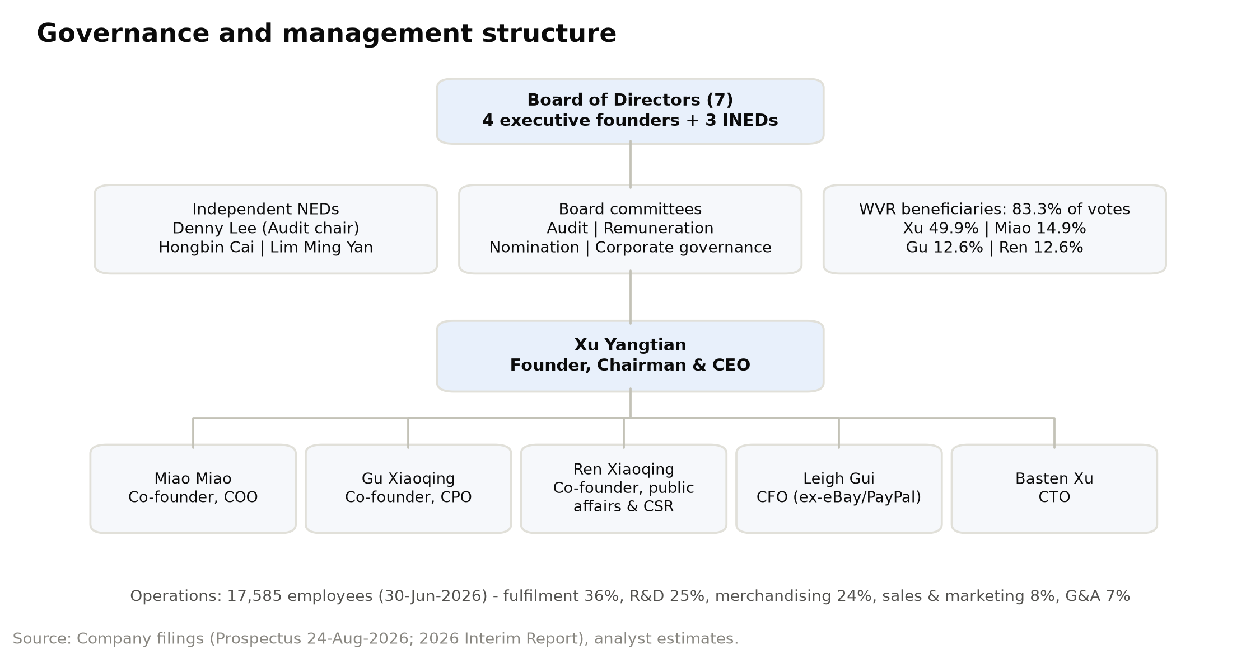

Xu Yangtian — Founder, Chairman and Chief Executive Officer (age 43)
Mr Xu founded SHEIN and has served as chairman, executive director and CEO since inception; he is responsible for group strategy and business management. Before SHEIN he worked with his co-founders at a company providing search-engine marketing to Chinese export businesses, and he holds a bachelor's degree in international trade from Qingdao University of Technology (2007). His background explains much of SHEIN's DNA: an obsession with customer-acquisition efficiency, rapid A/B testing and data-driven decision-making that was later applied to merchandising through LATR. Mr Xu is famously low-profile — he has given almost no interviews and the first Chairman's Statement in the Interim Report is one of his few public written communications. That statement is revealing: he frames SHEIN as a "richly diversified brand collection" built on a "vertically integrated, first-party-led" model, commits that the first-party business "will always remain at the core", and sets three one-to-two-year priorities — broadening the price range towards higher-priced brands, raising quality and compliance investment, and more proactive consumer communication/brand marketing. He also defended the decision to absorb elevated freight costs in 2Q26 rather than raise prices, calling them transitory. After the IPO, Mr Xu beneficially owns 798,973,148 Class A and 487,090,102 Class B shares — 30.3% of the share capital and 49.9% of the votes — through Apex Sight Holdings, which he controls via a family trust. As the largest WVR beneficiary and the controlling shareholder, he effectively determines board composition and strategic direction. His holdings are subject to a 24-month lock-up. For investors, Mr Xu's record is one of exceptional execution in building scale (net revenues above US$40bn within roughly 13 years of the 2012 launch) but also of a reserved, control-oriented style; the combination of CEO and chairman roles is a disclosed deviation from Hong Kong's Corporate Governance Code.

Miao Miao — Co-Founder, Executive Director and Chief Operating Officer (age 41)
Ms Miao is a co-founder, has been an executive director since inception and chief operating officer since 2017, overseeing the Group's day-to-day operations. She also serves as a director or senior manager of several subsidiaries. Like Mr Xu she previously worked at the search-engine-marketing firm where the founders met, and she holds a bachelor's degree in management from Nanjing University of Posts and Telecommunications (2007). As COO she sits at the centre of the operational machinery that investors are underwriting: the fulfilment network (6.0m m² of leased warehouse space across 72 warehouses), customer service (25 centres) and the operating cadence that turned 715m orders in 2023 into 1.08bn in 2025 while cutting fulfilment cost per order from US$18.9 to US$17.7. Her operational remit also covers the tariff response — shifting to formal customs entry in the US, localising inventory in Europe and running the trade-compliance function — which is the single most important near-term execution task. Ms Miao beneficially owns 205,579,906 Class A and 471,329,694 Class B shares (the latter including 393,169,450 shares held by Trendy Group Holdings, a trust whose beneficiaries are the four founders' holding vehicles and whose votes she controls), giving her ~14.9% of the votes. She sits on the Board's remuneration and nomination committees. Her dual role as operator and controller of the founders' shared trust makes her the second most influential person in the Company; her holdings are also locked up for 24 months.

Leigh Lei Gui — Chief Financial Officer (age 56)
Mr Gui joined SHEIN as CFO in March 2021 and oversees finance. He is the Company's most important interface with public-market investors and the most experienced public-company executive on the team. Before SHEIN he was CFO of VIPKid (May 2020 to February 2021), and from 2005 to 2020 he held a series of finance roles at eBay and PayPal, including CFO of Greater China at eBay and PayPal, CFO of Asia-Pacific cross-border trade at eBay and CFO of international cross-border trade at eBay. That cross-border e-commerce background is directly relevant: he has managed the finance function for businesses exposed to customs regimes, FX, payment platforms and multi-jurisdiction tax. He holds a bachelor's degree in genetics from Wuhan University (1990), a master's in molecular biology from Rice University (1995) and an MBA from the University of Toronto (1999). Under his watch SHEIN has run a conservative treasury policy — deposits and certificates of deposit with highly rated banks, no leverage, no speculative trading, no FX hedging — and has built the Hong Kong reporting and non-IFRS framework (adjusted EBIT, adjusted net income) introduced with the Interim Report. Capital allocation is the area where his influence will be most scrutinised: the dividend policy (≥50% of net profit after significant capex) and the deployment of US$1.7bn of IPO proceeds (40% technology, 40% brand and global presence, 10% corporate responsibility, 10% general purposes). Mr Gui is not a director and is not a WVR beneficiary.

Gu Xiaoqing — Co-Founder, Executive Director and Chief Product Officer (age 44)
Ms Gu is a co-founder, has been an executive director since inception and chief product officer since 2017, overseeing product management — the merchandising, design and category decisions that sit at the heart of LATR. She previously worked with the other founders at the search-engine-marketing firm and holds a bachelor of arts from Nanjing Tech University (2005). Product is where SHEIN's strategy is changing most visibly. The chairman's stated priority of moving up the price range is essentially a product-portfolio decision, and the Interim Report highlights product-led wins: MUSERA's expansion into sportswear, Aloruh's push into swimwear, sleepwear, sportswear and formal dresses, strong growth in childrenswear and sportswear, and the integration of the LATR supply chain with the "Design X" AI creative system for partner brands. The Everlane acquisition and the Xcelerator partners (AiiRZ, KIZN, Baby Phat, Fashion SZN) also fall within the product and brand agenda. Ms Gu will also carry much of the accountability for product-compliance issues — chemical-safety testing (800,000+ apparel inspections in 2025), IP screening (multi-layer image-recognition review) and marketplace listing controls — which have been a recurring source of regulatory action in France and the EU. She beneficially owns 205,579,906 Class A and 78,160,244 Class B shares (~12.6% of votes), locked up for 24 months.

Other key executives
- Ren Xiaoqing — Co-Founder and Executive Director (age 40). Formerly chief supply chain officer (from 2017), Mr Ren now oversees public affairs and corporate responsibility — a telling redeployment given SHEIN's regulatory and ESG exposure. He owns 205,579,906 Class A and 78,160,244 Class B shares (~12.6% of votes).
- Basten Hao Xu — Chief Technology Officer (age 38). CTO since inception and responsible for technology development, including the 1,700+ in-house software systems that run LATR, supplier cloud tools and warehouse management. Holds a computer-science degree from Nanjing Agricultural University (2010).

Board, governance and ownership
- Board: seven directors — the four co-founders plus three independent non-executive directors: Denny Lee (former NetEase CFO; audit-committee chair at NIO, New Oriental and Jianpu), Hongbin Cai (Dean of HKU Business School; former Dean of Peking University's Guanghua School) and Lim Ming Yan (Chairman of Changi Airport Group; former Group CEO of CapitaLand). Audit and corporate-governance committees are composed entirely of INEDs, as required for WVR issuers.
- Voting control: Class A shares (ten votes) are held only by the founders; on reserved matters (e.g., changes to constitutional documents, appointment/removal of INEDs and auditors, winding up) all shares vote one-for-one.
- Economic ownership after IPO (4,246.2m shares): founders ~2,531m shares (~59.6%, including Trendy Group); IDG ~7.2%, Sequoia China/HongShan-related ~3.8% of total, Sequoia Capital ~5.3%, Greenwoods ~3.9%; public float ~6.6% from the IPO.
- Lock-ups: founders 24 months; pre-IPO investors and cornerstone investors six months (to ~1 March 2027). Pre-IPO investors (~34% of shares) from Series A-C have deeply in-the-money positions (cost of US$0.01-1.28 per share vs. HK$30.84 ≈ US$3.93), creating a potential supply overhang when the lock-up ends.
- Remuneration: directors' aggregate pay was ~US$3m a year in 2023-25; the five highest-paid individuals (none directors in 2025) received US$14m in 2025.
- Compliance adviser: Somerley Capital (permanent, as required for WVR issuers). Auditor: Deloitte Touche Tohmatsu.
Assessment: Governance is the weakest part of the equity story. Founders hold near-absolute control, the CEO is also chairman, management has limited public-market experience beyond the CFO, and the pre-IPO restructuring transferred ~US$3.5bn of cash (US$2.2bn Conversion Adjustment + ~US$1.3bn distributions) to preferred holders — cash that would otherwise belong to all shareholders. Offsetting features are an experienced INED slate, a stated ≥50% payout policy and the founders' 24-month lock-up, which aligns their horizon with minority holders.
Figure 11: Ownership structure after the IPO (% of share capital and % of votes)
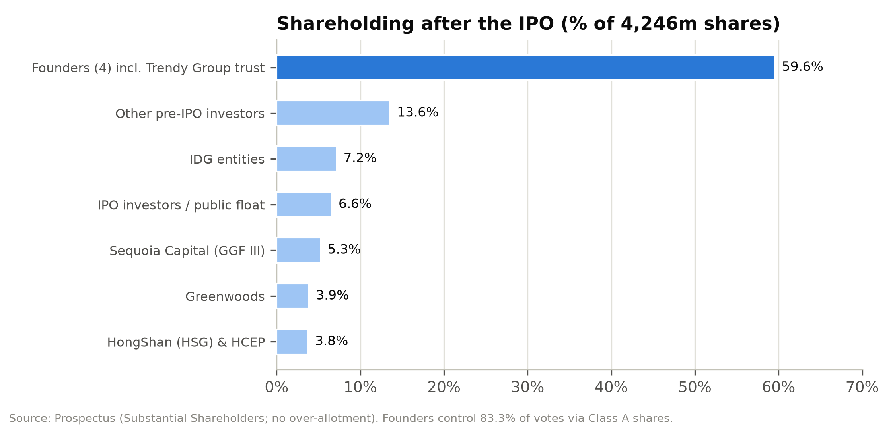

Products and Services

First-party brand portfolio (88.7% of 2025 net revenues)
SHEIN's first-party business sells company-branded and partnership-brand products sourced from contract manufacturers. The flagship SHEIN brand focuses on value women's fashion; sub-brands extend the range: MOTF (premium), Glowmode (activewear), SHEGLAM (cosmetics), MUSERA (dresses, now sportswear) and Aloruh (women's fashion expanding into swimwear, sleepwear and formal). Everlane, acquired in 2Q26, adds a US-heritage premium-basics brand with a sustainability positioning and an established US customer base. Categories span apparel (63.8% of 2025 revenues), footwear, accessories, beauty, home & living, childrenswear, sportswear and lifestyle. The apparel share has declined from 68.8% in 2023 as SHEIN broadened into categories that raise order frequency and basket size, though some (home & living) carry lower margins.
Pricing is cost-plus with dynamic adjustment. Management's stated strategy is to keep the value core while adding higher-priced brands, which should lift the platform's average selling price and — given operating leverage on a per-order fulfilment cost base of ~US$18 — improve margins.
Figure 12: Brand and business-model portfolio
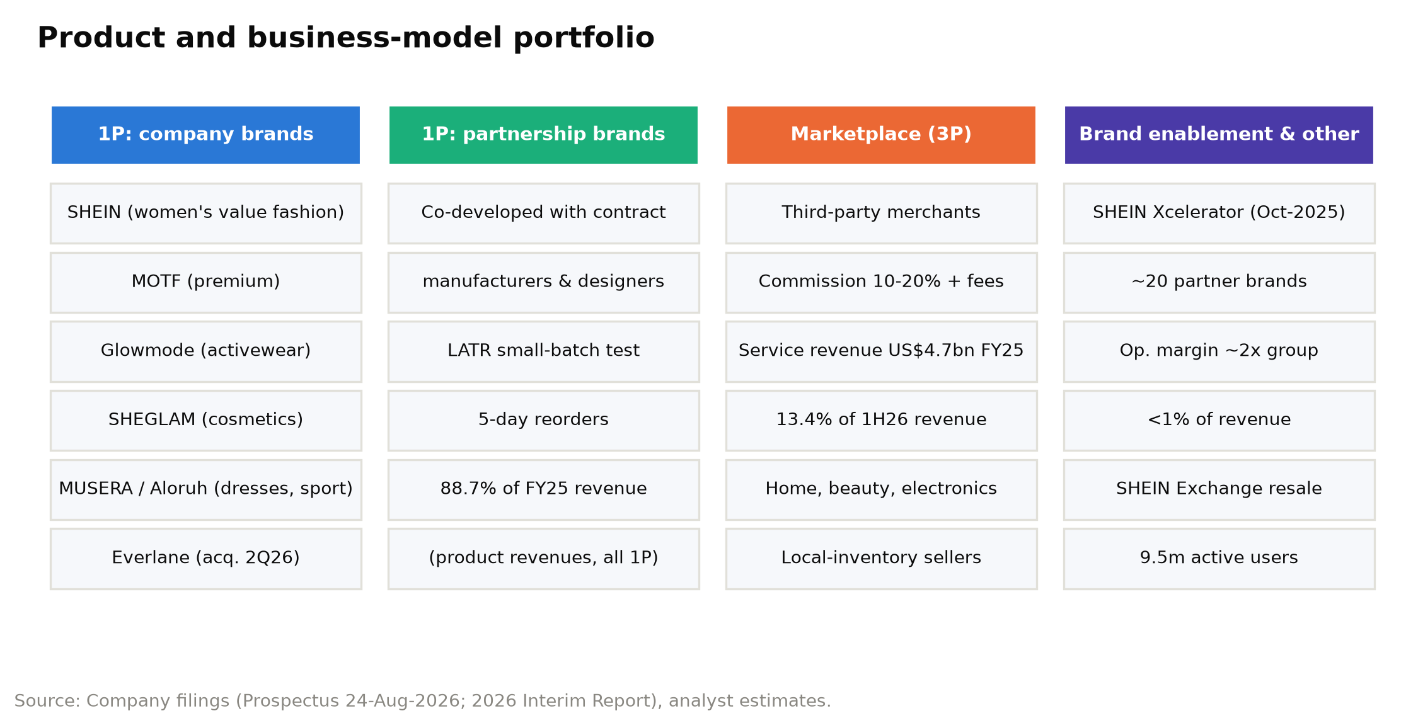

LATR: the operating system
LATR is the heart of the product proposition. Its five steps are: (1) data-informed small initial batches of 100-200 units per style; (2) customer orders; (3) real-time sales insights and automated reorders, with orders auto-allocated to suppliers with spare capacity; (4) restock in as few as five days; and (5) traffic optimisation to surface winners. The economics are compelling: low upfront commitment per style, unsold inventory in the low single digits and write-downs of ~1-2% of cost of sales, compared with industry inventory waste that CIC estimates can reach 30%. The model's limit, as the chairman acknowledges, is that it is best suited to categories "driven by diversity, where demand changes rapidly".

Marketplace (service revenues; 11.3% of 2025 net revenues, 13.4% in 1H26)
Launched in 2H22 and formally in 2023, the marketplace lets third-party merchants and brands sell to SHEIN's customers. SHEIN acts as agent and recognises service revenue: a commission of generally 10-20% of transaction value plus fulfilment fees for warehousing and delivery. Service revenues grew from US$0.9bn in 2023 to US$4.7bn in 2025 and +24.9% in 1H26 (+44.2% in 2Q26) as tariff changes pushed more volume through local-inventory merchants. Management describes the recent mix shift as a "short-term effect" of trade-policy changes and insists first-party remains the core. The marketplace does not incur cost of sales, which is why reported gross margin rose from 60.2% (2023) to 67.9% (2025) and ~70% in 1H26 — but because only the take rate is booked as revenue, it raises fulfilment and marketing costs as a percentage of revenue. SHEIN does not disclose GMV; at an assumed 25% blended take rate (our estimate), 2025 marketplace GMV would be ~US$19bn and total gross sales (first-party revenue plus marketplace GMV) ~US$56bn.
Figure 13: Net revenues by category: apparel vs. other categories (US$m)
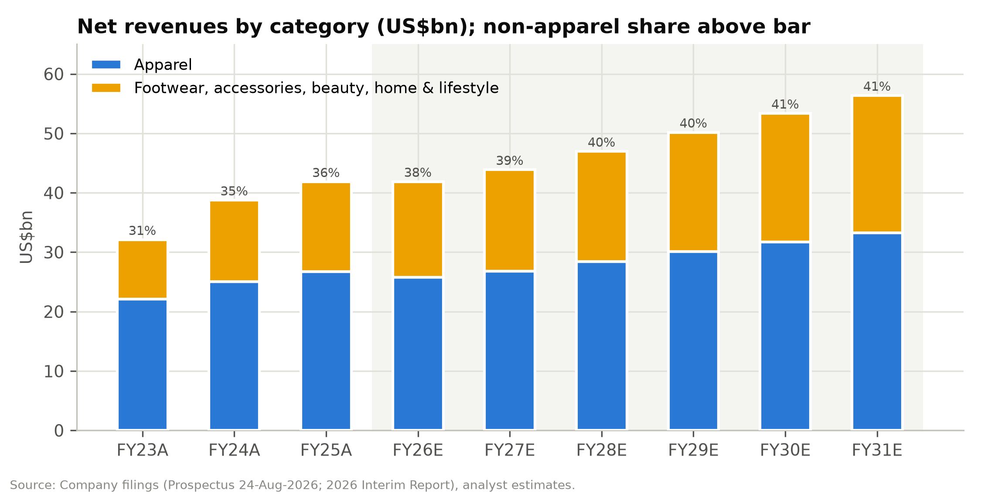

Brand enablement: SHEIN Xcelerator
The Xcelerator programme (upgraded from SHEIN X in October 2025) opens SHEIN's supply chain, design tools (including the Design X AI system), marketing and fulfilment to partner brands, from start-ups to established labels. The Prospectus cites one partner that grew sales ~15x in its second year while improving operating margin by 30+pp and cutting inventory days by two-thirds, and states that brand-enablement operating margin is roughly twice the group's. It is small — no more than 1% of revenue in 2025 — but it is the clearest path to a higher-margin, capital-light "infrastructure" revenue stream. Nearly 20 brands have been enabled.

Circularity and other services
SHEIN Exchange, a peer-to-peer resale platform for items bought from or through SHEIN (US, France, UK, Germany), had 9.5 million active users at end-2025. It is strategically important for SHEIN's sustainability narrative rather than financially material.

Supply chain and fulfilment infrastructure
- Suppliers: ~7,500 contract manufacturers in 2025 (5,800 in 2023), no exclusivity, one-year renewable contracts, no minimum purchase commitments; free cloud software manages orders, production, QA and shipping. 5,150 on-site social-responsibility (SRS) audits in 2025 (>99% by third-party auditors) covering suppliers representing ~95% of company-branded procurement value.
- Warehouses: 6.0m m² leased at 30 June 2026 — 37 in China (4.1m m²), 6 in the US (0.4m m²), 18 in Europe (1.0m m²) and 11 elsewhere (0.5m m²). Over 90% of 2025 revenue shipped from central warehouses in mainland China; localisation (especially in Europe) is increasing.
- Delivery: third-party logistics; >90% of orders delivered within 10 business days of dispatch; long-term air-freight capacity agreements.
- Technology: 1,700+ proprietary software systems; data hosted on AWS (EU data in Spain) and Microsoft Azure (US data in the US); ISO 27001/27701 and PCI DSS certified; ~190-person cybersecurity organisation. R&D spend was US$451m in 1H26.

Customers and Go-to-Market
Customer base. SHEIN served ~273 million active customers in 2025 (291 million in the twelve months to June 2026), primarily young women. Order frequency has been steady at ~4 orders per customer per year (3.8 in 2023, 4.0 in 2024-25, 3.9 LTM March 2026), so growth has come from customer acquisition rather than deeper wallet share. Net revenue per active customer fell from ~US$173 in 2023 to ~US$153 in 2025, reflecting marketplace mix, faster growth in lower-AOV markets and category mix.
Geographic mix. Growth has rotated sharply away from the US: US revenue fell 3.5% in 2025 and 9.9% in 1H26, while Europe grew 8.8% in 2025 before falling 13.9% in 2Q26 ahead of the EU duty change, and the rest of the world grew 15.4% in 2025 and 21.6% in 2Q26, led by Latin America. The rest of the world was 44% of revenue in 1H26 versus 39% in 2023.
Channels and marketing. SHEIN sells almost exclusively through its own apps and websites (with local-language versions, personalised recommendations and region-specific layouts), supplemented by pop-ups, showrooms and events. Marketing is heavily digital: influencer partnerships (a practice SHEIN pioneered at scale), paid search, product-listing ads, paid social and SEO. Marketing spend rose from 10.7% of revenue in 2024 to 14.8% in 2025 (advertising up from US$4.0bn to US$5.0bn) as the Company fought for engagement against Temu and tariff-driven price increases; it eased to 13.6% in 2Q26 as European advertising was cut ahead of the duty change. 40% of IPO proceeds (~HK$5.3bn) is earmarked for brand-building and performance marketing over 48 months.
Customer terms. Payment is taken at order; free shipping above thresholds; generous returns (free return shipping in selected regions); refunds may be issued without return. The prepayment model underpins the negative working-capital cycle (turnover days for net revenues of –12 to –13).
Seasonality. The fourth quarter — 11.11, Black Friday, Cyber Monday and Christmas — is the largest promotional window. Working capital builds in the first half and unwinds in the second: operating cash flow was US$2.9bn in 1H25 but –US$39m in 2H25.
Figure 14: Active customers and orders, FY2023A-FY2031E
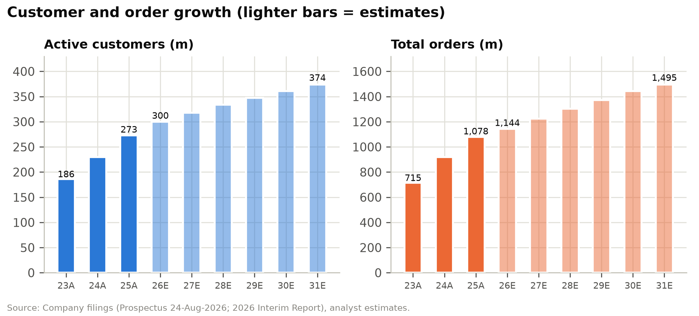

Industry Overview
Market size. CIC sizes the global fashion industry (apparel, footwear and accessories, retail sales value ex-VAT) at US$1,737bn in 2025, growing at a 2.7% CAGR over 2021-25 and forecast to grow at 3.4% to US$2,049bn by 2030. Apparel is US$1,370bn and footwear US$367bn. The online channel was US$606bn in 2025 (34.9% penetration), forecast to reach US$792bn by 2030 (38.7% penetration), a 5.5% CAGR — roughly twice offline growth (2.1%).
Structure. The industry is highly fragmented: the top 20 players held only ~20.5% of the market in 2025. CIC attributes this to the "trilemma" — the difficulty of simultaneously offering broad assortment, rapid design refresh and efficient inventory — which pushes most players into narrow niches.
Key trends.
1. Secular shift online driven by mobile payments, global fulfilment, social commerce and recommendation technology.
2. Individuality and trend velocity: social media accelerates trend cycles and fragments demand into a long tail, favouring broad, fast-refreshing assortments.
3. Value beyond fashion: consumers — and regulators — increasingly scrutinise labour practices, environmental impact and transparency; the EU is legislating on textile waste, product safety and platform accountability.
4. Supply-side innovation: small-batch production, real-time inventory management and warehouse automation are becoming table stakes.
5. Trade-policy re-regulation of cross-border e-commerce: the US ended de minimis for China (May 2025) and all countries (August 2025); the EU abolished the €150 duty exemption from 1 July 2026 (with a €3-per-item-category flat duty and a forthcoming handling fee); other markets are reviewing similar thresholds. This structurally raises the landed cost of direct-to-consumer cross-border parcels relative to locally stocked inventory.
Adjacent categories. CIC sizes home & living at US$1,408bn (online US$282bn → US$374bn by 2030), appliances & electronics at US$1,441bn (online US$659bn → US$1,067bn) and beauty & personal care at US$614bn (online US$171bn → US$264bn). These markets underpin SHEIN's category expansion and marketplace strategy.
Input costs. Polyester accounted for 82.7% of SHEIN's raw material by weight in 2025. China's man-made-fibre price index fell from 104.2 (2022) to 94.0 (2025) and China's apparel and footwear PPI was broadly flat (102.0 in 2025 vs 100.0 in 2021), so input costs have been benign; freight and duties are the more important variable costs.
Figure 15: Global fashion market size and online penetration, 2021-2030E
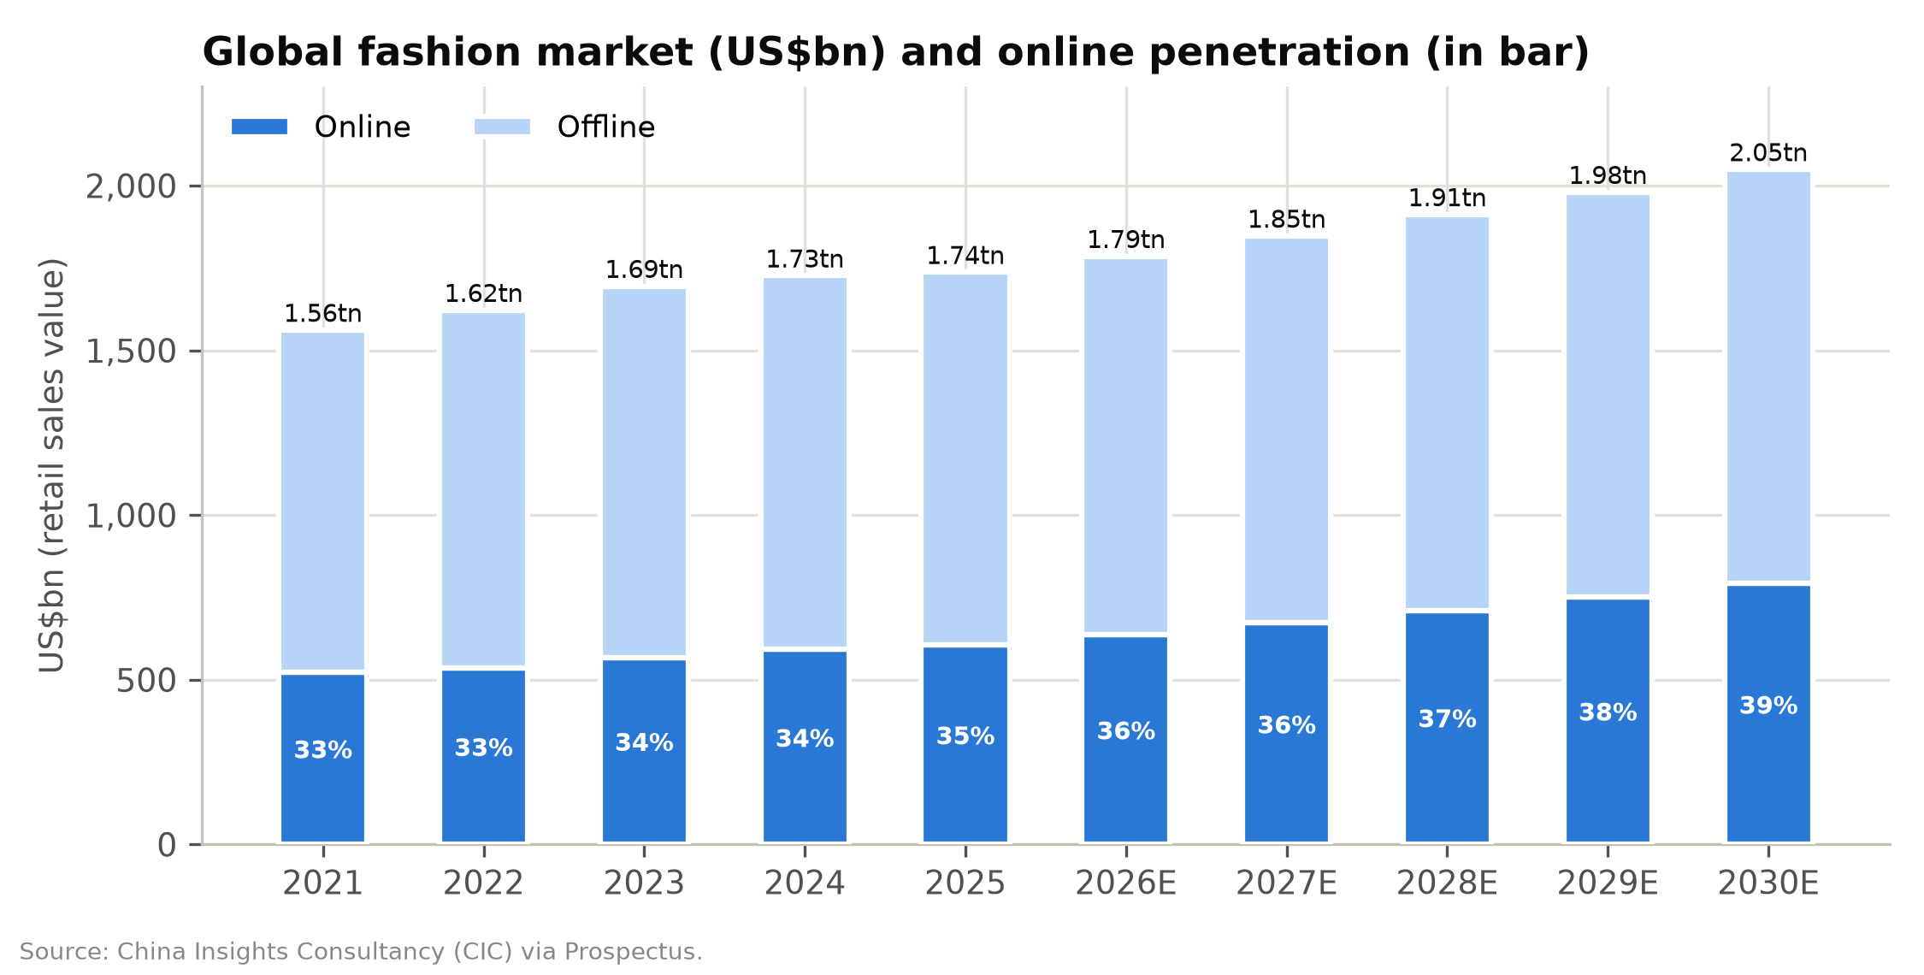

Figure 16: Global apparel and footwear market share, 2025 (CIC)
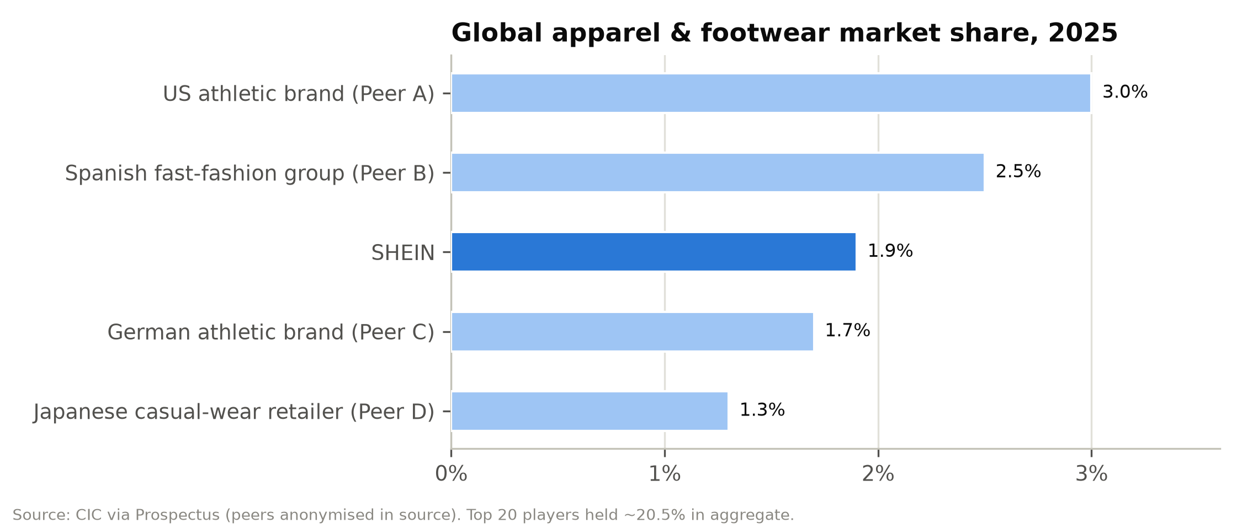

Competitive Landscape
SHEIN competes primarily with global fashion retailers and, to a lesser extent, with general e-commerce platforms that sell fashion. We group competitors into four categories.
1. Inditex (Zara) — the benchmark fast-fashion operator. Market share ~2.5% (CIC). Trailing revenue ~€41bn, EBITDA margin ~24%, net margin ~16%; trades at ~23.5x forward P/E. Inditex's proximity-sourcing model (Spain, Portugal, Morocco, Turkey) delivers two-to-four-week design-to-shelf cycles with a store-plus-online network. SHEIN offers far greater assortment at lower prices; Inditex offers brand equity, quality perception, physical presence and vastly superior margins and returns.
2. H&M Group. ~€19bn revenue equivalent (SEK221bn), EBITDA margin ~11%, forward P/E ~19x. H&M's longer lead times and store-heavy model leave it more exposed to markdowns; it has been losing share in value fashion to SHEIN and Primark.
3. Fast Retailing (Uniqlo). Share ~1.3%; revenue ¥3.85trn; premium valuation (~39x forward P/E, 22.6x EV/EBITDA) reflecting a basics-led, low-fashion-risk model with strong Asian growth. Limited direct overlap with SHEIN's trend-led assortment but a benchmark for what a global apparel franchise can be worth.
4. Athletic leaders (Nike, Adidas). Ranked #1 and #4 by CIC market share; relevant as share benchmarks and as competitors in sportswear, where SHEIN's MUSERA and Glowmode are growing.
5. PDD Holdings (Temu). SHEIN's most direct and aggressive competitor since 2023: a fully managed/semi-managed marketplace shipping low-priced Chinese goods worldwide, backed by PDD's ~US$66bn net cash. Temu competes on price across all categories, including fashion, and has contested SHEIN in courts (US antitrust complaint, partially dismissed September 2025; UK copyright and competition cases, with further trials in 2027). Temu faces the same de minimis headwinds. PDD trades at only ~6.8x forward P/E and ~3x EV/EBITDA, anchoring investor expectations for China-linked cross-border platforms.
6. Alibaba (AliExpress) and other China cross-border platforms. AliExpress's "Choice" programme competes on price and delivery; Alibaba trades at ~13.6x forward P/E.
7. Amazon (including Amazon Haul). Amazon's low-price storefront targets the same value shopper with local fulfilment advantages in the US and Europe; Amazon's scale in logistics is a structural threat as duties erode the cost advantage of direct cross-border shipping.
8. TikTok Shop. Social-commerce platforms compete for the same young consumer and the same influencer marketing budgets, and have lowered customer-acquisition barriers for smaller fashion brands.
9. Online fashion specialists: Zalando, ASOS, Boohoo, Revolve. Zalando (~€13.5bn revenue; ~12.9x forward P/E) is the leading European online fashion platform and a direct competitor in Europe, now expanding through its About You acquisition. ASOS (loss-making, EV/Sales ~0.5x) and Boohoo have lost share to SHEIN in the UK and US value segments. Revolve (~21x forward P/E) is a US premium online player.
10. Primark (ABF) and off-price retailers. Physical value fashion with strong unit economics in Europe; benefits from any increase in cross-border landed costs.
SHEIN's competitive position. SHEIN's advantages are assortment breadth (2m+ styles), speed (5-day restocks), inventory efficiency (36-day turnover), cost (value pricing enabled by LATR and Chinese supply-chain density) and a large, engaged customer base (291m). Its disadvantages are thin operating margins (2-4% versus 12-20% for Inditex and Fast Retailing), dependence on cross-border shipping from China (>90% of revenue shipped from Chinese warehouses) at a time when duty regimes are tightening, brand perception issues (quality, sustainability, IP), and regulatory scrutiny that its physical-retail peers largely escape. The competitive threat has shifted from Temu (price) toward platforms with local fulfilment (Amazon) and toward local value retail as duties rise.
Figure 17: Competitive positioning: price point vs. assortment breadth and speed
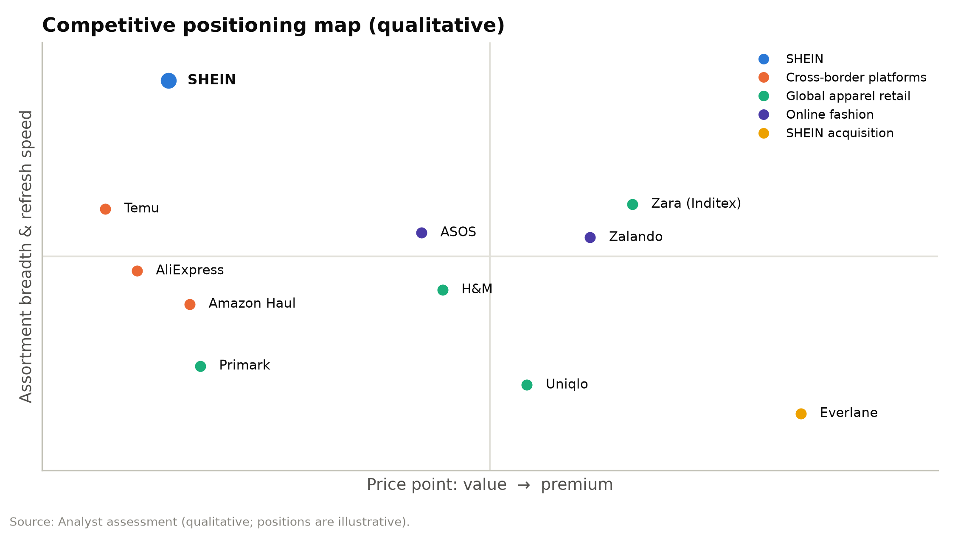

Figure 18: EBITDA margin benchmarking vs. peers (LTM)
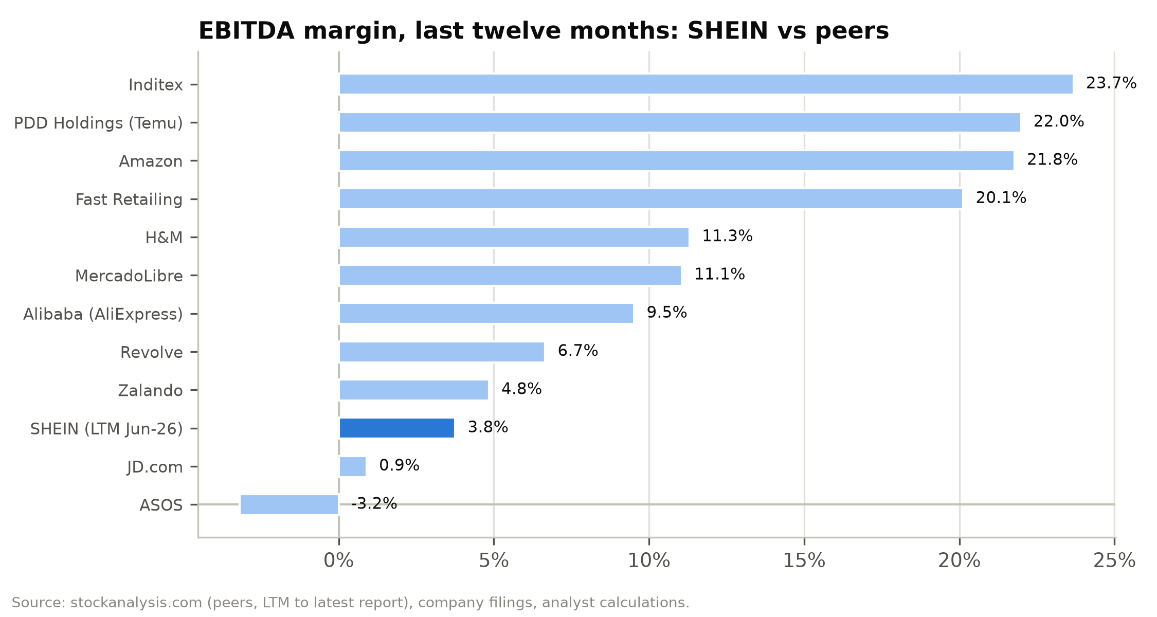

Market Opportunity
We frame SHEIN's addressable market in three layers:
Figure 19: Addressable market layers, 2025 and 2030E (CIC)
Layer | 2025 size | 2030E size | CAGR | SHEIN 2025 revenue / share
Global fashion (apparel, footwear, accessories) | US$1,737bn | US$2,049bn | 3.4% | ~1.9% share (CIC, by RSV)
Global online fashion | US$606bn | US$792bn | 5.5% | Largest online player
Online home & living | US$282bn | US$374bn | 5.8% | Adjacent category
Online beauty & personal care | US$171bn | US$264bn | 9.1% | SHEGLAM + marketplace
Online appliances & electronics | US$659bn | US$1,067bn | 10.1% | Marketplace only

Source: CIC via Prospectus. RSV = retail sales value ex-VAT.
Serviceable market. SHEIN's core serviceable market is online fashion (US$606bn, 2025), where its ~US$27bn of apparel revenue and a portion of its footwear/accessories revenue imply a high-single-digit share. Adding online beauty and home & living takes the serviceable online market to ~US$1.06trn in 2025, rising to ~US$1.43trn by 2030 (6.2% CAGR).
Share-gain runway. Even after a decade of hyper-growth SHEIN holds under 2% of global fashion. Management argues its current share is "relatively low". Our base-case model assumes net revenues grow at a 6.1% CAGR over 2026-31E (to US$56bn), modestly ahead of the online fashion market, with orders growing 5-7% a year and revenue per order stabilising as the price-range strategy offsets marketplace mix. Our bull case (8.6% CAGR) assumes Europe re-accelerates after the duty shock and the rest of the world continues to compound in double digits; our bear case (2.8% CAGR) assumes structural share loss in the US and Europe.
Constraints. The addressable market is not the binding constraint; trade policy and regulation are. The removal of low-value exemptions in the US and EU — SHEIN's two largest regions and ~60% of 2025 revenue — raises the cost of the direct-from-China model and forces a shift toward local inventory, which carries higher working capital, warehousing and duty costs but faster delivery.

Financial Analysis
SHEIN reports under IFRS in US dollars with a December year-end. Our historical analysis covers FY2023-FY2025 from the Accountants' Report in the prospectus, plus the first six months of 2026 and the 1Q/2Q splits disclosed in the 2026 Interim Report. Unless stated otherwise, "adjusted" figures use the company's non-IFRS definitions:
- Adjusted EBIT is operating income excluding share-based compensation.
- Adjusted net income also excludes fair-value changes of the convertible redeemable preferred shares, share of associates' results and impairments of long-term investments.

Revenue: from hyper-growth to a trade-policy pause
Net revenues grew from US$32.1bn in FY2023 to US$41.8bn in FY2025, a 14.2% CAGR. Growth slowed sharply, from 41.1% in FY2023 to 20.7% in FY2024, 8.0% in FY2025 and 1.0% in 1H26. The slowdown has three distinct causes, and they matter differently for the forecasts:
1. Marketplace mix (accounting, not demand). Service revenues rose from 2.7% of the total in FY2023 to 11.3% in FY2025 and 13.4% in 1H26. Marketplace sales are booked net, at the commission plus fulfilment fee. A shift of one order from first-party to the marketplace therefore reduces reported revenue even when the customer pays the same price. This is the main reason net revenue per order fell from US$44.9 in FY2023 to US$38.8 in FY2025.
2. Regional mix. The rest of the world (Latin America, the Middle East and Asia-Pacific) grew 15.4% in FY2025 and 16.0% in 1H26, becoming SHEIN's largest region at 44% of 1H26 revenue. Baskets in these markets are smaller than in the US and Europe.
3. Trade policy (genuine demand loss). US revenue fell 3.5% in FY2025 and 9.9% in 1H26 after the de minimis exemption was removed. Europe grew 8.8% in FY2025 and fell 13.9% in 2Q26 as SHEIN pre-emptively raised prices and cut advertising ahead of the EU duty.
Volume metrics are healthier than revenue:
- Orders grew 17.3% to 1.08bn in FY2025 and 6.4% in 1H26 (2Q26: +7.6%).
- Active customers reached 291m in the twelve months to June 2026 (+14.6%).
- Order frequency has been steady at about four orders per customer a year, so growth has come from new customers rather than deeper wallet share.
Figure 20: Net revenue trajectory, FY2023A-FY2031E (US$m) and YoY growth
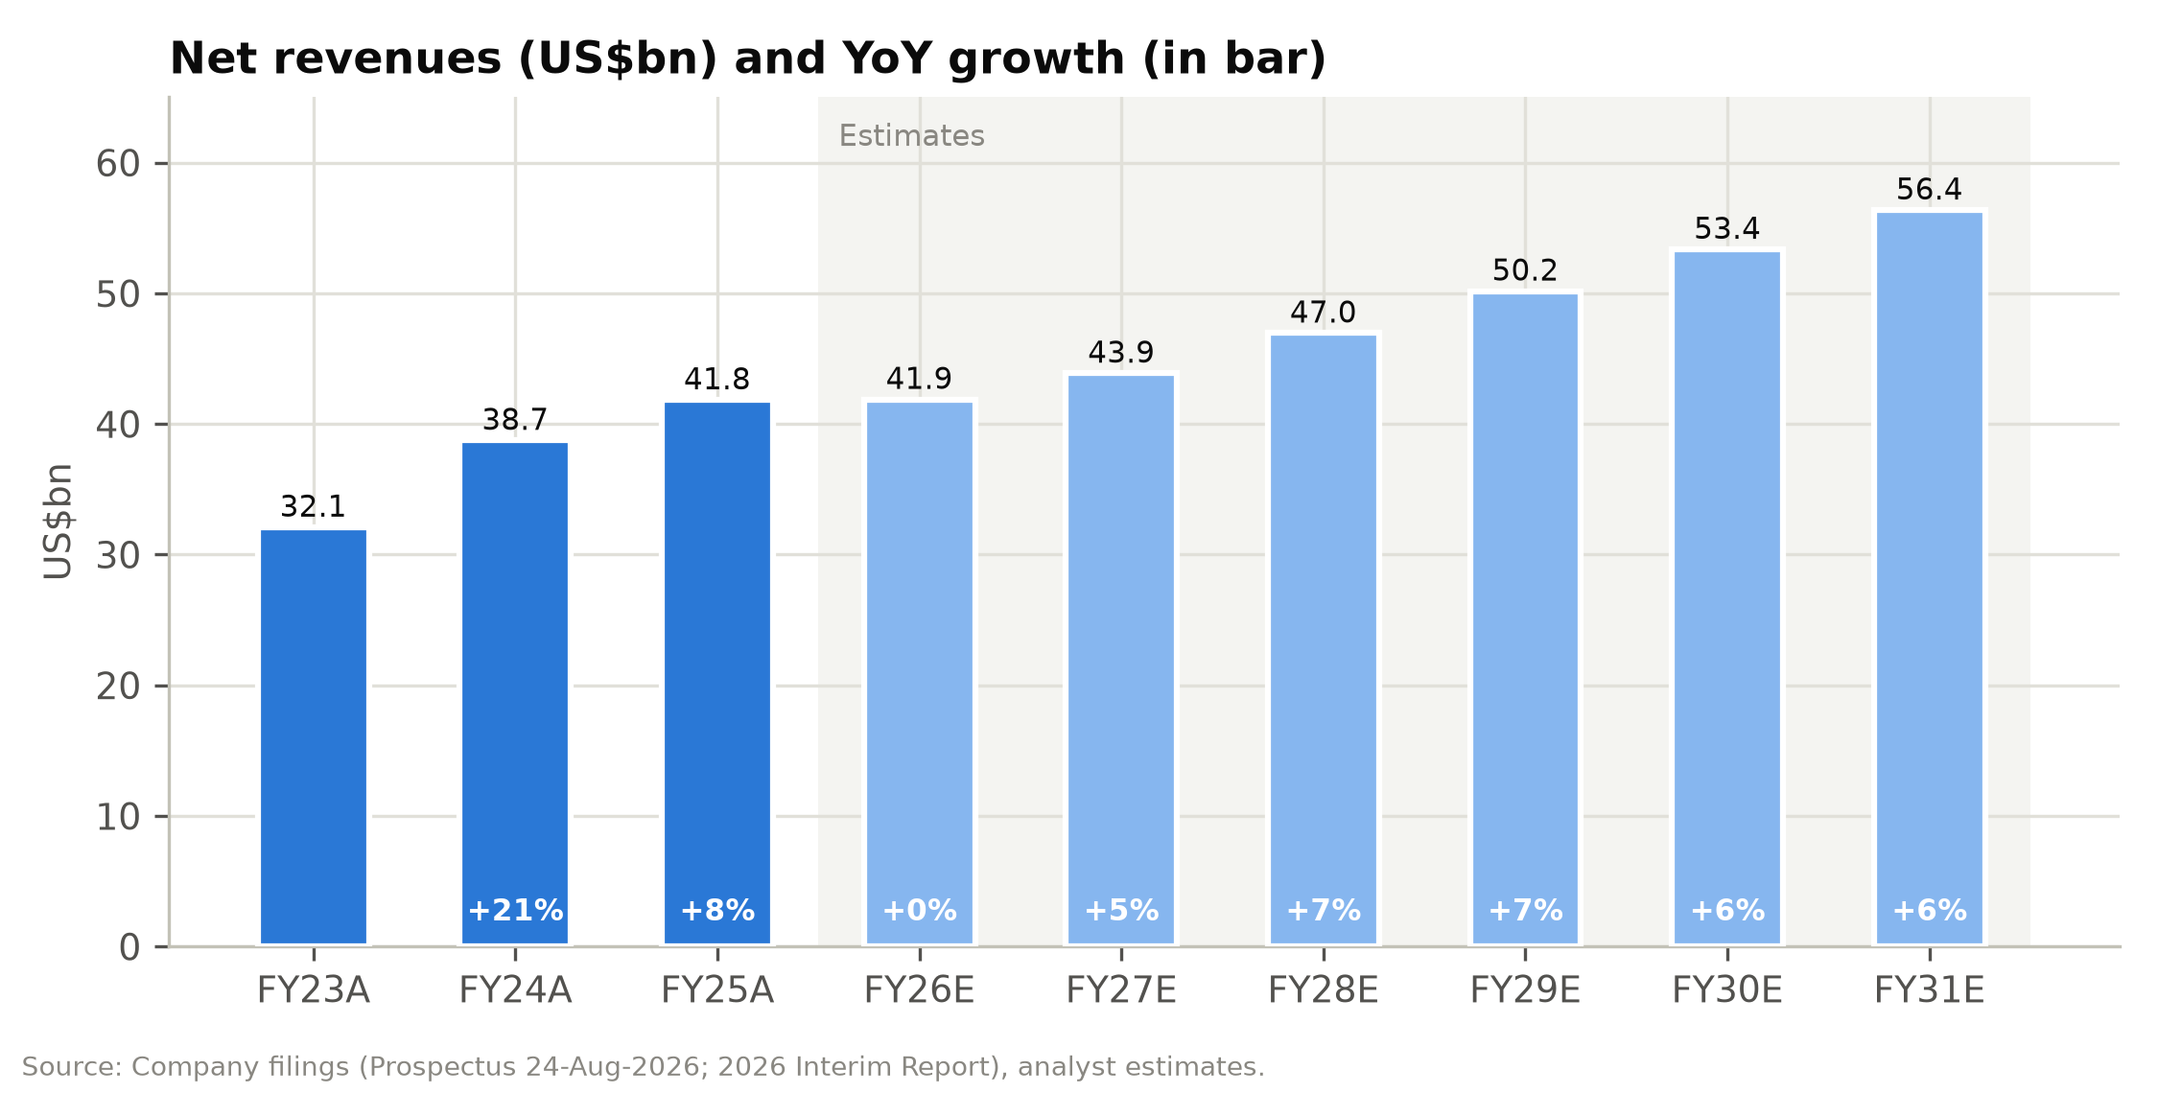

Figure 21: Historical income statement, FY2023A-FY2025A (US$m and % of revenue)
US$m | FY23A | FY24A | FY25A | % FY23 | % FY24 | % FY25
Net revenues | 32,103 | 38,748 | 41,847 | 100.0% | 100.0% | 100.0%
Product revenues | 31,235 | 35,351 | 37,107 | 97.3% | 91.2% | 88.7%
Service revenues | 868 | 3,397 | 4,740 | 2.7% | 8.8% | 11.3%
Cost of sales | (12,777) | (15,249) | (13,433) | (39.8%) | (39.4%) | (32.1%)
Gross profit | 19,326 | 23,499 | 28,414 | 60.2% | 60.6% | 67.9%
Fulfilment expenses | (13,501) | (16,847) | (19,072) | (42.1%) | (43.5%) | (45.6%)
Marketing expenses | (3,453) | (4,159) | (6,191) | (10.8%) | (10.7%) | (14.8%)
Technology & content | (668) | (849) | (896) | (2.1%) | (2.2%) | (2.1%)
General & administrative | (328) | (678) | (548) | (1.0%) | (1.7%) | (1.3%)
Operating income | 1,376 | 966 | 1,707 | 4.3% | 2.5% | 4.1%
FV changes of preferred shares | 1,231 | 2,431 | 328 | 3.8% | 6.3% | 0.8%
Interest income | 472 | 597 | 621 | 1.5% | 1.5% | 1.5%
Associates, FX & other | (84) | (225) | (142) | (0.3%) | (0.6%) | (0.3%)
Income before tax | 2,995 | 3,769 | 2,514 | 9.3% | 9.7% | 6.0%
Income tax | (206) | (404) | (450) | (0.6%) | (1.0%) | (1.1%)
Net income (IFRS) | 2,789 | 3,365 | 2,064 | 8.7% | 8.7% | 4.9%
Adjusted net income | 1,643 | 1,119 | 1,816 | 5.1% | 2.9% | 4.3%
Source: Prospectus (Accountants' Report), analyst calculations.
Quarterly and half-year data show the second-quarter pattern and the effect of the tariff changes by region. In the US, the year-on-year decline narrowed from 14.3% in 1Q26 to 6.0% in 2Q26 as customers adjusted to higher prices and SHEIN shifted to formal customs entry. In Europe, 1Q26 revenue was still up 2.3%, but 2Q26 fell 13.9% when pricing was raised ahead of the 1-Jul-2026 duty. The rest of the world accelerated from 10.1% in 1Q26 to 21.6% in 2Q26.
Figure 22: Quarterly and half-year revenue by region (US$m)
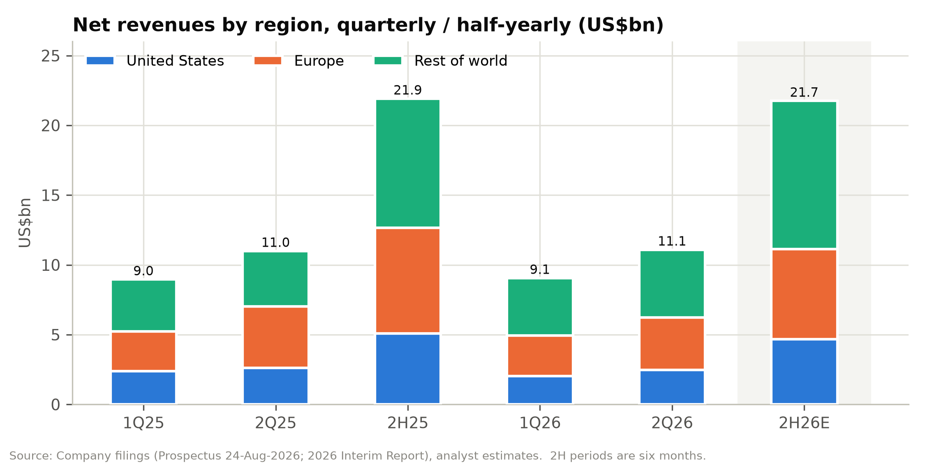

Figure 23: Revenue growth by region, FY2024A-FY2027E and 1H26
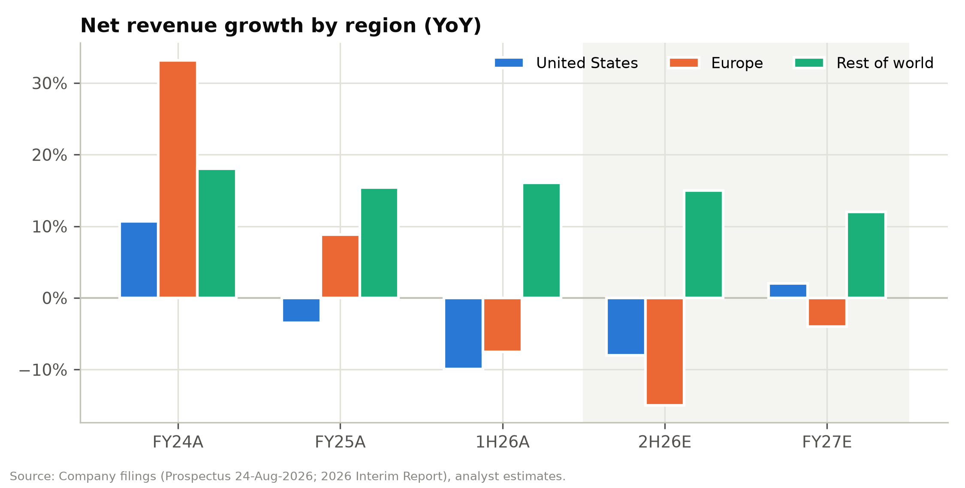

Gross margin: structurally higher because of the marketplace
Gross margin rose from 60.2% in FY2023 to 67.9% in FY2025 and 70.1% in 1H26. The prospectus attributes the decline in cost of sales (–11.9% in FY2025 despite higher volumes) to four factors:
- the rising share of the marketplace, which carries no cost of sales;
- pricing adjustments;
- cost optimisation;
- currency movements.
Cost of sales as a percentage of product revenue, our cleaner measure of first-party product margin, fell from 43.1% in FY2024 to 36.2% in FY2025 and about 34% in 1H26.
Because gross margin is flattered by mix, we focus on contribution margin after fulfilment: gross profit less fulfilment expenses, as a percentage of revenue. It improved from 18.1% in FY2023 to 22.3% in FY2025, then fell to 20.9% in 1H26 as freight costs spiked. It is the best single indicator of SHEIN's unit economics because fulfilment is the cost line most affected by the marketplace, duties and freight.
Figure 24: Gross margin and contribution margin after fulfilment, FY2023A-FY2031E
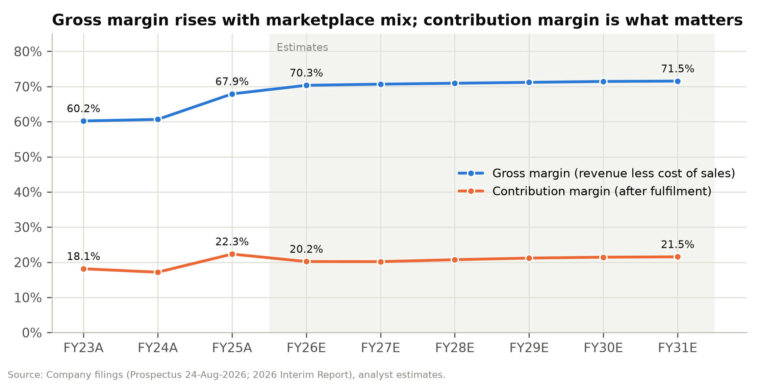

Fulfilment: the swing factor
Fulfilment expenses cover outbound logistics, warehousing and, since the removal of de minimis exemptions, duties on direct shipments. They are SHEIN's largest cost at 45.6% of FY2025 revenue and 50.4% of 2Q26 revenue.
Two effects drive the ratio in opposite directions:
- Per-order cost fell. Fulfilment cost per order declined from US$18.9 in FY2023 to US$17.7 in FY2025 as scale, local warehousing and carrier negotiations improved.
- Revenue per order fell faster. The marketplace mix and lower-basket markets meant fulfilment rose as a share of revenue even as unit cost fell.
In 2Q26 the ratio jumped to 50.4% from 43.1% a year earlier. Management attributes this mainly to the rise in oil prices and freight costs caused by the Iran conflict, with marketplace mix a secondary factor. SHEIN chose not to pass these costs on to customers.
Fulfilment is also where tariff costs land. Duties on direct-to-consumer shipments into the US (and, from July 2026, the EU) are booked in fulfilment rather than cost of sales. This is why we model the ratio at 50.0-51.0% throughout the forecast period rather than assuming a return to the FY2025 level.

Marketing: the FY2025 step-up is being reversed
Marketing expenses rose 48.9% to US$6.2bn in FY2025, or 14.8% of revenue vs. 10.7% in FY2024. Advertising grew from US$4.0bn to US$5.0bn "to drive better customer engagement" amid competition from Temu and tariff-driven price increases. In 2Q26 marketing fell 4.1% year on year to 13.6% of revenue as SHEIN cut online advertising in Europe alongside its price increases.
We assume the ratio settles at 13.5% in FY2027E and 13.2% from FY2029E. That is still well above FY2023-24, so it leaves room for upside if competitive intensity eases.
Figure 25: Marketing spend (US$m) and marketing intensity (% of revenue)
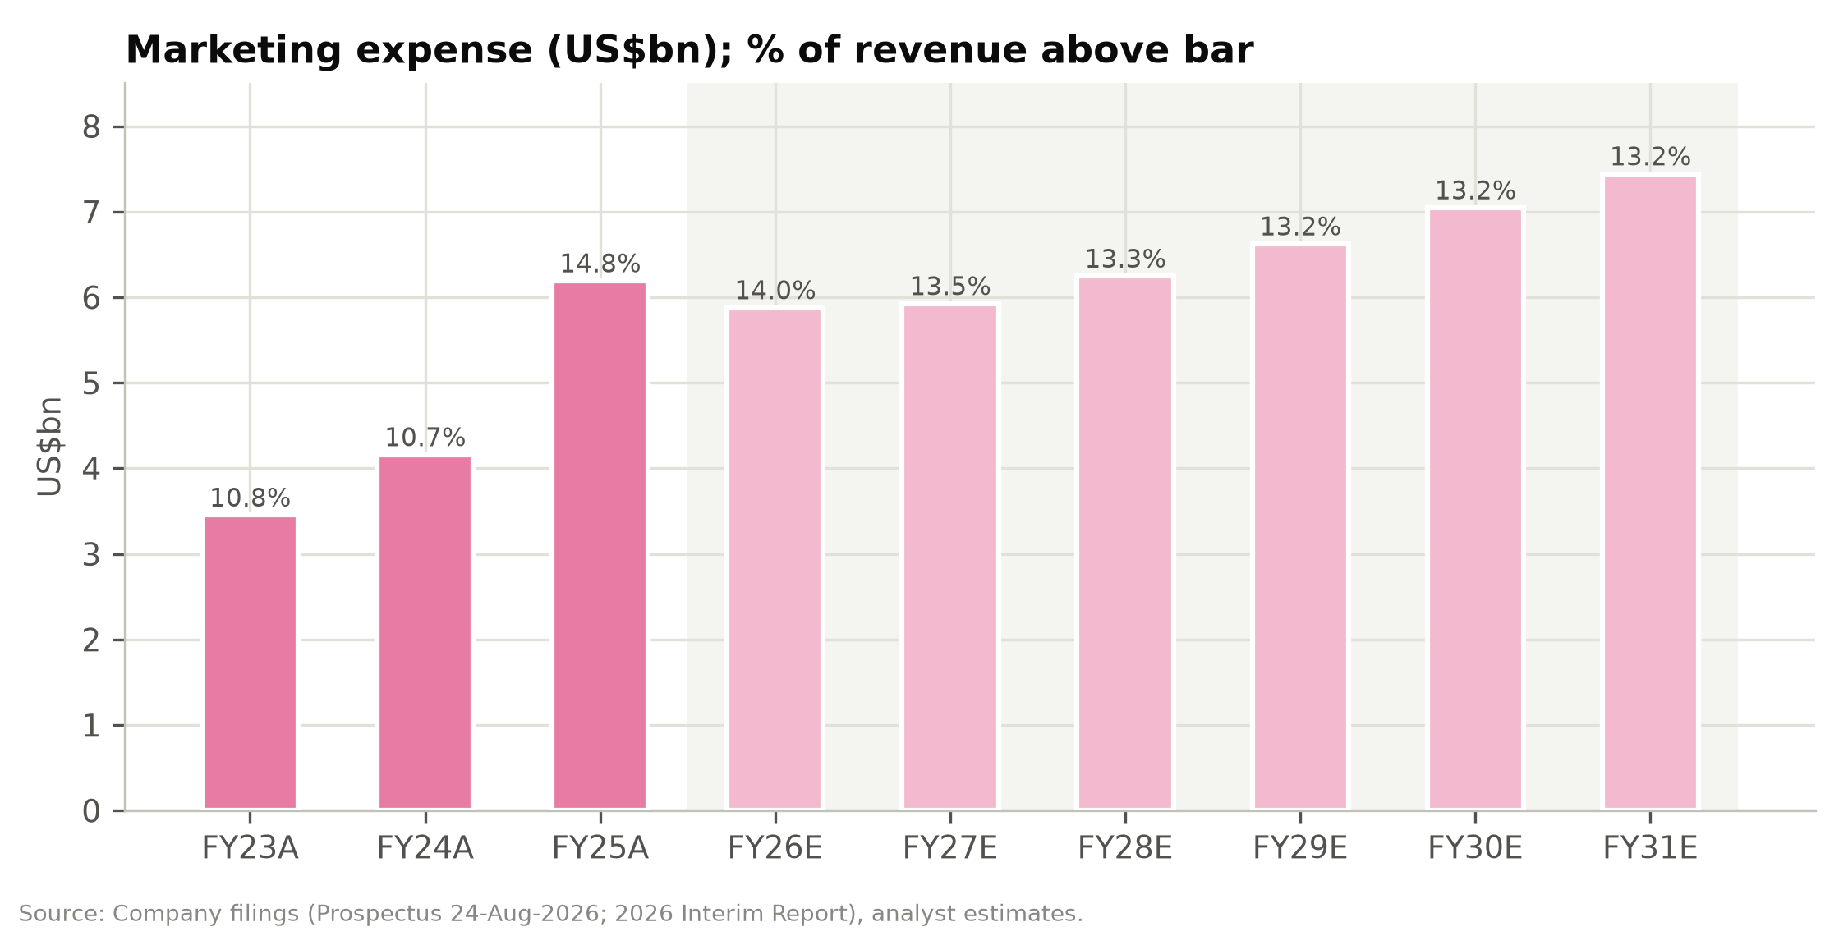

Technology, G&A and operating leverage
Technology and content expenses are modest at 2.1-2.5% of revenue: US$896m in FY2025 and US$499m in 1H26, with 2Q26 up 16.7% on infrastructure investment. Research and development spending was US$451m in 1H26. G&A is lean at 1.3% of revenue. Together these fixed-cost lines are under 4% of revenue, so the operating margin is driven almost entirely by three variable costs: product cost, fulfilment and marketing.
Figure 26: Technology and content investment (US$m and % of revenue)
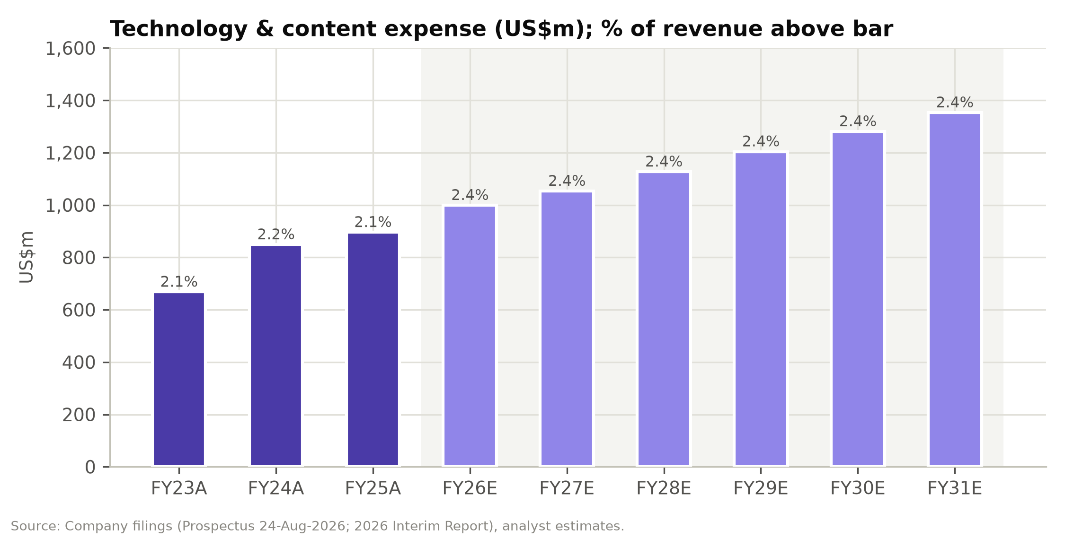

Profitability: a volatile, low-single-digit margin
Operating income has been volatile:
- FY2023: US$1,376m (4.3% margin).
- FY2024: US$966m (2.5%). Cost of sales rose to 43.1% of product revenue and fulfilment to 43.5% of revenue.
- FY2025: US$1,707m (4.1%). The gross-margin gain more than offset the marketing step-up.
- 1H26: US$493m (2.4%), down 52.9% year on year. 2Q26 alone was 2.1%.
The adjusted EBIT margin (excluding SBC of US$85m in FY2025) was 4.3% in FY2025 and 2.7% in 1H26.
Figure 27: EBITDA, adjusted EBIT and EBIT margins, FY2023A-FY2031E
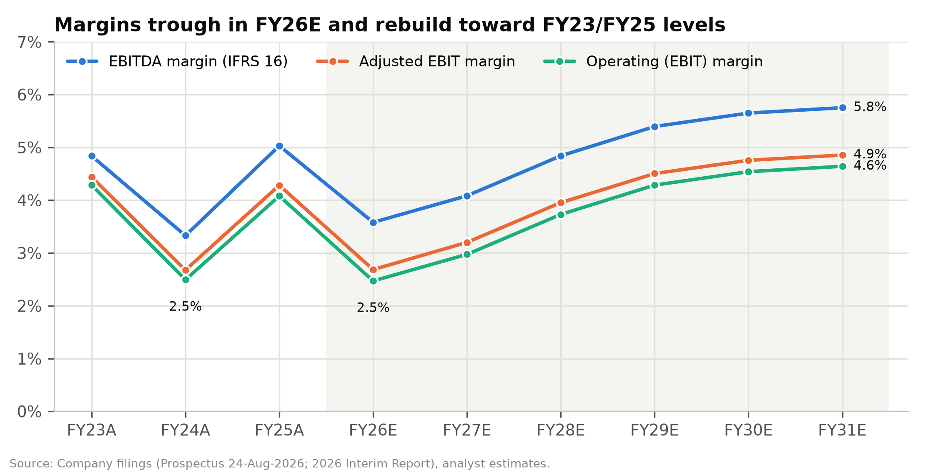

Figure 28: Half-year adjusted EBIT (US$m) and adjusted EBIT margin
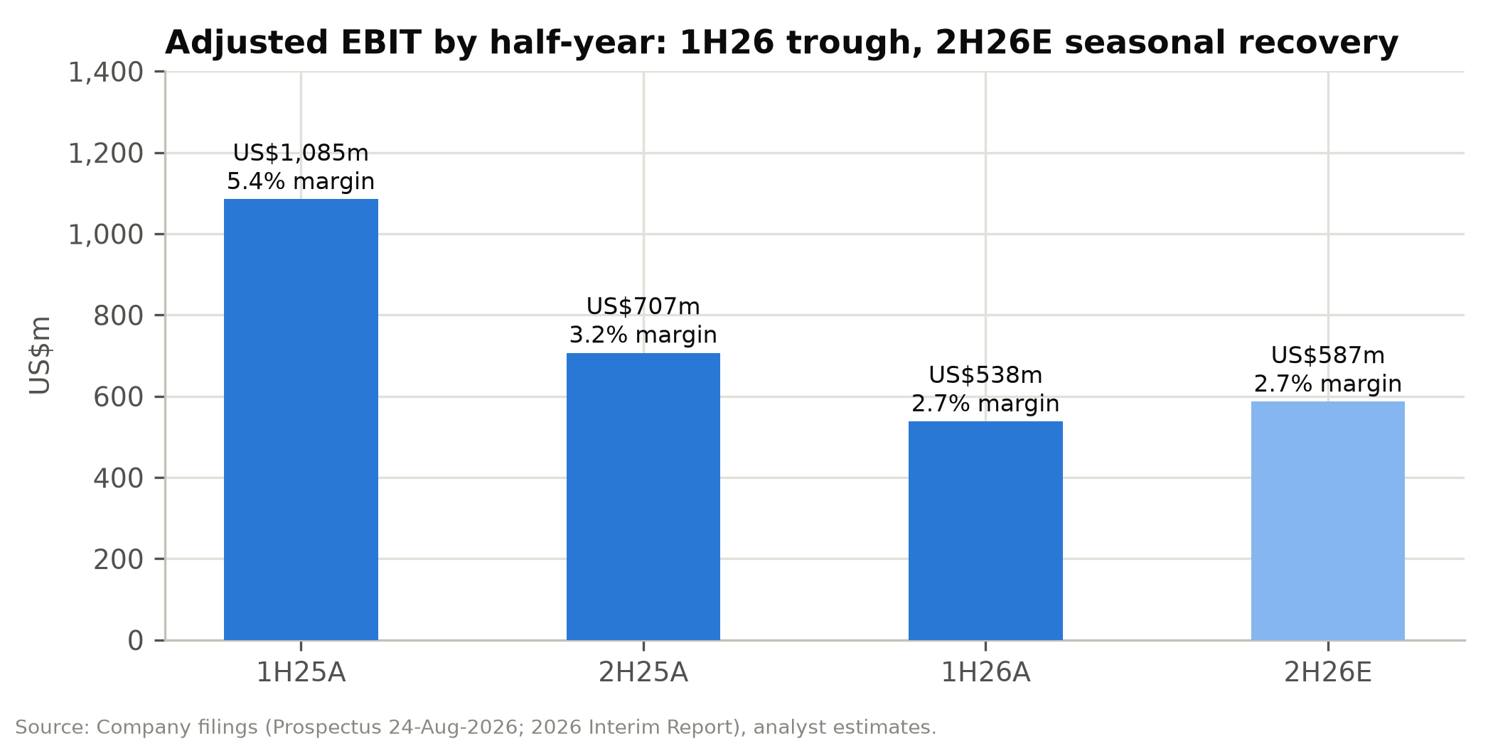

Below the line: preferred shares, interest income and tax
Three items dominate the gap between operating income and IFRS net income:
- Fair-value changes of preferred shares. Until listing, the convertible redeemable preferred shares were carried as liabilities at fair value. Gains were recognised when SHEIN's valuation fell: US$1,231m in FY2023, US$2,431m in FY2024, US$328m in FY2025 and a net US$1,861m in 1H26 (a US$328m loss in 1Q26 and a US$2,189m gain in 2Q26). At listing the preferred shares converted into 1,397.7m Class B shares. The carrying value was US$15.1bn at 30 June, against a conversion value of about US$11.1bn (shares at the IPO price plus cash compensation). We therefore book a further ~US$4.0bn non-cash gain in 2H26E, taking FY2026E IFRS net income to ~US$6.9bn. These gains have no cash or economic substance and are excluded from adjusted earnings.
- Interest income. SHEIN earned US$621m of interest in FY2025 on its deposit portfolio, a 4.7% yield on opening cash resources. That was about 28% of FY2025 pre-tax profit excluding fair-value gains. We model the yield falling to 3.3% by FY2029E as US dollar rates decline.
- Tax. The core effective tax rate, excluding fair-value changes and associates, has ranged from 11.4% (FY2023) to 26.8% (FY2024); it was 20.6% in FY2025 and about 26% in 1H26. We assume 22% from FY2027E, reflecting Singapore headquarters, OECD Pillar Two and the mix of profits across jurisdictions.
Adjusted net income was US$1,643m in FY2023, US$1,119m in FY2024, US$1,816m in FY2025 and US$499m in 1H26 (–55.6%).
Figure 29: Quarterly and half-year results (US$m)
US$m | 1Q25 | 2Q25 | 1H25 | 2H25 | FY25 | 1Q26 | 2Q26 | 1H26 | 2H26E | FY26E
Net revenues | 8,952 | 10,988 | 19,940 | 21,907 | 41,847 | 9,052 | 11,082 | 20,134 | 21,749 | 41,883
YoY |  |  |  |  |  | 1.1% | 0.9% | 1.0% | (0.7%) | 0.1%
United States | 2,380 | 2,632 | 5,012 | 5,089 | 10,101 | 2,040 | 2,474 | 4,514 | 4,682 | 9,196
Europe | 2,843 | 4,379 | 7,222 | 7,580 | 14,802 | 2,908 | 3,770 | 6,678 | 6,443 | 13,121
Rest of world | 3,729 | 3,977 | 7,706 | 9,238 | 16,944 | 4,104 | 4,838 | 8,942 | 10,624 | 19,566
Service % of revenue | 13.3% | 8.9% | 10.8% | 11.8% | 11.3% | 14.3% | 12.7% | 13.4% | 13.5% | 13.5%
Orders (m) | 240 | 277 | 517 | 561 | 1,078 | 251 | 298 | 549 | 595 | 1,144
Gross margin | 62.7% | 67.0% | 65.1% | 70.5% | 67.9% | 70.4% | 69.8% | 70.1% | 70.6% | 70.3%
Fulfilment % revenue | 42.8% | 43.0% | 42.9% | 48.0% | 45.6% | 47.7% | 50.4% | 49.2% | 51.0% | 50.1%
Marketing % revenue | 12.2% | 14.3% | 13.4% | 16.1% | 14.8% | 15.8% | 13.6% | 14.6% | 13.5% | 14.0%
Operating income | 348 | 698 | 1,046 | 661 | 1,707 | 258 | 235 | 493 | 542 | 1,035
Operating margin | 3.9% | 6.4% | 5.2% | 3.0% | 4.1% | 2.9% | 2.1% | 2.4% | 2.5% | 2.5%
Adjusted EBIT | 370 | 715 | 1,085 | 707 | 1,792 | 284 | 254 | 538 | 587 | 1,125
Net income (IFRS) | 395 | 691 | 1,086 | 978 | 2,064 | (99) | 2,398 | 2,299 | 4,630 | 6,929
Adjusted net income | 440 | 683 | 1,123 | 693 | 1,816 | 271 | 228 | 499 | 651 | 1,150
Adj. net margin | 4.9% | 6.2% | 5.6% | 3.2% | 4.3% | 3.0% | 2.1% | 2.5% | 3.0% | 2.7%
Note: 2H25 derived as FY25 less 1H25. 2H26E and FY26E are analyst estimates. 2H26E IFRS net income includes an estimated US$4.0bn non-cash FV gain on conversion of preferred shares.
Source: Prospectus, 2026 Interim Report, analyst estimates.

Cash flow and working capital
SHEIN's cash conversion is strong because of its negative working capital:
- Customers pay at the time of order.
- Suppliers are paid on about 34-day terms.
- Inventory turns in about 36 days.
Operating net working capital was –US$4.0bn at December 2025 (–9.6% of revenue) and –US$5.0bn at June 2026. The seasonal pattern is pronounced. Payables and accruals build in the first half and unwind in the second: operating cash flow was US$2.9bn in 1H25 and –US$39m in 2H25.
Free cash flow (operating cash flow less capex and lease payments) was US$1.3bn in FY2023, US$0.9bn in FY2024 and US$2.3bn in FY2025, or US$2.9bn including interest received. That is 160% of adjusted net income in FY2025.
Capex is very low at 0.5-1.0% of revenue, because warehouses are leased and SHEIN does not own manufacturing. D&A of property, equipment and intangibles is only 0.4% of revenue.
For FY2026E we forecast free cash flow of only US$0.5bn (US$1.1bn with interest). This reflects the second-half working-capital unwind and lower profits. We expect it to recover to US$1.6bn in FY2027E and US$2.8bn by FY2031E (both including interest).
Figure 30: Free cash flow (incl. interest received) vs. adjusted net income (US$m)
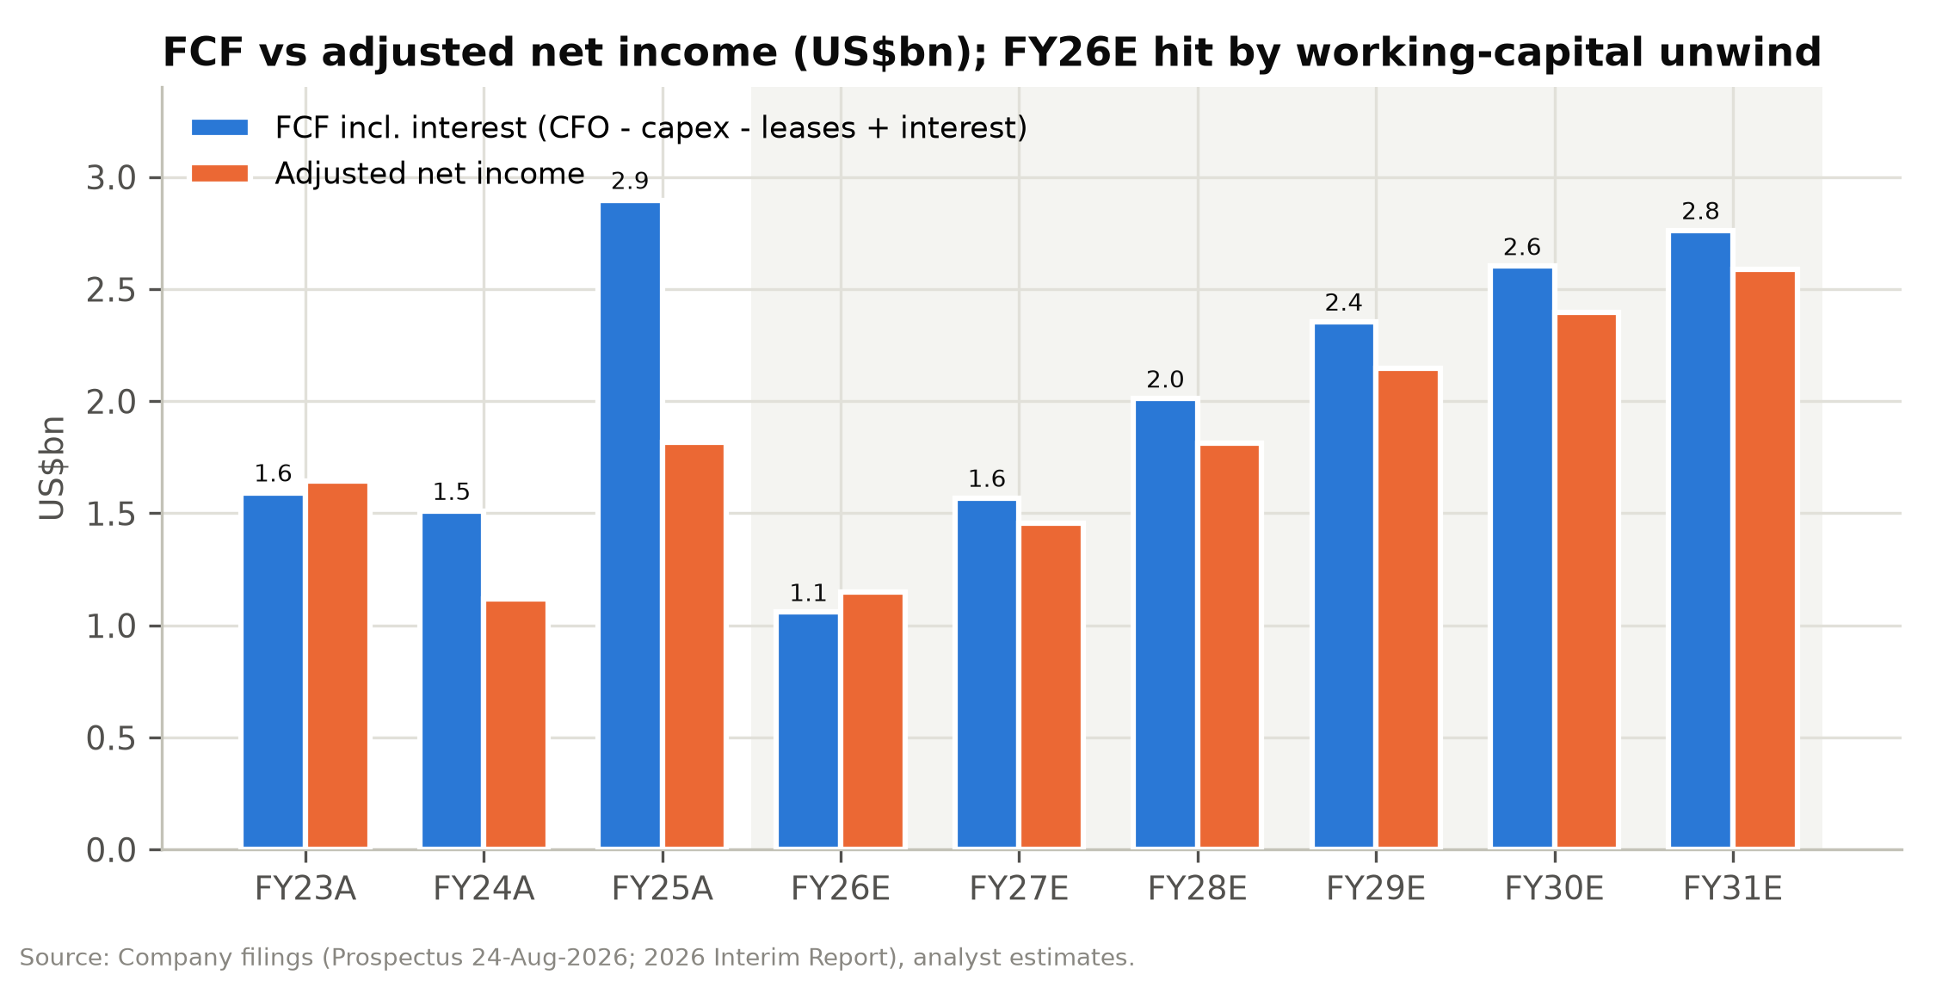

Figure 31: Operating net working capital (US$m and % of revenue)
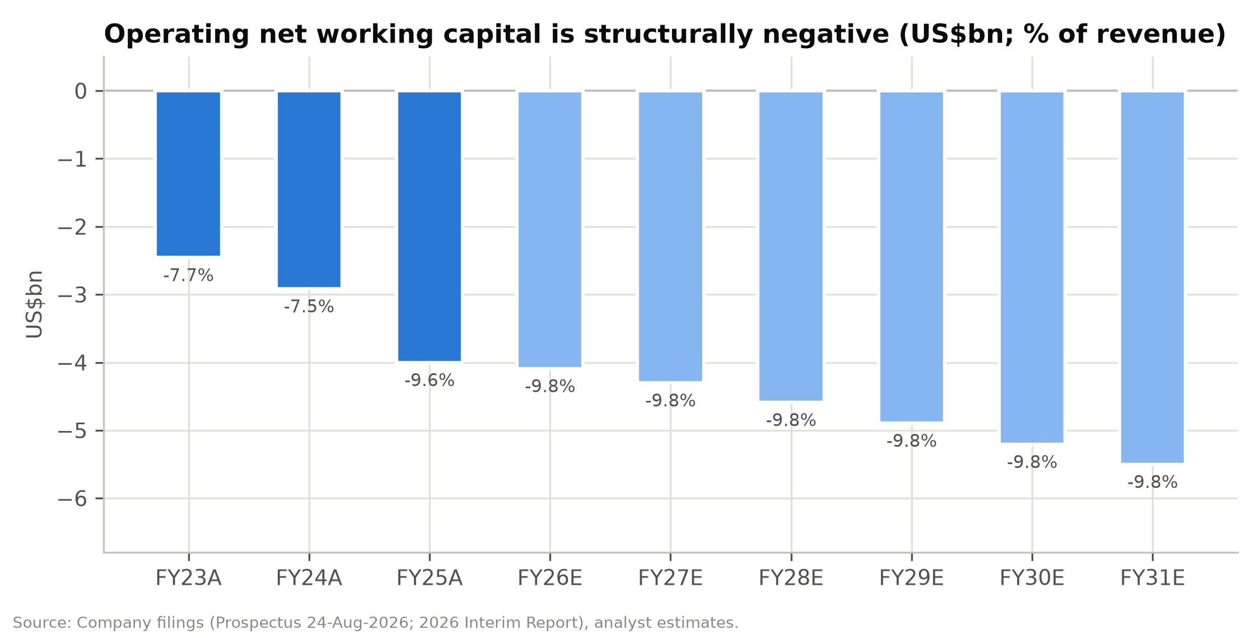

Balance sheet: a cash-rich, debt-free company after the listing
Before listing, SHEIN's balance sheet showed a shareholders' deficit of US$6.9bn at December 2025. This was because US$18.0bn of convertible redeemable preferred shares were classified as liabilities. The conversion at listing removes that liability. Our forecast has shareholders' equity of US$10.5bn at December 2026, after:
- US$11.1bn of conversion value credited to equity;
- the US$2.2bn Conversion Adjustment cash;
- the US$0.23bn 12% distribution;
- the US$1.68bn of IPO proceeds.
Cash resources (cash, restricted cash and time deposits) were US$15.2bn at 30 June 2026. We forecast US$13.9bn at December 2026, after the listing-related outflows and the second-half working-capital unwind, rising to US$20.7bn by FY2031E even with a 50% payout. The only interest-bearing obligations are US$1.1bn of lease liabilities. Adjusted return on equity reaches 13-17% in FY2027-31E, flattered by the large cash balance.

Projections and Estimates
Our model forecasts FY2026E-FY2031E. FY2026E is built from reported 1H26 plus explicit 2H26E drivers. Each forecast year is driven by the assumptions described below, which are selected in the model's Scenarios tab. We describe the base case here; bull and bear cases are in the Scenario Analysis section. All figures below are base case unless noted.

Revenue build: region-driven, cross-checked against orders
We forecast revenue by region because the regions face very different trade-policy conditions. We then cross-check the total against an orders × revenue-per-order build.
United States (22% of FY2026E revenue).
- FY2026E: –9.0%. The US has now lapped the removal of de minimis for China-origin goods (2 May 2025) and for all countries (29 August 2025). 1Q26 was –14.3% and 2Q26 –6.0%. We assume –8% in 2H26E, reflecting a tougher 3Q comparison before the August 2025 anniversary.
- FY2027E-FY2031E: +2% in FY2027E, then 3.5-4%. Growth is in line with US apparel e-commerce, helped by the price-range strategy (Everlane and higher-priced brands) and domestic fulfilment from six US warehouses.
Europe (31% of FY2026E revenue).
- FY2026E: –11.4%. The EU's €3-per-item-category duty on low-value parcels took effect on 1 July 2026, and management warns the impact could be "in line with or exceed" the US experience. We assume –15% in 2H26E, following 2Q26's –13.9% when price increases were implemented pre-emptively.
- FY2027E: –4%. 1H27 laps a pre-duty base.
- FY2028E-FY2031E: 4-5%. Local inventory (18 European warehouses, 1.0m m²) mitigates the landed-cost disadvantage.
Rest of world (47% of FY2026E revenue).
- FY2026E: +15.5%. Growth was 16.0% in 1H26 (21.6% in 2Q26), led by Latin America (Brazil and Mexico), with a low-single-digit drag from the Middle East conflict. We assume +15% in 2H26E.
- FY2027E-FY2031E: 12% in FY2027E, fading to 7% by FY2031E. Several of these markets are also reviewing low-value import thresholds, which is why we fade growth.
On this build, group revenue is broadly flat in FY2026E at US$41.9bn (+0.1%). It grows 4.8% to US$43.9bn in FY2027E and reaches US$56.4bn by FY2031E, a 6.1% CAGR from FY2026E. The rest of the world rises from 40.5% of revenue in FY2025 to 54% in FY2031E.
Figure 32: Net revenues by region, FY2023A-FY2031E (US$m)
US$m | FY23A | FY24A | FY25A | FY26E | FY27E | FY28E | FY29E | FY30E | FY31E
United States | 9,454 | 10,464 | 10,101 | 9,196 | 9,380 | 9,755 | 10,145 | 10,551 | 10,920
YoY |  | 10.7% | (3.5%) | (9.0%) | 2.0% | 4.0% | 4.0% | 4.0% | 3.5%
% of total | 29.4% | 27.0% | 24.1% | 22.0% | 21.4% | 20.8% | 20.2% | 19.8% | 19.4%
Europe | 10,214 | 13,603 | 14,802 | 13,121 | 12,596 | 13,100 | 13,755 | 14,443 | 15,093
YoY |  | 33.2% | 8.8% | (11.4%) | (4.0%) | 4.0% | 5.0% | 5.0% | 4.5%
% of total | 31.8% | 35.1% | 35.4% | 31.3% | 28.7% | 27.9% | 27.4% | 27.1% | 26.8%
Rest of world | 12,435 | 14,681 | 16,944 | 19,566 | 21,914 | 24,105 | 26,274 | 28,376 | 30,363
YoY |  | 18.1% | 15.4% | 15.5% | 12.0% | 10.0% | 9.0% | 8.0% | 7.0%
% of total | 38.7% | 37.9% | 40.5% | 46.7% | 49.9% | 51.3% | 52.4% | 53.2% | 53.9%
Total net revenues | 32,103 | 38,748 | 41,847 | 41,883 | 43,890 | 46,960 | 50,175 | 53,370 | 56,376
YoY |  | 20.7% | 8.0% | 0.1% | 4.8% | 7.0% | 6.8% | 6.4% | 5.6%
Source: Company filings, analyst estimates.
Figure 33: Net revenues by geography, FY2023A-FY2031E (US$m)
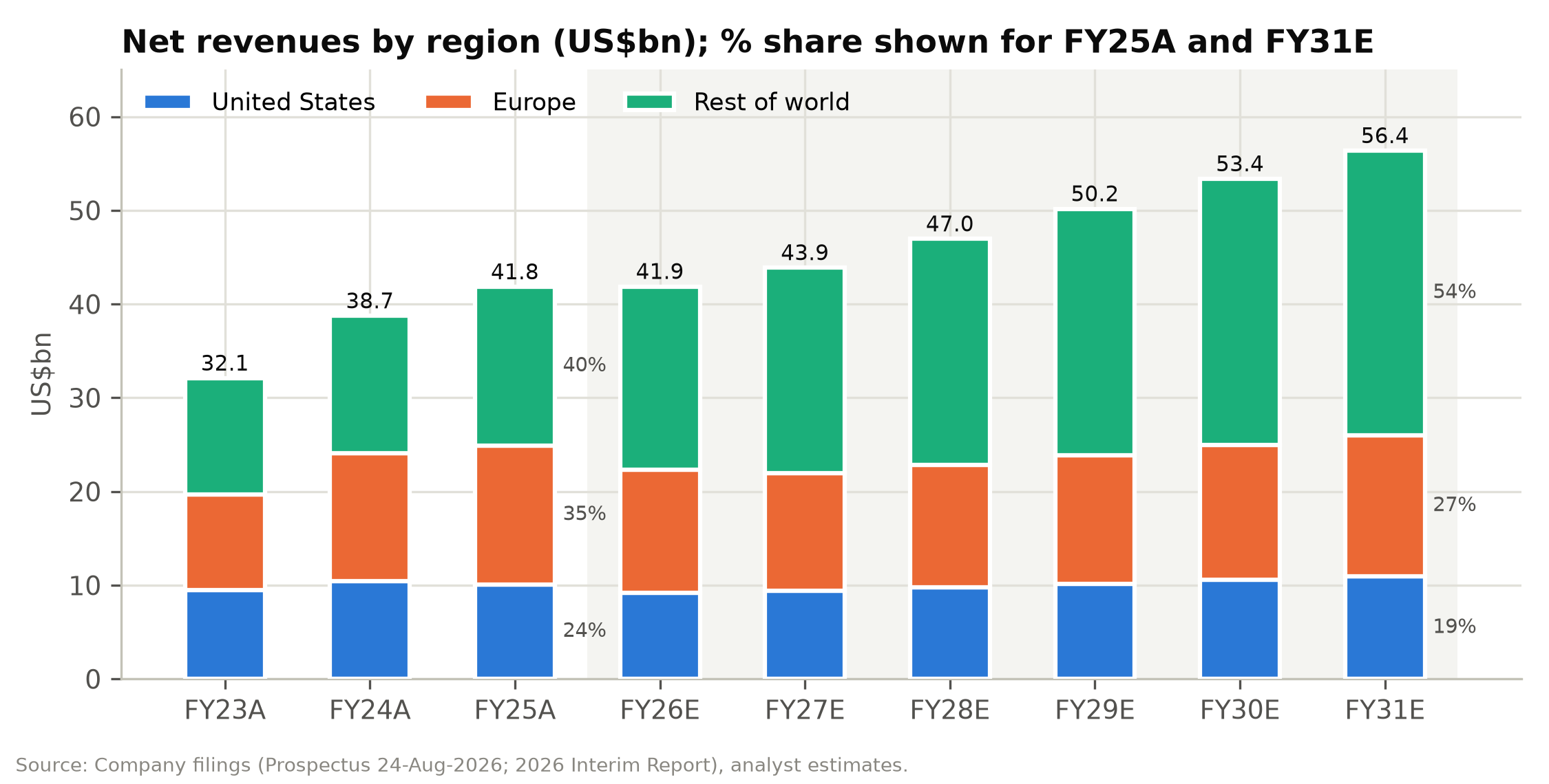

Business model and operating KPIs
Service revenue mix. We assume the marketplace share of revenue rises from 13.5% in FY2026E to 16.3% in FY2031E. That is a slower increase than in FY2024-25, reflecting management's commitment that first-party "will always remain at the core". Service revenues grow from US$5.6bn to US$9.2bn over the period. At an assumed 25% blended take rate, implied marketplace GMV reaches ~US$37bn by FY2031E. The company does not disclose GMV, and we use it only as a cross-check.
Customers and orders.
- Active customers: growth of 6.0% in FY2027E, easing to 3.5% by FY2031E, reaching 374m.
- Order frequency: recovering modestly from 3.81 in FY2026E to 4.00 by FY2030E, within the historical 3.8-4.0 range.
- Orders: these imply 1.22bn in FY2027E and 1.50bn by FY2031E.
- Revenue per order: falls to US$35.8 in FY2027E, then recovers to US$37.7 by FY2031E as higher price points offset marketplace mix.
We show the order-based build as a cross-check rather than a driver, because the regional build better captures trade-policy effects.
Category mix. Non-apparel categories (footwear, accessories, beauty, home and lifestyle) rise from 36.2% of revenue in FY2025 to 41.0% in FY2031E, consistent with SHEIN's multi-category strategy and the marketplace's broader assortment.
Figure 34: Operating KPIs, business model and category revenue, FY2023A-FY2031E
US$m unless stated | FY23A | FY24A | FY25A | FY26E | FY27E | FY28E | FY29E | FY30E | FY31E
Active customers (m) | 186 | 230 | 273 | 300 | 318 | 334 | 347 | 361 | 374
YoY |  | 23.7% | 18.7% | 9.9% | 6.0% | 5.0% | 4.0% | 4.0% | 3.5%
Orders per customer (x) | 3.84 | 4.00 | 3.95 | 3.81 | 3.85 | 3.90 | 3.95 | 4.00 | 4.00
Total orders (m) | 715 | 919 | 1,078 | 1,144 | 1,224 | 1,302 | 1,372 | 1,445 | 1,495
YoY |  | 28.5% | 17.3% | 6.1% | 7.1% | 6.4% | 5.3% | 5.3% | 3.5%
Net revenue per order (US$) | 44.9 | 42.2 | 38.8 | 36.6 | 35.8 | 36.1 | 36.6 | 36.9 | 37.7
Product revenues (1P) | 31,235 | 35,351 | 37,107 | 36,246 | 37,526 | 39,916 | 42,398 | 44,831 | 47,186
YoY |  | 13.2% | 5.0% | (2.3%) | 3.5% | 6.4% | 6.2% | 5.7% | 5.3%
Service revenues (marketplace) | 868 | 3,397 | 4,740 | 5,637 | 6,364 | 7,044 | 7,777 | 8,539 | 9,189
YoY |  | 291.4% | 39.5% | 18.9% | 12.9% | 10.7% | 10.4% | 9.8% | 7.6%
Service % of total | 2.7% | 8.8% | 11.3% | 13.5% | 14.5% | 15.0% | 15.5% | 16.0% | 16.3%
Implied marketplace GMV (est.) | 3,472 | 13,588 | 18,960 | 22,548 | 25,456 | 28,176 | 31,108 | 34,157 | 36,757
Apparel | 22,080 | 25,068 | 26,707 | 25,758 | 26,773 | 28,411 | 30,105 | 31,755 | 33,262
YoY |  | 13.5% | 6.5% | (3.6%) | 3.9% | 6.1% | 6.0% | 5.5% | 4.7%
Other categories | 10,023 | 13,680 | 15,140 | 16,125 | 17,117 | 18,549 | 20,070 | 21,615 | 23,114
YoY |  | 36.5% | 10.7% | 6.5% | 6.2% | 8.4% | 8.2% | 7.7% | 6.9%
Non-apparel % of total | 31.2% | 35.3% | 36.2% | 38.5% | 39.0% | 39.5% | 40.0% | 40.5% | 41.0%
Note: Implied marketplace GMV assumes a 25% blended take rate (commission plus fulfilment fees); GMV is not disclosed.
Source: Company filings, analyst estimates.
Figure 35: Revenue by business model: product (first-party) vs. service (marketplace), US$m
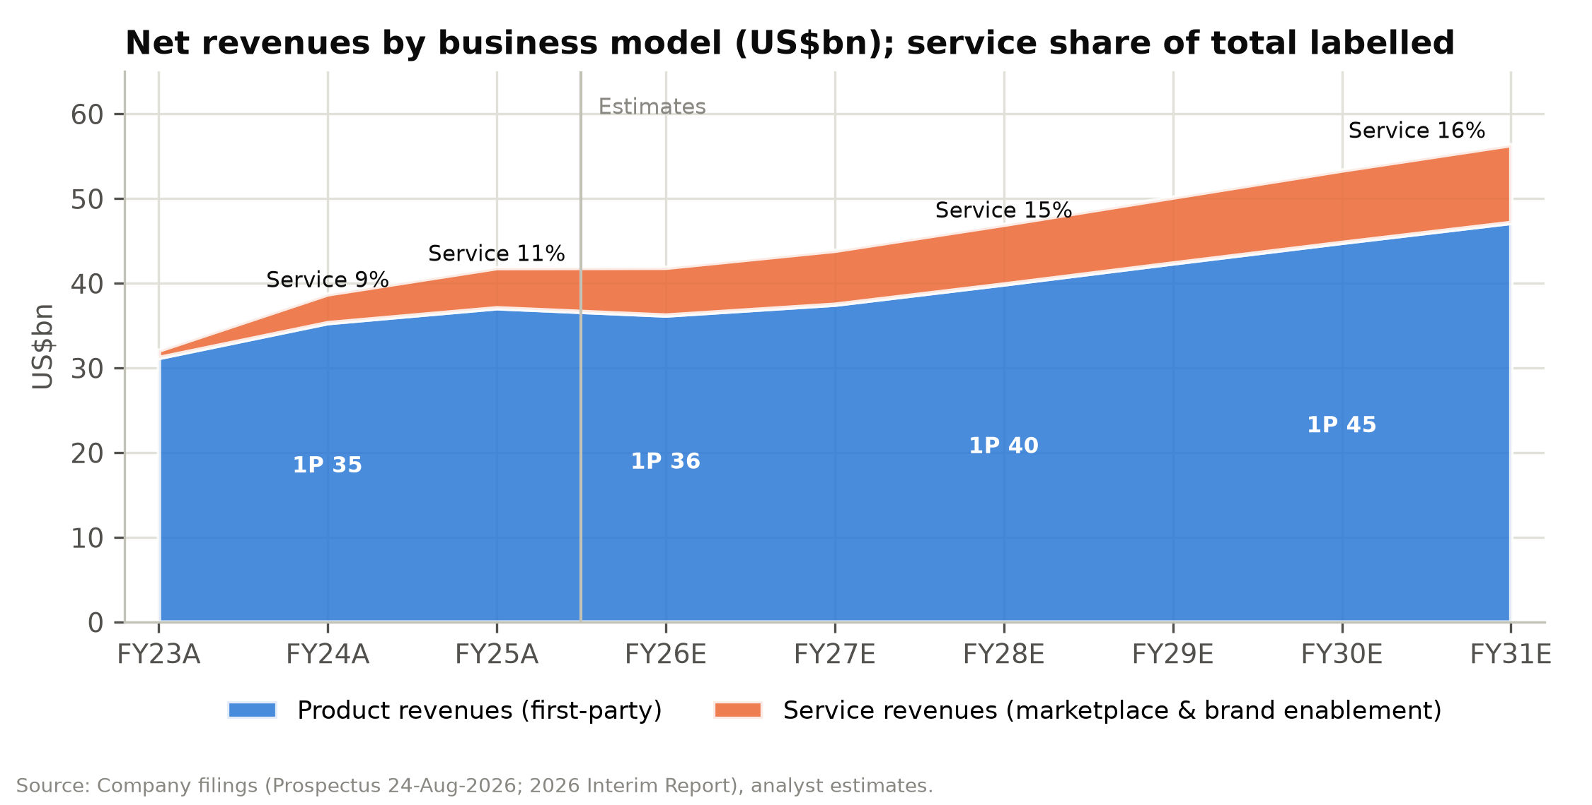

Figure 36: Operating KPI dashboard: customers, orders, frequency and revenue per order
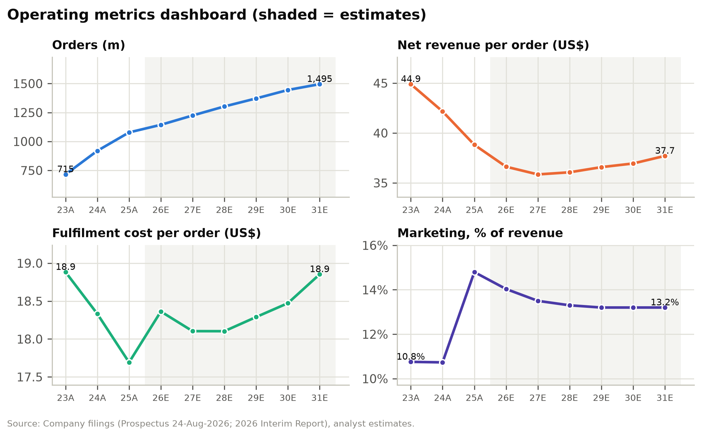

Cost structure and margins
Cost of sales. We model cost of sales as a percentage of product revenue: 34.0% in 2H26E and 34.3% in FY2027E, easing to 34.0% by FY2030E. This is in line with 1H26 (about 34%). Tariff-related cost increases on direct shipments are captured in fulfilment, and input costs (polyester, China apparel PPI) are benign. Blended gross margin rises from 70.3% in FY2026E to 71.5% in FY2031E, mainly because of marketplace mix.
Fulfilment. This is our most important cost assumption:
- 2H26E: 51.0% of revenue. This is above 1H26's 49.2%. The EU duty now applies, and freight had not normalised by the end of the period.
- FY2027E: 50.5%.
- FY2029E onwards: 50.0%.
Fulfilment per order therefore stays at US$18.1-18.9, above FY2025's US$17.7. A return to the FY2025 ratio of 45.6% would add about US$2bn to FY2027E EBIT, so we see freight normalisation as an upside risk rather than a base-case assumption.
Marketing. 13.5% of revenue in 2H26E and FY2027E, easing to 13.2% by FY2029E.
Technology, content and G&A. Technology and content at 2.4% of revenue, reflecting continued investment. G&A at 1.3%.
Share-based compensation. US$90m in FY2026E rising to US$120m by FY2031E. Post-IPO grants may increase this.
Resulting margins.
- EBIT margin: 2.5% in FY2026E, 3.0% in FY2027E, 3.7% in FY2028E, 4.3% in FY2029E and 4.6% by FY2031E.
- Adjusted EBIT margin: 2.7% in FY2026E, 3.2% in FY2027E and 4.9% by FY2031E.
In absolute terms, adjusted EBIT rises from US$1.13bn in FY2026E to US$1.41bn in FY2027E, US$1.86bn in FY2028E and US$2.74bn in FY2031E.
Figure 37: Margin, cost and capital assumptions, FY2023A-FY2031E
Driver | FY23A | FY24A | FY25A | FY26E | FY27E | FY28E | FY29E | FY30E | FY31E
Cost of sales % of product revenue | 40.9% | 43.1% | 36.2% | 34.3% | 34.3% | 34.2% | 34.1% | 34.0% | 34.0%
Gross margin | 60.2% | 60.6% | 67.9% | 70.3% | 70.7% | 70.9% | 71.2% | 71.4% | 71.5%
Fulfilment % of revenue | 42.1% | 43.5% | 45.6% | 50.1% | 50.5% | 50.2% | 50.0% | 50.0% | 50.0%
Fulfilment per order (US$) | 18.88 | 18.33 | 17.69 | 18.36 | 18.10 | 18.10 | 18.29 | 18.47 | 18.85
Contribution margin | 18.1% | 17.2% | 22.3% | 20.2% | 20.2% | 20.7% | 21.2% | 21.4% | 21.5%
Marketing % of revenue | 10.8% | 10.7% | 14.8% | 14.0% | 13.5% | 13.3% | 13.2% | 13.2% | 13.2%
Technology & content % of revenue | 2.1% | 2.2% | 2.1% | 2.4% | 2.4% | 2.4% | 2.4% | 2.4% | 2.4%
G&A % of revenue | 1.0% | 1.7% | 1.3% | 1.3% | 1.3% | 1.3% | 1.3% | 1.3% | 1.3%
Operating (EBIT) margin | 4.3% | 2.5% | 4.1% | 2.5% | 3.0% | 3.7% | 4.3% | 4.5% | 4.6%
SBC (US$m) | 49 | 71 | 85 | 90 | 100 | 105 | 110 | 115 | 120
Adjusted EBIT margin | 4.4% | 2.7% | 4.3% | 2.7% | 3.2% | 4.0% | 4.5% | 4.8% | 4.9%
EBITDA margin (IFRS 16) | 4.8% | 3.3% | 5.0% | 3.6% | 4.1% | 4.8% | 5.4% | 5.7% | 5.8%
Interest yield on cash |  | 5.4% | 4.7% | 4.1% | 3.6% | 3.4% | 3.3% | 3.3% | 3.3%
Interest income (US$m) | 472 | 597 | 621 | 585 | 501 | 507 | 534 | 582 | 633
Core effective tax rate | 11.4% | 26.8% | 20.6% | 24.2% | 22.0% | 22.0% | 22.0% | 22.0% | 22.0%
Capex % of revenue | 0.97% | 0.74% | 0.53% | 0.70% | 0.75% | 0.75% | 0.75% | 0.75% | 0.75%
Operating NWC % of revenue | (7.7%) | (7.5%) | (9.6%) | (9.8%) | (9.8%) | (9.8%) | (9.8%) | (9.8%) | (9.8%)
Source: Company filings, analyst estimates.

Below-the-line and per-share estimates
Interest income.
- Yield on opening cash resources: 4.1% in FY2026E, 3.6% in FY2027E and 3.3% from FY2029E.
- Resulting income: US$585m in FY2026E and US$501m in FY2027E.
- Share of profit: interest income is about 27% of FY2027E adjusted pre-tax profit, which is why we discuss ex-cash multiples in the valuation.
Other items.
- Exchange gains/losses: we forecast none beyond 1H26's reported US$151m loss.
- Associates: no contribution.
- "Others, net": a small negative line (lease interest and credit losses) of US$66-85m a year.
Tax. 22% from FY2027E. FY2026E is 24.2%, reflecting the 1H26 rate and a 23% 2H26E assumption.
Share count.
- Diluted shares: 4,419.2m, comprising 4,246.2m in issue after the IPO, 157.1m options with near-nil exercise prices and 15.9m RSUs.
- Dilution: we add 0.5% a year from FY2027E for new equity awards.
- Share-base convention: historical per-share figures are on the post-IPO share base for comparability.
Resulting per-share estimates.
- Adjusted diluted EPS: HK$2.04 in FY2026E, HK$2.57 in FY2027E, HK$3.18 in FY2028E and HK$4.48 in FY2031E.
- IFRS diluted EPS: FY2026E is distorted to US$1.57 by the fair-value gains.
Dividends. We assume a 50% payout of adjusted net income, giving DPS of HK$1.02 for FY2026E (paid in 2027), HK$1.29 for FY2027E and HK$1.59 for FY2028E.

Where we differ from the market
There is limited published sell-side coverage one month after listing, so we compare our estimates with the company's own guidance and the implied market narrative:
- 2H26 profitability. Management is "cautiously optimistic" about 2H26 adjusted net income and expects the operating environment to remain challenging. Our 2H26E adjusted net income of US$651m (3.0% margin) is above 1H26's US$499m but well below 2H25's US$693m. In our view this is a prudent reading of that guidance.
- Long-term margins. At HK$30.84, the market price implies SHEIN will never recover to its historical operating margins. We estimate the current price is consistent with a steady-state EBIT margin of about 1.5-2% and no growth. Our base case assumes margins recover to around the FY2023/FY2025 levels by FY2029E, and no further.

Scenario Analysis
SHEIN's equity value is unusually sensitive to two questions: whether Europe follows the US path after the duty change, and how much of the 2Q26 margin compression reverses. We therefore run three complete scenarios through the model. A single selector on the Scenarios tab switches every FY2027E-FY2031E driver, and every scenario re-runs the three statements, the DCF and the P/E valuation. Each scenario passes all of the model's integrity checks, including balance-sheet balance and cash reconciliation. The 2H26E assumptions are common to all three cases because that half-year is already under way.

Scenario definitions
Bull case: "Europe follows the US, and freight normalises."
- Revenue.
  - Europe returns to growth in FY2027E (+2%) as local warehousing offsets the €3 duty, then grows 6%.
  - The US recovers to +5%.
  - The rest of the world grows 16% in FY2027E, fading to 9%.
- Costs.
  - Fulfilment falls to 49.8% of revenue in FY2027E and 49.3% by FY2031E.
  - Marketing eases to 12.8%.
  - Higher price points lift product margins.
- Outcome. Revenue CAGR is 8.6% (FY2026E-31E) and the adjusted EBIT margin reaches 6.6% by FY2031E, still well below Inditex's.
Base case: "A slow grind back to historical margins."
- Revenue.
  - Europe declines 4% in FY2027E as it laps the pre-duty first half, then grows 4-5%.
  - The US grows 2-4%.
  - The rest of the world grows 12% fading to 7%.
- Costs.
  - Fulfilment is 50.5% of revenue in FY2027E, easing to 50.0%.
  - Marketing eases to 13.2%.
- Outcome. Revenue CAGR is 6.1% and the adjusted EBIT margin reaches 4.9% by FY2031E, around the FY2023/FY2025 level.
Bear case: "Europe breaks, and margins stay at the trough."
- Revenue.
  - Europe falls another 10% in FY2027E and grows only 3% thereafter.
  - The US declines 4% in FY2027E.
  - Rest-of-world growth slows to 8% and then 4%.
- Costs.
  - Fulfilment stays above 50.8% of revenue.
  - Marketing stays at 13.6-13.8%.
  - Customer growth slows to 2-3%.
- Outcome. Revenue CAGR is 2.8% and the adjusted EBIT margin is 1.8% in FY2027E and 3.0% by FY2031E, close to the 1H26 trough.
Figure 38: Scenario assumptions (FY2027E and FY2031E)
Driver | Bull 27E | Base 27E | Bear 27E | Bull 31E | Base 31E | Bear 31E
US growth | 5.0% | 2.0% | (4.0%) | 5.0% | 3.5% | 2.0%
Europe growth | 2.0% | (4.0%) | (10.0%) | 6.0% | 4.5% | 3.0%
Rest-of-world growth | 16.0% | 12.0% | 8.0% | 9.0% | 7.0% | 4.0%
COGS % product revenue | 34.0% | 34.3% | 34.6% | 33.5% | 34.0% | 34.6%
Fulfilment % revenue | 49.8% | 50.5% | 51.2% | 49.3% | 50.0% | 50.8%
Marketing % revenue | 13.3% | 13.5% | 13.8% | 12.8% | 13.2% | 13.6%
Tech & content % revenue | 2.3% | 2.4% | 2.5% | 2.3% | 2.4% | 2.5%
G&A % revenue | 1.2% | 1.3% | 1.4% | 1.2% | 1.3% | 1.4%
Active customer growth | 8.0% | 6.0% | 3.0% | 5.0% | 3.5% | 2.0%
Source: Company filings, analyst estimates.

Scenario outputs
The scenario spread is wide in earnings terms but narrow at the bottom end in valuation terms:
- FY2027E adjusted EPS ranges from HK$1.65 (bear) to HK$3.50 (bull), a spread of more than 2x around our HK$2.57 base case.
- Blended value ranges only from HK$29.64 to HK$61.32 per share. About HK$20 per share of net cash, after our US$2.5bn of haircuts, is common to all three cases.
The bear-case value is 4% below the current share price. The base case is 47% above and the bull case 99% above. We regard this asymmetry as the central feature of the investment case.
Cumulative unlevered free cash flow over 2H26E-FY2031E ranges from US$3.4bn in the bear case to US$12.8bn in the bull case. Even in the bear case, SHEIN generates enough cash to fund its 50% dividend policy without drawing down the balance sheet.
Figure 39: Scenario outputs (full-model re-runs)
Metric | Bull | Base | Bear
FY27E revenue (US$m) | 45,735 | 43,890 | 41,768
FY31E revenue (US$m) | 63,311 | 56,376 | 48,063
Revenue CAGR FY26E-31E | 8.6% | 6.1% | 2.8%
FY27E adj. EBIT margin | 4.5% | 3.2% | 1.8%
FY31E adj. EBIT margin | 6.6% | 4.9% | 3.0%
FY27E adj. net income (US$m) | 1,982 | 1,457 | 936
FY27E adj. EPS (HK$) | 3.50 | 2.57 | 1.65
FY31E adj. net income (US$m) | 3,749 | 2,589 | 1,514
Cumulative FCFF 2H26E-31E (US$m) | 12,843 | 8,082 | 3,370
DCF value (HK$/sh) | 73.64 | 54.35 | 36.13
P/E value @14x (HK$/sh) | 49.01 | 36.04 | 23.15
Blended value (HK$/sh) | 61.32 | 45.20 | 29.64
vs. current price | 99% | 47% | (4%)
Source: Company filings, analyst estimates.
Figure 40: Bull, base and bear revenue and operating (EBIT) margin paths
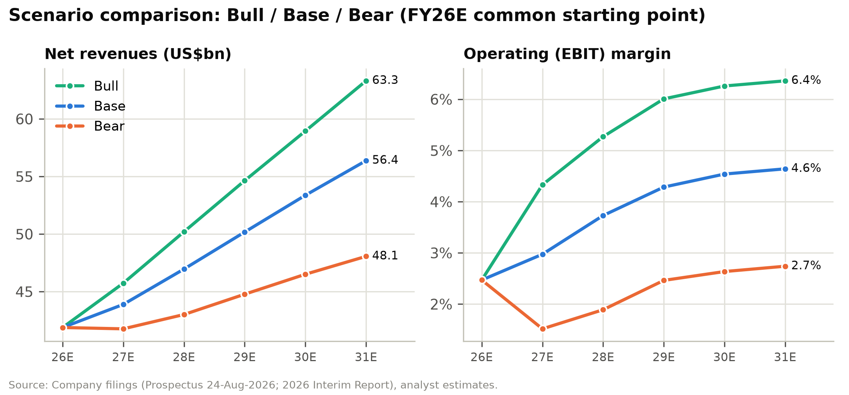

Figure 41: Bear, base and bull value per share vs. current price and target (HK$)
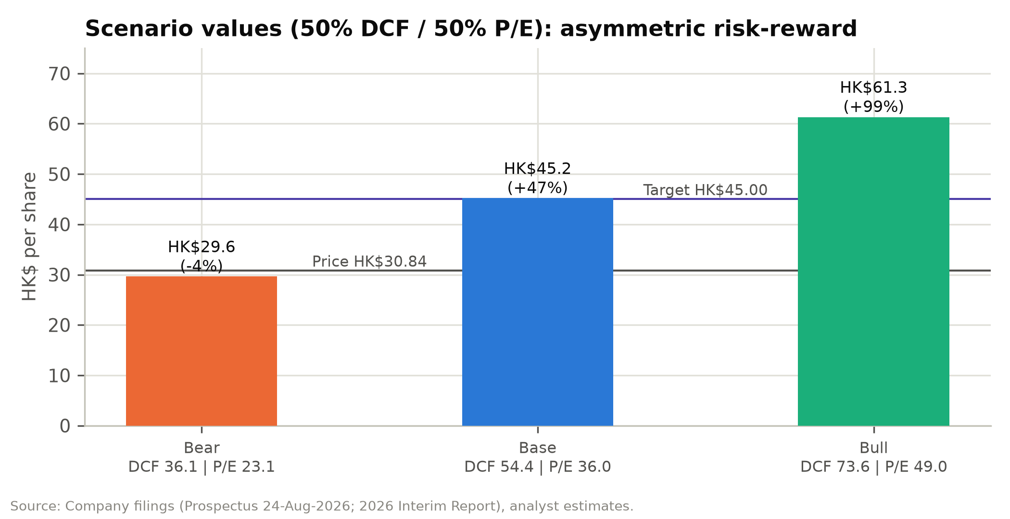

We do not probability-weight the scenarios in our price target, which is based on the base case. For reference, a 25/50/25 bull/base/bear weighting gives HK$45.34, almost identical to our base-case blended value. This is because the upside and downside cases are roughly symmetric around the base case in absolute terms, even though they are very asymmetric relative to today's share price.

Valuation
We value SHEIN using a 50/50 blend of a discounted cash flow model and a P/E multiple on FY2027E adjusted EPS. We cross-check the result against trading comparables, SHEIN's own private funding rounds, and the market-implied expectations embedded in the current share price. Our 12-month price target is HK$45.00, 45.9% above the 30 September 2026 close of HK$30.84. We initiate at BUY.
Figure 42: Price target derivation (HK$ per share)
Method | Value | Weight | Contribution
DCF (WACC 11.2%, g 2.5%) | 54.35 | 50% | 27.18
P/E: 14.0x FY27E adj. EPS | 36.04 | 50% | 18.02
Weighted value |  |  | 45.20
Price target (rounded to HK$0.50) |  |  | 45.00
Current price (30-Sep-2026) |  |  | 30.84
Upside |  |  | 45.9%
Implied P/E FY26E / FY27E |  |  | 22.0x / 17.5x
Implied EV/FY27E adj. EBIT |  |  | 8.2x
Source: Company filings, analyst estimates.
At our target the implied market capitalisation is US$25.3bn, just below the ~US$26bn IPO valuation. At that level the stock would trade at:
- 22.0x FY2026E and 17.5x FY2027E adjusted P/E;
- 8.2x FY2027E EV/adjusted EBIT, once pro forma cash is deducted.
All of these multiples are below the peer medians.

Discounted cash flow

Methodology
- Cash flows: unlevered FCF = EBIT × (1 – 22% tax) + D&A (PP&E and intangibles) – capex – Δ operating NWC.
  - Share-based compensation is treated as a real cost, so it is not added back.
  - IFRS 16 lease payments are treated as operating costs: right-of-use depreciation is not added back, and lease liabilities are not deducted in the bridge.
- Explicit period: a 2H26E stub plus FY2027E-FY2031E, discounted to the 30-Sep-2026 valuation date on a mid-period convention.
- Cash starting point: the 30-Jun-2026 balance sheet. The stub FCFF includes the seasonal second-half working-capital unwind of US$0.9bn, which offsets the working-capital float embedded in June cash.

Discount rate
We use an 11.2% WACC. SHEIN has no financial debt, so the WACC equals the cost of equity, which we derive from CAPM:
- Risk-free rate: 4.0%. This matches the rate used by the company's valuer for the 30 June 2026 preferred-share valuation.
- Beta: 1.2. This reflects Hong Kong-listed consumer-internet peers and the ~40% volatility assumed in the company's own option valuation.
- Equity risk premium: 6.0%. This includes a premium for China-linked geopolitical risk.
Our 2.5% terminal growth rate is roughly nominal global GDP growth, and well below CIC's 5.5% forecast CAGR for online fashion over 2025-30E.
Figure 43: Discount-rate assumptions
Input | Value
Risk-free rate | 4.0%
Equity beta | 1.20
Equity risk premium | 6.0%
Cost of equity | 11.2%
Debt / capital | 0.0%
WACC | 11.2%
Terminal growth | 2.5%
Tax rate on EBIT | 22.0%
Source: Company filings, analyst estimates.

Free cash flow, terminal value and enterprise value
Unlevered free cash flow (FCFF), on the base case:
- 2H26E stub: –US$519m. The seasonal working-capital unwind (US$0.9bn) more than offsets NOPAT.
- FY2027E: US$1,089m.
- FY2031E: US$2,154m.
Growth adds to cash flow because negative working capital scales with revenue.
Present values.
- Explicit period: the PV of 2H26E-FY2031E FCFF is US$5.8bn.
- Terminal value: the PV of the Gordon-growth terminal value is US$13.5bn, 70% of enterprise value.
- Operating enterprise value: US$19.2bn.
Implied exit multiples. The implied terminal multiples are 7.2x FY2031E EBITDA and 9.0x EBIT. Both are well below the peer median EV/EBITDA of 14.1x, so the terminal value is not stretched.
Figure 44: DCF - unlevered free cash flow (US$m)
US$m | 2H26E | FY27E | FY28E | FY29E | FY30E | FY31E
Net revenues | 21,749 | 43,890 | 46,960 | 50,175 | 53,370 | 56,376
EBIT (IFRS) | 542 | 1,305 | 1,752 | 2,150 | 2,423 | 2,617
EBIT margin | 2.5% | 3.0% | 3.7% | 4.3% | 4.5% | 4.6%
Taxes on EBIT (22%) | (119) | (287) | (385) | (473) | (533) | (576)
NOPAT | 422 | 1,018 | 1,366 | 1,677 | 1,890 | 2,041
+ D&A | 93 | 189 | 202 | 216 | 229 | 242
- Capex | (153) | (329) | (352) | (376) | (400) | (423)
- Increase in NWC | (881) | 211 | 288 | 305 | 312 | 294
FCFF | (519) | 1,089 | 1,504 | 1,822 | 2,031 | 2,154
Discount factor | 1.000 | 0.923 | 0.830 | 0.747 | 0.672 | 0.604
PV of FCFF | (519) | 1,005 | 1,249 | 1,360 | 1,364 | 1,301
Source: Company filings, analyst estimates.

Equity bridge
We start from the audited 30 June 2026 cash position and adjust it for the known listing-related flows:
- plus IPO net proceeds of HK$13.2bn (US$1.68bn);
- less the US$2.2bn Conversion Adjustment cash paid to Series Pre-D, D and D+ holders;
- less US$587m of preferred distributions paid after 30 June;
- less restricted cash.
The result is US$13.5bn of pro forma unrestricted cash.
We then apply two deliberate haircuts:
- Minimum operating cash of US$1.5bn (about 3.5% of revenue), reflecting the negative working-capital model.
- Regulatory contingency reserve of US$1.0bn, covering the open matters: the EU Digital Services Act investigation (maximum fine 6% of global turnover), the FTC investigation, the CNIL appeal and the Irish DPC inquiry.
Adding US$0.4bn of associates and investments gives an equity value of US$30.6bn, or HK$54.35 per diluted share. Net cash and investments after haircuts are HK$20.23 per share. We do not deduct lease liabilities (US$1.1bn), because lease costs are already inside FCFF.
Figure 45: DCF enterprise value to equity value (US$m)
Item | Value
Sum of PV of FCFF (2H26E-FY31E) | 5,761
PV of terminal value | 13,460
Operating enterprise value | 19,221
Terminal value % of EV | 70.0%
+ Cash resources, 30-Jun-2026 | 15,248
- Restricted cash | (660)
+ IPO net proceeds | 1,684
- Conversion Adjustment cash | (2,200)
- Preferred distributions after 30-Jun | (587)
- Minimum operating cash | (1,500)
- Regulatory contingency reserve | (1,000)
+ Associates & FVTPL investments | 411
Equity value | 30,618
Diluted shares (m) | 4,419.2
DCF value per share (US$) | 6.93
DCF value per share (HK$) | 54.35
Implied terminal EV/EBITDA | 7.2x
Implied P/E on FY27E adj. EPS | 21.1x
Source: Company filings, analyst estimates.
Figure 46: DCF value per share build-up (HK$)
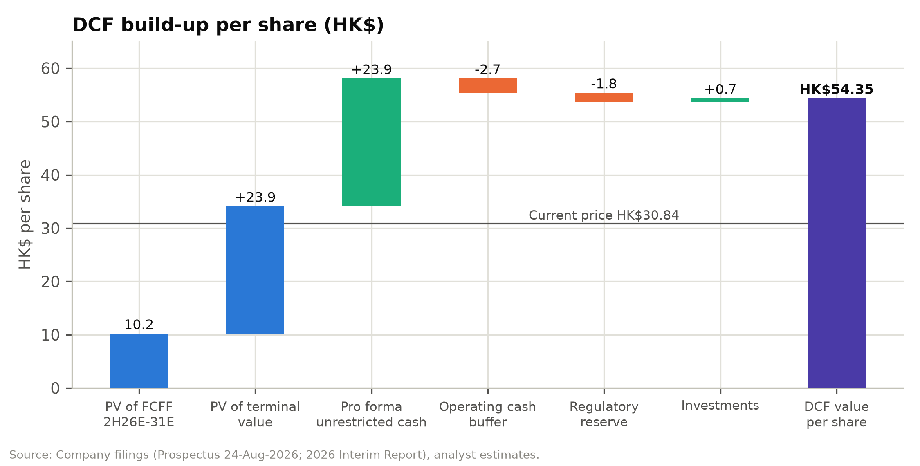

Sensitivity analysis
The DCF value ranges from HK$46.72 to HK$68.21 across WACC of 9.7-12.7% and terminal growth of 1.5-3.5%. The second grid varies the two operating drivers that matter most: the revenue CAGR and the FY2031E EBIT margin. It shows a range of HK$35.95-77.21. It is a simplified re-computation around the base case, so the central cell (HK$53.69) differs slightly from the full-model DCF value.
Every cell in both grids is above the current share price. The most pessimistic combination tested, a 2.1% revenue CAGR with a 2.6% terminal EBIT margin, still gives HK$35.95 per share. The balance sheet sets a floor close to today's price, and the operating business is valued at close to zero.
Figure 47: DCF value per share (HK$) - WACC vs terminal growth
WACC \ g | 1.5% | 2.0% | 2.5% | 3.0% | 3.5%
9.7% | 57.15 | 59.37 | 61.91 | 64.82 | 68.21
10.2% | 54.90 | 56.86 | 59.06 | 61.57 | 64.46
10.7% | 52.91 | 54.63 | 56.56 | 58.74 | 61.23
11.2% | 51.12 | 52.65 | 54.35 | 56.27 | 58.43
11.7% | 49.51 | 50.87 | 52.39 | 54.07 | 55.97
12.2% | 48.05 | 49.27 | 50.62 | 52.12 | 53.79
12.7% | 46.72 | 47.82 | 49.04 | 50.37 | 51.86
Source: Company filings, analyst estimates.
Figure 48: DCF sensitivity heatmap: WACC vs. terminal growth (HK$ per share)
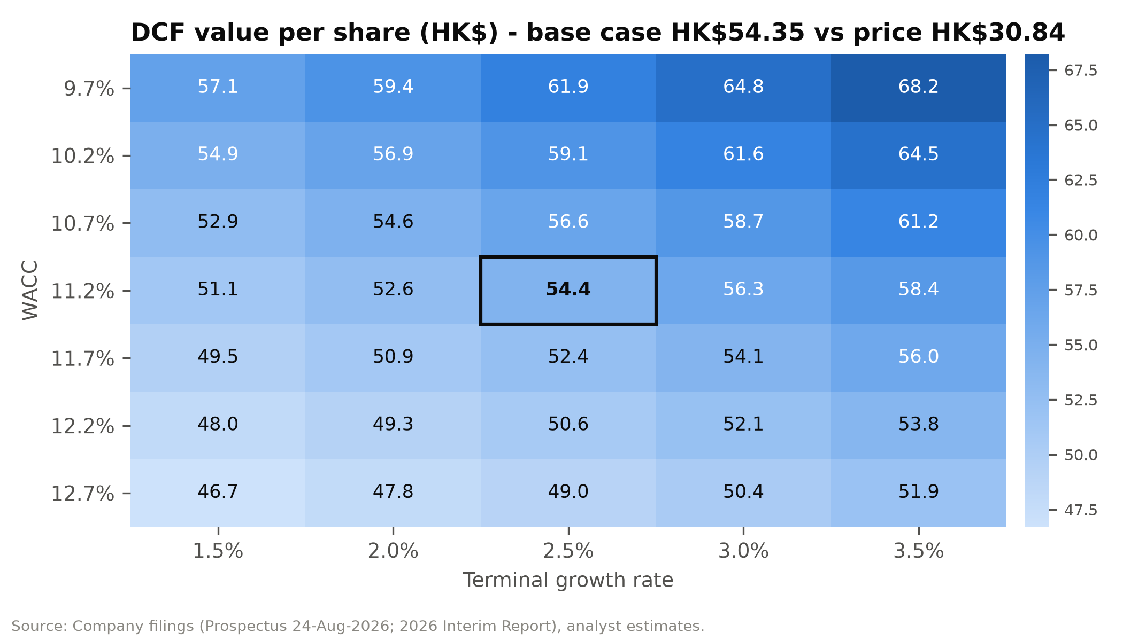

Figure 49: DCF value per share (HK$) - revenue CAGR FY26E-31E vs FY31E EBIT margin
CAGR \ margin | 2.6% | 3.6% | 4.6% | 5.6% | 6.6%
2.1% | 35.95 | 41.61 | 47.27 | 52.93 | 58.60
4.1% | 37.97 | 44.17 | 50.37 | 56.57 | 62.76
6.1% | 40.15 | 46.92 | 53.69 | 60.47 | 67.24
8.1% | 42.47 | 49.87 | 57.26 | 64.66 | 72.05
10.1% | 44.97 | 53.03 | 61.09 | 69.15 | 77.21
Source: Company filings, analyst estimates.

Comparable companies

Peer selection
SHEIN does not have a perfect comparable, so we use three peer groups:
- Global apparel retail (Inditex, H&M, Fast Retailing): vertically integrated fashion brands, which is what SHEIN says it is.
- Online fashion (Zalando, ASOS, Revolve): digital fashion models with similar customer-acquisition economics.
- E-commerce platforms (PDD/Temu, Alibaba/AliExpress, JD.com, Amazon, MercadoLibre): marketplaces and China-linked cross-border sellers that investors reference in practice.

Trading multiples
SHEIN's multiples on its enterprise value are in a different league from those of every peer:
- Enterprise value: US$3.5bn (fully diluted market cap less pro forma cash and investments, before any haircuts).
- Trailing multiples: 0.08x EV/Sales, 2.2x EV/EBITDA and 3.0x EV/EBIT. The peer medians are 1.4x, 14.1x and 24.1x.
On P/E, which includes the interest income on its cash, SHEIN trades at 14.6x LTM and 12.6x NTM adjusted earnings. These are discounts of 36% and 38% to the peer medians of 22.8x and 20.3x.
The closest valuation analogue is PDD Holdings (Temu), at 3.0x EV/EBITDA and 6.8x NTM P/E. However, PDD's cash is held largely in China and it has no dividend commitment.
Figure 50: Trading comparables (prices as of 29/30-Sep-2026)
Company | Segment | Mkt cap US$bn | EV/Sales LTM | EV/EBITDA LTM | EV/EBIT LTM | P/E LTM | P/E NTM | EBITDA mgn
Inditex | Global apparel | 189.2 | 3.9x | 14.1x | 19.2x | 25.9x | 23.5x | 23.7%
H&M | Global apparel | 25.3 | 1.4x | 8.2x | 15.3x | 19.0x | 19.3x | 11.3%
Fast Retailing | Global apparel | 138.6 | 5.4x | 22.6x | 29.0x | 42.1x | 38.8x | 20.1%
Zalando | Online fashion | 6.0 | 0.4x | 6.4x | 12.4x | 59.3x | 12.9x | 4.8%
ASOS | Online fashion | 0.8 | 0.5x | n.m. | n.m. | n.m. | n.m. | (3.2%)
Revolve | Online fashion | 1.5 | 0.9x | 14.1x | 15.0x | 21.0x | 21.2x | 6.7%
PDD Holdings (Temu) | E-com platform | 110.3 | 0.7x | 3.0x | 3.0x | 8.5x | 6.8x | 22.0%
Alibaba (AliExpress) | E-com platform | 267.8 | 1.6x | 17.1x | 35.7x | 24.6x | 13.6x | 9.5%
JD.com | E-com platform | 35.4 | 0.1x | 7.2x | 39.0x | 18.1x | 6.4x | 0.9%
Amazon | E-com platform | 2,660.0 | 3.6x | 16.5x | 29.8x | 19.8x | 26.3x | 21.8%
MercadoLibre | E-com platform | 87.5 | 2.7x | 24.4x | 32.7x | 46.9x | 41.0x | 11.1%
SHEIN (at HK$30.84) | Subject | 17.4 | 0.08x | 2.2x | 3.0x | 14.6x | 12.6x | 3.8%
Maximum |  |  | 5.4x | 24.4x | 39.0x | 59.3x | 41.0x | 23.7%
75th percentile |  |  | 3.2x | 16.9x | 31.9x | 38.0x | 25.6x | 21.0%
Median |  |  | 1.4x | 14.1x | 24.1x | 22.8x | 20.3x | 11.1%
25th percentile |  |  | 0.6x | 7.5x | 15.1x | 19.2x | 13.1x | 5.7%
Minimum |  |  | 0.1x | 3.0x | 3.0x | 8.5x | 6.4x | (3.2%)
Source: stockanalysis.com (peers; LTM to latest report, NTM consensus), company filings, analyst estimates. FX approximate.
Figure 51: Trading comparables: EV/EBITDA vs. EBITDA margin (LTM)
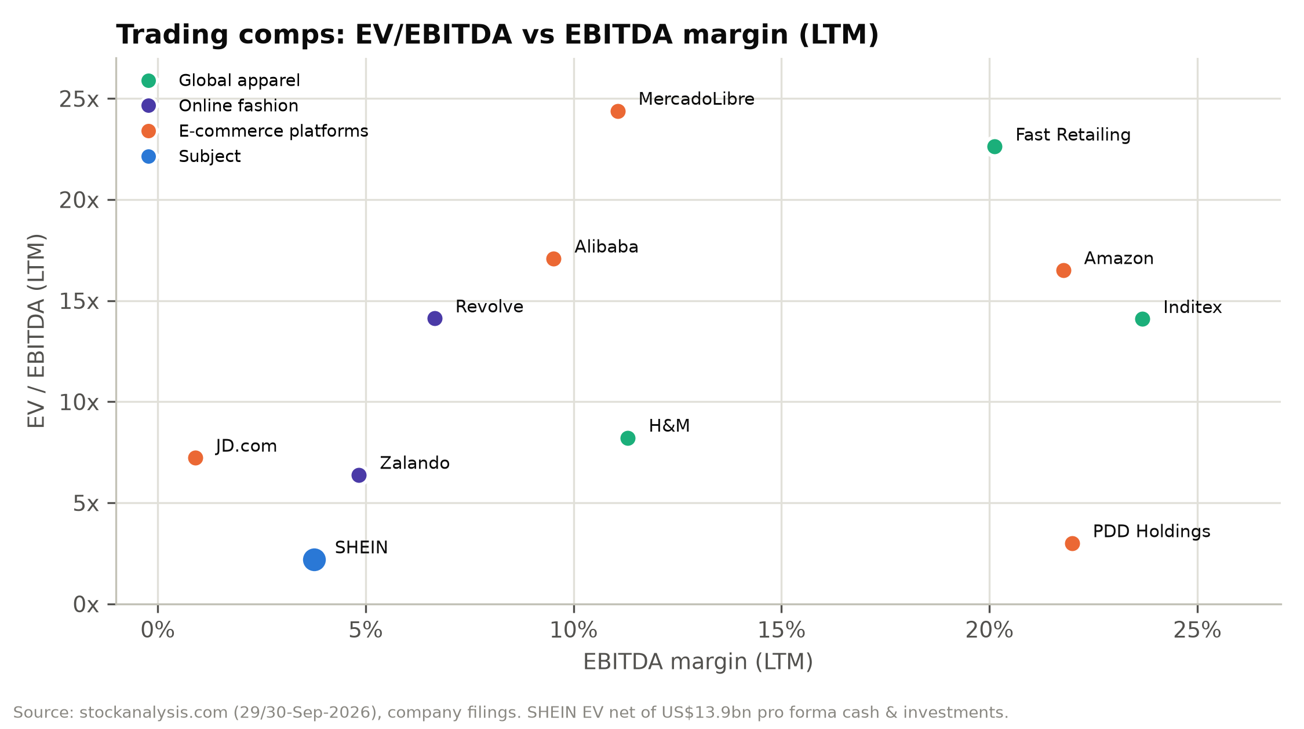

Figure 52: Peer NTM P/E comparison
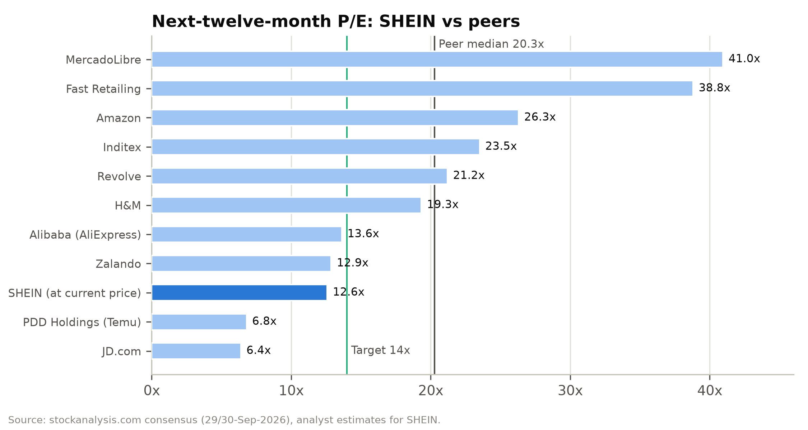

Figure 53: Implied values from peer multiples
Method | Multiple | HK$/share | vs. price
All-peer median P/E NTM × NTM EPS | 20.3x | 49.67 | +61%
Global apparel median P/E NTM | 23.5x | 57.62 | +87%
Online fashion median P/E NTM | 17.0x | 41.75 | +35%
E-commerce platforms median P/E NTM | 13.6x | 33.40 | +8%
EV/FY27E adj. EBIT 8x-12x + valuation net cash | 8-12x | 40.2-50.2 | +30-63%

Choosing our 14x target P/E. We apply 14x FY2027E adjusted EPS:
- It sits at the e-commerce-platform median and at the 25th percentile of all peers.
- It is well below the apparel peers that SHEIN's operating model resembles.
The discount reflects:
- SHEIN's lower margins (3-4% operating vs. 12-20% for Inditex and Fast Retailing).
- Its trade-policy and regulatory exposure.
- WVR governance.
At 14x, the implied ex-cash P/E is only about 8x (after deducting HK$20.2/share of net cash and the after-tax interest income), because roughly 27% of FY2027E adjusted pre-tax profit is interest income.
Why not PDD's 7x? PDD trades on a 3x EV/EBITDA partly because its cash is held largely in China and its core domestic business faces intense competition. SHEIN's cash is mostly US-dollar deposits held through a Singapore-headquartered group, and its board has committed to paying out at least 50% of profit.

Precedent transactions
There is no relevant control-transaction precedent for a business of SHEIN's scale. The most informative "transactions" are SHEIN's own private rounds:
Figure 54: SHEIN's private funding rounds vs. the current share price
Round | Date | Pre-money valuation | Price/share (split-adj.) | vs. HK$30.84 (US$3.93)
Series C+ | Mar-2020 | US$5.0bn | US$1.28 | Below
Series D | Mar/Apr-2022 | US$98.2bn | US$23.72 | 6.0x
Series D+ | May-Dec-2023 | US$64.0bn | US$15.02 | 3.8x
IPO | Sep-2026 | ~US$26bn | US$6.19 (HK$48.56) | 1.6x
Current | 30-Sep-2026 | ~US$17.4bn (diluted) | US$3.93 | —

SHEIN's valuer carried the preferred shares at US$15.1bn at 30 June 2026. At listing, the 1,397.7m Class B shares issued on conversion were worth US$8.65bn at the IPO price; adding the US$2.2bn cash compensation and the US$0.23bn 12% distribution gives a conversion value of about US$11.1bn. We therefore expect a ~US$4.0bn non-cash fair-value gain in 2H26. It will inflate FY2026E IFRS net income to ~US$6.9bn (diluted EPS US$1.57) but has no effect on cash, equity or adjusted earnings, which we use throughout.

Valuation football field
The football field brings together the valuation ranges from each method:
- Upper end (above our HK$45 target): the DCF range (HK$50.87-58.74), the IPO range and the upper half of the peer P/E range.
- Lower end (close to today's price): the 12x-16x P/E band (from HK$30.89), the post-listing low (HK$29.90) and the bear-case scenario (HK$29.64).
Our target sits close to the mid-point of the combined ranges, and below both the IPO range (HK$47.60-49.50) and the DCF range.
Figure 55: Valuation ranges (HK$ per share)
Method | Low | High
Trading range since listing | 29.90 | 48.56
IPO indicative price range | 47.60 | 49.50
DCF (WACC +/-0.5pp, g +/-0.5pp) | 50.87 | 58.74
P/E 12x-16x FY2027E adj. EPS | 30.89 | 41.19
Peer P/E NTM, 25th-75th percentile x NTM EPS | 32.01 | 62.75
EV / FY2027E adj. EBIT 8x-12x + valuation net cash | 40.18 | 50.16
Scenario blended value (Bear to Bull) | 29.64 | 61.32
Source: Company filings, analyst estimates.
Figure 56: Valuation football field (HK$ per share)
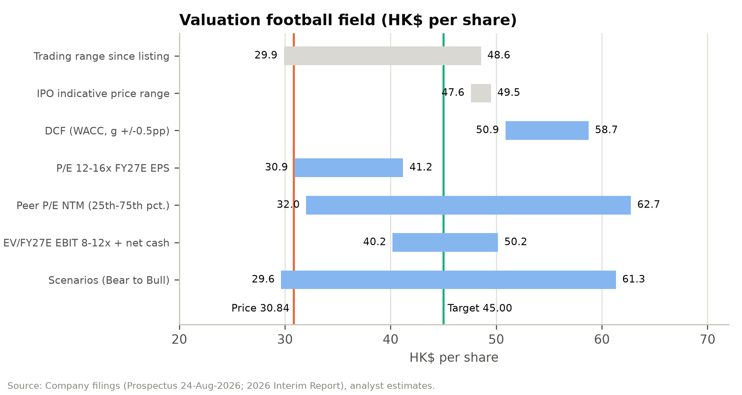

Sanity checks
- Market-implied expectations. At HK$30.84 and 11.2% WACC, the market price implies a steady-state EBIT margin of roughly 1.5-2% with no growth. That is below every annual margin SHEIN has reported (2.5-4.3%) and the 2.4% trough in 1H26.
- Target-implied multiples. At our target, EV/FY27E adj. EBIT is 8.2x and P/E 17.5x. Both are below the peer medians of 24.1x EV/EBIT and 20.3x NTM P/E.
- Private-market marks. The IPO priced at HK$48.56, and the Series D+ round in 2023 was priced at US$15.02 per share (split-adjusted). Our HK$45 target sits below both.
- Cash floor. Pro forma unrestricted cash is HK$23.9/share, 78% of the current price (HK$24.7, or 80%, including investments). After our US$2.5bn of haircuts, net cash is still HK$20.2/share.

Rating definitions
Our ratings are based on expected total return (share price change plus dividends) over 12 months:
- BUY: more than 15%.
- HOLD: between –10% and +15%.
- SELL: below –10%.
SHEIN's expected return to our HK$45.00 target is 45.9% before dividends (about 49% including the estimated FY2026E dividend), which supports a BUY rating.

Appendix A: Financial Statements
The following statements are extracted from the accompanying financial model (SHEIN_Financial_Model_2026-09-30.xlsx), which contains the full formula-driven build, 2H26E drivers, scenario selector and integrity checks. Historical years are from the Accountants' Report in the prospectus. Per-share data use the post-IPO share base for all years.
Income statement, FY2023A-FY2031E
US$m | FY23A | FY24A | FY25A | FY26E | FY27E | FY28E | FY29E | FY30E | FY31E
Net revenues (US$m)
Net revenues | 32,103 | 38,748 | 41,847 | 41,883 | 43,890 | 46,960 | 50,175 | 53,370 | 56,376
YoY growth |  | 20.7% | 8.0% | 0.1% | 4.8% | 7.0% | 6.8% | 6.4% | 5.6%
Product revenues | 31,235 | 35,351 | 37,107 | 36,246 | 37,526 | 39,916 | 42,398 | 44,831 | 47,186
Service revenues | 868 | 3,397 | 4,740 | 5,637 | 6,364 | 7,044 | 7,777 | 8,539 | 9,189
Operating expenses (US$m; shown as positive costs)
Cost of sales | 12,777 | 15,249 | 13,433 | 12,422 | 12,871 | 13,651 | 14,458 | 15,242 | 16,043
% of product revenues | 40.9% | 43.1% | 36.2% | 34.3% | 34.3% | 34.2% | 34.1% | 34.0% | 34.0%
% of net revenues | 39.8% | 39.4% | 32.1% | 29.7% | 29.3% | 29.1% | 28.8% | 28.6% | 28.5%
Gross profit | 19,326 | 23,499 | 28,414 | 29,460 | 31,018 | 33,309 | 35,717 | 38,128 | 40,332
Gross margin | 60.2% | 60.6% | 67.9% | 70.3% | 70.7% | 70.9% | 71.2% | 71.4% | 71.5%
Fulfilment expenses (logistics, warehousing, duties on direct shipments) | 13,501 | 16,847 | 19,072 | 21,001 | 22,164 | 23,574 | 25,087 | 26,685 | 28,188
% of net revenues | 42.1% | 43.5% | 45.6% | 50.1% | 50.5% | 50.2% | 50.0% | 50.0% | 50.0%
per order (US$) | 18.88 | 18.33 | 17.69 | 18.36 | 18.10 | 18.10 | 18.29 | 18.47 | 18.85
Contribution after fulfilment | 5,825 | 6,652 | 9,342 | 8,460 | 8,854 | 9,735 | 10,630 | 11,443 | 12,144
Contribution margin | 18.1% | 17.2% | 22.3% | 20.2% | 20.2% | 20.7% | 21.2% | 21.4% | 21.5%
Marketing expenses | 3,453 | 4,159 | 6,191 | 5,877 | 5,925 | 6,246 | 6,623 | 7,045 | 7,442
% of net revenues | 10.8% | 10.7% | 14.8% | 14.0% | 13.5% | 13.3% | 13.2% | 13.2% | 13.2%
Technology & content expenses | 668 | 849 | 896 | 999 | 1,053 | 1,127 | 1,204 | 1,281 | 1,353
% of net revenues | 2.1% | 2.2% | 2.1% | 2.4% | 2.4% | 2.4% | 2.4% | 2.4% | 2.4%
General & administrative expenses | 328 | 678 | 548 | 549 | 571 | 610 | 652 | 694 | 733
% of net revenues | 1.0% | 1.7% | 1.3% | 1.3% | 1.3% | 1.3% | 1.3% | 1.3% | 1.3%
Total operating expenses | 30,727 | 37,782 | 40,140 | 40,848 | 42,584 | 45,208 | 48,024 | 50,947 | 53,759
% of net revenues | 95.7% | 97.5% | 95.9% | 97.5% | 97.0% | 96.3% | 95.7% | 95.5% | 95.4%
Operating income (EBIT, IFRS) | 1,376 | 966 | 1,707 | 1,035 | 1,305 | 1,752 | 2,150 | 2,423 | 2,617
Operating margin | 4.3% | 2.5% | 4.1% | 2.5% | 3.0% | 3.7% | 4.3% | 4.5% | 4.6%
YoY growth |  | (29.8%) | 76.7% | (39.4%) | 26.1% | 34.2% | 22.8% | 12.7% | 8.0%
Share-based compensation (included above) | 49 | 71 | 85 | 90 | 100 | 105 | 110 | 115 | 120
Adjusted EBIT (non-IFRS) | 1,425 | 1,037 | 1,792 | 1,125 | 1,405 | 1,857 | 2,260 | 2,538 | 2,737
Adjusted EBIT margin | 4.4% | 2.7% | 4.3% | 2.7% | 3.2% | 4.0% | 4.5% | 4.8% | 4.9%
D&A of PP&E and intangibles, % of revenues | 0.18% | 0.32% | 0.36% | 0.43% | 0.43% | 0.43% | 0.43% | 0.43% | 0.43%
D&A of property, equipment & intangibles | 58 | 124 | 151 | 180 | 189 | 202 | 216 | 229 | 242
Right-of-use depreciation, % of revenues | 0.37% | 0.52% | 0.59% | 0.68% | 0.68% | 0.68% | 0.68% | 0.68% | 0.68%
Depreciation of right-of-use assets (warehouse & office leases) | 119 | 200 | 247 | 285 | 298 | 319 | 341 | 363 | 383
EBITDA (IFRS 16) | 1,553 | 1,290 | 2,105 | 1,499 | 1,792 | 2,273 | 2,707 | 3,015 | 3,243
EBITDA margin | 4.8% | 3.3% | 5.0% | 3.6% | 4.1% | 4.8% | 5.4% | 5.7% | 5.8%
Adjusted EBITDA (ex SBC) | 1,602 | 1,361 | 2,190 | 1,589 | 1,892 | 2,378 | 2,817 | 3,130 | 3,363
Adjusted EBITDA margin | 5.0% | 3.5% | 5.2% | 3.8% | 4.3% | 5.1% | 5.6% | 5.9% | 6.0%
Non-operating items (US$m)
FV changes of convertible redeemable preferred shares | 1,231 | 2,431 | 328 | 5,884 | – | – | – | – | –
Share of income/(losses) from associates | (36) | (171) | 3 | (15) | – | – | – | – | –
Interest yield on opening cash resources |  | 5.4% | 4.7% | 4.1% | 3.6% | 3.4% | 3.3% | 3.3% | 3.3%
Interest income | 472 | 597 | 621 | 585 | 501 | 507 | 534 | 582 | 633
Exchange gain/(loss) | (34) | (55) | (95) | (151) | – | – | – | – | –
Others, net as % of revenues |  |  |  |  | – | – | – | – | –
Others, net (lease interest, FV of investments, credit losses) | (14) | 1 | (50) | (70) | (66) | (70) | (75) | (80) | (85)
Income before income taxes | 2,995 | 3,769 | 2,514 | 7,268 | 1,740 | 2,188 | 2,609 | 2,925 | 3,165
Income tax expense | 206 | 404 | 450 | 339 | 383 | 481 | 574 | 644 | 696
Effective tax rate (ex FV changes & associates) | 11.4% | 26.8% | 20.6% | 24.2% | 22.0% | 22.0% | 22.0% | 22.0% | 22.0%
Net income (IFRS) | 2,789 | 3,365 | 2,064 | 6,929 | 1,357 | 1,707 | 2,035 | 2,282 | 2,469
Net margin | 8.7% | 8.7% | 4.9% | 16.5% | 3.1% | 3.6% | 4.1% | 4.3% | 4.4%
Non-IFRS adjusted earnings (company definition)
Impairment / FV changes on long-term investments | – | (57) | (2) | 1 | – | – | – | – | –
Adjusted net income | 1,643 | 1,119 | 1,816 | 1,150 | 1,457 | 1,812 | 2,145 | 2,397 | 2,589
Adjusted net margin | 5.1% | 2.9% | 4.3% | 2.7% | 3.3% | 3.9% | 4.3% | 4.5% | 4.6%
YoY growth |  | (31.9%) | 62.3% | (36.7%) | 26.7% | 24.3% | 18.4% | 11.7% | 8.0%
Per-share data (pro forma post-IPO share base, all years)
Basic shares (m) | 4,246.2 | 4,246.2 | 4,246.2 | 4,246.2 | 4,267.4 | 4,288.8 | 4,310.2 | 4,331.8 | 4,353.4
Diluted shares (m) | 4,419.2 | 4,419.2 | 4,419.2 | 4,419.2 | 4,441.3 | 4,463.5 | 4,485.9 | 4,508.3 | 4,530.8
Diluted EPS, IFRS (US$) | 0.63 | 0.76 | 0.47 | 1.57 | 0.31 | 0.38 | 0.45 | 0.51 | 0.54
Adjusted diluted EPS (US$) | 0.37 | 0.25 | 0.41 | 0.26 | 0.33 | 0.41 | 0.48 | 0.53 | 0.57
Adjusted diluted EPS (HK$) | 2.92 | 1.99 | 3.22 | 2.04 | 2.57 | 3.18 | 3.75 | 4.17 | 4.48
YoY growth |  | (31.9%) | 62.3% | (36.7%) | 26.1% | 23.7% | 17.8% | 11.2% | 7.5%
Dividend payout ratio (of adj. net income) | 0.0% | 0.0% | 0.0% | 50.0% | 50.0% | 50.0% | 50.0% | 50.0% | 50.0%
Dividend declared in respect of year (US$m) | – | – | – | 575 | 729 | 906 | 1,073 | 1,198 | 1,294
DPS declared (HK$) | – | – | – | 1.02 | 1.29 | 1.59 | 1.88 | 2.09 | 2.24
Source: Company filings, analyst estimates (SHEIN_Financial_Model_2026-09-30.xlsx).
Balance sheet, FY2023A-FY2031E
US$m | FY23A | FY24A | FY25A | FY26E | FY27E | FY28E | FY29E | FY30E | FY31E
Assets (US$m)
Cash and cash equivalents | 3,494 | 2,905 | 4,481 | 1,711 | 2,704 | 3,986 | 5,435 | 6,964 | 8,528
Restricted cash | 437 | 485 | 550 | 622 | 622 | 622 | 622 | 622 | 622
Short-term investments (time deposits) | 6,265 | 8,086 | 9,723 | 11,545 | 11,545 | 11,545 | 11,545 | 11,545 | 11,545
Receivables from payment platforms & service providers | 823 | 1,303 | 718 | 803 | 842 | 901 | 962 | 1,024 | 1,081
Other receivables and prepayments | 273 | 480 | 534 | 544 | 571 | 610 | 652 | 694 | 733
Inventories | 1,637 | 1,500 | 1,261 | 1,191 | 1,234 | 1,309 | 1,386 | 1,462 | 1,538
Other current assets | 88 | 127 | 326 | 335 | 351 | 376 | 401 | 427 | 451
Total current assets | 13,017 | 14,886 | 17,593 | 16,752 | 17,869 | 19,349 | 21,004 | 22,737 | 24,498
Property and equipment | 396 | 551 | 619 | 732 | 873 | 1,023 | 1,183 | 1,354 | 1,535
Right-of-use assets | 497 | 959 | 1,105 | 1,131 | 1,185 | 1,268 | 1,355 | 1,441 | 1,522
Intangible assets & goodwill | 40 | 39 | 38 | 135 | 135 | 135 | 135 | 135 | 135
Non-current restricted cash | 78 | 34 | 32 | 38 | 38 | 38 | 38 | 38 | 38
Deferred tax assets | 81 | 94 | 102 | 125 | 125 | 125 | 125 | 125 | 125
Investments in associates | 470 | 251 | 266 | 251 | 251 | 251 | 251 | 251 | 251
Investments at fair value through profit or loss | 82 | 169 | 158 | 162 | 162 | 162 | 162 | 162 | 162
Long-term time deposits | – | 211 | – | – | – | – | – | – | –
Other non-current assets | 157 | 127 | 120 | 109 | 109 | 109 | 109 | 109 | 109
Total non-current assets | 1,801 | 2,435 | 2,440 | 2,683 | 2,878 | 3,111 | 3,358 | 3,615 | 3,877
Total assets | 14,818 | 17,321 | 20,033 | 19,435 | 20,746 | 22,460 | 24,362 | 26,352 | 28,375
Liabilities (US$m)
Accounts payable | 2,749 | 2,935 | 3,019 | 3,113 | 3,264 | 3,468 | 3,684 | 3,906 | 4,120
Accrued expenses & other current liabilities (ex lease) | 1,836 | 2,623 | 3,035 | 3,057 | 3,204 | 3,428 | 3,663 | 3,896 | 4,115
Lease liabilities - current | 122 | 191 | 233 | 237 | 248 | 265 | 284 | 302 | 319
Contract liabilities (customer prepayments) | 694 | 770 | 789 | 796 | 834 | 892 | 953 | 1,014 | 1,071
Income tax payable | 707 | 771 | 933 | 838 | 878 | 939 | 1,003 | 1,067 | 1,128
Convertible redeemable preferred shares - current | – | – | 18,048 | – | – | – | – | – | –
Total current liabilities | 6,108 | 7,290 | 26,057 | 8,041 | 8,427 | 8,992 | 9,587 | 10,185 | 10,753
Convertible redeemable preferred shares - non-current | 20,807 | 18,376 | – | – | – | – | – | – | –
Deferred tax liabilities | 1 | 7 | 5 | 15 | 15 | 15 | 15 | 15 | 15
Lease liabilities - non-current | 407 | 744 | 868 | 890 | 933 | 998 | 1,067 | 1,135 | 1,199
Other long-term liabilities | 6 | 1 | – | 31 | 31 | 31 | 31 | 31 | 31
Total non-current liabilities | 21,221 | 19,128 | 873 | 936 | 979 | 1,044 | 1,113 | 1,181 | 1,245
Total liabilities | 27,329 | 26,418 | 26,930 | 8,977 | 9,406 | 10,037 | 10,700 | 11,366 | 11,998
Shareholders' equity (US$m)
Total shareholders' equity / (deficit) | (12,511) | (9,097) | (6,897) | 10,458 | 11,340 | 12,423 | 13,662 | 14,986 | 16,377
Total liabilities & shareholders' equity | 14,818 | 17,321 | 20,033 | 19,435 | 20,746 | 22,460 | 24,362 | 26,352 | 28,375
Balance check (assets less liabilities & equity) | – | – | – | – | – | – | – | – | –
Equity roll-forward (US$m)
Opening equity |  |  |  | (6,897) | 10,458 | 11,340 | 12,423 | 13,662 | 14,986
Net income |  |  |  | 6,929 | 1,357 | 1,707 | 2,035 | 2,282 | 2,469
Share-based compensation |  |  |  | 90 | 100 | 105 | 110 | 115 | 120
Conversion of preferred shares into Class B shares |  |  |  | 11,082 | – | – | – | – | –
Conversion Adjustment cash compensation |  |  |  | (2,200) | – | – | – | – | –
12% distribution to preferred holders |  |  |  | (230) | – | – | – | – | –
IPO net proceeds |  |  |  | 1,684 | – | – | – | – | –
Dividends paid |  |  |  | – | (575) | (729) | (906) | (1,073) | (1,198)
Other comprehensive income / other |  |  |  | – | – | – | – | – | –
Closing equity |  |  |  | 10,458 | 11,340 | 12,423 | 13,662 | 14,986 | 16,377
Memo items (US$m)
Total lease liabilities | 529 | 935 | 1,101 | 1,127 | 1,181 | 1,264 | 1,351 | 1,437 | 1,518
Cash resources (cash + restricted + ST & LT deposits) | 10,274 | 11,721 | 14,786 | 13,916 | 14,909 | 16,191 | 17,640 | 19,169 | 20,733
Net cash after lease liabilities | 9,745 | 10,786 | 13,685 | 12,789 | 13,728 | 14,927 | 16,289 | 17,732 | 19,215
Operating net working capital | (2,458) | (2,918) | (4,004) | (4,093) | (4,304) | (4,592) | (4,897) | (5,210) | (5,503)
% of net revenues | (7.7%) | (7.5%) | (9.6%) | (9.8%) | (9.8%) | (9.8%) | (9.8%) | (9.8%) | (9.8%)
Return on average equity (adj. NI) |  | n.m. | n.m. | n.m. | 13.4% | 15.2% | 16.4% | 16.7% | 16.5%
Source: Company filings, analyst estimates (SHEIN_Financial_Model_2026-09-30.xlsx).
Cash flow statement, FY2023A-FY2031E
US$m | FY23A | FY24A | FY25A | FY26E | FY27E | FY28E | FY29E | FY30E | FY31E
Operating activities (US$m; company presentation - interest received shown in investing)
Income before income taxes | 2,995 | 3,769 | 2,514 | 7,268 | 1,740 | 2,188 | 2,609 | 2,925 | 3,165
Inventory write-downs, credit losses, impairments & other | 120 | 157 | 181 | – | – | – | – | – | –
Depreciation of right-of-use assets | 119 | 200 | 247 | 285 | 298 | 319 | 341 | 363 | 383
D&A of property, equipment & intangibles | 58 | 124 | 151 | 180 | 189 | 202 | 216 | 229 | 242
Interest expense on lease liabilities | 25 | 44 | 56 | – | – | – | – | – | –
Interest income (reclassified to investing) | (472) | (597) | (621) | (585) | (501) | (507) | (534) | (582) | (633)
Share of (income)/losses from associates | 36 | 171 | (3) | 15 | – | – | – | – | –
Share-based compensation | 49 | 71 | 85 | 90 | 100 | 105 | 110 | 115 | 120
FV changes of convertible redeemable preferred shares | (1,231) | (2,431) | (328) | (5,884) | – | – | – | – | –
Change in receivables from payment platforms | (309) | (542) | 647 | (85) | (38) | (59) | (62) | (61) | (58)
Change in other receivables, prepayments & other assets | (163) | (286) | (204) | (32) | (42) | (64) | (68) | (67) | (63)
Change in inventories | (862) | (83) | 74 | 70 | (43) | (75) | (77) | (75) | (77)
Change in accounts payable | 927 | 228 | 36 | 94 | 150 | 204 | 216 | 222 | 215
Change in contract liabilities | 99 | 99 | (27) | 7 | 38 | 58 | 61 | 61 | 57
Change in accrued expenses & other current liabilities | 725 | 854 | 334 | 22 | 147 | 224 | 235 | 233 | 219
Change in other long-term liabilities & deferred taxes | 6 | (4) | (1) | 41 | – | – | – | – | –
Cash generated from operations | 2,122 | 1,774 | 3,141 | 1,486 | 2,038 | 2,596 | 3,047 | 3,363 | 3,572
Income taxes paid | (365) | (369) | (303) | (434) | (343) | (420) | (510) | (580) | (636)
Net cash from operating activities | 1,757 | 1,405 | 2,838 | 1,052 | 1,695 | 2,176 | 2,538 | 2,783 | 2,936
Investing activities (US$m)
Capex % of net revenues | 0.97% | 0.74% | 0.53% | 0.70% | 0.75% | 0.75% | 0.75% | 0.75% | 0.75%
Capital expenditure (PP&E, land use rights) | (311) | (285) | (222) | (293) | (329) | (352) | (376) | (400) | (423)
Interest received | 273 | 578 | 565 | 585 | 501 | 507 | 534 | 582 | 633
Net placement of short/long-term time deposits | (3,893) | (2,064) | (1,368) | (1,822) | – | – | – | – | –
Acquisitions (Everlane), investments, loans & other | 3 | (33) | 14 | (101) | – | – | – | – | –
Net change in restricted cash | (240) | (16) | (55) | (78) | – | – | – | – | –
Net cash used in investing activities | (4,168) | (1,820) | (1,066) | (1,709) | 172 | 155 | 158 | 182 | 210
Financing activities (US$m)
Issuance of preferred shares, net of costs | 1,737 | (18) | – | – | – | – | – | – | –
IPO net proceeds | – | – | – | 1,684 | – | – | – | – | –
Distributions to preferred holders (8% and 12% p.a.) | – | – | – | (1,312) | – | – | – | – | –
Conversion Adjustment cash compensation | – | – | – | (2,200) | – | – | – | – | –
Lease payments (principal and interest) | (127) | (188) | (284) | (285) | (298) | (319) | (341) | (363) | (383)
Dividends paid | (6) | – | – | – | (575) | (729) | (906) | (1,073) | (1,198)
Other financing | (5) | – | – | – | – | – | – | – | –
Net cash from/(used in) financing activities | 1,599 | (206) | (284) | (2,112) | (874) | (1,048) | (1,247) | (1,436) | (1,582)
Effect of exchange rate changes | 36 | 32 | 88 | – | – | – | – | – | –
Net change in cash and cash equivalents | (776) | (589) | 1,576 | (2,770) | 993 | 1,282 | 1,448 | 1,529 | 1,564
Cash and cash equivalents - beginning | 4,270 | 3,494 | 2,905 | 4,481 | 1,711 | 2,704 | 3,986 | 5,435 | 6,964
Cash and cash equivalents - ending | 3,494 | 2,905 | 4,481 | 1,711 | 2,704 | 3,986 | 5,435 | 6,964 | 8,528
Free cash flow (US$m)
Free cash flow (CFO - capex - lease payments) | 1,319 | 932 | 2,332 | 474 | 1,067 | 1,504 | 1,820 | 2,020 | 2,129
Free cash flow incl. interest received | 1,592 | 1,510 | 2,897 | 1,058 | 1,568 | 2,011 | 2,354 | 2,602 | 2,762
FCF (incl. interest) % of revenues | 5.0% | 3.9% | 6.9% | 2.5% | 3.6% | 4.3% | 4.7% | 4.9% | 4.9%
FCF (incl. interest) / adjusted net income | 96.9% | 134.9% | 159.5% | 92.0% | 107.6% | 111.0% | 109.7% | 108.6% | 106.7%
FCF yield on current market cap | 9.2% | 8.7% | 16.7% | 6.1% | 9.0% | 11.6% | 13.6% | 15.0% | 15.9%
Source: Company filings, analyst estimates (SHEIN_Financial_Model_2026-09-30.xlsx).
Revenue model, FY2023A-FY2031E
US$m | FY23A | FY24A | FY25A | FY26E | FY27E | FY28E | FY29E | FY30E | FY31E
Customer & order KPIs
Active customers (m) | 186 | 230 | 273 | 300 | 318 | 334 | 347 | 361 | 374
YoY growth |  | 23.7% | 18.7% | 9.9% | 6.0% | 5.0% | 4.0% | 4.0% | 3.5%
Orders per active customer (x) | 3.84 | 4.00 | 3.95 | 3.81 | 3.85 | 3.90 | 3.95 | 4.00 | 4.00
Total orders (m) | 715 | 919 | 1,078 | 1,144 | 1,224 | 1,302 | 1,372 | 1,445 | 1,495
YoY growth |  | 28.5% | 17.3% | 6.1% | 7.1% | 6.4% | 5.3% | 5.3% | 3.5%
Net revenue per order (US$) | 44.90 | 42.16 | 38.82 | 36.62 | 35.85 | 36.06 | 36.58 | 36.94 | 37.71
YoY growth |  | (6.1%) | (7.9%) | (5.7%) | (2.1%) | 0.6% | 1.4% | 1.0% | 2.1%
Net revenue per active customer (US$) | 172.6 | 168.5 | 153.3 | 139.6 | 138.0 | 140.6 | 144.5 | 147.8 | 150.8
Net revenues by geography (US$m)
United States | 9,454 | 10,464 | 10,101 | 9,196 | 9,380 | 9,755 | 10,145 | 10,551 | 10,920
YoY growth |  | 10.7% | (3.5%) | (9.0%) | 2.0% | 4.0% | 4.0% | 4.0% | 3.5%
% of net revenues | 29.4% | 27.0% | 24.1% | 22.0% | 21.4% | 20.8% | 20.2% | 19.8% | 19.4%
Europe | 10,214 | 13,603 | 14,802 | 13,121 | 12,596 | 13,100 | 13,755 | 14,443 | 15,093
YoY growth |  | 33.2% | 8.8% | (11.4%) | (4.0%) | 4.0% | 5.0% | 5.0% | 4.5%
% of net revenues | 31.8% | 35.1% | 35.4% | 31.3% | 28.7% | 27.9% | 27.4% | 27.1% | 26.8%
Rest of world (LatAm, Middle East, APAC & other) | 12,435 | 14,681 | 16,944 | 19,566 | 21,914 | 24,105 | 26,274 | 28,376 | 30,363
YoY growth |  | 18.1% | 15.4% | 15.5% | 12.0% | 10.0% | 9.0% | 8.0% | 7.0%
% of net revenues | 38.7% | 37.9% | 40.5% | 46.7% | 49.9% | 51.3% | 52.4% | 53.2% | 53.9%
Total net revenues | 32,103 | 38,748 | 41,847 | 41,883 | 43,890 | 46,960 | 50,175 | 53,370 | 56,376
YoY growth |  | 20.7% | 8.0% | 0.1% | 4.8% | 7.0% | 6.8% | 6.4% | 5.6%
Memo: net revenues outside the US | 22,649 | 28,284 | 31,746 | 32,687 | 34,510 | 37,205 | 40,029 | 42,819 | 45,455
YoY growth |  | 24.9% | 12.2% | 3.0% | 5.6% | 7.8% | 7.6% | 7.0% | 6.2%
Net revenues by business model (US$m)
Service revenues % of total | 2.7% | 8.8% | 11.3% | 13.5% | 14.5% | 15.0% | 15.5% | 16.0% | 16.3%
Service revenues (marketplace commissions, fulfilment & brand-enablement fees) | 868 | 3,397 | 4,740 | 5,637 | 6,364 | 7,044 | 7,777 | 8,539 | 9,189
YoY growth |  | 291.4% | 39.5% | 18.9% | 12.9% | 10.7% | 10.4% | 9.8% | 7.6%
Product revenues (first-party, own & partner brands) | 31,235 | 35,351 | 37,107 | 36,246 | 37,526 | 39,916 | 42,398 | 44,831 | 47,186
YoY growth |  | 13.2% | 5.0% | (2.3%) | 3.5% | 6.4% | 6.2% | 5.7% | 5.3%
% of net revenues | 97.3% | 91.2% | 88.7% | 86.5% | 85.5% | 85.0% | 84.5% | 84.0% | 83.7%
Total net revenues | 32,103 | 38,748 | 41,847 | 41,883 | 43,890 | 46,960 | 50,175 | 53,370 | 56,376
Assumed blended marketplace take rate (analyst estimate) | 25.0% | 25.0% | 25.0% | 25.0% | 25.0% | 25.0% | 25.0% | 25.0% | 25.0%
Memo: implied marketplace GMV (illustrative) | 3,472 | 13,588 | 18,960 | 22,548 | 25,456 | 28,176 | 31,108 | 34,157 | 36,757
Memo: implied gross sales (1P revenue + marketplace GMV) | 34,707 | 48,939 | 56,067 | 58,794 | 62,981 | 68,092 | 73,506 | 78,988 | 83,943
YoY growth |  | 41.0% | 14.6% | 4.9% | 7.1% | 8.1% | 8.0% | 7.5% | 6.3%
Net revenues by category (US$m)
Apparel % of net revenues | 68.8% | 64.7% | 63.8% | 61.5% | 61.0% | 60.5% | 60.0% | 59.5% | 59.0%
Apparel | 22,080 | 25,068 | 26,707 | 25,758 | 26,773 | 28,411 | 30,105 | 31,755 | 33,262
YoY growth |  | 13.5% | 6.5% | (3.6%) | 3.9% | 6.1% | 6.0% | 5.5% | 4.7%
Other categories (footwear, accessories, beauty, home & lifestyle) | 10,023 | 13,680 | 15,140 | 16,125 | 17,117 | 18,549 | 20,070 | 21,615 | 23,114
YoY growth |  | 36.5% | 10.7% | 6.5% | 6.2% | 8.4% | 8.2% | 7.7% | 6.9%
% of net revenues | 31.2% | 35.3% | 36.2% | 38.5% | 39.0% | 39.5% | 40.0% | 40.5% | 41.0%
Total net revenues | 32,103 | 38,748 | 41,847 | 41,883 | 43,890 | 46,960 | 50,175 | 53,370 | 56,376
Source: Company filings, analyst estimates (SHEIN_Financial_Model_2026-09-30.xlsx).

Appendix B: Glossary
Term | Definition
Active customer | A customer who placed at least one order in the period (company definition)
Adjusted EBIT | Operating income excluding share-based compensation (company non-IFRS measure)
Adjusted net income | Net income excluding SBC, fair-value changes of preferred shares, share of associates' results and impairments of long-term investments (company non-IFRS measure)
CIC | China Insights Consultancy, the industry consultant engaged for the prospectus
Contribution margin | Gross profit less fulfilment expenses, as a percentage of net revenues (analyst measure)
Conversion Adjustment | Compensation to Series Pre-D, D and D+ holders at listing: US$2.2bn cash plus 19.6m Class B shares
De minimis | Duty exemption for low-value imports (US: US$800, removed 2025; EU: €150, removed 1 July 2026)
DSA | EU Digital Services Act; fines of up to 6% of global annual turnover
FCFF | Unlevered free cash flow to the firm: NOPAT + D&A – capex – increase in net working capital
GMV | Gross merchandise value; SHEIN does not disclose marketplace GMV, so our estimate assumes a 25% take rate
LATR | Large-scale Automated Test and Reorder, SHEIN's small-batch, data-driven production model
LTM / NTM | Last twelve months / next twelve months
Marketplace (service revenue) | Third-party sales on SHEIN's platform, booked net as commission plus fulfilment fees
Pro forma cash | 30-Jun-2026 cash resources less restricted cash, plus IPO proceeds, less listing-related payments to preferred holders
SBC | Share-based compensation
WACC | Weighted average cost of capital
WVR | Weighted voting rights; SHEIN's Class A shares carry ten votes each
Xcelerator | SHEIN's brand-enablement programme offering supply chain, design, marketing and fulfilment to partner brands

Appendix C: Sources
All figures in this report are from the company's public filings, the sources listed below, or the analyst's own estimates in the accompanying model. Share prices are as of the close on 30 September 2026 unless stated.
1. SHEIN Global Holdings Ltd — Global Offering Prospectus, 24 August 2026. HKEXnews: https://www1.hkexnews.hk/listedco/listconews/sehk/2026/0824/2026082400019.pdf
2. SHEIN — Formal notice / Global Offering, 24 August 2026: https://www1.hkexnews.hk/listedco/listconews/sehk/2026/0824/2026082400009.pdf
3. SHEIN — Announcement of Final Offer Price and Allotment Results, 31 August 2026: https://www1.hkexnews.hk/listedco/listconews/sehk/2026/0831/2026083102409.pdf
4. SHEIN — Stabilising Actions, End of Stabilisation Period and Lapse of Over-allotment Option, 27 September 2026: https://www1.hkexnews.hk/listedco/listconews/sehk/2026/0927/2026092700013.pdf
5. SHEIN — 2026 Interim Report, 28 September 2026: https://www1.hkexnews.hk/listedco/listconews/sehk/2026/0928/2026092801831.pdf
6. HKEX news release, "HKEX Enhances Product Offering with SHEIN Debut": https://www.hkex.com.hk/News/News-Release/2026/260828news?sc_lang=en
7. CNBC, "Fast-fashion giant Shein's shares drop 9% in Hong Kong market debut", 1 September 2026: https://www.cnbc.com/2026/09/01/shein-ipo-market-debut-hong-kong.html
8. CNBC, "Shein targets $27 billion Hong Kong IPO", 24 August 2026: https://www.cnbc.com/2026/08/24/shein-ipo-valuation-hong-kong.html
9. Just Style, "Shein posts 1% H1 revenue growth in first results since listing": https://www.just-style.com/news/shein-first-interim-result/
10. Jing Daily, "Shein's Q2 profit falls 67% in first post-IPO results", 30 September 2026: https://jingdaily.com/intels/2026-09/30/shein-s-q2-profit-falls-67-in-first-post-ipo-results
11. Irish Times / Bloomberg, "Shein drops to record low after profit plunge in debut earnings", 29 September 2026: https://www.irishtimes.com/business/2026/09/29/shein-drops-to-record-low-after-profit-plunge-in-debut-earnings/
12. Hong Kong Free Press, "Shein shares dive more than 11% after earnings disappoint", 29 September 2026: https://hongkongfp.com/2026/09/29/shein-shares-dive-more-than-11-after-earnings-disappoint/
13. Investing.com, "Shein shares hit record low as quarterly profit slumps 67%": https://www.investing.com/news/stock-market-news/shein-shares-hit-record-low-as-quarterly-profit-slumps-67-4921542
14. Douglas Kim, "Shein IPO Valuation Analysis" (Substack): https://douglasresearch.substack.com/p/shein-ipo-valuation-analysis
15. stockanalysis.com quote and statistics pages for 0625.HK and peers (Inditex, H&M, Fast Retailing, Zalando, ASOS, Revolve, PDD, Alibaba, JD.com, Amazon, MercadoLibre), 29-30 September 2026: https://stockanalysis.com/quote/hkg/0625/

Important Disclosures
Nature of this report. This initiation report was prepared with the assistance of an AI system (Claude, developed by Anthropic) from publicly available information, including the SHEIN Global Offering prospectus, the 2026 Interim Report, HKEX announcements and media reports. It has not been reviewed by SHEIN Global Holdings Ltd or any regulated research provider.
Not investment advice. This document is an analytical work product for discussion purposes. It is not investment advice, a recommendation tailored to any individual's circumstances, or an offer or solicitation to buy or sell any security. Investors should conduct their own due diligence and consult a licensed adviser before making investment decisions.
Forecasts and data.
- The forecasts, price target and rating are the analyst's estimates, based on assumptions that may prove incorrect.
- Peer multiples are approximate and use third-party data that has not been independently verified.
- Currency conversions use approximate rates (HK$7.845 = US$1).
- Past performance is not indicative of future results.
Conflicts. The preparer holds no position in the securities discussed and has received no compensation from any company mentioned.

