

**FPT ACADEMY INTERNATIONAL**

**FPT – APTECH COMPUTER EDUCATION**

Centre Name: ACE-HCMC-2-FPT.

Address: 590 Cach Mang Thang 8, District 3, Ho Chi Minh City, Viet Nam.

**MA STORE**

|  |  |  |
| --- | --- | --- |
| **Supervisor.** | **LÊ MỘNG THÚY** | |
| **Batch.** | **T1.2109.M1** | |
| **Group.** | **3** | |
| **Serial No.** | **Enrollment Number** | **Student Name** |
| **1.** | **TRẦN NHẬT DUY** | Student1339032 |
| **2.** | **HOÀNG QUỐC VINH** | Student1331702 |
| **3.** | **HỒ THẮNG ĐỨC** | Student1339032 |
| **4.** | **TRẦN VĂN HƯNG** | Student1339266 |
| **5.** | **TRƯƠNG VIỆT HOÀNG** | Student1339029 |

Month 06 Year 2022

**CONTENT**

**REVIEW 1 ……………………………………………………………………………………………………………..3**

INTRODUCTION…………………………………………………………………………………………………….3

PROBLEM DEFINITION…………………………………………………………………………………………….5

CUSTOMER’S REQIUREMENTS SPECIFICATION (CRS)………………………………………………………6

CLIENT:………………………………………………………………………………………………………………4

TASK SHEET REVIEW 1……………………………………………………………………………………………8

**REVIEW 2……………………………………………………………………………………………………………..10**

1. USECASE…………………………………………………………………………………………………………10

2.DATA FLOW DIAGRAM (DFD)………………………………………………………………………………..39

3.ENTITY PROPERTIES…………………………………………………………………………………………..50

4.TABLE DESIGN………………………………………………………………………………………………….67

5.TASK SHEET REVIEW 2………………………………………………………………………………………..77

**REVIEW 1**

**INTRODUCTION**

We are in an age when information technology makes buying and selling more accessible than ever. People can order an

expensive phone for an everyday kitchen appliance and everything is done electronically and in real-time.

Motorcycle Accessories Stores are also not out of this cycle. So we are developing a website called MA Stores to provide easy access to buying motorcycle accessories spirit online.

MA Stores is for an organization that wants to develop an online store where the visitor can be a person who does not have much time to go to the accessories store or a person who has a shopping online habit or simply stay too far from a standalone store. It will provide its user with the following features.

For MA Store’s customer base:

• Unregistered visitor who can register member account.

• Registered visitors can log in and manage their accounts.

• Customer can search for any products such as traffic lights, viscous, battery, additives, etc.

• Customers can search for products by price.

• Customer can see products’ introduction before buying

•Visitors can buy products after adding products to the cart.

• Customer can view cart history.

• Customer can check out.

• Customer can review order history and make changes.

• Customers can interact with the website by giving questions, and feedback on the contact us function.

**PROBLEM DEFINITION**

After analyzing the project specifications of MA Stores, to fulfill customer’s requirements properly, we came to

the conclusion that to achieve the best result, we should deal with the following queries:

**THE VIEWPOINT OF THE CUSTOMER**

A homepage will show the main products, and a suitable logo, and display the logo on all the pages on the site.

• A navigation header and footer that will include all the functions implemented in the website.

• Customers can buy products, add the product to the cart, view the cart, and check out.

• Registered customers can log in to their profile, view order history, and receive email promotion/Coupon

**THE VIEWPOINT OF THE ADMINISTRATOR**

• A login page will grant access to MA Stores admin.

• Admin can view, add, update, delete and manage products.

• Admin can view, add, update, delete, find, lock, and unlock customer accounts.

• Admin can add, update, delete and manage orders.

• Admin can update, delete and manage registered user accounts.

• Admin can manage and send the newsletter.

• Admin can register and assign a role to staff users.

**CUSTOMER’S REQIUREMENTS SPECIFICATIONS**

**CLIENT: MA STORES**

**BUSINESS/PROJECT OBJECTIVE**

The project is to design an online website for advertising and selling all types of accessories for an instant: viscous, driven wheel, plastic truss, etc..

**INPUT TO THE SYSTEM:**

**MA Stores administrators need to provide:**

• Information required to create an account to access the admin system.

• Products are going to be shown on the website.

• Payment Method and Shipping cost when ordering a certain product.

• Information required to create staff accounts within the admin system.

• Personal information to buy products.

• Email information to receive weekly promotions or deals and coupons.

**OUTPUT FROM THE SYSTEM:**

**MA Stores administrators will be able to:**

• Login/Logout to the admin system.

• Manage (view, add, update, delete, hidden) products, price, and promotion.

• Manage (view, add, update, delete, find, lock, unlock) customer accounts.

• Manage (view, add, update) products, and orders.

**MA Stores guests will be able to:**

• Register customer account.

• Buy products after adding information.

• View products that they have chosen.

• View order history.

**MA Stores customer will be able to:**

• Register an account.

• Login/Logout to the account.

• Search products they want to buy by name, and price.

• Add product to cart and checkout.

• View purchase history.

**SCOPE OF WORK**

The application should perform the following functions:

**LOGIN:**

• There are 3 types of accounts in the application (“admin”). The administrator will log in as “admin”. Staff will log in as “staff”. “Viewer” will log in as “inspector”.

• For “admin”: can view and manage the order.

• For “inspector”: can only have access to admin/dashboard and only

**ORDERING PRODUCTS:**

• When customers choose a product and the selected product will be added to the cart.

**DATABASE:**

• The information about products orders will be stored in the database.

• The information from the contact us page.

**HARDWARE/SOFTWARE REQUIREMENTS:**

**HARDWARE**

**Web Server**

|  |  |
| --- | --- |
| **Processor** | Intel Core I7 or higher. |
| **Memory** | 32 GB RAM or greater. |
| **Modem/ADSL** | Internet access is required. |

**Client**

|  |  |
| --- | --- |
| **Processor** | Intel Core I5 or higher. |
| **Memory** | 8 GB RAM or greater. |
| **Monitor** | Super VGA (1024x768) or higher resolution. |
| **Modem/ADSL** | Internet access is required. |

**SOFTWARE**

**Web Server**

|  |  |
| --- | --- |
| **Operation System** | Window 10 or Window 11 |
| **Browser** | Google Chrome version 35 |
| **Database** | MySQL |
| **Software** | Internet Information Service |
| PHP - Laravel framework |

**Client**

|  |  |
| --- | --- |
| **Operation System** | Window 7 or higher |
| **Browser** | Google Chrome version 35 |

**DEVELOPMENT SOFTWARE**

• Microsoft Windows 10.

• MySQL.

• Visual Studio Code.

• Google Chrome.

• XAMPP.

**TECHNOLOGY**

• PHP - Laravel framework.

• HTML/CSS/Bootstrap

**TASK SHEET REVIEW 1**

|  |  |  |  |  |  |  |  |
| --- | --- | --- | --- | --- | --- | --- | --- |
| **Project: MA Stores** | | **Project**  **Name** | **Activity**  **Plan**  **Prepared**  **By** | **Date of Preparation of Activity Plan:** | | | |
| **Sr./No.** | **Task** | **Actual**  **Start**  **Date** | **Actual**  **Days** | **Team**  **member**  **name** | **Status** |
| **1** | **Acknowledgment** | **MA**  **Stores** | Vinh | 26-May-  22 | 1 | Vinh | Completed |
| **2** | **Introduction** | 26-May-  22 | 1 | Vinh | Completed |
| **3** | **Problem Definition** | 26-May-  22 | 1 | Vinh | Completed |
| **4** | **Customer**  **Requirement**  **Specification (CRS)** | 26-May-  22 | 1 | Vinh | Completed |
| **5** | **Scope of Work** | 26-May-  22 | 1 | Vinh | Completed |
| **6** | **Hardware/Software**  **Requirement** | 26-May-  22 | 1 | Vinh | Completed |
| **7** | **Task Sheet** | 26-May-  22 | 1 | Vinh | Completed |
| Date:26-May-22 | | | | | | | |
| **Signature of Instructor:**  **Ms. LE MONG THUY** | | | **Signature of Team Leader:**  **Hoàng QUốc Vinh** | | | | |

**REVIEW 2**

1. **USECASE**

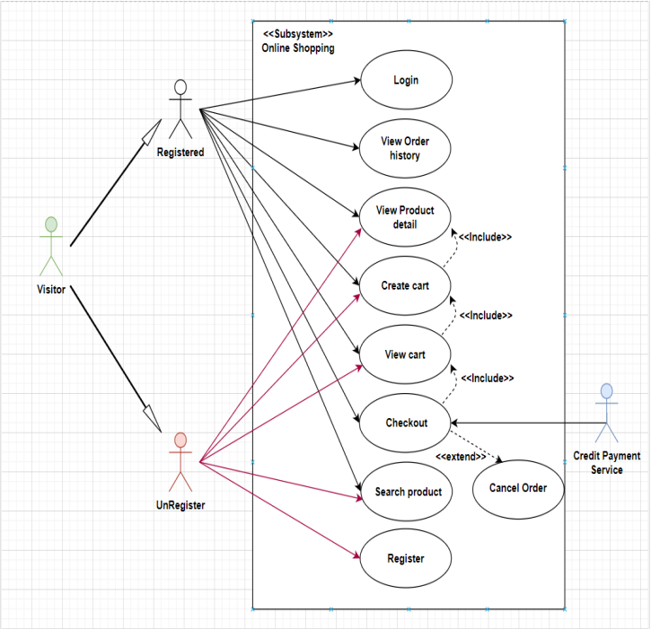

**CREATE CART**

|  |  |  |
| --- | --- | --- |
| **Use case name** | Create cart | |
| **Actor** | Registered customer | |
| **Description** | Customer can add product to their cart | |
| **Requirements** | Customer must choose at least one product | |
| **Pre-conditions** | Customer must log in before adding product | |
| **Post-conditions** | Success: Actor add product to cart successfully | |
| Fail: Refill information | |
| **Basic flow** | **Actor’s actions:** | **System’s responses:** |
| 1. Actor chooses a product and click  “Add to cart”. | 2. System adds selected product to  cart by id of this product.  . |
| **Exceptions** | **Actor’s action** | **System’s response** |
| 1. Actor inputs more products than  there are in stock. | 2. System shows messages:  - “Product out of stock”. |

**VIEW CART**

|  |  |  |
| --- | --- | --- |
| **Use case name** | View cart | |
| **Actor** | Registered customer | |
| **Description** | Customer can view their cart | |
| **Requirements** | N/A | |
| **Pre-conditions** | Customer must log in before view cart | |
| **Post-conditions** | Success: Customer can view their cart | |
| Fail: Refill information | |
| **Basic flow** | **Actor’s actions:** | **System’s responses:** |
| 1. Actor click on “Cart” icon. | 2. System shows cart and added  products. |
| **Alternative flow** | 1. Actor clicks “x”– Close button- on  table  3. Actor change quantity of a product  5. Actor clicks “x” – close button – in the  right side of each product. | 2. System redirects to current page.  4. System update quantity of this  product into cart.  6. System removes this product from  cart. |

**CHECKOUT**

|  |  |  |
| --- | --- | --- |
| **Use case name** | Check out and Place order | |
| **Actor** | Registered customer | |
| **Description** | Customer can order products | |
| **Requirements** | Customer must has at least 1 product in cart | |
| **Pre-conditions** | Customer must log in before adding product | |
| **Post-conditions** | Success: Actor order successfully | |
| Fail: Refill information | |
| **Basic flow** | **Actor’s actions:** | **System’s responses:** |
| 1. Actor click “Add to cart” button or  “Cart” icon.  3. Actor clicks “Check out with” button.  5. Actor inputs order information then  click “Place Order” button.  6. Actor inputs Card owner’s name, card  number and security code if actor  choose payment by credit card.  9. Actor views order’s status in Order  page. | 2. System shows cart and added  products.  4. System shows all products in cart  with calculated total price and show  following controls:  - “Customer name” text field.  - “Phone” text field.  - “Address” text field.  - “Province” select box.  - “Delivery time frame” select box.  - “Payment” table.  Systems shows Payment tab type  according to type of payment actors  choose. |
| **Alternative flow** | 1. Actor clicks “x”– Close button- on  table  3. Actor clicks “X” button on each  product.  5. Actors clicks “Home” button. | 2. System redirects to cart page.  4. System removes product from cart.  6. System redirect to Home pages. |
| **Exceptions** | **Actor’s action** | **System’s response** |
| 1. Actor inputs more products than  there are in stock.  2. Actor left “Billing name” text field  blank.  3. Actor left “Address” text field blank.  4. Actor left “Delivery date” blank.  5. Actor left “Delivery time frame”  blank.  6. Actor left “Payment” dropdown  blank.  7. Actor inputs invalid card information. | 8. System shows messages:  - “Product out of stock”.  - “Order name must not be blank”.  “Address must not be blank”.  “Must choose a delivery date”.  “Must choose a delivery time frame”.  “Must choose a payment method”.  “Invalid card”. |

**ADMIN**

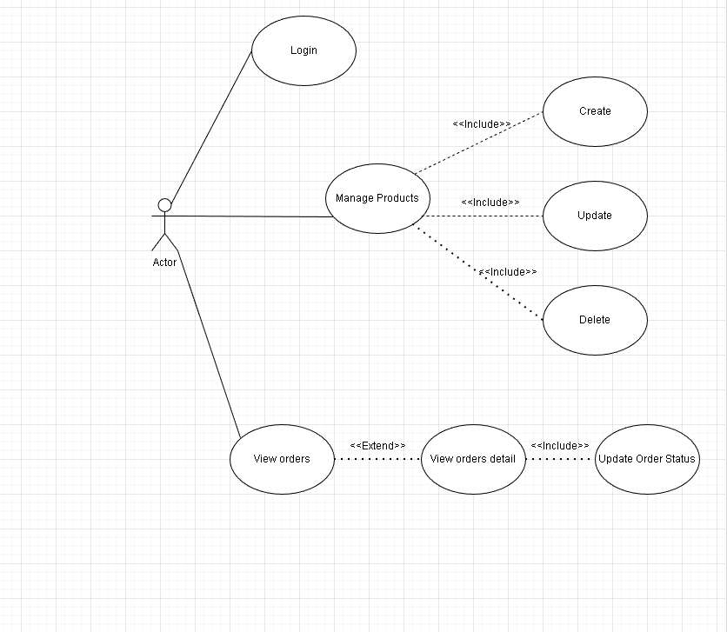

**Login**

|  |  |  |
| --- | --- | --- |
| **Use case name** | Login | |
| **Actor** | Admin | |
| **Description** | When admin wants to manage products, views orders and orders detail | |
| **Requirements** | Admin provides username and password | |
| **Pre-conditions** | Admin must exist on the database | |
| **Post-conditions** | Success: Admin is logged in to website admin | |
| Fail: refill information | |
| **Basic flow** | **Actor’s actions:** | **System’s responses:** |
| 1. Actor clicks on ‘Login’ button.  3. Actor inputs Email and Password,  then click the ‘Login’ button. | 2. System redirects to Login Page with  the following controls:  - 'Email' text field  - 'Password' text field  - 'Login' button  4. System validates the information.  5. System redirects to Admin website |
| **Exceptions** | **Actor’s actions:** | **System’s responses:** |
| 1. Actor inputs invalid email and  password | System redirects to Login page with the  following controls:  - ‘Email’ text field  - ‘Password’ text field  - ‘Login’ button. |

**Order**

**Order View**

|  |  |  |
| --- | --- | --- |
| **Use case name** | View Order | |
| **Actor** | Admin | |
| **Description** | When admin wants to know the order of the product | |
| **Requirements** | N/A | |
| **Pre-conditions** | Actor is logged in admin | |
| **Post-conditions** | Success: product is shown in the website | |
| Fail: Page View Order cannot see from the website | |
| **Basic flow** | **Actor’s actions:** | **System’s responses:** |
| 1. Actor chooses View Order on menu.  3. Actor clicks ‘View’ button. | 2. System redirects to ‘Order List’ page  and display a list of Order.  4. System show Order in the website.  5. System displays confirmation or  error. |

**View Order Detail**

|  |  |  |
| --- | --- | --- |
| **Use case name** | View Order Detail | |
| **Actor** | Admin | |
| **Description** | When admin wants to see View Order Detail from the website | |
| **Requirements** | N/A | |
| **Pre-conditions** | Actor is logged in admin | |
| **Post-conditions** | Success: Admin can view Order Detail on the website | |
| Fail: Admin cant’ view the Order Detail on the website | |
| **Basic flow** | **Actor’s actions:** | **System’s responses:** |
| 1. Actor chooses View Order on menu.  3. Actor clicks ‘Detail’ button. | 2. System redirects to ‘Order List’ page  and display a list of Order.  4. System show Order Details in the  website  5. System displays confirmation or  error. |

**2. DATA FLOW DIAGRAM (DFD)**

**LEVEL 0**

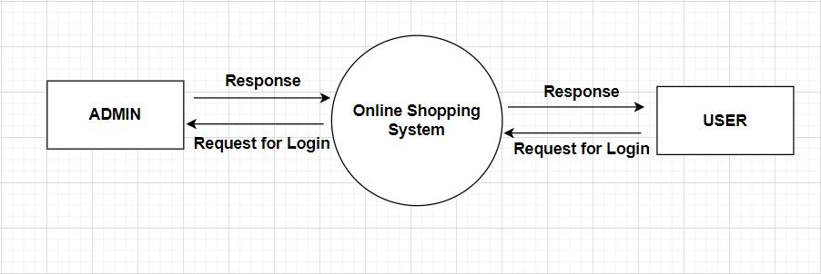

**USERSIDE LEVEL 1**

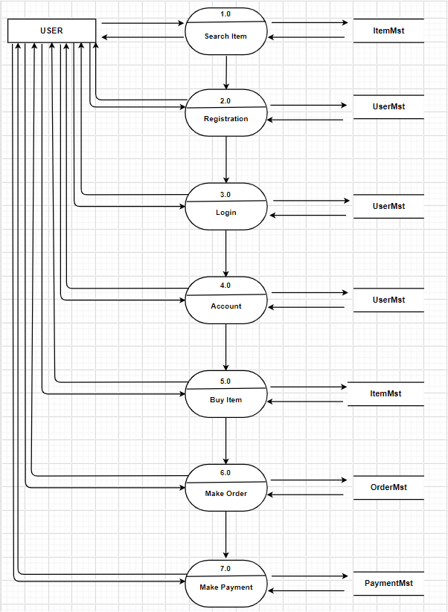

**ORDER**

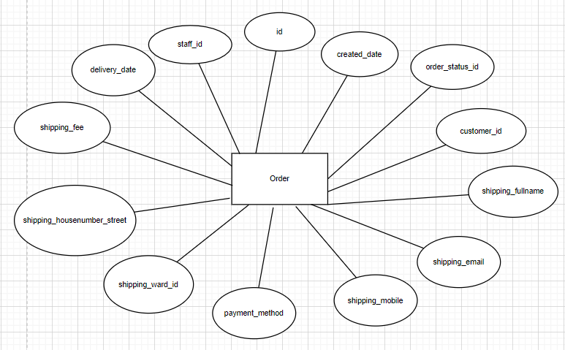

Order_item

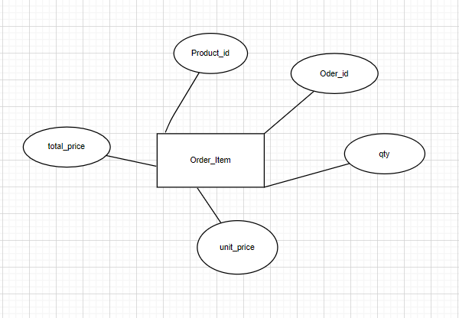

**WARD**

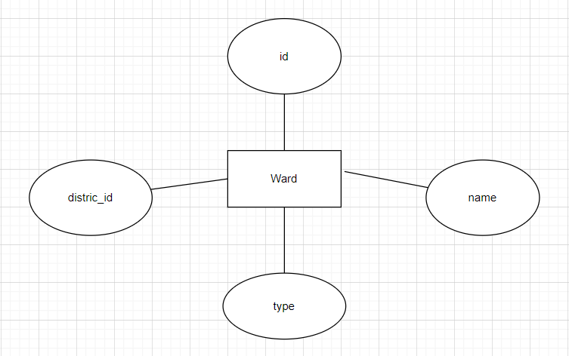

**DISTRIC**

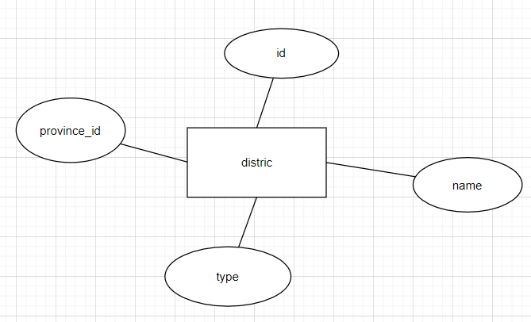

**PROVINCE**

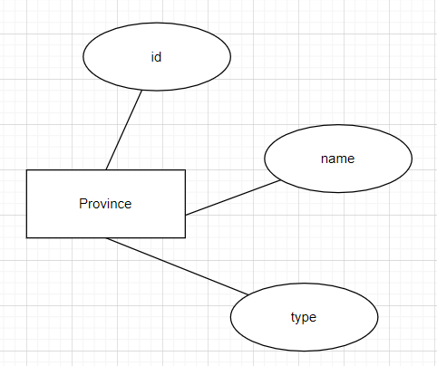

**View Product**

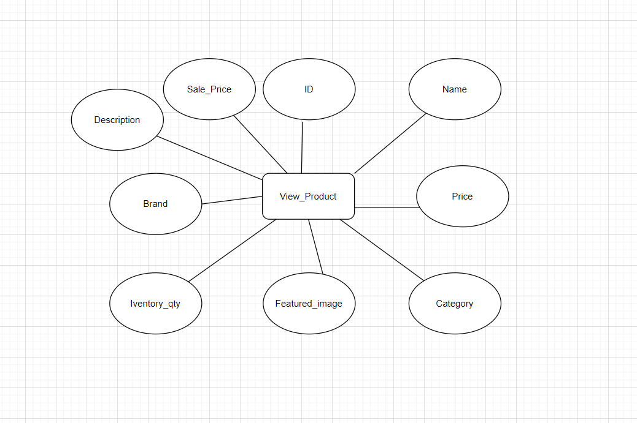

**ADMIN**

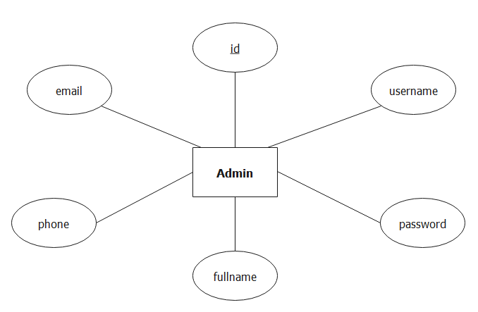

1. **TABLE DESIGN**

**TABLE STRUCTURE FOR TABLE DISTRICT**

|  |  |  |  |
| --- | --- | --- | --- |
| **TABLE DISTRIC** | | | |
| **Column** | **Type** | **Null** | **Default** |
| **id** | int(11) | No |  |
| **name** | varchar(100) | No |  |
| **type** | varchar(30) | No |  |
| **province_id** | int(11) | No |  |

|  |  |  |  |
| --- | --- | --- | --- |
| **TABLE ORDER** | | | |
| **Column** | **Type** | **Null** | **Default** |
| **id** | int(11) | No |  |
| **created_date** | datetime | No | **current_timestamp()** |
| **order_status_id** | int(11) | No | **1** |
|  |  |  |  |
| **shipping_fullname** | varchar(100) | Yes |  |
| **shipping_email** | varchar(255) | Yes | **NULL** |
| **shipping_ward_id** | int(11) | Yes | **NULL** |
| **shipping_fee** | int(11) | Yes | **0** |
|  |  |  |  |
|  |  |  |  |

**TABLE STRUCTURE FOR TABLE ORDER_ITEM**

|  |  |  |  |
| --- | --- | --- | --- |
| **TABLE ORDER_ITEM** | | | |
| **Column** | **Type** | **Null** | **Default** |
| **product_id** | **int(10)** | No |  |
| **order_id** | **int(10)** | No |  |
| **qty** | **int(4)** | No |  |
| **price** | **int(11)** | No |  |
| **total_price** | **int(10)** | No |  |

TABLE STRUCTURE FOR TABLE PROVINCE

|  |  |  |  |
| --- | --- | --- | --- |
| **TABLE PROVINCE** | | | |
| **Column** | **Type** | **Null** | **Default** |
| **id** | int(11) | No |  |
| **name** | varchar(100) | No |  |
| **type** | varchar(30) | No |  |

**TABLE STRUCTURE FOR TABLE WARD**

|  |  |  |  |
| --- | --- | --- | --- |
| **TABLE WARD** | | | |
| **Column** | **Type** | **Null** | **Default** |
| **id** | int(11) | No |  |
| **name** | varchar(100) | No |  |
| **type** | varchar(30) | No |  |
| **district_id** | int(11) | No |  |

**STRUCTURE FOR VIEW VIEW_PRODUCT**

**5. TASK SHEET REVIEW 2**

|  |  |  |  |  |  |  |  |
| --- | --- | --- | --- | --- | --- | --- | --- |
| **Project: MA Stores** | | **Project**  **Name** | **Activity**  **Plan**  **Prepared**  **By** | **Date of Preparation of Activity Plan:** | | | |
| **Sr./No.** | **Task** | **Actual**  **Start**  **Date** | **Actual**  **Days** | **Team**  **member**  **name** | **Status** |
| **1** | **Use Case** | **MA**  **Stores** | Vinh | 27-May-  22 | 1 | Vinh | Completed |
| **2** | **Data Flow Diagram**  **(DFD)** | 28-May-  22 | 1 | Vinh | Completed |
| **3** | **Entity Relationship**  **Diagram (ERD)** |  |  |  | Uncompleted |
| **4** | **Entity Properties** | 29-May-  22 | 1 | Vinh | Completed |
| **5** | **Table Design** | 29-May-  22 | 1 | Vinh | Completed |
| Date:29-May-22 | | | | | | | |
| **Signature of Instructor:**  **Ms. LE MONG THUY** | | | **Signature of Team Leader:**  **Hoàng Quốc Vinh** | | | | |

