**lottie-react-native 使用**

1. 引入lottie-react-native库：

yarn add lottie-react-native

(ios版) react-native link lottie-ios

react-native link lottie-react-native

(android版) react-native link lottie-react-native

1. 建立app文件夹，内部导入AE动画的json文件且新建Lottie.js文件，封装Component，文件夹结构如下：

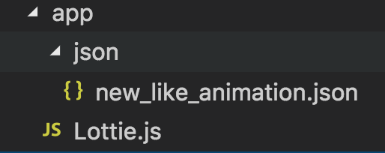

图1.app文件夹结构

Lottie.js文件内容如下:

//Lottie.js

import React, {Component} from 'react';

import {StyleSheet} from 'react-native';

import LottieView from 'lottie-react-native';

export class Lottie extends Component{

render(){

const {sourceJson,isAuto,isLoop,anotherStyle} = this.props;

return(

<LottieView

source={sourceJson ? sourceJson : require('./json/new_like_animation.json')}

autoPlay = {isAuto==undefined ? true : isAuto}

loop = {isLoop ==undefined ? true : isLoop}

style={[styles.container,anotherStyle]}/>

)

}

}

//undefined.null.false.0

const styles = StyleSheet.create({

container:{

width:300,

height:300,

backgroundColor:'#00000000'

}

})

1. App.js文件引入封装的Component即可。

//App.js

import React, {Component} from 'react';

import {StyleSheet, View,Dimensions} from 'react-native';

import { Lottie } from './app/Lottie';

type Props = {};

export default class App extends Component<Props> {

render() {

return (

<View style={styles.container}>

<Lottie/>

</View>

);

}

}

const styles = StyleSheet.create({

container: {

flex: 1,

justifyContent: 'center',

alignItems: 'center',

backgroundColor: '#F5FCFF',

},

});

1. 运行结果

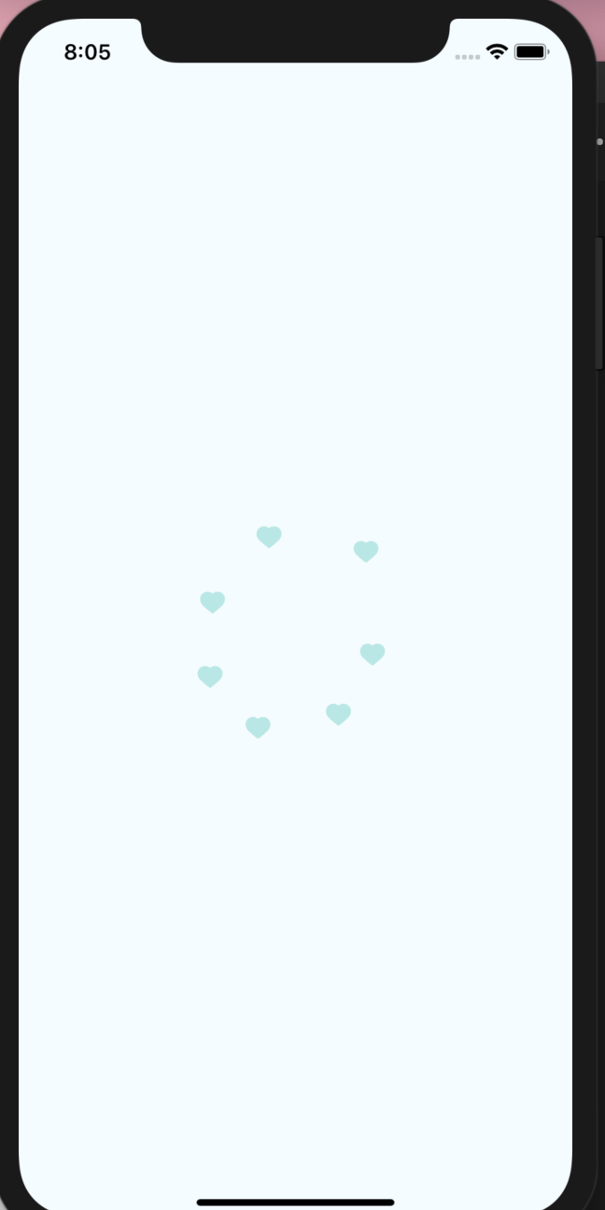

图2.运行结果