How to revise the Cookie.json
1. Press F12 to DevTools and select Network tab.
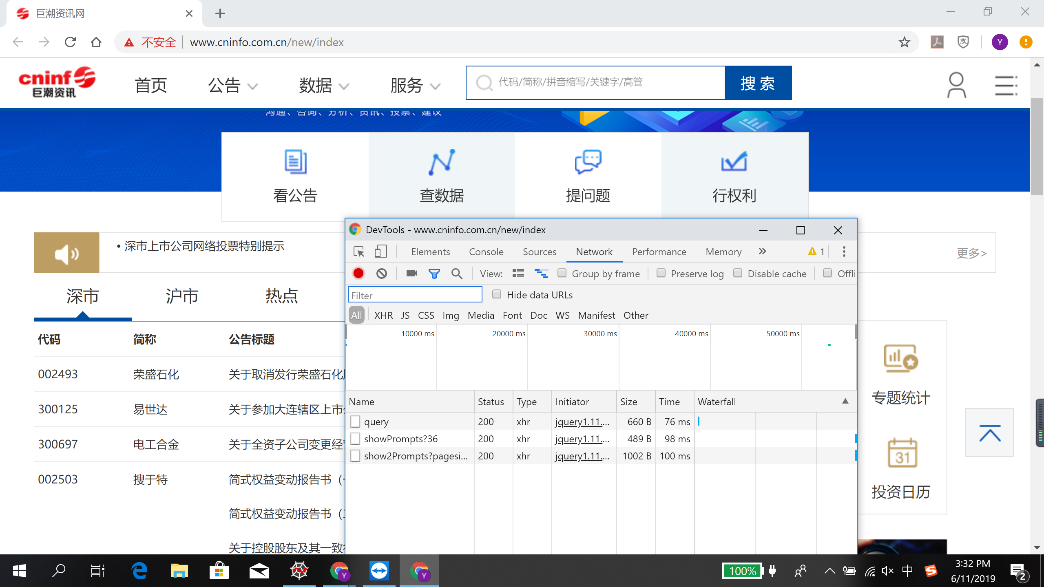

2. Search Keyword and select different pages more than twice
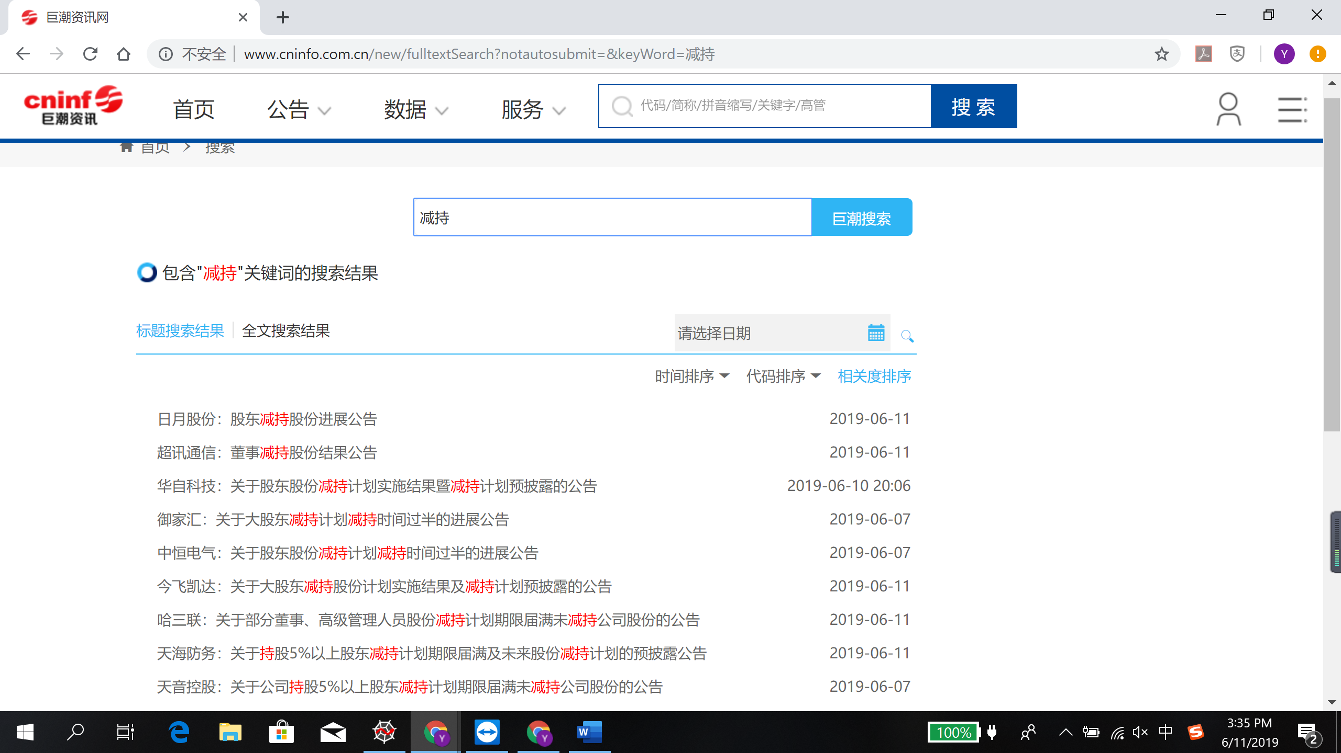
3. Get the latest cookie in DevTools
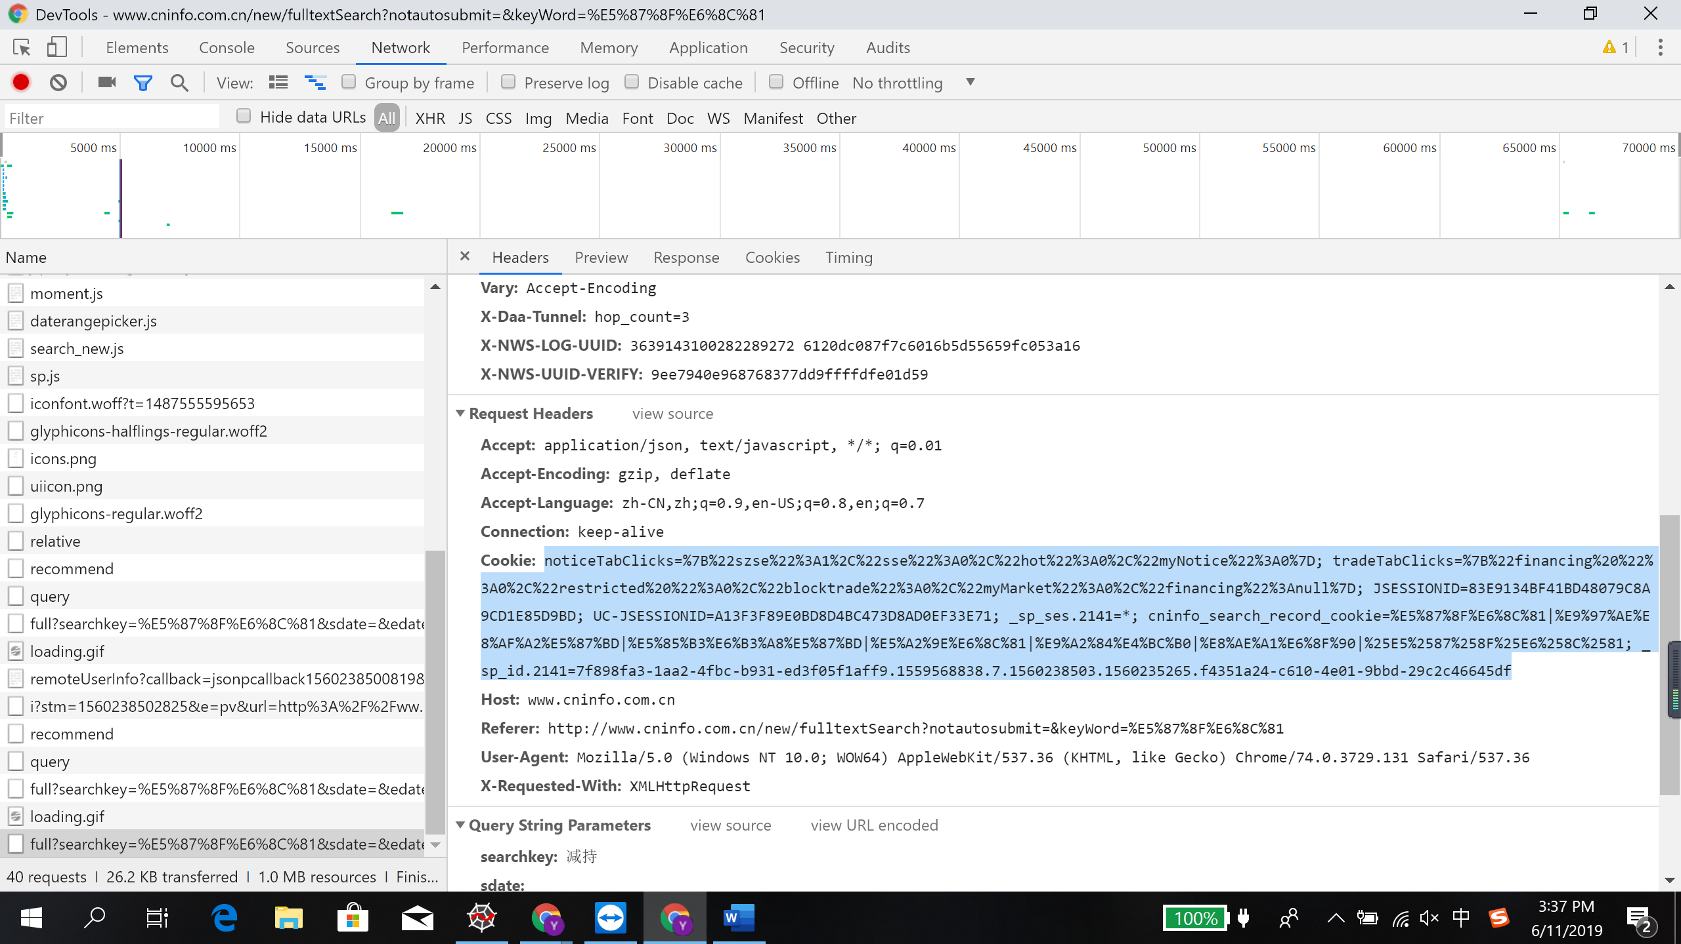
4. Input into cookie.json
