xml作业

1. C++继承中父类与子类析构函数与构造函数的调用顺序

class Grandpa

{

public:

Grandpa()

{

printf("Grandpa constructed\n");

}

~Grandpa()

{

printf("Grandpa destroyed\n");

}

};

class Father :public Grandpa

{

public:

Father()

{

printf( "Father constructed\n");

}

~Father()

{

printf("Father destroyed\n");

}

};

class Son :public Father

{

public:

Son()

{

printf("Son constructed\n");

}

~Son()

{

printf("Son destroyed\n");

}

};

int main()

{

Son s;

return 0;

}

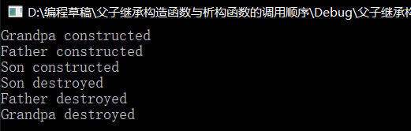

1. 用xml做一张学生信息表

<?xml version="1.0" encoding="UTF-8"?>

<class>

<![CDATA[学生信息]]>

<student>

<student1>

<![CDATA[姓名]]>

<name>小李</name>

<![CDATA[序号]]>

<number>1</number>

<![CDATA[性别]]>

<gender>女</gender>

<![CDATA[年龄]]>

<age>20</age>

</student1>

<student2>

<![CDATA[姓名]]>

<name>小张</name>

<![CDATA[序号]]>

<number>2</number>

<![CDATA[性别]]>

<gender>女</gender>

<![CDATA[年龄]]>

<age>19</age>

</student2>

<student3>

<![CDATA[姓名]]>

<name>小陈</name>

<![CDATA[序号]]>

<number>3</number>

<![CDATA[性别]]>

<gender>男</gender>

<![CDATA[年龄]]>

<age>21</age>

</student3>

<student4>

<![CDATA[姓名]]>

<name>小刘</name>

<![CDATA[序号]]>

<number>4</number>

<![CDATA[性别]]>

<gender>男</gender>

<![CDATA[年龄]]>

<age>19</age>

</student4>

<student5>

<![CDATA[姓名]]>

<name>小宋</name>

<![CDATA[序号]]>

<number>5</number>

<![CDATA[性别]]>

<gender>女</gender>

<![CDATA[年龄]]>

<age>20</age>

</student5>

</student>

</class>

