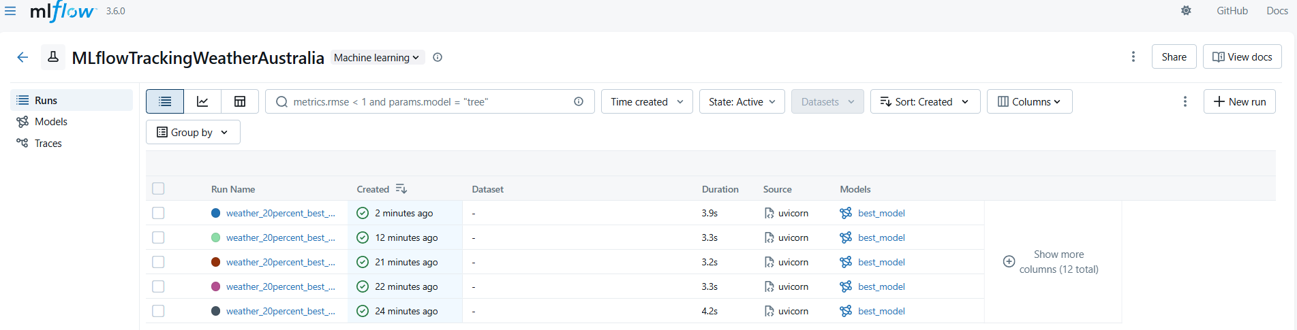
Triggert with buttons in Streamlit
Triggert with crontab every 10 minutes
