Screenshots for Backend API

- Router: http://127.0.0.1:8080/register
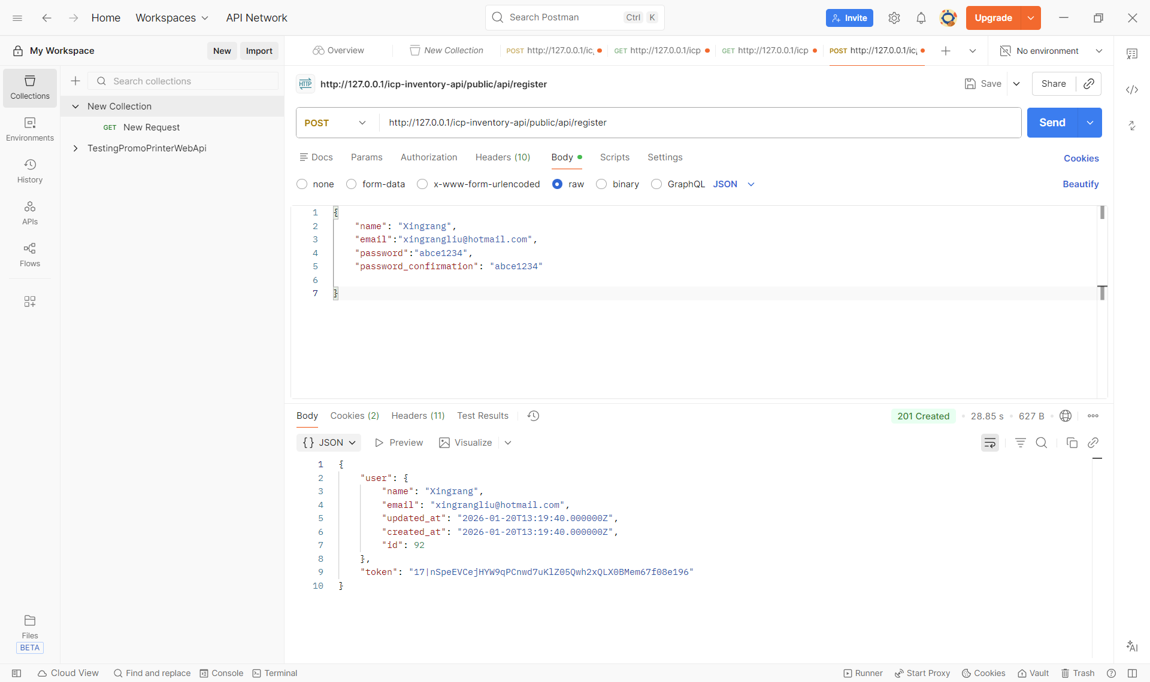

Using Postman to test the Sanctum method register, it is working.

- Router: http://127.0.0.1:8080/login

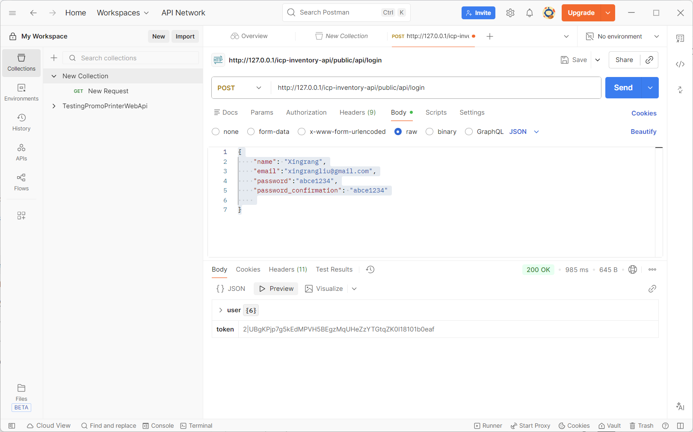

Using Postman to test the Sanctum method login, it is working.

- Router: http://127.0.0.1:8080/products

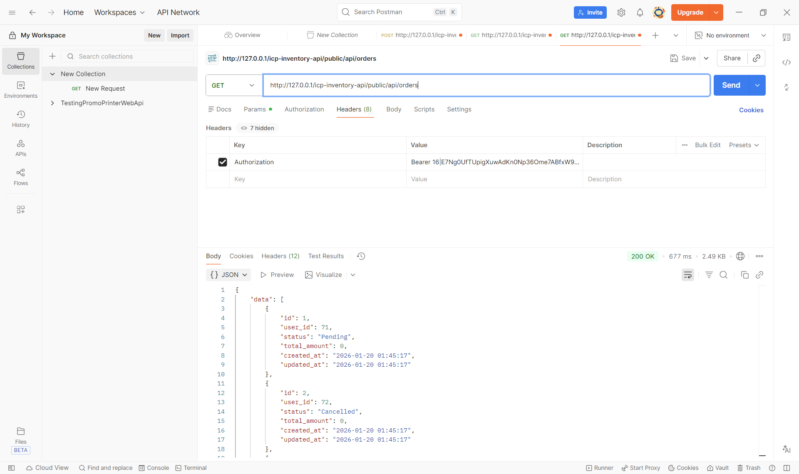

Using Postman to test API method products, it is working.

- Router: http://127.0.0.1:8080/orders

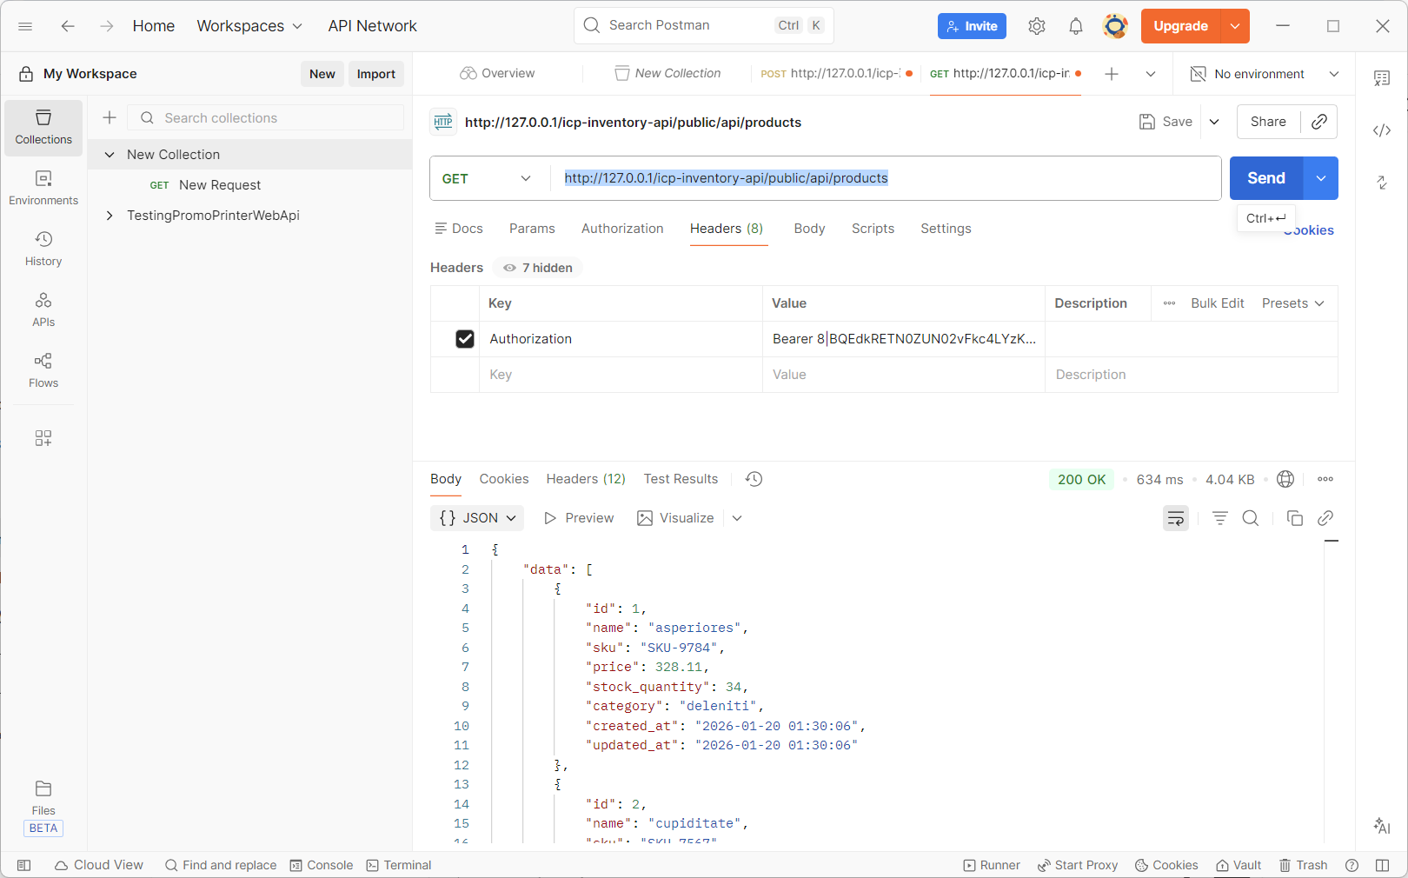

Using Postman to test the Sanctum method orders, it is working.

