**Task 1 -- Simulating SDE**

1. **Simulating geometric Brownian motion**

Given that

dS(t) = 0.1 dt + 0.26 dB(t); S(0) = 39;

We know that µ=0.1, σ=0.26

* + **What is the expectation value of S(3)?**

By using the formula of

To find expectation of S(3):

We will get 52.6444934954641 with the help of python.

* + **What is the variance of S(3)?**

By using the formula of

To find variance of S(3):

We will get 623.0964723299670 with the help of python.

* **Calculate the expectation value of S(3) based on the simulation.**

First, I take the last row of the data, which consist of 1000 values there and set a variable named “total” to zero initially. After that, I add up the 1000 values by using a *for* loop. Then I find the expected value of S(3) by taking the total and divide 1000 (the number of path).

* **Calculate the variance of S(3).**

First, I take the last row of data (consist of 1000 data) then take the square of the data and set the variable named “total_square” to zero initially. After that, I add up the 10000 values (which is already squared) by using a *for* loop.

With the help of variance formula:

I key in the formula in python, which is:

Note: the total is calculated when calculating expectation value of S(3)

* **Calculate P[S(3)> 39].**

To calculate the probability, I first set a variable named “count” as zero initially. After that, I use a *for* loop and a conditional *if* inside the *for* loop to check the last row of calculated stock price (which consist of 5 values) whether it is larger than 39. If it is larger than 39, then the variable “count” will add up by 1.

Then, after the *for* loop, the value of probability that S(3) is larger than 39 is calculated by taking the variable “count” divide number of path.

* **Calculate E[S(3) | S(3) > 39].**

When finding the probability that S(3) is larger than 39, we already find out that there are how many values which is larger than 39 (i.e. the variable named “count”)by using a *for* loop and conditional *if* in the loop. Furthermore, in the *for* loop, a variable named “Total” (which is assigned to zero initially) is used to get the total of the stock price which is larger than 39. After that, I counted the conditional expectation **E[S(3) | S(3) > 39]** by taking the “Total” divide “count”.

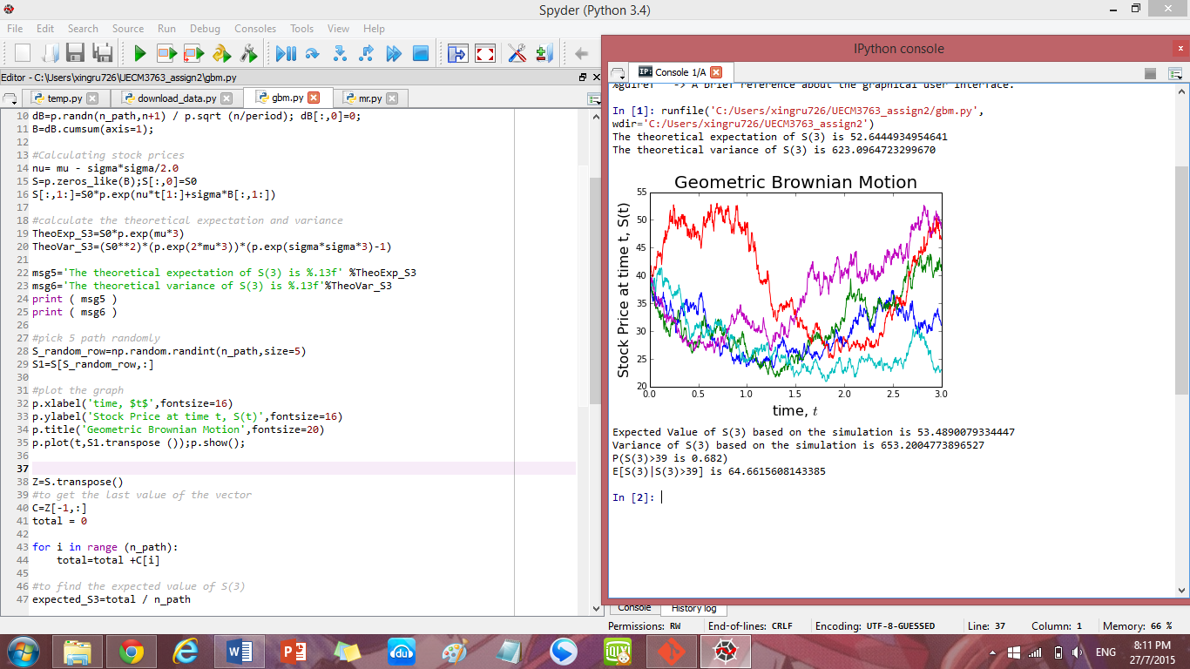

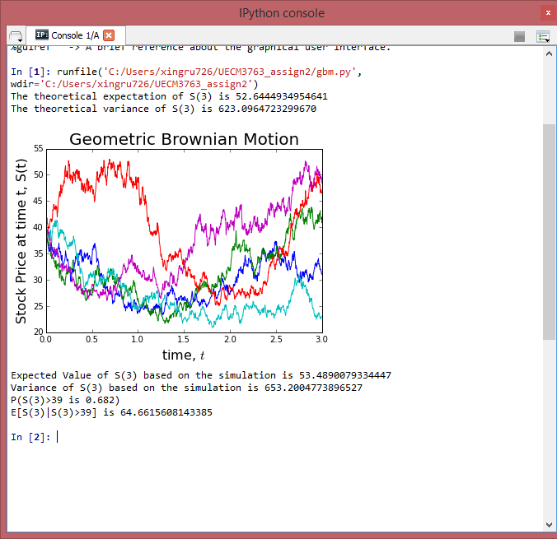

1. **Simulating mean reversal process**

Given that

dR(t) = [0.064 - R(t)] dt + 0.27 R(t) dB(t); R(0) = 3;

* **Calculate the expectation value of R(1) based on the simulation.**

First, I take the last row of simulated R(t) (i.e. R(1)) and set a variable named “total” as zero initially. , I add up all the selected data by using a *for* loop then take the total divide the number of path to get the expectation value of R(1).

* **Calculate P[R(1)> 2].**

I set up a variable called “count” as zero initially. To calculate the probability, I use a *for* loop then use a conditional *if* in the *for* loop to check that whether the value of R(1) is greater than 2. If the value of R(1) is greater than 2, then the variable “count” will add up by 1. After the *for* loop, I will take the count divide the number of path to get the probability that R(1) is greater than 2.

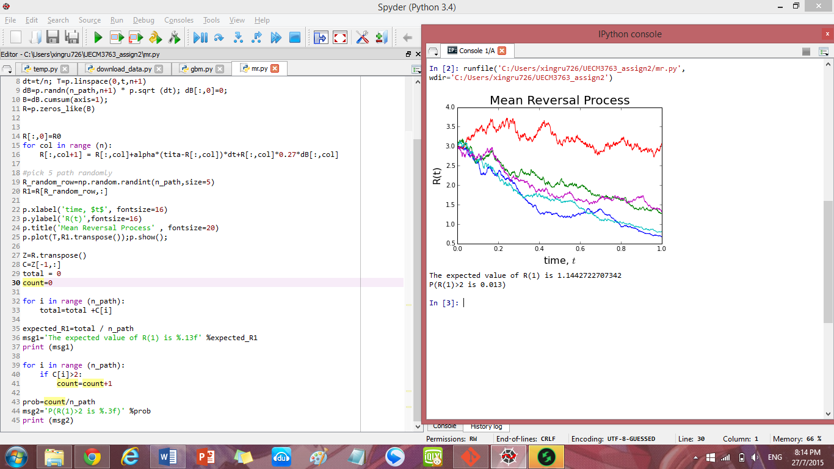

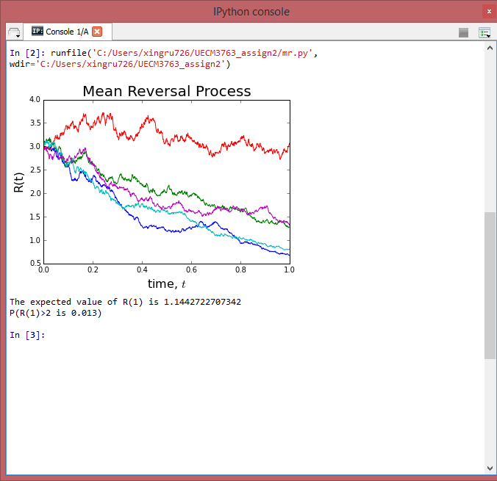

## Task 2 -- Downloading and manipulating stock data

1. **FTSE Bursa Malaysia KLCI Index**

There are 30 component stocks in FTSE Bursa Malaysia KLCI.

The following is the component stocks in FTSE KLCI:

|  |  |  |  |  |  |
| --- | --- | --- | --- | --- | --- |
| **Stock Name** | **Stock Code** | **Stock Sector** | **Weightage in FTSE KLCI** | **PE Ratio** | **Net Market Capital**  **(MYR in Billion)** |
| AMMB | 1015 | Financials | 11.6 | 8.82 | 16.97 |
| Astro Malaysia | 6399 | Financials | 9.32 | 28.06 | 15.761 |
| Axiata | 6888 | Trading Services | 9.28 | 24.18 | 55.349 |
| BAT Bhd | 4162 | Financials | 5.76 | 20.06 | 18.445 |
| CIMB Group Holdings | 1023 | Trading Services | 5.62 | 17.52 | 46.694 |
| DIGI.com | 6947 | Trading Services | 5.51 | 21.02 | 41.83 |
| Westports Holdings | 5246 | Infrastructure Proj | 4.16 | 26.6 | 13.9 |
| Genting | 3182 | Trading Service | 3.68 | 19.3 | 30.748 |
| Genting Malaysia | 4715 | Industrial Products | 3.55 | 20.59 | 25.71 |
| Hong Leong Bank | 5819 | Trading Services | 3.45 | 11.19 | 24.572 |
| Hong Leong Financial | 1082 | Industrial Products | 3.4 | 9.92 | 16.255 |
| IHH Healthcare | 5225 | Trading Services | 3.28 | 63.15 | 48.758 |
| IOI Corp | 1961 | Plantation | 2.99 | 73.65 | 26.731 |
| KLCC Property | 5235SS | Trading Services | 2.96 | 13.63 | 12.71 |
| Kuala Lumpur Kepong | 2445 | Trading Services | 2.5 | 29.21 | 23.983 |
| Malayan Banking | 1155 | Trading Services | 2.45 | 12.45 | 88.041 |
| Maxis | 6012 | Financial | 2.38 | 30.05 | 49.409 |
| MISC | 3816 | Plantation | 2.28 | 15.99 | 35.264 |
| Petronas Chemicals | 5183 | Trading Services | 1.98 | 21.83 | 50.64 |
| Petronas Dagangan | 5681 | Consumer Products | 1.8 | 37.05 | 20.445 |
| Petronas Gas | 6033 | Consumer Products | 1.7 | 22.79 | 42.741 |
| PPB Group | 4065 | Financial | 1.67 | 18.13 | 18.233 |
| Public Bank | 1295 | Trading Services | 1.63 | 15.21 | 73.368 |
| RHB Capital | 1066 | Consumer Product | 1.37 | 9.18 | 19.129 |
| Sapurakencana Petrol | 5218 | Trading Services | 1.22 | 12.08 | 14.321 |
| Sime Darby | 4197 | Trading Services | 1.21 | 21.89 | 52.671 |
| Telekom Malaysia | 4863 | Financial | 1.06 | 32.34 | 24.915 |
| Tenaga Nasional | 5347 | Trading Services | 0.93 | 9.15 | 69.304 |
| UMW | 4588 | Financial | 0.64 | 20.41 | 11.987 |
| YTL Corp | 4677 | Trusts | 0.63 | 14.95 | 16.67 |

By date 24/7/2015.

1. **Downloading data**
   * **Plot a 5-day moving average plot for the downloaded data. Explain how you calculate the 5-day moving average.**

To calculate the 5-day moving average, I use 2 nested *for* loop. In the outer for loop, I use the *i* in range of number of row +1 -5. I add one is because in python to find the number-th of row it will always start from zero. To minus 5 is because to calculate the 5-day moving average, the last 4 points will always be ignored, so the number of point (moving average) will always have difference of 5 with the number of being used to generate. For the inner *for* loop, I use the *j* in range 5 because we need 5 points to generate the 5-day moving average points. Furthermore, in the inner *for* loop, I use to sum the data from the 0-th to 5-th value then end of the inner loop, (in outer loop), I will take the average then let the sum to be zero again (initially the sum will set to be zero). After that, the outer loop will start to loop the 2nd point and in inner loop, it will continue to sum the data from the 1-st to 6-th value. This will continue calculating until the 5th data point from the back (i.e. the number of row +1-5), is used.

