# JAVA编程进阶上机报告



**学 院 智能与计算学部**

**专 业 软件工程**

**班 级 五班**

**学 号 3018216242**

**姓 名 邢思洋**

1. **实验要求**

1. 需求描述：

某计算机组装公司主要销售各类组装计算机，计算机一般由CPU、内存、主板、硬盘等组件构成。具体组件信息如下：

|  |  |  |
| --- | --- | --- |
| 组件名 | 组件品牌 | 组件属性 |
| CPU | Intel、AMD | Name，coreNum，price |
| 内存 | Samsung, Kingston | Name, volume, price |
| 硬盘 | Seagate, WestDigitals | Name, volume, price |
| 主板 | Asus、Gigabyte | Name，speed, price |

每个组件都有自己的工作方式，简单起见，每个组件的工作内容为打印“组件名+work”。

2. 实现功能：

具体要求：

1) 针对每个组件的每个品牌，设计一个类，并画成整体的类图

2) 设计计算机类（Computer.java），由上述四类组件组装而成，包括计算机的名称、计算机的描述（包括各个组件名）以及总价格等

3) 设计计算机销售主类（ComputerStore.java），包括3个由不同组件组装在一起的计算机实例，可实现计算机商品一览表，可展示每台计算机的描述、价格、工作等。

4) 设计时基于抽象类和接口，要尽可能的实现高内聚、低耦合。

1. **类图及设计思路**

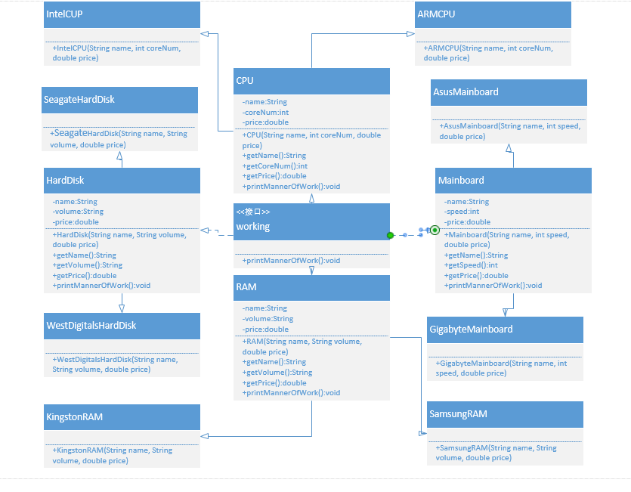

对于每种组件设计一个抽象类，即CPU、RAM、HardDisk、Mainboard四个抽象类，分别包括三种属性及各种方法，之后对于每种品牌，都分别从四个抽象父类中继承而来一个子类。另外，四个抽象父类都实现接口working中的printMannerOfWork方法，从而打印每个组件自己的工作方式。

1. **源代码**

**package** xsy.lab1;

**public** **abstract** **class** CPU **implements** working

{

**private** String name;

**private** **int** coreNum;

**private** **double** price;

**public** CPU(String name, **int** coreNum, **double** price)

{

**this**.name = name;

**this**.coreNum = coreNum;

**this**.price = price;

}

**public** String getName()

{

**return** **this**.name;

}

**public** **int** getCoreNum()

{

**return** **this**.coreNum;

}

**public** **double** getPrice()

{

**return** **this**.price;

}

**public** **void** printMannerOfWork()

{

System.***out***.println(**this**.name + " work");

}

}

**package** xsy.lab1;

**public** **class** IntelCPU **extends** CPU

{

**public** IntelCPU(String name, **int** coreNum, **double** price)

{

**super**(name, coreNum, price);

}

}

**package** xsy.lab1;

**public** **class** AMDCPU **extends** CPU

{

**public** AMDCPU(String name, **int** coreNum, **double** price)

{

**super**(name, coreNum, price);

}

}

**package** xsy.lab1;

**public** **abstract** **class** RAM **implements** working

{

**private** String name;

**private** String volume;

**private** **double** price;

**public** RAM(String name, String volume, **double** price)

{

**this**.name = name;

**this**.volume = volume;

**this**.price = price;

}

**public** String getName()

{

**return** **this**.name;

}

**public** String getVolume()

{

**return** **this**.volume;

}

**public** **double** getPrice()

{

**return** **this**.price;

}

**public** **void** printMannerOfWork()

{

System.***out***.println(**this**.name + " work");

}

}

**package** xsy.lab1;

**public** **class** SamsungRAM **extends** RAM

{

**public** SamsungRAM(String name, String volume, **double** price)

{

**super**(name, volume, price);

}

}

**package** xsy.lab1;

**public** **class** KingstonRAM **extends** RAM

{

**public** KingstonRAM(String name, String volume, **double** price)

{

**super**(name, volume, price);

}

}

**package** xsy.lab1;

**public** **abstract** **class** HardDisk **implements** working

{

**private** String name;

**private** String volume;

**private** **double** price;

**public** HardDisk(String name, String volume, **double** price)

{

**this**.name = name;

**this**.volume = volume;

**this**.price = price;

}

**public** String getName()

{

**return** **this**.name;

}

**public** String getVolume()

{

**return** **this**.volume;

}

**public** **double** getPrice()

{

**return** **this**.price;

}

**public** **void** printMannerOfWork()

{

System.***out***.println(**this**.name + " work");

}

}

**package** xsy.lab1;

**public** **class** SeagateHardDisk **extends** HardDisk

{

**public** SeagateHardDisk(String name, String volume, **double** price)

{

**super**(name, volume, price);

}

}

**package** xsy.lab1;

**public** **class** WestDigitalsHardDisk **extends** HardDisk

{

**public** WestDigitalsHardDisk(String name, String volume, **double** price)

{

**super**(name, volume, price);

}

}

**package** xsy.lab1;

**public** **abstract** **class** Mainboard **implements** working

{

**private** String name;

**private** **int** speed;

**private** **double** price;

**public** Mainboard(String name, **int** speed, **double** price)

{

**this**.name = name;

**this**.speed = speed;

**this**.price = price;

}

**public** String getName()

{

**return** **this**.name;

}

**public** **int** getSpeed()

{

**return** **this**.speed;

}

**public** **double** getPrice()

{

**return** **this**.price;

}

**public** **void** printMannerOfWork()

{

System.***out***.println(**this**.name + " work");

}

}

**package** xsy.lab1;

**public** **class** GigabyteMainboard **extends** Mainboard

{

**public** GigabyteMainboard(String name, **int** speed, **double** price)

{

**super**(name, speed, price);

}

}

**package** xsy.lab1;

**public** **class** AsusMainboard **extends** Mainboard

{

**public** AsusMainboard(String name, **int** speed, **double** price)

{

**super**(name, speed, price);

}

}

**package** xsy.lab1;

**public** **interface** working

{

**void** printMannerOfWork();

}

**package** xsy.lab1;

**public** **class** Computer

{

**private** String name;

**private** CPU cpu;

**private** RAM ram;

**private** HardDisk hardDisk;

**private** Mainboard mainboard;

**private** **double** price;

**public** Computer(String name, CPU cpu, RAM ram, HardDisk hardDisk, Mainboard mainboard)

{

**this**.name = name;

**this**.cpu = cpu;

**this**.ram = ram;

**this**.hardDisk = hardDisk;

**this**.mainboard = mainboard;

**this**.price = cpu.getPrice() + ram.getPrice() + hardDisk.getPrice() + mainboard.getPrice();

}

**public** String getName()

{

**return** **this**.name;

}

**public** **double** getPrice()

{

**return** **this**.price;

}

**public** String getDescribe()

{

**return** "CPU: " + cpu.getName() + "\nRAM: " + ram.getName()

+ "\nHard Disk: " + hardDisk.getName() + "\nMainboard: " + mainboard.getName();

}

}

**package** xsy.lab1;

**public** **class** ComputerStore

{

**public** **static** **void** main(String[] args)

{

CPU cpu1 = **new** IntelCPU("Intel i5-9400F", 6, 1199);

CPU cpu2 = **new** AMDCPU("AMD r5-3600", 6, 1369);

RAM ram1 = **new** SamsungRAM("Samsung DDR4 2666", "8G", 329);

RAM ram2 = **new** KingstonRAM("Kingston DDR4 2666", "8G", 369);

HardDisk harddisk1 = **new** SeagateHardDisk("Seagate ST2000DM008", "2T", 389);

HardDisk harddisk2 = **new** WestDigitalsHardDisk("WestDigitals WD20EZAZ", "2T", 355);

Mainboard mainboard1 = **new** AsusMainboard("Asus TUF B360M-PLUS", 0, 1028);

Mainboard mainboard2 = **new** GigabyteMainboard("Gigabyte B450M", 0, 1048);

Computer computer1 = **new** Computer("computer1", cpu1, ram1, harddisk1, mainboard1);

Computer computer2 = **new** Computer("computer2", cpu2, ram2, harddisk2, mainboard2);

Computer computer3 = **new** Computer("computer3", cpu1, ram2, harddisk1, mainboard2);

System.***out***.println("Computer Name: "+ computer1.getName());

System.***out***.println(computer1.getDescribe());

System.***out***.println("Price: " + computer1.getPrice() + "\n");

System.***out***.println("Computer Name: "+ computer2.getName());

System.***out***.println(computer2.getDescribe());

System.***out***.println("Price: " + computer2.getPrice() + "\n");

System.***out***.println("Computer Name: "+ computer3.getName());

System.***out***.println(computer3.getDescribe());

System.***out***.println("Price: " + computer3.getPrice() + "\n");

}

}

1. **实验结果**

