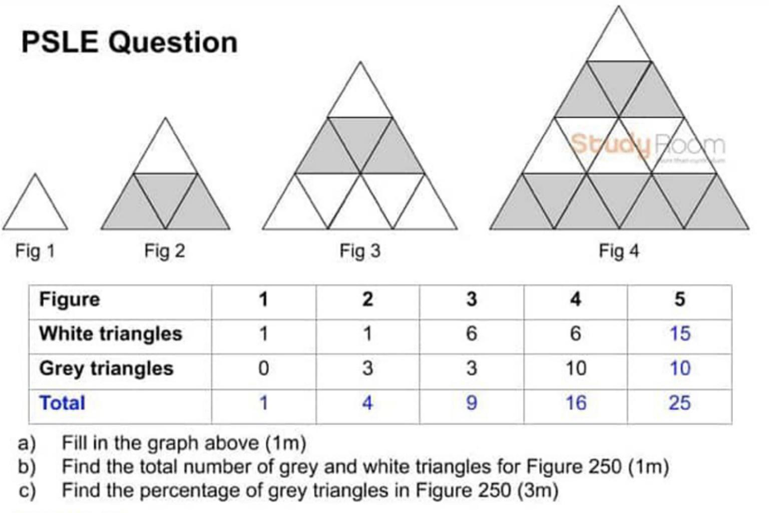

Based on the diagram above, write a function ***calculateColoredTriangles*** that takes in a parameter ***figure*** which represents the figure number and calculates the total number of white and grey triangles respectively based on the figure number.

You may assume that the triangle at the top is always white.

E.g.

calculateColoredTriangles ( 4 );

// “There are 6 white triangles and 10 grey triangles in figure 4.”