Movie Recommender System based on IMDB

System Design Specification (SDS)

v1.3

April 20, 2026

CHEN Fengyuan | 2430026009
CHEN Yixuan | 2430036019
CHEN Zheyu | 2430026021
YU Chengzhu | 2330026199
ZHI Xiwen | 2330026231

Computer Science and Technology Program

United International College
- Document Change Log
Change Date | Changed By | Version | Change Description
2/4/2026 | ZHI Xiwen | v1.0 | Prepared Document
18/4/2026 | ZHI Xiwen | v1.1 | Update Section 4 Tools and Standards.  Update Section 5 User Interface Design.
19/4/2026 | Chen Fengyuan | v1.2 | Update Section 3 Design Overview.
20/4/2026 | Yu Chengzhu | v1.3 | Update Section 7 Diagrams.
- Table of Contents
1. Document Change Log 2
2. Table of Contents 3
3. Design Overview 4
4. Tools and Standards 5
4.1. Tools 5
4.2. Standards 5
5. User Interface Design 6
5.1. Display Movie List and Movie Detail 6
5.1.1. Description 7
5.1.2. Basic Scenario - Filter Movie by Gernes 7
5.1.3. Basic Scenario - Filter and Sort Movie by Rating 8
5.1.4. Basic Scenario - View Movie Details 8
5.2. Data Analysis and Visualization Panel 8
5.2.1. Description 9
5.2.2. Basic Scenario – Display Data Analysis 9
5.3. Movie recommender system 9
5.3.1. Description: 10
5.3.2. Basic Scenario - Recommend Movies 10
6. Diagrams 11
6.1. Control Flow diagram 11
6.2. Class diagram 12

- Design Overview
Design Overview: This project delivers an end-to-end movie data analytics and recommendation platform, transforming raw, heterogeneous film datasets into actionable insights and personalized user experiences. The system is designed to serve two primary audiences: general movie audiences who struggle to discover films matching their preferences amid an overwhelming volume of releases, and industry stakeholders (e.g., studios, distributors) seeking data-driven understanding of market trends and commercial performance.

Functionality is organized across four interconnected layers:
1. Data Cleaning & Preprocessing Pipeline — Raw data sourced from TMDB (The Movie Database) and MovieLens is ingested across multiple files (movies_metadata.csv, credits.csv, keywords.csv, ratings_small.csv). The pipeline handles JSON column parsing, explicit and implicit missing values (notably, budget and revenue fields where 0 represents undisclosed data rather than true zero), duplicate removal, date standardization, and temporal filtering. Derived features such as ROI, profit, and primary genre are computed at this stage. The pipeline outputs three clean, analysis-ready files: movies_clean.csv, ratings_clean.csv, and a data_quality_report.txt for reproducibility and audit purposes.

2. Exploratory Data Analysis (EDA) — The cleaned dataset is analyzed to surface key patterns in the film industry, including: rating and release volume trends across decades, the rise and fall of genre popularity over time, director-level performance trajectories, language and regional production trends, and the relationship between budget, revenue, and audience reception. These analyses are supported by descriptive statistics and correlation studies.

3. Data Visualization — Analytical findings are communicated through intuitive, publication-quality charts and dashboards. Visualizations cover genre trend lines, director popularity rankings, year-over-year rating distributions, ROI comparisons across budget tiers, and more — enabling both technical and non-technical stakeholders to extract value from the results.

4. Movie Recommendation System — Users can input films they have previously enjoyed and optionally specify preferred genres. The system processes this input against the cleaned movie and ratings datasets to generate personalized film recommendations. The underlying model leverages collaborative filtering and/or content-based techniques trained on the MovieLens ratings data and TMDB metadata.
Technically, the platform is implemented in Python, utilizing pandas for data wrangling, matplotlib/seaborn for visualization, and scikit-learn or similar libraries for machine learning components. No external partners are currently involved; all data originates from publicly available TMDB and MovieLens datasets.
- Tools and Standards

Tools

Category | Tools / Packages | Purpose
Image / Poster Collection | Requests | Fetching movie posters from external APIs (e.g., TMDB) using HTTP requests.
Data Processing | Pandas, NumPy | Loading, cleaning, and manipulating movie metadata (genres, ratings, years, cast, descriptions, etc.).
Data Visualization | Matplotlib, Plotly | Generating dynamic and interactive charts for the Analysis Page (Production by Years, Genres Distribution, Cast Count, etc.).
Natural Language Processing | NLTK / SpaCy | Preprocessing movie descriptions and combining with genre data to evaluate movie similarity. TF-IDF (Term Frequency-Inverse Document Frequency) will be applied to textual data (descriptions + genres) to convert them into numerical feature vectors for similarity computation.
Recommendation Algorithm | Scikit-learn | Implementing content-based filtering using cosine similarity and TF-IDF vectorization.
Frontend Framework | Streamlit | Building the entire interactive web interface (movie list, detail page, recommender form, analysis charts) without needing separate HTML/CSS/JS.

Standards
The project will adhere to the following technical and operational standards:

Standard | Specification
Operating System | Cross-platform: Windows 11.
Web Browser Support | Latest versions of Google Chrome, Mozilla Firefox, Safari, and Edge.
Programming Language | Python 3.9+ (entire application, including Streamlit frontend).
Screen Resolution | Responsive design supporting 1280×720, 1920×1080, and 2560×1440.
Data Format | JSON for API communication; CSV/JSON for local movie datab storage.

- User Interface Design

Display Movie List and Movie Detail

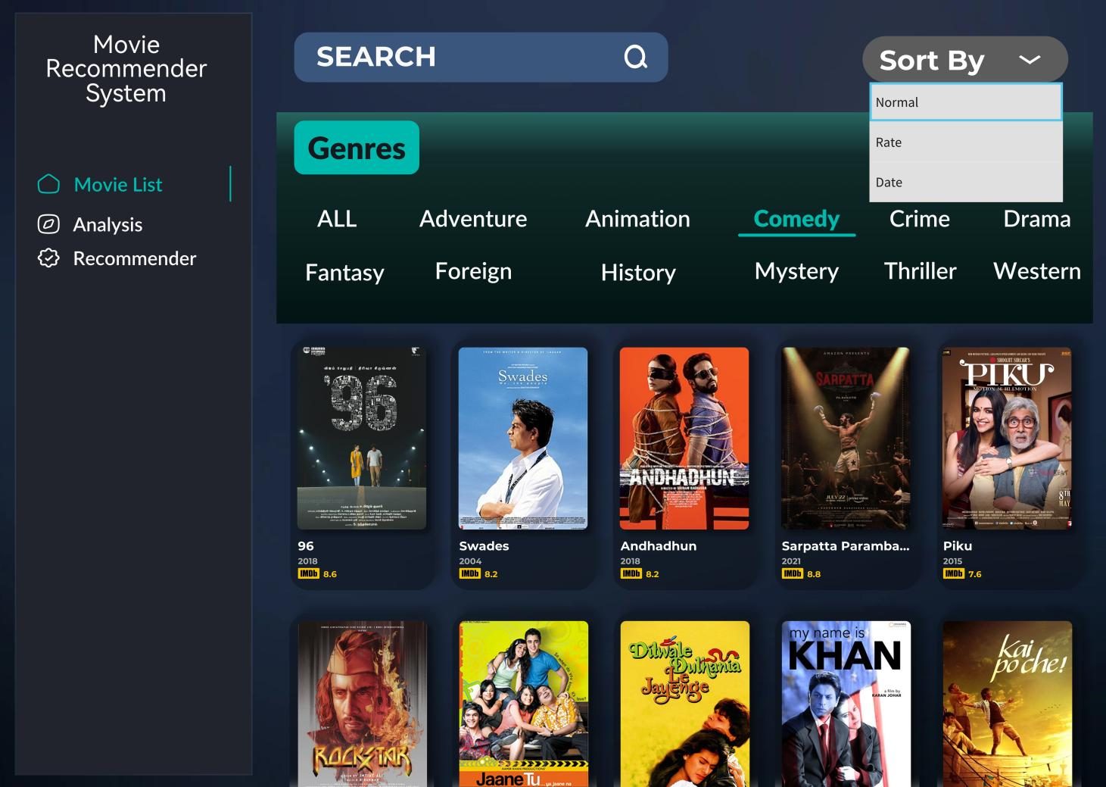

Figure 1. Movie List Page

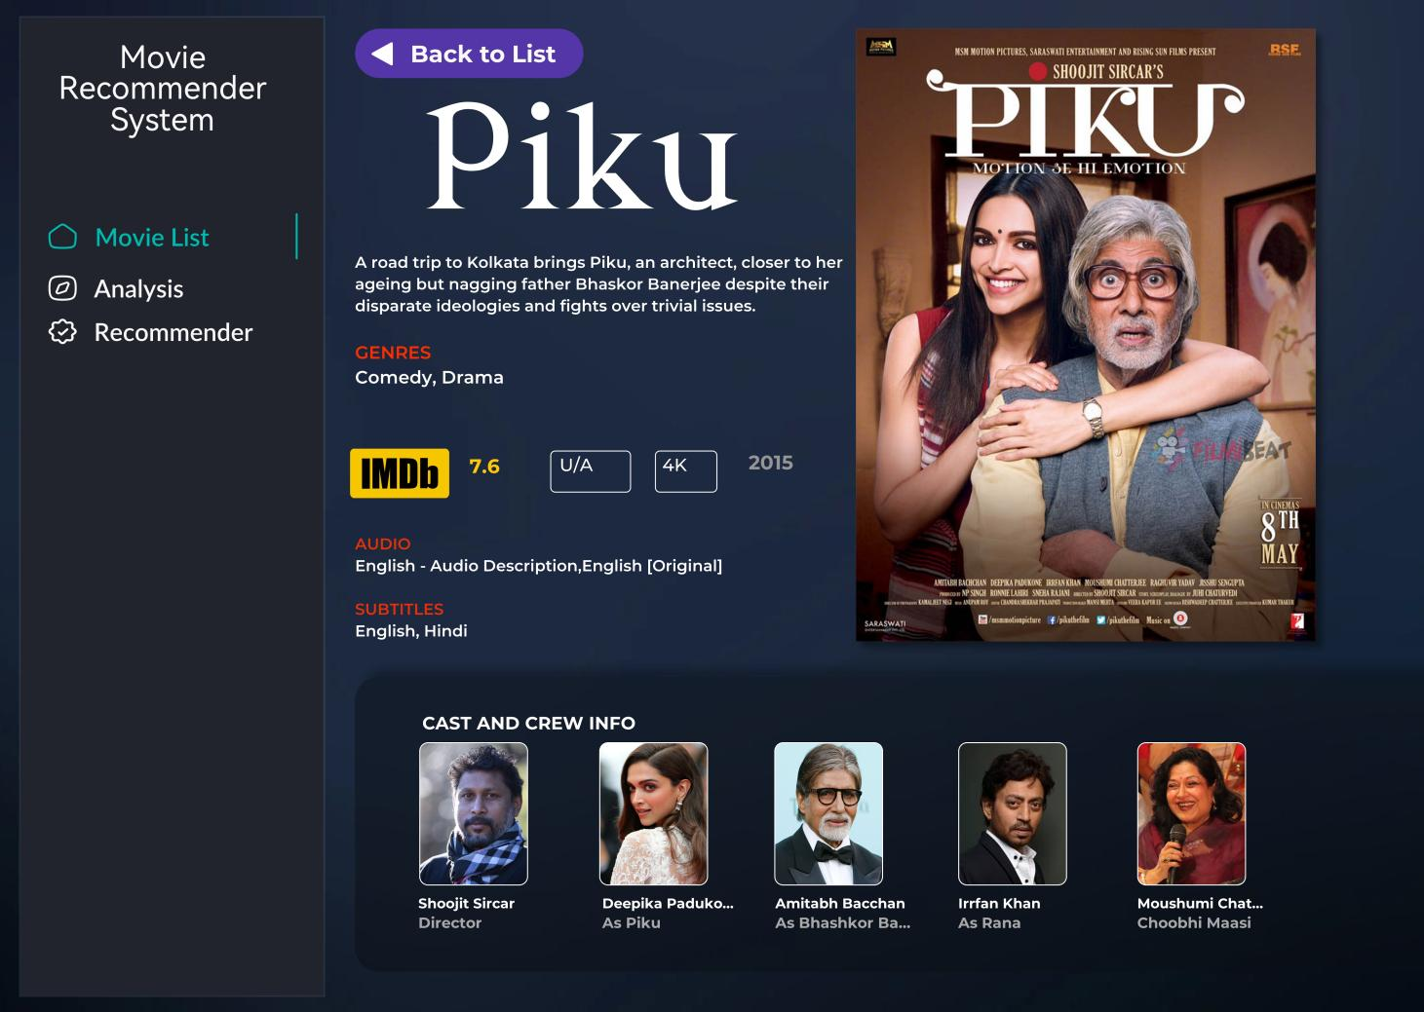

Figure 2. Movie Detail Page

Description
- Movie List Page
The Movie List Screen allows users to browse and filter the entire movie collection. At the top, there is a “Sort By” dropdown with options including Normal, Rate, and Date, allowing users to reorder the displayed movies. Below that, a horizontal genre filter bar includes all genres such as ALL, Adventure, Animation, Comedy, Crime, Drama, Fantasy, Foreign, History, Mystery, Thriller, and Western.

- Movie Detail Page
The Movie Detail Screen provides comprehensive information about a selected movie. The screen includes a “Back to List” button at the top left to return to the movie list. The main content displays the movie title (e.g., Piku), a description/overview, genres (e.g., Comedy, Drama), IMDb rating, certification (e.g., *U/A*), resolution (e.g., 4K), and release year (e.g., *2015*).

Assumption: The user is on Movie List Page (Figure 1) currently.

Basic Scenario - Filter Movie by Gernes
- The user clicks on a genre tag (e.g., Animation).
- The system immediately updates the movie list below to show only movies belonging to that genre.
- The system displays the movies as a card containing the movie title, release year, and IMDb rating (e.g., Swades, *2004*, IMDb 8.6).

Basic Scenario - Filter and Sort Movie by Rating
- The user clicks on a genre tag (e.g., Animation).
- The system immediately updates the movie list below to show only movies belonging to that genre.
- The user clicks on “Sort By”. then selects “Rate” box.
- The system displays the movies sorted by rating from highest to lowest.

Basic Scenario - View Movie Details
- User clicks on a movie.
- The system displays the “Movie Detail Page” (Figure 2).

Data Analysis and Visualization Panel
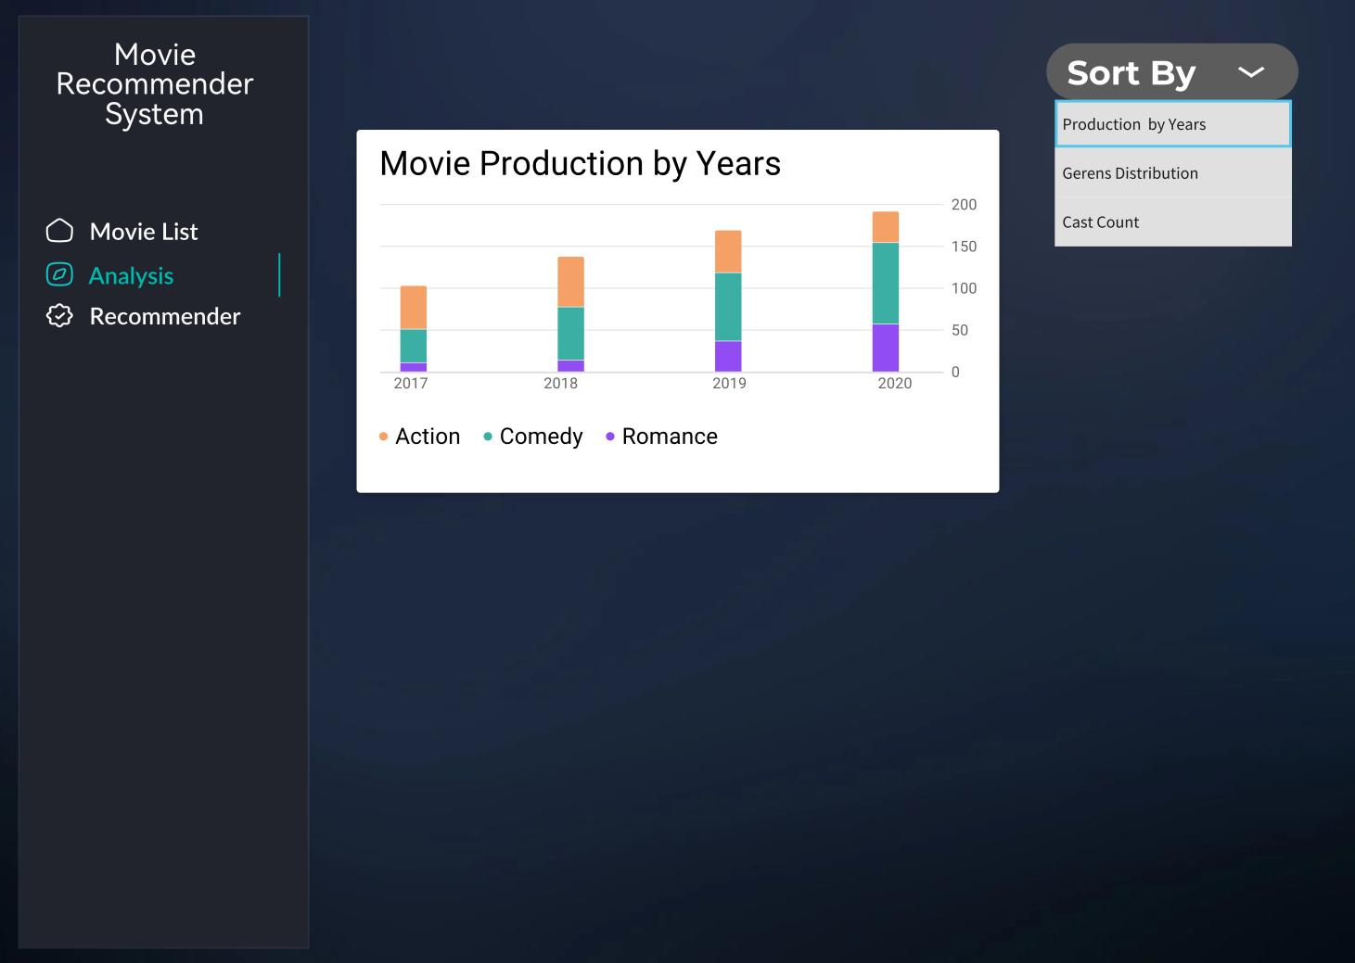

Figure 3. Data analysis and visualization

Description
The Analysis Panel provides data visualizations based on all movie metadata and user review data. At the top, there is a dropdown selector allowing users to choose between different chart types such as “Production by Years”, “Genres Distribution”, and “Cast Count”.
All visualizations are dynamically updated based on the dropdown selection, helping users understand trends in movie production and user preferences.

Basic Scenario – Display Data Analysis
Use the bar chart of movies per year for an example.
- The user selects Production by Years from the dropdown
- The system displays a bar chart showing the number of movies produced each year (e.g., 2017, 2018, 2019, 2020).

Movie recommender system

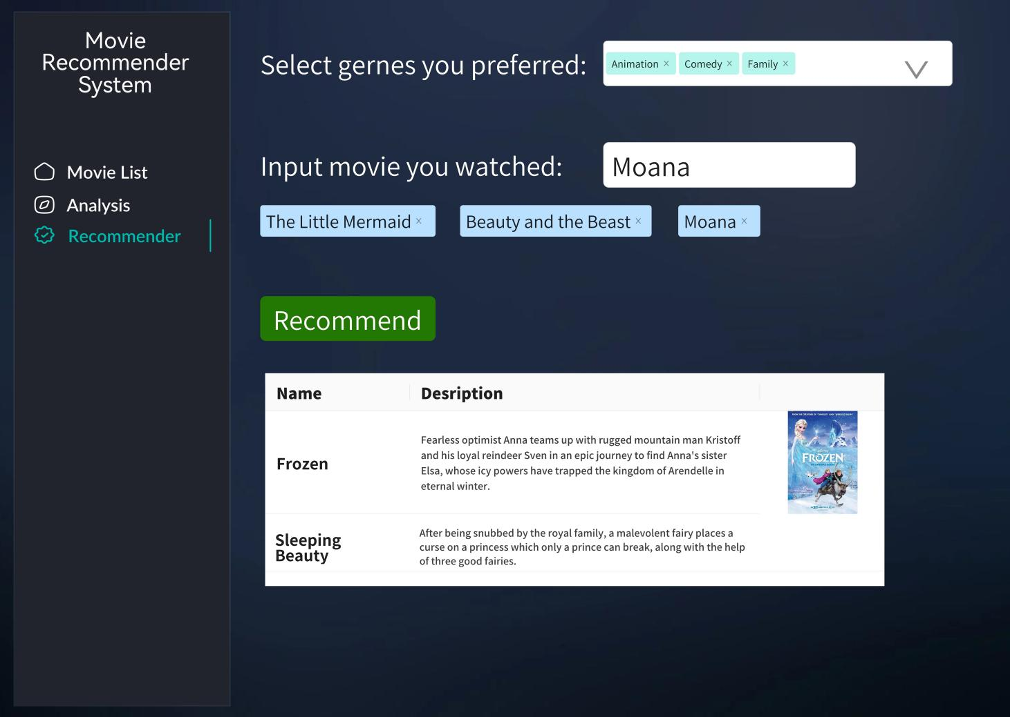

Figure 4. Movie Recommendation Page

Description:
The Recommender Screen allows users to receive personalized movie recommendations. The interface includes two input sections:

Section | Description
Select genres you preferred | A set of genre tags (e.g., Animation, Comedy, Family) that the user can click to select multiple genres (optional).
Input movie you watched | A text input field where the user can type a movie title they have watched and enjoyed (e.g., Moana).  Below the input field, previously entered movies appear as tags (e.g., The Little Mermaid x, Beauty and the Beast x, Moana x), which can be removed by clicking the “x”.

Basic Scenario - Recommend Movies
- The user selects one or more preferred genres and/or inputs one or more movies they have watched.
- The user clicks the “Recommend” button.
- The system generates a list of predicted movie recommendations, displayed below the button in a table format with columns: Name and Description. For example, Frozen is shown with its plot description, followed by Sleeping Beauty with its description.
- Diagrams

Control Flow diagram
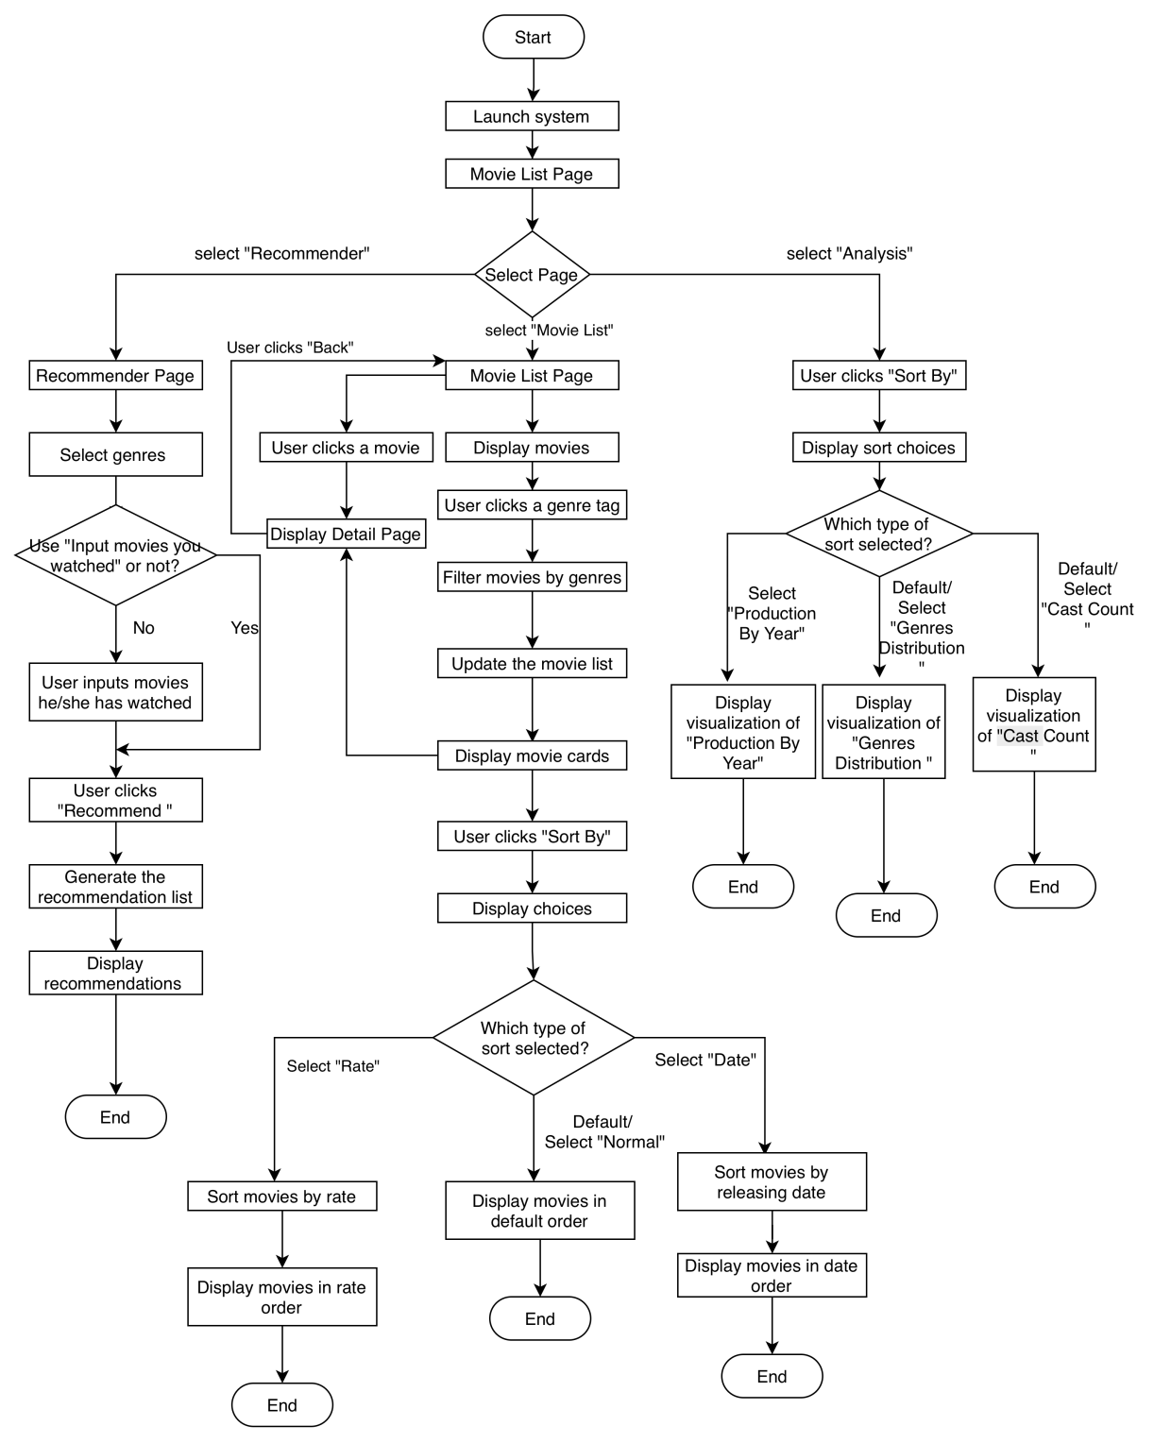

Class diagram
