**Freedom to Operate: Styrene Maleic Acid LipoProtein (SMALP)**

1. **Background to the SMALP Technology**
2. **SMALP**

Despite the great progress recently made in resolving their structures, investigation of the structural biology of membrane proteins still presents major challenges. The study of membrane proteins is often hampered by their tendency to misfold when extracted by detergent. A styrene-maleic acid co-polymer offers an interesting alternative to existing detergents, in that it is able to insert into biological membranes, form a nanodisc with the membrane contents in the centre of the disc and leave the membrane as a stable intact nanodisc. The lipid bilayer and resident membrane proteins are held within this disc, as depicted in the figure below. Once in the nanodisc, membrane proteins purified without exposure to further detergents, they show heightened thermal stability and retain full functional activity. This creates a number of commercial opportunities for life science companies.

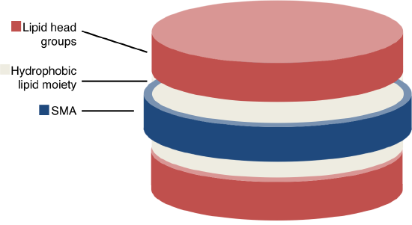

1. **Manufacture of Styrene Maleic Acid (SMA)**

SMA copolymer is formed from polymerization of a mixture of styrene and maleic anhydride in various ratios (3:1 and 2:1 being the most common). The anhydride moieties can subsequently be hydrolyzed to maleic acid. The alternating hydrophobic residues (styrene) and hydrophilic (maleic acid) is thought to be determining for the SMA properties of membrane solubilisation.

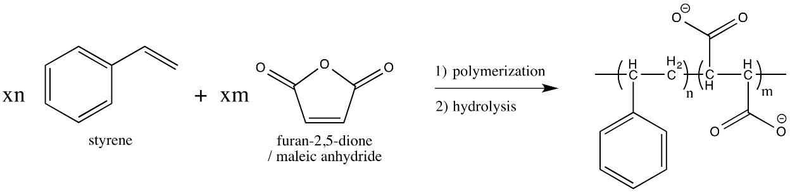

1. **SMA lipid particles (SMALPs)**

Originally being patented as Lipodisq, (patent 11 below: principally a drug delivery tool for hydrophobic pharmaceuticals), SMALPs can be used to purify membrane proteins (Knowles and co-workers: ref 2). Since that time, a variety of proteins have been purified successfully using the SMALP approach with the following results:

* + Membrane proteins of 1-36 transmembrane domains spontaneously incorporate in SMALP nanodiscs of 9-12nm diameter (refs 1, 3-5);
  + The proteins in SMALP nanodiscs can be purified by conventional methods (affinity, ion exchange, size exclusion chromatography) without removing them from the nanodisc;
  + The proteins in SMALP nanodiscs are stable, display native structure and are fully active;
  + The incorporation of membrane proteins in SMALP nanodiscs offers an attractive platform to discover new drugs to individual membrane proteins.

A number of research articles describing progress with SMALP to date are identified below, along with a comprehensive resource from the SMALP academic community. These are not essential reading, however they are a useful resource to consult as needed.

**Key papers**

1. Orwick, M. C. et al. Detergent-free formation and physicochemical characterization of nanosized lipid-polymer complexes: Lipodisq. Angew. Chemie - Int. Ed. 51, 4653–4657 (2012).
2. Knowles, T. J. et al. Membrane proteins solubilized intact in lipid containing nanoparticles bounded by styrene maleic acid copolymer. J. Am. Chem. Soc. 131, 7484–7485 (2009).
3. Orwick-Rydmark, M. et al. Detergent-free incorporation of a seven-transmembrane receptor protein into nanosized bilayer lipodisq particles for functional and biophysical studies. Nano Lett. 12, 4687–4692 (2012).
4. Swainsbury, D. J. K., Scheidelaar, S., van Grondelle, R., Killian, J. A. & Jones, M. R. Bacterial Reaction Centers Purified with Styrene Maleic Acid Copolymer Retain Native Membrane Functional Properties and Display Enhanced Stability. Angew. Chemie Int. Ed. 53, 11803–11807 (2014).
5. Scheidelaar, S. et al. Molecular Model for the Solubilization of Membranes into Nanodisks by Styrene Maleic Acid Copolymers. Biophys. J. 108, 279–290 (2015).

Further resources: [www.smalp.net](http://www.smalp.net)

1. **Scenario for Assignment**

**CRO Scenario**: A contract research organisation (CRO Co) is evaluating the freedom to operate in the supply of therapeutic antibody discovery services to membrane proteins using SMALPs as a means of preparing target proteins and screening for antibodies with the desired properties (as set out below).

1. **The proposed service**
2. Membrane proteins will be expressed in relevant mammalian or other cells as a fusion protein (that bears an affinity purification tag);
3. A target membrane protein will be extracted from the cells by exposure of the cells to a styrene maleic acid co-polymer at a suitable concentration;
4. Styrene Maleic Acid ("SMA") Copolymer will be prepared from a precursor source: styrene maleic anhydride (Xiran SZ25010: S/MA ratio 3:1; Mw 10000 from Polyscope);
5. The active styrene maleic acid polymer will be prepared using the protocol from Nat Protoc. 2016 Jul;11(7):1149-62 . In the laboratories of CRO Co., activation of SMA using this protocol results in a product (styrene maleic acid) with HLB of 16.5, free monomic styrene content of 0.25% (by weight), and free monomer maleic acid plus maleic anhydride of 0.3% by weight.
6. The target protein will be solubilised by SMA (as prepared above), purified using the appropriate affinity chromatography approaches to a suitable purity, and provided is to the client as a suspension in an appropriate buffer. The client will perform the screening assays.
7. **Patent Search**

A patent search was conducted to provide the data to assess the freedom to operate in specific areas. The search was conducted by a professional patent search company in PatBase. You have been provided with the most relevant patents from this comprehensive patent search set and the claims that are most relevant to the report have been highlighted. These are set out below:

|  |  |  |  |  |
| --- | --- | --- | --- | --- |
| Case | Title | **Patent ID** | Abstract | Claim |
| 4 | SOLUBILISATION OF MEMBRANE PROTEINS | **US2012142861B2** | A method is provided for solubilising a membrane protein. The method is applied to cellular material comprising the membrane protein and an associated membrane lipid. A copolymer of styrene and maleic acid, wherein the styrene:maleic acid ratio is between 1:2 and 10:1, is mixed with the cellular material to cause the copolymer, lipid and protein to form soluble macromolecular assemblies. | 1 |
| 11 | COMPOSITIONS COMPRISING MACROMOLECULAR ASSEMBLIES OF LIPID AND SURFACTANT | **WO2008/065451** | A composition comprising lipid and surfactant, characterised in that the surfactant has an HLB number of less than 20 and in that the lipid and surfactant are in the form of macromolecular assemblies of less than 100 nm in diameter. | 1-5 |
| 12 | STYRENE-MALEIC ANHYDRIDE COPOLYMERS FOR BIOAPPLICATIONS AND THEIR PREPARATION | **WO2007/115165** | The present invention discloses styrene-maleic anhydride copolymers preparations using solventless techniques. The solventless method resulted in reduced amounts of residues, such as unreacted styrene and/or maleic anhydride monomers, which makes the copolymers particularly suitable for bioapplications. | 1-6 |

For the purpose of this exercise please assume that the patent applications are granted in the UK in the form that has been supplied to you (the documents are in fact just applications or US patents).

1. Review extracts from Section 60 of the UK Patents Act in respect of infringing acts at annexe 1.
2. **Assignment Output**

Prepare a report for the commercial strategy group of CRO Co. that critically evaluates the freedom to operate in areas that fulfil the proposed commercial goal CRO Co. Identify the relevance, or otherwise, of each of the patents provided and provide solutions (technical and/or commercial) to the issues raised [1500 words].

***Schedule 1***

***Section 60 Patents Act 1977***

60.-(1) Subject to the provisions of this section, a person infringes a patent for an invention if, but only if, while the patent is in force, he does any of the following things in the United Kingdom in relation to the invention without the consent of the proprietor of the patent, that is to say –

1. where the invention is a product, he makes, disposes of, offers to dispose of, uses or imports the product or keeps it whether for disposal or otherwise;
2. .where the invention is a process, he uses the process or he offers it for use in the United Kingdom when he knows, or it is obvious to a reasonable person in the circumstances, that its use there without the consent of the proprietor would be an infringement of the patent;
3. where the invention is a process, he disposes of, offers to dispose of, uses or imports any product obtained directly by means of that process or keeps any such product whether for disposal or otherwise.

(2) Subject to the following provisions of this section, a person (other than the proprietor of the patent) also infringes a patent for an invention if, while the patent is in force and without the consent of the proprietor, he supplies or offers to supply in the United Kingdom a person other than a licensee or other person entitled to work the invention with any of the means, relating to an essential element of the invention, for putting the invention into effect when he knows, or it is obvious to a reasonable person in the circumstances, that those means are suitable for putting, and are intended to put, the invention into effect in the United Kingdom.

(3) Subsection (2) above shall not apply to the supply or offer of a staple commercial product unless the supply or the offer is made for the purpose of inducing the person supplied or, as the case may be, the person to whom the offer is made to do an act which constitutes an infringement of the patent by virtue of subsection (1) above.

(5) An act which, apart from this subsection, would constitute an infringement of a patent for an invention shall not do so if –

(a) it is done privately and for purposes which are not commercial;

(b) it is done for experimental purposes relating to the subject-matter of the invention;

(6D) For the purposes of subsection (5)(b), anything done in or for the purposes of a medicinal product assessment which would otherwise constitute an infringement of a patent for an invention is to be regarded as done for experimental purposes relating to the subject matter of the invention.

(6E) In subsection (6D), “medicinal product assessment” means any testing, course of testing or other activity undertaken with a view to providing data for any of the following purposes—

(a) obtaining or varying an authorisation to sell or supply, or offer to sell or supply, a medicinal product (whether in the United Kingdom or elsewhere);

(b) complying with any regulatory requirement imposed (whether in the United Kingdom or elsewhere) in relation to such an authorisation;

(c) enabling a government or public authority (whether in the United Kingdom or elsewhere), or a person (whether in the United Kingdom or elsewhere) with functions of—

(i) providing health care on behalf of such a government or public authority, or

(ii) providing advice to, or on behalf of, such a government or public authority about the

provision of health care, to carry out an assessment of suitability of a medicinal product for human use for the purpose of determining whether to use it, or recommend its use, in the provision of health care.

(6F) In subsection (6E) and this subsection—

“medicinal product” means a medicinal product for human use or a veterinary medicinal product;

“medicinal product for human use” has the meaning given by article 1 of Directive 2001/83/EC(2);

“veterinary medicinal product” has the meaning given by article 1 of Directive 2001/82/EC(3).