4

Technical Competency Assessment

# Java

Overview: This exercise will demonstrate your knowledge of the Java programing language, the Spring framework, REST APIs and overall Object Oriented development. This assessment is not pass or fail; rather it allows interviewers to see real work you would produce and how you would go about solving development challenges.

Background: XYZ Corporation has spent the last two years on the research and development of a revolutionary new beverage Diet Water. Recognizing the obesity epidemic in the United States, XYZ's Diet Water promises to be a game changer in the personal health and fitness markets.

In order to get the word out for future investors and customers, XYZ plans on a large multi-prong web and social media campaign to get the buzz out. The marketing department plans on collecting contact information so that promotional materials and free product samples of their Diet Water can be sent to would be consumers and investors.

The development teams are already at work - creating targeted emails, landing pages and social media posts. The front end work is a mix of web pages, tweets, photos on Instagram and Mail Chimp email campaigns.

What is needed is an application to receive the call to actions (CTA) on various contact forms. These CTAs will contain different messages for different audiences, but ultimately will contain a Sign-Up form where users will provide their names, email address, street address and phone numbers. (Figure l)

The application should also validate the addresses received. XYZ does not want to have to scrub every single contact registration received; rather the application should verify that the address data a user is entering is a valid address.

Full Name:

My e-mail address

Address Line:

Street address, P.Os box, company name, c/o

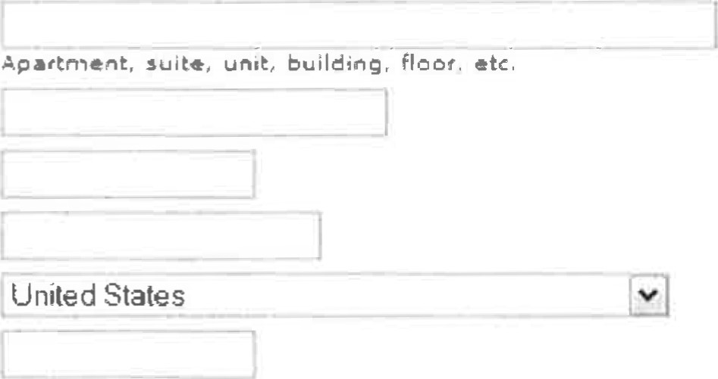City:

State/ Province/Region:

ZIP/Postal Code:

Country:

Phone Number:

Figure 1

Instructions: Develop a REST API endpoint for all CTA pages to post user information to. The REST API endpoint should be written as a Springboot application with Create, Update and Delete API endpoints for a single entity "Contact".

Requirements:

* The application should be written as a Spring Boot application e Java 8 should be used
* The application should be a REST API for the contact form (do not develop a web page)
* The application should have a Contact endpoint with Create, update and Delete capabilities
* The application should allow for basic search functionality of a contact by: first name, last name and zip code
* The application should validate all zip codes entered by the user against the following API:

https:l/www.zipcodeapi.com/APl#zipToLoc (see the Additional Notes below on this API below for clarification on this requirement)

* The application should use an H2 in memory database to store data

Additional Notes / Clarifications:

For zip code validation, the zip code should be a valid zip code as defined in the response from the API based on city and state.' For example, the following shows all zip codes for Chicago, IL:

YQMbkcWt4A4RtugEwGiVBCfla

Kn6bSKH6W2APmkPPJtilj/city-zips.json/chicag0/1L

"zip_codes"• 

"60290",

"60601",

"60606",

"60607",

"60608",

"60609",

"60610" ,

"60611 ,

"60612",

The application should verify the zip code entered is in the list returned by the zip code API. If the zip code is invalid - then a Bad Request should be returned.

Submission Instructions: Create a public GitHub repository and check in your code. Provide the URL for the repository in an email along with a screen shot of the unit tests passing and their associated code coverage.