COMP.2030 LAB 12/6/23

NAME ___________________________________________

1. Each byte sequence below indicates

address: Y86 encoding

For each byte sequence below, determine the Y86 instruction sequence it encodes.

0x100: 30f3fcffffffffffffff4063000800000000000000

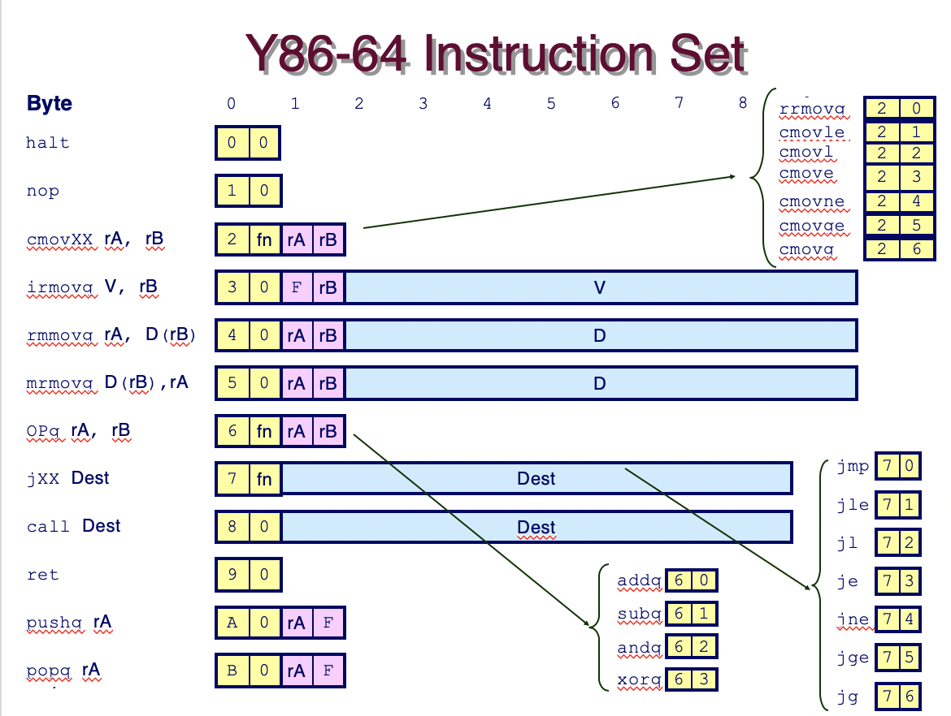

0x200: 50540700000000000000b01f

0x300: 611373000200000000000000

0x400: 6362a00f

1. A Y86 machine is a subset of x86 with the instruction set shown above right. Write the byte encoding of the following Y86 instruction sequence, starting at address 0x100.

irmovq $15, %rbx

rrmovq %rbx, %rcx

loop: rmmovq %rcx, -3(%rbx)

addq %rbx, %rcx

jmp loop

1. 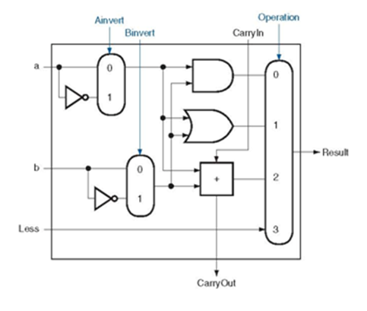Suppose that the 1-bit ALU in Y86 is constructed as on the right, except that OR gate is replaced by an XOR gate so that it can perform add, sub, and and xor operations.

Also shown are three control signals: Ainvert, Binvert, and Operation.

The 2-bit Operation controls the multiplexer to select the appropriate input to the output of the ALU. The two bits are determined by the Y86 instruction iCode of 6 for OP instructions and iFun code.

A separate combinational logic circuit takes two bits (ifun1 and ifun0) for four OP instructions (0, 1, 2, and 3 for add, sub, and, and xor), and generates appropriate values for Operation. Write the truth table for the combinational logic with inputs of ifun1 and ifun0 and the output tied to Operation.

ifun1 ifun0 Operation

-----------------------------------