**COLLEGE OF BUSINESS, ARTS AND SOCIAL SCIENCES**



**Investigating the Impact of Business Intelligence Technology on the Business Returns of CSR Enterprises**

**A dissertation submitted in the partial fulfillment of the requirement for the Degree of Master of Science**

**Supervisor:**

**Student ID: 1743545**

**Brunel Business School**

Table of Contents

**Chapter 1: Introduction** 11

1.1 Background of the Study 11

1.2 Problem Statement 14

1.3 Research Question 14

1.4 Research Aims and Objectives 15

1.5 Research Approach 15

1.6 Dissertation Structure 16

**Chapter 2: Literature Review** 19

2.1. CSR at the Strategic Level 19

2.2. Business Intelligence 19

2.2.1 Quantitative Relationship 20

2.2.2 Scorecard and Key Performance Indicators (KPIs) 21

2.2.3 Data Interpretation and Visualization 22

2.3 Literature Findings and Gaps 34

2.4 Justification of Research Model 34

**Chapter 3: Research Methodology** 36

3.1 Research Design 36

3.2 Research Choice Time and Horizon 37

3.3 Data Collection 37

3.4.1 Primary versus Secondary Data 38

3.4.1.1 Justification of Data Collection Source 39

3.4.2 Qualitative versus Quantitative Data (Methodological Choice) 41

3.4.2.1 Justification of Methodological Choice 41

3.4.3 Data Collection Technique (Questionnaire Survey) 42

3.5 Procedure 42

3.5.1 Sampling and Participant Selection 43

3.6 Data Analysis 43

3.7 Research Validity 43

3.8 Research Reliability 44

3.9 Limitation 44

3.10 Ethical Consideration 44

**Chapter 4: Results and Analysis** 45

4.1 Gender 45

4.2 Age 45

4.3 CSR Enterprise Employee 45

4.4 Reliability 46

4.5 Content Validity 46

4.6 KMO and Bartlett’s Test 47

4.7 Correlation 47

4.8 Regression Analysis 47

**Chapter 5: Discussion** 59

5.1 Discussion on Results of Hypothesis 1 and 4 52

5.2 Discussion on Results of Hypothesis 2 and 5 52

5.3 Discussion on Results of Hypothesis 3 and 6 52

**Chapter 6: Conclusions and Recommendations** 59

6.1 Conclusions 59

6.2 Limitations and Recommendations 60

References 63

Appendices 76

Appendix A: Questionnaire 76

Appendix B: Participant Information Sheet 77

Appendix C: Letter of Approval 81

**Introduction**

1.1 Background of the Study

Recently, business organizations have been very clear about their environmental and social responsibilities. For example, they need to develop policies aimed at protecting the environment and protecting employee benefits. Gone are the days when companies were recognized only for their production, manufacturing and profits; Modern business institutions are seen as entities whose objectives include social and environmental development (Porter, 2006). Here, these organizations are recognized not only as a top brand, but as an entity that promotes environmental protection and worker welfare programs (Burke, 1996). To achieve this unified goal, the company's mission needs to be expanded to ensure that its financial objectives meet the needs of all relevant stakeholders in the short and medium term (Cochran, 1984). As a result of this urgent need, companies are obliged to consider these important issues within society, which, if they arise, will affect the sustainable growth of the organization. Therefore, the company's goal is not entirely focused on financial goals such as profit and growth, but to adopt a three-dimensional approach that includes sustainable development of social welfare, economic growth and environmental protection. The strategy applied under this approach is called CSR strategy (Du, 2010).

However, the formulation and implementation of CSR strategy is not that easy, and there are numerous examples of enterprises failing to make good use of CSR strategy, which leads to the long-term benefits of the project (Porter, 2006). In 2004, for example, bp was fined a record $1.42 million in Alaska for health and safety problems, even though the company took corporate social responsibility very seriously and its programs were rewarded. Meanwhile, Costco, which provides health insurance and other benefits to its employees, has been told by shareholders to cut those benefits to compete with wal-mart in order to meet the short-term demands of the stock market (McWilliams, 2001).

So far, most companies have separated sustainability issues from strategic considerations of their main objectives and assessments of their overall performance (Branco, 2006). This significant relationship requires a study to explore how information technology and business intelligence tools can be used to maximize the benefits of CSR strategies. So this interconnection makes up the basis of this investigation.

Managers responsible for managing organizational information and data have had a lot of data to sort through for a long time, but now the main concern is not how big the data is, but how to do the current data analysis in the shortest possible time. In the above scenario, regardless of whether the data stored or recorded the previous day or this morning can be finished analyzing, it may not even be good enough to be used by the enterprise. Because of this fact, those responsible for decision making need the data to be accurate and up to date, and therefore require the same mechanisms as business information systems. In such cases, the role of the real-time analyst becomes critical in terms of data useful to the decision maker, which will enable the decision maker to analyze the data provided and propose appropriate steps.

It is expected that as the company grows in economy and size, IT-related data will become more cluttered. This makes information or data more confusing across departments or branches. This situation poses a greater risk to these critical data, and duplication of records and errors cannot be completely avoided. Therefore, important tools are needed to help find problems, solve problems, and clean up data. As a result, this will make it easier to keep information up to date and in line with company guidelines. For example, most large companies have dozens of data caches that must be put together to form a unified data center, which is handy. For most companies, data management tools are used to achieve business-relevant data integrity. Analysts of this data need tools that can collaborate and access high-quality data that is not accessible in the current environment. Successfully implementing and using analytical tools, especially in large business organizations, is not without challenges. However, the benefits from these modern things are more valuable in terms of performance and therefore outweigh the challenges. The accurate and correct implementation of this technology promises positive results.

The continuous innovation of enterprise information system and the fierce competition of enterprises bring new challenges to information management. Therefore, these challenges make the decision-making process necessary to be based on timely and accurate internal and external data. While such deployment may mean an increase in information, it does not always mean that the decision maker will derive value from it. It must be noted that most companies have reached the point where the use of technical tools has become strategically critical and necessary. After years of investment and the deployment of the necessary information platform, this has become possible, bringing efficiency to the company's structural operations. These innovations and initiatives led to the emergence of business intelligence. Business intelligence is a response to requirements related to information, for example, when making decisions that require heavy use of information.

Pratt and Fruhling (2019) describe business intelligence (BI) as a form of business in which service and software innovations are used to provide critical insights upon which decision makers can act. In other words, these insights are the basis for decision makers to make strategic decisions. More importantly, business intelligence can be described as a set of technologies and infrastructures that help to process raw data into interpretable information or results upon which decisions can be based. The term BI encapsulates a wide variety of tools that provide easy to understand and quickly accessible information about the current state of the company and its performance and operations based on available data. Because business intelligence represents data in a simpler way, it has become the preferred model for most enterprises. As a result, not only can energy be saved, but also time and other business-related resources can be saved.

Tools that are primarily used for BI purposes are the result of accessing and analyzing data, particularly in the form of maps, reports, graphs, dashboards, and summaries. This is done to clearly describe the current state of the business (Watson, 2007). Dashboards are an example of this, using hosted software that combines the available data about the company to produce separate graphs and charts to show the current situation. Business intelligence typically does not tell decision makers what to do or suggest possible solutions, nor does it report on its own. However, based on the recommendations of Haupt, Scholtz, and Calitz, they provide a window through which analysts can understand current trends and gain insights by questioning available information to make useful decisions about the business (Haupt, Scholtz, and Calitz, 2015). The enhanced use of data in a given economy leads to business intelligence models, which are thought to stimulate stability in a given business.

Ideally, technology platforms have been found to support the basic processes of the enterprise by reinforcing functional structures, these functional structures were implemented after significant investment. Using these technologies in the decision-making process for most companies has become more important than ever.

BI, suggested by Petrini and Pozzebon (2008) and (2009), seen as a game to tackle emerging problems, is designed to provide access to critical information through intensive use of ICT. Business intelligence requires the ability to maximize the use of technology by enhancing a company's ability to create a competitive advantage by building large amounts of data while making it accessible. According to Basu, this requires the final result of the analysis (Basu, 2008).

According to Canton (2009), the drivers of CSR strategy were defined and summarized as Operation driven, compliance driven and customer driven. Furthermore, according to Petrini (2009), the discussion on how business intelligence (BI) systems support the sustainable management of the organization was conducted, and the information planning phase of BI was focused. However, there is still a gap in the literature that has not been filled. This study aims to fill this gap and explore how to use business intelligence to develop and implement CSR strategy to maximize the business return of enterprises.

1.2 Problem Statement

Previous research on CSR has focused on the factors of strategy formulation or the application of business intelligence tools to maintain enterprise sustainability. They neglected to use business intelligence to analyze data and improve the formulation and implementation of CSR strategies to maximize business returns. CSR transformation is very important for the survival of an enterprise. In today's business environment, CSR strategy is inevitable for enterprises to maintain their competitiveness, meet the needs of consumers and achieve sustainable development. Through data analysis, business intelligence can help enterprises make better business decisions. Therefore, the focus of this study is to apply business intelligence to maximize the business return of CSR strategy.

1.3 Research Question

Although the application of CSR strategy is of great significance to the adaptation of an enterprise society and its own development, for an enterprise, profit is the purpose. The optimization of CSR strategy by using business intelligence technology has aroused great concern. To this end, the following questions are raised:

1.Can business intelligence technology effectively help enterprises improve the content and channels of CSR publicity?

2.Through business intelligence technology, can an enterprise accurately understand its problems and the relationship with its stakeholders?

3.Is there a positive correlation between CSR publicity and business returns?

1.4 Research Aim and Objectives

The aim of this study is to explore the effective channels and conceptual models of the influence of business intelligence on CSR strategy and business returns.

The aim of this study includes the completion of the following objectives:

Review relevant literature on CSR to identify the factors that affect the success of CSR strategy.

Identify the importance of business intelligence, as well as its help and significance in business decisions.

Identify the relationship between business intelligence, corporate CSR communication, and business returns from the literature, and propose hypotheses and conceptual models.

1.5 Research Approach

This paper collects quantitative data by means of interpretation and deduction to explore the use of business intelligence to maximize the commercial returns of CSR strategy. Major data were collected by Qualtrics and questionnaires were distributed by social media software WeChat. In this study, SPSS data analysis software was used to test the reliability and validity of the questionnaire, and the questionnaire results were analyzed and tested to determine the significance of the relationship between different variables.

1.6 Dissertation Structure

The structure of this dissertation is shown as follows (Table 1).

|  |  |
| --- | --- |
| Chapter | Contents |
| 1)Introduction | The research background, research rationale, research questions, aims and objectives, research approach and research questions are introduced in this paragraph. The focus of this research is to explore the application of business intelligence and maximize the commercial returns of CSR strategy. |
| 2)Literature Review | The literature is critically reviewed in this chapter, the importance of CSR and its strategic significance are discussed, and the role of business intelligence in business decision making and its achievements in data analysis are explained. CSR strategy is an important consideration for today's enterprises to maintain competitiveness and meet social needs. Its formulation and decision-making process can apply business intelligence technology, and its ways and interactions are also discussed. Gaps were found in the literature and six hypotheses were constructed. On the basis of literature, the conceptual model of business intelligence influencing decision and economic benefit is proposed. |
| 3)Research Methodology | This chapter describes the research methods and data collection methods. The reasons of method selection are explained and the advantages and disadvantages of research tools are provided. In this study, quantitative data were collected by means of online questionnaire and distributed by social software Wechat. Of the 245 results obtained, 95 did not meet the inclusion criteria and were excluded. You end up with 150 valid results. |
| 4)Results and Analysis | This chapter describes the analysis of valid results. In this study, SPSS statistical analysis software was used to analyze all 150 valid results and provide visual results. The results were obtained by linear correlation and regression analysis. In addition, reliability analysis and validity analysis were used to evaluate the quality of the questionnaire. As for the hypothesis presented in the paper, the test results show that there is sufficient evidence to support hypotheses 1 to 6. The application of business intelligence technology has been shown to effectively and positively influence corporate decision making and cognition, and is positively correlated with business returns. |
| 5)Discussion | In this chapter, the test results obtained in the previous chapter are discussed in detail, and the test results are evaluated according to the research contributions of literature. |
| 6)Conclusions and Recommendations | In this chapter, the research questions are answered by evidence, and the structure and content of the entire paper are condensed. In addition, limitations of the study are raised and recommendations for the future of the research are provided. |

Table 1

**Literature Review**

2.1 CSR at the Strategic Level

The concept of corporate social responsibility has long been embedded in corporations around the world. Regardless of their size, they are encouraged to operate responsibly socially. Although different papers and websites take different interpretations of the definition of CSR, after 37 literature and web pages have been sorted out and analyzed, Dahlsrud (2008) discovered, the definitions of CSR are largely consistent, encompassing no more than five dimensions: environmental, social, economic, stakeholder and voluntary dimension. In addition, companies are required to comply with regulations and different national legislation. The EU believes that the importance of CSR can be understood from two aspects, that is, from the perspective of enterprises themselves and society as a whole. Corporate social responsibility (CSR) is an effective marketing tool for enterprises (Kara, 2018). On the one hand, it provides enterprises with unique competitive advantages; on the other hand, it improves the performance and reputation as well as the value of enterprises. At the same time, corporate social responsibility also continues to meet consumers' wishes, contribute to society, and be responsible for the environment, helping companies coordinate economic, social and environmental sustainability (Preuss, 2006). However, this does not mean that any socially responsible behavior or practice will bring economic returns and social benefits to enterprises. Protecting the environment and natural resources, ensuring social welfare, and volunteering for charitable activities do not, in fact, ensure that they will help businesses increase profits. In other words, markets do not achieve economic, social and environmental self-balancing, which is Doane's (2005) first fallacy about corporate social responsibility. In all, he collates four myths about CSR, including that moral consumers will drive change and that companies will compete with each other for the highest morality. In fact, while a small segment of the market is actively rewarding "ethical" companies, most consumers still value quality, price, and so on. For some companies, CSR is used as a public relations opportunity rather than an active social responsibility. The last one is in the global economy, countries are considered to compete with each other for the best ethics, but they are not. For most firms, high profits in the short term may still be more attractive than moral glory, and firms tend to press production rather than invest in CSR.

Therefore, corporations are supposed to understand CSR properly and respond to the market demand instead of waiting for the future to meet them. According to Du (2010), the formulation and implementation of CSR strategy is crucial. Reviewing the previous literature, enterprises need to consider various constraints and success factors when formulating and implementing corporate social responsibility strategies. In addition to strategic goals and outcomes, there are laws and standards, and for cross-border companies, the culture, regulatory environment and NGOs of different city-states must also be mentioned in the analysis, as shown in Figure 1. To solve "what the enterprise can do" is the first problem that the strategist must face. It is the premise of "what the enterprise wants to do". For most enterprises, as profit-making organizations, it is extremely necessary to give full play to the benefits of CSR to the economy. However, there is no systematic method for the formulation or implementation of CSR strategy in the past. Compared with the actual situation of the enterprise, the action taken by the enterprise depends on experience or is subject to legal constraints. In today's business environment, any decision should rely on the reality and rational analysis.

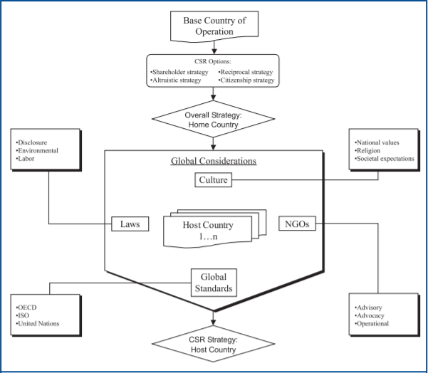

Figure 1 Source: Galbreath (2006)

2.2 Business Intelligence

The previous day's notes, or the information available at the beginning of the day, may not be sufficient. Leaders need the freshest information, that is, the most real-time information to make the proper choices. Continuous analysis, in this way, empowers leaders to acquire, investigate, and track information. Be aware that the more business there is, the more information there is. It turned out that the data was kept arbitrarily between departments. Furthermore, false and duplicate records cannot be used as strategic resources. Therefore, devices need to be used to help find problems, fix problems, and clean up information when necessary.

2.2.1 Quantitative Relationship

The most basic test for an enterprise is to have a coordinated evaluation structure that describes the scale of execution, is fully aligned with the organization's plan, and then analyzes and reveals the results. Taking the elements of business insight as the main factors of profit and interpret the results, is the business scorecard in business knowledge strategy. Business scorecards facilitate the evaluation and execution of business models. Consolidation of business knowledge and scorecard, such a structure is a solid guide in the differentiation of key objectives (Lönnqvist, 2006).

As innovation expands, today's organizations look for ways to establish respect for status. To a large extent, the business intelligence framework provides the ability to investigate corporate data to enhance and support decisions, including the broad business interactions of executives. These organization see impressive value in companies' data assets, which affects interest in large information frameworks (Freeman, 2013). Although enterprise interest in the impressive value of business knowledge frameworks continues to expand, there is by no means a complete and definitive way to measure a company's value and growth prospects. Knowledge about business frameworks includes the possibility of expanding the utilization of information to build a large cache of information and make it accessible by enhancing correlation capabilities, thus establish some flexibility in completing the survey.

Business insights are derived from the large amount of data collected in the course of daily activities, which are converted into information and knowledge to prevent partnership forgetting and speculation (Sharda, 2014). The main highlight of the business insight framework is the top-level ability to delegate information management, support critical activities, For example, after the goal is defined, identified, scheduled, and executed, external and internal information is collected, decomposed, and coordinated into key execution tags (Matten, 2004). Depending on the requirements of the official data, the Business insight framework can be queried for ongoing and real information.

In addition, administrators at each level can include a changing perspective that separates information from a particular source and summarizes information as important markup. Administrators need data to make strategic and critical choices, requesting as many combinations of data as possible from ERP and non-ERP systems (Matten, 2004). Typical improvements in the reporting structure of daily tasks do not meet the requirements of venture capital. Managers cannot keep track of the changing choices in monthly point-by-point revenue reports. Information must be collected and guidance provided by business type. ERP is a process-centric system and is incapable of interpretation. Formal and critical supervisors need to come up with innovative arrangements that can extract, visualize, and disaggregate information from enterprise resources and planning as well as from a business-independent framework (Turban, 2010). The business framework is still a model that includes exchanges that create reliable information and exchange data with the entire business system (Williams, 2010).

In addition, information readiness and platforms are key to business manageability and achievement. In this respect, according to Krenskey(2015), the data generated by large tasks is high-speed, which may lead to errors, thus preventing the realization of the expected results. Kerensky notes that for continuous work, the best class model is closer to 51%. The head of data analysis always has a lot of data to work with, but the main focus may be to investigate the information available as quickly as possible (Watson, 2007).

2.2.2 Scorecard and Key Performance Indicators (KPIs)

An extremely urgent issue for the enterprise is to establish a complete evaluation system, which describes the proportion of the execution, is consistent with the organization's technology, and then analyzes and reveals the results (Nørreklit, 2003). The element of business insight is one of the ways in which an enterprise utilizes the knowledge of the business scorecard. It is an important central element that helps and explains the estimated results of the presentation. Therefore, this will help manage the functionality of the business organization. Combining the business scorecard with the business insight system helps provide reliable guidance in achieving important goals, evaluating against the results of the assessment, and receiving the right activities.

The business scorecard model is primarily designed and combined with BI elements, such as diagnostic charts, dashboards, and exhibitions of some organizational data innovation arms, to describe clear connections between key objectives (Kanji, 2002).

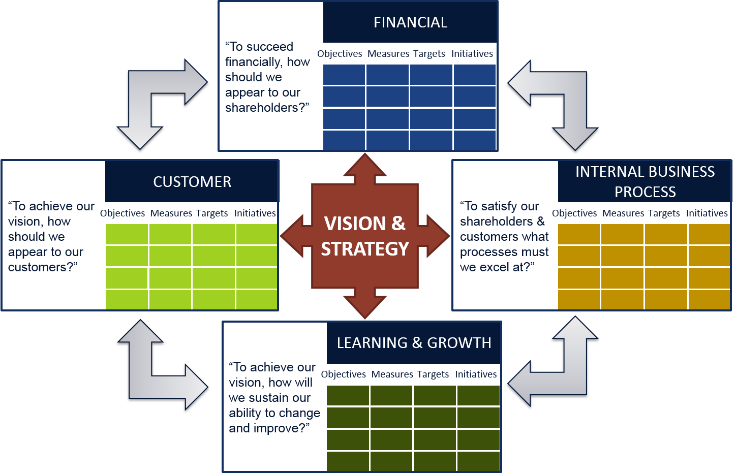

Figure 2: Business Scorecard Model

Source: Coates (2014)

2.2.3 Data Interpretation and Visualization

Business knowledge is isolated into management and specialized methods. The specialized view represents business insight as a device that facilitates dynamic processes (Hanssen, 2001). It revolves around advances that allow data to be recovered, investigated, recorded, and controlled. Although there is some contrast between the management framework and the business insight framework, both provide the following key ideas:

1. the unification of business knowledge collection, investigation and data decentralization.
2. the goal is to support life dynamic processes.

Through key selection, it is possible to infer the selection related to the assessment and use of levels, strategies, objectives and visions, which are intended to contain medium - and long-term recommendations for the company, as opposed to the business run selection, which is natural and executed on a daily basis (Petrini and Pozzebon, 2008).

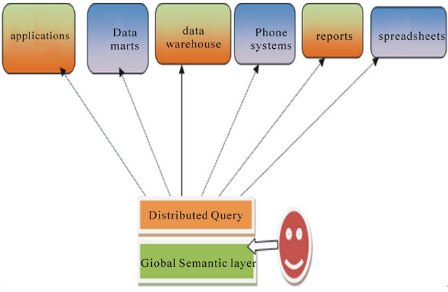

Figure 3 Source: AbdelFattah (2013)

Elements of business knowledge as a fundamental factor revolve around profit estimates and interpretation of results. The business scorecard assists in the evaluation and execution of organizational processes. Combining the business insight structure with the business scorecard can provide very reliable guidance for the determination of goals and estimation of results (Chen, 2012).

Business intelligence transforms data into information to further generate graphs, Outlines descriptions and adopts instruments to enable dashboards and scorecards to perform display business measurements (Sarkar, 2008). As a result, key leaders can quickly see the company's ability to execute procedures and experience these tests (abdel fattah Khedr, Solayman, 2015). A business intelligence model is a model that gives an enterprise the opportunity to change rough, valuable, and important data, build a productive, important arrangement over a specific time period, and further reach the pinnacle of operational and strategic dynamic experience (Bakass and El Manouar, 2015).

The business insight process collects raw data and changes it into important data, and further changes it into information that needs to be used with intelligence. According to Rizvi and Ridhirgr, the business knowledge process is based on five stages referenced below: data source, information check, information mindfulness, opportunity assessment, and selection help. (Rizvi 2015 and Ridhigrg 2018).

2.3 Literature Findings and Gaps

According to Petrini (2009), how business intelligence (BI) systems support the sustainable management of organizations is discussed, and the importance of business intelligence to information planning is considered to play an important role in helping organizations implement and monitor sustainable practices. According to Haupt (2015), business intelligence has been found to be able to effectively manage enterprise information and reports, and business intelligence is an effective way to support strategic sustainability. According to Hba (2016), the green IT model was proposed to effectively manage and benefit the sustainable development of enterprises, mainly focusing on improving the enterprise's social and environmental performance. However, there is still a gap in the literature. As for the strategic CSR communication of corporate, the effect of business intelligence on economic returns needs to be discussed. Based on previous literature, conceptual models and hypotheses are established to explore how business intelligence maximizes business returns when enterprises formulate and implement CSR strategies.

2.4 Justification of Research Model

Based on the powerful capabilities of business intelligence tools in text analysis and the influence of text content on CSR communication, H1 and H4 are proposed. The data visualization and information acquisition functions of business intelligence have significant effects and prospects on the self-knowledge and strategic decision-making of enterprises, which cannot be ignored. Before enterprises publicize CSR to the outside world, the relationship between stakeholders and themselves, the enterprise's reserves and so on should be considered, the channel or way of publicity plays a key role in consumer acceptance. According to Du (2010), CSR returns of enterprises depend on shareholders' understanding of CSR activities, therefore, H2, H3, H5, and H6 are proposed in this study. Accordingly, the conceptual model of this study is established as follows.

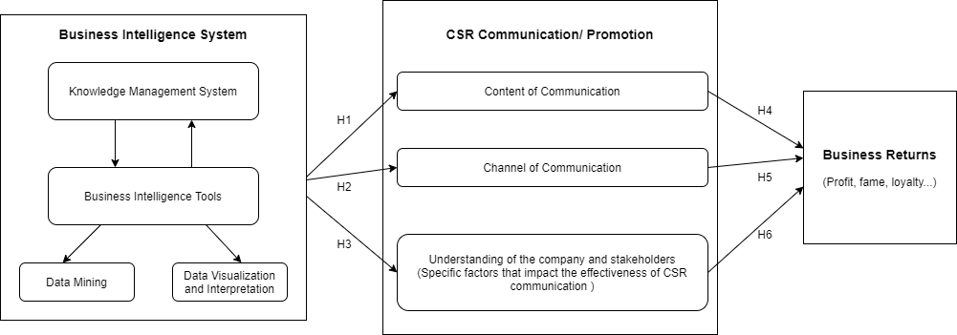Figure 4: Research Conceptual Model

Hypothesis1: Business Intelligence can effectively help CSR companies create better content for CSR communication.

Hypothesis2: Business Intelligence can effectively help CSR companies select better channel for CSR communication.

Hypothesis3: Business Intelligence can effectively help CSR companies better understand themselves and their stakeholders.

Hypothesis4: Good content of communication have a positive effect on business returns.

Hypothesis5: Good channel of communication have a positive effect on business returns.

Hypothesis6: A good understanding of themselves and their stakeholders helps companies achieve business returns.

**Research Methodology**

3.1 Research Design

A research design as defined by Hyman and Sierra (2016) is the method which is used in evaluating the variables which are stated the research hypothesis. The research employed a cross-sectional research design that was time and context bound. This means that the research collected data based on the context of the research in relation to the variable of the research which were needed in testing the hypothesis. The data was collected from the business intelligence and corporate social responsibility related participants in order to understand the relationship between the independent and the dependent variables. Collecting the data from the affected individuals helped to get the needed information the variables and thus avoid making the wrong inferences and conclusion on the data which was collected. Therefore, the research hypothesized the relationship between the variables and through the analysis the paper the paper was able to test the hypothesis. On the main hypothesis, was that BI has a positive impact on CSR benefits.

3.2 Research Choice Time and Horizon

There are two more steps of research that are very important. The first one is about the methodology to collect data. It could be single, multiple, or a mixture of methods. The second one is to choose how long the research will be (Harrell, 2009). It could either be a cross-section of a continuous one. Because this dissertation has a finite scope of time and resources, thus, the researcher chose to perform a cross-sectional study and only utilized one methodology to collect data, also known as mono-method data collection.

3.3 Data Collection

In order to study existing or new statistical relationships of certain phenomenons, researchers collect data, which represented by numbers, graphs, and other facts (Adams, Khan and Raeside, 2014). The below paragraphs will discuss multiple data collection methodologies.

3.4.1 Primary versus Secondary Data

Researchers collect data via two ways, primary and secondary methods (Black, 1996). The primary methodology means the researcher collects his or her own data to serve the purpose of the research (Adams, Khan and Raeside, 2014). Popular ways of collecting primary data include doing surveys or interviews, or conducting behavioral observations or focus group sessions (Vartanian, 2010). The secondary methodology means to use the existing published works from other researchers and utilize the data from it. The published work could be in any form, either online or offline, such as journals, essays, reports, articles, books, etc (Dillman, 2001).

Each methodology of data collection has its own strengths and weaknesses. The primary data collection method matches perfectly with the researcher’s purpose because, by definition, it is designed to serve this research. In addition, all the primary data comes directly from the participants of the research, so the result will be more solid. However, the major drawbacks of this method are the resources it will cost, including time and money. In addition, some of the data may be very hard to collect (Frick, 2009). For the secondary data collection method, it can save time and money for researchers; also, because the previous research may take place in different time period or location, researchers can get the opportunity to compare them (Becker, Bryman, and Ferguson, 2012; Dale Arber and Procter, 1988). However, because the population and sample size are not designed for this research, it may not fit (De Leeuw, 2005).

3.4.1.1 Justification of Data Collection Source

In order to ensure the reliability of the research result, the researcher decided to collect primary data due to the fit of participants and design. Another reason is that the ideal research participants ought to be employees with knowledge of business intelligence. Due to this very limited scope, the researcher could not find enough related secondary resources regarding the profitability that business intelligence can get, in the view of corporate social responsibility. Thus, it is better to conduct primary research to get accurate data.

3.4.2 Qualitative versus Quantitative Data (Methodological Choice)

Quantitative and Qualitative methods are two choices researchers can choose to do (Bryman and Bell, 2011). Quantitative research looks at numbers during the data collection process. Usually, it focuses on testing hypotheses to determine correlational and causal relationships, etc (Anderson, 2006; Bryman, 2016). There are two main factors to perform quantitative data collection: random sampling and surveys. Surveys could have many forms, such as questionnaires, or perform via phone, computer, or even face-to-face conversations. It could also come from experiments in a laboratory setting, or observation in a natural setting. In addition, quantitative research also could be used to testify if the current data is consistent with the previous researches, which called a deductive approach (Thomas, 2006). While collecting and analyzing data, qualitative research looks as literations, such as words instead of numbers (Anderson, 2006). Generally, qualitative research serves the purpose to explore the topic and gather information in order to create hypotheses, rather than testing them (Bryman, 2016).

Both quantitative and qualitative methods have their own advantages and disadvantages (Ogiela, 2009). The major advantage of quantitative data is that it can cross-compare data among multiple databases; also, because of the presence of numbers, researchers can test their theories faster, with solid proof. Applying statistical software, such as SPSS, could save a lot of time as well. But it could be costly to conduct the research. In addition, because the researcher designed the questions beforehand, the result could be limited, and therefore not representative enough and the result may not be able to apply to the population (Anderson, 2006). Due to its small sample size, qualitative data collection usually costs less money (Anderson, 2006). Also, because during the qualitative collection process, researchers often ask open-ended questions to participants, it is more encouraging and therefore may inspire new findings. Admittedly, it may cost more time to put together and analyze the data, especially when there are too many details to pay attention to for researchers. Thus, it may be had to summarize the research result (Anderson, 2006).

3.4.2.1 Justification of Methodological Choice

The best use of quantitative research is to test theories for relationships when there are existing variables. Thus, this method should be applied in this research, because the purpose of this research is to learn the relationship between business intelligence and the outcome it produces based on corporate social responsibility. In this research, questionnaires and literature reviews were utilized to fulfill such purpose.

3.4.3 Data Collection Technique (Questionnaire Survey)

Researchers use questionnaires to collect data from the participants (Hannula, 2003). They utilize the questions to obtain important information, and it is very helpful to collect data by asking close-ended questions. Usually, data collected from questionnaires are easy to analyze (Patten, 2016). In addition, it is easy for researchers to collect clean and detailed data (Peffers, 2007). There are several advantages that an online questionnaire could offer to the researchers. First, the process is simple because there are automated online programs to help design and dispatch surveys, in a neat format. Researchers can easily utilize the existing format and template to save time. Second, usually, making and dispatching online surveys is cheaper than a paper survey, in terms of the cost of printing, distributing, etc. Especially, there are many free-to-use software online. Third, those automated programs will help researchers to collect and manage data, which is very convenient. Last, online questionnaires can have a very broad reach of participants, beyond the physical location limitations. It will also help generate a more representative result. Because of the limited time and resources, the researcher chose to utilize an online questionnaire to collect data.

The first section of the questionnaire collects demographic and other basic information, including the participants’ age, sex, work status and knowledge of business intelligence. The latter two questions serve as a filter, to screen the participants that are not eligible for the rest of the survey if they do not know business intelligence or have nothing to do with a company that has corporate social responsibility strategy. The researcher put binary options (yes and no) to these two questions. The second section serves the purpose to investigate the hypotheses related to business intelligence and corporate social responsibility. The answers to these questions are measured in the form of a Likert scale with five points. Because the validity and reliability are not affected, the researcher removed the midpoint in the scale (Garland, 1991). In this section, 1 means either strongly disagree or hardly ever; 5 means strongly agree or almost every time. This Likert scale enables the survey participants to show their tendency in a measurable way.

3.5 Procedure

The way research dispatched the survey is social media. There are two requirements for the valid answers to be considered: participants shall be 18 years old or older, and they should have knowledge about business intelligence and/or corporate social responsibility, as mentioned above. All the participants received an information sheet disclosing the research purpose and what they have contributed. Also, their basic rights as participants were stated as well. The researcher spent six days on this process.

3.5.1 Sampling and Participant Selection

There is also a sampling process in the research, serving the purpose to filter eligible participants and find out interview participants that would be more possible to provide useful information (Bryman, 2016). The requirements of the participants stay the same: 18 years old or older, and have the knowledge of business intelligence and employed by a corporate social responsibility company. Internet distribution was utilized to ensure that the researcher could recruit enough qualified participants because it is more efficient. After six days of collection, the researcher obtained 150 samples with valid data to analyze.

3.6 Data Analysis

The process of demonstrating, explaining, and assessing data using different methods is called data analysis (Peffers, 2007). SPSS, a software widely used by researchers to analyze data, is used in order to analyze the data collected from the survey (Cohen et al., 2013).

3.7 Research Validity

The researcher utilized Denscombe (2010)’s basic criteria to measure how valid the secondary data in this research is. There are five criteria as below: authenticity of the original research; representativeness of the secondary research subjects; a clear definition of terms in the secondary research; credibility of the secondary research (that it does not have any mistakes); reliability of the secondary research (the data should be checked and assign weights accordingly).

3.8 Research Reliability

Reliability measures how consistent a research is, such that it will produce a similar result if duplicate (Bryman, 2016, p.157). SPSS was utilized to test how reliable the data is, measured by the sampling error calculated, using the Cronbach’s Alpha coefficient (Straub, 1989). According to Hair et al., (1998), 0.6 is the baseline for the subject to be reliable enough. If the value equals or is higher than 0.8, it is consistent enough to be representative of the population. In this research, the researcher calculated all the Cronbach’s Alpha coefficient for all the factors, and they are all higher than 0.6, which means they are reliable enough.

3.9 Limitations

Understanding the limitation of research methods is very important because it will be helpful to figure out the existence of any flaws or weaknesses, and their impact on the final result(Bryman, 2016). The researcher pursued objectivity all the way, but it is inevitable to avoid misunderstanding for the participants of the questionnaire because the research could not explain every question they raised during the process of filling out the form. It is very difficult to avoid this situation through an online questionnaire, and the researcher will put more effort in the future to avoid the problem.

3.10 Ethical consideration

In the analytical method of ethical thought, the choice of respondents is created by those who have the will. Hence, no use of force. It's worth noting that the questionnaire was set up in a very customized way to avoid mining a lot of personal information, which can cause psychological distress to the interviewee (Morrissette, 2006).

In the process of issuing questionnaires to the respondents, the respondents were explained the analytical methods before trying to inquire, and the survey results were guaranteed to be confidential. Any information provided by the informant is guaranteed to be private and, in order to maintain confidentiality, is used for analysis only. Anonymity is allowed, the questionnaires collected their responses by using a set of characters. Respondents were encouraged not to write personal information anywhere on the questionnaire. The research was honestly designed and conducted. There is no element of forgery in the report's strategy, results and conclusions (Morrissette, 2006).

**Results and Analysis**

4.1 Gender

Among the 150 people surveyed, it shows that 48% are men while 52% are women. (As shown in Table 2 and Figure 5)

|  |  |  |  |  |  |
| --- | --- | --- | --- | --- | --- |
| **Gender** | | | | | |
|  | | Frequency | Percent | Valid Percent | Cumulative Percent |
| Valid | Male | 72 | 48.0 | 48.0 | 48.0 |
| Female | 78 | 52.0 | 52.0 | 100.0 |
| Total | 150 | 100.0 | 100.0 |  |

Table 2: Gender Distribution of Participants

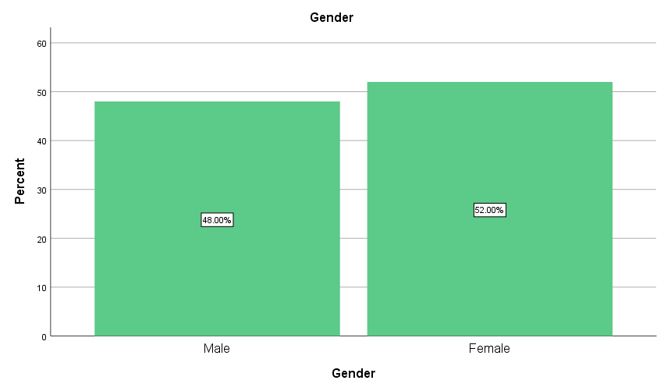

Figure 5: Gender Distribution of Participants

4.2 Age

Of the 150 eligible respondents, 49 were aged between 27 and 35, accounting for 32.7% of the total; 47 were aged between 18-26, occupying 31.3%; there were also 36 and 18 people aged 36-44 and 45 or above, respectively, accounting for 24% and 12% of the total. (See Table 3 and Figure 6)

|  |  |  |  |  |  |
| --- | --- | --- | --- | --- | --- |
| **Age** | | | | | |
|  | | Frequency | Percent | Valid Percent | Cumulative Percent |
| Valid | 18-26 | 47 | 31.3 | 31.3 | 31.3 |
| 27-35 | 49 | 32.7 | 32.7 | 64.0 |
| 36-44 | 36 | 24.0 | 24.0 | 88.0 |
| 45 and above | 18 | 12.0 | 12.0 | 100.0 |
| Total | 150 | 100.0 | 100.0 |  |

Table 3: Age Distribution of Participants

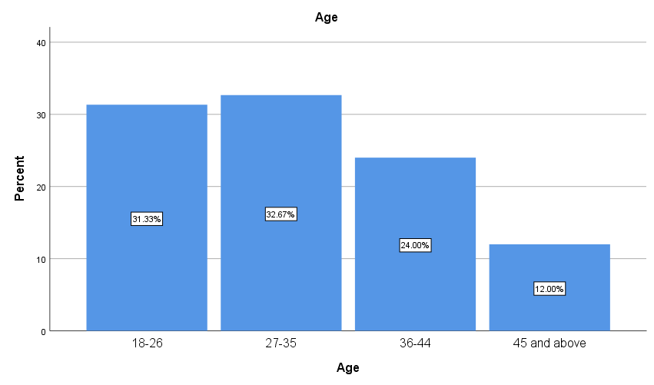

Figure 6: Age Distribution of Participants

4.3 CSR Enterprise Employee

81 participants were working for CSR companies, accounting for 54% of the total, while the others were not working for CSR companies.

|  |  |  |  |  |  |
| --- | --- | --- | --- | --- | --- |
| **CSREmployee** | | | | | |
|  | | Frequency | Percent | Valid Percent | Cumulative Percent |
| Valid | yes | 81 | 54.0 | 54.0 | 54.0 |
| no | 69 | 46.0 | 46.0 | 100.0 |
| Total | 150 | 100.0 | 100.0 |  |

Table 4: Employment Distribution of Participants

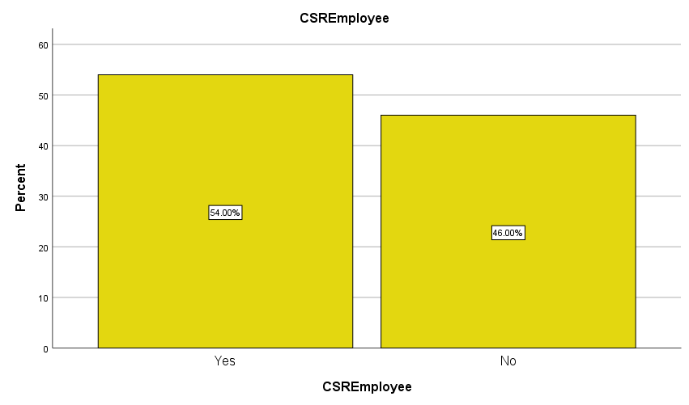

Figure 7: Employment Distribution of Participants

4.4 Reliability

Reliability refers to the degree of consistency or reliability of the test results. Reliability analysis is used to measure whether the sample answers in the questionnaire are reliable and whether they are true answers. The higher the test reliability is, the more reliable the result is. Reliability is a necessary condition for any kind of measurement. Reliability analysis of a questionnaire must be carried out before it is formally put into use to ensure that the questionnaire survey results are true and reliable.

Cronbach's α coefficient is the most common method to measure the reliability. It is used to test the internal consistency between problems, that is, whether multiple problems measure the same content or concept.

The following table shows the results of SPSS analysis, indicating that the Cronbach's α reliability coefficients of all topics are above. 6, showing a high degree of consistency.

|  |  |
| --- | --- |
| **Reliability Statistics** | |
| Cronbach's Alpha | N of Items |
| .919 | 3 |

Table 5: Cronbach’s α –Business Intelligence

|  |  |
| --- | --- |
| **Reliability Statistics** | |
| Cronbach's Alpha | N of Items |
| .911 | 3 |

Table 6: Cronbach’s α –CSRContent

|  |  |
| --- | --- |
| **Reliability Statistics** | |
| Cronbach's Alpha | N of Items |
| .910 | 3 |

Table 7: Cronbach’s α –CSRChannel

|  |  |
| --- | --- |
| **Reliability Statistics** | |
| Cronbach's Alpha | N of Items |
| .896 | 3 |

Table 8: Cronbach’s α –CSRUnderstanding

|  |  |
| --- | --- |
| **Reliability Statistics** | |
| Cronbach's Alpha | N of Items |
| .767 | 2 |

Table 9: Cronbach’s α –Content

|  |  |
| --- | --- |
| **Reliability Statistics** | |
| Cronbach's Alpha | N of Items |
| .784 | 2 |

Table 10: Cronbach’s α –ContentReturns

|  |  |
| --- | --- |
| **Reliability Statistics** | |
| Cronbach's Alpha | N of Items |
| .796 | 2 |

Table 11: Cronbach’s α –Channel

|  |  |
| --- | --- |
| **Reliability Statistics** | |
| Cronbach's Alpha | N of Items |
| .754 | 2 |

Table 12: Cronbach’s α –ChannelReturns

|  |  |
| --- | --- |
| **Reliability Statistics** | |
| Cronbach's Alpha | N of Items |
| .609 | 2 |

Table 13: Cronbach’s α –Understanding

|  |  |
| --- | --- |
| **Reliability Statistics** | |
| Cronbach's Alpha | N of Items |
| .757 | 2 |

Table 14: Cronbach’s α –UnderstandingReturns

4.5 Content Validity

Validity refers to the degree to which the measured results reflect the content to be inspected. The more consistent the measured results are with the content to be inspected, the higher the validity is; otherwise, the lower the validity is.

As shown in Table 15 and 16, all the questions in the questionnaire are divided into three principal components, which represent three principal factors. According to the design of the questionnaire, this way of division is reasonable. At this time, the component coefficients of each variable are greater than. 6. The cumulative variance contribution rate was 73.635%, more than 70%. Therefore, the validity analysis of the questionnaire indicates that the questionnaire is effective.

|  |  |  |  |
| --- | --- | --- | --- |
| **Rotated Component Matrixa** | | | |
|  | Component | | |
| 1 | 2 | 3 |
| BI1 | .905 |  |  |
| Content1 | .900 |  |  |
| Channel3 | .892 |  |  |
| Channel2 | .889 |  |  |
| Understanding1 | .886 |  |  |
| Understanding3 | .881 |  |  |
| BI3 | .881 |  |  |
| BI2 | .878 |  |  |
| Content3 | .872 |  |  |
| Understanding2 | .869 |  |  |
| Content2 | .864 |  |  |
| Channel1 | .858 |  |  |
| ContentReturns2 |  | .900 |  |
| Channel5 |  | .888 |  |
| Content5 |  | .833 |  |
| ChannelReturns2 |  | .818 |  |
| Content4 |  | .802 |  |
| ChannelReturns1 |  | .793 |  |
| ContentReturns1 |  | .789 |  |
| Channel4 |  | .611 |  |
| Understanding5 |  |  | .887 |
| UnderstandingReturns2 |  |  | .851 |
| UnderstandingReturns1 |  |  | .834 |
| Understanding4 |  |  | .648 |
| Extraction Method: Principal Component Analysis.  Rotation Method: Varimax with Kaiser Normalization. | | | |
| a. Rotation converged in 4 iterations. | | | |

Table 15: Rotated Component Matrixa

|  |  |  |  |  |  |  |  |  |  |
| --- | --- | --- | --- | --- | --- | --- | --- | --- | --- |
| **Total Variance Explained** | | | | | | | | | |
| Component | Initial Eigenvalues | | | Extraction Sums of Squared Loadings | | | Rotation Sums of Squared Loadings | | |
| Total | % of Variance | Cumulative % | Total | % of Variance | Cumulative % | Total | % of Variance | Cumulative % |
| 1 | 10.370 | 43.208 | 43.208 | 10.370 | 43.208 | 43.208 | 9.553 | 39.805 | 39.805 |
| 2 | 4.687 | 19.529 | 62.736 | 4.687 | 19.529 | 62.736 | 5.428 | 22.618 | 62.423 |
| 3 | 2.616 | 10.899 | 73.635 | 2.616 | 10.899 | 73.635 | 2.691 | 11.213 | 73.635 |
| 4 | .767 | 3.196 | 76.831 |  |  |  |  |  |  |
| 5 | .683 | 2.844 | 79.675 |  |  |  |  |  |  |
| 6 | .579 | 2.413 | 82.088 |  |  |  |  |  |  |
| 7 | .478 | 1.992 | 84.080 |  |  |  |  |  |  |
| 8 | .437 | 1.823 | 85.903 |  |  |  |  |  |  |
| 9 | .387 | 1.615 | 87.517 |  |  |  |  |  |  |
| 10 | .352 | 1.466 | 88.984 |  |  |  |  |  |  |
| 11 | .323 | 1.347 | 90.331 |  |  |  |  |  |  |
| 12 | .313 | 1.303 | 91.634 |  |  |  |  |  |  |
| 13 | .282 | 1.174 | 92.808 |  |  |  |  |  |  |
| 14 | .234 | .976 | 93.784 |  |  |  |  |  |  |
| 15 | .211 | .881 | 94.665 |  |  |  |  |  |  |
| 16 | .192 | .802 | 95.467 |  |  |  |  |  |  |
| 17 | .188 | .784 | 96.251 |  |  |  |  |  |  |
| 18 | .173 | .721 | 96.972 |  |  |  |  |  |  |
| 19 | .165 | .689 | 97.662 |  |  |  |  |  |  |
| 20 | .150 | .627 | 98.289 |  |  |  |  |  |  |
| 21 | .143 | .596 | 98.884 |  |  |  |  |  |  |
| 22 | .124 | .517 | 99.401 |  |  |  |  |  |  |
| 23 | .087 | .364 | 99.766 |  |  |  |  |  |  |
| 24 | .056 | .234 | 100.000 |  |  |  |  |  |  |
| Extraction Method: Principal Component Analysis. | | | | | | | | | |

Table 16: Total Variance Explained

4.6 KMO and Bartlett’s Test

Kmo (Kaiser Meyer Olkin) test statistic is used to compare simple correlation coefficient and partial correlation coefficient among variables. Bartlett's sphericity test is a mathematical term. It is used to test the correlation between the variables in the correlation matrix, whether it is a unit matrix, that is, to test whether each variable is independent.

The analysis results of this study are shown in Table 17. The KMP value is. 925, which is greater than the international requirement of. 5. Therefore, this questionnaire is considered to be of analytical significance.

|  |  |  |
| --- | --- | --- |
| **KMO and Bartlett's Test** | | |
| Kaiser-Meyer-Olkin Measure of Sampling Adequacy. | | .925 |
| Bartlett's Test of Sphericity | Approx. Chi-Square | 3445.443 |
| df | 276 |
| Sig. | .000 |

Table 17: KMO and Bartlett's Test

4.7 Correlation

In correlation analysis, the correlation coefficient is used to indicate the relationship between the analysis items. First, determine whether there is a relationship, and then determine whether the relationship is positive correlation or negative correlation (correlation coefficient greater than 0 is positive correlation, otherwise is negative correlation).

Correlation analysis was carried out on two sets of variables, BusinessIntelligence and CSRContent. Under the assumption that the two variables are completely unrelated, the results showed that the significance was .000, proving that there is a correlation between the two; In addition, the Pearson coefficient of .919 indicates a positive correlation between the two. (See Table 18)

|  |  |  |  |
| --- | --- | --- | --- |
| **Correlations** | | | |
|  | | BusinessIntelligence | CSRContent |
| BusinessIntelligence | Pearson Correlation | 1 | .919** |
| Sig. (2-tailed) |  | .000 |
| N | 150 | 150 |
| CSRContent | Pearson Correlation | .919** | 1 |
| Sig. (2-tailed) | .000 |  |
| N | 150 | 150 |
| **. Correlation is significant at the 0.01 level (2-tailed). | | | |

Table 18: Correlations –BusinessIntelligence and CSRContent

While about variables BusinessIntelligence and CSRChannel, the results showed that the significance was .000, proving that there is a correlation between the two; In addition, the Pearson coefficient of .910 indicates a positive correlation between the two. (See Table 19)

|  |  |  |  |
| --- | --- | --- | --- |
| **Correlations** | | | |
|  | | BusinessIntelligence | CSRChannel |
| BusinessIntelligence | Pearson Correlation | 1 | .910** |
| Sig. (2-tailed) |  | .000 |
| N | 150 | 150 |
| CSRChannel | Pearson Correlation | .910** | 1 |
| Sig. (2-tailed) | .000 |  |
| N | 150 | 150 |
| **. Correlation is significant at the 0.01 level (2-tailed). | | | |

Table 19: Correlations –BusinessIntelligence and CSRChannel

About BusinessIntelligence and CSRUnderstanding, the results showed that the significance was .000, proving that there is a correlation between the two; In addition, the Pearson coefficient of .917 indicates a positive correlation between the two. (See Table 20)

|  |  |  |  |
| --- | --- | --- | --- |
| **Correlations** | | | |
|  | | BusinessIntelligence | CSRUnderstanding |
| BusinessIntelligence | Pearson Correlation | 1 | .917** |
| Sig. (2-tailed) |  | .000 |
| N | 150 | 150 |
| CSRUnderstanding | Pearson Correlation | .917** | 1 |
| Sig. (2-tailed) | .000 |  |
| N | 150 | 150 |
| **. Correlation is significant at the 0.01 level (2-tailed). | | | |

Table 20: Correlations –BusinessIntelligence and CSRUnderstanding

About Content and ContentReturns, the results showed that the significance was .000, proving that there is a correlation between the two; In addition, the Pearson coefficient of .800 indicates a positive correlation between the two. (See Table 21)

|  |  |  |  |
| --- | --- | --- | --- |
| **Correlations** | | | |
|  | | Content | ContentReturns |
| Content | Pearson Correlation | 1 | .800** |
| Sig. (2-tailed) |  | .000 |
| N | 150 | 150 |
| ContentReturns | Pearson Correlation | .800** | 1 |
| Sig. (2-tailed) | .000 |  |
| N | 150 | 150 |
| **. Correlation is significant at the 0.01 level (2-tailed). | | | |

Table 21: Correlations –Content and ContentReturns

About Channel and ChannelReturns, the results showed that the significance was .000, proving that there is a correlation between the two; In addition, the Pearson coefficient of .599 indicates a positive correlation between the two. (See Table 22)

|  |  |  |  |
| --- | --- | --- | --- |
| **Correlations** | | | |
|  | | Channel | ChannelReturns |
| Channel | Pearson Correlation | 1 | .599** |
| Sig. (2-tailed) |  | .000 |
| N | 150 | 150 |
| ChannelReturns | Pearson Correlation | .599** | 1 |
| Sig. (2-tailed) | .000 |  |
| N | 150 | 150 |
| **. Correlation is significant at the 0.01 level (2-tailed). | | | |

Table 22: Correlations –Channel and ChannelReturns

About Understanding and UnderstandingReturns, the results showed that the significance was .000, proving that there is a correlation between the two; In addition, the Pearson coefficient of .649 indicates a positive correlation between the two. (See Table 23)

|  |  |  |  |
| --- | --- | --- | --- |
| **Correlations** | | | |
|  | | Understanding | UnderstandingReturns |
| Understanding | Pearson Correlation | 1 | .649** |
| Sig. (2-tailed) |  | .000 |
| N | 150 | 150 |
| UnderstandingReturns | Pearson Correlation | .649** | 1 |
| Sig. (2-tailed) | .000 |  |
| N | 150 | 150 |
| **. Correlation is significant at the 0.01 level (2-tailed). | | | |

Table 23: Correlations –Understanding and UnderstandingReturns

4.8 Regression Analysis

Regression analysis is a predictive modeling technique that studies the relationship between dependent variables (targets) and independent variables (predictors). The linear regression analysis was used to verify the six hypotheses proposed in this study.

Firstly, about hypothesis 1, the following is the linear regression analysis of the independent variable BusinessIntelligence and dependent variable CSRContent (See Table 24). The significance was .000 and the R value was .919, indicating that there was a significant linear relationship between the two. The adjusted R squared value is .843, indicating that 84.3% of dependent variables can be explained by independent variables. According to the coefficient table, the linear equation can be sorted as:

*CSRContent* = 0.759 + 0.814 *BusinessIntelligence*

|  |  |  |  |  |  |
| --- | --- | --- | --- | --- | --- |
| **Model Summaryb** | | | | | |
| Model | R | R Square | Adjusted R Square | Std. Error of the Estimate | Durbin-Watson |
| 1 | .919a | .844 | .843 | .34940 | 2.201 |
| a. Predictors: (Constant), BusinessIntelligence | | | | | |
| b. Dependent Variable: CSRContent | | | | | |

|  |  |  |  |  |  |  |
| --- | --- | --- | --- | --- | --- | --- |
| **ANOVAa** | | | | | | |
| Model | | Sum of Squares | df | Mean Square | F | Sig. |
| 1 | Regression | 98.004 | 1 | 98.004 | 802.802 | .000b |
| Residual | 18.067 | 148 | .122 |  |  |
| Total | 116.071 | 149 |  |  |  |
| a. Dependent Variable: CSRContent | | | | | | |
| b. Predictors: (Constant), BusinessIntelligence | | | | | | |

|  |  |  |  |  |  |  |
| --- | --- | --- | --- | --- | --- | --- |
| **Coefficientsa** | | | | | | |
| Model | | Unstandardized Coefficients | | Standardized Coefficients | t | Sig. |
| B | Std. Error | Beta |
| 1 | (Constant) | .759 | .103 |  | 7.380 | .000 |
| BusinessIntelligence | .814 | .029 | .919 | 28.334 | .000 |
| a. Dependent Variable: CSRContent | | | | | | |

Table 24: Regression Analysis of BusinessIntelligence_Impacts_CSRContent

Hypothesis 2: The independent variable BusinessIntelligence and dependent variable CSRChannel are analyzed (See Table 25). The significance was .000 and the R value was .910, indicating that there was a significant linear relationship between the two. The adjusted R squared value is .827, indicating that 82.7% of dependent variables can be explained by independent variables. According to the coefficient table, the linear equation can be sorted as:

*CSRChannel* = 0.711 + 0.811 *BusinessIntelligence*

|  |  |  |  |  |  |
| --- | --- | --- | --- | --- | --- |
| **Model Summaryb** | | | | | |
| Model | R | R Square | Adjusted R Square | Std. Error of the Estimate | Durbin-Watson |
| 1 | .910a | .828 | .827 | .36908 | 2.086 |
| a. Predictors: (Constant), BusinessIntelligence | | | | | |
| b. Dependent Variable: CSRChannel | | | | | |

|  |  |  |  |  |  |  |
| --- | --- | --- | --- | --- | --- | --- |
| **ANOVAa** | | | | | | |
| Model | | Sum of Squares | df | Mean Square | F | Sig. |
| 1 | Regression | 97.339 | 1 | 97.339 | 714.584 | .000b |
| Residual | 20.160 | 148 | .136 |  |  |
| Total | 117.499 | 149 |  |  |  |
| a. Dependent Variable: CSRChannel | | | | | | |
| b. Predictors: (Constant), BusinessIntelligence | | | | | | |

|  |  |  |  |  |  |  |
| --- | --- | --- | --- | --- | --- | --- |
| **Coefficientsa** | | | | | | |
| Model | | Unstandardized Coefficients | | Standardized Coefficients | t | Sig. |
| B | Std. Error | Beta |
| 1 | (Constant) | .711 | .109 |  | 6.542 | .000 |
| BusinessIntelligence | .811 | .030 | .910 | 26.732 | .000 |
| a. Dependent Variable: CSRChannel | | | | | | |

Table 25: Regression Analysis of BusinessIntelligence_Impacts_CSRChannel

Hypothesis 3: The independent variable BusinessIntelligence and dependent variable CSRUnderstanding are analyzed (See Table 26). The significance was .000 and the R value was .917, indicating that there was a significant linear relationship between the two. The adjusted R squared value is .840, indicating that 84.0% of dependent variables can be explained by independent variables. According to the coefficient table, the linear equation can be sorted as:

*CSRUnderstanding* = 0.789 + 0.807 *BusinessIntelligence*

|  |  |  |  |  |  |
| --- | --- | --- | --- | --- | --- |
| **Model Summaryb** | | | | | |
| Model | R | R Square | Adjusted R Square | Std. Error of the Estimate | Durbin-Watson |
| 1 | .917a | .841 | .840 | .35034 | 2.015 |
| a. Predictors: (Constant), BusinessIntelligence | | | | | |
| b. Dependent Variable: CSRUnderstanding | | | | | |

|  |  |  |  |  |  |  |
| --- | --- | --- | --- | --- | --- | --- |
| **ANOVAa** | | | | | | |
| Model | | Sum of Squares | df | Mean Square | F | Sig. |
| 1 | Regression | 96.267 | 1 | 96.267 | 784.331 | .000b |
| Residual | 18.165 | 148 | .123 |  |  |
| Total | 114.433 | 149 |  |  |  |
| a. Dependent Variable: CSRUnderstanding | | | | | | |
| b. Predictors: (Constant), BusinessIntelligence | | | | | | |

|  |  |  |  |  |  |  |
| --- | --- | --- | --- | --- | --- | --- |
| **Coefficientsa** | | | | | | |
| Model | | Unstandardized Coefficients | | Standardized Coefficients | t | Sig. |
| B | Std. Error | Beta |
| 1 | (Constant) | .789 | .103 |  | 7.645 | .000 |
| BusinessIntelligence | .807 | .029 | .917 | 28.006 | .000 |
| a. Dependent Variable: CSRUnderstanding | | | | | | |

Table 26: Regression Analysis of BusinessIntelligence_Impacts_CSRUnderstanding

Hypothesis 4: The independent variable Content and dependent variable ContentReturns are analyzed (See Table 27). The significance was .000 and the R value was .800, indicating that there was a significant linear relationship between the two. The adjusted R squared value is .638, indicating that 63.8% of dependent variables can be explained by independent variables. According to the coefficient table, the linear equation can be sorted as:

*ContentReturns* = 0.994 + 0.745 *Content*

|  |  |  |  |  |  |
| --- | --- | --- | --- | --- | --- |
| **Model Summaryb** | | | | | |
| Model | R | R Square | Adjusted R Square | Std. Error of the Estimate | Durbin-Watson |
| 1 | .800a | .640 | .638 | .44063 | 1.791 |
| a. Predictors: (Constant), Content | | | | | |
| b. Dependent Variable: ContentReturns | | | | | |

|  |  |  |  |  |  |  |
| --- | --- | --- | --- | --- | --- | --- |
| **ANOVAa** | | | | | | |
| Model | | Sum of Squares | df | Mean Square | F | Sig. |
| 1 | Regression | 51.114 | 1 | 51.114 | 263.269 | .000b |
| Residual | 28.734 | 148 | .194 |  |  |
| Total | 79.848 | 149 |  |  |  |
| a. Dependent Variable: ContentReturns | | | | | | |
| b. Predictors: (Constant), Content | | | | | | |

|  |  |  |  |  |  |  |
| --- | --- | --- | --- | --- | --- | --- |
| **Coefficientsa** | | | | | | |
| Model | | Unstandardized Coefficients | | Standardized Coefficients | t | Sig. |
| B | Std. Error | Beta |
| 1 | (Constant) | .994 | .183 |  | 5.439 | .000 |
| Content | .745 | .046 | .800 | 16.226 | .000 |
| a. Dependent Variable: ContentReturns | | | | | | |

Table 27: Regression Analysis of Content_Impacts_ContentReturns

Hypothesis 5: The independent variable Channel and dependent variable ChannelReturns are analyzed (See Table 28). The significance was .000 and the R value was .599, indicating that there was a significant linear relationship between the two. The adjusted R squared value is .354, indicating that 35.4% of dependent variables can be explained by independent variables. According to the coefficient table, the linear equation can be sorted as:

*ChannelReturns* = 1.376 + 0.680 *Channel*

|  |  |  |  |  |  |
| --- | --- | --- | --- | --- | --- |
| **Model Summaryb** | | | | | |
| Model | R | R Square | Adjusted R Square | Std. Error of the Estimate | Durbin-Watson |
| 1 | .599a | .359 | .354 | .61124 | 2.335 |
| a. Predictors: (Constant), Channel | | | | | |
| b. Dependent Variable: ChannelReturns | | | | | |

|  |  |  |  |  |  |  |
| --- | --- | --- | --- | --- | --- | --- |
| **ANOVAa** | | | | | | |
| Model | | Sum of Squares | df | Mean Square | F | Sig. |
| 1 | Regression | 30.913 | 1 | 30.913 | 82.738 | .000b |
| Residual | 55.296 | 148 | .374 |  |  |
| Total | 86.208 | 149 |  |  |  |
| a. Dependent Variable: ChannelReturns | | | | | | |
| b. Predictors: (Constant), Channel | | | | | | |

|  |  |  |  |  |  |  |
| --- | --- | --- | --- | --- | --- | --- |
| **Coefficientsa** | | | | | | |
| Model | | Unstandardized Coefficients | | Standardized Coefficients | t | Sig. |
| B | Std. Error | Beta |
| 1 | (Constant) | 1.376 | .284 |  | 4.848 | .000 |
| Channel | .680 | .075 | .599 | 9.096 | .000 |
| a. Dependent Variable: ChannelReturns | | | | | | |

Table 28: Regression Analysis of Channel_Impacts_ChannelReturns

Hypothesis 6: The independent variable Understanding and dependent variable UnderstandingReturns are analyzed (See Table 29). The significance was .000 and the R value was .649, indicating that there was a significant linear relationship between the two. The adjusted R squared value is .417, indicating that 41.7% of dependent variables can be explained by independent variables. According to the coefficient table, the linear equation can be sorted as:

*UnderstandingReturns* = 1.312 + 0.697 *Understanding*

|  |  |  |  |  |  |
| --- | --- | --- | --- | --- | --- |
| **Model Summaryb** | | | | | |
| Model | R | R Square | Adjusted R Square | Std. Error of the Estimate | Durbin-Watson |
| 1 | .649a | .421 | .417 | .57806 | 2.221 |
| a. Predictors: (Constant), Understanding | | | | | |
| b. Dependent Variable: UnderstandingReturns | | | | | |

|  |  |  |  |  |  |  |
| --- | --- | --- | --- | --- | --- | --- |
| **ANOVAa** | | | | | | |
| Model | | Sum of Squares | df | Mean Square | F | Sig. |
| 1 | Regression | 36.014 | 1 | 36.014 | 107.779 | .000b |
| Residual | 49.454 | 148 | .334 |  |  |
| Total | 85.468 | 149 |  |  |  |
| a. Dependent Variable: UnderstandingReturns | | | | | | |
| b. Predictors: (Constant), Understanding | | | | | | |

|  |  |  |  |  |  |  |
| --- | --- | --- | --- | --- | --- | --- |
| **Coefficientsa** | | | | | | |
| Model | | Unstandardized Coefficients | | Standardized Coefficients | t | Sig. |
| B | Std. Error | Beta |
| 1 | (Constant) | 1.312 | .259 |  | 5.064 | .000 |
| Understanding | .697 | .067 | .649 | 10.382 | .000 |
| a. Dependent Variable: UnderstandingReturns | | | | | | |

Table 29: Regression Analysis of Understanding_Impacts_UnderstandingReturns

**Discussion**

5.1 Discussion on Results of Hypothesis 1 and 4

The content of CSR communication is considered to be positively influenced by business intelligence technology and positively promote the economic benefits of strategic CSR communication. Du (2010) proposed that in the implementation of strategic CSR communication, what (information content) should be communicated is what managers need to have a deep understanding of, which is the key premise to obtain strategic benefits of CSR. The text mining and analysis phase of business intelligence technology extracts business insights from enterprise data sources, which is beneficial for enterprises to understand consumers' will and create CSR communication content that conforms to and adapts to consumers' emotions, the feature words extracted from the text can be quantified to represent the text information (Ward, 2010). Text analysis is a key solution for customer experience, market research, customer insight, digital analysis, and even media metrics. Based on text mining and analysis, companies gain new business insights and solve key intellectual problems.

5.2 Discussion on Results of Hypothesis 2 and 5

CSR communication channels are also believed to be positively influenced by business intelligence technologies, and the right channels can positively promote the economic benefits of strategic CSR communication. Similarly, Du (2010) mentioned that enterprises should be clear about where to communicate with consumers, and the choice of communication channels is a crucial factor for CSR promotion, as well as the attribution of economic returns of CSR activities. Data visualization and data interpretation in business intelligence are conducive to the selection of communication channels and can assist in business operation decisions, which can be made at the operational level, as well as at the tactical and strategic levels. Help decision-makers to grasp the macro statistical trends, suitable for operational indicators supporting problems. According to Gangadharan, 2004, when managing an organization, access to its data and information is required to understand real-time conditions and assess performance. But it is usually more about improving decisions, which Provost (2013) says is the company's top concern. This practice of making decisions based on data analysis rather than pure intuition is called data-driven decision making. As a data storage, management, analysis and visualization technology, BI can be used to analyze key business data to help enterprises better understand their business and market and make timely business decisions (Chen, 2012). With BI, enterprises can improve business execution decisions, business operations and increase enterprise value (Zeng, 2006).

5.3 Discussion on Results of Hypothesis 3 and 6

Enterprises are supposed to establish the awareness of stakeholders and manage the attributions of stakeholders to CSR activities, and understand the specific factors that affect the effectiveness of CSR communication. Through knowledge sharing, organizations can improve the efficiency and efficiency of execution and enhance their competitiveness (Sahay, 2008). The application of business intelligence and enterprise knowledge management complement each other. Knowledge management enables each department of the enterprise to effectively and fully recognize the needs of various stakeholders of the enterprise, so as to better implement CSR strategy.

The application of business intelligence in the formulation or implementation of strategic CSR communication will become more and more common. Business intelligence can truly and effectively assist the sustainable development of enterprises and maximize the commercial returns of CSR enterprises.

**Conclusions and Recommendations**

6.1 Conclusions

This study combines the importance and trends of CSR in today's business environment, analyzes the advantages of business intelligence in decision-making and corporate cognition. Based on a lot of literature, essentially, business intelligence plays a central role in excellent design and technical implementation. It helps users aggregate, access, analyze, and store information. A suite of applications aligned within the scope of business intelligence allows companies to economically implement assistance systems, the application of on-line analytical process views, data processing, forecasting, and statistical analysis. Therefore, this study puts forward the hypothesis that the application of business intelligence in CSR strategy is beneficial to enterprise economy. A conceptual model was designed according to the literature, quantitative data were collected in the form of online questionnaire, the collected results were analyzed by statistical analysis software, and the research hypothesis was verified.

6.2 Limitation and Recommendations

In essence, this study adopts the strategy of online survey to explore the operation of business intelligence tools in terms of CSR communication content style, communication channel selection and corporate understanding. Therefore, there is an assumption that in most completely different industries, CSR enterprises are well positioned to leverage business intelligence tools to enhance business attributes. However, it is worth noting that the analysis method adopted in this study only involves a small sample size, it is impossible to fully describe all the factors that lead CSR companies to adopt business intelligence. In other words, the findings may not apply to any or all industries.

More broadly, the report focuses on the positive role of business intelligence in enhancing corporate assets, particularly the economy, through corporate social responsibility. However, due to the limitation of research time and other conditions, this paper did not explore the negative impact of business intelligence model on business, help to balance the benefits of various business intelligence tools against their performance criteria to fairly recommend their use. This is the basis for future research. It is worth pointing out that this research is therefore open to criticism, as there will be a lot of attention focused on different perspectives on the integration of business intelligence to improve the effectiveness of business sustainability.

**APPENDIX A: Questionnaire**

Dear participants,

I am ... currently doing a masters in business intelligence and social media at Brunel university in London. The following is a questionnaire designed for my research topic "Investigating the Impact of Business Intelligence Technology on the Business Returns of CSR Enterprises". I hereby guarantee that any information you provide in the questionnaire will be kept confidential and used for research purposes only. Data is not provided to any organization and all communications are confidential. Thank you for your support and valuable time.

**GENDER**

Male

Female

**AGE**

0-17

18-26

27-35

36-44

Over 45

**Do you know anything about Business Intelligence?**

Yes

No

**Do you work for a socially responsible company?**

Yes

No

1. **An Intelligent IT system/ Business intelligence (BI) system is helpful for text analysis and information mining.**

1 2 3 4 5 (1 for strongly disagree and 5 for strongly agree)

1. **A knowledge management system facilitates enterprises create effective CSR communicate content.**

1 2 3 4 5 (1 for strongly disagree and 5 for strongly agree)

1. **A CSR company needs to analyze historical data on a regular basis for better CSR promotion content creating.**

1 2 3 4 5 (1 for strongly disagree and 5 for strongly agree)

1. **Interpreting and visualizing data makes it easier to take reasonable decisions.**

1 2 3 4 5 (1 for strongly disagree and 5 for strongly agree)

1. **The BI system is conducive to the evaluation of various publicity channels of corporate social responsibility.**

1 2 3 4 5 (1 for strongly disagree and 5 for strongly agree)

1. **A well processed data in BI system helps the planning and decision process.**

1 2 3 4 5 (1 for strongly disagree and 5 for strongly agree)

1. **A knowledge management system helps enterprises to understand their positioning in the market.**

1 2 3 4 5 (1 for strongly disagree and 5 for strongly agree)

1. **Creating a daily revenue report helps manage the relationship between the business and its stakeholders.**

1 2 3 4 5 (1 for strongly disagree and 5 for strongly agree)

1. **BI system and knowledge management system complement each other.**

1 2 3 4 5 (1 for strongly disagree and 5 for strongly agree)

1. **The impact of different CSR communication content on consumer attitudes varies greatly.**

1 2 3 4 5 (1 for strongly disagree and 5 for strongly agree)

1. **Effective CSR promotion can bring economic benefits.**

1 2 3 4 5 (1 for strongly disagree and 5 for strongly agree)

1. **The selection of CSR communication channel is the key to CSR strategy.**

1 2 3 4 5 (1 for strongly disagree and 5 for strongly agree)

1. **A good CSR campaign can boost a company's reputation.**

1 2 3 4 5 (1 for strongly disagree and 5 for strongly agree)

1. **Knowing the stakeholders helps keep them loyal to the company.**

1 2 3 4 5 (1 for strongly disagree and 5 for strongly agree)

1. **Only by understanding themselves can enterprises avoid negatively affecting the promotion of CSR.**

1 2 3 4 5 (1 for strongly disagree and 5 for strongly agree)

**APPENDIX B：Participant Information Sheet**

**MODEL PARTICIPANT INFORMATION SHEET**

**Checklist – you should complete each of these headings in detail – see** [**Participant Information Sheet Guidance**](https://intra.brunel.ac.uk/m/UREC/_layouts/15/WopiFrame.aspx?sourcedoc=/m/UREC/Forms%20Policies%20and%20Procedures/Procedures/Participant%20Information%20Sheet%20Guidance.docx&action=default)

**Study title**

Investigating the Impact of Business Intelligence Technology on the Business Returns of CSR Enterprises

**Invitation Paragraph**

You are being invited to take part in a research study. Before you decide, it is important for you to understand why the research is being done and what it will involve. Please take time to read the following information carefully and discuss it with others if you wish. Ask me/us if there is anything that is not clear or if you would like more information. Take time to decide whether or not you wish to take apart.

Thank you for reading this.

**What is the purpose of the study?**

The topic of my project is "Analysis of maximizing business returns under the business model of business intelligence promoting corporate social responsibility". The current literature discusses the importance of CSR for the sustainable development of enterprises, the benefits of CSR strategy for the enterprise economy, etc., but does not use business intelligence to make better decisions for CSR strategy and maximize business returns, so the main goal of this study is to fill this gap. This study uses the data collection method of online questionnaire to collect 150 samples, which will be randomly selected through social media (wechat) online, but the sample age must be over 18 years old, the whole project will take 4 months and the data collection process will take 5 days.

**Why have I been invited to participate?**

Because this study randomly selected social media users older than 18 years, and you meet this requirement, the study requires a total of 150 participants.

**Do I have to take part?**

As participation is entirely voluntary, it is up to you to decide whether or not to take part. If you do decide to take part you will be given this information sheet to keep and be asked to sign a consent form. If you decide to take part you are still free to withdraw at any time and without giving a reason.

**What will happen to me if I take part?**

Surveys were administered online, and took about 10–15 min to complete. Other than that, there is no follow-up survey. With regard to research, it is only necessary to agree to the study and to provide the actual situation of the individual.

**What do I have to do?**

There are no lifestyle restrictions.

**What are the possible disadvantages and risks of taking part?**

No risk.

**What if something goes wrong?**

The person to be contacted if the participant wishes to complain about the experience should be the Chair of the principal investigator’s College Research Ethics Committee. Refer to the flow chart at the end of this section.

**Will my taking part in this study be kept confidential?**

All information which is collected about you during the course of the research will be kept strictly confidential. Any information about you which leaves the University, will have your name and address removed so that you cannot be identified from it.

**What will happen to the results of the research study?**

The results of the study will be based on data analysis and will be published in the author's dissertation as a postgraduate paper for Brunel University in March 2020, which will not be identified in any reports/publications.

**Who is organising and funding the research?**

No institution sponsors this research, this study is the author's research as a dissertation at Brunel University.

**What are the indemnity arrangements?**

This study will not affect health-related insurance.

**Who has reviewed the study?**

the University Research Ethics Committee will review this study.

**Include a passage on the University’s commitment to the UK Concordat on Research Integrity**

Brunel University is committed to compliance with the Universities UK Research Integrity Concordat. You are entitled to expect the highest level of integrity from our researchers during the course of their research.

**Contact for further information and complaints**

A copy of the information form and signed consent form will be provided to the individual.

