Selected Draft Chapters for the Credit Risk Course Paper
LGD & EAD Estimation, Expected Loss, and Risk Segmentation Analysis
Chapters 4 through 6 are updated below to reflect the dual-PD framework, refreshed loss-reserve application, and segmentation results.

1. Introduction

2. Data and Methodology

3. Probability of Default Modeling

4. LGD & EAD Estimation

4.1 Data, Sample Construction, and Observability Constraints
The LGD and EAD layer is built from three processed datasets that play distinct empirical roles. The file `charged_off_loss_proxy.csv` contains 268,537 charged-off loans with a strictly positive charged-off exposure proxy and is the sole sample used to study realized severity. The file `test_with_loss_metrics.csv` contains 225,611 temporally held-out resolved loans and therefore permits ex post benchmarking against realized net loss. The file `cecl_active_snapshot.csv` contains 912,609 active loans and supports reserve-style measurement for the currently outstanding portfolio. This separation is economically important: severity estimation requires resolved defaults, whereas reserve analytics require current balances and remaining-life information.
Public LendingClub-style loan histories do not provide a bank-grade workout ledger with an exact balance-at-default timestamp, post-default cash-flow waterfall, or contractual exposure snapshot captured at the moment of default. Accordingly, the present framework does not attempt to recover a structural default-resolution model from unobserved states. Instead, it constructs transparent proxies from funded principal, principal already repaid, reported recoveries net of collection costs, observed outstanding balance, contractual term, and elapsed months on book. The resulting LGD and EAD measures are therefore best interpreted as measurement devices for portfolio loss analytics rather than as exact workout-accounting quantities.
Table 4.1. Principal variables used in loss-given-default and exposure-at-default construction.
Variable | Definition | Analytical role
Original funded principal | Original funded principal of the loan | Base exposure reference for resolved loans and the starting point for all EAD calculations
Cumulative principal recovered | Cumulative principal recovered before charge-off or resolution | Subtracted from original funded principal to infer unpaid principal exposure
Gross recoveries | Gross post-default recovery cash flow | Used to compute realized recovery on charged-off loans
Collection recovery fee | Recovery-related collection cost | Netted from recoveries to avoid overstating workout proceeds
Outstanding principal | Observed outstanding principal for active loans | Primary current-exposure measure for reserve analytics
Loan term (months) | Contractual maturity in months | Defines amortization horizon and remaining term
Months on book | Elapsed months from origination to last observed payment month, capped at term | Inputs the scheduled-balance fallback and seasoning logic
Origination year | Origination calendar year | Enters the exact LGD lookup while preserving temporal segmentation

4.2 EAD Proxy Design
For charged-off loans, exposure at default is proxied by the portion of funded principal that had not yet been recovered as principal by the time the account entered its terminal charged-off state. This definition is consistent with the economic notion of default exposure in an amortizing installment setting: principal already collected is not at risk, while unrecovered principal remains exposed to loss. For active loans, the framework uses observed outstanding principal whenever that balance is available and resorts to an amortization-based scheduled-balance proxy only as a fallback. The fallback is driven by contractual installment size, annual percentage rate, and months on book, so that current exposure declines with seasoning in the absence of a reported balance.
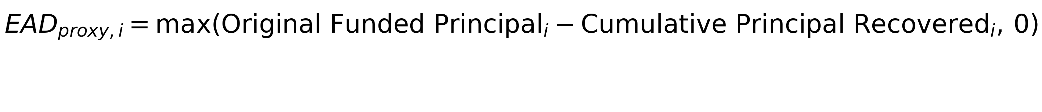
Equation (4.1). Charged-off exposure proxy.
In the charged-off proxy sample, the mean exposure proxy equals $11.2 thousand, the median equals $9.5 thousand, and the 90th percentile equals $22.5 thousand. These magnitudes confirm that default severity in this portfolio is economically material even after partial principal recovery.
Figure 4.1 reports the cross-grade distribution of charged-off EAD and provides an empirical diagnostic on how exposure at resolution varies with underwriting grade.
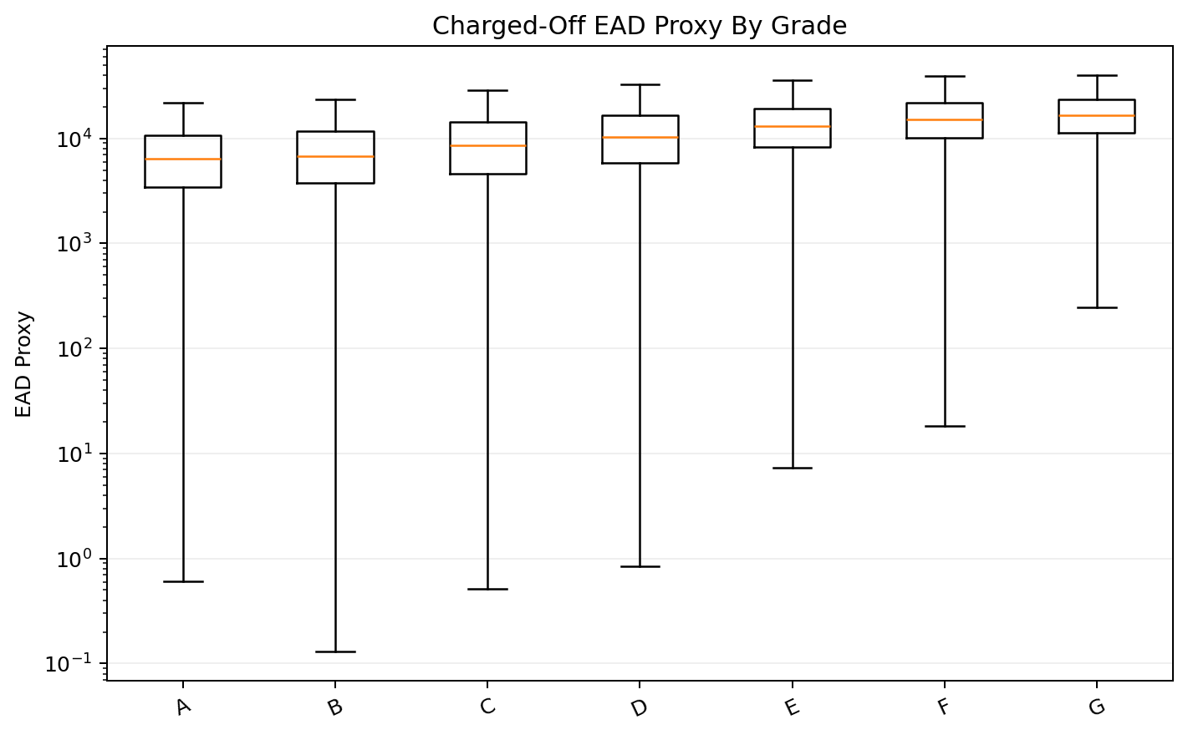
Figure 4.1. Charged-off EAD proxy by credit grade.
The boxplot shows a clear upward shift from grade A through grade G in both the central tendency and upper tail of charged-off exposure. This pattern is economically intuitive: weaker-grade borrowers not only default more often, but also tend to default with larger remaining balances. That feature matters downstream because a risk framework that models only PD would understate the contribution of weaker grades to dollar loss.

4.3 LGD Proxy Design and Credibility-Weighted Expectation
Loss given default is measured on the charged-off subsample after netting out collection costs from reported recoveries. The empirical LGD proxy is therefore the complement of the net recovery rate on the charged-off exposure proxy. This construction is deliberately parsimonious. It maps directly into the course definition of severity, respects the available accounting fields, and avoids the false precision that would come from imposing unobserved workout assumptions.

Equation (4.2). Realized loss-given-default proxy on charged-off observations.
Expected LGD is then estimated through a credibility-weighted lookup rather than a fully parametric severity model. The exact segment key is grade by loan term by origination year, and each cell mean is shrunk toward the portfolio mean using a weight of n divided by n plus 50. The lookup is fit on 220,529 charged-off observations from the train and validation vintages, and the portfolio fallback LGD equals 90.14%. This design stabilizes sparse cells while keeping the estimator interpretable to a credit-risk audience.

Equation (4.3). Credibility-weighted expected loss-given-default lookup.
Table 4.2. Usage of the loss-given-default lookup by analytical scope.
Scope | Loss-given-default source | Loan count
Active snapshot | Exact segment | 199,399
Active snapshot | Grade-term fallback | 713,210
Resolved holdout | Grade-term fallback | 225,611

4.4 Empirical Diagnostics and Interpretation
The charged-off proxy sample has a mean realized LGD of 90.86%, which already suggests that unsecured installment defaults in this dataset are characterized by low recovery. On the temporally held-out charged-off test loans, the credibility-weighted expected LGD lookup produces an MAE of 0.0692 and an RMSE of 0.0892.
A noteworthy identification detail is that all resolved holdout loans are scored with the grade-term fallback rather than the exact grade by term by origination-year cell. This is not a defect. It is a direct implication of the temporal design: the test vintages are 2017 onward, whereas the expected-LGD lookup is estimated only on pre-2017 charged-off data. Preserving temporal purity therefore requires the model to fall back to segment structures observed in the historical estimation window.
Figure 4.2 compares expected LGD with the realized LGD proxy on charged-off holdout loans and summarizes the empirical dispersion of the severity layer.
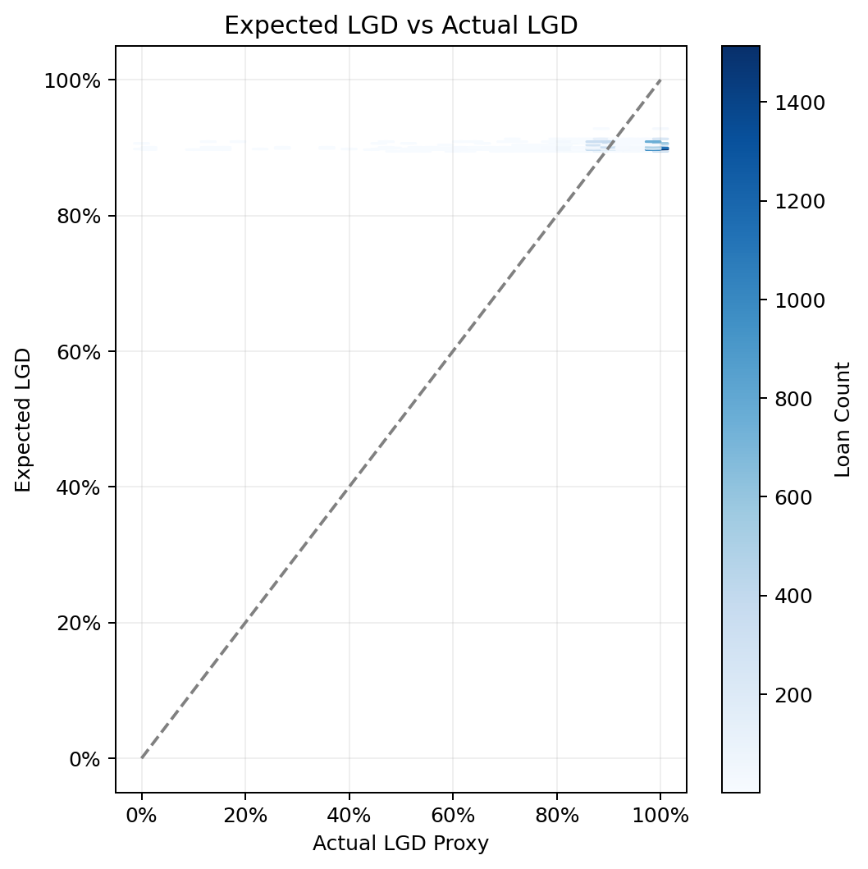
Figure 4.2. Expected LGD versus realized LGD proxy on charged-off holdout loans.
The diagnostic illustrates that both actual and predicted severity mass is concentrated near the upper end of the unit interval, which limits cross-sectional rank dispersion and makes simple correlation less informative. The error metrics are more relevant for the present application: an RMSE below ten percentage points indicates that the LGD layer is sufficiently stable for expected-loss aggregation and reserve segmentation under the available public-data constraints.

5. Expected Loss (Loan & Portfolio Level)

5.1 Conceptual Framework and Notation
Expected loss is the bridge between borrower-level risk estimation and portfolio-level financial measurement. The updated framework now uses the original static HistGradientBoosting loan-level model for lifetime PD and a separate calendar-time hazard model for twelve-month PD.
Table 5.1. Conceptual mapping for expected-loss measurement.
Concept | Definition | Empirical source | Use in this paper
12-month PD | Probability that a loan defaults within the next twelve months | Calibrated calendar-time hazard model | Near-term expected-loss measurement on full observable 12-month cohorts
Lifetime PD | Probability that a loan defaults over its remaining contractual life | Original static HistGradientBoosting loan-level model | Remaining-life reserve-style analytics
Expected LGD | Expected share of exposure lost if default occurs | Credibility-weighted lookup from charged-off loans | Common severity input across forecasting horizons
EAD | Dollar amount at risk when loss is measured | Original funded amount for resolved loans; current exposure for active loans | Dollar scaling of expected loss
EL | Product of PD, LGD, and EAD | Integrated output of the three risk components | Loan-level and portfolio-level loss measurement

The auxiliary reserve hazard comparison remains useful for governance because it provides a time-consistent benchmark. It is no longer the source of lifetime PD: lifetime expected loss uses the rerun original static model, while twelve-month expected loss uses the calibrated calendar-time hazard model.

Table 5.2. Auxiliary legacy reserve hazard benchmark, not used as the main PD input.
Hazard model | Selected | Validation lifetime AUC | Validation lifetime KS | Validation lifetime Brier | Test lifetime AUC | Test lifetime KS | Test lifetime Brier
HistGradientBoosting Hazard | True | 0.6944 | 0.2800 | 0.1629 | 0.6833 | 0.2706 | 0.1551
Pooled Logistic Hazard | False | 0.6943 | 0.2797 | 0.1628 | 0.6830 | 0.2685 | 0.1554

The twelve-month PD model produces short-horizon risk through calendar-time survival aggregation. Each row represents an account-month snapshot identified by sample_id and snapshot_month, and the target target_1m equals one when the account charges off or defaults in the following month. Splits are based on snapshot_month rather than issue_date, so the same account can legitimately contribute early observations to training and later observations to validation or test, matching how a bank would operate a monthly production risk file.
Predicted monthly hazards are converted into cumulative twelve-month PDs by multiplying monthly survival probabilities. For numerical stability, the implementation sums log survival terms before converting back to cumulative PD. The lifetime PD is not produced from the calendar hazard curve in this version; it is supplied by the rerun static HGB loan-level model.
PD_12m = 1 - exp[sum log(1 - monthly hazard)], over the next twelve months; PD_life = static HGB calibrated loan-level probability.
Equation (5.1). Twelve-month hazard aggregation and static lifetime PD mapping.

5.2 Loan-Level Expected-Loss Construction
At the loan level, expected loss is measured as the product of default likelihood, expected severity, and an exposure reference aligned with the analytical scope. For resolved holdout loans, the exposure reference is set equal to original funded principal, so expected loss is interpreted as a fraction of original funded exposure. This convention permits direct comparison with realized net loss after resolution. For active loans, by contrast, expected loss is scaled by current EAD, which reflects the principal that remains outstanding at the snapshot date.
The distinction between horizons is equally important. Twelve-month expected loss uses calibrated calendar-time hazard predicted_pd_12m, whereas lifetime expected loss uses the rerun original static HistGradientBoosting predicted_pd. This two-model design avoids forcing a single hazard specification to serve both short-horizon monitoring and lifetime reserve analytics.

Equation (5.2). Loan-level expected loss under the twelve-month and lifetime horizons.

5.3 Portfolio Aggregation and Holdout Comparison
Portfolio expected loss is obtained by summing loan-level expected loss across the relevant scope. The resulting summary table highlights two separate use cases. For the resolved holdout, predicted twelve-month EL can be benchmarked against realized net loss because both are referenced to the same origination vintages and the same funded-exposure base. For the active snapshot, the output is better interpreted as a reserve-style measure of dollar risk embedded in the currently outstanding loan book.

Equation (5.3). Portfolio aggregation of loan-level expected loss.
Table 5.3. Portfolio-level expected-loss results by scope and horizon.
Scope | Forecast horizon | Number of loans | Average PD (%) | Average LGD (%) | Average EAD | Total EL | Actual net loss
Full 12M cohort | 12-month | 443,579 | 8.03 | 90.17 | $14,845 | $504.2M | $350.4M
Resolved holdout | Lifetime | 225,611 | 26.09 | 90.11 | $14,446 | $839.0M | $616.3M
Active snapshot | 12-month | 912,609 | 8.00 | 90.48 | $10,468 | $732.7M
Active snapshot | Lifetime | 912,609 | 26.11 | 90.48 | $10,468 | $2.452B

On the full observable twelve-month cohort, the model-implied expected loss equals $504.2M, whereas realized twelve-month net loss equals $350.4M. The conservative overlay therefore makes expected loss exceed realized loss by $153.7M, and the expected-loss coverage ratio is 143.87% of realized twelve-month loss. The resolved-only twelve-month comparison is retained as a diagnostic because that subset excludes surviving active loans and therefore overstates default intensity.
For the active snapshot, the reported twelve-month EL equals $732.7M, while the lifetime reserve-style EL equals $2.452B. The lifetime result is based on the static HGB model and is higher because its average lifetime PD (26.11%) exceeds the average twelve-month hazard PD (8.00%).
Figure 5.1 reports portfolio expected loss in both dollar and normalized terms, separating the resolved holdout from the active reserve snapshot.
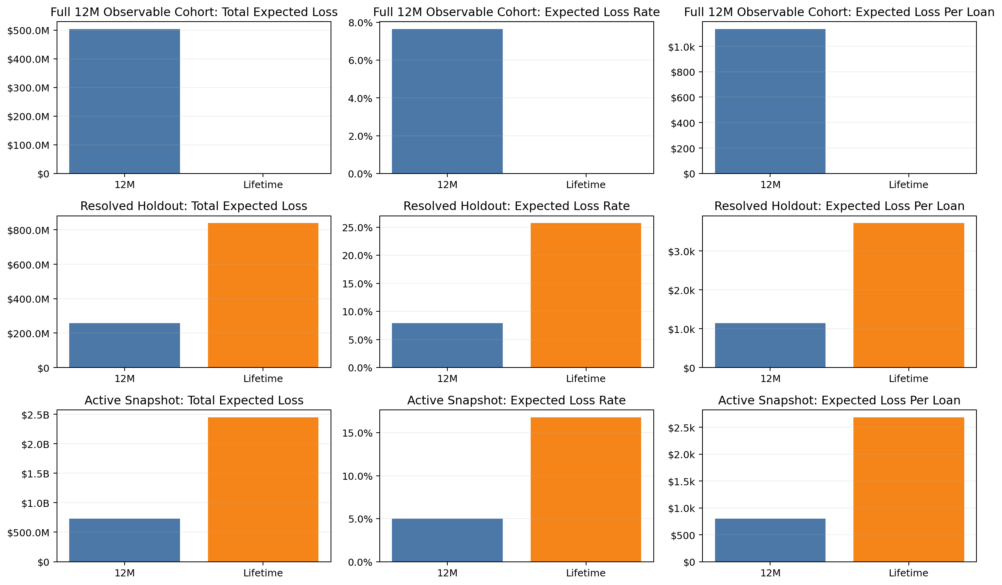
Figure 5.1. Portfolio expected loss by scope, horizon, and normalization basis.
The figure highlights two distinct points. First, the active portfolio is larger in aggregate dollars, so absolute expected loss naturally exceeds the resolved holdout. Second, normalized expected loss behaves differently from absolute totals; the resolved holdout exhibits a higher expected-loss rate than the active snapshot, even though the active portfolio contributes more aggregate dollar risk. That distinction is central to portfolio management because balance size and risk intensity are not the same object.
Figure 5.2 reports expected and realized loss separately for the full observable twelve-month cohort and the resolved lifetime diagnostic.
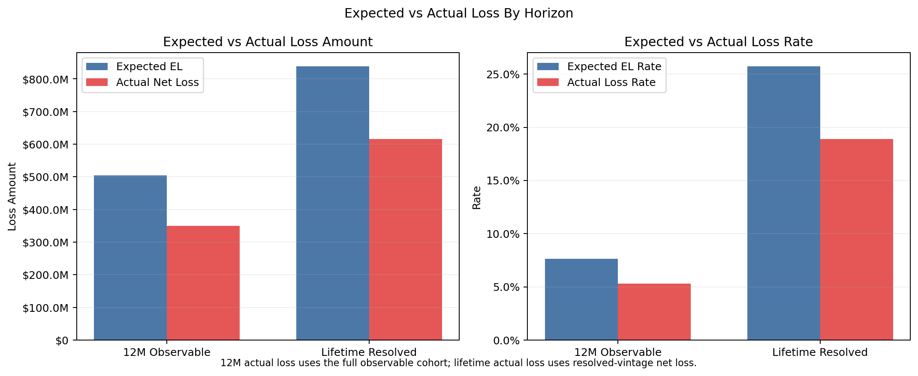
Figure 5.2. Expected and realized loss by horizon under the dual-PD framework.
The evidence indicates that the full-cohort twelve-month comparison is materially less distorted than the resolved-only diagnostic. For lifetime, predicted EL equals $839.0M versus realized lifetime net loss of $616.3M, covering about 136.14% of realized loss.

5.4 Interpretation for Reserve-Style Analytics
The key contribution of this chapter is therefore not merely the computation of a scalar EL number. Rather, it is the construction of an internally linked measurement framework in which borrower-level PD, severity, and exposure estimates propagate into loan-level dollar loss and then into portfolio aggregates. That linkage is what makes the subsequent segmentation analysis economically meaningful.
Concentration diagnostics reinforce this point. The top 1,000 loans explain only 0.79% of lifetime EL in the active snapshot and 2.42% in the resolved holdout. Expected loss in this portfolio is therefore not dominated by a tiny number of single-name exposures.

6. Risk Segmentation Analysis

6.1 Segmentation Design and Managerial Purpose
Risk segmentation is the managerial layer that translates loan-level expected loss into a form that can support monitoring, resource allocation, and policy discussion. The segmentation design adopted here follows standard retail-credit reporting logic: grade captures underwriting quality, loan term captures maturity and amortization structure, FICO bucket captures bureau risk, purpose group approximates use-of-proceeds heterogeneity, and annual income band captures repayment capacity. Each cut is broad enough to be stable and narrow enough to be economically interpretable.
The empirical objective is not to prove that one segmentation axis is universally superior. It is to identify where expected loss concentrates in the current portfolio and whether those concentrations are consistent across the resolved holdout and active reserve snapshot. That comparison matters because a segmentation scheme that appears salient only in historical defaults but not in the live book would have limited governance value.

6.2 Segment Aggregation Methodology
For each segmentation axis, the workflow aggregates loan count, funded amount, mean PD, mean LGD, mean EAD, mean EL, total EL, and share of portfolio EL. The key portfolio-share statistic is the ratio of a segment’s total expected loss to the total expected loss of the full analytical scope. This normalization ensures that segmentation results remain interpretable even when the absolute size of the resolved holdout and active snapshot differs substantially.

Equation (6.1). Segment-level expected loss and portfolio share.
Table 6.1. Lifetime expected loss by credit grade across the two analytical scopes.
Grade | Resolved holdout expected loss | Resolved holdout share of expected loss | Active snapshot expected loss | Active snapshot share of expected loss
A | $38.0M | 4.53% | $168.8M | 6.89%
B | $143.6M | 17.11% | $533.5M | 21.76%
C | $282.7M | 33.70% | $878.5M | 35.83%
D | $201.7M | 24.04% | $564.2M | 23.01%
E | $103.6M | 12.35% | $220.0M | 8.97%
F | $43.8M | 5.23% | $64.8M | 2.64%
G | $25.5M | 3.05% | $22.2M | 0.90%

Table 6.2. Dominant lifetime expected-loss segments by reporting axis.
Segmentation axis | Resolved dominant segment | Resolved share of expected loss | Active dominant segment | Active share of expected loss
Credit grade | C | 33.70% | C | 35.83%
Loan term | 60 months | 50.87% | 60 months | 66.81%
Loan purpose | Debt Consolidation | 62.10% | Debt Consolidation | 61.69%
FICO bucket | Fair | 62.92% | Fair | 58.94%
Income band | $50,000-$100,000 | 51.45% | $50,000-$100,000 | 50.40%

6.3 Empirical Concentration Results
Several concentration patterns are immediate. In the active snapshot, grade C alone contributes 35.83% of lifetime EL, followed by grade D at 23.01% and grade B at 21.76%. The resolved holdout exhibits a similar but slightly less concentrated pattern, with grade C contributing 33.70% and grade D contributing 24.04%.
The cross-axis concentration statistics reinforce the same story. Debt Consolidation loans account for 62.10% of resolved lifetime EL, while Debt Consolidation loans account for 61.69% of active lifetime EL. The leading term segment is 60 months in the resolved holdout (50.87%) and 60 months in the active snapshot (66.81%), indicating that contractual tenor remains a primary driver of reserve exposure.
Figure 6.1 reports aggregate grade-level EL contributions across the resolved holdout and active snapshot.
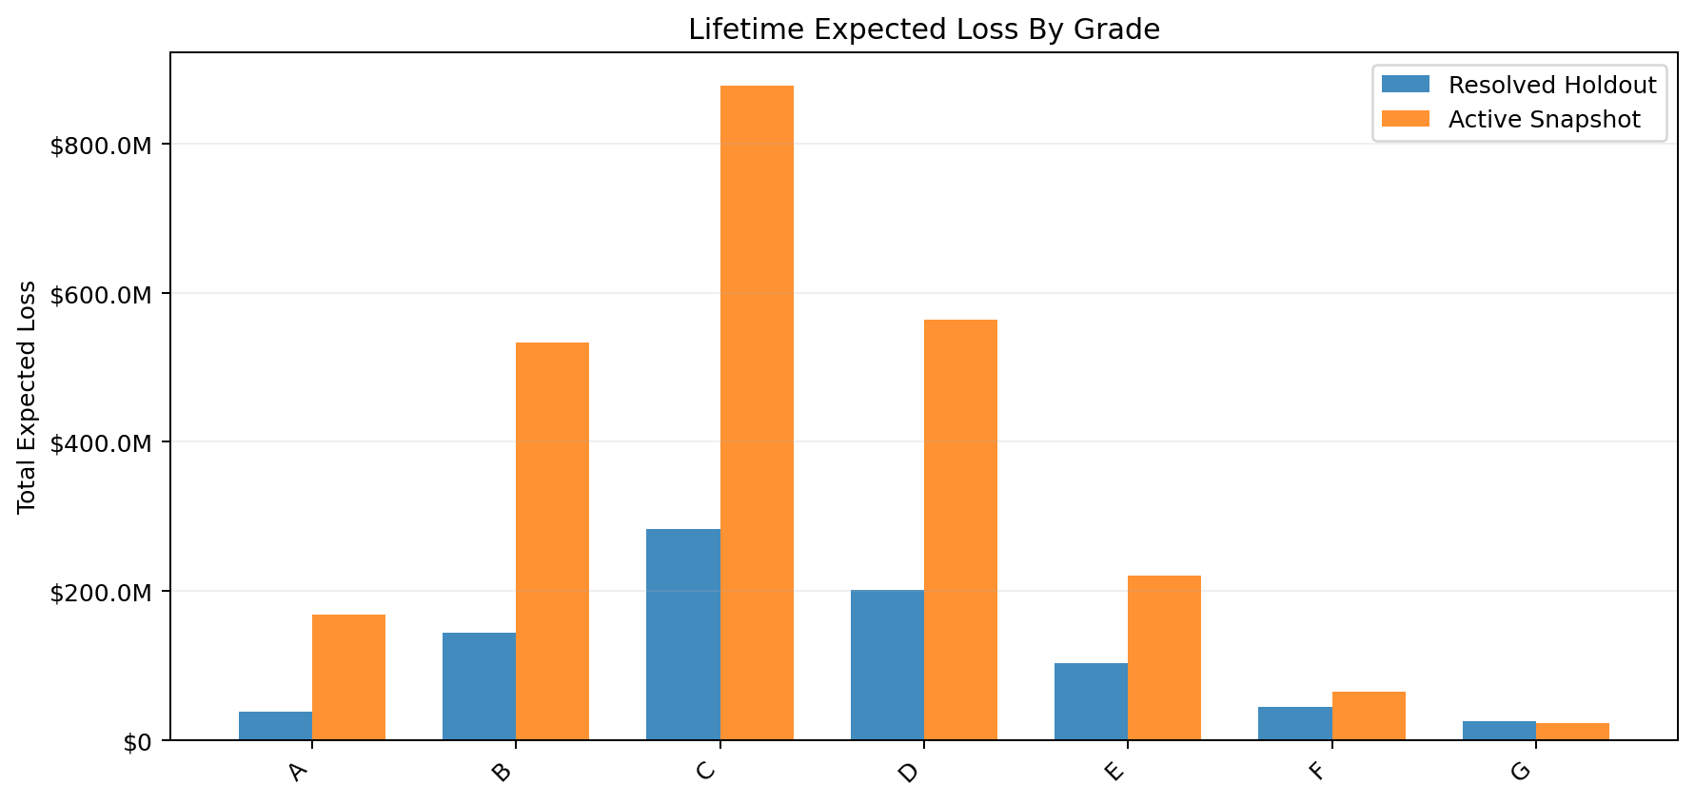
Figure 6.1. Lifetime expected loss by credit grade across the resolved holdout and active snapshot.
The grade comparison makes clear that the active portfolio is not simply a scaled-up version of the resolved holdout. It remains concentrated in grades B through D, especially grade C, while the weakest grades carry high loan-level severity but smaller aggregate shares because fewer loans sit in those buckets.
Figure 6.2 maps the interaction between underwriting grade and contractual maturity in the active snapshot.
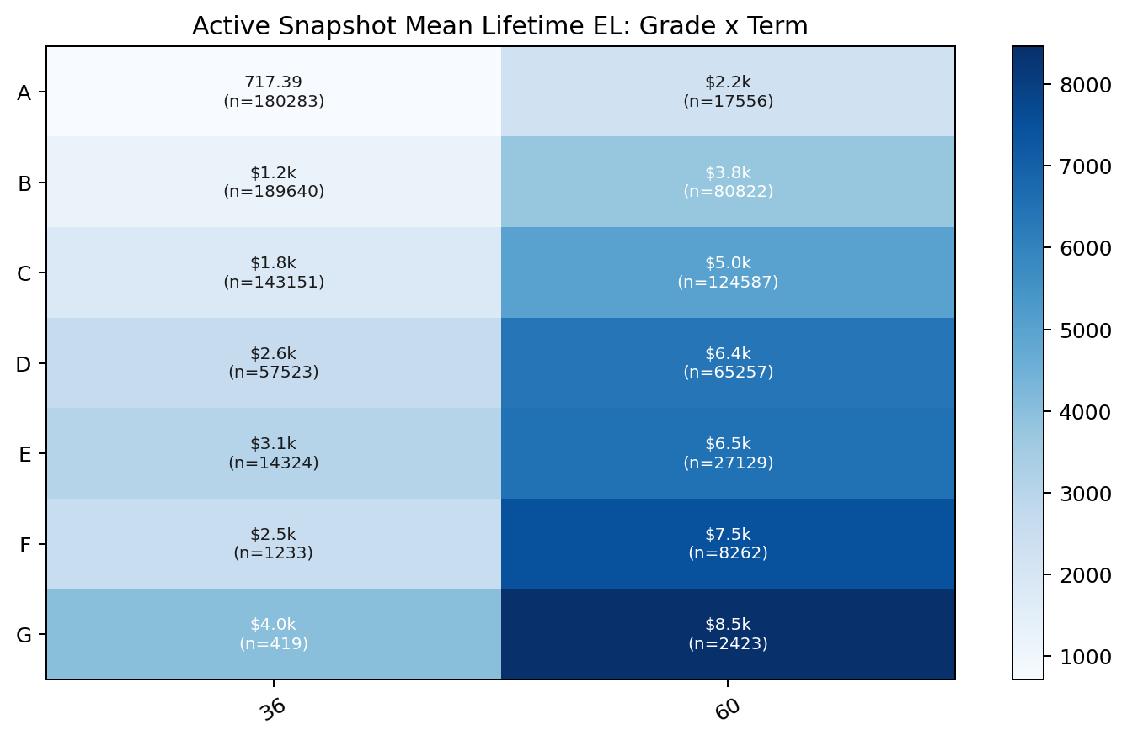
Figure 6.2. Active-snapshot mean lifetime expected loss across credit grade and term.
The heatmap shows a strong interaction effect: within every grade, sixty-month loans have materially higher mean lifetime EL than thirty-six-month loans, and within each term bucket the mean EL rises sharply from investment-grade segments toward speculative-grade segments. This interaction is economically useful because it suggests that maturity and underwriting quality should be monitored jointly rather than in separate dashboards.

6.4 Interpretation and Governance Value
From a governance perspective, the segmentation results imply that expected loss in this portfolio is structural and monitorable. It is structural because the dominant concentrations recur across the resolved holdout and the active snapshot. It is monitorable because the dominant drivers map to standard managerial buckets such as grade, maturity, purpose, and bureau quality. In other words, the segmentation layer converts the integrated PD-LGD-EAD framework into a set of reporting views that a risk committee could plausibly consume.
Equally important, the segmentation results expose what the present framework does not yet do. They identify where loss is concentrated, but they do not yet convert those concentrations into pricing spreads, capital charges, or scenario-conditioned stress losses. Those would be the natural next steps. For the purposes of the current paper, however, the segmentation chapter already demonstrates that the modeled expected loss is rich enough to support economically meaningful portfolio discussion rather than merely loan-level prediction.

7. Risk-Based Pricing Design

8. Capital (Economic Capital) Estimation

9. Backtesting and Visualization

10. Conclusion

