CS271 Fall 2021 Computer Graphics II

HomeWork 2

**Name:**

**Student ID:**

**E-mail:**

**Acknowledgements:**

* Deadline: **2022-10-25 23:59:59**
* You can choose C++ or Python, and no restrictions on programming framework. You can freely use frameworks such as openGL.
* The full score of this HW2 is 100 points.
* The **report** submits as a PDF file, the **programming part** should package all the files include **code**, **input files**, **executable file**, **readme.txt**, and **report**. The package name is your_student_name+student_id.zip.
* You will get Zero if the code not passing the plagiarism check.

**The Application of K-means Clustering[1]**

Explore the application of K-means clustering in **image superpixel segmentation[2]** and **mesh simplification[3]**. Give details of the algorithms, experimental results, and analysis.

[1] k-means clustering:

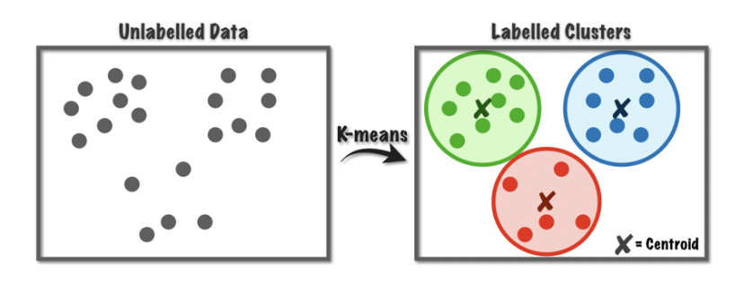

[2] for example:

**Superpixel:**

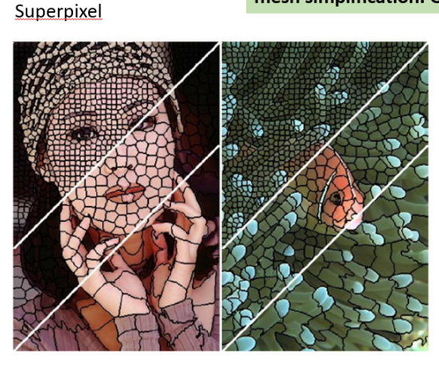

[3] for example:

